Evaluating The Marine Transportation Sector of Akwa Ibom State Within The Framework of The Nigerian Blue Economy

Abstract

The marine transportation sector of Akwa Ibom State was evaluated in order to ascertain its potential for the development of the State in the context of the Blue Economy. Some coastal communities with a direct connection to the Atlantic Ocean were selected from the five local government areas of the State. Parameters on maritime transportation such were studied. The result showed that there were two ports with moderate warehousing spaces. These were Marina and Ibaka ports. Based on connection with Land-based Transport System, the study showed that Marina Port, Ibaka Port, Jetty, and Mc Friday Port are the only ports with a direct connection to the road network. Also, based on the connection with the Inland waterways, Mbe Ndoro, Mc Friday, Ibaka, Iwu Owo Okpolom and Emereoke Port were the only recognized port with direct access to the inland waterways. For the Navigability of the waters, the Eastern waters were somewhat stable for navigation while the southern waters were sometimes turbulent and characterized by storm surge. In collecting data for the economic valuation of the sector. a total sample size of 768 respondents was obtained using the Godden’s (2004) formula. The questionnaire was administered using the purposive sampling technique. The result further showed that Engine Propelled and Manually Propelled were the major boat/ship types used. For the evaluation of the marine transportation sector, the consumer willingness-to-pay (WTP) method in market price approach was employed. The present economic valuation of the Marine transport sector of the area was high; an indication that the marine transportation sector of the Akwa Ibom blue Economy is viable and that investing in it is bound to be profitable, as customers are willing to pay more for its services.

Key Words: harnessing, marine transportation, framework, blue economy

- Introduction
As a traditional blue economy sector, environmental concerns associated with marine transport have garnered increasing attention. According to Adeyemi et al. (2024) inadequate port infrastructure and inefficiencies in logistics negatively impact marine transportation in Nigeria, limiting economic growth potential. The study underscores the importance of public-private partnerships (PPPs) in improving infrastructure and services in the maritime sector, thereby enhancing the overall efficacy of marine transportation. Similarly, Oguntade et al. (2023) through case studies and stakeholder interviews, found that while digital technologies, such as vessel tracking systems and automated cargo handling, can significantly improve operational efficiency, a lack of comprehensive training and investment hampers their full implementation. They recommend enhanced training programs and stakeholder collaboration to bridge the technology gap in the sector. In addressing the issue of sustainable marine transportation, Okeke et al. (2025) suggested that while biofuels, hydrogen, and electric propulsion technologies are promising alternatives, the transition is hindered by infrastructure limitations and regulatory challenges. They argue for more robust policies and incentives to facilitate this transition, ensuring that marine transportation becomes a key player in achieving global sustainability goals. Furthermore, the study by Ibrahim and Babalola (2024) showed that existing policies often lack coordination and clear guidelines, resulting in inefficiencies. They recommend policy reforms aimed at streamlining procedures and enhancing transparency, thus improving marine transportation effectiveness and fostering economic growth. In conclusion, the findings from these studies highlight the multifaceted challenges and opportunities within the marine transportation sector. Enhancing efficiency, safety, and sustainability through technological advancements, policy reforms, and infrastructural improvements is essential for fostering a robust marine transportation system that can benefit economies globally and in regions like Nigeria.
According to Emmanuel, Ifabiyi, and Chijioke (2018), Nigeria has 853 kilometres of coastline, 450 kilometres of inland waterways and a sovereign right to 200 nautical miles exclusive economic zone. They concluded that inland waterways have a high potential for transportation, but it is largely underutilized. The study recommended stronger policies and the need to encourage private-public participation in waterway transport development in the southwest coastal area of Nigeria. Also, Emmanuel, Ifabiyi and Chijioke, (2018) demonstrated that the potential of inland waterways transport was high and concluded that inland waterways have a high potential for transportation, but it is largely underutilized. The study recommended stronger policies and the need to encourage private-public participation in waterway transport development in the southwest coastal area of Nigeria. It was, therefore, necessary to carry out an economic valuation of this sector to determinie its viability within the context of the State’s blue economy.
The advocacy of valuing ecosystem services in monetary terms is embedded in the logic of market environmentalism, prominent since the late 1980s alongside the expansion of the neoliberal ideology (Bakker, 2005). One method used in the valuation of market-based resources and services is Economic valuation using the Willingness–to-Pay method, using the Producer surplus approach. This is the extra money that a company earns when it sells a product or service for more than the expected price. It works by asking individuals hypothetical questions about their willingness to pay for goods or services or their willingness to accept compensation for loss, placing a monetory value on these non- market goods in a simulated market scenario. The reliability depends on carful survey design to minimize bias and ensure the validity of the hypothetical contex. Respondents are asked how much they will be willing to pay for an improvement in the resource (WTP) or how much they wil be willing to accept (WTP).
Governments use economic valuations to inform policy decisions, ensuring that economic activities do not come at the cost of depletion of natural resources. These valuatiomns guide taxation, subsidies, or regulations to encourage sustainable practices. Also, valuing natural resources can assist in determining fair market prices for goods and services derived from nature, leading to more accurate pricing in industries such as agriculture, fishing and energy (Chi, 2025). Proper resource evaluation ensures that nature resources are used effectively and sustainably. By understanding their values, societies can implement strategies to conserve resources, prevent depletion, and protect ecosystem for future generations. It also helps in underdtanding the long–term impacts of resource use on the environment and highlights the hidden costs of environmental degradation, such as pollution, habitat destruction, climate change, which can be factored into the decision – making process.

- Study Area
The study area is located in the Niger Delta region of Nigeria. The area is a stretch of coastal area along the Bight of Bonny on the Atlantic Ocean. It has a shoreline approximately 119.64km in length and spans from a point at Eastern Obolo on latitude 4˚28'N and longitude 7˚55'E to Oron on latitude 4˚50'N and longitude 8˚14'E (Udosen, Olabanjo, and Etok, 2014; Ekong, 2017; Udoudo, Emengini, and Igbokwe, 2019).
The area has two distinct seasons namely the wet or rainy and the dry season. The climate characteristics correspond to Koppen’s climate classification. It is characterized by very high rainfall (annual totals >4000 mm), high temperatures values of about 27˚C, and high values of relative humidity with a mean value of 80.3%. It has been suggested that shoreline erosion rates are expected to change in response to changes in climate (Atser, Etim, Beulah and Ekong, 2010). Also, very high climatic factors will lead to an increase in the rate of shoreline change. The present study is a move to show what has happened to the area with the current climate change.
The General vegetation class of the study area can be divided from the shoreline as mangrove/Nypa palms/phoenix belt, the secondary forest, the oil palm and abandoned farmlands and fallowed areas. The geomorphology of the study area consists of level to gently undulating sandy plains. The terrain is heavily incised by numerous creeks, shallow streams, rivers, although, they are few and far between in the Northern part of the study area. Long rectilinear slopes (>400 m) with gentle inclinations of less than 50 m, shallow depressions and water-logged valley bottoms constitute the major landforms. During the rainy season, many of the depressions may be inundated but consist of heaps of sand and sometimes thick deposits of clay when the water subsides. Generally, the relief of the study area ranges from less than 3 metres above sea level along the beach to about 45 metres inland. The gently-sloping beaches, wave breakers and a few small swamps systems are prone to flooding. The beaches were probably formed during the development of coastal basins and trough spanning the entire Gulf of Guinea in the cretaceous era (AKIPOFTZ, 2015; Ekong, 2017)
In terms of the socio-economic activities in the area, there is a high level of dependence on natural resources for livelihood sustenance. Fishing is a male-dominated enterprise while women dominate the gathering of periwinkles and crabs from the shallow swamps and dry season farming. The women also exploit the mangrove forest for firewood and gathering non-timber forest products such as mushroom, wild fruits and vegetables. They also process raw fish via drying or smoking and engage in the farming of local food crops (cassava, yams, cocoyam among others) (Ekong, 2017).
Through the advent of oil exploration and the sitting of Exxon Mobil, Qua Iboe Terminal at Ibeno and migration of a large population the area has witnessed tremendous human activities. These human activities in turn result in the removal and disappearance of the native vegetation from the area thereby making the soil easily eroded (Ekong, 2017).

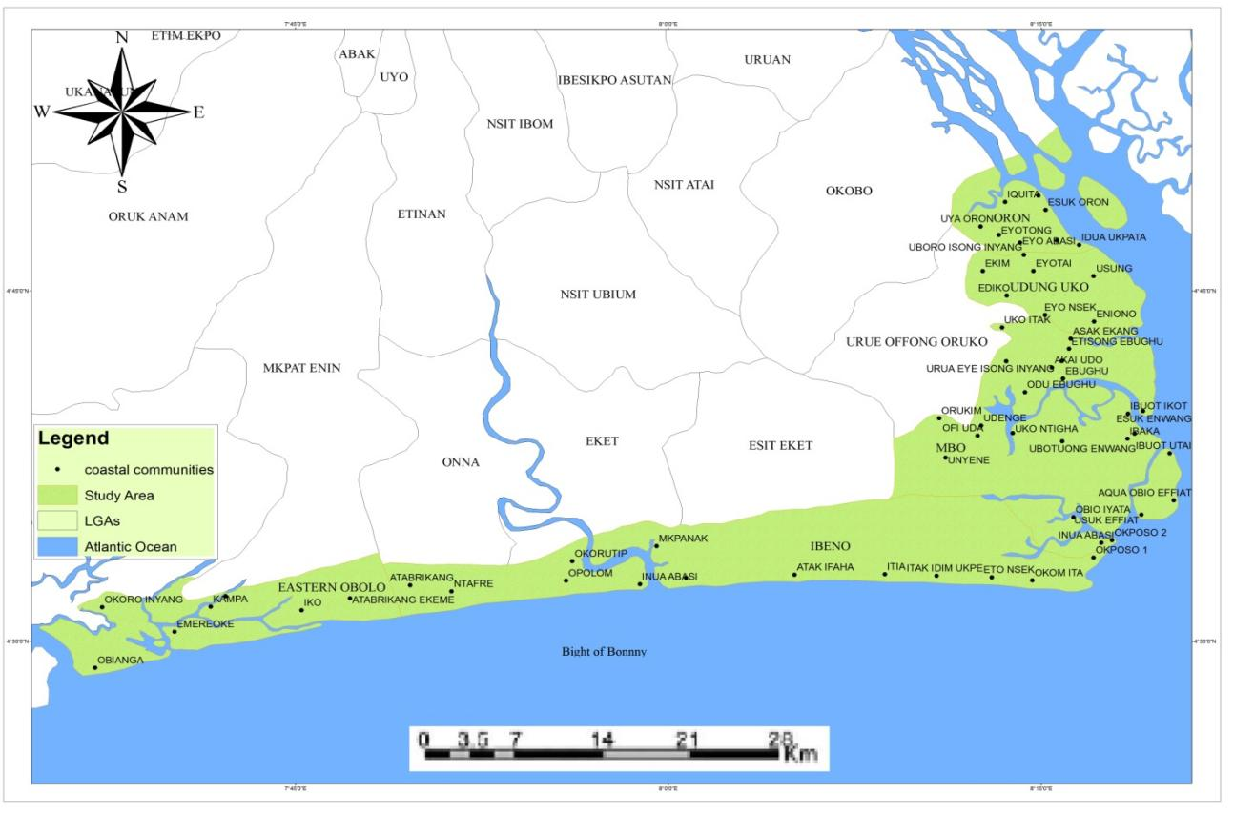
Figure 1.1: Study Area Map Showing Coastal Area and Communities
Source: GIS Laboratory, Department of Geography, University of Uyo

- Materials and Methods:
3.1) Population and Sample size
For the respondents, all the community heads and representatives participated in the study. In the course of the administration of the questionnaire, there were no records available to show the population figures of the selected communities. In a situation where the population size is infinite or cannot be accurately estimated in terms of respondents, Godden’s (2004) opined that the infinite population sampling formula can be used to determine the sample size. Thus, a sample size of three hundred and eighty-four (384) respondents was adopted for this study using Bill Godden 2004 sample size determination formula as shown:

SS = Z² x (p) x (1-p)
C²
Where:
Z = 1.96 Z value (1.96 for 95% confidence level)
P = 0.5 per cent picking a choice, expressed as a decimal (.5 used for sample size needed)
C = 5% confidence interval, expressed as decimal (0.05).
Thus:

SS = 1.96² × (0.5) × (1-0.5)
0.05²

SS = 3.8416 × 0.5× (0.5)
0.0025
SS = 1.9208 × (0.5)
0.0025
SS = 384.

In order to give more reliable results with greater precision and power, it was necessary to double the sample size of 384 to 768 for the purpose of this study
A sampling of the respondents involved travelling to the location of the study area, and living with the people for proper acquisition of data, i.e. each household were purposively chosen and respondents not less than 18years were administered the questionnaire. Some 768 copies of the questionnaire were administered in the entire 29 communities as presented in Table 3.1. While 26 copies of the questionnaire were proportionally administered to all the villages, 28 copies were judgementally administered to some villages due to the observed level of development among the selected communities. An attempt was made by the research team to eliminate gender inequality in the course of the administration of the questionnaire. It also involves the assistance of a locally trained field assistant for each local government area. Furthermore, copies of the questionnaire were administered to respondents to acquire information on waste disposal, the contribution of ocean-based resources and services to the local livelihood system.
First, a pre-field was conducted over the entire coastline as an avenue for consultation from Oron, Udung Uko, Mbo, Ibeno, to Eastern Obolo. Letters of introduction were served and dates were fixed for the real studies after which the actual study begins with the research team. Data collection was only carried out on Sundays. The justification for this was that the major occupation of the people is fishing, hence, respondents needed for the study were only available on Sundays which is their resting days and engagement in other activities such as religion among others were minimal.
Table 3.1: Proportion of administered questionnaires
Communities | Copies of Administered Questionnaire
ORON
Esin Ufot | 28
Esuk Oron | 28
Idua Afaha Eduaok | 26
Idua Asang | 28
Idua Esit Edek | 26
Idua Ukpata | 26
Ine Ekong | 26
MBO
Aqua Obio Effiat | 26
Esuk Effiat | 26
Esuk Enwang | 26
Ibaka | 28
Ibuot Ikot | 26
Inua Abasi | 26
Mbe Ndoro | 26
Okposo 1 and 2 | 26
Unyeghe | 28
IBENO
Akata | 26
Atia | 26
Edetsie | 26
Inua Eyet Ikot | 28
Itak Afaha | 26
Itak Edim Ukpe | 26
Iwu Owo Okpolom | 26
Ndito Eka Iba | 26
Okom Ita | 26
EASTERN OBOLO
Emereoke | 28
Elekpon | 26
Obianga | 26
UDUNG UKO
Itakakpa | 26
Total | 768
Source: Fieldwork (Updated in 2022)

3.2. Instrument for data collection
The study adopted different methods for data collection which are observation, and questionnaire. The questionnaire was used as an instrument for data collection which was structured to answer relevant questions needed for the study. It was constructed and designed in two languages which include formal language (English Language), and the indigenous language. GPS co-ordinate was taken using GPS and a Recording Book was used for documentation.

  - Economic Valuation Method
To determine the current economic valuation of ocean-based resources and services within the blue economic framework, Lipton, Katherine, Isobel and Rodney (1995) and Ulibarri and Wellman (1997) adopted market price using producer surplus based on willingness to pay method. The producer surplus represents the difference between the amount that a seller would be willing to accept for his product or service versus what the product or service are actually woeth on the market. It is the extra money that a company earns when it sells a product or service for more than the expected price. This is given as;
Producer Surplus = Net Willingness-to-pay – Total Variable Cost
Where:
Net Willingness-to-pay = total days of activities × quantity × fixed cost.
The Weaknesses of Contigency Evaluation Methods (CEM) which uses Willingnes-to-Pay, is its reliance on hypothetical scenarios rather than actual market behavior. Leading to various biases and questioning the valididty and reliability of the results. This means that respondents may overstate their WTP because they do not actually have to pay the amount stated often called “rubber money reponses, leading to an overestimation of values.” According to (Silvertown, 2015), one source of concern is the cognitive demands that it places on respondents in terms of understanding the policy being valued. Unless respondents understand what is being valued, and believe their answers to be consequential in influencing the policy choice, the cannot be expected to give meaningful answers.
While, the producer surplus may prove useful for evaluating policy impacts, its limitations in accounting for market power, externalities, and accurate, dynamic cost structure requires that it be used with a bit of causion and often combined with oher indicators.

4) Methods of Data Analysis
4.1 Data Acquisition
Data for this study was generally primary. The dataset for the study is presented in Table 4.1.

Table 4.1: Dataset for ocean-based resources and services
Blue Economy Sectors | Variables |  | Measurement | Type of Data
Blue Economy Sectors | Resources | Services | Measurement
Maritime Transportation |  | Depth of water, Port Operation, Warehousing space, Connection with Land-based Transportation/Inland Waterway, Navigability of the water, Boat/Ship Category (Emmanuel et al., 2018) | Nominal | Primary Data
Source: Fieldwork (2022)

- Results and Discusssion
As consumers age, gender, income, educational status and where they live can impact on WTP (Anand, 2020), as cited in Harvad Business School Online (2020), it was necessary to investigates these attribues for a proper known of their willing ness to pay for marine security and coastal protection.
5.1) Socioeconomic Characteristics of the Respondents
- Age of Respondents
Table 5.1: Age of Respondents
Age | Number of Respondents | Percentage
20 - 29 | 160 | 20.8%
30 - 39 | 280 | 36.5%
40 - 49 | 150 | 19.5%
50 - 59 | 120 | 15.6%
60 and above | 58 | 7.6%
Total | 768 | 100
Source: Field Data (Updated in 2023)

Table 5.1 shows that about 21% of the respondents were between 20 and 29 years of age, and about 37 % of the respondents were of ages of beteen 30 and 39 years of age. Respondents of 60% and above were the least (7.6%) in the sample.

- Marital Status of Respondents
Table 5.2: Marital Status of Respondents:
Marital Status | Number of Respondents | Percentage (%)
Single | 188 | 24.5
Married | 181 | 23.5
Divorced | 228 | 29.8
Widow/Widower | 171 | 22.2
Total | 768 | 100
Source: Field Data (Updated in 2023)

The study investigated the marital status of respondents across the sampled communities, as detailed in Table 5.1. From the analysis of the marital status, of respondents, it was seen that 24.5% of the respondents sampled were single, 23.5 % were married, 29.8% were divorced and 22.2% were widowed / Widowers.

- Educational Qualifications of Respondents
Table 5.3: Educational Qualifications of Respondents
Educational Qualification | Number of Respondents | Percentage (%)
No Formal Education | 228 | 29.6
Primary Education (FSLC) | 188 | 24.5
Secondary Education | 180 | 23.5
Tertiary Education | 172 | 22.4
Total | 768 | 100
Source: Field Data (Updated in 2023)

For the Educational status, the responses presented in Table 5.3 shows that close to 30 % of the respondents had no formal education, 24.5% had primary education, 22.4 % were products of secondary education. It must be noted that educational levels of the respondents play a key role in the economic valuation of non-market based resources where the economic implication is not easily understood.

- Occupational Status of Respondents: The study also investigated the occupational status of the respondents. Their responses are presented in Table 5.4:
Table 5.4: Occupational Status of Respondents
Occupation | Number of Respondents | Percentage
Civil Servants | 80 | 10.4%
Minners | 70 | 9.1%
Traders | 190 | 24.7%
Farmers | 120 | 15.6%
Fishermen | 380 | 40.2%
Total | 768 | 100
Source: Field Data (Updated in 2023)

Table 5.4 shows that fishermen made up close to 40.2% of the respondents followed by Traders with 24.7%. This confirms that the area is dominated by fishermen and traders.

v) Monthly Income of Respondents
Table 5.5: Monthly Income of Respondents
Monthly Income | Number of Respondents | Percentage
Below 30, 000 | 260 | 33.0
30, 000 – 50, 000 | 178 | 23.2
51 – 100, 000 | 238 | 30.9
100, 000 and above | 92 | 12.9
Total | 768 | 100
Source:
The monthly income of the respondents was sought for in the study and is presented in Table 4.5. The table shows that 33.0 % of the repondents earned income of below 30, 000 representing the largest group. This was followed by those who earned 100, 000 and above with 12.9%.
5.2 Maritime transportation characteristics of the study area. The result in Table 5.1 showed that the depth of water is between 0 – 1000 meters based on the earlier computed bathymetry of the zone in Fig. 5.1. The port operations in greater part of the study area are mostly managed by the local council. Marina Port (Esuk Oron, Oron), Ibaka Port (Ibaka, Mbo), and Jetty (Inua Eyet Ikot, Ibeno) are the only port been managed by recognized management staff. The result also showed that there are two ports with moderate warehousing spaces in the study area. These ports are Marina and Ibaka port. Based on connection with Land-based Transport System, the study showed that Marina Port, Ibaka Port, Jetty, and Mc Friday Port are the only port with a direct connection to the road network. Also, based on the connection with the Inland waterway, Mbe Ndoro, Mc Friday, Ibaka, Iwu Owo Okpolom and Emereoke Port are the only recognized port with direct access to the inland waterway. Looking at the Navigability of the water, the Eastern waters are somewhat stable for navigation while the southern waters are sometimes turbulent and characterized by storm surge. The result also showed that out of a total number of 52 Boat/Ship sited and counted, Engine Propelled 41 (78.85%) and Manually Propelled 11 (21.15%) are the major boat/ship types in the study area.
Table 5.1: Maritime transportation characteristics of the study area.
Parameters | Observations |  | Remarks by Respondents
Depth of water | 0 – 1000m (Based on the Bathymetry) |  | Depth of water will limit the size of the ship and can affect National and International Trade
Port Operation | Government | Local Council | It is necessary to promote efficiency and Competition
Port Operation | Marina Port (Esuk Oron, Oron), Ibaka Port (Ibaka, Mbo), and Jetty (Inua Eyet Ikot, Ibeno) | Itakakpa port, (Udung Uko), Mbe Ndoro Port (Mbe Ndoro, Mbo) Iwu Owo Okpolom port (Iwu Owo Okpolom, Ibeno), Mc Friday port (Qua Iboe River Estuary) Emereoke Port (Emereoke, Eastern Obolo) | It is necessary to promote efficiency and Competition
Warehousing Space | Marina port and Ibaka Port |  | It will promote the protection of goods
Connection with Land-based Transport system | Marina Port, Ibaka Port, Jetti, and Mc Friday Port, Obianga Jetty |  | It promotes the efficiency of goods transported
Connection with Inland waterway | Mbe Ndoro, Mc Friday, Ibaka, Iwu Owo Okpolom and Emereoke Port. |  | It will determine the type of boat used and the ways goods are moved.
Navigability of water | Stable Eastern waters and turbulent Southern water characterized by storm surge |  | It affects movement and types of ship used
Boat/Ship types | Engine Propelled 41 (78.85%) and Manually Propelled 11 (21.15%) |  | It affects the speed and efficiency
Sources: Fieldwork (Updated in 2023)

The result in Table 5.2 showed that six major types of goods are transported along the water body. These goods are Agricultural outputs, Fishes, Forest Resources, Musical Equipment, construction materials, and commercial products. Also, Humans are transported along this route, for example, Indigenous people, Tourist, Traders, company staff among others. Fig. 5.1 showed fishermen transporting fishes caught on the river, while Fig. 5.2 showed the distribution of port facilities in the study area.

Table 5.2: Types of goods transported on the water
Type of goods | Examples
Agricultural output | Vegetables, fruits, palm oil
Fishes | Fishes caught along the river
Forest Resources | Firewood, Leaves, Timber
Musical Equipment | Musical Equipment
Construction Materials | Cement, Sands, Gravels, Irons, Building tools
Commercial products | Drinks, Snacks, Clothes, Boks, Plastics, etc.
Human Freight | Indigenous people, Tourist, Traders, company staff among others.
Source: Fieldwork (Updated in 2023)
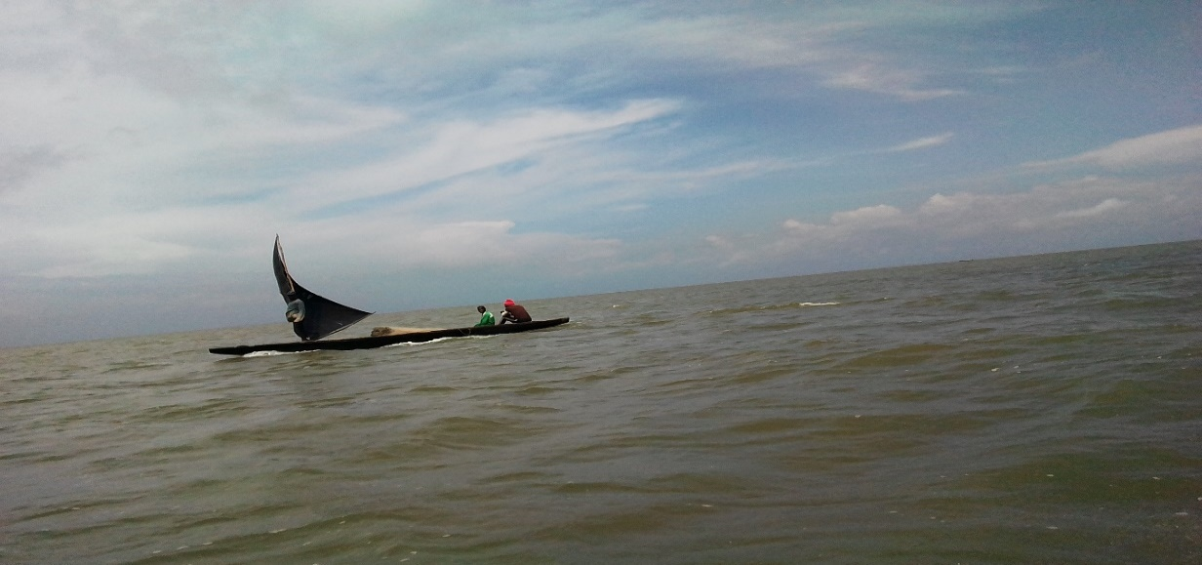
Fig. 5.1: Fishermen transporting fishes caught on the river
Source: Fieldwork (2021)
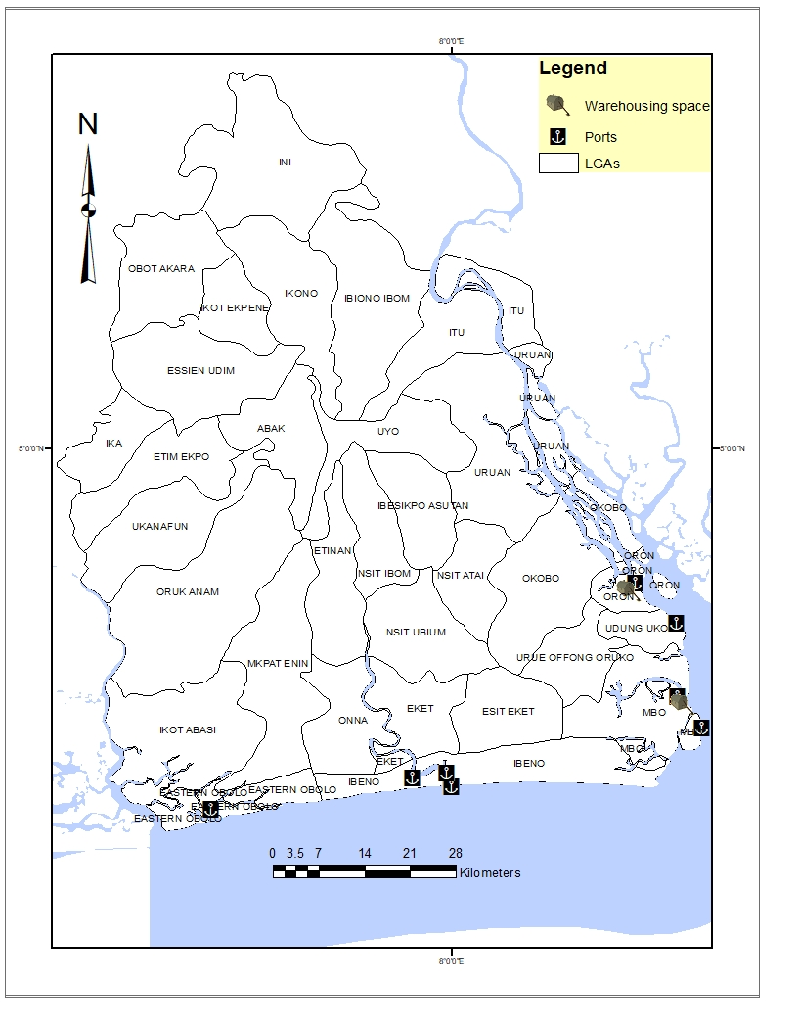
Fig. 4.2: Distribution of port facilities in the study area
Source: Fieldwork (Updated in 2023)

The port operations in most of the identified ports in the study area are managed by the local councils. Marina Port (Esuk Oron, Oron), Ibaka Port (Ibaka, Mbo), and Jetty (Inua Eyet Ikot, Ibeno) are the only port been managed by recognized management staff. The result also showed that there are two ports with moderate warehousing spaces in the study area. These ports are Marina and Ibaka port. Based on connection with Land-based Transport System, the study showed that Marina Port, Ibaka Port, Jetty, and Mc Friday Port are the only port that has a direct connection to the road network. Also, based on the connection with the Inland waterway, Mbe Ndoro, Mc Friday, Ibaka, Iwu Owo Okpolom and Emereoke Port are the only recognized port with direct access to the inland waterway. Looking at the Navigability of the water, the Eastern waters are somewhat stable for navigation while the southern waters are sometimes turbulent and characterized by storm surge. The result also showed that out of a total number of 52 Boat/Ship sited and counted, Engine Propelled 41 (78.85%) and Manually Propelled 11 (21.15%) are the major boat/ship types in the study area. The result further showed that six major types of goods are transported along the water body. These goods are Agricultural outputs, Fishes, Forest Resources, Musical Equipment, construction materials, and commercial products. Also, Humans are transported along this route, for example, indigenous people, tourist, traders, company staff among others.

4.1 Economic valuation of marine transport industry in Akwa Ibom State
Since the identified Maritime transport service are services that are rendered in the market, the market price approach using producer surplus method was adopted to estimate the economic value based on net willingness to pay (WTP). Table 4.3 showed the summary of transport fare and number of passengers per day in eight identified port location in the study area.
Table 4.3: Summary of transport fare and number of passengers
Port Location | Fixed price/Kg (Naira) | Variable cost (Naira) | Maximum price/kg (Naira) | No. of passengers per day
Marina port, Oron | 800 | 1200 | 2000 | 160
Ibaka port, Mbo | 600 | 400 | 1000 | 80
Inua Eyet Ikot Jetty, Ibeno | 700 | 100 | 800 | 40
Itakakpa Port, Udung Uko | 400 | 200 | 600 | 15
Mbe Ndoro port, Mbo | 700 | 100 | 800 | 25
Iwu OWo Okpolom port, Ibeno | 500 | 200 | 700 | 30
Mc Friday port, Ibeno | 600 | 100 | 700 | 65
Emereoke port, Eastern Obolo | 700 | 300 | 1000 | 65
Total | 5000 | 2600 | 7600 | 480
Mean | 625 | 325 | 950 | 60
Source: Fieldwork (Updated in 2023)

Willingness-to-pay = Total days of operation × no. of passengers × price per trip
Total days of operation = 365days
Willingness-to-pay = 365 × 60 × 625
Willingness-to-pay = 13,687,500 Naira (91,250 Dollars).
Next is to find the total variable cost. The total variable cost are those costs that vary in relation to trip volume. To find total variable cost, we have;
Total variable cost = 365 × 60 × 325
Total Variable cost = 7,117,500 Naira
The next step is to find the producer surplus which is given as
Producer Surplus = Willingness-to-pay – Total Variable Cost
Producer Surplus = 13,687,500 - 7,117,500
Producer Surplus = 6,570,000 Naira (4,380 Dollars).
This means that a company will earn extra 6,570, 000 Naira (4,380 Dollars) when it sells a product in the marine transport sector for more than the expected amount. Customers in the maritime transportation sector perceive high value, signaling strong demand, which drives revenue and helps businesses understand what features to develop, justifying higher prices leading to profitable strategies rather than just hoping prices work. The high WTP obtained indicates high demand for maritime transport services; customers see the marine transport services as solving a problem effectively and are ready to pay, revealing stronger consumer benefits. A good WTP means the market values the offering highly, creating a strong foundation for pricing and strategic growth of the marine tourism sector.

Figure 4.1 shows the producer surplus curve of the Marine transport sector.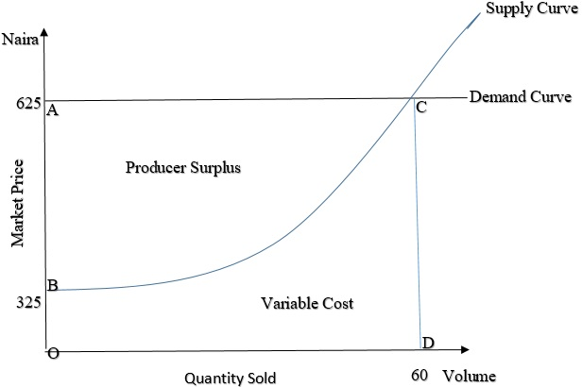
Fig. 4.1: Producer surplus curve of the marine transport sector of the study area
Source: Fieldwork (Updated in 2023)
The demand curve in Figure 4.1 is flat which represents the price, meaning that as the cost of marine transportation decreases, more people will be willing to patronize the sector. The area under the curve OBCD is the total variable cost of the marine transportation sector when rendering the services at 60 passengers per day. The area ABC is the producer surplus which is the total amount that operators benefit.

A WTP graph visualizes perceived value and market demand, guiding pricing by showing how much consumers value overall quantity. A higher producer suplus generally indicates that consumers are better off, as they are receiving high values from boat boat making and repair relative to their cost, thereby encouraging more investment. If the market price increases, producer surplus increases; if the market price decreases, it shrinks. This is an indication that the marine transportation sector of the Akwa Ibom blue Economy is viable and that investing in it is bound to be profitable, as customers are willing to pay more for its services.

- Conclusion and Recommendations
This study was carried out to assess the marine transportation services of Akwa Ibom State in order to ascertain and tap into its potential for the development of the State in the context of the Blue Economy. Although the maritime transport infrastructure is considered as an integral part of any country's transport system as opined by Ahmed (2019) Marine transport infrastructure in the study area is still not given much attention despite its potential for promoting internal and international trade. It is on this note that Faith (2019) opined that its role can affect the economy positively or can also be a set back to the economy as a whole, hence, more structures especially ports must be constructed. Current economic valuation showed that the Marine transport sector within the blue economic framework in the study area is estimated at 6,570,000 Naira (4,380 Dollars). This result generally indicated that despite its abundant potential for development, the sector when looking at it internally is highly underutilized (Itohowo, 2021). This position corroborated with Emmanuel et al. (2018) about Nigeria waterway, especially the inland waterways have a high potential for transportation, but it is largely underutilized. If the economic challenges of the state must be addressed, coastal community’s maritime transportation as opined by Emmanuel et al (2018) should have a wider implication on job creation, revenue-generating, investment and industrial development with local and recreational amenity value increase.

References
Anand, (2020), Harvad Business School Online.
Adeyemi, S. A., Olatunde, O. O., & Iledare, O. (2024). Challenges and opportunities in Nigeria's marine transportation sector: A mixed-methods analysis. Maritime Policy & Management, 51(2), 259-276.
Ahmed, P. B. E. (2019). Developing maritime infrastructure and its impact on the economic growth: an empirical study on Egypt from 2007-2016. Cairo University theses.
AKIPOFTZ (2015). Freetrade Zone in Ibaka, Mbo L.G.A, Government of Akwa Ibom State.
Atser, J., Etim, N., Beulah O. and Ekong F. (2010). An overview of the changing pattern of rainfall and its implication for environmental and agricultural development, Akwa Ibom State, Nigeria: A Case Study, Journal of Agriculture and Social Sciences, 3, 67-72.
Bakker K (2005) Neoliberalizing nature? Market environmentalism in water supply in England and Wales. Annals of the Association of American Geographers 95, 542–565.
Ekong, F. U. (2017). GIS based analysis of shoreline change in Ibeno, Akwa Ibom state, Nigeria. Journal of Environmental Protection, 8(5), 637-649.
Emmanuel, O. A., Ifabiyi, P. I. and Chijioke, A. U. (2018). Opportunities and challenges of inland waterways transport in the Southwest coastal belt of Nigeria. The Planning Research Journal, Godden, B. (2004). Sample size formulas. Journal of Statistics, 3(66).
Ibrahim, I., & Babalola, S. O. (2024). The role of maritime policies in enhancing trade facilitation in Nigeria: An analysis of existing frameworks. Transportation Research Part A: Policy and Practice, 162, 101182.
Itohowo, S. A. (2021): Harnessing Ocean-Based Resources and Services Potential Within the Blue Economy Framework for the Development of Akwa Ibom Coastal Areas. An Unpublishe PhD Thesis, Department of Geography and Natural Resources Management, University of Uyo, Nigeria.
Lipton, D. W., Wellman, K. F., Sheifer, I. C., and Weiher, R. F. (1995). Economic valuation of natural resources: a handbook for coastal resource policymakers (No. 5). US Department of Commerce, National Oceanic and Atmospheric Administration, Coastal Ocean Office.
Oguntade, S. A., Adebisi, O., & Lanre, A. (2023). Advancing safety and efficiency in marine transportation: Technological innovations in Nigeria. Journal of Shipping and Trade, 8(1), 45-58.
Okeke, M. O., Ezeh, E., & Nwankwo, M. (2025). Sustainable marine transportation: The role of alternative fuels in the Nigerian shipping industry. Journal of Cleaner Production, 306, 127292.
Silvertown, J. (2015). Have Ecosystem Services Been Oversold? Trends in Ecology and Evolution. Elsevier Ltd.
Udosen, C., Olabanjo, R., and Etok, A. I. S. (2014). Geospatial application in mapping gully development for effective remediation and control. Journal of Geography and Geology, 6(4), 153.
Udoudo, N. P., Emengini, E. J., and Igbokwe, J. I. (2019). Coastal flood mapping of Eastern Obolo and Ibeno Lgas of Akwa Ibom State, using srtm and satellite imageries. Tropical Built Environment Journal, 6(2).
Ulibarri, C. A., and Wellman, K. F. (1997). Natural resource valuation: A primer on concepts and techniques (No. PNNL--11661). Pacific Northwest National Lab.

