Adenoid cystic carcinoma of the submandibular gland presenting as a huge mass – A rare case with review of literature
Authors: Nanda Patil¹, Drashti Maradiya², Shivani Khillare²

1 - Professor & head
2 - Residents

Department of Pathology,
Krishna Institute of Medical Science, Krishna Vishwa Vidyapeeth
Karad, Maharashtra, India.
Correspondence: Drashti Maradiya (Email id: drdrashti30@gmail.com)

ABSTRACT
Background: Adenoid cystic carcinoma is a rare but aggressive tumor arising from the major salivary gland. It has been described as a tumor with indolent, persistent and recurrent growth with late onset of metastasis, which eventually leads to death.
Case Report: We present a case of Adenoid cystic carcinoma in 60 year old patient, presenting as a huge right submandibular mass, growing since 10 years with metastasis in right lung, we highlight the rare features in this case that is huge tumor size and site as well as uncommon occurrence in male patient.
Conclusion: Adenoid cystic carcinoma is a malignant tumor of the salivary gland with paradox clinical behavior. In spite of slow growth it presents with late onset of hematogenous metastasis. The prolonged asymptomatic clinical course of ACC may cause a delay in diagnosis till distant metastasis appear. Histopathological examination remains gold standard for definite diagnosis which is necessary to plan therapeutic intervention.
Key-words: Adenoid cystic carcinoma, Huge size Submandibular gland, Late metastasis, Slow growth.

INTRODUCTION:
Adenoid cystic carcinoma (ACC) is a rare but aggressive tumor of the salivary gland and accounts for 1% of the tumors of oral and maxillofacial region [1]. It comprises 10% of malignant salivary gland tumor with slight female predominance [2]. ACC is relatively uncommon tumor, found in both major and minor salivary gland [3]. Other sites are tracheobronchal tree, esophagus, breast, lung, prostate, uterine cervix and lacrimal glands as well as skin [4].
We present a case of Adenoid cystic carcinoma in a 60 year old male patient to highlight its rare occurrence in male patient, involvement of submandibular gland which is also rare as well as its huge size.

CASE REPORT:
A 60 year old male presented with slow growing, painless swelling over the right submandibular region since 10 years. There were no other comorbidities and no exposure to radiation. There was no lymphadenopathy. CT scan showed a well-defined, soft tissue density lesion measuring
(~10.2 x 9.2 x 11.7 cm) was noted arising from right submandibular region, feature suggestive of malignant neoplasm of submandibular gland (figure 1). Sections of thorax showedmultiple well defined lesions noted in right upper lobe and left lower lobe i.e. Cannon-ball metastasis.
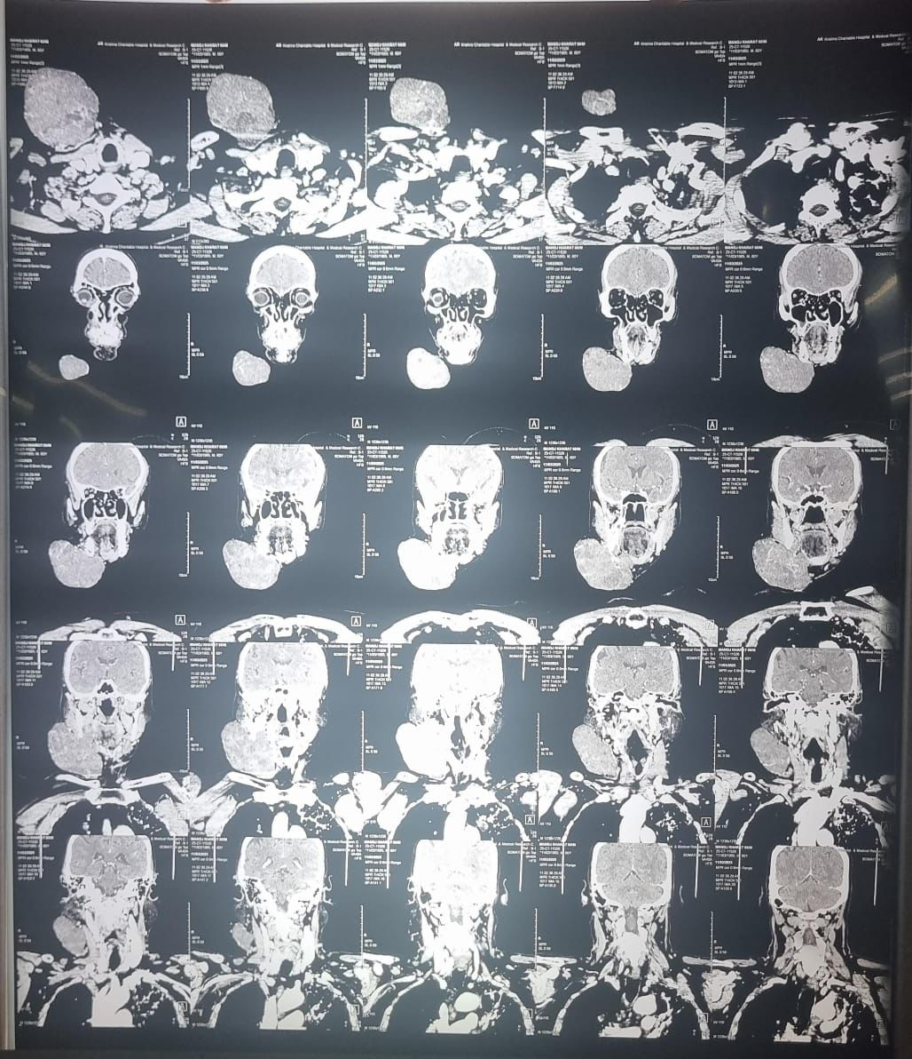
Figure 1: Tumor showing soft tissue density at right submandibular region.
Excision biopsy was done and tumor was sent for histopathological examination. Gross examination revealed a single, large bosselated, soft to firm, grey-white to grey-brown mass measuring 14 x 10 x 6.5 cm. Cut section of which was grey-white to grey-brown, soft to firm, nodular and translucent (figure2)
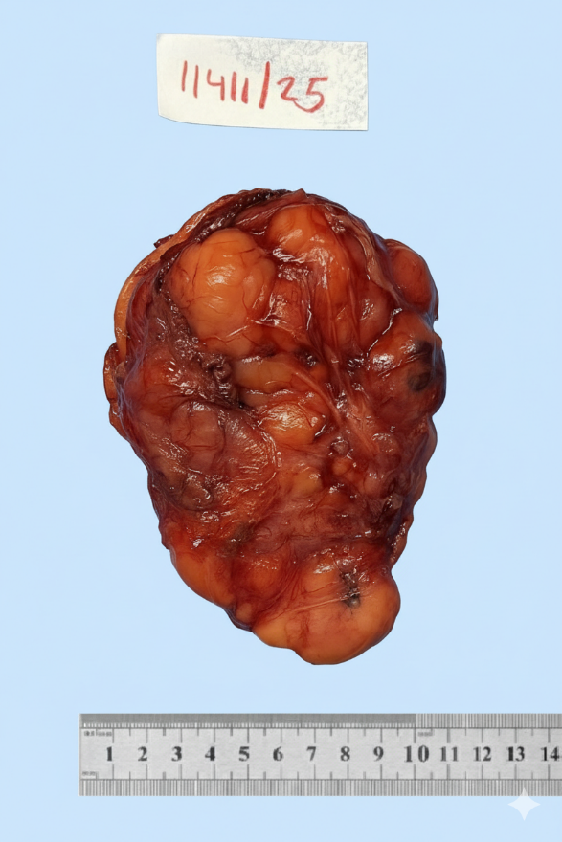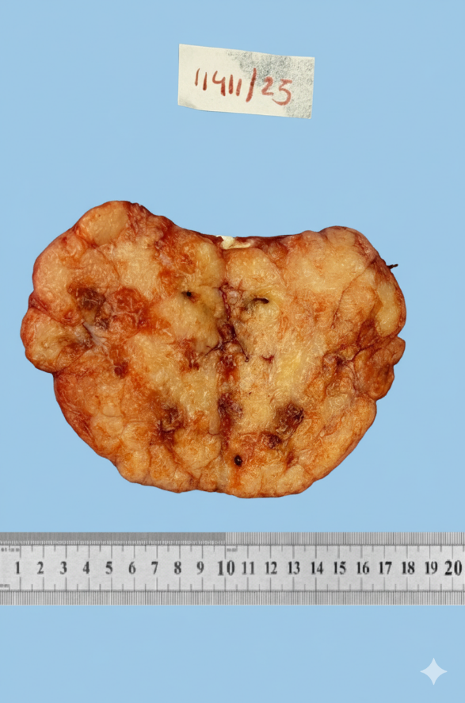
Figure 2: Huge lobulated mass, Cut section is grey-brown and nodular
Microscopic examination revealed basaloid neoplastic cells arranged in cribriform, tubular and solid patterns with characteristic pseudocyst containing hyaline basement membrane like material. Tumor cells were small with hyperchromatic nuclei with scant cytoplasm.
Considering the microscopic features and given the history, the diagnosis was offered as Adenoid cytic carcinoma (fig 3)
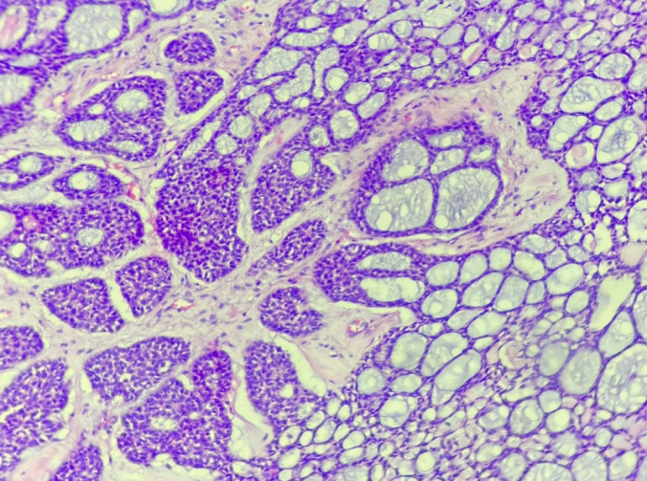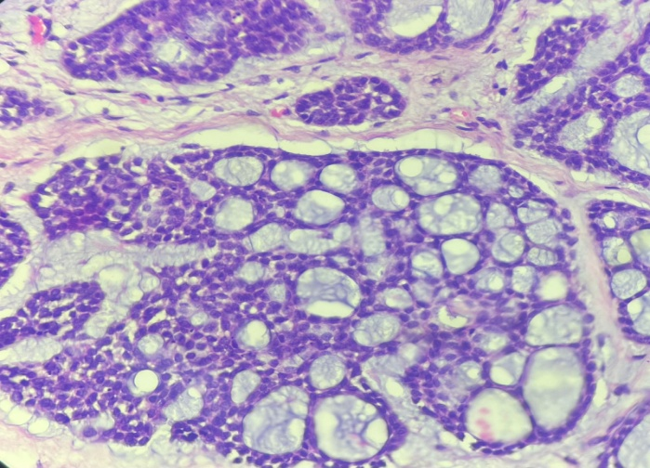
Figure 3: Basaloid neoplastic cells with cribriform and tubular pattern (A&B 100 X and 400 X H&E)
One month post-operative follow up is uneventful.

DISCUSSION:
ACC exhibits a slow growth rate and occurs during 5th and 6th decades of life as seen in our case [1]. It has female predominance but in our case the patient was a 60 year old male patient. Usually these tumors are small, having gradual progression [2].In our case the patient presented with a huge tumor of 14 cm size. Though the tumor has low likelihood of metastasis to regional lymph nodes, it has high potential for hematogenous spread [4]. Similar observation is noted in our case with metastasis in right lung in spite of slow growth.
Several factors have been linked to the development of adenoid cystic carcinoma which are ionizing radiation, occupational exposure in agriculture, nickel and rubber workers, hair dressers and beauty salon employees along with low intake of vitamin C [4]. No such risk factors were associated in our case. Radiological investigations like computerized tomography (CT) and magnetic resonance imaging (MRI) can help to delineate the extension of primary tumor and useful for staging purpose [5]. Because of false negative results in FNAC, It is less useful for diagnosis. Biopsy of the tumor is needed for definitive diagnosis where the characteristic histological features and IHC markers confirm the diagnosis. ACC has distinct histopathological features which consist of three architecture types that is cribriform, tubular and solid. The cribriform pattern is particular characteristic of ACC. The solid pattern indicate a poor prognosis [6].ACC is classified into 3 grades, Grade 1 tumor shows cribriform and tubular pattern without solid areas. Grade 2 tumor shows < 30% solid area, while grade 3 tumor displays >30% solid portion. Our case was classified as grade 2. Considering immunohistochemistry markers for ACC, duct lining cells are positive for C-kit (CD117) and myoepithelial cells are positive for S-100 protein, calponin, p63, smooth muscle actin and myosin. Expression of S-100, glial fibrillary acidic protein and neural cell adhesion molecule have been correlated with the presence of perineural invasion. P-53 mutations appear to be involved with tumor progression and recurrence [7]. Surgical resection with wide local excision ,while ensuring clear margins and preservation of unaffected nerves is considered as primary treatment method for ACC. New target therapy includes antiangiogenic agents such as anti-epidermal growth factor receptor(EGFR) [8]. Long term survival rate of ACC at 15 years falls around 10% despite post operative radiotherapy, as ACC typically tends to recur.

CONCLUSON:
Adenoid cystic carcinoma is a malignant tumor of the salivary gland with paradox clinical behavior. In spite of slow growth it presents with late onset of hematogenous metastasis.The prolonged asymptomatic clinical course of ACC may cause a delay in diagnosis till distant metastasis appear. Histopathological examination remains the gold standard for definite diagnosis which is necessary to plan therapeutic intervention.

REFERENCE :
- Tuan HX, Tu NHT, Duc NM. Adenoid cystic carcinoma of the parotid gland. Radiol Case Rep. 2023;18:1069–72. https://doi.org/10.1016/j.radcr.2022.12.047.
- Saleh E, Ukwas A. Adenoid cystic carcinoma of salivary glands: a ten-year review and an assessment of the current management, surgery, radiotherapy, and chemotherapy. Int J Otolaryngol. 2023;2023:1–16. https://doi.org/10.1155/2023/7401458.
- Chowsilpa S, An D, Maleki Z. Adenoid cystic carcinoma cytology: Salivary gland and nonsalivary gland. DiagnCytopathol. 2020;48:1282–9. https://doi.org/10.1002/dc.24573.
- Cantù G. Adenoid cystic carcinoma. An indolent but aggressive tumour. Part a: from aetiopathogenesis to diagnosis. ActaOtorhinolaryngolItalica. 2021;41:206–14. https://doi.org/10.14639/0392-100X-N1379.
- Mohammad AmmadUd Din; Hira Shaikh. "Adenoid Cystic Cancer" University of Cincinnati Medical Cente, Update: April 14, 2023 ,PMID: 32491778
- Eberle-Singh J, Tuluc M, Chan JSY. Educational case: an invasive salivary gland tumor: adenoid cystic carcinoma of the parotid gland. AcadPathol. 2023. https://doi.org/10.1016/j.acpath.2023.100098.
- MedhiniSingaraju, SasidharSingaraju, Shubham Patel, Shweta Sharma: "Adenoid cystic carcinoma: A case report and review of literature" J Oral MaxillofacPathol. 2022 Feb 28;26(Suppl 1):S26–S29. doi:10.4103/jomfp.jomfp_458_20
- Michaelides I, Künzel J, Ettl T, Beckhove P, Bohr C, Brochhausen C, et al. Adenoid cystic carcinoma of the salivary glands: a pilot study of potential therapeutic targets and characterization of the immunological tumor environment and angiogenesis. Eur Arch Otorhinolaryngol. 2023;280:2937–44. https://doi.org/10.1007/s00405-023-07884-3

