Subscription Sharing Platform for Digital Services

- Introduction
In today’s digital economy, most entertainment, education, and productivity platforms function on subscription-based ac-cess models. While this ensures continuous access to premium content, maintaining multiple active subscriptions places a
heavy financial burden on individual users. The rapid adoption of OTT platforms (such as YouTube Premium and Disney+ Hotstar), music streaming services (like Spotify and Apple Music), cloud storage providers (e.g., Google One and Mi-crosoft 365), gaming networks, and AI-driven tools (such as Adobe Creative Cloud, Canva Pro, and ChatGPT Plus) has further amplified this cost challenge.
To minimize expenses, users often rely on informal methods such as sharing login credentials or splitting costs manually through messaging apps. However, these practices compromise data security, violate platform policies, and lack automation or accountability. Therefore, there is a growing demand for a secure, automated, and transparent system that allows multiple verified users to share subscriptions without compromising privacy or trust.
This paper introduces SubPool, a secure subscription shar-ing platform designed to manage premium subscriptions within verified user groups. The system ensures safe authen-tication, automated payments, and dynamic pool management through Flutter, Firebase, and Razorpay integration. It also provides offline accessibility via SQLite, ensuring uninter-rupted usage even in low-connectivity conditions. By imple-menting role-based group management, verified user badges, and subscription tracking, the proposed system ensures an affordable, transparent, and secure environment for managing shared digital subscriptions.

A. Objective for Platform :
- To make premium digital services more affordable by allowing multiple users to share the cost of subscriptions through a structured and transparent cost-splitting system.
- To provide a secure way for users to share subscriptions without exposing personal information, login credentials, or compromising the privacy and security of their accounts.
- To introduce automated cost distribution and payment handling, ensuring that every contribution is accurately pro-cessed, eliminating manual errors, and preventing financial disputes between users.
- To offer flexible access options through different pooling models (Standard, Rental, Instant), enabling users to choose subscription duration based on their individual needs.
- To ensure real-time updates and seamless user experi-ence by automatically managing subscription status, expiry reminders, and group activity.
- To support users even in low-connectivity situations by providing uninterrupted access to essential subscription information.
- To increase trust and transparency among users through group verification, clear tracking of subscription periods, and role-based management.
- Literature Review
The rising prices of OTT streaming services, cloud tools, gaming platforms, and productivity applications have pushed researchers to explore smarter ways of managing and sharing digital subscriptions. Recent studies introduce various models that aim to lower individual costs by enabling users to collec-tively access premium services. Many of these works focus on automated pooling mechanisms, secure user verification, and fair payment handling through escrow like systems. Research also points toward the growing use of cloud technologies such as Firebase, serverless backends, and integrated payment gateways to simplify group creation, authenticate members, and automatically deliver subscription access or tokens. In addition, several studies highlight the value of real-time alerts, automated provisioning, and continuous monitoring to enhance reliability and user satisfaction. Together, these advancements provide a strong foundation for developing an efficient, secure, and scalable subscription-sharing system like the one proposed in this project. The following research papers highlight major contributions in this field.
- Consumer research domains in the sharing economy: an organizing and categorizing review with research implications
Recent studies on the sharing economy highlight a major shift from traditional ownership to access-based consumption, where users prefer sharing resources to reduce individual costs. Prior research shows that digital platforms enabling collaborative use—such as accommodation and transporta-tion—have grown due to convenience, affordability, and trust-based systems. The base paper emphasizes that economic benefits, ease of access, and secure interactions motivate users to participate in shared services. However, existing literature
also identifies concerns about security, reliability, and misuse when sharing digital accounts informally. Although sharing concepts are well-studied in physical service domains, there is limited research on structured subscription-sharing systems for OTT, music, gaming, and cloud platforms. This gap highlights the need for secure, automated solutions like SubPool, which aligns with the principles of collaborative consumption by providing verified groups, transparent payments, and flexi-ble access models.

- A Study on Subscription and Retention Patterns in OTT Platforms
Recent studies on OTT consumption highlight a major shift toward digital, on-demand entertainment, where users prefer flexible access and personalized content over tradi-tional TV models. The uploaded base paper emphasizes that user motivations such as seamless accessibility, immersive viewing experiences, engaging content, and stress-free leisure strongly influence subscription decisions and continued OTT usage. Research also shows that binge-watching, easy nav-igation, and platform convenience have become important factors in building user loyalty. These insights reveal that users highly value affordability, convenience, and uninter-rupted access—key drivers behind subscription purchasing behavior. However, despite the increasing demand for digital platforms, there remains limited focus on cost-sharing or collaborative consumption within OTT services. This creates a clear opportunity for structured subscription-sharing systems like SubPool, which aligns with user motivations by offering affordable, accessible, and flexible access to premium digi-tal services.

- Implementation Of Firebase In The Development Of Android-Based Queue Reservation And Treatment Record Ap-plications
Recent studies show that mobile applications supported by cloud-based services significantly improve efficiency in service oriented environments such as salons, healthcare, and booking systems. The uploaded base paper highlights how Firebase provides real time data handling, secure authentication, and automatic notifications, making it suitable for applications re-quiring fast updates and accurate record keeping. Researchers have found that features like Firestore, Cloud Messaging, and Cloud Functions reduce manual work and enhance user experience by enabling instant synchronization and automated processes. Similar studies also emphasize the importance of modern app architectures such as MVVM for better code organization and long-term maintainability. The base paper’s results show that Firebase drastically reduces booking time and improves operational workflow, which supports the idea that cloud-driven automation can transform traditional manual systems. Although the research focuses on queue and treatment management, the same principles real time updates, secure data flow, and automated backend processing—are directly relevant to digital subscription sharing systems like SubPool,

where fast processing, reliable authentication, and automated access control are essential for user satisfaction.
- Mapping sharing economy themes: science mapping, topic modeling, and research agenda
The sharing economy has rapidly reshaped digital markets by enabling users to access services collaboratively rather than owning them individually. As highlighted in recent studies, digital platforms now play a crucial role in connecting users, reducing costs, and improving convenience across industries such as accommodation, transportation, retail, and online services. Research shows that the success of sharing-based models depends heavily on trust, transparent transactions, and positive user experience, which are reinforced through tech-nology such as AI, data analytics, and secure digital platforms. Academic reviews emphasize that modern sharing systems rely on features like user ratings, automated recommendations, and platform-driven governance to maintain transparency and service quality. Moreover, the literature identifies that cost-saving, ease of access, and flexible usage are the major reasons users participate in sharing ecosystems. However, challenges such as review bias, user misbehavior, and platform security continue to affect reliability in digital-sharing environments.
Summary of Findings: The literature shows that most shar-ing economy research focuses on physical services, while digital subscription sharing remains largely unexplored. OTT studies point out that users care about affordability and convenient access, but they do not suggest collaborative or shared payment models. Research on cloud platforms, includ-ing Firebase, proves that modern technologies can automate processes and secure data, yet these benefits are not applied to subscription pooling systems. Studies on digital platforms also highlight the importance of trust and transparency, but there is no established framework for managing secure group access or handling shared digital accounts. Overall, the findings reveal a clear need for a secure, automated, and well-managed subscription-sharing solution like SubPool.
Gap: Most existing sharing-economy studies concentrate on tangible services like transport or accommodation, leaving the concept of sharing digital subscriptions largely overlooked. Research on OTT platforms discusses user spending habits and retention behavior, yet it rarely explores models where users can legally and collaboratively share subscription costs. Cloud-based studies, including those focused on Firebase, demonstrate strong capabilities for automation and secure data handling, but these advantages have not been applied to subscription-pooling systems. Science-mapping literature stresses the importance of trust, transparency, and platform governance, but does not offer clear frameworks for managing secure digital access within groups. There is currently no integrated solution that brings together escrow-style payments, automated access provisioning, and verified group creation in one platform. Existing work also lacks mechanisms to prevent misuse and ensure the reliability required for digital subscription sharing. Together, these gaps highlight the need for a secure, automated system like SubPool, built on modern
cloud technologies to enable trustworthy and affordable shared digital access.
- Proposed System
The proposed system, named SubPool, is designed to provide a secure and affordable way for users to access premium digital services by sharing subscription costs through a structured and automated platform. Unlike informal account-sharing methods that rely on manually exchanging passwords and splitting money through unsecured channels, SubPool offers a managed environment where users can join verified groups, make safe payments, and receive access without exposing personal account credentials.
- Workflow Algorithm :
Step 1: Verify user identity through secure authentication. Step 2: Display available digital services and pooling op-
tions.
Step 3: User selects service and chooses Standard, Rental, or Instant Pool.
Step 4: System calculates required payment and collects the amount through the integrated payment gateway.
Step 5: Hold payment temporarily in escrow.
Step 6: If Rental Pool slot is available:Assign slot imme-diately; Provide instant access;Set validity period. Proceed to Step 10.
Step 7: If Instant Pool is selected: Provide immediate short-term access Proceed to Step 10.
Step 8: If Standard Pool is selected: Add user to the pool Check if required number of members is reached.
Step 9: If Standard Pool completes: Release escrow pay-ment; Activate subscription for all members.
Else if time expires: Cancel pool and refund payment.
Step 10: Monitor access period, send reminders, and update status on expiry.
- Flowchart of System :

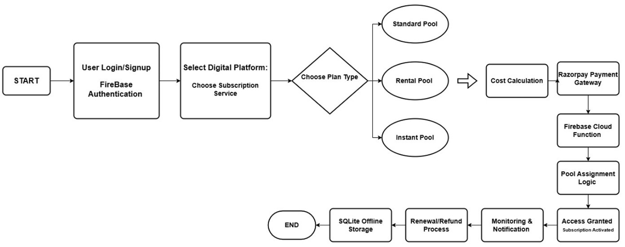

Fig. 1: Workflow of the Sub-Pool System.

- System Design
The system architecture shown in Figure 2 represents the SubPool platform, which is built to make subscription sharing simple, secure, and reliable. The system is designed in a modular way so that each part works independently but still

connects smoothly with the others. SubPool handles every-thing from logging in users, forming subscription pools, and managing payments, to automatically giving access once a pool is ready. The architecture is structured to support real-time updates, safe transactions, and a smooth experience for anyone using the app.

- Design Objectives:
To create an easy-to-understand interface that allows users to navigate the app without any difficulty. To ensure every user is verified properly so the platform remains safe and trustwor-thy. To manage all pool types Standard, Rental, and Instant automatically based on the user’s choice and availability. To process payments securely by keeping them in a protected escrow system until the pool is confirmed. To provide real time updates so users can instantly see changes in their dashboard and subscription status.

- Architecture Overview:
  - Frontend Layer:Flutter: Delivers a smooth, cross-platform interface for user authentication, pool selection, payments, and subscription tracking.
  - Backend Layer: Firebase: Handles secure authentication, pool automation, notification triggers, payment checks, and overall system logic.
  - Database Layer: Firestore: Stores user details, pool data, payment history, and subscription records with real-time syncing and scalability.
  - Payment Gateway:Razorpay: Manages secure payments, escrow holding, and automated refunds during pool com-pletion or cancellation.

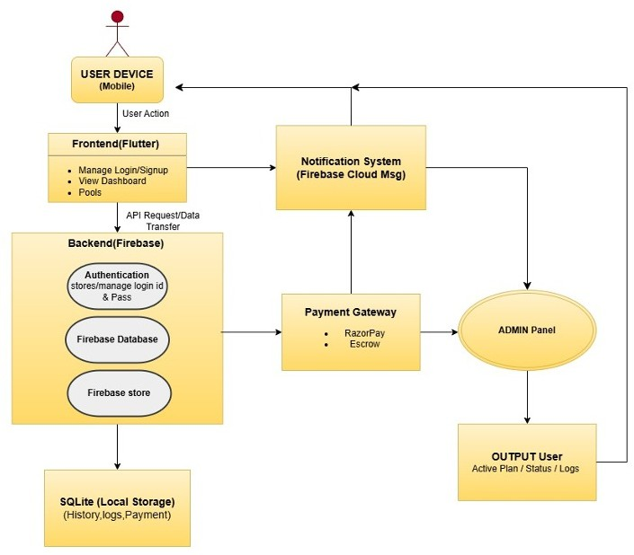

Fig. 2: System Architecture of Subpool System.
- Methodology
The SubPool system adopts a modular methodology focused on secure payment processing, automated pool management, and cross-platform accessibility. The application is developed using Flutter, offering a single codebase for Android, iOS, and web platforms. Firebase serves as the backend infras-tructure, managing authentication, database operations, and background automation. Razorpay is integrated to facilitate online transactions through an escrow-based payment model, ensuring that funds remain protected until a subscription pool is complete. Offline data storage is achieved through SQLite, enabling access to essential information even without internet connectivity.
The system workflow begins with user registration and authentication using Firebase Authentication, ensuring that only verified users can participate. Once authenticated, users select a digital platform and choose one of the three available pool types—Standard, Rental, or Instant—based on their usage duration and budget. The cost is automatically divided among members, and payments are processed securely through Razor-pay. Firebase Cloud Functions then verify transactions, update pool data in Cloud Firestore, and manage pool activation and expiry. Notifications are sent to users through Firebase Cloud Messaging (FCM), while incomplete pools trigger automatic refunds. This approach ensures transparency, automation, and user convenience throughout the subscription lifecycle.
The combination of Flutter, Firebase, and Razorpay pro-vides a robust ecosystem for handling authentication, pay-ments, and synchronization. By integrating SQLite, the plat-form ensures continued functionality in offline environments. Overall, this methodology enables a secure, transparent, and efficient subscription-sharing experience for users across mul-tiple digital service domains.
- ADVANTAGES
Cost Savings SubPool significantly reduces the financial burden on users by allowing multiple individuals to share the cost of premium digital services, making high-value subscrip-tions more affordable.
Instant and Flexible Access With support for different pool types such as Standard, Rental, and Instant, users can choose subscription access based on their duration require-ments—ranging from quick short-term access to full monthly plans.
Secure Sharing Environment The platform eliminates the risks associated with informal account sharing by providing a safe and controlled way to access shared subscriptions without exposing personal login credentials.
Transparent Payment Handling Through automated cost distribution and escrow-based payment processing, SubPool ensures that transactions are clear, accurate, and free from manual errors or disputes.
Automated Subscription Management Users benefit from automatic updates, expiry tracking, reminders, and real-time notifications, reducing the need for manual monitoring and improving the overall experience.

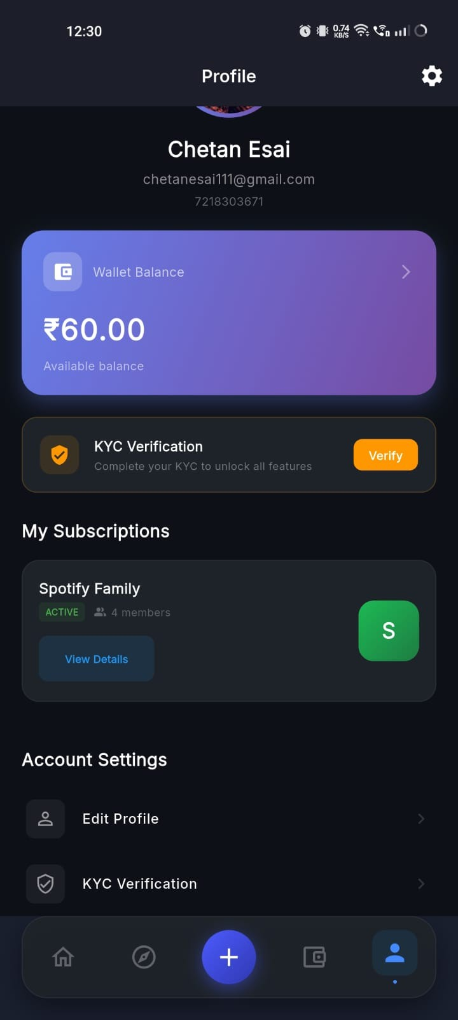
User Trust and Accountability Features such as verified group members and clear usage tracking promote trust within sharing groups, helping users feel confident when joining or creating pools.
Enhanced Accessibility The platform is designed to function smoothly even in low-connectivity environments, ensuring that essential information remains accessible to users at all times.
Support for Diverse Digital Services SubPool can be used across various service categories, including OTT streaming, music, gaming, cloud storage, and AI tools, making it a versatile and scalable solution.

- Implementation Screenshot

User Panel

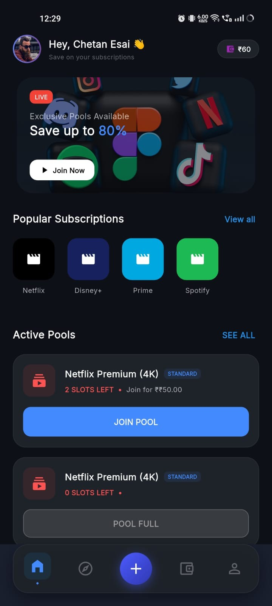
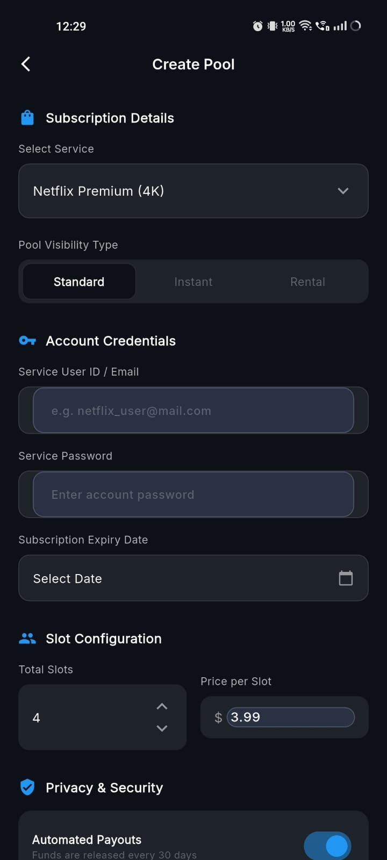

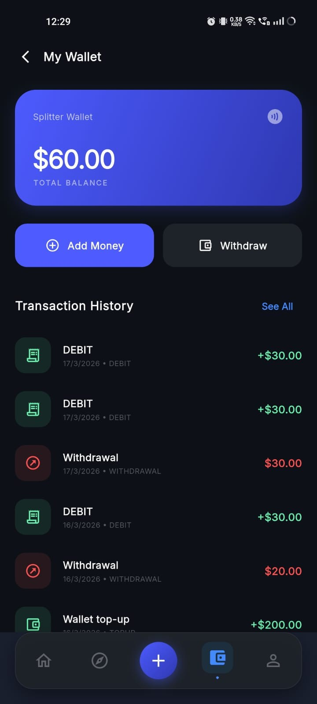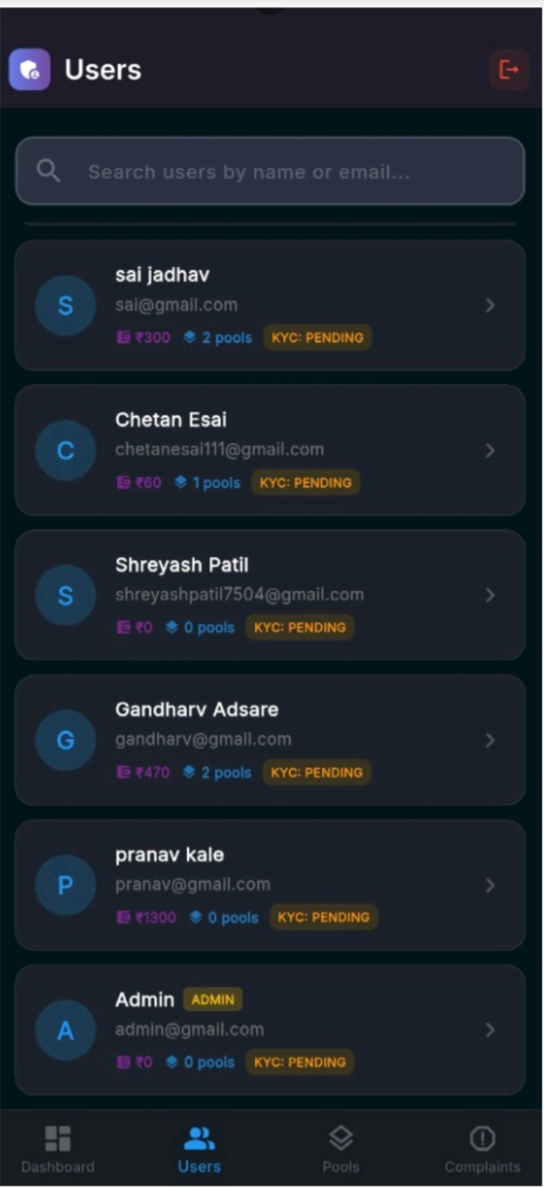

Admin Panel
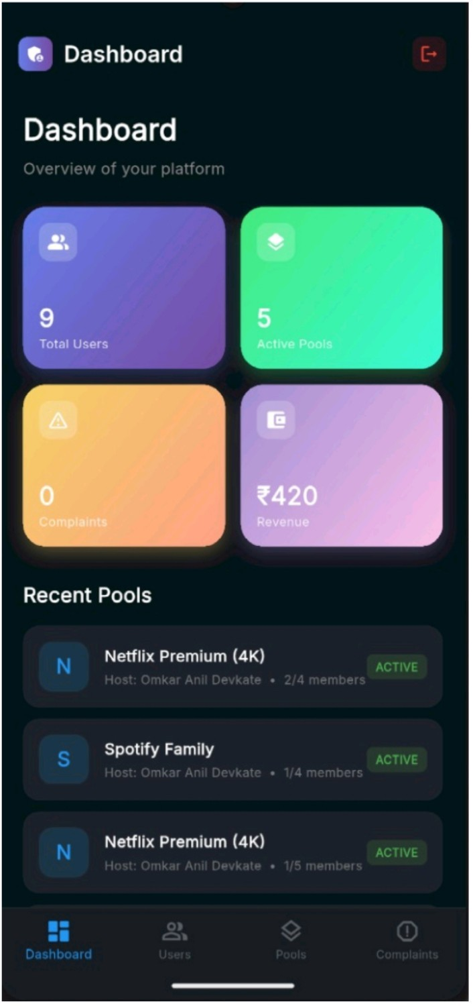
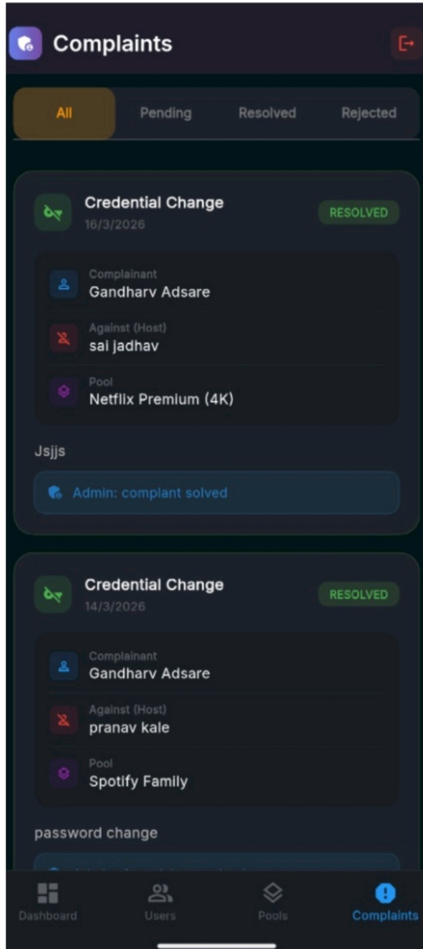

- Results and Discussion
The evaluation of the SubPool platform demonstrates that the proposed system successfully addresses the challenges associated with high subscription costs and insecure sharing practices. The platform enables users to access premium digital services at a significantly lower cost by distributing subscription fees among multiple members. This cost-sharing mechanism proved effective across various service categories, including OTT platforms, music applications, cloud services, gaming subscriptions, and AI-based tools, making SubPool a versatile and practical solution for a wide range of digital users.
During testing, the platform showed smooth and uninter-rupted operation for all three pooling models Standard, Rental, and Instant. The Standard Pool effectively accommodated users who preferred full duration subscriptions, while the Rental Pool offered flexible mid-duration access and immedi-ately assigned slots when available. The Instant Pool provided quick short-term access, meeting the needs of users looking for immediate and temporary use of premium services. These multiple access options enhanced user convenience and offered greater control over subscription duration.
The system’s automated processes played a significant role in improving user experience. Automated cost distribution ensured that payments were error-free and transparent, re-ducing the likelihood of disputes between pool members. The automated tracking of subscription expiry, reminders, and updates eliminated the burden of manual monitoring. Real-time notifications helped users stay informed about pool status, activation, expiry, and renewal options. These features collectively contributed to a more reliable and user-friendly environment
Such enhancements would strengthen user trust and create a more reliable environment for financial and data-related operations. Over time, these innovations can help SubPool grow into a key player within the shared-economy ecosystem, offering equitable access to premium digital services and contributing to a more inclusive digital world.
Future expansion may also involve collaborations with ser-vice providers, allowing the creation of official subscription-sharing bundles specifically designed for group users while ensuring compliance with service policies. Additionally, part-nerships with public organizations or government bodies could enable the platform to guide eligible users toward available subsidies, digital-access schemes, or financial support pro-grams, further enhancing digital affordability and bridging accessibility gaps.
X. Conclusion
The SubPool platform presents a practical, secure, and affordable approach to managing shared digital subscriptions. By combining Flutter for cross-platform support, Firebase for backend automation, and Razorpay for secure payments, the system provides an end-to-end solution that addresses the limitations of informal account sharing. Through dynamic pooling models and escrow-based transactions, SubPool en-sures transparent and conflict-free cost management among verified users. Its flexibility across OTT, music, gaming, cloud, and AI platforms makes it a scalable solution adaptable to future digital ecosystems. In conclusion, the proposed system effectively reduces subscription costs, ensures data protection, and automates management processes, offering a reliable framework for secure digital service sharing.

- Future Work :
The future development of the SubPool shared subscription platform presents a wide range of possibilities for expanding its capabilities and improving user experience. As the demand for low-cost access to digital services continues to rise, the platform can evolve by introducing intelligent features that make subscription sharing even more efficient and personal-ized. One major opportunity lies in adopting advanced data-driven models, where smart recommendation systems can analyze individual user behavior and preferences to suggest the most suitable pool groups. This not only simplifies the process of finding compatible members but also increases the chances of forming successful pools quickly.
Another promising direction is the incorporation of real-time insights and usage analytics, enabling SubPool to identify patterns in subscription demand, predict renewal behavior, and recommend budget-friendly alternatives tailored to each user. These insights may also help users discover new services that match their interests, making the platform more engaging and supportive of informed decision-making.
As digital security becomes increasingly important, integrat-ing blockchain-based mechanisms could provide tamper-proof transaction records and ensure a higher level of transparency.

References
- Mar´ın-Carrillo, M. B., Sa´nchez-Pe´rez, M., Tera´n-Ye´pez, E., & Rueda-Lo´pez, N. ”Consumer research domains in the sharing economy: An organizing and categorizing review with research implications”. Man-agement Review Quarterly, 2025. Link: https://doi.org/10.1007/s11301-025-00509-5
- Gavit A. B., Gupta R. P., & Slatewala T. B. ”A Study on Subscrip-tion and Retention Patterns in OTT Platforms.” International Journal for Multidisciplinary Research (IJFMR), Volume 6, Issue 6, Novem-ber–December 2024, pp. 1–8. Available at: https://www.ijfmr.com
- ElKattan A. G., Gavilan D., Elsharnouby M. H., Mahran A. F. A. ”Mapping sharing economy themes: science mapping, topic modeling, and research agenda”. Journal of Marketing Analytics, 2024. Link: https://doi.org/10.1057/s41270-023-00238-2
- Ariani A. F., Putra A. B., Sugata T. L. I. ”Implementation of Firebase in the Development of Android-Based Queue Reservation and Treatment Record Applications”. SiI — Jurnal Sistem Informasi, 2025. Link: https://doi.org/10.30656/jsii.v11i1.6936
- Mulyani, S., & Cahyani, I. ”Development of Cloud-Based Mobile Applications Using Firebase Realtime Database”. International Confer-ence on Engineering and Emerging Technologies (ICEET), 2021. Link: https://doi.org/10.1109/ICREST51555.2021.9331088
- Bahrami A., & Shams S. ”Cross-Platform Mobile Application De-velopment Using Flutter Framework”. International Conference on Information Management and Technology (ICIMTech), 2020. Link: https://doi.org/10.1109/ICIMTech50083.2020.9211128

