Small Scale Energy Trading using Smart Contracts
Ambati Satya Sai Vaishnavi¹ M veera kumari² K. Akash Sai³
G. Pavan Kiran³ T. Venkatesh³ Ch. Adhi Seshu³ T. Sai Kumar³
1 PG Scholar 2 Professor 3 UG Scholar
EEE Department ,Sir CRReddy College of Engineering,Eluru ,Andhra Pradesh ,India .
Corresponding author mail ID : veerakumari.m@gmail.com

Abstract— Peer-to-peer (P2P) energy trading has emerged as an innovative solution to modern energy challenges by enabling decentralized electricity exchange among users. The Small-scale market allows prosumers to sell excess energy directly to consumers without relying on centralized authorities. Blockchain ensures transparency, security, and immutability of transactions, while smart contracts automate trading operations based on predefined conditions. A MATLAB-based simulation environment is developed to model energy generation, consumption, and transaction processes, along with a digital ledger for recording trades. The results of different case studies demonstrate efficient energy utilization, reduced transaction costs, and improved reliability. The system promotes renewable energy adoption and supports the transition toward decentralized smart grids. This work highlights the feasibility of integrating blockchain technology with energy systems for sustainable and scalable power trading solutions.

Keywords— Energy trading, Blockchain, Smart contract.

Introduction
Energy trading plays a crucial role in maintaining the balance between electricity generation and consumption. Traditionally, power systems operate under centralized models where electricity is generated at large plants and distributed to consumers through grid infrastructure. These systems suffer from limitations such as transmission losses, lack of transparency, and limited consumer participation. With the rapid growth of renewable energy sources such as solar and wind, there is a significant shift toward decentralized energy systems.
In decentralized systems, with the widespread use of households’ rooftop solar systems individuals can generate electricity using these panels and act as “prosumers,” meaning they both produce and consume energy. This shift has enabled the concept of peer-to-peer (P2P) energy trading [1], where users can directly buy and sell electricity without intermediaries. Prosumer economy is growing ie they can sell excess electricity to their neighbours, set price for the electricity and engage in peer-to-peer electricity market. Consumers instead of depending on main energy grid, they have control over production and distribution. However, implementing such systems requires secure, transparent, and automated transaction mechanisms.
Blockchain technology [2] provides an effective solution by offering a distributed ledger that records all transactions in a secure and tamper-proof manner. It eliminates the need for centralized control and enhances trust among participants. Additionally, smart contracts [3]-[5] enable automated execution of transactions when predefined conditions are met, ensuring efficiency and reliability.

Table 1: Comparision between Traditional energy trading and Blockchain energy trading
Feature | Traditional Energy System | Blockchain based system
Energy Flow | Centralized | Decentralized
Pricing | Fixed/Regulated | Dynamic/Market driven
Payment speed | Limited | High
User Role | Slow | Instant
This paper proposes a blockchain-based P2P energy trading system using MATLAB simulation for Small scale energy market. The system models energy generation, consumption, and trading between multiple prosumers and consumers. It incorporates smart contracts for automated trading and a digital ledger [6]-[8] for transaction recording. The objective is to demonstrate a decentralized, efficient, and scalable energy trading framework.

Methodology
The proposed system is designed using a combination of blockchain technology, smart contracts. It consists of prosumers, consumers, a blockchain ledger, and a smart contract module. The methodology follows a structured workflow to enable secure and efficient energy trading.
Initially, energy is generated by prosumers using renewable sources such as solar panels. Smart meters measure energy generation and consumption in real time. They provide accurate information about P2P transactions, which is verified and stored in blockchain. This verified credentials [9]-[10]ensures parties are authorized and information about generation is true and transactions are legal.
The surplus energy available for trading is then broadcast to the network along with pricing details. Consumers access the system and submit their energy requirements based on availability and cost preferences.
A smart contract mechanism is implemented to automatically match buyers and sellers. It verifies whether the prosumer has sufficient energy and whether the consumer meets the required conditions. Once the criteria are satisfied, energy is transferred through the grid infrastructure. After successful delivery, the smart contract executes the payment automatically. Settlement is automatic and immutable Table 2 :Comparision of Discom based settlement and blockchain settlement..
Criteria | Discom-based Settlement | BlockChain Settlement
Billing frequency | Monthly or longer | Near real-time
Transparency | Limited visibility | Immutable ledger
Pricing structure | Fixed or regulated | Demand-responsive
Transaction costs | Higher for small volumes | Lower for micro-units
Data auditability | Manual reconcilation | Automated verification

All transactions are recorded in a blockchain-based ledger, ensuring transparency, immutability, and traceability. MATLAB is used to simulate the entire process, including random transaction generation, energy flow analysis, and visualization through graphs and a user interface.
The system integrates blockchain, smart contracts, and MATLAB simulation shown in fig1.
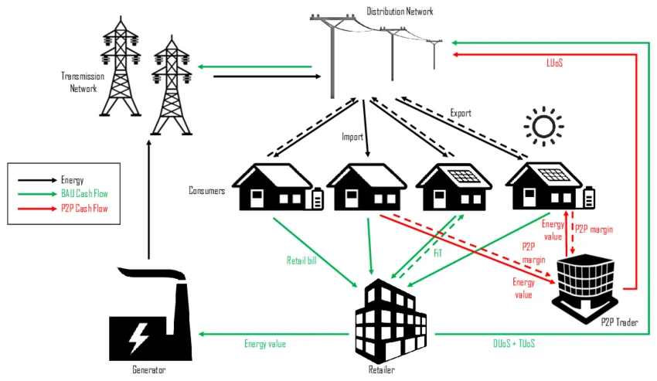
Figure 1. Peer to Peer energy transactions in small scale market

Benefits of blockchain based energy trading

For Consumers
i)Lower Electricity Cost
By purchasing energy directly from local prosumers (individuals or households generating surplus energy), consumers avoid traditional utility markups. This decentralized model reduces transmission losses and overhead costs, resulting in cheaper electricity bills.

ii)Access to Clean Energy
Consumers gain direct access to renewable sources such as solar or wind power generated by nearby prosumers. This increases the share of green energy in their consumption mix and supports sustainability goals without needing to install their own generation systems.
iii).Greater Transparency
Blockchain-based trading platforms record every transaction immutably. Consumers can see exactly where their energy comes from, how much they are paying, and the environmental impact. This builds trust and eliminates hidden charges often associated with centralized utilities.
B. For Prosumers
i)Better Earnings for Surplus Energy
Instead of selling excess energy back to utilities at low feed-in tariffs, prosumers can trade directly with neighbors or local businesses at competitive rates. This maximizes their return on investment in renewable infrastructure.
ii)Control Over Pricing
Prosumers can set their own prices for surplus energy, adjusting based on demand, time of day, or market conditions. This flexibility empowers them to optimize earnings and respond dynamically to local energy needs.
iii)Reduced Reliance on Utilities
By participating in peer-to-peer markets, prosumers become less dependent on centralized utilities for revenue. This independence strengthens energy resilience and encourages community-driven energy ecosystems.
C. For Environment
i) Increased Use of Renewable Energy
Peer-to-peer platforms encourage households and businesses to invest in solar panels, wind turbines, or other renewable sources because they can directly monetize surplus energy. This accelerates the adoption of clean energy technologies and reduces reliance on fossil fuels.
ii)Reduced Carbon Emissions
By shifting consumption toward locally generated renewable energy, communities cut down on greenhouse gas emissions. Less dependence on coal or gas-fired power plants translates into measurable reductions in carbon footprints, supporting climate change mitigation goals.
iii)Efficient Energy Utilization
Surplus energy that would otherwise be wasted is redistributed within the community. This localized exchange minimizes transmission losses and ensures that renewable energy is consumed closer to where it is produced, improving overall efficiency.
D. For Environment
i)Increased Use of Renewable Energy
Peer-to-peer platforms encourage households and businesses to invest in solar panels, wind turbines, or other renewable sources because they can directly monetize surplus energy. This accelerates the adoption of clean energy technologies and reduces reliance on fossil fuels.
ii)Reduced Carbon Emissions
By shifting consumption toward locally generated renewable energy, communities cut down on greenhouse gas emissions. Less dependence on coal or gas-fired power plants translates into measurable reductions in carbon footprints, supporting climate change mitigation goals.
iii)Efficient Energy Utilization
Surplus energy that would otherwise be wasted is redistributed within the community. This localized exchange minimizes transmission losses and ensures that renewable energy is consumed closer to where it is produced, improving overall efficiency.
E. For Government
i)Improved Grid Management
Decentralized trading reduces stress on centralized grids by balancing supply and demand at the local level. Governments benefit from smoother load management, fewer peak demand crises, and enhanced resilience against outages.
ii)Reduced Transmission Losses
Traditional grids lose a significant portion of energy during long-distance transmission. Localized peer-to-peer exchanges minimize these losses, making national energy systems more efficient and cost-effective.
iii)Enhanced EnergySecurity
By diversifying energy sources and empowering communities to generate and trade their own electricity, governments reduce vulnerability to fuel price volatility, geopolitical risks, and centralized system failures. This strengthens national energy independence and long-term security.
Peer-to-peer (P2P) energy trading systems generate multifaceted benefits that extend beyond individual stakeholders to society at large. From an environmental perspective, such frameworks facilitate the integration of cleaner energy sources, thereby reducing greenhouse gas emissions and promoting more intelligent utilization of available resources. These outcomes contribute directly to global sustainability objectives, reinforcing commitments to climate mitigation and ecological preservation.
On the governmental level, P2P energy trading enhances grid resilience by decentralizing supply and reducing systemic vulnerabilities. It simultaneously minimizes inefficiencies inherent in traditional centralized energy distribution, while advancing energy sovereignty through localized production and consumption. This alignment with policy priorities underscores the potential of P2P models to strengthen national energy strategies and reduce dependence on external sources.Taken together, the environmental and governmental gains illustrate how P2P energy trading embodies a “win–win” paradigm. By harmonizing sustainability goals with policy imperatives, these systems not only advance ecological stewardship but also reinforce socio-political stability. Consequently, P2P energy trading emerges as a transformative mechanism within the broader discourse on sustainable energy transitions.

Algorithm for Small scale Energy Market trading
The algorithm ensures systematic processing, efficient matching, and accurate updating of transactional records.
- Initialization of Process The system begins by generating an order request, which serves as the primary input to the trading mechanism.
- Order Placement The generated order is allocated to the appropriate block—either the bid block (buy orders) or the ask block (sell orders)—through the function add_to_block(order).
- Iterative Block Evaluation A loop is initiated to continuously evaluate the order block. While the block remains non-empty, the system proceeds to the matching stage.
- Order Matching The algorithm identifies potential matches between bid and ask orders based on predefined criteria such as price compatibility and available quantity.
- Transaction Creation Upon successful matching, a transaction dictionary is constructed using create_tx(). This transaction is subsequently appended to the fills list via add_to_fills().
- Quantity Adjustment or Removal:If the order is partially fulfilled, the remaining quantity is updated using reduce_quantity(order, quantity).If the order is fully executed, it is removed from the block through remove_from_block(order).
- Cache Update The system state is refreshed using update_cache(block, add, remove, price, quantity), ensuring that all modifications are accurately recorded.
- Visualization of Block State Finally, the updated block is rendered through draw_block(cache), providing a visual representation of the current trading status.
V RESULTS
High Demand Case: The consumers request for energy by bids, prosumers allocate the surplus energy to the consumers, this transactions are carried out in real time .Fig 2 shows energy supplied from prosumers and amount of price they received.
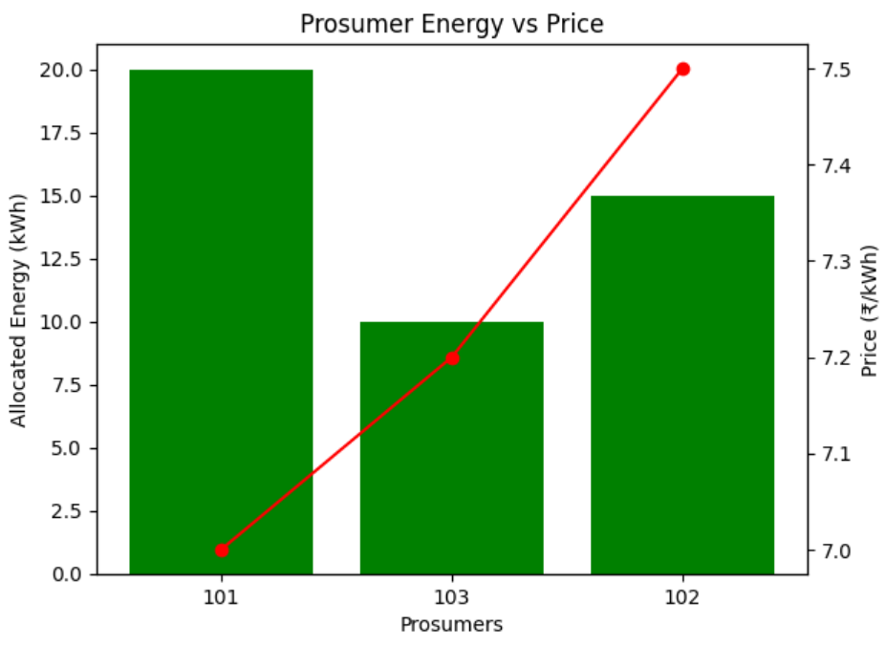
Fig 2:Energy supplied by prosumers and revenue thsy gain in high Demand case
Fig 3 shows the energy received by the consumers as per their demand and price they pay to the prosumers.
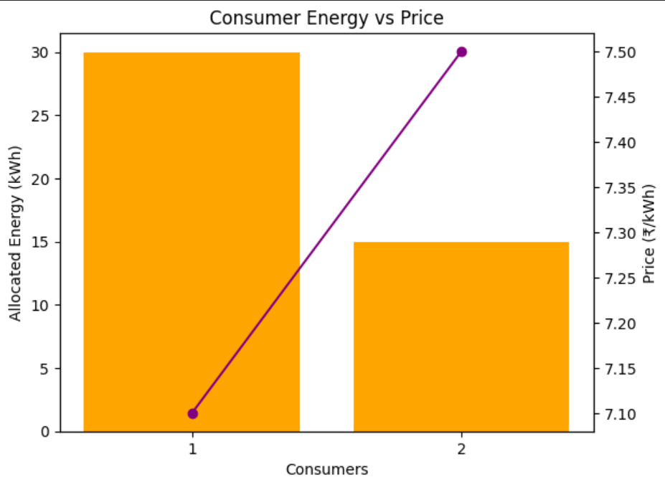
Fig 3 : Energy Allocated to Consumers and price they are paying in high demand case.
Multiple sharing Case:Three prosumers share supplying the three consumers in the best feasible way of supplying the energy.Fig 4,5 shows the results of Energy supplied by prosumers and revenue they gain in Multiple sharing case, Energy Allocated to Consumers and price they are paying in multiple sharing case respectively

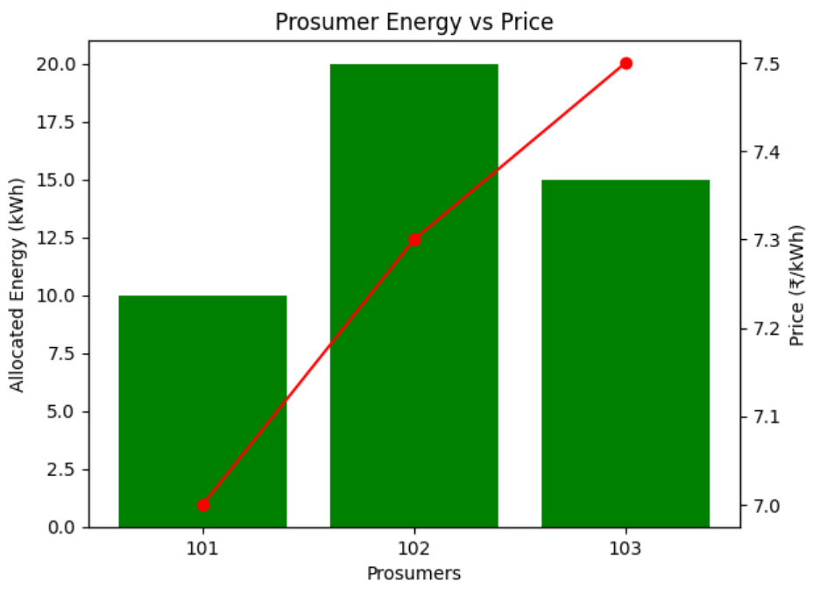
Fig 4: Energy supplied by prosumers and revenue they gain in Multiple sharing case
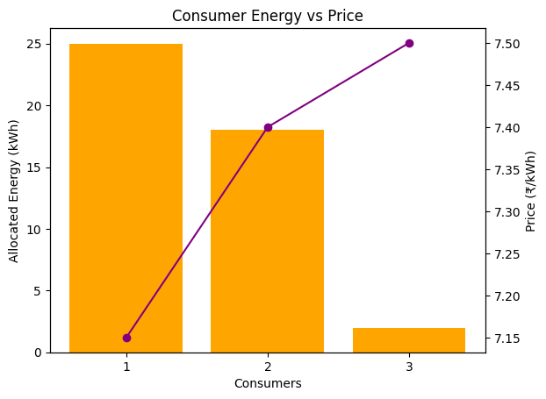
Fig 5 : Energy Allocated to Consumers and price they are paying in multiple sharing case
Fair Sharing Case:Three prosumers share supplying the four consumers in the best feasible way of supplying the energy.Fig 5,6 shows the results of Energy supplied by prosumers and revenue they gain in fair sharing case, Energy Allocated to Consumers and price they are paying in fair sharing case respectively. The MATLAB simulation demonstrates effective peer-to-peer energy trading between multiple participants. The results indicate that prosumers successfully sell surplus energy while consumers purchase energy at competitive prices. The smart contract mechanism ensures accurate matching and secure transactions. The system shows high trading efficiency and balanced energy distribution. Additionally, the blockchain-based transactions ensures transparency and prevents data tampering. Overall, the results validate the feasibility of decentralized energy trading using blockchain technology.

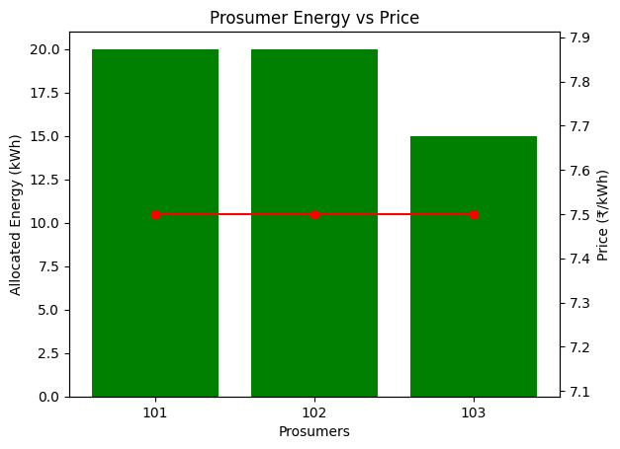
Fig 6: Energy supplied by prosumers and revenue they gain in Multiple sharing case

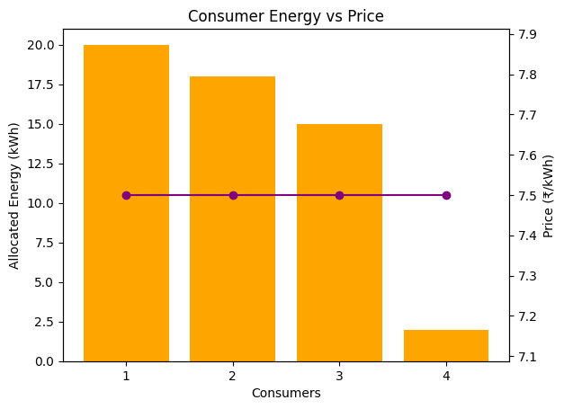
Fig 7: Energy Allocated to Consumers and price they are paying in fair sharing case.

VI Conclusion
This paper presents a blockchain-based peer-to-peer energy trading system that enables decentralized and automated electricity exchange. The integration of blockchain technology ensures secure, transparent, and tamper-proof transactions, while smart contracts automate the trading process, eliminating the need for intermediaries. The MATLAB-based simulation provides a practical platform to analyse system performance, energy flow, and transaction efficiency.
The results demonstrate that the proposed system effectively balances energy supply and demand, reduces operational costs, and enhances reliability. Prosumers are empowered to sell surplus energy, while consumers benefit from flexible pricing and improved access to renewable energy. The system also supports the transition toward smart grids and sustainable energy solutions.
Furthermore, the paper highlights the potential of combining digital technologies with power systems to create scalable and efficient energy markets. Future work may include real-time implementation using IoT devices, deployment on blockchain platforms like Ethereum, and integration with artificial intelligence for demand prediction. Overall, the proposed model represents a significant step toward modernizing energy trading systems and promoting a decentralized, eco-friendly energy ecosystem.

Acknowledgment
The authors gratefully acknowledge the support given by Sir C R Reddy college of Engineering, Eluru, India.

References

- Mengel Kamp, Esther; Philipp Staudt; Johannes Gärtner; Christof Weinhardt, Trading on local energy markets: A comparison of market designs and bidding strategies 14th International Conference on the European Energy Market (EEM), IEEE, pp. 1–6 2017.
- Singh, A.; Click, K.; Parizi, R.M.; Zhang, Q.; Dehghantanha, A.; Choo, K.K.R Sidechain technologies in blockchain networks .Journal of Network and Computer Applications, Vol. 149, Article 102471,2020
- Drishana Jhunjhunwall Revolutionizing domestic solar power systems with IoT-enabled Blockchain technology.ISSN:2252-8792, DOI: 10.11591/ijape.v13.i1, pp. 255–262
- Liu, Ziming; Dazhi Wang; Jiaxing Wang; Xinghua Wang; Hao Li , blockchain-enabled secure power trading mechanism for smart grid employing wireless networks IEEE Access, Vol. 8, pp. 177745–177756,2020
- Khan, Abduallah Ayub; Asif Ali Laghari; Mamoon Rashid; Hang Li; Abdul Rehman Javed; Thippa Reddy Gadekallu, Artificial intelligence and blockchain technology for secure smart grid and power distribution automation: A state-of-the-art review Sustainable Energy Technologies and Assessments, Vol. 57, Article 103282..
- Vasant, U. S., Shukla, D., Thakur, A. K., & Singh, S.P. (2022). Blockchain based transactive energy market using peer-to-peer (P2P) energy trading. In 2022 IEEE IAS Global Conference on Emerging Technologies (GlobConET) (pp. 947–953). IEEE.https://doi.org/10.1109/GlobConET53749.2022.9872378.
- Najafabadi, A. A., & Hosseinian, S. H. (2025). Blockchain-enabled peer-to-peer energy trading with cooperative game theory for enhanced security. In 2025 15th Smart Grid Conference (SGC) (pp. 1–6). IEEE. https://doi.org/10.1109/SGC69320.2025.11372425.
- A. Singh, K. Click, R.M. Pariz, Q. Zhang, A. Dehghantanha, K.K.R. Choo,Sidechain technologies in blockchain networks Journal of Network and Computer Applications, Vol. 149, Article 1024712020
- Ziming Liu, Dazhi Wang, Jiaxing Wang, Xinghua Wang, Hao Li ,A blockchain-enabled secure power trading mechanism for smart grid employing wireless networks IEEE Access, Vol. 8, pp. 177745–177756,2020.
- Tushar, W., Saha, T.K., Yuen, C., Smith, D.B Blockchain-based peer-to-peer energy trading: A review.IEEE Transactions on Smart Grid, Vol. 10, No. 3, pp. 2393–24022019

IEEE conference templates contain guidance text for composing and formatting conference papers. Please ensure that all template text is removed from your conference paper prior to submission to the conference. Failure to remove template text from your paper may result in your paper not being published.

