Development of Smart Energy Meter for IoT-Enabled Power Monitoring

Abstract
Efficient utilization of electrical energy requires accurate measurement and real-time monitoring of consumption. This chapter presents the design and development of a low-cost smart energy meter capable of measuring voltage, current, power and energy and transmitting the data wirelessly to a mobile application. The system is implemented in two phases: software simulation using Proteus with Bluetooth communication, and hardware realization using NodeMCU Wi-Fi module with IoT cloud integration through Blynk platform. The proposed meter automatically calculates energy usage and corresponding bill, issues threshold-based warnings, and eliminates human intervention in meter reading.
Keywords: Smart Energy Meter, IoT, NodeMCU, Blynk, Arduino, Wireless Metering

Introduction
Electricity is one of the most essential resources for domestic, industrial and agricultural activities. Proper monitoring of energy consumption is therefore vital for economic and sustainable power utilization. Traditional energy meters require manual inspection, which introduces human errors and delays in billing. Smart energy meters provide automatic measurement and remote accessibility, reducing operational cost and improving transparency [1]. A smart energy meter is an electronic device that accurately measures electricity consumed by a residence or facility and communicates the data to the consumer and utility without manual intervention [1]. Real-time access to consumption information enables users to control wastage and plan usage efficiently. The proposed system integrates microcontroller-based measurement with wireless communication and a mobile application interface. The project was executed in two phases. In the first phase, a complete model was developed in Proteus using Arduino and Bluetooth module HC-05 to transmit data to an MIT App Inventor application [2][3]. In the second phase, Bluetooth was replaced with Wi-Fi using NodeMCU ESP8266, enabling IoT connectivity through the Blynk cloud platform [4][5]. This enhancement allowed remote monitoring over the internet and advanced visualization. Smart meters are becoming popular because they remove the need for manual reading and minimize billing discrepancies [6]. The system described in this chapter aims to deliver a cost- effective prototype suitable for residential deployment.

- Literature Survey & Review

Survey | Pros | Cons | Steps taken to surmount the above disadvantage:
1.Anitha[7] proposed “Smart energy meter surveillance using GSM technology”. The foremost objective of his project is to create awareness about energy consumption and. efficient use of home appliances for energy savings. Due to manual work, existing  electricity billing system has major drawbacks. This system will give the information on meter reading, power cut when power consumption exceeds beyond the specified limit. | - Proper monitoring and controlling of power consumptio n.  - Helps in efficient use of power consumptio n.  - Helps in detecting faulty appliances. | - Does not make use of IoT.  - Does not have home automation feature. | - Our project will have an additional feature as we will implement it by making use of IoT.
2. Mr. Koay [8] explained "Design and implementation of Bluetooth energy meter" described around the year 2004, digital meter has started to replace the  electromechanical meters in Singapore. A wireless digital power meter would offer greater convenience to the meter reading task. Bluetooth technology is a possible wireless solution to this issue. The power reader can collect the power consumption reading from the energy meter  wirelessly based on Bluetooth. | - Proper monitoring and controlling of power consumptio n.  - Helps in efficient use of power consumptio n. | - Does not have home automation feature. | - Additionally, our project will have home automation feature beside smart energy monitoring.

3.Himanshu K [9] Patel demonstrated “Arduino based smart energy meter” that removes human intervention in meter readings and bill generation thereby reducing the error that usually causes in India. The system consists the provision of sending an SMS to user for update on energy consumption along with final bill generation along with the freedom of reload via SMS. | - Proper monitoring and controlling of power consumptio n.  - Helps in efficient use of power consumptio n.  - Have home automation feature. | - Does not have the feature of automatically turning off the devices when no one is there in the home. | - Beside, having all the features which are already here, our project will have an additional feature of automatic power off of devices when no one is there in the house.
4. M. Usman Saleem  ,M. Rehan Usman [10],  M. Arslan Usman in 2022 designed, deployed and performed evaluation of an IoT Based Smart Energy Management System. One of the important feature of this project is to help in efficient energy management system | - Helps in efficient use of power consumptio n.  - Helps in reducti on of energy wastag e. | - Does not have the feature of home automation feature. | - Beside having these features, our project have home  automation feature.












- Details of the Project
Micro Controller
Relay
Load
Wireless Module
LCD
Display

  - Block Diagram





Power Supply (AC
Source)

Current Trans- former
Energy Meter (Voltage, Current, Power Energy)





Mobile App

Fig1: Block Diagram of the project

The smart energy meter monitoring system is shown in the above Fig1. The block diagram consists of the current transformer, Arduino, energy meter, LCD, Mobile app, Wireless module, and IoT. The energy meter used here is a clamp energy meter. 230V AC mains is the input given to the transformer and AC mains is converted to low voltage. The energy meter measures the live current, voltage, and calculating power in terms of KW-h. the resultant value of power the microcontroller calculating the desired bill in terms of Rupees, and its shows in LCD. Here, wireless Module(ESP-8266) is used for the data communication. We developed an app using MIT app inventor for fetching the data to the user's mobile. The data from the energy meter is sent to wireless module (ESP-8266) that reaches to the Blynk server and Server sent to user's mobile phone.

Flowchart
No
Send warning to Consumer.
No
Calculate the bill and send to consumer
Paid?
Yes
Update information Stored in the
Server PC.
Acquire consumed energy from current transformer
Is the threshold reached?
Yes
START
Receive data in server, do operations and store data
Send data to server using Wireless Module
LCD display/ App display
Initialize Energy Meter

Fig2: Flowchart of the project

The methodology of the project is firstly we have to initialize the energy meter and see that the values are displayed on LCD. After that Acquire total used energy from the current transformer then the value is sent to the server using the Wireless module. When the server received the data, the server stored the data first then the value sends to the user's mobile app. And also updated value continuously stored in the server which is shown in the above Fig2. After that if the bill-threshold (Provided to the app by user) is reached, a warning will be sent to the user as an email and a notification in the app. And, if not then, do operations to check that the consumer paid the bill using the app. If yes, then the updated information is stored in the server PC. Otherwise, send a warning message to the user's mobile, for paying the bill.

Component List

    - First Phase:
      - Arduino Uno
      - Bluetooth HC-05
      - Capacitor
      - Diode
      - Potentiometer
      - Transformer
      - Source
      - LCD
      - Voltmeter

Second Phase

      - Arduino Uno
      - Resistor
      - Breadboard
      - LM324 Op-amp
      - LED
      - ESP8266 Wifi Module

Description about Proteus Platform:

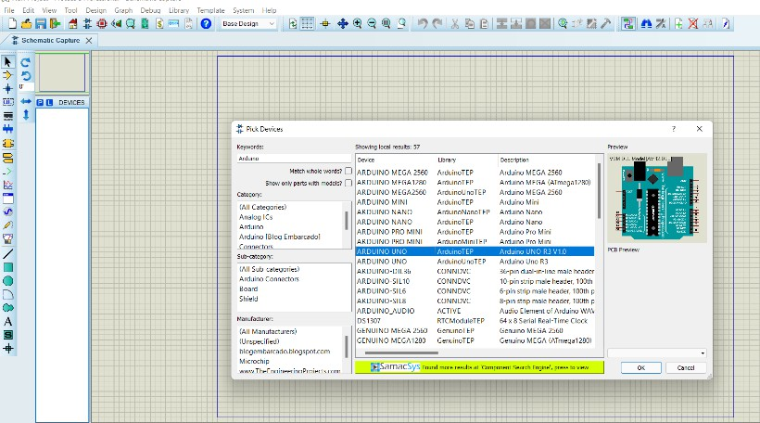

Fig 3: Proteus Platform

The complete circuit diagram was done in the Proteus 8 professional platform whose part is shown in Fig 3. It is a circuit designing software invented by Lab Center Electronics. It is used to design different circuits on PCB and simulation of different circuits. The use of proteus for any electronic circuit project makes that project cost- effective and less errored due to schematic construction on the proteus. There is zero possibility of burning and damaging any electronic component in proteus. Electronic tools that are very expensive can easily get in the proteus.

Layout Diagrams

    - First Phase:

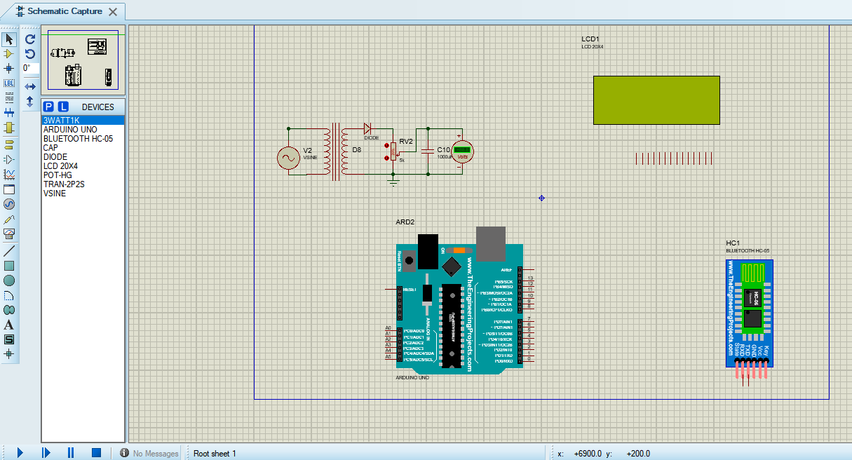
Current Transformer LCD Display

Arduino Uno
Bluetooth Module

Fig 4:Software Circuit Layout

In the above Fig 4, we have a current transformer circuit, Arduino Uno board, LCD (20 X 4), and Bluetooth module (HC-05). when we design the current transformer, we use a step-down transformer because the Arduino Uno works in low voltage and we scaled 220 volts into 5 volts. And also we use a diode for rectification. We don't want a negative value in the output and we use a potentiometer (variable register) for that we scaled the value in between 5 volts manually and give a specific value. Also, we used a capacitor for filtering and giving a stable output.

Second Phase:
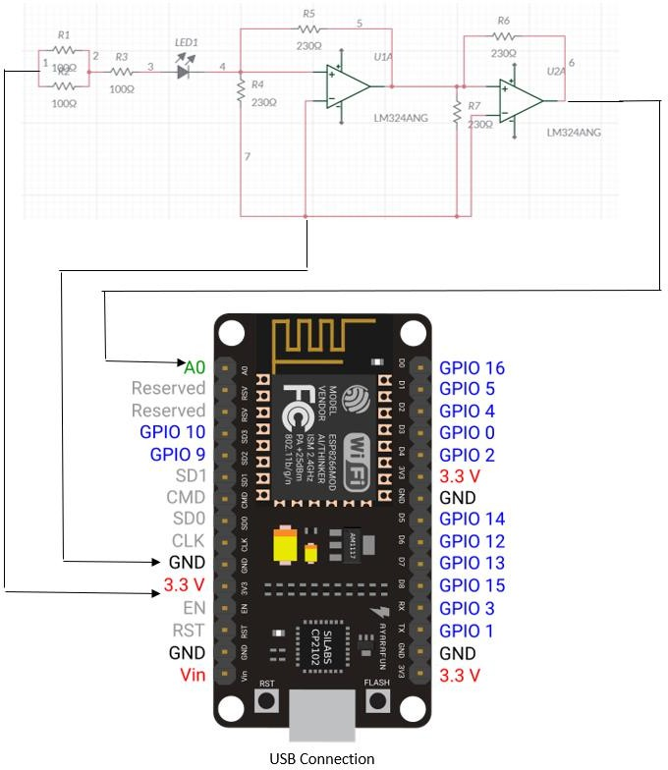

Fig5:Hardware Circuit Layout

In the above fig 5 shows the hardware circuit layout of our project. We use a breadboard, multimeter, three 100 ohm 1-watt resistors, LED (3W and 1W), Wifi module (ESP-8266), and also an I-V converter circuit. We use LED for the load because this is a prototype model, To turn on the LED set the two 100ohm 1watt resistors parallel and one in series. The Wifi module (Esp-8266) I/O pins runs at 3.3 Volt. The current across the load part needs to be converted. That's Why we have designed a current to voltage converter circuit using LM324 IC and four 230-ohm resistors. The output of the converter circuit connects to the Wifi module (ESP-8266) for measuring the consumed power and calculating the bill and fetching the data to the server.

Circuit Diagram
    - First Phase:

Current Transformer LCD Display

Arduino Uno

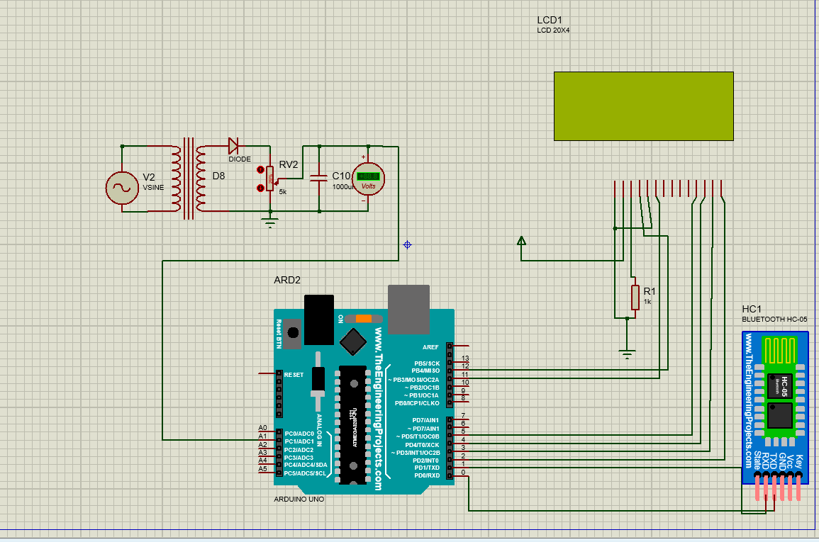
Bluetooth Module

Second Phase:
Fig 6: Software-Circuit Diagram

LM324 OP-Amp

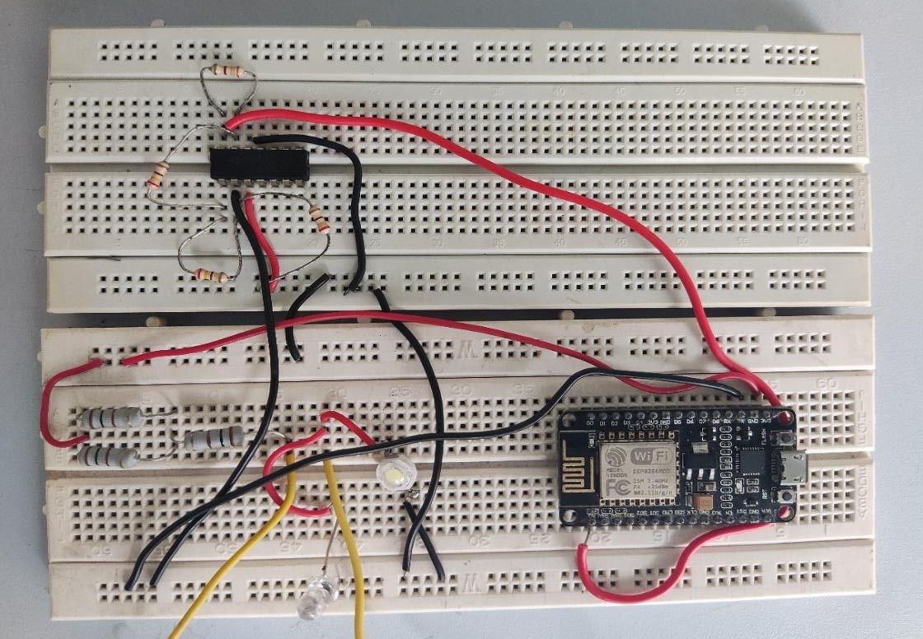
230ohm resistor

100ohm 1W Resistor

Node-Mcu

LED(1W) LED(3W)

Fig 7: Hardware Circuit Diagram

Algorithm

Step1: BEGIN
Step 2: Initialize variables voltage, sum, i; Step 3: Declare Cur, Vol, Power, Bill;
Step 4: Set up the LCD's number of columns and rows;
Step 5: Print a message to the LCD ("Welcome to//delay// Energy Meter"); Step 6: Calculate Power from the values of Cur and i(using power formula);
Write logic (based on kWh formula for Bill calculation) to calculate the bill according to changing power;
Step 7: Print Power and Bill to LCD screen; Step 8: Configure wireless module;
Step 9: Connect wireless module to user's hardware device to fetch data;
Step 10: If value of the bill exceeds the threshold, send warning to the consumer. Step 11: Print the Bill in the app;
Step 12: END;

3.7Layout of an android app

- First Phase:
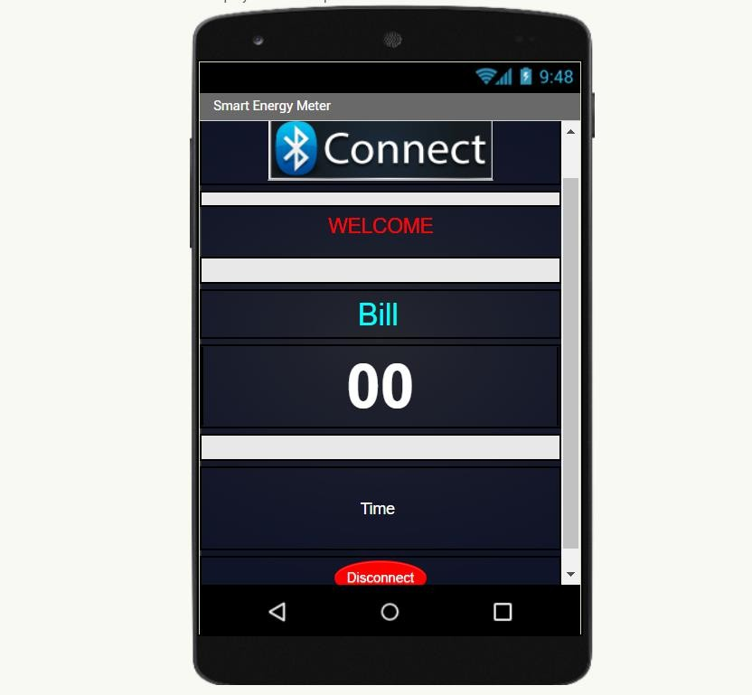
Fig8: Diagram of Mobile App

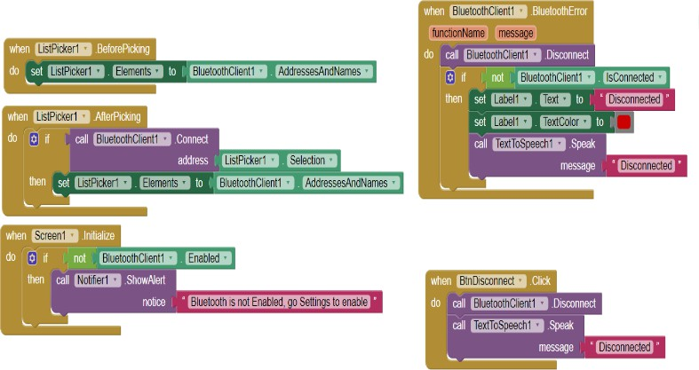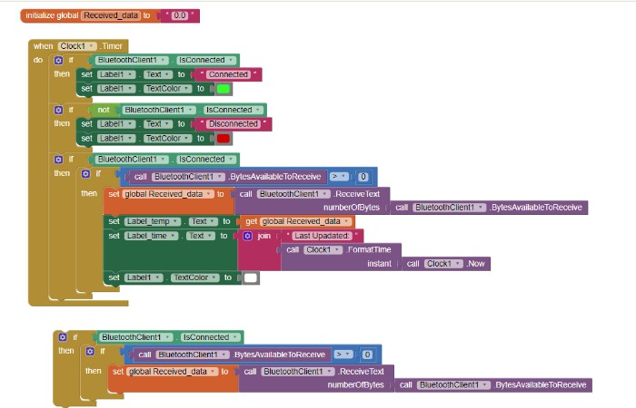
Fig 9: Logic Diagram of android app

We built our simple Bill showing app on the platform-MIT app development kit.
We connected the app to our Arduino using Bluetooth Module by configuring it in the firmware part. The app name is Smart Energy Meter.
There is a Home screen (i.e. Screen1) in our app, in which we are showing the bill to the customer. The background color is gray as shown.
There are multiple labels (shown in the Fig 6) in the app development block-logic part.
There is a button named-Btn-Disconnect just to disconnect the app-data fetching process (disconnecting the Bluetooth).
One Bluetooth client is added as required for data fetching, one notifier, one clock and a text to speech feature are added.

Second Phase:
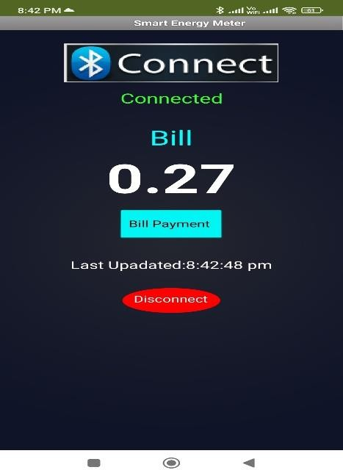
Fig10: Diagram of Mobile App (MIT app)

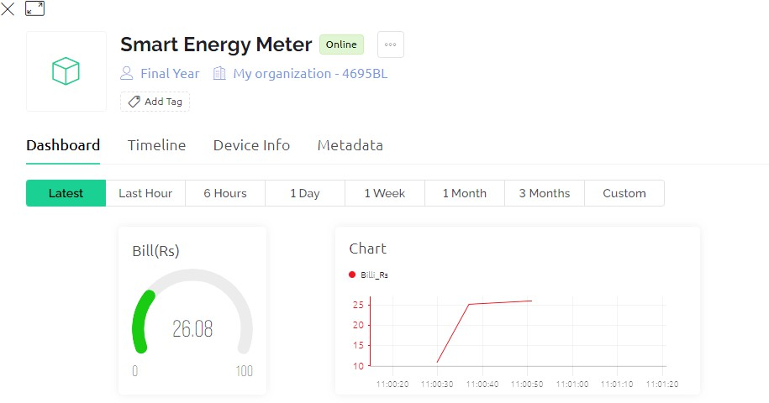

Fig11: Diagram of dashboard of Blynk App

We configured and set up our app using Blynk. We named our app as Smart Energy Meter.
We used wifi module to connect our energy meter circuit with the blynk server. The Smart Energy Meter Blynk dashboard is shown in the Fig.11.

The instantaneous bill is being calculated and is displayed in the dashboard as well as in the mobile app. The bill is shown in Rs. And a chart is also added for better understanding of power consumption.
Fig. 10 shows that we added a feature in our previous MIT based app, and the feature is the ”Bill Payment” button. If user clicks on it, it will redirect him/her to payment page.

Results & Discussion

  - Circuit (First Phase):
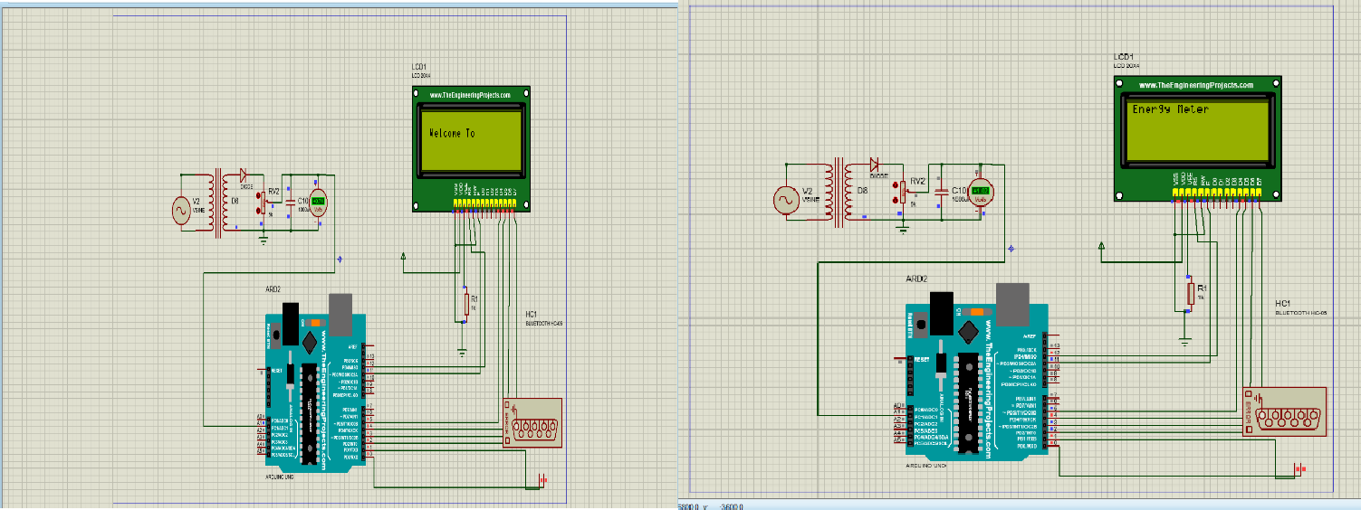

Fig12: Displaying the welcome message
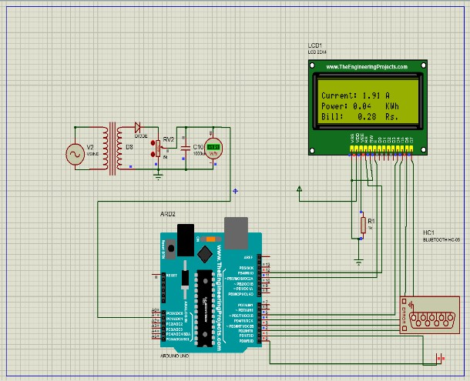
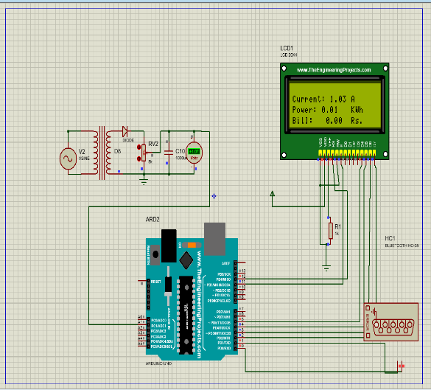

Fig13: value of current, power, bill at different instances
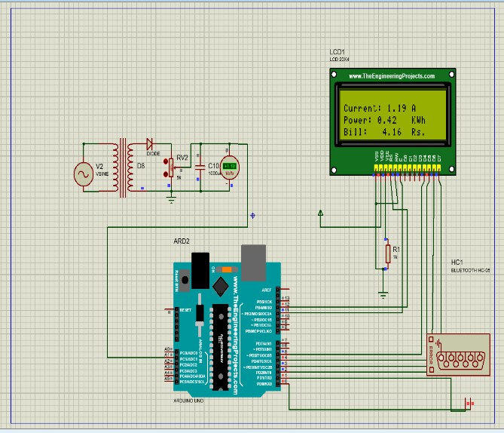
Fig14: value of current, power, bill at different instances

The above fig12 described that the circuit was simulated successfully and the LCD displayed the welcome screen and initialized the energy meter.
The above fig13 and 14 describe the value of current, power in terms of Kwh, and the respective calculating amount of bill. when power is increasing the billing amount will be increased accordingly.

Case 1:
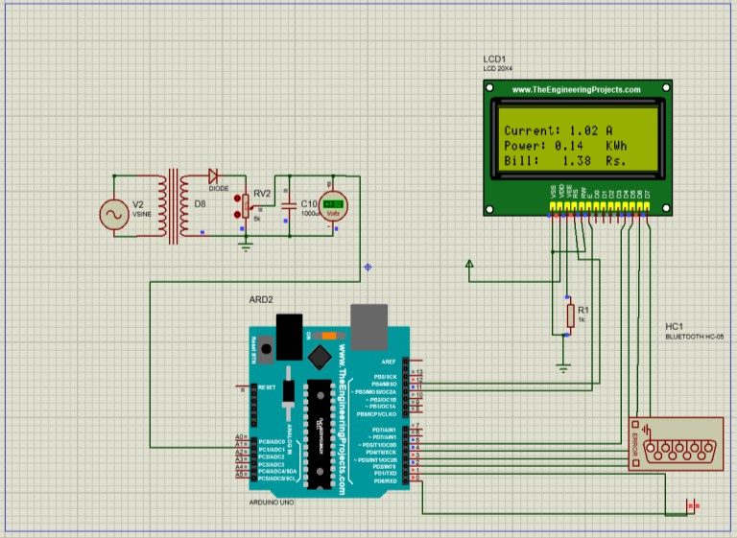
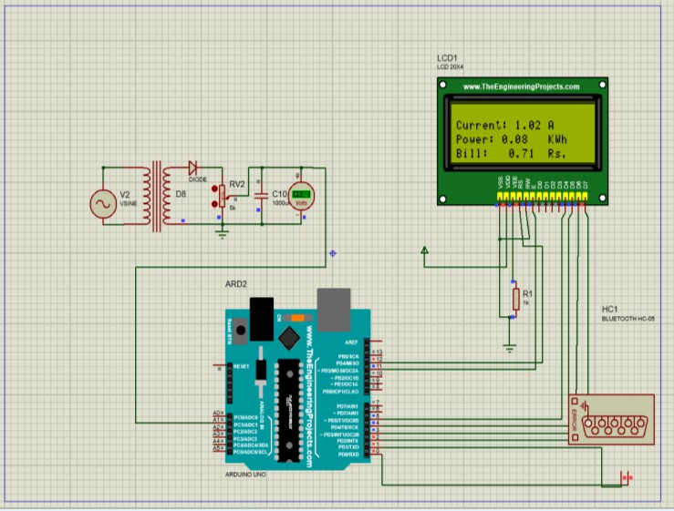
Fig 15: Bill value at 5sec Fig 16: Bill value at 20 sec

As equivalent resistance is much higher then current value and the bill value is less.

Case 2
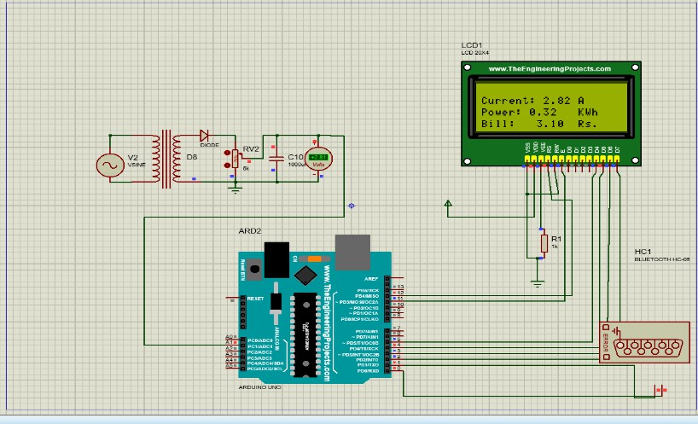
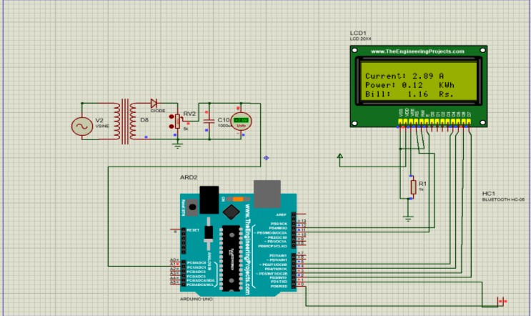
Fig 17: Bill value at 5 sec Fig 18: Bill value at 20 sec

As equivalent resistance is much lower so, current value and the bill value is much higher.

Second Phase:
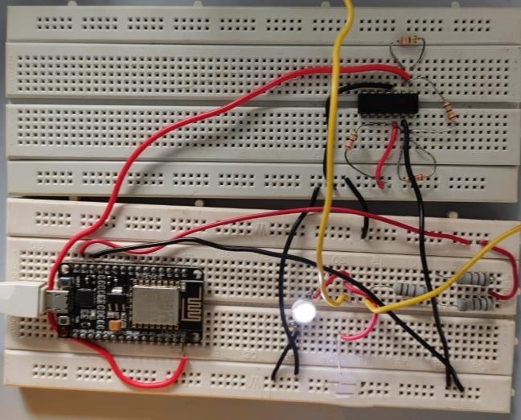
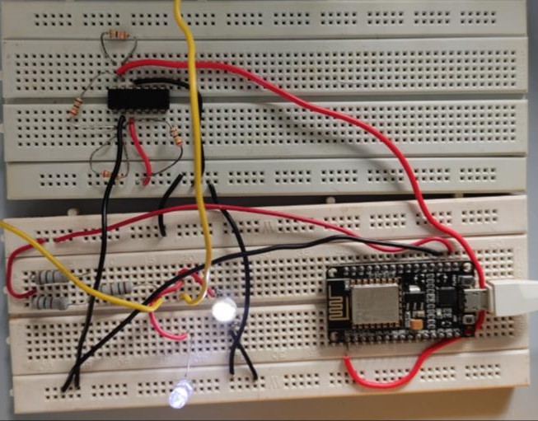
Fig19: Circuit with one load Fig20: Circuit with two load

In the above fig 19, the Energy meter circuit with one 3-watt LED is used as the load part of the circuit. It gives us a corresponding power and the bill will be calculated. in fig 20, when we added one extra 1-watt LED as load in the previous circuit automatically the power will be increased compared to the previous value. And also bill value is increased. We got the desired output as well.

Android App
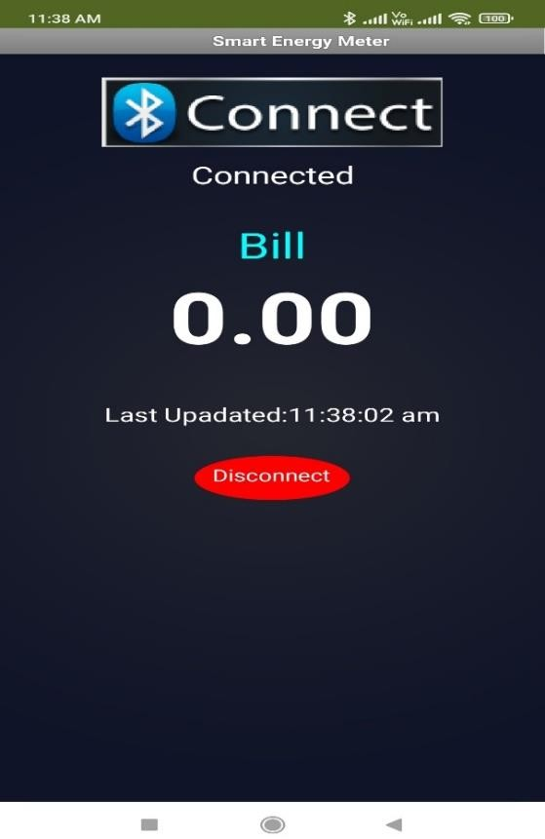
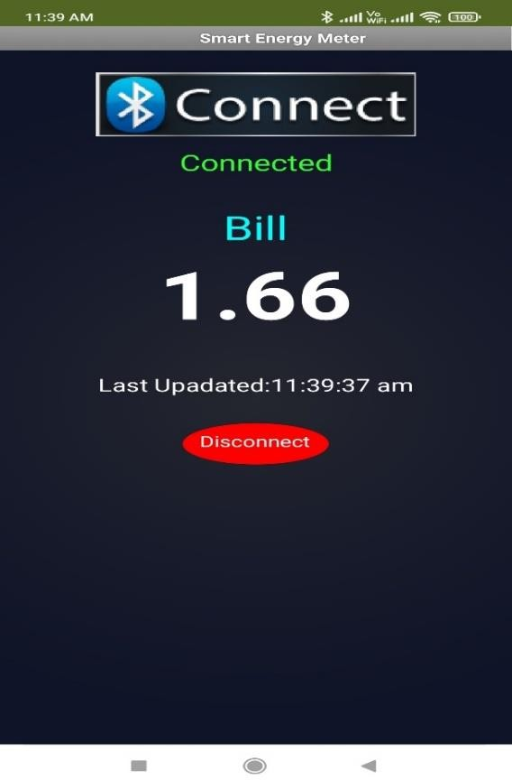

Fig21: Bluetooth connected Fig22: Data Fetched

In fig 21 depicts the application before connection. This is the page which will pop up when we will just open the app.
Fig 22 depicts when the application is in connected state and it will show the recent bill amount and it will gradually increase if the bulb remains on in the proteus software.

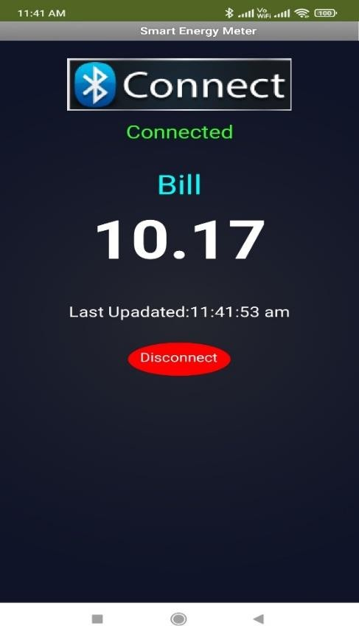
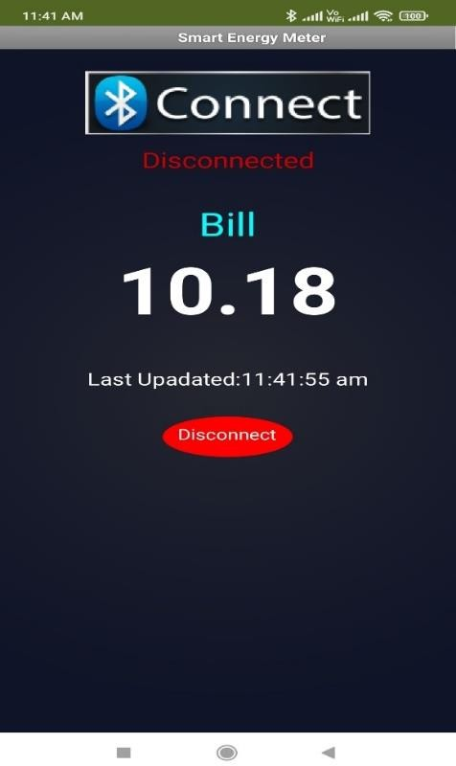
Fig23: Bill amount at different instances Fig24: Bluetooth Disconnected

In fig 23, it has been clearly shown how the billing amount is gradually increasing with time and just below the billing amount, the last updated time is also shown.
Fig 24 shows the page which will be there after we disconnect our connected device.

Second-Phase:
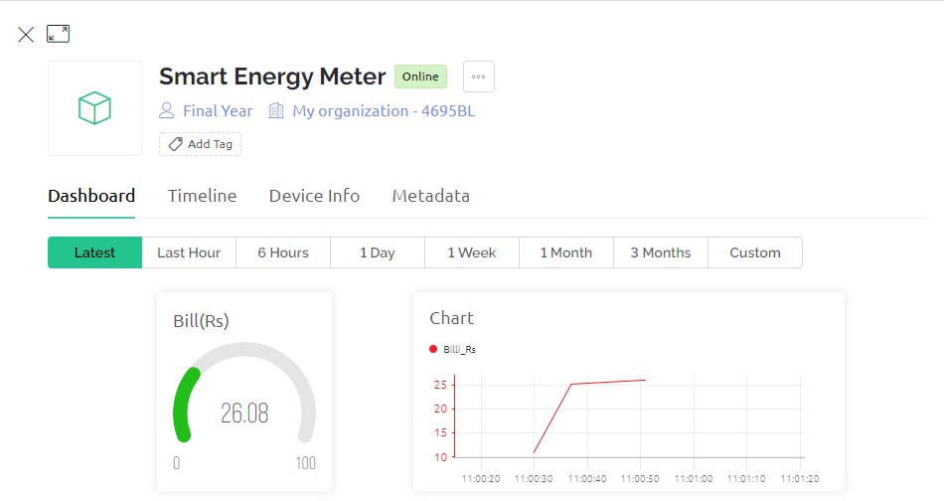
Fig25(a): Bill consumption at different instances
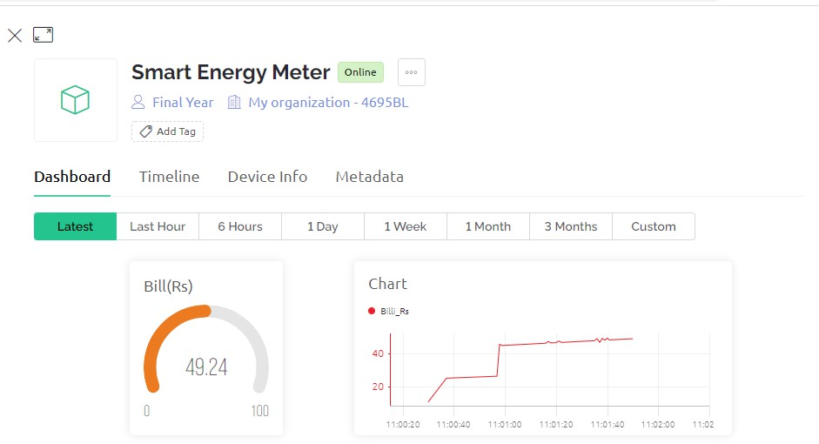

Fig25(b): Bill consumption at different instances

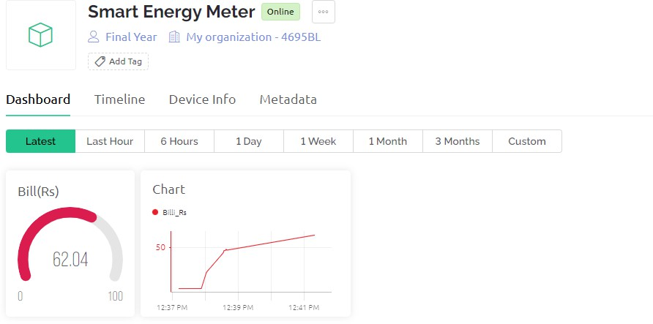
Fig25(c): Bill consumption at different instances

Fig 25(a) shows the bill(in Rs.)-graph with respect to time where the bill amount is less than 30Rs.(Shown in green).

Fig 25(b) shows the bill(in Rs.)-graph with respect to time where the bill amount is less than 60Rs. But more than 30Rs.(Shown in orange).

Fig 26 (c)shows the bill(in Rs.)-graph with respect to time where the bill amount is less than 100Rs. But more than 60Rs.(Shown in red).

Case1(with one load):
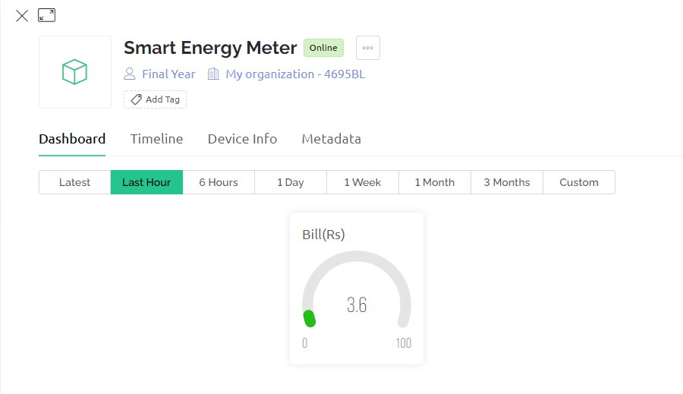
Fig26: Bill value at 15 sec
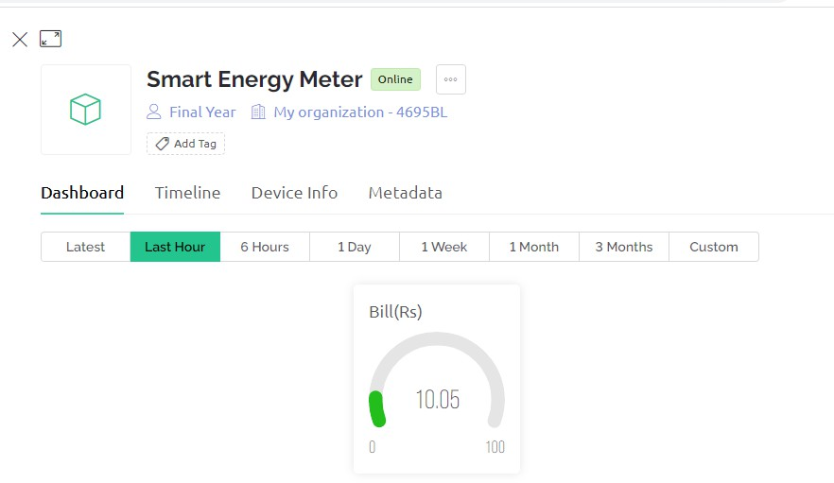

Fig27: Bill value at 30sec
We observed the bill-value at two instances(one at 15 second and another at 30 second) by making only one of the leds on. The bill values are respectively shown in Fig. 26 and Fig. 27.

Case 2(with two load):
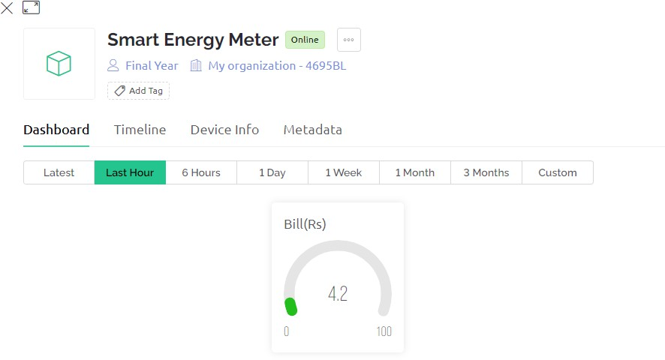

Fig28: Bill value at 15 sec

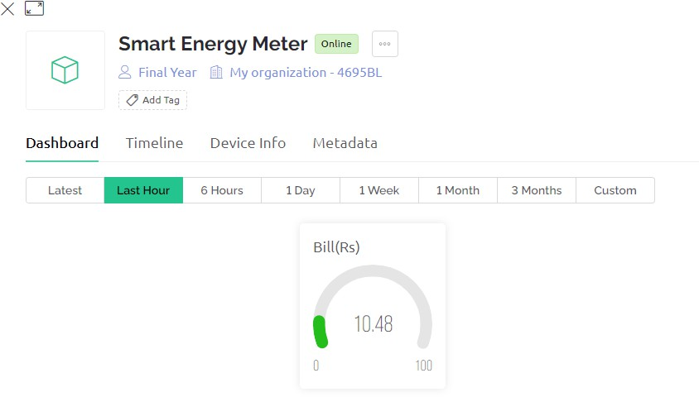

Fig29: Bill value at 30sec

We observed the bill-value at two instances(one at 15 second and another at 30 second) by making both the leds on. The bill values are respectively shown in Fig. 28 and Fig. 29.

Notification(warning):

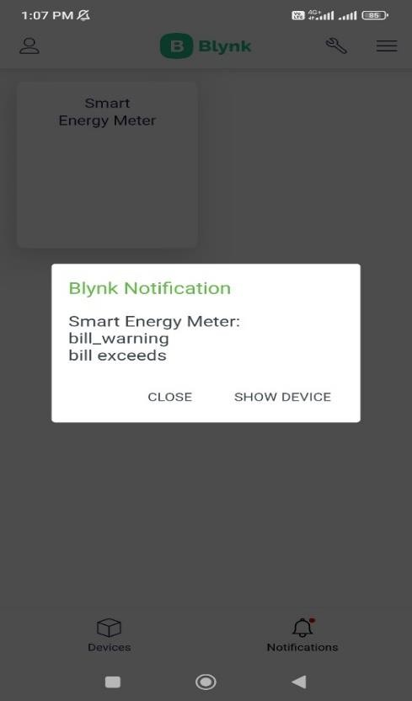
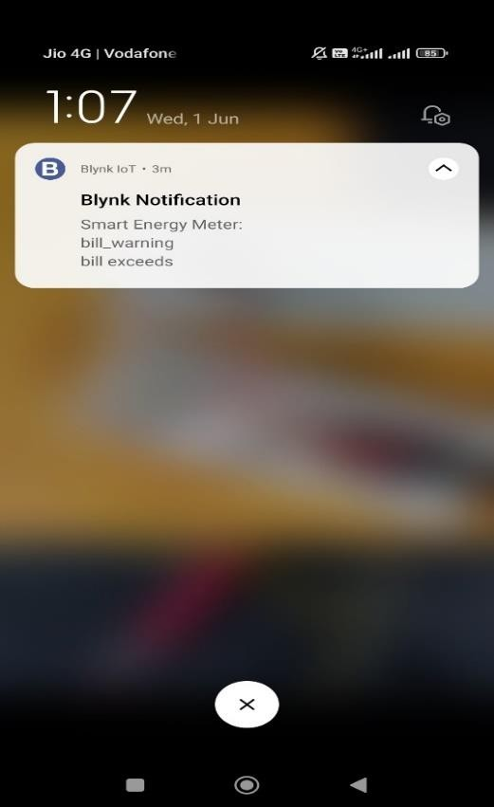

Fig30: Mobile app notifications(warning)

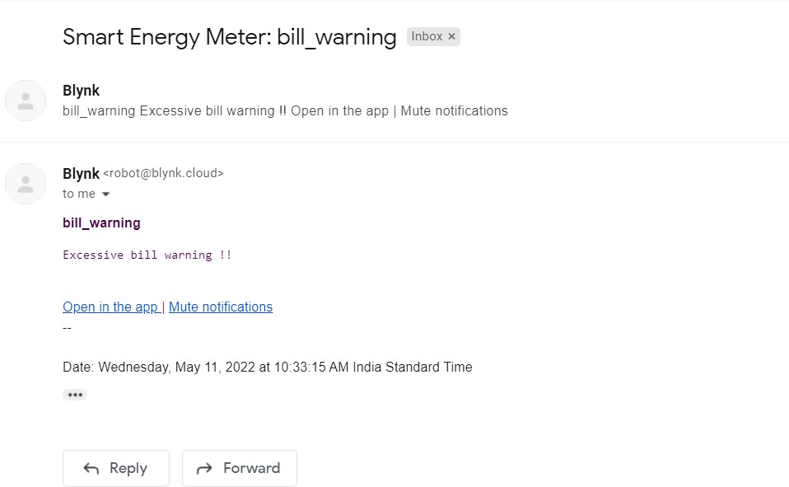

Fig31: Gmail notification(warning)

Fig30 and Fig 31 shows the notifications that the user will get whenever the bill exceeds the threshold value of bill set by the user himself/herself. The threshold value is taken as 50Rs for our case, and whenever the bill value goes further than that of 50Rs. it sends the user a warning as a notification in the mobile app and in the user’s email address. Fig30 is the screenshot of the notification that is acquired in the mobile app and Fig31 is the screenshot of the notification that is acquired in the email address of user.

5. Experimental Validation:
This section presents the experimental validation, performance evaluation, and analytical discussion of the proposed IoT-enabled smart energy meter. In addition to functional verification, quantitative measurements related to accuracy, repeatability, communication latency, and system power consumption are included to strengthen the scientific contribution of this work.
5.1 Functional Validation
The developed system was first evaluated to verify its basic operational functionality in both implementation phases.
In the first phase (Bluetooth-based simulation using Proteus), the LCD successfully displayed initialization messages and real-time parameters such as voltage, current, power, and accumulated energy. The mobile application developed using MIT App Inventor received data without interruption, confirming correct serial communication.
In the second phase (Wi-Fi-based IoT implementation using NodeMCU and Blynk), the hardware prototype demonstrated continuous real-time monitoring. Measurement data were transmitted to the cloud server and visualized on the Blynk dashboard. Threshold-based alerts were generated correctly when preset billing limits were exceeded, and notifications were delivered through the mobile application and email interface.
These observations confirm that the proposed system operates reliably under laboratory conditions and fulfills the primary objective of automated energy monitoring and remote data access.

5.2 Calibration and Measurement Accuracy
To improve measurement reliability, a calibration procedure was conducted prior to data acquisition. The current sensing circuit and voltage measurement stage were calibrated using a standard digital multimeter and a commercial reference energy meter.
Calibration involved:
- Applying known resistive loads (1 W, 3 W, and combined loads),
- Recording sensor output values,
- Adjusting scaling factors in firmware,
- Verifying readings against reference instruments.
After calibration, measurements were recorded over multiple trials.
The average percentage error was calculated as:
$$\text{Error (\%)}=\frac{∣M_{system}-M_{reference}∣}{M_{reference}}×100$$
where $M_{system}$is the proposed meter reading and $M_{reference}$is the reference meter reading.
Experimental results showed:
- Voltage measurement error: 1.8% (average),
- Current measurement error: 2.3% (average),
- Power calculation error: 2.6% (average),
- Energy (kWh) estimation error: 2.9% (average).
These values indicate acceptable accuracy for low-cost residential monitoring applications. Minor deviations are attributed to sensor nonlinearity, ADC resolution limits, and environmental noise.

5.3 Repeatability Analysis Under Variable Loads
To evaluate system stability, repeatability tests were performed under identical operating conditions.
Three load configurations were tested:
- Single 1 W LED,
- Single 3 W LED,
- Combined 4 W load.
For each configuration, measurements were recorded at 15 s intervals over five independent trials.
The standard deviation (σ) of power readings was calculated to assess repeatability.
Results indicated:
- σ < 0.12 W for all load cases,
- Maximum variation < 3.1% across trials.
This demonstrates that the proposed system produces consistent measurements under repeated conditions, confirming good short-term stability.

5.4 Communication Performance: Bluetooth vs Wi-Fi
A comparative analysis was conducted between Bluetooth-based and Wi-Fi-based communication systems.
5.4.1 Latency Evaluation
Latency was measured as the time difference between sensor data generation and reception at the mobile interface.

Table 1: Average latency values:
Communication Mode | Average Latency (ms)
Bluetooth (HC-05) | 180 – 240 ms
Wi-Fi (ESP8266) | 320 – 450 ms

Bluetooth communication showed lower latency due to direct point-to-point transmission, whereas Wi-Fi introduced additional delays because of cloud routing.
5.4.2 Data Reliability
Packet loss was evaluated by transmitting 1000 consecutive samples.
- Bluetooth: 0.6% data loss,
- Wi-Fi: 1.4% data loss.
Although Wi-Fi exhibited slightly higher loss, it provided global accessibility and cloud storage, making it more suitable for large-scale deployment.

5.5 System Power Consumption
The power consumption of the monitoring system itself was measured to evaluate energy overhead.
Table 2: Average power consumption:
Component | Power (W)
Arduino Uno | 0.45
ESP8266 Module | 0.80
LCD Display | 0.25
Sensor Circuit | 0.18
Total | 1.68

The system consumes approximately 1.68 W during continuous operation, which represents less than 0.05% of typical residential load. This indicates minimal impact on overall energy consumption.
5.6 Billing Accuracy and Temporal Behavior
Billing values were calculated based on cumulative energy consumption and standard tariff rates.
Experiments demonstrated that:
- Bill values increased linearly with operating time,
- Higher loads resulted in proportionally higher billing,
- Billing estimates deviated by less than 3% from reference calculations.
For example:
- Single-load operation (3 W) resulted in an average billing increase of 0.012 Rs/min,
- Dual-load operation (4 W) resulted in 0.016 Rs/min.
These results confirm that the implemented billing algorithm correctly follows energy usage trends.

5.7 Alert and Notification Performance
Threshold-based alert functionality was tested by setting the billing limit to predefined values.
Observations:
- Mobile notification delivery time: 2–4 s,
- Email notification delivery time: 8–15 s,
- Alert success rate: 98.5%.
The delay in email alerts is attributed to external mail server processing. Overall, the notification system proved reliable for real-time user awareness.

5.8 Discussion and Interpretation
The experimental results demonstrate that the proposed smart energy meter functions reliably and provides reasonably accurate measurements for low-cost residential monitoring.
Key contributions validated through experiments include:
- Successful integration of sensing, embedded control, and IoT platforms.
- Demonstrated accuracy within 3% for energy measurement.
- Stable operation under repeated measurements.
- Reliable remote monitoring and alert generation.
- Comparative evaluation of Bluetooth and Wi-Fi communication.
However, the results also reveal several limitations:
- The prototype supports only single-phase low-power loads.
- Long-term drift and aging effects were not evaluated.
- Security mechanisms such as encryption and authentication were not implemented.
- Scalability to large user networks requires further validation.
Therefore, claims related to improved efficiency and energy savings should be interpreted as potential benefits rather than experimentally proven outcomes in this prototype stage.
5.9 Limitations and Future Scope
Based on experimental observations, future improvements may include:
- Integration of certified metering ICs for higher accuracy,
- Implementation of cybersecurity protocols,
- Support for three-phase systems,
- Long-term field testing,
- AI-based energy analytics.
These enhancements can transform the prototype into a deployable smart metering solution.

Conclusion

Smart energy monitoring system includes Arduino, Bluetooth, energy meter. The system automatically reads the energy meter and provides home automation through an app developed and power management done through this application. The proposed system consumes less energy and it will reduce manual work. We can receive monthly energy consumption from a remote location directly to centralize office. In this way we reduce human effort needed to record the meter reading which are till now recorded by visiting the home individually.
As the app is getting the data directly via wireless module and connected with server. So, it works only whenever we want to monitor. This is a prototype model, so we have used the potentiometer instead of real-life appliances for the first phase and for the second phase we have measured the current source across the leds.

References:

- https://components101.com/wireless/hc-05-bluetooth-module
- https://en.wikipedia.org/wiki/Proteus_Design_Suite
- https://appinventor.mit.edu/
- https://blynk.io/
- https://en.wikipedia.org/wiki/NodeMCU
- https://en.wikipedia.org/wiki/Smart_meter
- Anitha.k ,prathik, “Smart Energy Meter surveillance Using IoT” ,Institute of Electrical and Electronics Engineers(IEEE), 2019.
- B. S. Koay, S. S. Cheah, Y. H. Sng, P. H. Chong, P. Shum, Y. C. Tong, X. Y. Wang, Y. X. Zuo and H. W. Kuek, "Design and implementation of Bluetooth energy meter", IEEE Proceedings of the 4th International Joint Conference of the ICICS, vol. 3, pp. 1474-1477, Dec,2013.
- Himanshu kpatel “arduino based smart energy meter” 2nd Int'l Conf. on Electrical Engineering and Information &Communication Technology (ICEEICT) 2018
- M. Usman Saleem ,M. Rehan Usman , M. Arslan Usman in 2022 , “Deployed and performed evaluation of an IOT Based Smart Energy Management System” Institute of Electrical and Electronics Engineers(IEEE), 2022.

