FORMULATION AND DEVELOPMENT OF A FUNCTIONAL FERMENTED BEVERAGE FROM GUAVA LEAVES
Sreelakshmi S ¹
Department of Food Processing and preservation technology,
School of Engineering,
Avinashilingam Institute for Home Science and
Higher Education for Women- Coimbatore.
Ms Sharmeela R ²
Assistant Professor
Department of Food Processing and preservation technology,
School of Engineering,
Avinashilingam Institute for Home Science and
Higher Education for Women- Coimbatore.

Abstract: There has been more interest in making functional drinks in the last several years because more people are looking for natural and health-promoting items. Guava leaves were chosen for the beverage's development because of their therapeutic effects on the human body (antibacterial, anti-inflammatory, anti-diabetic), their high polyphenol, flavonoid, and antioxidant content. Guava leaves can be transformed into a novel fermented herbal drink, integrating traditional herbal uses with contemporary nutraceutical applications, which is the first step toward developing a novel beverage. The aim of this research is to develop a functional beverage while utilizing an underused product with various health benefits. This natural, health-driven novel beverage adheres to global consumer demands for inclusive, sustainable and nutrient-dense drinking options and provides artisanal and commercial sectors with a scalable solution to sustainable global demands for economic equity, environmental efficacy and health.

Abstract: There has been more interest in making functional drinks in the last several years because more people are looking for natural and health-promoting items. Guava leaves were chosen for the beverage's development because of their therapeutic effects on the human body (antibacterial, anti-inflammatory, and anti-diabetic), their high polyphenol, flavonoid, and antioxidant content. Guava leaves can be transformed into a novel fermented herbal drink, integrating traditional herbal uses with contemporary nutraceutical applications, which is the first step toward developing a novel beverage. This research aims to develop a functional beverage while utilizing guava leaves with various health benefits. This natural, health-driven novel beverage adheres to global consumer demands for inclusive, sustainable and nutrient-dense drinking options and provides artisanal and commercial sectors with a scalable solution to sustainable global demands for economic equity, environmental efficacy and health.
Keywords: Guava leaves, Therapeutic effects, Herbal beverage, Herbal drink, Functional beverage

- INTRODUCTION
Natural foods and drinks are currently gaining huge popularity among customers all over the world. Limiting sugar and sweeteners in beverages is an effort to reduce obesity and enhance health. Fermented dairy products and non-dairy beverages are popular substitutes for carbonated artificial beverages in several nations (Irkin., et al 2019).
Diabetes is a huge and growing medical and public health problem. In 2015, the International Diabetes Federation (IDF) estimated that 415 million adults worldwide have diabetes and that by 2040, this number will rise to 642 million. Diabetes is also a huge economic burden (Herman., et al 2016).
Lifestyle changes are contributing to the increasing number of people suffering from Type 2 diabetes. Various cases have been reported to involve several drugs, such as metformin and rosiglitazone. Such drugs cause side effects such as weight gain, hypoglycaemia and an increased risk of heart disease. The prolonged use of such drugs affects the lifestyle of patients since Type 2 diabetes is a chronic disease. The treatment expenses also contribute to the difficulties faced by the patients (Kalsi., et al 2017).
Guava leaves have strong properties that help with diarrhea, spasms, bacteria, and inflammation due to their high levels of flavonoids like quercetin and guaijaverin. Extracts prepared with water, ethanol, or methanol exhibit strong antibacterial activity against Salmonella, Shigella, E. coli, Pseudomonas, and Staphylococcus aureus. Guava leaf extracts also show antiviral efficacy against aquatic viral infections, including influenza viruses. Their traditional use in respiratory conditions such as cough, bronchitis, and asthma is supported by their antioxidant properties, owing to their polyphenols and tannins (Devi., et al 2025).
- LITERATURE REVIEW

2.1. Guava Leaves: Phytochemical and Therapeutic Profile
Guava leaves are used as food and medicine. Their chemical makeup, pharmacological qualities, and medical applications have been the focus of many scientific studies. The leaves contain various chemical components, including alkaloids, polyphenolic compounds, flavonoids, terpenoids, saponins, tannins, carbohydrates, lipids, fats, oils, and different types of glycosides and amino acids. They are also sources of structure elucidation with a wide range of strong secondary metabolites (Bulugahapitiya et al., 2021).
Since people rarely consume guava leaves and their health advantages are not well recognized, they are regarded as one of the non-traditional dietary items. Guava leaves and other plant parts, which are abundant in flavonoids, tannins, and other chemicals, have been demonstrated to have antibacterial, antioxidant, anti-diabetic, and anti-inflammatory properties (Khanna et al., 2025).
Traditionally, people have used leaf preparations in folk medicine in various countries, mainly to treat diarrhea. Additionally, many other uses have been reported globally, except in Europe. Depending on the illness, the remedy can be used either orally or topically. In India, China, Pakistan, and Bangladesh, the most common ways to address several disorders, including rheumatism, diarrhea, diabetes, and cough, are through decoctions, infusions, and boiled preparations. In Southeast Asia, decoctions are used as gargles for mouth ulcers and as antibacterial agents in Nigeria (Díaz-de-Cerio., et al 2017).

2.2. Lactic acid fermentation in plant-based substrates
Lactic acid fermentation is one of the oldest and most commonly used methods of bio conservation. This process is commonly employed in food preservation and in the production process, which utilizes the metabolism of lactic acid bacteria (LAB) to convert carbohydrates into lactic acid. The process of fermentation provides food products with distinct flavors and textures and also helps in their preservation and provides them with health benefits. The process of lactic acid fermentation of food products employs old and new bacteria (Sionek., et al 2023).
Lactic acid bacteria (LAB) refer to a large group of Gram-positive bacteria that produce lactic acid as their main metabolic by product from breaking down carbohydrates. Traditionally, LAB have been seen as acid- and oxygen-tolerant anaerobes in the Gram-positive bacterial phylum. Molecular taxonomy has shown that LAB is a group within the low-percentage G+C Gram-positive bacteria. This group also includes other Firmicutes, such as Clostridium, Bacillus, Staphylococcus, and Listeria (Fan et al., 2015).
The trend among consumers is shifting towards ready-to-eat or ready-to-drink foods and beverages that are fresh, nutritious, health-promoting, and flavorful. This change is increasing. Lactic acid fermentation is viewed as a straightforward and useful method to maintain or improve the safety, nutrition, sensory qualities, and shelf life of fruits and vegetables (Di Cagno., et al 2013).
Lactic acid bacteria may grow well in a variety of food matrices and have a wide range of enzymatic activities, particularly the capacity to positively alter the organoleptic properties of fermented foods. Therefore, the scent of fermented foods may be improved by choosing lactic acid bacteria with strong growth potential and intriguing enzymatic activity toward the plant matrix (Lorn, D. 2020).
Numerous functional elements created during fermentation, including as carbohydrates, organic acids, vitamins, phenolic compounds, small molecule metabolites, and other bioactive substances, might enhance the products' physicochemical and sensory qualities. Fermented plant-based drinks have specific probiotic benefits for people, such as lowering blood sugar and cholesterol levels and controlling the equilibrium of human flora. Additionally, several LAB fermentation metabolic pathways are crucial for raising the caliber of plant-based drinks. As a result, LAB has a promising future in the food and pharmaceutical sectors (Chen., et al 2025).

2.3. Probiotic and functional potential of LAB fermented beverages
Fermentation is one of the oldest ways to prepare food all around the world. It preserves foods by using the growth and activities of microorganisms. Lactic acid bacteria (LAB) are common in the food industry. They produce substances that improve nutritional quality, boost sensory properties, and help with food preservation. LABs create various metabolites during their metabolism, including organic acids, lactic acid, short-chain fatty acids (SCFAs), bacteriocins, amino acids, and vitamins. LAB can also use their enzymes to change the phenolics in plant materials, like flavonoids, phenolic acids, and tannins (Jun., et al 2024).
It has been discovered that 60–70% of the market for functional foods is made up of food items that include probiotics. According to one definition, probiotics are "live microorganisms which, when administered in adequate amounts, confer a health benefit on the host." Probiotics must be able to reach the small intestine in a living form, in addition to surviving in the food product. The diverse group of lactic acid bacteria includes the majority of common probiotics, and the genus Lactobacillus rhamnosus is a well-researched strain with established probiotic qualities (Nasef., et al 2020).
Traditionally, several parts of Europe, Asia, America, Africa, etc. have produced fermented foods and drinks. Ethnic groups use their local understanding of the raw materials accessible in their areas to create these. Nine distinct categories of fermented foods, such as fermented cereals, vegetables, legumes, roots/tubers, milk, meat, fish
products, miscellaneous fermented items, and alcoholic beverages, can be distinguished based on the raw material utilized. Foods and drinks that have undergone fermentation can be produced through starter culture, probiotic addition, or spontaneous fermentation (Garcia., et al 2020).

- MATERIALS AND METHODOLOGY

3.1 EXPERIMENTAL SETUP
Response Surface Methodology (RSM) is a statistical tool employed for optimization, which enables the simultaneous investigation of three major factors, guava leaf powder, sugar concentration, and fermentation time, to understand their cumulative effect on the quality of the beverage. By implementing Box Behnken Design (BBD), the project was successfully able to investigate the interaction of these factors with only 17 experiments, thus saving time and minimizing wastage by not implementing single-variable analysis. This approach enables the development of a mathematical model to determine the "sweet spot" where the desired pH and density are achieved to ensure the product is not only biologically stable but also optimally beneficial.

Runs | Factor 1  A-Guava leaves powder | Factor 2  B- Sugar concentration | Factor 3  C- Fermentation time | Response 1 pH | Response 2  Total soluble solids | Response 3  Titratable acidity
1 | 2 | 7 | 48 | 3.9 | 5.4 | 0.9
2 | 0.5 | 2 | 48 | 4.2 | 2.4 | 0.4
3 | 0.5 | 4.5 | 24 | 4 | 4.3 | 0.6
4 | 0.5 | 4.5 | 72 | 3.5 | 2.5 | 1.1
5 | 1.25 | 4.5 | 48 | 3.2 | 5.5 | 1.2
6 | 1.25 | 4.5 | 48 | 3.3 | 5.7 | 1.26
7 | 1.25 | 4.5 | 48 | 3.4 | 5.8 | 1.3
8 | 2 | 4.5 | 72 | 3.7 | 3.2 | 0.95
9 | 1.25 | 2 | 72 | 4.4 | 2.6 | 0.35
10 | 2 | 2 | 48 | 4.7 | 2.7 | 0.45
11 | 0.5 | 7 | 48 | 3.7 | 5.5 | 0.93
12 | 1.25 | 7 | 72 | 3.5 | 4.5 | 1.1
13 | 1.25 | 7 | 24 | 4.2 | 4.7 | 0.6
14 | 2 | 4.5 | 24 | 4.2 | 4 | 0.6
15 | 1.25 | 4.5 | 48 | 3.34 | 6 | 1.4
16 | 1.25 | 4.5 | 48 | 3.42 | 6.5 | 1.5
17 | 1.25 | 2 | 24 | 4.7 | 4.8 | 0.3

Raw Material Procurement and Preparation
The fresh guava leaves (Psidium guajava) were cleaned of any dirt and then washed with distilled water. The leaves were then put in a hot air oven at 50°C to dry until they reached a steady weight. After that, they were ground into a fine powder. Fresh

ginger and cinnamon sticks were bought from an organic store.

Preparation of the Aqueous Extract
To extract the most heat-stable polyphenols from the aqueous extract, a decoction method was employed:
Formulation: 1.25 g of guava leaf powder, 2.5 g of crushed ginger, and 1 g of cinnamon were added to 250mL of distilled water.
Thermal Treatment: The mixture was subjected to a temperature of 100℃ at a rolling boil for 8 minutes. This formed a critical control point (CCP) in the elimination of indigenous microflora.
Filtration: The hot extract was passed through a sterilized muslin cloth and then filter paper to get a clear liquid phase.
  - Formulation and Standardization
The hot extract was passed through sterile muslin cloth into borosilicate glass containers. After that, the extract was allowed to cool to 37℃ for the purpose of inoculum. Sugar was incorporated as a fermentable substrate, while stevia was included as a natural sweetener. Inoculation was performed using a standardized starter culture of Lactobacillus plantarum.
  - Fermentation Conditions
Anaerobic fermentation was conducted in a controlled incubator set at 37°C for 48 hours. Throughout this time, the sugars were transformed into organic acids, including lactic acid, by L. plantarum, which led to a decrease in the pH of the medium. The fermentation rate was tracked by observing the decline in pH and the consumption of Total Soluble Solids.

  - Stabilization via In-Bottle Pasteurization
To ensure the biological stability and longevity of the final product, the beverage was packaged in sterilized glass bottles. These sterilized glass bottles underwent in-bottle pasteurization in a thermostatic water bath at a temperature of 65°C for 20 minutes.

- RESULT AND DISCUSSION

4.1 OPTIMIZATION OF FERMENTED BEVERAGE FORMULATION

The following graphs were made with Response Surface Methodology (RSM) software. They show how different formulation parameters work together and change the functional beverage.

4.1.1 pH
The effect of interaction on the pH of the beverage is shown in Fig. 4.1. As can be seen from the graphic, it is clear that the descending curve represents how the pH value is reduced with an increase in the concentration of both sugar and leaf powder. This is an indication that the pH is reduced to a range of 3.2-3.5. This is an indication of how L. plantarum is able to ferment sugar.

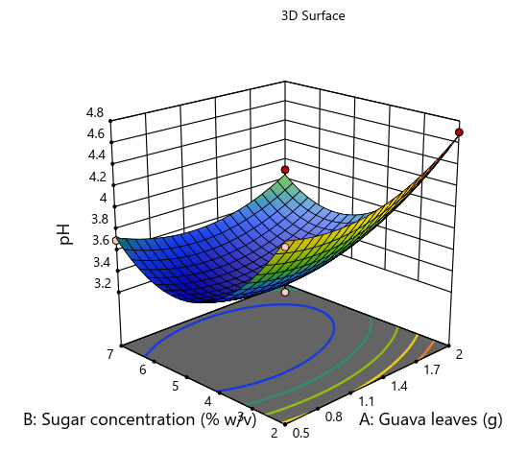
Fig no 4.1: pH 3D

4.1.2 Total Soluble Solids
Response surface for the Total Soluble Solids (TSS) is shown in Figure 4.3. A properly balanced formulation yields a nutritious juice with a constant TSS value of 5.5 °Brix, as evident from the significant interaction effect between sugar and guava leaf concentrations, as shown on the graph. This helps understand how effective raw materials are transformed into a dissolved liquid state. An optimal solution area is represented visually through the gradient color contour of the three-dimensional surface plots. In sensitive areas of the study design space, small changes in the levels of factor A and factor B significantly affect the beverage properties.

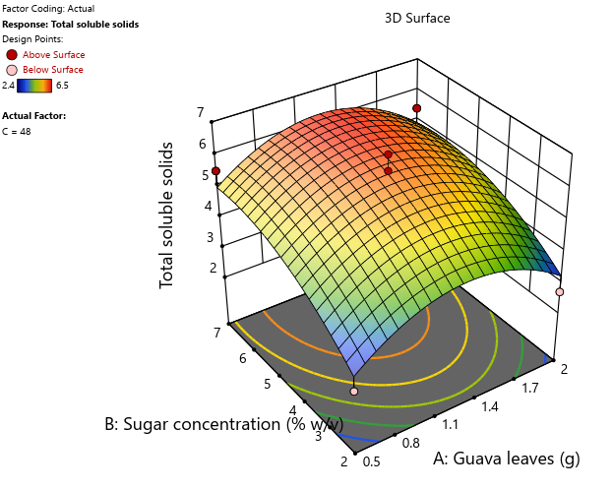
Fig no 4.2: TSS 3D

4.1.3 Titratable Acidity
The relationship between sugar concentration and guava leaf weight and its effect on the titratable acidity of the drink is illustrated in the 3D surface graph shown in Fig. 4.3. It is evident from the data obtained that there is a significant relationship between the two factors in terms of their effect on the acidity, which ranges between 0.3 to 1.5.

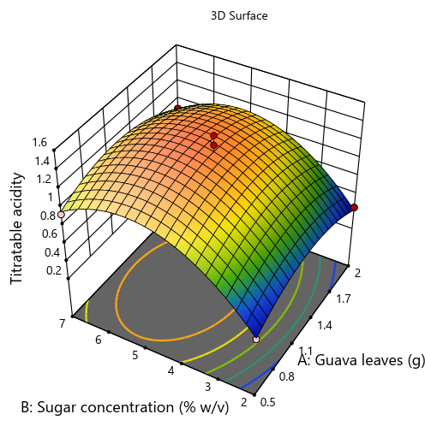
Fig no 4.3: TA 3D

The fermented guava leaf drink was shown to have a consistent acidity, healthy probiotic counts, and desirable physicochemical properties. The drink also offers health benefits through the use of natural probiotics. It is more cost-effective and environmentally friendly compared to other functional beverages. This is because it uses agricultural waste, has a clearer label, and has a lower glycemic index while having the same or better probiotic and antioxidant capacity. This makes it a viable and health-conscious drink.
4. 1 Nutritional Analysis
Sl no | Parameters | Unit | Result
1. | pH | pH | 3.2
2. | Total Soluble Solids | °Brix | 5.5
3. | Titratable Acidity | %(w/v) | 1.2
4. | Total Sugar | % | 1.53
5. | Total Energy | kcal/100mL | < 10
6. | Total Energy | kcal/100mL | < 10
7. | Ascorbic acid | mg/L | BLQ(LOQ:1.0)
8. | Protein | % | 2.49
9. | Iron | mg/100mL | 1.22
10. | Potassium | mg/100mL | 10.9
11. | Total Tannin | mg/L | 51.83 ± 1.07

The beverage has a stable, acidic pH of 3.2 and is low in calories, making it suitable for diabetics, according to nutritional analysis. Its high protein, iron, and potassium content indicates that the nutrients were successfully extracted from the guava leaves and ginger. The drink is discovered to have a high total tannin content without sacrificing its safety or clarity.

- CONCLUSION

The research demonstrated that guava leaves, which are regarded as agricultural waste, might be transformed into a unique beneficial fermented beverage. The beverage's formulation was successful since the guava leaves' potential as the main ingredient was confirmed by the beverage's stable qualities. The beverage's nutritional analysis shows that because it is low in calories, sugar, and antioxidants, it can be consumed by people who are concerned about their health or who have metabolic health issues. Due to the antioxidant properties of guava leaves, the product can provide a number of health benefits while still being a low-calorie, low-sugar drink. The substance can be very useful in treating metabolic diseases. The proposed product can be considered unique and marketable, especially considering the highly saturated market for dairy-based probiotics and sugary soft drinks. The product can also be considered sustainable, as it can help reduce crop waste while catering to the health needs of the vegan and lactose-intolerant population. By providing therapeutic value and environmental responsibility, the beverage creates a distinctive market segment for functional foods that are not only health-focused but also environmentally conscious.

- FUTURE SCOPE
The transformation of the guava leaf and ginger probiotic drink from a laboratory prototype to a product with the ability to be sold commercially is the key objective for the future scope of the research project. Accelerated Shelf Life Testing (ASLT) is one of the key objectives in order to establish an exact shelf-life of the beverage and stability of the bioactive components under different storage conditions. In order to validate the bioavailability of the detected iron and potassium as well as establish the exact effects of the L. plantarum strain on health status, additional in-vivo studies will be needed. Microencapsulation may contribute to increasing probiotic survivability during gastrointestinal passage, while green and environmentally-friendly packaging would enhance market appeal. Finally, the next step towards the mass production of the product would include scaling up the pasteurization process from the current batch method in bottles to a continuous system.

REEFERENCE
- Bulugahapitiya, V. P., Kokilananthan, S., Manawadu, H., & Gangabadage, C. S. (2021). Phytochemistry and medicinal properties of Psidium guajava L. leaves: A review. Plant Science Today, 8(4), 963-971
- Irkin, R. (2019). Natural fermented beverages. In Natural beverages (pp. 399-425). Academic Press.
- Kalsi, A. R. S. H. P. R. E. E. T., Singh, S. H. I. V. A. N. G. I., Taneja, N. A. N. C. Y., Kukal, S. A. M. I. K. S. H. A., & Mani, S. H. A. L. I. N. I. (2017). Current treatments for type 2 diabetes, their side effects and possible complementary treatments. International Journal, 10(3), 13-18.Díaz-de-Cerio, E., Verardo, V., Gómez-Caravaca, A. M., Fernández-Gutiérrez, A., & Segura-Carretero, A. (2017). Health effects of Psidium guajava L. leaves: an overview of the last decade. International journal of molecular sciences, 18(4), 897.
- Jun, B. G., Kim, S. H., Kim, S. H., Hong, S. M., Lee, H., Lim, Y., ... & Lee, C. H. (2024). Metabolomic comparison of guava (Psidium guajava L.) leaf extracts fermented by limosilactobacillus fermentum and lactiplantibacillus plantarum and their antioxidant and antiglycation activities. Nutrients, 16(6), 841.
- Nasef, H. Y., Ahmed, A. F., Eman, F. M., Abd El-Aziz, N. S., & Ibrahim, G. A. (2020). Evaluation quality of guava juice fortified with probiotic. Middle East J Appl Sci, 10(3), 442-60.
- Lorn, D. (2020). Screening of lactic acid bacteria for their use as aromatic starters during fermentation of vegetables (Doctoral dissertation, Université Bourgogne Franche-Comté).
- Chen, Y., Hu, Y., Xie, Y., Cui, M., Jiang, J., Li, Y., ... & Gao, F. (2025). A comprehensive review of lactic acid bacteria-fermented plant-based beverages: substrate types, nutritional quality, probiotic characteristics, metabolic pathways and future development trends. Critical Reviews in Food Science and Nutrition, 1-29.
- Fan, L., Hanses, L. T., Sharpe, D. V., Chen, S., & Zhang, H. (2015). Role of lactic acid bacteria in the fermentation and biopreservation of plant-based foods. Handbook of vegetable preservation and processing. 2nd ed. CRC Press, Boca Raton, FL, 779-796.
- Herman, W. H. (2016). The global burden of diabetes: an overview. Diabetes mellitus in developing countries and underserved communities, 1-5.
- Garcia, C., Guerin, M., Souidi, K., & Remize, F. (2020). Lactic fermented fruit or vegetable juices: Past, present and future. Beverages, 6(1), 8.
- Devi, S., Yograj, Paul, S., & Arora, S. (2025). Ayurvedic medicinal use of Psidium guajava L. in the management of different disorders. Journal for Research in Applied Sciences and Biotechnology, 4(5), 81–8.
- Khanna, S., Singh, P., Chauhan, P., & Chauhan, E. S. (2025). Medicinal and nutritional potential of guava leaves: A natural remedy for health and wellness. Journal of Advances in Food Science & Technology, 12(1), 13-20.
- Di Cagno, R., Coda, R., De Angelis, M., & Gobbetti, M. (2013). Exploitation of vegetables and fruits through lactic acid fermentation. Food microbiology, 33(1), 1-10.
- Sionek, B., Szydłowska, A., Küçükgöz, K., & Kołożyn-Krajewska, D. (2023). Traditional and new microorganisms in lactic acid fermentation of food. Fermentation, 9(12), 1019.

