CHAPTER 1

INTRODUCTION

Background​ Study
Generation is grouping individual based on range year birth used​ For understand difference experience social, cultural and developmental technologies that influence pattern think as well as behavior they. Every generation grow in different era contexts, starting from from condition economy, change politics, until progress technology. Differences context the form values, preferences, and method interactions that are typical of each group generation .
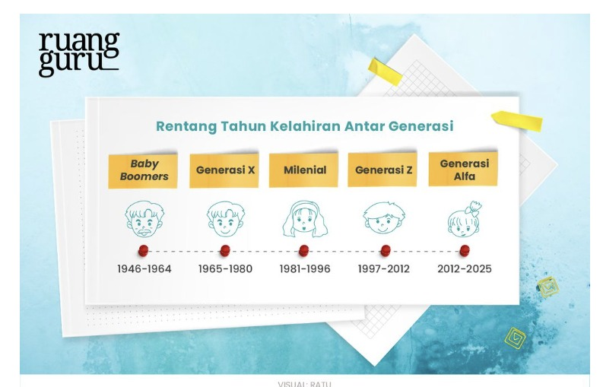
Figure 1 Range Intergenerational Birth Years
Source : Ruang Guru
The picture display distribution range year birth between Baby Boomers generation was in the range of 1946–1964, Generation X in 1965–1980, Millennials in 1981–1996, Generation Z in 1997–2012, and Generation Alpha in 2012–2025. The visual show order chronological every generation along with illustration simple representing each group​​ age . Division This used as reference in identify position Generation Z in structure demographics cross generation .
In research this , in Generation Z who were born in period very rapid digital development . Group This grow simultaneously with technology that has been proceed such as the internet, social media which includes in life everyday. Exposure technology since age early form pattern communication , ways get information , as well as view to education and the world of work that have characteristics alone compared to generation previously .
Generation Z, born in 1997–2012 , began enter age productively and effectively gradually increase the proportion in composition power work . Report employment and various publication academic take notes that group This grow in digital environment that shapes preference different work​ compared to generation previously . Presence they in organization No just focus on quantity , but also on change dynamics interaction , communication , and method interpret work in structure modern company .
A number of study latest study How characteristics Generation Z is related with attitude to jobs . Generation Z is starting dominate composition power work and bring method distinctive view​ to environment work , with give attention big on creation balance between not quite enough answer work and life outside​ job . as important thing , besides​ existence room For grow and contribute in a way real in organization . Conditions environment supportive work​ transparency , two -way communication , and participation active employee in convey view they also become enough things​ noticed by generations this . On the other hand , expectations to work aspects to be considered No only limited to profit financially , but also on how individual feel experience his work in a way overall . (Salem, 2025, Nugroho et al., 2025). For employees young people , especially Generation Z, conditions the often faced with the need will flexibility , comfort environment work , and existence opportunity For develop .
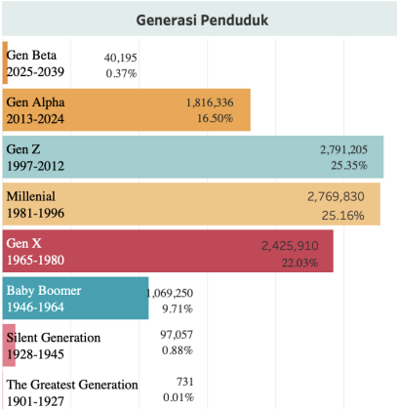
Figure 2 Amount Population Generation Z in DKI Jakarta
Source : Civil Registration Service DKI Jakarta Province (2025)
The picture show arrangement amount public based on group generation along with percentage . Generation with amount the biggest are Gen Z (1997–2012) as many as 2,791,205 people or around 25.35%, followed by Millennials (1981–1996) with 2,769,830 people or 25.16%, and Gen X (1965–1980) with 2,425,910 people or 22.03 %. generation This become group dominant in structure population . Furthermore , Gen Alpha (2013–2024) numbered 1,816,336 people or 16.50%, while Baby Boomers (1946–1964) reached 1,069,250 people or 9.71%. As for the older generation , old like the Silent Generation (1928–1945) only by 0.88% and The Greatest Generation (1901–1927) by 0.01%. Meanwhile that , Gen Beta (2025–2039) has proportion of 0.37%, which is still relatively small . mastery Generation Z in the region This shows that DKI Jakarta is supported from amount resident age productive dominated​ group age young , with criteria as well as interest to different jobs​ from generation previously . Sufficient amount​ big This Can indicates companies in DKI Jakarta need more flexible and responsive For adapt policy and environment work . This is Because Generation Z will become the dominant group sector employment and have role important For influence turnover intention level in various type industry .
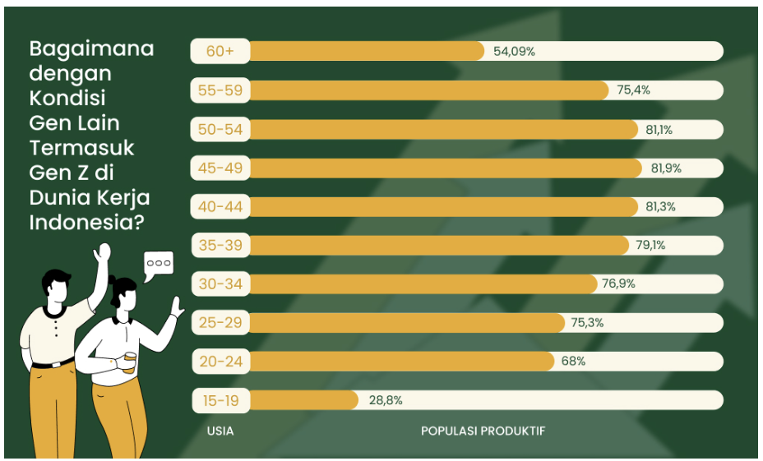
Figure 3 Presentation Amount Population Productive in Indonesia
Source : Weefer (2024)
Data regarding condition employment in Indonesia shows that Generation Z now own an increasing role significant in the labor market work . This reflected from level participation work in groups age of majority originate from Generation Z, namely by 68% in the range aged 20–24 years and 75.3% in the range aged 25–29 years . Meanwhile that , group ages 15–19 years own level participation more work​ low , namely 28.8%, which is likely caused by still many individual in group age those who are currently go through education . Findings This indicates Group Generation Z is dominated by the range aged 20–29 years . have involved active in the world of work . With the more dominant Generation Z in composition power work , organization need understand characteristics and preferences Work generation This For support management source Power more human​ effective .

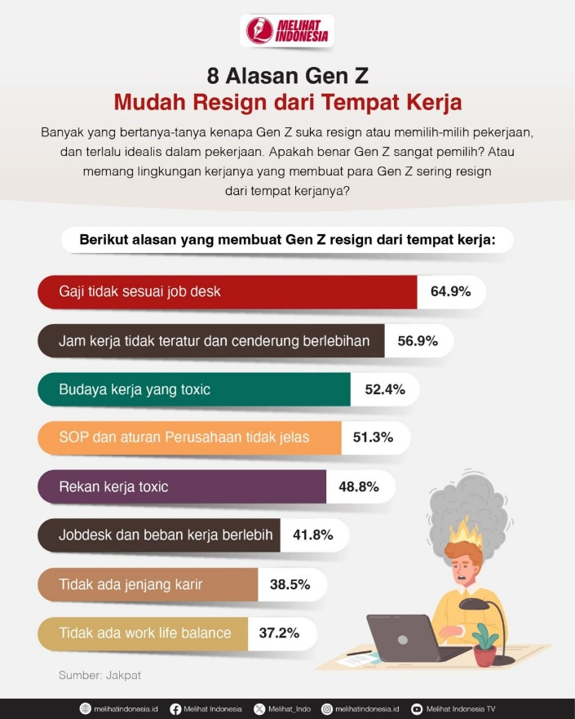
Figure 1. 4Reasons Why Gen Z Easily Resigns from Place Work
Source : Jakpat
From the picture above describe condition when rewards received​ employee assessed No comparable with room scope tasks carried out . In practice , a employee often do outside work​ description early , handle a number of function at once , or accept not quite enough answer enough extra​ complex . However , the magnitude salary received​ still be at the beginning level without adjustment to expansion role the situation . This bring up evaluation that compensation given​ Not yet represent contribution and level difficulty work done . In addition limitations opportunity development position inside​ organization . Employees No get clear picture​ about possibility promotion , transfer position , or improvement role in term time certain . Structure position tend stagnant , and mechanism evaluation performance Not yet followed with scheme targeted job level increase . Conditions​ the make direction development career in the company difficult mapped by employees . Furthermore , the situation work faced​ employee every day can make things difficult they in share time in a way proportional between affairs work and life outside​ work . Working hours often beyond the normal time limit , communication work still takes place outside of working hours , and time Rest No fully can used For need private . Space for activity family , education , and recovery physical and mental to be limited in routine Work daily .
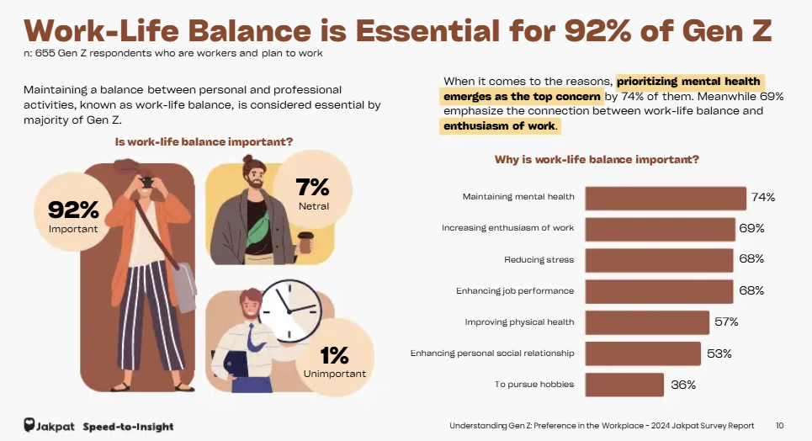
Figure 5 The Importance of Work-Life Balance for Generation Z
Source : Jakpat (2024)
Based on information mentioned , it can be seen that harmony between demands work and personal life become focus main for Generation Z. Based on survey Jakpat In 2024, 92 % said that work-life balance become aspect important , this data describe that part Gen Z places a large balance life as aspects to be considered in the world of work . Some reasons that arise in survey including maintaining​ mental health , improving Spirit work , reduce stress levels , as well as support performance work . In addition , there are also other reasons such as guard condition physical , expanding interaction social , and have time in undergo things to like or activity personal .
The retail industry is one of the sectors that have dynamics high employment​ Because characteristics its busy operations work and service oriented . Success​ retail organizations are highly dependent on the quality source Power humans interacting​ direct with customer .
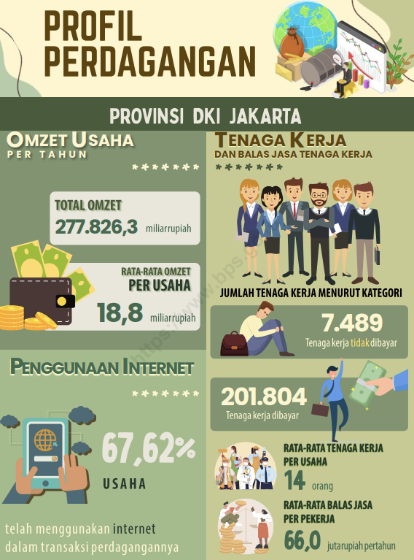
Figure 6 Profile Trade DKI Jakarta Province
Source : Central Statistics Agency
Based on picture the explain that sector trade in DKI Jakarta Province has a total turnover of amounting to 277,826.3 billion rupiah per year with an average turnover per business reached 18.8 billion rupiah. This sector also absorb Lots power work , namely 201,804 workers paid and 7,489 workers No paid , with an average of 14 workers per business as well as reply service amounting to 66 million rupiah per year . In addition , as many as 67.62% of businesses Already using the internet in activity trade , so that show that trade in DKI Jakarta is quite go ahead and start develop digitally .
The size turnover , high absorption power work , and development digitalization in the sector trading show that the retail industry has contribution big to growth economy in Indonesia, especially in DKI Jakarta. Conditions This supported by data from the Central Statistics Agency which shows that sector trading or retail becomes classified as as sector with contribution dominant to the Indonesian economy as reflected in (GDP). In publication Profile Indonesia's trade in 2024, BPS said that sector trading become contributor the biggest second to national GDP structure after industry processing . Conditions the show that the retail sector does not only play a role as driving force activity economy , but also become sector strategic in create field jobs and improve growth economy national .
The business being researched in study This including in specialist retail category , namely type business sales - focused retail​ product in category certain . Specialist retail generally own superiority in depth variation products in the category certain as well as greater understanding​ Good to need consumer compared to with general retail .
From the side channel distribution , business This apply the concept of omnichannel retailing, namely integration between sale through (offline) and digital platforms (online). Approach This allows consumer For get convenience in shop through various interconnected channels​ connected . With Thus , the implementation of omnichannel does not only expand market reach , but also increase experience customer in a way overall in the purchasing process .
Calista, C., & Erdiansyah , R. (2025) stated that as many as 34% of employees in Indonesia and Southeast Asian countries are known in a way active look for work new in 2023 . Condition This indicates that part employee No fully committed to the organization place they work , but rather has own trend For move to other jobs . Conditions the reflect there is trend intention For go out relative work​ high on employees , which can become indication beginning occurrence displacement Work in a way current if No managed with both by the company . According to Mobley (1977) turnover intention is strong predictor​ to occurrence turnover actual . This matter show that before employee truly go out from organization , there are stages psychological in the form of intention or desire For leave work . In line with That , Tett and Meyer (1993) explain that the turnover process started from emergence dissatisfaction later work​ develop become thinking For thinking of quitting , until Finally formed intention For exit ( intention to quit ). Therefore​ that , turnover intention often used as indicator beginning For detect potential lost employee in something organization .
Based on matter said , the height proportion employees who have intention For out , like by 34%, can become signal Serious for organization Because reflect existence sufficient tendency​ big to potential turnover in the future . Although No there is limitation standard about percentage categorized turnover intention height , number the show that part significant power Work is at in condition psychologically vulnerable​ For leave organization . This is reinforced by Bothma and Roodt (2013) who explain that turnover intention is one of the sufficient indicators​ accurate For estimate behavior employee in leave his job ,
More further , the emergence turnover intention No let go from various factors that reflect condition place Work as well as experiences experienced​ employee in organization . Some frequent factors​ identified in literature including Compensation ,​ career growth opportunities , work-life balance , as well as job stress . According to Mathis and Jackson (2019), compensation that is not competitive can lower satisfaction work and improve desire employee For look for other jobs . In addition , the opportunity development limited careers can also be push employee For leave organization in order to obtain more prospects​ good (Dessler, 2020). On the other hand , the imbalance between life work and personal ( work-life balance ) and height job stress levels are proven​​ contribute to increasing pressure psychological employees who ultimately trigger emergence turnover intention (Robbins & Judge, 2017). With Thus , understanding and managing factors the become necessary factors​ managed optimally so that the tendency employee For leave organization can minimized .
In line with matter said , the level high turnover also becomes​ attention important in something organization . According to Roseman (1981, quoted in Sunarjaya et al., 2024), level turnover categorized tall if exceeding 10% in something company or industry . Data from Mercer and Clayton (2019, cited in Danti et al., 2023) shows that level turnover in the retail industry in Indonesia reached 16.9%, which means be on top the threshold​ as well as more big compared to the industry average other . Conditions This indicates that the retail industry has more challenges​ big in maintain employees , so that need attention special to things that can influence turnover intention .
In the sector retail industry , the issue of turnover becomes more stand out Because service customer is the core of activity business . Quality interaction between employee with customer and suppliers become determinant main reputation and sustainability business . High turnover intention rate potential bother consistency service , considering employee new need time For adapt and understand standard operational company . Characteristics jobs in the sector This often relate with working hours who does not flexible , level relative wages​ low , and limitations guarantee Work .
With consider dynamics said , retention strategy specific and targeted employees​ become relevant For discussed more continue . Management compensation , control stress work , provision opportunity development career , as well as creation balance life Work is interrelated factors​ interact in form attitude employee to sustainability his career in the company . This study make an effort know connection between compensation , job stress, career growth opportunities, and work-life balance to turnover intention in context retail industry in DKI Jakarta.
Framework thinking study This put compensation , job stress , career growth opportunities, and work-life balance as variables independent considerations​ in understand phenomenon turnover intention . With understand factors the in a way comprehensive research​ This directed For contribute in a way academic in increase coverage knowledge and research about management source Power man in retail sector .
Beside​ that , research This expected capable give benefit practical for company as reference in develop effort maintain employee in a way more optimal so that desire power Work young For leave company can minimized . Researchers also hope that the research results This expected capable give useful input​ for company in make condition environment comfortable , conducive and positive work​ so that qualified employees​ can still stay inside​ organization . Therefore that , researcher pushed For do study with title The following is the " Effect of Compensation, Job Stress, Career Growth Opportunities, and Work-Life Balance on Employee Turnover Intention" Generation Z in the Retail Industry in DKI Jakarta”

Formulation Problems and Questions Study
Based on condition height trend intention stop Work (turnover intention ) in Generation Z reflects existence difficulties faced​ company in guard sustainability power work . Situation This can triggered by various related factors​ with experience employee during work , like giving compensation , level pressure work , opportunities development career , as well as balance between work and life personal . When things the Not yet fulfilled optimally , the level satisfaction and enthusiasm Work employee can decrease so that increase encouragement For leave company and switch to other jobs . Based on the phenomenon said , so that formulation problems in research This can formulated as following :
- Whether Compensation has impact significant negative​ to Turnover Intention ?
- Whether Job Stress own impact significant positive​ to Driver Intention ?
- Whether Career growth opportunities have impact significant negative​ to Turnover Intention ?
- Whether Work–life balance own impact significant negative​ to Turnover Intention ?
- Whether Compensation, Job Stress, Career Growth Opportunities, Work-Life Balance have significant impact on Turnover Intention ?

Research purposes

The purpose of the research conducted that is
- For know results analysis influence Compensation for Turnover Intention
- For know results analysis influence Job Stress to Turnover Intention
- For know results analysis influence Career growth opportunities to Turnover Intention
- For know results analysis influence Work–life balance Against Turnover Intention
- For Know results analysis The influence of Compensation, Job Stress, Career Growth Opportunities, Work-Life Balance on Turnover Intention

Benefits of research
- Academic Benefits
Study This expected Can give contribution in development to retail industry , especially those related with things that influence turnover Intention to Generation Z. In addition , research this is also capable made into reference For studies next one that discusses variables similar or other variables that are still relate with turnover intention ,r phenomena and characteristics generation young in the world of work .
- Non- Academic Benefits
Study This expected capable give benefit practical For retail companies in know Things that influence employee turnover intention Generation Z, especially those related to with compensation, job stress, career growth opportunities , and work-life balance in the retail sector .
Research result This capable made into as reference in formulate management strategies retail employees become more optimal, such as giving compensation with more competitive , management burden and stress frequent work​ appear due to dynamic working hours , provision opportunity development clear career , as well as improvement balance life work and personal employees . Because of this that , Research This expected capable give useful insights​ for retail companies in minimize intention For leave organization , improve ability company in maintain employees , as well as make environment more work​ in harmony with characteristics as well as need Generation Z in the retail industry .

Research Limitations
Study This limited so that the discussion more directed and productive appropriate findings​ with focus problems , so that writer set a number of room scope and limitations study as following .
- Location and Object Study
Study This focus on employees who work in industry
Specialty Retail in DKI Jakarta
- Research Time
Period research conducted​ study is in the semester
even year academic year 2025/2026.
- Variables Study
Variables used​ in study This
- Compensation ( Independent Variable )
- Job Stress ( Variable) independent )
- Career growth opportunities ( Independent Variable )
- Work–life balance ( Independent Variable )
- Turnover Intention ( Variable Dependent )

Systematics Writing
CHAPTER I INTRODUCTION
In Chapter I, the author to describe conditions and situations general background​ implementation study .
CHAPTER II THEORETICAL BASIS
In Chapter II, the author serve runway relevant theory , review​ results study previously , and to explain framework conceptual study .
CHAPTER III RESEARCH METHOLOGY
In Chapter III, the author explain profile object research , design and design research , engineering analysis used , characteristics​ population and sample research , operationalization variables , as well as procedure testing hypothesis .
CHAPTER IV ANALYSIS AND DISCUSSION
In Chapter IV, the author to explain results research findings​ from the data analysis process and discuss findings the For answer formulation problem study .
CHAPTER V CONCLUSIONS AND SUGGESTIONS
In Chapter V, the author compile conclusion based on results research that has been done as well as provide suggestions for study furthermore with topic similar .

CHAPTER II
THEORETICAL BASIS

Theoretical Review

2.1.1 Compensation
According to Dessler, G. (2020) Compensation is all over form reply services provided​ organization to employee as reward on contributions that have been made given in implementation work . Reward the No only realized in form financial , such as salary , wages , incentives , bonuses, and various allowances , but also in non- financial forms . Non- financial forms can in the form of appreciation on performance , recognition from organization , opportunities development competencies and levels career , as well as environment conducive and supportive work environment . In the context of management source Power human , compensation viewed as one of the mechanism important to use company For influence attitude , motivation , and level productivity employee so that can support achievement objective organization . (Martocchio, 2025).
More Furthermore , compensation is also related with the dynamics of the world of work that continue developing , especially in context flexibility and certainty law in connection work . According to (Suryadi et al., 2022) , compensation is Compensation is all over form awards given​ organization to employee as reply service on contributions , energy and time that have been poured out in implementation work , good in the form of benefit financial both financial and non- financial . Giving compensation that is considered proper , proportional and appropriate with contributions made​ employee can push improvement satisfaction Work as well as strengthen motivation in operate duties and responsibilities answer , and help company in maintain employees who have performance Good .
In addition , Cascio and Boudreau (2025) compensation is one of the practice important in management source Power human being in view as investment organization to employee Because can give impact financial for organization . Policy designed compensation​ in a way effective and capable give impact positive to achievement performance organization in a way overall . So , planning system good compensation​ become key For create mark sustainable addition​ for organization .

2.1.2 Job Stress
Fauquet-Alekhine and Erskine (2023) define work stress as adverse responses that arise​ consequence mismatch between demands work and capacity individual in fulfill it . The situation This show that work stress is quite a phenomenon complex and involving interaction between individual and environment work . Job Stress is conditions that arise consequence mismatch between burden as well as demands work with ability individual in fulfil demands that . which condition This can cause response physique and emotional impact​ negative to health and performance employee .
Zheng (2024) stated that that demands work that is not handled with Good potential cause various bother mental and physical health , as well as lower quality life individual . Imbalance between not quite enough answer work and affairs personal often become​ trigger main the emergence of stress, which then impact on productivity and satisfaction work . In the context of deep , job stress own close relationship​ with welfare employees and balance life Work .
Ramteke (2026) also stated that pressure For reach progress career and fulfill expectation organization can increase job stress on employees . In conditions certain demands​ For Keep going develop without adequate support​ can make things worse condition stress . So from that , management stress Work own role important in maintain balance between demands employment and welfare individual .

2.1.3 Career Growth Opportunities
Ramteke (2026) explains that career growth opportunities include opportunity For get promotion , improvement skills , as well as experience supportive work​ development term long . Perception to existence opportunity This play a role big in influence Spirit Work as well as loyalty employee to company . Career growth opportunities refers to perception individual to availability track For develop and improve ability in organization .
Furthermore , Cascio and Boudreau (2025) emphasize that investing organizations​ in career growth opportunities tend own level greater engagement and retention​ high . Training program , development competence , as well as planning structured career​ can help employee reach potential maximum . With thus , the opportunity growth career No only impact positive for employee in a way personal , but also improve performance organization in a way overall .
On the other hand , Clear (2024) links career growth opportunities with formation consistent and sustainable habits . In the context of organization , opportunities development career can viewed as a gradual process that requires commitment term long . At the time organization can provide supportive environment​ learning and development , so employee more pushed For Keep going developing . Therefore that is , career growth opportunities become element important in create power adaptive work​ as well as improvement - oriented sustainable .

2.1.4 Work-life Balance
According to Zheng (2024) states work-life balance own significant role​ in support health as well as welfare employees . When demands work and life personal No can managed in a way proportional , condition the potential cause pressure that can influence health physique and psychological individual . Work-life balance describe ability somebody in manage and align obligation work with personal life in general harmonious . Concept This No only emphasize on distribution time between second aspect said , but also on the ability individual in fulfil demands work and life personal without cause excessive conflict , but also illustrative​ creation harmony between activity work and life outside​ work so that both of them can walk in harmony .
In context development of the world of work , concept work-life balance the more relevant along with increasing flexibility work . Knappertsbusch and Wisskirchen (2024) emphasize that change pattern work , such as flexibility time and place work , demand organization For designing capable policies​ support balance life employees . With existence appropriate flexibility , employees​ can manage not quite enough answer work without ignore need personal , so that create condition more work​ sustainable .
In addition , according to (Hotama & Setiorini, 2025) , Work-life balance can understood as ability individual in manage as well as align demands work with life his personal in a way proportional . With creation balance said , individual still capable operate his job optimally without​ sacrifice health psychological and quality connection social conditions . This support creation harmony in operate various role life at a time minimize possibility occurrence conflict between obligation work and interests personal . For Generation Z, work-life balance No only related with balance role , but also includes flexibility in arrangement time and location work , and availability room For development self and outdoor activities​ environment work , which is considered important in support well-being and satisfaction life they .

2.1.5 Turnover Intention
Hom et al. (2024) stated that turnover intention is not just describe displacement employees , but also reflects quality relationships and attachments between employee with organization . Conditions the can appear consequence various factors , such as low level satisfaction work , height demands and pressures work , as well as disharmony between life work and life personal factors​ that in the end potential lower level loyalty and commitment employee to organization .
Martocchio (2025) states that various factor organizations , including system compensation , have influence to level Turnover Intention . When employees evaluate that rewards received​ Not yet reflect contribution , burden work , and not quite enough the answer that has been they run , so that trend leave organization will increased . On the other hand , the system giving appropriate and competitive rewards​ capable reduce desire employee For go out from company Because can increase satisfaction​ as well as loyalty to organization .
In addition , Zheng (2024) emphasized that welfare employees , including aspect work-life balance is also factors that play a role in influence turnover intention . Inability employee in guard harmony between demands work and life his personal can reduce level satisfaction Work as well as push emergence desire For leave organization . Therefore that , the effort company in controlling turnover intention does not Enough only through giving reward financial , but also necessary supported by capabilities organization in build environment capable work​ support health , comfort and well-being employee in a way comprehensive .

Research Model
Research model This developed with referring to research entitled A Comparative Study of Turnover Drivers Among Real Estate Sales Professionals in Lebanon and the UAE by (Sarkis et al., 2026) . Study the study various factor organizations that influence turnover intention employee through approach comparative study of two countries. In the study these variables​ organization like compensation , stress work , opportunities growth career , and balance life Work identified as determinant main in explain dynamics turnover intention . Framework research used​ This referring to to framework conceptual that has been tested in a way empirical , however with adjustment in accordance with need study .
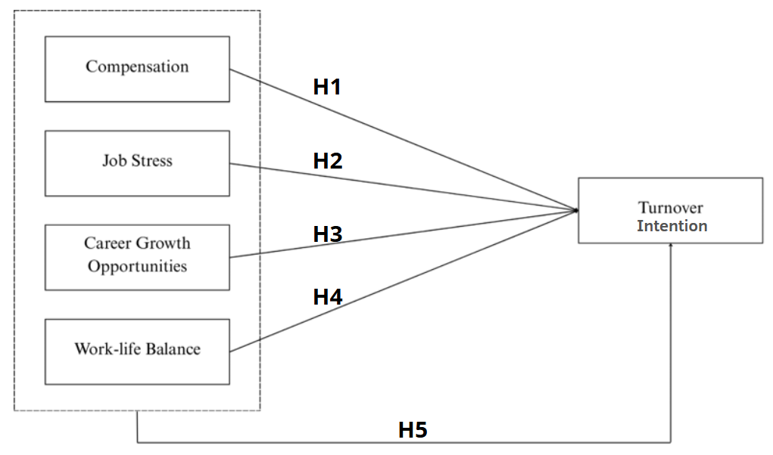
Figure 1Research Model
Source : Sarkis et al., (2025)
H 1 : Compensation own influence Negative to Turnover Intention
H 2 : Job Stress own influence Positive to Turnover Intention
H 3 : Career Growth Opportunities own influence Negative to
Turnover Intention
H 4 : Work-Life Balance own influence Negative to Turnover
Intention
H 5 : Compensation, Job Stress, Career Growth Opportunities and Work-Life
Balance in terms of simultaneous influential on Turnover Intention
In a way conceptually , this model describe that desire employee For leave work No appear in a way directly , but formed consequence various conditions and internal organizational factors experienced by employees​ during operate his job . With applying the model from Sarkis et al. (2025), the study This make an effort test return relevance and consistency connection intervariable in different contexts . Therefore​ that , research model This become runway in compilation hypothesis as well as analysis empirical that will done in chapter furthermore .
Figure 2.1 shows framework conceptual linking​ four variables independent , namely Compensation, Job Stress, Career Growth Opportunities, and Work-life Balance to variables dependent , namely Turnover intention. Different like the original model , research This do development with add testing simultaneous to see influence combination from all over variables independent to turnover intention . Therefore that , this model No just test connection in a way separately , but also in simultaneous in One unity analysis .
Based on this model , the relationship intervariable can explained through two approaches testing . First , testing formulated partial​ in H1, H2, H3, and H4, which assumes existence influence direct every variables independent on turnover intention. Second , testing formulated simultaneously​ in H5, which assumes that Compensation, Job Stress, Career Growth Opportunities, and Work-life Balance in a way together own influence significant towards Turnover intention. Addition hypothesis This aim in give description in a way more comprehensive related strength influence collective variables the .
In a way concept , modification of this model show that turnover intention is not happen in a way separated consequence One reason only , but formed from connection various factor in organization as perceived by employees . With adapting and developing the model from Sarkis et al. (2025), the research This make an effort test return relevance connection intervariable at a time give greater understanding​ comprehensive in context different research . Therefore​ that , research model This become foundation in compilation hypothesis as well as analysis empirical in the next process

Hypothesis

2.3.1 Compensation has an impact negative to Turnover Intention
Compensation often become​ reason determinant in determine whether employee choose still Work or go out from organization . According to (Suhardi & Oktari, 2023) show that compensation own influence negative and significant to turnover intention . The results explain that moment company can give appropriate and fulfilling rewards​ hope employees , desires employee For leave company tend reduced . Employees who receive award through giving adequate compensation​ usually will own level more loyalty​ tall as well as more choose still work in a company .
(Wijayanti & Anisa, 2022) also found that compensation influential negative to turnover intention. In the research results show that giving proportional compensation​ to not quite enough answer work can push the emergence of a feeling of satisfaction and comfort in oneself employee during working . condition This make desire move to other companies become more low Because need economy and award on work has fulfilled .
(Haliza et al., 2025) who stated that compensation influential negative and significant to turnover intention . Research This confirm that compensation Good capable strengthen commitment employee to company as well as increase satisfaction work . When employees feel proper benefits​ from his work , then encouragement For leave organization tend reduced . Based on description said , then formulated hypothesis as following :
H1: Compensation has influence negative on Turnover Intention

2.3.2 Job Stress influential positive to Turnover Intention
(Abdillah, 2024) results study put forward that job stress own influence positive and significant to turnover intention . Findings the explain that increasing level pressure perceived work​ employee potential increase trend For look for outside work​ organization or leave company . Condition the can triggered by various factors , such as burden excessive work , high​ demands target achievement , responsibility answer big job​ make employee feel not enough comfortable in operate his job . Condition the can lower Spirit Work as well as push employee start consider chance work somewhere else you think more Good .
(Natalya et al., 2025) put forward that job stress influential positive and significant to turnover intention . The height burden hard work , demands​ intense work , and conditions work that causes fatigue can increase level perceived stress​ employees . If stress Work happen in term long time , employees​ potential experience fatigue in a way physique and psychological which then increase trend employee For go out from organization and consider opportunity other assessed work capable give comfort as well as certainty more work​ Good .
(Chandana & Kintani, 2024) put forward that job stress influential positive and significant to turnover intention . The results state that pressure increasing work​ heavy tend followed with increasing intention employee For leave organization . The density burden tasks , pressure that arises from environment work , and increasing expectation company to employee become a number of things that can trigger stress work . When the conditions This No managed with good , employee will more easy consider For move to place other work . Based on findings empirical said , then obtained formulation hypothesis as following :
H2: Job Stress own influence positive on Turnover Intention

2.3.3 Career Growth Opportunities influential negative to turnover intention
Career Growth Opportunities often viewed as factors that can consideration for employee in decide For endure and end connection his work with organization . (So seen & Salendu, 2023) put forward that career growth opportunity own connection negative and significant to turnover intention . This means that the more big opportunity development careers provided​ companies , increasingly small trend employee For leave organization . Employees who see existence opportunity promotion , improvement skills and progress position tend feel the future Still open so that more choose stay in the company .
(Zahirah & Satrya, 2024) put forward that career growth has influence negative to turnover intention . This means that the more big chance growth and development career experience​ employee during become part from organization , increasingly small possibility emergence intention For leave company . Condition This happen Because employee feel organization give clear , good future prospects​​ in form opportunities for promotion , advancement not quite enough answer , and development supporting competencies​ development professional they .
(Jiaying & Young, 2023) put forward that career growth influential negative to turnover intention. This indicates that employees who have perception positive to opportunity progress career generally own level more commitment​ tall to companies and more tendencies​ low For look for other jobs . There are opportunities development ability professional , improvement experience work , and track a better career directed push employee For look at that company provide prospects a better career Good for the future they . Based on explanation said , the hypothesis study formulated as following .:
H3: Career Growth Opportunities have influence negative on Turnover Intention
2.3.4 Work-Life Balance has an effect negative on Turnover Intention
(Dewi & Ekawaty, 2026) Study the state that work-life balance own influence negative significant to turnover intention. results study This disclose that generation young tend consider balance life as one of the aspect important in choose place work . If company can apply flexible working hours management​ accompanied by with burden suitable job​ with capacity employees , tendencies For go out become more low .
(Saleem et al., 2024) show that work-life balance influential negative and significant to turnover intention. The results indicate that successful employees​ guard balance between work and life his personal tend own level desire For go out from more organizations​ low . Findings the also shows that companies that provide support to work-life balance , for example through implementation flexibility work and management burden proportional work , potential​ increase comfort Work at a time strengthen effort maintain employee in organization .
Study (Pamungkas & Sudiro, 2024) show that work-life balance influential negative and significant to turnover intention . Findings this indicates that individuals who can balance work and life personal tend own intention For leave more work​ low . Availability time For family , rest , and activity personal viewed important in create comfort work . In addition , there is a good balance between work and life personal to employees generally related with increasing attachment to organization as well as low desire For leave company . Based on various findings said , so that hypothesis study set as following :
H4: Work-life Balance has influence negative on Turnover Intention

2.3.5 Simultaneous Test Variables Independent to Turnover Intention
Compensation often become​ reason determinant in determine whether employee choose still Work or go out from organization . According to (Suhardi & Oktari, 2023) show that compensation own influence negative and significant to turnover intention. The results explain that moment company can give appropriate and fulfilling rewards​ hope employees , desires employee For leave company tend reduced . Employees who receive award through giving compensation worthy​ usually will own level more loyalty​ tall as well as more choose still work in a company .
(Abdillah, 2024) results study put forward that job stress own influence positive and significant to turnover intention. Findings the explain that increasing level pressure perceived work​ employee potential increase trend For look for outside work​ organization or leave company . Condition the can triggered by various factors , such as burden excessive work , high​ demands target achievement , responsibility answer big job​ make employee feel not enough comfortable in operate his job . Condition the can lower Spirit Work as well as push employee start consider chance work somewhere else you think more Good .
(Solihat & Salendu, 2023) put forward that career growth opportunity own connection negative and significant to turnover intention . This means that the more big opportunity development careers provided​ companies , increasingly small trend employee For leave organization . Employees who see existence opportunity promotion , improvement skills and progress position tend feel the future Still open so that more choose stay in the company .
(Dewi & Ekawaty, 2026) Study the state that work-life balance own influence negative significant to turnover intention . results study This disclose that generation young tend consider balance life as one of the aspect important in choose place work . If company can apply flexible working hours management​ accompanied by with burden suitable job​ with capacity employees , tendencies For go out become more low .
H5: Compensation, Job Stress, Career Growth Opportunities, and Work-life Balance simultaneous own influence significant on Turnover Intention.

Study Previously
Table 1 Study Previously
NO | Researchers | Researcher Title | Core Findings
1 | Sarkis et al. (2026) | A Comparative Study of Turnover Drivers Among Real Estate Sales Professionals in Lebanon and the UAE | Study This made into references and references main variables in study this , namely Compensation, Job Stress, Career Growth Opportunities, Work-life Balance and Turnover Intention . Findings in journal This help strengthen runway research theories and models writer .
2 | Suhardi, AR & Oktari , SD (2023) | The Role of Compensation and Loyalty to Employee Turnover Intention | Study This used as reference For explain variables Compensation and Turnover Intention . Findings in journal This show that compensation own influence negative significant on Turnover Intention.
3 | Erika Putri Wijayanti & Friztina Anisa (2022) | The Influence of Compensation, Job Satisfaction , and Stress Work on Turnover Intention | Study This used as reference For explain variables Compensation , and Turnover Intention. Findings study show that compensation influential negative to turnover intention, whereas stress Work influential positive to turnover intention.
4 | Haliza, et al., (2025) | The Effect Of Compensation On Turnover Intention With Job Satisfaction And Organizational Commitment As Intervening Variables At Diponegoro National Hospital, Semarang | Study This used as reference For explain variables Compensation and Turnover Intention. Research Results show that compensation has an effect negative to turnover intention.
5 | Bara Muttaqien Abdillah (2023) | Analysis Influence Satisfaction Work and Stress Work on Turnover Intention | Study This used as reference For explain variables Job Stress, and Turnover Intention. Findings in journal This show stress Work influential positive and significant to turnover intention.
6 | Natalya, AC et al. (2025) | The Influence of Job Stress and Job Insecurity on Employee Turnover Intention Indomaret & Alfamart Solo Raya Retail | Study This used as reference For explain variables Job Stress and Turnover Intention . Research Results show that job stress influential positive and significant to turnover intention.
7 | (2023) | The Relationship Between Career Growth Opportunity and Turnover Intentions in Employees in Startup Companies | Study This used as reference For explain variables Career Growth Opportunity and Turnover Intention. Findings in journal This show that chance development career own connection negative significant to Turnover Intention.
  Solihat , WS & Salendu , A.
8 | Dewi, ORS & Ekawaty , N. (2026) | of Workload and Work-Life Balance on Turnover Intention among Generation Z in Bekasi City | Study This used as reference For explain variables , Work-Life Balance , and Turnover Intention. Findings in journal This show that Work-Life Balance influential negative significant to Turnover Intention.
9 | Triningsih , NN & Darma, GS (2023) | Compensation, Worklife Balance, Employee Engagement, and Turnover Intention | Study This used as reference For explain variables Compensation, Work-Life Balance and Turnover Intention. Findings in journal This show that Compensation and Work-Life Balance influential negative significant to Turnover Intention.
10 | Saleem, M., Ashraf, I., & Shahzad, S. (2024) | The Impact of Work Life Balance on Turnover Intention: The Mediating Role of Job Engagement among Employees | Study This used as reference For explain variables Work-Life Balance, and Turnover Intention . Findings in journal This show that Work-Life Balance has an effect negative significant to Turnover Intention.
Appendix F. Turn Result 1Checking Attachment
CHAPTER III
RESEARCH METHODOLOGY

Object Overview Study
Study This worker - focused Generation Z working in industry Specialty retail in the DKI Jakarta area. Generation Z in study This refers to a group individuals born in the range 1997–2012 . Research centralize attention to characteristics generation the in work context​ Specialty Retail, which is characterized by intensity interaction with customers , usage technology operational , as well as dynamics Work target -based . In some year Lastly , Generation Z is known own high attention​ to aspect welfare psychological , mental health , and personal meaning in jobs . In the retail environment in DKI Jakarta, workers Generation Z is also a lot involved in a position service direct , operational shop , as well as activity sales , with pattern demanding work​ flexibility time , mobility height , and adaptation to system digital work .

Research Design
Research design can interpreted as drafted design​ in a way directed and systematic For directing the data collection and analysis process , so that the questions study can answered or hypothesis can tested with appropriate .

3.2.1 Research Data
Research design is something design integrated used​ as reference in implementation data collection , determination technique measurement , as well as procedure data analysis . Design the functioning For direct researchers in utilise source available power​ in a way more structured through determination appropriate research methods and strategies with objective research (Cooper & Schindler, 2014, p. 124)
According to Creswell (2023) Research design can interpreted as structured framework​ as reference in carry out the research process , which includes election approach research , strategies used , and technique certain in the process of collecting and processing data. Design the help researchers so that the research process can walk in a way planned , structured , and aligned with objective research . In determining design research , there are a number of type differentiated methods​ based on characteristics of the data used .
- Study quantitative is the approach used For study relatedness inter-element study with utilize data in the form of the numbers obtained through instruments that have been standardized , such as questionnaire or survey . concept This based on reasoning deductive as well as support the testing process hypothesis in a way objective through implementation analysis statistics .
- Study qualitative emphasize effort For understand in a way deep experience , angle view , and the meaning contained behind​ something incident or phenomenon . Data collected through technique like interviews , observations direct , and review document , then processed with analysis thematic to describe context study in a way comprehensive .
- Mixed methods approach is a research strategy that combines method quantitative and qualitative in get understanding in a way comprehensive . Through draft this , researcher can gather as well as analyzing numerical data and non- numerical data Good in a way simultaneous and in a way gradual , adjusted with goals and needs that have been set in study .
In research this , the author use design study with method quantitative . This method chosen For analyze problems and phenomena through depiction connection between variables that include Compesation , Job Stress, Career Growth Opportunities, Work-life Balance to Turnover Intention . In addition , the data obtained in the form of number so that can processed with method statistics For test connection between variables , with thus results study become more accurate , objective , and capable represent view Generation Z.

3.2.2 Types of Research
Based on Malhotra's opinion (2017, p. 61), there are two types design general research​ used in something research , namely
general research​ used , namely
- Exploratory Research Design is design research that has level flexibility high and used For dig as well as get understanding beginning about something phenomena that have not been can measured in a way clear . This design generally applied to conditions when availability information about problem study Still limited .
- Conclusive Research Design is design directed research​ For produce findings of a nature firm and convincing through the measurement process to variables or phenomena that have formulated in a way clear as well as can measured in a way appropriate .
This design divided Again into two forms , namely :
- Descriptive Research is type research used​ For to explain or explain characteristics , situations , and condition certain , such as condition field , pattern behavior consumers , as well as utility or activity certain things that become focus study .
- Causal Research is type research that aims For get proof empirical about connection cause and effect between two or more variables studied .​
In research this , the author use approach quantitative For analyze the phenomenon being studied , with type study in the form of descriptive research . Data collection was carried out through distribution questionnaire in a way direct using Google Forms to respondents who have chosen in accordance criteria research . Respondents Then give evaluation to every statement use Likert scale 1 to 5, so the answer given can describe conditions and experiences that they feel in a way more objective .

3.3 Research Population and Sample

3.3.1 Population
Population is the entire unit that becomes target observation and analysis in A research . According to Sugiyono (2023, p. 126), population is a generalization area consisting of from object and subjects who have amount as well as characteristics certain conditions determined by researchers For investigated as well as made into base in interesting conclusion . Therefore that , population No solely understood as gathering individuals , but also includes all over characteristics or attributes attached to objects​ research . Population in research This is workers who work in industry Specialty Retail among Generation Z in the DKI Jakarta area

3.3.2 Sample

According to Sugiyono (2021), Sample is part member defined population​ according to criteria certain . In the research , the samples used need can describe condition population in a way comprehensive , then findings produced​ capable describe condition population in a way precise and can accountable . Researchers in study This set criteria special in determine respondents , such as category age certain things that are included in category Generation Z , status as workers in industry Specialty Retail, as well as other relevant characteristics with objective research . Therefore that is , sampling frame used For identify and map part specific from population target , namely Generation Z retail workers working in the DKI Jakarta area , as base in determination respondents research . In addition , to guard quality and validity of data, researchers set requirements that must be met fulfilled by every respondents involved​ in study This , namely:

Worker Specialty Retail which is Generation Z was born between 1997-2012​

Worker Specialty Retail working in the DKI Jakarta area

3.3.3 Sampling Techniques
according to Sugiyono (2023, p 128), Sampling techniques are procedures applied​ researchers For determine and take a number of member from population as sample in research . Various sampling techniques can applied so that the samples obtained in accordance with characteristics population as well as in line with objective research to be conducted achieved . According to Sugiyono there are two techniques sampling , namely :
- Probability Sampling
In technique probability sampling , each member population have equal opportunities​ For chosen as respondents in research . Probability sampling method covers a number of type technique taking samples , including :
- Simple Random Sampling
In engineering this , sample chosen in a way random from all over member population without consider difference group or strata.
- Proportionate Stratified Random Sampling
This technique used if population study nature diverse and has arranged to in a number of layer or group certain different , with​ the proportion of each stratum that has been determined .
- Disproportionate stratified random sampling
This technique implemented For set size samples in a population that has division of strata with amount members who do not comparable . In the condition said , the number of strata the elements relatively A little can included all of it as sample to remain get representation in study .
- Cluster Sampling (Area Sampling)
Area sampling technique is applied if coverage population study spread over a wide geographical area . In engineering this , determination sample done with based on the division of certain areas that have been set previously as base taking respondents .
- Non-Probability Sampling
Non-probability sampling is method taking samples that are not give equal opportunity​ for every member population For selected . For selected as respondents , even possibility the election No can determined in a way clear . The technique generally applied to research exploratory , research with limitations time , and research that aims get description beginning related something phenomenon . In its application , non-probability sampling consists of of the five common methods used , namely :
- Systematic Sampling
This technique is method Sample determination is determined based on the previous population list has compiled and given number massage moreover first . Election respondents done based on pattern number certain , such as number odd number​ even , or number intervals certain in accordance with the provisions stipulated researcher .
- Quota Sampling
This technique determine sample with set amount respondents from group certain until quota that has been set fulfilled . As for example , if amount targeted respondents​ is five hundred people, then data collection was carried out until amount the achieved , without notice How many many units or source taking respondents .
- Incidental Sampling
This technique used with take respondents who are No on purpose encountered by researchers in the field , throughout individual the fulfil criteria that have been determined and assessed worthy made into data sources in study .
- Purposive Sampling
Purposive sampling technique is technique taking sample based on selection​ respondents in accordance with criteria special that has been formulated by researchers . Respondents chosen Because considered own characteristics , experiences , or appropriate information​ with focus and goals study .

- Saturated Sampling
This technique set all over member population as respondents research . Approach the usually used if size population relatively limited or when researchers want level very minimal error . Because it involves all element population , technique This also known as method census .
- Snowball Sampling
Snowball sampling technique was carried out with start data collection from a number of limited respondents , then​ develop in a way gradually along with addition respondents new through recommendation from respondents previously . This process started with choose a number of the individual being assessed in accordance with focus research , next they requested pointing or recommend candidate other respondents who have information relevant .
In research This used technique non-probability sampling with method purposive sampling . This technique implemented Because election respondents No done in a way random , but rather based on criteria certain that have been customized with objective research . In research this , the respondents were selected is worker Generation Z working in industry Specialty Retail in the DKI Jakarta area.

3.3.4 Sampling Size
Size sample is determination amount respondents who will used For represent population in A research . Sekaran and Bougie (2019) explain that good sample​ must capable reflect characteristics population so that results study can generalized in a way more wide , so that determination amount sample become crucial thing . Besides​ that , Hair et al. (2019) in Analysis stated that size The sample is also determined by the complexity of the research model , including amount variables and indicators used​ in analysis , including amount variables and indicators used . The magnitude sample in study can counted with multiply amount indicator with factor ten , so that amount respondents obtained​ considered Already Enough For support the data analysis process .
Total Sample = Number Indicator x 10
= 20 x 10
= 200
In research This 20 indicators used question For represents five variables research . Number indicator the Then multiplied with number ten , so that obtained need amount minimum of 200 respondents for needs testing and proof study .

3.4 Data Collection Techniques

3.4.1 Sources and methods data collection
Sekaran and Bougie (2019) explain that the research data generally obtained from two sources main , namely primary data and secondary data , which have difference Good from aspect characteristics and method collection .
- Primary Data
Primary data is types of data collected directly by researchers from source main in accordance with need research . This data collection can done through interviews , observations , and questionnaire . Because it was obtained in a way directly , the data generated nature original and representative condition or the phenomenon being studied .
- Secondary Data
Secondary data is data that is not obtained in a way directly by researchers, but rather originate from other parties who then used return For support research . This data usually sourced from various documents, such as report official, books, journals, publications scientific, as well as available information​ via the internet. In its use, the data need checked return its suitability to remain relevant as well as capable support need study.

In research this , researcher utilise second type data sources , namely primary data and secondary data. Primary data is obtained through distribution questionnaire to respondents Generation Z working in specialty retail in the DKI Jakarta area . that is secondary data collected from various relevant references, such as books, journals, and sources literature others, to support as well as complete need information in study.

Method of collecting data

data collection method is method or techniques used​ researchers For get required information​ in answer problem research. With use method this, researcher can Obtain precise, relevant and aligned data with objective research. Sekaran and Bougie (2019) stated that that there is three method main in data collection , namely :
- Interview
This method is method data collection through interaction ask answer between researchers and respondents , with objective get greater understanding​ deep about views , experiences , as well attitude respondents to topic research . Interview can done in a way direct or face face , through telephone , or online . In addition , the method this also allows researchers For request explanation more carry on If answer respondents Still not enough clear .
- Observation
This method is technique data collection carried out do observation in a way direct to behavior , activities , or related conditions​ with research . Through method this , researcher can obtain data based on observation real in the field . In its implementation , researchers No must interact in a way direct with respondents , However , researchers only need observe as well as take notes events that occur in the field . Through observation , researcher can get a clearer picture real about situation or current behavior​ researched , so that the data produced tend more objective .

- Questionnaire
This method is method data collection through giving question written to respondents with use questionnaire as instrument main . Questionnaire the can distributed through various media, such as email, online platforms, or shared in a way directly . This method Lots used Because assessed effective in reach respondents in amount big with more time​ efficient . Besides that , the data obtained tend more easy processed Because question has designed in a way systematic .
In research this , researcher apply method data collection in the form of questionnaire . Researchers designing a series questions that include variables Compesation , Job Stress, Career Growth Opportunities, Work-life Balance and Turnover Intention . Entire question the Then served in form questionnaire and distributed in a way direct to respondents through the Google Forms platform.

3.5 Period Study
Period study This implemented in the even semester of 2026/2027. Research done in two stages, namely stage First in the form of a pre-test using data from 30 respondents, then to be continued with a main test involving 200 respondents.

3.6 Research Scale
Sekaran and Bougie (2019) stated that Likert scale used For measure level agreement or disagreement respondents to something statement . usually , scale This has 5 options the answer is :
Table 1Likert Scale Table
Scale | Information
1 | Strongly Disagree (STS)
2 | Disagree (TS)
3 | Neutral (N)
4 | Agree (S)
5 | Strongly Agree (SS)

Source : Researcher Data Processing Results (2026)

Operationalization Variables

According to Sekaran and Bougie (2019), the variable is something attribute or characteristics whose value can changed , good between individual or in the same individual in range time certain . In the context of research , variables used For represent various phenomenon or characteristics studied , which can stated in form numbers , categories, and level certain . Understanding about variables become important for researchers For analyze the process of occurrence something phenomenon as well as identify connection between the variables studied . In the study this, the author using two types variables, namely variables independent ( variable free ) and variable dependent ( variable bound ).

3.7.1 Independent Variable (X)

Variables independent is variables that provide influence to variables dependent , good in form influence positive and negative , and can form relationships that are linear or nonlinear . Changes that occur in variables independent generally will followed by changes in the variables dependent . In other words, the increase or decrease in variables independent can impact on change variables dependent . In research this , variable independent used​ are Compensation, Job Stress, Career Growth Opportunities, and Work Life Balance.

3.7.2 Dependent Variable (Y)
Variables dependent is variables that are influenced by variables independent and emerging as consequence from changes that occur in variables Changes in the variables​ independent , good in the form of improvement and decline , generally will followed by changes in the variables dependent . Therefore that , variable dependent used For measure to what extent does it influence variables independent to current phenomenon​ researched . In the research this , variable dependents used​ is Turnover Intention.
Following It is an Operational Table Variables :
Table 2Operational Table Variables
Variables | Definition | Code | Measurement | Items From Journal
Compensation | In perspective management source Power human , compensation become instrument strategic that influences behavior and performance employee in a way directly (Martocchio, 2025). | COMP1 | I am satisfied with package compensation I in a way overall . | I am satisfied with my overall compensation package
Compensation |  | COMP2 | Structure commission I motivating I For reach performance tall . | My commission structure motivates me to achieve high performance.
Compensation |  | COMP3 | Compensation I including competitive | My compensation is competitive compared to similar real estate firms.
Compensation |  | COMP4 | Payment I comparable with Work hard I . | My financial rewards fairly reflect the effort I put into my job.
JOB STRESS | Fauquet-Alekhine and Erskine (2023) define work stress as adverse responses that arise​ consequence mismatch between demands work and capacity individual in fulfill it . This is show that stress Work is complex and involving phenomena​ interaction between individual and environment Work . | JBST1 | Competition strict between colleague increase level stress I . | High competition among colleagues increases my stress levels.
JOB STRESS |  | JBST2 | I feel overwhelmed with burden Work in role I moment This . | I feel overwhelmed by the workload in my current role.
JOB STRESS |  | JBST3 | Pressure For meet performance targets cause I significant stress .​ | The pressure to meet performance targets causes me significant stress.
JOB STRESS |  | JBST4 | Lack of support from superior make I stress . | I experience stress due to insufficient managerial support.
Career Growth Opportunities | Ramteke (2026) explains that career growth opportunities covers opportunity For get promotion , improvement skills , as well as experience supportive work​ development term long . Perception to existence opportunity This become factor important in form motivation and commitment employee to organization . | CGO1 | Organization I provide clear opportunity​ For progress career . | My organization provides clear opportunities for career advancement
Career Growth Opportunities |  | CGO2 | I accept training and opportunities development adequate professional .​ | I receive adequate training and professional development opportunities.
Career Growth Opportunities |  | CGO3 | I see clear path​ For promotion in​ organization I . | I see a clear path for promotion within my organization.
Career Growth Opportunities |  | CGO4 | Work I allows I For develop supporting skills​ objective career term long I . | My job allows me to develop skills that support my long-term career goals.
Work-Life Balance | Zheng (2024) explains that work-life balance play a role important in guard health and well-being employees , because imbalance between second aspect the can cause pressure that impacts conditions​ physique and mental. | WLB1 | I have Enough time For together family and friends . | I have sufficient time to spend with family and friends.
Work-Life Balance |  | WLB2 | Work I allows I For guard healthy balance​ between work and life personal . | My job allows me to maintain a healthy balance between work and personal life.
Work-Life Balance |  | WLB3 | work schedule I allows I For manage not quite enough answer personal in a way effective . | My work schedule allows me to manage personal responsibilities effectively
Work-Life Balance |  | WLB4 | Demands work seldom bother life personal I . | Work demands rarely interfere with my personal life.
TURNOVER INTENTION | Hom et al. (2024) explains that turnover Intention No only reflect displacement power work , but also describes dynamics connection between employees and organizations . | TRNO1 | I often think For stop from work I moment This . | I frequently think about quitting my current job.
TURNOVER INTENTION |  | TRNO2 | I am in a active look for opportunity Work alternative . | I am actively seeking alternative job opportunities
TURNOVER INTENTION |  | TRNO3 | I intend to For leave company place I Work moment This in One year to front . | I intend to leave my current employer within the next year
TURNOVER INTENTION |  | TRNO4 | If I own more opportunities​ okay , me will leave organization This . | If I had a better opportunity, I would leave this organization.

3.8 Data Analysis Techniques

Data obtained through questionnaire Then processed and analyzed use device IBM SPSS software version 31. The data analysis process in study This consists of over two stages main , namely testing instrument research that includes validity tests and reliability tests , as well as testing prerequisite analysis through assumption testing classic .

3.8.1 Pre-Test
According to Sekaran and Bougie (2019), a pre-test is trial phase​ the beginning of what was done before questionnaire used in primary data collection . Stage This aim For ensure that every grains question has formulated in a way clear , easy understood , and capable represent variables study with right . Through the pre-test, the researcher can identify the question items that are still need repaired or customized before questionnaire distributed to respondents in more amount​ big .
In research this , pre-test was conducted with spread questionnaire via Google Forms to a number of more respondents​ limited compared to main test stage , namely around 30 people. Respondents the chosen based on criteria as employee Generation Z is currently work in a company Specialty retail.

3.8.2 Instrument Testing
Instrument testing is stages carried out For ensure that the data obtained own level accuracy and relevance with objective research . Through this process , researchers evaluate whether every grains question has fulfil criteria validity so that worthy used at the stage analysis furthermore .

3.8.2.1 Validity Test
According to Malhotra (2020), the validity test is a process that is carried out For ensure that instrument study truly can measure what it should be measured . Through testing this , researcher can evaluate whether results obtained​ has in accordance with condition or characteristics that become focus research , so that data is produced assessed precise and relevant with objective research . For determine data validity , there is a number of mark or necessary indicators​ be noted . The results of the validity test presented in the table following .
Table 3Validity Test Table
 | Validity Measure | Condition
Validity | KMO | KMO ≥ 0.5
Validity | Bartlett's Test | Sig. < 0.05
Validity | Anti-image Correlation Matrix | MSA ≥ 0.5
Validity | Factor Loading of Component Matrix | CM ≥ 0.5
Source : Researcher Data Processing Results (2026)

3.8.2.2 Reliability Test
According to Malhotra (2020), reliability testing is a process that is carried out For ensure that instrument study capable produce consistent data . A instrument it is said reliable if every grains question give relative results​ stable when used in the same condition . With Thus , reliability show that the data obtained can trusted and consistent in the measurement . and it is appropriate used in research . There are several values used​ For evaluate level reliability based on results measurement presented in the table following .
Table 4Reliability Test Table
No | Validity Measure | Index | Condition
1 | Cronbach's Alpha | Chronbach's Alpha | Cronbach's Alpha > 0.6
Source : Researcher Data Processing Results (2026)

Research Data Analysis

3.9.1 Assumption Test Classic

Assumption test classic is a series tests conducted​ For ensure that the data has been fulfil condition base in analysis regression testing​ This covers inspection whether the residuals are normally distributed , no there is high correlation​ between variables independent , and whether residual variance is constant . If all over criteria the fulfilled , then results analysis regression can stated worthy used and can interpreted in a way right . There are several assumption tests classic used​ For evaluate feasibility of the regression model is as following .

3.9.1.1 Normality Test
Normality test is tests conducted​ For ensure that the residuals in the regression model normally distributed . According to Malhotra (2020), the test This can done through residual histogram, normal probability plot or PP Plot, as well as One Sample Kolmogorov-Smirnov (KS) Test . Residuals are said normally distributed if pattern its distribution seen symmetrical , the points on the PP Plot follow the diagonal line, and mark significance in the KS test > 0.05 which shows that the data follows normal distribution .

Heteroscedasticity Test
Heteroscedasticity test is the tests used For know whether residual variance in the regression model nature constant or precisely changes every​ level prediction . According to Hair et al. (2019), testing This can done through scatterplot graph with evaluate whether the residuals are spread in a way random without form pattern certain. Regression model stated No experience heteroscedasticity if No seen existence pattern like waves , narrowing or widening distribution , as well as pattern regular others , as well as residual points are scattered in a way random above and below​ number 0 on the Y axis . In addition , Ghozali (2021) explains that testing can also be done done in a way statistics using the Park test, namely with analyze influence variables independent to residual variance through regression . If mark significance > 0.05, then the regression model can stated free from heteroscedasticity .

3.9.1.3 Autocorrelation Test
Autocorrelation test is the tests used For know There is or whether or not correlation between residuals on one observation with residuals on observations other in the regression model . According to Ghozali (2021), existence autocorrelation can cause results estimate become not enough accurate as well as lower level reliability in testing statistics . Testing This generally done with use method Durbin-Watson (DW). If mark Durbin-Watson approach number 2, then the regression model can stated No experience autocorrelation .

Multicollinearity Test
Multicollinearity test is the tests used For know There is or whether or not high correlation​ intervariable independent in the regression model . According to Malhotra (2020), the existence of multicollinearity can cause coefficient regression become No stable , less reliable , and difficult interpreted . Testing This generally done with use mark Variance Inflation Factor (VIF) and Tolerance. Regression Model stated free from multicollinearity if VIF value < 10 and Tolerance value > 0.10. If both criteria the fulfilled , then can concluded that the model does not experience problem multicollinearity .

3.10 Hypothesis Testing
Hypothesis testing is a series the tests used For evaluate whether the relationship obtained from results data analysis has significance in a way statistics . In the analysis regression , testing This used For know what model is used? significant in a way overall , testing the influence of each variable independent , and evaluate to what extent the model's capabilities in explain variables dependent . There are several hypothesis tests used in study This is as following :

3.10.1 Individual Parameter Significance Test (t Test )
The t-test is the tests used For know the influence of each variable independent in a way partial to variables dependent . According to Malhotra (2020), testing This done with notice t - value as well as level its significance , with provision as following :
- If mark significance t < than 0.05 or t- count value > t- table , then variables independent stated own influence significant to variables dependent .
- If mark significance t > 0.05 or t- count value < t- table , then variables independent stated No own influence significant to variables dependent .

3.10.2 Coefficient Test Determination (R²)
Coefficient test determination used For measure to what extent the variables independent capable explain variations in variables dependent . According to Malhotra (2020), the R² value is in the range of 0 to 1. Values approaching 0 indicate that ability variables independent in explain variables dependent Still low , whereas values close to 1 indicate ability increasingly clear explanation strong . Therefore that , R² is used For evaluate level regression model fit in describe connection between variables as well as model capabilities in do prediction to variables dependent .

3.10.3 Multiple Linear Regression Test
Multiple linear regression test is method analysis used​ For study connection between One variables dependent with two or more variables independent . According to Malhotra (2020), testing This aim For know size the influence of each variable independent to variables dependent with assumptions other variables are considered constant . In multiple linear regression , the coefficient partial or beta describes changes in variables dependent when one of variables independent experience changes . As for the form general equality multiple linear regression is as following :
Y = β0 + β1X1 + β2X2 + β3X3 + … + β kXk + e
In research , the value actual coefficient​ No can known in a way direct so that need estimated based on the sample data obtained . Therefore that , the equation regression in study stated in form as following :
𝒀 " = 𝐚 + 𝒃𝟏𝑿𝟏 + 𝒃𝟐𝑿𝟐 + 𝒃𝟑𝑿𝟑 + ⋯ + 𝒃𝐤𝑿𝐤
Information :
Y = Turnover Intention
X1 = Compensation
X2 = Job Stress
X3 = Carrier Growth Opportunities
X4 = Work Life Balance
a = Constant
b1-4 = Coefficient linear regression
e = Error

CHAPTER IV
ANALYSIS AND DISCUSSION

Description results Study

In research this , data collection was carried out through distribution questionnaire online using Google Forms to respondents who have fulfil the established criteria , with a total of 230 respondents who were successful obtained . Before enter main test stage , researcher moreover formerly conducted a pre-test on 30 respondents beginning with help device SPSS software . This pre-test stage aim For ensure that every indicator in study has meet the validity and reliability tests . After all over indicator stated worthy , research Then to be continued to main test stage with involving 200 respondents who work in specialty retail in the DKI Jakarta area. The criteria respondents in study This includes :
- Employees included​ in Generation Z ( born 1997-2012 ) .
- Employees working at Specialty Retail​
- Employees who reside and work in the Special Region area The capital city of Jakarta.

Profile Respondents

4.2.1 Profile Respondents based on age
Based on results screening questions at the stage beginning data collection , all respondents in study This totaling 200 people and all of them including in category Generation Z. With Thus , 100% of respondents is at in group age said . This is show that all over participants be in range appropriate age​ with characteristics Generation Z who became focus in study This .

4.2.2 Profile Respondents Based on Gender

Figure 1 Characteristics respondents based on gender
Source : Results of researcher data processing (2026)
Based on the diagram in Figure 4.1, the majority respondents in study This is man with percentage by 53% or around 106 people. Meanwhile that , respondents Woman own percentage by 47% or around 94 people. This is show that participation respondents in study This A little more dominated by men .

4.2.3 Amount Respondents Based on Status

Figure 2 Respondent Status Percentage
Source : Survey Results (2026)
Based on the diagram in Figure 4.2, of the total respondents
there were 200 respondents with 100% percentage of status Not yet Marry .

4.2.4 Amount Respondents Based on Education Level

Figure 3 Percentage of Respondents ' Education Level
Source : Survey Results (2026)
Based on the level diagram education , visible that part big respondents own background behind high school/vocational school education , namely as many as 124 people. Next , the group the biggest second originate from 76 undergraduate graduates ,

4.2.5 Amount respondents who work in industry Specialty Retail

Figure 4 Workers working in the Specialty Retail Industry
Source : Survey results (2026)
Based on the data above as many as 200 respondents with
the percentage of 100% is employees who work in Industry
Specialty Retail.

4.2.6 Amount Respondents Based on Work Division

Figure 5 Amount Respondents By Division
Source : Survey Results (2026)
Figure 4.5 shows​ amount respondents based on respondent division the working . Seen from the data shows that most respondents​ 70 people work in the Packer division . 41 respondents work in the Admin division , 28 people work in the Marketing division, 21 people work in the Finance division, and 15 people work in the Human Resources division . There is also a Driver division with 13 people, and also a warehouse division. as many as 12 respondents .

4.2.7 Amount Respondents Working in DKI Jakarta

Figure 6 Presentation workers who work in DKI Jakarta
Source : Survey Results (2026)
In the picture the describe that all over
respondents , namely by 100%, according to with condition study This
describe that they working in the DKI Jakarta area.

Analysis Descriptive

In research this , researcher apply analysis descriptive For identify trend answer respondents in each indicator from the variables studied , namely Compesation , Job Stress, Career Growth Opportunities , Work-life Balance as well Turnover Intention . The mean value is used For describe trend So that the results average calculation can understood with more clear , researchers use interval scale as base in data grouping . This interval scale obtained through calculation use formula certain . Such as :
$$Interval Kelas=\frac{(Nilai Tertinggi-Nilai Terendah)}{Jumlah Kelas}$$
$$=\frac{(5-1)}{5}=0,8$$
from results calculations that have been done , obtained class interval value of 0.8. This value Then made into as reference in compilation category assessment , with Thus , the average value can be shared to in five specified categories​ as following :
Table 1 Interval Scale Categories
Interval | Category
1.00 ≤ x ≤ 1.80 | Very Low
1.80 ≤ x ≤ 2.60 | Low
2.60 ≤ x ≤ 3.40 | Enough
3.40 ≤ x ≤ 4.20 | Tall
4.20 ≤ x ≤ 5.00 | Very high
Source : Researcher Data Processing Results (2026)

4.3.1 Compensation
Table 2 Evaluation Respondents Against Variable Compensation
Code | Indicator | Frequency Answer |  |  |  |  | Mean | Category
Code | Indicator | 1 | 2 | 3 | 4 | 5 | Mean | Category
COMP1 | I am satisfied with package compensation I in a way overall . | 47 | 102 | 41 | 7 | 3 | 2.09 | Low
COMP2 | Structure commission I motivating I For reach performance tall . | 62 | 94 | 32 | 8 | 4 | 1.99 | Low
COMP3 | Compensation I including competitive . | 62 | 82 | 46 | 4 | 6 | 2.05 | Low
COMP4 | Payment I comparable with Work hard I . | 53 | 84 | 50 | 8 | 5 | 2.14 | Low
Total Mean |  |  |  |  |  |  | 2.07 | Low
Source : Researcher Data Processing Results (2026)
Based on results data processing in Table 4.2, variables Compensation get the average value is 2.07 which is included in category low . All indicators on variables this also shows average values of 2.09, 1.99, 2.05, and 4.14. These results show that part big respondents evaluate compensation given​ company Still Not yet satisfactory . Respondents feel that package compensation received​ Not yet in accordance with expectations . In addition , the structure existing commissions​ assessed Not yet capable push improvement performance optimally , as well as compensation given​ considered not enough competitive compared to with expectation they . Respondents also felt that rewards received​ Not yet comparable with business and work hard that has been given . In overall , low average value of the variable Compensation show that aspect compensation Still need become attention company Because can influence satisfaction Work employee as well as increase possibility occurrence turnover intention.

Job Stress
Table 3 Evaluation Respondents To Job Stress Variable
Code | Indicator | Frequency Answer |  |  |  |  | Mean | Category
Code | Indicator | 1 | 2 | 3 | 4 | 5 | Mean | Category
JBST1 | Competition strict between colleague increase my stress level . | 3 | 9 | 47 | 85 | 56 | 3.91 | Tall
JBST2 | I feel overwhelmed with burden Work in role I moment This . | 4 | 2 | 51 | 79 | 64 | 3.99 | Tall
JBST3 | Pressure For meet performance targets cause I am significantly stressed . | 5 | 4 | 44 | 87 | 60 | 3.97 | Tall
JBST4 | Lack of support from superior make I'm stressed. | 3 | 4 | 40 | 93 | 60 | 4.02 | Tall
Total Mean |  |  |  |  |  |  | 3.97 | Tall
Source : Researcher Data Processing Results (2026)
Based on results data processing in Table 4.3, variables Job Stress gets the average value is 3.97 which is included in category high . All indicators on variables this also shows high average value , namely of 3.91, 3.99, 3.97, and 4.02. These results indicates that part big respondents experience level stress relative work​ tall in work they moment this . Respondent evaluate that fierce competition​ between colleague Work can increase stress work . In addition , respondents also felt fatigue with burden work faced​ in work they moment this . Pressure For achieving work targets is also assessed give impact enough stress​ big for respondents . Indicators with highest average score found in the lack of support from the boss who shows that respondents feel support from leadership Still not optimal in help face pressure work . In overall , high average value on the variables Job Stress show that stress Work Still become problems that need to be addressed noticed by the company . Conditions the can influence comfort work , lower performance employees , as well as potential increase turnover intention if No managed with Good .

4.3.3 Career Growth Opportunities
Table 4 Evaluation Respondents To Career Growth Opportunities Variable
Code | Indicator | Frequency Answer |  |  |  |  | Mean | Category
Code | Indicator | 1 | 2 | 3 | 4 | 5 | Mean | Category
CGO1 | Organization I provide clear opportunity​ For progress career . | 54 | 103 | 29 | 10 | 4 | 2.04 | Low
CGO2 | I accept training and opportunities development adequate professional .​ | 62 | 88 | 38 | 7 | 5 | 2.03 | Low
CGO3 | I see clear path​ For promotion in​ organization I . | 59 | 98 | 32 | 5 | 6 | 2.01 | Low
CGO4 | Work I allows I For develop supporting skills​ objective career term long I | 54 | 95 | 40 | 7 | 4 | 2.06 | Low
Total Mean |  |  |  |  |  |  | 2.03 | Low
Source : Researcher Data Processing Results (2026)
Based on results data processing in Table 4.4, variables Career Growth Opportunity get the average value is 2.03 which is included in category low . All indicators on variables this also shows low average value that is of 2.04, 2.03, 2.01, and 2.06. These results indicates that majority respondents evaluate opportunity development and progress given career​ company Still Not yet adequate . Respondents feel company Not yet provide clear opportunity​ For progress career them . In addition , respondents also assessed that training and opportunities development professional provided​ Still not enough support improvement ability work . Respondents also felt Not yet see existence track clear promotion within​​ company so that opportunity For reach level a better career tall considered Still limited . In addition that , the work that is done moment This assessed Not yet fully help respondents in develop skills For support objective career term long . In terms of overall , low average value of the variable Career Growth Opportunity show that company Still need increase attention to development career employees . Lack of chance development and clarity track career can influence motivation work , lower satisfaction employees , as well as increase possibility occurrence turnover intention.

4.3.4 Work-life Balance
Table 5 Evaluation Respondents To Work-Life Balance Variable
Code | Indicator | Frequency Answer |  |  |  |  | Mean | Category
Code | Indicator | 1 | 2 | 3 | 4 | 5 | Mean | Category
WLB1 | I have Enough time For together family and friends . | 61 | 107 | 25 | 6 | 1 | 2.00 | Low
WLB2 | Work I allows I For guard healthy balance​ between work and life personal . | 72 | 87 | 35 | 4 | 2 | 1.89 | Low
WLB3 | work schedule I allows I For manage not quite enough answer personal in a way effective . | 70 | 87 | 38 | 4 | 1 | 1.90 | Low
WLB4 | Demands work seldom bother life personal I . | 68 | 88 | 38 | 4 | 2 | 1.92 | Low
Total Mean |  |  |  |  |  |  | 1.93 | Low
Source : Researcher Data Processing Results (2026)
Based on results data processing in Table 4.5, variables Work-Life Balance get the average value is 1.93 which is included in category low . All indicators on variables this also shows low average value that is of 2.00, 1.89, 1.90, and 1.92. These results show that majority respondents evaluate balance between work and life personal Still Not yet walk optimally . Respondents feel Not yet own Enough time For together family and friends Because demands enough work​ high . In addition , respondents also assessed that work being carried out Not yet fully support creation healthy balance​ between work and life personal . Existing work schedules are also considered Not yet help respondents in arrange not quite enough answer personal in a way effective . In addition that , respondents feel that demands work often bother life personal they.In a way overall , low average value of the variable Work-Life Balance show that company Still need give attention more to balance life Work employees . Lack of work-life balance can influence welfare employees , increasing work stress , decreasing satisfaction work , and potential increase turnover intention.

4.3.5 Turnover Intention
Table 6 Evaluation Respondents To Turnover Intention Variable
Code | Indicator | Frequency Answer |  |  |  |  | Mean | Category
Code | Indicator | 1 | 2 | 3 | 4 | 5 | Mean | Category
TRNO1 | I often think For stop from work I moment This . | 0 | 1 | 11 | 145 | 43 | 4.15 | Tall
TRNO2 | I am in a active look for opportunity Work alternative . | 1 | 2 | 29 | 140 | 28 | 3.96 | Tall
TRNO3 | I intend to For leave company place I Work moment This in One year to front | 1 | 1 | 33 | 135 | 30 | 3.96 | Tall
TRNO4 | If I own more opportunities​ okay , me will leave organization This . | 0 | 1 | 3 | 116 | 80 | 4.38 | Very high
Total Mean |  |  |  |  |  |  | 4.11 | Tall
Source : Researcher Data Processing Results (2026)
Based on results data processing in Table 4.6, variables Turnover Intention get the average value is 4.13 which is included in category high . Most of the indicators on variables this also has high average value , namely of 4.15, 3.96, and 3.96. Meanwhile that , there is One indicators that obtain the average value is 4.38 and includes in very high category . The results show that part big respondents own sufficient intention​ strong For leave company place they Work moment this . Indicator with highest average value found in the statement "If I own more opportunities​ okay , me will leave organization this " with the mean value is 4.38. This indicates that respondents tend willing move to other companies if there is opportunity work that is considered more good . In addition , respondents also showed trend For consider resignation self from work moment This as well as look for alternative outside work​ organization . Respondents also have intention For leave company in term time certain , which shows that level turnover intention among employee classified as Enough high . Its height turnover intention the can influenced by various factor like dissatisfaction work , height pressure work , lack of balance between life work and life personal , as well as perceived compensation​ not enough adequate , as well as existence opportunity career that is considered more good in other companies . In general overall , height average value of the variable turnover intention show that company need give attention more to factors that can increase loyalty as well as comfort Work employees . If condition This No quick handled, then can impact on increasing level turnover employees, disruption stability organization, as well as decline effectiveness and productivity company.

4.4 Pre-Test Instrument Test
In the pre-test stage , the researcher do testing to instrument study with involving 30 respondents who had fulfil criteria study through distribution questionnaire using Google Forms. Testing This done For ensure that every grains statement has fulfil criteria validity and reliability before used in research main . Data obtained from pre-test stage then analyzed use device IBM SPSS Statistics software version 31 for support processing and calculation processes statistics in a way appropriate .

Pre-Test Validity Test

Validity test done For ensure that the data at the pre-test stage is capable represent every variables study in a way accurate . In testing this , researcher use a number of method that is Kaiser-Meyer-Olkin (KMO) Measure of Sampling Adequacy, Bartlett's Test of Sphericity, Anti-Image Correlation Matrix, as well as factor loading values in the Component Matrix . The results of the validity test at the pre-test stage are presented as following :
Table 7Validity Test Results Pre-Test
No. | Variables | Code | Validity Test |  |  |  | Criteria
No. | Variables | Code | KMO ≥ 0.5 | Sig. < 0.05 | MSA ≥ 0.5 | CM ≥ 0.5 | Criteria
1 | Compensation | COMP1 | 0.810 | <0.001 | 0.831 | 0.844 | Valid
1 | Compensation | COMP2 | 0.810 | <0.001 | 0.794 | 0.874 | Valid
1 | Compensation | COMP3 | 0.810 | <0.001 | 0.860 | 0.851 | Valid
1 | Compensation | COMP4 | 0.810 | <0.001 | 0.770 | 0.904 | Valid
2 | Job Stress | JBST1 | 0.849 | <0.001 | 0.864 | 0.891 | Valid
2 | Job Stress | JBST2 | 0.849 | <0.001 | 0.843 | 0.900 | Valid
2 | Job Stress | JBST3 | 0.849 | <0.001 | 0.879 | 0.865 | Valid
2 | Job Stress | JBST4 | 0.849 | <0.001 | 0.817 | 0.919 | Valid
3 | Career Growth Opportunities | CGO1 | 0.859 | <0.001 | 0.906 | 0.882 | Valid
3 | Career Growth Opportunities | CGO2 | 0.859 | <0.001 | 0.862 | 0.917 | Valid
3 | Career Growth Opportunities | CGO3 | 0.859 | <0.001 | 0.862 | 0.911 | Valid
3 | Career Growth Opportunities | CGO4 | 0.859 | <0.001 | 0.817 | 0.936 | Valid
4 | Work-life Balance | WLB1 | 0.775 | <0.001 | 0.802 | 0.895 | Valid
4 | Work-life Balance | WLB2 | 0.775 | <0.001 | 0.796 | 0.810 | Valid
4 | Work-life Balance | WLB3 | 0.775 | <0.001 | 0.735 | 0.890 | Valid
4 | Work-life Balance | WLB4 | 0.775 | <0.001 | 0.776 | 0.908 | Valid
5 | Turnover Intention | TRNO1 | 0.749 | <0.001 | 0.752 | 0.859 | Valid
5 | Turnover Intention | TRNO2 | 0.749 | <0.001 | 0.897 | 0.885 | Valid
5 | Turnover Intention | TRNO3 | 0.749 | <0.001 | 0.738 | 0.855 | Valid
5 | Turnover Intention | TRNO4 | 0.749 | <0.001 | 0.668 | 0.965 | Valid
Source : Researcher Data Processing Results (2026)
Based on the results of the validity test at the pre-test stage , all variables research consisting of from Compensation, Job Stress, Career Growth Opportunities, Work-Life Balance, and Turnover Intention declared valid. This matter Because all over variables has fulfil criteria the test shown through KMO value ≥ 0.5, value significance on Bartlett's Test < 0.05, and MSA and Component Matrix values are > 0.5. These results show that each statement item in questionnaire has capable represent measured variables​ as well as fulfil criteria validity according to Malhotra. Therefore that , the whole indicator stated worthy and able used in the next main test stage .

4.4.2 Pre-Test Reliability Test
Reliability test done For ensure that the data used in the pre-test stage has level good consistency​ as well as can trusted , so that every indicators for each variable capable represent condition respondents in a way accurate . In research this , testing reliability done with use method Cronbach's Alpha . The results of the reliability test at the pre-test stage are presented. as following :
Table 8Results of the Pre-Test Reliability Test
No. | Variables | Code | Chronbach's Alpha >0.6 | Criteria
1 | Compensation | COMP1 | 0.888 | Reliable
1 | Compensation | COMP2 | 0.888 | Reliable
1 | Compensation | COMP3 | 0.888 | Reliable
1 | Compensation | COMP4 | 0.888 | Reliable
2 | Job Stress | JBST1 | 0.915 | Reliable
2 | Job Stress | JBST2 | 0.915 | Reliable
2 | Job Stress | JBST3 | 0.915 | Reliable
2 | Job Stress | JBST4 | 0.915 | Reliable
3 | Career Growth Opportunities | CGO1 | 0.932 | Reliable
3 | Career Growth Opportunities | CGO2 | 0.932 | Reliable
3 | Career Growth Opportunities | CGO3 | 0.932 | Reliable
3 | Career Growth Opportunities | CGO4 | 0.932 | Reliable
4 | Work-Life Balance | WLB1 | 0.899 | Reliable
4 | Work-Life Balance | WLB2 | 0.899 | Reliable
4 | Work-Life Balance | WLB3 | 0.899 | Reliable
4 | Work-Life Balance | WLB4 | 0.899 | Reliable
5 | Turnover Intention | TRNO1 | 0.913 | Reliable
5 | Turnover Intention | TRNO2 | 0.913 | Reliable
5 | Turnover Intention | TRNO3 | 0.913 | Reliable
5 | Turnover Intention | TRNO4 | 0.913 | Reliable
Source : Researcher Data Processing Results (2026)
Based on the results of the reliability test at the pre-test stage , all variables research that includes Compensation, Job Stress, Career Growth Opportunities, Work-Life Balance, and Turnover Intention stated reliable . This is indicated by the value Cronbach's Alpha on each variable is > 0.6, so that every indicator considered consistent and able trusted . Findings This indicates that statement in questionnaire has understood with both by respondents as well as capable represent every variables in a way appropriate in accordance with criteria reliability according to Malhotra. With Thus , all variables at the pre-test stage are stated worthy For used in analysis more continue to the main test stage .
4.5 Instrument Testing Main Test
At the main test stage , researchers do testing return to instrument study after All statement items in the pre-test stage were declared valid and reliable . Next , the questionnaire distributed to 200 respondents who have fulfil criteria research . The data obtained Then processed and analyzed For ensure that every indicators on variables study Still fulfil provision validity and reliability . The data processing and testing process remains done using IBM SPSS Statistics software version 31.

4.5.1 Main Test Validity Test
At the main test stage , validity test done return For ensure that every grains statement in questionnaire Still worthy used in research main . The testing process still use the same procedure as in the pre-test stage . Following served Validity test results at the main test stage :
Table 9Results of the Main Test Validity Test
No. | Variables | Code | Validity Test |  |  |  | Criteria
No. | Variables | Code | KMO ≥ 0.5 | Sig. < 0.05 | MSA ≥ 0.5 | CM ≥ 0.5 | Criteria
1 | Compensation | COMP1 | 0.834 | <0.001 | 0.842 | 0.846 | Valid
1 | Compensation | COMP2 | 0.834 | <0.001 | 0.836 | 0.848 | Valid
1 | Compensation | COMP3 | 0.834 | <0.001 | 0.838 | 0.848 | Valid
1 | Compensation | COMP4 | 0.834 | <0.001 | 0.820 | 0.864 | Valid
2 | Job Stress | JBST1 | 0.803 | <0.001 | 0.808 | 0.836 | Valid
2 | Job Stress | JBST2 | 0.803 | <0.001 | 0.787 | 0.849 | Valid
2 | Job Stress | JBST3 | 0.803 | <0.001 | 0.828 | 0.784 | Valid
2 | Job Stress | JBST4 | 0.803 | <0.001 | 0.796 | 0.819 | Valid
3 | Career Growth Opportunities | CGO1 | 0.827 | <0.001 | 0.797 | 0.870 | Valid
3 | Career Growth Opportunities | CGO2 | 0.827 | <0.001 | 0.849 | 0.823 | Valid
3 | Career Growth Opportunities | CGO3 | 0.827 | <0.001 | 0.838 | 0.832 | Valid
3 | Career Growth Opportunities | CGO4 | 0.827 | <0.001 | 0.833 | 0.837 | Valid
4 | Work-Life Balance | WLB1 | 0.761 | <0.001 | 0.770 | 0.752 | Valid
4 | Work-Life Balance | WLB2 | 0.761 | <0.001 | 0.722 | 0.828 | Valid
4 | Work-Life Balance | WLB3 | 0.761 | <0.001 | 0.762 | 0.768 | Valid
4 | Work-Life Balance | WLB4 | 0.761 | <0.001 | 0.812 | 0.737 | Valid
5 | Turnover Intention | TRNO1 | 0.699 | <0.001 | 0.684 | 0.763 | Valid
5 | Turnover Intention | TRNO2 | 0.699 | <0.001 | 0.670 | 0.892 | Valid
5 | Turnover Intention | TRNO3 | 0.699 | <0.001 | 0.650 | 0.760 | Valid
5 | Turnover Intention | TRNO3 | 0.699 | <0.001 | 0.814 | 0.808 | Valid
Source : Researcher Data Processing Results (2026)
Based on validity test results at the main test stage , all variables research consisting of from Compensation, Job Stress, Career Growth Opportunities, Work-Life Balance , and Turnover Intention declared valid. This matter proven with all over variables that have been fulfil criteria testing , such as mark KMO ≥ 0.5, value significance Bartlett's Test < 0.05, and mark MSA and Component Matrix are > 0.5. The results are indicates that all statement items in questionnaire has represent measured variables​ with good , so all over indicator assessed fulfil eligibility For used in analysis furthermore .

Table 4. 10Results of the Main Test Reliability Test
No. | Variables | Code | Chronbach's Alpha >0.6 | Criteria
1 | Compensation | COMP1 | 0.873 | Reliable
1 | Compensation | COMP2 | 0.873 | Reliable
1 | Compensation | COMP3 | 0.873 | Reliable
1 | Compensation | COMP4 | 0.873 | Reliable
2 | Job Stress | JBST1 | 0.840 | Reliable
2 | Job Stress | JBST2 | 0.840 | Reliable
2 | Job Stress | JBST3 | 0.840 | Reliable
2 | Job Stress | JBST4 | 0.840 | Reliable
3 | Career Growth Opportunities | CGO1 | 0.861 | Reliable
3 | Career Growth Opportunities | CGO2 | 0.861 | Reliable
3 | Career Growth Opportunities | CGO3 | 0.861 | Reliable
3 | Career Growth Opportunities | CGO4 | 0.861 | Reliable
4 | Work-Life Balance | WLB1 | 0.773 | Reliable
4 | Work-Life Balance | WLB2 | 0.773 | Reliable
4 | Work-Life Balance | WLB3 | 0.773 | Reliable
4 | Work-Life Balance | WLB4 | 0.773 | Reliable
5 | Turnover Intention | TRNO1 | 0.820 | Reliable
5 | Turnover Intention | TRNO2 | 0.820 | Reliable
5 | Turnover Intention | TRNO3 | 0.820 | Reliable
5 | Turnover Intention | TRNO4 | 0.820 | Reliable
Source : Researcher Data Processing Results (2026)
Based on reliability test results at the main test stage , all variables research consisting of from Compensation, Job Stress, Career Growth Opportunities, Work-Life Balance , and Turnover Intention stated reliable . This is seen from Cronbach's Alpha value for each variables exceeding 0.6 indicate​ that indicator in questionnaire own good consistency . Therefore​ that , all statement items considered capable measure variables study in a way stable and viable used at the stage analysis next .

4.6 Assumption Test Classic

4.6.1 Normality Test
Normality test used For know is the research data normally distributed . In the study this , testing normality done with use chart histogram and Normal PP Plot of Regression Standardized Residual For see whether pattern data distribution follows normal distribution . In addition to the approach graphs , testing was also carried out in a way statistics through One-Sample Kolmogorov-Smirnov (KS) Test for test residual normality . The results of the normality test in study This served as following :
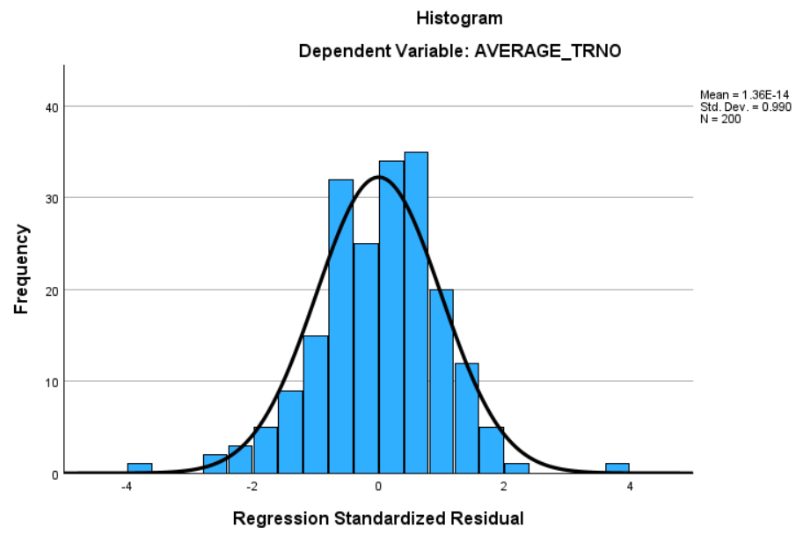
Figure 7Normality Test Results Histogram Graph
Source : Researcher Data Results (2026)
Based on The histogram graph in Figure 4.7 shows from pattern residual distribution forms approaching curve​ normal distribution . The distribution of data on the histogram is also not too leaning to the left or to right as well as own the peaks that are around mark middle . Condition the indicates that the research data normally distributed .

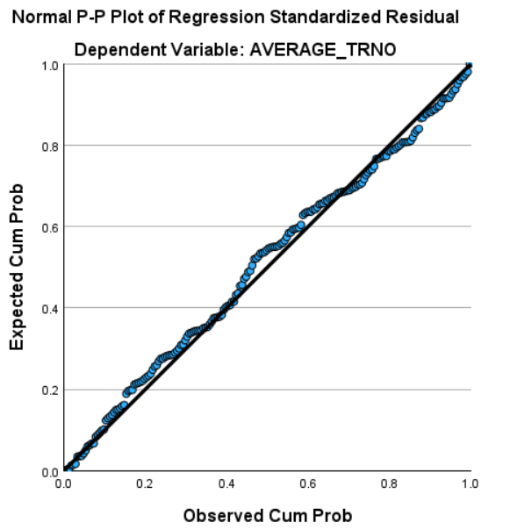
Figure 8Results of PP Plot Normality Test
Source : Researcher Data Processing Results (2026)
Apart from using histogram graph , testing normality is also carried out through Normal PP Plot of Regression Standardized Residual . Based on Figure 4.8, the residual points appear spread around the diagonal line and follow the line pattern . This is show that residual distribution tends to approach normal distribution . With thus, the data in study This can stated normally distributed .
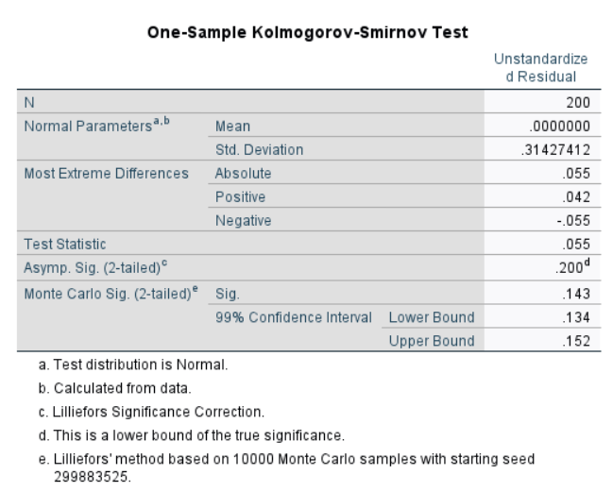
Figure 9Normality Test Results One-Sample Kolmogrov-Smirnov(KS) Test
Source : Researcher Data Processing Results (2026)
Due to the assessment normality through chart histogram and PP Plot tend nature subjective , researchers also use statistical tests One-Sample Kolmogorov-Smirnov (KS) Test so that the results obtained more objective . Based on table in Figure 4.9, it is known that mark significance on Asymp . Sig. (2-tailed) and Monte Carlo Sig. (2-tailed) > 0.05. With Thus , the data in study This can stated normally distributed .
Based on results from three testing normality that has been done through chart histogram, Normal PP Plot, and One-Sample Kolmogorov-Smirnov (KS) Test, can concluded that the data in study This normally distributed . Consistency results from third methods used​ show that assumptions normality has fulfilled in study This .

Heteroscedasticity Test
Heteroscedasticity test done For know whether residual variance in the regression model nature still or constant at every level prediction . In research this , testing done with use chart scatterplot . Regression model stated free from heteroscedasticity if the points on the scatterplot are spread out in a way random , no form pattern certain , as well as spread above and below​ number zero on the Y axis . The results of the heteroscedasticity test in the study This served as following :
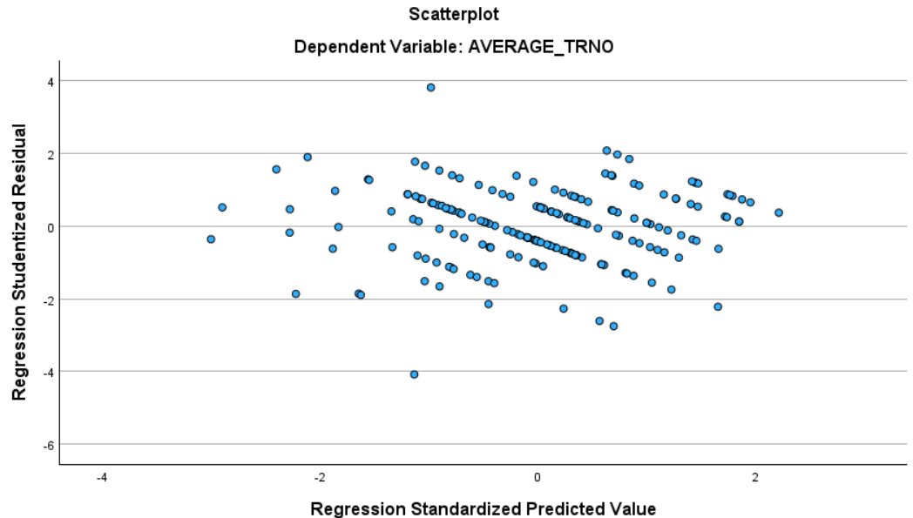
Figure 4. 10Results of the Scatterplot Heteroscedasticity Test
Source : Researcher Data Processing Results (2026)
Based on chart scatterplot in Figure 4.10, distribution residual points on the scatterplot are spread out in a way random around the zero line without form pattern certain conditions​ This show that residual variance is constant across a range level prediction, so that the regression model can stated No experience heteroscedasticity.

Autocorrelation Test
Autocorrelation test done For know whether there is connection between residuals on one observation with residuals on observations other in the regression model . If there is correlation between residuals, then results regression can become not enough accurate . In research this , testing autocorrelation done using the Durbin-Watson (DW) test . Regression model stated free from autocorrelation if mark Durbin-Watson approach number 2. The results of the autocorrelation test in the study This served as following :
Table 11 Tabulation of Durbin-Watson Test Results
Model Summary
Model | Std.Error of the Estimate | Durbin-Watson
1 | 0.3175 | 1,809
Source : Researcher Data Processing Results (2026)
Based on Table 4.11, it is obtained mark Durbin-Watson amounting to 1,809. This value approach number 2 which shows that the regression model No experience autocorrelation. With thus, it can concluded that the regression model in study This has fulfil assumptions classic autocorrelation so that results estimate regression stated Enough reliable and worthy used in analysis study.
Table 12 Tabulation of Multicollinearity Test Results
Variable Model | Code | Collinearity Statics
Variable Model | Code | Tolerance > 0.10 | VIF < 10
Compensation | COMP | 0.997 | 1,003
Job Stress | JBST | 0.993 | 1,007
Career Growth Opportunities | CGO | 0.993 | 1,007
Work-Life Balance | WLB | 0.996 | 1,004
Source : Researcher Data Processing Results (2026)
Based on the results of the multicollinearity test in Table 4.12, all variables independent show tolerance value > 0.10 and VIF value < 10. The results indicates that No there is too much correlation strong intervariable independent . With Thus , the regression model in study This can stated free from problem multicollinearity.

4.7 Hypothesis Testing

4.7.1 ANOVA Significance Test (F Statistic Test )
F test is performed For know whether all over variables independent in a way simultaneous own influence to variables dependent . In research this , testing done with compare calculated F value with F table as well as notice level significance obtained . The results of the F test in the study This served as following :
Table 13 Tabulation of Significance Test Results Simultaneous (F Test)
ANOVA
Model | Sum of Squares | df | Mean Square | F | Sig.
Regression | 23,065 | 4 | 5,766 | 57,208 | <0.001
Residual | 19,655 | 195 | 0.101
Total | 42,720 | 199
Source : Researcher Data Processing Results (2026)
Based on the results of the F test in Table 4.13, obtained calculated F value of 57.208 > F table of 2.37. In addition , the value The significance obtained was also below 0.05 , namely < 0.001 . These results show that the regression model in study This assessed worthy and significant For used . With Thus , all variables independent consisting of from Compensation, Job Stress, Career Growth Opportunities, and Work-Life Balance in a way together own influence to Turnover Intention.

4.7.2 Individual Parameter Significance Test (t Test)
The t-test was performed For know whether each variable independent own significant influence​ to variables dependent in a way partial . In research this , testing done with compare t - value with t- table as well as notice mark significance obtained . The results of the t-test in the study This served as following :
Table 14 Tabulation of Individual Parameter Significance Test Results (t Test)
 |  | t- count > t- table (1.6449) | Sig.< 0.05 | Criteria Testing
(Constant) |  | 24,117 | < 0.001
Hypothesis
H1 | Compensation has an impact negative to Turnover Intention | - 7,054 | < 0.001 | Results support hypothesis
H2 | Job Stress influential positive to Turnover Intention | 9,415 | < 0.001 | Results support hypothesis
H3 | Career Growth Opportunities influential negative to Turnover Intention | - 6,420 | < 0.001 | Results support hypothesis
H4 | Work-Life Balance influential negative on Turnover Intention | - 5,952 | < 0.001 | Results support hypothesis
Source : Researcher Data Processing Results (2025)
Based on t-test results in Table 4.14, variable Compensation has t - value of -7.054 with mark significance < 0.001 so that t- count value > compared to t- table of 1.6449. The result show that Compensation influential negative and significant to Turnover Intention . This means that the more low or not enough in accordance compensation received​ employees , then Turnover Intention level will the more high . With thus , it can concluded that H0 is rejected and H1 is accepted .
On the variable Job Stress, obtained t - value amounting to 9,415 with mark significance < 0.001 so that t- count value > compared to t- table of 1.6449. The result show that Job Stress influential positive and significant to Turnover Intention . This means that the more tall perceived level of work stress employees, then the more Turnover Intention is also high. Therefore tha , can concluded that H0 is rejected and H2 is accepted.
On the variable Career Growth Opportunities , obtained t - value of -6,420 with mark significance < 0.001 so that t- count value > compared to t- table of 1.6449. The result show that Career Growth Opportunities influential negative and significant to Turnover Intention. This means , when opportunity development given career​ company low , then level Turnover Intention employee tend increased . With thus , it can concluded that H0 is rejected and H3 is accepted .
Next , the variables Work-Life Balance own t - value of -5.952 with mark significance < 0.001 so that t- count value > compared to t- table of 1.6449. The result show that Work-Life Balance influential negative and significant to Turnover Intention. This means that if balance between life work and life personal employee low , then Turnover Intention will the more high . Therefore that, can concluded that H0 is rejected and H4 is accepted.

4.7.2 Coefficient Test Determination (R²)
R² test is performed For know how much big ability variables independent in explain variables dependent on the research model . In research this , testing done with see R² value is in the range of 0 to 1. The more small R² value or approaching 0, then ability variables independent in explain variables dependent the more low . On the other hand , if the R² value is close to 1, then ability variables independent in explain changes in variables dependent the more strong. The results of the R² test in the study This served as following:

Table 15 Tabulation of the Results of the Determination Coefficient (R²) Test
Model Summary
Model | R | R Square | Adjusted R Square
1 | 0.735 | 0.540 | 0.530
Source : Researcher Data Processing Results (2026)
Based on the results of the R² test in Table 4.15, obtained The Adjusted R Square value is 0.530. These results show that Turnover Intention variable can explained by 53% by variables independent in study this consists of from Compensation, Job Stress, Career Growth Opportunities, and Work-Life Balance. Meanwhile, that , the remaining 47% influenced by other factors outside the research model that are not discussed in study This .
.

4.7.3 Multiple Linear Regression Test
Multiple linear regression test done For know whether a number of variables independent in a way simultaneous own relationships and influences to variables dependent. In addition, testing this is also used For see direction connection as well as big the influence of each variable independent to variables dependent with assumptions variables independent other considered still or constant.

4.7.3.1 Results of the Equation Regression
Equality regression used For know direction connection as well as size the influence of each variable independent to variables dependent . Through equality said , researchers can understand How every variables independent contribute in explain changes that occur in variables dependent .
Table 16 Tabulation of Equation Results Regression
Variable Model | Code | Unstandardized B ( Coefficient Influence )
(Constant) |  | 4,206
Compensation | COMP | - 0.205
Job Stress | JBST | 0.290
Career Growth Opportunities | CGO | - 0.191
Work-Life Balance | WLB | - 0.215
Source : Researcher Data Processing Results (2026)
Y= 𝐚 + 𝒃𝟏𝑿𝟏 + 𝒃𝟐𝑿𝟐 + 𝒃𝟑𝑿𝟑 + ⋯ + 𝒃𝐤𝑿𝐤
Formula Analysis Regression Double down on research This :
TI = 4.206 + -0.205 COMP + 0.290 JBST + -0.191 CGO +
-0.215 WLB
Equality regression in study This refers to the unstandardized beta value in Table 4.15 with mark constant as big as 4,206. The value show that if all over variables independent consisting of from Compensation, Job Stress, Career Growth Opportunities, and Work-Life Balance is worth 0, then estimated Turnover Intention value amounting to 4,206.
Variables Compensation own mark coefficient regression of -0.205. This show that every decline one unit on Compensation can increase Turnover Intention of 0.205 with assumptions variables other remains . The result show that Compensation own connection negative to Turnover Intention.
Variables Job Stress own mark coefficient regression of 0.290. This means that every improvement one unit on Job Stress can increase Turnover Intention of 0.290 with assumptions variables other is at in condition remains . The result show that the more tall perceived level of work stress employees , then the more tall Turnover Intention .
Variables Career Growth Opportunities own mark coefficient regression of -0.191. This show that every decline one unit in Career Growth Opportunities can increase Turnover Intention of 0.191 with assumptions variables other still . With Thus, Career Growth Opportunities have connection negative to Turnover Intention.
Variables Work-Life Balance own mark coefficient regression of -0.215. This means that every decline one unit on Work-Life Balance can increase Turnover Intention of 0.215 with assumptions variables other is at in condition remains . The result show that Work-Life Balance own connection negative to Turnover Intention.

4.7.3.2 Comparison Influence Variables in the Regression Model
Comparison influence variables done For know variables which independent provides the biggest influence to variables dependent . In research this , comparison the seen through standardized beta value . Variables that have the highest standardized beta value show variables the become the most influential factor in the regression model .
Table 17 Tabulation of Comparison Results Influence Variables in the Regression Model
Variable Model | Code | Standardized Beta ( Influence Largest )
(Constant)
Compensation | COMP | -0.343
Job Stress | JBST | 0.459
Career Growth Opportunities | CGO | -0.313
Work-Life Balance | WLB | -0.290
Source : Researcher Data Processing Results (2026)
Based on results comparison influence variables in the regression model in Table 4.16, the variables that have the most influence to Turnover Intention is Job Stress with beta value of 0.459. Where the results are disclose that compared to variables independent others , Job Stress give the biggest contribution in explain changes in Turnover Intention.

4.8 Interpretation of Research Results

Based on results research that has been done done as well as analysis of data that has been obtained , then can withdrawn a number of conclusion as following :

Influence Compensation On Turnover Intention
Based on results research that has been obtained , variable Compensation own t - value by -7.054 > compared t- table value of 1.6449, and mark significance < 0.001 < 0.05. In addition , the value coefficient regression of -0.205 indicates that every decline one unit of Compensation can increase Turnover Intention by 0.205 points with assumptions variables other still constant . Based on results said , can concluded that Compensation own influence negative on Turnover Intention.
Research result this is also consistent with study previously conducted by ( Suhardi & Oktari , 2023) which proved that compensation influential negative and significant to turnover intention . Research the explain that low compensation received​ employee can increase desire For leave company Because employee feel that rewards given​ Not yet comparable with contributions and efforts that have been done . Apart from that , research conducted by (Haliza et al., 2025) also found that insufficient compensation​ adequate can lower satisfaction as well as commitment employee to company , so that level turnover intention become more high . Findings the show that the more low perceived compensation​ employees , then the more big trend they For leave company .
Research result show that compensation received​ employee can influence increasing turnover intention. Employee feel structure commission given​ Not yet capable motivating performance in a way maximum compensation received​​ Still Not yet Enough competitive , as well as payment given​ Not yet fully in accordance with Work hard work done . Conditions the cause level satisfaction and engagement employee to company decrease so that appear desire for switch to other jobs that offer more rewards​ Good .

The Effect of Job Stress on Turnover Intention
variables Job Stress own t - value of 9,415 which is > compared t- table value amounting to 1.6449, as well as mark significance < 0.001 < 0.05. In addition , the value coefficient regression of 0.290 indicates that every improvement one unit on Job Stress can increase Turnover Intention by 0.290 points with assumptions variables other still constant . Based on results said , can concluded that Job Stress own influence positive to
Research result this is also consistent with study previously conducted by (Abdillah, 2024) which proved that job stress influential positive and significant to turnover intention . Research the explain that the more tall pressure perceived work​ employees , then the more big desire too they For leave company . In addition , research from (Natalya et al., 2025) also found that height pressure work as well as condition tiring work​ can increase stress Work employees . If stress Work ongoing in a way continuously , then employee tend own desire For leave company and looking for other work that is considered more comfortable .
In addition , the results study This show that Job Stress play a role important in increase Turnover Intention . This reflected from condition work faced​ employee every day , like sales target pressure , burden high work schedule​​ busy work , demands​ frequent work​ drain energy and emotions . Employees who continue is at in pressure high work​ tend feel tired , difficult focus , and less comfortable moment working . Condition the can lower Spirit Work as well as make employee start consider other work that is felt more stable and not too pressing . In addition , the lack of time rest and height demands work can also make things worse level perceived stress​ employees . Therefore that , the more big Job Stress experienced employees , then the more big trend occurrence Turnover Intention .

The Influence of Career Growth Opportunities on Turnover Intention
Variables Career Growth Opportunities own t - value by -6,420 > compared t- table value of 1.6449, and mark significance < 0.001 < 0.05. In addition , the value coefficient regression of -0.191 indicates that every decline one unit in Career Growth Opportunities can increase Turnover Intention by 0.191 points with assumptions variables other still constant . Based on results said , can concluded that Career Growth Opportunities own influence negative to Turnover Intention .
Research result this is also in line with study previously conducted by ( Solihat & Salendu , 2023) which proved that career growth opportunities influential negative and significant to turnover intention . Research the explain that low opportunity promotion , development skills , and clarity level career can increase desire employee For leave company . In addition , research from (Zahirah & Satrya , 2024) also shows that career growth own influence negative to turnover intention . This It means the more low opportunity growth and development career experience​ employee in company , then the more tall trend they For own intention go out from company . Condition the happen Because employee feel company Not yet capable give future vision​ clear , good career​ through opportunity promotion , improvement not quite enough answer , and development supporting capabilities​ development professional they .
Research result show Career Growth Opportunities felt employee can increase Employee Turnover Intention feel organization Not yet fully provide clear opportunity​ For progress career path​ promotion in​ company Still Not yet seen in a way sure , and work being carried out Not yet fully support development skills For reach objective career term long . Condition the cause employee feel the future career they are in the company not enough clear so that satisfaction and engagement to company tend decreased . When employees see opportunity development limited career , appears​ trend For switch to other companies that are considered capable provide chance promotion and development a better self good . With thus , the more low Perceived Career Growth Opportunities employees , then the more high tendency​ they For own intention go out from company .

The Influence of Work-Life Balance on Turnover Intention
Variables Work-Life Balance own t - value by -5.952 > compared t- table value of 1.6449, and mark significance < 0.001 < 0.05. In addition , the value coefficient regression of -0.215 indicates that every decline one unit on Work-Life Balance can increase Turnover Intention by 0.215 points with assumptions other variables remain constant constant . Based on results said , can concluded that Work-Life Balance has influence negative on Turnover Intention.
Research result this is also consistent with study Previously carried out by (Dewi & Ekawaty , 2026) which proves that Work-Life Balance influential negative and significant to Turnover Intention in employees Generation Z. Research the explain that low balance between work and life personal can increase desire employee For leave company . In addition , research conducted by ( Saleem et al., 2024) also found that Low Work-Life Balance can lower comfort as well as satisfaction Work employee so that level turnover intention become more high . Findings the show that the more low perceived work - life balance employees , then the more big trend they For leave company .
Research result show that Perceived Work - Life Balance employee contribute to increasing Turnover Intention . This seen from perception employees who feel Not yet own enough time​ For together family and friends , work done​ Not yet fully support creation balance between work and life personal , as well as timetable unfinished work​ facilitate management not quite enough answer personal in a way effective . Condition the result in employee difficulty balance life work and personal so that comfort as well as satisfaction Work decreases . When the balance life No achieved , employees tend more easy experience fatigue and stress later work​ push emergence desire For look for environment other work that is capable give work-life balance which are more good . Therefore that , the more low Perceived Work - Life Balance employees , then the more high tendency​ occurrence Turnover Intention.

4.8.5 Influence Compesation , Job Stress, Career Growth Opportunities, Work-Life Balance on Turnover Intention
Based on results testing , obtained calculated F value of 57.208, the value of which is > compared to the F table of 2.37. In addition , the value significance <0.05 , namely <0.001. The results show that the regression model in study This assessed worthy and significant For used . With Thus , all variables independent consisting of from Compensation, Job Stress, Career Growth Opportunities , and Work-Life Balance in a way together own significant influence​ to Turnover Intention.
With Thus , the fourth variables independent in study This No only influential in a way individual , but also as a together capable explain variation changes in turnover intention employees . Conditions This show that decision employee For endure or leave organization influenced by a combination various factors , namely compensation , pressure work , opportunities development career , as well as balance between life work and life personal .
In addition , the results it also shows that handling to One factor just No Enough For suppress turnover intention optimally , because every variables own interconnectedness and interrelationship influence in form perception employee to his job . Because of that that , is necessary integrated approach​ in management policy companies , including repair system compensation , control burden and stress work , strengthening opportunity development career , as well as improvement balance work and life personal . A holistic approach the expected capable create condition more work​ stable , improving attachment employees , and ultimately lower level turnover intention in a way sustainable .

4.9 Managerial Implications
Based on results research that has been done , there is four hypothesis used​ as base in compilation implications managerial . The results of testing the hypotheses H1, H3, and H4 show existence influence negative , while H2 shows existence influence positive in accordance with direction relationship that has been estimated previously . With thus , it can concluded that Compensation influential negative to Turnover Intention, Job Stress influential positive to Turnover Intention, Career Growth Opportunities influential negative to Turnover Intention and Work-Life Balance also have an influence negative to Turnover Intention. Based on results from fourth hypothesis said , then arranged a number of implications managerial as following :

4.9.1 Efforts To Increase Compensation Against Turnover Intention
Research result This show that Compensation own influence negative to Turnover Intention . Based on results analysis Component Matrix, indicator with mark highest show that employee feel system commission given​ Not yet capable push they For reach better performance​ high , compensation received​ Still Not yet Enough competitive , as well as payment given​ Not yet fully in accordance with business and work hard work done . Conditions the show that system compensation that has not been in accordance with hope employee can impact on the decline satisfaction Work as well as decrease attachment employee to company . When employees feel that their contributions and efforts​ give Not yet valued in a way worthy , then appear trend For compare compensation received​ with other companies that are considered capable give more appreciation​ better and better competitive . Situation that in the end can bring up improvement desire employee For look for alternative other work and go out from company .
Based on findings said , the company need do evaluation to system compensation to be more fair and capable compete with other companies , especially related structure commission that can motivating performance employees , giving appropriate compensation​ with standard industry , as well as suitability between fees and charges work done​ employees . The company can do review wages in a way periodically , providing incentive based on achievement work , and provide award addition for employees who have contribution and responsibility answer high work .​ This step important For increase satisfaction Work at a time lower turnover intention employees . This is also in line with research ( Suhardi & Oktari , 2023) which explains that appropriate compensation​ with hope employee can increase loyalty and reduce desire employee For leave company .
In addition , companies are also advised increase openness related mechanism giving commissions , incentives and rewards work so that employees understand that compensation received​ given based on performance and contribution they to company . According to ( Suryadi et al., 2022) , transparent and aligned compensation with contribution employee can increase motivation Work as well as help company maintain employees who have performance Good .

4.9.2 Efforts To Increasing Job Stress on Turnover Intention
Research result This show that Job Stress own influence positive to Turnover Intention . Based on results analysis Component Matrix, indicator with mark highest show that high competition​ between colleague Work increase level stress employees , burden work received​ make employee feel overwhelmed , and lack of support from superior be one of reason emergence stress work . Conditions the show that pressure high work​ become factor important things that influence desire employee For leave company . When employees Keep going faced with demands overwork , environment​​ overwork​​ competitive , and minimal support from superiors , then a sense of comfort and satisfaction Work will decreased . In addition , stress work in progress in long time can also influence condition emotional and passionate Work employee so that they start look for place other work that is considered more comfortable and supportive . Condition that in the end can increase turnover intention employee .
Based on findings said , the company must more notice work stress management in a way effective , especially in relation to with height competition between colleagues , burdens overwork​​ weight , and lack of support from superiors . The company can set higher work targets​ realistic , share work in a way more balanced , and increase role superior in give guidance and support to employees . These steps important Because research (Abdillah, 2024) indicates that the more tall stress perceived work​ employees , then the more there is also a big tendency they For leave company . With Thus , management stress good job​ be one of effort important For pressing turnover intention employee .
In addition , companies are also advised For create environment more work​ conducive and supportive through communication open work , evaluation​ burden Work in a way periodically , and provision time adequate rest for employees​ No experience excess burden Work in operate his job . This in accordance with indicator dominant which shows that competition work , height burden work , and lack of support superior become source main stress Work employees . According to Fauquet-Alekhine and Erskine (2023), work stress arise Because existence imbalance between demands work and skills individual in fulfill it . Through management stress more work​ effective , company can create environment more work​ healthy and comfortable so that turnover intention can minimized in a way sustainable .

4.9.3 Efforts To Increasing Career Growth Opportunities Against Turnover Intention
Research result This show that Career Growth Opportunities have influence negative to Turnover Intention . Based on results analysis Component Matrix, indicator with mark highest show that employee feel company Not yet fully provide opportunity progress clear career path​​ promotion Still Not yet seen with sure , and work being carried out Not yet fully help development skills For reach objective career term long . Condition the show that chance development career be one of factor important things that influence decision employee For stay inside​ company . When employees own perception opportunity promotion and development self Still limited , then level satisfaction work and engagement to company tend decreased . In addition , employees can also start look for other companies that are considered capable give opportunity a better career clear and supportive development professional they . Condition that in the end can bring up improvement desire employee For leave company .
Based on findings said , the company need more notice development system a better career directed and transparent , especially in provide opportunity progress clear career path​​ definite promotion , as well as development supporting skills​ objective career term long employees . The company can provide training and development programs competence , doing evaluation related performance​ with opportunity promotions , as well as give more information​ open about level career in​ company . The steps important Because research ( Solihat & Salendu , 2023) explains that career growth opportunities are good can help lower turnover intention Because employee see the existence of the future a better career clear inside​ company .
In addition , companies are also advised increase communication about opportunity development career for employees more understand chance promotion and development available self . This​ in accordance with indicator dominant which emphasizes importance opportunity progress career path​ clear promotion , as well as development skills For support objective career term long . According to Ramteke (2026), career growth opportunities covers opportunity promotion , improvement skills and experience work that can support development professional employees . With existence system development a better career clear and focused , company can increase belief employee towards the future career they so that turnover intention can be decrease in a way gradually .

4.9.4 Efforts To Improving Work-Life Balance Against Turnover Intention
Research result This show that Work-Life Balance own influence negative on Turnover Intention. Based on results analysis Component Matrix, indicator with mark highest show that employee feel time For together family and friends Still limited , work carried out Not yet fully support creation balance between work and life personal , as well as timetable existing work​ Not yet support employee in arrange not quite enough answer personal in a way maximum . Condition the show that balance between work and life personal is one of the matter important things that influence decision employee For stay in the company . when demands work felt too large and reduce time For life personal , then satisfaction work and sense of belonging employee to company tend decreased . In addition , employees can also start look for place other perceived work can give balance a better life good . Condition that in the end can trigger increasing desire employee For leave company .
Based on results said , the company need more notice arrangement time and load work to be more balanced . Companies need to ensure that employee own sufficient time​ For family and life personal , capable guard balance healthy living , and​ can arrange not quite enough answer personal with more good . Efforts that can be made done that is with determine priority work in a way more clear , reduce demands work outside working hours , as well as provide timetable more work​ flexible and adaptable need employees . These steps important Because research (Dewi & Ekawaty , 2026) shows that the more Good perceived work - life balance employees , then the more low level desire they For leave company .
In addition , companies are also advised For provide support more work​ flexible and supportive , such as give tolerance to need family as well as designing supportive policies​ welfare employees . This in harmony with indicator dominant which shows importance balance between work and life personal as well as ability employee in manage not quite enough answer personal . According to Zheng (2024), work-life balance play a role important in guard welfare employee Because imbalance between work and life personal can cause pressure physique both physically and mentally. With policy more work​ support balance life , company expected capable create environment more work​ Healthy as well as lower turnover intention in a way sustainable .

4.9.5 Efforts To Increasing Compensation, Job Stress, Career Growth Opportunities, Work-Life Balance on Turnover Intention
Simultaneous test results show that compensation, job stress, career growth opportunities , and work-life balance in a way together influential on turnover intention. These results show that decision employee For endure or leave company No only influenced by one factors , but rather by various aspect mutually supportive work integrated . Therefore that , the company need apply approach better management​ comprehensive to all over factor the .
Based on findings said , the company recommended For increase system compensation to be more fair , competitive , and in accordance with burden work and contribution employees . Compensation is considered worthy can increase satisfaction Work so that capable lower desire employee For leave company . In addition , the company also needs notice management stress Work through adjustment burden work , improvement support from superiors , and creation environment more work​ comfortable so that the pressure perceived work​ employee can minimized .
Furthermore , the company also needs to give chance development a better career clear through provision level directed career , training programs , and development ability employee in a way sustainable . This step can increase motivation employee For survive and grow together company . On the other hand , the increase work-life balance is also necessary noticed through giving flexibility work , more flexible working hours​ adapt need employees , as well as policies that support creation balance between work and life personal .
In a way overall , improvement in aspects compensation , work stress , development career and work-life balance in a way simultaneously expected can create condition more work​ positive and comfortable for employees . This is in line with simultaneous test results showing​ that fourth variables the in a way together influence turnover intention, so that company need apply comprehensive approach​ For lower level turnover intention employee

CHAPTER V
CONCLUSIONS AND SUGGESTIONS

5.1 Conclusion
Study This aim For know influence Compensation, Job Stress, Career Growth Opportunities, and Work-Life Balance to Turnover Intention in employees Generation Z working in the retail industry in DKI Jakarta. Research it also focuses on efforts understand size influence compensation , level stress work , opportunities development career , as well as balance between work and life personal to decision employee For endure or choose go out from company . The method used is approach quantitative with data collection through distribution questionnaire in a way direct to respondents who meet the requirements criteria research . The data obtained Then processed and analyzed using IBM SPSS Statistics software for know connection intervariable at a time measure size the influence of each variable to Turnover Intention . Based on results research that has been done , obtained a number of conclusion as following :
- Variables Compensation known own influence negative to Turnover Intention. This seen from t-test results show t - value of -7.054 > from 1.6449 with mark significance <0.001 < 0.05 . In addition , the unstandardized beta value of -0.205 indicates existence connection negative between Compensation and Turnover Intention . Based on results said , can concluded that when compensation received​ employee felt Not yet in accordance with contribution and hope they , then desire employee For leave company will the more increase .
- Variables Job Stress proven influential positive to Turnover Intention. This shown from t-test results with t - value of 9.415 > from 1.6449 and mark significance <0.001 < 0.05. The unstandardized beta value of 0.459 also shows existence connection positive between Job Stress and Turnover Intention . With thus , it can concluded that the more big level of work stress experienced employees , then the more big trend they For own intention go out from company .
- Variables Career Growth Opportunities own influence negative to Turnover Intention. Statement the supported by the results of the t-test which shows t - value of -6.420 > from 1.6449 with level significance <0.001 < 0.05. In addition , the unstandardized beta value of -0.313 indicates connection negative between Career Growth Opportunities and Turnover Intention . Therefore that , it is concluded that when opportunity development and levels career in company Not yet seen with clear , then the more tall trend employee For look for work elsewhere .​
- Variables Work-Life Balance is also proven own influence negative to Turnover Intention . This can seen from t-test results show t - value of -5.952 > from 1.6449 with level significance <0.001 < 0.05. The unstandardized beta value of -0.290 also indicates existence connection negative to Turnover Intention. Based on results said , it is concluded that if balance between life work and life personal employee Not yet achieved with okay then​ desire employee For leave company tend increase .

5.2 Suggestions
Based on results research and conclusions that have been described, author give a number of suggestions are expected can become material consideration for company and researchers furthermore in develop study with similar topics.​

5. 2.1 Suggestions for companies
The height level turnover intention can impact on disruption stability operational company as well as lower productivity and effectiveness Work employees . Based on findings research , Compensation, Career Growth Opportunities, Work-Life Balance, and Job Stress proven influence to turnover intention employees . Although all over indicator in study This Already fulfil the specified standards , still There is a number of things to do improved so that the company can build environment more work​ comfortable , positive , and able increase loyalty employee For still stay in the company . Because of that that , the company recommended For apply various step strategic to improve aspects mentioned . There are a number of suggestions that can be made into consideration for company is as following :
- Increase A Fairer and More Competitive Compensation System .
Companies can do evaluation to structure commission , giving incentives , and systems wages to be more in accordance with contributions and burdens Work employees . In addition , companies can also give award based performance as well as increase transparency related mechanism giving compensation . These efforts can make employee feel more noticed and appreciated so that can pressing desire they For move to other companies .
- Managing Job Stress Effectively More Effective .
Companies need to build environment more work​ support with minimize load and pressure overwork , doing​​ distribution task in a way evenly , and increase support from superior to employees . In addition , companies can also build communication more work​ open and do routine evaluation of burden Work employees . This step can help reduce level stress Work so that employee turnover intention can pressed .
- Developing Clearer Career Growth Opportunities .
Companies can provide track more promotions​ transparent , training program For development skills , as well as evaluation connected performance​ with opportunity development career . This step can help employee see the existence of the future a better career clear inside​ company so that increase loyalty and lower turnover intention .
- Increase Work-Life Balance Policy .
Companies can arrange burden work and schedule Work in a way more proportionally so that employees own healthy balance​ between work and life personal . In addition , companies can also give flexibility work , limit demands work outside working hours , as well as give tolerance to need personal and family employees . This step can help reduce pressure Work at a time make employee feel more comfortable moment Work .
- Create Environment More Work​ Supportive and Well - Being Oriented Employee .
Companies need to build environment work that can support well-being , comfort and development employee in a way comprehensive . These efforts can done with give appropriate and competitive compensation , providing​ chance development career which are more clear , apply better work-life balance good , and managing work stress with right . In addition , the company also needs to strengthen communication between superiors and employees , providing award on results Work employees , and create atmosphere positive work​ as well as each other support . With existence step mentioned , it is hoped that satisfaction work and loyalty employee to company can increase so that turnover intention can decrease in a way gradually .

5.2.2 Suggestions for Research Furthermore
Study This Still own a number of limitations that can become attention for study next . With Thus , the author give a number of expected input​ capable become reference For development study next to get more optimal and in-depth results . As for the suggestions that can be considered that is as following :
- In the Adjusted R Square test results , the variable Compensation, Job Stress, Career Growth Opportunities, and Work-Life Balance only capable explain by 53% against Turnover Intention . Meanwhile that , the rest 47 % is influenced by other factors outside the research model this . Condition the indicates that intention employee For leave work No solely influenced by compensation , stress work , opportunity development career , and work-life balance , but also can influenced by various other factors that have relatedness . With Thus , future research​ recommended For consider addition other variables to be able to give a clearer picture broad and deep about factors that influence turnover intention, such as work environment . ( Revania Selvika Sari & Arief Subyantoro , 2024) stated that work environment own significant relationship​ with turnover intention . Research results the show that condition environment work , atmosphere work , and connection between employee become aspects that can influence desire employee For still endure and leave company . Findings the show that work environment become factor important things that can considered in study furthermore For understand turnover intention in a way more comprehensive .
- Study furthermore recommended using more research methods​ diverse , such as approach qualitative or mixed methods, can used For get greater understanding​ deep about factors that influence decision employee For still endure and leave company . Approach can also be help researchers dig more Far about phenomenon or results research . With Thus , the use of more methods​ diverse expected capable enrich research data related things that influence turnover intention .
- Study This limited to employees Generation Z working in industry specialty retail in the DKI Jakarta area. leh because that , research next expected can expand research area coverage to other regions in Indonesia. In addition , research next can also do studies comparison between generations , such as Generation Z, Millennials , and Generation X, for know whether influence compensation, job stress, career growth opportunities, and work-life balance to turnover intention has differences in each generation in the world of work.

BIBLIOGRAPHY
Sarkis, N., Al Maalouf, N.J., Abi Raad, R., Habib, C., & Wakim, J. (2026). A comparative study of turnover drivers among real estate sales professionals in Lebanon and the UAE. Administrative Sciences, 16(1), 48. https://doi.org/10.3390/admsci16010048
Abdillah, BM (2023). Analysis influence satisfaction work and stress Work on turnover intention. Journal Entrepreneurship and Innovation , 2 (3), 651–665. http://dx.doi.org/10.21776/jki.2023.02.3.03
Alif, AA (2024, August). Uniting Gen Z and other generations in the workplace ? Possible! Weefer Indonesia. https://www.weefer.co.id/id/2024/08/gen-z-di-dunia-kerja/
Statistics Agency . (2024). Profile Indonesian trade 2024. Central Statistics Agency. https://www.bps.go.id/id/publication/2025/12/31/1b526749c21a883818c1c74d/profil-perdagangan-indonesia-2024.html
Bothma, C.F.C., & Roodt, G. (2013). The validation of the turnover intention scale. SA Journal of Human Resource Management, 11(1), 1–12. https://doi.org/10.4102/sajhrm.v11i1.507
Calista, C., & Erdiansyah , R. (2025). Factors influencing turnover intention (A study on Generation Z employees in Jakarta). International Journal of Social Science and Human Research, 8(4), 2571–2582. https://doi.org/10.47191/ijsshr/v8-i4-76
Cascio, W.F., & Boudreau, J.W. (2025). Investing in people: Financial impact of human resource initiatives (3rd ed.). Pearson.
Clear, J. (2024). Atomic habits: An easy & proven way to build good habits and break bad ones .
Cooper, D.R., & Schindler, P.S. (2014). Business research methods (12th ed.). McGraw-Hill Education. https://www.mheducation.com/
Creswell, J. W. (2023). Research design: Qualitative, quantitative, and mixed methods approaches (6th ed.). SAGE Publications. https://us.sagepub.com/
Danti, PM, & Elmi, F. (2023). The influence of organizational culture, career development, and job satisfaction on turnover intention at PT. CMK West Jakarta. European Journal of Business and Management Research, 8(2), 197–203. https://doi.org/10.24018/ejbmr.2023.8.2.1884
Dessler, G. (2020). Human resource management (16. e). Pearson.
Dewi, DS (2022, April 8). This is the difference style Study between Generations : Baby boomers, Gen X, millennials , Gen Z, and alpha . Ruangguru . https://www.ruangguru.com/blog/perbedaan-gaya-belajar-antar-generasi
Dewi, ORS, & Ekawaty , N. (2026). Workload and work-life balance on turnover intention among Generation Z in Bekasi City. Eqien : Journal of Economics and Business , 15 (1), 16–32. https://doi.org/10.34308/eqien.v15i01.2256
Civil Registration Service DKI Jakarta Province . (2025). Population data Jakarta Province . https://kependudukancapil.jakarta.go.id/
Fauquet-Alekhine, P., & Erskine, J. A. K. (2023). Work stress and organizational behavior. Journal of Occupational Health Psychology, 28 (2), 120–134.
Goh Jiaying, A., & Young, A.L. (2023). The effect of career growth on employee turnover intention in Sarawak construction industry. Journal of Cognitive Sciences and Human Development, 9 (2), 133–150. https://doi.org/10.33736/jcshd.5879.2023
Hair, JF, Black, WC, Babin, BJ, & Anderson, RE (2019). Multivariate data analysis (8th ed.). Cengage. https://www.cengage.com/
Haliza, Supriyadi, A., & Listyorini , H. (2025). The effect of compensation on turnover intention with job satisfaction and organizational commitment as intervening variables at Diponegoro National Hospital, Semarang. Indonesian Interdisciplinary Journal of Sharia Economics (IIJSE), 8 (3), 11841–11855. https://doi.org/10.31538/iijse.v8i3
Hom, P. W., Mitchell, T. R., Lee, T. W., & Griffeth, R. W. (2017). Reviewing employee turnover: Focusing on proximal withdrawal states and an expanded criterion. Psychological Bulletin, 143 (3), 1–40. https://doi.org/
Hotama, V. A., & Setiorini , A. (2025). The effect of work-life balance, self-esteem, and work motivation on organizational commitment of Gen Z employees. International Journal of Research and Innovation in Social Science (IJRISS), 9 (4), 738–745. https://doi.org/10.47772/IJRISS.2025.90400055
JAKPAT. (2024). Understanding Gen Z: Preference in the workplace – 2024 JAKPAT survey report . https://www.scribd.com/document/938498232/PDF-Report-Understanding-Gen-Z-Preference-in-the-Workplace-2024-Jakpat-Survey-Report-43243-1
Kintani , ACS, & Wahyuningtyas , R. (2024). Effect on turnover intention: Career development, compensation and job stress. Tennessee Research International of Social Sciences, 6 (2), 124–136. https://triss.org/index.php/journal/article/view/62
Knappertsbusch , F., & Wisskirchen , G. (2024). Flexible work and work-life balance in organizations. International Journal of Human Resource Studies, 14 (1), 45–59.
Lionel, LKG, Channuwong , S., & Wongmajarapinya , K. (2023). Human resource management and organizational performance. International Journal of Advanced Research, 11(5), 872–881. https://doi.org/10.21474/IJAR01/16940
Malhotra, N. K. (2017). Marketing research: An applied orientation (7th ed.). Pearson. https://www.pearson.com/
Martocchio, J. J. (2025). Strategic compensation: A human resource management approach (11th ed.). Pearson.
Mathis, R.L., & Jackson, J.H. (2019). Human resource management (16th ed.). Cengage Learning.
Looking at Indonesia. (2024). 8 reasons why Gen Z is becoming a job hopper , easily resigning from... place Work . https://mebayarindonesia.id/8-alasan-gen-z-jadi-kutu-loncat-mudah-resign-dari-plac-kerja/
Mobley, W. H. (1977). Intermediate linkages in the relationship between job satisfaction and employee turnover. Journal of Applied Psychology, 62 (2), 237–240. https://doi.org/10.1037/0021-9010.62.2.237
Natalya, AC, Istiqomah , AP, Ratnasih , DA, Aprilia, A., Sari, SN, & Mahesti , AER (2025). The effect of job stress and job insecurity on turnover intention of retail employees at Indomaret & Alfamart Solo Raya. Determination : Journal of Economics , Management and Accounting , 3 (3), 379–387. https://jsr.lib.ums.ac.id/index.php/determinasi
Pamungkas , RA, & Sudiro , A. (2024). The influence of work-life balance and compensation on employee turnover intention generation Millennials . Journal Entrepreneurship and Innovation , 3 (4), 1034–1044. https://doi.org/10.21776/jki.2024.03.4.09
Ramteke, S. (2026). Career growth opportunities and employee commitment. International Journal of Management Research, 18 (2), 80–95.
Ramteke, S. (2026). Career pressure and job stress among employees. International Journal of Management Research, 18 (2), 66–79.
Robbins, S.P., & Judge, T.A. (2022). Organizational behavior (19th ed.). Pearson. https://www.pearson.com/en-us/subject-catalog/p/organizational-behavior/P200000003482
Saleem, M., Ashraf, I., & Shahzad, S. (2024). The impact of work life balance on turnover intention: The mediating role of job engagement among employees . International Journal of Contemporary Issues in Social Sciences, 3(4), 1649–1661. https://ijciss.org/
Sari, RS, & Subyantoro , A. (2023). The influence of job satisfaction and work environment on turnover intention with commitment organizational as variables mediation . Journal Management and Business , 7 (1), 14–19. https://jurnal.uts.ac.id/index.php/jmb/index
Sekaran, U., & Bougie, R. (2019). Research methods for business: A skill-building approach (8th ed.). Wiley. https://www.wiley.com/
Sobayar , W.S., & Salendu , A. (2023). The relationship between career growth opportunity and turnover intentions in employees in startup companies X: Career planning coaching program designed as an intervention. Gema Wiralodra, 14 (2), 1012–1025. https://doi.org/10.31943/gw.v14i2
Sugiyono . (2021). Research methods quantitative , qualitative , and R&D . Alfabeta . https://cvalfabeta.com/
Suhardi, AR, & Oktari , SD (2023). The role of compensation and loyalty in employee turnover intention. JENIUS: Jurnal Scientific Management Human Resources , 6 ( 2), 267–272. https://doi.org/10.32493/jjsdm.v6i2.24039
Sunarjaya , IG, & Nugraha , YE (2019). Analysis Employee empowerment perceptions on employee turnover intention at Dewi Sinta Hotel. JOURNEY, 1(1), 182–206. https://doi.org/10.46837/journey.v1i1.35
Suryadi , GP, Utomo, FC, & Setiorini , A. (2022). The role of compensation and work environment on employee job satisfaction (A case study at container terminal). International Journal of Research and Innovation in Social Science, 6(12), 674–677. https://www.rsisinternational.org/journals/ijriss/articles/the-role-of- compensation-and-work-environment-on-employee-job-satisfaction-a-case-study-at-container-terminal/
Tett, R.P., & Meyer, J.P. (1993). Job satisfaction, organizational commitment, turnover intention, and turnover: Path analyzes based on meta-analytic findings. Personnel Psychology, 46 (2), 259–293. https://doi.org/10.1111/j.1744-6570.1993.tb00874.x
Triningsih , NN, & Darma, GS (2024). Compensation, work-life balance, employee engagement and turnover intention . Quantitative Economics and Management Studies (QEMS), 5 (1), 10–21. https://doi.org/10.35877/454RI.qems2158
Widiastuti , T., & Sudrajat , A. (2024). The influence of job satisfaction and work environment on turnover intention with commitment organizational as variables mediation . Journal Management and Business , 7(2), 120–134. https://jurnal.uts.ac.id/index.php/jmb/article/view/3912
Wijayanti, EP, & Anisa, F. (2022). The Influence compensation , satisfaction work and stress Work on turnover intention. Journal Focus Business Management , 12 (2), 194–205. https://doi.org/10.12928/fokus.v12i2.6665
Zahirah, NG, & Satrya , A. (2024). The influence of career growth and perceived organizational support on turnover intention: The role of organizational commitment among Indonesian millennial employees. Ecombis Review: Journal Scientific Economics and Business , 12(4). https://jurnal.unived.ac.id/index.php/er/article/view/6179
Zheng, C. (2024). Work-life balance and employee wellbeing in modern organizations. Human Resource Development Review, 23 (1), 88–102.

