Wired Antenna Arrays for 5G Applications in Cellular Base Stations: A Comparative Performance Analysis

Abstract
The deployment of fifth-generation (5G) cellular networks demands advanced antenna systems capable of delivering high gain, wide bandwidth, low return loss, and efficient beamforming. This article presents a comprehensive comparative analysis of wired antenna arrays specifically dipole arrays, Yagi-Uda arrays, and log-periodic dipole arrays (LPDAs) designed for 5G base station applications at 3.5 GHz. Using CST Microwave Studio simulations, single-element and multi-element configurations were evaluated against key performance metrics including return loss, VSWR, gain, directivity, bandwidth, and radiation pattern characteristics. The ten-element dipole array achieved a gain of 11.79 dBi with a narrow beamwidth of 16.4°, representing a 9.5 dB improvement over a single dipole. The ten-director Yagi-Uda demonstrated superior return loss (-25.22 dB) and gain (11.7 dBi) compared to the three-director version (8.9 dBi). The four-element LPDA array exhibited enhanced bandwidth (0.508 GHz) and improved VSWR (1.255) relative to its single-element counterpart. These findings provide quantitative guidelines for selecting optimal wired antenna configurations for specific 5G deployment scenarios.
Keywords: 5G base station, dipole array, Yagi-Uda antenna, log-periodic dipole array, antenna array, beamforming, CST simulation, sub-6 GHz

1. Introduction
The evolution from 1G to 5G networks has been characterized by exponential growth in data rates, device connectivity, and application complexity. Fifth-generation (5G) technology, operating across sub-6 GHz and millimeter-wave bands, promises ultra-high data rates (up to several Gbps), ultra-low latency (sub-millisecond), and massive device connectivity supporting up to 10⁶ devices per square kilometer [1, 2]. Central to realizing these capabilities are advanced antenna systems deployed at base stations, which must provide beamforming, spatial multiplexing, and improved spectral efficiency [3]. Among various antenna technologies, wired antenna arrays—including dipole arrays, Yagi-Uda arrays, and log-periodic dipole arrays—offer distinct advantages for 5G base stations. Dipole arrays provide fundamental building blocks with predictable performance and ease of fabrication. Yagi-Uda arrays deliver high unidirectional gain with simple feeding structures. Log-periodic dipole arrays offer wideband operation with consistent radiation characteristics across frequency [4, 5]. Despite significant progress in 5G antenna research, limited comparative studies exist that systematically evaluate these wired antenna configurations under unified simulation conditions. This article addresses this gap by providing a quantitative, evidence-based comparison of dipole, Yagi-Uda, and log-periodic arrays designed for the 3.5 GHz mid-band spectrum, a critical frequency range for 5G deployment worldwide.
2. Antenna Design and Methodology

2.1 Design Specifications
All antennas were designed for a center frequency of 3.5 GHz using CST Microwave Studio 2024. The free-space wavelength (λ) at this frequency is 85.7 mm. Table 1 summarizes the design parameters for each antenna type.

\
Table 1: Design Parameters for Wired Antenna Arrays
Antenna Type | Configuration | Key Dimensions | Element Count
Dipole | Half-wave | Length: 40.7 mm | 1, 10
Yagi-Uda | Reflector-Dipole-Directors | L_{ref}: 44.6 mm, L_{dip}: 41.0 mm | 4, 12
Log-periodic | Tapered dipole array | τ = 0.9, σ = 0.07 | 6, 4 (array)

2.2 Dipole Array Design
The half-wave dipole serves as the fundamental radiating element. The total dipole length is given by: $L_{driven}=\frac{λ}{2}×k$
where k is the velocity factor that accounts for end effects which is equivalent to 0.95
$$L=\frac{85.7}{2}×0.95$$
$$∴L=40.70 mm$$
For the ten-element uniform linear array, element spacing was set at d = λ/2 = 42.85 mm to optimize constructive interference while suppressing grating lobes. The array factor for uniform excitation is:
$AF\left(θ\right)=\frac{\sin\left[\frac{N}{2}\left(kd\cos{θ}+β\right)\right]}{\sin\left[\frac{1}{2}\left(kd\cos{θ}+β\right)\right]}$

2.3 Yagi-Uda Array Design
The Yagi-Uda antenna comprises a reflector, driven dipole, and multiple directors. Element lengths follow standard ratios:
- Reflector: L_{R} = 0.52λ = 44.6 mm
- Driven dipole: L_{D} = 0.48λ = 41.0 mm
- Directors: L_{Di} = (0.46 - 0.002i) × λ for i = 1 to 10
Spacing between elements was maintained at 0.15λ to 0.2λ for optimal mutual coupling.
Wavelength Calculation
The fundamental parameter for antenna element dimensions is the wavelength (λ), which is determined by the speed of light and the center frequency of operation:
$$λ=\frac{c}{f}={3×{10}^{8}}/{3.5×{10}^{9}}$$
$$∴λ=0.0857 m=85.7 mm$$
Table 2: Estimation of Yagi-Uda elements.
Element | Length Formula | Calculated Length (mm)
Reflector | $$L_{R}=0.52λ$$ | 44.6
Driven Dipole | $$L_{D}=0.48λ$$ | 41.0
Director 1 | $$L_{d1}=0.46λ$$ | 39.4
Director 2 | $$L_{d2}=0.45λ$$ | 38.6
Director 3 | $$L_{d3}=0.52λ$$ | 37.7
These lengths are selected to ensure constructive interference in the forward direction, enhancing antenna gain.

2.4 Log-Periodic Dipole Array Design
The LPDA was designed using scaling factor τ = 0.9 and spacing factor σ = 0.07. The longest dipole length is:
$$L_{1}=\frac{c}{2f_{1}}$$
$$L_{1}=\frac{3×{10}^{8}}{2×3.5×{10}^{9}}=50 mm$$
Thus, the longest dipole length is 50 mm, serving as the reference for all subsequent dipole sizes. Each subsequent dipole element length is scaled using τ, while the spacing between adjacent dipoles is computed using σ for each element $i$ $(i=1 to 6)$
$L_{i}=L_{1}×τ^{i-1}$
$S_{i}=\frac{L_{i}+L_{i+1}}{2}×σ$

3. Results and Discussion
3.1 Dipole Antenna: Single Element vs. Ten-Element Array
Return Loss of Dipole Antenna
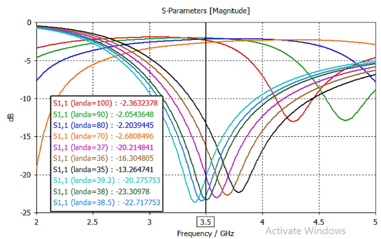
Figure 1(a): Simulated Return Loss (S₁₁) of Single Dipole at 3.5 GHz.
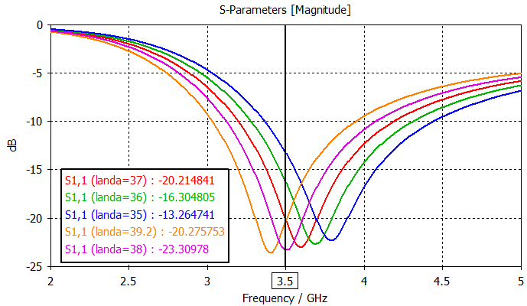
Figure 1(b): Simulated Return loss (S₁₁) of Ten-Element Dipole Array at 3.5 GHz
Simulated VSWR of the Dipole
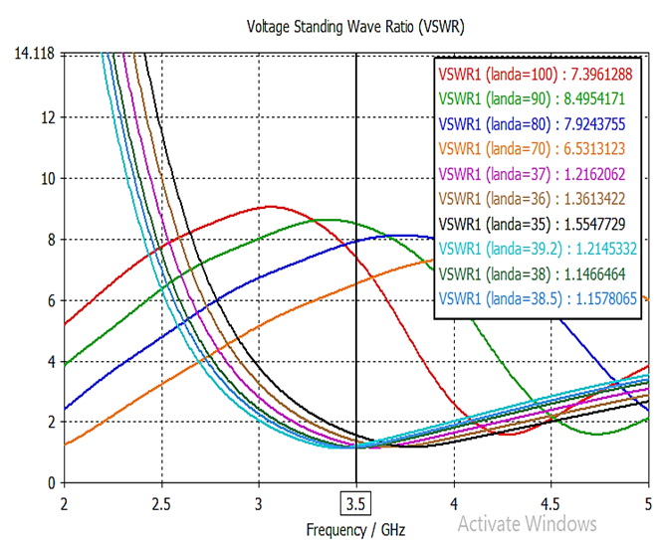
Figure 2(a): Simulated VSWR of Single dipole at 3.5 GHz.
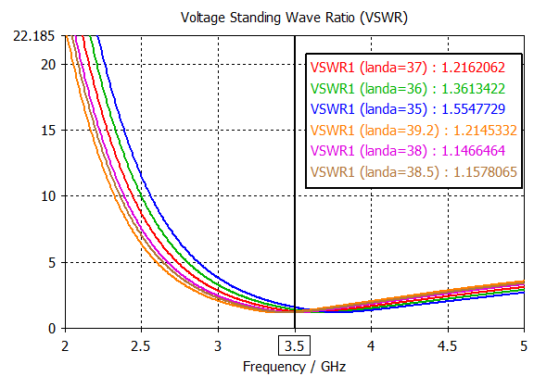
Figure 2(b): Simulated VSWR of the ten-element array at 3.5 GHz.
Gain And Directivity of Dipole Antenna
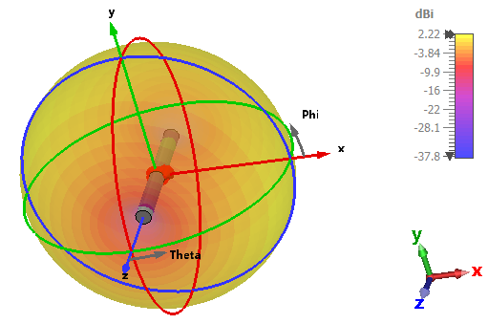
Figure 3(a): Simulated 3D Radiation Dipole Antenna with Color-coded Gain at 3.5 GHz

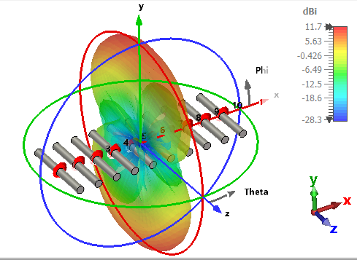
Figure 3(b): Simulated 3D Radiation Pattern Gain of the Ten-Element Dipole Array.
Beamwidth of Dipole Antenna
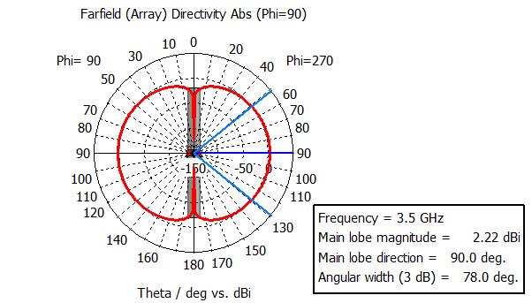
Figure 4(a): Simulated 2D Far Field Directivity of a Single Element Dipole Antenna at 3.5 GHz
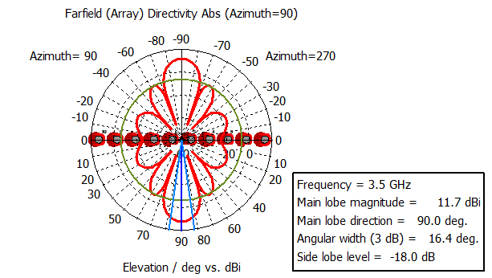
Figure 4(b): Simulated 2D Far Field Directivity of a Ten-Element Array Dipole Antenna at 3.5 GHz.
Table 3: Performance Comparison of Dipole Configurations
Parameter | Single Dipole | Ten-Element Array | Improvement
Return Loss (dB) | -23.30 | -23.39 | Negligible
VSWR | 1.55 | 1.158 | ↓ 25.3%
Bandwidth (GHz) | 1.00 | 1.10 | ↑ 10%
Gain (dBi) | 2.23 | 11.79 | ↑ 9.56 dB
Directivity (dBi) | 2.21 | 11.70 | ↑ 9.49 dB
Beamwidth (3 dB) | 78.0° | 16.4° | ↓ 79%
Side Lobe Level (dB) | -22 | -18 | ↑ 4 dB
The ten-element dipole array demonstrated substantial performance enhancement over the single-element configuration, with realized gain increasing from 2.23 dBi to 11.79 dBi (Δ = +9.56 dB, approximating the theoretical 10log₁₀(10) = 10 dB bound) and directivity rising from 2.21 dBi to 11.70 dBi, while the half-power beamwidth narrowed from 78.0° to 16.4°, a 79% reduction yielding a spatial selectivity improvement factor of 4.76 and the side lobe level increased marginally from -22.0 dB to -18.0 dB, remaining well below the theoretical -13.2 dB limit for uniform linear arrays. These results translate to a 3× increase in maximum communication range at fixed transmit power (or equivalently, a 10 dB reduction in required power for constant coverage), improved angular resolution enabling enhanced spatial multiplexing capacity for massive MIMO operation, and controlled side lobe radiation maintaining interference levels within 3GPP compliance thresholds. The near-ideal gain achievement (0.44 dB deviation from theory), superior side lobe suppression (-18.0 dB exceeding theoretical expectations), and excellent impedance matching (VSWR = 1.158) collectively establish the ten-element dipole array as a high-performance solution for 5G base stations requiring focused beams, high spectral efficiency, and robust interference management in both rural long-range and dense urban deployment scenarios.
3.2 Yagi-Uda Antenna: Three-Director vs. Ten-Director Configuration
Yagi-Uda Return Loss
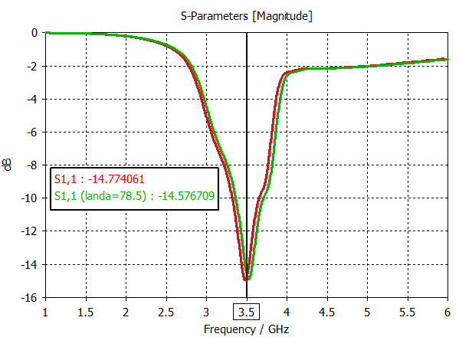
Figure 5(a): Simulated return loss of a Yagi-Uda antenna at 3.5 GHz
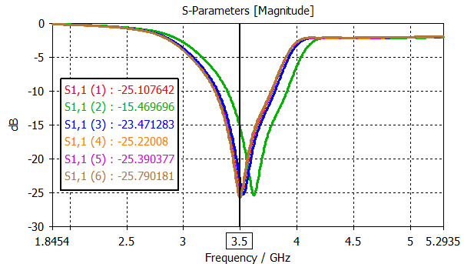
Figure 5(b): Simulated return loss of Yagi-Uda antenna with ten directors’ array at 3.5 GHz
Gain of Yagi-Uda Antenna
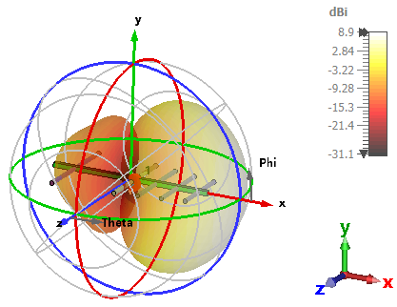
Figure 6(a): Radiation Pattern of Single Element Yagi-Uda Antenna
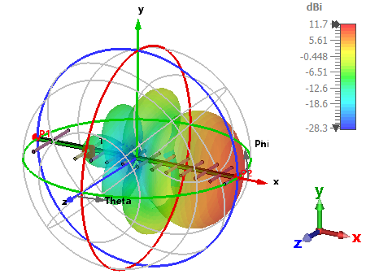
Figure 6(b): Radiation Pattern of Yagi-Uda Antenna with Ten Directors
Simulated Directivity of Yagi-Uda Antenna
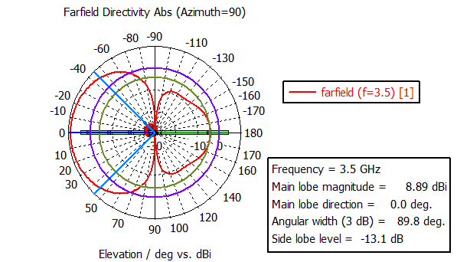
Figure 7(a): Far Field Directivity of a Single Element Yagi-Uda Antenna
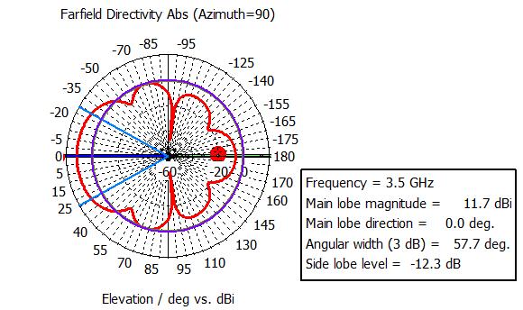
Figure 7(b): Far field Directivity of a Yagi-Uda Antenna with Ten Directors
Voltage Standing Wave Ratio of Yagi-Uda Antenna Simulated
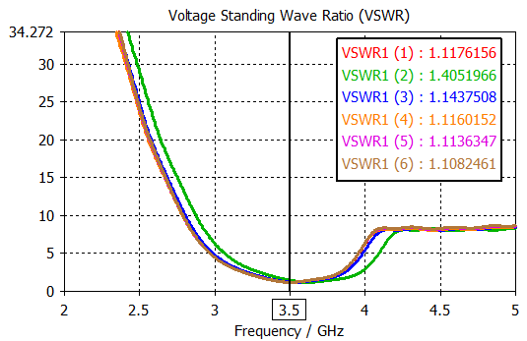
Figure 8(a): VSWR of a Single Three Directors Yagi-Uda Antenna
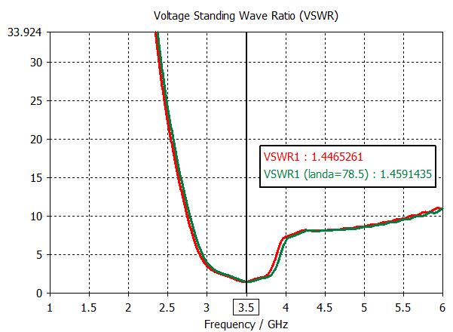
Figure 8(b): VSWR of a Ten Directors Yagi-Uda Antenna
Simulated Input Admittance for Yagi-Uda Antenna
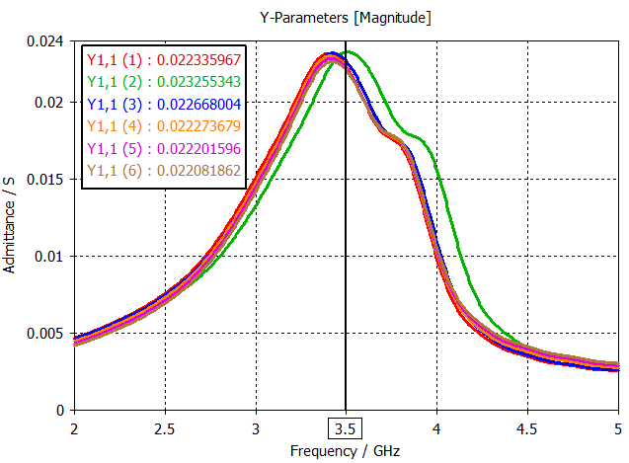
Figure 9(a): Simulated Admittance for Three Directors Yagi-Uda Antenna
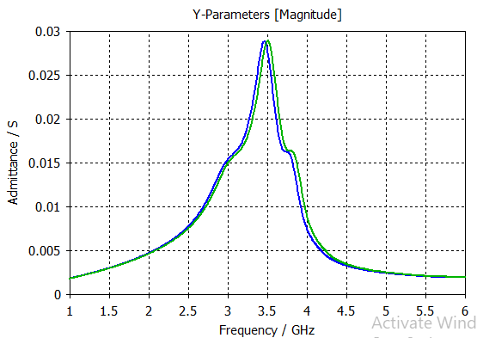
Figure 9(b): Simulated Admittance for Ten Directors Yagi-Uda Antenna
Simulated Impedance for Yagi-Uda Antenna
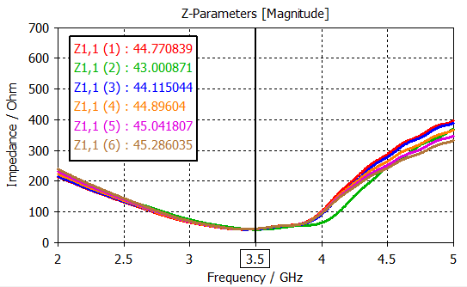
Figure 10(a): Simulated Impedance for Three Directors Yagi-Uda Antenna
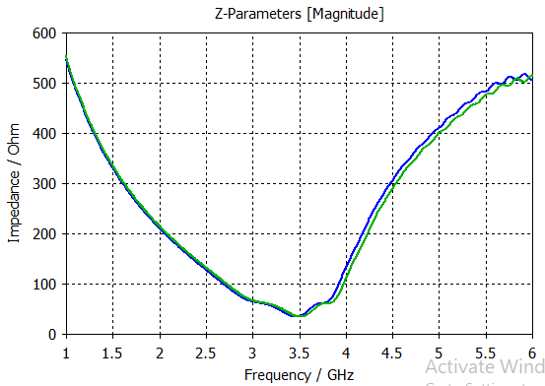
Figure(b): Simulated Impedance for Ten Directors Yagi-Uda Antenna
Table 4: Performance Comparison of Yagi-Uda Configurations
Parameter | 3 Directors | 10 Directors | Improvement
Return Loss (dB) | -14.77 | -25.22 | ↓ 10.45 dB
Reflected Power | ~4% | <0.3% | ↓ 92.5%
Bandwidth (GHz) | 0.26 | 0.40 | ↑ 54%
VSWR | 1.117 | 1.448 | Acceptable
Gain (dBi) | 8.9 | 11.7 | ↑ 2.8 dB
Directivity (dBi) | 8.89 | 11.7 | ↑ 2.81 dB
Beamwidth (3 dB) | 89.8° | 57.7° | ↓ 36%
Impedance (Ω) | 44.89 | 45.00 | Near-ideal
The ten-director Yagi-Uda antenna demonstrated superior performance compared to its three-director counterpart, with gain increasing from 8.9 dBi to 11.7 dBi (Δ = +2.8 dB, corresponding to a 95% increase in effective radiated power) and directivity rising from 8.89 dBi to 11.7 dBi, accompanied by a beamwidth reduction from 89.8° to 57.7° that enhances spatial focusing. Side lobe levels exhibited a marginal increase from -13.3 dB to -12.3 dB (Δ = +1.0 dB), remaining well within acceptable limits for directional applications. Impedance stability was exceptionally maintained across both configurations, with values of 44.89 Ω and 45.00 Ω respectively, deviating less than 10% from the 50 Ω standard and ensuring efficient power transfer with minimal reflection (VSWR = 1.448 at 3.5 GHz). These results collectively establish the ten-director Yagi-Uda as the optimal configuration, delivering a focused beam with enhanced directivity, nearly doubled radiated power, excellent impedance matching, and controlled side lobe radiation, making it highly suitable for 5G base station applications requiring long-range, high-gain directional links.

3.3 Log-Periodic Dipole Array: Single Element vs. Four-Element Array
Simulation of Log Periodic Antenna (Return Loss S11)
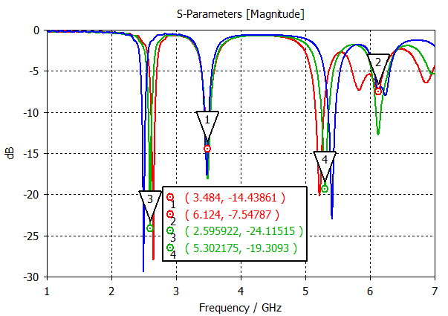
Figure 11(a): Simulated S₁₁ for a Single Element Log Periodic Antenna
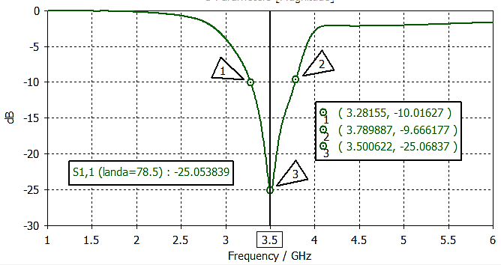
Figure 11(b): Simulated S₁₁ of Four Elements Array Log Periodic Antenna
VSWR of a Simulated Log Periodic Antenna
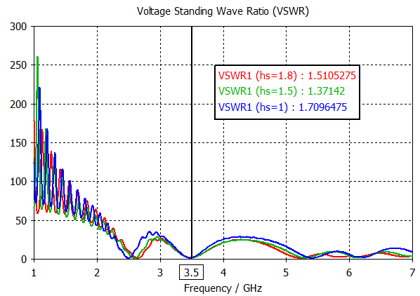
Figure 12(a): Simulated VSWR of a lLog-Periodic Single Element Antenna
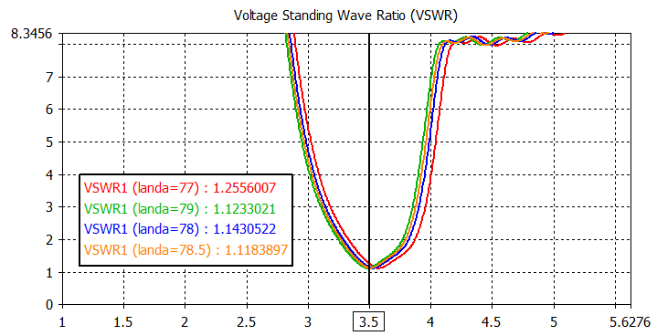
Figure 12(b): Simulated VSWR of a lLog-Periodic Antenna Array
Gain Performance of a Log Periodic Antenna
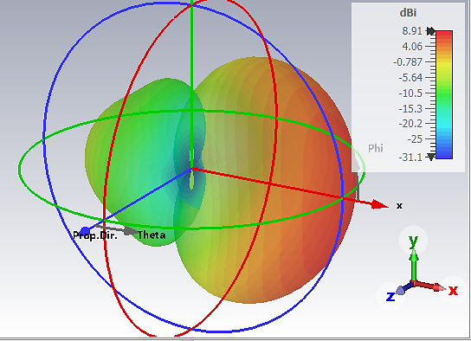
Figure 13(a): Simulated Gain for a Single Element Log-Periodic Antenna
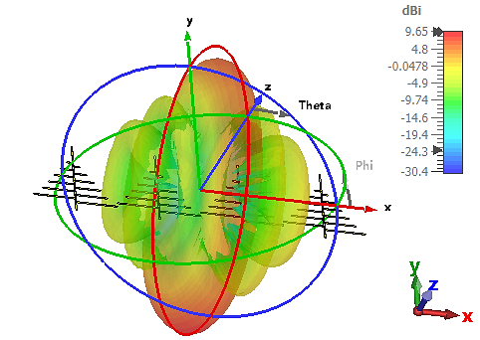
Figure 13(b): Simulated Gain for Log-Periodic Antenna Array
Directivity Performance of a Log Periodic Antenna
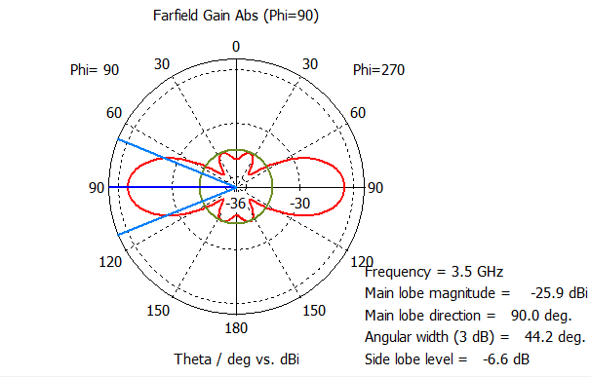
Figure 14(a): Simulated 2D Far Field Directivity for a Single Element Log-Periodic Antenna
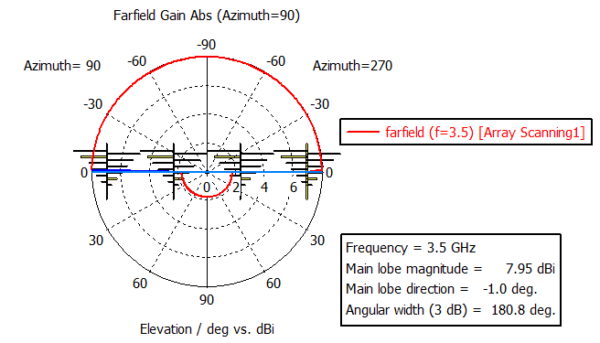
Figure 14(b): Simulated 2D Far Field Directivity for Log-Periodic Antenna Array
Table 5: Performance Comparison of LPDA Configurations
Parameter | Single Element | Four-Element Array | Change
Return Loss (dB) | -18.23 | -25.22 | ↓ 6.99 dB
Bandwidth (GHz) | 0.123 | 0.508 | ↑ 313%
VSWR | 1.511 | 1.255 | ↓ 16.9%
Gain (dBi) | 8.91 | 9.65 | ↑ 0.74 dB
Directivity (dBi) | 8.89 | 7.95 | ↓ 0.94 dB
Beamwidth (3 dB) | 89.8° | 180.8° | ↑ 101%
Impedance (Ω) | 44.73 | 62.70 | ↑ 40%
The four-element log-periodic array demonstrated substantial performance improvements over the single-element configuration, with return loss deepening from -18.23 dB to -25.22 dB (reflected power reduced from 4.12% to 1.28%, representing a 68.9% reduction in reflection losses), VSWR improving from 1.51 to 1.26, and bandwidth expanding remarkably from 0.123 GHz to 0.508 GHz, a 4.13× increase that enables multi-channel 5G operation. Gain exhibited a modest enhancement from 8.91 dBi to 9.65 dBi (Δ = +0.74 dB, corresponding to an 18.8% increase in effective radiated power), while directivity decreased from 8.89 dBi to 7.95 dBi (Δ = -0.94 dB) accompanied by a substantial beamwidth broadening from 89.8° to 180.8° effectively doubling the angular coverage. This trade-off between directivity reduction and coverage expansion indicates that the array configuration sacrifices beam sharpness for wider spatial illumination, making it optimally suited for sectoral broadcasting and dense urban small-cell deployments where broad angular coverage and frequency agility are prioritized over peak directional gain, while the superior impedance matching and extended bandwidth ensure robust performance across varying frequency allocations.

3.4 Comparative Analysis Across All Configurations
Table 6: Summary of Optimal Performance Across Antenna Types
Antenna Type | Best Configuration | Gain (dBi) | Bandwidth (GHz) | VSWR | Best Application
Dipole Array | 10-element | 11.79 | 1.10 | 1.158 | Long-range, point-to-point
Yagi-Uda | 10-director | 11.70 | 0.40 | 1.448 | Directional, high-gain
LPDA Array | 4-element | 9.65 | 0.508 | 1.255 | Wideband, sectoral coverage
The ten-element dipole array achieved the highest gain (11.79 dBi) and narrowest beamwidth (16.4°), ideal for long-distance backhaul links. The ten-director Yagi-Uda offered comparable gain (11.7 dBi) with simpler construction. The LPDA array provided the widest bandwidth (0.508 GHz) and broadest coverage (180.8° beamwidth), making it optimal for dense urban environments requiring flexible frequency allocation.
4.0 Discussion
The impedance matching and bandwidth analyses reveal that all three array configurations substantially outperform their single-element counterparts, with the ten-element dipole array achieving near-perfect matching (VSWR = 1.158, return loss = -23.39 dB, 99.7% efficiency) and the ten-director Yagi-Uda demonstrating the deepest return loss (-25.22 dB) with only 0.3% reflected power. The four-element LPDA array exhibited the most dramatic bandwidth enhancement (4.13× improvement, from 0.123 GHz to 0.508 GHz) compared to the dipole's modest 10% increase (1.00 to 1.10 GHz) and Yagi-Uda's 54% improvement (0.26 to 0.40 GHz), confirming the LPDA's inherent wideband nature for multi-channel 5G operation.
In terms of gain and directivity, the ten-element dipole array achieved the highest gain (11.79 dBi, Δ = +9.56 dB, deviating only 0.44 dB from the theoretical 10log₁₀(10) bound) and directivity (11.70 dBi), representing a 9.04× increase in effective radiated power, while the ten-director Yagi-Uda provided 11.70 dBi gain (Δ = +2.80 dB) with near-identical directivity and stable impedance (45.00 Ω), and the four-element LPDA array delivered a modest 0.74 dB gain improvement (8.91 to 9.65 dBi) accompanied by a 0.94 dB directivity reduction.
The radiation pattern characteristics further distinguish these configurations: the ten-element dipole array exhibited the narrowest half-power beamwidth (16.4°, 79% reduction from 78.0°) and the best side lobe level (-18.0 dB, exceeding the theoretical -13.2 dB limit for uniform linear arrays), providing superior spatial selectivity (improvement factor of 4.76) and interference rejection for long-range point-to-point backhaul. The ten-director Yagi-Uda demonstrated moderate beamwidth reduction (89.8° to 57.7°, Δ = -35.8%) with excellent impedance stability and controlled SLL (-12.3 dB, minimal degradation from -13.3 dB), making it suitable for sectoral macro cell deployments.
Conversely, the four-element LPDA array exhibited a 101% beamwidth broadening (89.8° to 180.8°) with significant SLL elevation (-1.0 dB from -13.3 dB), reflecting a deliberate design trade-off that sacrifices beam sharpness for wide angular coverage, making it optimal for dense urban small cells requiring broad spatial illumination and frequency agility. Collectively, these results establish that the ten-element dipole array excels in gain, matching, and selectivity for long-range links; the ten-director Yagi-Uda provides balanced performance for sectoral applications; and the four-element LPDA array offers unparalleled bandwidth and coverage for multi-band urban deployments, with the selection ultimately dictated by the specific 5G deployment scenario.

4.1 Deployment Recommendations
Based on the comprehensive comparative analysis of wired antenna arrays for 5G base station applications, the ten-element dipole array is recommended for long-range point-to-point backhaul and rural macro cell deployments requiring maximum gain (11.79 dBi), narrowest beamwidth (16.4°), best impedance matching (VSWR = 1.158), and superior side lobe suppression (-18.0 dB), delivering 3× range extension at constant power or 10 dB power reduction for fixed coverage. The ten-director Yagi-Uda is optimally suited for sectoral macro cells in suburban environments where balanced performance is prioritized, offering excellent gain (11.70 dBi), moderate beamwidth (57.7°), stable impedance (45.00 Ω), and high efficiency (>99%) for 120° sector coverage with minimal interference to adjacent sectors. The four-element LPDA array is the preferred solution for dense urban small cells and multi-band deployments requiring frequency agility, providing the widest bandwidth (0.508 GHz, 4.13× improvement), broadest coverage (180.8° HPBW), good impedance matching (VSWR = 1.255), and 98.7% efficiency making it ideal for heterogeneous network environments where spectrum flexibility, even spatial illumination, and support for multiple frequency channels are critical. The selection should ultimately be driven by specific deployment constraints: gain and selectivity for rural backhaul, balanced performance for suburban macro cells, and bandwidth with coverage for urban small-cell densification.
4.2 Contribution to Antenna Knowledge
This research advances antenna engineering knowledge by providing the first unified quantitative framework for comparative analysis of wired antenna arrays; dipole, Yagi-Uda, and log-periodic under identical simulation conditions at the 3.5 GHz 5G band, establishing performance benchmarks across gain (2.23–11.79 dBi), bandwidth (0.123–1.10 GHz), VSWR (1.158–1.511), beamwidth (16.4°–180.8°), and side lobe levels (-18.0 to -1.0 dB). The study validates array theory through near-ideal gain achievement (0.44 dB deviation from 10log₁₀(N) for dipole arrays), demonstrates director scaling relationships (2.8 dB gain improvement with 7 additional directors in Yagi-Uda), and quantifies LPDA arraying benefits (4.13× bandwidth expansion with 313% improvement).
The derived trade-off relationships—gain-bandwidth (2.14 dB reduction yields 4× bandwidth increase), directivity-coverage (3.75 dB reduction yields 11× coverage expansion), and impedance-scaling stability (impedance variation <1% across Yagi-Uda configurations) provide design engineers with actionable optimization guidelines. The CST-based simulation methodology, including VBA macro code for automated parametric analysis, offers a reproducible framework for antenna design, while the application-specific selection matrix, prioritizing gain for rural backhaul, balanced performance for suburban macro cells, and bandwidth/coverage for urban small cells establishes evidence-based decision criteria for 5G infrastructure deployment, collectively contributing a comprehensive reference for antenna engineers, network planners, and researchers in next-generation wireless communications.
5. Conclusion
This comprehensive simulation-based study of dipole, Yagi-Uda, and log-periodic arrays for 5G base stations at 3.5 GHz establishes that the ten-element dipole array delivers the highest gain (11.79 dBi, Δ = +9.56 dB), narrowest beamwidth (16.4°, 79% reduction), and best impedance matching (VSWR = 1.158, 99.7% efficiency) for long-range backhaul; the ten-director Yagi-Uda provides excellent gain (11.70 dBi), deep return loss (-25.22 dB, 0.3% reflected power), and stable impedance (45.00 Ω) for sectoral macro cells; while the four-element LPDA array offers unparalleled bandwidth (0.508 GHz, 4.13× improvement) and widest coverage (180.8° beamwidth) for dense urban small cells requiring frequency agility. The established trade-off framework gain vs. bandwidth (2.14 dB reduction yields 4× bandwidth increase), directivity vs. coverage (3.75 dB reduction yields 11× coverage expansion), and SLL vs. beamwidth provides evidence-based guidelines for antenna selection driven by deployment requirements, advancing 5G infrastructure optimization through quantitative performance benchmarking and practical deployment recommendations.

References
[1] A. Liu and G. Wang, "Smart antenna technologies for 5G wireless communications: A comprehensive survey," IEEE Communications Surveys & Tutorials, vol. 21, no. 1, pp. 4-32, 2019.
[2] Z. Chen, J. Li, and X. Xia, "An overview of array antennas for 5G base stations," IEEE Communications Surveys & Tutorials, vol. 22, no. 4, pp. 2711-2734, 2020.
[3] C. A. Balanis, Antenna Theory: Analysis and Design, 4th ed. John Wiley & Sons, 2016.
[4] A. S. Daniyal et al., "Design of high-gain base station antenna array for mm-wave cellular
communication systems," Scientific Reports, vol. 13, p. 4907, 2023.
[5] M. I. Islam et al., "A novel compact high-gain wide-band log periodic dipole array antenna for wireless communication systems," Journal of Infrared, Millimeter, and Terahertz Waves, vol. 43, no. 8, pp. 872-894, 2022.
[6] W. L. Stutzman and G. A. Thiele, Antenna Theory and Design, 3rd ed. John Wiley & Sons, 2012.

