Unity Narratives: A Semiotic Analysis of Petronas' Sepenuh Hati

ABSTRACT

Advertisements for National Day and Malaysia Day are a means of promoting national unity, social ideals, and patriotism. Advertisements create meanings that represent a country's identity and goals via the use of verbal and visual cues. Using Saussure's Semiotic Theory (1974), this study examines the unity narrative presented in Petronas' National Day and Malaysia Day short video Sepenuh Hati. The advertisement's content was analyzed using a qualitative method. The relationship between signifiers and signifieds present in the film's linguistic and visual components was examined in order to analyze the data. The results show that the Rukun Negara, educators, students from various ethnic backgrounds, the school setting, and the Malay language serve as important signifiers that produce meanings related to civic values, unity, social harmony, and national identity. The connection between these indicators creates a story that emphasizes how crucial it is to comprehend, internalize, and put shared ideals into practice in daily life. The investigation also demonstrates how awareness, appreciation, and group participation within the school community gradually shape the narrative of togetherness. The commercial presents unity as a value that transcends ethnic divides and fosters social cohesion through the character of Cikgu Murni and the relationships between pupils from various ethnic origins.Overall, the study demonstrates that Sepenuh Hati functions as an effective semiotic medium for communicating messages of unity through representations that are closely connected to the lived experiences of Malaysians. The findings also confirm that the construction of unity narratives in advertisements relies on the strategic use of signs that embody cultural meanings, national values, and a shared sense of identity.

Key Words: Rukun Negara, Unity Narrative, Semiotics, National Day, National Identity, Advertisement, Petronas
______________________________________________________________________________________________
1. INTRODUCTION
Malaysia’s ethnic, cultural, and religious diversity makes unity a fundamental pillar in the process of nation building. Within a multicultural society, continuous efforts to cultivate shared values, tolerance, and mutual respect are essential to maintaining social harmony. Unity not only contributes to social and political stability but also strengthens national identity and promotes the overall well-being of society (Ministry of National Unity, 2021; Wan Husin et al., 2022).
The media has evolved beyond its traditional role as a channel for delivering information and now plays an important role in shaping how people perceive, interpret, and understand the world around them. This transformation has been driven largely by advancements in communication technology. According to Edgerly (2022), audiences are not passive recipients of media messages; instead, they actively make sense of the information and narratives they encounter, which influences their understanding of social realities. In a similar vein, Saleem and Ismail (2025) contend that media contributes to the formation of social identity through the representations, narratives, and messages it communicates. As a result, media has become a powerful platform for transmitting social, cultural, and national values. In this regard, it can play a significant role in promoting unity by presenting narratives that emphasise togetherness, harmony, and a shared national identity.
One type of medium that can convey such messages by utilizing linguistic, narrative, and visual components is advertising. Unlike commercial commercials that focus largely on promoting products or services, National Day and Malaysia Day advertisements generally promote themes of patriotism, unity, and national identity via stories that are strongly tied to the experiences and reality of ordinary life.
According to a study by Ahmad, Saad, and Sarudin (2025), Merdeka advertisements by Malaysian businesses that emphasize corporate social responsibility (CSR) create narratives of unity. They accomplish this by depicting various civilizations coexisting peacefully, cooperating, and constructing the country. These results imply that ads can be very effective means of fostering a sense of unity and making the connection between national ideals and societal realities. Because they have the power to do so, advertisements play a significant role in shaping a nation's identity.
When it comes to corporate advertising in Malaysia, Petronas is one of the companies that often creates celebratory and patriotic ads that highlight the importance of humanity, family, and social cohesion. According to Nazri et al. (2025), Petronas Hari Raya commercials effectively tell the story of a father figure as a representation of tenacity, selflessness, and close family ties. The traditional cultural values of Malaysian society are reflected in this symbolism. Petronas adverts demonstrate the importance of advertising as a vehicle for communicating meanings that go beyond commercial purposes by integrating visual elements and storytelling to change audience understanding of the values being conveyed.
In conjunction with the 2025 National Day and Malaysia Day celebrations, Petronas released a short film entitled Sepenuh Hati (With All Our Hearts), which places the appreciation of the Rukun Negara at the center of its narrative. The story portrays a teacher’s efforts to help her students understand the true meaning of the principles of the Rukun Negara, which they routinely recite during school assemblies. Through interactions between the teacher and students from diverse backgrounds, the advertisement presents a range of visual and linguistic signs associated with unity, national identity, and civic responsibility.
A semiotic perspective holds that meaning is not inherent in a text but rather is produced by the relationship between signs and the concepts they represent. Semiotic analysis, therefore, enables academics to examine how language and visual elements in an advertisement function as signs that provide audiences with particular interpretations. While earlier research has examined the use of semiotics in advertising and narrative construction in corporate advertisements, there is still a dearth of studies that particularly concentrate on the development of unity narratives in Petronas National Day and Malaysia Day advertisements using a semiotic approach. Accordingly, this study adopts Saussure’s Semiotic Theory (1974) to explore the link between the signifier and the signified in the production of unity narratives provided in the short film Sepenuh Hati. In addition to enhancing academic conversations in the domains of semiotics, media, and national identity, it is hoped that this research will deepen our understanding of the function of signs in creating meanings of unity.

2. LITERATURE REVIEW
Any research project must include a literature review since it offers a thorough grasp of the ideas, theories, and earlier research pertaining to the subject being studied. The idea of unity narratives, the function of advertising as a vehicle for conveying social and national values, semiotic studies in advertising, and Saussure's Semiotic Theory, which provides the analytical framework, are the main topics of this study's literature evaluation. Examining earlier research strengthens the case for investigating the creation of unity narratives in Petronas National Day and Malaysia Day commercials by highlighting current findings, trends, and research gaps.

Unity Narratives in a Multicultural Society

Building a nation requires unity, especially in nations like Malaysia that are diverse in terms of ethnicity, culture, and religion. Unity in a multicultural community is the capacity of individuals from various origins to coexist peacefully, show respect for one another, and pursue shared ideals in the interest of the country. The Ministry of National Unity (2021) asserts that social stability and long-term national development are based on unity in diversity. As a result, efforts to promote unity must be consistently carried out through a variety of social institutions and communication channels.
Wan Husin et al. (2022) investigated the impact of education, economic variables, and religion on fostering ethnic cohesion among young Malaysians. These three areas considerably improve ethnic cohesion, according to their research. The report also highlighted the importance of religious tolerance, fair economic opportunity, and comprehensive education in promoting peaceful relations across Malaysia's ethnic communities. In this regard, the media is likewise seen as a significant force that may advance national identity and unity. Therefore, to ensure the longevity of harmony in a heterogeneous society, attempts to foster unity should follow a holistic approach including social, economic, and educational elements.

2.2 Advertising as a Medium for Communicating Social Narratives
According to developments in communication technology, advertising is now a platform for communicating social and cultural ideals rather than just a promotional instrument. Advertisements use language, imagery, and symbolic narrative to influence public opinions of social concerns in addition to promoting goods and services. Audiences actively participate in sensemaking processes based on their social and cultural experiences, claims Edgerly (2022). In a similar vein, Saleem et al. (2025) contended that audiences' exposure to media representations and narratives had a substantial impact on the development of social identities.
Audiences actively participate in sensemaking processes based on their social and cultural experiences, claims Edgerly (2022).
In Malaysia, National Day and Malaysia Day advertisements are frequently used to communicate messages of patriotism, unity, and national identity. Ahmad, Saad, and Sarudin (2025) found that Merdeka-themed Corporate Social Responsibility (CSR) advertisements produced by corporations such as Petronas, Tenaga Nasional Berhad (TNB), and Telekom Malaysia (TM) construct unity narratives through six major themes: multicultural harmony, collective resilience, intergenerational continuity, cultural celebration, nation-building, and everyday kindness. Their findings also showed that authentic ethnic representation and emotionally driven storytelling increased audience engagement with messages of unity. However, the researchers emphasized that high levels of digital engagement do not necessarily translate into deeper social cohesion. Therefore, while advertisements can shape national sentiment and communicate messages of unity, their long-term effectiveness in fostering social cohesion requires further investigation.

Although Ahmad et al. (2025) examined unity narratives in Merdeka-themed CSR advertisements, their study focused on multimodal and natural language processing analyses across various corporate advertisements. Consequently, there remains a need to examine more specifically how unity narratives are constructed through the relationship between signifiers and signifieds using Saussure’s semiotic framework. Accordingly, this study focuses on Petronas advertisement Sepenuh Hati to understand how meanings of unity are constructed through visual and linguistic signs.

Additionally, recent research shows that modern advertising increasingly depends on social connections and emotional appeal to affect audience response. It has been discovered that narratives that highlight unity, empathy, and shared experiences are more successful in building relationships between messages and target audiences. This concept emphasizes how advertising serves as a cultural communication medium that communicates identities and social values in addition to being a marketing tool.

2.3 Semiotic Studies in Advertising
A method for comprehending how meaning is created and conveyed through sign systems is semiotics. Signs in advertising can be words, pictures, colors, symbols, objects, characters, and behaviors that give audiences meanings. Researchers can determine the connection between signs and the meanings generated by communication processes by using semiotic analysis.
According to Sazan, Md. Yusoff and Karimon (2023) ads have parts that tell viewers something. They looked at posters. Found that when ads use both words and pictures it creates a certain meaning that helps people understand the message. This means that ads get their meaning not from text but also from lots of different visual parts. Nazri et al. (2025) Studied Petronas Hari Raya Aidilfitri commercials in Malaysia. They found that these ads create meaning using symbols and stories that are closely tied to what local communities experience in everyday life.The commercials use these symbols and stories to connect with people.The meaning, in these ads comes from the symbols and stories used. Their research showed that the language and visual components of Petronas commercials serve as signifiers, communicating particular meanings and influencing viewers' comprehension of the societal ideals being promoted. These results align with Mokhtar's (2023) brand communication study using Saussure's semiotic model. According to the study, audience perceptions of organizational messages are significantly influenced by signifiers and signifieds. Similarly, Prasetya (2025) contended that semiotic analysis is still applicable in the digital age because it clarifies the ways in which signs, symbols, and images are employed to form identities, evoke strong feelings, and affect audience response.
Overall, previous studies indicate that semiotics is an appropriate approach for examining how meanings are constructed in advertising texts. However, most existing studies focus on commercial advertising, brand communication, and cultural values, while research examining the construction of unity narratives in National Day and Malaysia Day advertisements through Saussure’s semiotic framework remains limited. Therefore, this study seeks to address this gap by examining the relationship between signifiers and signifieds in the construction of unity narratives in the Petronas National Day and Malaysia Day advertisement Sepenuh Hati.

3. RESEARCH OBJECTIVES
This study aims to:
i. Identify the signifiers used in the Petronas National Day and Malaysia Day advertisement Sepenuh Hati.
ii. Analyse the relationship between signifiers and signifieds in the construction of unity narratives presented in the advertisement.

4. RESEARCH METHODOLOGY
In order to analyze unity narratives in the Petronas National Day and Malaysia Day advertising Sepenuh Hati, this study uses a qualitative method utilizing content analysis. Because it is appropriate for comprehending and interpreting meanings ingrained in the verbal and visual components of media texts, a qualitative method was selected (Alyaqoub et al., 2024). The advertising Sepenuh Hati, which was purposefully chosen for the study's focus on togetherness, respect for the Rukun Negara, and interpersonal connections within Malaysia's multicultural culture, makes up the study's data. In order to identify scenarios, dialogues, symbols, texts, and visual aspects associated with the research theme, data were gathered through repeated observations of the advertising. Saussure's Semiotic Theory (1974), which highlights the connection between signifiers and signifieds in meaning production, was used to analyze the data. The advertisement's language and visual components are referred to as signifiers, and the meanings they convey are referred to as signifieds. To explain the unity narratives depicted in Sepenuh Hati, the study entailed locating signifiers associated with unity and evaluating the signifieds they produce. In order to illustrate the connection between signifiers, signifieds, and the meanings of unity created inside the commercial, the results are provided descriptively.

4.1 Research Sample
The commercial Sepenuh Hati (With All Our Hearts), created by Petronas in support of the 2025 National Day and Malaysia Day festivities, makes up the research sample. The advertising, which was directed by Ismail Kamarul, was chosen through purposive sampling because it emphasizes the concept of unity through images of Malaysia's multicultural population, teacher-student interactions, and admiration of the Rukun Negara. The commercial had received almost 9.5 million views on Petronas' official YouTube channel at the time of data collection. This advertisement can be analyzed using Saussure's Semiotic Theory (1974) to look at how unity narratives are constructed through the relationship between signifiers and signifieds because of elements like the Rukun Negara, students from various ethnic backgrounds, the school setting, and the use of the Malay language.
5. FINDINGS

According to an analysis of Petronas' National Day and Malaysia Day commercial Sepenuh Hati, unity narratives are created by utilizing a variety of linguistic and visual cues that are closely tied to national identity, values, and the realities of Malaysia's multicultural society. The signifier and the signified are the two primary parts of a sign, according to Saussure's Semiotic Theory (1974). The connection between these two elements creates significance, which in turn helps to build the advertisement's unification story.
5.1 Signifiers in Sepenuh Hati
The Rukun Negara, teachers, pupils from various ethnic backgrounds, the school setting, and the Malay language were found to be the five dominating signifiers in Sepenuh Hati.
5.1.1 The Rukun Negara
The Rukun Negara is the most prominent signifier in Sepenuh Hati. Students' recital of the Rukun Negara principles during the school assembly, as well as conversations and scenarios pertaining to their appreciation, directly present this signifier. The Rukun Negara is positioned as the main center of the story, making it the essential component that propels the advertisement's entire plot. Additionally, the recurring appearance of scenes with the Rukun Negara shows that it plays a crucial role in creating the message that is presented to the audience.

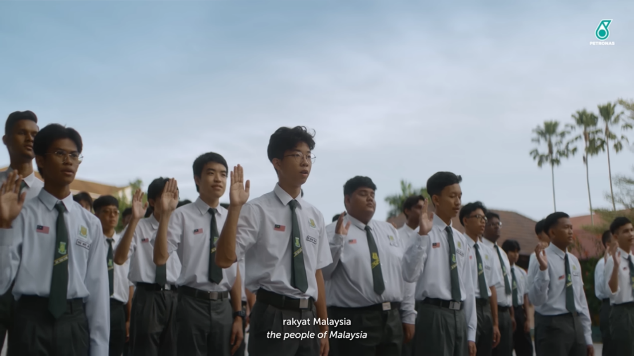
Figure 1. Selected scenes illustrating the recitation of the Rukun Negara.

5.1.2 Teacher
Through the character of Cikgu Murni, who is essential to the story's progression, the teacher acts as a signifier. She is portrayed as a someone who helps students comprehend the significance found in the Rukun Negara's tenets. Apart from being the primary character, the teacher's presence connects the message of the advertisement to the children's classroom learning experiences.


Figure 2. Representation of the character Cikgu Murni in the advertisement.

5.1.3 Students from Diverse Ethnic Backgrounds

Another signal that appears repeatedly in the narrative is the presence of students from different ethnic backgrounds. Students from many ethnic backgrounds, including Chinese, Indian, and Malay, can be observed participating in class discussions, activities, and social interactions. The diversity of Malaysian society, which is reflected in this signifier, is a crucial element of the social scene portrayed in the commercial.

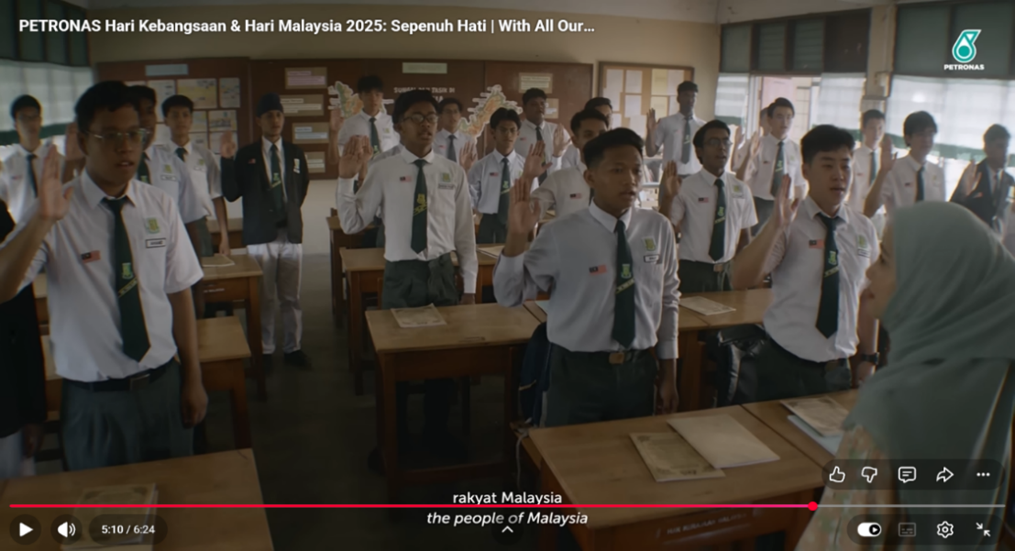
Figure 3: A classroom scene showing the presence of students from diverse ethnic backgrounds.

5.1.4 School

The main location in Sepenuh Hati is the school. The classroom setting, school grounds, and assembly area, which serve as the settings for the majority of the story's events, serve as representations of this signifier. The advertisement's main message is communicated through the school, which also acts as a venue for characters from various backgrounds to come together.

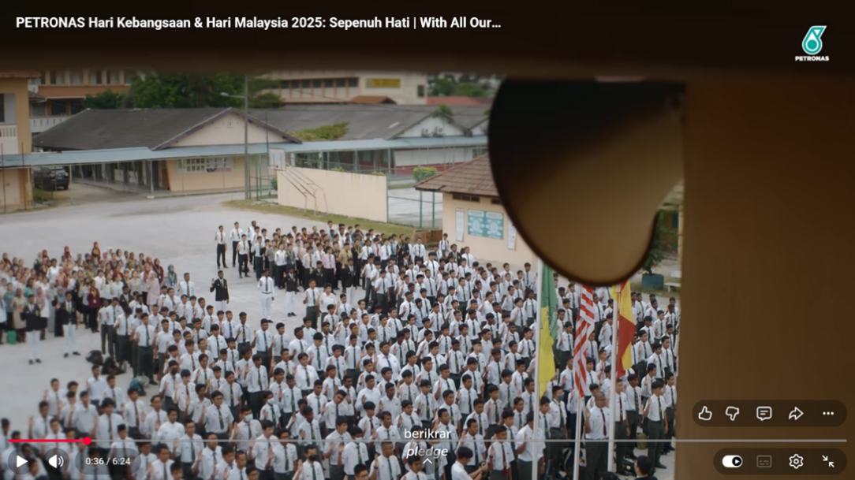
Figure 4: A Scene Depicting the School Assembly Area.

5.1.5 Malay Language

The advertising also identifies the Malay language as a significant signifier. Malay is the main language used in all conversations and exchanges between the characters. Both the delivery of messages pertaining to the Rukun Negara and the interactions between the teacher and pupils are examples of its utilization. The Malay language is used consistently throughout the story, establishing it as one of the primary signifiers assisting in the advertisement's meaning formation.

Overall, the study shows that the main signifiers underpinning the story of Sepenuh Hati are the Rukun Negara, teachers, students from various ethnic backgrounds, the school setting, and the Malay language. These signifiers serve as the foundation for the meaning building covered in the next section on signifieds and are constantly represented through verbal and visual components. According to Saussure's semiotic theory, these signifiers serve as the tangible representations used in the advertisement's unity story to generate deeper ideas and meanings.

5.2 Signifieds in Sepenuh Hati

Saussure (1974) defined a signified as the idea, concept, or meaning that a signifier conveys. This study uses interpretations of the verbal and visual components found in Sepenuh Hati to identify signifieds. According to the analysis, each signifier carries particular signifieds that are strongly related to patriotism, unity, and national identity. A deeper comprehension of the advertisement's messages is made possible by the link between signifiers and signifieds. Shared values and the basis of national unity, education as a tool for character development, harmony in variety, social integration and the creation of national identity, and unity through the national language are among the signifieds that have been identified.

5.2.1 Shared Values and the Foundation of National Unity

Shared values and the basis of national unity are the first signified identified. This concept refers to the existence of ideals and principles that society as a whole embraces as guidelines for national life. Regardless of variations in ethnicity, culture, or religion, similar ideals act as a basis for unity among citizens. These common ideals allow society to grow in respect for one another, sense of duty, and dedication to the welfare of the country. As a result, unity is presented as the result of adopting and upholding shared principles in society.

5.2.2 Education as an Agent of Character Formation

The function of education as a vehicle for social awareness and character development is the second signified. In addition to imparting knowledge, education helps to mold the values, morals, and sense of civic duty of the next generation. People are exposed to the ideals of unity, tolerance, and respect for one another through education, which serve as the cornerstones of a multicultural society. This implies that character development and learning procedures must be used to consistently foster unity.

5.2.3 Harmony in Diversity

The signified of harmony in diversity refers to society’s ability to accept and appreciate differences within social life. In Malaysia, ethnic, cultural, and religious diversity forms an integral part of national identity and contributes to the uniqueness of its society. The Ministry of National Unity (2021) explains that the concept of Unity in Diversity is fundamental to maintaining harmony and stability in Malaysia’s multicultural society. This concept emphasizes that diversity should not be viewed as an obstacle to unity but rather as a strength that enriches social and cultural life.

This signified illustrates that differences are not factors of division but sources of strength that contribute to building a more inclusive and harmonious community. According to Wan Husin et al. (2022), unity in a multiethnic society can be strengthened through tolerance, mutual respect, and positive social interactions. Therefore, harmony in diversity can be achieved when individuals embrace openness, respect differences, and build relationships based on mutual understanding and trust.

5.2.4 Social Integration and the Formation of National Identity

The creation of a sense of unity and belonging among citizens is referred to as social integration and national identity formation. When people from different origins communicate, exchange stories, and form wholesome bonds in their day-to-day lives, social integration takes place. The basis of national integration is social cohesion, which is strengthened and mutual understanding is fostered by harmonious social connections (Zakaria et al., 2022). This method helps people establish a sense of national identity in a multicultural culture by making them feel like they belong to a broader group, specifically Malaysians. Wan Husin et al. (2022) assert that tolerance, social interaction, and education can promote unity among many ethnic groups. Therefore, social integration plays a significant role in shaping a national identity grounded in togetherness, mutual respect, and shared aspirations.

5.2.5 Unity through the National Language

The final signified identified is unity through the national language. Language is a communication tool that facilitates interaction and mutual understanding between people from different origins. Language acts as a symbol of identity and common belonging in addition to being a tool for communication. In Malaysia, the Malay language is crucial for bringing individuals from all ethnic backgrounds together and creating a sense of national identity. All citizens, regardless of ethnicity or culture, have a shared communication space thanks to Malay's status as the national language. Social engagement is more successful when people speak the same language, which promotes comprehension and social integration. Yusof (2024) asserts that the Malay language serves as a means of bringing different populations together via a common language and sense of national identity. As a result, language not only transmits information but also fortifies Malaysians' sense of solidarity, togetherness, and national identity.

Overall, the signifieds found in this study show that social harmony, education, common ideals, integration, and the national language all work together to create unity. These signifieds imply that unity is a social process involving the internalization of values, identity formation, and shared experiences within society rather than just an abstract idea. According to Saussure's semiotic theory, these signifieds create the layers of meaning that support Sepenuh Hati's unity story.

5.3 Construction of Unity Narratives through the Relationship between Signifiers and Signifieds

According to Saussure (1974), the meaning of a sign is formed through the relationship between the signifier and the signified, enabling messages to be communicated and understood within specific social and cultural contexts. In Sepenuh Hati, the unity narrative is constructed through the integration of multiple signifiers and signifieds that complement one another throughout the narrative. The analysis reveals that the unity narrative develops progressively through situations closely related to Malaysian society. Signifiers such as the Rukun Negara, teachers, students from diverse ethnic backgrounds, the school environment, and the Malay language are linked with signifieds associated with shared values, education, social harmony, integration, and national identity. This relationship emphasizes that unity is not merely a slogan or a principle to be memorized, but a value that must be understood, appreciated, and practised. Several key scenes were identified as shaping the unity narrative through the relationship between signifiers and signifieds, illustrating how meanings of unity are constructed and communicated to audiences in Sepenuh Hati.

5.3.1 The Rukun Negara as the Foundation of the Unity Narrative

The unity narrative in Sepenuh Hati is established as early as the school assembly scene between minutes 0:30 and 0:59, where students recite the Rukun Negara together. Within Saussure’s semiotic framework (1974), the recitation of the Rukun Negara functions as a signifier that refers to the signified of shared values and the foundation of national unity. As a national ideology, the Rukun Negara provides a framework of values shared by Malaysians in their efforts to build a united, democratic, and harmonious society. Therefore, its inclusion in the opening scene positions unity as the central theme underlying the entire narrative.

Significantly, the recitation is led by a Sikh student. From a semiotic perspective, the selection of this character goes beyond narrative necessity and signifies inclusivity, equality, and a shared national identity. Although the Sikh community represents a minority group within Malaysian society, the student is entrusted with leading the recitation of the Rukun Negara, a symbol of the principles and values shared by all Malaysians. This portrayal suggests that the appreciation of national values and the responsibility of preserving unity transcend ethnic and cultural boundaries. This finding is consistent with the National Unity Policy, which emphasizes the concept of Unity in Diversity through acceptance and appreciation of diversity within society (Ministry of National Unity, 2021).


Figure 5: A Sikh Student Leading the Recitation of the Rukun Negara.

However, the advertisement does not merely portray the recitation of the Rukun Negara as a routine practice. At minute 0:40, Cikgu Murni is shown observing several students who appear inattentive and fail to fully appreciate the recitation. This scene introduces the initial conflict in the narrative and serves as the starting point for the advertisement’s central question: to what extent are the principles of the Rukun Negara truly understood and practised in everyday life? From a semiotic perspective, the teacher functions as a signifier that refers to the signified of education and character formation. This role suggests that the appreciation of unity values does not occur spontaneously but must be nurtured through education and the development of social awareness. This finding is consistent with Wan Husin et al. (2022), who argue that education plays an important role in strengthening unity through the cultivation of tolerance, mutual respect, and social responsibility among younger generations.

Furthermore, between minutes 0:40 and 0:59, three students from Malay, Chinese, and Indian ethnic backgrounds are portrayed teasing one another while the Rukun Negara is being recited. From a semiotic perspective, the presence of students from different ethnic groups functions as a signifier referring to the signified of harmony in diversity. Although their behaviour reflects a lack of attention to the recitation, their interaction takes place in a friendly atmosphere, free from prejudice or ethnic conflict. This scene suggests that harmonious social relationships already exist in their daily lives, even though their understanding of national values still requires strengthening. According to Wan Husin et al. (2022), unity in a multicultural society can be enhanced through positive social interactions and mutual respect among individuals from

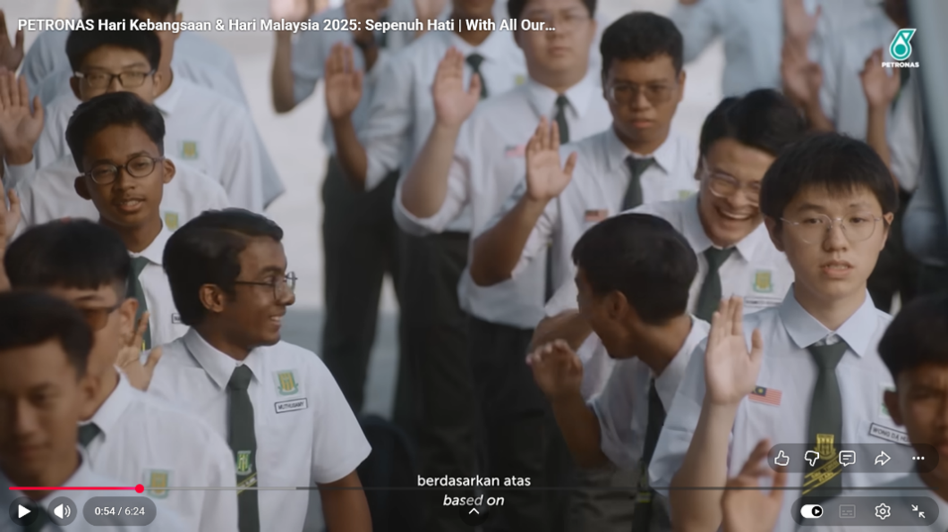
Figure 6: A Scene Showing Students Not Paying Attention During the Recitation of the Rukun Negara.

Overall, the school assembly scene between minutes 0:30 and 0:59 serves as the foundation of the unity narrative in Sepenuh Hati. Signifiers such as the recitation of the Rukun Negara, the Sikh student leading the recitation, the teacher, and students from diverse ethnic backgrounds generate signifieds related to shared values, inclusivity, education, and social harmony. This relationship constructs a narrative that unity is not merely something to be memorised, but rather something that must be understood, appreciated, and practised in everyday life.

5.3.2 Education as a Medium for Fostering Unity

The unity narrative in Sepenuh Hati continues to develop through a classroom scene that takes place between minutes 1:55 and 5:06. In this scene, Cikgu Murni seeks to help her students understand the true meaning of the pledge they recite every day. From Saussure’s semiotic perspective (1974), the character of Cikgu Murni functions as a signifier that refers to the signified of education and character formation. The relationship between this signifier and signified constructs a narrative that unity must be nurtured through an educational process that encourages understanding, appreciation, and the practice of values in everyday life. At minute 1:55, Cikgu Murni asks her students, “What did all of you recite during the assembly this morning?” Kenneth Yeong Tuck Wei responds at minute 2:05, stating that they recited the pledge. Subsequently, at minute 2:14, Cikgu Murni asks Muthusamy Karupiah how long they have been reciting the pledge, before Azim interjects at minute 2:31, replying that they have been doing so since Year One. This dialogue illustrates that the pledge has become part of the students’ daily routine. However, Cikgu Murni’s question at minute 2:40 whether they truly understand what they are reciting opens the door to reflection on the actual meaning of the pledge.


Figure 7: Cikgu Murni asking students about the pledge

This scene signifies that education is not merely a process of transmitting knowledge but also a means of cultivating awareness and appreciation of values among students. This finding is consistent with Wan Husin et al. (2022), who argue that education plays an important role in fostering tolerance, social responsibility, and unity within a multicultural society. In the context of this advertisement, the educational process portrayed goes beyond memorisation and instead emphasizes understanding the values that underpin a particular practice.

The climax of this scene can be observed between minutes 3:45 and 4:21, when Cikgu Murni explains the meaning of the pledge in a calm yet deeply reflective tone. She describes the pledge as a promise written to unite society, enabling people with differing views to understand one another, strangers to become like family, and enemies to become friends. During this explanation, the students are shown standing and focusing their attention on the text of the pledge printed on the back cover of their exercise books. This visual focus on the pledge functions as a signifier that reflects a process of reflection and understanding taking place among the students. Unlike the assembly scene at the beginning of the advertisement, where they recite the pledge without appreciation, this scene demonstrates a shift as the students begin to pay attention to the meaning behind the words they recite.


Figure 8: Students looking at the Rukun Negara text printed on the back of their exercise books

At the same time, using soft, quiet background music is crucial to establishing a deeply emotional mood. This aural component serves as a signifier from a semiotic standpoint, referring to the signifieds of awareness, appreciation, and contemplation of the ideals being communicated. Cikgu Murni's speech, the pledge's visual emphasis, and the poignant music all work together to produce a dramatic effect that invites viewers to consider the pledge's actual meaning. The discourse itself serves as a language signifier that alludes to the signifieds of social cohesion, understanding, and unity. The advertisement illustrates that unity is based on a shared commitment to understanding, respecting, and appreciating one another rather than just a shared identity through the use of visual, linguistic, and auditory aspects.

Cikgu Murni raises her hand between minutes 4:22 and 4:53, reciting her commitment to teaching her students with diligence as a teacher. This scene serves as an illustration of how educators must first model the ideals they teach their students. Semiotically speaking, this activity supports the idea that education is a process of creating values via dedication, sacrifice, and example. The close-up of Cikgu Murni’s tearful eyes while reciting the oath further communicates her sincerity and determination to completing her responsibilities as a teacher.

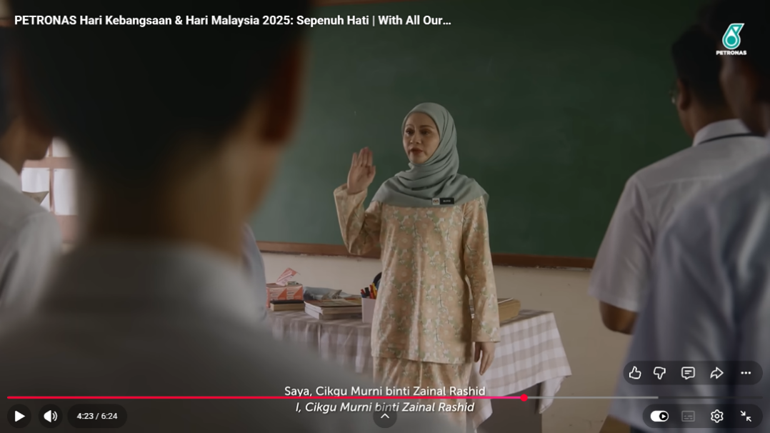
Figure 9: Cikgu Murni reciting her promise as a teacher

At minute 5:00, Azim willingly raises his hand and says the word "Pledge," and at minute 5:06, the other pupils follow suit, demonstrating the efficacy of this instructional process. Notably, Azim leads the recitation, which reverberates across the school premises. This change signifies a change from reciting the promise on a daily basis to truly understanding and appreciating it. From a semiotic standpoint, this behavioral shift shows that good education may foster understanding of the principles of solidarity and shared accountability among Malaysian residents.


Figure 10: Azim leading the recitation of the Rukun Negara pledge

All things considered, this school picture creates the impression that education is a vital tool for promoting harmony. The relationship between signifieds pertaining to awareness, responsibility, and unity and signifiers like the teacher, dialogue, pledge, and students' responses results in the meaning that unity cannot be established solely through memorization or ritual but rather through understanding and appreciation fostered through an ongoing educational process.

5.3.3 Internalising Shared Values within the School Community

The instructional process that occurs in the classroom is not the conclusion of Sepenuh Hati's unity story; rather, it becomes a common practice that is accepted by the entire school community. This is evident starting around minute 5:06, when Azim leads the other kids in reciting the promise. This picture illustrates how the pupils' appreciation of the commitment, which started out on an individual basis, progressively develops into a shared consciousness. From a semiotic standpoint, the students' group recitation serves as a signifier for the community's shared values, solidarity, and togetherness. According to Zakaria et al. (2022), social cohesion is formed when members of a community share common values, goals, and experiences, thereby creating a sense of belonging.

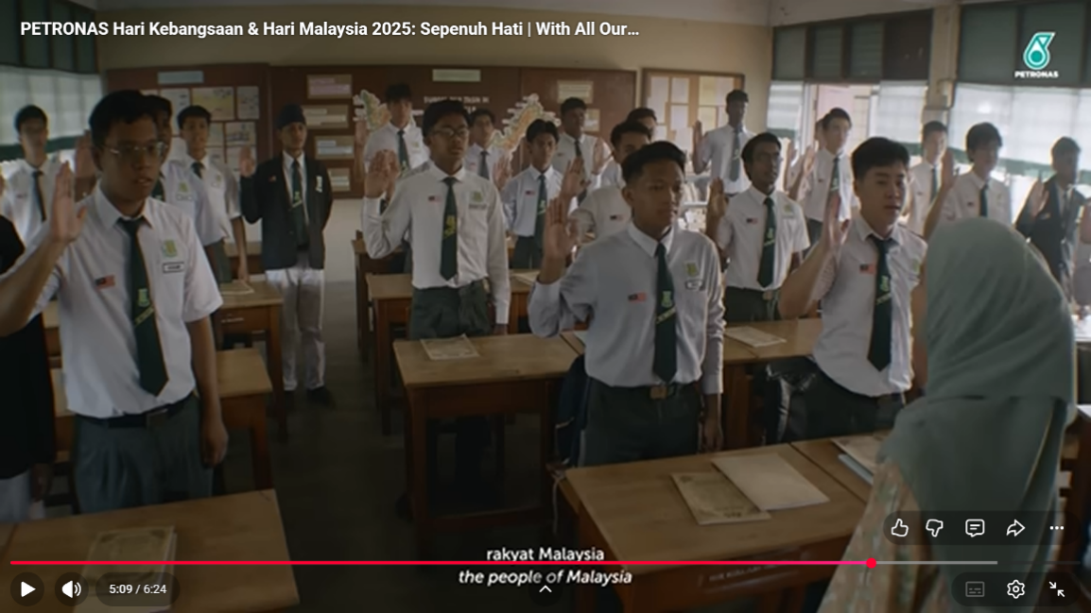
Figure 11: Students reciting the Rukun Negara in the classroom

The director moves the camera to a different classroom at minute 5:16, when the pledge recitation is also audible. The headmaster is then seen on camera listening to the vow being recited from the classroom at minute 5:17. This change in the camera's focus from one area to another shows how the message is now spread throughout the entire school setting rather than just a certain group of children. From a semiotic standpoint, this storytelling style serves as a visual signifier that alludes to the signifieds of value distribution and the growth of collective awareness among school community members. This result is in line with Edgerly's (2022) theory that media representations of common communal experiences might influence social meaning and collective identity.


Figure 12: A scene showing the pledge recitation being heard throughout the school grounds

Unity is effectively portrayed by Sepenuh Hati as a virtue that needs to be comprehended, valued, and used in daily life. This study highlights the ability of advertising to serve as a medium of social education that conveys messages of unity to society and shows that the semiotic approach is still applicable for analyzing meaning production in media. Future studies could examine how the advertisement's unifying messages are received by viewers.


Figure 13: The security guard reciting the Rukun Negara pledge

Overall, the scenario lasting minutes 5:06 to 5:49 establishes a narrative that unity does not stop at the level of individual knowledge but develops via the sharing of ideals throughout a community. Signifieds of unity, belonging, and shared responsibility are produced by the interaction of signifiers like the pledge recitation, the reverberating voices heard throughout the campus, the attention paid by members of the school community, and the security guard's involvement. This scene's narrative illustrates how a community becomes more cohesive when its members share and uphold the principles that they have internalized.
6. CONCLUSION

Overall, the results show that the link between signifiers and signifieds represented by the advertisement's visual, linguistic, and aural components constructs the unity story. Signifieds about common values, education, social harmony, and national identity are produced by signifiers such the Rukun Negara, educators, pupils from various ethnic backgrounds, the school setting, and the Malay language. The research also shows that awareness, appreciation, and the application of values are the methods by which the unity story gradually evolves. The engagement of the entire school community shows that togetherness arises from a shared understanding and appreciation of common ideals, while the character of Cikgu Murni serves as an instructional agent who helps students comprehend the true meaning of the vow.

Unity is effectively portrayed by Sepenuh Hati as a virtue that needs to be comprehended, valued, and used in daily life. This study highlights the ability of advertising to serve as a medium of social education that conveys messages of unity to society and shows that the semiotic approach is still applicable for analyzing meaning production in media. Future studies could examine how the advertisement's unifying messages are received by viewers.
.

REFERENCES
Ahmad, J., Saad, S., & Sarudin, N. (2025). Digital CSR Merdeka advertisements and national unity narratives: A multimodal and NLP analysis of Malaysian social media (2019–2023). TPM: Testing, Psychometrics, Methodology in Applied Psychology, 32(S8), 1854–1864. https://tpmap.org/submission/index.php/tpm/article/view/3019
Alyaqoub, R., Khan, M. A., Khan, M. H., & Abdullah, I. H. (2024). Elaboration of underpinning methods and data analysis process of directed qualitative content analysis for communication studies. Journal of Intercultural Communication, 24(2), 39–56.
Edgerly, S. (2021). The head and heart of news avoidance: How attitudes about the news media relate to levels of news consumption. Journalism. Advance online publication. https://doi.org/10.1177/14648849211012922
Mahadir, N. B., Osman, Z. J., Thambu, N., & Piang, T. B. (2019). Malaysian unity and integration aspiration: Enhancing cultural inclusiveness through investigating minority group identity experiences. International Journal of Academic Research in Business and Social Sciences, 9(10). https://doi.org/10.6007/ijarbss/v9-i10/6448
Ministry of National Unity. (2021). Dasar Perpaduan Negara. Ministry of National Unity. Dasar Perpaduan Negara
Mokhtar, Aida and Kasirye, Faiswal (2023) Gestalt and semiotic analyses of brand communication on disability inclusion: the case of Malaysia and the US. Intellectual Discourse, 31(1). pp. 83-111. https://doi.org/10.31436/id.v31i1
Nazri, N. A., Tuan Zaki, T. S. A., Abdullah, N. H., Mohamed Ibrahim, S. B., & Abdul Halim, M. Z. (2025). Iklan hari raya aidilfitri Petronas: suatu analisis terhadap pembinaan figura bapa melalui naratif semiotik. Journal of Human Development and Communication, 14, 37–53. https://doi.org/10.58915/johdec.v14.2025.2259
Petronas. (2024, April 4). Petronas Hari Kebangsaan & Hari Malaysia 2025: Sepenuh Hati With All Our Hearts Petronas. https://www.youtube.com/watch?v=PqMvsD2Cezo&t=29s
Rasha Alyaqoub, Alsharairi, A., & Muhammad Zammad Aslam. (2024). elaboration of underpinning methods and data analysis process of directed qualitative content analysis for communication studies. Journal of Intercultural Communication, 108–116. https://doi.org/10.36923/jicc.v24i2.573
Saleem, M., Ismail, I., Tsfati, Y., & Ramasubramanian, S. (2025). Testing the bi-directional influence of media and identity: A longitudinal study of Muslim American adolescents. Human Communication Research, 51(3), 153–163. https://doi.org/10.1093/hcr/hqaf011
Saussure, F. de. (1974). Course in General Linguistics (W. Baskin, Trans.). London: Fontana.
Sazan, D., Md Yusoff, M. Z. N., & Karimon, J. (2023). Analisis poster iklan Nescafe terpilih: Satu penelitian komunikasi visual. PENDET,14(2), 121–130. https://doi.org/10.37134/pendeta.vol14.2.10.2023
Teguh Iman Prasetya. (2025). The role of semiotics analysis in advertisement: Bibliometric analysis. Journal La Sociale, 6(3), 711–720. https://doi.org/10.37899/journal-la-sociale.v6i3.2029
Wan Husin, W. N., Samsudin, N. K. I., Zainol, N. A., Nordin, N. N. H., Mujani, W. K., Zainurin, S. J., & Mahmood, N. A. N. (2022). The influence of education, economy and religion domains in enhancing ethnic unity among Malaysian youths. Ethnicities, 22(6), 922–942. https://doi.org/10.1177/14687968221101401
Zakaria, J., Yaakob, A. F., & Zawawi, H. Y. (2022). social cohesion for community development in Malaysia: Impact to national integration. International Journal of Academic Research in Business and Social Sciences, 12(11). https://doi.org/10.6007/ijarbss/v12-i11/15651

‌

