Does Financial Inclusion Moderate Effects of CAMELS Financial Indicators on Financial Performance of Domestic Systemically Important Banks in Nigeria. Evidence from PLS-SEM.

Muhammad Bako
Department of Finance, Bayero University Kano.
mbako.fin@buk.edu.ng
Mu’azu Yunusa Riruwai
Department of Finance, Bayero University Kano.
myriruwai.fin@buk.edu.ng

Abstract
The surge of global financial crisis mostly caused by the failure of giant banks, which are commonly known as systemically important banks, spark the interest on studying the factors affecting the financial performance of such giant banks. This paper assesses the moderating effect of financial inclusion on the effects of CAMELS financial indicators on financial performance of domestic systemically important banks (DSIBs) in Nigeria. CAMELS is an acronym denoting capital adequacy, assets quality, management efficiency, earnings quality, liquidity and sensitivity to market risk. The paper used correlational research design to assess the relationship between the variables. Population of the study comprises all the five DSIBs in Nigeria as of 2023 which are; Access Bank, FirstBank, GT Bank, UBA and Zenith Bank. Census sampling technique was used to select all the five DSIBs. Financial reports between 2005 and 2023 of these five banks were used to extracts data on financial ratios based on the CAMELS parameters. Each of the CAMELS parameter was measured by three financial ratios while financial inclusion was measured by five proxies; branches, POS, ATM, BVN/Account No. and ATM/100000 adults. DSIBs financial performance was measured by return on assets, return on equity and return on capital employed. Pooled least square structural equation modelling (PLS-SEM) was used to analyzed the data and SmartPLS-4 software was used to run the analysis. The study found that capital adequacy, earnings quality, liquidity, sensitivity to market risk and financial inclusion significantly impacted on the DSIBs financial performance while assets quality and management efficiency were found to have insignificant effects on the DSIBs financial performance. Moderating effect of financial inclusion on the effects of CAMELS financial indicators on the financial performance of DSIBs in Nigeria was found to be insignificant. The paper recommends expansion in the level of financial inclusion in Nigeria by opening more bank branches, ATM and POS outlets especially in the underserved communities for better financial services delivery and increased financial performance of DSIBs.

Key words: CAMELS financial Indicators, Financial Inclusion, DSIBs Financial Performance, PLS-SEM.

1. Introduction
The global financial crisis of 2007 that emanated from United States (US) Mortgage Banks and spilled over to the rest of the world has affected the financial performance of many banks and other financial institutions which caused a radical change in the regulation and supervision of very big financial institutions that later came to be known as Systemically Important Financial Institutions (SIFIs). Before the 2007 global financial crisis, governments’ measures to tackle financial distress of big financial institutions was more of reactive than proactive (CBN, 2014). Reactive measure has to do with government’s effort to tackle financial distress by providing financial support from the treasury in form of bailout package to save large banks from failure. However, after the wave of contagion effect of the failing financial institutions spreads across jurisdictions, governments around the world decides to take proactive measure to prevent big and systemically important financial institutions from making risky investments that could jeopardize the stability of the financial system (Dogarawa, 2020).
In 2014, the Central Bank of Nigeria (CBN) developed guidelines for identifying, regulating and supervising domestic systemically important banks (DSIBs) in Nigeria. The guidelines provide four parameters for identifying DSIBs in Nigeria which are; size of the bank as defined by total assets, interconnectedness as defined by net interbank transactions, complexity as defined by branch network and number of foreign subsidiaries and substitutability which is defined as the ease with which an institution could be replaced (CBN, 2014). The CBN in 2014, using these criteria, identified eight (8) largest Nigerian banks as DSIBs. The identified banks were; First Bank of Nigeria Limited, Access Bank Plc, United Bank for Africa, Guaranty Trust Bank Plc, Zenith Bank Plc, Eco Bank Plc, Skye Bank and Diamond Bank (CBN, 2014). However, Diamond Bank was later acquired by Access Bank on first April, 2019. Also, the revocation of the banking license of Skye Bank by the CBN in 2019 due non-compliance with applicable laws and regulations brought the list of D-SIBs from eight to six (Sogunro, et al, 2021).
According to financial stability report of 2022, only five banks make the CBN’s list of DSIBs which are; First Bank of Nigeria Limited, Access Bank Plc, United Bank for Africa, Guaranty Trust Bank Plc and Zenith Bank Plc. These five D-SIBs accounted for N37.73 trillion (57.62 per cent) of the industry’s total assets of N65.48 trillion, N25.41 trillion (60.45 per cent) of the total industry’s deposits of N42.03 trillion and N15.22 trillion (56.25 per cent) of the aggregate industry credit of N27.06 trillion, (Financial Stability Report, FSR, 2022). These figures of market share of DSIBs made to them to be systemically important and their failure could have a contagion effect on the financial system in particular and consequent spillover effects on the entire economy. Hence, the importance of assessing the factors that affect the financial performance of DSIBs cannot be overemphasized. Financial performance can be viewed as the ability of bank to effectively and efficiently utilize assets at its disposal to generate profit and increase shareholders’ wealth.
CAMELS financial indicators is one of the parameters used to assess the financial performance of commercial banks initially introduced by Uniform Financial Institutions Rating System in 1997 (UFIRS, 1997). CAMELS is an acronym denoting capital adequacy, assets quality, management efficiency, earnings quality, liquidity and sensitivity to market risk. These are resources internal control by commercial banks and their variations affect the financial performance of banks (Alfaradi, 2023). Extant literature on relationship between CAMELS and banks’ financial performance documented a lot of inconsistency of findings (Maude and Dogarawa, 2016).
Because of inconsistency of findings on the relationship between CAMLES and banks’ financial performance, which is one of the reasons for introducing a moderating variable (Memon, et al., 2019), this paper introduced financial inclusion to assess its moderating effects on the effects of CAMELS financial indicators on the DSIBs financial performance in Nigeria. Financial inclusion refers to the availability and utilization of affordable and useful financial products and services provided for businesses and individuals to meet their needs, such as transactions, credit payments, and savings, and the delivery of these services to them in a responsible and sustainable manner. National Financial Inclusion Strategy (NFIS,2018) defined financial inclusion as “when adults in Nigeria have access to a broad range of formal financial services that are affordable, meet their needs and are provided at an affordable cost”.
Based on the foregoing, this paper aimed to assess the moderating effect of financial inclusion on the effects of CAMLES financial indicators on financial performance of DSIBs in Nigeria between 2005 and 2023 using resource-based view and stakeholder theories as its underpinning theories. Resource-based view theory explains how effective and efficient utilization of firm’s internal resources can generate and increase profitability of the firm. All CAMELS financial indicators are resources internally owned and controlled by the D-SIBs and therefore, effective utilization of CAMELS by D-SIBs could improve their financial performance. Also, stakeholder theory explains how a firm can grow and develop by taking care of the interest of all its stakeholders including customers. Therefore, increasing access to modern financial services through increased financial inclusion can increase customer-base of D-SIBs which in turn increase the effectiveness of CAMELS in impacting their financial performance.
2. Literature Review and Hypotheses Development
Capital Adequacy and Banks’ Financial Performance
Previous empirical studies on the relationship between CAMELS financial indicators and banks’ financial performance have documented different and inconsistent findings on the direction, nature and significance of this relationship. Starting with the relationship between capital adequacy and banks’ financial performance, capital adequacy ratio shows the internal strength of the bank to withstand losses during crisis. It is directly proportional to the resilience of the bank to crisis situations (Ongore & Kusa, 2013). It has also a direct effect on the profitability of banks by determining its expansion to risky but profitable ventures or areas (Sangmi and Nazir, 2010). Mathuva (2009), while analyzing the effects of capital adequacy on the performance of commercial banks in Kenya, found positive effect of capital adequacy on the performance of Kenyan commercial banks. Jha & Hui (2012) also found significant effect of capital adequacy on the financial performance of Nepalese commercial banks while Onalapo and Olufemi (2012) found no significant effect of capital adequacy on financial performance of Nigerian commercial banks. Dogarawa, et al., (2020) and Alfaradi (2023) found positive and significant effect of capital adequacy on banks’ financial performance. Based on resources-based view theory and these findings, this paper hypothesized that;
H_{o1}: Capital adequacy has no significant effect on DSIBs financial performance in Nigeria
Assets Quality and Banks’ Financial Performance
Assets of banks comprise loans and advances to private individuals, business entities and government agencies. Because interest income coming from loans and advances constitute the major sources of income to banks, loans and advances therefore constitute the major assets of banks. Quality of assets is commonly measured by non-performing loans to total assets (Dogarawa, et al, 2020) and non-performing loans to total loans (Moon, 2018). Dabaghie and Rajha (2019) found significant effect of assets quality on the financial performance of Saudi commercial banks. While Dembel (2020) found significant effect of assets quality on Ethiopian commercial banks between 2010 and 2018, Ashena (2020) found insignificant effect of assets quality of same Ethiopian banks between 2016 and 2020. Based on resources-based view theory and these findings, this paper hypothesized that:
H_{o2}: Assets quality has no significant effect on DSIBs financial performance in Nigeria
Management Efficiency and Banks’ Financial Performance
Management efficiency is used to measure efficiency and effectiveness of the bank’s management. Success or failure of any organization largely depends upon managerial capability regarding business affairs. The higher the managerial efficiency, higher will be the organizational success and vice versa. Gautam (2020) used Credit to Core Capital and Deposits (CCD) to measure management efficiency. Jimor and Attah and Abdul (2021) and Kasa (2021) measured management efficiency with Cost-to-Income ratio while Dogarawa, et al., (2020) measured it with non-interest expenses to non-interest income. Brito, Pignanelli and csillag (2008), Nguyen and Nguyen and Pham (2020), Nyakieni et al (2022), Suman & Suwati (2023) and Harsono, (2024) all found significant positive effect of management efficiency on banks’ financial performance. Paul and James (2020) found negative effect of management efficiency on financial performance of Rwandan commercial banks. Also, Kandel (2019) found insignificant effect of management efficiency on financial performance of Nepalese banks. Based on resources-based view theory and these findings, this paper hypothesized that:
H_{o3}: Management efficiency has no significant effect on DSIBs financial performance in Nigeria
Earnings Quality and Banks’ Financial Performance
The quality of a bank's earnings represents an important criterion that determines its ability to earn consistently. It evaluates the profitability of a bank and explains its sustainability and growth in earnings in future (Nimalathasan, 2008). High earnings quality should reflect the firm’s current operating performance and a good indicator of future operating performance. The quality of earnings is an extremely significant parameter which expresses the quality of profitability and capability of a bank to sustain quality and earning consistently (Aspal & Dhawan, 2016). It is measured by net interest income to total loan and advances, net profit to total shareholders’ equity and net profit to net interest income. Kandel (2019), Utami, et al (2019), Thisaranga, & Ariyasena (2021) and Shrestha & Gnawali (2022) all found significant effect of earnings quality on banks’ financial performance. Based on resources-based view theory and these findings, this paper hypothesized that:
H_{o4}: Earnings quality has no significant effect on DSIBs financial performance in Nigeria
Liquidity and Banks’ Financial Performance
Liquidity refers to the ability of a bank to meet its short-term obligations and ability to meet own loan commitment. FDIC (2019) defined liquidity as to the ability of a bank to fund assets and meet financial obligations as they come due. It is measured by cash and liquid assets to total deposits ratio, liquid assets to total assets (Kasa, 2021), loan-to-deposit ratio (Istanti, et al 2022 and Dogarawa, 2020 and Crowley et al 2022). Owolabi, Obiakor and Okwu (2011), Awan (2014) and Minh, Tho and Tuan (2022) all found significant effect of liquidity on banks’ financial performance while Rehman, Khan and Khokhar (2015) and Sahyouni and Wang (2019) found insignificant effect of liquidity on banks’ financial performance. Based on resources-based view theory and these findings, this paper hypothesized that:
H_{o5}: Liquidity has no significant effect on DSIBs financial performance in Nigeria
Sensitivity to Market Risk and Banks’ Financial Performance
Sensitivity to market risk is defined as the extent to which earnings or capital of a financial institution will be adversely affected due to changes in interest rates, foreign exchange rates, commodity prices, or equity prices (FDIC, 2019). It is measured by net interest-income to total assets, total reserves to total assets and total investment to total assets (Abuzarqa, 2022), interest-sensitive assets and interest-sensitive liabilities (Jearah, et al., 2020). Significant effect of sensitivity to market risk on banks’ financial performance has been found by many studies; Ekinci (2016), Frank (2022) and Yousef and Taha and Mahmud and Abidin (2023) while Taiwo, et al (2021) and Orjinta and Ighoseye (2022) found insignificant effect of sensitivity to market risk on banks’ financial performance. Based on resources-based view theory and these findings, this paper hypothesized that:
H_{o6}: Sensitivity to market risk has no significant effect on DSIBs financial performance in Nigeria.
Financial Inclusion and Banks’ Financial Performance
Financial Inclusion is the process of increasing the number of bankable populations among adults by providing easy access to various formal financial services that meet peoples’ expectation and are provided at affordable prices. It is measured by branches, ATMs, POS, account number/BVN, ATMs/100000 adults. Several studies found positive and significant effects of financial inclusion on banks’ financial performance; Wairumi and Omagwa (2020), Shahideh (2021), Muhammad (2022), Khatib et al (2022) and Nasution and Kamilah and Rahmani (2024). While Sari and Rayahu and Ridwan (2023) found insignificant effect of financial inclusion on banks’ financial performance. Based on stakeholder theory and these findings, this paper hypothesized that:
H_{o7}: Financial inclusion has no significant effect on DSIBs financial performance in Nigeria.
Moderating Effect of Financial Inclusion on Banks’ Financial Performance
A number of previous empirical studies assessed the moderating effects of financial inclusion on the relationship between one or more independent variables and financial performance of commercial banks and they found varying significant moderating effect of financial inclusion on the relationship. Yang and Masron (2023) assessed the moderating effects of financial inclusion on the relationship between digital transformation and financial performance of Chinese commercial banks and found that digital transformation and financial inclusion interact significantly, demonstrating that their combined influence increases the profitability of commercial banks. Dzombo, et al (2018), Zulkieflimansyah et al. (2020), Riwayati et al. (2020), Shihadeh and Liu (2019) and Murauni and Gichure (2019) all found significant moderating effect of financial inclusion on financial performance of commercial banks in their respective jurisdictions. While Anastesia et al. (2020) found no significant moderating effect of financial inclusion, measured by account numbers, on the financial performance of commercial banks in Nigeria. Based on stakeholder theory and these findings, this paper hypothesized that:
H_{o8}: Financial inclusion has no significant moderating effect on DSIBs financial performance in Nigeria.
Conceptual Framework of the Study

Capital Adequacy
Assets Quality
D-SIBs Financial Performance (ROA, ROE)
Management Efficiency

Liquidity
Financial Inclusion
Earnings Quality
Sensitivity to Market Risk

Figure 1: Conceptual framework of the study (Source: Author’s literature review).
Figure 1 above presents the relationship that exist between the three variables of the study; independent variables which are the six components of CAMELS financial indicators, the moderating variable which is financial inclusion and dependent variable which is D-SIBs financial performance. The arrow that connected the dependent and independent variables shows direct relationship between the variables while the arrow that connected financial inclusion and halfway of the arrow that shows direct relationship indicates the moderating effect of financial inclusion on the direct relationship between dependent and independent variables of the study.
3. Methodology
The paper used correlational research design to assess the relationship between the variables. Population of the study comprises all the five DSIBs in Nigeria as of 2023 which are; Access Bank, FirstBank, GT Bank, UBA and Zenith Bank. Census sampling technique was used to select all the five DSIBs. Financial reports between 2005 and 2023 of these five banks were used to extracts data on financial ratios based on the CAMELS parameters. Each of the CAMELS parameter was measured by three financial ratios while financial inclusion was measured by five proxies; branches, POS, ATM, BVN/Account No. and ATM/100000 adults. DSIBs financial performance was measured by return on assets, return on equity and return on capital employed as presented in table 1.
Table 1: Measurement of the Study Variables
Variables | Symbol | Selected Ratios for Measurements
Financial Performance (FP) | ROA | Net Profit/Total Assets
 | ROE | Net Profit/Shareholders’ Equity
 | ROC | Net Profit/Total capital employed
Financial Inclusion  (FIN) | F1 | Banks’ Branches
Financial Inclusion  (FIN) | F2 | Point of Sales (POS)
Financial Inclusion  (FIN) | F3 | Number of ATMs/ per 100,000 persons
Financial Inclusion  (FIN) | F4 | Number of ATMs (Access)
Financial Inclusion  (FIN) | F5 | BVN Enrollment (Affordability)
Capital adequacy (CAR) | C1 | Equity / Risk Weighted Assets
Capital adequacy (CAR) | C2 | Total Equity/ Total Liabilities (TE/TL)
Capital adequacy (CAR) | C3 | Total Equity/Total Debt
Asset quality (AST) | A1 | Total of loan loss provision/ Total loans
Asset quality (AST) | A2 | NPLs/ Total Assets (NPLs/TA)
Asset quality (AST) | A3 | Total loans / Total assets (TL/TA)
Management Efficiency (MGT) | M1 | Operating expenses/Operating Income
Management Efficiency (MGT) | M2 | Cost-to-income ratio
Management Efficiency (MGT) | M3 | Interest Expense/ Net Profit.
Earnings Quality (ERN) | E1 | Interest income/Interest expenses
Earnings Quality (ERN) | E2 | Operating profit/ Total revenue
Earnings Quality (ERN) | E3 | Recurrent Operating income/Total income
Liquidity (LQT) | L1 | liquid assets / Short term liabilities
Liquidity (LQT) | L2 | Cash & cash equivalents / Total assets
Liquidity (LQT) | L3 | Total Loans / Total Deposits
Sensitivity to Market Risk (SEN) | S1 | Interest Bearing Assets / Total Assets
Sensitivity to Market Risk (SEN) | S2 | Interest Bearing Income/Total Assets
Sensitivity to Market Risk (SEN) | S3 | Interest Bearing Liabilities/Total Assets
Source: Extracted from the Author’s literature review
Pooled least square structural equation modelling (PLS-SEM) was used to analyzed the data. The choice of PLS-SEM is in line with Abdulrahaman, (2023) and Aliyu (2024). Although the sample size (five D-SIBs) is small but it is a representative sample because census sampling technique was used to select all the members of the population. Also, the population from which the sample was drawn is not heterogeneous and therefore large sample size is not necessary (Hair, et al., 2018).
Three functional equations and three structural models were developed to represents the relationship between the variables of the study. The functional relationships of PLS-SEM are;
Y_{i} = (X_{i1}, X_{i2,} X_{i3},…., X_{it})
Y_{i} = β_{o} + β₁X_{i1} + β₂X_{i2} + β₃X_{i3} + ….. + β_{n}X_{in} + ε_{in}---------------------------------------------------(1)
FP_{i} = β0 + β1CARit + β2ASTit + β3MGTit + β4EARit + β5LQTit + β6SMRit + ɛit--------------------------------(2)
FP_{i} = β0 + β1CARit + β2ASTit + β3MGTit + β4EARit + β5LQTit + β6SMRit + β7FINit+ ɛit----------------(3)
FP_{i} = β0 + β1CAR_{it}*(FIN)it + β2AST_{it}*(FIN)it + β3MGT_{it}*(FIN)it + β4EAR_{it}*(FIN)it + β5LQT_{it}*(FIN)it + β6SMR_{it}*(FIN)it + ɛit-------------------------------------------------------------------------------------------(4)
CAR represent capital adequacy, AST represent assets quality, MGT represent the management efficiency, EAR represent the earnings quality, LQT represent liquidity and SMR represent sensitivity to market risk. FIN represent financial inclusion, βs in the models represent the coefficients of the respective explanatory variables. εit is a random error term or dummy variable that captures all other factors that determines banks profitability not captured by the models. The structural relationship between the dependent, independents and the observed variables is presented on figure 3.1.
Figure 1: Structural Relationship Between CAMELS and DSIBs Financial Performance
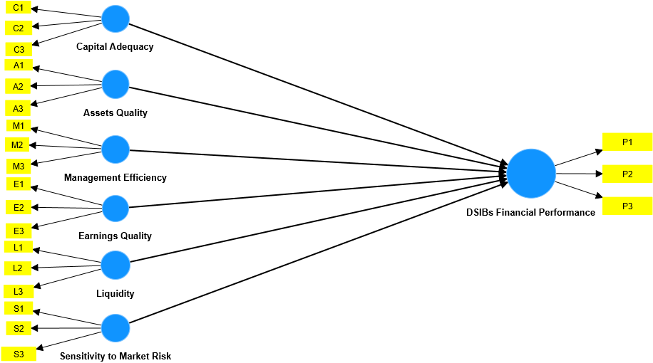
Source: Designed by the Author using SmartPLS-4
Figure 1 shows two types of the structural relationship between the latent variables and their measurements which were structured based on variables measurement presented in table 1 above. The outer model or measurement model presents relationship between latent variables (CAMLES) and their respective observed variables or indicators while inner or structural model presents relationship between endogenous latent variable (DSIBs financial performance) and exogenous latent variables (CAMELS). Figure one is structural representation of equation 2.
Figure 2: Structural Relationship Between CAMELS, Financial Inclusion and DSIBs Financial Performance.
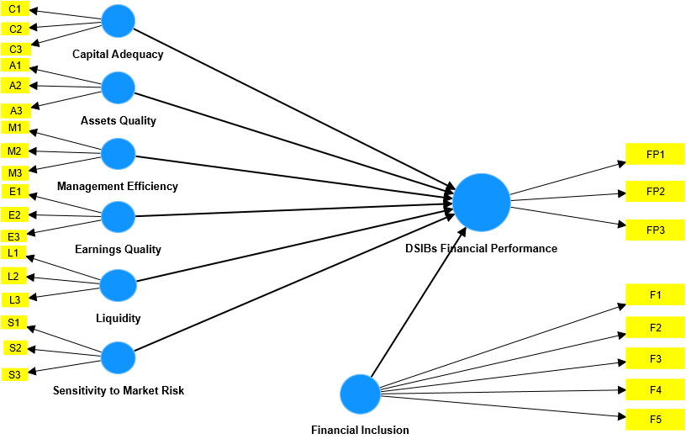
Source: Designed by the Author using SmartPLS-4
Figure 2 shows financial inclusion as another independent latent variable while figure 3 presents financial inclusion as a moderating variable between CAMELS and DSIBs financial performance.
Figure 3: Moderating Relationship Between CAMELS, Financial inclusion and DSIBs Financial Performance
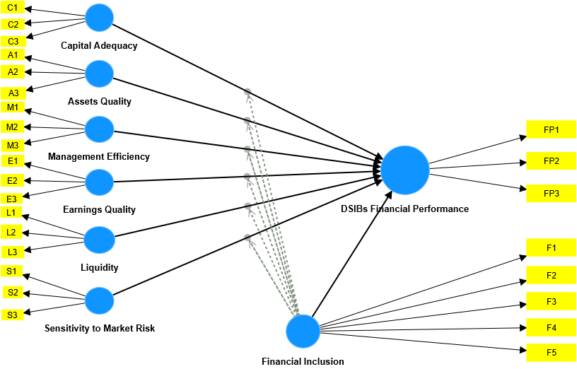
Source: Designed by the Author using SmartPLS-4
Structural model in figure 2 represents functional equation 3 while structural model in figure 3 represents functional equation 4.
4. Data Analysis
Analyzing PLS-SEM results involves assessing both measurement or outer model and structural or inner model. Outer model assessment involves assessing reliability, internal consistency, convergent and discriminant validity of the indicators. Reliability of the observed variables or indicators shows the extent to which each individual indicators measured the latent variable or construct it intent to measure and it is achieved if the loading of all the indicators is at least 0.5 or 0.7 (Hair, et al., 2014; Aburumman, et al., 2023). From the results of the outer model presented in figure 4 below, all the twenty-six indicators of all the latent variables are greater than the threshold of 0.5 and therefore, reliability of the indicators is achieved resulting to no deletion. Similarly, internal consistency which shows the consistency of indicators in measuring a particular construct is achieved if the scores of Cronbach’s alpha, rho_A or rho_C is at least 0.7 (Fornell and Larcker, 1981; Dijkstra and Henseler, 2015; Aliyu, 2024). From table 2 which presents the result of internal
Figure 4: PLS-SEM Outer Model Results of the Measurement Model with a Moderator
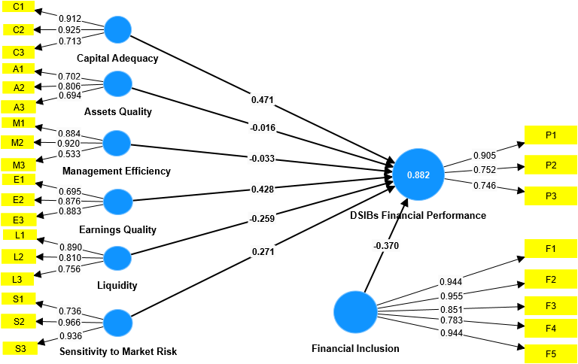
Source: Conceptual model generated by the Author (2025) using SmartPLS Version 4. (Details of the result is presented in Table 4)
consistency and convergent validity of the indicators, the scores of Cronbach’s alpha, rho_A or rho_C of all the exogenous latent variables are greater than the threshold of 0.7 except asset quality which has scores Cronbach’s alpha and rho_A less than 0.7 but it has score of rho_C which is greater than 0.7 and therefore, all the constructs achieved internal consistency.
Convergent validity is assessed to ensure correlation among indicators measuring a particular latent variable.
Table 2: Internal Consistency and Convergent Validity of Indicators
Variable | Cronbach's Alpha | Composite Reliability (rho_A) | Composite Reliability (rho_C) | Average variance extracted (AVE)
Assets Quality | 0.585 | 0.594 | 0.779 | 0.542
Capital Adequacy | 0.819 | 0.904 | 0.890 | 0.732
DSIBs Financial Performance | 0.724 | 0.750 | 0.845 | 0.647
Earnings Quality | 0.760 | 0.803 | 0.862 | 0.677
Liquidity | 0.766 | 0.843 | 0.860 | 0.673
Management Efficiency | 0.693 | 0.786 | 0.834 | 0.637
Sensitivity to Market Risk | 0.858 | 0.908 | 0.915 | 0.783
Financial Inclusion | 0.941 | 0.974 | 0.954 | 0.806
Source: Computed by the Author (2025) using SmartPLS Version 4.
Convergent validity is achieved if average variance extracted (AVE) score is at least 0.5 (Hair, 2007). From table 2, it can be seen that all the constructs achieved convergent validity and therefore retained.
Discriminant Validity assess the uniqueness nature of a particular indicator in measuring the intended latent variable. Uniqueness means how well a particular indicator measured the intended construct and at the same time is distinct from other related but different constructs in the model (Henseler, et al., 2014). Due to criticisms of Fornell and Larcker criterion (1981) in assessing discriminant validity (Aburumman. et al., 2023), Heterotrait-Monotrait (HTMT) is suggested as efficient measure of discriminant validity (Henseler, et al., 2014). The conservative threshold of HTML criterion is 0.85 while liberal threshold for discriminant validity using HTML criterion is 0.9 (Henseler, et al., 2015). Result in table 3 below shows that only cross correlations between capital adequacy and sensitivity to mark risk, DSIBs financial performance and financial inclusion, earnings quality and financial inclusion, liquidity and earnings quality, sensitivity to mark risk and financial inclusion, sensitivity to mark risk and liquidity and sensitivity to mark risk and management efficiency have HTMT scores of less than the threshold of 0.85 or 0.9 and therefore, only them achieved discriminant validity based on the HTMT criterion. The rest of the cross correlations have HTMT scores greater than the threshold of 0.85 or 0.9 and therefore, failed to achieve discriminant validity based on the HTMT criterion.
Table 3: Heterotrait Monotrait (HTMT) Result
Variable | Assets Quality | Capital Adequacy | DSIBs Financial Performance | Earnings Quality | Financial Inclusion | Liquidity | Management Efficiency | Sensitivity to Market Risk
Assets Quality
Capital Adequacy | 1.225
DSIBs Financial Performance | 1.273 | 1.073
Earnings Quality | 1.221 | 0.949 | 1.149
Financial Inclusion | 1.037 | 0.985 | 0.855 | 0.846
Liquidity | 1.099 | 1.010 | 0.911 | 0.829 | 0.942
Management Efficiency | 1.346 | 1.106 | 1.142 | 1.191 | 0.935 | 1.043
Sensitivity to Market Risk | 1.039 | 0.836 | 1.028 | 1.007 | 0.726 | 0.596 | 0.857
Source: Computed by the Author (2025) using SmartPLS Version 4.
Assessment of Significance of the Structural Model or Inner Model
Assessing the structural model involves four main assessments; assessment of the path coefficients, variance explained (R²), cross-validated redundancy or predictive relevance (Q²), and effect. Figure 4 below present the results of the inner model without a moderator. it can be seen that all the indicators used by the study significantly measured the latent variables they intent to measure at 99% confidence level. Also, the result shows that capital adequacy, earnings quality and sensitivity to market risk were positively and significantly related to DSIBs financial performance at 99% level of confidence while assets quality management efficiency and liquidity were insignificantly related to DSIBs financial performance.
Figure 5: Structural Model Without a Moderator
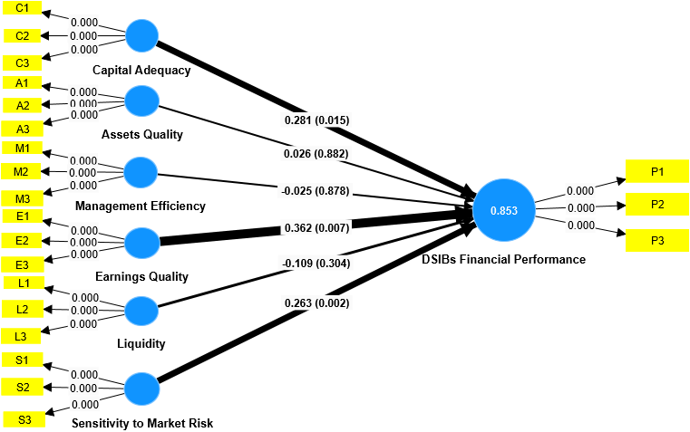
Source: Conceptual model generated by the Author (2025) using SmartPLS Version 4. (Details of the result is presented in Table 4)
However, after adding financial inclusion into the model, liquidity was also significantly related to DSIBs financial performance as can be seen in figure 6 below.
Figure 6: Structural Model with a Moderator
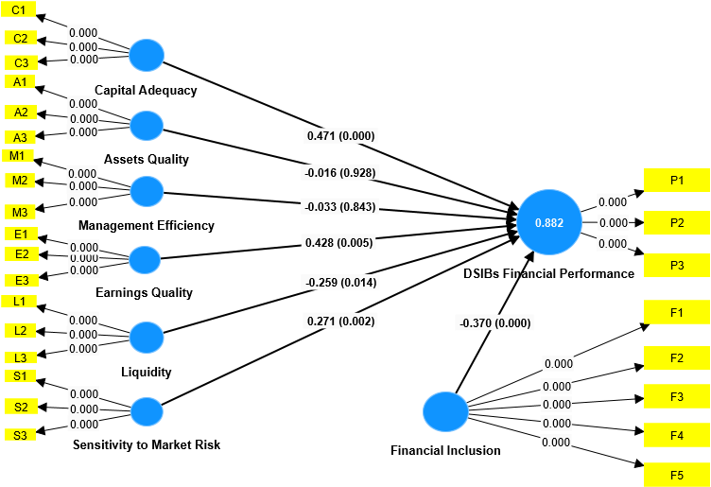
Source: Conceptual model generated by the Author (2025) using SmartPLS Version 4. (Details of the result is presented in Table 4)
The result presented in figure 6 shows that financial inclusion was significantly related to DSIBs financial performance at 99% level of confidence which is one of the reasons to justify its inclusion into the model as a moderator (Hayes and Matthes, 2009). The other reason to justify financial inclusion as a moderator to the model is changes in the value of R² from 0.853 to 0.882 in figure 5 and 6 respectively (Sharma, et al., 1981). Figure 7 below present the results of the moderated model of the study.
Figure 7: Moderated Structural Model
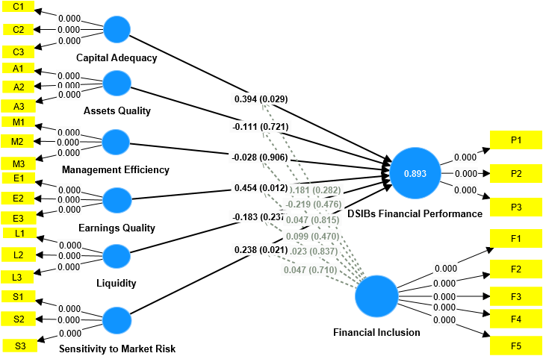
Source: Conceptual model generated by the Author (2025) using SmartPLS Version 4. (Details of the result is presented in Table 4)
The results in figure 7 show that capital adequacy, earnings quality and sensitivity to market risk were all significantly related to DSIBs financial performance while asset quality, management efficiency and liquidity were insignificantly related to DSIBs financial performance. The moderating effect of financial inclusion DSIBs financial performance was also insignificant because all the p-values of the measurements exceed 0.5 threshold.
Assessment of Path Coefficients and Hypotheses Testing
Table 4: Assessment of Path Coefficients and Hypotheses
H | Path | Beta | T-values | P-values | Decision
H₁ | CAR→DSIBs Performance | 0.4713 | 3.8375 | 0.0001*** | Supported
H₂ | AST→DSIBs Performance | (0.0159) | 0.0909 | 0.9275 | Not Supported
H₃ | MGT→DSIBs Performance | (0.0332) | 0.1976 | 0.8433 | Not Supported
H₄ | ERN→DSIBs Performance | 0.4281 | 2.8306 | 0.0047*** | Supported
H₅ | LQT→DSIBs Performance | (0.2592) | 2.4683 | 0.0136*** | Supported
H₆ | SEN→DSIBs Performance | 0.2713 | 3.0571 | 0.0022*** | Supported
H₇ | FIN→DSIBs Performance | (0.3702) | 3.9072 | 0.0000*** | Supported
H₈ | CAR*FIN→DSIBs Performance | 0.1812 | 1.0767 | 0.2823 | Not Supported
H₉ | AST*FIN→DSIBs Performance | (0.2193) | 0.7121 | 0.4764 | Not Supported
H₁₀ | MGT*FIN→DSIBs Performance | 0.0474 | 0.2341 | 0.8154 | Not Supported
H₁₁ | ERN*FIN→DSIBs Performance | 0.0991 | 0.7224 | 0.4703 | Not Supported
H₁₂ | LQT*FIN→DSIBs Performance | 0.0233 | 0.2062 | 0.8371 | Not Supported
H₁₃ | SEN*FIN→DSIBs Performance | 0.0471 | 0.3719 | 0.7103 | Not Supported
Source: Computed by the Author (2025) using SmartPLS Version 4.
H₁: Capital adequacy has no significant effect on DSIBs financial performance in Nigeria
Result in table 4 shows t-value and p-value corresponding to direct relationship between capital adequacy and DSIBs financial performance as 3.8375 and 0.0001 respectively which indicates that there is significant relationship between the two variables and therefore, reject the null hypothesis and accepted the alternative hypothesis that says capital adequacy has significant effect on financial performance of domestic systemically important banks in Nigeria.
H₂: Assets quality has no significant effect on DSIBs financial performance in Nigeria
Also, from table 4, the t-value and p-value corresponding to direct relationship between assets quality and DSIBs financial performance are 0.0909 and 0.9275 respectively which indicates that assets quality has insignificant effect on DSIBs financial performance and therefore, accept the null hypothesis and rejected the alternative hypothesis.
H₃: Management efficiency has no significant effect on DSIBs financial performance in Nigeria
The t-value and p-value of management efficiency are 0.1976 and 0.8433 respectively which implies insignificant effect of management efficiency on financial performance of DSIBs and therefore, accepted the null hypothesis and rejected the alternative hypothesis.
H₄: Earnings quality has no significant effect on the financial performance of DSIBs in Nigeria
The path connecting earnings quality and DSIBs financial performance reported t-value of 2.8306 and p-value of 0.0047 which indicates significant effect of earnings quality on the financial performance of DSIBs and therefore, rejected the null hypothesis and accepted the alternative hypothesis that says earnings quality significantly influence DSIBs financial performance.
H₅: Liquidity has no significant effect on the financial performance of DSIBs in Nigeria
The path connecting liquidity and DSIBs financial performance reported t-statistic value of 2.4683 and p-value of 0.0136 which is less than the threshold of 0.05 and therefore, rejected the null hypothesis and accepted the alternative hypothesis that says liquidity significantly effect financial performance of DSIBs in Nigeria.
H₆: Sensitivity to market risk has no significant effect on the financial performance of DSIBs in Nigeria
Result in table 4 shows that path connecting sensitivity to market risk and DSIBs financial performance has t-value of 3.0571 and p-value of 0.0022 which provides evidence of statistically significant effect of sensitivity to market risk on the financial performance of DSIBs in Nigeria and therefore, rejected the null hypothesis and accepted the alternative hypothesis that says sensitivity to market risk has significant effect on the financial performance of DSIBs in Nigeria.
H₇: Financial inclusion has no significant effect on the financial performance of DSIBs in Nigeria
The direct relationship between financial inclusion and DSIBs financial performance as presented in table 4 has t-statistic value of 3.9072 and p-value of 0.0000 which indicates strong and statistically significant relationship between the two variables and therefore, rejected the null hypothesis and accepted the alternative hypothesis that says financial inclusion significantly affect financial performance of domestic systemically important banks in Nigeria.
H₈: Financial inclusion has no significant moderating effect on the effect of CAMELS on DSIBs financial performance in Nigeria.
The cross correlation between financial inclusion and the six components of CAMELS financial indicators has p-values of 0.2823, 0.4764, 0.8154, 0.4703, 0.8371 and 0.7103 respectively which are all greater than 0.05 and therefore, accept that says financial inclusion has no significant moderating effect on the effect of CAMELS on DSIBs financial performance in Nigeria.
Assessment of the Variance Explained (R²)
Assessing the extent of variation in the endogenous latent variable explained by exogenous variables involves calculating the R-square value, a crucial metric for evaluating the structural model's validity (Aliyu, 2024). The guidelines from the literature shows that R-square values of 0.1, 0.5 and 0.75 are classified as weak, moderate and adequate respectively (Hair, et al., 2010). Table 5 below presents the R-square values for the three models of the study namely; structural model without a moderator, with a moderator and moderated model.
Table 5: Values of Variance Explained for the Three Models
Models | Variance Explained (R²)
Structural Model without a Moderator | 0.853
Structural Model with a Moderator | 0.882
Moderated Structural Model | 0.893
Source: Computed by the Author (2025) using SmartPLS Version 4.
Results in table 4 shows that R-square values for the three models all exceeded the threshold of 0.75 adequacy level which indicates that CAMELS financial indicators together with financial inclusion as a moderator adequately explained the variability of financial performance of domestic systemically important banks in Nigeria within the study period.

Assessment of Individual Construct Specific Effect Size (F²)
Individual construct’s specific effect on endogenous variable is determined by the change in R-squared for the latent variable to which the path is directed in proportion to the amount of the variance in the latent variable that remained unexplained (Chin, 1998). The guidelines from the literature classified values 0.02, 0.15 and 0.35 of F² as small or weak, moderate or medium and strong or large effects respectively (Cohen, 2013; Aburumman, et al., 2023). Table 6 below presents the result of the effect size of each endogenous variable on exogenous variable.
Table 6: Assessment of the Effect Size (F²)
Independent Variable | Dependent Variable | (F²) | Effect Size
Assets Quality | DSIBs Financial Performance | 0.040 | Small
Capital Adequacy | DSIBs Financial Performance | 0.069 | Small
Earnings Quality | DSIBs Financial Performance | 0.210 | Medium
Financial Inclusion | DSIBs Financial Performance | 0.204 | Medium
Liquidity | DSIBs Financial Performance | 0.081 | Small
Management Efficiency | DSIBs Financial Performance | 0.027 | Small
Sensitivity to Market Risk | DSIBs Financial Performance | 0.164 | Medium
Financial Inclusion*Sensitivity to Market Risk | DSIBs Financial Performance | 0.018 | No effect
Financial Inclusion*Liquidity | DSIBs Financial Performance | 0.023 | No effect
Financial Inclusion*Earnings Quality | DSIBs Financial Performance | 0.048 | Small
Financial Inclusion*Management Efficiency | DSIBs Financial Performance | 0.020 | Small
Financial Inclusion*Assets Quality | DSIBs Financial Performance | 0.040 | Small
Financial Inclusion*Capital Adequacy | DSIBs Financial Performance | 0.069 | Small
Source: Computed by the Author (2025) using SmartPLS Version 4.
Result in the table shows that while capital adequacy, assets quality, liquidity, management efficiency, financial inclusion*earnings quality, financial inclusion*management efficiency, financial inclusion*assets quality and financial inclusion*capital adequacy have small individual effect on DSIBs financial performance while financial inclusion, earnings quality and sensitivity to market risk have medium effect on the endogenous variable. The result also shows that financial inclusion*sensitivity to market risk and financial inclusion*liquidity have virtually no effect on the endogenous variable.

Assessment of Predictive Relevance (Q²)
Assessing predictive relevance of the model involves calculating Stone-Geisser's Q² which shows the model’s capability to predict or account for omitted cases (Aliyu, 2024). The process requires resampling method where data for each indicator of endogenous constructs are systematically omitted and then predicted. Value of Q² greater than zero is considered to be adequate for the model to have predictive relevance (Hair, et al., 2013). Table 7 presents the result of predictive relevance of the model.
Table 7: Predictive Relevance of the Model
Model | Q²
Moderating effect of financial inclusion on the effects of CAMELS on the financial performance of DSIBs in Nigeria | 0.157
Source: Computed by the Author (2025) using SmartPLS Version 4.
The result in table 7 shows that Q² = 0.157 which is greater than zero indicating the robustness and validity of the overall model in predicting the moderating effect of financial inclusion on the effects of CAMELS financial indicators on financial performance domestic systemically important banks in Nigeria.
Discussion of the Findings
Results in table 4 shows that capital adequacy has coefficient value of 0.4713 which implies one unit change in capital adequacy will cause DSIBs financial performance to change by 0.47 or 47.1%. The value of its t-statistic is 3.8375 with a corresponding p-value of 0.0001 which implies statistically significant effect of capital adequacy on the financial performance of domestic systemically important banks in Nigeria at 99% level of confidence. Assets quality has coefficient value of 0.0159, in absolute term, which shows a tiny or negligible effect of assets quality on DSIBs financial performance because one unit change in assets quality will cause changes in DSIBs financial performance by 1.6% approximately. This negligible effect of assets quality makes its t-statistic to be 0.0909 which is small and consequently its p-value to be 0.9275 which is greater than the threshold of 0.05 which indicates statistical insignificant effect of assets quality on DSIBs financial performance.
Management efficiency has coefficient value of 0.0332, in absolute term, which indicates 3.3% changes in DSIBs financial performance as a result of one unit change in management efficiency. This effect is very small which makes t-value of management efficiency to be 0.1976 and its corresponding p-value to be 0.8433 and consequently makes management efficiency to have insignificant effect on DSIBs financial performance. Earnings quality has coefficient value of 0.4281 which shows large effect because DSIBs financial performance will change by 41.8% as a result of one unit change in earnings quality. This large effect of earnings quality makes its t-value to be 2.8306 which is also large and its corresponding p-value to be 0.0047 which smaller than the threshold of 0.05 and hence, makes earnings quality to have statistically significant effect on DSIBs financial performance at 99% confidence interval.
Liquidity has coefficient value of 0.2592, in absolute term, which indicates 25.9% changes in DSIBs financial performance as a result of one unit change in liquidity. Its t-value of 2.4683 which is large, couple with its corresponding p-value of 0.0136 which is smaller than 0.05, makes liquidity to have statistically significant effect on DSIBs financial performance at 99% level of confidence. Sensitivity to market risk has coefficient value of 0.2713 which implies that one unit change in sensitivity to market risk will cause changes in DSIBs financial performance by 27.1%. Its large t-value of 3.0571 couple with its small p-value of 0.0022 makes sensitivity to market risk to have statistically significant effect on the financial performance of domestic systemically important banks in Nigeria at 99% level of confidence.
Financial inclusion has coefficient value of 0.3702, in absolute term, which indicates 37% changes in DSIBs financial performance as a result of unit change in the level of financial inclusion in Nigeria. Its large value of t-statistic of 3.9072 couple with its corresponding small p-value of 0.0000 makes financial inclusion to have statistically significant effect on the DSIBs financial performance at 99% level of confidence. The moderating effect of financial inclusion on capital adequacy has coefficient value of 0.1812 which shows net changes of 18.1% in financial performance of DSIBs as a result unit change in influential effect of financial inclusion on capital adequacy. The influential effect of financial inclusion on capital adequacy has small t-value of 1.0767 and its corresponding large p-value of 0.2823 which it to have statistically insignificant influential effect on the effect of capital adequacy on DSIBs financial performance.
The moderating effect of financial inclusion on assets quality has coefficient value of 0.2193, in absolute term, which translates to 21.9% changes in the effect of assets quality on DSIBs financial performance. Its small t-statistic value of 0.7121 couple with its large p-value of 0.4764 makes financial inclusion to have statistically insignificant influential effect on assets quality. The moderating effect of financial inclusion on management efficiency has coefficient value of 0.0474 which is negligible effect because only 4.7% changes in the effect of management efficiency on DSIBs financial performance will occur as a result of unit change in influential effect of financial inclusion on management efficiency. This small influential effect, couple with its small t-value of 0.2341 and its large p-value of 0.8154, makes financial inclusion to have statistically insignificant influential effect on the effect of management efficiency on DSIBs financial performance.
Moderating effect of financial inclusion on earnings quality has coefficient value of 0.0991 which translates to 9.9% changes in the effect of earnings quality on DSIBs financial performance as a result of unit change in the influential effect of financial inclusion on earnings quality. This small influential effect financial inclusion on earnings quality is reflected on its corresponding small t-value of 0.7224 and its large p-value of 0.4703 makes it be statistically insignificant at 90% level of confidence. Also, moderating effect of financial inclusion on liquidity has coefficient value of 0.0233 which negligible because one unit change in the influential effect of financial inclusion on liquidity will cause 2.3% change in the effect of liquidity on DSIBs financial performance. This is corroborated with its small t-value of 0.2062 and its corresponding large p-value of 0.8371 which makes financial inclusion to have statistically insignificant influential effect on the effect of liquidity on DSIBs financial performance. Lastly, moderating effect of financial inclusion on sensitivity to market risk has coefficient value of 0.0471 which translates to small changes of 4.7% in the effect of sensitivity to market risk on DSIBs financial performance as a result of unit change in the influential effect of financial inclusion on the latent exogenous variable. This small change is emphasized by its tailored small t-statistic value of 0.3719 and its corresponding large p-value of 0.7103 which exceeds the threshold of 0.05 and hence, makes influential effect of financial inclusion on the effect of sensitivity to market risk on DSIBs financial performance to be statistically insignificant.
5. Conclusion
It is established in this study that CAMELS financial indicators significantly impacted on the financial performance of domestic systemically important banks in Nigeria. The results shows that CAMELS financial indicators account for more than seventy percent (70%) variability in the financial performance of domestic systemically important banks in Nigeria.
Expansion in the level of inclusivity of financial services provision has significant impact on increasing the financial performance of domestic systemically important banks in Nigeria. Banks with large number of branches, ATM and POS outlets have great potentials of increasing their customer base which could ultimately impacted on their overall financial performance.
Increasing total capitalization and assets base of domestic systemically important banks have potentials to make them financially viable to withstands abrupt shocks which could reduce their contagion effects on the economy. Balancing DSIBs liquidity level to align with their immediate and future needs and spreading their loans and investment portfolios between short term and long term could mitigate their exposure to market and interest risk which consequently increase their financial performance.

6. Recommendations
Based on the findings of this study the following recommendations were made to guide policy formulation and implementation with respect to management of DSIBs in Nigeria.
- The central bank of Nigeria should increase the capital adequacy ratio of domestic systemically important banks from the current 16% to a reasonable percentage. This will increase resilience of the banks to withstand financial distress and therefore, prevent their failure which have contagion effects on the economy.
- The central bank should innovate and improve on their regulatory and supervisory technologies (Reg-Tech and Sup-Tech) in dealing with domestic systemically important banks in the country. This will ensure maximum compliance with all the regulatory and supervisory guidelines by the domestic systemically important banks which, consequently, prevent them from taking highly risky investment or financing highly risky project.
- The central bank of Nigeria should encourage and even incentivized domestic systemically important banks to open more branches, ATM and POS outlets especially in the underserved rural communities. This is a stakeholder approach because it will benefit CBN by increasing financial inclusion in the country which is one of CBN core objectives, it will benefit DSIBs because increased financial inclusion has significant impact on their financial performance and also, it will benefit the general public by providing them with easy access to affordable financial services within their reach.
- The management of domestic systemically important banks should diversify their investment portfolios by balancing long term interest-bearing assets with short-term and medium-term interest-bearing assets to mitigate their market and interest rate risk. This will go a long way in increasing their overall financial performance.
- The management of domestic systemically important banks should invest heavily in training their management staff and equip them state of the art technologies to make them more efficient which would reduce cost of operation and increase financial performance.
Reference
Abdulrahman, S. (2023). Mitigating Effect of COVID 19 Pandemic on Banks Profitability in Nigeria: The Moderating Role of Government Financial Support. Bayero Business Review, 7(1), 314-334.
Abebe, G. (2022). Does CAMEL affect financial performance of banks in emerging economy? From post IFRS adoption audited financial statement. Research Square, DOI: https://doi.org/10.21203/rs.3.rs-1540159/v1
Aburumman, O.J., Omar, K., Al Shbail, M., Aldoghan, M. (2023). How to Deal with the Results of PLS-SEM?. In: Alareeni, B., Hamdan, A. (eds) Explore Business, Technology Opportunities and Challenges ‎After the Covid-19 Pandemic. ICBT 2022. Lecture Notes in Networks and Systems, vol 495. Springer, Cham. https://doi.org/10.1007/978-3-031-08954-1_101
Abuzarqa, R. (2022). Evaluation Banks Financial Performance Using CAMELS Model: A Comparative Study of Local Commercial Banks in Qatar, Kuwait & Jordan. PhD Doctoral Dissertation submitted to Károly Ihrig Doctoral School of Management and Business, University Of Debrecen
Access Bank (2017 - 2023). Annual Financial Reports.
Adesina, K. S. (2012). A comparative performance evaluation of the Nigerian banking sector in the post – 2005 consolidation through the camel rating system. International Journal of Business and Social Science, 3(13): 259-268.
Al-abedallat, A. Z. (2019). The Factors Affecting the Performance of the Jordanian Banks using Camels Model. European Journal of Scientific Research, 152(2), 116 – 127.
Alfaradi, K. M. S. (2023). Evaluating Performance of Libyan Banks Using CAMELS Model. European Journal of Business and Management Research. Vol 8 | Issue 4.
Aliyu, S. U. R. (2024, August 18). Africa infrastructure deficit: Islamic finance as a gap filler. Paper presented at the monthly seminar organized by International Institute of Islamic Thought (IIIT), Kano, Nigeria.
Baron, R. M. & Kenny, D. A. (1986). The Moderator-Mediator Distinction in Social Psychological Research: Conceptual, Strategic and Statistical Considerations. Journal of Personality and Social Psychology. 51(6), 1173-1182.
Central Bank of Nigeria (2014). Framework for the Regulation and Supervision of Domestic Systemically Important Banks (SIBs) in Nigeria. A Letter to the Domestic Systemically Important Banks in Nigeria. CNB, 09-462-36425.
Central Bank of Nigeria (2015-2022). Financial Stability Report. CBN.
Chauvet, L. & Jacolin, L. (2016). Financial Inclusion, Bank Concentration and Firm Performance. Banque de France working paper.
Chin, C.L., Yao, G.: Convergent validity. In: Michalos A.C. (2014). Encyclopedia of Quality of Life and Well-Being Research. Springer, Dordrecht. https://doi.org/10.1007/978-94-007-0753-5.
Chin, W. W. (1998). Commentary: Issues and Opinion on Structural Equation Modelling. MIS Quarterly, 22(1), pp. 7–16.
Dabaghie, M. N. & Rajha, K. S. (2019). Evaluating the Performance of Saudi Commercial Banks Using CAMELS Methodology. Research Journal of Finance and Accounting. 10 (12).
Dang, U. (2011). The CAMELSrating system in banking supervision: A case study. Thesis, submitted to Arcada University of Applied Sciences. International Business School
Debreu, G. (1951), The coefficient of resource utilization, Econometrica 19(3), 273- 92.
Dembel, B. (2021). Factors Affecting the Performance of Commercial Banks (A Case Study on Commercial Banks in Ethiopia): CAMELSRatings. Research Journal of Finance and Accounting. Vol.11, No.5.
Dogarawa, A. B. (2020). Effect of CAMELS Financial Indicators on Profitability of Systemically Important Banks (SIBs) in Nigeria. [S.l.] : SSRN. https://ssrn.com/abstract=3666896.
Financial Stability Report (2015- 2022). Publication of Central Bank of Nigeria.
FirstBank (2017 - 2023). Annual Financial Reports and Accounts
Fornell, C. and Larcker, D. F. (1981). Evaluating Structural Equation Models with Unobservable Variables and Measurement Error. Journal of Marketing Research, 18(1), p. 39. DOI: 10.2307/3151312.
Gautam, K. R. (2020). Financial Performance Analysis of Nepalese Financial Institutions in the Framework of CAMEL. Janapriya Journal of Interdisciplinary Studies. JRCC, Janapriya Multiple Campus.
Getahun, M. (2015). Analyzing financial performance of commercial banks in Ethiopia: CAMEL Approach. Thesis submitted to Adis Ababa University, Ethiopia.
Guaranty Trust Bank (2017- 2023). Annual Financial Reports and Accounts
Hair, J. F., Black, W. C., Babin, B. J. & Anderson, R. E. (2010). Multivariate Data Analysis. 7th Edition, Pearson, New York.
Hair, J. F. (2007). Research Methods for Business. Education + Training, 49(4), pp. 336–337, DOI: 10.1108/et.2007.49.4.336.2.
Hair, J. F. C., Ringle, M. and Sarstedt, M. (2013). Partial Least Squares Structural Equation Modeling: Rigorous Applications, Better Results and Higher Acceptance. Long Range Plann, 46(1–2) pp. 1–12. DOI: 10.1016/j.lrp.2013.01.001.
Hair, J. F., Sarstedt, M., Hopkins, L. and Kuppelwieser,V. G. (2014). Partial least Squares Structural Equation Modeling (PLS-SEM). European Business Review, 26(2), pp. 106–121, DOI: 10.1108/EBR-10-2013-0128.
Hair, J.F., Risher, J.J., Sarstedt, M., Ringle, C.M. (2019). When to use and how to report the results of PLS-SEM. Eur. Bus. Rev. 31(1), 2–24.
Harnoso, I. (2024). The Influence of Risk, Management Quality, Company Size and Bank Liquidity on Banking Financial Performance (2018-2022). Economics Studies and Banking Journal (DEMAND), 1 (1), 26-36.
Harrison, J.S. & Bosse, D.A. & Phillips, R.A. (2010). Managing for stakeholders, stakeholder utility functions and competitive advantage. Strategic Management Journal, 58-74.
Hayes, A. F. & Matthes, J. (2009). Computational procedures for probing interactions in OLS and logistic regression: SPSS and SAS implementations. Behavior Research Methods, 41: 924-936.
Hays F. H, Lurgio, S. A. & Gilbert, A. H. (2011). Efficiency Ratios and Community Bank Performance. Journal of Finance and Accountancy, 1: 1-15.
Henseler, J., Ringle, C. M. and Sarstedt, M. (2014). A New Criterion for Assessing Discriminant Validity in Variance-Based Structural Equation Modelling. Journal of the Academy of Marketing Science, 43, pp115-135. DOI: 10.1007/s11747-014-0403-8.
Henseler, J., Ringle, C. M., & Sinkovics, R. R. (2015). The Use of Partial Least Squares path modeling in international marketing. In New challenges to International Marketing. Emerald Group Publishing Limited.
Hidayat, W. W. (2022). CAMEL Ratio on Profitability Banking performance: Case Studies of Banks in Indonesia. Jurnal Ilmiah Akuntansi, 5(2) 456 – 468.

