PROJECT BEEDS: SCAFFOLDING READING READINESS OF KINDERGARTEN LEARNERS THROUGH LETTER AND SOUND RECOGINTION OF GUMACA INTEGRATED SCHOOL

Abstract

Purpose: The main purpose of this study was to scaffold the reading readiness of kindergarten learners through letter and sound recognition using Project BEEDS (Bracing and Enhancing Early literacy by Developing Strategies and materials). The research addressed the level of reading readiness, as evidenced by pre-test performance levels.
Methodology: Employing a The study used the quasi-experimental method of research, teacher-made worksheets, pre and post-test to determine the frequency percentage of kindergarten reading readiness through letter and sound recognition of Gumaca Integrated School. The researcher purposefully selected 42 Kindergarten pupils as the main respondents. Frequency and percentage were The statistical instruments employed.
Findings: The implementation of Project BEEDS revealed that the scaffolding of reading readiness of kindergarten through letter and sound recognition were lowered the status of beginner from 86% of the learners to 17% who were categorize as full refresher with the number of 7 learners in letter recognition. In sound recognition from the pre-test result of 93% beginner lowered to 17% with the total number of 7 learners who were in the full refresher status that recommended for full intervention to the next grade level. All the necessary data gathered were treated accordingly.
Conclusions and Recommendations: The study implies that using project BEEDS can enhance the reading readiness of kindergarten learners. This study showed a positive outcome and suggested that it is an effective program for uplifting the learners' reading readiness ability. The researcher recommended that the materials used in the program can be used not only kindergarten teachers but also the grade 1 teacher who has full intervention learners

Keywords: | Kindergarten Reading Readiness, Letter Scound Recognition, Early Literacy

Acknowledgment

I would like to express my heartfelt gratitude to all those who supported and guided me throughout the journey of conducting this action research.

First and foremost, I would like to thank Mrs. Lourdes M. Tan, Ma’am Nanette D. Ramirez Ma’am Judith B. Fortuna for learning opportunities that helped me for providing invaluable guidance, support, advises, comments, suggestions, and provisions that helped in the completion and success of this study.

I am deeply grateful to my colleagues and peers, who provided support, shared ideas, and contributed to the implementation of the research interventions.

My sincere thanks to the participants of this research, kindergarten learners and parents whose cooperation, engagement, and feedback were central to the success of this project.

Lastly, I am forever grateful to my family and friends for their unwavering encouragement, patience, and support throughout this endeavor.

This research would not have been possible without the collective effort and contributions of all these individuals, and I am deeply thankful to each one of you.

- Context and Rationale
Reading readiness is the abilities that children need to develop before they can begin formal reading instruction. These skills form the foundation for successful reading development in later years. In a kindergarten setting, enhancing reading readiness is crucial as it prepares children for future academic success by fostering early literacy skills.
Children in kindergarten come from diverse backgrounds, which means that their exposure to language, books, and print can vary significantly. While some kids may have a passion for reading and good language abilities when they start school, others might not have had as much exposure to print-rich surroundings. If this is not handled right away, it may result in achievement gaps that get wider.
The kindergarten years are critical for brain development, particularly in the areas of language and reading. Children are at this period when they are most open to acquiring the fundamentals that will help them succeed academically. Improving children's reading readiness at this age guarantees that they are prepared to acquire powerful literacy abilities.
Kindergarten learners at Gumaca Integrated School who do not possess the readiness abilities determined by a readiness assessment frequently face difficulties during the academic year. Thus, giving kindergarten teachers more restrictions guarantees that learners get the necessary results at the end of the school year.

- Action Research Questions
This study aims to determine the perceived impact of Scaffolding the Reading Readiness of Kindergarten Learners Through Letter and Sound Recognition.
Specifically, this study answers the following questions:
1. What is the reading status of kindergarten learners in letter recognition before and after the implementation of the program in terms of;
a. Beginner
b. Developing
c. Consistent
2. What is the reading status of kindergarten learners in sound recognition before and after the implementation of the program in terms of;
a. Beginner
b. Developing
c. Consistent
5. What reading readiness materials made to scaffold the reading readiness of kindergarten pupils through letter and sound recognition?
- Proposed Innovation, Intervention, or Strategy

The goal of Project BEEDS was to scaffold kindergartens’ reading readiness to prepare them for formal reading instruction. The teacher developed simple teacher made activity/ materials for learners to scaffold capability of reading. This project also conducted storytelling that foster love for reading ,with the proper guidance of the researcher, the school, and Kindergarten parents would help the beneficiaries enhance their reading capability.
Pre-implementation Process
- The proponent submitted a letter of request informing the School Principal about the project.
- Identify the level of reading readiness of the learners.
- Coordinated with the parents about the project.

Implementation Process
  - Launch the Project BEEDS.
  - Preparation of the materials to be used like story books, teacher made reading materials and activities and worksheets.
  - Discuss the learning materials used to the school principal, parents, and kindergarten learners.
  - Conduct story telling for the learners.
  - During and after lesson, the observation, and progress are recorded in a journal to document any changes or areas of concern.
Post Implementation Process
  - Conduct a Monthly Monitoring.
  - Assess the utilization of the Self-Made Activity sheets or the learning materials for further improvement.
  - Give feedback and submit an Action Plan for Sustainability for next year.
This action research focused on scaffolding kindergarten reading capability program, the Project BEEDS (Bracing and Enhancing Early literacy by Developing Strategies and materials) for the academic year 2023 to 2024. It is limited to determining the status of reading capability of the kindergarten pupils before and after the implementation of Project BEEDS. Resources included in Project BEEDS are educational tool supplies like a ream of bond paper, a printer, ink, individual reading notebook.
- Action Research Methods
- Participants and/or other Sources of Data and Information
The action research was a quasi-experimental method employed the paired group pre and post-test design. Kindergarten learners conducted pre-test to determine the reading capability status of kindergarten pupils through letter and sound recognition . Afterwards, the Project BEEDS was employed, which lasted for several sessions/ months. A post-test was administered after the use of Project BEEDS as an enhancement reading activity for kindergarten pupils. The study was conducted in Gumaca Integrated School. The researchers chose this locale since this is also where the researcher is practicing her profession. There was no sampling procedure to be used among 42 kindergarten pupils as there was a complete enumeration of the said respondents.
- Data Gathering Methods
Prior to the conduct of the study, the researcher sought permission from the principal and district supervisor. Upon receiving the approved permit, the researcher conducted data collection and administered Pre-test before the utilization of the program and Post-test after the utilization of the program. The researcher conducted the orientation and obtained further permits for the parents or legal guardians of the target respondents. Teacher made worksheets were employed to the learners. To determined the kindergartens’ reading readiness through letter and sound recognition, the researcher administered pre-test assessment to know the reading readiness capability of the learners. Based on the result of the pre-test the researcher proposed a program, Project BEEDS to scaffold the reading readiness of kindergarten pupils. After administering and utilizing the program the post test was done to know if the reading readiness through letter and sound recognition was enhanced or improved. This was conducted during the school year 2023-2024. Data were gathered to enable an adequate statistical analysis. Calculations, data processing, analysis, and data interpretation, as well as the creation of improvement suggestions, were done.

- Data Analysis Plan
The data collected were based on the pre-assessment and post-assessment result. The researcher used the reading readiness assessment as pre and post-sources of data. The primary instrument used was the Project BEEDS as the main enhancement reading readiness activity. The reading readiness activity was conducted in the School Year 2023-2024. In finding the significant difference, the researcher used the frequency percentage score.
The formula for frequency and percentage distribution shown as:
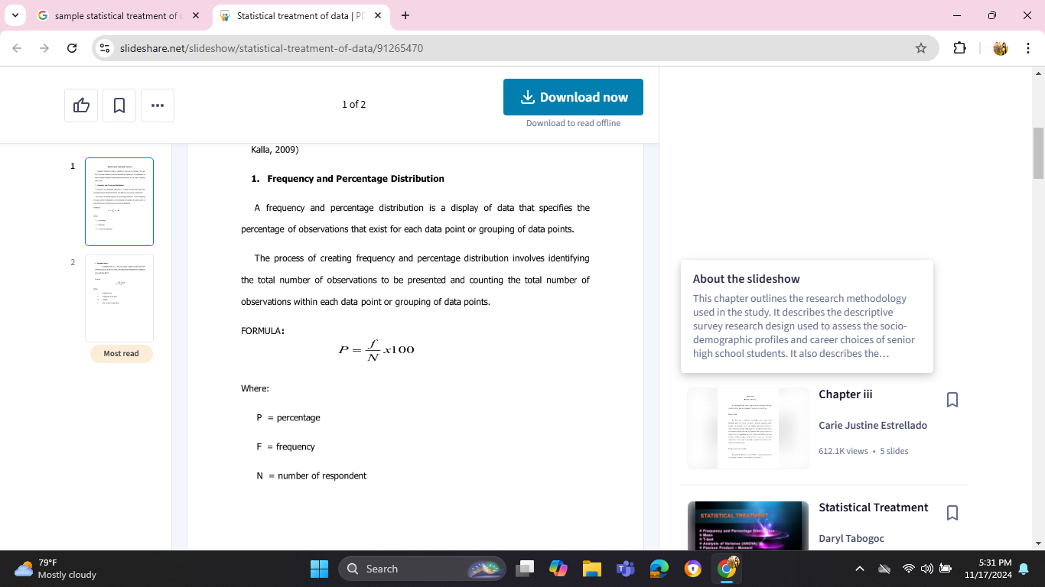

Where:
P= percentage
F= Frequency
N= Number of respondents
- Discussion of Results and Reflection
The frequency and percentage of distribution of data specified the percentage of observations that exist of each data, it involved identifying the total number of observations presented and counting the total number of observations within each data.
Table 1. The reading status of kindergarten learners in letter recognition before and after the implementation of the program.
STATUS | FREQUENCY | PERCENTAGE
BEGINNER | 36 | 86%
DEVELOPING | 2 | 5%
CONSISTENT | 4 | 9%
FIGURE 1

Based on table 1, the result showed that 86% of the learners were classified as beginner, indicating that the program was highly needed by the majority, 5% were under developing status and 9 percent were consistent in letter recognition.
Table 2. Reading status of kindergarten learners in sound recognition before the implementation of the program.
STATUS | FREQUENCY | PERCENTAGE
BEGINNER | 39 | 93%
DEVELOPING | 3 | 7%
CONSISTENT | 0 | 0%

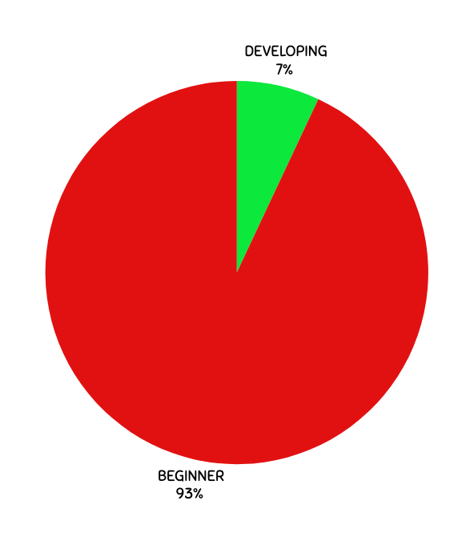
FIGURE 2

Based on table 2, the result showed 93% of the learners were classified as beginner, indicating that the program was highly needed by the majority, 7% were under developing status and 0% for consistent in sound recognition.

Table 3. Reading status of kindergarten learners in letter recognition after the implementation of the program.
STATUS | FREQUENCY | PERCENTAGE
BEGINNER | 7 | 17%
DEVELOPING | 8 | 19%
CONSISTENT | 27 | 64%

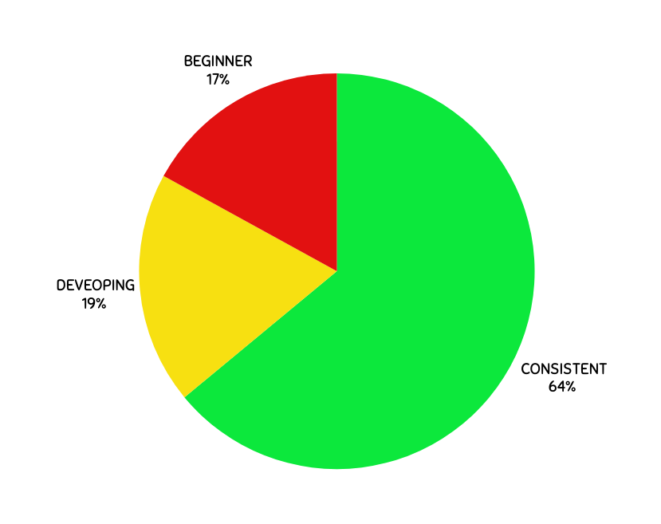
FIGURE 3

Based on table 3, the result revealed that after the implementation of the program, 17% of the total learners were at the beginner status, 19% of them were at the developing and 64% of the total learners were at the consistent status in letter recognition.

Table 4. Reading status of kindergarten learners in sounds recognition after the implementation of the program.
STATUS | FREQUENCY | PERCENTAGE
BEGINNER | 7 | 17%
DEVELOPING | 8 | 19%
CONSISTENT | 27 | 64%
FIGURE 4

Based on table 4, the result revealed that after the implementation of the program, only 17% of the total learners were at the beginner status, 19% of the them were at the developing and 64% of the total learners were in the consistent status in letter recognition.
From the findings above, the implementation of Project SIKAP revealed that the scaffolding of reading readiness of kindergarten through letter and sound recognition were lowered the status of beginner from 86% of the learners to 17% who were categorize as full refresher with the number of 7 learners in letter recognition. In sound recognition from the pre-test result of 93% beginner lowered to 17% with 7 learners who were in the full refresher status that recommended for full intervention to the next grade level.
- Action Plan

TITLE: PROJECT SIKAP: Sama samang Iaangat, Karunungan at Pag-unlad sa Pagbasa

PLACE OF IMPLEMENTATION: Gumaca Integrated School
Brgy. Inaclagan, Gumaca, Quezon
PERIOD OF IMPLEMENTATION: October -May 2024
PROPONENT BIONOTE: Maica M. Cordero


MMC is taken up her Masters degree In Reading at Philippine Normal University, Manila under the Linking Standards and Quality Practice (LiSQup) Program under NEAP. She has been nurturing the minds of young learners for 7 years. She is handling Kindergarten class from 2017 at present. In addition to this, she is working on completing her Master of Arts in Education major in Educational Management in Marinduque State University.

TARGET AND NUMBER OF PARTICIPANTS:
1 School Head
1 Teacher
42-Kindergarten learners

I. RATIONALE:
DepEd’s Every Child a Reader Program (ECARP) is one of the most important educational programs affecting learning. Simply put, student learn better when they know how to listen to and read stories and other forms of texts, appreciate reading, and read with comprehension. Reading interventions are religiously implemented and harmonized with different PPAs in all schools. School leaders, teachers, parents and stakeholders are encouraged to take part in this endeavor in order to create a positive learning environment in their classrooms/class homes to ensure that learners will become more confident, high achievers and good at solving problems and have a strong social skill caused by their ability to listen, read, and comprehend.
In this context, Gumaca Integrated School will be conducted a program PROJECT SIKAP: Sama samang Iaangat, Karunungan at Pag-unlad sa Pagbasa. The principle of lifelong learning and DepEd’s commitment to the development learners through reading successes and the achievement of the DepEd’s ultimate goal; Quality Learning Outcome is supported and inspired by school head, reading teachers, parents and other stakeholders who are in full support in achieving an ideal learning for learners.

II.OBJECTIVES:
Terminal Objective/s:
The conduct of Gumaca Integrated School Project BEEDS ( Bracing and Ehancing Early literacy by Developing Strategies and materials) recognizes the importance of enrichment activities for kindergarten in scaffolding the reading readiness of kindergarten learners through letter and sound recognition with the support of their teachers and parents in a move to bridge literacy gaps among learners, its campaign on reading proficiency with the 3Bs initiative (Bawat Bata Bumabasa).Making learners love and appreciate listening and reading stories and other forms of texts and literature. This program will also strengthen the pedagogical concepts and skills of teachers and parents on how to build, enhance and sustain love for reading to achieve positive results in their learning.

Enabling Objective/s:
General Objectives
To assess and improve literacy level of the learners.
Specific Objectives:
KINDERGARTEN
- improve / enhance reading readiness for kindergarten.
- develop an early reading for kindergarten learners.
- provide all parents, stakeholders and teacher avenue to build, establish and enhance love for reading through Kindergraten Storytelling Program:Building Learners Authentic Zeal of Excellence in Reading ;
- capacitate teachers and parents to sustain love for reading among Kindergarten learners through storytelling and enhancement activities for reading.
- do selected reading activities at home with the presence of a parent or guardian; and
- strengthen learning partnership with the parents and other stakeholders.

III- DESCRIPTION OF THE PROGRAM.
Gumaca Integrated School Project SIKAP (Sama samang Iaangat, Karunungan at Pag-unlad sa Pagbasa: Building Learners Authentic Zeal of Excellence in Reading (SIKAP: BLAZER). It is a program to support the ECARP and 3Bs Initiatives of DepEd focusing on building love, appreciation and reading among learners. The learners will undergo daily activities in reading readiness. Each learner will have a notebook and portfolio.

IV- PRODUCTION
AREAS

RESOURCES NEEDED
Human Resources
- School Reading Team – for program designing, monitoring & evaluation and enhancement
- School Head – for program monitoring and evaluation also for checking the proper implementation of the program and for providing the needs of the teachers and learners.
- Reading teacher – provide reading materials and implement the reading intervention program.
- Parents/Guardians-serve as guide in home-based learning.
- Learners- beneficiaries of the program

Material Resources

- Instructional Tools such as reading materials /storybooks, assessment instruments, reading portfolio/notebooks, monitoring tools, template for status reports.
- Budget for the reading materials and giving rewards for the pupils.

EXPECTED OUTPUTS:
At the end of the implementation of Gumaca Integrated School Project SIKAP (Sama samang Iaangat, Karunungan at Pag-unlad sa Pagbasa: Building Learners Authentic Zeal of Excellence in Reading (SIKAP: BLAZER): Building Learners Authentic Zeal of Excellence in Reading , it is expected that:
1. School Program Sama samang Iaangat Karunungan at Pagunlad sa Pagbasa: Building Learners Authentic Zeal of Excellence in Reading will scaffold the Reading Readiness of the Kindergarten learners .
2. kindergarten reading readiness will improve,
3.enhance the ability to decode simple word,
3.strong partnership with the stakeholders of the schools will be enhanced and sustained.

Submitted by: | Lead Researcher | MAICA M. CORDERO

[Note: Please indicate N/A to above name fields that are not applicable, e.g. in case of sole researcher. Delete this after reading.]

Decision
Accept Research Proposal: | ☐ With minor editing  ☐ Without editing or revision
Return Research Proposal: | ☐ With minor revision  ☐ With major revision

Reviewed by:  (Signature Over Printed Name) | SDRC Content Expert
Reviewed by:  (Signature Over Printed Name) | SDRC Technical Expert

[Note: Please leave blank the above name fields. Delete this after reading.]

[Disclaimer: The content of this Action Research Proposal Template was adapted from DepEd Order No. 43, s. 2015 – Revised Guidelines for the Basic Education Research Fund (BERF); DO 16, s. 2017 – Research Management Guidelines; and DepEd IV-A CALABARZON’s BERF Action Research Proposal Appl

