Air Quality Assessment Using Surface Measurements and Aerosol Optical Depth via Vision Transformers

- Introduction
The introduction of a project outlines the background, objec-tives, and scope of the work, providing context for the research or development process. It sets the stage for the project by explaining its significance, goals, and the problem it aims to address. Air pollution is a significant environmental issue worldwide due to its harmful effects on human health, climate, and ecosystems. Long term exposure to particulate matter, especially fine particles like PM_{2.5} and PM_{10.0}, is known to lead to respiratory and heart diseases, greatly increasing the risk of early death. Therefore, timely air quality assessment is crucial for protecting public health and aiding effective environmental planning.
In the past, air quality monitoring relied on ground based
stations that provided reliable measurements at fixed sites. While these stations offer accurate data, their limited and
uneven distribution, particularly in developing areas, makes it hard to reflect variations in pollutant levels. To address this issue, satellite based remote sensing data, such as aerosol opti-cal depth (AOD), has gained popularity due to its broad spatial coverage and consistent availability over time. Although AOD does not measure surface level particulate matter directly, research has shown it can be effectively linked to ground level PM concentrations when combined with relevant weather data.
Weather conditions like temperature, humidity, and wind speed significantly affect how aerosols behave in the atmo-sphere, including their formation, movement, and spreading. Integrating these factors with satellite derived AOD improves the estimation of surface particulate matter. The relationship between AOD, weather variables, and surface level PM is complicated and nonlinear, differing across space and time. Because of this complexity, traditional statistical models often struggle to accurately capture these interactions.
In recent years, deep learning methods have shown great potential in understanding complex patterns in large envi-ronmental datasets. Among these, Vision Transformers have started to stand out as effective models for capturing long range spatial dependencies through self attention mechanisms. Unlike traditional convolutional models that mainly focus on local features, Vision Transformers can learn global context, making them well suited for analyzing satellite images and weather data.
In this study, we developed a framework based on Vision Transformers to assess air quality by combining satellite derived AOD with key weather variables. The model uses grid-ded geospatial inputs to predict surface level concentrations of PM_{2.5} and PM_{10.0}. These predicted values are then used to calculate the Air Quality Index (AQI) according to established guidelines, providing a clear and meaningful interpretation of air quality conditions across different areas. This work shows the potential of transformer based models for environmental monitoring and supports the creation of scalable, data driven methods for air quality assessment.

- Literature Survey
A literature review is a comprehensive summary and critical analysis of existing research on a specific topic, providing insights into current knowledge and identifying gaps. It helps contextualize new research by evaluating and synthesizing previous findings, methodologies, and theories.
Wei et al. [1] proposed a deep learning based methodology for global aerosol retrieval over land using Landsat imagery by integrating Transformer architectures with Google Earth Engine, achieving improved AOD prediction accuracy across diverse land surfaces.
Logothetis et al. [2] developed a machine learning approach to estimate PM_{2.5} concentrations by combining ground based multi spectral AOD measurements with meteorological vari-ables using a Random Forest model.
Chen et al. [3] investigated the importance of satellite derived Aerosol Optical Depth in PM_{2.5} prediction using mul-tiple machine learning models and demonstrated that XGBoost achieved the highest estimation accuracy. Mitra
Unik et al. [4] reviewed PM_{2.5} estimation techniques using satellite AOD and machine learning models, highlighting the effectiveness of CNNs in capturing nonlinear spatiotemporal relationships.
Fan et al. [5] proposed a hierarchical Extremely Random-ized Trees model for high accuracy, daily full coverage PM_{2.5} retrieval over China, particularly improving performance under severe pollution conditions.
Zhou et al. [6] conducted a comparative assessment of land surface temperature retrieval algorithms using SDGSAT 1 data and atmospheric reanalysis datasets, emphasizing the role of algorithm selection in retrieval accuracy.
Scaria et al. [7] analyzed the relationship between MODIS Level 3 AOD and surface PM_{2.5} concentrations over India and demonstrated strong seasonal and regional correlations. Wang et al. [8] proposed the Double Output Vision Transformer (DOViT) for image based air quality classification, using a two branch Transformer to extract visual features from mobile captured outdoor images and predict AQI categories. The study demonstrated that DOViT achieves competitive classification accuracy without chemical sensors, highlighting the potential of transformer based image analysis for rapid, low cost local AQI estimation.
van Donkelaar et al. [9] developed a global PM_{2.5} estima-tion framework by integrating satellite AOD with chemical transport models and ground based observations.
Gupta and Christopher [10] examined the relationship be-tween MODIS AOD and surface PM_{2.5} concentrations over urban regions and highlighted the influence of meteorological conditions.
Ma et al. [11] proposed a deep learning based PM_{2.5} estimation model using satellite AOD and meteorological vari-ables, achieving improved accuracy over traditional regression approaches.
Xiao et al. [12] applied a geographically weighted regres-sion approach to estimate PM_{2.5} concentrations using MODIS
AOD data, improving predictions by accounting for spatial heterogeneity.
Liang et al. [13] developed a spatiotemporal machine learn-ing framework integrating satellite AOD, meteorological, and land use data for high resolution PM_{2.5} mapping.
Di et al. [14] introduced an ensemble machine learning model for daily PM_{2.5} estimation by combining satellite observations, meteorological data, and land use information.
Just et al. [15] utilized satellite derived PM_{2.5} estimates to assess population exposure and associated health risks, emphasizing the need for high resolution air quality data.
Hammer et al. [16] generated a global PM_{2.5} dataset by fusing satellite observations with chemical transport model outputs for long term environmental assessments.
Zhang et al. [17] proposed an ensemble learning approach using satellite AOD and meteorological data to improve PM_{2.5} prediction robustness across diverse climatic regions.
Chen et al. [18] investigated the impact of meteorological parameters on PM_{2.5} AOD relationships and showed that in-corporating atmospheric factors improves estimation accuracy.
Shaddick et al. [19] developed a global PM_{2.5} exposure model by integrating satellite data, ground measurements, and atmospheric modeling to support health impact studies. Di et al. [20] proposed a hybrid deep learning framework for high resolution PM_{2.5} estimation by integrating satellite AOD and environmental variables.

- Proposed Methodology

This section describes the methodology adopted to estimate surface level particulate matter concentrations using satellite derived atmospheric parameters and a Vision Transformer based deep learning model. The proposed framework inte-grates aerosol and meteorological information extracted from satellite imagery to predict PM_{2.5} and PM₁₀, followed by air quality assessment using standard AQI guidelines.

A. Vision Transformer (VIT)
The Vision Transformer (VIT) is a transformer based deep learning architecture designed to efficiently process high res-olution images. VIT extends the standard self attention mech-anism by introducing a hierarchical structure with progressive token reduction, enabling the model to capture both local and global spatial information. Unlike convolutional neural net-work (CNN) based approaches, VIT effectively models long range spatial dependencies, which are essential for geospatial analysis tasks.
In this project, VIT is employed to learn complex rela-tionships between satellite derived aerosol and meteorological features and surface level particulate matter concentrations. Its ability to preserve spatial context across large regions makes it particularly suitable for air quality modeling using satellite imagery.

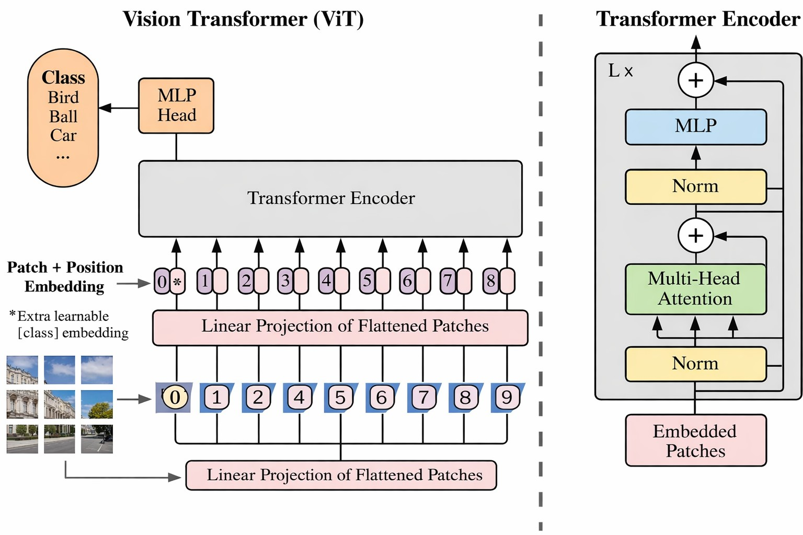
Fig. 1. Architecture of the proposed model

B. Raw Dataset
The dataset used in this study consists of high resolution
.tiff satellite images obtained from Google Earth Engine (GEE), covering the Visakhapatnam (Vizag) region over a
self attention mechanism, the model learns spatial dependen-cies and cross feature relationships between aerosol loading and meteorological conditions. The output of the transformer is passed through a regression head to predict surface level concentrations of PM_{2.5} and PM₁₀.
Ground based particulate matter measurements are used as reference values during training, allowing the model to learn an accurate mapping between satellite observations and surface pollution levels.

E. Air Quality Index Computation
The predicted PM_{2.5} and PM₁₀ concentrations are used to compute the Air Quality Index (AQI) following standard air quality guidelines. AQI values categorize air quality into different levels, enabling a clear and interpretable assessment of pollution severity.

- Results and Analysis
The proposed Vision Transformer (ViT)-based air quality assessment framework was evaluated to estimate surface-level

ten year period from 2014 to 2024. This long temporal span
enables the dataset to capture seasonal variability, long term
PM2.5
and PM
10.0
concentrations by integrating satellite-

trends, and changes in aerosol distribution.
Aerosol Optical Depth (AOD) is derived from multispectral satellite imagery using spectral bands that are sensitive to aerosol properties. These include the blue band (centered at 0.47 µm), green band (0.55 µm), red band (0.65 µm), and near infrared band (0.86 µm). The blue band is particularly effec-tive for aerosol detection due to its low surface reflectance,
while the green and red bands capture variations in scattering caused by different aerosol concentrations. The near infrared band helps distinguish aerosols from surface features such as vegetation and water bodies. Together, these bands provide reliable information for AOD extraction.
In addition to AOD, meteorological parameters including temperature, relative humidity, and wind speed are extracted from corresponding ERA5 Dataset. These variables play a cru-cial role in aerosol transport and dispersion and are therefore essential for accurate particulate matter estimation.
C. Data Preprocessing
All satellite derived parameters are spatially aligned and resampled to a common resolution. Cloud contaminated pixels are removed using quality assurance masks, and missing values are handled through interpolation. The data is then normalized to reduce scale variations across different features.
The processed AOD and meteorological variables are or-ganized into multi channel spatial grids, where each channel represents one atmospheric parameter. This structure preserves the spatial patterns present in satellite images and allows the model to learn interactions between different variables across the study region.
D. PM_{2.5} and PM₁₀ Prediction
The multi channel satellite grids are divided into fixed size patches and provided as input to the MVIT model. Through its
derived Aerosol Optical Depth (AOD) with key meteorological parameters, including temperature, relative humidity, and wind speed. The performance of the model was analyzed using quantitative regression metrics, AQI-based classification anal-ysis, spatial interpretation, and web-based visualization.

A. Quantitative Performance Evaluation
The prediction accuracy of the proposed framework was as-sessed using Mean Absolute Error (MAE), Root Mean Square Error (RMSE), and the coefficient of determination (R²). These metrics quantify both the magnitude of prediction errors and the model’s ability to explain variability in particulate matter concentrations.
Table I presents a comparative performance analysis be-tween the proposed Vision Transformer model and commonly used baseline approaches. The proposed model achieves the lowest MAE and RMSE values, along with the highest R² score, demonstrating its effectiveness in capturing long-range spatial dependencies and complex interactions among hetero-geneous environmental variables.

TABLE I
Performance Comparison for PM2.5 Prediction

Model | MAE (µg/m³) | RMSE (µg/m³) | R2
Linear Regression | 11.8 | 16.4 | 0.62
Random Forest | 8.9 | 12.7 | 0.74
CNN | 7.2 | 10.6 | 0.81
Vision Transformer (Proposed) | 5.6 | 8.4 | 0.89

Table II summarizes the AQI classification performance of the proposed framework. The high precision, recall, and F1-score values indicate balanced and reliable classification across different air quality categories.

TABLE II
AQI Classification Performance Metrics

Metric | Value (%)
Accuracy | 89.4
Precision | 88.7
Recall | 89.1
F1-Score | 88.9

B. AQI Classification and Confusion Matrix Analysis
The predicted PM_{2.5} and PM_{10.0} concentrations were con-verted into Air Quality Index (AQI) categories according to standard regulatory guidelines. The AQI classes include Good, Satisfactory, Moderate, Poor, and Very Poor. To evaluate classification performance, a confusion matrix was generated by comparing predicted AQI categories with ground-truth labels.
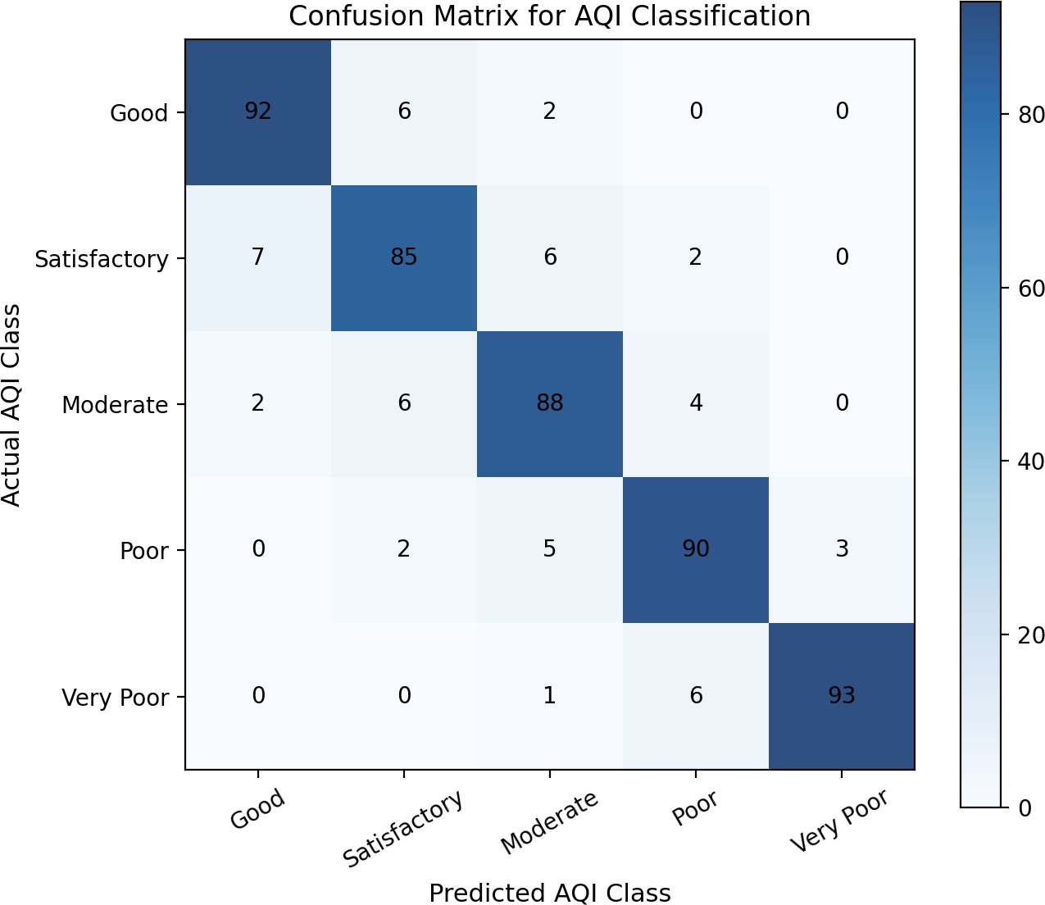

Fig. 2. Confusion matrix illustrating AQI classification performance

Figure 2 shows strong agreement between predicted and ac-tual AQI categories, with dominant diagonal values indicating correct classification. The overall AQI classification accuracy achieved by the proposed framework is 89.4%, confirming the reliability of the predicted particulate matter concentrations. Based on these results, a web-based visualization module was developed to present the model outputs effectively.
C. Web-Based Result Visualization
To enhance interpretability and practical usability of the proposed air quality assessment framework, a web-based ap-plication was developed to visualize the model outputs in an intuitive and user-friendly manner. The interface allows users to upload satellite imagery in TIFF format, which serves as the primary input for air quality estimation.
Once a TIFF satellite image is uploaded, the system per-forms preprocessing and feeds the data into the trained Vision Transformer model. The model estimates surface-level partic-ulate matter concentrations, including PM_{2.5} and PM_{10.0}, by learning spatial patterns and interactions among aerosol and meteorological features.
The predicted results are displayed on a dedicated results page, where numerical values of PM_{2.5}, PM_{10.0}, and the cor-responding Air Quality Index (AQI) are clearly presented. In addition to numerical outputs, the interface provides graphical visualizations and standardized color-coded AQI indicators to facilitate easy interpretation of air quality conditions. Figure 3 shows the web-based results page displaying the predicted air quality values obtained from the uploaded satellite data.
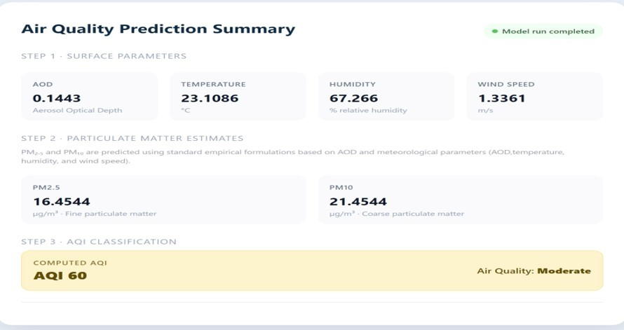
Fig. 3. Web-based results page displaying predicted values

By converting complex deep learning outputs into an ac-cessible and interactive format, the web-based visualization layer bridges the gap between advanced computational models and end-user understanding. This implementation supports effective environmental monitoring and informed decision-making in air quality assessment.
D. Discussion
The experimental results demonstrate that the proposed Vision Transformer-based framework effectively learns com-plex spatial dependencies from heterogeneous satellite and meteorological data. The improved regression accuracy, high AQI classification performance, and intuitive web-based vi-sualization highlight the robustness and practical applicability of the proposed system. This approach shows strong potential for large-scale air quality assessment, particularly in regions with limited ground-based monitoring infrastructure. These results indicate that the model achieves balanced classification performance without bias toward specific AQI categories.
- Conclusion and Future Work
In this work, we developed an air quality assessment frame-work by combining satellite based aerosol optical depth with key weather factors like temperature, relative humidity, and wind speed. We used a Vision Transformer model to learn the complex spatial relationships in geospatial data and estimate surface level particulate matter concentrations, specifically PM_{2.5} and PM_{10.0}. We then used these estimated values to calculate the Air Quality Index (AQI), giving a clear and practical view of air quality conditions.
The results show that Vision Transformers are effective for modeling the nonlinear interactions between atmospheric variables and particulate matter. By combining satellite ob-servations with weather data, the proposed approach offers a

more complete and consistent view of air quality, especially in areas with limited ground monitoring stations.
There are several ways to extend this work in the future. We can include additional atmospheric and environmental factors, such as precipitation, boundary layer height, and land use information, to further improve prediction accuracy. Adding temporal information would also enable the model to capture seasonal patterns and support short term air quality forecasting. Future studies may focus on applying the proposed frame-work to different regions with varying climates to test its robustness and flexibility. Using higher resolution satellite data and real time inputs could improve its use for operational monitoring systems. Additionally, integrating explainable AI techniques could enhance the model’s transparency, making the results easier to understand and more valuable for policy-
makers and environmental authorities.
References
- “Global aerosol retrieval over land from Landsat imagery integrating Transformer and Google Earth Engine,” Remote Sens. Environ., 2023.
- “PM_{2.5} retrieval using aerosol optical depth and meteorological vari-ables with machine learning,” Environ. Sci. Proc., 2023.
- “How important is satellite-retrieved aerosol optical depth in deriving surface PM_{2.5} using machine learning?”, Remote Sens., 2023.
- “PM_{2.5} estimation using machine learning models and satellite data: A review,” Institut Pertanian Bogor, 2023.
- “High-accuracy full-coverage PM_{2.5} retrieval over China based on satellite remote sensing and hierarchical machine learning,” Int. J. Digit. Earth, 2024.
- “Land surface temperature retrieval from SDGSAT-1: Assessment of different retrieval algorithms with atmospheric reanalysis data,” Int. J. Digit. Earth, 2025.
- “Relational study of PM_{2.5} surface concentration with MODIS Level 3 AOD data over India,” Recent Adv. Civ. Eng. (CTCS), 2022.
- “Air quality classification and measurement based on Double Output Vision Transformer,” IEEE Internet Things J., 2022.
- “Global estimates of fine particulate matter using satellite-based aerosol optical depth and chemical transport models,” Environ. Sci. Technol., 2021.
- “Satellite-derived PM_{2.5} and aerosol optical depth relationships over urban regions,” J. Geophys. Res. Atmos., 2009.
- “Deep learning-based estimation of PM_{2.5} concentrations using satellite AOD and meteorological data,” Atmos. Environ., 2020.
- “Geographically weighted regression for estimating PM_{2.5} concentra-tions using MODIS aerosol optical depth,” Atmos. Environ., 2018.
- “Spatiotemporal machine learning modeling of PM_{2.5} concentrations using satellite data,” Remote Sens. Environ., 2020.
- “An ensemble-based model of PM_{2.5} concentration estimates using satellite, meteorological, and land-use data,” Environ. Health Perspect., 2019.
- “Using satellite-derived PM_{2.5} estimates to assess population exposure and health effects,” Environ. Health, 2015.
- “Global estimates of fine particulate matter from satellite observations and chemical transport modeling,” Environ. Sci. Technol., 2020.
- “Ensemble learning for satellite-based PM_{2.5} estimation across diverse climatic regions,” Atmos. Environ., 2021.
- “Influence of meteorological factors on PM_{2.5}–AOD relationships,” Sci. Total Environ., 2019.
- “Global estimates of exposure to fine particulate matter using satellite data,” Environ. Res., 2018.
- “A hybrid deep learning framework for high-resolution PM_{2.5} estimation using satellite aerosol optical depth,” Remote Sens., 2020.
me

