CLASSROOM MANAGEMENT, EFFICACY BELIEFS and ATTITUDES TOWARDS INCLUSIVE EDUCATION

ABSTRACT
Attitudes are widely recognized as a multidimensional construct encompassing beliefs, perceptions, and feelings that shape teachers’ readiness to include all students in mainstream classrooms. Despite global efforts to promote inclusive education, research continues to reveal that many teachers exhibit negative attitudes toward inclusion, which can hinder student achievement, compromise instructional practices, and weaken the overall success of the inclusion process. Addressing these challenges requires examining the factors that influence teachers’ dispositions toward inclusion. Thus, the present study investigated the relationship between classroom management, efficacy beliefs, and attitudes toward inclusive education among public junior high school science teachers. Specifically, it sought to determine how classroom management and efficacy beliefs affect teachers’ attitudes toward inclusion. A quantitative research approach was employed, utilizing a descriptive correlational design. The study involved 121 public junior high school science teachers in District 1 of the Division of Davao City, who were randomly selected as respondents. Data were gathered using validated survey questionnaires, and statistical analyses were conducted through mean, standard deviation, Pearson’s r, and multiple linear regression. Findings revealed that classroom management and efficacy beliefs were rated very high, while attitudes toward inclusive education were rated high. Furthermore, both classroom management and efficacy beliefs were found to significantly influence teachers’ attitudes, underscoring the importance of strengthening these domains to cultivate more positive orientations toward inclusive practices. These results highlight the need for continuous professional development, targeted training, and supportive policies to enhance teachers’ readiness for inclusive education, particularly in science classrooms where diverse learning needs must be addressed.
Keywords: Classroom management, teacher efficacy beliefs, attitudes
inclusive education, science teachers

INTRODUCTION

Attitudes are conceptualized as a multidimensional construct encompassing beliefs, perceptions, and feelings that shape teachers’ readiness to include all students in mainstream classrooms (Charitaki et al., 2024). Yet, research consistently indicates that science teachers often exhibit resistant attitudes toward inclusive education (Krainer et al., 2024). Similarly, although many teachers endorse the philosophy of inclusion, their actual classroom practices frequently reflect hesitation and resistance (Jugan et al., 2024).
At the global level, Jury et al. (2023) reported that 508 French teachers—including science educators—expressed predominantly negative attitudes toward inclusive education. In parallel, Lindner et al. (2026), through a review of 28 European studies, found that secondary school teachers, including those in science, commonly perceived inclusion as a challenge rather than a fundamental right. Supporting these findings, Subban et al. (2022) emphasized that teachers often regarded inclusion as more problematic in secondary schools compared to primary settings.
In the Philippine context, Chitiyo et al. (2024) surveyed 199 teachers across two regions and revealed mixed, yet frequently resistant, attitudes toward inclusive education, with science teachers reporting particular challenges in implementation. Likewise, Espina and Pinili (2024) documented reluctance among regional science teachers in Mindanao, while Siason et al. (2022) noted that prospective teachers demonstrated “somewhat negative” attitudes, reflecting hesitation and limited confidence in managing inclusive classrooms.
Although teachers’ attitudes toward inclusion have been widely examined, insufficient evidence exists regarding whether classroom management skills and efficacy beliefs significantly predict positive attitudes toward inclusive education. Most studies have investigated classroom management, efficacy beliefs, and attitudes in isolation rather than exploring their interrelationship. Consequently, there remains limited empirical evidence on whether classroom management competencies and teacher efficacy beliefs meaningfully influence science teachers’ attitudes toward inclusive education. This gap underscores the need to investigate how these variables interact among public junior high school science teachers in the Division of Davao City

Significance of the Study
By situating this study within the SDG 4 framework, the research underscores the need for strengthened teacher preparation, effective instructional leadership, and supportive educational systems that enable inclusive, equitable, and high-quality learning environments. The findings aim to inform local educational policies and capacity-building initiatives that align with global commitments to inclusive and transformative education.

Statement of the Problem
This study aimed to determine the significant influence of classroom management and efficacy beliefs on the attitudes towards inclusive education among public junior high school science teachers in District 1, Davao City Division. Specifically, it sought answers to the following questions:
- What is the level of classroom management among the public junior high school science teachers in terms of:
  - People Management;
  - Behavior Management; and,
  - Instructional Management?
- What is the level of efficacy beliefs among the public junior high school science teachers in terms of:
2.1 Personal Science Teaching Efficacy; and,
2.2 Science Teaching Outcome Expectancy?
- What is the level of attitudes towards inclusive education among the public junior high school science teachers in terms of:
3.1 Behavior and Management of Students;
3.2 Working Conditions;
3.3 Workload; and,
  - Support and Recognition of the State?
- Is there a significant relationship between:
4.1 Classroom Management and Attitudes towards Inclusive Education;
4.2 Efficacy Beliefs and Attitudes towards Inclusive Education?
- Do classroom management and efficacy beliefs significantly influence attitude towards inclusive education?

Theoretical Framework

This study was anchored to the three educational theories: Universal Design for Learning (Meyer et al., 2014), Differentiated Instructions (Tomlinson, 2017), and Self-efficacy Theory (Bandura, 1977).
The Theory of Universal Design for Learning (UDL) provides guidance for creating instructional objectives, strategies, resources and assessments that produce inclusion of all learners. In this study, the universal design for learning theory recognizes student variability as the norm rather than the exception and that learning environments should be flexible enough to accommodate this diversity. To ensure inclusiveness for all students, teachers are encouraged to use diverse platforms that facilitate representation, expression and engagement.
The Theory on Differentiated Instruction ensures optimal learning for all students in a classroom, regardless of varying abilities, this approach involves tailoring educational environments and methods to provide diverse avenues for learning. Moreover, teachers are proactive and focus on common goals for each student by providing them with multiple options in anticipation of and in response to differences in readiness, interest, and learning needs. Thus, teachers proactively plan varied activities addressing what students need to learn, how they will learn it, and how they show what they have learned.
In this study, differentiated instruction proactively develop teachers’ diverse range of tactics to determine the content that their students need to learn, specifically, teachers are expected to modify science-related activities to enhance the learning of students with special needs. Using differentiated instruction, science teachers in inclusive classrooms may have the opportunity to acquire content-based knowledge and how it will be utilized and emphasized effectively to the learning needs of students. With the use of this model, teachers may have the chance to highlight the importance of adapting inclusivity, provide effective instruction to the diverse needs of students, and primarily align the objectives of the modified science learning tasks to inclusive education.
Self-efficacy Theory is concerned with a person’s confidence in his or her ability to plan and carry out the necessary actions to handle future circumstance that involve a lot unclear, uncertain, and frequently stressful elements.
In this study, teachers’ self-efficacy belief is their ability to express acceptable behavior to produce a high level of personal science teaching efficacy and science teaching outcome expectancy are essential in facilitating teaching and learning to students with special needs.

Conceptual Framework

Figure 1 shows the independent variables which are classroom management and efficacy beliefs, while the dependent variable is attitudes of teachers towards inclusive education. Classroom management refers to any technique that teachers use to facilitate teaching and to ensure that students learn most effectively in a smooth classroom environment. It has the following indicators: people management, behavioral management, and instructional management. People management refers to conceptualized services for children with special needs making the learning process conducive, effective and efficient. Behavioral management focuses on psychosocial wellness and learning of students with special needs. Instructional management refers to the effectiveness of the instructional materials utilized by inclusive education teachers in assisting and facilitating learning of students with exceptionalities and difficulties.
Efficacy beliefs refer to a person’s ability to have a significant impact. It consists of two indicators: personal science teaching efficacy and science

Independent Variables Dependent Variable

Classroom Management

People Management
Behavior Management
Instructional Management

Attitudes towards Inclusive Education

Behavior and Management
of students
Working Conditions
Workload
Support and Recognition of
the State

Efficacy Beliefs

Personal Science Teaching
Efficacy
Science Teaching
Outcome Efficacy

Figure 1. The Conceptual Framework of the Study

teaching outcome efficacy. Personal science teaching efficacy is the belief of teachers in their ability to teach science effectively with innovative techniques
leading to an increase in students’ academic achievement, while science teaching outcome expectancy is promoting effective science teaching approaches to improve underachieving students and increasing learners’ achievement.
Attitudes are viewpoints of teachers that hold about educating students with different needs in the same classroom. It has four indicators: behavior and management of students, working conditions, workload, and support and
recognition of the state. Behavior and management of students which highlights controlling disruptive behavior of students and consulting with a student who displays challenging behavior. Working conditions emphasize designing learning and assessment tasks for students with special needs and providing assistance to struggling learners. Workload refers to including students regardless of their ability and teaching low-achieving students, and support and recognition of the state includes modifying the curriculum to meet the learning difficulties and needs of students and consulting parents of struggling students.

METHODOLOGY
Presented in this chapter are the research design, locale, respondents, sampling design, and the instruments as well as the data gathering procedures, statistical tools, and ethical considerations.
Research Design
This study utilized quantitative research, particularly descriptive correlational design. A quantitative approach, according to Creswell (2014), entails gathering, assessing, analyzing, and documenting the study's findings. In the same way, Babbie (2018) defined quantitative research focuses on gathering numerical data and generalizing it across groups of people or explaining a particular phenomenon. Similarly, Coghlan and Brydon-Miller (2014) defined quantitative research as a systematic approach to studying occurrences by collecting quantifiable data and applying statistical, mathematical, or computational techniques. This research methodology employs quantitative data and quantifiable elements to systematically examine occurrences and their connections. Surveys and observations are two types of statistical relationships that are commonly employed.
Further, to clarify how they relate to one another, Stangor and Walinga (2014) defined descriptive research as a designed to create an impression or view of the behavior, feelings, and thoughts of individuals. Further, correlational research, according to Babbie 2010, is a method of describing and predicting how variables are related without the researcher's attempt to change them. Furthermore, a correlational technique was utilized to identify the relationship between two or more variables. The study employed a correlational approach, which according to Hair et al. (2019), measures the strength and direction of variables moving together and in what order, whether it’s a positive or negative relationship.
In this study the descriptive design was used to determine the levels of classroom management, self-efficacy beliefs and attitudes towards inclusive education of public junior high school science teachers. Moreover, the correlational is used to determine the relationship between classroom management, self-efficacy beliefs and attitudes towards inclusive education.
In addition, descriptive correlational research is a quantitative, non-experimental methodology in which the degree of correlations between various variables or groupings of scores are evaluated and quantified using correlational statistics (Creswell, 2014); by examining the degree of correlation, which is represented as a number, one can evaluate whether two variables are related or whether one can predict the other.
With this, the use of a descriptive correlational design was appropriate in this study since it established the relationship between classroom management, self-efficacy beliefs and attitudes towards inclusive education. It also determined the strength of the relationship between variables; classroom management and self-efficacy beliefs on the attitudes towards inclusive education of science teachers in the first congressional district, Division of Davao City.

Research Locale
The study was conducted at Davao City involving the district 1 public secondary high schools of the Department of Education (DepEd). These schools are under the supervision of the Division of Davao City, which include Public Secondary School A, Public Secondary School B, Public Secondary School C, Public Secondary School D, Public Secondary School E, Public Secondary School F, Public Secondary School G, Public Secondary School H, Public Secondary School I, Public Secondary School J, and Public Secondary School K.
Geographically, Davao City is located on Mindanao's southeast coast, within the grid squares of 6°58′ to 7°34′ N latitude and 125°14′ to 125°40′ E longitude. It is the largest city in the Philippines in terms of total land area, consisting of 2,444 square km.
Although it is the largest city in Davao del Sur province in terms of both population and land area, the city is administered and maintained independently from the province. It is geographically located inside the province and is classed as such by the Philippine Statistics Authority. The city is divided into eleven administrative districts and three congressional districts, with a total of 182 barangays. Mount Apo, the tallest peak in the Philippines, is situated in the Davao region and is visible from a large portion of Davao City. The city is also known as the “Durian Capital of the Philippines”.
The city also acts as Mindanao's primary trade in business and education. It is also one of the frontlines in producing graduates who are excellently performing in various national and international industries.

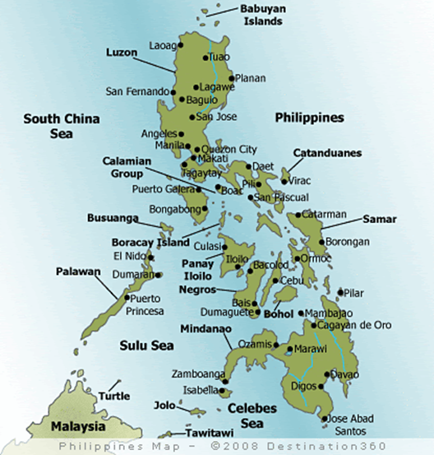



Figure 2. Maps of the Philippines and Region XI

Research Respondents
The respondents of this study were the 121 public junior high school science teachers in the district 1 of Davao City. The names of the science teachers who responded in the study were acquired from their respective department heads. Using the online Raosoft sample size calculator with 95% confidence level and 5% margin of error, there were 121 public high school science teachers randomly chosen for the study. The ratio and proportion were utilized to determine the sample size per school.
In this study, all the identified science teachers were informed of the research objectives and were invited to take part in this endeavor since they are part of the program teaching science in the inclusive education.

Research Instrument
There were three survey questionnaires used to collect the data, specifically on the teachers’ classroom management, efficacy beliefs, and attitudes towards inclusive education. The first two questionnaires focused on the independent variables, which were the teachers’ classroom management and efficacy beliefs, and the third questionnaire focused on the dependent variable, which was the teachers’ attitudes toward inclusive education. To ensure the quality and reliability of these questionnaires, they were validated by three experts: one from the panel and two from UIC faculty.
For the classroom management, the questionnaire was adopted from the study conducted by Yeliz Temli-Durmuş (2016) on Development of Classroom Management Scale for Science Teachers. The instrument has Cronbach-alpha reliability coefficient of the first subscale was.82, for the second subscale .75 and for the third subscale was .85, making it valid and reliable for the adult respondents. This research questionnaire allows inclusive education teachers measure key factors in facilitating learners with special needs and offers high quality inclusive education program. In this study, the respondents were asked to rate the items under all the areas using a five-point scale. The range of the five-point scale includes the following: 5 – strongly agree; 4 – agree; 3 – somewhat agree; 2 – disagree; and 1 – strongly disagree.
To interpret the rating the range of scales below has been used:
 | Range | Description | Interpretation
 | 4.20 – 5.00 | Very High | Efficient classroom management of  teachers is always evident.
 | 3.40 – 4.19 | High | Efficient classroom management of  teachers is oftentimes evident.
 | 2.60 – 3.39 | Moderate | Efficient classroom management of  teachers is sometimes evident.
 | 1.80 – 2.59 | Low | Efficient classroom management of  teachers is rarely evident.
 | 1.00 – 1.79 | Very Low | Efficient classroom management of  teachers is never evident.
For the efficacy beliefs, this research questionnaire would allow inclusive education science teachers measure their efficacy beliefs, specifically their personal science teaching belief (PSTB) and science teaching outcome expectancy (STOE) in facilitating learners with special needs. This survey questionnaire on teachers’ PSTB and STOE was adopted from the study conducted by Riggs and Enochs (1990) on Toward the Development of an Elementary Teacher’s Science Teaching. In this study, the respondents were asked to rate the items under all the areas using a five-point scale. The range of the five-point scale includes the following: 5 – strongly agree; 4 – agree; 3 – somewhat agree; 2 – disagree; and 1 – strongly disagree.
To interpret the rating the range of scales below has been used:
 | Range | Description | Interpretation
 | 4.20 – 5.00 | Very High | The efficacy beliefs of teachers are  always manifested.
 | 3.40 – 4.19 | High | The efficacy beliefs of teachers are  oftentimes manifested.
 | 2.60 – 3.39 | Moderate | The efficacy beliefs of teachers are  sometimes manifested.
 | 1.80 – 2.59 | Low | The efficacy beliefs of teachers are  rarely manifested.
 | 1.00 – 1.79 | Very Low | The efficacy beliefs of teachers are  never manifested.
For attitudes towards inclusive education, this research questionnaire would allow inclusive education teachers articulate key factors in facilitating learners with special needs. The factor analysis indicated four major stressors, a) the management and the behavior of students b) working conditions c) teachers’ workload d) support and recognition by the state. The questionnaire on the attitudes towards inclusive education was adopted from Galaterou, et al. (2017) study on Teachers’ Attitudes towards Inclusive Education: The Role of Job Stressors and Demographic Parameters. In this study, the respondents were asked to rate the items under all the areas using a five-point scale. The range of the five-point scale includes the following: 5 – strongly agree; 4 – agree; 3 – somewhat agree; 2 – disagree; and 1 – strongly disagree.
To interpret the rating the range of scales below has been used:
 | Range | Description | Interpretation
5 | 4.20 – 5.00 | Very High | Favorable attitude of teachers is  always demonstrated.
4 | 3.40 – 4.19 | High | Favorable attitude of teachers is  oftentimes demonstrated.
3 | 2.60 – 3.39 | Moderate | Favorable attitude of teachers is  sometimes demonstrated.
2 | 1.80 – 2.59 | Low | Favorable attitude of teachers is  rarely demonstrated.
1 | 1.00 – 1.79 | Very Low | Favorable attitude of teachers is  never demonstrated.
Data Gathering Procedure
The following protocols were undertaken by the researcher. A letter of permission was sent by the researcher asking permission from the Dean of the Graduate School of the University of the Immaculate Conception (UIC) allowing the researcher to carry out the study. The researcher secured an Ethical Clearance from the office of UIC-Research Ethics Committee (UIC REC). After the approval of the Graduate School Dean, a permission was secured from the respective School Heads or School Principals of the eleven secondary public junior high school science teachers of District 1 in Davao City who were handling students in the inclusive education.
After having permission from different authorities, the researcher asked for the list of all teacher respondents, from the respective eleven secondary public schools, who were possible respondents of the study based on the given criteria. The researcher scheduled the specific date and time for the administration of the questionnaire face-to-face to the identified science teachers handling inclusive sections. Prior to answering the questionnaire, an Informed Consent Form was given to the respondents, explaining to them the purpose and objectives of the study. When the teachers expressed agreement and signed the consent, the research instrument was then administered. To give the respondents enough time to read and respond to the three equally important research questionnaires.
Similarly, to ensure the retrieval of the survey questionnaire, all the teacher respondents were informed about intention of the study by ensuring the informed consent. Privacy and confidentiality were maintained by using codes to hide the identity of the respondents. The respondents were assured that the data obtained would be used for the purpose of the study and kept confidential; and lastly, tallying of the responses for data analysis and interpretation of results, all the data collected were reported and tallied. It would be used in the analysis as the basis for the presentation of the results of the study. The analysis and interpretation of data were presented with the help of a statistician and consultant.
Statistical Tools
The researcher utilized the following tools for data treatment:

Mean.

In this study, mean was used to determine the level of teachers’ classroom management, efficacy beliefs, and attitudes toward inclusive education.

Standard Deviation.

The standard deviation determines the variability or disparity of the responses. In the study, it was used to determine the disparity of the following: teachers’ classroom management, efficacy beliefs, and attitudes toward inclusive education.

Pearson-r Moment Correlation.

In the study, it was used to determine the relationship of the following: teachers’ classroom management and attitudes toward inclusive education, and efficacy beliefs and attitudes toward inclusive education.

Multiple linear regression.
In the study, multiple regression was used to determine the significant influence of classroom management, efficacy beliefs on attitudes toward inclusive education.

Ethical Considerations
The researcher took steps to ensure that the necessary ethical procedures were followed. As a result, the ethical standards of UIC Research Committee were properly observed in this study.

Social Value

It is the intention of the study to reveal ethically and morally a complete explanation on the teachers’ level of satisfaction in terms of classroom management, self-efficacy, and attitude towards inclusive education through Expectancy-Disconfirmation Theory of Customer Satisfaction. Moreover, the results of the study would lead to determine the influence of teachers’ classroom management in terms of people management, behavior management, and instructional management; self-efficacy in terms of efficacy belief and outcome expectancy; and attitude towards inclusive education in terms of negative sentiments, positive sentiments, and logical concerns Thus, the school administration, cluster 1 science teachers, and other stakeholders may use the findings of the study in maintaining, sustaining, and improving the academic performance of students in the inclusive education.
Relatively, this research study is aligned with the Basic Education Research Agenda of DepEd, which is stipulated in DO 39 series of 2016 is the Teaching and Learning. Furthermore, through the support of DepEd Order No. 44 series of 2021, which promotes inclusive education, the teachers under the program would provide a better environment for all learners to collaborate, regardless of their issues or differences and ensure that students with exceptionalities and special needs are included in mainstream or general education classes.

Informed Consen

The researcher would make sure that the respondents are informed of all the necessary information related to the conduct of the study including its purpose as reflected in the Informed Consent Form (ICF). The researcher secured the informed consent for permission and coordination with the School Principals. The researcher further would ensure that the respondents understood what it means to take part in the study so they could thoroughly decide rationally and deliberately whether they could participate or not. The researcher asked for consent from the Schools Division Superintendent of DepEd Davao City; after the approval, the researcher sent a letter to the participating schools together with the approved letter to conduct the study.
The respondents were informed that their participation was purely voluntary, and refusal would be accepted at any time. If the respondent decided to participate in the survey, they were asked to affix their signature on the ICF as evidence of their willingness to participate in the study.

Vulnerability of Research Participants

The respondents were not vulnerable since they are DepEd teachers handling inclusive education, and they are all at their legal age and can justify their participation in this research study. However, they have the freedom to drop out at any time without repercussion. Furthermore, even if respondents may not be categorized as "vulnerable" traditionally, they nevertheless may be in a way that is consistent, which makes it conceivable for them to feel compelled or coerced into participation. The researcher would appreciate their cooperation and prioritized their well-being throughout the study as a result; hence, special care is needed to ensure that their involvement is truly voluntary. When requesting their approval, they also ought to have made them aware of the limitations of the secrecy. They received the surveys as well. As a result, they have the sole authority to accept or decline the request to do the survey.

Risks, Benefits and Safety

Practically the researcher identified minimal risks if not negligible regarding physical harm or discomfort that they might experience during the conduct of the study. Specifically, whatever might cause adverse effects on personal relationships, loss of status, privacy, or time of the respondents would be taken into consideration in the planning stage of the conduct of the study so that such things are minimized if not prevented fully as per RA 9262, the Anti-Violence Against Women and their Children Act of 2004 on section 44, confidentiality that it must be well-kept, and shall be confidential and all public officers and employees. Whoever publishes or causes to be published, in any format, the name, address, telephone number, school, business address, employer, or other identifying information of a victim or an immediate family member, without the latter's consent, shall be liable to the contempt power of the court. The researcher would consider that no harm or injury, whether physical, psychological, social, or economic, occurs due to participation in a research study. Thus, the researcher would make sure that the face-to-face interaction with the participants is purely for research purposes only; as such, the conduct of the survey was using pen and paper.
A panel of experts validated the items in the questionnaires to see that no word, phrase, or statement were considered offensive or harmful to the respondents physically, mentally, and emotionally. The benefits that the respondents would gain from this study were generated relevant information which can be helpful to school administrators, teachers, and the rest of the academic community.
Further, the researcher informed the respondents that they would receive small amount of monetary compensation, and the results would be beneficial for them in terms of the knowledge as they would receive feedback from the results of the study to help them improve their performance in handling learners with exceptionalities and special needs. The respondents were also informed that the summary of the data would be disseminated to the professional community but there is no way to trace the responses of the individuals. The data gathered from the survey would be kept confidential and would be used only to verify the findings of the study.

Privacy and Confidentiality of Information

The respondents were given the assurance that any information they would share in the survey would be kept secret and confidential about confidentiality and security. By regulating the gathering, recording, association, collecting, updating or adjustment, access, consultation, use, blocking, deletion, or destruction of personal data, the Data Privacy Act of 2012 is observed which the Philippines has met based on the international norms. To promote growth and progress, it also safeguards individual privacy while promoting the open exchange of information. Therefore, no responders' private information was disclosed (NPC). Moreover, the respondents were informed of the primary purpose of their participation in the study. There was personal information to be collected as part of the questionnaires. The data gathered was strictly used only for the purposes of the research and not in any way for commercial purposes. As such, the collection or personal data would adhere to the Rule IV: Data Privacy Principles, Section 18 of the Privacy Act of 2012. Therefore, the processing of personal data shall be allowed but subject to the principles of: (a) Transparency- the data subject must be aware of the purpose of the study. (b) Legitimate Purpose-the processing of information shall be related to a declared purpose and shall not in contrast to the moral laws. (c) Proportionality- the processing of information relevant and not excessive in relation to the specified purpose. As such, any deception or exaggeration about the aims and objectives of the study shall be strictly avoided.
Consequently, the researcher would refrain from disclosing the names of the participants in reporting the results of the study. In case the respondents wish to withdraw from the study and may not want to answer further questions, the researcher would allow it. The researcher would also be careful in wording the questions so that no harm would be inflicted.
Additionally, the data collected in this study like the teachers’ name and information would remain confidential. Paper records were shredded, and records stored on the computer hard drive were deleted to remove all the confidential data related to the respondents.

Justice

As I was the sole person in charge of conducting this research, there was no expectation that any other individual or group would contribute to the costs. Furthermore, the responders' eligibility was thoroughly considered. The researcher was fair in selecting the respondents of the study. No restriction or qualification was set in the selection of respondents if the respondents fit in the inclusion criteria set forth in the study for as long as the respondents are willing to participate in the survey. The researcher would ensure the respect and integrity in the treatment of the respondents to receive an effective response. The concept of fairness, the appropriateness of the research questions, and the readiness of the researcher was maintained.
The respondents, who are Science teachers within the district 1 and handling inclusive education learners, were reminded of their responsibility to provide honest and true responses being the source of the information to avoid bias in the conduct of the study. The researcher would take responsibility of the study from beginning to end.

Qualifications of the Researcher

The researcher is credible in undertaking the study on teachers’ classroom management, self-efficacy, and attitude towards inclusive education. The Researcher was once a recipient of the STE program in 1993 and the STE Coordinator since 2016. Indeed, my 25 years of teaching science and my exposure to science teachers of the program have honed my understanding on their level of satisfaction. In fact, I have explored some principles in teaching and professional education to personally and professionally equip myself with academic and non-academic responsibilities in the learning environment and in teaching science. Furthermore, the researcher is closely monitored by a highly qualified and competent adviser and mentor in the field of teaching science and physics. With the ethical direction of the mentor, the researcher believes that he can carry out the current study. Additionally, as the STE Coordinator and Master Teacher at Davao City National High School, the Division of Davao City had been inviting me as one of the Resource Speakers in a Division-wide training related to Science Teaching and in the facilitation of conducting Strategic Intervention Material (SIM) in Teaching Science for Junior High School.

Adequacy of the Facilities

There were several online sources, journal publications, and science curriculum books that can be accessed by the researcher to enrich interpretation and analysis of the present study. Likewise, the researcher has an excellent internet connection where he could navigate the browser for reading online resources. He has also access to online research journals such as Scopus Index Journals, Google Scholar, Ebrary and ProQuest, and with the University library and its resources such as books as a source of information, these research journals and resources were in great help during the analysis, interpretation, and discussion of results of the study on teachers’ classroom management, self-efficacy, and attitude towards inclusive education. Furthermore, the presence of the research adviser, consultants, chairperson, and panel members who helped the researcher improve the paper through their suggestions, comments, and recommendations. It is expected that the scientific presentation and writing of any technical parts of the research study would be emphasized.

Community Involvement

The researcher has planned to disseminate or present the study results and findings to the cluster 1 school administration, teachers, and students in a conference. If given the opportunity, this study would also be presented in a research colloquium where school administrators, teachers, researchers and experts in teachers’ classroom management, self-efficacy, and attitudes towards inclusive education are expected to be in attendance to make this study enriched with the information needed for scientific development. Lastly, the researcher is determined to publish the study in a reputable research journal to disseminate research findings and be cited by future researchers.

RESULTS AND DISCUSSION

Presented in this chapter are the findings, analysis, interpretation, and implication of the data generated. The results are presented in descriptive and tabular manner.

Level of Classroom Management
among Public Junior High School
Science Teachers

The level of classroom management as reflected in Table 1 has an overall mean of 4.40, described as very high, which means that efficient classroom management of public junior high school science teachers is always evident. In addition, the discussions of teachers’ classroom management are focused on people management, behavior management, and instructional management. This implies that science teachers are efficient in encouraging students with special needs to determine classroom rules; during interaction, they can persuade them to be obedient. Also, this further shows that teachers are proficient in classroom management by acknowledging appropriate behavior of students with special needs in the classroom. The exposure of teachers to inclusive education has provided them with effective modification relative to classroom management, particularly in encouraging students to engage in learning tasks. In addition, its overall standard deviation is 0.48, which denotes that the respondents’ ratings are nearly similar.
Table 1. Level of Classroom Management among the Public Junior High School
Science Teachers
 | Mean | SD | Description
People Management
- encouraging students to determine classroom rules. | 4.60 | 0.56 | Very High
- persuading students to obey the classroom rules. | 4.49 | 0.56 | Very High
- requiring skills about classroom management | 4.36 | 0.59 | Very High
- providing effective communication skills in classroom. | 4.36 | 0.59 | Very High
- designing effective learning environment using enough school facilities | 3.69 | 0.85 | High
- noticing what students demand for encouraging them in classroom rules. | 4.16 | 0.71 | High
Category Mean | 4.27 | 0.48 | Very High
Behavior Management
1. coping with disruptive behaviors. | 4.31 | 0.62 | Very High
2. using preventive strategies. | 4.30 | 0.63 | Very High
3. dealing with students’ misbehaviors | 4.32 | 0.65 | Very High
4. setting rules to the students for behavioral  expectation in the classroom | 4.50 | 0.53 | Very High
5. acknowledging appropriate behavior of the  students as sample in the classroom | 4.54 | 0.53 | Very High
Category Mean | 4.39 | 0.49 | Very High
Instructional Management
1. encouraging students to engage in learning tasks. | 4.71 | 0.52 | Very High
2. preparing good-structured learning activities. | 4.51 | 0.63 | Very High
3. encouraging students to be active during learning –teaching process. | 4.59 | 0.56 | Very High
4. being good at time management. | 4.54 | 0.70 | Very High
5. knowing effective strategies to attract students’ attention. | 4.37 | 0.64 | Very High
6. designing suitable seating arrangement. | 4.51 | 0.66 | Very High
Category Mean | 4.54 | 0.47 | Very High
OVER-ALL MEAN | 4.40 | 0.48 | Very High

The result confirms the study by Kurniawati (2017) which concluded that the attitudes of teachers towards inclusion of students with special educational needs are providing a high level of classroom management. The said finding further confirms the study done by Marzano (2003) which stated that classroom management is the most important factor in influencing school learning. The said findings furthermore confirm the ideas of Yasar (2008) which stated that classroom management is effective for a successful delivery of instruction.
Based on the study of Sanchez (2023, the results support the contention that a consistent classroom management and even appropriate and suitable techniques in teaching is an effective tool in managing children with special needs in an inclusive classroom. Likewise, Helmke (2014) emphasizes three factors for effective classroom management: clear rules and the early establishment and consistent realization of social and academic norms, successful time management which facilitates the smooth transition from one activity to the next and prevents tardiness and unnecessary waiting, and the effective prevention and handling of classroom disruptions. Further, the common denominator that is most closely linked with effective teaching beyond academic content preparation is strong classroom management (Lemov, 2010). Furthermore, the focus of the present study reiterates Sucuoğlu’s et al. (2017) that effective classroom management promotes psychosocial wellness and learning of students with special needs; as expected, it lessens behavioral issues inside the classroom.

People Management.

This indicator has a category mean of 4.27, described as very high. It has a mean range of 3.69 to 4.60. The item, encouraging students to determine classroom rules reveals a rating of 4.60, while the item, designing effective learning environment using enough school facilities has a mean rating of 3.69.
The findings confirm the study by Alter and Haydon (2017) indicated that the two most important characteristics of effective classroom rules are teaching the rules to students and tying rules to positive and/or negative consequences. According to the results obtained by Sen (2022), it determines that the classroom rules in basic education are necessary for classroom management, quality education, character education and effective communication. It has been revealed that the methods that teachers use most while teaching the rules are modelling, drama and expression.
This study confirms the study by Sales (2019) that the challenges faced by teachers in inclusive education are lack of special education teachers, lack of facilities for special care, lack of special education classes, lack of appropriate resources and inappropriate allocation of learning materials and Saleem et al., (2021) conclude that the coordination and implementation of classroom programs and initiatives by presenting specific guidelines and input establishes effective classroom management.

Behavior Management.

It has a category mean of 4.39, described as very high. It has a mean range of 4.30 to 4.54. The item, acknowledging the appropriate behavior of the students as a sample in the classroom gets a mean of 4.54, while the item, using preventive strategies shows a mean of 4.30.
The findings affirm the study by Sucuoğlu et al. (2017) that effective classroom management promotes psychosocial wellness and learning of students with special needs as it lessens behavioral issues inside the classroom. The result reinforces the statement of Kilcrease (2024) who believed that K–2 teachers need classroom management strategies, evidence-based practices, and teaching practices to minimize the effects of disruptive behaviors in inclusive classrooms. Hence, having the classroom management and teaching techniques of general education teacher affects the behavior of children with special needs inside the inclusive education (Sanchez, 2023). Eventually, the finding of the study confirms the study by Shaheed (2022) who discovered seven key strategies for effective classroom management such as setting rules and routines, developing student interest, acknowledging appropriate behavior, building cooperative and friendly environment, proper seating arrangements, interactive teaching techniques and fostering sense of collaboration.
Furthermore, the present study emphasizes the findings of Cilliers et al. (2020) that teaching in an inclusive classroom requires a large amount of effort and time, which can make the desired change in teacher behaviors or classroom learning outcomes. In resilience, the present study supports Carneiro’s et al. (2015) contention that to effectively facilitate behavior management of students, teachers are expected to include these classroom management strategies, such as preventive strategies, support and communication strategies, general intervention strategies, and motivation strategies.
Similarly, the actual experiences of science teachers in handling learners with special needs are also evident in Sucuoğlu’s et al. (2017) as they claim that a well-managed classroom supports the academic and social development of all children with or without special needs; it helps reduce problem behaviors and prevents most potential negative behaviors. In addition, it further justifies Pas’s et al. (2019) explanation that that teachers who received training with expert education support and simulator practice were more successful in coping with peer bullying than those who did not.

Instructional Management.

It has a category mean of 4.54, described as very high. It has a mean range of 4.37 to 4.71. The item, encouraging students to engage in learning tasks obtains a mean of 4.71, while the item, knowing effective strategies to attract students’ attention with acquires a mean of 4.37.
The findings confirm the study by Delceva (2014) that teachers, as efficient classroom managers, need to have skills in planning and preparing for the education process, and know how to organize the teaching and how to guide the class. The findings support the study by Jordan and McGhie-Richmond (2014) that classroom management as an effective teaching practice that correlated with the amount of instructional time. With effective management of instructional strategies (Gaias et al., 2019), teachers can improve students' success, level of participation in activities, and positive peer relationships, also reduce problem behaviors that are off-task, destructive, and disturb the teacher and other students in the classroom. The result also supports the findings of Temli-Durmuş (2016) that learning environment is constructively motivating students to follow some expected rules and tasks to ensure the positive impact of instructional time and other classroom practices which enhance learning. The finding cited above further supports the study by Mitchell (2019) emphasized that teachers who have a higher sense of instructional effectiveness devote additional time to learner knowledge, offer more assistance to students with learning disabilities, and praise students more.
Furthermore, the results support the revelation of Graziano and Navarre (2012) that the effectiveness of inclusion was strengthened if regular education teachers use the co-teaching model by providing sport and collaborative opportunities to meet the needs of all students. It hopes that the collaboration of classroom teachers and co-facilitators of learning is observed and applied, it would enhance learning of students in the special education. Likewise, the findings confirm Sucuoğlu’s et al. (2017) contention that teachers differentiate their instructions according to the needs of students, they established a more efficient interaction with children that display different ability levels.

Level of Efficacy Beliefs among
Public Junior High School Science Teachers

Shown in Table 2 is the level of efficacy beliefs which has an overall mean of 4.24, described as very high. The result means that the efficacy beliefs of science teachers are always manifested. Further, the discussions of the status of efficacy beliefs are focused on personal science teaching efficacy and science teaching outcome expectancy. This implies that science teachers are efficient in finding continually better ways to teach science, particularly the inclusion of basic knowledge to learn the steps and science concepts for students with special needs. However, they find some difficulties explaining to students the importance of science experiments and typically answering students’ questions. Relatively, some of them are wondering if they have the necessary skills to teach science in an inclusive learning environment. To respond to these challenges, science teachers are still submissive to their master teachers for monitoring and evaluation of their instructional management. In addition, its overall standard deviation is 0.48 denotes that the respondents have ratings that are nearly similar.
Table 2. Level of Efficacy Beliefs among the Public Junior High School Science
Teachers
 | Mean | SD | Description
Personal Science Teaching Efficacy
- finding continually better ways to teach science. | 4.53 | 0.61 | Very High
- teaching science as well as in other subjects. | 4.18 | 0.68 | High
- knowing the steps necessary to teach science concepts effectively. | 4.32 | 0.61 | Very High
- monitoring science experiments effectively. | 4.13 | 0.66 | High
- teaching science ineffectively. | 4.26 | 0.57 | Very High
- understanding science concepts well enough to be effective in teaching secondary science.  - finding it easy to explain to students why science experiments work.  - answering students’ science questions.  - having the necessary skills to teach science  - inviting a master teacher to evaluate my science teaching.  - understanding student difficulty in science concept.  - acknowledging the student’s questions in teaching science.  - knowing what to do to turn students on to science | 4.31  4.28  4.33  4.42  4.42  4.48  4.63  4.24 | 0.61  0.67  0.58  0.59  0.63  0.58  0.52  0.67 | Very High  Very High  Very High  Very High  Very High  Very High  Very High  Very High
Category Mean | 4.35 | 0.45 | Very High
Science Teaching Outcome Expectancy | Mean | SD | Description
1. exerting little extra effort to develop the  students’ learning. | 4.12 | 0.66 | High
2. improving students’ science grades by  providing effective teaching approaches | 4.07 | 0.70 | High
3. providing effective science teaching.  approaches to improve the performance of  underachieving students.  4. providing effective teaching strategies to  enhance students’ background in science  5. giving extra attention and focus to students  with low science achievement.  6. spending extra attention to low achieving  students.  7. increasing effort in science teaching to  change learners’ achievement | 3.94  4.22  4.32  3.97  4.31 | 0.79  0.66  0.64  0.84  0.62 | High  Very High  Very High  High  Very High
8. being responsible for the achievement of  students in science.  9. believing that students’ achievement is  directly related to teacher’s effectiveness in  science teaching.  10. affirming the parent’s comment that their child  is showing more interest in science at school  is probably due to the performance of their  teacher  11. considering the effectiveness in science  teaching has little influence on the  achievement of students with low motivation.  12. teaching abilities of teachers help some kids  learn science concepts. | 4.02  4.03  3.96  4.15  4.44 | 0.75  0.67  0.76  0.64  0.60 | High  High  High  High  High
Category Mean | 4.13 | 0.51 | High
OVER-ALL MEAN | 4.24 | 0.48 | Very High

The level of science teachers’ efficacy beliefs is evident in the study of Savolainen et al. (2020) that teachers with higher teacher self-efficacy may also be more willing for students with disability to be included in mainstream schools, and more willing to teach these students within their own classroom. Thus, the results support the ideas of Tschannen-Moran and Hoy’s (2001) which have emphasis that teacher's belief in their own capabilities to facilitate desired student outcomes such as learning and engagement or their belief in their own capabilities to undertake the actions necessary to successfully complete a particular teaching task. Significantly, the results affirm the articulation of Min (2019) that teachers’ outcome expectations affect their willingness to actively engage in the process of educational reform and adapt their practices.
In a study conducted by Siddiqui et al. (2021), the results highlight that individual with high efficacy makes a difference toward their action and feeling good. Figuring out the findings of Pajares and Schunk (2001), it reveals that an individual's self-efficacy influences their goal setting, effort expenditure when faced with difficulties, and resilience and perseverance in consideration of their teaching profession.
Moreover, teachers’ self-efficacy has influenced their reflection and confidence towards their teaching (Jung, 2007). The present findings confirm Savolainen’s et al. (2020) and Woodcock and Jones’s (2020) arguments that that teachers with higher self-efficacy hold more positive beliefs in inclusive education. Furthermore, the present result affirms the study by Savolainen et al. (2020) that teachers with higher teacher self-efficacy are more willing to teach students with special needs to be included in mainstream schools.
Personal Science Teaching Efficacy.

It has a category mean of 4.35, described as very high. It has a mean range of 4.13 to 4.63. The item, answering questions from students with special needs obtains a mean rating of 4.63, while the item, monitoring science experiments works effectively has mean rating of 4.13.
This result could be attributed to the emphasis of Webb-Williams (2018) that concept of self-efficacy belief in science teaching can be viewed as teachers’ belief in their ability to teach science with innovative techniques, leading to an increase in students’ academic achievement. This finding aligns with the study by Tschannen-Moran and Hoy’s (2001) that personal science teaching efficacy was considered as consisting of a teacher's beliefs in their capabilities in the areas of instructional strategies, classroom management and student engagement. Relatively, the present findings support the study by Sharma and Sokal (2016) that teachers with a high sense of teaching efficacy employed more inclusive practices. Also, Sharma et al. (2021) highlighted that teaching efficacy beliefs were the strongest predictors of inclusive practices.
Relatively, the present study highlights the findings of Cantrell (2003) that a teacher with a high sense of efficacy tends to think in more innovative ways when executing classroom tasks and demonstrates change in students’ learning. Similarly, Oppermann et al. (2019) find a significant and positive relationship between science teaching self-efficacy and the teachers’ frequency of engaging children in exploring science related questions.
In the field of Inclusive Education, this result further justifies the stand of UN (2015) that inclusive teaching efficacy must focus on inclusive teaching strategies, managing challenging behavior, and collaborative teaching. To facilitate science-related learning tasks, Oppermann et al. (2019) have suggested that teachers must be more engaged in exploring science together with the children in their classrooms. Evidently, the results support the study by Sandholtz and Ringstaff (2014) that their implementation of hands-on and student-centered science activities, were significantly correlated to their perceived effectiveness in teaching science.

Science Teaching Outcome Expectancy.

It has a category mean of 4.13, described as high. It has a mean range of 3.94 to 4.44. The item, teaching abilities of teachers help some kids learn science concepts gets a mean of 4.44, while the item, providing effective science teaching approaches to improve the performance of underachieving students has a mean of 3.94.
Concurrently, the result confirms the study by Zee and Koomen (2016) that teacher's belief in their teaching capabilities may also be predictive of their students' motivation and positively associated with students' achievement. In addition, the finding recognizes the ideas of Chen (2022) that teachers’ perceptions of the importance of science and the interpersonal support they received played a significant role in directly predicting their science teaching outcome expectations. Moreover, the study affirms Maier’s et al. (2023) contention that teachers’ supportive beliefs about teaching science to foster children’s interest and skills.
However, if not resolved, the present findings affirm the report by Greenfield et al. (2009) that teachers with low self-efficacy may affect the teaching of science. Thus, this study strengthens the findings of Burić and Kim (2020) that teachers’ self-efficacy has been positively associated with instructional quality, such as classroom management strategies and the supportive climate of the classroom.
The results support the findings of McGinnis (2013) that it is extremely important to decide which teaching strategies are effective in supporting the learning needs and to have high levels of self-efficacy belief in teaching this subject.

Level of Attitudes towards Inclusive
Education among the Public Junior
High School Science Teachers

The level of science teachers’ attitudes towards inclusive education in Table 3 has an overall mean of 4.18, described as high. The result means that a favorable attitude of teachers is oftentimes demonstrated. Moreover, the discussions of teachers’ status of their attitudes toward inclusive education are focused on the management and behavior of the student, working conditions, workload, and support and recognition of the State. This implies that science teachers have oftentimes demonstrated favorable attitudes in including students with severe disabilities and physically aggressive, for it might affect the social activities in class. Meanwhile, science teachers are somewhat confident in designing learning tasks that would respond to accommodate individual needs and learning of students with special needs. Relatively, teachers have perceived the importance of education regardless of students’ ability to help them socially and academically. Thus, it is one of their hopes to change the curriculum that meet the learning needs of students with learning difficulties and to undertake any professional development programs, so that they can teach students with diverse learning needs well and it would help them collaborate with other professionals and become more confident with the existing laws and policies related to inclusivity. In addition, its overall standard deviation is 0.65 denotes that the respondents have ratings that are somewhat similar.
Table 3. Level of Attitudes towards Inclusive Education among the
Public Junior High School Science Teachers
 | Mean | SD | Description
3.1 Management and Behavior of the Student
- consulting with a student who is displaying challenging behaviors to find out better ways to work with him/her. | 4.17 | 0.76 | High
- including students with severe disabilities in a range of social activities in class. | 3.94 | 0.78 | High
- making my expectations clear about student behavior. | 4.21 | 0.71 | Very High
- managing students’ disruptive behavior. | 4.20 | 0.71 | Very High
- having confidence in my ability to prevent disruptive behavior in the classroom before it occurs. | 4.18 | 0.70 | High
- controlling disruptive behavior in the classroom  - getting children to follow classroom rules.  - having confidence when dealing with students who are physically aggressive.  - providing an alternate explanation or an example when students are confused. | 4.29  4.31  4.03  4.36 | 0.66  0.65  0.77  0.66 | Very High  Very High  High  Very High
Category Mean | 4.19 | 0.57 | High
3.2 Working Condition
1. being excited to teach students with a range  of abilities in my class. | 4.26 | 0.64 | Very High
2. being happy to have students who need  assistance with their daily activities included  in my classrooms. | 4.21 | 0.73 | Very High
3. changing the assessment tasks to suit the  learning profile of a student who is struggling  (e.g., providing longer time to complete the  task or modifying test questions).  4. gauging accurately student comprehension  of what I have taught.  5. providing appropriated challenges for very  capable students.  6. having confidence in designing learning tasks  so that the individual needs of students with  disabilities are accommodated.  7. having confidence in my ability to get student  students to work together in pairs or in small  groups. | 4.21  4.12  4.22  4.00  4.40 | 0.71  0.71  0.66  0.76  0.68 | Very High  High  Very High  High  Very High
8. using a variety of assessment strategies  (e.g., portfolio assessment, modified tests,  performance-based assessment). | 4.31 | 0.68 | Very High
Category Mean | 4.22 | 0.56 | Very High
Workload
1. teaching all students regardless of their ability in regular classrooms. | 4.10 | 0.87 | High
2. improving students’ social skills in regular  classrooms | 4.18 | 0.76 | High
3. improving students’ academic performance in regular classrooms. | 4.09 | 0.77 | High
4. willing to adapt the curriculum to improve the  learning of students | 4.19 | 0.87 | High
5. being pleased of having the opportunity to teach students with lower academic ability alongside other students in my class. | 4.16 | 0.76 | High
6. being pleased that including students with a  range of abilities will make a better teacher. | 4.24 | 0.76 | Very High
Category Mean | 4.16 | 0.65 | High
Support and Recognition of the State
1. changing the curriculum to meet the learning  needs of a student with learning difficulty  enrolled in your class | 3.85 | 0.86 | High
2. consulting with the parents of a student who  is struggling in your class. | 4.30 | 0.73 | Very High
3. consulting with your colleagues to identify  possible ways you can assist a struggling  student in your class.  task or modifying test questions). | 4.35 | 0.68 | Very High
4. undertaking a professional development  program, so you can teach students with  diverse learning needs well.  5. making parents feel comfortable coming to  school.  6. assisting families in helping their children do  well in school.  7. having confidence in my ability to get parents  involved in school activities of their children  with abilities. | 4.10  4.38  4.16  4.13 | 0.68  0.80  0.67  0.75 | High  Very High  High  Very High
8. collaborating with other professionals (e.g.,  itinerant teachers or speech pathologists) in  designing educational plans for students with  disabilities.  9. working jointly with other professionals and  staff (e.g., aides, other teachers) to teach  students with disabilities in the classroom.  10. having confidence in informing others who  know little about laws and policies relating to  the inclusion of students with disabilities. | 4.09  4.15  3.96 | 0.74  0.84  0.83 | High  High  High
Category Mean | 4.15 | 0.83 | High
OVER-ALL MEAN | 4.18 | 0.65 | High

The results support the findings of Humphrey and Lewis (2008) that the active participation of teachers, parents, and learners has positive impact in the integration of inclusivity. This finding affirms the study by Kington (2017). that inclusion can only be achieved when all stakeholders assist and are required to create learning environments that will encourage the use of practices to reinforce all students, This result confirms the study by Takala et al. (2009) justification that an adaptation of teaching style (pedagogical and teaching methods) and curriculum, cooperation of teachers, and support from the principal of the school unit. Contrarily, the collective teachers’ attitude is different from Boer et al. (2011) explanation that most teachers had embraced neutral or negative attitudes toward inclusive education despite the integration of policy relative to its implementation.

Management and Behavior of the Student.

It has the category mean of 4.13, described as high. It has a mean range of 3.94 to 4.36. The item, providing an alternate explanation or an example when students are confused gets a mean value of 4.36, while the item, including students with severe disabilities in a range of social activities in class has garnered a mean value of 3.94.
The findings of the study support the arguments of Foreman (2008) that teachers’ attitude determines the success in the education of children with special needs. Teachers’ interactions with children in inclusive schools are influenced by the way they think about their students. Thus, it further highlights the stand of Beacham (2011) that having a positive attitude towards students with disabilities is an important condition for the development of effective strategies. The success of inclusion is only possible when teachers show that they are receptive to children with students with special needs.
Moreover, the present findings recognize the justification of Leidig and Possinger (2017) that teachers in inclusive contexts find dealing with challenging behavior to be particularly stressful and difficult. Thus, the results affirm the study by Eckstein et al. (2016) that teachers regard disruptions in teaching as one of the most difficult aspects of inclusive education. But not only teachers, according to Schwab (2018), students also struggle with peers with behavior problems.
Relatively, in the context of inclusive education, the present study strengthens the philosophy of Fraser and Walberg (2005) as cited in Mitchell (2015) that educators are expected to adopt the philosophy of inclusive education and be willing to apply its curricular purpose. Furthermore, it supports the stand of Humphrey et al. (2008) that inclusive education requires commitment to culture, respect for differences, and access to the learning opportunities for all students. However, it further highlights that inclusive practices are about the presence, active, essential participation, and acceptance of students with disabilities in a general education class or activity. In addition, it affirms the statements of Slee (2011) that an adaptation of teaching style (pedagogical and teaching methods) and curriculum, cooperation of teachers.

Working Condition.

It has the category mean of 4.22, described as very high. It has a mean range of 4.00 to 4.40. The item, having confidence in their ability to get students to work together in pairs or small groups obtains a mean value of 4.40, while the item, having confidence in designing learning tasks so that the individual needs of students with disabilities are accommodated garners a mean value of 4.00.
The results support the findings of Zakariya (2020) that teachers have positive impact for both facilitators of learning and students. Those with high teacher self-efficacy may experience greater job satisfaction. For this reason, having a positive attitude towards students with disabilities, for Beacham (2011), is an important condition for the development of effective strategies and success of inclusion when teachers show that they are receptive to children with special needs. Imperatively, attitudes of teachers toward the education of students with special needs, according to Sharma and Sokal (2016), have been proposed as a decisive factor in increasing the participation of these children in school.

Workload.

It has a category mean of 4.16, described as high. It has a mean range of 4.10 to 4.24. The item, being pleased that including students with a range of abilities will make a better teacher shows a mean value of 4.24, while the item, highlighting inclusion benefits of students academically garners a mean value of 4.09.
The findings corroborate with the study by Salem (2013) that the positive attitude towards inclusion of students with special needs is one of the requirements of the success of inclusive education and it has played a crucial role to address and develop student learning. Furthermore, it supports the contention of Monsen et al. (2014) that teachers’ perception toward willingness in handling learners with disabilities is essential for the success of the inclusive education, such as positive perceptions of teachers have been associated with elevated levels of willingness and their acceptance of even the most severe forms of disability. Evidently, it strengthens the ideas of Kurniawati et al. (2012) that the implementation of inclusive practice appears to help teachers familiarize the system and consequently shape positive attitudes towards inclusive education.
In the context of inclusive education, this study adopts the ideology of De Vroey et al. (2019) that together with the development of pedagogical skills and knowledge, teacher’s positive attitude, that according to Yada and Savolainen (2019), has influenced learners’ achievement in the inclusive classrooms. Thus, for Ávalos et al. (2010), attitudes of teachers toward the education of students with special needs have been proposed as a decisive factor in increasing the participation of these children in school. In addition, the results support the study by Finkelstein et al. (2019) that teachers believe that teaching children with special educational needs is beyond the scope of their expertise and therefore they should not be expected to teach the students without help.

Support and Recognition of the State.

It has a category mean of 4.15, described as high. It has a mean range of 3.85 to 4.38. The item, making parents feel comfortable coming to school depicts a mean value of 4.38, while the item, changing the curriculum to meet the learning needs of a student with learning difficulty enrolled in your class garners a mean value of 4.09.
The present findings support the study by Chen (2022) that teachers’ perceptions of the importance of science and the interpersonal support they received have played a significant role in directly predicting their science teaching outcome expectations. In fact, this also confirms the findings of Roxas et al. (2019) that one common problem encountered by teachers is the availability of instructional materials and financial support. Relatively, the results confirm the study by Torquati et al. (2013) that many teachers lack confidence in implementing science instruction. Also, this finding affirms the ideas of Ali et al. (2018) that some teachers constantly demand additional practice support, especially for classroom behavioral interventions. With proper implementation, Scruggs et al. (2007) report that most teachers were comfortable when students with special needs were placed in the inclusive classrooms. However, many teachers also believe that teaching children with special educational needs is beyond the scope of their expertise and therefore they should not be expected to teach the students without help (Engelbrecht, 2006). Thus, Scruggs’s et al. (2007) emphasize that integration depends to a la large extent on the attitude of teachers and their willingness to include students with learning difficulties.
In response to inclusivity in the basic education, DepEd (2013) recognizes the role of teachers and parents in enhancing the learners with physical and psychosocial needs. The parents’ comfortability is a directive in the Implementing Rules and Regulations (IRR) of RA 1O533, Sec. 8 which states that inclusiveness of enhanced basic education necessitates the implementation of programs designed to address the physical, intellectual, psychological, and cultural needs of learners, including, but not limited to, programs for learners with disabilities. However, Roxas et al. (2019) mention that the most common problems encountered by teachers were the parents in the in-denial stage. Therefore, orientation should be conducted to the parents in addressing the problems encountered in the SPED programs.
Indeed, science teachers’ insurgence was clearly emphasized in Angelides et al. (2006) that “inclusion” does not refer only to the placement of a child with special educational needs within the regular school, but also to the conditions under which all children can be educated. Furthermore, the results support the advocacy of Leung and Mak (2010) that the positive perceptions of teachers are deemed to be necessary for the development of a suitable inclusive school environment. Also, teachers’ active participation helps improve the system in enhancing the learners’ capability inside and outside the classroom. Therefore, according to Peters (2007), schooling should be actualized in accordance with the specific needs of each child, rather than attempting to adapt them in the specifications of the existing curriculum.

Significance of the Relationship between the
Level of Classroom Management and Level
of Efficacy Beliefs on Attitudes towards
Inclusive Education

Table 4.1 presents the relationship between the independent variables—Classroom Management and Efficacy Beliefs—and the dependent variable, Attitude toward Inclusive Education. The results show that both independent variables are significantly correlated with Science Teachers' Attitude toward Inclusive Education (p < 0.05). Specifically, the correlation coefficients (r values) are 0.703 for Classroom Management and 0.807 for Efficacy Beliefs. These values indicate a significant, positive, and strong relationship between Science Teachers' Classroom Management (r = 0.703) and Efficacy Beliefs (r = 0.807) with their attitudes toward inclusive education (p < 0.05). This suggests that higher levels of classroom management and stronger efficacy beliefs are associated with more favorable attitudes toward inclusive education among science teachers.

Table 4.1. Significance of the Relationship between the Level of Classroom
Management and Level of Efficacy Beliefs on Attitudes towards
Inclusive Education

 | r | p | Remarks
Classroom management | 0.703 | .000 | Significant
Efficacy beliefs | 0.807 | .000 | Significant

The result corroborates with the findings of Yada and Savolainen (2019) that teachers’ behavior toward inclusive education had expressed positive relationship to self-efficacy beliefs. The result aligns with the justification of Salvolainen (2020) that the relationship was stronger between efficacy and concerns, which implies that increasing teacher efficacy for inclusive practices is likely to change their attitudes toward positive direction and implications for the development of inclusive education.
Moreover, it also confirms the study by Nagase et al. (2020) that teacher efficacy and teachers’ attitudes toward inclusive education are factors that influence teachers’ emotional distress in the inclusive education system. Consequently, according to Mckay (2016), one aspect that has been deemed important in this regard is teachers’ feeling of self-efficacy to respond to the challenges of inclusive education.
In addition, the current findings have redirected the articulation of Marzo and Pascua (2012) that teachers who were newer in service were more reluctant on the inclusion of inclusive education probably because they have not been trained or have not acquired the variety and latitude of experiences that were vital in teaching children with disabilities. Furthermore, Burić and Kim (2020) noted that self-efficacy has been positively associated with teachers' instructional quality, such as classroom management strategies.
Significance of the Influence of Classroom
Management and Efficacy Beliefs on Attitudes
towards Inclusive Education

The results of the regression analysis, as presented in Table 4.2, reveal that the two independent variables, classroom management and efficacy beliefs, significantly influence teachers' attitudes toward inclusive education. The model is statistically significant, as indicated by an F-value of 118.26 and a p-value of 0.000. Specifically, the independent variables account for 66.2% of the variation in teachers' attitudes toward inclusive education, as evidenced by an R² value of 0.662, while the remaining 33.8% is attributed to factors not included in the study.
Specifically, the individual beta standardized result shows that the positive causal relationship between classroom management and attitude towards inclusive education (β=0.196) implies that the increased change in the level of classroom management by science teachers is directly causing an increased change in their status of attitudes toward inclusive education. Likewise, the positive causal relationship between efficacy beliefs and attitudes toward inclusive education (β=0.656) implies that the increased change in the status of efficacy beliefs anxiety by science teachers is directly causing an increased change in their status of attitudes toward inclusive education.
In the context of this study, it shows that for every one-point increase in teachers' classroom management, their attitude toward inclusive education increases by 0.196 times, assuming the other variable remains constant. Similarly, a one-point increase in efficacy beliefs results in 0.656 times increase in teachers' attitude toward inclusive education, holding the other variable constant. These results underscore the significant role that both classroom management and efficacy beliefs play in shaping teachers' attitudes toward inclusive education.

Table 4.2. Significance of the Influence of Classroom Management and Efficacy
Beliefs on Attitudes towards Inclusive Education

Variables paired with Attitude | B | p | t | Remarks
Classroom management | .196 | .000 | .021 | Significant
Efficacy beliefs | .656 | .000 | .000 | Significant
R² = .662 F = 118.26 p = .000

The results of this study confirm the findings of Monsen et al. (2014) that teachers’ classroom management strategies were found significant to their attitudes toward inclusive education. The study supports the study by Martinez (2003) that teachers’ attitude is one major determinant factor of success or failure of Inclusive Education. In fact, according to Yada and Savolainen (2019), teacher’s positive attitude has influenced learners’ achievement in the inclusive classrooms. Thus, teachers’ attitudes about Inclusive Education not only affect their students but also affect their teaching and the success of the inclusion process.
Moreover, the result highlights the ideas of Mieghem et al. (2018) that teachers’ attitudes towards inclusive education are influenced by teachers’ knowledge of disabilities and their experiences in the inclusive classrooms. Additionally, Schwab (2018) stresses out that teachers’ attitudes play a key role in the implementation of successful inclusive education. However, the result deviates the stand of Zee and Koomen (2016) that self-efficacy beliefs and attitudes do not directly influence teachers’ practices, while other studies indicated that both constructs combined do influence the intentions of teachers and their practices. Furthermore, it confirms the findings of Nagase (2021) that teachers’ level of efficacy and inclusive instruction are unique predictors of their attitudes toward integrated classroom management.
The findings of the study validate the Self-Efficacy Theory developed by Bandura (1977). According to this notion, Self-efficacy Theory is believed to be closely linked to teachers’ self-efficacy; it is an action-outcome expectancy that implies development concerning individual learning capability. Furthermore, teachers’ self-efficacy belief expresses acceptable behavior that produces a high level of personal science teaching efficacy and science teaching outcome expectancy are essential in facilitating teaching and learning to students with special needs.

CONCLUSION

The level of classroom management of science teachers was described as very high. This indicates that their efficiency in classroom management is always evident. This implies that teachers handling students with special needs are efficient in people management, behavior management, and instructional management. This suggests that science teachers must encourage students with special needs to be obedient to classroom rules and be proficient in classroom management strategies that acknowledge appropriate behavior of the students as sample in the classroom. Teachers in inclusive education should also modify classroom management practices, particularly in encouraging students to engage in learning tasks, in designing an effective learning environment using enough school facilities, and in noticing the students’ demands to encourage students with special needs to follow certain rules and learning tasks.
The level of efficacy beliefs of science teachers was described as very high. This means that the efficacy beliefs of science teachers handling students with special needs are always manifested, particularly with their personal science teaching efficacy and science teaching outcome expectancy. This suggests that science teachers must be efficient in finding continually better ways to teach science, particularly the inclusion of basic knowledge to learn the steps and science concepts for students with special needs. Despite some difficulties explaining to students the importance of science experiments, they should provide reasonable responses to students’ questions. Even if teachers are wondering about the necessary skills to teach science in an inclusive learning environment, they should respond to some personal science teaching efficacy and science teaching outcome expectancy challenges and be submissive to their master teachers for monitoring and evaluation of their instructional management.
The level of attitudes toward inclusive education of science teachers was rated high. This means that science teachers handling students with special needs have oftentimes demonstrated favorable attitudes in managing students’ behavior, in their working condition and workload, and toward support and recognition of the state. This suggests that teachers are more challenged in including students with severe disabilities and physically aggressive, which affects their social activities in class. Considerably, science teachers should have confidence in designing learning tasks that would respond to and accommodate the individual needs and learning of students with special needs. Relatively, teachers should perceive the importance of education regardless of students’ ability to help them socially and academically. Therefore, adapting the curriculum that meets the learning needs of students with learning difficulties and undertaking any professional development programs would help them collaborate with other professionals and become more confident with the existing laws and policies related to inclusivity.
Based on the findings, both the science teachers’ classroom management and efficacy beliefs are significantly correlated with the attitudes towards inclusive education. This suggests that higher levels of classroom management and stronger efficacy beliefs are associated with more favorable attitudes toward inclusive education among science teachers.
Based on the findings, science teachers’ classroom management and efficacy beliefs significantly influenced their attitudes towards inclusive education. It suggests that when teachers are efficient in classroom management and use their personal science teaching ability, their attitude towards inclusive education is efficiently and highly demonstrated in providing alternate explanation and examples when students are confused. They have confidence in their ability to get students to work together in pairs or in small groups. Also, they are pleased to include students with a range of abilities and make parents feel comfortable coming to school.

ACKNOWLEDGEMENTS

The researcher would like to express his deepest gratitude and appreciation to the people who offered their assistance and unwavering support for him to complete this study. The success of this study would not be possible without the help of the following people:
Dr. Maria Teresa M. Gravino, his thesis adviser, for the countless hours she has spent giving insightful comments, prompt feedback, unwavering encouragement, and continuous guidance throughout the research process.
Dr. Sylvia J. Pidor, the chairperson of the technical panel, and the members, Prof. Venchie C. Badong, Engr. Raymundo S. Moso, and Engr. John Carlo O. Asis, for sharing their expertise, wisdom, and valuable time in rigorously checking this research paper. Their words of encouragement, motivation, constructive feedback, and guidance motivated him to push through with the study despite his roller-coaster schedule.
The Schools Division Superintendent of the Division of Davao City, Public Schools District Supervisors, and School Heads, for their positive response and full support to the request of conducting this study in their respective locale.
Junior High School Science Teachers of District 1 for their warm accommodation and full support during the data-gathering procedure of the study.
Friends and colleagues at Davao City National High School are sincerely acknowledged for their unwavering support in various ways and for their readiness to extend assistance whenever needed. Special gratitude is expressed to my dearest friend and colleague, Dr. Ramil R. Cubelo, whose encouragement and generosity have been invaluable throughout this journey.
Family of the researcher for their unconditional love, prayers, and moral support in times of discouragement and doubts.
Dr. Mary Jane B. Amoguis, Dean of the Graduate School, for her valuable assistance and support needed for the completion of the study.
Above all, to the Lord almighty for his gifts of wisdom, knowledge, good health, and all that the researcher needed to successfully finish the study.
BSN

RERENCES
- Ali, A., Mustapha, R., & Jelas, Z. M. (2018). Teachers’ demand for practice support in classroom behavioral interventions. International Journal of Inclusive Education, 22(3), 289–305.
- Alter, P. J., & Haydon, T. (2017). Characteristics of effective classroom rules: A review of the literature. Preventing School Failure: Alternative Education for Children and Youth, 61(2), 131–142. https://doi.org/10.1080/1045988X.2016.1254086
- Angelides, P., Stylianou, T., & Leigh, J. (2006). The meaning of inclusion in schools: Exploring teachers’ and parents’ perspectives. International Journal of Inclusive Education, 10(2–3), 179–199. https://doi.org/10.1080/13603110500221720
- Ávalos, B., Cavada, P., Pardo, M., & Sotomayor, C. (2010). Teacher professional development and attitudes toward inclusion. Teaching and Teacher Education, 26(3), 485–496. https://doi.org/10.1016/j.tate.2009.06.012
- Bandura, A. (1977). Self-efficacy: Toward a unifying theory of behavioral change. Psychological Review, 84(2), 191–215. https://doi.org/10.1037/0033-295X.84.2.191
- Babbie, E. R. (2018). The practice of social research (15th ed.). Boston, MA: Cengage Learning.
- de Boer, A., Pijl, S. J., & Minnaert, A. (2011). Regular primary schoolteachers’ attitudes towards inclusive education: A review of the literature. International Journal of Inclusive Education, 15(3), 331–353. https://doi.org/10.1080/13603110903030089
- Beacham, N. (2011). Attitudes towards students with disabilities: Conditions for effective inclusive strategies. International Journal of Inclusive Education, 15(3), 341–356.
- Burić, I., & Kim, L. E. (2020). Teacher self-efficacy, instructional quality, and classroom climate: A meta-analysis. Educational Psychology Review, 32(3), 1–28. https://doi.org/10.1007/s10648-020-09506-9
- Cantrell, P. (2003). Science teaching self-efficacy and innovative classroom practices. Journal of Science Teacher Education, 14(3), 177–193.
- Carneiro, R., Lefrere, P., Steffens, K., & Underwood, J. (2015). Self-regulated learning in technology enhanced learning environments. Rotterdam: Sense Publishers.
- Charitaki, G., Kourti, I., Gregory, J. L., Ozturk, M., Ismail, Z., Alevriadou, A., Soulis, S.-G., Sakici, Ş., & Demirel, C. (2024). Teachers’ attitudes towards inclusive education: A cross-national exploration. Trends in Psychology, 32, 1120–1147. https://doi.org/10.1007/s43076-022-00240-0
- Chen, J. A. (2022). Teachers’ perceptions of science importance and interpersonal support as predictors of science teaching outcome expectations. International Journal of Science Education, 44(12), 1675–1692. https://doi.org/10.1080/09500693.2022.2071234
- Cilliers, J., Fleisch, B., Prinsloo, C., & Taylor, S. (2020). How to improve teaching practice? Experimental evidence on student-teacher feedback. American Economic Journal: Applied Economics, 12(1), 109–141. https://doi.org/10.1257/app.20180478
- Coghlan, D., & Brydon-Miller, M. (Eds.). (2014). The SAGE encyclopedia of action research (Vols. 1–2). London: SAGE Publications. https://doi.org/10.4135/9781446294406
- Creswell, J. W. (2014). Research design: Qualitative, quantitative, and mixed methods approaches (4th ed.). Los Angeles, CA: SAGE Publications.
- De Vroey, A., Struyf, E., & Petry, K. (2019). Teachers’ pedagogical skills and attitudes in inclusive classrooms. European Journal of Special Needs Education, 34(3), 301–315. https://doi.org/10.1080/08856257.2018.1533096
- Delceva, J. (2014). Teachers as efficient classroom managers: Skills in planning, organizing, and guiding instruction. International Journal of Cognitive Research in Science, Engineering and Education, 2(1), 47–52.
- Department of Education (DepEd). (2013). Implementing Rules and Regulations of Republic Act No. 10533: Enhanced Basic Education Act of 2013. Manila: DepEd.
- Eckstein, K., Noack, P., & Gniewosz, B. (2016). Teachers’ perceptions of classroom disruptions in inclusive education. Teaching and Teacher Education, 55, 30–39.
- Engelbrecht, P. (2006). The implementation of inclusive education in South Africa after ten years of democracy. European Journal of Psychology of Education, 21(3), 253–264.
- Espina & Pinili (2024) Espina, R., & Pinili, L. (2024). Creating a supportive environment: Strategies for inclusive teaching in special education. World Journal on Education and Humanities Research, 4(2), 276–287.
- Finkelstein, S., Sharma, U., & Furlonger, B. (2019). Teachers’ beliefs about teaching children with special educational needs: Expertise and support requirements. International Journal of Inclusive Education, 23(5), 1–17. https://doi.org/10.1080/13603116.2018.1440487
- Foreman, P. (2008). Inclusion in action (2nd ed.). South Melbourne, Australia: Thomson Learning.
- Fraser, B. J., & Walberg, H. J. (2005). Research on classroom and school climate. In D. Mitchell (2015), What really works in special and inclusive education: Using evidence-based teaching strategies (2nd ed., pp. 45–62). London: Routledge.
- Gaias, L. M., Lindstrom Johnson, S., White, R. M. B., Pettigrew, J., & Dumka, L. E. (2019). Effects of classroom management practices on student success, participation, peer relationships, and behavior. Journal of Applied Developmental Psychology, 62, 124–135. https://doi.org/10.1016/j.appdev.2019.02.004
- Galaterou, J., & Antoniou, A.-S. (2017). Teachers’ attitudes towards inclusive education: The role of job stressors and demographic parameters. International Journal of Inclusive Education, 21(5), 479–493. https://doi.org/10.1080/13603116.2016.1197327
- Graziano, K. J., & Navarre, J. (2012). Co-teaching in inclusive classrooms: The impact on student learning and teacher collaboration. Journal of Special Education Apprenticeship, 1(2), 1–13.
- Greenfield, D. B., Jirout, J., Dominguez, X., Greenberg, A., Maier, M., & Fuccillo, J. (2009). Science in early childhood classrooms: Teachers’ low self-efficacy and its impact on science teaching. Early Childhood Research Quarterly, 24(2), 122–133. https://doi.org/10.1016/j.ecresq.2009.03.002
- Hair, J. F., Hult, G. T. M., Ringle, C. M., & Sarstedt, M. (2019). A primer on partial least squares structural equation modeling (PLS-SEM) (2nd ed.). Thousand Oaks, CA: SAGE Publications.
- Helmke, A. (2014). Unterrichtsqualität und Lehrerprofessionalität: Diagnose, Evaluation und Verbesserung des Unterrichts (5th ed.). Seelze: Klett Kallmeyer.
- Humphrey, N., Bartolo, P., Ale, P., Calleja, C., Hofsaess, T., Janikova, V., ... & Lous, A. M. (2008). Understanding and responding to diversity in the primary classroom: An international study. European Journal of Teacher Education, 31(2), 187–202.
- Humphrey, N., & Lewis, S. (2008). ‘Make me normal’: The views and experiences of pupils on the autistic spectrum in mainstream secondary schools. Autism, 12(1), 23–46. https://doi.org/10.1177/1362361307085267
- Jordan, A., & McGhie-Richmond, D. (2014). Effective teaching practices for students with and without special needs: Constructing a conceptual framework. Exceptionality Education International, 23(2), 55–74.
- Jung, W. S. (2007). Teacher self-efficacy and reflection in teaching practice. Asia Pacific Education Review, 8(2), 250–261.
- Jury, M., Laurence, A., Cèbe, S., & Desombre, C. (2023). Teachers’ concerns about inclusive education and the links with teachers’ attitudes. Frontiers in Education, 7, Article 1065919. https://doi.org/10.3389/feduc.2022.1065919
- Jugan, M. B., Delos Reyes, N. R. T., Pepito, J. C., Capuno, R. G., Pinili, L. C., Cabigon, A. F. P., Sitoy, R. E., & Mamites, I. O. (2024). Attitudes of elementary teachers towards inclusive education of learners with special education needs in a public school. Power System Technology, 48(1), 2173–2202. https://doi.org/10.52783/pst.487
- Kilcrease, C. (2024). Classroom management strategies for K–2 teachers in inclusive settings. Journal of Inclusive Education Research, 12(1), 45–62.
- Kington, A. (2017). The role of stakeholders in promoting inclusive education. International Journal of Inclusive Education, 21(5), 543–556.
- Krainer, I., Pinili, L., Espina, R., & Opingo, K. M. (2024). Teachers’ self-efficacy, attitudes, and challenges in the implementation of inclusive education. World Journal on Education and Humanities Research, 4(1), 136–145. https://doi.org/10.5281/zenodo.10987654
- Kurniawati, F., de Boer, A. A., Minnaert, A., & Mangunsong, F. (2017). Attitudes of Indonesian teachers towards inclusive education: The role of experience and professional development. Disability, CBR & Inclusive Development, 28(2), 27–52. https://doi.org/10.5463/dcid.v28i2.615
- Leidig, T., & Possinger, C. (2017). Teachers’ stress in inclusive contexts: Managing challenging behavior. European Journal of Special Needs Education, 32(4), 543–556.
- Lemov, D. (2010). Teach like a champion: 49 techniques that put students on the path to college. San Francisco, CA: Jossey-Bass.
- Leung, C., & Mak, D. (2010). Inclusive education in Hong Kong: Teachers’ positive perceptions and school environment development. International Journal of Inclusive Education, 14(2), 167–183.
- Lindner, K.-T., Pirker, A., Avramidis, E., & Schwab, S. (2026). Secondary school teachers’ attitudes towards inclusive education: A systematic review of recent results and research trends. European Journal of Special Needs Education. Advance online publication. https://doi.org/10.1080/08856257.2026.2649541
- Maier, U., Kleickmann, T., & Möller, K. (2023). Teachers’ supportive beliefs about science teaching and their role in fostering children’s interest and skills. Research in Science Education, 53(2), 451–470. https://doi.org/10.1007/s11165-021-10012-7
- Martinez, R. S. (2003). Teacher attitudes as determinants of success or failure in inclusive education. Journal of Inclusive Education, 7(3), 231–243.
- Marzano, R. J. (2003). Classroom management that works: Research-based strategies for every teacher. Alexandria, VA: Association for Supervision and Curriculum Development (ASCD)
- Marzo, J. A., & Pascua, R. (2012). Teachers’ attitudes toward inclusive education: The role of training and experience. Asia Pacific Journal of Education, 32(3), 345–360.
- McGinnis, J. R. (2013). Deciding effective teaching strategies in science education: The role of teacher self-efficacy. Journal of Science Teacher Education, 24(7), 1237–1256. https://doi.org/10.1007/s10972-013-9342-9
- McKay, M. (2016). Teacher self-efficacy and challenges in inclusive education. Journal of Education and Practice, 7(29), 45–52.
- Meyer, A., Rose, D. H., & Gordon, D. (2014). Universal design for learning: Theory and practice. Wakefield, MA: CAST Professional Publishing.
- Mieghem, A., Verschueren, K., Petry, K., & Struyf, E. (2018). An analysis of teachers’ attitudes toward inclusive education: The role of knowledge and experience. International Journal of Inclusive Education, 22(2), 205–221. https://doi.org/10.1080/13603116.2017.1364426
- Min, B. (2019). Teachers’ outcome expectations and their role in educational reform. Educational Studies, 45(3), 345–360.
- Mitchell, D. (2019). What really works in special and inclusive education: Using evidence-based teaching strategies (3rd ed.). London: Routledge.
- Monsen, J. J., Ewing, D. L., & Kwoka, M. (2014). Teachers’ attitudes toward inclusion and willingness to teach students with disabilities. Educational Psychology, 34(2), 257–271. https://doi.org/10.1080/01443410.2013.785061
- Nagase, T., Shimizu, K., & Yamamoto, T. (2020). Teacher efficacy, attitudes toward inclusive education, and emotional distress in inclusive systems. International Journal of Inclusive Education, 24(12), 1342–1357.
- Oppermann, E., Brunner, M., & Anders, Y. (2019). Science teaching self-efficacy and engagement in inquiry-based learning. International Journal of Science Education, 41(12), 1607–1625. https://doi.org/10.1080/09500693.2019.1612123
- Pajares, F., & Schunk, D. H. (2001). Self-beliefs and school success: Self-efficacy, self-concept, and school achievement. In R. Riding & S. Rayner (Eds.), Self-perception (pp. 239–266). London: Ablex Publishing.
- Pas, E. T., Waasdorp, T. E., & Bradshaw, C. P. (2019). Examining contextual influences on classroom-based implementation of positive behavior interventions and supports. Journal of School Psychology, 77, 24–37. https://doi.org/10.1016/j.jsp.2019.10.002
- Peters, S. J. (2007). Education for all: Inclusive schooling and curriculum adaptation. International Journal of Inclusive Education, 11(5–6), 459–470. https://doi.org/10.1080/13603110701391350
- Raosoft, Inc. (2004). Sample size calculator. Seattle, WA: Raosoft, Inc. Retrieved from http://www.raosoft.com/samplesize.html
- Riggs, I. M., & Enochs, L. G. (1990). Toward the development of an elementary teacher’s science teaching efficacy belief instrument. Science Education, 74(6), 625–637. https://doi.org/10.1002/sce.3730740605
- Roxas, R. E., Cruz, M. A., & Villanueva, J. (2019). Challenges in special education programs: Instructional materials, financial support, and parental involvement. Philippine Journal of Education, 96(2), 45–60.
- Saleem, M., Ali, A., & Khan, R. (2021). Effective classroom management through coordinated programs and initiatives: Guidelines for teachers. Journal of Educational Research, 24(3), 45–60.
- Salem, A. (2013). Teachers’ attitudes toward inclusion of students with special needs: Requirements for successful inclusive education. International Journal of Inclusive Education, 17(6), 643–658.
- Sales, R. (2019). Challenges faced by teachers in implementing inclusive education: A case study. International Journal of Inclusive Education, 23(12), 1245–1260.
- Sanchez, M. A. (2023). Classroom management strategies for inclusive education: Supporting children with special needs. International Journal of Education and Research, 11(2), 45–58.
- Sandholtz, J. H., & Ringstaff, C. (2014). The impact of hands-on science activities on teacher efficacy and student learning. Journal of Science Education and Technology, 23(2), 149–163.
- Savolainen, H., Malinen, O., & Schwab, S. (2020). Teacher efficacy and attitudes towards inclusive education: A comparative study of teachers in Finland, South Africa, and China. International Journal of Inclusive Education, 24(1), 1–18. https://doi.org/10.1080/13603116.2018.1544294
- Schwab, S. (2018). Attitudes towards peers with behavior problems: Perspectives of students in inclusive classrooms. International Journal of Inclusive Education, 22(1), 82–97.
- Scruggs, T. E., Mastropieri, M. A., & McDuffie, K. A. (2007). Teachers’ perceptions of inclusion: A review of the literature. International Journal of Inclusive Education, 11(1), 59–79. https://doi.org/10.1080/1360311050029604
- Sharma, U., Loreman, T., & Forlin, C. (2021). Predictors of inclusive practices: Teacher efficacy beliefs as the strongest determinant. International Journal of Inclusive Education, 25(7), 785–799.
- Slee, R. (2011). The irregular school: Exclusion, schooling and inclusive education. London: Routledge.
- Siddiqui, N., Ahmad, S., & Khan, M. (2021). Teacher self-efficacy and its impact on professional practice: A study of action and affect. Journal of Education and Practice, 12(5), 77–85.
- Sen, A. (2022). The importance of classroom rules in basic education: Implications for classroom management, quality education, character education, and effective communication. Journal of Education and Practice, 13(4), 55–67.
- Siason, R., et al. (2022). Association of anticipated HIV testing stigma and provider mistrust on preference for HIV self-testing among cisgender men who have sex with men in the Philippines. BMC Public Health, 22, 14834. https://doi.org/10.1186/s12889-022-14834-x
- Shaheed, A. (2022). Effective classroom management strategies in inclusive classrooms: A practical framework. Journal of Educational Practices, 8(4), 112–128.
- Stangor, C., & Walinga, J. (2014). Introduction to psychology. BCcampus.
- Subban, P., Bradford, B., Sharma, U., Loreman, T., Avramidis, E., Kullmann, H., et al. (2022). Does it really take a village to raise a child? Reflections on the need for collective responsibility in inclusive education. European Journal of Special Needs Education, 1–12. https://doi.org/10.1080/08856257.2022.2059632
- Sucuoğlu, B., Akalın, S., & Demir, S. (2017). The relationship between classroom management skills and the psychosocial well-being of students with special needs. International Journal of Inclusive Education, 21(3), 312–329. https://doi.org/10.1080/13603116.2016.1197327
- Takala, M., Pirttimaa, R., & Törmänen, M. (2009). Inclusive special education: The role of special education teachers in Finland. British Journal of Special Education, 36(3), 162–173. https://doi.org/10.1111/j.1467-8578.2009.00432.x
- Temli-Durmuş, Y. (2016). Development of classroom management scale for science teachers. Universal Journal of Educational Research, 4(9), 1950–1957. https://doi.org/10.13189/ujer.2016.040904
- Tomlinson, C. A. (2017). How to differentiate instruction in academically diverse classrooms (3rd ed.). Alexandria, VA: ASCD.
- Torquati, J. C., Cutler, K., Gilkerson, J., & Sarver, S. (2013). Lack of confidence in science instruction among teachers: Implications for professional development. Early Childhood Education Journal, 41(6), 381–389. https://doi.org/10.1007/s10643-013-0579-5
- Tschannen-Moran & Hoy (2001) Tschannen-Moran, M., & Hoy, A. W. (2001). Teacher efficacy: Capturing an elusive construct. Teaching and Teacher Education, 17(7), 783–805. https://doi.org/10.1016/S0742-051X(01)00036-1
- United Nations. (2015). Transforming our world: The 2030 Agenda for Sustainable Development. New York: United Nations. Retrieved from https://sdgs.un.org/2030agenda
- Webb-Williams, J. (2018). Science self-efficacy in the primary classroom: Using innovative teaching techniques to enhance student achievement. Research in Science Education, 48(1), 1–20. https://doi.org/10.1007/s11165-016-9552-3
- Woodcock, S., & Jones, G. (2020). Examining teacher efficacy and inclusive education practices. International Journal of Educational Research, 100, 101534. https://doi.org/10.1016/j.ijer.2020.101534
- Yada, A., & Savolainen, H. (2019). Teachers’ attitudes and self-efficacy beliefs as predictors of learner achievement in inclusive classrooms. International Journal of Inclusive Education, 23(4), 402–417. https://doi.org/10.1080/13603116.2018.1440487 Yasar, S. (2008). Effective classroom management for successful instruction. Journal of Instructional Psychology, 35(1), 33–39.
- Zakariya, Y. F. (2020). The impact of teacher self-efficacy on job satisfaction and student outcomes: Evidence from facilitators of learning. International Journal of Instruction, 13(2), 783–796. https://doi.org/10.29333/iji.2020.13253a
- Zee, M., & Koomen, H. M. Y. (2016). Teacher self-efficacy and its effects on classroom processes, student academic adjustment, and teacher well-being: A review of the literature. Educational Research Review, 17, 98–120. https://doi.org/10.1016/j.edurev.2015.11.003

APPENDIX A

Permission Letters

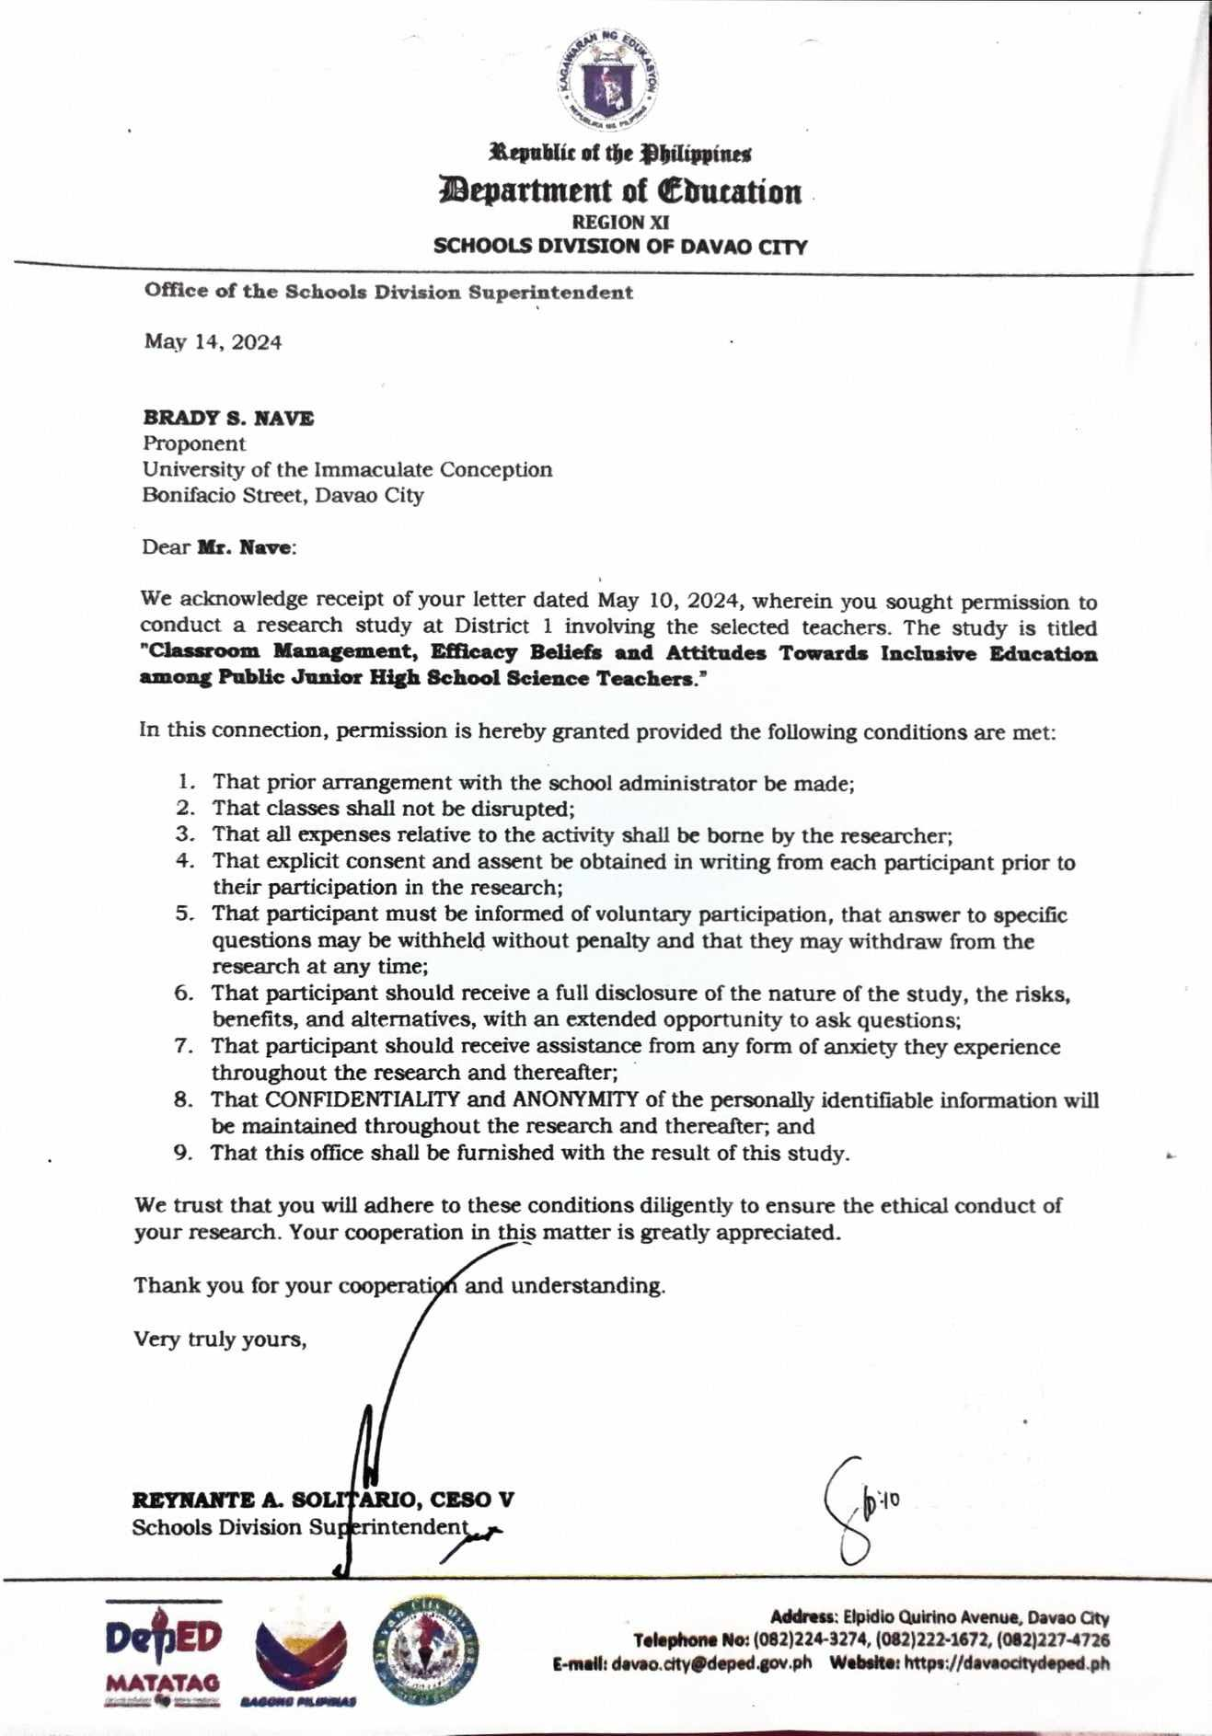

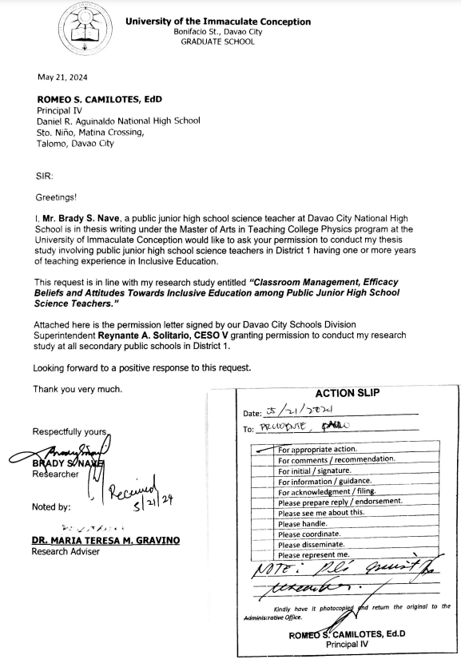

APPENDIX B

Ethical Clearance

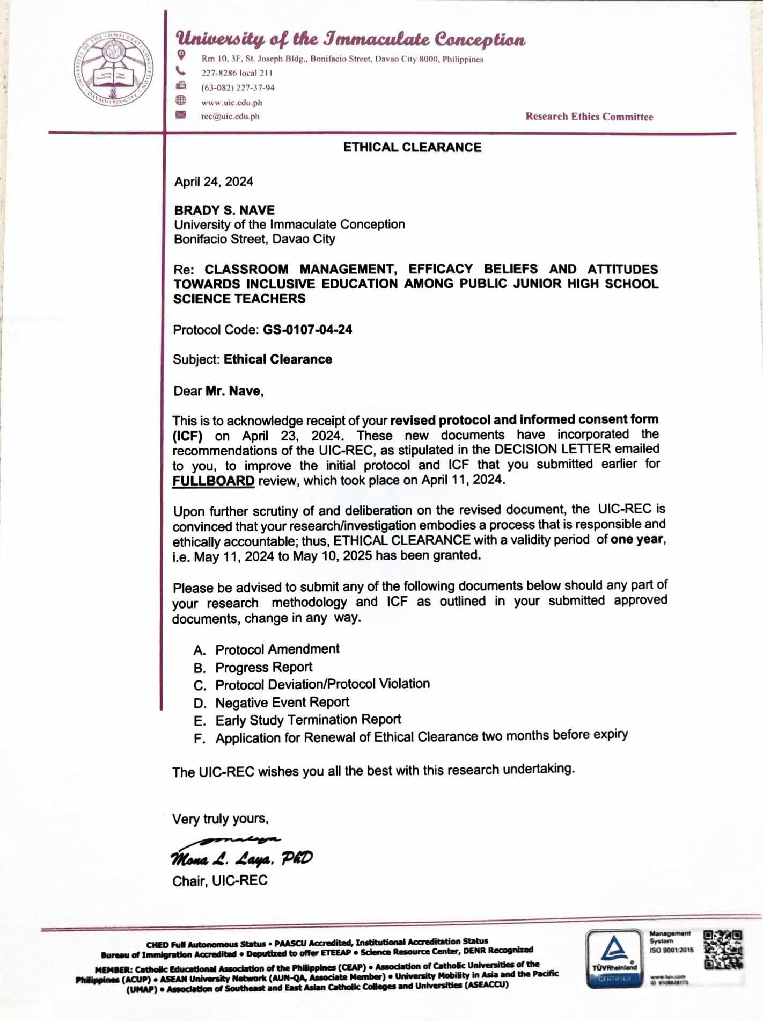

APPENDIX C

Endorsement for Pre-Final Defense
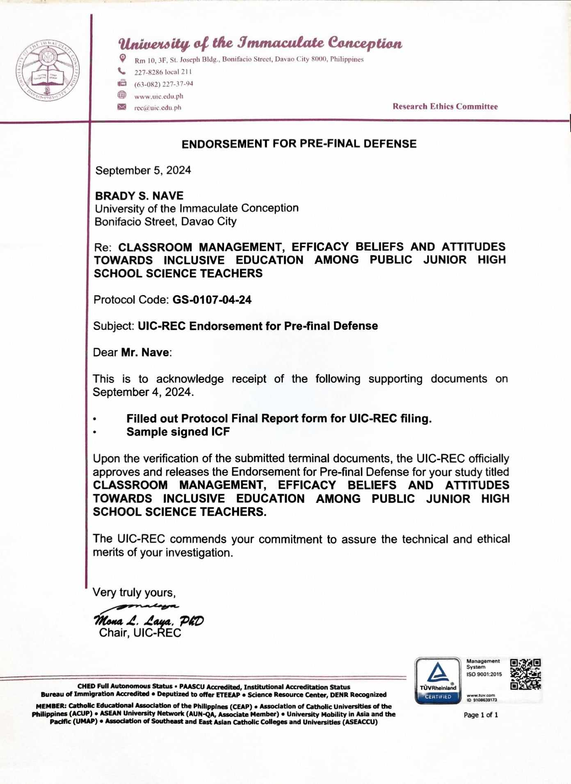

APPENDIX D
Research Instruments

Attitudes towards Inclusive Education among Public Junior High School Science Teachers

Part 1 - Demographic Profile

Name: __________________________________________ (optional)
Age: __________
Gender Orientation (Pls. Check): ___ Male ___ LGBTQIA+
___ Female ___ (prefer not to mention)
School :____________________________________________________
Educational Attainment (Pls. Check): ___ College Level
___ Graduate/Post-Graduate Level

Dear Respondents,

You are invited to participate in a research study on Classroom Management, Efficacy Beliefs, and Attitudes towards Inclusive Education among Public Junior High School Science Teachers, which is conducted by Brady S. Nave, a candidate for Master of Arts in Teaching College Physics at the University of the Immaculate Conception because you fit the inclusion criteria as research respondents of the study.
You are reminded that your participation is completely voluntary. As one of my teacher respondents, please ask questions about anything you do not understand, before deciding whether to participate. Also, please take as much time as you need to read the consent form. If you decide to participate, you will be asked to sign this form, and you will be given a copy of this form.
The purpose of this study is to protect and promote the junior high school science teachers’ level of satisfaction in terms of classroom management, self-efficacy, and attitude towards inclusive education ethically and morally. If you volunteer to participate in this study, you will be asked to participate by answering the research questionnaires which you can finish in less than one hour.

Rest assured that your responses are treated with confidentiality.

Thank you for your cooperation.

Respectfully yours,

Brady S. Nave
Researcher

Research Questionnaire

Classroom Management, Efficacy Beliefs, and Attitudes towards Inclusive Education among Public Junior High School Science Teachers

Please indicate the degree to which you agree or disagree with each statement below by encircling the appropriate scale to the right of each statement: 5 – Strongly Agree; 4 – Agree; 3 – Moderately Agree; 2 – Disagree; and 1 – Strongly Disagree.

INDICATORS | SCALE
TEACHER’S CLASSROOM MANAGEMENT
A. People Management
1. I can encourage students to determine classroom rules. | 5 | 4 | 3 | 2 | 1
2. I can persuade students to obey the classroom rules. | 5 | 4 | 3 | 2 | 1
3. I have the required skills in classroom management. | 5 | 4 | 3 | 2 | 1
4. I can provide effective classroom communication skills. | 5 | 4 | 3 | 2 | 1
5. School facilities are enough to design an effective  learning environment. | 5 | 4 | 3 | 2 | 1
6. I can notice what students demand to encourage them  in classroom rules. | 5 | 4 | 3 | 2 | 1
B. Behavior Management
1. I can cope with disruptive behaviors. | 5 | 4 | 3 | 2 | 1
2. I can use preventive strategies. | 5 | 4 | 3 | 2 | 1
3. I can deal with students’ misbehaviors. | 5 | 4 | 3 | 2 | 1
4. I set rules for the students for behavioral expectations in the classroom. | 5 | 4 | 3 | 2 | 1
5. I acknowledge the appropriate behavior of the students in the classroom | 5 | 4 | 3 | 2 | 1
C. Instructional Management
1. I encourage students to engage in learning tasks. | 5 | 4 | 3 | 2 | 1
2. I can prepare good-structured learning activities. | 5 | 4 | 3 | 2 | 1
3. I can encourage students to be active during the learning and teaching process. | 5 | 4 | 3 | 2 | 1
4. I am good at time management. | 5 | 4 | 3 | 2 | 1
5. I know effective strategies to attract students’ attention. | 5 | 4 | 3 | 2 | 1
6. I can design suitable seating arrangements. | 5 | 4 | 3 | 2 | 1
EFFICACY BELIEFS
A. Personal Science Teaching Efficacy
1. I am continually finding better ways to teach science. | 5 | 4 | 3 | 2 | 1
2. I can teach science as well as in other subjects. | 5 | 4 | 3 | 2 | 1
3. I know the steps necessary to teach science concepts  effectively. | 5 | 4 | 3 | 2 | 1
4. I am effective in monitoring science experiments. | 5 | 4 | 3 | 2 | 1
5. I generally teach science effectively. | 5 | 4 | 3 | 2 | 1
6. I understand science concepts well enough to be effective in teaching secondary science. | 5 | 4 | 3 | 2 | 1
7. I find it easy to explain to students why science experiments work. | 5 | 4 | 3 | 2 | 1
8. I am typically able to answer students’ science  questions. | 5 | 4 | 3 | 2 | 1
9. I have the necessary skills to teach science. | 5 | 4 | 3 | 2 | 1
10. I would invite a master teacher to evaluate my science teaching. | 5 | 4 | 3 | 2 | 1
11. When a student has difficulty understanding a science  concept, I can help the student understand it better. | 5 | 4 | 3 | 2 | 1
12. When teaching science, I usually welcome student questions. | 5 | 4 | 3 | 2 | 1
13. I know what to do to turn students on to science. | 5 | 4 | 3 | 2 | 1
B. Science Teaching Outcome Expectancy
1. When a student does better than usual in science, it is often because I exerted an extra effort. | 5 | 4 | 3 | 2 | 1
2. When the science grades of students improve, it is most often due to my effective teaching approach. | 5 | 4 | 3 | 2 | 1
3. If students are underachieving in science, it is most likely providing effective approaches to science teaching. | 5 | 4 | 3 | 2 | 1
4. The inadequacy of a student’s science background can be overcome by providing effective strategies in teaching science. | 5 | 4 | 3 | 2 | 1
5. The low science achievement of some students can be  mitigated by giving extra attention and focus. | 5 | 4 | 3 | 2 | 1
6. When a low-achieving child progresses in science, it is usually due to my extra attention. | 5 | 4 | 3 | 2 | 1
7. The increased effort in science teaching produces changes in learners’ achievement. | 5 | 4 | 3 | 2 | 1
8. I am generally responsible for the achievement of students in science. | 5 | 4 | 3 | 2 | 1
9. Students’ achievement in science is directly related to my effectiveness in science teaching. | 5 | 4 | 3 | 2 | 1
10. If parents comment that their child is showing more interest in science at school, it is probably due to my teaching performance. | 5 | 4 | 3 | 2 | 1
11. Effectiveness in science teaching influences the  achievement of students with low motivation. | 5 | 4 | 3 | 2 | 1
12. Teachers with good science teaching abilities help  some kids learn science concepts. | 5 | 4 | 3 | 2 | 1
Teachers’ attitudes toward inclusive education
A. Management and Behavior of the Student
1. I can consult with a student who is displaying  challenging behaviors to find out better ways to work  with him/her. | 5 | 4 | 3 | 2 | 1
2. I can include students with special needs in a range of  social activities in class. | 5 | 4 | 3 | 2 | 1
3. I can make my expectations clear about student  behavior. | 5 | 4 | 3 | 2 | 1
4. I can calm a student who is disruptive or noisy. | 5 | 4 | 3 | 2 | 1
5. I am confident in my ability to prevent disruptive  behavior in the classroom before it occurs. | 5 | 4 | 3 | 2 | 1
6. I can control disruptive behavior in the classroom | 5 | 4 | 3 | 2 | 1
7. I can get children to follow classroom rules. | 5 | 4 | 3 | 2 | 1
8. I am confident when dealing with physically aggressive  students. | 5 | 4 | 3 | 2 | 1
9. I can provide an alternate explanation or an example  When students are confused. | 5 | 4 | 3 | 2 | 1
B. Working Condition
1. I am excited to teach students with a range of abilities in  my class. | 5 | 4 | 3 | 2 | 1
2. I am happy to have students who need assistance with  their daily activities included in my classrooms. | 5 | 4 | 3 | 2 | 1
3. I can change the assessment tasks to suit the learning  profile of a student who is struggling (e.g., providing a  longer time to complete the task or modifying test  questions). | 5 | 4 | 3 | 2 | 1
4. I can accurately gauge student comprehension of what I  have taught. | 5 | 4 | 3 | 2 | 1
5. I can provide appropriate challenges for capable  students. | 5 | 4 | 3 | 2 | 1
6. I am confident in designing learning tasks so that the  individual needs of students with special needs are  accommodated. | 5 | 4 | 3 | 2 | 1
7. I am confident in my ability to get students to work  together in pairs or small groups. | 5 | 4 | 3 | 2 | 1
8. I can use a variety of assessment strategies (e.g.,  portfolio assessment, modified tests, performance-  based assessment). | 5 | 4 | 3 | 2 | 1
C. Workload
- I believe that all students regardless of their ability  should be taught in regular classrooms. | 5 | 4 | 3 | 2 | 1
- I believe that inclusion is beneficial to all students  socially. | 5 | 4 | 3 | 2 | 1
- I believe that inclusion benefits all students  academically. | 5 | 4 | 3 | 2 | 1
- I believe that all students can learn in inclusive  classrooms if their teachers are willing to adapt the  curriculum. | 5 | 4 | 3 | 2 | 1
- I am pleased that I can teach students with lower  academic ability alongside other students in my class. | 5 | 4 | 3 | 2 | 1
- I am pleased that including students with a range of  abilities will make a better teacher. | 5 | 4 | 3 | 2 | 1
D. Support and Recognition of the State
- I can modify the curriculum to meet the learning needs  of a student with learning difficulty enrolled in my class | 5 | 4 | 3 | 2 | 1
- I consult the parents of students who are struggling in  my class. | 5 | 4 | 3 | 2 | 1
- I consult my colleagues to identify possible ways to assist a struggling student in my class. | 5 | 4 | 3 | 2 | 1
- I undertake a professional development program, so  that I can teach students with diverse learning needs  well. | 5 | 4 | 3 | 2 | 1
- I can make parents feel comfortable coming to school. | 5 | 4 | 3 | 2 | 1
- I can assist families in helping their children do well in  school. | 5 | 4 | 3 | 2 | 1
- I am confident in my ability to get parents involved in  school activities for their children with special needs. | 5 | 4 | 3 | 2 | 1
- I can collaborate with other professionals (e.g., teachers  or speech pathologists) in designing educational plans  for students with special needs. | 5 | 4 | 3 | 2 | 1
- I can work jointly with other professionals and staff  (e.g., aides and other teachers) to teach students with  special needs in the classroom. | 5 | 4 | 3 | 2 | 1
10. I am confident in informing others who know little about  laws and policies relating to the inclusion of students  with special needs. | 5 | 4 | 3 | 2 | 1

____________________________________
Respondent’s Signature
____________________
Date

APPENDIX E

Validation Forms
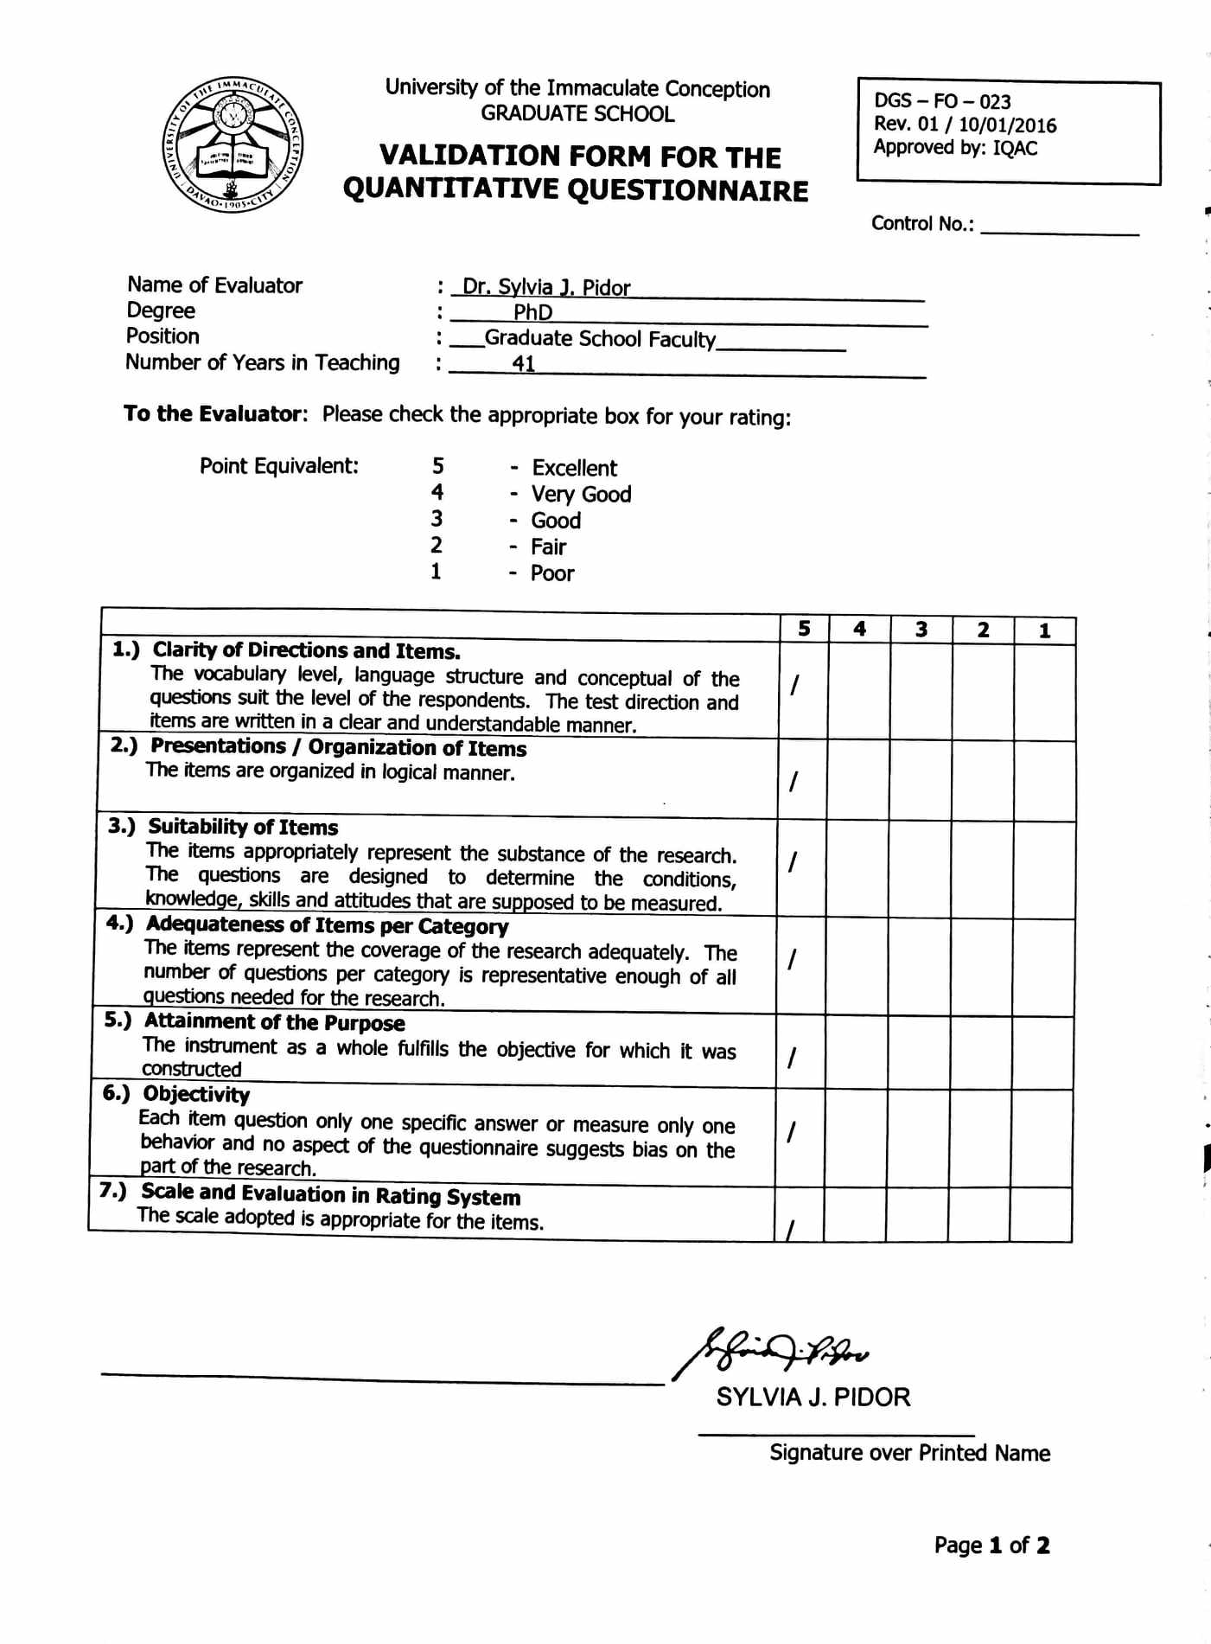

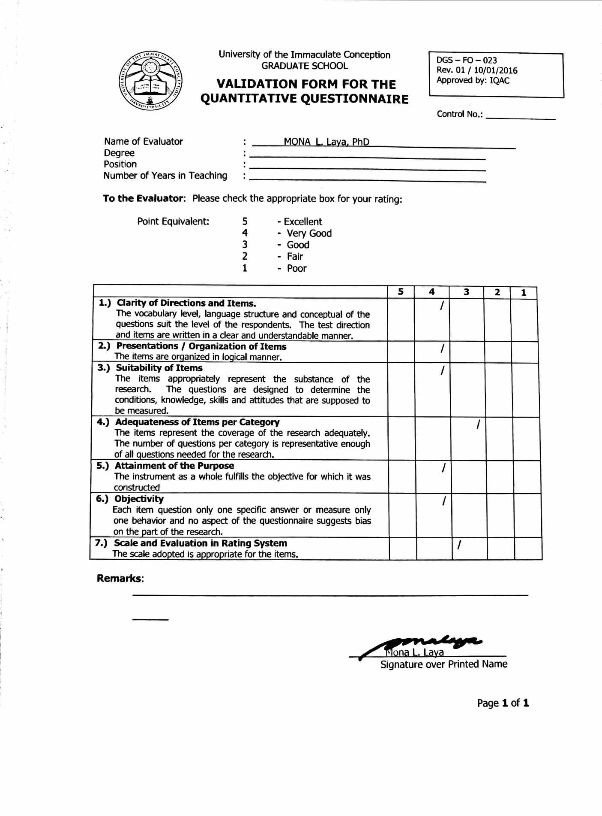

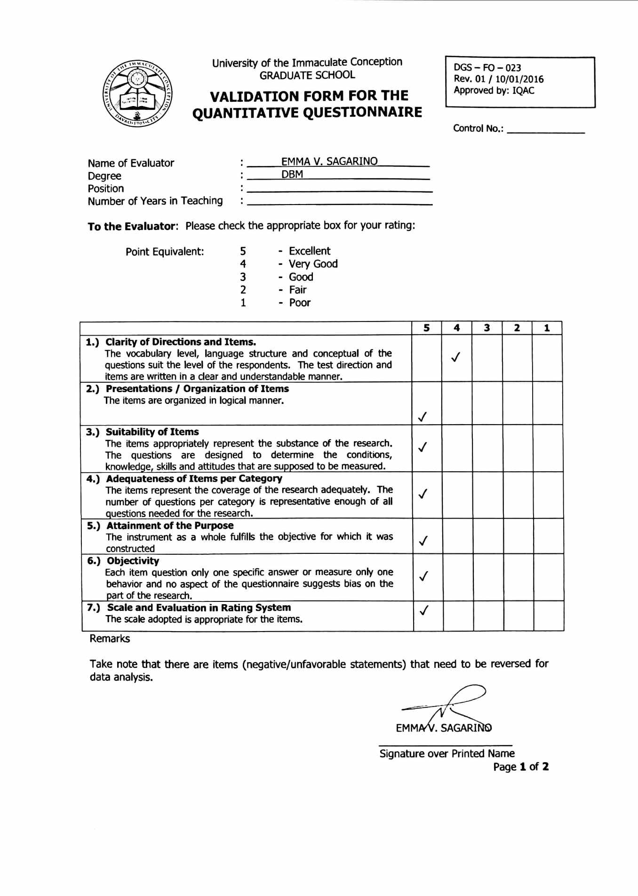

APPENDIX F

Sample Informed Consent Form



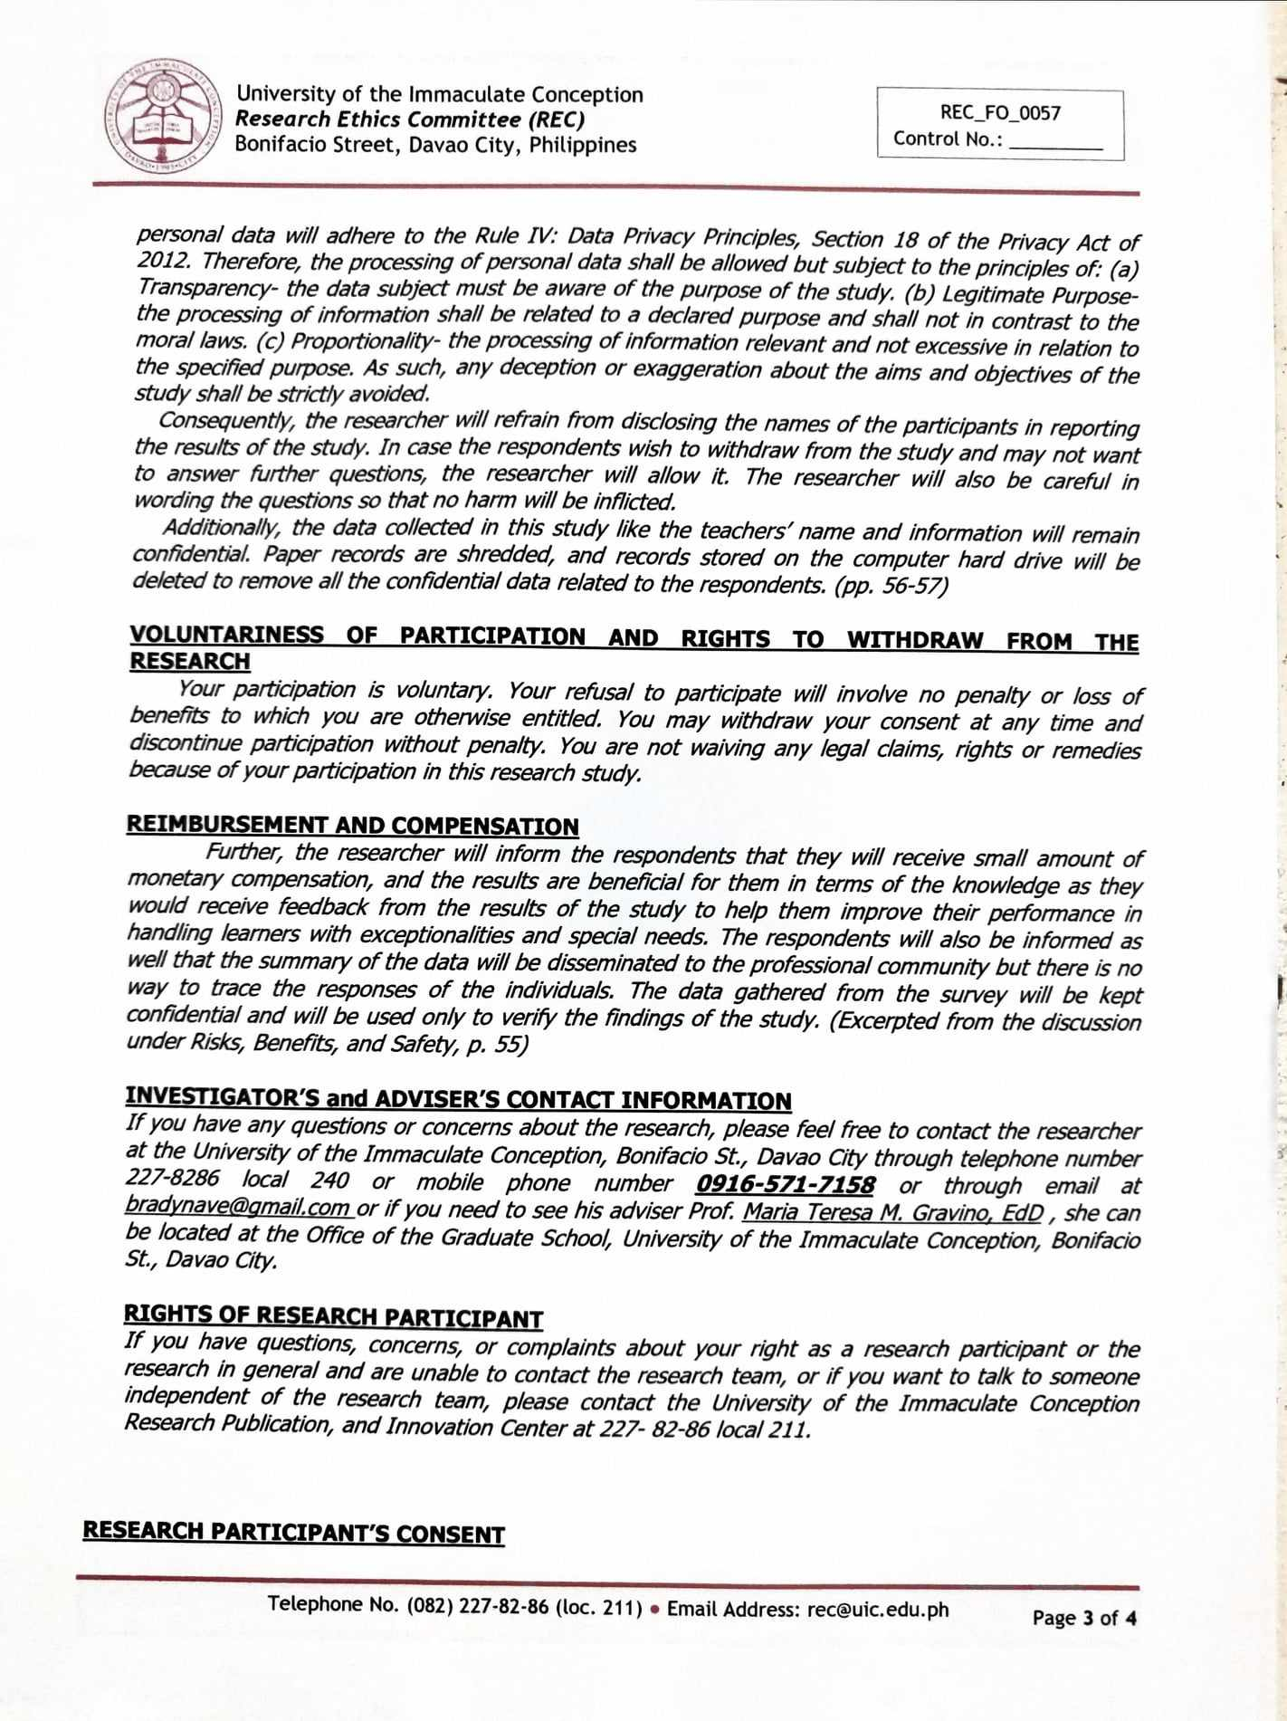

Questionnaire on Classroom Management, Efficacy Beliefs, and

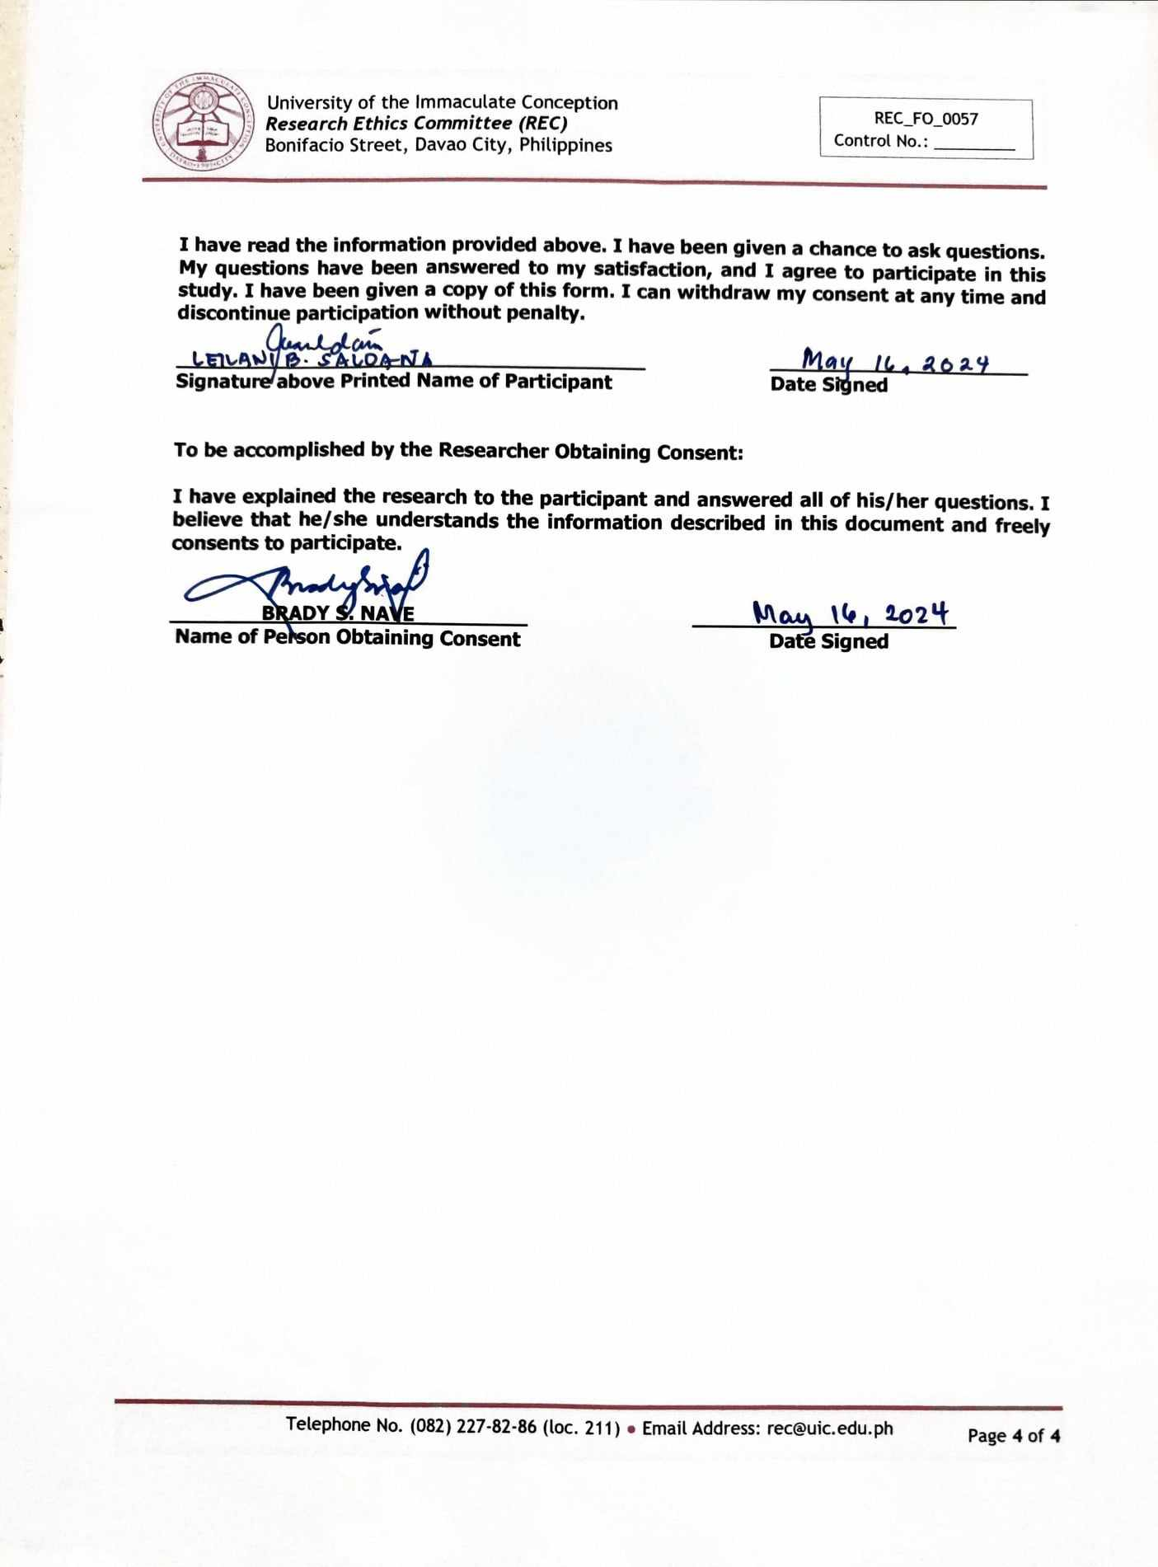

APPENDIX G

Similarity Index Report

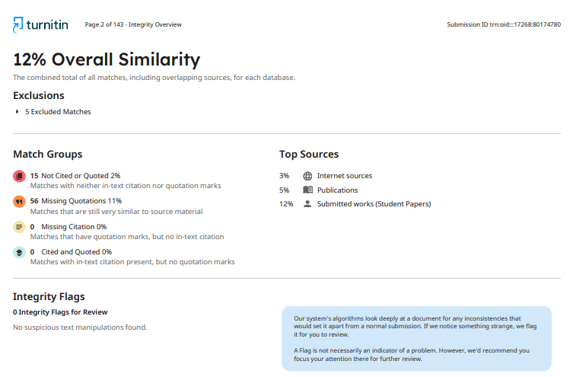

APPENDIX H

AI Compliance Report

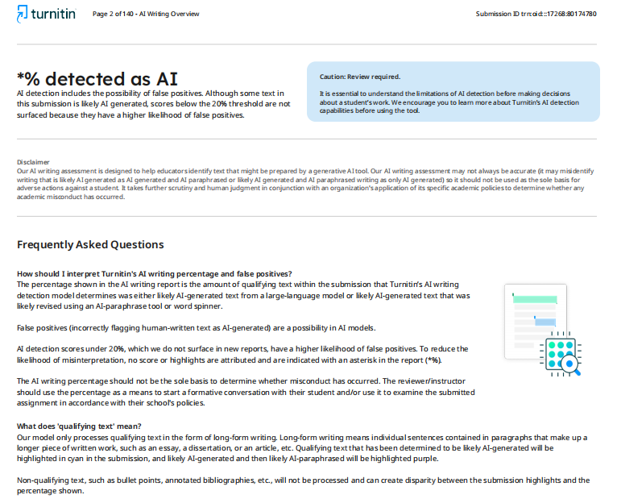

APPENDIX I

Certificate of Originality

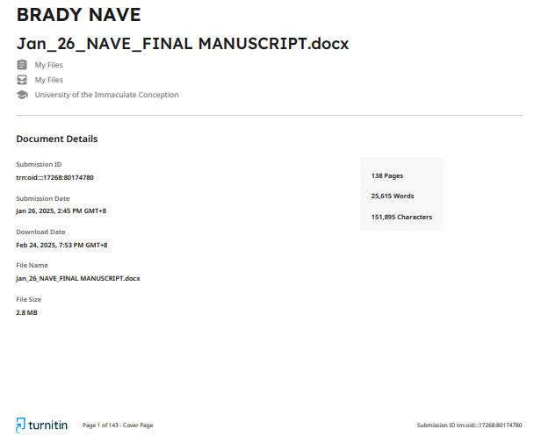

CURRICULUM VITAE


Brady Sotelo Nave
09165717158
bnave_210000000089@uic.edu.ph

EDUCATIONAL BACKGROUND:

Post-Graduate Studies: N/A

Graduate Studies: University of the Immaculate Conception
Bonifacio St., Davao City
Master of Arts in Teaching College Physics
On-going

University of Southeastern Philippines
Bo. Obrero., Davao City
Master of Arts in Science Teaching – Physics (CAR)
June 2002 – December 2016

Tertiary: Ateneo de Davao University
Roxas Avenue, Davao City
Bachelor of Secondary Education major in Physics
March 2001

Secondary: Davao City National High School
F. Torres Street, Davao City
March 1997

Elementary: Dumanlas Elementary School
Dumanlas, Buhangin Proper, Davao City
March 1993

ELIGIBILITY

Licensed Professional Teacher 2001

WORK EXPERIENCES:

Inclusive Dates: May 4, 2021 - Present
Position Title : Master Teacher I
Company : Davao City National High School, F. Torres St., Davao City

Inclusive Dates: January 2016 – July 2024
Position Title : JHS Science, Technology and Engineering Program Coordinator
Company : Davao City National High School, F. Torres St., Davao City

Inclusive Dates: October 1, 2018 – May 3, 2021
Position Title : Teacher III
Company : Davao City National High School, F. Torres St., Davao City

Inclusive Dates: March 15, 2017 – September 30, 2018
Position Title : Teacher II
Company : Davao City National High School, F. Torres St., Davao City

Inclusive Dates: December 2012 – March 14, 2017
Position Title : Teacher I
Company : Davao City National High School, F. Torres St., Davao City

Inclusive Dates: June 2017-December 2020
Position Title : Part-Time College Physics Instructor
Company : Assumption College of Davao – College Department, Cabaguio Ave., Davao City

Inclusive Dates: June 2013- March 2017
Position Title : Part-Time College Physics Instructor
Company : Holy Cross of Davao College, 14-B Sta. Ana Ave., Poblacion
District, Davao City

Inclusive Dates: June 2011 – Oct 2011
Position Title : Part-Time College Physics Instructor
Company : San Pedro College, 12 Guzman St., Poblacion District, Davao City

Inclusive Dates: June 2001 – May 2011
Position Title : High School Physics Teacher
Company : Assumption College of Davao, Cabaguio Ave., Davao City

Inclusive Dates: June 2002 – March 2011
Position Title : Part-Time High School Physics Teacher
Company : Assumption College of Davao- Sunday School Program, Cabaguio
Ave., Davao City

SEMINARS/TRAININGS ATTENDED:

Title : Training of Untrained Teachers on Pedagogical Retooling in Math,
Language and Science (PRIMALS) for Junior High School
Date : November 19 - 21, 2022
Venue : Davao City National High School, Davao City

Title : Regional Training on Manipulation of Science Laboratory,
Apparatus Materials, Equipment and Ensuring Safety in the
Laboratories
Date : May 18 - 20, 2022
Venue : Mati National High School, Mati City
Title : In – Service Training on Teachers’ Literacy on Assessment
Tools / Methods and Action Research
Date : January 5 - 7, 2022
Venue : Davao City National High School, Davao City

