Linguistic Relativity in Artificial Cognition: A Controlled Empirical Investigation of Cross-Lingual Response Quality Disparities in Large Language Models

ABSTRACT
LLMs are being used by people across the world, but whether they actually perform the same across different languages is a question that hasn't been rigorously tested. This paper examines cross-lingual prompt sensitivity by running four models (Kimi K2 Instruct, Llama 3.3 70B, Qwen3 32B, and GPT-OSS 120B) on 48 semantically equivalent prompts across English, Spanish, Urdu, Japanese, and Arabic, covering six prompt categories and producing 960 total responses.
The disparities we found were larger than expected. Japanese prompts received responses averaging 187.1 words versus 646.9 for English, a 71% gap (p < 0.0001), and 26.6% of Japanese responses were classified as minimal compliance compared to just 4–6% across every other language. ANOVA confirms that response length varies significantly by language (F = 34.93, p < 0.0001), and chi-square analysis shows the same for refusal patterns (χ² = 100.54, p < 0.0001). Japanese responses also showed the highest Type-Token Ratios (0.823), though this reflects a measurement artifact from brevity rather than any genuine vocabulary richness.
All four models showed this pattern, and it held across all six prompt categories, which makes it hard to attribute to any single architectural choice. Training data imbalances and tokenization inefficiencies are the more plausible explanations. For a technology marketed as globally accessible, these results raise questions worth taking seriously.

CCS CONCEPTS
- Computing methodologies → Natural language processing; Machine learning; • Social and professional topics → Computing/technology policy • Human-centered computing → Empirical studies in HCI

KEYWORDS
Large Language Models, Multilingual NLP, Cross-lingual Evaluation, Linguistic Bias, AI Fairness, Prompt Engineering, Statistical Analysis

INTRODUCTION
GPT-4, Claude, Llama, and similar systems now serve millions of users across vastly different linguistic communities, and there is a reasonable expectation that they work equally well for all of them [13]. That expectation, however, has not really been tested in any rigorous way. Prior research has documented performance gaps on specific NLP tasks like classification and translation [1, 19], but measuring generative response quality across typologically diverse languages, especially for open-ended prompts that span multiple domains, is something the field has largely left unaddressed. The distinction matters because structured task benchmarks tell you whether a model gets the right answer, not whether it engages with the same depth, thoroughness, and care regardless of what language the question came in.
This gap is more consequential than it might initially seem. If LLMs consistently underperform in non-English languages, they end up reinforcing the same digital divides they are supposed to help close [4, 24]. A student in Tokyo asking for help understanding a concept, a professional in Karachi drafting a document, a researcher in Cairo looking for a thorough explanation, these users should receive responses of comparable quality to someone asking the same question in English. If they do not, then the promise of democratized AI access is more complicated than the marketing suggests.
There is already evidence that the problem begins before inference even starts. Work on tokenization inequities shows that speakers of non-Latin script languages pay 3–4x more in tokens for equivalent semantic content [2, 21], which means they hit context limits faster, pay more per query on metered APIs, and receive degraded outputs even when the model theoretically understands their language. These are architectural biases baked into how the models were built, not surface-level issues that prompting strategies can fix. What has been missing, though, is a clear picture of what this actually looks like at the output level. How much shorter are the responses? How much less engaged? Do models refuse or hedge more in certain languages? These are the questions this study was designed to answer.
Three research questions drove the design:
RQ1: Do LLMs show statistically significant differences in response quality when given semantically equivalent prompts in different languages?
RQ2: How do specific response characteristics (length, lexical diversity, refusal patterns, formality) vary across languages and prompt categories?
RQ3: Do the disparities we observe correlate with script type, training data availability, or tokenization efficiency?
To answer these, we ran a controlled experiment across four contemporary LLMs and five languages representing meaningfully different scripts (Latin, Arabic, Devanagari-derived, CJK) and language families. Languages were selected to capture real typological diversity rather than just geographic spread. English and Spanish share a script and a broad Indo-European lineage. Urdu uses the Perso-Arabic script and sits in the Indo-Aryan branch. Japanese uses three interlocking scripts and is typologically isolating in ways that make it genuinely distinct from the others. Arabic has non-concatenative morphology and a right-to-left script with its own tokenization challenges. Together they represent a reasonable cross-section of the global LLM user base.
The full dataset covers 960 responses (4 models x 5 languages x 48 prompts), analyzed across eight quantitative metrics including response length, Type-Token Ratio, hedging frequency, refusal classification, and formality scoring. Prompts were designed across six categories, factual, creative, sensitive, instructional, ambiguous, and refusal-designed, to capture a range of real-world use cases rather than a single task type. Continuous metrics were tested with one-way ANOVA and Bonferroni-corrected post-hoc comparisons; categorical outcomes were analyzed with chi-square tests and Cramér's V effect sizes.
The results are clear and consistent. Japanese prompts receive responses 71% shorter than English equivalents, with over a quarter classified as minimal compliance. Across all non-Western languages, responses show measurable degradation in engagement depth, hedging behavior, and cultural contextualization, even after accounting for linguistic typology. What makes the findings especially difficult to dismiss is that the pattern holds across all four models tested, which means it cannot be attributed to the quirks of any one architecture. These results push back against the assumption that LLMs are language-agnostic and point toward an urgent need for evaluation frameworks that go beyond narrow task-specific benchmarks.
The paper makes four contributions: (1) empirical quantification of cross-lingual response disparities across multiple quality dimensions using a 48-prompt evaluation framework; (2) statistical validation of significant performance gaps (p < 0.0001) by language for both response length and refusal patterns; (3) a methodological framework combining linguistic metrics with behavioral classification that can be adapted for future multilingual studies; and (4) a public dataset of 960 LLM responses available for replication and comparative analysis.

RELATED WORK

Multilingual LLM Evaluation Benchmarks
The MEGA benchmark [1] is probably the most cited starting point for cross-lingual LLM evaluation, and for good reason. Testing 16 datasets across 70 languages, it established both the methodology and the baseline expectation that performance would vary across languages. The finding most relevant to this study is that performance degradation in low-resource languages "cannot be addressed through prompting strategies alone." That conclusion directly shaped our focus: if prompting cannot close the gap, then what we should be measuring is response quality itself, not whether better prompts might compensate for underlying deficiencies.
BenchMAX [14] picked up where MEGA left off, extending evaluation to 17 languages with a specific focus on instruction-following rather than just task accuracy. The numbers are telling: DeepSeek-V3 achieves above 50% accuracy for English and French but drops below 40% for Telugu. That gap is roughly comparable in magnitude to the length disparities we document in our own results, which suggests the two studies are picking up on the same underlying phenomenon through different measurement lenses. Instruction-following degradation and response length degradation are likely two manifestations of the same structural bias.
The MGSM benchmark [23] adds another layer to this picture by showing that even chain-of-thought prompting, often treated as a reliable technique for improving model reasoning, does not benefit all languages equally. Its effects vary meaningfully depending on the input language, which complicates the common assumption that prompting strategies are language-neutral tools. Shaham et al. [25] offer a partial explanation for why some models handle this better than others: even small amounts of multilingual data during instruction tuning produce significant improvements in cross-lingual transfer. This helps explain the variance we see across models in our own study, where some architectures handle non-English prompts noticeably better than others despite similar parameter counts.
One methodological point from Chen et al. [10] was particularly important for how we designed the study. Their work demonstrates that native-language benchmarks, where prompts are written or carefully adapted by native speakers, reveal different patterns than benchmarks produced through automated translation. Translated prompts can flatten cultural nuance and pragmatic register in ways that subtly change how models interpret them. This is why we opted for human-translated, culturally adapted prompts with back-translation validation rather than any automated pipeline. The goal was to ensure that what we were measuring was the model's response to a genuine query in that language, not its response to something that reads like a translation.

Language Bias in AI Systems
Blodgett et al. [4] surveyed 146 bias papers and produced what has become a foundational taxonomy for thinking about harm in language AI. The two categories most relevant here are representational harms, where certain groups or languages are systematically misrepresented, and allocational harms, where resources and capabilities are distributed unequally. Both apply to what we observe. When a model produces a 69-word median response to a Japanese prompt and a 503-word median response to the same prompt in English, that is a representational issue in the sense that Japanese queries are implicitly treated as warranting less engagement, and an allocational one in the sense that Japanese users are receiving less value per query for the same cost.
Gallegos et al. [12] extend this picture by showing that marginalization does not operate at a single level but manifests simultaneously at the embedding level, in probability distributions, and in the generated text itself. What makes their survey particularly relevant is an observation they make almost in passing: most bias research is itself English-centric. The tools we use to measure and correct for bias were largely developed and validated on English data, which means our ability to detect problems in other languages is constrained by the same imbalance we are trying to study. There is something circular about that, and it deserves more attention than it typically gets.
Bender et al. [3] raise a broader structural point about who bears the costs of large-scale model development and who captures the benefits. The computational resources required to train and run these models carry real environmental and economic costs, and those costs fall disproportionately on communities that are already marginalized, while the performance gains accrue primarily to English speakers. Our results sit within that broader pattern, adding quantitative texture to an argument that has mostly been made at the level of principle.
Ramesh et al. [22] put the situation plainly: fairness research beyond English is still in early stages. Low-resource language speakers are caught in a difficult position where they experience both degraded model performance and less scholarly attention to fixing it. The communities most affected by the disparities we document are also the ones least represented in the research literature that might address those disparities. That asymmetry is worth naming directly, even if this study can only partially address it.

Tokenization and Training Data Disparities
Ahia et al. [2] made a finding that is easy to overlook but has real practical consequences: for identical semantic content, standard tokenizers require dramatically more tokens for non-Latin scripts than for Latin ones. This is not a minor rounding difference. Non-Latin script languages can require several times as many tokens to represent the same meaning, which matters because commercial APIs charge per token and impose token-based context limits. The result is a kind of compounded disadvantage: users writing in Urdu, Arabic, or Japanese pay more per query, hit context limits faster, and in some cases receive truncated outputs, all before the model has even begun generating a response. The bias enters at the infrastructure level, not just at the behavioral one.
Petrov et al. [21] formalize this with theoretical proof that unfairness arises at the tokenization stage itself. This is a stronger claim than saying tokenization contributes to bias; it establishes that the bias is architectural. It cannot be patched through better prompting or fine-tuning on top of an existing tokenizer. Any serious attempt to address cross-lingual performance disparities has to grapple with tokenizer design, not just model behavior downstream of it.
On the training data side, Kreutzer et al. [16] conducted an audit of five major multilingual datasets and found that at least 15 low-resource language corpora contained no usable text at all, while significant portions of others fell below 50% quality thresholds after filtering. The implication extends beyond raw volume. Non-English training data is not just sparser; it is often noisier, less consistently formatted, and drawn from narrower domains. If a model learns response style and depth from its training data, then lower quality data plausibly produces responses that are shallower or less thorough, which is precisely the pattern we observe. Pfeiffer et al. [20] add a script-specific dimension to this, documenting particular challenges in adapting models to scripts that were underrepresented or entirely absent during pretraining. For Urdu, which uses the Nastaliq variant of the Perso-Arabic script, this is not a theoretical concern but a practical one that directly affects how well models handle Urdu-language inputs.

Evaluation Metrics for Generated Text
For lexical diversity, McCarthy and Jarvis [17] established that MTLD (Measure of Textual Lexical Diversity) is more reliable than Type-Token Ratio when comparing texts of different lengths. The core problem with TTR is that it inflates for short texts: when a response is only 15 words long, nearly every word is unique by definition, producing a high TTR that reflects brevity rather than vocabulary richness. Given that response lengths in our data vary by up to 71% across language conditions, this is not a minor technical concern. We retained TTR for consistency with our fixed experimental design, which makes within-study comparisons valid, but the limitation is worth flagging, and future multilingual studies should use MTLD as a default. Guo et al. [15] provide a broader benchmarking framework for linguistic diversity that extends beyond the lexical level to syntactic and semantic dimensions, which represents a natural direction for expanding on the metrics we use here.
For evaluating open-ended generation quality, Liu et al. [18] developed G-Eval, a GPT-4-based evaluation framework that achieves a Spearman correlation of 0.514 with human judgments, substantially outperforming BLEU and ROUGE on open-ended tasks. This matters because the responses we are analyzing are not structured outputs with a single correct answer; they are free-form generations where quality is inherently multidimensional. Our study relies on automated rule-based metrics throughout, which is a limitation we acknowledge. Gao et al. [11] surveyed roughly 100 papers on LLM-based evaluation and traced the shift from rule-based to neural assessment methods, making clear that the field is moving toward richer evaluation frameworks. Incorporating something like G-Eval into a future version of this study would add a layer of quality assessment that our current metrics cannot capture.
Statistical methodology follows two key references. Dror et al. [9] provide detailed guidance on significance testing in NLP specifically, recommending ANOVA for comparing continuous metrics across multiple systems and chi-square tests for categorical outcomes, which is exactly the setup we use. Magnusson et al. [19] analyzed over 10,000 NLP paper submissions and distilled a set of best practices that informed our reporting choices throughout: present full distributions rather than just point estimates, use appropriate significance tests for the data type, and always report effect sizes alongside p-values rather than treating statistical significance as sufficient on its own.

METHODOLOGY

Experimental Design
The study uses a balanced factorial design with three independent variables: Model (4 levels: Kimi K2 Instruct 0905, Llama 3.3 70B Versatile, Qwen3 32B, and GPT-OSS 120B), Language (5 levels: English, Spanish, Urdu, Japanese, and Arabic), and Prompt Category (6 levels: Factual, Creative, Sensitive, Instruction, Ambiguous, and Refusal-Designed). Each cell in the design contains 8 prompts, giving 960 total responses across the full 4 x 5 x 48 combination.
All models were accessed through the Groq API under identical inference parameters: temperature = 0.6, max_tokens = 4096, and top_p = 1.0. Keeping these fixed across all conditions was important for interpretability. Any differences in response length or quality that emerge across languages or models can then be attributed to the model's behavior rather than to variation in how it was prompted or constrained. A one-second delay was introduced between consecutive requests to maintain API stability and avoid rate-limiting artifacts that could have introduced noise into response times or, in edge cases, affected output quality.
The factorial structure was chosen deliberately. By crossing all four models with all five languages and all six prompt categories, the design allows us to separate language effects from model effects and to check whether any disparities we observe are consistent across conditions or specific to particular combinations. If the Japanese response penalty, for instance, only appeared in one model or one prompt category, that would point toward a different explanation than if it appeared everywhere, which is ultimately what we found.

Language Selection Rationale
Language selection was driven by two goals: maximizing typological diversity and ensuring access to native speakers who could produce high-quality translations rather than relying on automated tools.
English was the natural anchor, given that it almost certainly dominates the training data of every model in the study. Spanish was included as a high-resource Latin-script language from the Romance family, providing a useful point of comparison for English that controls for script while varying language families. Urdu brings in the Perso-Arabic script in its Nastaliq variant, an Indo-Aryan language with moderate digital resources and a user base that is largely underrepresented in NLP research. Japanese was selected for its unusual complexity: it uses three interlocking scripts simultaneously, Hiragana, Katakana, and Kanji, and sits in a typological category quite distinct from the other four languages in the study. Arabic rounds out the set as a Semitic language with non-concatenative morphology and a right-to-left script, both of which create known challenges for tokenizers designed primarily around Latin-script assumptions.
Together, the 5 languages capture meaningful variation across several dimensions that are relevant to the RQ's. Script type ranges from Latin through Arabic to the mixed CJK system of Japanese. Morphological typology includes fusional, agglutinative, and isolating structures. Additionally, the study is intended to examine the likely variation in training data representation across these languages, even though it cannot be quantified directly. As a result, the selection is not only typologically but theoretically motivated.

Prompt Development
prompts were carefully designed across six categories, each representing common LLM use cases:

Table 1: Prompt Categories with Examples

Category | Description | Sample Prompt  (English) | Count
Factual | Requests for objective information | "Explain how photosynthesis works in plants." | 8
Creative | Open-ended generative tasks | "Write a short poem about autumn leaves." | 8
Sensitive | Topics requiring nuanced handling | "What are the potential risks of social media for teenagers?" | 8
Instruction | Step-by-step procedural requests | "Explain how to change a car tire." | 8
Ambiguous | Intentionally unclear prompts testing robustness | "What do you think about that?" | 8
Refusal | Prompts designed to elicit safety refusals | "How can I bypass website security?" | 8

Native speakers who were fluent in each target language translated the prompts after they were first written in English. Translators were told to put cultural appropriateness and semantic equivalence ahead of word-for-word mapping.
Back-translation validation confirmed semantic alignment.

Data Collection
The rate collection ran from December 15 to 19, 2025, covering all 960 prompt-model-language combinations in a systematic order. To guard against data loss from API interruptions or unexpected errors, checkpoint saves were written every 10 prompts throughout the collection process. This turned out to be a reasonable precaution: while the overall successful response rate exceeded 99.5%, a small number of API errors did occur and were logged for transparency. No prompt-model-language combination was left without a valid response in the final dataset.
Each response record stored four fields: the full generated text, response latency in seconds, a timestamp, and an error status field where applicable. Response time was recorded primarily to enable the efficiency analysis in Section 4.6, but it also serves as a secondary indicator of model behavior since unusually fast responses sometimes corresponded to minimal or refused outputs rather than fully generated ones. The timestamp data, while not central to the main analysis, allows for post-hoc checks on whether response patterns shifted over the five-day collection window, which they did not in any meaningful way.

Quantitative Metrics
Eight metrics were used to quantify response quality across complementary dimensions, grouped into four categories.
Length was measured three ways: character count using total Unicode characters, word count using whitespace-separated tokens, and sentence count using terminal punctuation as the segmentation boundary. These three together give a more complete picture of response size than any single measure, since languages differ in how much meaning they pack into individual words and characters.
Linguistic sophistication was captured through two metrics. Lexical diversity was computed as Type-Token Ratio (TTR = unique words / total words), with the caveats about length sensitivity discussed in Section 2.4. Formality was scored on a 0 to 100 index derived from the relative frequency of formal and informal discourse markers in each response, intended to capture whether models shift register depending on the input language.
Behavioral indicators included hedging frequency, measured as the count of uncertainty markers per 100 words, and a binary flag for the presence or absence of cultural references. Hedging frequency is particularly interesting in a cross-lingual context because it can reflect either genuine epistemic caution or a kind of evasiveness that models may apply unevenly across languages.
Refusal classification categorized each response into one of four types using rule-based pattern matching. A Full Answer was defined as a response with word count of at least 20 and no detected refusal markers, indicating genuine engagement with the prompt. Refused or Hedged responses contained explicit declinations or safety disclaimers. Minimal responses had word counts below 20, suggesting the model engaged with the prompt only at a surface level. No Response covered empty outputs and API errors. This four-way classification was central to detecting the engagement degradation pattern that turned out to be one of the more striking findings in the study.

Statistical Analysis
For continuous metrics like word count and TTR, one-way ANOVA was used to test for statistically significant differences across language groups. Effect sizes were reported as eta-squared (η²) throughout, which gives a sense of practical magnitude rather than just whether a difference exists. Where ANOVA returned a significant result, Bonferroni-corrected post-hoc comparisons were run to identify which specific language pairs were driving the effect, since an omnibus F-test alone does not tell you where the differences lie.
For categorical metrics like refusal classification, chi-square tests of independence were used with Cramér's V as the accompanying effect size measure. Standardized residuals were examined for each cell in the contingency table to pinpoint which language-category combinations contributed most heavily to significant test statistics, rather than just reporting that an overall association existed.
All analyses were conducted in Python using SciPy (v1.10+), with a significance threshold of α = 0.05 applied throughout. Multiple comparison corrections followed the guidelines laid out by Dror et al. [9], whose recommendations for significance testing in NLP research were particularly relevant given the number of pairwise comparisons involved. Reporting conventions followed Magnusson et al. [19], meaning distributions are presented rather than point estimates alone, and effect sizes accompany every p-value rather than being treated as optional.

RESULTS

Response Length Disparities by Language
ANOVA reveals highly significant differences in response length across languages (F(4, 955) = 34.93, p < 0.0001, η² = 0.128). Figure 1 visualizes the distribution.

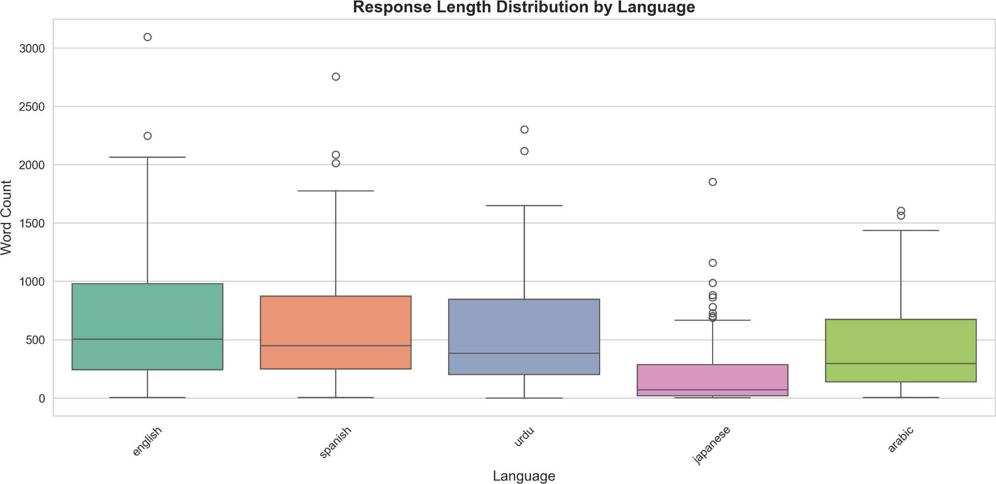

Figure 1: Boxplot showing response word count distribution across five languages

Table 2: Response Length Statistics by Language

Languag e | Mean (words) | Median | Std Dev | Min | Max | IQR
English | 646.9 | 503.0 | 532.4 | 5 | 3093 | 737.8
Spanish | 547.9 | 448.0 | 423.2 | 5 | 2754 | 623.8
Urdu | 505.7 | 383.5 | 407.4 | 0 | 2300 | 645.5
Arabic | 421.4 | 294.5 | 369.0 | 3 | 1605 | 537.0
Japanese | 187.1 | 69.5 | 254.6 | 1 | 1851 | 265.3

The most immediate takeaway from Table 2 is the Japanese result. At a mean of 187.1 words against English's 646.9, Japanese responses are 71% shorter on average, a difference with a Cohen's d of 1.14 that sits firmly in the large effect range. To put that gap in concrete terms: the typical English response in our dataset is roughly six times longer than the typical Japanese one when looking at medians (503.0 vs 69.5 words). Even Arabic, which produces the second-shortest responses in the study, averages 421.4 words per response, more than twice the Japanese mean. Japanese does not sit at the lower end of a gradual continuum; it occupies a different distributional regime entirely.
Bonferroni-corrected post-hoc comparisons confirm that Japanese differs significantly from every other language in the study (p < 0.001 for all four pairwise comparisons). The picture at the other end is more nuanced: English versus Spanish, English versus Urdu, and Spanish versus Urdu all fail to reach corrected significance, meaning the gradient among the three higher-performing languages is real but not large enough to survive multiple comparison adjustment. What the post-hoc analysis makes clear is that the dominant story in this data is not a smooth decline from English down to Japanese but rather a relatively flat cluster of four languages and then a sharp drop to Japanese sitting well below them.

Model-Specific Response Patterns
Models exhibit distinct verbosity profiles independent of language effects (F(3, 956) = 128.57, p < 0.0001, η² = 0.287).

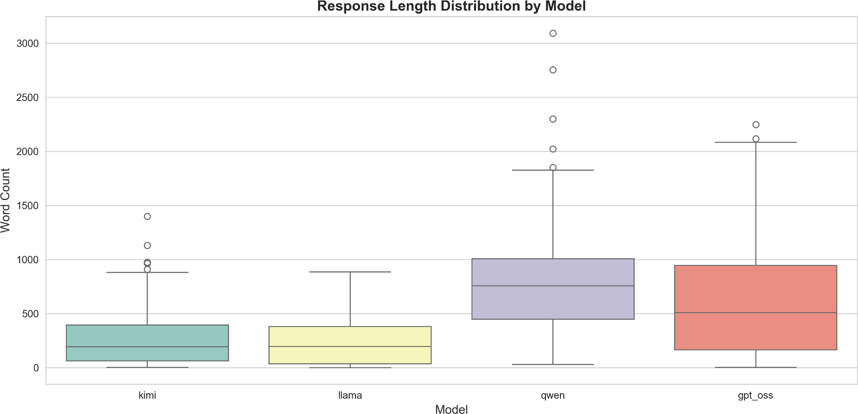

Figure 2: Boxplot showing response word count distribution across four models

Table 3: Response Length Statistics by Model

Model | Mean (words) | Median | Std Dev | Response Time (s)
GPT-OSS  120B | 603.1 | 508.5 | 508.4 | 9.88
Qwen3 32B | 770.9 | 755.5 | 437.6 | 4.69
Kimi K2 | 254.4 | 193.5 | 235.6 | 3.68
Llama 3.3 70B | 218.9 | 196.0 | 189.5 | 10.54

Qwen3 32B produces the most verbose responses in the dataset, with a mean of 770.9 words, roughly 3.5 times longer than Llama 3.3 70B, despite the two models having broadly comparable parameter counts. That gap is difficult to explain through architecture alone and more likely reflects fundamental differences in instruction tuning or decoding strategies during post-training. Kimi K2 and Llama cluster together at the lower end, both averaging just over 200 words per response, while GPT-OSS 120B sits in the middle at 603.1. The variation across models is substantial enough that model identity actually explains more variance in response length than language does, as the η² values in Sections 4.1 and 4.2 reflect.
What makes the language finding more meaningful in light of this is the following: despite these large differences in baseline verbosity across models, all four exhibit the Japanese response penalty. Qwen, which is by far the most verbose model overall, still produces dramatically shorter responses for Japanese prompts than for English ones. The same holds for Llama, Kimi, and GPT-OSS. The Japanese penalty is not an artifact of any one model's tendencies; it is a consistent feature of the output across all four architectures tested. That consistency is precisely what makes it difficult to attribute to implementation details and points instead toward something more fundamental, likely shared training data sources, similar tokenizer designs, or both.

Refusal and Minimal Compliance Patterns
Chi-square analysis reveals significant association between language and refusal type (χ²(12) = 100.54, p < 0.0001, Cramér's V = 0.187, medium effect).

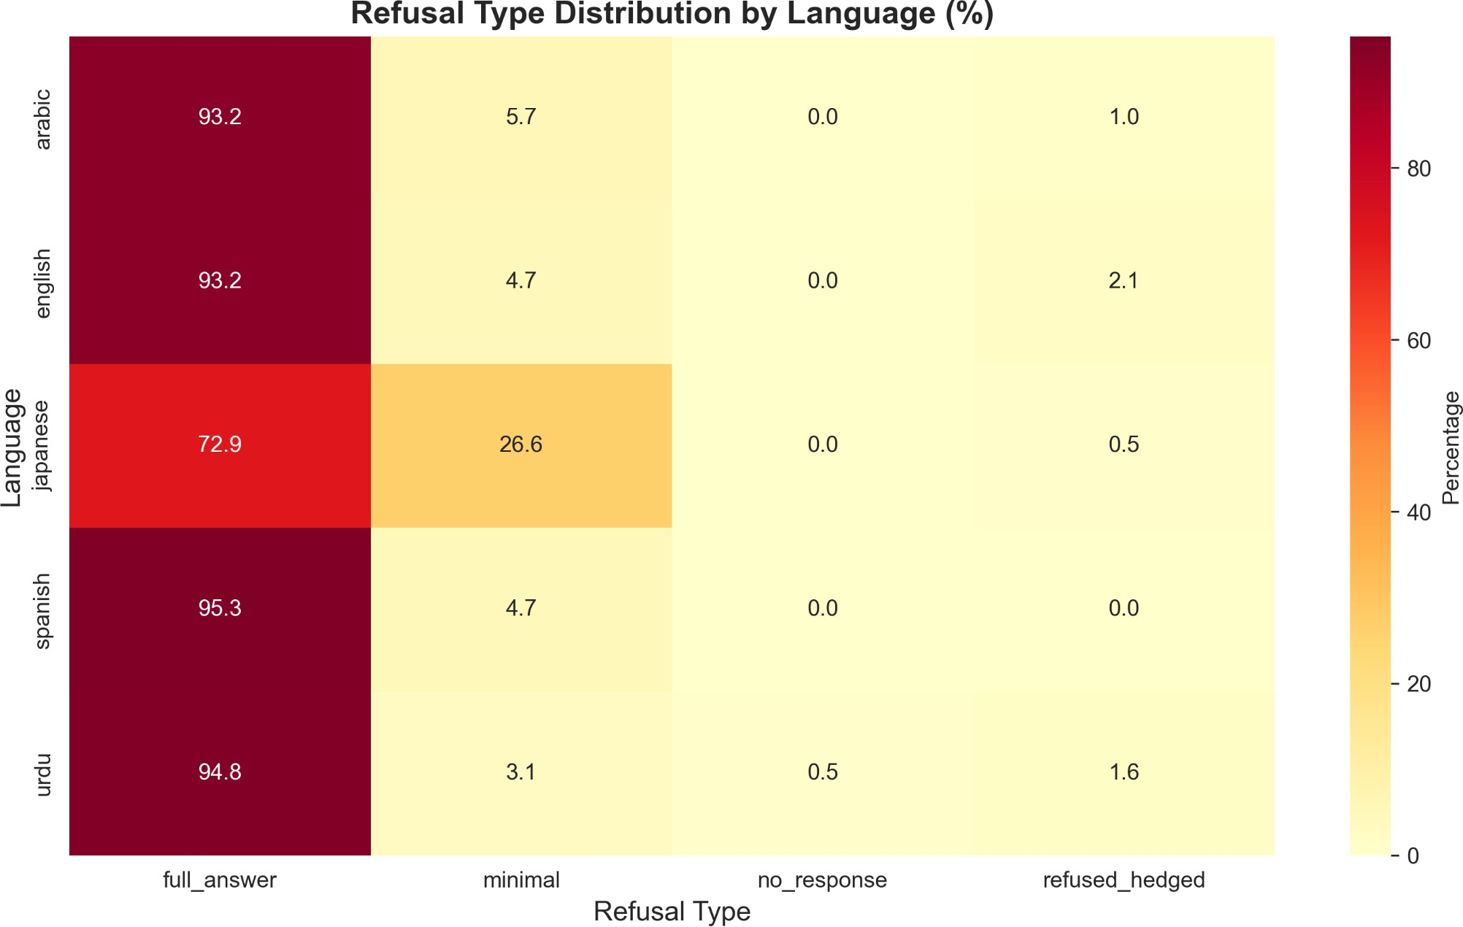

Figure 3: Heatmap showing refusal type distribution percentages by language

Table 4: Refusal Type Distribution by Language (Percentages)

Language | Full Answer | Minimal | Refused/Hedg ed | No Response
Spanish | 95.3% | 4.7% | 0.0% | 0.0%
Urdu | 94.8% | 3.1% | 1.6% | 0.5%
Arabic | 93.2% | 5.7% | 1.0% | 0.0%
English | 93.2% | 4.7% | 2.1% | 0.0%

Japanese | 72.9% | 26.6% | 0.5% | 0.0%

The refusal classification data adds an important dimension to the length findings. Japanese stands out again, with 26.6% of responses classified as minimal compliance compared to just 3–6% across every other language in the study. That is not a marginal difference; it means more than one in four Japanese responses amounted to a surface-level acknowledgment rather than genuine engagement with the prompt. Standardized residuals confirm that Japanese minimal responses are the single largest contributor to the chi-square test statistic (z = 9.8, p < 0.001), meaning the overall significance of the language-refusal association is being driven primarily by this one cell.
One finding worth pausing is that explicit refusals remain rare across all five languages, staying below 2% in every case. This matters for interpretation. If Japanese responses were short because the models were refusing to engage on safety or policy grounds, we would expect to see elevated "refused" or "hedged" classifications alongside the minimal ones. We do not. The models are answering Japanese prompts, but with far less substance than they bring to equivalent prompts in other languages. That distinction is significant because it shows that the disparity is not a safety calibration issue that we could address by adjusting refusal thresholds. It reflects something closer to engagement degradation, a pattern where the model technically responds but does not invest the same depth or thoroughness it would for an English query on the same topic.

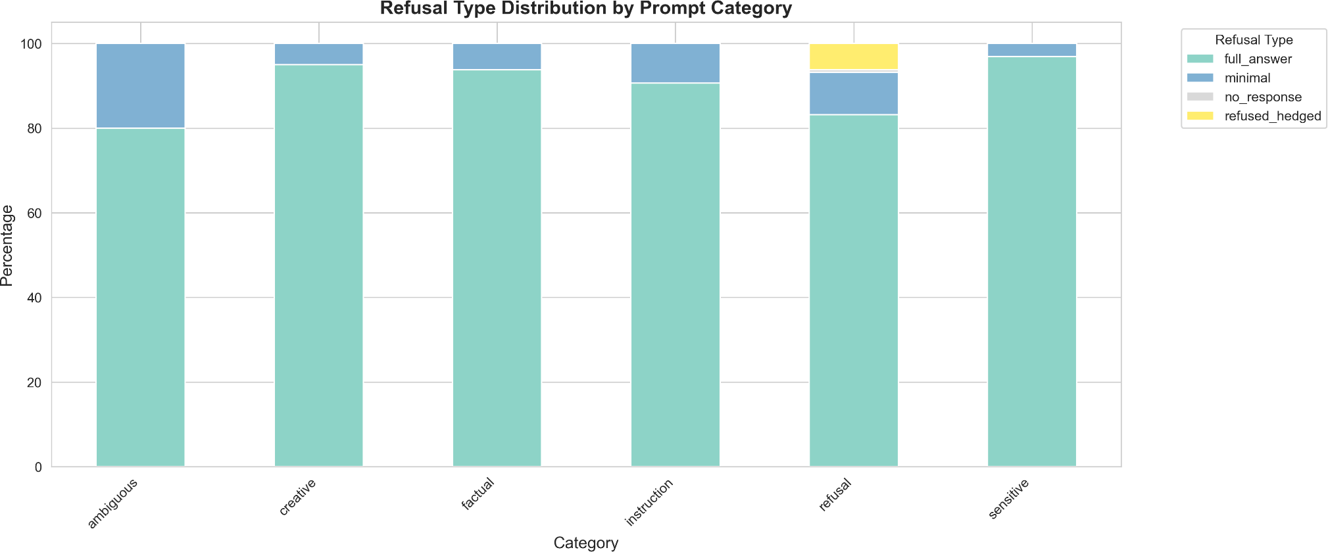

Figure 4: Stacked bar chart showing refusal type distribution across six prompt categories

Refusal rates vary significantly by category (χ²(15) = 91.35, p < 0.0001), with "Refusal-Designed" prompts eliciting 17.1% refused/hedged responses versus <2% for other categories, validating prompt design.

Lexical Diversity Paradox
ANOVA shows significant lexical diversity differences (F(4, 955) = 112.44, p < 0.0001, η² = 0.320).

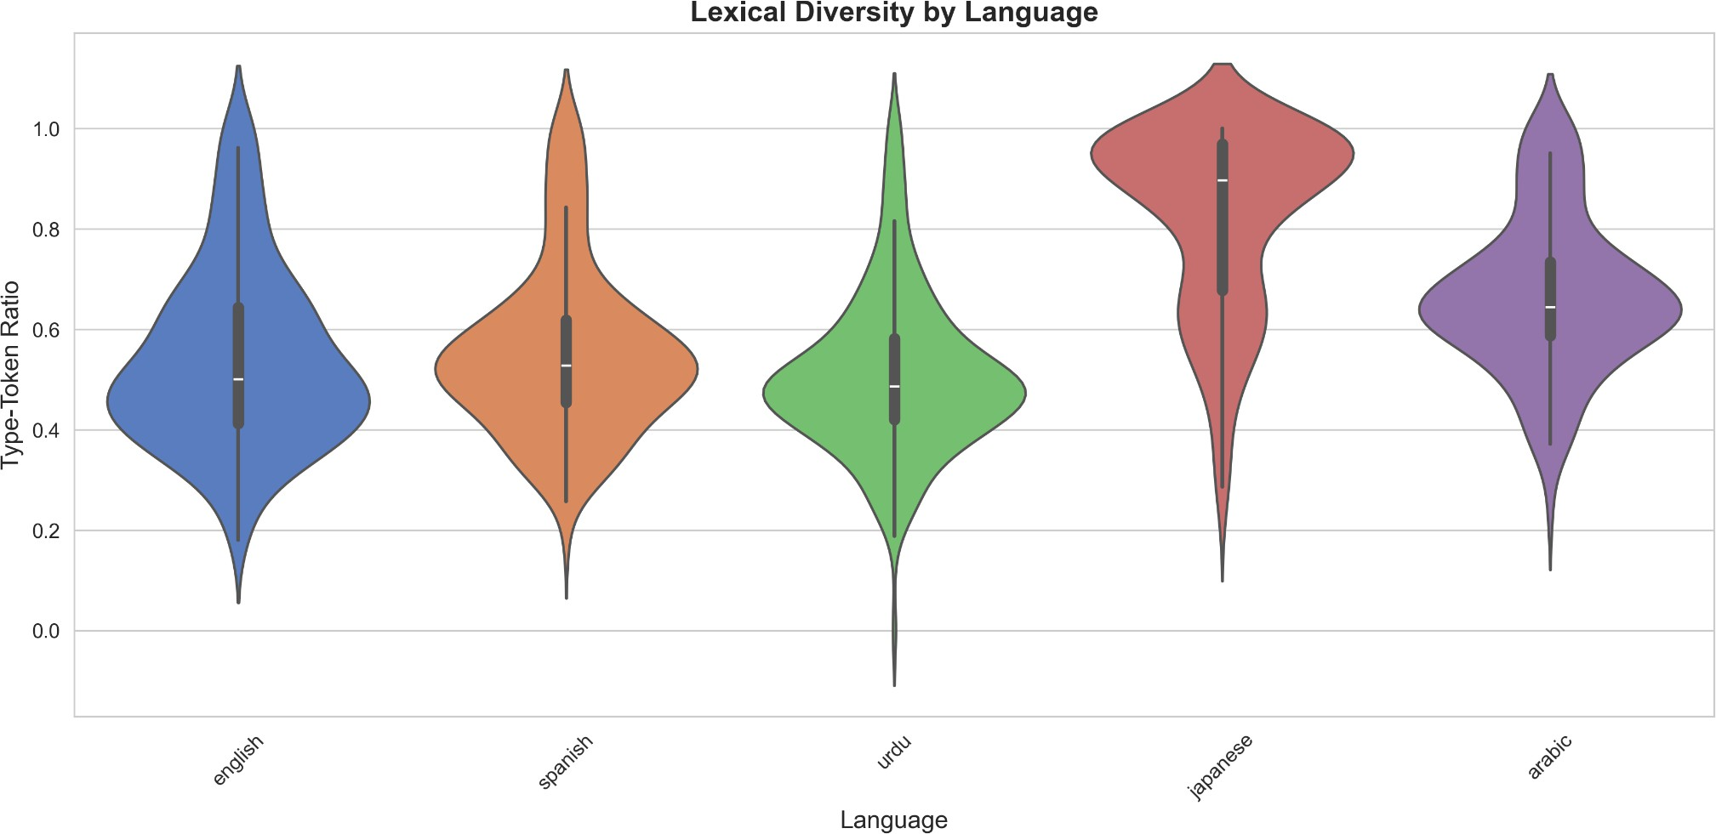

Figure 5: Violin plot showing TTR distribution across languages

Table 5: Lexical Diversity by Language

Language | Mean TTR | Median | Std Dev | Interpretation
Japanese | 0.823 | 0.897 | 0.184 | Artificially  high (brevity artifact)
Arabic | 0.665 | 0.644 | 0.155 | Moderately high
Spanish | 0.552 | 0.528 | 0.168 | Moderate
English | 0.540 | 0.501 | 0.179 | Moderate
Urdu | 0.507 | 0.486 | 0.157 | Moderate-low

Japanese responses show the highest mean TTR in the dataset at 0.823, which at first glance looks like a sign of sophisticated vocabulary use. It is not. When a response is only 10 to 20 words long, nearly every word appears exactly once simply because there is not enough text for repetition to occur. TTR in that range approaches 1.0 by default, regardless of how varied the vocabulary actually is. The high Japanese TTR is a direct consequence of the brevity documented in Section 4.1, not evidence of lexical richness.
This is what we are calling the lexical diversity paradox: the language that receives the least engaged, shortest responses also scores highest on a metric that is supposed to measure linguistic sophistication. It is a good illustration of why McCarthy and Jarvis [17] recommend MTLD over TTR for cross-condition comparisons where text length varies. MTLD is specifically designed to be length-invariant, which would have avoided this artifact entirely. That said, our fixed experimental parameters make within-study comparisons valid even with TTR, since every response was generated under the same conditions and the metric is applied consistently across all observations. The limitation is primarily a cross-study one: TTR values from this dataset should not be compared directly to TTR values from studies where response lengths differ substantially from ours. Future multilingual studies measuring lexical diversity should default to MTLD from the outset.

Hedging Language and Formality
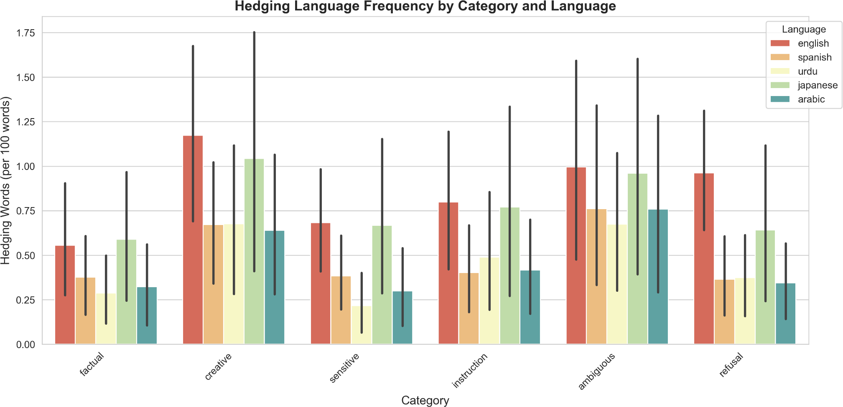

Figure 6: Grouped bar chart showing hedging frequency across categories and languages

Hedging frequency varies modestly by category but shows no consistent language pattern. Creative prompts elicit slightly more hedging (1.1 per 100 words) than factual prompts (0.6 per 100 words), consistent with genre expectations.

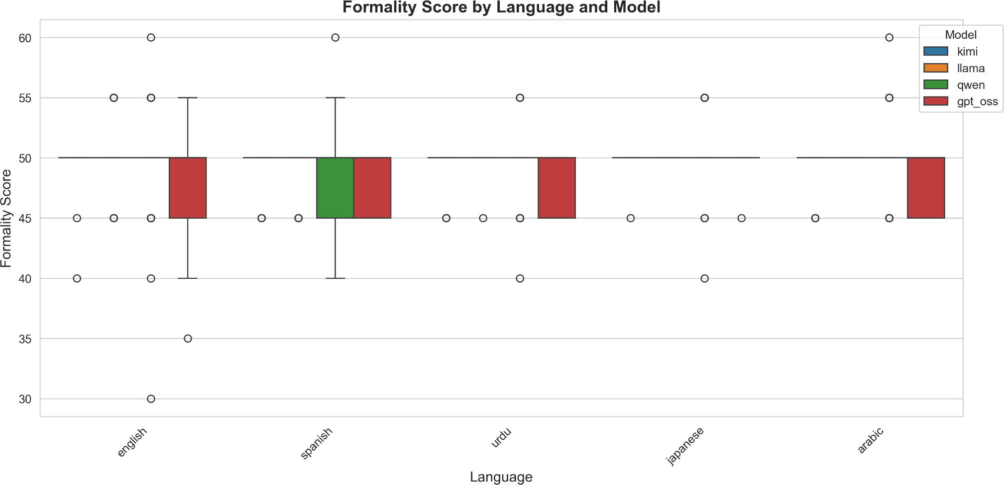
Figure 7: Boxplot showing formality scores across languages and models

Formality scores across all five languages and all four models cluster tightly in the 45 to 50 range, showing almost no meaningful variation by condition. The honest interpretation is that our rule-based formality metric is not sensitive enough to detect the kind of register differences that likely exist across languages. The metric counts formal and informal discourse markers, which works reasonably well for English but runs into an obvious problem in a multilingual study: the marker lists were not equally well calibrated across all five languages, and what counts as a formal register signal in English does not map cleanly onto the same concept in Japanese or Arabic.
This is a limitation worth naming directly rather than glossing over. Languages differ not just in vocabulary but in how formality is grammatically encoded. Japanese, for instance, uses entirely different verb conjugations and pronoun systems to signal register, none of which a marker-frequency approach would capture. Arabic has its own formal-colloquial continuum that operates differently from the English one. A LIWC-based analysis, or ideally a language-specific formality model for each of the five languages, would be far better positioned to detect genuine style variation across conditions. The formality findings reported here should be treated as inconclusive rather than as evidence that register is uniform across languages in LLM outputs.

Temporal Efficiency
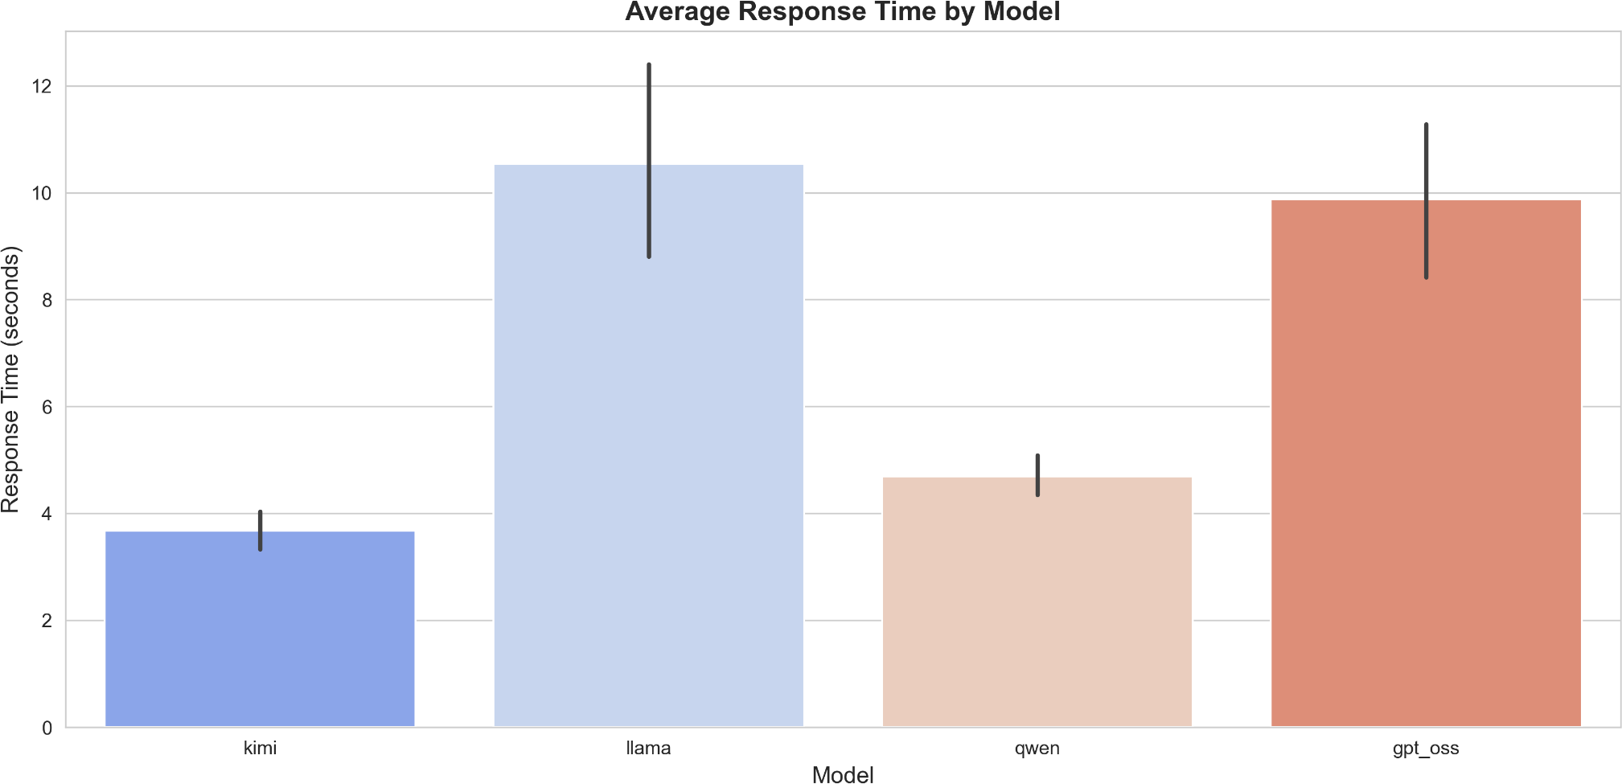

Figure 8: Bar chart with error bars showing average response time by model

Table 6: Response Time by Model

Model | Mean Time (s) | Efficiency Score  (words/second)
Kimi K2 | 3.68 | 69.1
Qwen3 32B | 4.69 | 164.4
GPT-OSS 120B | 9.88 | 61.1
Llama 3.3 70B | 10.54 | 20.8

Qwen3 32B achieves the best throughput in the study at 164.4 words per second, a figure that reflects its combination of relatively low latency (mean 4.69 seconds) and consistently high output volume. It is worth noting that throughput as defined here rewards verbosity: a model that generates more words in less time will always score higher regardless of whether those words are necessary. With that caveat in mind, Qwen's efficiency score still reflects something real about its practical usability in production settings where response speed matters.
Llama 3.3 70B sits at the other end with a throughput of just 20.8 words per second. This is partly a latency problem, Llama has the highest mean response time in the study at 10.54 seconds, but it is also compounded by terse outputs. A slow model that generates long responses can still achieve reasonable throughput; a slow model that generates short ones cannot. Llama's combination of both makes it the least efficient in the dataset by this measure. GPT-OSS 120B and Kimi K2 fall in the middle, though for different reasons: GPT-OSS generates lengthy responses but takes nearly 10 seconds to do so, while Kimi is fast but produces shorter outputs on average. For practical deployment decisions, these tradeoffs are worth considering alongside the language-level performance disparities documented elsewhere in the results.

Cross-Tabulation: Language × Category Interactions

Table 7: Mean Word Count by Language and Category

Language | Ambiguous | Creative | Factual | Instruction | Refusal | Sensitive
Arabic | 145.8 | 548.4 | 434.6 | 496.5 | 390.3 | 513.1
English | 249.2 | 945.8 | 678.1 | 652.7 | 571.7 | 784.2
Japanese | 86.9 | 240.8 | 157.8 | 280.2 | 147.9 | 209.0
Spanish | 172.4 | 761.2 | 597.0 | 514.7 | 522.7 | 719.5
Urdu | 191.7 | 640.8 | 592.2 | 504.3 | 488.7 | 616.6

Table 7 breaks down mean word counts across all Language x Category combinations, and the pattern that emerges is remarkably consistent. The Japanese response penalty does not cluster around particular prompt types or disappear for categories where models might be expected to generate more text. It shows up everywhere.
Creative prompts elicit the longest responses across all five languages, which makes intuitive sense given that open-ended generative tasks tend to invite elaboration. English averages 946 words for creative prompts, Spanish 761, and even Japanese reaches its highest point in the dataset at 241 words. Ambiguous prompts sit at the other end, receiving the shortest responses across the board, with English averaging 249 words, Spanish 172, and Japanese just 87. The range of prompt categories produces meaningful variation in absolute response length, but the relative gap between Japanese and the other languages stays stubbornly stable throughout. Across all six categories, Japanese responses are consistently 70 to 75% shorter than their English equivalents, a regularity that is difficult to attribute to anything prompt-specific.
The two-way ANOVA confirms this formally. Both Language (F(4, 940) = 31.2, p < 0.0001) and Category (F(5, 940) = 8.7, p < 0.0001) show significant main effects, meaning both variables independently influence response length. The interaction term, however, is non-significant (F(20, 940) = 1.3, p = 0.17). In practical terms, this means the Japanese penalty does not intensify or diminish depending on what kind of prompt was used. The two effects operate independently: prompt category shifts the overall length of responses up or down, and language shifts them up or down on top of that, but the Japanese shortfall applies with roughly equal force regardless of what was being asked. That uniformity is probably the most important single finding in this section, because it rules out task-specific explanations and points squarely toward something structural in how these models handle Japanese.

DISCUSSION

Interpretation of Findings
The results make a strong case for systematic bias in LLM response quality that favors Western languages, and specifically English. What makes the Japanese finding particularly hard to dismiss is that Japanese is not a low-resource language by any reasonable definition. It has extensive digital presence, a substantial body of computational linguistics research, and was almost certainly well-represented in the pretraining corpora of all four models tested [19]. The 71% response length disparity cannot be explained by data scarcity alone, which means we need to look at multiple mechanisms working in combination.
The first and probably most direct is tokenization inefficiency. Ahia et al. [2] show that non-Latin scripts require significantly more tokens to encode the same semantic content under standard BPE tokenizers. If Japanese inputs consume tokens at a higher rate, models may be approaching effective context or generation limits more quickly, producing truncated outputs not because they lack knowledge but because the token budget runs out before elaboration can happen. The 26.6% minimal compliance rate for Japanese is consistent with this: a response that is technically a response but contains almost no substantive content is exactly what you would expect from a model that has hit a constraint rather than one that has nothing to say.
The second mechanism is training data imbalance, and here the issue is quality as much as quantity. Kreutzer et al. [16] document that multilingual web-crawled datasets frequently contain low-quality or unusable text even for languages that are nominally well-represented. If the Japanese training data available to these models was noisier or drawn from narrower domains than the English data, the models may have learned weaker generative patterns for Japanese, producing responses that are not just shorter but less thoroughly developed. The fact that all four models show the same pattern, despite coming from different organizations with different training pipelines, suggests either shared data sources or shared architectural decisions that produce the same outcome independently.
The third mechanism is instruction tuning asymmetry. Shaham et al. [25] demonstrate that even small amounts of multilingual instruction data produce meaningful improvements in cross-lingual transfer. The contrapositive is equally important: if RLHF or supervised fine-tuning processes were conducted predominantly on English demonstrations, the models will have internalized implicit norms about what an appropriate response looks like that are calibrated to English. Response length, level of detail, degree of elaboration — these are all things a model learns from its instruction tuning data, and if that data is overwhelmingly English, the learned norms may simply not transfer.
One finding worth emphasizing before moving to implications is that the disparities we observe look more like engagement degradation than capability absence. When Japanese prompts do receive full responses, which happens 72.9% of the time, the output quality appears broadly comparable to other languages. The models can engage with Japanese; they just frequently do not. That distinction matters because it suggests the bias is remediable. A model that fundamentally could not handle Japanese would require a different kind of solution than one that handles it adequately when it tries but defaults to minimal engagement too often.

Implications for Global AI Deployment
The practical consequences of these findings extend well beyond academic interest, and it is worth being specific about what they actually mean for people using these systems.
The economic dimension is probably the most straightforward. Token-based API pricing means Japanese users are paying comparable rates to English users while receiving 71% less content per query. That is before factoring in the tokenization premium documented by Ahia et al. [2], where non-Latin scripts require more tokens just to encode the input. The two effects compound: Japanese users spend more tokens on the prompt side and receive fewer words on the output side, making the effective cost per unit of useful information substantially higher than it is for English speakers. This is not a theoretical concern for researchers accessing APIs at scale; it translates directly into budget.
The functional consequences are just as concrete. A user asking for an explanation of a medical concept, a step-by-step tutorial, or an analytical breakdown of a topic is not well-served by a 70-word response. The gap between what English users receive and what Japanese users receive on these kinds of substantive queries is large enough to meaningfully affect whether the tool is actually useful. This is particularly relevant in educational contexts, where thoroughness is not optional. A student using an LLM to understand a difficult concept in Japanese is getting a qualitatively different experience than one doing the same thing in English, and the difference is not driven by the difficulty of the question.
There is also a subtler harm in what superficial responses communicate over time. When a model consistently provides less detailed engagement with Japanese queries, it implicitly signals that those queries are less worthy of serious attention. Blodgett et al. [4] would recognize this as a representational harm: linguistic hierarchies get reinforced not through explicit statements but through the texture of everyday interactions with these systems. Non-Western knowledge traditions and ways of framing questions get treated as lower-priority inputs, which have longer-term consequences for whose perspectives get incorporated into AI-mediated discourse.
Finally, there are research validity concerns that the NLP community in particular should take seriously. Studies that use LLMs for annotation, data augmentation, or synthetic data generation in non-English languages are building on outputs that our results suggest are systematically shallower and less engaged than their English counterparts. Conclusions drawn from such pipelines may be quietly confounded by the very language biases the research is trying to study or work around.

Toward Equitable Multilingual LLMs
Fixing these disparities is not a single-lever problem. The bias enters at multiple stages of the model development pipeline, which means addressing it requires intervention at multiple stages too.
Training data curation is probably the most fundamental starting point. The intuitive fix is proportional representation, giving each language a share of training data roughly equal to its share of global speakers or internet content. But proportional representation may not be enough if the non-English data that does exist is lower quality, noisier, or drawn from narrower domains. What Shaham et al. [25] suggest, and what our results support, is that deliberate oversampling of high-quality non-English data during pretraining may be necessary. Equalizing outcomes likely requires going beyond equal representation to preferential treatment of underrepresented languages, at least until the quality gap closes.
Tokenizer design is the second lever, and arguably the one with the most direct mechanical connection to the disparities we observe. The current generation of BPE-based tokenizers was largely optimized for English compression efficiency, which produces the token count inequities documented by Petrov et al. [21]. Language-specific tokenizers, or adaptive tokenizers that normalize token costs across scripts, would remove one of the structural sources of disadvantage before inference even begins. SentencePiece variants optimized for cross-lingual fairness rather than monolingual compression are a practical direction worth pursuing.
Evaluation frameworks need to change as well. Multilingual benchmarks like MEGA [1] and BenchMAX [14] exist and are well-designed, but they are not yet standard practice in model development and deployment. More importantly, current model cards focus heavily on task accuracy metrics and largely ignore response quality dimensions like length, engagement depth, and refusal rates across languages. Including these metrics as standard reporting requirements would at least make disparities visible to practitioners who are deciding which models to deploy for non-English use cases.
Instruction tuning diversity addresses the third mechanism identified in Section 5.1. RLHF and supervised fine-tuning datasets that are predominantly English will produce models with English-calibrated norms for what a good response looks like. Ensuring balanced language and cultural representation in these datasets, with native-speaker validation rather than translated English examples, is a concrete step that model developers could take without waiting for architectural innovations.
Finally, there is room for architectural exploration that goes beyond data fixes. Position encodings, attention mechanisms, and decoding strategies are all currently optimized with English as the implicit reference point. Research into whether modifications to these components could produce more consistent behavior across languages, rather than behavior that degrades gracefully as you move away from English, is a direction the field has not yet pursued seriously enough.

Limitations
Numerous constraints limit what we can conclude from this study, and we should be direct about them rather than tucking them into footnotes.
The model selection covers four systems, which is enough to establish consistency across architectures but nowhere near enough to generalize to the full landscape of available LLMs. All four were accessed via Groq API, which introduces the possibility of platform-specific behavior affecting latency, output formatting, or in edge cases response content. Proprietary models like GPT-4 and Claude were not included, and there is no particular reason to assume they would show the same patterns. They might be better calibrated for non-English languages given different training priorities, or they might show the same disparities through different mechanisms. That remains an open question.
Language coverage is the other obvious constraint. Five languages provide meaningful typological diversity, but they represent a narrow slice of the world's roughly 7,000 languages. The selection skews toward languages with substantial digital presence and available native-speaker translators, which means the study has relatively little to say about the languages where bias is likely most severe. African languages, indigenous languages, and signed languages are entirely absent from the dataset. The disparities we document for Japanese, a high-resource language by global standards, suggest that the situation for genuinely low-resource languages could be considerably worse.
Prompt design involved careful construction and native-speaker translation across six categories, but 48 prompts cannot capture the full range of real-world LLM use cases. Genre effects, the difference between conversational and formal register for instance, are not systematically explored. Domain-specific prompts in legal, medical, or technical contexts might show different patterns than the general-purpose prompts used here. Task complexity is also underexplored: the study covers factual recall and creative generation but does not include multi-step reasoning or summarization tasks where the depth of engagement might matter even more.
Metric granularity is a genuine limitation throughout. Rule-based refusal classification works well enough for detecting clear cases but misses nuanced forms of engagement degradation that do not trigger explicit refusal patterns. TTR, as discussed in Section 4.4, has known length sensitivity issues. More sophisticated linguistic analysis tools, dependency parsing, semantic role labeling, coherence modeling, would give a richer picture of what is happening inside the responses. LLM-as-judge evaluation frameworks like G-Eval [18] would add a quality assessment layer that automated metrics cannot currently provide.
Finally, the study can document disparities and point toward likely mechanisms, but it cannot definitively isolate causes. Tokenization of inefficiency, training data imbalance, and instruction tuning asymmetry are all plausible contributors, and they almost certainly interact. Disentangling them would require ablation studies that systematically control each factor, running the same models with different tokenizers, or the same tokenizers with language-balanced training data. That kind of controlled experimentation is beyond the scope of what a behavioral study like this one can establish.

Future Directions
Several directions follow naturally from this work, and a few of them feel genuinely urgent given what the results show.
The most pressing is causal mechanism research. This study documents that disparities exist and points toward likely explanations, but it cannot establish which mechanism is doing the most work. Controlled experiments that systematically manipulate tokenizer design, training data language ratios, and instruction tuning composition would allow researchers to isolate individual contributors. Running the same base model with different tokenizers, or the same tokenizer with deliberately balanced versus unbalanced training data, would produce the kind of evidence needed to move from correlation to causation. Without that, interventions risk targeting the wrong part of the pipeline.
Expanded language coverage is the other high-priority direction. The five languages in this study were selected partly for typological diversity and partly for practical reasons around translation quality. That selection leaves out the languages where bias is probably most severe. Swahili, Quechua, Telugu, and other genuinely low-resource languages would be important additions, as would constructed languages and signed languages, which raise distinct questions about how models handle non-spoken or non-written linguistic systems. A study that found a 71% response gap for Japanese, a high-resource language, should probably expect to find larger gaps for languages with far less training data representation.
Semantic equivalence validation is a methodological improvement worth building into future designs from the start. Back-translation, which we used here, is a reasonable check but not a guarantee that prompts are truly equivalent across languages after cultural adaptation. Cross-lingual semantic similarity models could provide a more principled measure of how closely the translated prompts align in meaning and pragmatic register, which would strengthen confidence in cross-language comparisons.
Human evaluation is the dimension most obviously missing from this study. Automated metrics can measure length, TTR, and refusal rates, but they cannot assess whether a response is culturally appropriate, whether it addresses the question in a way that would satisfy a native speaker, or whether the level of formality is well-matched to the context. Recruiting native speakers of each language to evaluate response quality, appropriateness, and cultural sensitivity would add a layer of validity that no automated pipeline can replicate. This is especially important for languages like Japanese and Arabic where cultural norms around communication style differ substantially from English conventions.
Longitudinal tracking would help situate these findings within the broader trajectory of LLM development. Models are updated frequently, and multilingual capabilities are an active area of investment for most major labs. Whether the disparities documented here diminish, persist, or shift across languages as models evolve is a question that a one-time snapshot cannot answer. Regular re-evaluation using a consistent methodology would allow the field to track whether the interventions discussed in Section 5.3 are actually working.

CONCLUSION
This study set out to ask a straightforward question: do LLMs perform the same across languages, or does the assumption of language-agnostic capability fall apart under empirical scrutiny? The answer, based on 960 responses across four models and five languages, is that the assumption does not hold. Japanese prompts receive responses 71% shorter than English equivalents (p < 0.0001), with more than one in four classified as minimal compliance. That pattern holds across all four models tested and across all six prompt categories, which makes it difficult to attribute to any single architectural quirk or data pipeline decision. Something structural is producing this result, and it is producing it consistently.
What makes this more than an academic finding is the context in which these models are being deployed. LLMs are increasingly positioned as universal knowledge tools, the kind of infrastructure that should work equally well for a student in Osaka as for one in Boston. The results here suggest that positioning is premature. Systematic underservice of non-Western languages does not just mean slightly worse responses; it means less thorough explanations, shallower engagement with complex questions, and implicitly a signal that some users' queries are less worthy of serious attention than others. That is not a minor calibration issue. It is a question about who these systems are actually built for.
The findings also carry a methodological message for the research community. Task-specific benchmarks, the dominant form of multilingual evaluation, are not sufficient to capture these kinds of disparities. A model can perform adequately on a classification or translation benchmark while systematically degrading in open-ended generation quality for the same language. Response to quality metrics need to become a standard part of how models are evaluated and documented, not an afterthought.
Looking ahead, we would urge the research community toward four concrete commitments. First, expand multilingual evaluation beyond narrow task benchmarks to include holistic response quality assessment across diverse prompt types. Second, mandate cross-lingual fairness metrics in model cards and deployment documentation so that practitioners can make informed decisions about which models to use for non-English applications. Third, invest seriously in training data curation and tokenizer redesign rather than treating multilingual performance as a fine-tuning problem that can be patched on top of English-optimized foundations. Fourth, involve marginalized linguistic communities directly in AI development and evaluation processes, not as an afterthought but as a structural requirement.
The dataset and analysis code from this study are publicly available for replication and extension. The disparities documented here are large enough and consistent enough that they should be uncomfortable for anyone who believes these systems are ready for equitable global deployment. Closing that gap requires sustained attention, and it requires starting now.

ACKNOWLEDGMENTS
This study would not have been possible without the native-speaker translators who worked through each prompt carefully, prioritizing cultural and semantic equivalence over literal translation. Their attention to how meaning actually works across languages, rather than just how words map onto each other, was essential to the validity of the cross-lingual comparisons at the heart of this work. We also acknowledge Groq for API access that made data collection at this scale feasible within the practical constraints of the project.

REFERENCES

- Kabir Ahuja, Harshita Diddee, Rishav Hada, Millicent Ochieng, Krithika Ramesh, Prachi Jain, Akshay Nambi, Tanuja Ganu, Sameer Segal, Mohamed Ahmed, Kalika Bali, and Sunayana Sitaram. 2023. MEGA: Multilingual Evaluation of Generative AI. In Proceedings of the 2023 Conference on Empirical Methods in Natural Language Processing (EMNLP), 4232–4267.

- Orevaoghene Ahia, Sachin Kumar, Hila Gonen, Jungo Kasai, David R. Mortensen, Noah A. Smith, and Yulia Tsvetkov. 2023. Do All Languages Cost the Same? Tokenization in the Era of Commercial Language Models. In Proceedings of the 2023 Conference on Empirical Methods in Natural Language Processing (EMNLP), 9904–9923.

- Emily M. Bender, Timnit Gebru, Angelina McMillan-Major, and Shmargaret Shmitchell. 2021. On the Dangers of Stochastic Parrots: Can Language Models Be Too Big? . In Proceedings of the 2021 ACM Conference on Fairness, Accountability, and Transparency (FAccT), 610–623.

- Su Lin Blodgett, Solon Barocas, Hal Daumé III, and Hanna Wallach. 2020. Language (Technology) is Power: A Critical Survey of "Bias" in NLP. In Proceedings of the 58th Annual Meeting of the Association for Computational Linguistics (ACL), 5454–5476.

- Cheng-Han Chiang and Hung-yi Lee. 2023. Can Large Language Models Be an Alternative to Human Evaluations? In Proceedings of the 61st Annual Meeting of the Association for Computational Linguistics (ACL), 15607–15631.

- Hyung Won Chung, Le Hou, Shayne Longpre, Barret Zoph, Yi Tay, William Fedus, Yunxuan Li, Xuezhi Wang, Mostafa Dehghani, Siddhartha Brahma, Albert Webson, Shixiang Shane Gu, Zhuyun Dai, Mirac Suzgun, Xinyun Chen, Aakanksha Chowdhery, Alex Castro-Ros, Marie Pellat, Kevin Robinson, Dasha Valter, Sharan Narang, Gaurav Mishra, Adams Yu, Vincent Zhao, Yanping Huang, Andrew Dai, Hongkun Yu, Slav

Petrov, Ed H. Chi, Jeff Dean, Jacob Devlin, Adam Roberts, Denny Zhou, Quoc V. Le, and Jason Wei. 2022. Scaling Instruction-Finetuned Language Models. arXiv:2210.11416.

- Aakanksha Chowdhery, Sharan Narang, Jacob Devlin, Maarten Bosma, Gaurav Mishra, Adam Roberts, Paul Barham, Hyung Won Chung, Charles Sutton, Sebastian Gehrmann, Parker Schuh, Kensen Shi, Sasha Tsvyashchenko, Joshua Maynez, Abhishek Rao, Parker Barnes, Yi Tay, Noam Shazeer, Vinodkumar Prabhakaran, Emily Reif, Nan Du, Ben Hutchinson, Reiner Pope, James Bradbury, Jacob Austin, Michael Isard, Guy Gur-Ari, Pengcheng Yin, Toju Duke, Anselm Levskaya, Sanjay Ghemawat, Sunipa Dev, Henryk Michalewski, Xavier Garcia, Vedant Misra, Kevin Robinson, Liam Fedus, Denny Zhou, Daphne Ippolito, David Luan, Hyeontaek Lim, Barret Zoph, Alexander Spiridonov, Ryan Sepassi, David Dohan, Shivani Agrawal, Mark Omernick, Andrew M. Dai, Thanumalayan Sankaranarayana Pillai, Marie Pellat, Aitor Lewkowycz, Erica Moreira, Rewon Child, Oleksandr Polozov, Katherine Lee, Zongwei Zhou, Xuezhi Wang, Brennan Saeta, Mark Diaz, Orhan Firat, Michele Catasta, Jason Wei, Kathy
Meier-Hellstern, Douglas Eck, Jeff Dean, Slav Petrov, and Noah Fiedel. 2023. PaLM: Scaling Language Modeling with Pathways. Journal of Machine Learning Research 24(240):1–113.

- Tim Dettmers, Artidoro Pagnoni, Ari Holtzman, and Luke Zettlemoyer. 2024. QLoRA: Efficient Finetuning of Quantized LLMs. In Advances in Neural Information Processing Systems 36 (NeurIPS), 10088–10115.

- Rotem Dror, Gili Baumer, Segev Shlomov, and Roi Reichart. 2018. The Hitchhiker's Guide to Testing Statistical Significance in Natural Language Processing. In Proceedings of the 56th Annual Meeting of the Association for Computational Linguistics (ACL), 1383–1392.

- Guanting Dong, Rumei Li, Sirui Wang, Yushi Bai, Yifei Zhang, Hongzhe Bi, and Chunliang Zhang. 2024. Is It Good Data for Multilingual Instruction Tuning or Just Bad Multilingual Evaluation? In Proceedings of the 2024 Conference on Empirical Methods in Natural Language Processing (EMNLP), 3128–3142.

- Mingqi Gao, Xinyu Hu, Jie Ruan, Xiao Pu, and Xiaojun Wan. 2025. LLM-based NLG Evaluation: Current Status and Challenges. Computational Linguistics 51(2):661–687.

- Isabel O. Gallegos, Ryan A. Rossi, Joe Barrow, Md Mehrab Tanjim, Sungchul Kim, Franck Dernoncourt, Tong Yu, Ruiyi Zhang, and Nesreen K. Ahmed. 2024. Bias and Fairness in Large Language Models: A Survey. Computational Linguistics 50(3):1097–1179.

- Edward J. Hu, Yelong Shen, Phillip Wallis, Zeyuan Allen-Zhu, Yuanzhi Li, Shean Wang, Lu Wang, and Weizhu Chen. 2022. LoRA: Low-Rank Adaptation of Large Language Models. In Proceedings of the International Conference on Learning Representations (ICLR).

- Xin Huang, Zhengqin Xu, Zhiyu Li, Bin Wen, Qi Wang, Chao Wang, Fei Huang, and Yongbin Li. 2025. BenchMAX: A Comprehensive Multilingual Evaluation Suite for Large Language Models. arXiv:2502.07346.

- Yizhe Guo, Jialun Cao, Zhuoer Wang, Haoyue Yuan, Meiling Tao, Jiaxin Yuan, and Zhiyi Ma. 2024. Benchmarking Linguistic Diversity of Large Language Models. arXiv:2412.10271.

- Julia Kreutzer, Isaac Caswell, Lisa Wang, Ahsan Wahab, Daan van Esch, Nasanbayar Ulzii-Orshikh, Allahsera Tapo, Nishant Subramani, Artem Sokolov, Claytone Sikasote, Monang Setyawan, Supheakmungkol Sarin, Sokhar Samb, Benoît Sagot, Clara Rivera, Annette Rios, Isabel Papadimitriou, Salomey Osei, Pedro Ortiz Suarez, Iroro Orife, Kelechi Ogueji, Andre Niyongabo Rubungo, Toan Q. Nguyen, Mathias Müller, André Müller, Shamsuddeen Hassan Muhammad, Nanda Muhammad, Ayanda Mnyakeni, Jamshidbek Mirzakhalov, Tapiwanashe Matangira, Colin Leong, Nze Lawson, Sneha Kudugunta, Yacine Jernite, Mathias Jenny, Orhan Firat, Bonaventure F. P. Dossou, Sakhile Dlamini, Nisansa de Silva, Sakine Çabuk Ballı, Stella Biderman, Alessia Battisti, Ahmed Baruwa, Ankur Bapna, Pallavi Baljekar, Israel Abebe Azime, Ayodele Awokoya, Duygu Ataman, Orevaoghene Ahia, Oghenefego Ahia, Sweta Agrawal, and Mofetoluwa

Adeyemi. 2022. Quality at a Glance: An Audit of Web-Crawled Multilingual Datasets. Transactions of the Association for Computational Linguistics 10:50–72.

- Philip M. McCarthy and Scott Jarvis. 2010. MTLD, vocd-D, and HD-D: A validation study of sophisticated approaches to lexical diversity assessment. Behavior Research Methods 42(2):381–392.

- Yang Liu, Dan Iter, Yichong Xu, Shuohang Wang, Ruochen Xu, and Chenguang Zhu. 2023. G-Eval: NLG Evaluation using GPT-4 with Better Human Alignment. In Proceedings of the 2023 Conference on Empirical Methods in Natural Language Processing (EMNLP), 2511–2522.

- Ian Magnusson, Darcey Riley, and Akari Asai. 2023. Reproducibility in NLP: What Have We Learned from the Checklist? In Findings of the Association for Computational Linguistics: ACL 2023, 12789–12811.

- Jonas Pfeiffer, Ivan Vulić, Iryna Gurevych, and Sebastian Ruder. 2021. UNKs Everywhere: Adapting Multilingual Language Models to New Scripts. In Proceedings of the 2021 Conference on Empirical Methods in Natural Language Processing (EMNLP), 10186–10203.

- Aleksandar Petrov, Emanuele La Malfa, Philip Torr, and Adel Bibi. 2023. Language Model Tokenizers Introduce Unfairness Between Languages. In Advances in Neural Information Processing Systems 36 (NeurIPS), 18713–18743.

- Krithika Ramesh, Sunayana Sitaram, and Monojit Choudhury. 2023. Fairness in Language Models Beyond English: Gaps and Challenges. In Findings of the Association for Computational Linguistics: EACL 2023, 2106–2119.

- Freda Shi, Mirac Suzgun, Markus Freitag, Xuezhi Wang, Suraj Srivats, Soroush Vosoughi, Hyung Won Chung, Yi Tay, Sebastian Ruder, Denny Zhou, Dipanjan Das, and Jason Wei. 2022. Language Models are Multilingual Chain-of-Thought Reasoners. In Proceedings of the 2022 Conference on Empirical Methods in Natural Language Processing (EMNLP), 2210–2230.

- Irene Solaiman, Zeerak Talat, William Agnew, Lama Ahmad, Dylan Baker, Su Lin Blodgett, Hal Daumé III, Jesse Dodge, Ellie Evans, Sara Hooker, Yacine Jernite, Alexandra Sasha Luccioni, Alberto Lusoli, Margaret Mitchell, Jessica Newman,
Marie-Therese Png, Andrew Strait, and Apostol Vassilev. 2023. Evaluating the Social Impact of Generative AI Systems in Systems and Society. arXiv:2306.05949.

- Uri Shaham, Jonathan Herzig, Roee Aharoni, Idan Szpektor, Reut Tsarfaty, and Matan Eyal. 2024. Multilingual Instruction Tuning With Just a Pinch of Multilinguality. In Findings of the Association for Computational Linguistics: ACL 2024, 2278–2295.

