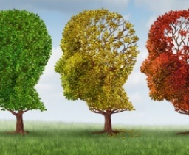

Oluwatoyin Mary Yerokun
Department of Computer Science
Faculty of Science
Ekiti State University
Ado Ekiti, Nigeria

Dipo Theophilus Akomolafe
Department of Computer Science
School of Computing
Olusegun Agagu University of Science and Technology
Okitipupa, Nigeria

and
Isoken Praise Ehigie
Department of Computer Science
College of Science and Computing
Wellspring University
Benin City, Nigeria

Corresponding Author: Oluwatoyin Mary Yerokun
08037466972; yerokunoluwatoyin@gmail.com

Abstract
AI came into existence to improve the quality of human living from birth to death, including and especially transition stages such as reproductive-ageing years in women, known as menopause. Often accompanied by debilitating symptoms that impact daily life, menopause is currently managed by religious, cultural and social systems which puts career women at a disadvantage as they are branded sickly or incapable of full delivery of services. The few machines created to relieve the menopause strains on women are at best, one-size-fits-all wearables. This research investigated the neglected individual differences approach in symptom profiles and health needs and employed artificial intelligence tools to design and evaluate an intelligent menopause management system that can provide personalized support and guidance to women in navigating the menopause phases. Data collected through surveys and interviews showed that quality of life of women drastically reduced from perimenopause years and often, women are forced to retire prematurely. The system designed analyzed collected data, identified patterns, predicted symptoms severity, immediate relief actions and potential complications with correlations between symptoms. It provides a personalized approach to treatment options and communication tools with healthcare providers.
Keywords: analytics, menopause, machine, predictive, symptoms, lifestyle, algorithm.
1.0 Introduction
Machines have a history of helping man to do his work and improving the quality of life. Machines evolved from simple hand-held and make-shift devices, through mechanical and electromechanical devices, to electronic devices, and recently, to intelligent devices. Any electronic device that can accept data, process it, produce an output as result, and save it all in its memory for future use is regarded as a computer. It is a machine that helps man to do work effectively and efficiently. Addition of human intelligence into electronic devices, aptly named artificial intelligence (AI) would remain the best innovation for generations to come.
Artificial intelligence (AI) has long graduated from communication and information protocols into the center stage in all human endeavors. Today, AI applications range from education to manufacturing, engineering, justice, finance, business, lifestyle, medicine, and health management for the overall wellbeing of mankind (Diaz, et.al., 2019). Computers revolutionized the healthcare and medical industries by transforming diagnosis, treatment, management and patient care. Medical imaging and diagnostics, electronic health records, telemedicine and remote monitoring, medical research and education, clinical decision support systems, administration and management; and more recently, the application of AI into predictive analysis, disease prevention, diagnosis and personalized medicine.
Personalized medical treatment is an approach that recognizes that individuals have distinct genetic make-up and therefore should not use the one-size-fits-all in the diagnosis and treatment of all patients with similar symptoms. It is a precision style that considers the specific lifestyle, environment, generations and history of the patient to guide the diagnosis and treatments accordingly. It is a more effective way of delivering healthcare, reducing trial-and-error approaches, minimizing unnecessary treatments with associated costs and allergies. almost eradicating allergies.
Personalized medicine is agreed to be the best way to treat hormonal issues. Hormones are regulated by the body system in exclusively personal manners. Most patients with hormonal issues require more than the supplements to treat. One of such challenges is found in the ageing process in women, transitioning from child-bearing years to older adult years.
Women’s ages can be classified into various stages, each with distinct physical, emotional and reproductive characteristics. They are:
- Adolescent: 13 – 19 years (Puberty and rapid growth)
- Young adult: 20-29 years (Reproductive prime and establishing independence – career).
- Adult: 30-44 years (Career establishment, financial stability, pregnancy, childbirth, parenting.
- Perimenopause: 45-54 years (Hormonal fluctuations, menstrual irregularities, physical and emotional changes while transitioning to menopause).
- Menopause: 55 years and above (Complete cessation of menstruation, decreased estrogen levels, increased health risks, physical unavoidable symptoms of post-menopause.
- Older Adults: 65 years and above (Ageing gracefully with life reflections and legacy).
2.0 Definition of Problem
Menopause is one of the unavoidable ageing processes for women. According to available statistics on women’s health, menopause hits women between ages 40 to 60 years, systematically. It is always preceded by unusual feelings of ill-health which when reported to medical practitioners are almost always misdiagnosed as with other illnesses and mostly accorded with mysterious awe when untreatable (Winfrey, 2025). In a survey of forty-four (44) women, almost all of them had cases of insomnia, amnesia, brain fog, panic attacks, migraine, night sweats, hot flashes, unusual fatigue, etc. while many of them had been recorded with clinical depression after been treated for high fever or typhoid with no results. The chart in figure 1A is a clear illustration of the symptoms.
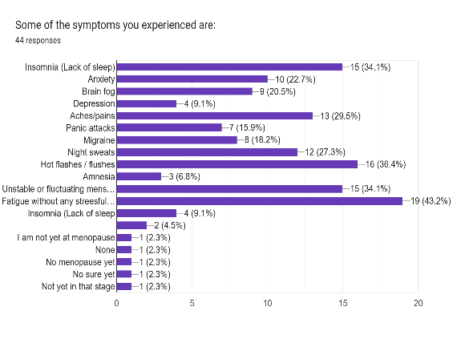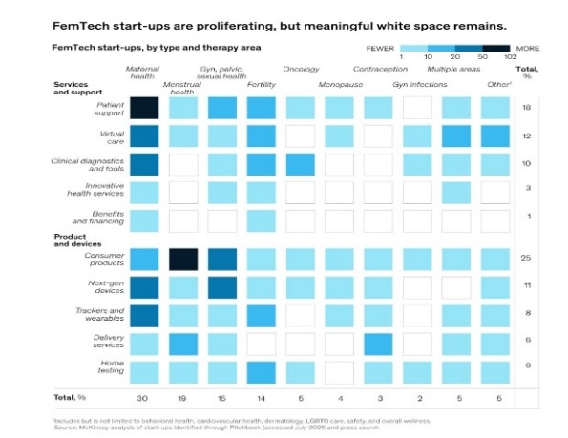
Figure 1A: Chart showing various symptoms experienced by menopausal women.
Figure 1B: Block chart showing meaningful spaces representing areas of women’s health not yet receiving AI or technological applications. Source: FemTech (2024).
AI-based health solutions have not yet addressed menopause issues. Technological devices available are at best the generalized ones which cannot address the various peculiarities of women’s different lifestyles and medical history (O’Kane, et.al., 2024). In a study conducted by FemTech (2024), there is still much to be done in the provision of meaningful technologies to assist women in dealing with menopausal issues. Figure 1B is a block chart depicting the many areas of women’s health and their available technologies, Innovative services and menopause are clearly fewer and outrightly not existing in severe cases.
Women’s health is currently receiving good attention from the government and health service providers viz: maternal health, reproductive health, maternity and post-partum stress management, etc. (WHO records), however, many issues pertaining to women’s reproductive health remains shrouded in myths, traditional fables, religious mysteries and generational questionable social standards. One of such “mysterious” issues is menopause and its relative effect on women’s overall life and career.
Menopause is being ignored simply because it is a natural occurrence, not preventable, not curable and can only be managed (Burst et. al. 2024). For women that do not have adequate information or experienced guides, menopause becomes a nightmare, and some are branded as weird, queer, or unnatural, at the peak of menopausal symptomatic manifestations (Yerokun & Akomolafe, 2025).
Timely detection will enable accurate early diagnosis of onset of menopause and largely eliminate the misclassification of symptoms. This will invariably lead to precise management before the symptoms become severe thereby easing the transition phase with resultant overall wellness. Menopause experience is personal and varies from one individual to another, treatment should therefore be tailored to suit individual woman’s medical history and lifestyle.
3.0 Research Aim and Objectives
This research is aimed at designing an AI-based menopause management model that can match and integrate self-reported physiological symptoms with the database, use multimodal data fusion machine learning techniques to identify the stages of menopause, provide personalized recommendations in managing menopause symptoms and link user with support communities. The specific objectives are to:
- collect data from women communities, extract, interpose and prepare a comprehensive dataset based on individual experiences by women at the various stages of menopause;
- design algorithms and models that can analyze data to predict symptoms onset and severity of symptoms;
- design an interactive platform to assist users in prompt diagnosis and recommend instructions for management of individual symptoms; and
- evaluate the performance of the model in terms of sensitivity, specificity, and overall classification accuracy by comparing the results of the system with the locally existing systems.
4.0 Significance of Study
The system will significantly make theoretical and practical contributions to women’s healthcare and delivery in the following ways:
- An easy-to-reach assistant with comprehensive database for evidence-based tools in diagnosing menopause phenomenon.
- Demystify menopause by easing the burden of secrecy and isolated sufferings associated with menopause by opening a platform for discussion, information and experience sharing.
- Significantly draw more attention to the wide research possibilities in women’s reproductive health.
- Provide experts with more information on specific areas of need for digital intervention and propel more AI solutions.
5.0 Review of Related Literature
Woytuk, Nilsson & Liu (2019) summarized their paper on menstrual periods as a call for the society to discontinue the exasperations caused by taboos around menstruation. The paper highlighted how the ways in which researchers present or explore design spaces with women without adequate consideration of their personal needs and how such insensitivities have a significant effect on the discussions held and design ideas produced. The major recommendation of the paper was that period-positive technologies are urgently needed with emphasis on individual differences, as the best way to ensure women’s trust in digital technologies.
Diaz, et.al., (2019) discussed the various health complications that women suffer because of misdiagnosed and late treatment of menopausal transitional symptoms. Osteoporosis was focused upon as an avoidable sickness if diagnosed early. Basing their study on large clinical data from hospitals spread across online databases, they strongly opined that implementation of AI in early phase of menopause can drastically reduce the occurrence of osteoporosis, especially with Deep Learning (DL) techniques. They claimed that neural network architecture has been combined with advanced algorithms to input parameters which can lead to identification of groups at risk for osteoporosis and positive results have been obtained with sensitivity values between 81% and 91%. They argued that image identification and recognition has also improved through the combination of bone density indicators and several texture parameters by models using feed forward neuronal networks, probabilistic neural networks, learning vectors quantification, and support vector machines (SVMs), which could potentially automate the diagnosis of osteoporosis and risk of fracture when approaching menopause.
Burst, Felice & O’Kane (2024) stated that women transition through menopause differently, and with respect to individual lifestyle and medical history. Their research was carried out to determine the appropriateness of support systems available for menopausal women. It was discovered that only two devices are currently available for symptomatic relief, and they are generally not suitable for use at some times of the day and night because of their intrusive modes of operation. The second discovery from their interview of thirty-eight (38) group-based questionnaire and eleven (11) group-based interviews was that “there is a lack of research on what current menopause practices are with technology”. Technology has never been appropriately applied for personal assistance of menopausal and transiting women.
Almeida, Balaam & Comber (2020) conducted research to assess the level of involvement of women in the design process of devices to be used by women. From breastfeeding assisted devices to menstrual relieving systems, the authors discovered that women who are the users of these devices were mostly not the primary concern in the design of such devices. Many factors, among which are profitability, rank first in the design processes instead of personalized needs. They stretched the importance of including women in the design process and described it as “critical to improving women’s experiences in bodily transactions, choices, rights, and access to and in health and care”.
Yerokun & Akomolafe (2025) studied the impact of Natural Binary Patterns (NBPs) on the religious beliefs of both digital and analogue natives, especially with respect to their decision-making processes. In a six-themed survey, the study discovered that most private needs are treated mainly with religious beliefs trained by NBPs and there are currently not enough innovative applications for solving individual intimate challenges (such as menopausal transitioning issues). One of the recommendations of the authors is that the future of computing technologies should be targeted on Bio-inspired solutions - nature-inspired binary algorithms to solve age-long personal problems.
5.1 Review of Existing Systems
In the work of Burst, et.al. (2024), several technologies are making the rounds in some female circles. Some of them are:
- wearable technology bracelets (Grace, Embr and Thermaband); cooling clothing, jewelry, mists; and menopause magnets, are targeted at hot flushes. They work by providing a cooling sensation at the wrist or neck which in turn helps cool down the whole body;
- Menopod, a hand-held device which when placed on the neck can provide a cooling sensation.
The major challenges with these devices are:
- Unavailability: Only Embr and Menopod are currently available and in limited supplies while the others are still in their development stages.
- Impracticability: The devices operate by being held directly to the affected areas, but most often, hot flashes are unpredictable and irregular, thereby making the use of the devices inappropriate or awkward on most needed occasions such as during office activities like board meetings, classes, training, etc. Its use at night is also often intrusive because night sweats would have intruded and interrupted the night sleep before it can be activated.
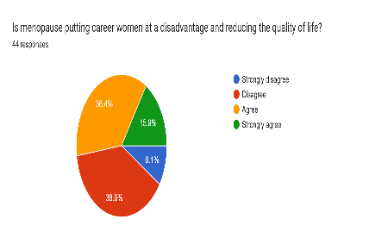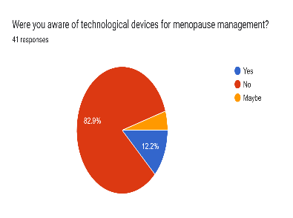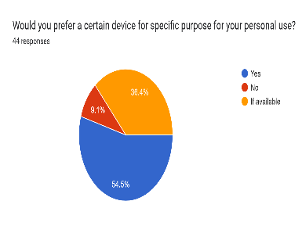
Fig. 2:Charts showing (a) Women’s position on effects of menopause on their career; (b) awareness about assisting devices; and (c) preferences of device options.
- Lack of information and awareness: Approximately 83% of respondents surveyed had never heard of any technology-based device for easing menopause symptoms. 12% had a kind of awareness but had not seen or used such devices and very little understanding of how these devices are used in the real-world. 90% of the women interacted with had different needs and specifications they would like technology to fix. Apps such as Balance, Stella, Midday, Femilog, and Caria are available, but their databases are not comprehensive. The information on databases is mostly about women in advanced countries and their recommendations are based on Western culture. The specific issues relating to Nigerian (Black) women are not catered for in the physiological and medical suggestions on those apps.
  - Methodology
  - Data Collection
The qualitative method used in this research employed a mixed approach of questionnaire and semi-structured interviews. The questionnaire was administered through Google forms to individuals, and forty-six (46) respondents returned their completed forms. Two (2) local community women’s groups and two (2) religious-based women’s groups with a minimum of ten (10) members participated in the group interview. The groups met in different settings, providing a combination of diverse backgrounds, experience and exposures. They were women spread across relevant ages (35 to 85 years) within the south-west, South-South and South-East Nigeria. They were visited during their monthly meetings and interviewed using the structured questions. Religious and market groups embody a rich blend of all ages, tribes, education and social status of people living in urban and rural areas. The questionnaire met mostly well-educated women while the interviewed groups covered the not-well-educated women. All women captured in the population have different levels of the menopause experience (perimenopause, menopause or post menopause).
The research questions were mapped into three (3) sub-themes – background information, menopause experience and knowledge of ICT making a total of twenty-six questions in all. They covered personal beliefs, traditional/religious practices, history/handed-down information on menopause, personal experience, knowledge of ICT devices, management of symptoms and their use for diagnosis. The discussions all tailed into the meeting points between technology and their needs. The researchers ensured that the important qualities of feminist interaction as advised by Bardzell (2022), were prioritized in the design of the instruments – pluralism, participation, advocacy, ecology and self-disclosure. The Research Committees of both the Computing Department in Wellspring University, Benin City and Computer Science Department of Ekiti State University, Ado-Ekiti reviewed and approved the ethics application for this research.
All the respondents are female except two males that spoke for wife/mother and from general experience as religious leaders. The group interviews ranged from 45 to 90 minutes, and were captured on video for easier transcription, analysis and future research use.
  - Data Pre-processing and Analysis
All the data collected were analyzed objectively. While recognizing the inevitable influence of the researchers in the analysis, the academic training of the researchers prevailed in the interpretation and analysis of data. This is important because the experience of menopause is a transition that is highly individual, and it is best presented as raw as possible without colorations of researchers’ bias.
7.0 Results / Discussion of Findings
In clear terms, all the respondents accepted that there is need for AI-based system that can ease the challenges of menopausal women. Charts presented in figures 3a, b, c and d show the needs and eagerness to accept technology in management of their symptoms.
(a) 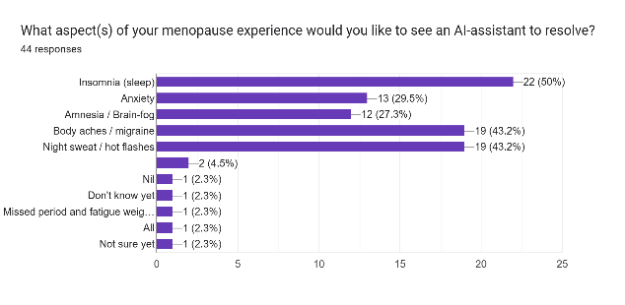 (b)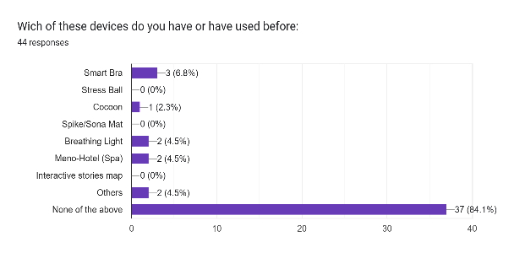
(c) 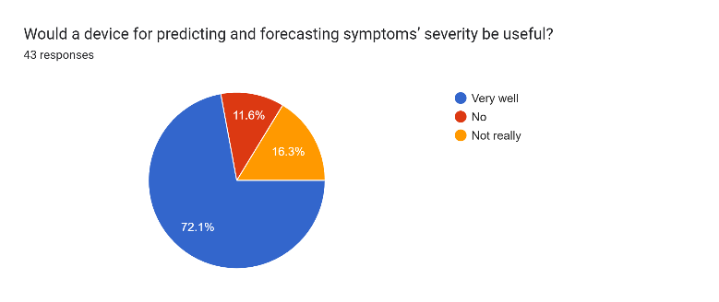 (d) 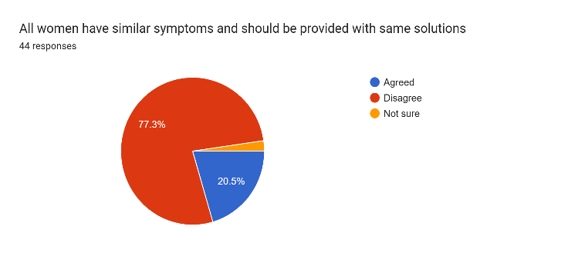
Fig 3: The needs and eagerness of women to accept technology in management of their menopause symptoms.
- System Design
The system is designed to have three major layers of interaction: interphase, matching and recommender. The interphase level is where the user interacts with the system by feeding personal data and requests. The data input is matched with existing history in database for new users or returning users. The stage of menopause is identified while the lifestyle implications are listed. The next possible symptoms are predicted by the machine learning algorithm, indicating the degree of severity and suggesting immediate next line of actions while connecting with a real-time mentor/adviser/consultant. The system concludes with a review section for users to add their experience, suggestions for upgrade and further research. Figure 4 is a flowchart of the system as designed for easy interfacing with users.
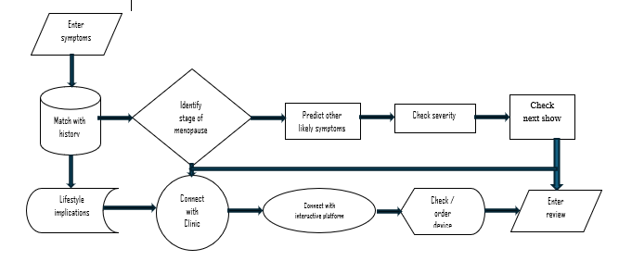
Fig. 4: System flowchart / Use-case diagram / system design
9.0 Implementation
The system is made up of the following components:
- User interphase: for entry of physiological data, history and symptoms and interactions with the system.
- Knowledge / Database: comprising of traditional and medical characteristics of menopause; possible symptoms and matching manifestations that can match users’ descriptions.
- Neural network modules: for learning and adaptation.
- Inference Engine is made up of a fuzzifier, a rule base, an inference engine, and a de-fuzzifier for enabling decision-making with uncertain or imprecise data.
- Recommendation: section where decisions are weighed with respect to medical experts’ judgement before final prescriptions are made.
- Links to community support base for older women’s experiential counselling and roundtable discussions; and
- Library of recommendations, instructions and users’ log-in records.
Conclusion
This system is needed for women. Every possible assistant should be supported in bringing relief to women, especially in health matters.
However, due to the complex nature of the system, full implementation is scheduled for another phase of this research. This is necessary for standardization, authorization and authentication processes.

References
Akomolafe, D. & Yerokun, O. M. (2022). Emergence of Digital Systems through Indigenous Knowledge. Asian Journal of Pure and Applied Mathematics 4(3): 139-157, 2022; Article no.AJPAM.922.
Awati, R (2024) WhatIs – Definition Binary. TechTarget. www.computerweekly.com.
Bentley, P. (2022). How do you read binary numbers. Science Focus. www.sciencefocus.com/science/how-to-read-binary
Boashash B. and Ben-Jabeur, T. (2015). Time-Frequency Features for Pattern Recognition Using High-Resolution TFDs: A Tutorial Review. Natural Signal – ScienceDirect. www.sciencedirect.com/topics/computerscience/natural-signal
Burst, E.L, Felice, M.C. & O’Kane, A.A. (2024). Using and Appropriating Technology to Support The Menopause Journey in the UK. In Proceedings of the CHI Conference on Human Factors in Computing Systems (CHI ’24), May 11–16, 2024, Honolulu, HI, USA. ACM, New York, NY, USA, 14 pages. https://doi.org/10.1145/3613904.3642694.
Diaz, Z.M, Muka, T. & Franco, O.H. (2019). Personalized Solutions for Menopause through Artificial Intelligence: Are We There Yet? ScienceDirect (Elsevier) Maturitas 129, www.elsevier.com/locate/maturitas, pages 85-86.
FemTech (2024). FemTech and Menopause Tech at Telefonica. https://www.femtech.org/
Ghulaxe, P.P. (2024): THE RUBRICS JOURNAL OF INTERDISCIPLINARY STUDIES International, Indexed and Peer Reviewed e-Journal, Vol.6 Issue 2 Pp 1326 – 1331
Kanade, V. (2025). What is Artificial Intelligence (AI)? Definition, Goals, Challenges and Trends in 2022. https://www.spiceworks.com/tech/artificial-intelligence/articles/what-is-ai/
Nadia Campo Woytuk, Linette Nilsson, and Mingxing Liu. (2019). Your Period Rules: Design Implications for Period-Positive Technologies. In Extended Abstracts of the 2019 CHI Conference on Human Factors in Computing Systems (CHI EA ’19), 1–6. https://doi.org/10.1145/3290607.3312888
National Aeronautics and Space Administration, NASA (2014). https:/www.nasa.gov/what-is-artificial-intelligence.
Olorode, O. (2016). Overcoming the Challenges of Development through Indigenous Knowledge; a Public Lecture Delivered at the Ondo State University of Science and Technology, Okitipupa, Ondo State, Nigeria. Unpublished.
Pooja, K., Dhawale, 1, Rekha, C. & Maggirwar, A. (2024). Diversity of Arbuscular Mycorrhizal Fungi and their Symbiotic Association with Salvia splendens. The Rubrics Journal Of Interdisciplinary Studies, Vol.6(2), March 2024. e-Journal www.therubrics.in.
Samuel, O.W. and Omisore, M.O. (2013). Hybrid Intelligent System for the Diagnosis of Typhoid Fever. Journal of Computer Engineering & Information Technology, Volume 2(2), 1-9.
Suhas M Pidhekar (2024): Technology Integration in Higher Education: Life Science and Technology Narendra Manwar1 and THE RUBRICS JOURNAL OF INTERDISCIPLINARY STUDIES International, Indexed and Peer Reviewed e-Journal, Vol.6 Issue 2. Pp 1304=1309. www.rubrics.com
Surhatono, D, Aditya, W. Lestari, M. and Yasin, M. (2013). Expert system in detecting coffee plant diseases. International Journal of Electrical Energy, 1(3), 156-162.
Teresa Almeida, Madeline Balaam, and Rob Comber. 2020. Woman-Centered Design through Humanity, Activism, and Inclusion. ACM Trans. Comput.-Hum. Interact. 27, 4. https://doi.org/10.1145/3397176.
Winfrey, O. (2025). The Menopause Revolution. Oprah Winfrey Reveals the Unexpected Menopause Symptom that made her feel Like She Was “Going to Die”. womanandhome.com http://opr.news/73b337df250401en_ng?link=1&client=news
Yerokun, O.M, Owolabi, A.A., Iyawa, I.J. & Nwanze, M.N. (2022). Using Expert System for Industrial Utilization of Leguminous Crops. Computer Networks (Elsevier) Volume 216 (24) August 2022, 108798.
Yerokun, O.M. & Akomolafe, D.T. (2025). Impact of Natural Binary Patterns on Cognition and Perception in the Digital Age: A Comparative Study of Digital and Analogue Native Populations. International Journal of Computer Science and Mathematical Theory (IJCSMT) E-ISSN 2545-5699 P-ISSN 2695-1924 Vol 11. No.2 2025 www.iiardjournals.org. DOI: 10.56201/ijcsmt.v11.no2.2025, pgs. 85-96
Yerokun, O.M. & Onyesolu, M.O. (2021): On the Development of Neuro-Fuzzy Expert System for Detection of Leghemoglobin (NFESDL) in Legumes. Journal of Digital Innovations & Contemp Res. in Science, Engineering & Technology. Vol. 9, No. 1. Pp 129-140 DOI: dx.doi.org/10.22624/AIMS/DIGITAL/V9N1P1
Yerokun, O.M. (2024). Artificial Intelligence in Indigenous Knowledge and Practices: A Comparative Analysis. The Rubrics Journal Of Interdisciplinary Studies, Vol.6(2), March 2024. e-Journal www.therubrics.in.
Yerokun, O.M., Erukpe, O.B. & Nwanze, M.N. (2024). Design of an Automated System for Synthesis of Gold Nanoparticles from Thaumatococcus Daniellii (Sweet Prayer Leaf). Science Direct (Computer Science Review) Volume 52, May 2024. https://www.sciencedirect.com/journal/computer-science-review
v

