Title Page

Article Title:
Design rationale for improvements in needle and guidewire for access of central veins and peripheral vasculature: Introduction of the Accelerated Seldinger Kit.

Abstract:
Access to central veins and peripheral arteries remain amongst the most commonly performed procedures in the world yet are associated with persistent low frequency complications. We introduce improvements in the design of guide needles and guidewires, to be used for central venous and peripheral vascular access targeting improved patient safety and ease of use. The modifications include an echogenic needle bulb enhancing ultrasonic visualization and haptic feedback during insertion as well as an integrated guidewire.

Manuscript:

The Seldinger technique is used for arterial and venous vascular access into large central veins such as internal jugular, subclavian or femoral vein. The technique, developed in 1953, involves puncturing the targeted artery or vein with a guide needle and syringe, blood aspiration to determine success in access, detaching of the syringe, insertion of a guidewire, removing the needle and sliding a catheter over the wire onto the artery or vein. ^{1,2} The initial description promoted through and through artery and vein punctures and pull back of the needle into the vascular lumen. ^{3,4} The procedure is now performed both emergently and electively, providing reliable vascular access for administration of medications, fluids, blood products and total parenteral nutrition, and facilitates rapid infusion of fluids in critically ill patients while allowing delivery of irritant or hypertonic medications which may otherwise damage smaller peripheral veins; it also enables hemodynamic monitoring, including measurement of central venous pressure, and repeated blood sampling. ^{5,6,7} Broadening indications for central venous access has increased its applicable populations, and is often required for the management of acutely ill patients with more comorbidity and morbid risk of access complications or failure. ^{8,9} In 1998, it was estimated that central venous catheters were inserted 5 million times in the USA; ¹⁰ current estimates are 27 million central venous catheters are inserted worldwide. ¹¹ In addition to the venous access, approximately 8 million brachial and radial arterial lines are created with the Seldinger technique in the United States every year for numerous diagnostic and therapeutic procedures. ¹²

Central venous catheter placement is associated with low but measurable rates of serious complications. ^{13,14} Estimates of complications for central venous access range from 5%-19%. ^{15,16} A 2024 systematic review and meta-analysis published in JAMA Internal Medicine analyzing 130 separate studies from 2015-2023 found that while reported rates varied considerably, major complications occurred in an average of 3% of central venous catheter placements including placement failure occurring at a rate of 20.4 events per 1000, arterial puncture at 16.2 events per 1000, and pneumothorax at 4.4 events per 1000, while use complications rates of 4.8 events per 1000 for infection and 2.7 events per 1000 for deep vein thrombosis. ¹¹

The introduction of real time ultrasound has become the gold standard for central venous access, possibly reducing many of the complications, in particular pneumothorax. ^{17,18,19,20} However, the tools used for Seldinger access have neither been optimized for ultrasound visualization nor for guidewire manipulation: 1) the needle tip is not always readily visible under ultrasound necessitating a secondary blood flash-back confirmation, and 2) introduction of the guidewire still requires putting down the ultrasound probe while detaching the syringe from guide needle and inserting the guidewire into the needle hub. These manipulations both risk inadvertent with-drawal of the needle from vascular lumen or advancing it through the posterior wall of the vein or artery. Additionally, the current access procedure causes the operator to often end visual ultrasound imaging while detaching the syringe and obtaining and advancing a guidewire (“third hand dilemma”). The “blind” stabilization of the needle during manipulations risks dislodging or inadvertently advancing the needle should any operator or patient movement occur. This “third hand dilemma” also results in the blind introduction of the guidewire, which is not the standard of care. Continuous visualization of the needle tip could ensure persistent proper positioning of the needle bevel within the lumen of the target vessel. And, continuous visualization could ensure safer introduction of the guidewire.

A novel Accelerated Seldinger Kit has recently been approved by the FDA for human use by the 510k pathway, which addresses these specific deficiencies by creating an echogenic bulb on the introduction needle, helping to both optically and haptically identify the outside of the vessel wall as the needle bevel advances into the vessel lumen, thereby reducing risk of posterior wall puncture or laceration. Additionally, inclusion of an integrated guidewire, with advancer, pre-connected to the needle obviates the need for a syringe detachment and wire introduction into the needle hub, and simultaneously resolves the “third hand dilemma”.

This novel Accelerated Seldinger Kit could represent a larger workflow redesign - creating a central venous access tool optimized for ultrasound visualization and facilitating continuous visualization of guidewire insertion. The echogenic properties and haptic feel of the bulb transform the needle from a passive cylinder into a direct visual interface that constitutes a functional element of the image itself. Furthermore, the integrated guidewire system eliminates the “third-hand dilemma” and potentially minimizes the time between vessel puncture and guidewire placement, reducing both needle manipulations and maintaining continuous ultrasound visualization of all steps.

This novel Accelerated Seldinger Kit potentially leads to improvements in patient safety and ease of use. Further studies are currently underway to prospectively capture the procedural and outcome-specific improvements associated with the Accelerated Seldinger Kit.

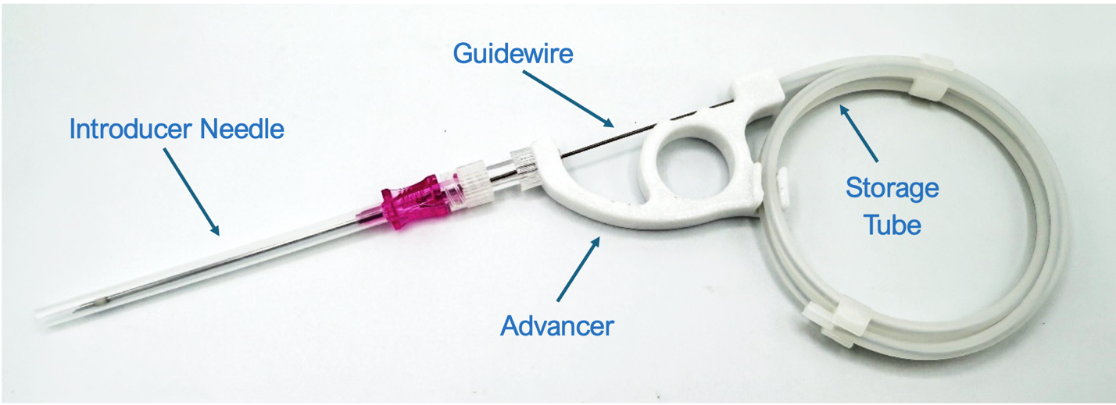
Figure 1-1. Primero SAS
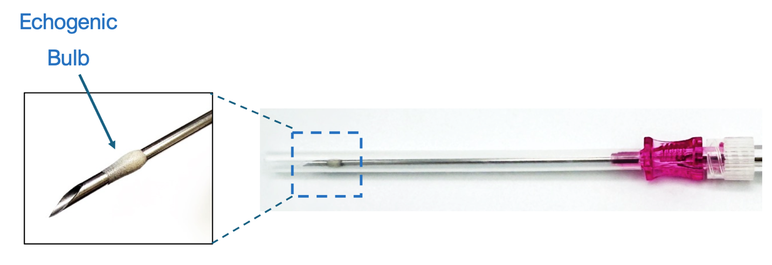
Figure 1-2. Primero Introducer Needle Echogenic Bulb

Acknowledgments:
Pictures provided by the manufacturer.

Ethical Statement:
The preparation of this review included no human or animal subjects. All studies referenced come from peer reviewed and published sources

Statements and declarations:
No Author has any financial conflicts of interest with the Accelerated Seldinger Kit.

Declaration of conflicting interest:
Paul A Sobotka – Employee at CoreAvie Medical
Thomas J Allen – Employee at University of Minnesota

Funding statement:
No funding provided

References:
- Seldinger SI. Catheter replacement of the needle in percutaneous arteriography; a new technique. Acta Radiologica 1953; 39(5): 368-376.
- Kolikof J, Peterson K, Williams C, et al.; Central Venous Catheter Insertion. In: StatPearls [Internet]. Treasure Island (FL): StatPearls Publishing, 2025. Available from: https://www.ncbi.nlm.nih.gov/books/NBK557798/
- Mangar D, Thrush DN, Connell GR, et al.; Direct or modified Seldinger guide wire-directed technique for arterial catheter insertion. Anesth Analg 1993; 76(4): 714-717.
- Nohara AM, Kallmes DF. Transradial cerebral angiography: technique and outcomes. AJNR Am J Neuroradiol 2003; 24(6): 1247-1250.
- Rupp SM, Apfelbaum JL, Blitt C, et al.; Practice guidelines for central venous access: a report by the American Society of Anesthesiologists Task Force on Central Venous Access. Anesthesiology 2012; 116(3): 539-573.
- Mermel LA, Allon M, Bouza E, et al.; Clinical practice guidelines for the diagnosis and management of intravascular catheter-related infection: 2009 Update by the Infectious Diseases Society of America. Clin Infect Dis 2009; 49(1): 1-45.
- Link MS, Berkow LC, Kudenchuk PJ, et al.; Part 7: Adult Advanced Cardiovascular Life Support: 2015 American Heart Association Guidelines Update for Cardiopulmonary Resuscitation and Emergency Cardiovascular Care. Circulation. 2015; 132(18): 444-464.
- O'Grady NP, Alexander M, Burns LA, et al.; Guidelines for the prevention of intravascular catheter-related infections. Clin Infect Dis. 2011; 52(9): 162-193.
- Schiffer CA, Mangu PB, Wade JC, et al.; Central venous catheter care for the patient with cancer: American Society of Clinical Oncology clinical practice guideline. J Clin Oncol 2013; 31(10): 1357-1370.
- Raad I. Intravascular-catheter-related infections. Lancet 1998; 351: 893-898.
- Teja B, Bosch NA, Diep C, et al.; Complication Rates of Central Venous Catheters: A Systematic Review and Meta-Analysis. JAMA Intern. Med 2024; 184(5): 474-482.
- Gardner RM. Direct arterial pressure monitoring. Curr Anaesth Crit Care 1990; 1(4): 239-46.
- Woodfall K, Van Zundert A. Central Venous Access: An Update on Modern Techniques to Avoid Complications. Healthcare. 2025; 13(10): 1168-1188.
- Kornbau C, Lee KC, Hughes GD, et al.; Central line complications. Int J Crit Illn Inj Sci 2015; 5(3): 170-178.
- McGee DC, Gould MK. Preventing complications of central venous catheterization. N Engl J Med 2003; 348(12): 1123-1133.
- Tsotsolis N, Tsirgogianni K, Kioumis I, et al.; Pneumothorax as a complication of central venous catheter insertion. Ann Transl Med 2015; 3(3): 40-49.
- Lamperti M, Bodenham AR, Pittiruti M, et al.; International evidence-based recommendations on ultrasound-guided vascular access. Intensive Care Med 2012; 38(7): 1105-1117.
- Brass P, Hellmich M, Kolodziej L, et al.; Ultrasound guidance versus anatomical landmarks for internal jugular vein catheterization. Cochrane Database Syst. Rev 2015; 1(1): CD006962.
- Pal R, Thakur VS, Gill RS, et al.; Comparison between landmark and ultrasound-guided techniques for internal jugular vein cannulation: A prospective observational study. Bioinformation 2025; 21(9): 2946-2949.
- Vegas A, Wells B, Braum P, et al.; Guidelines for Performing Ultrasound-Guided Vascular Cannulation: Recommendations of the American Society of Echocardiography. J Am Soc Echocardiogr 2025; 38(2): 57-91.

