ORIGINAL RESEARCH PAPER
ENHANCING PRECLINICAL NEUROPSYCHIATRIC DRUG DISCOVERY RESEARCH IN A RESOURCE-CONSTRAINED SETTING THROUGH IMPROVISION OF DROSOPHILA MELANOGASTER LIGHT-DARK BEHAVIOURAL MAZES

ABSTRACT
Background: Global and local prevalences and burden of neuropsychiatric disorders are on the increase while budgetary allocations to preclinical research are on the decrease in most sub-Saharan African jurisdictions. This scenario coupled with high cost of imported research tools and support infrastructure slows down preclinical neuropsychiatric drug discovery efforts. To sustain preclinical research to bridge the widening disease burden-remedy gap, there is therefore need for researchers/scientists to adopt Appropriate Technology to fashion out alternative affordable eco-friendly research tools. Aim & Methodology: This study aimed to fashion out three different Drosophila dark-light mazes from locally available resources. Materials were cut to appropriate sizes and joined together with rubber gum and super glue. Results: Units of T-maze, open-field and Tunnel dark-light mazes were obtained. Discussion/Conclusion: Pilot studies indicated these mazes were sensitive to Drosophila behaviours, operationally simple, affordable, portable, sustainable and eco-friendly.
Keywords: Poor research funding, Fruit fly, Fabrication, Resource-scarce
INTRODUCTION
The more than her fair share of the ever-increasing global prevalences and burden of neuropsychiatric disorders attributable to the sub-Saharan Africa due to her unduly skewed socio-economic indices makes the need for accelerated research in this field imperative in this region of the world(Bigna & Noubiap, 2019; Nulu, 2017; World Bank Group, 2023). Meanwhile, the scarce national resources responsible for deteriorating public health in sub-Saharan Africa is also responsible for the generally low budgetary allocation towards education and research, especially preclinical neuroscience (Lewin, 2020). This is the factor driving the dearth of the much needed preclinical neurology/biologic psychiatric research tools (– including sophisticated video tracking systems and telemetry), the essential infrastructure – including electricity to support them and the attendant poor pace of discovering/developing novel pharmacophores into useful therapeutics desperately required to meet the existing and emerging neuropsychiatric disorders in sub-Saharan Africa (Apeagyei et al., 2024; Mbiydzenyuy et al., 2021; Shemesh & Chen, 2023).
In the light of the foregoing, adopting appropriate technology by scientists/researchers to harness available scarce resources to come with immediate solutions that will meet the rising health needs of the public has been suggested (Lissenden et al., 2015; Marume et al., 2024). In Behavioural preclinical research, this is with a view to appropriating locally sourced materials to proffering viable and affordable research tool alternatives to the sophisticated expensive imported tools that often need high infrastructural support, high technical and maintenance requirements (Aderinto et al., 2023). In the face of increasing budgetary constraints across most African nations, several preclinical behavioural scientists and research platforms in these jurisdictions continue to adopt low-cost appropriate technology (AT) to improvise simple essential lab implements – comprising self-fabricated single and composite rodent behavioural tools to sustain their already slow-paced research activities and make their contributions to the fast-pacing global preclinical drug discovery efforts (A. M. & F., 2024; Magaji et al., 2008, 2015; Umarudeen et al., 2020; Umarudeen & Magaji, 2020). The adoption of Appropriate Technology (AT), described as any affordably sustainable culture and community-oriented low-scale, decentralized, technical innovation set up to meet specific socio-economic ends (Lissenden et al., 2015; Patnaik & Bhowmick, 2018), to enhance preclinical testing of potential neuropsychiatric therapeutics is ingenious. This is because preclinical testing of potential neuropsychiatric therapeutics through behavioural and other experimentations, until recently largely restricted to rodents, is critical to successful medicine development by evaluating – and where necessary optimising - a drug candidate's efficacy, safety, potential drug-drug and drug-chemical interactions before its human exposure (Chinn et al., 2020; Dougherty et al., 2016; Janus et al., 2023; Neuhaus et al., 2014).
The increasing emergence and adoption of Drosophila melanogaster as a veritable model organism for several neuropsychiatric disorders has necessitated the need to develop different behavioural tools appropriate for modelling specific human diseases in the model organism. Developing multiple behavioural tools (mazes) to evaluate different aspects of the same human disorder being modelled in Drosophila fly is expected to enhance the translational power of the findings. Previously, rodent studies have shown the greater the variety of these preclinical research tools by which drug candidates are screened the more reliable both their toxicological and efficacy outcomes are – thus facilitating drug discovery and development through early detection of attrition factors (Blokland et al., 2012; Chinn et al., 2020; Dougherty et al., 2016; Garcia-Gomes et al., 2020; Janus et al., 2023; You et al., 2019).
Likewise, to enhance our greater understanding of Drosophila behaviours, three different behavioural tools i.e., the light-dark mazes (LDMs), were recently crafted in our lab. Thus, this report is to showcase the construction of these tools.
MATERIALS & METHODS
Materials
The following materials were sourced from the neighbourhood markets in Gwagwalada Abuja, Federal Capital Territory (FCT), Nigeria. Half sheet of 2-mm thick plastic glass (Made in China) (N20, 000.00k). Two (2) 75-ml rubber gum (N6000.00k). Four (4) super glue, Mr. Bond brand (Made in China) (N8000.00k). Two (2) glass cutters (Made in China) (N8000.00). Sandpaper (1/4 yard) (N3000.00k). I roll of black cellotape (N6000.00k). One (1) carton of Bama salad cream empty scrap bottles (N3000.00k per carton). 2 rolls of plastic petri dishes (N3000.00k per roll). A standard tin of black auto base paint (N3000.00k). Two glass and 1 plastic 100-ml measuring cylinders (N3000.00k apiece). One (1) roll of cotton wool (N2500.00k). Two (2) masking tapes (N1500.00k). Two (2) soldering irons (N8000.00k). One metal measuring tape (N4000.00k) and one cloth tape rule (N500.00k). Silk cotton fibres (N5000.00k).
Methodology
The fabrication process of these tools took place in the neurobehavioral lab of the Department of Pharmacology & Therapeutics, university of Abuja, FCT, Nigeria in the month of February 2026.
Construction of the Drosophila Light-Dark T-Maze
The overall structure of the light-dark T-maze (LDMTM) in this study was conceptualized to afford a closed thorough fare for Drosophila melanogaster flies introduced from the base up to the cross of an erect LDMTM in the following steps. Step 1: Firstly, all plastic sizes were cut in place with the aid of the plastic cutters. Next, the base of the intending T-maze is made up of four (4) 13 x 8 cm plastic glasses joined together with a mixture of rubber and superglue along their lengths. This base was made to stand on its 8 x 8 cm square base (Fig. 1).

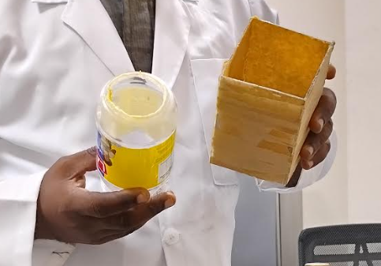
Fig.1a: Separate components of the tail of the T-maze

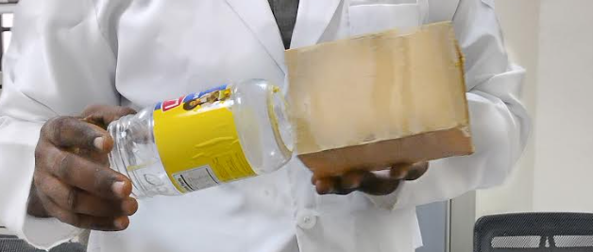
Fig. 1b: Plastic container being inserted into the tail of the T-maze
Step 2: Next a 5 x 5 cm hole was made with the aid of a burning soldering iron in the base of one (1) 7.5 cm diameter 13-cm high plastic container (fig. 1). The plastic container was then inserted inside the 4-walled base of the T-maze made in step 1 in such a way that the container was tightly enclosed with them and the height of the container’s base now with a central hole was made level with the height of the erect T-maze base. The four angles of the T-maze base left vacant due to the roundish sides of the inserted plastic container were packed tight with white silk fibres. This was done to discourage access to any stray flies during experimentation. Step 3: Next, the cross of the T-maze was constructed by joining four (4) equal 24 x 8-cm transparent plastics together with a mixture of rubber gum and superglue. Next, the 8 x 8-cm opposing ends of the resulting transparent rectangle were equally sealed plastic pieces. Step 4: A 5 x 5-cm circle was removed at the middle of the rectangular transparent box made in step 3 (Fig. 2). Next, the box was then laid horizontally on the erect base so that the middle 8 x 8-cm portion of the cross perfectly align with 8 x 8-cm top of the erect base so that the 5 x 5-cm circles in of middle of the cross and at the centre of the up-turned plastic container inserted into the T-maze’s base perfectly align together. Furthermore, the aligning underside of the cross and the base of the upturned plastic container were made to appose so tightly to obliterate any potential spaces that distract the flies in their upward ascent from T-maze’s base into the cross (Fig. 2).

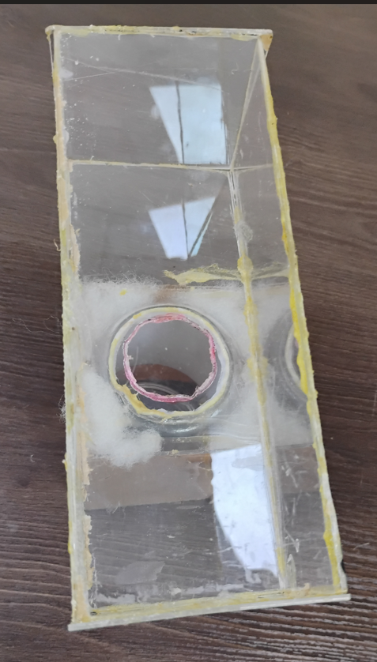
Fig. 2: Overview of the T-maze’s cross mounted
on the tail
Step 5: Finally, the whole of the base or tail and half of the cross were darkened by covering them with black cellotape to partition the cross into 2 equal dark and light portions of the T-maze (Fig. 3). It is worth noting that caution was taken not to make the T-mazes airtight along its edges when the plastics were being joined to afford the minimal oxygenation required for optimal well-being of the flies. In addition, the mouth of the inserted plastic container was intentionally made to face outwards from the tail of the T-maze. This was done so that the transfers of experimental Drosophila flies from a culture or fly stock bottle or plastic having similar mouth can be seamless (Fig. 3).

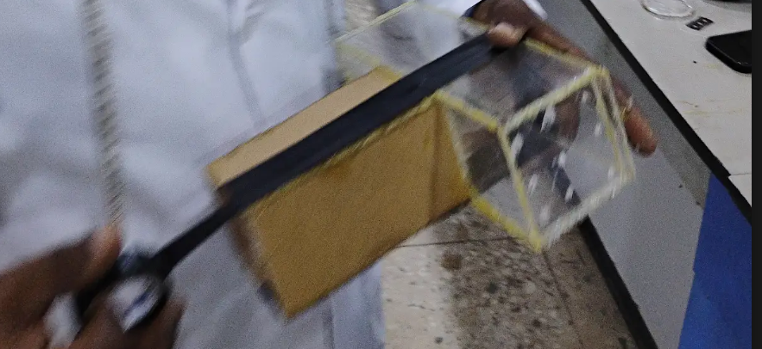
Fig. 3: One-half of the coupled T-maze being black-cello taped

Fabricating the Tunnel Light-Dark Maze
This was done simply by partitioning 100 ml measuring cylinders into 2 equal dark and light compartments by applying black cellotape to upper half of a measuring cylinder. The uppermost 1-cm circumference of each cylinder was also padded to give a near level balance with the height due to its round base when laid horizontally. Finally, a 2-mm strip of masking tape was used to make circumferential landmark at the 20-mm³ mark of the cylinder. The mouths of the Tunnel Light-Dark mazes are each covered with cotton wools when flies are in-situ (Figs. 5 a & b).
Fabricating the Open Field Light-Dark Maze
This was achieved by simply painting half of the outer part of a petri dish covering black while leaving the other half untouched. The outer part of the petri dish was painted white for good background contrast while the floor of the dish was divided into an inner and outer segments with red ink.
RESULTS
Construction of Drosophila Light-Dark T-Maze
Six (6) units of Drosophila Light-Dark T-Maze were made.
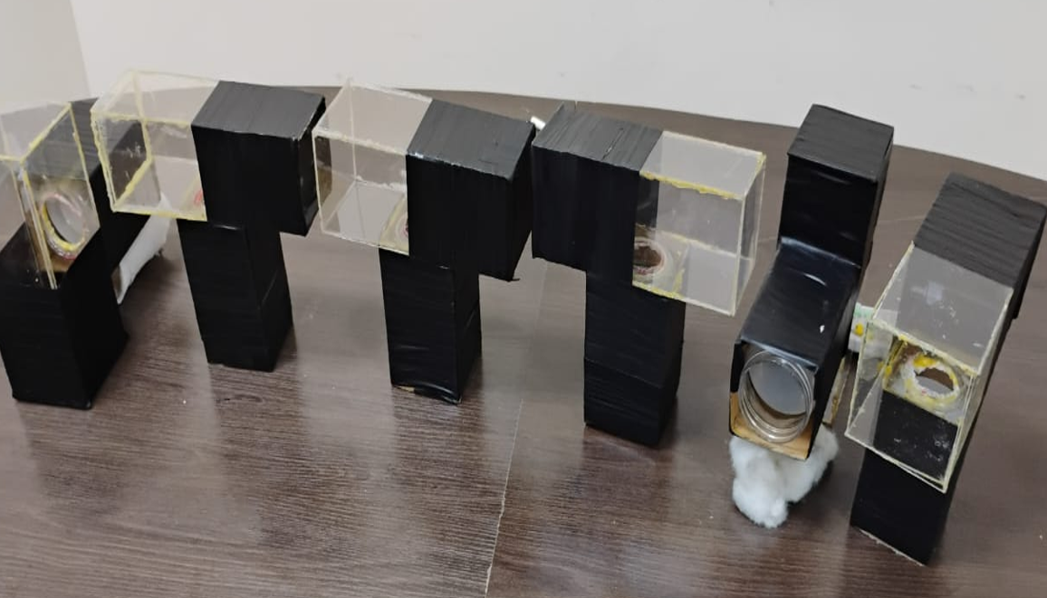
Fig.4: Completed units of dark-light T-maze

Fabricating the Tunnel Light-Dark Maze
Two (2) units of the Tunnel light-dark maze were fabricated.
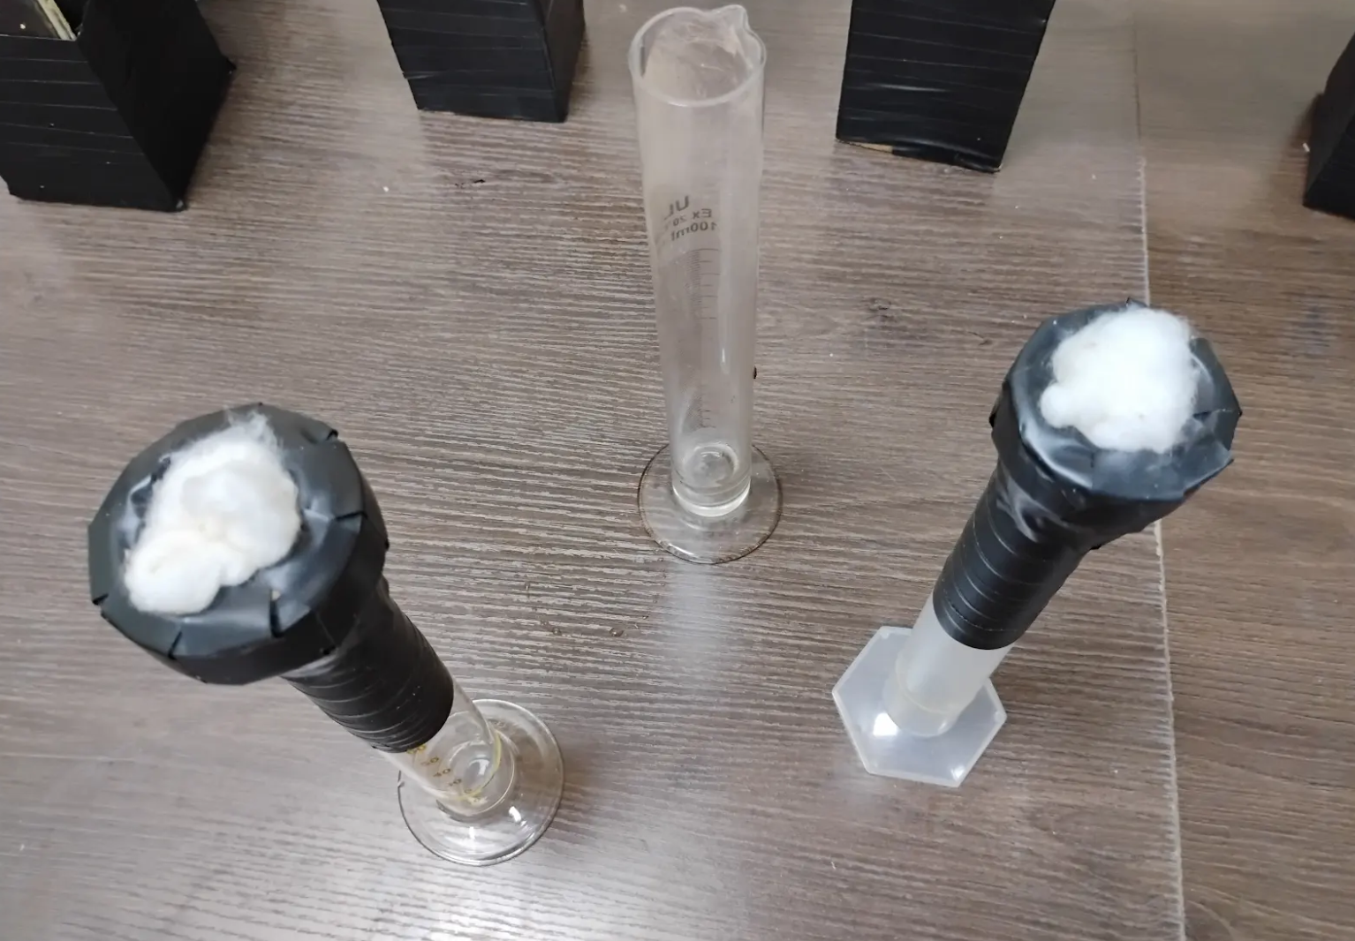
Fig. 5a: Units of the Tunnel dark-light maze standing erect

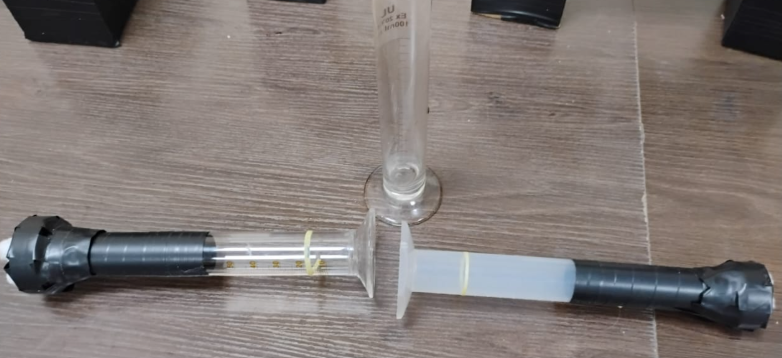
Fig. 5b: Units of the Tunnel dark-light maze laid horizontal

Fabricating the Open Field Light-Dark Maze
Over ten (10) units of the open-field light-dark maze were produced.

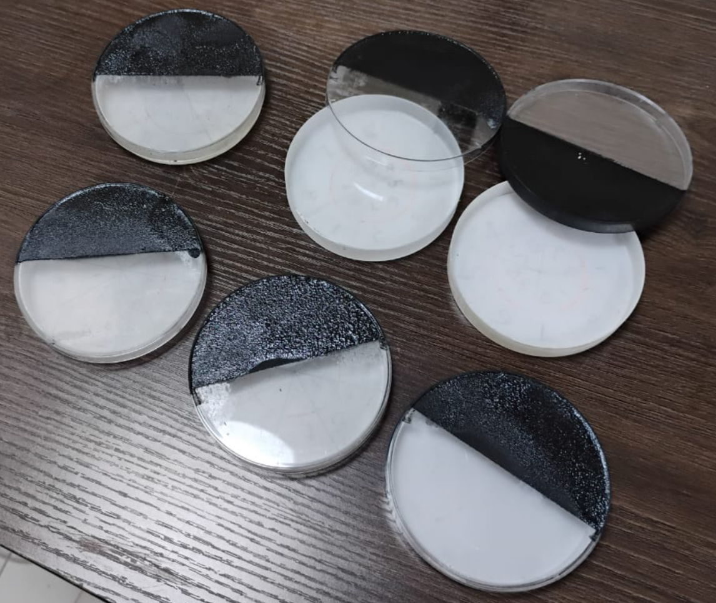
Fig. 6: Units of open-field dark-light maze

DISCUSSION
Some of the positive features of Appropriate Technology (AT) such as productivity, operational simplicity, affordability, sustainability, portability, and eco-friendliness (Lissenden et al., 2015; Zhou et al., 2017) are clearly manifest in these light-dark mazes. By productivity, pilot studies in each of these fabrications showed Drosophila flies exposed to each of these fabrications exhibited positive phototaxis; greater percentages of the flies demonstrating preferences to the light portions of each maze. This implies the mazes are all ethologically correct and sensitive to Drosophila behavioural indices. This realization is expected to translate into greater preclinical neuropsychiatric drug discovery research in the immediate and adjoining environments. The tendency for our products to positively and productively impact the local populace by the appropriate technology we have adopted is in line with the views of Hezeltine and Bull in Field Guide to Appropriate technology in their compilations of diverse technical and non-technical expositions related to appropriate technology (Hazeltine & Bull, 2003). Affordability is another strong attraction to the newly constructed light-dark mazes. With a total budget of about one hundred naira (N100,000.00k) and average cost of about five thousand naira (N5000.00) per unit of the mazes, the cost is clearly affordable. Spoilt or destroyed ones can be easily replaced by producing new ones without not necessarily incurring huge expenditures. A good product of Appropriate technology is expected by its very definition and description to be low priced with a clear intent to be made affordable by the local users or uptakers of such technology. This feature of high affordability of these products is in keeping with the strong views of Slabbert (1985) and World Health Organization (WHO) both of which assert an appropriate technology products must be scientifically sound, acceptable, readily ownable, adaptable, utilizable and maintainable by the local end users and benefactors of such products (Slabbert, 1985; “Technologies -- Appropriate and Inappropriate.,” 1995). Closely related to affordability inevitably is the important issue of sustainability in the supply of these devices. The materials for the fabrication of these items are easily sourced from the local markets; any destroyed part can be easily replaced and repaired by us and any adjustments required to adapt them to different and related uses can be made by us to meet such needs. Eco-sustainability is another asset of our newly crafted research tools. The inert nature of the raw materials used in the fabrication of these mazes shows these light-dark mazes are not likely to exert negative impact on the immediate environment – facilitating earth sustainability. This contrasts with medical machines, gadgets and diagnostics may require the use of fossil fuel and electricity that may have negative impact on the environment. Eco-friendly nature is a critical requirement for any product of appropriate technology like those presented in this study. Adoption of appropriate technology has been shown to enhance eco-sustainability in various settings at different regions of the world (Arslan & Karakuş, 2024; Régnier, 2023; Sonjaya et al., 2024; Tekpe et al., 2022).
Portability is huge asset to all three light-dark mazes. These mazes are so light and can be easily transported from one lab to another without any significant impact on the functionality of the devices. The last positive aspect of these devices is their operational simplicity: behavioural experimentation on each of these crafts can be easily learned and can be carried out even by novices following a few instructions and training. An otherwise desirable feature of our products is automation of data harvesting from them. This is ordinarily expected to enhance reliability of our findings. However, it can be argued by some schools of thoughts that the lack of this feature in our products presents an opportunity to generate employment for the locals. These schools posit appropriate technology by design must be labour-generative and socioeconomically sustaining instead of rendering the end users jobless. In this light, the making of these items have generated labour in two ways. One, labour was generated by engaging lab assistants in the fabrication process. Secondly, labour is also going to be generated when assistants are engaged to read and harvest the video-recorded behavioural data at the end of every study. This way, the socioeconomic harmony of the environment is believed achieved than a technology leads to job loss. This former position aligns well with the advocacy of Sonjaya et al. (2024) and Regnier (2012) in which human and earth sustainability must be a critical consideration whenever the design of any appropriate technology product is being contemplated (Régnier, 2023; Sonjaya et al., 2024).

CONCLUSION
Three different low-cost and eco-friendly Drosophila dark-light mazes were fabricated to enhance greater understanding of Drosophila behaviours and greater neuropsychiatric drug discovery. They are all ethologically sensitive to the Fly’s behavioural parameters. Automation will further enhance their productivity

Statement on Conflict of Interest
No conflicting interest(s) exist(s) among the authors of this study.
Authors’ contribution to the study
Authors 1, 2 & 3 designed the study and did purchase of raw materials to this study, did the fabrication and drafted the initial manuscripts. Author 4 proof-red the scripts. All authors approved the final manuscript.

REFERENCES
- M., U., & F., K. (2024). Behavioural Ethograms of Treatments-/Assays-Naïve Mice on a Novel Anxiety Multitest. International Journal of Research and Innovation in Applied Science, IX(V), 9–20. https://doi.org/10.51584/ijrias.2024.905002
- Aderinto, N., Abdulbasit, M., Olatunji, G., & Edun, M. (2023). The landscape of neuroscience research in Africa: current state, progress, and challenges; a perspective. Annals of Medicine & Surgery, 85(10). https://doi.org/10.1097/ms9.0000000000001219
- Apeagyei, A. E., Lidral-Porter, B., Patel, N., Solorio, J., Tsakalos, G., Wang, Y., Warriner, W., Wolde, A., Zhao, Y., Dieleman, J. L., & Nonvignon, J. (2024). Financing health in sub-Saharan Africa 1990–2050: Donor dependence and expected domestic health spending. PLOS Global Public Health, 4(8). https://doi.org/10.1371/journal.pgph.0003433
- Arslan, K., & Karakuş, N. (2024). Environmental Teaching Supported by Web 2.0-Based Digital Games for a Sustainable Life. Sustainability (Switzerland), 16(22). https://doi.org/10.3390/su16229691
- Bigna, J. J., & Noubiap, J. J. (2019). The rising burden of non-communicable diseases in sub-Saharan Africa. In The Lancet Global Health (Vol. 7, Number 10). https://doi.org/10.1016/S2214-109X(19)30370-5
- Blokland, A., ten Oever, S., van Gorp, D., van Draanen, M., Schmidt, T., Nguyen, E., Krugliak, A., Napoletano, A., Keuter, S., & Klinkenberg, I. (2012). The use of a test battery assessing affective behavior in rats: Order effects. Behavioural Brain Research, 228(1). https://doi.org/10.1016/j.bbr.2011.11.042
- Chinn, G. A., Pearn, M. L., Vutskits, L., Mintz, C. D., Loepke, A. W., Lee, J. J., Chen, J., Bosnjak, Z. J., Brambrink, A. M., Jevtovic-Todorovic, V., Sun, L. S., & Sall, J. W. (2020). Standards for preclinical research and publications in developmental anaesthetic neurotoxicity: expert opinion statement from the SmartTots preclinical working group. In British Journal of Anaesthesia (Vol. 124, Number 5). https://doi.org/10.1016/j.bja.2020.01.011
- Dougherty, J. P., Springer, D. A., & Gershengorn, M. C. (2016). The treadmill fatigue test: A simple, high-throughput assay of fatigue-like behavior for the mouse. Journal of Visualized Experiments, 2016(111). https://doi.org/10.3791/54052
- Garcia-Gomes, M. S. A., Zanatto, D. A., Yamamoto, P. K., Wadt, D., Antiorio, A. T. F. B., Aleman-Laporte, J., Alexandre-Ribeiro, S. R., Marson, G. A., Guizzo, C., Massironi, S. M. G., Bernardi, M. M., & Mori, C. M. C. (2020). A Simple and Fast Battery Test for Phenotypic Characterization of Mice. Bio-Protocol, 10(7). https://doi.org/10.21769/BioProtoc.3568
- Hazeltine, B., & Bull, C. (2003). Field Guide to Appropriate Technology. In Field Guide to Appropriate Technology. https://doi.org/10.1016/B978-0-12-335185-2.X5042-6
- Janus, A., Lustyk, K., & Pytka, K. (2023). MK-801 and cognitive functions: Investigating the behavioral effects of a non-competitive NMDA receptor antagonist. In Psychopharmacology (Vol. 240, Number 12). https://doi.org/10.1007/s00213-023-06454-z
- Lewin, K. M. (2020). Beyond business as usual: Aid and financing education in Sub Saharan Africa. International Journal of Educational Development, 78. https://doi.org/10.1016/j.ijedudev.2020.102247
- Lissenden, J., Maley, S., & Mehta, K. (2015). An Era of Appropriate Technology: Evolutions, Oversights and Opportunities. Journal of Humanitarian Engineering, 3(1). https://doi.org/10.36479/jhe.v3i1.34
- Magaji, M. G., Anuka, J. A., Abdu-Aguye, I., Yaro, A. H., & Hussaini, I. M. (2008). Behavioural effects of the methanolic root bark extract af Securinega virosa in rodents. African Journal of Traditional, Complementary and Alternative Medicines, 5(2). https://doi.org/10.4314/ajtcam.v5i2.31266
- Magaji, M. G., Musa, A. M., Abdullahi, M. I., Ya ’u, J., & Hussaini, I. M. (2015). Isolation of bergenin from the root bark of Securinega virosa and evaluation of its potential sleep promoting effect. Ajp, 5(6).
- Marume, A., Takudzwa, ;, Falanela, B., & Dhawale, C. (2024). The Readiness of Sub-Saharan Africa to Adapt Technology in Public Health Surveillance. African Journal of Computing & ICT Reference Format Amos Marume, 17(1).
- Mbiydzenyuy, N. E., Pieme, C. A., Brown, R. E., & Nguemeni, C. (2021). Neuroscience education and research in Cameroon: Current status and future direction. In IBRO Neuroscience Reports (Vol. 10). https://doi.org/10.1016/j.ibneur.2021.02.006
- Neuhaus, A. A., Rabie, T., Sutherland, B. A., Papadakis, M., Hadley, G., Cai, R., & Buchan, A. M. (2014). Importance of preclinical research in the development of neuroprotective strategies for ischemic stroke. In JAMA Neurology (Vol. 71, Number 5). https://doi.org/10.1001/jamaneurol.2013.6299
- Nulu, S. (2017). Neglected chronic disease: The WHO framework on non-communicable diseases and implications for the global poor. Global Public Health, 12(4). https://doi.org/10.1080/17441692.2016.1154584
- Patnaik, J., & Bhowmick, B. (2018). Appropriate Technology : Revisiting the Movement in Developing Countries for Sustainability. International Scholarly and Scientific Research & Innovation, 12(3).
- Régnier, P. (2023). Innovation, Appropriate Technologies and Entrepreneurship for Global Sustainability Development: A Review Until the Early Twenty-first Century. Journal of Entrepreneurship, 32(2_suppl). https://doi.org/10.1177/09713557231201115
- Shemesh, Y., & Chen, A. (2023). A paradigm shift in translational psychiatry through rodent neuroethology. In Molecular Psychiatry (Vol. 28, Number 3). https://doi.org/10.1038/s41380-022-01913-z
- Slabbert, T. J. C. (1985). Development and inappropriate or appropriate technology. Development Southern Africa, 2(1). https://doi.org/10.1080/03768358508439126
- Sonjaya, Y., Noch, M. Y., & Sutisna, E. (2024). The Role of Appropriate Technology in Sustainable Development Design. Advances in Community Services Research, 2(1). https://doi.org/10.60079/acsr.v2i1.341
- Technologies -- appropriate and inappropriate. (1995). Safe Motherhood, (18).
- Tekpe, E., Ansah, S. K., & Akomah, B. B. (2022). Appropriate Technology and Design: A Solution for Sustainable and Affordable Housing Delivery in Major Cities of Ghana. Journal of Engineering Research and Reports. https://doi.org/10.9734/jerr/2022/v23i8739
- Umarudeen, A. M., & Magaji, M. G. (2020). Appraising the Neurobehavioural Toxicity Potential of Aqueous Methanol Leaf Extract of Tapinanthus globiferus Growing on Azadirachta indica. International Neuropsychiatric Disease Journal. https://doi.org/10.9734/indj/2020/v14i230123
- Umarudeen, A. M., Magaji, M. G., Bello, O. S., Aminu, C., & Abdullahi, M. I. (2020). Pharmacological Investigation of Serial Anxiety Tests in the Mouse: A Pilot Study. Journal of Advances in Medical and Pharmaceutical Sciences. https://doi.org/10.9734/jamps/2020/v22i430166
- World Bank Group. (2023). The Global Burden of Disease: Main Findings for Sub-Saharan Africa. The World Bank Group.
- You, R., Liu, Y., & Chang, R. C.-C. (2019). A Behavioral Test Battery for the Repeated Assessment of Motor Skills, Mood, and Cognition in Mice. Journal of Visualized Experiments, (145). https://doi.org/10.3791/58973-v
- Zhou, J., Jiao, H., & Li, J. (2017). Providing appropriate technology for emerging markets: Case study on China’s solar thermal industry. Sustainability (Switzerland), 9(2). https://doi.org/10.3390/su9020178

