ABSTRACT

Language plays an important role in students' participation, learning, and sense of belonging in higher education. However, the dominance of English in academic settings may create challenges for students who prefer to express their ideas in Filipino. This study examined the relationship between epistemic injustice in Filipino language use and social inclusion among College of Education students at Bataan Peninsula State University (BPSU)–Balanga Campus. Specifically, it determined the extent of epistemic injustice, the level of social inclusion, the relationship between these variables, and the extent to which the dimensions of epistemic injustice predict social inclusion.

INTRODUCTION
Language is not only a tool for communication but also a tool of power and knowledge (Foucault, 1980). In the Philippines, this is reflected in educational policies where both English and Filipino are recognized as official languages for communication and instruction (Republic of the Philippines, 1987). However, language in education is not neutral; it shapes which forms of knowledge are considered legitimate and whose voices are recognized within academic spaces. In higher education, English is often associated with academic competence, credibility, and professional success, while Filipino and other local languages are frequently positioned as less appropriate for intellectual discourse. These language practices can influence students’ opportunities for participation, recognition, and inclusion in academic environments.
Miranda Fricker (2007) explains this issue through the concept of epistemic injustice, which occurs when individuals are treated unfairly in their capacity as knowers. Fricker identifies testimonial injustice, where a speaker’s credibility is unfairly reduced because of prejudice, and hermeneutical injustice, where individuals experience difficulty expressing or understanding their experiences due to gaps in language or interpretive resources. In educational settings where English is dominant, students who are more comfortable expressing themselves in Filipino may experience reduced credibility or difficulty communicating complex academic ideas. Studies in Philippine higher education show that English continues to dominate classroom instruction and academic discourse despite the widespread use of Filipino among students and faculty (Parba et al., 2024). Bernardo (2004) and Tupas (2015) further explain that English proficiency is often associated with higher educational status and academic achievement, which may marginalize Filipino language users in academic settings.
These conditions often affect students’ participation, confidence, and sense of belonging within the university environment. According to Alaga (2016), students who are less confident using English may become hesitant to participate in academic discussions, particularly in settings where English is strongly prioritized.These issues become more evident in multilingual regions such as Bataan, where several local languages coexist alongside Filipino and English. Existing Philippine studies primarily focus on language proficiency, bilingual education, code-switching, and language policy implementation. However, there remains a lack of quantitative investigations examining how epistemic injustice experienced by Filipino language users influences social inclusion outcomes among college students.
In response, this study examines the relationship between epistemic injustice in expressing knowledge in Filipino and social inclusion among college students at BPSU–Balanga Campus. Specifically, it investigates whether students experience unequal recognition when using Filipino in academic settings and how these experiences can influence their participation, sense of belonging, and inclusion within the university environment.
Theoretical Framework

This study is anchored on key theories that explain how language use influences students’ social participation in academic settings. Specifically, it draws on Miranda Fricker’s Theory of Epistemic Injustice, Social Inclusion Theory, and Lev Vygotsky’s Sociocultural Theory to provide a comprehensive understanding of the relationship between Filipino language use, epistemic injustice, and social inclusion among students at BPSU–Balanga Campus.

These theories are relevant because they collectively explain how language can affect students’ credibility as knowers, their opportunities for participation, and their sense of belonging within the academic community. Epistemic Injustice Theory explains how prejudice often affects how students’ ideas are received and valued. Social Inclusion Theory emphasizes the importance of equal participation and recognition in institutional settings. Meanwhile, Sociocultural Theory highlights the role of language and social interaction in learning and knowledge construction.

Together, these theories provide a strong foundation for examining how Filipino language use may shape students’ academic and social experiences, particularly in relation to inclusion within the university environment.

Relevant Theories

Epistemic Injustice

The foundation of this research is Miranda Fricker's (2007) Theory of Epistemic Injustice, which is discussed in Epistemic Injustice: Power and the Ethics of Knowing. She explains that people may experience injustice when prejudice affects how their knowledge, experiences, or perspectives are recognized by others. Fricker identifies two forms of epistemic injustice:

Testimonial injustice occurs when a speaker’s credibility is unfairly reduced due to prejudice. In this study, students who primarily use Filipino may experience reduced credibility when their ideas are undervalued compared to those expressed in English. This can influence their participation, confidence, and sense of inclusion in academic discussions.

Hermeneutical injustice happens when people lack the language and concepts needed to understand and explain their experiences. In academic settings where English is dominant, students who use Filipino may experience difficulty expressing complex ideas, which may limit participation and contribute to feelings of exclusion.

Social Inclusion Theory

This study is also supported by Social Inclusion Theory, which emphasizes equal participation, recognition, and respect for all individuals in society and institutions. According to the World Bank (2013), social inclusion involves improving access to opportunities, resources, participation, and respect for rights, particularly among marginalized groups. The Council of the European Union (2000) also highlights that inclusion promotes equal opportunities for participation and values diversity.

In educational contexts, social inclusion is achieved when students are given equal opportunities to participate and express themselves regardless of language background. Language practices in the classroom may therefore influence students’ sense of belonging, participation, and inclusion.

On the other hand, language is closely linked to identity, participation, and inclusion in educational settings. Norton (2013) explains that language use is connected to power relations and identity formation. When students perceive their language as undervalued, they may experience reduced participation and exclusion from academic activities.

In multilingual learning environments, allowing the use of students’ native language may enhance understanding, confidence, and engagement. However, when a dominant language is imposed, students who are less proficient may experience barriers to participation and inclusion.

Sociocultural Theory
Sociocultural Theory, developed by Lev Vygotsky (1978), emphasizes that learning is a socially mediated process shaped by language, culture, and interaction. Language functions as a primary tool for thinking, communication, and knowledge construction. Wertsch (1985) further explains that meaningful learning develops through social interaction within a learner’s cultural and linguistic context.
In this study, language use is understood as a key factor in shaping students’ participation in academic discourse and their engagement within the learning environment. The use of Filipino, which is closely connected to students’ cultural and linguistic background, may facilitate clearer expression of ideas and encourage participation in classroom interactions. However, when certain languages are privileged over others in educational environments, students may experience unequal opportunities to have their ideas heard, recognized, and valued. This reflects how language not only supports learning but also mediates inclusion and participation in educational spaces.
Review of Related Literature

Knowledge, Power, and Language in Education
Language is closely connected to power because it influences which forms of knowledge are recognized, valued, and legitimized within educational institutions and society. Foucault (1980) explains that power operates through discourse, shaping what is accepted as truth and determining whose voices are heard or ignored. According to Wandel’s (2001) discussion of Foucault’s theory, discourse functions as a system that produces and regulates knowledge, meaning that language is not neutral but embedded within structures of power and social control. In educational settings, this creates language hierarchies where dominant and global languages, particularly English, are associated with intelligence, authority, and academic competence, while regional and indigenous languages are often placed in lower positions. The University of Groningen (“Common Language Hierarchy,” n.d.) explains that language hierarchies operate at educational, economic, and policy levels, influencing which languages are formally taught, institutionally supported, and considered legitimate in academic spaces. Similarly, Jorolan-Quintero (2018) emphasizes that local and indigenous languages play an important role in learning, cultural preservation, and educational participation, particularly within Mother Tongue-Based Multilingual Education (MTB-MLE). The study argues that learners understand and express ideas more effectively when their first language is utilized in instruction and highlights how some Philippine languages, such as Bisaya, have historically been treated as inferior despite being widely spoken. These conditions suggest that language practices in education affect not only learning outcomes but also students’ participation, recognition, and sense of inclusion. In the Philippine context, the continued dominance of English in higher education may reinforce the perception that Filipino and other local languages are less appropriate for academic discourse, potentially contributing to experiences of epistemic injustice and reduced social inclusion among students who are more comfortable expressing knowledge in Filipino.

English Dominance in Educational Settings
Brook and Karathanos (2009) highlighted the value of students' native languages and cultures as learning and academic resources. They explained that many educational institutions function in English-dominated settings where students are expected to adjust to the language of instruction rather than letting their linguistic backgrounds play a role in their education. The authors claim that students who are unable to fully express themselves in the dominant language may find it challenging to engage in class discussions and develop significant academic understanding.
The reviewed literature shows that language plays an important role in shaping students’ academic participation, credibility, identity, and social inclusion. Studies on epistemic injustice explain how students may experience unequal treatment and reduced credibility because of language-related prejudice. Research on multilingual education further shows that allowing students to use their native language improves participation, comprehension, and confidence. Moreover, studies on social inclusion emphasize the importance of equal participation and recognition within educational institutions. Students who feel excluded because of language barriers may experience lower confidence, reduced participation, and a weaker sense of belonging. Overall, the reviewed literature supports the present study by showing that Filipino language use can influence students’ experiences of epistemic injustice and social inclusion at BPSU–Balanga Campus.
Epistemic Injustice in Education Settings
Epistemic injustice refers to the unfair treatment of individuals in their capacity as knowers due to prejudice and unequal social power. Fricker (2007) explains that people may experience this form of injustice when their ideas, experiences, or contributions are disregarded because of factors such as language, gender, ethnicity, or social standing. In educational environments, epistemic injustice may occur when students are not equally recognized, respected, or trusted during classroom discussions and other academic interactions. Dotson (2011) further argues that academic institutions often silence marginalized groups by excluding them as legitimate knowers and contributors of knowledge, resulting in what she describes as “epistemic oppression.” This suggests that language-based prejudice often affect students’ participation, confidence, and ability to engage in academic discourse. Medina (2013) also emphasizes that epistemic injustice becomes systemic when institutions continuously privilege dominant ways of knowing while marginalizing others. In educational settings where English is treated as the primary academic language, students who are more comfortable expressing themselves in Filipino may experience reduced credibility or difficulty communicating their ideas effectively. These conditions may limit students’ participation and sense of inclusion within academic spaces. Therefore, these perspectives are relevant to the present study because they help explain how Filipino language users may experience unequal recognition, reduced credibility, and barriers to participation in higher education environments where English is often dominant.
Filipino Use in Higher Education
Filipino plays an important role in the Philippine educational system as one of the country’s official languages and as a recognized medium of instruction. The 1987 Philippine Constitution identifies both Filipino and English as official languages for communication and education in the country (Republic of the Philippines, 1987). Despite this recognition, English continues to dominate higher education institutions, particularly in academic instruction, research, and professional communication. Bernardo (2004) explains that English is often associated with academic excellence, intelligence, and socioeconomic mobility, leading many universities to prioritize English-medium instruction. As a result, students may perceive English as more appropriate for formal academic discourse, while Filipino is often limited to informal communication and everyday interaction.
The dominance of English in universities is also influenced by globalization and the internationalization of education. Brown (2014) argues that English functions as the global academic language because of its strong presence in international research, publishing, and higher education systems. Consequently, universities frequently emphasize English proficiency to remain globally competitive. In the Philippine context, this preference for English may reinforce the perception that Filipino is less credible or less suitable for intellectual and scholarly discussions. Tupas (2015) further notes that language practices in Philippine education often reflect social inequalities, where English proficiency becomes associated with higher status and educational advantage.
These conditions can influence students’ language preferences and participation in academic environments. Many students prefer using English in classroom discussions and academic writing because it is viewed as more professional and academically acceptable. However, students who are more comfortable expressing themselves in Filipino may experience difficulty communicating complex ideas in English, which can affect their confidence and classroom participation. According to Fricker’s (2007) concept of epistemic injustice, students may experience reduced credibility or unequal recognition when their preferred language is undervalued in academic settings. In this way, the continued dominance of English in higher education may create barriers for Filipino language users in expressing knowledge and participating fully in academic discourse.
Language Anxiety in Academic Discussions
Chen and Du (2025) discovered that students' confidence, involvement in class, and communication are all adversely affected by language learning anxiety. According to their research, students who struggle with language use may steer clear of social interaction and involvement in classroom environments. This validates the current study because when Filipino-speaking students' language use is undervalued in educational environments, they may also feel hesitant, less credible, or excluded.
Language and Social Inclusion
Language is closely connected to identity, participation, and social inclusion within educational settings. Norton (2013) explains that language use and learning are shaped by identity and power relations, suggesting that students who perceive their language as undervalued may experience exclusion and reduced participation in academic environments. Similarly, García and Wei (2014) argue that multilingual learners participate more effectively when they are allowed to use their full linguistic abilities in the classroom, as the use of multiple languages supports comprehension, communication, and identity expression. Wei (2018) further explains that translanguaging practices help students express ideas more confidently and engage more actively in classroom interaction. These perspectives suggest that language practices influence students’ sense of belonging and inclusion in educational institutions. Social inclusion, according to the World Bank (2013), refers to improving individuals’ opportunities, participation, and access to resources regardless of social or linguistic background. UNESCO (2017) also emphasizes that inclusive education ensures equal participation for all learners regardless of language, culture, or identity. Ainscow (2020) explains that students are more engaged in learning when they feel accepted, valued, and respected within the classroom environment. However, language barriers may limit participation and contribute to exclusion, particularly in educational settings where dominant languages are prioritized.
Supporting these ideas, Vygotsky’s Sociocultural Theory highlights that language plays a central role in learning, communication, and knowledge construction through social interaction (Vygotsky, 1978). Wertsch (1985) further explains that learning becomes more meaningful when students interact using culturally and linguistically familiar languages. MacSwan (2017) also argues that multilingual classroom practices enhance students’ cognitive development, participation, and engagement. In the Philippine context, UNESCO Philippines (2019) reports that language differences continue to create barriers to participation in higher education institutions, especially in classrooms where English is strongly emphasized. These studies suggest that the use of Filipino in university contexts can influence students’ participation, confidence, and sense of inclusion within higher education institutions.
Synthesis
The reviewed literature consistently shows that language plays a significant role in shaping students’ participation, credibility, identity, and social inclusion within educational settings. Studies on language and power emphasize that dominant languages, particularly English, are often associated with academic legitimacy, authority, and intellectual competence, while local and indigenous languages may be marginalized in formal academic discourse (Foucault, 1980; Wandel, 2001; Brown, 2014). Similarly, literature on epistemic injustice explains how students may experience unequal recognition, reduced credibility, and barriers to participation when their preferred language or way of expressing knowledge is undervalued (Fricker, 2007; Dotson, 2011; Medina, 2013). Research on multilingual education and sociocultural learning also suggests that allowing students to use familiar languages supports comprehension, confidence, participation, and inclusion within classroom environments (García & Wei, 2014; Vygotsky, 1978; Wertsch, 1985).
Although existing studies generally agree that language influences students’ academic experiences and opportunities for participation, most previous research has focused on language proficiency, multilingual education, English dominance, and language policy implementation. Limited studies have quantitatively examined how Filipino language use relates specifically to epistemic injustice and social inclusion in higher education contexts. Moreover, there is a lack of localized research examining how students in Philippine universities experience credibility, recognition, and participation when expressing knowledge in Filipino, particularly in institutions such as Bataan Peninsula State University (BPSU)–Balanga Campus. Therefore, the present study addresses this gap by examining the relationship between epistemic injustice in Filipino language use and social inclusion among college students, with emphasis on students’ participation, sense of belonging, and experiences of recognition within academic spaces.
Review of Related Studies

Foreign Studies
Macaro (2018) conducted a study on English-medium instruction in multilingual classrooms involving students from different linguistic backgrounds. Using classroom observations and student interviews, the study found that learners demonstrated better comprehension and classroom engagement when they were allowed to use their first language alongside English. The findings suggested that strict English-only policies may reduce participation among students who are less proficient in English. This study is relevant to the present research because it shows how language policies may influence students’ classroom participation and confidence.
Hall and Cook (2012) investigated first-language use in language teaching through a review of classroom practices in multilingual educational settings. Their findings revealed that the use of students’ native language helped clarify difficult concepts, reduced anxiety, and encouraged active classroom interaction. The study supports the idea that familiar language use may improve students’ participation and learning experiences.
Norton (2013) examined the relationship between language, identity, and classroom participation among language learners. The study found that students were more willing to participate when their language and identity were recognized and respected within the learning environment. Students who perceived their language as undervalued tended to withdraw from classroom interaction. These findings are relevant to the present study because they demonstrate how language practices may affect students’ sense of inclusion and participation.
Wei (2018) explored translanguaging practices in multilingual classrooms and found that flexible language use improved students’ confidence, comprehension, and engagement in academic discussions. The study emphasized that multilingual students benefit socially and academically when they are allowed to use multiple languages during classroom communication.
Ainscow (2020) conducted research on inclusive education and classroom participation. The study showed that students participate more effectively in learning environments where they feel accepted, respected, and valued. The findings further indicated that language barriers may negatively affect students’ sense of belonging and inclusion within the classroom.
Wee et al. (2023) examined the experiences of epistemic injustice among minority language students aged 6–16 in Nordic educational settings and found that negative teacher perceptions and stereotypes contributed to unfair treatment, weakened student–teacher relationships, and experiences of epistemic injustice among learners from minority language backgrounds. The study revealed that some students responded through self-silencing, which negatively affected their participation, learning, psychological well-being, and identity development. These findings are relevant to the present study because they demonstrate how language-related prejudice and unequal recognition in educational environments can influence students’ participation and sense of inclusion. Similarly, the present study investigates epistemic injustice related to the use of the Filipino language and its relationship to social inclusion among college students at BPSU–Balanga Campus.
Local Studies
Bernardo (2018) conducted a study on language and learning in Philippine higher education institutions. Using student interviews and classroom observations, the research found that many Filipino university students experienced difficulty expressing complex academic ideas in English. As a result, some students became hesitant to participate in discussions despite understanding the lesson content. The study highlights how language proficiency may affect classroom participation and confidence.
Tupas (2015) examined the role of language in Philippine education and argued that the dominance of English in academic institutions contributes to educational inequality. The study revealed that students who were more comfortable using Filipino often experienced reduced confidence and participation in English-dominated classrooms. These findings are relevant to the present study because they show how language preference may influence students’ academic experiences.
Borlongan (2011) studied code-switching practices among Filipino students in classroom settings. The findings showed that students frequently shifted between Filipino and English to communicate ideas more effectively. The study suggested that flexible language practices may enhance classroom communication and student participation.
UNESCO Philippines (2019) reported that language barriers remain one of the challenges to inclusive education in Philippine higher education institutions. The report emphasized that students from diverse linguistic backgrounds may experience unequal participation in classrooms where English is strongly prioritized. This supports the present study’s focus on language use and social inclusion.
The Commission on Higher Education (CHED, 2013) highlighted the importance of bilingual competence in higher education through policy recommendations and educational reports. The findings suggested that the use of both Filipino and English may improve accessibility, participation, and learning outcomes among students in Philippine educational institutions.
A related study by Gaite (2025) on Indigenous Filipino students in higher education revealed that students experienced subtle discrimination, cultural marginalization, and institutional barriers that affected their academic participation and sense of inclusion. The study emphasized the importance of culturally responsive educational practices and inclusive institutional support systems. These findings are relevant to the present study because they demonstrate how educational environments may contribute to exclusion and unequal participation among students, particularly when cultural and linguistic identities are not fully recognized or valued.
While the previous study focused on Indigenous identity and educational barriers, the present study specifically examines epistemic injustice related to the use of the Filipino language and its relationship to social inclusion among college students.
The reviewed studies consistently show that language use influences students’ participation, confidence, comprehension, and sense of inclusion in academic settings. Foreign and local studies indicate that the use of familiar languages promotes meaningful classroom interaction. The studies also suggest that English dominance in educational institutions may create barriers for students who are more comfortable using Filipino. Overall, these findings support the present study by demonstrating that Filipino language use may shape students’ experiences of epistemic injustice and social inclusion at BPSU–Balanga Campus.
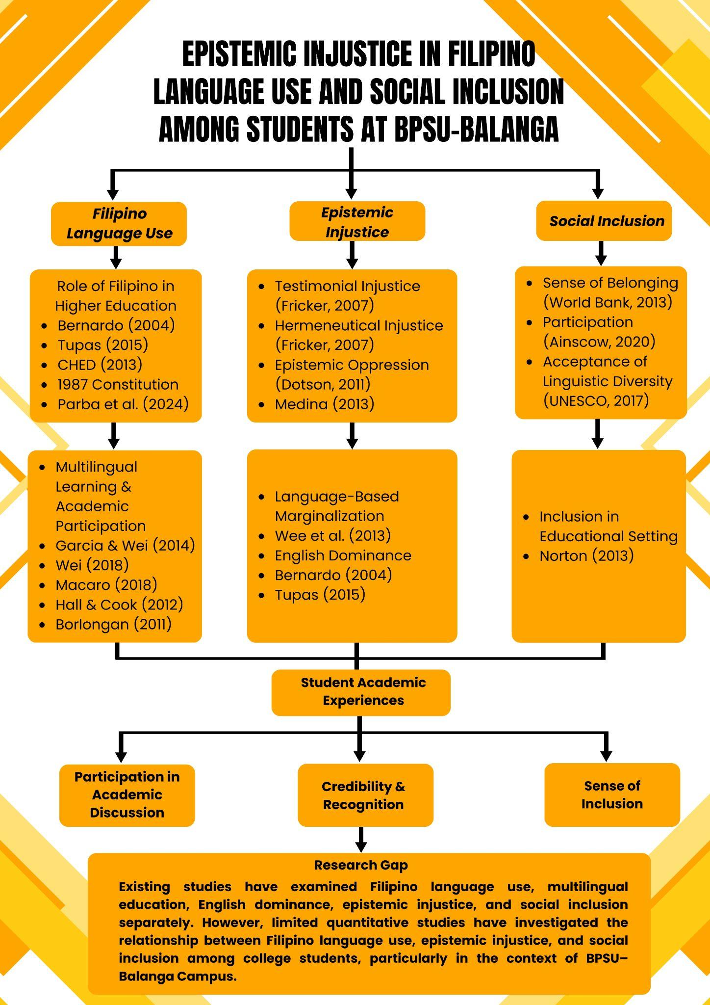
Conceptual Framework
This study is anchored on a conceptual framework that examines the relationship between epistemic injustice in Filipino language use and social inclusion among students at BPSU–Balanga Campus. The framework is derived from Fricker's Theory of Epistemic Injustice, Social Inclusion Theory, and Vygotsky's Sociocultural Theory, which collectively explain how language-related experiences may influence students' participation and inclusion within academic environments.
In this study, epistemic injustice in Filipino language use serves as the independent variable and is measured through perceived credibility (testimonial injustice), difficulty in expressing academic knowledge (hermeneutical injustice), and opportunities to use Filipino in academic discourse (linguistic marginalization). Social inclusion serves as the dependent variable and is measured through a sense of belonging, participation, and acceptance of linguistic diversity.
The framework assumes that students who experience higher levels of epistemic injustice when expressing knowledge in Filipino may also experience lower levels of social inclusion within the university environment. Thus, the study examines whether epistemic injustice significantly influences students' participation, sense of belonging, and acceptance within the academic community.
Variables

VARIABLE TYPE | VARIABLE
Independent Variable | Epistemic Injustice in Filipino Language Use
Dependent Variable | Social Inclusion

Conceptual Flow

This study follows a linear conceptual relationship that illustrates how Filipino language use can influence students’ experiences within the university.

CONCEPTUAL FLOW DIAGRAM
Epistemic Injustice in Filipino Language Use
Linguistic Marginalization
Epistemic Injustice (Testimonial & Hermeneutical)
⬇️
Social Inclusion
(Sense of Belonging in the Academic Community, Participation in Classroom and Campus Activities, and Acceptance of Linguistic Diversity)

The framework suggests that students' experiences of epistemic injustice related to Filipino language use may influence their level of social inclusion within the university environment. When students perceive that their ideas are given less credibility, encounter difficulties expressing academic knowledge, or experience limited opportunities to use Filipino in academic settings, they may feel less included in the academic community. These experiences may affect their sense of belonging, participation in academic activities, and acceptance within a linguistically diverse learning environment.

Paradigm of the Study (IPO MODEL)
INPUT | PROCESS | OUTPUT
- Students’ use of Filipino language in academic and social contexts  - Experiences of epistemic injustice:  - Testimonial injustice (credibility bias based on language use)  - Hermeneutical injustice (difficulty expressing academic concepts in Filipino)  - Linguistic marginalization (limited opportunities to use Filipino in academic settings)  - Sociocultural and academic environment of BPSU–Balanga Campus  - Student profile (year level, program, demographic variables) | - Distribution and retrieval of questionnaires  - Data coding and tabulation  - Weighted Mean  - Pearson Product-Moment Correlation  - Multiple Linear Regression Analysis  - Interpretation of results | - Level of epistemic injustice experienced by students  - Level of social inclusion among students  - Relationship between:  - Epistemic injustice in Filipino language use  - Social inclusion  - Identified patterns of linguistic inequality in academic settings  - Evidence-based recommendations for:  - Inclusive language practices at BPSU–Balanga Campus  - Improved academic support for Filipino language use

Statement of the Problem
This study aims to examine the relationship between epistemic injustice in expressing knowledge in the Filipino language and social inclusion among College of Education students at Bataan Peninsula State University (BPSU) – Balanga Campus.
Specifically, it seeks to answer the following questions:
- What is the extent of epistemic injustice experienced by College of Education students in expressing knowledge in Filipino in terms of:
  - 1.1 Perceived credibility (testimonial injustice);
  - 1.2 Difficulty in expressing academic knowledge (hermeneutical injustice); and
  - 1.3 Opportunities to use Filipino in academic discourse (linguistic marginalization)?
- What is the level of social inclusion among College of Education students in terms of:
  - 2.1 Sense of belonging in the academic community;
  - 2.2 Participation in classroom and campus activities; and
  - 2.3 Acceptance of linguistic diversity among peers and instructors?
- Is there a statistically significant relationship between epistemic injustice in Filipino language use and social inclusion among College of Education students?
- To what extent do the dimensions of epistemic injustice in Filipino language use (perceived credibility, difficulty in expressing academic knowledge, and opportunities to use Filipino in academic discourse) predict social inclusion among College of Education students?
Hypothesis of the Study
Null Hypothesis (H₀₁)
There is no statistically significant relationship between epistemic injustice in Filipino language use and social inclusion among College of Education students at BPSU–Balanga Campus.
Alternative Hypothesis (H₁₁)
There is a statistically significant relationship between epistemic injustice in Filipino language use and social inclusion among College of Education students at BPSU–Balanga Campus.
Null Hypothesis (H₀₂)
None of the dimensions of epistemic injustice significantly predict social inclusion among College of Education students.
Alternative Hypothesis (H₁₂)
At least one dimension of epistemic injustice significantly predicts social inclusion among College of Education students.
Objectives of the Study
The primary objective of this study is to examine the relationship between epistemic injustice in Filipino language use and social inclusion among College of Education students at Bataan Peninsula State University (BPSU) – Balanga Campus.
Specifically, this study aims:
- To determine the extent of epistemic injustice related to Filipino language use among College of Education students in terms of:
  - perceived credibility;
  - difficulty in expressing academic knowledge; and
  - opportunities to use Filipino in academic discourse.
- To determine the level of social inclusion among College of Education students in terms of:
  - sense of belonging in the academic community;
  - participation in classroom and campus activities; and
  - acceptance of linguistic diversity among peers and instructors.
- To investigate the relationship between epistemic injustice in Filipino language use and social inclusion among College of Education students.
- To identify which dimension of epistemic injustice best predicts social inclusion among College of Education students.
Significance of the Study
This study examines the relationship between epistemic injustice in Filipino language use and social inclusion among college students at BPSU–Balanga Campus. The findings of this study may contribute to a better understanding of how language-related experiences influence students' participation, recognition, and sense of belonging in higher education.
Students. The findings may help students become more aware of the challenges associated with language-based prejudice and unequal recognition in academic settings. The study may also encourage greater appreciation of linguistic diversity and promote more inclusive interactions among peers.
Faculty Members. The results may provide instructors with insights into how language practices influence students' participation and engagement. This may help faculty members develop more inclusive classroom strategies that recognize and value students' linguistic backgrounds.
University Administrators. The study may serve as a basis for strengthening institutional policies and programs that promote linguistic inclusion, equal participation, and supportive learning environments for all students.
Curriculum Developers and Educational Leaders. The findings may contribute to discussions regarding language use in higher education and support the development of educational practices that encourage equitable participation regardless of language preference.
Policy Makers. The results may provide evidence that can inform language-related policies and initiatives aimed at fostering inclusive educational environments and recognizing the value of Filipino in academic discourse.
Future Researchers. The study may serve as a reference for future investigations related to language, epistemic injustice, social inclusion, multilingual education, and higher education research in the Philippine context.
Researcher. The study will enhance the researcher's understanding of language, knowledge, and inclusion in educational settings while developing skills in conducting quantitative research and analyzing language-related issues in higher education.
Scope and Delimitation of the Study
This study focused on examining the relationship between epistemic injustice in Filipino language use and social inclusion among students of the College of Education at Bataan Peninsula State University (BPSU) – Balanga Campus during the Academic Year AY 2025–2026.
Specifically, the study investigated the dimensions of epistemic injustice, namely perceived credibility (testimonial injustice), difficulty in expressing academic knowledge (hermeneutical injustice), and opportunities to use Filipino in academic discourse (linguistic marginalization). It also examined social inclusion in terms of sense of belonging in the academic community, participation in classroom and campus activities, and acceptance of linguistic diversity among peers and instructors.
The respondents were limited to 189 students from the First Year, Second Year, Third Year, and Fourth Year levels of the College of Education. Students from other colleges or academic units of BPSU–Balanga Campus were not included in the study. Consequently, the findings of this research are limited to the experiences and perceptions of College of Education students and may not be generalized to students from other colleges or universities.
Definition of Terms
For clarity and easy understanding of a few terms used in this study, the following terms will be defined conceptually and operationally.
Academic Discourse. Academic discourse refers to formal communication used in educational settings for sharing knowledge, ideas, and arguments (Hall & Cook, 2012; Macaro, 2018). In this study, academic discourse describes how college students at BPSU-Balanga Campus use both Filipino and English language in class discussions, presentations, and other academic interactions.
Academic Community. Academic community refers to a group of learners, educators, and researchers who engage in the creation, sharing, and application of knowledge within educational institutions (Wenger, 1998). In this study, the academic community refers to the students, instructors, and other members of BPSU–Balanga Campus who participate in educational and academic activities.
Academic Competence. Academic competence refers to an individual's ability to successfully perform academic tasks and meet educational expectations (DiPerna & Elliott, 1999). In this study, academic competence refers to the students’ perceived ability to participate successfully in academic discussions, activities, and learning experiences.
Academic Resources. Academic resources refer to materials and tools that support teaching, learning, and research activities, including books, journals, databases, and instructional materials (UNESCO, 2017).In this study, academic resources refer to books, journals, references, instructional materials, and other learning resources used by students in academic tasks.
Code-switching. Code-switching is the practice of alternating between two or more languages during communication (Borlongan, 2011). In this study, code -switching refers to the practice of students alternating between Filipino and English language when participating in class discussions or expressing academic ideas.
Convenience Sampling. Convenience sampling is a non-probability sampling technique in which participants are selected based on accessibility and willingness to participate (Etikan, Musa, & Alkassim, 2016). In this study, convenience sampling refers to the selection of students of College of Education at BPSU-Balanga Campus who were readily available and voluntarily participated in answering the survey questionnaire.
Descriptive-Correlational Research Design. Descriptive-correlational research design is a quantitative research design that describes existing conditions and examines relationships between variables without manipulating them (Creswell & Creswell, 2018). In this study, descriptive-correlational refers to the research method that was used to assess the degree of social inclusion, the extent of epistemic injustice in Filipino language use, and the relationship between these variables among the students of the College of Education at BPSU–Balanga Campus.
Epistemic Injustice. Epistemic injustice is the unfair treatment of individuals in their capacity as knowers due to prejudice (Fricker, 2007). In this study, epistemic injustice means that when students use the Filipino language in academic settings, they may experience limited participation, diminished credibility, or unequal recognition.
Hermeneutical Injustice. Hermeneutical injustice occurs when people lack the language and concepts needed to understand and explain their experiences (Fricker, 2007). In this study, hermeneutical injustice is the term used to describe the challenges that students face when trying to articulate difficult academic concepts in Filipino due to a lack of academic terminology, resources, or explanations.
Language Policy. Language policy refers to official rules and guidelines governing language use in educational institutions and society (Bernardo, 2018). In this study, language policy refers to the BPSU-Balanga Campus's institutional practices and preferences regarding the use of Filipino and English in instruction, classroom communication, and academic activities.
Language-Based Prejudice. Language-based prejudice refers to negative attitudes, judgments, or discriminatory behaviors directed toward individuals because of the language or language variety they use (Lippi-Green, 2012). In this study, language-based prejudice refers to unfavorable perceptions or treatment that students may experience when using Filipino in academic settings.
Linguistic Diversity. Linguistic diversity refers to the existence of multiple languages and language varieties within a society or community (UNESCO, 2019). In this study, linguistic diversity refers to the presence and acceptance of different language preferences and practices among students and instructors at BPSU–Balanga Campus
Linguistic Marginalization.Linguistic marginalization refers to the reduced recognition, acceptance, or exclusion of certain languages in institutions or society (Tupas, 2015). In this study, linguistic marginalization is the term used to describe how students who use the Filipino language in academic discussions and university activities have fewer opportunities or are less accepted.
Likert Scale. Likert scale is a psychometric scale used to measure attitudes, opinions, and perceptions through levels of agreement or disagreement (Likert, 1932). In this study, the Likert scale refers to the four-point rating scale used to measure the respondents’ experiences of epistemic injustice and level of social inclusion.
Multiple Regression Analysis. Multiple regression analysis is a statistical technique used to determine how multiple independent variables predict a dependent variable (Field, 2018). In this study, multiple regression analysis refers to the statistical procedure used to determine whether the dimensions of epistemic injustice significantly predict social inclusion among College of Education students.
Non-Probability Sampling. Non-probability sampling refers to a sampling method in which not all members of a population have an equal chance of being selected (Creswell & Creswell, 2018). In this study, non-probability sampling refers to the procedure used in selecting respondents based on accessibility rather than random selection.
Pearson Product-Moment Correlation Coefficient. Pearson Product-Moment Correlation Coefficient is a statistical measure used to determine the strength and direction of the linear relationship between two continuous variables (Schober et al., 2018). In this study, Pearson Product-Moment Correlation Coefficient refers to the statistical tool used to determine whether a significant relationship exists between epistemic injustice in Filipino language use and social inclusion.
Perceived Credibility. Perceived credibility refers to the degree to which an individual, source, or message is considered trustworthy, knowledgeable, and believable (McCroskey & Teven, 1999). In this study, perceived credibility refers to the respondents’ perceptions of whether their academic ideas and opinions are given equal recognition and respect when expressed in Filipino.
Sense of Belonging. Sense of BelongingSense of belonging refers to students' perceived social support on campus, a feeling of connectedness, and the experience of being accepted, respected, valued, and included within a community (Strayhorn, 2019). In this study, sense of belonging refers to the respondents’ feelings of acceptance, involvement, and connection within the academic community of BPSU–Balanga Campus.
Social inclusion. Social inclusion refers to equal participation, recognition, and access to opportunities regardless of social or linguistic background (World Bank, 2013). In this study, social inclusion refers to students ' feelings of acceptance, involvement, and belonging within the academic community, regardless of the language they use.
Sociocultural Theory. Sociocultural Theory explains that learning develops through social interaction, language, and culture (Vygotsky, 1978). In this study, sociocultural theory describes how social interaction and the use of the Filipino language affect students ' participation, learning, and inclusion in educational environments.

Statistical Significance. Statistical significance refers to the probability that an observed result is unlikely to have occurred by chance alone, based on a specified significance level (Wasserstein & Lazar, 2016). In this study, statistical significance refers to the basis for determining whether the relationships and predictive effects observed between the variables are meaningful and reliable.

Technical Vocabulary. Technical vocabulary refers to specialized words and expressions associated with a particular discipline, profession, or field of study (Nation, 2013). In this study, technical vocabulary refers to academic and scholarly terms that students use when discussing or explaining concepts in Filipino.
Testimonial Injustice. Testimonial injustice occurs when a speaker’s credibility is unfairly reduced because of prejudice (Fricker, 2007). In this study, the term testimonial injustice describes circumstances in which students believe that their scholarly opinions are not given the same weight when expressed in Filipino.

Translanguaging. Translanguaging refers to the flexible use of multiple languages to communicate and learn effectively (García & Wei, 2014; Wei, 2018). In this study, translanguaging means when students use both Filipino and English to effectively communicate in academic settings, explain concepts, and participate in discussions.

CHAPTER 2
RESEARCH METHOD
This chapter presents the methodology employed in the study entitled "Epistemic Injustice in Filipino Language Use and Social Inclusion among College of Education Students at BPSU–Balanga Campus." It discusses the research design, research locale, respondents of the study, sampling procedure, research instrument, validation and reliability of the instrument, data gathering procedure, statistical treatment of data, and ethical considerations. These procedures were adopted to ensure the validity and reliability of the findings and to address the objectives of the study.
Research Design
This study employed a quantitative research approach, specifically the descriptive-correlational research design. The descriptive aspect was utilized to determine the extent of epistemic injustice in Filipino language use and the level of social inclusion among College of Education students. The correlational aspect was used to determine whether a significant relationship exists between epistemic injustice and social inclusion.
Furthermore, the study utilized multiple regression analysis to determine the extent to which the dimensions of epistemic injustice predict social inclusion among students. This design was considered appropriate because it enables the researchers to gather numerical data and statistically analyze relationships among variables.
Research Locale
The study was conducted at Bataan Peninsula State University (BPSU) – Balanga Campus, specifically within the College of Education. The College of Education was selected as the locale of the study because it provides a learning environment where Filipino and English are commonly used in classroom instruction, academic discussions, presentations, and other educational activities.
As a teacher education institution, the College of Education serves as an appropriate setting for examining issues related to epistemic injustice in Filipino language use and social inclusion. The diverse linguistic backgrounds of students and the regular use of Filipino in academic interactions make it a suitable environment for investigating the variables included in this study.
Respondents of the Study
The respondents of the study were one hundred eighty-nine (189) students from the College of Education of Bataan Peninsula State University (BPSU) – Balanga Campus enrolled during the Academic Year 2025–2026 .
The respondents were composed of First Year, Second Year, Third Year, and Fourth Year students. They were selected because they regularly participate in academic discussions, classroom activities, presentations, and other learning experiences where Filipino is used as a medium of communication. Their experiences and perceptions are essential in examining epistemic injustice in Filipino language use and its relationship with social inclusion.
Participation in the study was voluntary, and all information obtained from the respondents was treated with strict confidentiality.
Sampling Procedure
This study employed the Convenience Sampling Technique, a non-probability sampling method. Convenience sampling was utilized because the respondents were selected based on their accessibility and willingness to participate in the study.
The survey questionnaire was administered through Google Forms and distributed through the official group chats and communication channels of College of Education students at BPSU–Balanga Campus. Students who received the survey link and voluntarily completed the questionnaire were included as respondents in the study.
The researchers did not randomly select participants from the entire student population. Instead, participation depended on the respondents’ availability and willingness to answer the survey during the data collection period. A total of one hundred eighty-nine (189) completed responses were obtained and used for data analysis.
Although convenience sampling may limit the generalizability of the findings to the entire College of Education population, it enabled the researchers to gather relevant data efficiently and obtain insights regarding epistemic injustice in Filipino language use and social inclusion among the respondents.
Research Instrument
The primary instrument used in this study was a researcher-made questionnaire employing a four-point Likert scale. The questionnaire was designed to gather data regarding epistemic injustice in Filipino language use and social inclusion among College of Education students.
The questionnaire consisted of three parts:
Part I. Respondents’ Profile
This section gathered information regarding the respondents' age, sex, year level, primary language spoken at home, and frequency of Filipino language use in academic discussions.
Part II. Epistemic Injustice in Filipino Language Use
This section measured the respondents' experiences regarding epistemic injustice through the following dimensions:
- Perceived Credibility (Testimonial Injustice)
- Difficulty in Expressing Academic Knowledge (Hermeneutical Injustice)
- Opportunities to Use Filipino in Academic Discourse (Linguistic Marginalization)
Part III. Social Inclusion
This section measured the respondents' level of social inclusion in terms of:
- Sense of Belonging in the Academic Community
- Participation in Classroom and Campus Activities
- Acceptance of Linguistic Diversity
The respondents indicated their level of agreement using the following scale:
SCALE | VERBAL INTERPRETATION
4 | STRONGLY AGREE
3 | AGREE
2 | DISAGREE
1 | STRONGLY DISAGREE
Validation of the Instrument
To establish content validity, the questionnaire was submitted to experts in education, language studies, and research methodology. The validators evaluated the instrument in terms of clarity, relevance, appropriateness, and alignment with the objectives of the study.
The suggestions and recommendations of the validators were incorporated into the final revision of the questionnaire to ensure that the instrument accurately measured the variables under investigation.
Reliability of the Instrument
The reliability of the instrument was ensured through careful construction of questionnaire items based on established literature and theoretical frameworks on epistemic injustice and social inclusion. Each item was developed to align with the defined dimensions of the study, including perceived credibility, difficulty in expressing academic knowledge, opportunities to use Filipino in academic discourse, and indicators of social inclusion.
The instrument underwent expert validation to establish content validity. However, reliability testing through pilot testing or Cronbach's alpha was not conducted, which limits the assessment of the instrument's internal consistency.
Furthermore, the use of a structured four-point Likert scale contributed to the consistency of responses by providing uniform response options for all items. This helped ensure that the instrument measured the constructs in a systematic and comparable manner across all respondents.
Overall, while statistical reliability testing was not conducted, the combination of theoretical grounding, expert validation, and standardized measurement scale provided sufficient basis to ensure that the instrument was appropriate and dependable for the purposes of the study. However, this limitation is acknowledged in the study as it may affect the assessment of internal consistency.
Data Gathering Procedure
Prior to the conduct of the study, the researchers secured permission from the Dean of the College of Education of Bataan Peninsula State University (BPSU) – Balanga Campus. Upon approval, the Dean coordinated with the class representatives of the different year levels regarding the dissemination of the survey questionnaire.
The questionnaire was administered through Google Forms. The survey link was distributed to the selected respondents through their respective class representatives. Before answering the questionnaire, the respondents were provided with all necessary information regarding the study, including its objectives, significance, procedures, and ethical considerations.
An informed consent statement was included in the Google Form, informing the respondents of their rights, such as voluntary participation, the right to withdraw from the study at any time, and the assurance of confidentiality and anonymity of their responses. Only those who voluntarily agreed to participate were allowed to proceed with answering the questionnaire.
Statistical Treatment of Data
The data gathered in the study were analyzed using the following statistical tools:
Frequency and Percentage
Frequency and percentage distributions were used to describe the profile of the respondents and other relevant background characteristics related to Filipino language use.
Weighted Mean and Standard Deviation
Weighted mean and standard deviation will be used to determine the extent of epistemic injustice in Filipino language use and the level of social inclusion among College of Education students.
Pearson Product-Moment Correlation Coefficient (Pearson r)
Pearson Product-Moment Correlation Coefficient (Pearson r) will be used to determine whether a statistically significant relationship exists between epistemic injustice in Filipino language use and social inclusion among College of Education students.
Regression Analysis
Multiple linear regression analysis will be utilized to determine whether the dimensions of epistemic injustice, namely perceived credibility, difficulty in expressing academic knowledge, and opportunities to use Filipino in academic discourse, significantly predict social inclusion among College of Education students.
Level of Significance
All hypotheses will be tested at the 0.05 level of significance. The null hypothesis will be rejected if the computed p-value is less than 0.05 and accepted if the p-value is greater than or equal to 0.05.
Ethical Considerations
The researchers adhered to ethical standards throughout the conduct of the study. Participation in the research was entirely voluntary, and informed consent was obtained electronically through the Google Form before respondents were allowed to answer the questionnaire.
The respondents were informed of the purpose of the study, the procedures involved, the expected duration of participation, and their rights as research participants. They were also informed that they could decline participation or withdraw from the study at any time without penalty.
To protect the privacy of the respondents, no personally identifying information was required unless necessary for the study. All responses were treated with strict confidentiality and anonymity. The information collected was used solely for academic and research purposes and was stored securely to prevent unauthorized access.
The researchers ensured that the study posed no physical, psychological, emotional, or social harm to the respondents and that all ethical principles governing research involving human participants were observed throughout the study.
CHAPTER 3
RESULTS
This chapter presents the findings of the study entitled "Epistemic Injustice in Filipino Language Use and Social Inclusion among College of Education Students at BPSU–Balanga Campus." The results are organized according to the statement of the problems and are based on the responses of 189 College of Education students. The findings are presented using weighted mean, Pearson Product-Moment Correlation Coefficient, and multiple linear regression analysis.
Problem 1 Findings:
Extent of Epistemic Injustice Experienced by College of Education Students in Expressing Knowledge in Filipino
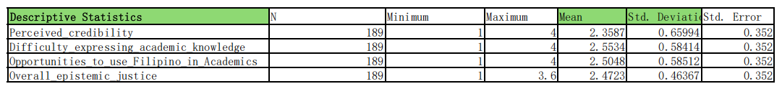

The findings revealed a low overall level of epistemic injustice among the respondents (M = 2.47). This suggests that College of Education students generally do not experience frequent discrimination, exclusion, or diminished credibility when using Filipino in academic settings. The result may indicate that the College of Education provides a relatively supportive environment where students can express ideas in Filipino without experiencing strong forms of linguistic prejudice.
Among the dimensions measured, difficulty in expressing academic knowledge obtained the highest mean score. This finding suggests that students encounter greater challenges when explaining complex academic concepts in Filipino than when dealing with issues of credibility or recognition. The result may be attributed to the limited availability of Filipino academic references, technical vocabulary, and scholarly materials commonly used in higher education. Since many academic texts and instructional resources remain English-dominated, students may find it more difficult to articulate specialized concepts entirely in Filipino.
In contrast, perceived credibility obtained the lowest mean score, indicating that students generally believe their academic ideas are respected regardless of the language they use. This may imply that instructors and classmates evaluate contributions based more on the quality of ideas than on whether they are expressed in Filipino or English.
Overall, the findings suggest that while students do not commonly experience direct forms of epistemic injustice, challenges related to the academic use of Filipino remain evident. These challenges appear to be associated more with language resources and academic terminology than with prejudice against Filipino speakers.
Problem 2 Findings:
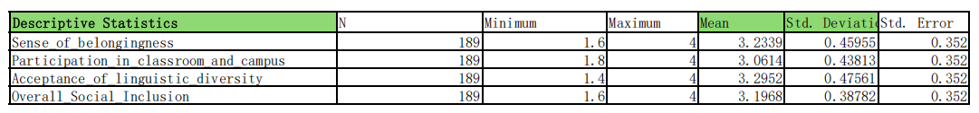
Level of Social Inclusion among College of Education Students

The results showed a high level of social inclusion among the respondents (M = 3.20). This indicates that students generally perceive themselves as accepted, respected, and involved members of the academic community. The finding suggests that the university environment promotes positive social interactions and provides opportunities for students to participate regardless of linguistic background.
Acceptance of linguistic diversity obtained the highest mean score among the dimensions of social inclusion. This finding implies that students recognize and respect different language preferences and practices within the university. Such a result reflects an academic environment where both Filipino and English are generally accepted as means of communication, thereby reducing the likelihood of language-based exclusion.
Meanwhile, participation in classroom and campus activities obtained the lowest mean among the three dimensions, although it remained within the high category. This suggests that while students generally participate in academic and extracurricular activities, factors beyond language use may still influence the degree of their involvement. These factors may include confidence, personal interests, academic workload, or opportunities for engagement.
Overall, the findings indicate that the respondents experience a strong sense of inclusion within the university community. The high ratings across all dimensions suggest that students generally feel valued and accepted regardless of the language they use in academic settings.
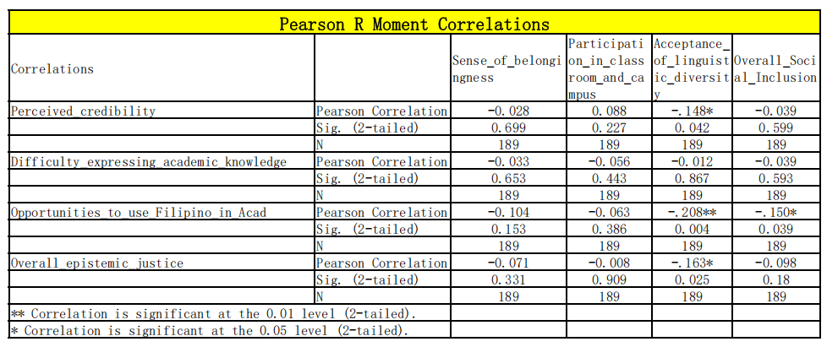
Problem 3 Findings:
Relationship Between Epistemic Injustice in Filipino Language Use and Social Inclusion

The third objective of the study was to determine whether a statistically significant relationship exists between epistemic injustice in Filipino language use and social inclusion among College of Education students.
Pearson Product-Moment Correlation Coefficient (Pearson r) was used to determine the relationship between the variables.
The results revealed that the relationship between overall epistemic injustice and overall social inclusion was not statistically significant (r = -0.098, p = .189). The computed p-value exceeded the 0.05 level of significance, indicating insufficient evidence to reject the null hypothesis.
However, a significant negative relationship was observed between overall epistemic injustice and acceptance of linguistic diversity (r = -0.163, p = .025).
Further analysis revealed significant relationships between specific dimensions of epistemic injustice and social inclusion.
A significant negative relationship was found between perceived credibility and acceptance of linguistic diversity (r = -0.148, p = .042).
Similarly, a significant negative relationship was observed between opportunities to use Filipino in academic discourse and acceptance of linguistic diversity (r = -0.208, p = .004).
In addition, opportunities to use Filipino in academic discourse showed a significant negative relationship with overall social inclusion (r = -0.150, p = .039).
The results indicate that while the overall relationship between epistemic injustice and social inclusion was not statistically significant, several dimensions demonstrated statistically significant associations with specific aspects of social inclusion.
Based on the findings, the null hypothesis stating that there is no significant relationship between overall epistemic injustice and social inclusion was accepted.
Problem 4 Findings:
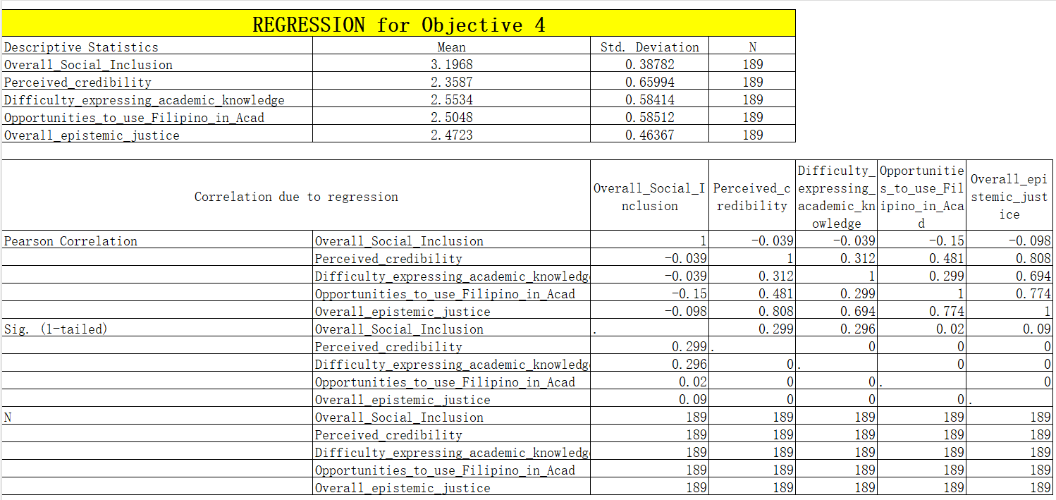
Extent to Which the Dimensions of Epistemic Injustice Predict Social Inclusion

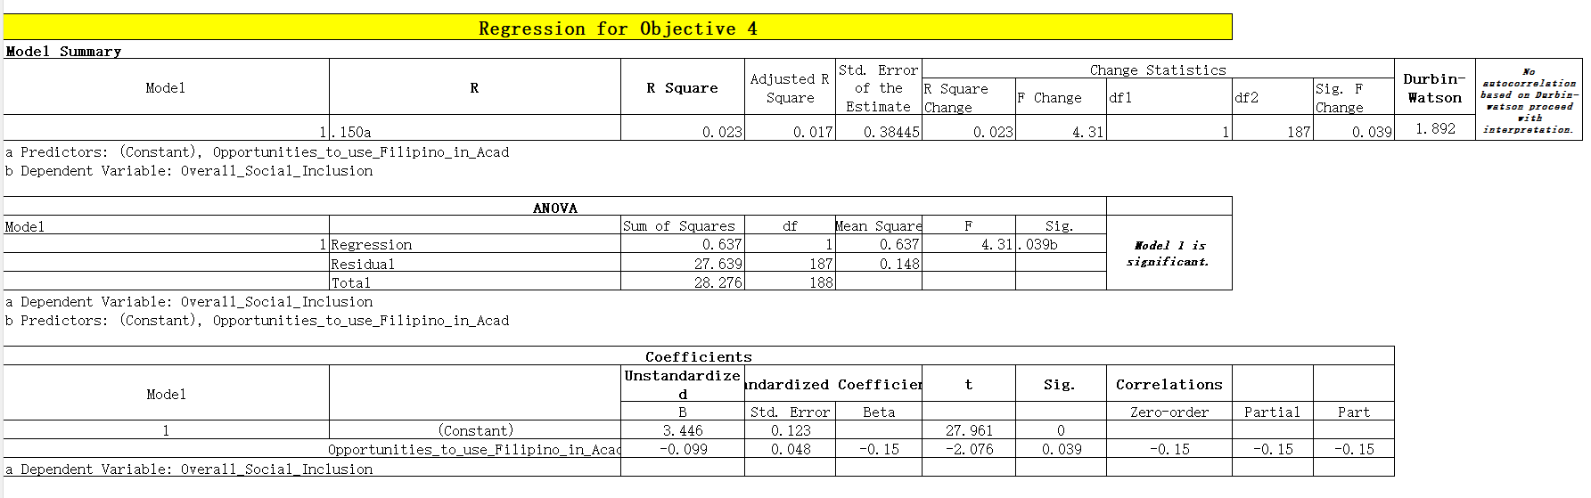

The fourth objective of the study was to determine the extent to which the dimensions of epistemic injustice predict social inclusion among College of Education students.
Multiple linear regression analysis was employed using perceived credibility, difficulty in expressing academic knowledge, and opportunities to use Filipino in academic discourse as predictor variables.
The results revealed that the regression model was statistically significant (F = 4.310, p = .039). The model explained approximately 2.3% of the variance in social inclusion (R² = .023).
Among the predictor variables included in the model, only opportunities to use Filipino in academic discourse emerged as a significant predictor of social inclusion. The dimensions of perceived credibility and difficulty in expressing academic knowledge did not significantly predict social inclusion.
The findings indicate that only one dimension of epistemic injustice contributed significantly to the prediction of social inclusion among the respondents.
Based on the results, the null hypothesis stating that none of the dimensions of epistemic injustice significantly predicted social inclusion was rejected, as at least one dimension significantly contributed to the model.

Summary, Conclusion, and Recommendation
Summary of Findings
This study examined the relationship between epistemic injustice in Filipino language use and social inclusion among College of Education students at BPSU–Balanga Campus. Specifically, it sought to determine the extent of epistemic injustice experienced by students, the level of social inclusion, the relationship between the two variables, and the extent to which the dimensions of epistemic injustice predict social inclusion.
Based on the analysis of data gathered from 189 respondents, the following findings were obtained:
Problem 1. What is the extent of epistemic injustice experienced by College of Education students in expressing knowledge in Filipino?
The findings revealed that the overall extent of epistemic injustice experienced by the respondents was low, with an overall mean of 2.47. Among the three dimensions, difficulty in expressing academic knowledge (hermeneutical injustice) obtained the highest mean, indicating that students experienced greater challenges in expressing complex academic ideas in Filipino. This was followed by opportunities to use Filipino in academic discourse (linguistic marginalization). Meanwhile, perceived credibility (testimonial injustice) obtained the lowest mean, suggesting that students generally did not feel that their academic ideas were judged unfairly because they used Filipino.
Problem 2. What is the level of social inclusion among College of Education students?
The results showed that the respondents experienced a high level of social inclusion, with an overall mean of 3.20. Among the dimensions, acceptance of linguistic diversity received the highest mean score, indicating that students generally perceived respect and acceptance for different language preferences within the university. This was followed by sense of belonging in the academic community. The lowest mean was obtained by participation in classroom and campus activities, although it still fell within the high-level category.
Problem 3. Is there a statistically significant relationship between epistemic injustice in Filipino language use and social inclusion?
The findings revealed that there was no statistically significant relationship between overall epistemic injustice and overall social inclusion (r = -0.098, p = .189). Since the p-value was greater than the 0.05 level of significance, the null hypothesis was accepted.
However, significant negative relationships were found between certain dimensions of epistemic injustice and specific aspects of social inclusion. Overall epistemic injustice was significantly related to acceptance of linguistic diversity (r = -0.163, p = .025). Likewise, perceived credibility showed a significant negative relationship with acceptance of linguistic diversity (r = -0.148, p = .042), while opportunities to use Filipino in academic discourse showed significant negative relationships with both acceptance of linguistic diversity (r = -0.208, p = .004) and overall social inclusion (r = -0.150, p = .039).
Problem 4. To what extent do the dimensions of epistemic injustice predict social inclusion?
The results of the multiple linear regression analysis revealed that the regression model was statistically significant (F = 4.310, p = .039). The model explained approximately 2.3% (R² = .023) of the variance in social inclusion.
Among the three dimensions of epistemic injustice, only opportunities to use Filipino in academic discourse emerged as a significant predictor of social inclusion. In contrast, perceived credibility and difficulty in expressing academic knowledge did not significantly predict social inclusion. Therefore, the null hypothesis stating that none of the dimensions significantly predict social inclusion was rejected.

Conclusion

Based on the findings of the study, the following conclusions were drawn:

- College of Education students at BPSU–Balanga Campus generally experience low levels of epistemic injustice when expressing knowledge in Filipino. This suggests that students are not commonly subjected to unfair treatment, reduced credibility, or exclusion because of their use of the Filipino language in academic settings.
- The students demonstrate a high level of social inclusion, indicating that they generally feel accepted, respected, and valued within the academic community. The findings further suggest that linguistic diversity is recognized and appreciated among students and instructors.
- The study concludes that epistemic injustice in Filipino language use is not a major factor influencing the overall social inclusion of College of Education students. Despite experiencing some language-related challenges, students continue to maintain a strong sense of belonging and participation within the university.
- However, opportunities to use Filipino in academic discourse remain an important aspect of students' academic experiences. The findings suggest that when students perceive greater opportunities to use Filipino in academic settings, their sense of inclusion may be affected. This highlights the role of language practices in shaping students' experiences within the academic community.
- The results support the idea that promoting inclusive language practices can contribute to a more supportive and equitable learning environment. While English continues to be widely used in higher education, providing space for Filipino in academic communication may strengthen students' participation and recognition within the university.
- Overall, the study affirms that fostering respect for linguistic diversity and providing opportunities for students to express knowledge using Filipino can help promote a more inclusive academic environment at BPSU–Balanga Campus.

Recommendations

The study revealed that College of Education students at BPSU–Balanga Campus experience a low level of epistemic injustice and a high level of social inclusion. Although no significant relationship was found between overall epistemic injustice and social inclusion, opportunities to use Filipino in academic discourse emerged as a significant predictor of social inclusion. Thus, the following recommendations are hereby presented:

- Since opportunities to use Filipino in academic discourse were found to influence social inclusion, faculty members should provide students with appropriate opportunities to express ideas and participate in academic discussions using Filipino when necessary.
- University administrators should continue promoting inclusive language practices that recognize the value of both Filipino and English in academic settings to sustain students' sense of belonging and participation.
- Students should be encouraged to respect linguistic diversity and support the use of Filipino as a legitimate language for academic communication.
- Curriculum developers may consider providing more Filipino academic resources and learning materials to help students express academic concepts more effectively.
- A similar study should be conducted involving students from other colleges and universities to determine whether similar findings can be obtained in different educational settings.
- Future researchers may investigate other factors that influence social inclusion, since the findings suggest that variables other than epistemic injustice may contribute to students' sense of inclusion within the academic community.

Disclosure of AI Use
This study utilized ChatGPT to assist in paraphrasing, improving clarity of expression, refining academic writing, and enhancing the organization of certain sections of the manuscript. Grammarly was also used for grammar checking, spelling correction, punctuation, and language refinement.
The AI tools were used solely as writing support tools and did not generate research data, perform statistical analyses, interpret findings, or formulate the study’s conclusions and recommendations. All research design decisions, data collection procedures, statistical analyses, interpretations, and conclusions were conducted and determined by the researchers.
The researchers take full responsibility for the accuracy, integrity, and originality of the content presented in this study.

APPENDICES:
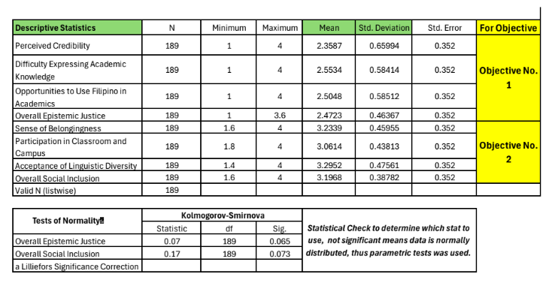
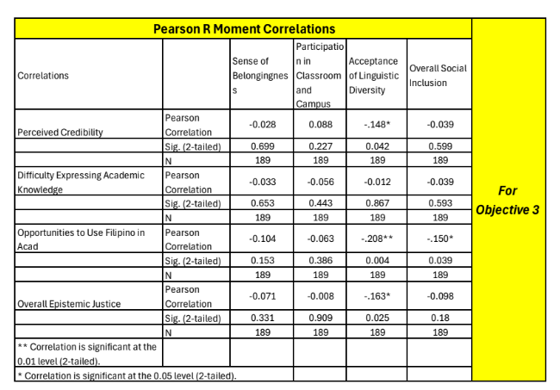
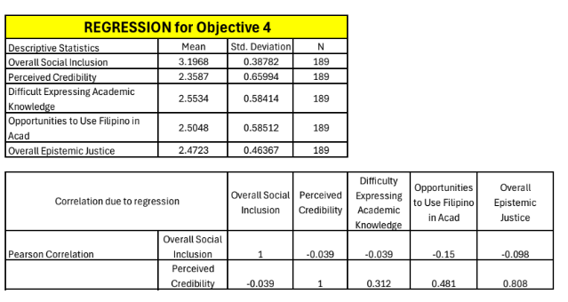
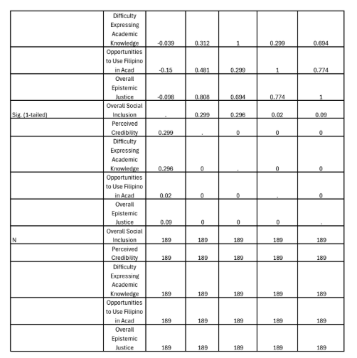
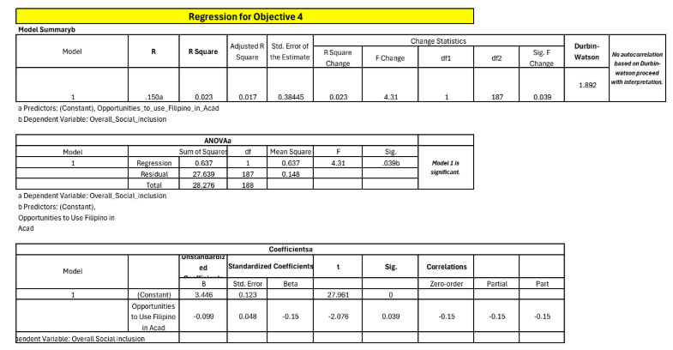

Prof. Sisenando Masangcap, Jr.
Campus Director
Bataan Peninsula State University – Balanga Campus

Thru: Leandro T. Olubia
Dean, College of Education
Dear Dr. Olubia and Prof. Masangcap:
Greetings of peace and excellence!
We, the researchers from Bataan Peninsula State University-Graduate School, respectfully request permission to conduct data gathering at Bataan Peninsula State University – Balanga Campus, particularly within the College of Education, for our research study entitled “Epistemic Injustice in Filipino Language Use and Social Inclusion among Students at BPSU-Balanga Campus.”
The study aims to examine how Filipino language use relates to epistemic injustice and social inclusion among students. In line with this, we intend to gather data from one hundred eighty-nine (189) student respondents through random sampling.
We assure your good office that the conduct of the study shall observe proper research ethics. Participation of the respondents will be voluntary, and all information gathered will be treated with utmost confidentiality and will be used solely for academic purposes.
In this regard, we humbly seek your approval to conduct the said data gathering within the College of Education of BPSU-Balanga Campus.
We hope for your favorable response regarding this matter. Thank you very much for your time and consideration.
Prepared by:
Mr. Kian H. Sanchez Ms.Zennia Rose Ann Santos
09706807049 09193470421
kianhsanchez@gmail.com santoszenniaroseann@gmail.com
Mrs.Annleeh Llorente -Jovero Monera T. Ampuan
09509293300
annleehjovero@gmail.com

Title of the Study : Epistemic Injustice in Filipino Language Use and Social Inclusion among Students at BPSU–Balanga Campus

Part I. Respondent Profile
Direction: Please check or write the appropriate answer.
- Age: ________
- Sex:
☐ Male
☐ Female
☐ Prefer not to say
- College/Department: ____________________
- Year Level:
☐ First Year
☐ Second Year
☐ Third Year
☐ Fourth Year
- Primary language spoken at home: ____________________
- How often do you use Filipino in academic discussions?
☐ Always
☐ Often
☐ Sometimes
☐ Rarely
☐ Never

Part II. Epistemic Injustice in Expressing Knowledge in Filipino
Directions: Read each statement carefully and indicate your answer using the scale below:

In this study:

· Testimonial injustice refers to situations where a student is not taken seriously or is judged unfairly because of the language they use.
· Hermeneutical injustice refers to difficulties in expressing or understanding academic ideas because of limited Filipino terms, resources, or explanations.
· Linguistic marginalization refers to having fewer opportunities or less acceptance in using Filipino in academic discussions and activities.
Scale | Description
5 | Strongly Agree
4 | Agree
3 | Neutral
2 | Disagree
1 | Strongly Disagree
A. Perceived Credibility (Testimonial Injustice)
Statements | 5 | 4 | 3 | 2 | 1
1. I feel that my academic ideas are taken less seriously when I express them in Filipino during class discussions. | ☐ | ☐ | ☐ | ☐ | ☐
2. Some instructors appear to give greater academic credibility to students who speak English. | ☐ | ☐ | ☐ | ☐ | ☐
3. I receive more academic respect when I communicate in English rather than Filipino. | ☐ | ☐ | ☐ | ☐ | ☐
4. My classmates sometimes assume I am less academically capable when I use Filipino. | ☐ | ☐ | ☐ | ☐ | ☐
5. Students who frequently use Filipino are sometimes perceived as less academically competent. | ☐ | ☐ | ☐ | ☐ | ☐

B. Difficulty in Expressing Academic Knowledge (Hermeneutical Injustice)
Statements | 5 | 4 | 3 | 2 | 1
6. I struggle to express complex academic ideas clearly in Filipino. | ☐ | ☐ | ☐ | ☐ | ☐
7. The lack of appropriate Filipino academic terms makes it difficult to explain scholarly concepts. | ☐ | ☐ | ☐ | ☐ | ☐
8. I feel intellectually limited when discussing technical or scholarly topics in Filipino | ☐ | ☐ | ☐ | ☐ | ☐
9. Academic discussions are often structured in ways that make English easier to use than Filipino. | ☐ | ☐ | ☐ | ☐ | ☐
10. The limited availability of Filipino academic resources affects my confidence in expressing knowledge. | ☐ | ☐ | ☐ | ☐ | ☐

C. Opportunities to Use Filipino in Academic Discourse (Linguistic Marginalization)
Statements | 5 | 4 | 3 | 2 | 1
11. Filipino is rarely encouraged in classroom discussions. | ☐ | ☐ | ☐ | ☐ | ☐
12. I feel hesitant to use Filipino in presentations and academic activities. | ☐ | ☐ | ☐ | ☐ | ☐
13. English is often treated as more appropriate than Filipino in academic settings. | ☐ | ☐ | ☐ | ☐ | ☐
14. Students who use Filipino have fewer opportunities to express academic ideas than English-speaking students. | ☐ | ☐ | ☐ | ☐ | ☐
15. Using Filipino in academic discourse is sometimes socially discouraged in the university. | ☐ | ☐ | ☐ | ☐ | ☐

Part III. Social Inclusion Among College Students
A. Sense of Belonging in the Academic Community
Statements | 5 | 4 | 3 | 2 | 1
16. I feel accepted in the academic community regardless of the language I use in class. | ☐ | ☐ | ☐ | ☐ | ☐
17. I feel academically valued by my classmates and instructors. | ☐ | ☐ | ☐ | ☐ | ☐
18. I feel comfortable participating in academic discussions | ☐ | ☐ | ☐ | ☐ | ☐
19. I believe my opinions are respected in academic settings. | ☐ | ☐ | ☐ | ☐ | ☐
20. I feel a strong sense of belonging within the university community. | ☐ | ☐ | ☐ | ☐ | ☐

B. Participation in Classroom and Campus Activities
Statements | 5 | 4 | 3 | 2 | 1
21. I actively participate in classroom discussions and activities. | ☐ | ☐ | ☐ | ☐ | ☐
22. I am able to participate in academic activities regardless of language differences. | ☐ | ☐ | ☐ | ☐ | ☐
23. I feel encouraged to share my ideas during class. | ☐ | ☐ | ☐ | ☐ | ☐
24. I participate confidently in campus programs and organizations. | ☐ | ☐ | ☐ | ☐ | ☐
25. Language-related concerns do not prevent me from participating in academic activities. | ☐ | ☐ | ☐ | ☐ | ☐

C. Acceptance of Linguistic Diversity Among Peers and Instructors
Statements | 5 | 4 | 3 | 2 | 1
26. Students in the university respect different language preferences and practices. | ☐ | ☐ | ☐ | ☐ | ☐
27. Instructors are supportive of students who use Filipino in academic discussions. | ☐ | ☐ | ☐ | ☐ | ☐
28. Linguistic diversity is valued within the university community. | ☐ | ☐ | ☐ | ☐ | ☐
29. Students are treated fairly regardless of the language they use academically | ☐ | ☐ | ☐ | ☐ | ☐
30. The university promotes inclusivity for both Filipino-speaking and English-speaking students. | ☐ | ☐ | ☐ | ☐ | ☐

Suggested Interpretation of Mean Scores
Mean Range Interpretation
4.21 – 5.00 Very High
3.41 – 4.20 High
2.61 – 3.40 Moderate
1.81 – 2.60 Low
1.00 – 1.80 Very Low

REFERENCES:
Ainscow, M. (2020). Promoting inclusion and equity in education: Lessons from international experiences. Nordic Journal of Studies in Educational Policy, 6(1), 7–16. https://doi.org/10.1080/20020317.2020.1729587

Alaga, N. A. (2016). Motivation and attitude in learning English as a second language among Filipino students. International Journal of English Language Teaching, 4(5), 33–45.
Bernardo, A. B. I. (2004). McKinley’s questionable bequest: Over 100 years of English in Philippine education. World Englishes, 23(1), 17–31. https://doi.org/10.1111/j.1467-971X.2004.00332.x
Bernardo, A. B. I. (2018). Language policy and practice in Philippine higher education: Challenges in the implementation of an English-dominated curriculum. Philippine Journal of Linguistics, 49, 23–45.
Borlongan, A. M. (2011). Relocating Philippine English in Schneider’s dynamic model. Asian Englishes, 14(2), 5–35.
Bourdieu, P. (1991). Language and symbolic power. Harvard University Press.
Brooks, K., & Karathanos, K. (2009). Building on the cultural and linguistic capital of English learner (EL) students. Multicultural Education, 16(4), 47–51. https://eric.ed.gov/?id=EJ858589
Brown, P. G. (2014, August 28). The problem of English dominance in higher education globalization. International Student. https://www.internationalstudent.com/study-abroad/the-international-student-blog/2014/08/28/the-problem-of-english-dominance-in-higher-education-globalization/
Chen, X., & Du, Y. (2025). Language learning anxiety and classroom participation among university students. Journal of Language and Education, 11(2), 45–59.
Creswell, J. W., & Creswell, J. D. (2018). Research Design: Qualitative, Quantitative, and Mixed Methods Approaches (5th ed.). SAGE Publications.
Creswell, J. W. (2014). Educational Research: Planning, Conducting, and Evaluating Quantitative and Qualitative Research (4th ed.). Pearson.
Commission on Higher Education. (2013). CHED Memorandum Order No. 20, series of 2013: General education curriculum. CHED.
Council of the European Union. (2000). Presidency conclusions: Lisbon European Council (March 23–24, 2000). https://www.europarl.europa.eu
Department of Education. (2009). Department Order No. 74, s. 2009: Institutionalizing mother tongue-based multilingual education (MTB-MLE). https://www.deped.gov.ph
DiPerna, J. C., & Elliott, S. N. (1999). Development and validation of the Academic Competence Evaluation Scales. Journal of Psychoeducational Assessment, 17(3), 207–225.
Dotson, K. (2011). Tracking epistemic violence, tracking practices of silencing. Hypatia, 26(2), 236–257. https://doi.org/10.1111/j.1527-2001.2011.01177.x
Etikan, I., Musa, S. A., & Alkassim, R. S. (2016). Comparison of Convenience Sampling and Purposive Sampling. American Journal of Theoretical and Applied Statistics, 5(1), 1–4.
https://www.researchgate.net/publication/308935381_Comparison_of_Convenience_Sampling_and_Purposive_Sampling
Field, A. (2018). Discovering statistics using IBM SPSS statistics (5th ed.). SAGE Publications.
Foucault, M. (1980). Power/knowledge: Selected interviews and other writings, 1972–1977 (C. Gordon, Ed.). Pantheon Books.
Fricker, M. (2007). Epistemic injustice: Power and the ethics of knowing. Oxford University Press.
Gaite, C. R. G. (2025). Indigenous Filipino students’ challenges, coping strategies, and recommendations in higher education. Xavier University–Ateneo de Cagayan and Central Mindanao University. https://www.researchgate.net/publication/403737112_Indigenous_Filipino_Students'_Challenges_Coping_Strategies_and_Recommendations_in_Higher_Education
García, O., & Wei, L. (2014). Translanguaging: Language, bilingualism and education. Palgrave Macmillan.
Hall, G., & Cook, G. (2012). Own-language use in language teaching and learning. Language Teaching, 45(3), 271–308. https://doi.org/10.1017/S0261444812000067
Jorolan-Quintero, G. (2018). Oral traditions: An aid to implementation of mother tongue-based multilingual education in the Philippines’ basic education programme. International Review of Education, 64(6), 803–824.
Likert, R. (1932). A Technique for the Measurement of Attitudes. Archives of Psychology, 140, 1–55.https://legacy.voteview.com/pdf/Likert_1932.pdf
Lippi-Green, R. (2012). English with an accent: Language, ideology and discrimination in the United States (2nd ed.). Routledge.
Macaro, E. (2018). English medium instruction. Oxford University Press.
MacSwan, J. (2017). A multilingual perspective on translanguaging. American Educational Research Journal, 54(1), 167–201. https://doi.org/10.3102/0002831216683935
Medina, J. (2013). The epistemology of resistance: Gender and racial oppression, epistemic injustice, and resistant imaginations. Oxford University Press.
McCroskey, J. C., & Teven, J. J. (1999). Goodwill: A Reexamination of the Construct and Its Measurement. Communication Monographs, 66(1), 90–103.
Mignolo, W. D. (2009). Epistemic disobedience, independent thought and decolonial freedom. Theory, Culture & Society, 26(7–8), 159–181. https://doi.org/10.1177/0263276409349275
Nation, I. S. P. (2013). Learning vocabulary in another language (2nd ed.). Cambridge University Press.
Norton, B. (2013). Identity and language learning: Extending the conversation (2nd ed.). Multilingual Matters.
Phillipson, R. (1992). Linguistic imperialism. Oxford University Press.
Republic of the Philippines. (1987). The 1987 Constitution of the Republic of the Philippines. https://www.officialgazette.gov.ph/constitutions/1987-constitution/
Santos, B. de S. (2014). Epistemologies of the South: Justice against epistemicide. Routledge.
Schober, P., Boer, C., & Schwarte, L. A. (2018). Correlation coefficients: Appropriate use and interpretation. Anesthesia & Analgesia, 126(5), 1763–1768. https://doi.org/10.1213/ANE.0000000000002864
Strayhorn, T. L. (2019). College students' sense of belonging: A key to educational success for all students (2nd ed.). Routledge.
Tupas, R. (2015). Inequalities of multilingualism: Challenges to mother tongue-based multilingual education. Language and Education, 29(2), 112–124. https://doi.org/10.1080/09500782.2014.977295
Tupas, R. (2015). Unequal Englishes: The politics of Englishes today. Palgrave Macmillan.
UNESCO. (2017). A guide for ensuring inclusion and equity in education. UNESCO Publishing. https://unesdoc.unesco.org/ark:/48223/pf0000248254
UNESCO Philippines. (2019). Inclusive education and multilingualism in the Philippines. UNESCO Philippines.
UNESCO. (2019). World Report of Languages.https://www.unesco.org/en/linguistic-diversity
UNESCO. (2021). Reimagining our futures together: A new social contract for education. UNESCO Publishing.
University of Groningen. (n.d.). Common language hierarchy. In Multilingual practices: Tackling challenges and creating opportunities. FutureLearn. https://www.futurelearn.com
Vygotsky, L. S. (1978). Mind in society: The development of higher psychological processes. Harvard University Press.
Wandel, T. (2001). The power of discourse: Michel Foucault and critical theory. Cultural Values, 5(3), 368–382.
Wasserstein, R. L., & Lazar, N. A. (2016). The ASA statement on p-values: Context, process, and purpose. The American Statistician, 70(2), 129–133.
Wei, L. (2018). Translanguaging as a practical theory of language. Applied Linguistics, 39(1), 9–30. https://doi.org/10.1093/applin/amx039
Wee, H. L., Karkkulainen, E. A., & Tateo, L. (2023). Experiences of epistemic injustice among minority language students aged 6–16 in the Nordics: A literature review. Education Sciences, 13(4), 367. https://doi.org/10.3390/educsci13040367
Wertsch, J. V. (1985). Vygotsky and the social formation of mind. Harvard University Press.
World Bank. (2013). Inclusion matters: The foundation for shared prosperity. World Bank. https://doi.org/10.1596/978-1-4648-0010-8

