Federated Learning Framework for privacy aware Smart City data analytics

INTRODUCTION

The quick development of technologies and urban infrastructure has accelerated the development of urban systems worldwide. Modern cities rely on Internet of Things devices, intelligent sensors, transportation networks, environmental monitoring systems and smart energy platforms to collect and process amounts of real-time data. These technologies enable urban management through improved mobility efficient resource use,
environmental sustainability and data-driven decision-making. However, as cities become interconnected and data-intensive significant challenges arise in terms of data storage, computational scalability, communication efficiency, privacy protection and cybersecurity.

Traditional machine learning systems often use a learning approach. In this approach data from distributed devices and systems is sent to a local server for processing and model training. Although centralized learning can achieve accuracy in forecasting it has several limitations in smart city environments. Sending amounts of raw data increases communication overhead and storage needs. It also exposes information to potential security threats and privacy breaches. Applications like healthcare monitoring, traffic analysis, energy consumption management and environmental surveillance often involve user and infrastructure data. This makes centralized data sharing both risky and inefficient.

This project proposes a Federated Instruction Framework for Urban System Data Analytics. It combines machine learning strategies with privacy-preserving distributed learning. The framework focuses on three smart city areas: air quality monitoring, traffic volume prediction and household energy consumption analysis. Machine learning algorithms like Random Forest Regressor and XGBoost Regressor are used to improve accuracy and analytical performance across distributed datasets. The proposed system also includes a visualization dashboard based on Streamlit. This dashboard enables real-time analysis of city data, model performance comparison and prediction monitoring.

The framework aims to support traffic management, sustainable urban planning, pollution monitoring and energy optimization. It does so while maintaining data confidentiality and reducing communication overhead. The experimental evaluation shows that Federated Instruction can be an efficient solution for distributed urban intelligence systems and next-generation smart city analytics.

LITERATURE SURVEY

The expansion of intelligent urban infrastructure has led to continuous data generation from interconnected IoT devices, surveillance platforms, environmental sensors, and smart public systems. Ancient, centralized ML techniques have been widely used. to analyze this data, but they have substantial issues with data privacy, communication costs, scalability, and security.

A thorough paper titled "Advances and main Problems in Federated Learning" by P. Kairouz et al. explored the key ideas, frameworks, issues, and goals of the field. Their research made Federated Learning a practical option for applications that are sensitive to privacy, such as smart city systems, healthcare, and finance.

H. B. McMahan et al. described Federated Averaging (FedAvg) in "Communication-Efficient Learning of Neural Systems from Distributed Data." The FedAvg algorithm allows decentralized devices to perform local model training while transmitting only parameter updates for centralized aggregation. To build a global model, the server compiles these modifications. Because it dramatically lowers transmission costs while maintaining user anonymity, this approach has grown to be one of the most widely used aggregation approaches in Federated Learning systems.

Non-identically distributed (Non-IID) data, system heterogeneity, communication bandwidth limitations, and Security concerns are one of the technical challenges that T. Li et al. addressed in their paper "Federated Learning: Challenges, Technique, and Horizon Directions. “In order to enhance the effectiveness and robustness of Distributed Learning frameworks, the Writers also investigated a few optimization strategies and possible directions for additional research.

The concept and utilization of Distributed ML models were explained in "Federated Machine Learning: Concept and Applications," by Q. Yang et al. As per the report,
Distributed learning can be applied in several sectors, including finance, healthcare, IoT, and smart cities. The authors stressed that privacy preservation and decentralized learning are key needs for modern intelligent systems managing sensitive user data.

Federated Learning was implemented in IoT-based smart settings by a few scholars. In "Federated Learning for the Internet of Things: Applications, Challenges, and Opportunities," T. Zhang et al. looked at how FL functions in IoT systems where a lot of devices are constantly producing dispersed data. The study highlighted how Federated Learning improves scalability and reduces dependency on centralized cloud infrastructures while enabling real-time analytics for smart city applications.

In their study "Performance-Enhanced equal Distributed Learning with Differential Privacy for IoT," X. Shen et al. suggested incorporating Differential Privacy techniques to get around this problem. The study incorporated noise injection mechanisms into model updates to minimize privacy leakage while maintaining acceptable predictive performance. Differential privacy can significantly increase security in Distributed Learning systems, as this study demonstrated.

PROBLEM STATEMENT
Modern cities need things like energy grids, intelligent transportation systems and sensors that check the environment. These things give us a lot of information all the time. We use this information to make our cities safer to manage traffic, to plan our cities to keep the environment clean and to use energy wisely.
The usual way of using ML techniques is to collect all the information in one place and then process it. But this way has a problem. It is not good for big systems. When our cities get more advanced and we have information the usual way of doing things gets stuck. It is hard to process all the information in time and to manage our resources well.
So, we need a way of doing things that is safe, can handle a lot of information and keep our private information safe. This new way should be able to look at a lot of information from our cities without having to move all the information around.
The new framework we are talking about focuses on three areas: how much energy people have use at home; how many cars are on the road and how clean the air is. We want to ensure that our projections are accurate., that we can handle a big of information,

that we can do city analytics, in a sense that is distributed and that we keep people's private information safe.
This framework is designed for cities that are getting smarter. we want to guarantee that our towns are clean. and nice places to live. We also want to make sure that we can handle all the information we are getting from our cities without any problems.
The three areas we are focusing on are very important. We want to know the amount of energy people use at home so we can help them use energy. We want to know how many cars are on the road so we can manage traffic better. We want to know how clean the air is so we can keep our cities healthy.

OBJECTIVES

This project's main purpose is to develop a federated learning- based smart city data analytics platform that is safe and private. Without revealing private user information to a main server, the Structure is made to effectively evaluate dispersed smart city data.

The specific objectives of the project are:
- To design a privacy-preserving analytical framework for distributed smart city environments.
- To use federated learning approaches to enable decentralized model training.
- To investigate a few smart city-related areas.
- To develop accurate machine learning prediction models.
- To contrast federated and centralized learning strategies.
- To support real-time data monitoring and predictive analytics.
- To Display Evaluation Metrics and Prediction Results
- To reduce communication costs and network overhead in distributed urban systems.
- To make smart city analytics more scalable.
- To facilitate intelligent and safe urban decision-making.

PROPOSED METHODOLOGY
To provide secure, scalable, and privacy-conscious predictive analytics for contemporary smart city applications, the suggested system offers a Distributed Learning Framework for Urban City Data Analytics. The framework effectively analyzes urban data without directly exchanging sensitive raw data between systems
by combining machine learning techniques, Federated Learning principles, real-time prediction mechanisms, and interactive visualization tools.
The suggested framework uses a distributed learning strategy, in contrast to conventional centralized machine learning systems that send all information to a single server for analysis. To provide privacy and facilitate interactive model training, local devices keep their datasets and send only model improvements to a single server. This approach is ideal for large-scale smart city contexts because it increases scalability, lowers communication costs, and improves privacy protection.
Three key smart city domains are the main objective of the suggested system:
  - Air Quality Monitoring

Using ML models, the system forecasts environmental pollution levels and tracks air quality indices. To ensure environmental sustainability, this aids authorities in analyzing pollution trends and implementing preventive measures.
  - Traffic Volume Prediction

The framework uses both historical and current traffic data to forecast traffic flow and evaluate patterns of traffic congestion. These forecasts aid in efficient transportation management and lessen urban traffic jams.
  - Energy Consumption Analysis

The technology predicts household energy use to enable efficient power management and smart grid optimization. Sustainable energy management is encouraged, and energy utilization is improved.
To enable real-time display and tracking of prediction outcomes, an interactive Streamlit dashboard was created. The dashboard supports live predictions, AQI monitoring, confusion matrix visualization, actual versus predicted comparisons, and evaluation of multiple models’ performance.
The proposed system works through the following stages:

    - Data Collection

Real-world data on household energy use, traffic volume, and air quality are gathered from various smart city sources.

    - Data Preprocessing

The collected datasets are cleaned by removing errors, filling in missing values, and converting data into the proper numerical formats so that ML models can be trained.

    - Feature Engineering

To enhance model performance and prediction accuracy, key characteristics like temperature, humidity, traffic timing patterns, and energy usage factors are retrieved.

    - Model Training

Different models including centralized learning models, improved machine learning models, and Federated Learning models are trained separately using ML algorithms.
    - Federated Learning Integration

Using their own datasets, local devices or clients train models on their own throughout the Federated Learning process. To provide secure distributed learning and privacy preservation, only model changes are sent to the central server rather than raw data.

    - Prediction and Evaluation

The trained models generate predictions for air quality, traffic volume, and energy consumption. Model performance is evaluated using standard evaluation metrics such as:
- R² Score ,Mean Squared Error (MSE) ,Mean Absolute Error (MAE) ,Root Mean Squared Error (RMSE)
    - Visualization and Monitoring

The Streamlit dashboard provides interactive visualization features including live prediction, AQI gauge display, confusion matrix visualization, actual versus predicted graphs, and comparative analysis of model performance.

SYSTEM ARCHITECTURE

The proposed architecture begins with a dataset acquisition layer that collects publicly available smart city datasets related to air quality, traffic flow, and household energy consumption. These
datasets include crucial data needed for predictive analytics in smart city settings. The data may contain missing values, inconsistent formats, and extraneous information that needs to be handled before model training because it is gathered from many domains and sources. The Data Preprocessing Layer receives the gathered datasets after that. This step entails data transformation and cleaning to develop the quality of the data and prepare it for
ML algorithms. Preprocessing operations include handling missing records, removing inconsistent entries, and converting categorical attributes into machine-readable numerical formats.
Following preprocessing, the data is transmitted to the ML Layer, where methods like RF Regressor and XGBoost Regressor are used to train various prediction models.
The system also has a Federated Learning Layer, which is most important elements of the proposed structure. Within this layer, distributed client nodes independently train local models using privately stored datasets without transferring raw information. The Prediction Layer then uses the learned models to produce automatic and real-time predictions for household energy use, transportation congestion, and air quality levels. Users can provide input values through the dashboard and instantly receive prediction results.
Lastly, Streamlit is required to create the Visualization and User Interface Layer, offering an interactive dashboard. The dashboard presents prediction results, performance metrics, comparative model analysis, live forecasting modules, AQI visualizations, and dataset summaries through an interactive interface.
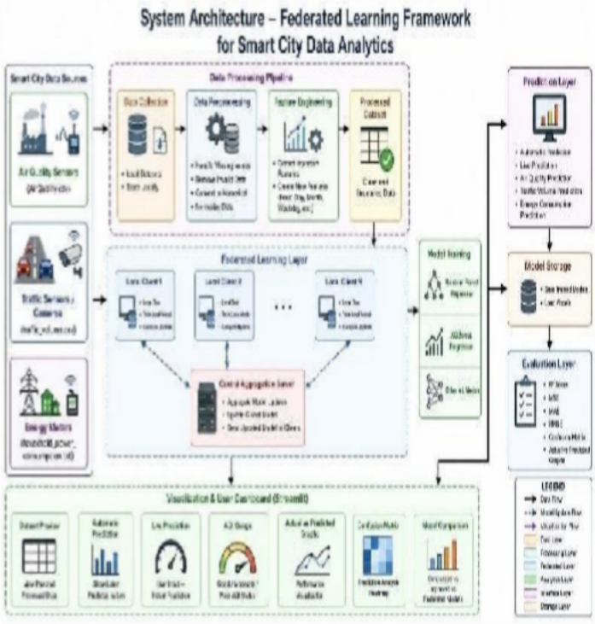
All things considered, the suggested system architecture offers a scalable, safe, and privacy-conscious foundation for smart city analytics.

Fig 6.1: System Architecture of Federated learning Framework for smart city

RESULTS

Comparing the effectiveness of improved machine learning models, federated learning-based models, and centralized learning models while preserving data privacy and minimizing raw data exchange was the experiment's primary goal. Model performance and prediction accuracy were assessed using a variety of evaluation metrics, including R2 Score, Mean Squared Error (MSE), Mean Absolute Error (MAE), and Root Mean Squared Error (RMSE).

  - Air Quality Monitoring Results

The Air Quality Monitoring module analyzes environmental sensor data to predict air quality conditions. The system preprocesses air quality attributes such as: CO(GT) ,NOx(GT)
,Temperature ,Humidity ,Sensor measurements .

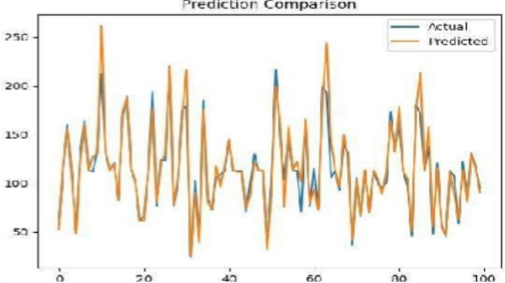

Figure 7.1 Air Quality Monitoring Actual vs Predicted

  - Energy Consumption Prediction Results

The Energy Consumption Prediction module estimates household energy usage using electrical measurements such as: Global reactive power, Voltage ,Current intensity
,Sub-metering values
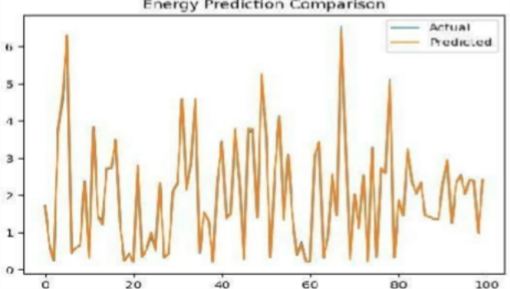

Figure 7.2 Energy Consumption Actual vs Predicted

  - Traffic Volume Prediction Results

The Traffic Volume Prediction module estimates traffic flow using weather and time-related attributes such as: Temperature
,Rainfall , Snowfall , Cloud coverage .

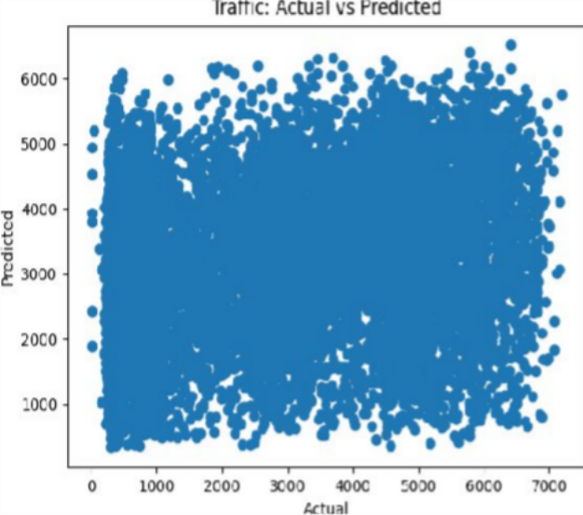

Figure 7.3 Traffic Volume Actual vs Predicted

CONCLUSION

The platform combined three crucial smart city domains— energy consumption analysis, traffic volume prediction, and air quality monitoring—into a single interactive Streamlit interface. The system offered a complete solution for real-time smart city monitoring, prediction, and visualization by integrating various domains into a single platform. The interface made it simple and quick for users to engage with prediction models, track analytical results, and see system performance.

Several machine learning techniques, including federated learning-based models, centralized learning models, and augmented machine learning models, were implemented using real-world datasets. The outcome of the experiment showed that the improved machine learning models performed better in terms of prediction accuracy than the traditional baseline models.
Federated learning models enabled improved privacy preservation and less raw data sharing while achieving prediction performance that was comparable to centralized learning approaches.

REFERENCES

- IEEE Internet of Things Journal, vol. 9, no. 15, pp. 13567-13579, 2022; X. Shen, Y. Liu, and J. Zhang.
"Performance-Enhanced Federated Learning with Differential Privacy for IoT."

- T. Zhang, Y. Liu and W. Wang, “Federated Learning for the Internet of Things: Applications, Challenges, and Opportunities,” IEEE Internet of Things Magazine, vol. 5, no. 1,
pp. 24–29, 2022.

- M. Shaheen, M. A. Ozair and A. H. Abdullah, “Applications of Federated Learning: A Survey,” IEEE Access, vol. 10, pp. 12345–12360, 2022.

- L. Witt, M. Bennis and R. Tandon, “Decentralized and Incentivized Federated Learning Frameworks: A Systematic Review,” IEEE Communications Surveys & Tutorials, vol. 24, no. 3, pp. 1555–1580, 2022.

- Federated Learning: Applications, Challenges, and Future Directions, S. Bharati, M. Mondal, and S. Podder, Proceedings of the International Conference on Smart Computing and Artificial Intelligence, 2022.

- Federated Learning for Resource-Constrained IoT Devices: Panoramas and State-of-the-Art, A. Imteaj, U. Thakker,
S. Wang,
J. Li, and M. H. Amini, IEEE Internet of Things Journal, vol. 9, no. 1, pp. 1–21, 2022.

- Y. Zhao, H. Wu, and R. Li, "Privacy-Preserving Federated Learning for Smart City Applications," IEEE Access, vol. 11, pp. 45678–45691, 2023.

- International Journal of Intelligent Systems and Applications, vol. 15, no. 2, pp. 89–101, 2023; K. Sharma and P. Singh, "Secure Federated Learning Framework for Smart Healthcare and Smart City Systems."
- M. Chen, L. Wang and X. Zhou, “Efficient Federated Learning Techniques for IoT-Based Smart Cities,” IEEE Transactions on Network Science and Engineering, vol. 10, no. 4, pp. 2234–2245, 2023.
- S. Verma and R. Gupta, “Privacy-Aware Distributed Learning for Smart City Data Analytics Using Federated
Learning,” Journal of Big Data, vol. 10, no. 1, pp. 1–18, 2023.

- H. Kim and J. Lee, “Scalable Federated Learning Architecture for Real-Time Smart City Analytics,” IEEE Access, vol. 12, pp. 11234–11248, 2024.

- P. Rao, N. Kumar and S. Reddy, “Federated Learning-Based Intelligent Traffic Prediction System for Smart Cities,” International Journal of Advanced Computer Science and Applications, vol. 15, no. 3, pp. 210–220, 2024.

- D. Patel and A. Joshi, “Enhancing Privacy in Smart City Analytics Using Differentially Private Federated Learning,” IEEE Internet of Things Journal, vol. 11, no. 2, pp. 3345–3357, 2024.

- "Communication-Efficient Federated Learning Framework for Large-Scale IoT Networks," R. Mehta and S. Kulkarni, IEEE Transactions on Industrial Informatics, vol. 20, no. 1, pp. 556–567, 2024.

- Journal of Artificial Intelligence and Data Science, vol. 6, no. 1, pp. 45–58, 2025; V. Narayanan and P. Bhat, "AI-Driven Federated Learning Model for Privacy-Aware Smart City Infrastructure."

