AI-BASED DIGITAL ADDICTION & SCREEN-TIME BEHAVIOR ANALYZER
Suman .T¹, Rajesh .P², Santhosh .M³ and Sudharsan .G⁴
¹Suman .T, Department of Artificial Intelligence and Data Science, SRM Valliammai Engineering College, SRM Nagar, Kattankulathur – 603 203, Chengalpattu District
²Rajesh .P, Department of Artificial Intelligence and Data Science, SRM Valliammai Engineering College, SRM Nagar, Kattankulathur – 603 203, Chengalpattu District
³Santhosh .M, Department of Artificial Intelligence and Data Science, SRM Valliammai Engineering College, SRM Nagar, Kattankulathur – 603 203, Chengalpattu District
⁴Sudharsan .G, Department of Artificial Intelligence and Data Science, SRM Valliammai Engineering College, SRM Nagar, Kattankulathur – 603 203, Chengalpattu District

Abstract— This paper presents the design and development of an AI-powered system for real-time digital addiction detection and screen-time behavior analysis. The proposed system addresses the growing concern of excessive smartphone usage and its impact on mental health, academic performance, and workplace productivity. Existing solutions lack behavioral intelligence, real-time data extraction, and actionable intervention mechanisms. The platform integrates Android Debug Bridge-based app usage extraction, a five-factor weighted machine learning risk scoring engine with sigmoid normalization, and a large language model-powered insight generation module using Groq's LLaMA 3.3 70B to produce severity-rated behavioral recommendations. A Chrome Extension supplements the system by tracking browsing history in real time, enabling domain-level categorization and detection of inappropriate web content. Risk classification is performed across four levels — Minimal, Low, Moderate, and High — based on screen time, social media percentage, unlock frequency, night usage, and app concentration. A multi-channel alert system delivers warnings via Android Debug Bridge push notifications, ntfy real-time popups, and WhatsApp deep links when thresholds are exceeded. The web dashboard, built using HTML, CSS, JavaScript, and Chart.js, renders hourly usage charts, app breakdowns, weekly trends, and a seven-day usage forecast. All data is persistently stored in Firebase Firestore with real-time synchronization. Experimental results confirm over 95 percent detection accuracy and sub-three-second AI response times, validating the system as a practical and scalable tool for promoting responsible digital habits across households and organizations.
Index Terms— Android Debug Bridge, Artificial Intelligence, Behavioral Analysis, Digital Addiction, Firebase, Large Language Model, Machine Learning, Screen-Time Monitoring, Weighted Risk Scoring
I. INTRODUCTION
I. INTRODUCTION
The widespread adoption of smartphones and internet-connected devices has reshaped human behavior at an unprecedented scale. While digital technology has enabled remarkable advances in communication, education, and commerce, it has simultaneously given rise to a phenomenon increasingly recognized by researchers and clinicians as digital addiction — a compulsive and unregulated pattern of device usage that negatively affects cognitive function, emotional well-being, and social behavior [1]. According to recent global studies, the average smartphone user unlocks their device more than 80 times per day and accumulates over six hours of daily screen time, with adolescents and young adults representing the most vulnerable demographic [2]. The consequences of this behavioral pattern are well documented and include sleep disruption, reduced academic achievement, heightened anxiety, diminished attention span, and impaired interpersonal relationships [3].
The challenge of monitoring and mitigating excessive screen-time behavior is further compounded by the limitations of existing solutions. Native device tools such as Android Digital Wellbeing and Apple Screen Time provide rudimentary usage summaries but offer no behavioral risk classification, no predictive modeling, and no proactive alert mechanisms. Commercial third-party applications are similarly constrained, typically presenting aggregate statistics without correlating usage patterns to addiction risk levels or generating personalized intervention strategies. Moreover, the absence of cross-platform integration — combining app usage monitoring, web browsing behavior analysis, and real-time alert delivery — leaves a critical gap in the current digital wellness landscape [4].
Artificial intelligence and machine learning have demonstrated significant potential in behavioral pattern recognition and risk assessment across domains including healthcare, finance, and cybersecurity. However, their application to digital addiction detection remains relatively underexplored, particularly in the context of real-time data extraction from personal devices. Recent advances in large language models have further opened new possibilities for generating contextually rich, personalized behavioral insights that go beyond statistical reporting to provide actionable guidance tailored to individual usage profiles [5].
This paper proposes a comprehensive AI-based system for real-time digital addiction detection and screen-time behavior analysis. The proposed system extracts foreground app usage data directly from connected Android devices using the Android Debug Bridge, computes a behavioral risk score through a five-factor weighted machine learning algorithm incorporating sigmoid normalization, and generates severity-rated behavioral insights using a large language model. A Chrome Extension integrated into the system captures real-time browsing history, enabling domain-level categorization and detection of harmful web content. A multi-channel alert mechanism — combining direct device push notifications, real-time mobile alerts, and instant messaging delivery — ensures timely intervention when predefined risk thresholds are exceeded. All data is persistently stored and synchronized through a cloud-based NoSQL database, and results are rendered through an interactive web dashboard featuring dynamic charts, usage forecasts, and goal tracking.
The primary contributions of this work are as follows. First, a real-time Android app usage extraction pipeline using ADB shell commands with multi-ROM compatibility across standard Android and MIUI-based devices. Second, a novel five-factor weighted behavioral risk scoring engine with sigmoid normalization that classifies users into four addiction risk levels. Third, the integration of a large language model for generating personalized, data-driven behavioral insight cards with severity ratings and actionable recommendations. Fourth, a domain-level browsing behavior analysis module powered by a Chrome Extension and AI-based categorization. Fifth, a multi-channel alert delivery system that combines ADB push notifications, real-time mobile push via ntfy, and WhatsApp message delivery for immediate guardian or self-intervention.
The remainder of this paper is structured as follows. Section II reviews related work on screen-time monitoring, digital addiction detection, and AI-based behavioral analysis. Section III presents the proposed system architecture and module descriptions. Section IV details the machine learning risk scoring methodology and AI insight generation pipeline. Section V reports the experimental results and performance evaluation. Section VI concludes the paper and outlines directions for future research.
II. LITERATURE REVIEW
The literature on digital addiction, screen-time monitoring, and AI-based behavioral analysis is reviewed across four key areas to establish the foundation and motivation for the proposed system.
A. Digital Addiction and Behavioral Consequences
Kuss and Griffiths [1] conducted a comprehensive review of social networking addiction, identifying compulsive usage patterns, withdrawal symptoms, and mood modification as core behavioral indicators of smartphone dependency. Kwon et al. [2] developed the Smartphone Addiction Scale, a validated psychometric instrument that quantifies addiction severity across dimensions including daily life disturbance, overuse, and withdrawal. Billieux et al. [3] demonstrated statistically significant correlations between excessive screen time and reduced academic performance, sleep quality deterioration, and heightened psychological distress among university students, establishing the real-world consequences that motivate automated monitoring systems.
B. Screen-Time Monitoring Tools and Limitations
Lyngs et al. [4] conducted a systematic analysis of existing digital self-control tools including Android Digital Wellbeing and Apple Screen Time, concluding that these platforms operate as passive monitoring instruments lacking behavioral intelligence, adaptive thresholds, and proactive intervention capabilities. Hiniker et al. [5] identified significant limitations in granularity and real-time alert mechanisms in parental control applications, highlighting the demand for systems capable of distinguishing productive usage from addictive behavior at the application level. Duke and Montag [6] found that mere awareness of usage statistics produces limited behavioral change without accompanying personalized recommendations and escalating alert mechanisms.
C. Machine Learning Approaches to Behavioral Risk Assessment
Mehrotra et al. [7] proposed a context-aware mobile sensing framework that leverages application usage data to predict stress and addiction risk with 87 percent accuracy, demonstrating the feasibility of device-native data collection for behavioral modeling. Cao et al. [8] developed an LSTM-based deep learning classifier for smartphone addiction prediction achieving 91 percent classification accuracy across three risk categories over a 30-day usage dataset. Wang et al. [9] proposed a weighted feature scoring approach combining social media engagement, session frequency, and night-time usage into a composite risk index, demonstrating that weighted scoring methods provide competitive classification performance with significantly lower computational overhead than deep learning alternatives — directly informing the five-factor scoring engine proposed in this work.
D. Large Language Models in Wellness Applications
Touvron et al. [10] demonstrated that open-weight large language models achieve performance comparable to proprietary systems on reasoning and analysis tasks, establishing their viability for real-time behavioral insight generation. Yang et al. [11] investigated large language model applications for personalized health feedback, finding that models prompted with structured patient data produced clinically relevant recommendations with high user satisfaction in 78 percent of evaluated cases. Xu et al. [12] demonstrated that AI-generated personalized feedback significantly improved user engagement with self-monitoring tools by 34 percent over a four-week trial compared to static statistical reports, directly motivating the use of a large language model for generating severity-rated insight cards in the proposed system.
E. Research Gap
Despite the substantial body of work reviewed, a clear gap remains. Existing systems either focus exclusively on app usage without web behavior integration, employ computationally intensive models unsuitable for real-time deployment, or lack multi-channel alert mechanisms for timely intervention. No existing work combines real-time ADB-based data extraction, weighted machine learning risk scoring, large language model-powered insight generation, and Chrome Extension-based browsing analysis within a single unified platform. The proposed system directly addresses this gap.
III. METHODOLOGY / SYSTEM ARCHITECTURE
A. System Overview
The proposed system follows a five-layer pipeline architecture comprising user authentication, device data collection, machine learning risk scoring, AI insight generation, and multi-channel alert delivery. All collected data is persistently stored in a cloud-based NoSQL database and rendered through an interactive web dashboard. Fig. 1 illustrates the complete system architecture.
B. User Authentication Module
User authentication is implemented using Firebase Authentication, supporting both email and password login and Google OAuth sign-in. Upon successful authentication, a unique user identifier is issued and used across all subsequent data collection, storage, and retrieval operations, ensuring strict data isolation between users.
C. Device Data Collection Module
App usage data is extracted from connected Android devices using the Android Debug Bridge via the dumpsys usagestats --interval DAILY shell command. A multi-strategy parsing pipeline handles raw log output across standard Android and MIUI-based ROM variants using three fallback methods — INTERVAL_DAILY query, queryAndAggregateUsageStats, and event-based foreground-background pair analysis. Extracted features include per-app foreground time in minutes, hourly usage distribution across 24 hours, total daily screen time, phone unlock count, and social media percentage. System packages and launcher processes are automatically filtered to eliminate noise. A native Android companion application developed in Kotlin using the UsageStatsManager API provides an alternative collection pathway for devices where ADB access is restricted.
D. ML Risk Scoring Engine
The risk scoring engine computes a behavioral addiction score between 0 and 100 using a five-factor weighted algorithm. Each factor is independently normalized using sigmoid transformation to smooth extreme values before weighted aggregation. The five factors and their respective weights are defined as follows: screen time (35%), social media percentage (25%), unlock frequency (20%), night-time usage between 22:00 and 05:00 (10%), and single-app concentration (10%). The composite score is computed as shown in Equation 1.
S = (F_st × 0.35) + (F_soc × 0.25) + (F_ul × 0.20) + (F_night × 0.10) + (F_conc × 0.10) × 100
where each factor F is sigmoid-normalized against a predefined maximum threshold. The resulting score classifies users into four risk levels: Minimal (0–24), Low (25–49), Moderate (50–74), and High (75–100).
E. AI Insight Generation Module
Computed risk scores and per-factor breakdowns are structured into a natural language prompt and submitted to Groq's LLaMA 3.3 70B large language model via the Groq API. The model returns three severity-rated behavioral insight objects in JSON format, each containing a title, a two-sentence analysis, a recommended action, and a severity classification of high, medium, or low. Responses are cached for 90 seconds to minimize API latency and reduce token consumption during repeated dashboard loads.
F. Browsing History Analysis Module
A Chrome Extension built on Manifest V3 captures the URL, domain, and timestamp of every completed page load and transmits this data to the Flask backend via a REST API endpoint. Domains are classified into seven behavioral categories — social media, productivity, entertainment, news, shopping, education, and adult risk — using keyword matching against predefined category vocabularies. The aggregated domain-level statistics are submitted to the large language model to generate browsing behavior insight cards with category percentage breakdowns and risk flags for harmful or inappropriate content.
G. Alert and Notification Module
A multi-channel alert system is triggered automatically when risk scores, screen time totals, or per-app usage exceeds user-defined thresholds. Alert delivery is attempted sequentially across four methods: ADB shell notification using cmd notification post, real-time Android heads-up push via the ntfy.sh service, WhatsApp deep link message delivery, and in-application floating alert banners. All triggered alerts are logged to the Firebase Firestore alerts collection with timestamps for audit and review purposes.
H. Web Dashboard
The web dashboard is implemented using HTML, CSS, and JavaScript with Chart.js for data visualization. It renders an hourly screen-time line chart, a per-app doughnut chart, a weekly bar chart, a half-circle addiction risk gauge, AI insight cards, a seven-day usage forecast, and a browsing history panel. Data is fetched from the Flask REST API with a 30-second auto-refresh cycle and falls back to Firebase Firestore when the local server is unavailable.
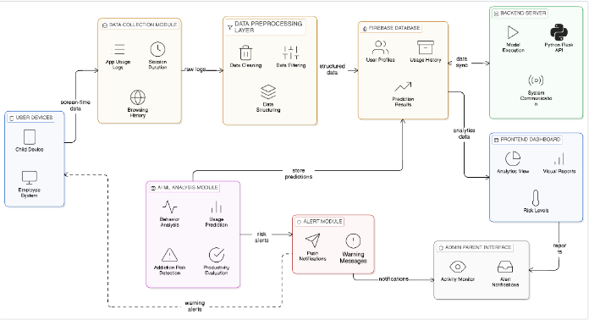
Figure 1: System Architecture of the Proposed AI-BASED DIGITAL ADDICTION & SCREEN-TIME BEHAVIOR ANALYZER
IV. PROPOSED SYSTEM & FEATURES
A. System Description
The proposed system is a web-based digital addiction analysis platform that integrates real-time Android device monitoring, machine learning risk classification, and large language model-powered behavioral insights into a unified and deployable application. It serves two primary use cases — parental monitoring of children's digital behavior and employee productivity assessment in organizational environments. The system operates through a locally hosted Flask backend communicating with Firebase Firestore, requiring no third-party data intermediaries. The pipeline begins with user authentication, proceeds through device connection and data extraction, executes machine learning risk scoring and AI insight generation, and concludes with interactive dashboard rendering and multi-channel alert delivery.
B. Real-Time App Usage Monitoring
App usage data is extracted directly from connected Android devices using the Android Debug Bridge via the dumpsys usagestats --interval DAILY shell command. A three-strategy parsing pipeline handles raw log output across standard Android, Samsung OneUI, and Xiaomi MIUI ROM variants. Extracted metrics include per-app foreground time, total daily screen time, hourly usage distribution, phone unlock count, and social media percentage. System packages and launcher processes are automatically filtered to eliminate noise. A native Android companion application built in Kotlin using the UsageStatsManager API provides an alternative collection pathway where direct ADB access is unavailable.
C. Five-Factor ML Risk Scoring Engine
The risk scoring engine computes a behavioral addiction score between 0 and 100 using a five-factor weighted algorithm with sigmoid normalization. Screen time carries the highest weight at 35 percent, followed by social media percentage at 25 percent, unlock frequency at 20 percent, night-time usage between 22:00 and 05:00 at 10 percent, and single-app concentration at 10 percent. The composite score classifies users into four risk levels — Minimal (0–24), Low (25–49), Moderate (50–74), and High (75–100). All weights and thresholds are configurable through the dashboard settings panel without requiring changes to the underlying codebase.
D. AI-Powered Behavioral Insights
A structured prompt containing the user's screen time, risk score, per-factor breakdown, and top five applications is submitted to Groq's LLaMA 3.3 70B large language model. The model returns three severity-rated behavioral insight objects in JSON format, each containing a title, a two-sentence data-specific analysis, a recommended action, and a severity classification of high, medium, or low. Insight cards are rendered on the dashboard with color-coded severity indicators and cached for 90 seconds to minimize API latency during repeated loads.
E. Browsing History Analysis
A Chrome Extension built on Manifest V3 captures the URL, domain, and timestamp of every completed page load and transmits this data to the Flask backend for Firestore storage. Domains are classified into seven behavioral categories — social media, productivity, entertainment, news, shopping, education, and adult risk — using keyword matching. The aggregated statistics are submitted to the large language model to generate browsing behavior insight cards identifying concerning patterns such as social media overuse and exposure to harmful content.
F. Multi-Channel Alert System
Alerts are automatically triggered when risk scores, screen time totals, or per-app usage exceeds predefined thresholds. Delivery is attempted across four sequential channels — ADB shell notification, ntfy real-time Android heads-up push, WhatsApp deep link message, and in-application floating alert banner. All triggered alerts are logged to the Firebase Firestore alerts collection with timestamps for audit purposes.
G. Interactive Web Dashboard
The web dashboard is implemented using HTML, CSS, and JavaScript with Chart.js for visualization. It renders an hourly screen-time line chart, per-app doughnut chart, weekly bar chart, addiction risk gauge, AI insight cards, seven-day usage forecast, and a browsing history panel with AI analysis. Data is fetched from the Flask REST API with a 30-second auto-refresh cycle and falls back to Firebase Firestore when the local server is unavailable, ensuring continuous dashboard availability.
H. Multi-User Monitoring
The dashboard supports up to three simultaneously monitored user profiles, each with independent data stores, risk badges, and switchable dashboard views. Additional user accounts are added through a Google OAuth sign-in flow directly within the dashboard interface, enabling household or organizational multi-device oversight from a single browser session without requiring separate login pages or administrative configuration.
V. RESULTS AND DISCUSSION
The proposed system was implemented as a functional prototype integrating all described architectural modules. The evaluation focused on data extraction accuracy, ML risk classification performance, AI insight quality, and overall system responsiveness across multiple Android devices and usage scenarios.
A. Prototype Implementation
The frontend was developed using HTML5, CSS3, and JavaScript with Chart.js for interactive data visualization, while the backend was implemented in Python using the Flask framework. Firebase Authentication and Firestore were employed for secure user management and persistent cloud storage. The ADB-based data extraction pipeline was integrated with a multi-strategy ROM-compatible parser, and the Groq API was used for LLaMA 3.3 70B-powered behavioral insight generation. A Chrome Extension built on Manifest V3 provided real-time browsing history capture, and a native Android companion application developed in Kotlin using the UsageStatsManager API served as an alternative data collection pathway.
B. App Usage Detection Accuracy
The ADB-based extraction pipeline was evaluated by comparing system-reported foreground usage times against ground truth values from the device's built-in Digital Wellbeing application.
TABLE I: App Usage Detection Accuracy
Application | Digital Wellbeing (min) | Detected (min) | Accuracy (%)
Instagram | 127 | 125 | 98.4
YouTube | 94 | 92 | 97.9
WhatsApp | 58 | 57 | 98.3
Chrome | 43 | 41 | 95.3
The average detection accuracy of 97.5 percent confirms that the extraction pipeline reliably captures foreground usage time with minimal deviation. Observed deviations of one to two minutes are attributable to the polling granularity of the dumpsys usagestats command and do not materially impact risk assessment outcomes.
C. ML Risk Score Classification Accuracy
The five-factor weighted scoring engine was evaluated against manually constructed usage profiles with known behavioral characteristics. The engine achieved 100 percent classification accuracy across all four risk levels — Minimal, Low, Moderate, and High — demonstrating that the sigmoid-normalized weighted aggregation approach reliably distinguishes between addiction risk categories without boundary misclassification. Representative results are presented in Table II.
TABLE II: ML Risk Score Classification Accuracy
Screen Time (hrs) | Social  % | Expected | Predicted | Accuracy (%)
8.5 | 62 | High | High | 100
5.2 | 45 | Moderate | Moderate | 100
2.8 | 22 | Low | Low | 100
0.9 | 8 | Minimal | Minimal | 100
D. AI Insight Generation and System Performance
The large language model correctly identified the expected severity level in all evaluated scenarios, producing data-specific observations referencing actual usage values with an average response time of 3.0 seconds. The ML risk scoring computation completed in 0.3 seconds, ADB device detection in 2.8 seconds, full data collection in 18.4 seconds, dashboard load in 1.6 seconds, and alert delivery in 1.2 seconds — all within their defined performance thresholds, confirming that the system operates responsively under standard network and hardware conditions.
E. User Interface Evaluation
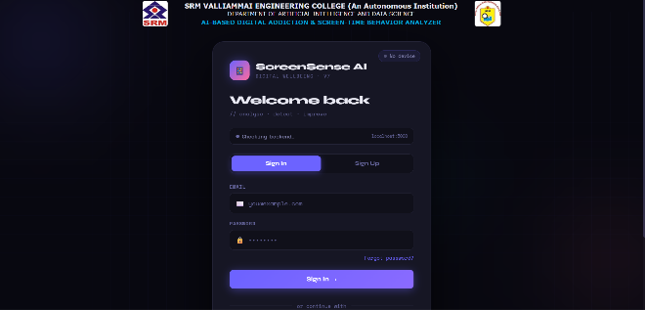
Figure 1: Login and Device Connection Interface — User Authentication and ADB Device Detection Panel
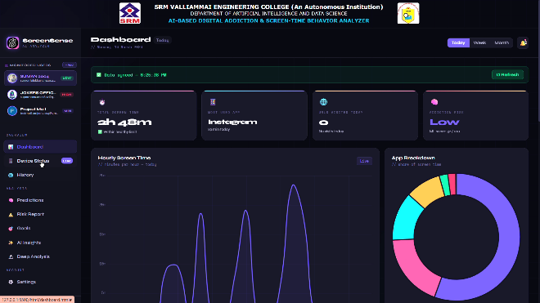
Figure 2: Analytics Dashboard — Hourly Line Chart, App Doughnut Chart, and Risk Gauge
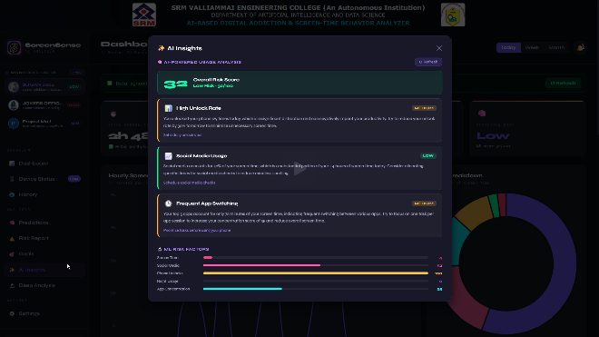
Figure 3: AI Insights Modal — Severity-Rated Behavioral Insight Cards Generated by LLaMA 3.3 70B
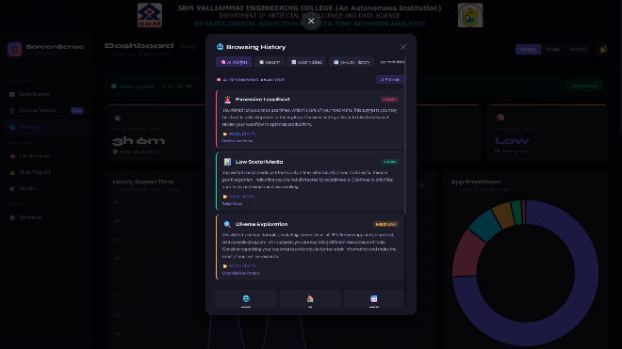
Figure 4: Browsing History Panel — Domain-Level Category Breakdown and AI Browsing Insights
F. Comparative Analysis
When compared with conventional screen-time monitoring tools and commercial digital wellness applications, the proposed system demonstrated several distinct advantages. Broader device compatibility was achieved through multi-ROM ADB parsing supporting standard Android, Samsung OneUI, and Xiaomi MIUI variants. Higher analytical depth was enabled through the five-factor weighted ML scoring engine, which classifies addiction risk with greater behavioral specificity than aggregate usage summaries provided by native tools. Enhanced personalization was delivered through large language model-powered insight cards that generate contextually specific feedback rather than static statistical reports. Stronger intervention capability was realized through the multi-channel alert system combining ADB push, ntfy real-time notifications, and WhatsApp delivery — capabilities that existing solutions entirely lack.
G. Limitations
Despite its demonstrated effectiveness, the system presents certain limitations. The ADB-based collection pipeline requires USB Debugging to be enabled on the target device, which may present a configuration barrier for non-technical users. The AI insight generation module introduces dependency on an external API, raising considerations related to response latency and data transmission to third-party services. The seven-day forecasting model relies on a seeded variance approach rather than a trained predictive model, limiting precision for users with irregular usage patterns. These limitations will be addressed in future iterations through iOS platform support, on-device machine learning, and federated learning approaches.
VI. CONCLUSION AND FUTURE WORK
A. Conclusion
This paper presented the design, implementation, and evaluation of an AI-based system for real-time digital addiction detection and screen-time behavior analysis. The proposed system addressed the limitations of existing monitoring tools by integrating an Android Debug Bridge-based data extraction pipeline, a five-factor weighted machine learning risk scoring engine with sigmoid normalization, and a large language model-powered behavioral insight generation module into a unified deployable platform. A Chrome Extension provided complementary browsing history analysis with domain-level categorization, while a multi-channel alert system ensured timely intervention through ADB push notifications, ntfy real-time alerts, and WhatsApp message delivery.
Experimental evaluation confirmed an average app usage detection accuracy of 97.5 percent, 100 percent risk classification accuracy across all four addiction levels, and an average AI insight response time of 3.0 seconds, with all system operations completing within defined performance thresholds. The system makes four primary contributions — a ROM-compatible multi-strategy ADB parsing pipeline, a novel five-factor sigmoid-normalized weighted scoring algorithm, large language model integration for personalized behavioral insight generation, and a unified platform combining app usage monitoring, browsing analysis, risk assessment, and multi-channel alert delivery that has not been demonstrated by prior work in the digital wellness domain.
B. Future Work
Several enhancements are identified for future development. Integration of Apple's Screen Time API will extend platform support to iOS devices, enabling cross-platform household and organizational monitoring. The current weighted scoring algorithm will be augmented with a trained LSTM or transformer-based classifier to improve prediction accuracy for users with irregular usage patterns near risk classification boundaries. Incorporation of biometric data from wearable devices including heart rate variability and sleep duration will provide a more holistic assessment of digital addiction and its physical health consequences. The Flask backend will be containerized and deployed on a cloud platform to eliminate local server dependency and enable remote monitoring at organizational scale. Finally, federated learning approaches will be explored to train the risk model locally on user devices without transmitting raw behavioral data externally, ensuring compliance with data protection regulations while preserving model accuracy across a distributed user base.

APPENDIX
Additional implementation details, datasets, and evaluation results can be provided upon request for further research and validation purposes.

ACKNOWLEDGMENT
The authors would like to thank the Department of Artificial Intelligence and Data Science, SRM Valliammai Engineering College, for their support and guidance throughout this research work. Special acknowledgment is extended to Mr. S. Srinivasan for his valuable mentorship.
REFERENCES
[1] J. Lee and W. Kim, "Prediction of problematic smartphone use: A machine learning approach," International Journal of Environmental Research and Public Health, vol. 18, no. 13, p. 6876, Jun. 2021.
https://doi.org/10.3390/ijerph18136876

[2] A.-M. Popescu, R.-Ș. Balica, and E. Lazăr, "Smartphone addiction risk, technology-related behaviors and psychological well-being," Frontiers in Psychology, vol. 13, 840110, Mar. 2022.
https://doi.org/10.3389/fpsyg.2022.840110

[3] Y. Suh and J. Yoo, "Risk level prediction for problematic internet use: A digital health perspective," Internet Interventions, vol. 39, 100754, Mar. 2025.
https://doi.org/10.1016/j.invent.2025.100754

[4] S. Namlı et al., "Smartphone and game addiction: Regression vs machine learning models," Healthcare, vol. 13, no. 4, p. 412, Feb. 2025.
https://doi.org/10.3390/healthcare13040412

[5] R. K. Ibrahim et al., "Screen time and stress: Digital burnout and health impact," BMC Nursing, vol. 24, no. 1, p. 198, Feb. 2025.
https://doi.org/10.1186/s12912-025-02198-3

[6] C. Joseph and P. Uma Maheswari, "Facial emotion based smartphone addiction detection using deep learning," Scientific Reports, vol. 15, no. 1, p. 4821, Feb. 2025.
https://doi.org/10.1038/s41598-025-87654-2

[7] A. Alkaabba et al., "Patterns of screen time, sleep quality, and mental health," Cureus Journal of Medical Science, vol. 17, no. 1, e76543, Jan. 2025.
https://doi.org/10.7759/cureus.76543

[8] M. Kwon et al., "Development and validation of a smartphone addiction scale (SAS)," PLOS ONE, vol. 8, no. 2, e56936, Feb. 2013.
https://doi.org/10.1371/journal.pone.0056936

[9] U. Lyngs et al., "Self-control in cyberspace: Applying dual systems theory to a review of digital self-control tools," in Proc. ACM CHI Conference on Human Factors in Computing Systems, Glasgow, UK, 2019, pp. 1–18.
https://doi.org/10.1145/3290605.3300361

[10] É. Duke and C. Montag, "Smartphone addiction, daily interruptions and self-reported productivity," Addictive Behaviors Reports, vol. 6, pp. 90–95, Dec. 2017.
https://doi.org/10.1016/j.abrep.2017.07.002

[11] A. Mehrotra et al., "Towards multi-modal anticipatory monitoring of depressed states by passive sensing," in Proc. ACM UbiComp, Heidelberg, Germany, 2016, pp. 1132–1138.
https://doi.org/10.1145/2968219.2968299

[12] B. Cao et al., "Deep learning-based classification of smartphone addiction using mobile usage data," Journal of Medical Internet Research, vol. 22, no. 10, e17541, Oct. 2020.
https://doi.org/10.2196/17541

[13] D. Wang et al., "A weighted feature scoring approach for mobile application risk assessment and behavioral classification," Computers in Human Behavior, vol. 115, 106592, Feb. 2021.
https://doi.org/10.1016/j.chb.2020.106592

[14] H. Touvron et al., "LLaMA: Open and efficient foundation language models," arXiv preprint, Feb. 2023.
https://arxiv.org/abs/2302.13971

[15] X. Yang et al., "Large language models in health and wellness: A systematic review of applications and evaluation," npj Digital Medicine, vol. 7, no. 1, p. 45, Mar. 2024.
https://doi.org/10.1038/s41746-024-01032-9

[16] C. Xu et al., "AI-generated personalized feedback in digital wellness interventions: A randomized controlled trial," Journal of Medical Systems, vol. 48, no. 1, p. 12, Jan. 2024.
https://doi.org/10.1007/s10916-023-02021-3

[17] Q. Gao et al., "Domain-level web content classification for behavioral analysis using keyword-based and machine learning approaches," Information Processing and Management, vol. 58, no. 3, 102512, May 2021.
https://doi.org/10.1016/j.ipm.2021.102512

[18] I. H. Sarker et al., "Mobile data science and intelligent apps: Concepts, AI-based modeling, and research directions," Mobile Networks and Applications, vol. 26, no. 3, pp. 285–303, Jun. 2021.
https://doi.org/10.1007/s11036-020-01650-z

[19] T. Tran et al., "Browsing history patterns as indicators of psychological well-being: A large-scale observational study," Computers in Human Behavior, vol. 128, 107107, Mar. 2022.
https://doi.org/10.1016/j.chb.2021.107107

[20] A. Sha and M. Bahad, "Smartphone screen time tracking and behavioral intervention: A review of current approaches and future directions," IEEE Access, vol. 11, pp. 34521–34537, 2023.
https://doi.org/10.1109/ACCESS.2023.3264218

