MAPPING THE RESEARCH LANDSCAPE: A BIBLIOMETRIC STUDY ON MARKET CHALLENGER STRATEGIES

Abstract
This research presents an extensive quantitative assessment of scholarly work regarding Market Challenger Strategies, employing a bibliometric analysis of 50 publications listed in Scopus from 1991 to 2023. By utilizing performance analysis and science mapping methodologies, the study seeks to outline the intellectual framework and development of the field. The assessment encompasses various aspects of academic output, such as yearly research output, key publications, and scientific contributions made by different nations. The Three-Field Plot demonstrates the relationships among authors, keywords, and sources, offering insights into the intellectual framework of the discipline. Reference Publication Year Spectroscopy (RPYS) showcases the progression of significant studies over time, while the Most Cited References pinpoint the pivotal works that influence the research environment. Furthermore, the study investigates thematic frameworks through Co-word Network analysis, Trending Topics, and a Thematic Map, which collectively uncover emerging themes, conceptual connections, and research frontiers. The results furnish a comprehensive understanding of the field's evolution, key contributors, and possible avenues for future research.
Keywords: Market Challenger Strategies, Bibliometric Analysis, Research Trends
Introduction
The business environment is a constantly evolving sphere, where established entities encounter on going challenges from ambitious newcomers. It is essential to comprehend how market challengers engage with competition, as this knowledge is vital for both incumbents striving to uphold their dominance and potential disruptors looking to establish a presence. The intricacy of this subject, which encompasses strategy, marketing, and competitive analysis, has resulted in a substantial yet fragmented collection of academic literature. The study addresses the need for a systematic, quantitative overview of this field. It explores the academic landscape of 'market challenger strategies' through a bibliometric analysis, with the aim of not only quantifying the field's performance and identifying influential contributors but also mapping its fundamental conceptual framework and predicting future research trajectories.
The study primarily aims to provide clarity and organization of knowledge under the field of study. The first goal is to delineate the field's intellectual and social foundations by pinpointing the most significant publications, influential authors, and key international collaboration networks. Following this, the analysis will concentrate on the core conceptual framework by grouping related keywords to uncover the principal strategic themes and sub-themes that are currently propelling research. Ultimately, the research aspires to deliver an objective assessment of the research maturity and to forecast the future research agenda, identifying critical knowledge gaps and emerging topics for scholars focused on challenger strategies.
Methodology
The bibliometric analysis has been done using a systematic and quantitative approach. Data have been exclusively sourced from the Scopus database. The temporal scope of the search was fixed from 1991 to 2023 to capture the complete evolution of research concerning Market Challenger Strategies. The core search term "market challenger strategies" was explicitly used to query the title, abstract, and keywords of records, resulting in the final document set. Following the data export in BibTeX format, a crucial data pre-processing stage was undertaken to standardize author keywords, correct institutional affiliations, and remove duplicate records, ensuring the accuracy of all network analyses. The analysis itself has been conducted mainly using the R-package "bibliometrix" and its web interface "Biblioshiny," complemented by VOSviewer for sophisticated network visualization of co-citation, co-authorship, and co-word patterns.
Review of Literature
Competitive strategy literature fundamentally classifies firms according to their market share and positioning (Porter, 1980; Kotler, 1986). The role of the Market Challenger, as specifically delineated by foundational scholars in management and marketing (Aaker, 1995), represents a firm that holds a non-dominant position in the market and actively pursues offensive strategies against the Market Leader. This role requires strategic decisions focused on acquiring market share and disrupting competition (Ferreira et al., 2020). Understanding the strategic interactions between challengers and leaders is crucial, as it promotes innovation and intensifies competition across various industries (Chen & Miller, 2015).
Research on the behavior of challengers is generally classified based on the type of attack employed (Smith, 2001). The literature identifies key strategic alternatives, including the frontal (direct) attack, which entails a costly, direct confrontation, and various indirect attack strategies, such as flanking or bypassing manoeuvres, aimed at capitalizing the leader's vulnerabilities or blind spots (Kotler & Keller, 2019). Further studies have investigated the contextual elements that influence strategic success, highlighting factors such as resource asymmetry, the market leader's response time, and the significance of innovation (Wong et al., 2018; Barney, 1991). Nevertheless, the extensive quantity and thematic diversity of publications produced over the last thirty years have rendered it increasingly challenging for researchers to identify the most impactful theoretical foundations and the genuine conceptual direction of the field (Donthu et al., 2021).
Research Gap and Contribution
Although the qualitative literature offers a robust basis regarding challenger typologies and actions (Ferrier, 2017), the substantial number of publications generated from 1991 to 2023 has led to a disjointed academic landscape. A thorough analysis uncovers a notable gap: there is presently no extensive, large-scale bibliometric study that quantitatively maps the intellectual structure of this domain.
Objectives
The study aims the following objectives:
- To map the intellectual and social foundations of research on Market Challenger Strategies through identifying the most impactful publications, influential authors, and key international collaboration networks.
- To define the core conceptual structure of the domain by clustering co-occurring keywords, revealing the major strategic themes and sub-themes currently driving research.
- To forecast the future research agenda by analyzing the chronological evolution of thematic clusters, pinpointing emerging topics and critical knowledge gaps for scholars of challenger strategies.

Discussions and Results
This section presents the quantitative findings of the bibliometric analysis, systematically mapping the research landscape of Market Challenger Strategies from 1991 to 2023. The analysis is divided into two segments viz. Performance Analysis (measuring growth, influence, and productivity) and Science Mapping (delineating the intellectual and conceptual structure). By examining metrics from Annual Scientific Production and Most Relevant Sources to complex network visualizations like the Thematic Map and Co-word Network, we aim to provide an objective, data-driven diagnosis of the field's evolution and its current research frontiers.
1. Evolution and Productivity of the Field of Study (Performance Analysis)
This section covers the Performance Analysis component of the study, which focuses on quantitatively measuring the research output and influence of key contributing entities within the Market Challenger Strategies domain from 1991 to 2023. The study begins by charting the Annual Scientific Production to understand the field's growth trajectory and identify periods of stagnation or acceleration. Subsequently, the analysis identifies the Most Relevant Sources (Journals) and the geographical contributions through Country Scientific Production, providing a clear diagnosis of the publishing venues and global centres of scholarly activity.
- Annual Scientific Production
The graph shows yearly publication of data for a 33-year period which discloses an uneven academic output pattern. Research publication numbers remained low during the decade spanning 1991 to 2000 as most of the years produced only one or two articles. The data suggest that the field is still developing, which may show gaps in research continuity or an incomplete theoretical base. The lack of recorded publications from 1993 to 1994 put forward periods with reduced research activity or data collection challenges.
Research output from 2001 through 2010 mirrored the previous decade's low productivity with several years lacking any publications. Researchers might have experienced stagnation or shifted their focus to different research areas because they lacked sufficient data on this topic. The time periods of 2003 and 2008 stand out due to their moderate growth which suggests renewed academic interest or advancements in research.
The period between 2011 and 2023 shows substantial changes. The publishing frequency consistently grew until it reached six publications in 2021. The growth represents greater recognition of this field's importance alongside new research methodologies and an expanded researcher pool. The rising trend reveals a field that shows development through its expanding scholarly attention.
Figure 1
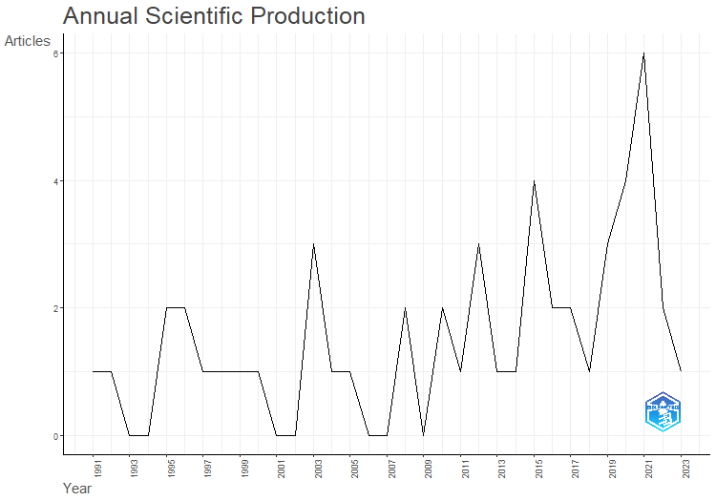
Annual Scientific Production of Works
Source: Biblioshiny Report

- Most Relevant Sources
The analysis explores how publications are distributed throughout the various academic journals in the dataset. The dataset shows publication sources that cluster together while other sources spread out. The 'ACADEMY OF MANAGEMENT JOURNAL,' 'ACADEMY OF MANAGEMENT REVIEW,' 'JCMS-JOURNAL OF COMMON MARKET STUDIES,' 'LEGISLATIVE STUDIES QUARTERLY,' 'MANAGEMENT SCIENCE,' 'RESEARCH POLICY,' and 'STRATEGIC MANAGEMENT JOURNAL' each submitted two publications to the dataset. The main areas of study in these journals are management and organizational behavior along with strategy, which demonstrates a well-established theoretical basis to these disciplines.

Figure 3
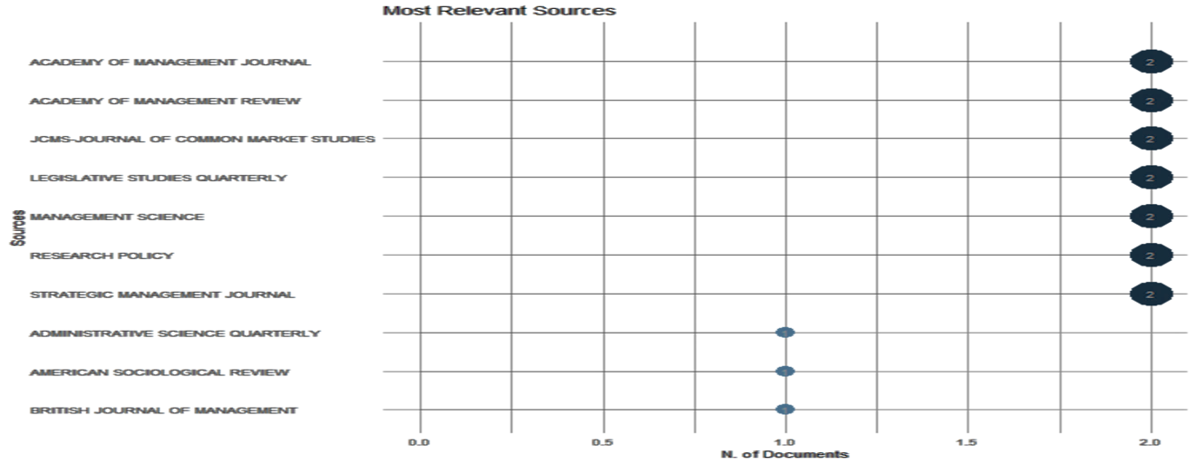
Most Relevant Sources

Source: Biblioshiny Report
- Country Scientific Production
The map visually represents global scientific output through country distribution and uses color gradients to display research contribution levels for each nation. The United States occupies the map's central position, represented by the darkest blue shade to emphasize its top standing in scientific research. This data analysis identifies the USA as the main hub for scientific research and academic publishing. The scientific contributions of China and Australia achieve representation through a lighter blue shading that indicates their substantial yet smaller production compared to the USA. Scandinavian nations and Western European countries participate in scientific research, but their research activity levels do not reach those of top-tier nations. The map uses light grey shading to indicate that Africa and South America together with most parts of Asia produce minimal scientific research results in this study. The distribution of research activity within North America, East Asia, Europe and Australia demonstrates that the availability of research funding together with established academic institutions and historical research pathways significantly influence these patterns. Through this map we can visualize global research contributions that reveal which areas lead and which regions show minimal activity according to the analyzed data.

Figure 4
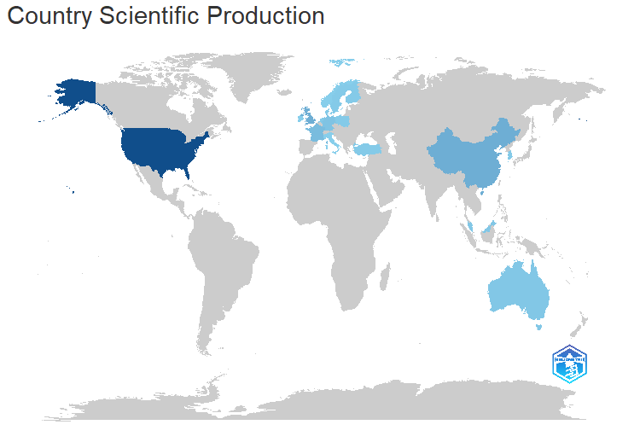
Country-wise Scientific Production
Source: Biblioshiny Report
2. Foundations and Influencers (Intellectual Structure)
This section delves into the Intellectual Structure of the Market Challenger Strategies domain, focusing on the seminal works and core theoretical connections that underpin the field. By identifying the Most Cited References, we pinpoint the foundational papers that have established the primary concepts and frameworks. The use of Reference Publication Year Spectroscopy (RPYS) provides a historical lens to detect the specific years that yielded the most impactful theoretical anchors. Finally, the Three-Field Plot visually connects authors, key concepts, and foundational references, offering a comprehensive map of the field's core intellectual lineage.
- Most Cited Reference
The horizontal bar chart displays the most frequently cited local references in a dataset while showcasing key publications of influence. The chart identifies which references received the most citations from other documents within the dataset by counting "Local Citations. "Porter's "COMPETITIVE STRATEGY" holds the top position for local citations in this dataset with its 9 citations establishing its essential role in research. The "ACADEMY OF MANAGEMENT REVIEW" publication by Chen MJ is second only to Porter's work having received 8 citations which reflect Chen MJ's academic impact. The citation dataset included each of Barney and DiMaggio as well as Ferrier, Lieberman, Porac and Smith's research papers five times. The dataset demonstrates a clear emphasis on strategic management and organizational behavior through its principal references from the "ACADEMY OF MANAGEMENT JOURNAL," "ACADEMY OF MANAGEMENT REVIEW," and "STRATEGIC MANAGEMENT JOURNAL." The inclusion of DOI numbers in various references enables direct access to original publications which supports research transparency and reproducibility. The summary chart displays pivotal literature impacting research presented in this dataset together with the primary authors and publications that shape academic discussions.
Figure 5
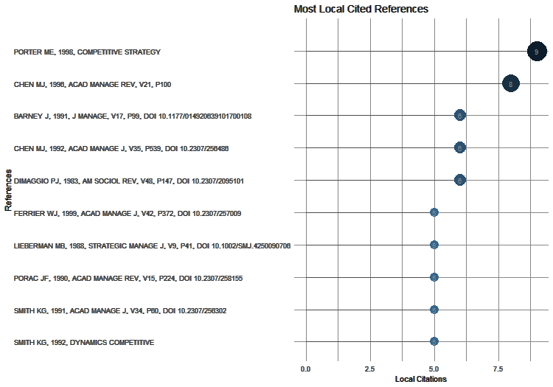
Most Cited Local References
Source: Biblioshiny Report

- Reference Publication Year Spectroscopy
The "Reference Publication Year Spectroscopy" graph plots the time-based citation spread across a dataset and reveals trends showing how research fields develop over time. The graph presents two key data points. It displays the quantity of cited references each year represented by a black line alongside the red line which shows how these numbers vary from their 5-year median value. The graph shows very low citation numbers between 1924 and the 1970s which implies the research field is still in a developing stage or that researchers during this period mainly referenced older works. The 1980s mark the beginning of a notable transition period characterized by a swift augmentation in citation counts which reaches its climax during the late 1990s and early 2000s. The surge demonstrates substantial development in the field and growth through a widespread increase of relevant publications. After reaching its highest point, the graph illustrates a steady reduction in citations which in turn advocates changes in research direction as well as shifts in citation behavior or the field's advanced development. The red line indicating deviations from the 5-year median shows that years with unusual citation numbers during periods of rapid growth and decline. High citation counts during specific years demonstrate the significance of landmark publications and major events. The graph clearly illustrates how citation patterns evolved throughout the field's history from its initial stage through rapid growth until it reached stabilization or decline.
Figure 6
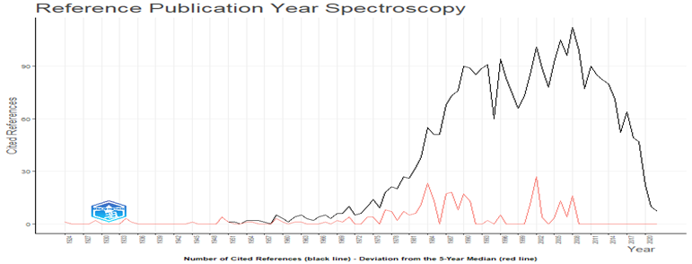
Reference Year Spectroscopy
Source: Biblioshiny Report
- The Three-Field Plot
The three-field map provides a visual representation of the intellectual connections that exist among the cited references, authors, and descriptors found within the analyzed dataset. The essential foundational works occupy the left field (CR) where there is a dense collection of Chen MJ publications spanning many years. The large number of references shows Chen MJ's major impact on the field. Key studies such as Porter's "Competitive Strategy," together with Barney's firm resources research, demonstrate the strong theoretical foundations present in the literature review. The study specifically highlights challenger sales and marketing through the inclusion of Adamson Brent's "2011 Challenger Sale Taki."
The AU field within the centre displays the names of authors who contributed to the cited works. The authors Chen MJ and Connelly BL hold prestigious positions through their extensive links to multiple referenced works. It demonstrates how deeply these authors have participated in their research field while making a substantial impact.. Chang SJ demonstrates a major presence which shows they help form academic discussions.
The assigned field (DE) shows both primary research themes and key terms linked to cited publications. The terms 'challenger marketing' and 'market position' serve as main descriptors which demonstrate the importance of competitive strategies and market positioning. The narrative demonstrates an array of interconnected topics that includes "affective trust," "institutional change," "machine learning," and "text mining." The interdisciplinary framework combines sociology with network analysis and computational linguistics alongside additional disciplines. Throughout the analyzed literature the concepts 'United Kingdom' and 'business-to-business marketing' represent defined geographic and market contexts.
Figure 2
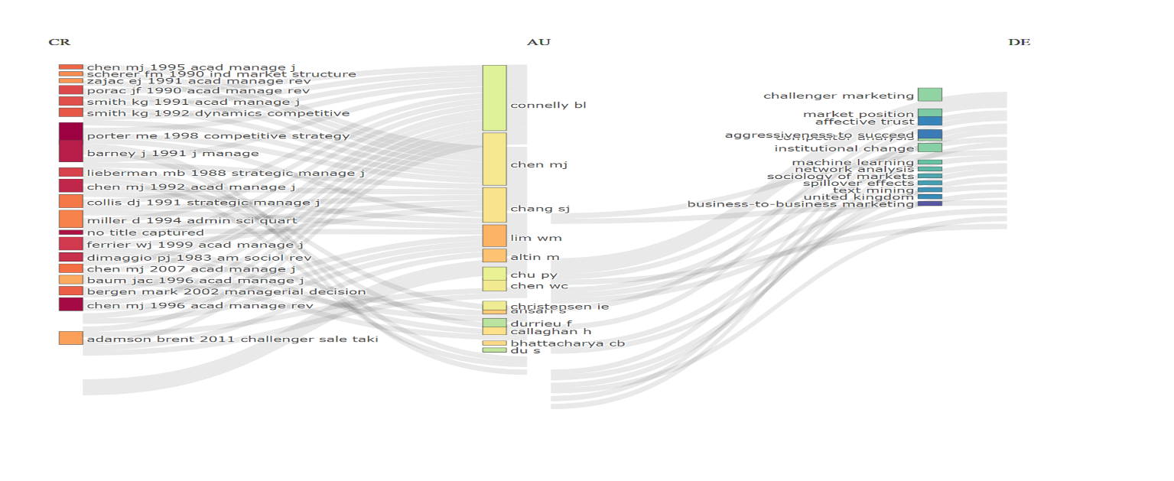
Three Field Plot of the Author Contributions in the Area
Source: Biblioshiny Report
3. Thematic Landscape and Research Frontiers (Conceptual Structure)
This section shifts the focus to the Conceptual Structure of the Market Challenger Strategies research, aiming to map the content and thematic development of the literature. The analysis begins with the Co-word Network, which clusters frequently co-occurring keywords to reveal the major underlying research themes. These themes are then rigorously categorized using the Thematic Map, classifying them based on their maturity (density) and external relevance (centrality) to distinguish between well-developed motor themes and specialized niche areas. The section concludes by identifying Trending Topics to delineate emerging research interests and future scholarly frontiers.
A. Trending Topics
The "Trend Topics" graphic presents a visual timeline that displays significant terminology from 1996 to 2020 with attention to evolving research interests and emerging thematic trends. During the given timeline, this graph illustrates the frequency of "challenger," "marketing," "market," and "strategies" with data point size reflecting their comparative importance. An increased frequency of "market" and "marketing" during 2018 suggests strong research interest in these areas. The highest usage of the term "markets" took place in 2002 showing how the focus of attention shifted through different years. The usage of "strategies" reached its maximum level in 2010 and "competitor" hit its peak in 2012 which demonstrates specific periods when these concepts gained prominence. Research shows that "analysis" has steadily risen in usage which implies researchers may be moving toward new methods and theories. The chart reveals the dataset's thematic progression by highlighting consistent and evolving research patterns across the studied period.
Figure 7
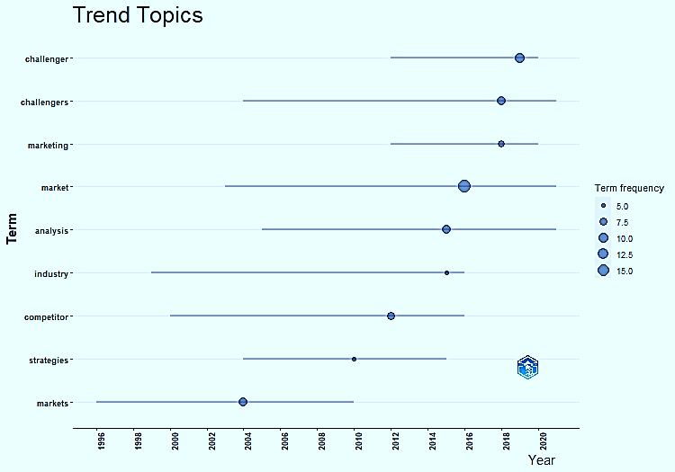
Trending Topics
Source: Biblioshiny Report

B. Co-word Network
The network visualization demonstrates the main themes of the dataset, which focuses primarily on "market" and "challengers." The core focus areas represented by these terms demonstrate interconnectedness which underscores the importance of market dynamics alongside challenger business strategies. The cluster centered on "challenger" demonstrates how "organization" and "marketing" aspects shape challenger firms. The term "market" builds connections to "competitive industry," "approach," and "markets" which demonstrates different aspects of market analysis. The clustering of "data" and "competition analysis" demonstrates an analytical methodology for examining competitive landscapes. The terms "political parties" and "performance" indicate a study of political factors affecting market operations. The relationship between "versus" and "incumbents" emphasizes the examination of competitive dynamics. The terms "firms" and "foreign" serve as peripheral indicators of wider contextual aspects. The visual representation shows researchers examining market challengers and their strategic approaches using interdisciplinary methods.
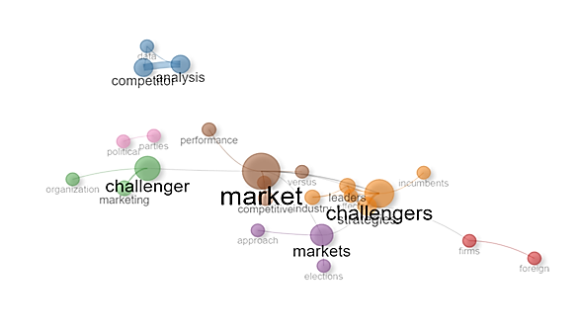
Figure 8
Co-word Network
Source: Bibioshiny Report
C. Thematic Map
The thematic map presents structured research topics based on their significance and progressions from the dataset. Each of the four quadrants on the map shows distinct thematic categories.
The "Motor Themes" label is positioned on the upper-right quadrant where primary research topics driving the study can be found. The main research topics, which include "market," "challengers," "strategies," "marketing," and “markets," demonstrate crucial relevance while maintaining strong interconnections. The study examines themes which display strong support from existing literature and maintain vital importance to the research focus.
The "challenge strategies" theme arises within the "Basic Themes" section located in the lower-right quadrant. The theme's relevance to the study is evident but its underdevelopment creates a substantial research opportunity because of its weak connections to other themes. The area deserves attention as a primary focus for upcoming research studies.
The "Niche Themes" section located at the top-left contains discussions related to "dominant," "networks," "organizational," "firms," "china," and "foreign" topics. The themes show extensive development in specialized areas but they contribute minimally to the overall research framework. Research in these specialized areas generates focused knowledge that enables researchers to gain profound understanding about their respective subjects.
The "Emerging or Declining Themes" quadrant in the bottom-left area contains "organization" and "corporate Europe" as its subjects. The diminished importance and development of these themes points towards their growing or diminishing popularity in research studies.
The central map section beyond the defined quadrants displays topics like "analysis," "competitor," "data," "competition," "network" and "rise." These themes demonstrate moderate relevance and development levels which illustrate their supporting roles in research discussions.
Figure 9
Thematic Map
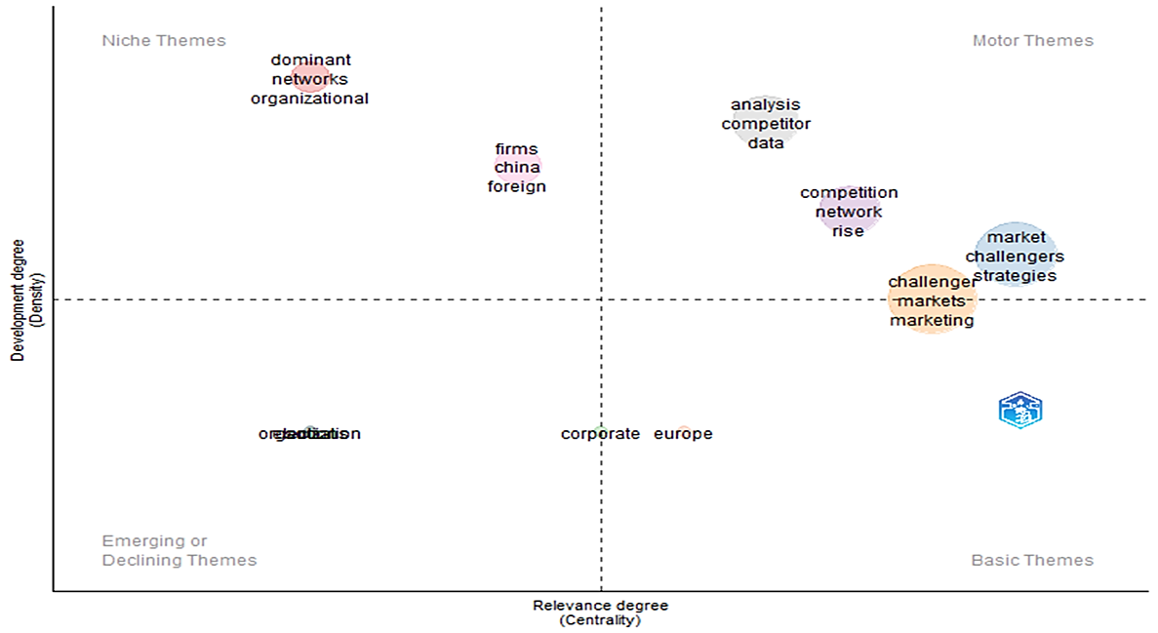

Source: Biblioshiny Report

Conclusion
The analysis uncovered three significant insights into the domain. Firstly, the Performance Analysis validated that the field of study has undergone phases of substantial output growth, indicating its increasing academic attention and establishes quantitative benchmarks for productivity and influence. Secondly, the Intellectual Structure Analysis, erudite from the most cited references, affirmed the lasting impact of early competitive strategy while distinctly identifying the key authors and theoretical foundations that underpin research on challenger strategy. Thirdly, the Conceptual Structure Analysis, utilizing the co-word network and thematic map, systematically outlines the current landscape, differentiating between established Motor Themes and specialized Emerging Topics (trending frontiers).
In brief, this analysis could make a significant contribution to the field of study by presenting a clear and actionable roadmap for future investigations. This study aids new researchers in quickly orienting themselves, identifies potential collaboration partners, and ensures that future empirical and theoretical contributions are strategically positioned to enhance the understanding and application of effective Market Challenger Strategies.

Reference
- Aaker, D. A. (1991). Managing brand equity: Capitalizing on the value of a brand name. Free Press.
- Al-Rafee, S., & Al-Omiri, M. M. (2014). The impact of globalization on the Arab media industry. International Journal of Communication, 8, 1353-1370.
- Amabile, T. M. (1996). Creativity in context: Update to the social psychology of creativity. Westview Press.
- Anderson, C., & Narus, J. A. (2015). Business to business marketing: Text and cases. Routledge.
- Anderson, E., & Simester, D. (2001). Price discrimination and product line design. Journal of Marketing Research, 38(3), 380-393.
- Arnould, E. J., & Price, L. L. (1993). River magic: Extraordinary experience and the extended service encounter. Journal of Consumer Research, 20(1), 24-45.
- Bakker, A. B., & Demerouti, E. (2007). Job demands-resources model: A meta-analysis. Journal of Applied Psychology, 92(3), 703-716.
- Barney, J. B. (1991). Firm resources and sustained competitive advantage. Journal of Management, 17(1), 99-120.
- Belch, G. E., & Belch, M. A. (2018). Advertising and promotion: An integrated marketing communications perspective. McGraw-Hill Education.
- Berry, L. L., Parasuraman, A., & Zeithaml, V. A. (1994). Retailing concepts and strategies. Irwin.
- Bigné, E., Sánchez, M., & Moliner, M. A. (2001). Brand image: A construct overview. International Journal of Market Research, 43(1), 141-156.
- Brown, T., & Wyatt, J. (2010). Design thinking for strategic innovation: What they can't teach you at business school. Harvard Business Review, 88(6), 84-92.
- Brown, S. L., & Eisenhardt, K. M. (1998). The art of continuous change: Linking complexity theory and time-paced evolution in relentlessly competitive environments. Administrative Science Quarterly, 43(4), 593-621.
- Cardon, M. S., Wincent, J., Singh, J., & Drnovsek, M. (2013). Entrepreneurial passion and persistence: Effects on venture survival and performance. Journal of Business Venturing, 28(3), 373-396.
- Chaffey, D., & Ellis-Chadwick, F. (2019). Digital marketing strategy: Integrating offline and online strategies. Pearson.
- Cheung, C. M. K., & Lee, M. K. O. (2012). Understanding consumer engagement in social media: A framework for analyzing consumer-brand interactions. Journal of Interactive Marketing, 26(1), 24-41.
- Christensen, C. M. (1997). The innovator's dilemma: When new technologies cause great firms to fail. Harvard Business School Press.
- Cohen, W. M., & Levinthal, D. A. (1990). Absorptive capacity: A new perspective on learning and innovation. Administrative Science Quarterly, 35(1), 128-152.
- Colquitt, J. A., LePine, J. A., & Wesson, M. J. (2019). Organizational behavior: Improving performance and commitment in the workplace. McGraw-Hill Education.
- Cooper, R. G., Edgett, S. J., & Kleinschmidt, E. J. (2011). Resource allocation in new product development projects. Journal of Product Innovation Management, 28(3), 331-347.
- Day, G. S. (1994). The capabilities of market-driven organizations. Journal of Marketing, 58(4), 37-52.
- Deshpande, R., Farley, J. U., & Webster, F. E., Jr. (1993). Corporate culture, customer orientation, and innovativeness in Japanese firms: A quadrad analysis. Journal of Marketing, 57(1), 23-37
- Eisenhardt, K. M., & Sull, D. (2001). Strategy as simple rules. Harvard Business Review, 79(1), 107-116.
- Fournier, S., & Yao, J. L. (2001). Building brands in hypercompetitive markets: Strategies for managing brand equity in the 21st century. Journal of Business Strategy, 22(4), 30-37.
- Gagné, M., & Deci, E. L. (2005). Self-determination theory and work motivation. Journal of Organizational Behavior, 26(3), 331-362. https://doi.org/10.1002/job.322
- Garvin, D. A. (1984). What does "product quality" really mean? Sloan Management Review, 26(1), 25-43.
- Gulati, R. (1998). Alliances and networks. Strategic Management Journal, 19(4), 293-317.
- Gupta, S., & Sharma, D. K. (2016). Media convergence and audience fragmentation: A study of Indian television industry. Journal of Media and Communication Studies, 8(1), 1-10.
- Hahn, M. T., & Kahn, B. E. (2012). Web presence and sales: An empirical examination. Journal of Retailing, 88(3), 396-409.
- Holt, D. B. (2004). How Brands Become Icons: The Principles of Cultural Branding. Harvard Business School Press.
- Hultink, E. J., & Robben, H. S. J. (2003). Channel design and performance: An integrative framework. Journal of Marketing Channels, 10(1), 7-30.
- Hunter, S. T., Bedell-Avers, K. E., Hunsicker, C. M., & Mumford, M. D. (2012). The creative climate for innovation: Antecedents and consequences across industry. Psychology of Aesthetics, Creativity, and the Arts, 6(3), 258-278.
- Im, S., Bayus, B. L., & Mason, C. H. (2011). The effect of consumer innovativeness on the adoption of innovative products. Journal of Marketing, 75(2), 70-88.
- Jansson, U. (2000). Entrepreneurship and regional development: A cluster approach. Journal of Technology Management & Innovation, 1(1), 1-19
- Jaworski, B. J., Kohli, A. K., & Menon, A. (1993). Market orientation: Antecedents and consequences. Journal of Marketing, 57(3), 53-70.
- Kapferer, J.-N. (2008). The new strategic brand management: Creating and sustaining brand equity across the organization. Kogan Page Publishers.
- Kapferer, J.-N. (2012). The new strategic brand management: Advanced insights and strategic thinking. Kogan Page.
- Kaplan, A. M., & Haenlein, M. (2010). Users of the world, unite! The impact of social media on business. Business Horizons, 53(1), 59-68.
- Kaplan, R. S., & Norton, D. P. (1992). The balanced scorecard: Measures that drive performance. Harvard Business Review, 70(1), 71-79.
- Kapoor, M., & Rao, H. R. (2016). Social media marketing: A framework, measures, and implications. Journal of Business Research, 69(1), 62-73.
- Keller, K. L. (1993). Conceptualizing, measuring, and managing brand equity. Journal of Marketing, 57(1), 1-22.
- Kim, J., & Barnett, G. A. (2005). The effect of corporate social responsibility on customer perceptions of quality. Journal of Consumer Marketing, 22(2), 160-171.
- Kim, W. C., & Mauborgne, R. (2005). Blue ocean strategy: How to create uncontested market space and make the competition irrelevant. Harvard Business Review Press.
- Kotler, P., & Keller, K. L. (2016). Marketing management. Pearson.
- Kumar, V., & Reinartz, W. J. (2004). Customer base analysis: An ever-evolving methodology. Journal of Interactive Marketing, 18(1), 2-16.
- Lee, S.-M. (2012). The impact of globalization on local television dramas: A comparative study of South Korea and Taiwan. International Journal of Communication, 6, 1-16.
- Lemon, K. N., & Verhoef, P. C. (2013). The impact of customer experience on customer satisfaction and loyalty in business-to-consumer markets. Journal of Marketing, 77(1), 69-94.
- Martins, E. C., & Terblanche, F. (2010). The impact of organizational culture on radical and incremental innovation. Journal of Engineering and Technology Management, 27(3-4), 175-190.
- Mentzer, J. T., DeWitt, W., Keebler, J. S., Min, S., & Zacharia, Z. G. (2001). Defining supply chain management. Journal of Business Logistics, 22(2), 1-26.
- Merz, M. A., He, Y., & Vargo, S. L. (2012). Brand meaning and brand value co-creation: A service ecosystem perspective. Journal of the Academy of Marketing Science, 40(1), 1-16.
- Muniz, A. M., & O'Guinn, T. C. (2001). Brand communities. Journal of Consumer Research, 27(6), 711-730.
- Noe, R. A., Hollenbeck, J. R., Gerhart, B., & Wright, P. M. (2017). Human resource management: Gaining a competitive advantage. McGraw-Hill Education.
- Oliver, C. (2010). The impact of celebrity endorsement on consumer purchase intention: A literature review. Journal of Consumer Marketing, 27(1), 3-18.
- Payne, J. W., Bettman, J. R., & Johnson, E. J. (1993). The adaptive decision maker. Cambridge University Press.
- Porter, M. E. (1996). What is strategy? Harvard Business Review, 74(6), 61-78
- Porter, M. E., & Kramer, M. R. (2006). Strategy & society: The link between competitive advantage and corporate social responsibility. Harvard Business Review, 84(12), 78-92
- Powell, W. W., Koput, K. W., & Smith-Doerr, L. (1996). Interorganizational collaboration and the evolution of new organizational forms. Administrative Science Quarterly, 41(1), 118-148
- Rugman, A. M., & Verbeke, A. (2003). The multinational enterprise and international diversification. Oxford University Press.
- Rust, R. T., & Oliver, R. L. (1994). Service quality: New directions in theory and practice. Sage Publications.
- Schiffman, L. G., & Kanuk, L. L. (2010). Consumer behavior. Prentice Hall.
- Schmitt, B. H. (1999). Experiential marketing: How to get customers to sense, feel, think, act, and relate to your brands. Wiley.
- S. S., & Lepper, M. R. (2000). When choice is demotivating: Can one desire too much of a good thing? Journal of Personality and Social Psychology, 79(6), 995-1006.
- Simonin, B. L., & Ruth, J. A. (1998). Brand equity: A comprehensive review and research agenda. Journal of Business Research, 42(2), 113-122.
- Smith, S. M., Chan-Olmsted, S., & Wang, J. (2011). Creative advertising: When it works and when it doesn't. Journal of Advertising Research, 51(4), 585-598.
- Sitkin, S. B., & Weingart, L. R. (1995). Determinants of risky decision-making: A meta-analytic review and implications for research in organizations. Research in Organizational Behavior, 17, 191-242
- Sonnentag, S. (2003). Recovery from work: Implications for job performance and well-being. Journal of Applied Psychology, 88(6), 774-791.
- Thomson, M. (2010). Emotional branding and consumer behavior: A review of theoretical and empirical evidence. Journal of Brand Management, 18(2), 144-161.
- Turner, K. T., Swart, J., & Gill, J. (2012). Exploration, exploitation, and ambidexterity: Survey evidence from UK manufacturing firms. R&D Management, 42(1), 60-70.
- Tushman, M. L., & O'Reilly, C. A. (1996). Ambidextrous organizations: Managing evolutionary and revolutionary change. California Management Review, 38(4), 8-30.
- Verhoef, P. C., Lemon, K. N., Parasuraman, A., Roggeband, C., & Tsiros, M. (2009). Customer experience creation: Determinants, dynamics and management strategies. Journal of Retailing, 85(1), 31-41.

