Comparative Analysis of AI Usage among Faculty Members based on Age and Teaching Experience

Abstract
Artificial Intelligence (AI) has become an integral part of higher education and academic research practices. Faculty members increasingly use AI-assisted tools for literature review, academic writing, research idea generation, data interpretation, and content organization. The present study aimed to conduct a comparative analysis of AI usage among faculty members based on age groups and teaching experience in higher education institutions. A descriptive quantitative research design was adopted for the study. Primary data were collected from 55 faculty members through a structured bilingual Google Form questionnaire using a five-point Likert scale. Statistical techniques such as mean score analysis, ANOVA, and t-test were used for data analysis and interpretation. The findings revealed that faculty members across all age groups and experience categories actively use AI tools in research and academic activities. The mean AI usage score was comparatively higher among faculty members above 55 years (Mean = 4.14), while faculty members with 11–15 years of teaching experience showed slightly lower AI usage (Mean = 3.69). ANOVA analysis indicated no statistically significant difference in AI usage among different age groups (F = 0.267, p = 0.848). Similarly, t-test results showed no significant difference between younger and senior faculty members regarding AI adoption. The study concludes that AI technologies are widely accepted among faculty members irrespective of age and teaching experience. The research emphasizes the importance of AI literacy, ethical AI practices, and institutional support for responsible AI integration in higher education.
Keywords: Artificial Intelligence, Faculty Members, Higher Education, AI Usage, Teaching Experience, Age Groups, Academic Research.

Introduction
Artificial Intelligence (AI) has transformed the landscape of higher education and academic research by introducing intelligent tools that support teaching, learning, administration, and scholarly activities. AI-powered platforms such as ChatGPT, Grammarly, Gemini, and other generative AI systems are increasingly used by faculty members for literature review, academic writing, research idea generation, data analysis, and content summarization. These technologies improve efficiency, reduce repetitive tasks, and support academic productivity.
In recent years, AI adoption among academicians has increased significantly due to the rapid digitalization of higher education systems. Faculty members from different age groups and teaching experience categories are now integrating AI-assisted technologies into their academic and research practices. However, differences in technological adaptability, digital literacy, professional exposure, and research practices may influence AI adoption patterns among younger and senior faculty members.
The present study attempts to compare AI usage among faculty members based on age and teaching experience in higher education institutions. The study provides empirical evidence regarding AI adoption patterns and identifies whether demographic variables influence faculty engagement with AI technologies.

Review of Literature
Dwivedi et al. (2023) highlighted that AI technologies improve research productivity by assisting researchers in literature review, data analysis, and scholarly communication. The study emphasized the growing acceptance of generative AI systems in academic research.
Kasneci et al. (2023) observed that AI tools support idea generation and academic writing but also create challenges related to overdependency and academic integrity.
Holmes, Bialik, and Fadel (2019) discussed the transformative role of AI in education and argued that AI technologies can significantly improve academic efficiency and innovation.
Zawacki-Richter et al. (2019) conducted a systematic review on AI applications in higher education and found that AI integration is increasing in teaching, administration, and adaptive learning environments.
Cotton et al. (2024) explored faculty perceptions regarding AI-assisted research and reported that faculty members widely accept AI tools for academic tasks, although concerns regarding originality and ethical use remain significant.
The review of literature indicates that AI technologies are rapidly being adopted in higher education. However, comparative studies examining AI usage based on age groups and teaching experience among faculty members remain limited, especially in the Indian higher education context.

Objectives of the Study
The study was conducted with the following objectives:
- To examine the level of AI usage among faculty members in higher education institutions.
- To compare AI usage among faculty members based on different age groups.
- To compare AI usage among faculty members based on teaching experience.
- To analyze whether significant differences exist in AI adoption among faculty members.
- To suggest strategies for effective and ethical integration of AI in higher education.

Hypotheses of the Study
H01: There is no significant difference in AI usage among faculty members belonging to different age groups.
H02: There is no significant difference in AI usage among faculty members based on teaching experience.

Research Methodology
The present study adopted a descriptive quantitative research design. The research was survey-based and cross-sectional in nature. Data were collected using a structured bilingual Google Form questionnaire.

Population of the Study
The population consisted of faculty members working in higher education institutions from departments such as Education, Agriculture, Pharmacy, Science, Commerce, Management, Arts and Humanities, and Computer Science.

Sample of the Study
A total of 55 faculty members participated in the study through online responses collected using Google Forms.

Sampling Technique
Convenience sampling technique was used for selecting respondents.

Tool for Data Collection
A structured bilingual questionnaire based on AI usage was used. Responses were measured through a five-point Likert scale.

Statistical Techniques Used
- Mean Score Analysis
- ANOVA
- Independent t-test
- Percentage Analysis
- Graphical Representation

Data Analysis and Interpretation

Table 1: Mean AI Usage Score based on Age Groups
Age Group | Mean Score
25–35 Years | 4.02
36–45 Years | 3.89
46–55 Years | 4.00
Above 55 Years | 4.14

Interpretation
The findings indicate that faculty members across all age groups actively use AI tools in academic and research activities. Faculty members above 55 years reported the highest AI usage score (4.14), while the 36–45 years age group reported comparatively lower AI usage (3.89). The results suggest that AI technologies are widely accepted across different age categories.

Graphical Representation: AI Usage based on Age Groups

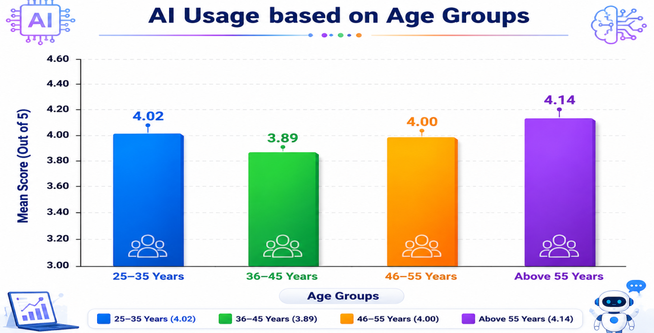

Table 2: Mean AI Usage Score based on Teaching Experience
Teaching Experience | Mean Score
0–5 Years | 4.01
6–10 Years | 4.00
11–15 Years | 3.69
More than 15 Years | 4.03

Interpretation
The results show that faculty members with more than 15 years of teaching experience demonstrated high AI usage (4.03). Faculty members with 11–15 years of experience reported comparatively lower AI adoption (3.69). Overall, AI tools are actively used across all teaching experience categories.

Graphical Representation: AI Usage based on Teaching Experience
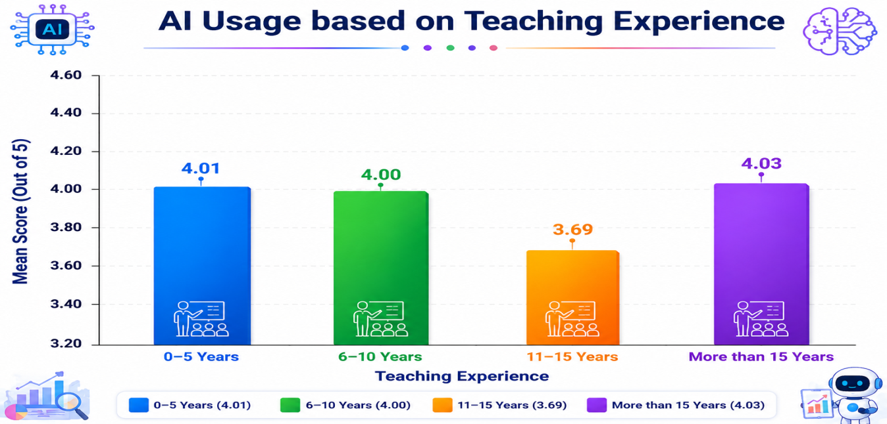

Table 3: ANOVA Analysis for AI Usage across Age Groups
Source | F-value | p-value | Result
Age Groups | 0.267 | 0.848 | Not Significant

Interpretation
The ANOVA analysis revealed no statistically significant difference in AI usage among faculty members belonging to different age groups (F = 0.267, p = 0.848). Therefore, the null hypothesis was accepted.

Table 4: Independent t-test between Younger and Senior Faculty Members
Category | t-value | p-value | Result
Younger vs Senior Faculty | -0.467 | 0.656 | Not Significant

Interpretation
The t-test analysis indicated no statistically significant difference between younger and senior faculty members regarding AI adoption and usage in academic activities.

Testing of Hypotheses

Hypothesis 1
H01: There is no significant difference in AI usage among faculty members belonging to different age groups.
To test the hypothesis, one-way ANOVA analysis was conducted. The obtained result showed F = 0.267 and p = 0.848, which is greater than the significance level of 0.05.
Therefore, the null hypothesis (H01) was accepted. The findings indicate that there is no statistically significant difference in AI usage among faculty members belonging to different age groups.

Hypothesis 2
H02: There is no significant difference in AI usage among faculty members based on teaching experience.
An independent t-test analysis was conducted to examine the difference in AI usage based on teaching experience categories. The obtained result showed t = -0.467 and p = 0.656, which is greater than the significance level of 0.05.
Therefore, the null hypothesis (H02) was accepted. The findings indicate that there is no statistically significant difference in AI usage among faculty members based on teaching experience

Results and Discussion
The findings of the study reveal that AI technologies are widely accepted and used by faculty members irrespective of age groups and teaching experience. The overall mean scores indicate high AI adoption among academicians for academic writing, literature review, content generation, and research-related activities.
The study found that senior faculty members also actively utilize AI tools, which contradicts the traditional assumption that younger faculty members are more technologically adaptive. Faculty members above 55 years demonstrated the highest AI usage score. Similarly, faculty members with extensive teaching experience also showed positive acceptance toward AI technologies.
The ANOVA and t-test results indicate that there is no statistically significant difference in AI usage among different demographic categories. This finding suggests that AI technologies are becoming universally integrated into higher education research practices.
The results support previous studies which emphasized that AI-assisted technologies enhance academic productivity and research efficiency. However, the study also suggests that institutions should ensure responsible and ethical AI usage while promoting digital literacy among faculty members.

Conclusion
The present study examined AI usage among faculty members based on age groups and teaching experience in higher education institutions. The findings revealed that faculty members across all demographic categories actively use AI-assisted technologies for academic and research purposes.
The study found no statistically significant difference in AI adoption among different age groups and teaching experience categories. This indicates that AI technologies are becoming an integral part of higher education irrespective of demographic differences.
The study concludes that faculty members increasingly recognize the usefulness of AI tools in improving research productivity, academic efficiency, and information accessibility. However, balanced and ethical integration of AI technologies is essential to maintain originality, academic integrity, and responsible research practices.

Recommendations
- Universities should organize AI literacy and faculty training programs.
- Higher education institutions should develop ethical guidelines for AI usage in academic research.
- Faculty members should be encouraged to use AI tools responsibly while maintaining originality and academic integrity.
- Institutions should promote awareness regarding the benefits and limitations of AI-assisted technologies.
- Future studies may include larger samples and comparative institutional analysis.

References
- Baidoo-Anu, D., & Owusu Ansah, L. (2023). Education in the Era of Generative Artificial Intelligence: Understanding the Potential Benefits of ChatGPT in Promoting Teaching and Learning. Journal of AI in Education, 7(1), 52–62.
- Cotton, D. R. E., Cotton, P. A., & Shipway, J. R. (2024). Chatting and Cheating: Ensuring Academic Integrity in the Era of ChatGPT. Innovations in Education and Teaching International, 61(2), 228–239.
- Dwivedi, Y. K., et al. (2023). So What if ChatGPT Wrote It? Multidisciplinary Perspectives on Opportunities, Challenges and Implications of Generative Conversational AI for Research, Practice and Policy. International Journal of Information Management, 71, 102642.
- Holmes, W., Bialik, M., & Fadel, C. (2019). Artificial Intelligence in Education: Promises and Implications for Teaching and Learning. Boston: Center for Curriculum Redesign.
- Kasneci, E., et al. (2023). ChatGPT for Good? On Opportunities and Challenges of Large Language Models for Education. Learning and Individual Differences, 103, 102274.
- Selwyn, N. (2019). Should Robots Replace Teachers? AI and the Future of Education. Cambridge: Polity Press.
- UNESCO. (2021). AI and Education: Guidance for Policy-makers. Paris: UNESCO Publishing.
- Zawacki-Richter, O., Marín, V. I., Bond, M., & Gouverneur, F. (2019). Systematic Review of Research on Artificial Intelligence Applications in Higher Education. International Journal of Educational Technology in Higher Education, 16(39), 1–27.

