“Interlinking unpaid care and the SDGs: A multi-dimensional theoretical inquiry”

Abstract: While SDG5 targets full gender equality by 2030, current progress is hindered by the exclusion of unpaid care work from gender gap analyses. Unpaid work has a heterogeneous nature, is larger in volume, and much more is unknown. Unpaid care is primarily covered by women of our family in Indian society. This is not only performed by illiterate and less educated women but also by the educated, as well as working professionals. The caregivers (women) are not only for children; they also provide care for the family's elders. A part from the caring work, they perform other household chores like cleaning and cooking. The literature indicates that the gender gap in unpaid work affects the existing gender gap in employability. This paper argues that unpaid labour is the "invisible pillar" of Agenda 2030 and addresses the conceptual disconnect between sustainable growth and social norms through a care-SDG nexus. By integrating feminist economics with sustainable development theory, this research reveals how the care economy remains marginalised in standard measures like GDP and labour force participation. Ultimately, this article provides a multi-dimensional framework that encourages researchers and policymakers to move beyond traditional economic indicators toward a more inclusive understanding of development.
Introduction: Indian society is deeply family-centred, typically characterised by multigenerational households where children, parents, and siblings reside together. Within this framework, a traditional division of labour often persists: men are primarily the breadwinners, while women manage the household. However, treating domestic chores as a woman’s sole obligation—rather than a shared responsibility—limits her capacity to contribute to the broader economy.
​Currently, the immense volume of household work performed by women remains invisible in national accounts. This disproportionate burden prevents many women, particularly homemakers, from pursuing formal employment, thereby lowering the national labour force participation rate. These factors combined create significant hurdles in India’s journey towards the accomplishment of the SDG5 agenda of 2030. SDG5 (gender equality) have 9 specific targets. In our discussion, we will focus on SDG5.4. SDG 5.4 aims to recognise and value unpaid care and domestic work by providing them with help services, infrastructure, and social security schemes, alongside promoting shared household responsibilities. To address this target, the Indian government has initiated various strategic interventions and policies, such as the Jal Jeevan Mission, PM Ujjwala Yojana, and Mission Shakti ( Palna scheme), etc.
Theoretical framework: The 5Rs framework of SDG5 includes recognise, reduce, redistribute and represent or reward. These Rs aid our study and are also used as a roadmap to achieve the sustainability goals.
¹Assistant professor, Department of Commerce, Indira Gandhi University, Haryana
²Research scholar, Department of Commerce, Indira Gandhi University, Haryana
³Research scholar, Department of Commerce, Indira Gandhi University, Haryana

1 Recognition: Acknowledging the contribution of unfair work to the national economy primarily through time use surveys and national statistics.
2 Reduce: Lowering the burden of domestic tasks through investment in infrastructure such as piped water, sanitation, and clean energy.
3 Redistribute: Shifting responsibilities from the House of labour to the state or private sector through public services like creches, child care, and elderly support.
4 Reward: Implementing social protection policies and compensating care work to make it an economic activity.
5. Representation: Guarantee the right of care workers to organise, join unions and engage in social dialogue and collective bargaining.
REVIEW OF LITERATURE:
“The care economy plays a crucial role in fostering economic growth. As noted, not only does care work directly affect survival, nutrition, health, longevity, learning abilities, education and well-being, but it also enables workers to participate in economic activity and contribute to GDP, yet care work remains undervalued and largely invisible. While India's paid workers account for only about 5.8% of the total workforce, paid care workers are only a small subset of all care workers. A large proportion of care work, unpaid care work, is not included in GDP, while noting that women's share in the paid care workforce is 56.6% compared to 43.4% for men, women also perform the majority of unpaid care work, which by some estimates, accounts for3.1%of GDP compared to 0.4% by men” (Mehta & Mehta, 2025). “Gender equity is a long-term goal that involves significant changes in social spheres. To achieve this, public policies must reconcile the work-life balance of men and women, promoting caregiving responsibilities across society. The differences between countries in the gender gap in unpaid work are related to the degree of development; thus, women dedicate more time to unpaid domestic work in developing countries, while within each country, inequalities in unpaid domestic work are explained by sociodemographic variables. Higher female employment rates are associated with smaller gender gaps in the time spent on domestic work” (Rodríguez Pérez et al., 2026). “Men with higher educational attainment participate more actively in caregiving tasks, suggesting not only an incipient generational and cultural shift but also a strategic entry point for designing public policies aimed at promoting responsible masculinities. When men share domestic and care work responsibilities, the gender gap in labour participation and income decrease”(García-luque et al., 2023).
Objectives:
- To compare the results of the time-use survey of 2019 and 2024 in India.
- To scrutinise the effect of the unpaid care work load on the labour force participation.
- To approximate the value of unpaid care work as a percentage of GDP.
Comparative analysis:
1-Time use survey of 2019 and 2024
The time use survey is conducted by the National Statistical Office. Earlier, it was conducted in 2019. India is one of the countries where a time use survey is conducted and released. There are some key highlights of the survey:
- “Female participants aged 15-59 years in unpaid domestic services spent about 315 minutes during 2019 in those activities, which has come down to 305 minutes during 2024, signifying the shift from unpaid to paid activities”.
- “41 per cent of females aged 15-59 years participated in caregiving for their household members, male participation in this age group in such caregiving was 21.4 per cent. Also, female participants in caregiving activities spent about 140 minutes a day, compared to 74 minutes spent by male participants aged 15-59 years. This corroborates the Indian social fabric wherein most of the caregiving responsibilities for household members are borne by the females of the household”.
- “During 2024, 75 per cent of the males and 25 per cent of the females in the age group 15-59 years participated in employment and related activities during the reference period of 24 hours. Such participation was 70.9 per cent for males and 21.8 per cent for females in the age group 15-59 years during 2019”.
Category (15 -59) | 2019(min.) | 2024(min.)
Female unpaid domestic services | 315 | 305
Male unpaid domestic services | 94 | 87
Female caregiving services | 140 | 164
Male caregiving services | 75 | 77

The above table indicates that the women's unpaid domestic work shows a slight decrease, but male unpaid domestic work also shows a reduction. While women caregiving shows a tremendous increase, on the other hand, men caregiving shows a stagnant change.
- Now we inquire data according to TUS ,2024 in % of total time in different activities in a day per person of age 6 years and above:
Description of activity | Male (out of 100%) | Female (out of 100%)
Unpaid domestic services for household members | 1.7 | 16.4
Unpaid caregiving services for household members | 0.9 | 3.3

2- Labour force participation rate
As we are discussing the care economy, we will consider the female labour force participation rate in India. LFPR refers to the percentage of women aged 15 and older who are either employed or actively seeking work, relative to the total population of that age.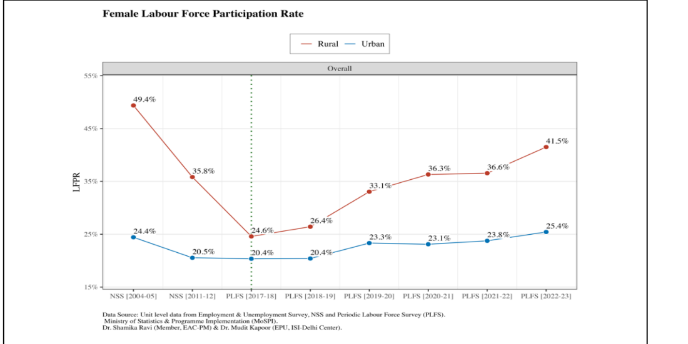

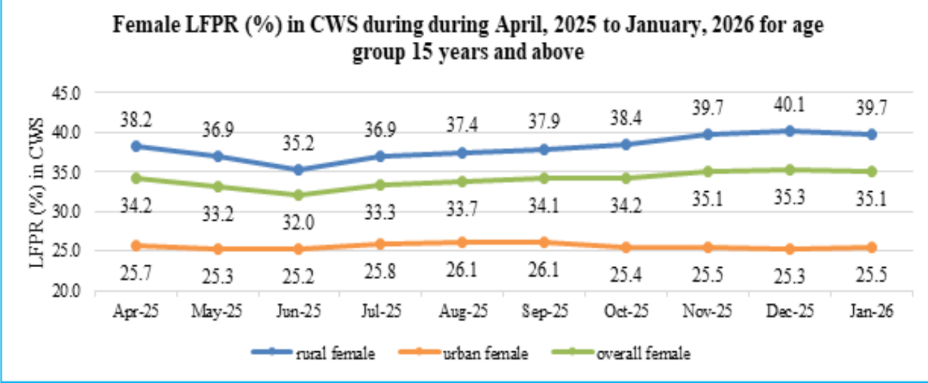The two diagrams provide a detailed look at the Female Labour Force Participation Rate in India across different time scales: a long-term historical view, 2004- 2023, and a recent high-frequency view, 2025 to 2026. SDG 5.4 is not just about; It’s about reducing the burden of unpaid work, so women can participate in the labour force if they choose.
The rural-urban divide
The data shows a persistent The rural women participate at a much higher rate (Approximately 15% point higher). Higher rural rates often reflect distressed employment or participation in agricultural work, which is easier to balance with domestic duties. The lower urban rate suggests that in cities, the lack of childcare and the double burden of domestic work remain significant barriers to Formal employment.
The U- shaped recovery
The first graph indicates a deep decline by 2017, followed by a robust recovery. The post 2018 flourish indicates that Policy interventions Like Clean cooking fuel, water, and sanitation may be reducing the time women spend on domestic chores, effectively freeing up time for the labour market’
The second graph indicates that the percentage of women working is not increasing and is stuck at around 35%. It’s not going up, and it’s not going below. It's stuck now. To move beyond the 35% overall, India likely needs a second wave of time release. Here, time release means now we have to move beyond just saving time at home. Now we have to provide Real support like Affordable Creches, Safe transport and shared housework.
A paradox is created as more women enter the workforce, the TUS 2024 shows that the unpaid care work responsibility is not significantly shifted to men, although it creates a double shift working setup for women. The rise in LFPR without a corresponding decrease in the care burden means Indian women are experiencing ‘time poverty’.
3-The GDP connection:
The unpaid caregiving services are not monetised, we estimate their value using the average method, the weighted average method. As per the reports from the Ministry of Women and Child Development, 2024, “the unpaid care work of women is worth between 15 and 17 per cent of India's GDP”. It is difficult to estimate the value of unpaid care work contributed by women. Note that in India, women’s unpaid labour amounts to a staggering 22.7 lakh crore rupees (Rural: `14.7 lakh crore and Urban: `8.0 lakh crore). This is about 7.5% of India’s GDP. If the time spent on unpaid care work across the world were valued, it would be about to 9% of the global GDP, which is about USD 11 trillion.
Government policies: attracting toward SDG 5.4
Our government starts various interventions to shift the burden of care, redistribute the load of care, and recognise care work.
For the reduction of the encumbrance of work, the Indian government launches Ujjawal yojana, Jal Jeevan yojana, Mission Shakti, etc.
- Ujjwala yojna: this yojna targets the rural women for providing LPG cylinders over 10 cr. Connections are provided, which saves them 2 to 3 hours, so that time they can invest in their education, spend leisure time, etc.
- Jal Jeevan Mission: JJM was launched in 2019 by PM Narender Modi to provide piped water to every household by 2024. Now, it is extended through 2028 under JJM 2.0. It also helps women save their time.
- Mission Shakti: it was launched on 1st April,2022. It has two constituent 1. Sambal 2. Samarthya. Samarthya, based on women empowerment like Sakhi Niwas, Shakti Sadan, etc., while Sambal is for women's safety, like a one-stop centre, women helpline 181, Beti Bachao, Beti Padhao.
Now, India has reached a point where women can save time, for example, by using LPG and piped water. As per the time use survey analysis 2024, it should now launch further initiatives to shift the burden from the household to the state and market to achieve SDG5.4.
Recommendations:
Why we need further initiatives: 1. “ ICRIER2025 26 suggests that in India, if 2% of GDP is invested into the care economy, there are chances of creating 11 million new jobs”.
2. “There is a double benefit to investment in the care economy. First, it reduces the burden on women at home so that they can step out and participate in economic activities. Secondly, increased investments for the establishment of childcare institutions, particularly crèches, located near workplaces and work sites, generate jobs, especially for women”.
3. “The total budget allocation for care infrastructure stood at about 0.18 per cent of the GDP (which is 0.73 per cent of the total budget expenditure) for the year 2023-24 and about 0.15 percent of the GDP (which is 0.6 percent of the total budget expenditure) for the year 2024-25. In 2024-25, Saksham Anganwadi and the POSHAN 2.0 scheme were allocated 80 per cent of the MoWCD budget to fight malnutrition and support early childhood care”.
4. “When we compare India with G20 countries, we see that women spend more time on unpaid care work compared to men in all the countries. Disparity in India is the second-highest. The number of hours that women spend on unpaid work is the highest in India. Nordic countries are performing much better than the rest of the world in achieving parity in unpaid care work. Most nations spend a significant proportion of their GDP on care. Developed countries dedicate about 1 per cent to 4 per cent of their GDP, whereas developing countries dedicate between 1 per cent and 3.9 per cent of their GDP to this essential sector”.
There are some suggestions we can opt for from different nations:
- There is a need for a satellite account, which should be prepared alongside the GDP account that identifies and records the monetary value of unpaid work.
- Care allowances should be provided, or care credit should be given to the caregivers of the elderly or disabled, based on the UK model.
- The unpaid caring workers (homemakers) should be recognised as social and economic activity. Like in Venezuela, article 88 of the 1999 constitution guarantees that homemakers are entitled to social security benefits, establishing that domestic work creates added value and wealth, aiming to ensure equality for women.
- Cabo Verde's national care plan is an example of how a country can make a policy that is fully focused on distributing unpaid care work and supporting family caregivers
- The Swedish model of incentivising fathers to take leave is called the daddy quota. There are reserved leaves of 90 days for each parent, which cannot be transferred, so that the fair distribution of the parenting responsibility can be established. The leave is approx. 80% of salary up to a high-income cap, making it financially feasible for fathers.
We can make initiatives based on these pillars in India:
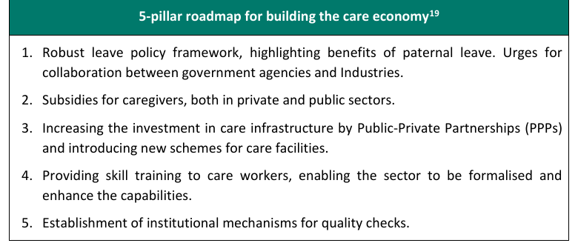
References:
- García-luque, O., López-martínez, M., & Rodríguez-pasquín, M. (2023). Co-responsibility of Domestic Work to Achieve Gender Equality. https://doi.org/10.4324/9781003640189-4
- Mehta, B. S., & Mehta, A. K. (2025). Paid and Unpaid Care Work: Gender Inequities and Policy Pathways. Indian Journal of Human Development, 19(1), 50–67. https://doi.org/10.1177/09737030251357106
- Rodríguez Pérez, R. E., Lugo, D. C., & Terrazas Troyo, R. M. (2026). Co-responsibility for Care as a Determinant of Gender Inequality in the Mexican Labour Market. Women, Work and the Care Economy, 213–235. https://doi.org/10.4324/9781003640189-11
- https://sbi.bank.in/documents/13958/25272736/010323-Ecowrap_20230228.pdf/b026257e-8b66-4f4b-b746-270338fdc8b7?t=1677652287574
- https://www.pib.gov.in/PressReleasePage.aspx?PRID=2106113&reg=3&lang=2
- https://www.un.org/sites/un2.un.org/files/purple_economy_14_march.pdf
- https://mospi.gov.in/uploads/latestReleases/latest_release_1771238931793_de83f41f-e1c3-4581-a99b-3432ee80881c_Monthly_Press_note_January_2026.pdf
- https://static.pib.gov.in/WriteReadData/specificdocs/documents/2024/mar/doc202435319501.pdf
- texthttps://icrier.org/pdf/PB35-Care_Economy.pdf

