From Maternal Trauma to Social Mission: Transforming Personal Loss into Social Support
ABSTRACT
The loss of a child is one of the most traumatic events, capable of significantly impacting a mother's psycho-emotional state, social roles, and life prospects. Even while caring for a seriously ill child, the lives of parents, and especially mothers, change dramatically, accompanied by high levels of stress, emotional exhaustion, social isolation, and significant financial strain on the family. However, despite the high level of psycho-emotional trauma, some people are able to transform their own difficult experiences into a source of personal development, recovery, or the formation of prosocial activities and even leadership. This is especially evident in the processes of establishing charitable foundations and organizations.
The purpose of this article is to analyze the relationship between the traumatic experience of loss and the process of subsequent personal growth in the mother, as well as the formation of a social mission through charitable work. Particular attention is paid to:
- The mechanisms of finding meaning and purpose after the loss of a child;
- The role of altruistic activity in the process of psychological rehabilitation;
- The study explores the potential and specific features of charitable organizations in providing support to families and mothers in crisis situations.
The methodological basis of this work is an analysis of contemporary psychological, sociological, and medical-social research on maternal grief, post-traumatic rehabilitation, and personal growth. A practical example of the implementation of these theoretical principles is the case of Tatyana Artemeva and her creation of the charitable foundation "NeuroChildren" for children with brain diseases. Ms. Artemeva was able to transform her own experience of loss into systemic assistance for children, mothers, and families facing difficult life circumstances.
These results confirm the role of charitable activity not only as a mechanism for providing social support to others but also as a key factor in reconstructing one's own identity, creating a new meaning in life, and developing social leadership after trauma.
Keywords: post-traumatic growth, maternal trauma, charity, social support, leadership.

INTRODUCTION
Motherhood is traditionally considered one of a woman's most important social roles. However, the birth of a child with a severe or incurable illness radically alters the usual course of family life, transforming the mother into the primary caregiver, coordinator of medical care, and psychological support for the child and other family members, and often the primary organizer of financial support for treatment [1,2]. This complex set of responsibilities is accompanied by prolonged physical and psycho-emotional stress, significantly exceeding the stress level typical for most families raising healthy children [3].
Research in recent decades indicates that mothers of children with severe illnesses have a significantly higher risk of developing depressive disorders, anxiety, burnout, and chronic stress [3,4]. Constant uncertainty regarding the prognosis of the disease, prolonged stays in medical institutions, the child's pain, financial difficulties, forced limitations in professional activity, and the gradual loss of social contacts create the so-called "carer burden"—the complex appearance associated with long-term care for a seriously ill person [5]. If treatment fails and the family is faced with the death of a child, the psychological consequences become even more complex. The loss of a child is one of the most devastating life events, capable of radically altering a person's value system, their understanding of their own identity, future, and relationships with society [6]. Modern psychological concepts emphasize that adaptation after loss does not mean the end of grief or the forgetting of the experience. On the contrary, it involves integrating the loss into the individual's recent life history and the gradual formation of new meanings of existence [7,8].
Along with the negative consequences of severe psychological trauma, increasing attention is being paid to the phenomenon of posttraumatic growth—positive personal changes that can occur after experiencing extreme life events [9]. According to the concept of R. Tedeschi and L. Calhoun, posttraumatic growth manifests itself in a rethinking of life values, the development of deeper interpersonal relationships, the strengthening of internal resilience, and the desire for socially significant activities [9]. One form of such growth could be charitable work, social activism, and support for people experiencing similar circumstances. This problem is particularly pressing due to the underdevelopment of long-term psychological and social support systems for parents after the loss of a child. While medical services naturally focus primarily on the patient during treatment, after the death of a child, mothers are often left outside the comprehensive support system. This gap between the completion of medical care and the lack of long-term psychological, informational, and social support can contribute to deepening isolation, loss of social role, and a protracted identity crisis [10].
In such circumstances, charitable and public organizations are particularly important. They not only provide practical assistance but also create communities of mutual support, facilitate the exchange of experiences, and help mothers gradually return to active social life [11].
The purpose of this article is to explore the process of transforming maternal trauma into a social mission through the prism of contemporary theories of posttraumatic growth, the search for meaning, and social leadership. Particular attention is given to the practical example of Tatyana Artemeva and her charitable foundation, NeuroChildren, which helps children with brain diseases, as an example of transforming a personal tragedy into long-term charitable work aimed at supporting children, mothers, and families in crisis situations.
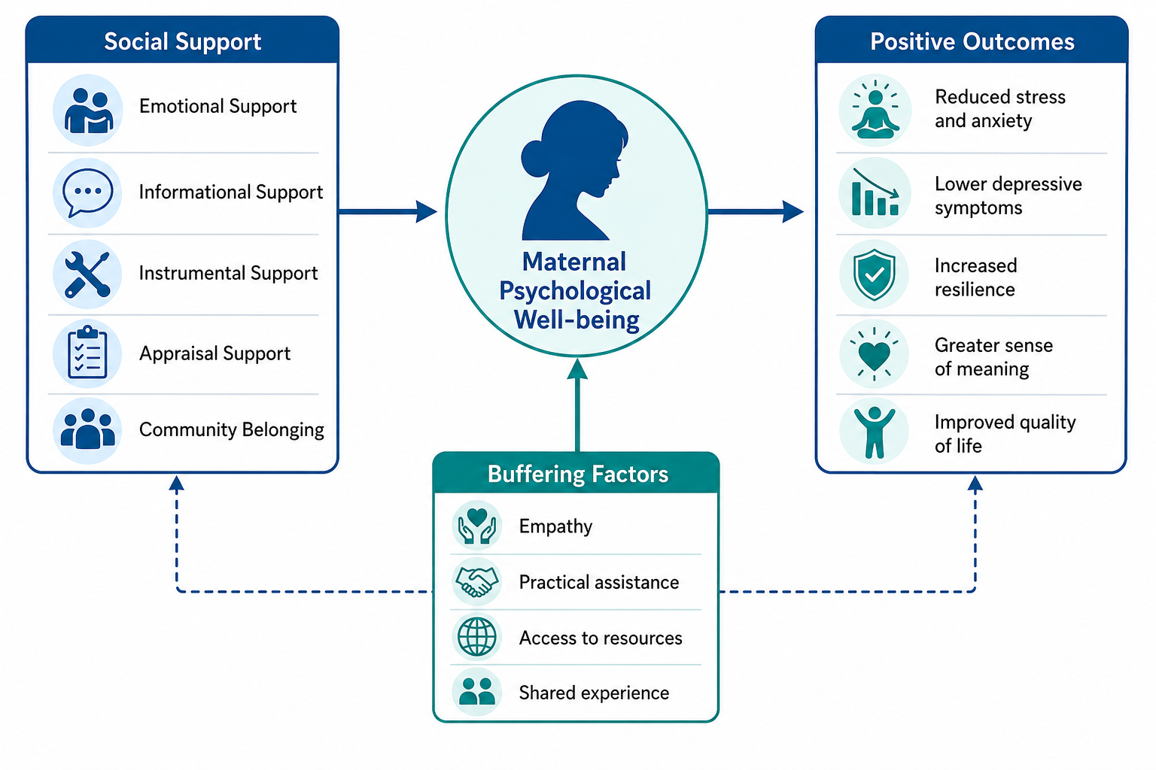
Figure 1. The impact of social support on maternal psychological well-being
Maternal Trauma as a Long-Term Psychological Crisis
Traditionally, when a child with a severe or incurable illness is born, the greatest burden falls on the mother. She not only fulfills the traditional parental role but also begins to assume multiple responsibilities related to treatment or rehabilitation [3,5]. This multitasking is accompanied by prolonged physical and psychological exhaustion, significantly increasing the risk of developing anxiety or depressive disorders [1,4]. Unlike acute stress, which is temporary, chronic caregiving creates a persistent sense of uncertainty, as family life is completely subordinated to the child's needs, medical procedures, and doctors' prognoses [2].
Limited social contacts, financial difficulties, and the constant expectation of a possible deterioration in the child's condition gradually alter life priorities and develop a special type of psychological adaptation, focused primarily on the survival and support of the child [4,6].
In the event of the child's death, this prolonged and difficult experience does not automatically end. On the contrary, it becomes part of the subsequent grieving process. This is why modern researchers view maternal grief not as an isolated event, but as a continuation of a long-term traumatic experience that begins long before the loss itself and significantly impacts a woman's subsequent psychological recovery [7,9].
While the healthcare and rehabilitation system quite logically focuses on the patient, the psychological state of family members, and especially mothers, remains neglected by professional support. The lack of properly structured, ongoing social and psychological rehabilitation further exacerbates feelings of alienation and loss of one's role, which contributes to the difficulty of adaptation after the tragedy [10,14].
For this reason, it is essential to create a system that focuses not only on medical issues and patient care, but also on the need for systemic support for families and mothers after the completion of treatment or the loss of a child. Therefore, it is crucial to support social initiatives, charitable organizations, and mutual aid communities. Such structures create a safe space for restoring social connections and a trauma-free return to active life.
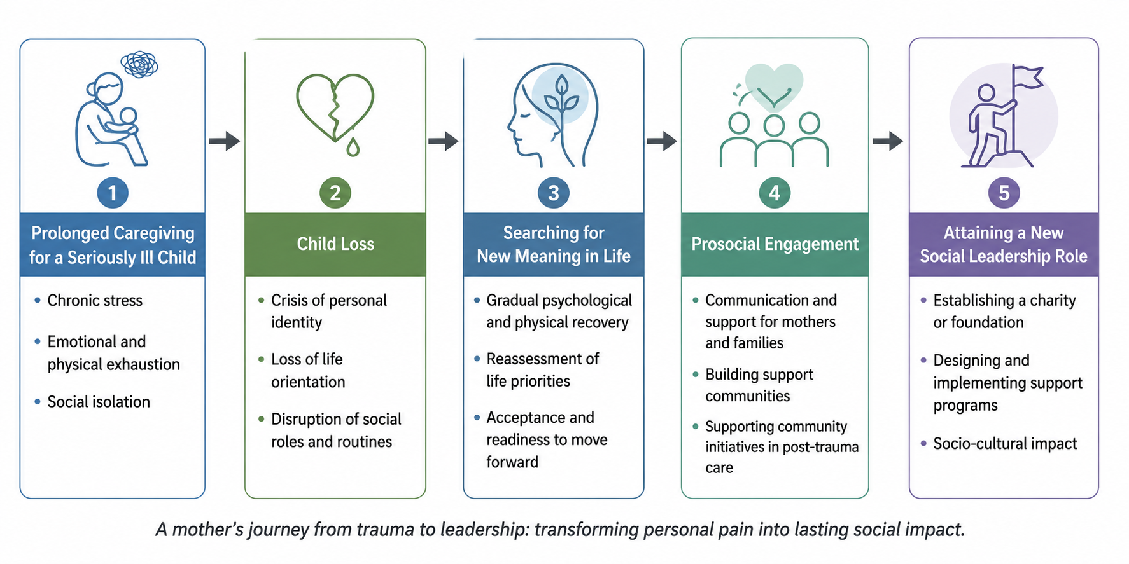
Figure 2. The maternal trauma transformation framework
Posttraumatic Growth and the Formation of Prosocial Behavior
After the loss of a child, grief remains an integral part of a person's life. However, the adaptation process can be accompanied by the formation of new life values, a rethinking of one's role in society, and the development of new behavior patterns. These positive changes are described by the concept of posttraumatic growth [9].
According to the theory of R. Tedeschi and L. Calhoun, posttraumatic growth occurs as a result of a prolonged rethinking of past experiences and a gradual reconstruction of life's meanings [9]. A person does not return to their previous life, but rather develops a new value system in which the experienced loss becomes part of their personal history.
In this study, the author proposes to consider the process of maternal trauma transformation as a sequential conceptual path, including five interconnected stages:
Stage 1. Long-term care for a seriously ill child:
- Chronic stress;
- Emotional and physical exhaustion;
- Social isolation;
Stage 2. Loss of a child:
- Identity crisis;
- Loss of life direction;
- Destruction of traditional social roles (the role of a woman in society before the illness and the role of a caregiver after medical interventions);
Stage 3. Search for a new meaning in life:
- Gradual psychological and physical recovery;
- Rethinking life priorities;
- Acceptance and willingness to move on;
Stage 4. Prosocial activity:
- Communicating and providing assistance to mothers and families facing similar problems;
- Creating support communities;
- Supporting public initiatives in the field of post-traumatic support;
Stage 5. Acquiring a new social role as a leader:
- Founding a charitable organization/foundation;
- Developing and implementing support programs;
- Sociocultural influence.
Illustratively, the described process of a woman's recovery after loss is presented in Figure 2.
Based on the presented model, it can be concluded that one of the most important manifestations of the recovery process is the development of prosocial activity. People who have been able to integrate their traumatic experiences into a new system of life meanings are more likely to demonstrate empathy, a willingness to support others, and a desire to use their own experiences to help others in similar circumstances [8,12]. Thus, personal tragedy transcends the confines of private experience and acquires social significance, fostering a culture of solidarity and mutual support [10,11].
It is at this stage that the transition from personal renewal to social leadership takes shape, when the experience becomes the basis for long-term action aimed at supporting others.

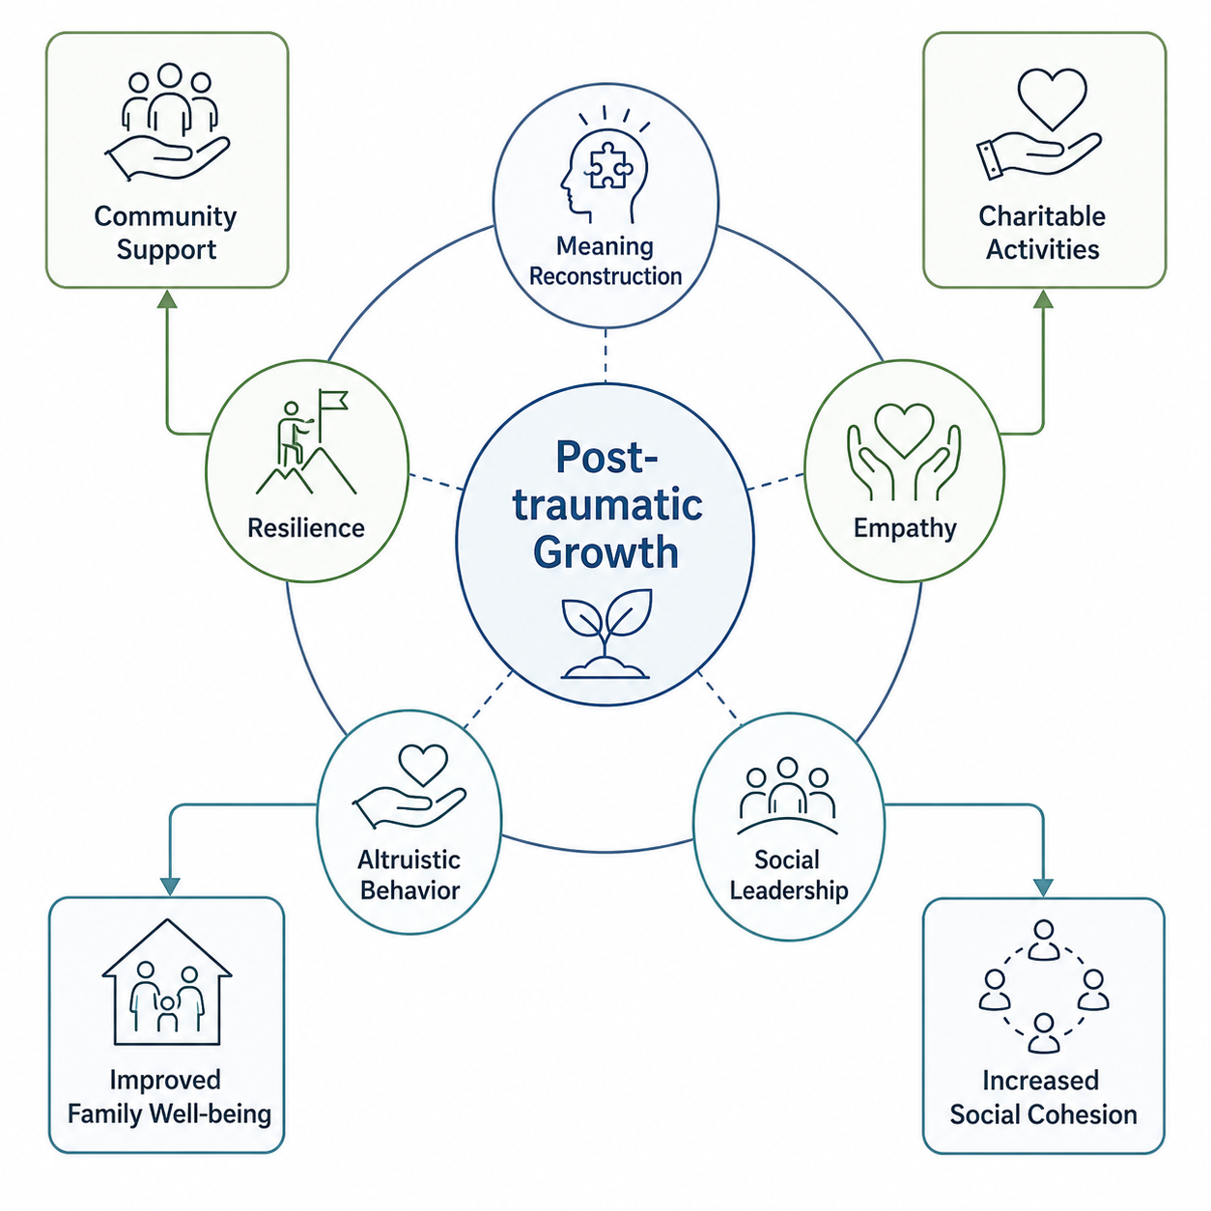
Figure 3. Conceptual model of posttraumatic growth after maternal loss

To demonstrate the practical application of the theoretical propositions described above, it is useful to consider a real-life example illustrating how personal traumatic experiences can be transformed into long-term socially beneficial activities. The case presented below is not a subject of study in itself, but is used as a practical illustration of the proposed conceptual model.

The Case of Tatyana Artemeva: Transforming Personal Loss into Public Support
The author, Tatyana Artemeva, provides practical proof that post-traumatic growth can lead to long-term socially useful action. Surviving her own child after a protracted struggle to save his life, Ms. Artemeva channeled her personal experience not into self-isolation, but into supporting the creation of families and other women, achieving success through similar trials.
Unlike many charitable initiatives that arise in response to individual life circumstances, Ms. Artemeva's work gradually evolved into a comprehensive system of assistance based on a combination of personal experience, empathy, and practical support mechanisms. Her goal became not only to provide financial assistance but also to create an environment in which parents are not left alone with their pain and can receive informational, psychological, and social support.
The NeuroChildren charitable foundation, founded by Tatyana Artemeva, has served as an example of a systematic approach to helping children with severe brain diseases and their families. Its activities extend beyond fundraising for treatment and include:
- Promoting medical rehabilitation;
- Assistance in obtaining specialized equipment;
- Providing informational support to parents;
- Collaborating with doctors and specialists in various fields;
- Creating support communities for families facing life crises.
It is the multifaceted nature of this work that makes it important not only from a charitable but also a socio-psychological perspective. By receiving support, families have the opportunity not only to address immediate financial needs but also to rebuild social connections, overcome isolation, and feel a sense of belonging to a community of people who understand their experiences.
After moving to the United States, Tatyana Artemeva's social work expanded beyond supporting children with neurological diseases. Artemeva's social initiatives have taken on a new direction. Today, new projects and methods developed and launched by the author are increasingly focused on supporting women themselves, who have experienced the loss of a child, long-term care for seriously ill family members, experienced emotional burnout, or found themselves in other life crises. These initiatives are aimed not only at providing psychological support but also at restoring social engagement, professional self-fulfillment, and developing new life goals through participation in joint projects and community activities.
CONCLUSION
The analysis of contemporary scientific literature and the author's case study demonstrate that maternal trauma associated with prolonged care for a seriously ill child and subsequent loss can have not only devastating psychological consequences but also become the starting point for profound personal transformation. In this context, charitable and social activities can be viewed not only as a form of helping others, but also as a mechanism for post-traumatic growth and the restoration of meaning in life.
The author's conceptual model of maternal trauma transformation demonstrates a consistent path from prolonged psychological burden and the experience of loss to a positive transformation of personal identity. It is important to emphasize that this process does not mean overcoming or forgetting grief, but rather reflects the possibility of integrating lived experience into a new system of values ​​and motivations.
The practical example of Tatyana Artemeva's work confirms that personal tragedy can become the foundation for the creation of long-term, socially significant initiatives. The activities of the NeuroChildren charitable foundation, as well as the continued development of social projects supporting women in the United States, demonstrate the potential of comprehensive community programs to provide not only material but also psychological, informational, and social support to people experiencing life crises.
The problem of inadequate long-term support for mothers after completing treatment or losing a child deserves special attention. In many cases, charitable organizations, community initiatives, and mutual aid communities provide the environment that helps reduce social isolation, restore a sense of self-worth, and gradually return to active participation in public life.
Therefore, the presented case should be viewed as a practical confirmation of the broader concept of maternal trauma transformation, rather than a study of an individual's activity. The specific conceptual model proposed constitutes the main scientific contribution of this work. The integration of personal experience, empathy, and community activism creates the preconditions for the development of sustainable support models capable of having a positive impact both on individuals and on the development of civil society as a whole.
The proposed findings and the author's conceptual model of maternal trauma transformation require further empirical testing with larger samples of participants, representatives of different cultural backgrounds, and diverse social contexts.
A promising direction for future research is to evaluate the effectiveness of long-term charitable programs as a tool for the psychological and social rehabilitation of mothers after the loss of a child. Equally important is the study of models of interaction between medical institutions, psychological services, and public organizations to create a comprehensive support system for families experiencing severe life crises. Furthermore, a separate study is needed to examine the impact of women's self-help communities and international social initiatives on the development of resilience, the restoration of social activity, and the development of post-traumatic growth.
Ethical Approval
This study is based on a review of the scientific literature and the author's own lived experience. It did not involve experiments involving humans or animals, and therefore did not require formal ethical approval.
Conflict of Interest
The author declares no conflict of interest.
REFERENCES
- Tedeschi RG, Calhoun LG. Posttraumatic Growth: Conceptual Foundations and Empirical Evidence. Psychological Inquiry. 2004;15(1):1–18.
- Cousino MK, Hazen RA. Parenting Stress Among Caregivers of Children With Chronic Illness: A Systematic Review. Journal of Pediatric Psychology. 2013;38(8):809–828.
- Tedeschi RG, Shakespeare-Finch J, Taku K, Calhoun LG, editors. Posttraumatic Growth: Theory, Research, and Applications. New York: Routledge; 2018.
- Staub E, Vollhardt JR. Altruism Born of Suffering: The Roots of Caring and Helping After Victimization and Other Trauma. American Journal of Orthopsychiatry. 2008;78(3):267–280.
- Pakenham KI, Cox S. The Nature of Caregiving in Chronic Illness: A Review of the Literature. Health Psychology Review. 2012;6(1):1–27.
- Pinquart M. Parenting Stress in Caregivers of Children With Chronic Physical Condition—A Meta-analysis. Stress and Health. 2018;34(2):197–207.
- Adelman RD, Tmanova LL, Delgado D, Dion S, Lachs MS. Caregiver Burden: A Clinical Review. JAMA. 2014;311(10):1052–1060.
- Arnold J, Gemma PB, Cushman LF. Exploring Parental Grief: Combining Quantitative and Qualitative Measures. Archives of Psychiatric Nursing. 2005;19(6):245–255.
- Neimeyer RA. Meaning Reconstruction in the Wake of Loss: Evolution of a Research Program. Behaviour Change. 2016;33(2):65–79.
- Stroebe M, Schut H. The Dual Process Model of Coping with Bereavement: Rationale and Description. Death Studies. 1999;23(3):197–224.
- Bonanno GA. Loss, Trauma, and Human Resilience: Have We Underestimated the Human Capacity to Thrive After Extremely Aversive Events? American Psychologist. 2004;59(1):20–28.
- Worden JW. Grief Counseling and Grief Therapy: A Handbook for the Mental Health Practitioner. 5th ed. New York: Springer Publishing; 2018.
- Frankl VE. Man’s Search for Meaning. Boston: Beacon Press; 2006.
- World Health Organization. Rehabilitation in Health Systems: Guide for Action. Geneva: WHO; 2019.
- United Nations Children's Fund (UNICEF). The State of the World's Children 2021: On My Mind – Promoting, Protecting and Caring for Children’s Mental Health. New York: UNICEF; 2021.

