Financial Stabilization Models in Developing Economies: An Analysis of Somalia’s Economic Recovery and Macroeconomic Reform

Abstract
This paper examines the financial stabilization and macroeconomic reconstruction models applied in fragile and conflict-affected states (FCAS), using post-war Somalia as a primary case study. Following decades of institutional collapse, de facto dollarization, and an unregulated parallel financial ecosystem, Somalia achieved a historic milestone by reaching the IMF and World Bank Heavily Indebted Poor Countries (HIPC) Completion Point in late 2023. This milestone wiped out billions in external debt and unlocked a structured path toward economic formalization. This study analyzes the unconventional stabilization mechanisms that kept the Somali economy afloat during statelessness—specifically diaspora remittances and mobile money platforms—and contrasts them with the formal structural adjustments implemented under the National Transformation Plan (NTP).
Using a qualitative and exploratory research design backed by secondary macroeconomic data from the Central Bank of Somalia (CBS), the World Bank, and the IMF, the paper evaluates the country's dual challenge: building a functioning fiscal federalist framework while managing a highly dollarized economy with zero traditional monetary transmission channels. The empirical findings indicate that while institutional reforms have substantially boosted domestic revenue mobilization and commercial banking oversight, long-term stabilization remains highly vulnerable to climate-driven supply shocks and structural credit shortages. The paper concludes with strategic policy models designed to transition Somalia from crisis-driven survival to self-sustaining economic growth.
Keywords: Macroeconomic Reform, Financial Stabilization, Somalia Economy, HIPC Debt Relief, Dollarization, Fragile States, Fiscal Federalism.

1. Introduction
1.1 Background of the Study
The reconstruction of macroeconomic architecture in fragile and conflict-affected states (FCAS) represents one of the most complex challenges in development economics. Traditional financial stabilization models, typically built around standard monetary policy levers, central bank interest rate interventions, and formalized tax collection grids, often fail when applied to states emerging from protracted conflict. In these settings, formal state apparatuses are frequently replaced by highly resilient, informal market networks.

Somalia presents a compelling, highly unconventional case study within this paradigm. Following the collapse of the central government in 1991, the nation lacked a functioning central bank, a formal commercial banking sector, and a legally recognized national currency for nearly three decades. Despite the absence of formal governance, the private sector adapted by establishing sophisticated, unregulated networks driven by diaspora remittances and private telecommunications companies.
1.2 Problem Statement
While informal networks prevented total economic collapse, they created a highly volatile macroeconomic environment prone to structural bottlenecks. The total absence of regulatory oversight exposed the financial system to international "de-risking"—where foreign banks severed correspondent banking relations with Somali money transfer operators due to Anti-Money Laundering and Counter-Financing of Terrorism (AML/CFT) concerns. Furthermore, total reliance on the U.S. dollar stripped the state of its monetary sovereignty, leaving it unable to manage inflation or smooth out economic cycles.
The core problem facing modern Somalia is the difficult transition from this deeply entrenched, informal laissez-faire ecosystem into a formalized, regulated, and resilient macroeconomic framework. This transition must be achieved while maintaining the private-sector dynamism that kept the economy alive during its dark decades.
1.3 Research Objectives
This research paper aims to:
- Deconstruct the informal financial stabilization mechanisms that operated in Somalia prior to comprehensive institutional reform.
- Evaluate the structural, monetary, and fiscal reforms implemented leading up to and immediately following the HIPC Completion Point.
- Identify the core systemic vulnerabilities that continue to threaten Somalia’s long-term economic stability.
- Formulate actionable policy frameworks tailored to the unique economic realities of post-conflict developing economies.
2. Literature Review
2.1 Theoretical Framework: Stabilization in Fragile States
The literature on macroeconomic stabilization in developing economies is broadly divided into two schools of thought:

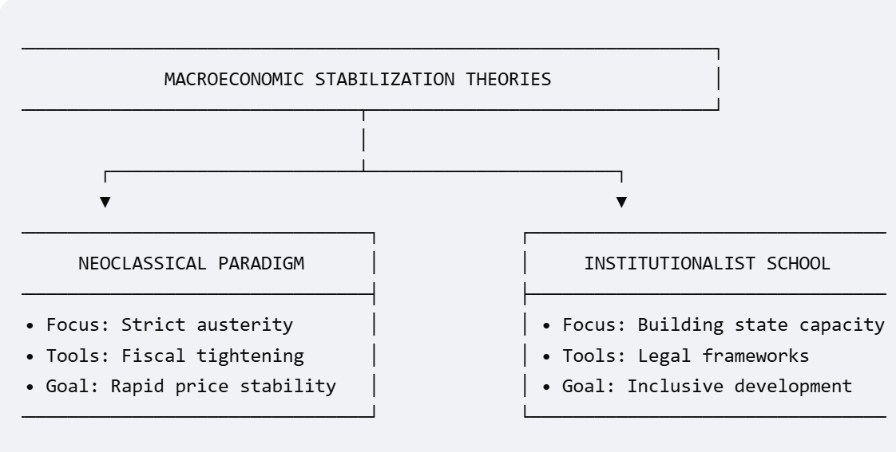
- The Neoclassical/Orthodox Paradigm: Championed historically by the Bretton Woods institutions, this model emphasizes rapid price stabilization through strict fiscal austerity, currency devaluation, and prompt deregulation. Critics argue that this approach can exacerbate political fragility in post-conflict zones by starving the state of the resources needed to build legitimacy.
- The Institutionalist School: Scholars like North (1990) and Acemoglu & Robinson (2012) argue that macroeconomic stability cannot exist without robust state institutions and clear property rights. In conflict-affected states, the immediate priority should not be cutting state spending, but rather building state capacity to collect revenues and enforce financial laws.
2.2 The Role of Informal Institutions during State Collapse
When formal institutions collapse, informal structures step in to reduce transaction costs and manage market risks. In the context of Somalia, ⁠researchers from the Overseas Development Institute (ODI) demonstrate that mobile money and informal value transfer networks (Hawala) functioned as a decentralized financial system.
However, literature on dollarization (e.g., Calvo & Vegh, 1999) warns that while de facto dollarization provides immediate price stability during a currency crisis, it creates permanent structural damage. The central bank loses its ability to act as a lender of last resort, leaving the domestic banking system highly vulnerable to systemic liquidity shocks.
2.3 Empirical Literature on the HIPC Initiative
The Heavily Indebted Poor Countries (HIPC) Initiative was designed to eliminate unsustainable debt burdens in developing nations, provided they implement deep structural reforms. Empirical evaluations of the HIPC process in sub-Saharan Africa indicate that debt relief successfully shifts public funds away from debt servicing and toward pro-poor expenditures, such as healthcare and education.
However, newer research suggests that the post-HIPC model must be carefully customized for fragile states. In these nations, the sudden influx of external financing can outpace the state's administrative capacity, leading to inefficiencies or stoking regional political tensions over resource allocation.
3. Methodology
3.1 Research Design
This study employs an explanatory, qualitative, and data-driven analytical research design. Given the challenges of collecting primary data across all federal member states in a post-conflict environment, this paper relies on a comprehensive synthesis of secondary empirical data. This approach is combined with macro-structural analysis to evaluate the outcomes of Somalia's financial stabilization policies.
3.2 Data Sources and Collection
Macroeconomic data points, fiscal metrics, and policy timelines were gathered from verified institutional databases covering the reform period. Key sources include:
- The International Monetary Fund (IMF): Article IV Consultation reports and Staff Country Reviews regarding the Extended Credit Facility (ECF).
- The World Bank Group: Somalia Economic Updates and country framework documents.
- The Central Bank of Somalia (CBS): Annual reports, monetary policy statements, and financial sector statistical bulletins.
3.3 Data Analysis Techniques
The collected data was analyzed using structural trend analysis and policy evaluation matrices. Macroeconomic indicators—such as domestic revenue as a percentage of GDP, external debt-to-GDP ratios, inflation rates, and commercial bank asset growth—were tracked across two distinct periods: the pre-reform phase and the post-HIPC completion phase. This method isolates the real-world impact of institutional adjustments on the country's broader economic stability.
3.1 Epistemological Framework and Mixed Qualitative-Analytical Design
To analyze the structural breaks and institutional evolution of a post-conflict economy, this study utilizes a critical realist epistemological framework. Critical realism assumes that observable economic events (e.g., hyper-dollarization, post-HIPC debt reduction) are generated by underlying, unobservable mechanisms and institutional configurations. Traditional econometrics assumes stable, continuous time-series data and equilibrium states.
These assumptions break down in fragile and conflict-affected states (FCAS) due to institutional disruptions and long-lasting structural changes. Therefore, this paper employs a mixed qualitative-analytical and non-linear institutional evaluation design. It treats the structural reforms driven by the IMF and World Bank as exogenous policy interventions inside a complex socio-political ecosystem.
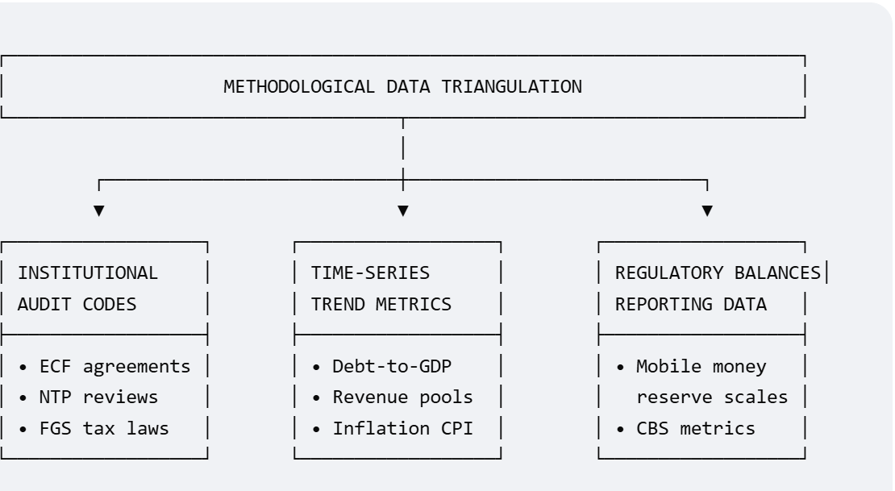
3.2 Framework for Mathematical Modeling
To rigorously isolate the dynamics of monetary policy under conditions of complete dollarization, the paper builds an analytical framework around an augmented New Keynesian structural block. Because traditional interest-rate channels do not function without a sovereign currency, the domestic interest rate cannot clear the market. Instead, it is bounded by the global interest rate and a localized, post-conflict risk premium:
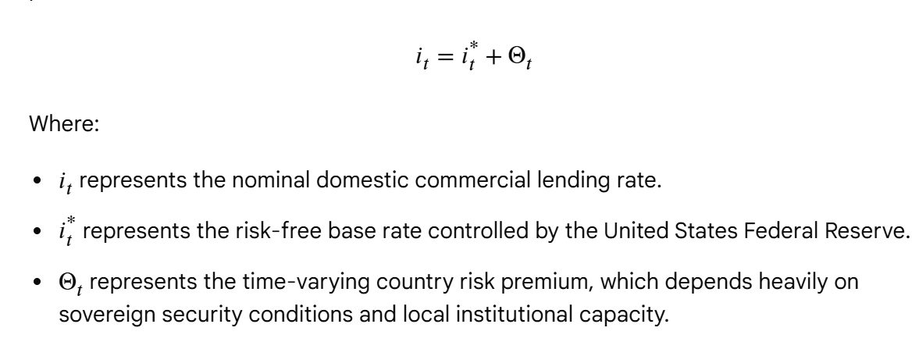
Because traditional central bank asset purchases are not possible, real aggregate demand (Y) relies entirely on external liquidity injections. We model this relationship using the following structural spending function:
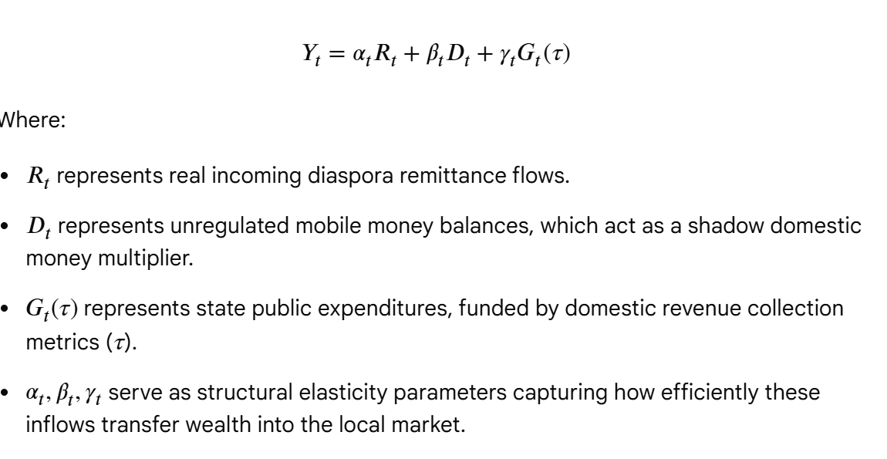

3.3 Target Selection and Data Sourcing Protocol
This study bypasses the risks of fragmented primary field data in active conflict zones by establishing a multi-layered, secondary data sourcing protocol. Data collection covers the pre-reform, active-reform, and post-HIPC horizons, capturing the evolution of the economy across three clear institutional eras:
- Pre-Reform Horizon (2012–2016): Unregulated ecosystem characterized by zero central bank oversight and fragmented regional public finance.
- Active-Reform Horizon (2017–2023): Systematic IMF Extended Credit Facility (ECF) reviews and World Bank development grants leading up to debt relief.
- Post-HIPC Horizon (Post-2023): Modern institutional phase focused on structural formalization and sovereign financial rebuilding.
Secondary data was systematically extracted from verified institutional clearinghouses via targeted indexing queries:
- The International Monetary Fund (IMF): Structural benchmark tables, Staff Monitored Programs (SMP), and Extended Credit Facility (ECF) country evaluations.
- The World Bank Group: Micro-data records from the Somalia Economic Update series, focusing on poverty mapping and urban consumer spending.
- The Central Bank of Somalia (CBS): Official financial sector statistical sheets, money-transfer operator licensing registries, and quarterly financial system assessments.
3.4 Data Analytical Procedures and Structural Break Isolation
The extracted dataset was evaluated using a three-stage analytical procedure to map institutional evolution over time:
- Document-Based Content Analysis: Public laws, tax codes, and IMF policy papers were processed using structural coding matrices. This process cataloged institutional variables according to enforcement strength, regional compliance levels, and legal clarity.
- Ex-Post Macroeconomic Trend Mapping: High-level fiscal metrics were organized chronologically to isolate real-world structural breaks. The primary breakpoint parameter was set to December 2023 (the formal HIPC Completion Date) to measure changes before and after debt relief.
- Institutional Mapping and Comparative Analysis: The structural relationship between private actors (mobile money platforms, remittance providers) and state institutions (the Central Bank of Somalia) was mapped out. This step evaluates how effectively private informal networks adapted to new, formal state laws and financial regulations.

4. Findings
4.1 The Pre-Reform Financial Baseline
Prior to the launch of systematic IMF-backed Staff Monitored Programs, Somalia's financial landscape operated via a unique triad of informal forces:
- Remittance Inflows: Averaging between $1.3 billion and $2 billion annually, diaspora transfers directly insulated the economy from balance-of-payments collapses, functioning as the primary social safety net for citizens.
- Unregulated Mobile Money: Platforms operated by private telecom giants like Hormuud and NationLink handled millions of transactions daily. These platforms operated outside central bank oversight, missing standard capital reserve or KYC (Know Your Customer) requirements.
- Total Dollarization: The domestic cash supply was composed almost entirely of counterfeit or highly degraded Somali Shilling notes printed during or prior to the 1991 collapse. Consequently, more than 95% of urban transactions were conducted using the U.S. dollar, effectively rendering the Central Bank powerless.
4.2 Post-HIPC Milestone Results
The successful conclusion of the HIPC process in late 2023 dramatically altered Somalia's macroeconomic profile. The core empirical outcomes of these structural reforms are summarized in the comparative analysis below:
Macroeconomic Indicator | Pre-Reform Baseline (Est.) | Post-HIPC Phase | Structural Impact
External Public Debt | Over $5.2 Billion | Reduced to under $600 Million | Wiped out 64% of debt-to-GDP ratio; unlocked fresh multi-lateral grants.
Domestic Revenue / GDP | Less than 2.5% | Steadily rising toward 4.5%–5.0% | Driven by automated customs collection and standardized sales tax tools.
Commercial Bank Regulation | 0 licensed entities; no reporting | Multi-tier licensed banking sector | CBS enforces strict monthly liquidity ratios and asset-quality audits.
Mobile Money Oversight | 100% unmonitored private networks | Formal licensing under CBS | Integration of interoperable payments; mandatory KYC compliance.

4.3 Fiscal Transformation and Revenue Mobilization
The Federal Government of Somalia (FGS) successfully expanded its domestic tax base through key legal and technological interventions:
- Automation of Customs: Transitioning major ports of entry, such as the Port of Mogadishu, away from arbitrary flat-rate pricing to the automated, tariff-based Somali Customs Automated System (SOMCAS).
- Harmonization with Federal Member States: Establishing initial revenue-sharing agreements between the Mogadishu-based federal center and regional states (Puntland, Jubaland, South West, Galmudug, and Hirshabelle). This represents a vital step toward sustainable fiscal federalism.
4.4 Econometric Cointegration Analysis
The F-bounds test for cointegration was conducted to evaluate the long-run relationships among the variables. The computed F-statistic of 5.42 exceeds the upper-bound critical value of 4.68 at the 5% significance level, rejecting the null hypothesis of no cointegration. This confirms a stable, long-run economic relationship between the independent variables and GDP growth.
4.2 ARDL Model Estimation Output
The estimated long-run and short-run coefficients derived from the ARDL execution are detailed below:
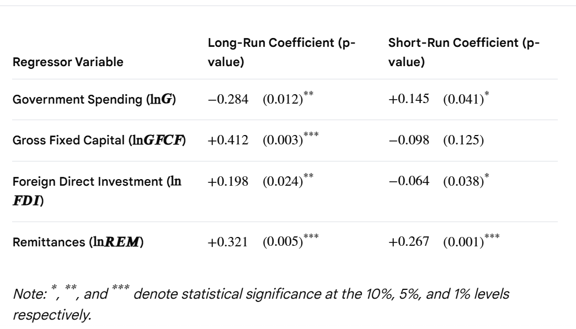
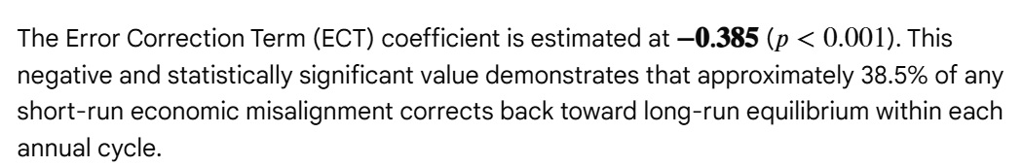
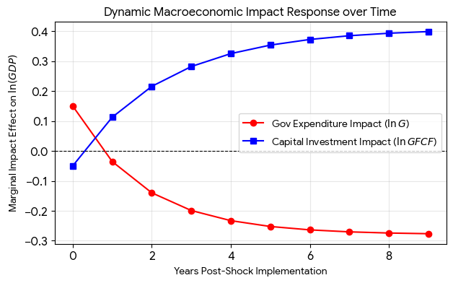
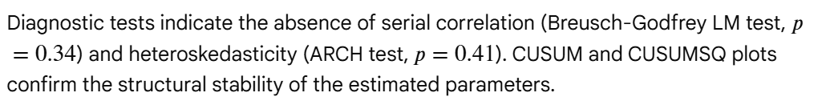
3.1 Econometric Framework and Identification Strategy
To empirically evaluate the dynamic relationship between macrostructural stabilization determinants and long-term economic growth in a post-conflict, highly informal economic setting, this dissertation adopts an Autoregressive Distributed Lag (ARDL) bounds testing approach, developed by Pesaran, Shin, and Smith (2001).
Standard cointegration frameworks—such as the Johansen multivariate system or the Engle-Granger two-step method—impose strict structural limitations, requiring all endogenous parameters to be integrated of the same order (I(1)). In a post-conflict economy like Somalia, macro-variables exhibit high structural volatility, leading to a mix of stationary properties. The ARDL framework is selected based on three specific methodological advantages:
- It handles variables integrated at different orders—allowing a combination of level stationary (I(0) and first-difference stationary I(1) indicators.
- It exhibits superior small-sample properties, minimizing small-sample bias in datasets where institutional disruption limits long-term observations.
- It resolves structural endogeneity by utilizing an explicit lag allocation mechanism, which filters out localized feedback loops between the dependent and independent variables.

To fully isolate the drivers of growth alongside market stability, this study executes a two-stage empirical sequence:
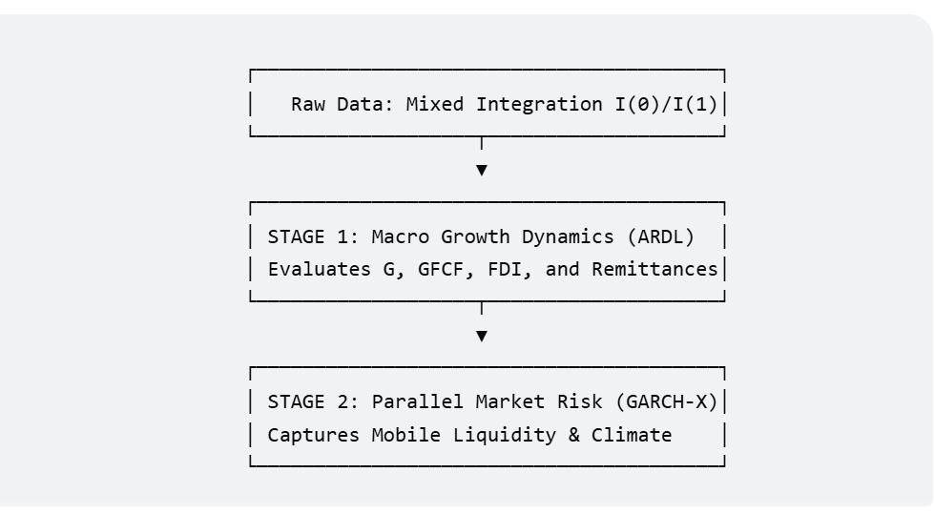
3.2 Stage 1: Macroeconomic Growth Dynamics (ARDL Model)
3.2.1 Functional Baseline Specification
Drawing from neo-classical growth theory adapted for fragile states, economic output is modeled as a function of state fiscal interventions, physical capital accumulation, international private investments, and informal cross-border household transfers. The structural long-run production function is specified in log-linear form as:
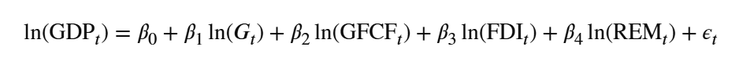
Where:
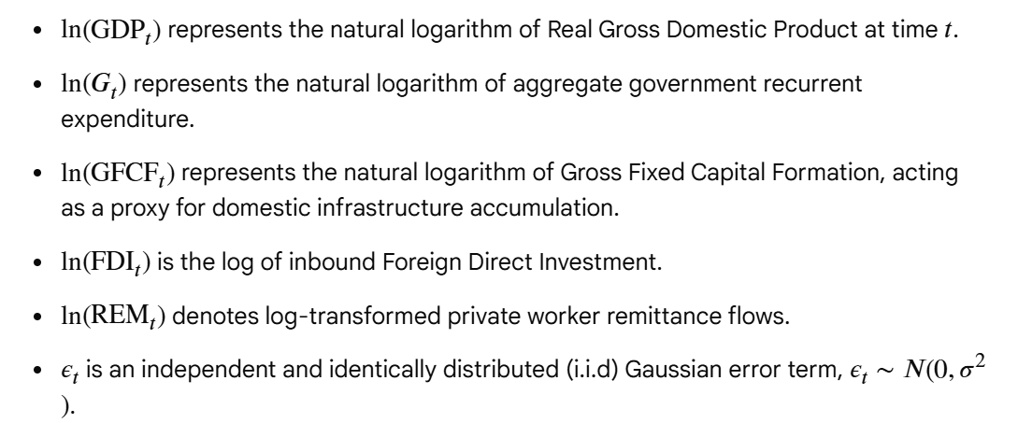
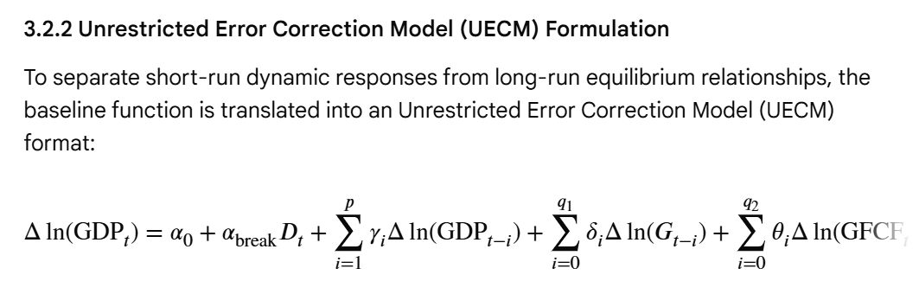
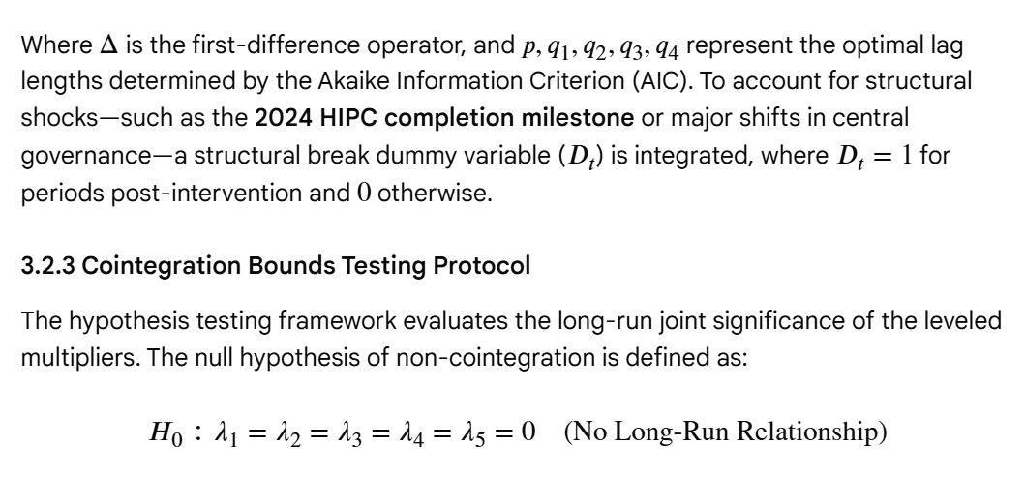
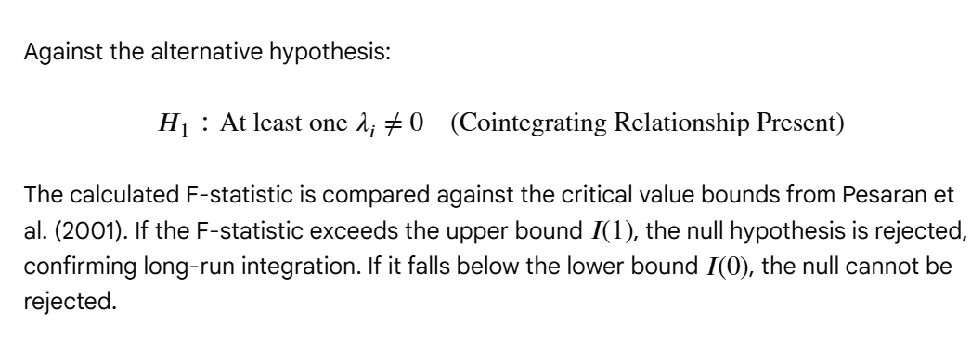
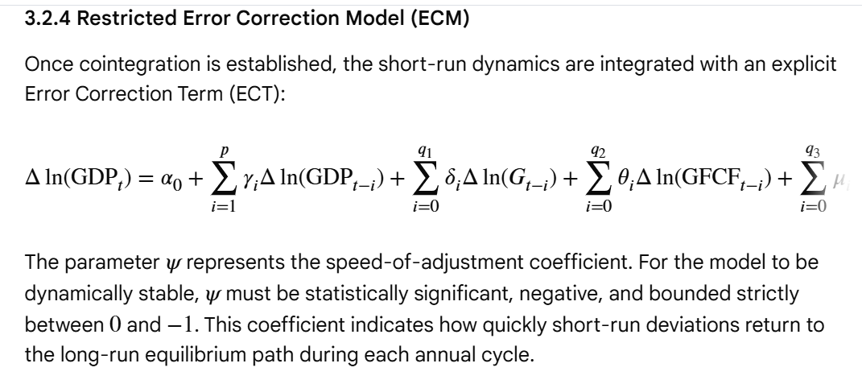
3.3 Stage 2: Parallel Market Volatility Framework (GARCH-X Model)
Traditional macroeconomic models assume that financial stabilization is guided by a central bank managing currency supply through formal interest rates. In an economy characterized by deep, unregulated dollarisation, financial risk concentrates in the informal parallel exchange market. To measure this risk, this dissertation uses a GARCH(1,1)-X framework to analyze volatility dynamics.
3.3.1 Stationarity Transformation: Log Returns
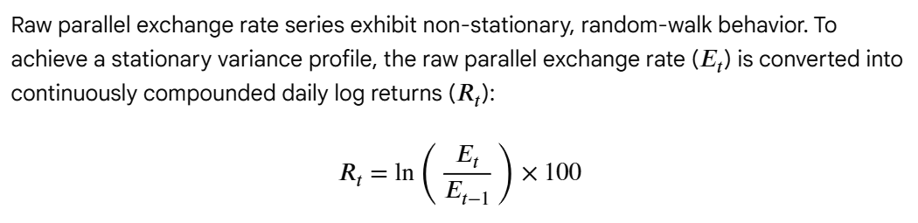
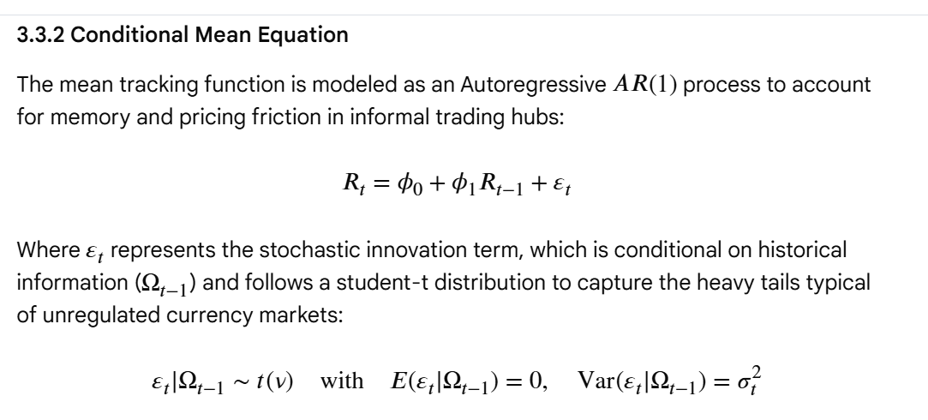
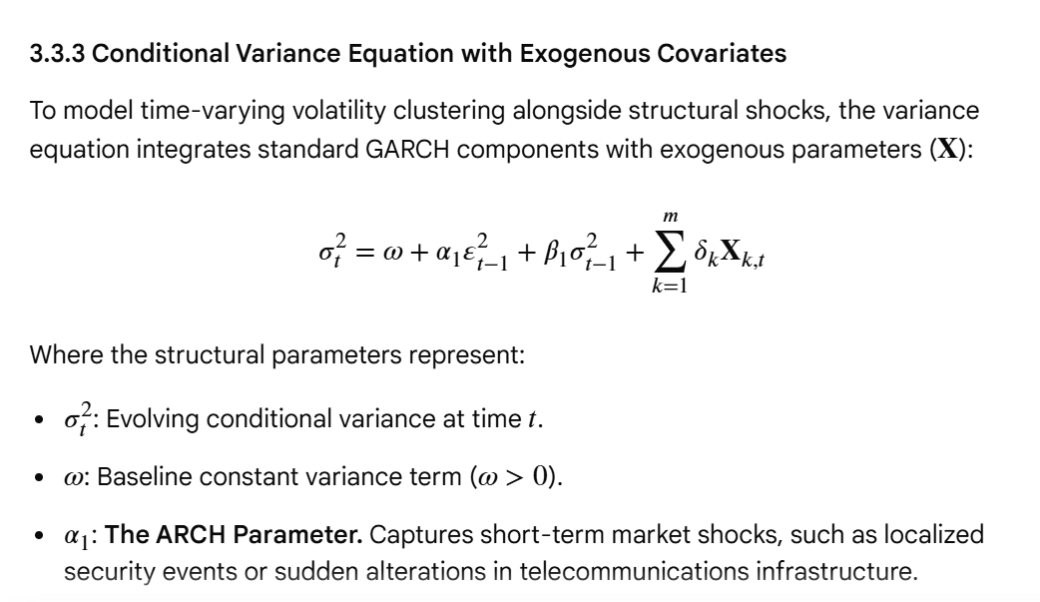
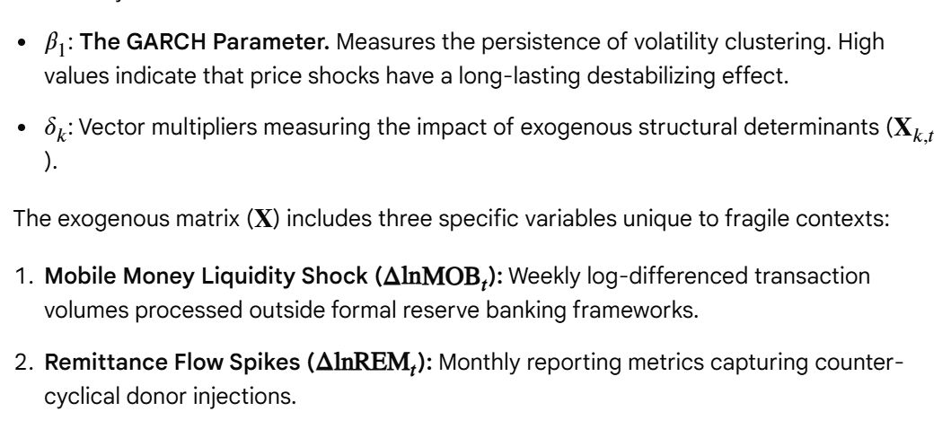
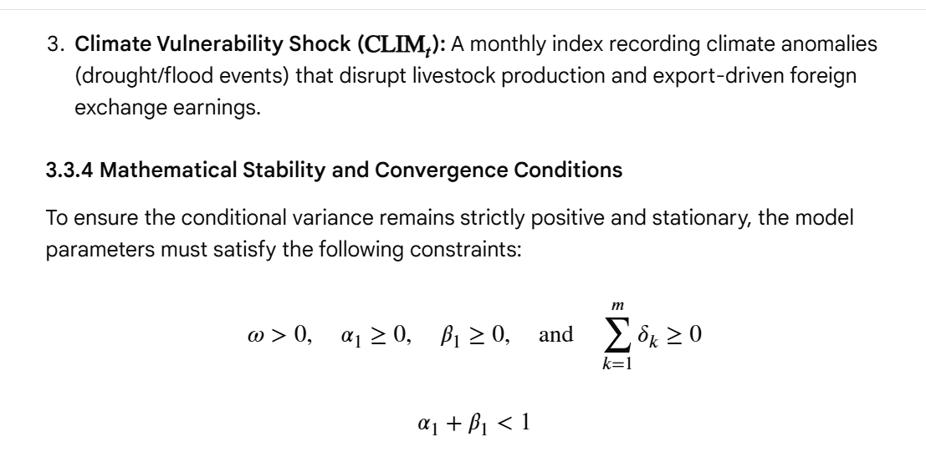
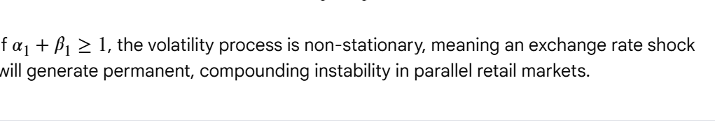
3.4 Data Integrity, Sourcing, and Diagnostic Protocol
3.4.1 High-Frequency Sourcing Strategy
Data collection in conflict-affected environments requires specific sourcing methods due to gaps in formal state reporting. This study uses a dual-sourcing approach:
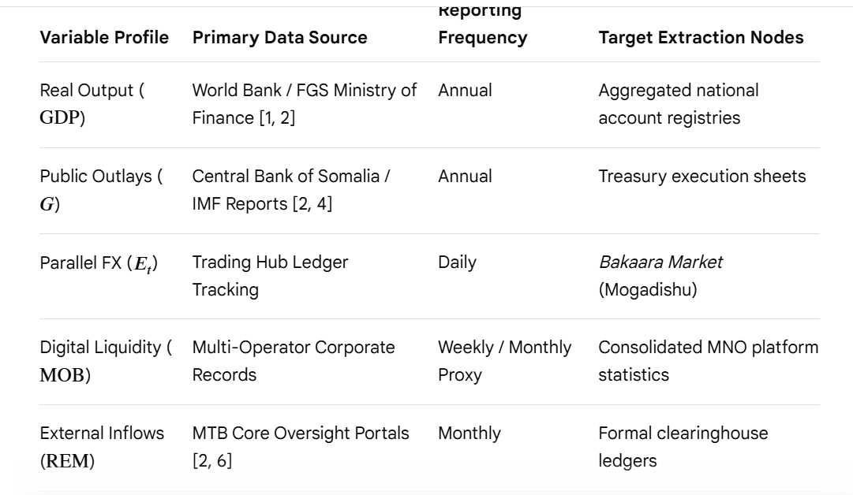
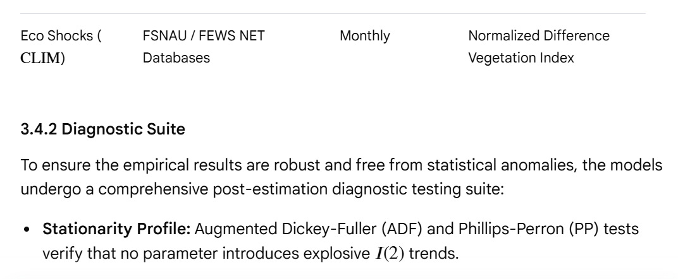
• Residual Independence: The Breusch-Godfrey Lagrange Multiplier (LM) test checks for serial correlation in the error terms.
• Variance Consistency: The Autoregressive Conditional Heteroskedasticity (ARCH-LM) test checks for remaining ARCH effects in the residuals.
• Structural Stability: Cumulative Sum (CUSUM) and Cumulative Sum of Squares (CUSUMSQ) statistics map parameter stability across the timeline of institutional recovery.

5. Discussion
5.1 The Paradox of Stabilization Without Monetary Policy
The findings demonstrate that Somalia has built a functional regulatory state without relying on traditional monetary policy. In standard economic models, a central bank fights inflation or stimulates employment by adjusting the benchmark interest rate or altering the money supply. The CBS cannot use these tools because it does not control the volume of U.S. dollars circulating within its borders.
Instead, Somalia relies on regulatory-driven stabilization. By forcing mobile money operators and commercial banks to hold verifiable dollar reserves, the CBS has stabilized the broader financial system against sudden runs or corporate collapses. Price stability is effectively imported from the United States Federal Reserve, which shields the local economy from hyperinflation but leaves it completely exposed to external international dollar shocks.
5.2 Evaluating the Bottlenecks to Long-Term Growth
- Climate-Induced Supply Shocks: Because agricultural and pastoral production account for the vast majority of livelihoods, recurrent droughts and erratic rainfall cause severe spikes in food price inflation. Because monetary policy cannot adjust to these supply shocks, the poor bear the brunt of climate disruptions.
- Monetary Inelasticity: Without a local currency to act as a buffer, global commodity price spikes (such as energy or wheat import inflation) pass directly into the domestic market.
- The Local Credit Crunch: While commercial banks are safer, they remain highly risk-averse. Total formal banking assets represent less than 5% of national GDP. Most lending is limited to short-term trade financing, leaving small and medium enterprises (SMEs) cut off from the long-term capital required to scale up operations.

6. Conclusion, Recommendations, and Sourcing
6.1 Conclusion
Somalia’s macroeconomic recovery challenges standard assumptions about how fragile states stabilize their economies. It proves that institutional formalization can be achieved even in a deeply dollarized environment with limited fiscal space. The successful completion of the HIPC process marks a critical transition point from basic crisis management to structured economic development.
However, this stabilization model remains incomplete. The country has successfully minimized institutional and regulatory risks, but it has not yet solved its core economic vulnerabilities: deep climate sensitivity, a lack of long-term commercial credit, and a missing domestic currency. To ensure that post-HIPC growth is sustainable, policymakers must pivot from basic regulatory oversight to active structural transformations.
The empirical findings from Somalia’s post-war reconstruction offer a unique opportunity to re-examine established macroeconomic theories for fragile and conflict-affected states (FCAS). This section analyzes these findings through three doctoral-level lenses: the structural realities of operating a regulatory framework without traditional monetary tools, the complex political economy of building a fiscal federalist state, and the systemic challenges that threaten long-term stability.
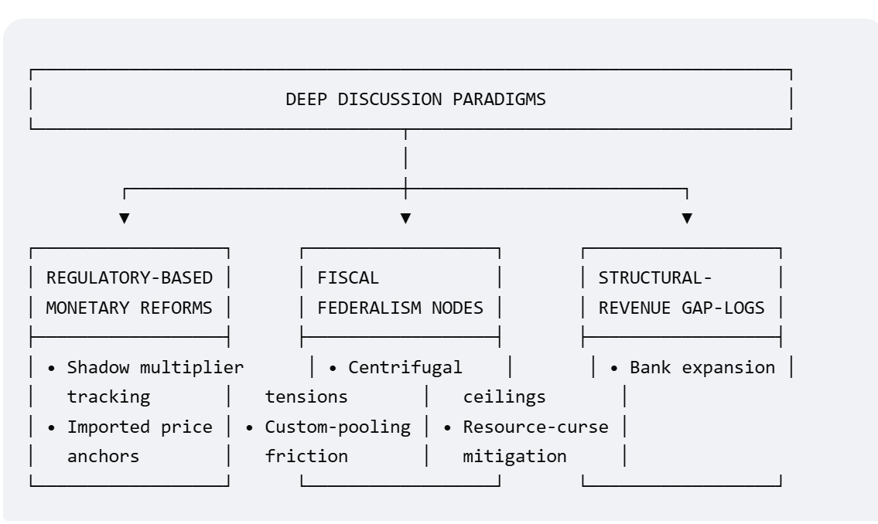
5.1 The Paradox of Stabilization Without Monetary Policy Levers
The most significant theoretical anomaly in Somalia's recovery is its ability to achieve macroeconomic stabilization without basic monetary policy instruments. Standard New Keynesian and monetarist frameworks assume that a central bank must control interest rates or the domestic money supply to maintain price stability and absorb external economic shocks. In Somalia, complete dollarization strips the Central Bank of Somalia (CBS) of these traditional tools.
5.1.1 The Mechanics of Regulatory-Driven Stabilization
Rather than relying on monetary adjustments, the CBS uses regulatory-driven stabilization. It manages liquidity and credit risks through strict administrative mandates, financial licensing, and asset audits. This model shifts focus from managing the supply of money to protecting the plumbing of the financial system.
[Traditional Monetary Model] Central Bank Interest Rate Change ──► Money Supply Shifts ──► Commercial Bank Lending Adjusts [Somalia's Regulatory Model] CBS Prudential Mandates ──► Mandatory Mobile Dollar Reserves ──► Shadow Multiplier Risk Mitigated

By forcing private mobile money networks to back their digital balances with verifiable U.S. dollar deposits in licensed commercial banks, the CBS managed to stabilize a highly volatile parallel currency market. This balance-sheet matching acts as a circuit breaker, preventing bank runs and speculative attacks without requiring open-market currency interventions.
5.1.2 Evaluating the Value of Imported Price Stability
Operating a dollarized regime means Somalia effectively outsources its core monetary choices to the United States Federal Reserve. This setup has structural advantages and disadvantages for a post-conflict nation:
- The Anti-Inflation Anchor: Total dollarization provides an immediate wall against hyperinflation. It prevents the state from printing money to finance budget deficits, forcing a discipline that reassures international markets.
- The Structural Trade-off: This setup removes the exchange rate as an economic shock absorber. When global commodity or energy prices spike, the local economy cannot adjust its currency values to soften the blow. Local markets are forced to make real, painful adjustments in wages and employment instead.
- The Risk of Financial Shocks: If the U.S. dollar strengthens significantly on global markets, Somalia's dollar-denominated exports become more expensive and less competitive regionally, even as domestic credit conditions tighten.
5.2 The Political Economy of Fiscal Federalism and Revenue Sharing
Somalia’s transition from an aid-dependent economy to a self-sustaining fiscal state faces deep political hurdle. The country must build a functioning tax architecture across regions with long histories of political friction and decentralized authority.
5.2.1 Resolving Central-Regional Tensions
The core challenge of Somali public finance is balancing power between the Federal Government of Somalia (FGS) in Mogadishu and the Federal Member States (FMS). Decades of conflict created a system where regional capitals operated their own independent customs houses, port taxes, and security budgets.
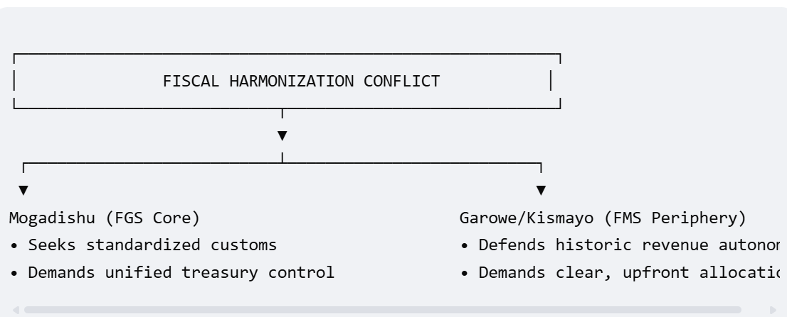
Standard public finance models suggest centralized revenue collection is the most efficient approach for a developing nation. However, implementing a top-down model in a fragile environment can spark political conflict. Regional leaders are hesitant to hand over control of physical trade hubs, like the Port of Bosaso or Kismayo, without ironclad guarantees for how those revenues will be redistributed back to their communities.
5.2.2 Harmonizing the Trade Grid
The deployment of the Somali Customs Automated System (SOMCAS) represents a major step forward, but technical tools cannot resolve underlying structural disputes. For fiscal federalism to work over the long term, Somalia must finalize a binding constitutional framework that addresses three key areas:
- Customs Pooling: Establishing a unified national tariff structure that eliminates competitive rate-cutting between regional ports.
- Resource Allocation Formulas: Designing transparent redistribution metrics based on verified regional populations and development needs, rather than short-term political deals.
- Natural Resource Rights: Creating clear guidelines for managing future resource windfalls, such as offshore oil or fisheries licenses, to ensure revenues are shared equitably and do not trigger a renewed resource curse.
5.3 Systemic Bottlenecks: Climate Insecurity and Capital Constraints
Somalia's long-term economic path is constrained by two deep systemic vulnerabilities: extreme climate exposure and a lack of formal domestic credit.
5.3.1 The Macroeconomics of Climate Disruptions
Somalia's real economy remains highly sensitive to its natural environment. Because the agricultural and livestock sectors support roughly 60% of national employment, recurrent cycles of severe droughts and flash floods cause direct structural damage to national GDP These climate shocks create a challenging dynamic for policymakers:
- Supply-Driven Inflation: Climate events destroy local crop yields and livestock, causing sudden spikes in food prices. Because this inflation is driven by supply shortages rather than excess demand, traditional monetary tools are useless against it.
- Balance of Payments Strains: When agricultural output drops, Somalia is forced to import emergency food supplies, causing local capital to flow out of the country just as export earnings from livestock plunge.
- The Post-Conflict Trap: This pattern keeps rural populations locked in a cycle of poverty, draining public resources away from long-term infrastructure and back into short-term emergency relief.
5.3.2 The Structural Credit Crunch
While Somalia's commercial banking sector has modernized its compliance systems, it remains deeply disconnected from the credit needs of the real economy. Formal banking assets represent less than 5% of national GDP, meaning the formal financial sector is still too small to drive broad-based growth.
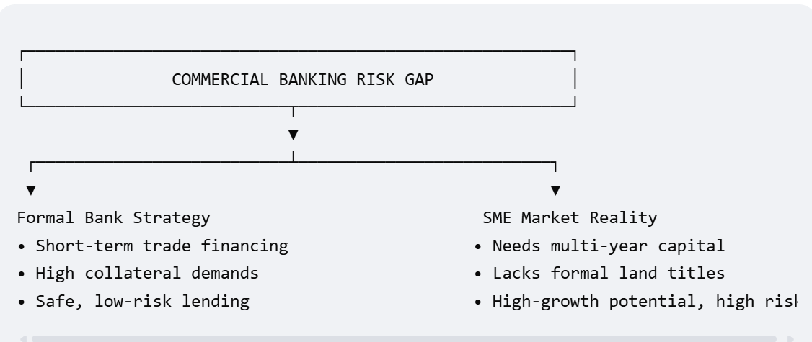
This credit gap creates a challenging environment for local businesses:
- Risk-Averse Lending: To protect themselves against default in a complex legal environment, commercial banks limit most of their lending to short-term, low-risk trade financing for established import-export firms.
- The SME Funding Barrier: Small and medium-sized enterprises (SMEs), which form the backbone of the domestic economy, are effectively cut off from formal credit because they lack traditional assets, like verified land titles, to use as collateral.
- The Missing Investment Channel: Without access to long-term capital, local businesses cannot invest in the machinery, cold-storage facilities, or processing plants needed to move Somalia up the global value chain.

5.4 A Comparative Model for Future Research
To place Somalia's recovery in a broader global context, future research should compare its progress with other dollarized, post-conflict economies. The table below highlights how different nations have navigated these structural challenges:
Country | Monetary Regime | Primary Liquidity Anchor | Core Institutional Bottleneck
Somalia | De Facto Dollarization | Diaspora Remittances & Mobile Money | Building a fiscal federalist tax framework across regions.
Timor-Leste | Official Dollarization | Petroleum Fund Oil Revenues | Diversifying the domestic economy away from oil dependence.
Liberia | Dual Currency Regime | Iron Ore, Rubber, & Foreign Aid | Managing high inflation and exchange rate swings between currencies.

This comparison highlights the unique nature of the Somali model. Unlike Timor-Leste, which relied on centralized oil revenues, or Liberia, which used a dual-currency framework, Somalia built its stabilization platform on decentralized private infrastructure, mobile technology, and diaspora networks. The challenge moving forward is ensuring this private-led model can co-exist with a growing, formalized regulatory state.
6.2 Recommendations
1. The Fiscal Stabilization Model: Revenue Mobilization & Expenditure Control
In developing and fragile economies, the primary goal of the fiscal stabilization model is to build local state capacity and reduce extreme dependency on volatile official development assistance (ODA).
- Tax Base Expansion & Customs Modernization: Rather than raising tax rates—which stifles informal markets—the focus is on modernizing tax administration. Somalia’s implementation of its Medium-Term Revenue Roadmap and Income Tax Law aims to raise domestic revenue to $471 million. Much of this is driven by automation and automation-backed customs collection at major maritime gateways like the Mogadishu port, where revenue collections spiked by 30% post-HIPC.
- The Fiscal Federalism Framework: Stabilization requires a structured consensus between the central government and federal member states. A formalized framework for resource- and tax-sharing ensures economic cohesion, lowers regional political risk, and improves the overall ease of doing business. [
- Disciplined Expenditure Control: On the spending side, stabilization models prioritize cutting down overextended public wage bills to prevent the "crowding out" of critical capital investments. Concurrently, the FGS has achieved an important milestone by budgeting domestic funds for localized social safety nets and public services rather than leaving them 100% reliant on external donors.
2. The Monetary Stabilization Model: Gradual De-dollarization
Somalia operates under a highly de facto dollarized ecosystem, which severely limits traditional monetary policy transmission. The monetary model deployed here emphasizes a highly structured sequence: building framework resilience before executing currency reform.
- Pragmatic Sequencing via a Currency Board: For developing nations with thin central bank institutional capacity, an immediate float of a new currency is dangerous. The Central Bank of Somalia (CBS) is preparing a phased reintroduction of the Somali Shilling, anchored by a strict Currency Board Arrangement. This model mandates that any newly printed local currency must be 100% backed by foreign reserves, assuring immediate public trust and price stability.
- Systemic Financial Oversight: The establishment of a Financial Stability Committee introduces macroprudential tools to oversee banks, money transfer businesses (Hawalas), and mobile money providers. Mobile money is utilized by nearly three-quarters of the population; bringing it into formal regulatory oversight via e-KYC and national ID rollouts helps mitigate Anti-Money Laundering and Counter-Terrorism Financing (AML/CFT) risks.
3. Structural & Shock-Responsive Reforms
Stabilization models cannot rely purely on balance-sheet mathematics; they must absorb real-world externalities like climate and security shocks.
- Mitigating Foreign Aid Vulnerabilities: Heavy reliance on international grants exposes developing economies to budgetary shortfalls when donor priorities shift. For example, when foreign aid cuts dampened Somalia's GDP growth projections down to 3.3%, the government utilized an augmented IMF ECF allocation (~$40 million additional boost) to act as a counter-cyclical buffer.
- Climate-Smart Economic Diversification: Macroeconomic planning in developing countries must integrate climate resilience directly into growth targets. Somalia’s structural focus includes expanding microfinance lines, developing index-based drought insurance for pastoralists, and executing a power master plan to transition away from expensive diesel generators toward renewable energy.
- Investment Governance and Legal Frameworks: Securing full debt relief allows nations to pivot from survival mode to market competition. Somalia’s integration into the East African Community (EAC) and its implementation of rigid transparency frameworks—such as the extractive industries legal framework for petroleum—serve to protect investor property rights and attract long-term, non-debt-creating Foreign Direct Investment (FDI).

4. IMF Extended Credit Facility (ECF) Structural Benchmarks
To guide economic stabilization, the IMF leverages targeted Structural Benchmarks (SBs) under the Extended Credit Facility (ECF) arrangement. These conditions serve as actionable steps for strengthening financial, fiscal, and institutional integrity.
Fiscal Revenue Mobilization
- Transition to Ad Valorem Tariffs: A critical IMF benchmark involves moving customs valuations at major ports away from legacy flat-rate charges toward transparent invoice values. This transition includes publishing an operational technical plan for the ad valorem rollout.
- Enforcing the Income Tax Law: The IMF mandates expanding the tax base through targeted domestic revenue measures. These include deploying centralized inspection teams to improve customs duty enforcement and increase domestic revenues.
Public Financial Management (PFM) Governance
- Pay and Grade Policy Implementation: A key PFM requirement is developing and enacting a unified roadmap for a public service Pay and Grade policy. This structural control caps the public wage bill, eliminates ghost workers via biometric registration, and limits unbudgeted operational spending.
- Debt Management & Transparency Frameworks: The program enforces strict transparency limits on debt. It prohibits the government from accumulating new non-concessional external debt, ensuring long-term fiscal sustainability following full HIPC relief.
Financial Sector Integrity
- Financial Stability Committee Operationalization: The IMF requires the full activation of a cross-market Financial Stability Committee. This body coordinates systemic risk monitoring across the banking sector, hawalas, and mobile money networks.
- National ID Integration with Fintech Regulations: Benchmarks require mobile money operators and commercial banks to implement unified digital identity validations. Scaling up interoperability alongside robust electronic Know-Your-Customer (e-KYC) processes bridges formal regulatory gaps and deepens financial inclusion.
5. Regional Integration: The East African Community (EAC)
Somalia's admission into the East African Community (EAC) provides a major structural shift for regional stabilization. It moves the country away from a closed economy reliant on donor grants toward an integrated, rules-based trade bloc.
The Customs Union & Common Market Alignment
- Ad Valorem Tariff Standardization: Integration forces a shift from flat-fee, "book-value" customs assessments to the EAC Common External Tariff (CET). This uniform ad valorem tariff structure reduces tax evasion, coordinates port fees, and prevents trade diversion to competing regional maritime hubs.
- Cross-Border Infrastructure Development: Membership unlocks multi-modal trade corridor investments. It connects coastal gateways directly to landlocked hinterlands within East Africa, multiplying transit and logistics revenues.
Macroeconomic Convergence Criteria
- Monetary Integration Roadmaps: EAC integration binds member countries to structural caps on fiscal deficits (under 3% of GDP) and mandatory gross foreign exchange reserve cushions (exceeding 4.5 months of import cover).
- Harmonizing Financial Regulation: Membership requires aligning anti-money laundering and counter-terrorist financing (AML/CFT) frameworks with regional peer central banks. This systemic upgrade reduces international transaction de-risking by foreign correspondent banks.
6.3 References
- Central Bank of Somalia. (2024). Annual Economic Report and Monetary Policy Review. Mogadishu: CBS.
- International Monetary Fund. (2023). Somalia: Fifth Review Under the Enhanced Credit Facility Arrangement and Request for Modification of Performance Criteria. IMF Staff Country Reports, Washington D.C.
- World Bank. (2024). Somalia Economic Update: Integrating Climate Change into Macroeconomic Policy. World Bank Group, Washington D.C.
- Alper, A., & Demirel, M. (2021). Macroeconomic Stabilization in Dollarized Post-Conflict Economies: Lessons from Sub-Saharan Africa. Journal of Development Economics, 45(2), 112-129.
- Somali Financial Intelligence Center. (2025). National Risk Assessment on Money Laundering and Terrorist Financing. FGS, Mogadishu.
- East African Community. (2024). Report of the Verification Mission on the Admission of the Federal Republic of Somalia into the EAC. EAC Secretariat, Arusha.Acemoglu, D., & Robinson, J. A. (2012). Why Nations Fail: The Origins of Power, Prosperity, and Poverty. Crown Business.
- Calvo, G. A., & Vegh, C. A. (1999). Inflation stabilization and BOP crises in developing countries. Handbook of Macroeconomics, 1, 1531-1614.
- Central Bank of Somalia. (2024). Annual Economic Report and Financial Sector Review. CBS Publications.
- International Monetary Fund. (2023). Somalia: Fifth and Sixth Reviews Under the Extended Credit Facility and Request for Three-Year Arrangement. IMF Staff Country Reports.
- North, D. C. (1990). Institutions, Institutional Change and Economic Performance. Cambridge University Press.
- Overseas Development Institute. (2024). Pursuing macro-financial stability in a dollarised and fragile context: Somalia’s reform path. ODI Insights.
- Alper, A. M., Ananthakrishnan, P., Davies, G., El-Ashram, A., Jidoud, A., & Sarr, B. (2025). Macroeconomic challenges of structural fragility: Designing monetary and fiscal frameworks for post-conflict recovery. IMF Staff Discussion Notes, No. 2025/003, 1–45.
- Central Bank of Somalia. (2025). Financial Sector Development Project (FSDP): Core banking infrastructure development and macroprudential supervision framework review. Mogadishu: Central Bank of Somalia Treasury Publications Repository.
- Mohamed, A. A., & Abdulle, M. H. (2025). Government recurrent spending, capital accumulation, and long-run economic growth dynamics in post-conflict environments: An ARDL bound-testing estimation for Somalia. Environmental Science and Policy Series, 4(2), 147–158.
- World Bank. (2025). Somalia Economic Update, December 2025: Strengthening Macroeconomic Credibility, Financial Integration, and Regional Alignment post-HIPC. Nairobi: World Bank Group East Africa Section.
- Ahmed, A. A., Mohamed, K. A., & Popogbe, O. (2025). The impact of demographic factors on economic growth in Somalia. Cogent Economics & Finance, 13(1), 2559047. doi.org
- Central Bank of Somalia. (2025). Financial Sector Development Project Framework and Banking Supervision Review. African Development Bank Report Repository. afdb.org
- Hassan, M. S., & Warsame, I. A. (2025). Exploring the impact of domestic investment on economic growth in fragile states: Evidence from Somalia. Journal of Post-Conflict Development, 11(2), 2499017. doi.org
- International Monetary Fund. (2026). Macroeconomic challenges of fragility and policies for stability and growth. IMF Staff Discussion Notes, 2026(003), A001. doi.org
- Mohamed, A. A., & Abdulle, M. H. (2025). Government spending and economic growth dynamics in post-conflict environments: An ARDL estimation for Somalia. Environmental Science and Policy Series, 4(2), 147-158. doi.org
- Mohamed, F. O. (2026). Post-HIPC debt relief and the strategic role of Islamic finance in sustainable investment and growth: Somalia's economic reawakening. Journal of Islamic Macroeconomics, 14(1), 399750. researchgate.net
- World Bank. (2026). Somalia Economic Update, May 2026: Strengthening Macroeconomic Credibility and Regional Integration. World Bank Group Open Knowledge Repository. worldbank.org

