Structural Elucidation of Copper (II) Groundnut thiourea complex

Abstract
Surfactants are amphiphilic compounds possessing both hydrophilic and hydrophobic characteristics due to their molecular structures. They are extensively employed in industrial applications, everyday products, and numerous electrochemical investigations. The hydrophobic moiety generally comprises long hydrocarbon chains, whereas the hydrophilic portion may contain a variety of functional groups. Commonly referred to as surface-active agents, surfactants lower the surface tension of aqueous solutions and are therefore widely utilized as emulsifying agents, solubilizers, detergents, and antimicrobial agents. Transition metal complexes have attracted considerable interest from researchers and industries because of their diverse properties and expanding applications in various fields. The present study aims to investigate the structural characteristics of copper-containing complexes synthesized from a natural edible oil, namely groundnut oil, in which nitrogen and sulfur atoms serve as donor sites for coordination. Biologically active compounds constitute one of the most significant categories of materials with promising potential for future scientific and technological developments.
Keywords: Surfactants, Surface tension, Groundnut oil, Transition metal complexes.

Introduction
Surfactants, commonly referred to as surface-active agents, are amphiphilic molecules composed of two distinct regions: a hydrophilic head and a hydrophobic tail. Owing to their unique molecular architecture, these organic compounds exhibit solubility in a variety of organic solvents [1]. Their distinctive behavior arises from their ability to form micelles in solution. Among the most significant characteristics of surfactants are micellization in the bulk phase and adsorption at interfaces, both of which have attracted substantial theoretical, practical, and biological interest, as evidenced by numerous research articles and review publications over the past three decades [2].
Copper (II) soaps derived from natural oils possess important physicochemical properties that influence their selection for specific applications, including emulsification processes and their use as herbicides, fungicides, pesticides, and insecticides [3]. Several researchers [4,5] have investigated copper-containing complexes using a range of spectroscopic techniques, such as infrared (IR) spectroscopy, nuclear magnetic resonance (NMR) spectroscopy, and magnetic susceptibility measurements. Mass spectrometry serves as a valuable analytical tool for determining molecular masses and understanding fragmentation pathways of chemical compounds [6,7]. Thermogravimetric analysis is widely employed to evaluate kinetic parameters and oxidative induction periods of materials [8,9]. Motivated by these considerations, the present work focuses on the synthesis of copper (II) soaps and the investigation of their thermal characteristics [10].

Experimental - Matreials and methods
Analytical grade chemicals were used throughout the study. The oil was procured directly from the market for experimental purpose. Copper (II) soaps were synthesized by direct metathesis of the respective potassium soaps obtained from refined groundnut oil, employing a marginal excess of copper sulfate at 50–55 °C [11]. Following washing with hot water and alcohol, the sample was dried at 80–100 °C and purified by recrystallization from hot benzene. The copper(II) groundnut complex was synthesized by treating an ethanolic solution of the thiourea ligand with copper(II) soap in a 1:1 molar proportion. The reaction mixture was then refluxed for approximately two hours under continuous stirring. Upon cooling, the resulting solid precipitate was collected by filtration, washed with hot distilled water and ethyl alcohol, and vacuum-dried [12]. The dried complexes were further purified through two successive recrystallizations using hot benzene. The obtained complexes were dark green, solid substances that exhibited solubility in solvents such as benzene, ether, and methanol–benzene mixtures, while remaining insoluble in water. All copper soap complexes demonstrated considerable stability.

To investigate the structural characteristics of copper (II) soap complexes, infrared (IR) spectra of complexes derived groundnut oil was recorded at the Department of Chemistry, S.P.C. Government College, Ajmer. The spectra were obtained in the range of 4000–600 cm⁻¹ using an ABB Horizon MB 3000 series spectrophotometer. Electron Spin Resonance (ESR) spectra of the copper (II) soap complexes were measured at liquid nitrogen temperature (LNT) at SAIF, IIT Powai, Mumbai, employing TCNE (g = 2.00277) as an internal standard. Proton Nuclear Magnetic Resonance (^1H NMR) spectra of the complexes were recorded at SAIF, CDRI, Lucknow, with C₆D₆ used as the reference solvent.

Result and Discussion
Infra-red Spectra
The absorption bands observed at 2924 and 2854 cm⁻¹ are attributed to the asymmetric and symmetric stretching vibrations of the methylene (–CH₂) groups, respectively. In the spectra of the carboxylate ion (COO⁻), two characteristic bands are present: a strong asymmetric stretching vibration in the range of 1520–1560 cm⁻¹ and a comparatively weaker symmetric stretching vibration between 1342 and 1373 cm⁻¹. The carbonyl (>C=O) stretching vibration is detected at 1744 cm⁻¹.
The out-of-plane C–H bending vibration appears at 879 cm⁻¹, while the in-plane scissoring mode of the methylene C–H group is observed at 1458 cm⁻¹. A weak absorption band at 1234 cm⁻¹ is assigned to the twisting and wagging vibrations of the –CH₂ group. Bands occurring in the regions of 1111–1160 cm⁻¹ and 717–725 cm⁻¹ are attributed to the rocking vibrations of –CH₃ and –CH₂ groups, respectively. The copper soap complexes exhibit characteristic bands in the range of 602–609 cm⁻¹, which are assigned to copper–oxygen (Cu–O) stretching vibrations [13].

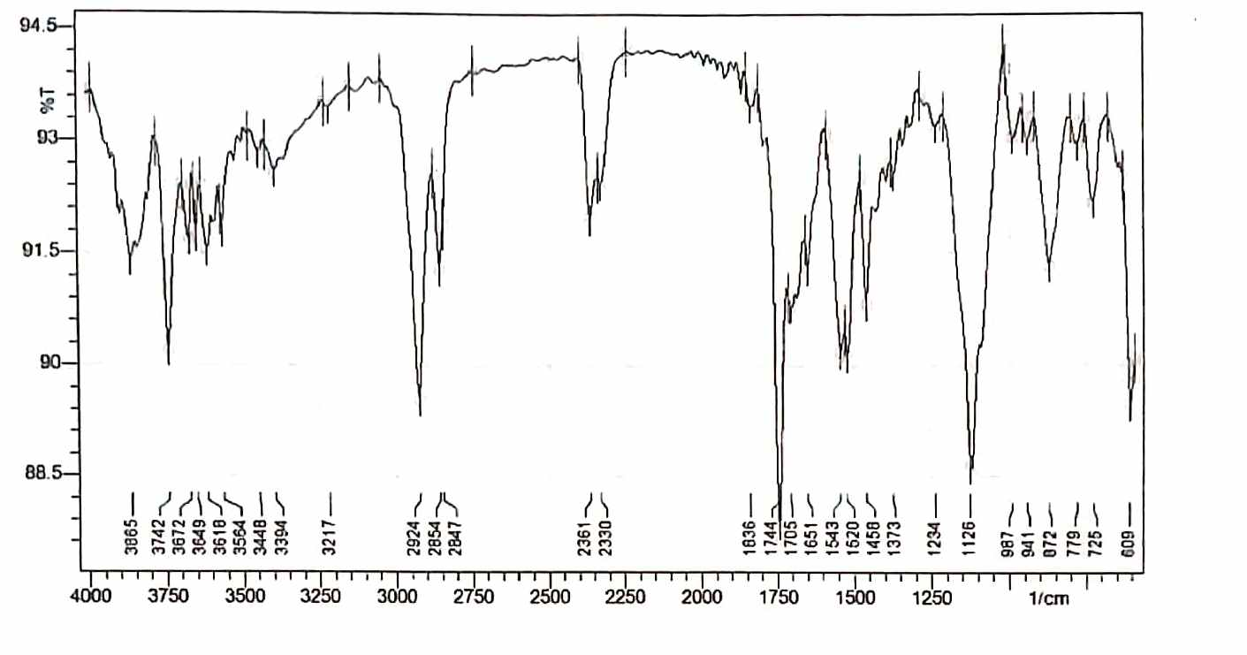
Figure-1: IR spectra of copper (II) groundnut thiourea complex
NMR Spectra
Figure 2 presents the ^1H NMR spectrum of the copper (II) groundnut thiourea complex. The signals appearing at δ 0.957 and δ 1.290 are assigned to the aliphatic protons of the –CH₃ and –CH₂ groups attached to the –CH₂R chain, respectively. The resonance signal at δ 2.10 corresponds to methylene protons adjacent to the carbon–carbon double bond (–C=C–). The vinylic proton gives rise to a characteristic signal near δ 5.50.
A broad resonance peak observed in the region of δ 3.20–4.20 is attributed to the amino (–NH₂) group of the thiourea ligand. The presence of this broadened signal suggests coordination of the ligand to the metal center through the –NH₂ group, indicating the involvement of the amino nitrogen atom in bonding with the copper ion [14].
.

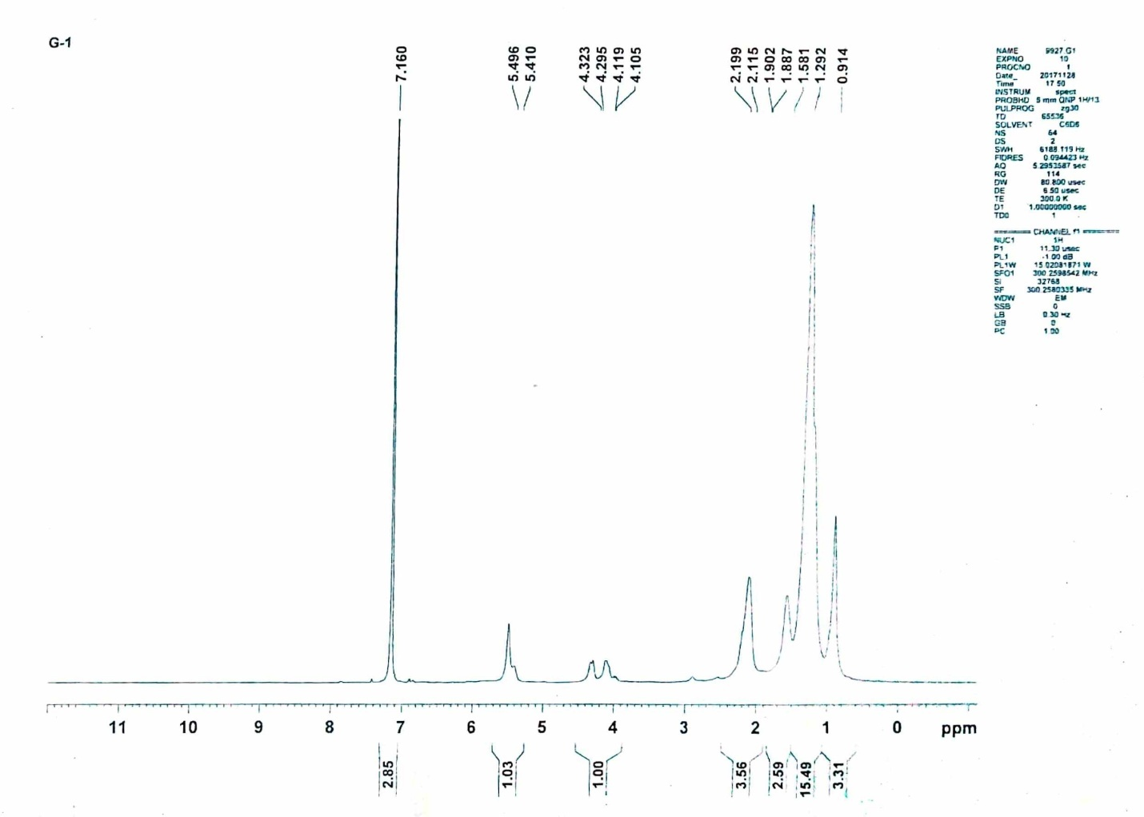

Figure-2: NMR spectra of copper (II) groundnut thiourea complex.
ESR Spectra
The ESR spectra of the complexes revealed two characteristic g-values, namely g∥ and g⊥. Since both g∥ and g⊥ are close to 2 and g∥ > g⊥, the results suggest the presence of tetragonal distortion around the Cu(II) ion. The observed relationship g∥ > g⊥ > gₑ (2.00277) indicates that the unpaired electron is predominantly localized in the d<sub>x²−y²</sub> orbital, which represents the ground state of the Cu(II) ion. The spectral features also imply the existence of axial symmetry within the complexes.
These observations support the assignment of a distorted or elongated octahedral geometry around the copper center. Furthermore, g∥ values greater than 2.3 are generally associated with an ionic metal–ligand environment, whereas g∥ values lower than 2.3 indicate significant covalent character in the bonding. Since the g∥ values obtained for the present complexes are below 2.3, the metal–ligand interactions can be considered predominantly covalent in nature [15].
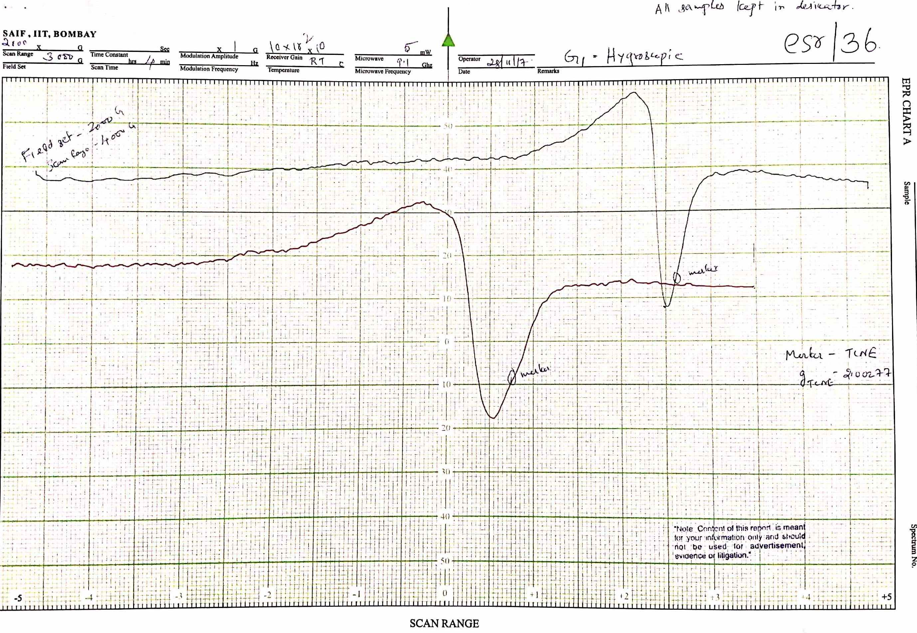
Figure-3: ESR spectra of copper (II) groundnut thiourea complex.

Conclusion
The Copper (II) groundnut thiourea complex was successfully synthesized and characterized using various spectroscopic techniques. The obtained spectral data confirmed the coordination of thiourea ligands with the copper ion through donor atoms, leading to the formation of a stable complex. Analysis of the spectroscopic results provided valuable information regarding the bonding pattern, molecular structure, and electronic environment of the complex. The findings demonstrate that spectroscopic methods are effective tools for elucidating the structural features of metal–ligand complexes. The synthesized Copper (II) groundnut thiourea complex may possess potential applications in coordination chemistry, catalysis, and biological studies, warranting further investigation of its physicochemical and functional properties.

References
- Meena A., Synthesis and characterization of copper (II) soap complexes derived from natural edible oils with substituted benzothiazoles, Research Journal of Chemistry and Environment, Vol. 27(12), 2023. DOI: 10.25303/2712rjce083089
- Joram A., Sharma R. and Sharma A.K., Spectroscopic characterization and thermo-gravimetric analysis of bioactive copper 2-amino 6-methyl benzothiazole complexes derived from various oils, Curr. Phy. Chem., 2019, 9, 58-76.
- Dutta R. L. and Syamal A., Elements of magnetochemistry, 2nd ed., Affiliated East‐West Press Pvt Ltd., New Delhi, 1995, 206-253.
- Gunstone F. D., An introductions to the chemistry of fats and fatty acids, Chapmann and Hall Ltd, London; c1958. 63-64.
- Coupland J. N., McClements D. J. ,Physical properties of liquid edible oils, J Amer Oil Chem Soc. 1997;74(12):1559-1564. https://doi.org/10.1007/s11746-997-0077-1
- Mishra A. and Pandey L., Synthesis, characterization and solid state structural studies of oxovanadium(IV)-O,N donor Schiff base chelates, Indian J. Chem., A, 2005, 44(1), 94-97.
- Al-Shihri A. S. M. and Abdel-Fattah H. M., Thermogravimetric and spectroscopic characterization of trivalent lanthanide chelates with some Schiff bases, J. Therm. Anal. Cal., 2003, 71, 643-649. https://doi.org/10.1023/A:1022880615841A.
- Hathaway B.J., Comprehensive Coordination Chemistry, Pergamon Press (UK), 1987, 5, 534-540.
- Meena A., Sharma R. and Sukhadia V., Synthesis and characterization of chemical structures, thermal decomposition and biological properties of novel copper (II) bio-based surfactants, Curr. Phy. Chem., 10, 2020. https://doi.org/10.2174/ 1877946810666200116091321
- Meena A., Sukhadia V. and Sharma R., Solid State Kinetics and Antimicrobial Studies for Copper (II) Sesame and Copper (II) Groundnut Complexes with Substituted Benzothiazole Ligand, Letters in Organic Chemistry, 18, 477 (2021).
- Mishra A. P., Sharma N. and Jain R. K., Microwave synthesis, spectral, thermal and antimicrobial studies of some Ni(II) and Cu(II) schiff base complexes, Avances en Química, 2012, 7(1), 77-85.
- Meena A., Study of structural elucidation, degradation kinetics and antimicrobial analysis of copper (II) sesame-soap complexes with urea and thiourea ligand in non-aqueous solvents. Letters in organic chemistry, Vol. 21, 369-385, 2024. DOI: 10.2174/0115701786260899231023091359
- Mehta, V. P.; Hasan, M.; Heda, L. C. Solid-state kinetics and infrared spectra of cadmium soaps. J. Macromol. Sci. Chem., 1982, A17(3), 513-521. http://dx.doi.org/10.1080/00222338208056488
- Meena A., Structural elucidation by spectroscopic studies of copper (II) groundnut complexes with 2-amino-6-ethoxy benzothiazole as a ligand. International Journal of Scientific Research and engineering Department, Vol. 8(2), 2025. DOI :10.5281/zenodo.17016937
- Valko M., Pelikan P., Biskupic S., and Mazur M., ESR spectra of copper(II) complexes in the solids, Chem. Papers, 1990, 44 (6), 805- 813.

