GIS-BASED SPATIAL CLASSIFICATION OF ONSHORE WIND ENERGY POTENTIAL IN NIGERIA
ADEWUNMI ANDREW ADESANMI, AJAYI OLUWAJUWON EMMANUEL¹, MANNIR ABDU, ACHIGBULAM CHARLES, SANI KHADIJAT1, BILIAMINU SAMUEL AKEEM, SHUBHAM SINGH1, OLALEKAN AWOLOLA
ABSTRACT
Nigeria’s electricity sector continues to experience chronic shortages despite abundant natural resources. This study assesses the spatial potential of onshore wind energy across Nigeria through integrated Geographic Information Systems (GIS) and Multi-Criteria Decision Analysis (MCDA). Hourly wind data from NASA POWER and ERA5 reanalysis were extrapolated to 150 m hub height and combined with topographic, land cover, and socio-environmental datasets to evaluate national wind suitability. The analysis reveals a pronounced north–south gradient in wind resources, with the northern regions exhibiting higher mean wind speeds and more favourable topography for large-scale wind power development. Using the Analytical Hierarchy Process (AHP), suitability was classified into three categories (Most Preferred, Preferred, and Least Preferred) based on wind potential, land-use conflicts, and population pressure. The Most Preferred zone, covering approximately 18 % of Nigeria’s land area, lies predominantly in the northern savanna belt, offering the greatest opportunity for utility-scale deployment. The resulting spatial classification provides a strategic framework for targeted wind energy investment and forms a foundation for subsequent techno-economic and policy assessments.
Keywords: Analytical Hierarchy Process, GIS, MCDA, Nigeria, Renewable Energy Planning, Spatial Classification Mapping, Wind Energy, Wind Resource Assessment
INTRODUCTION
Access to reliable and affordable electricity is essential for economic growth, industrialization, and social development (World Bank, 2023). Nigeria, despite being rich in fossil fuel resources, faces persistent electricity shortages, with over 40% of the population lacking access to power and millions relying on costly, polluting generators (Figure 1). This crisis highlights the urgent need to diversify the energy mix. Wind energy, though underutilized in Nigeria, presents a significant opportunity to improve energy security, reduce dependence on fossil fuels, and contribute to climate goals (Dalero & Musa, 2018). However, most studies in the Nigerian context remain fragmented, focusing on isolated sites with limited datasets and little integration of economic feasibility or policy frameworks. This research addresses these gaps by providing a comprehensive assessment of the technical, economic, and regulatory potential of onshore wind energy in Nigeria.
AIM AND OBJECTIVES
This study aims to evaluate and classify the spatial potential of onshore wind energy resources across Nigeria through an integrated Geographic Information Systems (GIS) and Multi-Criteria Decision Analysis (MCDA) framework. The purpose is to generate a spatially explicit understanding of wind resource distribution that can guide targeted investments, support energy diversification, and inform future techno-economic and policy assessments.
To achieve this aim, the study:
- Acquires and harmonizes multi-source geospatial datasets, including wind speed, topography, land cover, population density, and protected areas, covering all 36 states and the Federal Capital Territory.
- Extrapolates wind speed data from 10 m to 150 m hub height to represent modern turbine conditions and estimate national-scale wind characteristics.
- Integrates wind resource, environmental, and socio-economic parameters using the Analytical Hierarchy Process (AHP) within a GIS-based MCDA environment.
- Develops a national wind suitability map that classifies Nigeria into zones for wind energy development.
- Identifies regions combining high wind potential with minimal land-use conflict to provide a foundation for future techno-economic feasibility and policy planning.
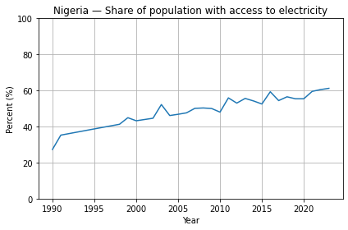
Figure 1 Nigerians without electricity
Source: (World Bank, 2025)
PURPOSE OF RESEARCH
The purpose of this study is to generate actionable insights into Nigeria’s wind energy potential, guiding policymakers, investors, and development partners in expanding renewable energy adoption. By doing so, it contributes to energy access, socio-economic development, and the national goal of achieving net-zero emissions by 2060 (United Nations Framework Convention, 2022).
RESEARCH JUSTIFICATION
Nigeria’s overdependence on natural gas for electricity generation exposes the economy to price volatility and exacerbates environmental challenges. The amount of CO₂ generated by Nigeria’s energy use and sources are quite high (Figure 2) While global and African studies employ integrated geospatial and techno-economic approaches, Nigerian research remains limited in scope. This study provides a more holistic analysis by combining geospatial mapping, techno-economic modelling, and policy benchmarking. It therefore fills critical knowledge gaps and offers practical recommendations for large-scale wind energy deployment.
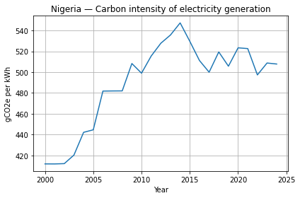
Figure 2 Carbon Intensity of electricity generation in Nigeria, 2000 to 2024
Source: (Ember, 2025)
HYPOTHESIS
This research hypothesizes that onshore wind energy in Nigeria, if strategically developed and supported by robust policies, is technically viable, economically competitive, and socially beneficial, offering a sustainable pathway to diversify the country’s energy supply.
LITERATURE REVIEW
The global technical potential for wind energy vastly exceeds world electricity consumption, as established by pioneering studies using reanalysis data and rigorous exclusion criteria (Lu, Mc Elroy, & Kivilvona, 2009). However, this immense potential is not uniformly distributed, and its viability is intensely local, hinging on precise wind resource assessment and suitable topography. The accuracy of these assessments depends critically on the methodologies employed, particularly in extrapolating wind data to modern turbine hub heights, where the power law has proven most reliable (Gualtieri, 2019).
This global context frames the situation in Nigeria, where a stark north-south divide in wind resources is well-documented. Broad-scale and regional studies have consistently identified the northern states as the primary zone of interest. Early work by Ayodele et al. using GIS overlays pointed to the suitability of northeasterly zones (Ayodele, Ogunjuyigbe, Munda, & Odigie, 2012), while nationwide benchmarks confirmed the inadequacy of wind resources in southern cities like Ibadan (Fadare, 2008) . Recent, more granular analyses have solidified this understanding. Appraisals of the Kano-Kaduna corridor position Kano as a Class III viable site with a high-power density of 443 W/m², significantly outperforming other regions Mas’ud et al (Akpaneno & Idris, 2024). This is supported by techno-economic simulations advocating for off-grid hybrid wind systems across Northern Nigeria (Olangunju, 2020).
However, a clear gap persists in having a concise site wide assessment of Nigerian onshore wind potential by identifying Wind resources and land use. The studies by Akpaneno & Idris (2024) and Olangunju (2020) provide the essential macro-context and methodological precedent, but they do not focus on the precise resource assessment and economic feasibility of expanding development at Lamber Rimi. Therefore, this article seeks to address this gap by applying advanced modelling and techno-economic analysis to provide a definitive assessment of the wind energy potential in Nigeria, expanding upon the foundational work in the region to guide targeted and viable investment.
MATERIALS AND METHODS
This study employed a mixed-methods approach to assess Nigeria's wind energy potential, integrating geospatial analysis, wind resource modelling, and multi-criteria decision analysis. The methodology was structured into three key phases: (1) study area definition and data acquisition, (2) wind resource assessment and modelling, (3) national suitability zoning.
STUDY AREA
The analysis encompassed Nigeria's 36 states and the Federal Capital Territory, covering a total area of 923,768 km². The country was stratified into its six geopolitical zones to account for regional variations in wind patterns and terrain. Preliminary analysis confirmed that the northern zones (e.g., Katsina, Sokoto, Kano, Jigawa, Kaduna) exhibited the highest potential, with mean wind speeds exceeding 6 m/s at a 150 m hub height. However, various demographic information will be analysed and a nationwide classification will be done.
DATA SOURCES
Multiple datasets were acquired and harmonized for this study
- Wind Data: Hourly wind speed data at 10 m height was sourced from the NASA Prediction of Worldwide Energy Resources (POWER) dataset (2024) due to the unavailability of high-resolution data from the Nigerian Meteorological Agency (NiMet). This reanalysis data has a spatial resolution of 0.5° $×$ 0.625°. Data validation was performed against the Global Wind Atlas (DTU, 2023) at hub height of 150 m (Figure 3 and Figure 4.)
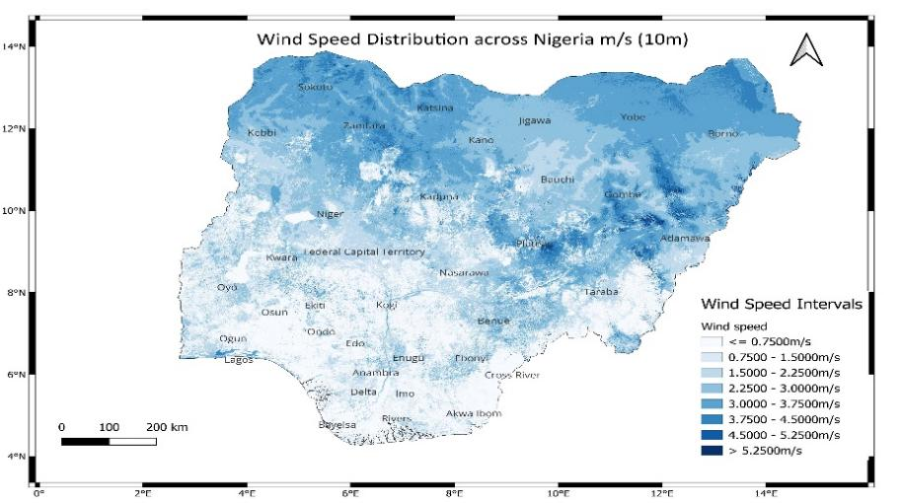
Figure 3 Wind Speed Map of Nigeria at 10 m
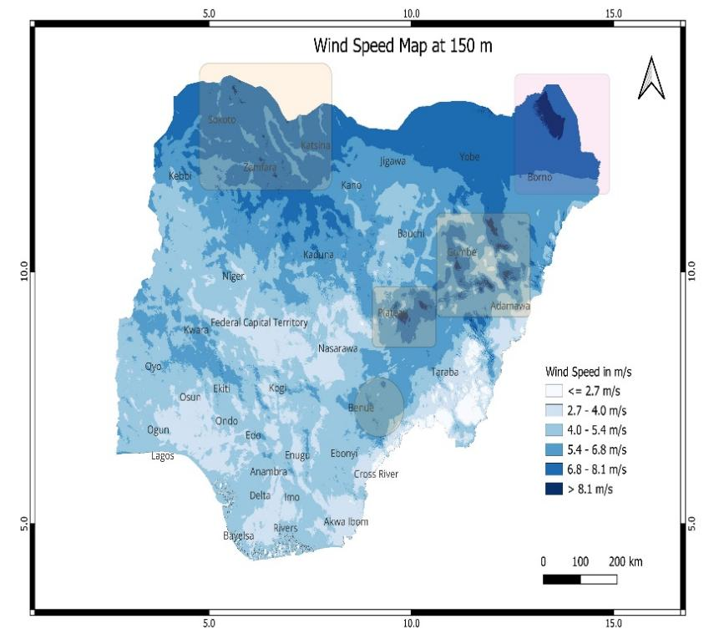
Figure 4 Wind Speed Map of Nigeria at 150 m
- Topographic Data: A 30-meter resolution Digital Elevation Model (DEM) from the Shuttle Radar Topography Mission (SRTM) was used to derive slope, roughness, elevation and hill shade layers (Figure 5,Figure 6,Figure 7 and Figure 8).
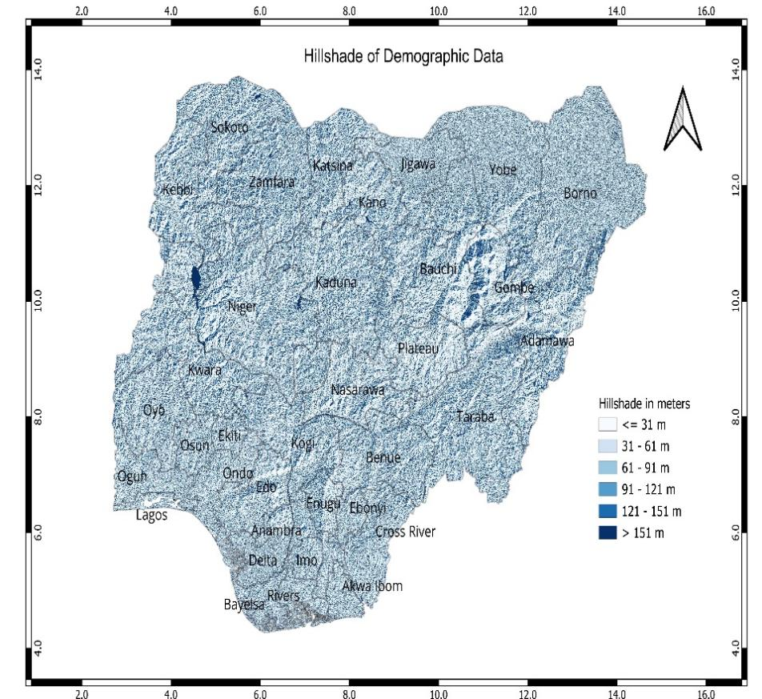
Figure 5 Hillshade map of Nigeria
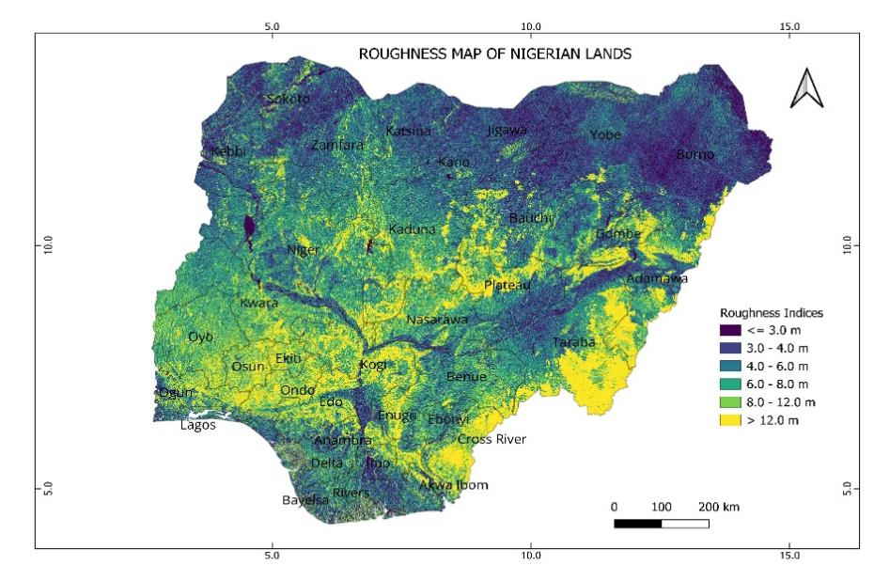
Figure 6 Rougness Map of Nigeria
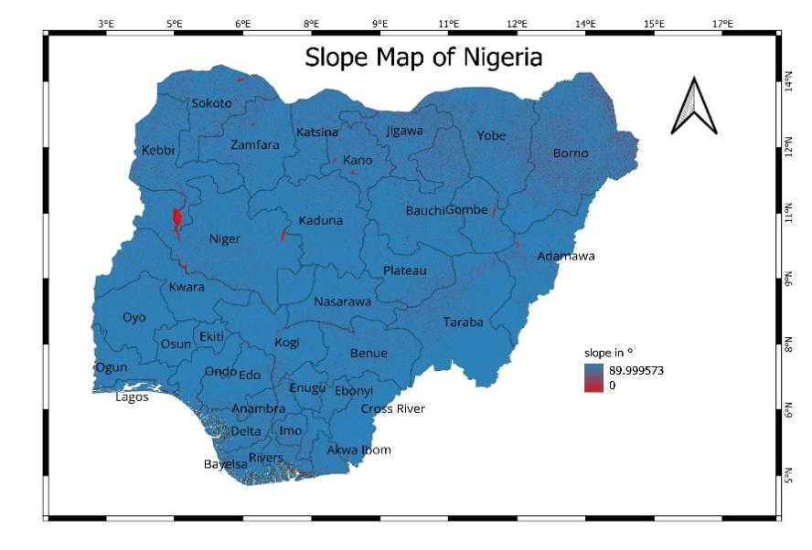
Figure 7 Slope Map of Nigeria
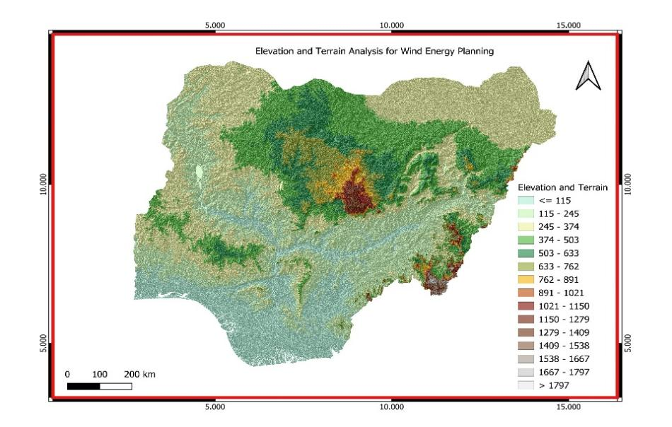
Figure 8 Elevation and Terrain Mapping
- Land Cover Data: A 2024 land cover classification was performed using Landsat 9 and Sentinel-2 imagery via the Google Earth Engine platform, employing a supervised Random Forest classifier. An overall accuracy of above 85% was achieved through ground-truthing (Figure 9).
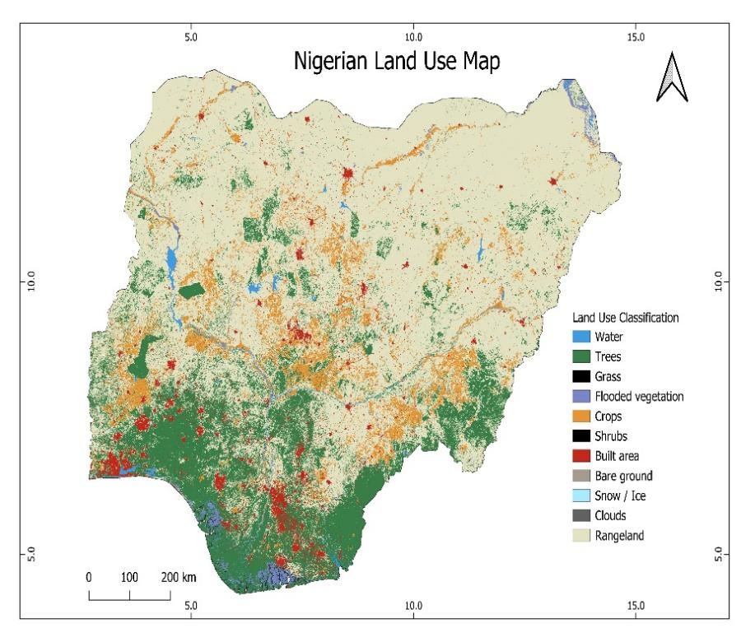
Figure 9 Land use Map
- Anthropogenic and Protected Data: The Global Human Settlement Layer (GHSL, 2019) identified urban areas, and the World Database on Protected Areas (WDPA, 2023) delineated conservation zones.
- Socio-economic and Policy Data: Population and land-use statistics were obtained from the National Bureau of Statistics (Nigeria Bureau of Statistics, 2024). Policy documents, including the National Renewable Energy and Energy Efficiency Policy (NPEEEP, 2015) and the Energy Transition Plan (ETP, 2023), were sourced from the Nigerian Electricity Regulatory Commission (NERC) and the Rural Electrification Agency (REA) (NERC, 2023).
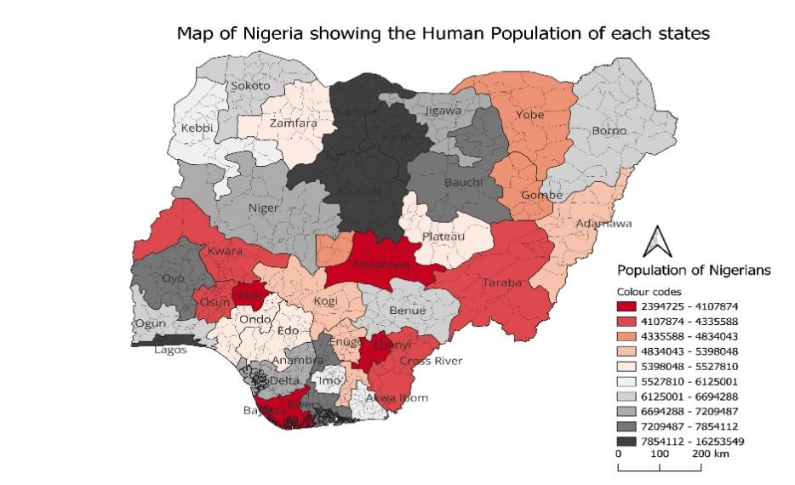
Figure 10 Map of Nigeria by Human Population
Source: Nigeria Bureau of Statistics, 2024
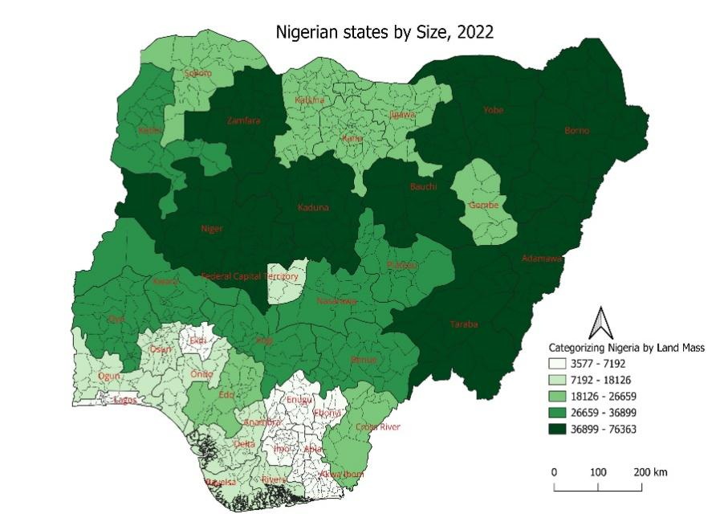
Figure 11 Map of Nigeria by size
Source: Nigeria Bureau of Statistics, 2024
DATA PREPROCESSING
Wind speeds from the 10 m NASA POWER data were extrapolated to a 150 m hub height, representative of modern wind turbines, using the power law:
$u(z)=u(Z_{r}){\left(\frac{Z}{Z_{r}}\right)}^{α}$ (1)
where $Z_{r}$ = 10 m and $α$ = 0.14 (open/agricultural terrain, Class II) (Gualtieri, 2019).
Annual mean calculated as $\ddot{u}=\frac{1}{8784}\sum{u_{i}}$; power density as $P=\frac{1}{2}ρ\ddot{u^{3}}$($ρ=1.225 kg/m^{3}).$Weibull distributions fitted (two-parameter):
$f(u)=\frac{k}{c}{\left(\frac{u}{c}\right)}^{k-1}exp\left[-{\left(\frac{u}{c}\right)}^{k}\right]$ ($SEQ Equation \backslash * ARABIC$$2$)
with shape k and scale c estimated via maximum likelihood.
National grouping into suitability zones employed MCDA with analytical hierarchy process (AHP) and categorized into Most Preferred (higher wind resources, least conflict), Preferred (Mid wind resources), Least Preferred (least wind resources, high land conflict).
RESULTS AND DISCUSSION
A PRONOUNCED NORTH-SOUTH GRADIENT DICTATES NATIONAL POTENTIAL
The foundational element of our suitability classification is the wind resource, which exhibits a definitive and strong latitudinal divide across Nigeria. The analysis of NASA POWER data at 10 m height (Figure 3) established a clear national pattern, with mean speeds ranging above 5.0 m/s in the northern states, slightly below 5 m/s in the central states, and consistently below 4.0 m/s throughout the south. This gradient is a direct consequence of the prevailing wind regimes and is powerfully reflected in the wind power density, which scales cubically with speed, ranging from a marginal 20–50 W/m² in the south to a promising 90–180 W/m² in the north.
This finding is critical as it immediately validates and refines the conclusions of previous regional studies. The low potentials we quantified in the south corroborate site-specific findings from Ibadan (Fadare, 2008) and Awka (Omotayo-Tomo & Onukwube, 2022), effectively ruling out large-scale wind development in these regions. Conversely, the high-power densities in the north confirm it as the primary zone for investment, providing a nationwide context for the high yields recently appraised in specific northern corridors like Kano-Kaduna (Akpaneno & Idris, 2024).
Extrapolation to a 150 m hub height, relevant for modern turbines, further amplified this disparity. Using the power law (Gualtieri, 2019), wind speeds in the key northern states reached 8 m/s (Figure 4), squarely placing them in the viable-to-excellent categories for commercial power generation.
SYNTHESIS OF CONSTRAINTS AND OPPORTUNITIES THROUGH MCDA
The robustness of our national classification stems from integrating the wind resource with critical constraints and opportunities. Our analysis revealed that the high-wind northern regions are serendipitously coupled with socio-environmental conditions that facilitate development.
- Low Land-Use Conflict: Population density data (Figure 10) indicated significantly lower pressure in the north (less than 100 persons/km² in Sokoto/Katsina) compared to the intense urban densities of the south (above 4000 persons/km² in Lagos). This minimizes relocation costs and social opposition, a common barrier identified in prior policy analyses (Mas'ud et al., 2017).
- Favourable Topography and Land Cover: The northern savannas are characterized by ideal, gently sloping terrain with elevation rising above 600 m, slopes less than 5° (Figure 8 and Figure 7) which reduces construction costs. Furthermore, land use and surface roughness maps (Figure 8,Figure 9) show a dominance of grasslands with low surface roughness, which minimizes turbulence and increases energy yield.
This convergence of high resource and low developmental friction is a rare and advantageous scenario, which our MCDA, incorporating fuzzy-AHP to handle uncertainty, was designed to quantitatively capture.
THE NATIONAL SUITABILITY CLASSIFICATION: A STRATEGIC ROADMAP
The final output of our GIS-MCDA model is a national suitability map (Figure 9) that classify Nigeria into three distinct strategic zones, summarized in Table 1.
Table 1 National Wind Energy Suitability Classification for Nigeria
Suitability Zone | Representative States | Key GIS Constraints
Most Preferred | Sokoto, Katsina, Kano, Jigawa, Borno, Yobe | Low (flat savanna, low population).
Preferred | Kaduna, Bauchi, Plateau, Niger, Gombe, Nasarawa, Taraba, Adamawa, Kwara, Benue, Kogi | Moderate (mild slopes, grid access).
Least Preferred | Lagos, Oyo, Osun, Ondo, Edo, Delta, Imo, Abia, Enugu, Ebonyi, Cross River, Akwa Ibom, Rivers, Bayelsa, Ogun, Ekiti, Anambra, FCT | High (dense population, steep and forested).
The area most classified is 18% of Nigeria’s land area. This zone represents a concentrated development corridor with a technical potential that could fundamentally transform Nigeria’s energy landscape.
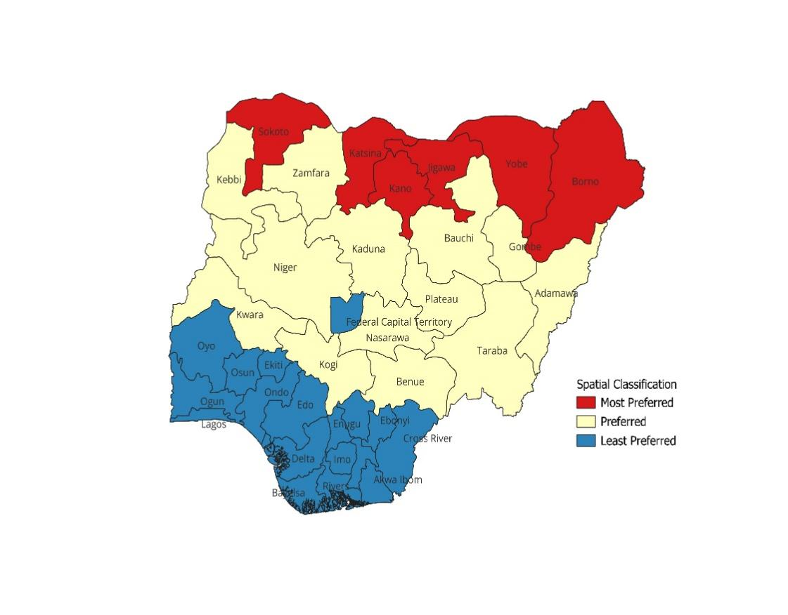
Figure 12 Nigeria Wind Suitability Classification by States

RESULTS AND DISCUSSION
This study applied Geographic Information Systems (GIS) and Multi-Criteria Decision Analysis (MCDA) to assess and classify onshore wind energy potential across Nigeria. By integrating wind resource data from NASA POWER and ERA5 with topographic, land cover, and socio-environmental parameters, a clear north–south gradient in wind potential was identified. Northern regions, particularly within the savanna belt, emerged as the most suitable zones for utility-scale wind power development due to higher wind speeds, favorable terrain, and lower land-use pressures. Southern regions, characterized by weaker winds and dense population, are more appropriate for small-scale or hybrid systems. The national suitability classification developed in this study provides a strategic spatial framework to guide renewable energy investments and infrastructure planning. Future research should focus on detailed techno-economic analyses and policy integration to translate these spatial potentials into practical contributions to Nigeria’s energy transition.
ACKNOWLEDGEMENTS
We express our gratitude to the developers and maintainers of the public secondary datasets that made this nationwide analysis possible, especially the NASA POWER program for the wind data, the USGS for the SRTM Digital Elevation Model, and the various organizations contributing to the Global Human Settlement Layer and the World Database on Protected Areas.
Recognition is also extended to the open-source software community including QGIS and the Python scientific computing libraries which provided the essential tools for geospatial analysis, modelling and visualization.
Finally, we acknowledge the foundational work of the researchers cited in this study, whose scholarly contributions informed our methodology and discussion.
REFERENCES
Akpaneno, A. F., & Idris, A. U. (2024). Assessment of Wind Energy Resources and its Energy Potential in three states of Northwest Nigeria. Asian Journal of Research and Reviews, 7(1), 12-20. doi:https://doi.org/10.9734/ajr2p/2024/v7i1179
Ayodele, T. R., Ogunjuyigbe, A. S., Munda, J. L., & Odigie, O. (2012). Wind power utilization assessment and site matching in Nigeria using GIS. Renewable Energy, 37(1), 3273-2281. doi:https://doi.org/10.1016/j.renene.2012.06.049
Dalero, M. S., & Musa, N. A. (2018). A brief review on Assessment of Wind Energy Resources in Nigeria. Solar and Wind Technology , 37(1), 45-52. doi:https://doi.org/10.1016/j.renene.2012.06.049
Ember. (2025). Carbon Intensity of Electricity Generation, 2000 to 2024. New York: Statisticsl Review of World Review. doi:https://ember-climate.org/data/
Ember. (n.d.). Carbon intensity of electricity gereration, 2000 to 2024.
Fadare, D. A. (2008). A statistical Analysis of Wind Energy Potential in Ibadan, Nigeria, based on the Weibull Distribution Function. Pacific Journal of Science and Technology, 9(1), 110-119.
Gualtieri, G. (2019). A comprehensive review on wind resource extrapolation models applied in wind energy. Renewable and Sustainable Energy Reviews, 102, 215-233. doi:https://doi.org/10.1016/j.rser.2018.12.002
Lu, X., Mc Elroy, M. B., & Kivilvona, J. (2009). Global Potential for Wind Generating Energy. Sustainable Science, 106(27), 10933-10938. doi:https://doi.org/10.1073/pnas.0904101106
Mas'ud, A. A., Wirba, A., Ardila-Rey, A., Sanchez , M. F., Sukki, M. F., Duque, A. J., . . . Munir, A. B. (2017). Wind Power Potentials in Cameron and Nigeria: Lessons from South Africa. Energies, 100-120.
NERC. (2023). Renewable Energy Mix of Nigeria. Abuja: Nigerian Electricity Regulatory Commission.
Nigeria Bureau of Statistics. (2024). Nigerian Population. Abuja: Nigeria Bureau of Statistics.
NPEEEP. (2015). Energy Transition Plan. Abuja: National Renewable and Energy Efficiency Policy.
Olangunju, O. (2020). Assessment of the viability of wind farm projects in Northern Nigeria (Master's Thesis). Hamburg: Hamburg University of Applied Sciences.
Omotayo-Tomo, M. S., & Onukwube, O. (2022). Statistical Assessment of the Wind Energy Potential of South East Nigeria using the Weibull Model. Coast Journal of the School of Science, 5-8.
United Nations Framework Convention. (2022). Climate Change (COP 27). Paris: UNFCCC.
World Bank. (2023). Access to Electricity (Nigeria in context). Chicago: World Develoment Indicators. Retrieved from https://data.worldbank.org/indicator/EG.ELC.ACCS.ZS?locations=NG
World Bank. (2025). Share of Nigerian population without electricity. New York: Our World in Data.

Department of Process Engineering and Energy Technology, Hochschule Bremerhaven, Bremerhaven, Germany
Department of Medical Biometry/Biostatistics, University of Bremen, Bremen, Germany
Department of Environmental Physics, University of Bremen, Bremen, Germany
Sam Kem Farms LTD, Kano, Nigeria
Department of Mechanical Engineering/Mechatronics, The Federal Polytechnic, Ilaro, Nigeria

