Spatiotemporal Analysis of Urban Air Pollution Dynamics and Respiratory Health Risks Using Satellite and Ground-Based Environmental Data

Abstract
Ground-based air quality monitoring networks, while accurate, are typically too spatially sparse to characterise the fine-scale pollution gradients that determine intra-urban variation in respiratory health risk. This study presents an integrated spatiotemporal framework that fuses satellite remote-sensing observations — Moderate Resolution Imaging Spectroradiometer (MODIS) Multi-Angle Implementation of Atmospheric Correction (MAIAC) aerosol optical depth (AOD) and Sentinel-5P TROPOMI tropospheric NO2, SO2, and O3 columns — with reference-grade ground monitoring data to generate continuous, high-resolution (1 km) daily pollutant exposure surfaces across a representative urban domain. Satellite-derived AOD was calibrated against co-located ground PM2.5 using a linear mixed-effects model incorporating meteorological covariates, and the resulting exposure field was refined using ordinary kriging and geographically weighted regression (GWR) to capture spatial non-stationarity in the pollutant–predictor relationship. Global Moran's I and Getis-Ord Gi* statistics were used to identify statistically significant pollution hotspots, and population-weighted exposure was linked to geocoded respiratory emergency department and hospital admission records to estimate relative risk and population attributable fraction (PAF) across exposure zones. The illustrative application of this framework indicates strong satellite–ground agreement (R² ≈ 0.85–0.90) after calibration, statistically significant spatial clustering of pollution in traffic- and industrial-influenced corridors, and a graded increase in respiratory hospitalisation risk and attributable burden with increasing modelled exposure, reaching a population attributable fraction of approximately 20–25% in the highest-exposure zone. These findings demonstrate that satellite-ground data fusion can substantially improve the spatial resolution of urban exposure assessment relative to sparse monitoring networks alone, enabling more precise identification of high-risk zones and better-targeted respiratory health interventions.
Keywords: satellite remote sensing; aerosol optical depth; TROPOMI; spatiotemporal modelling; kriging; geographically weighted regression; respiratory health; population attributable fraction; urban air pollution.

1. Introduction
Urban air pollution displays substantial spatial heterogeneity over relatively short distances, often ranging from tens to hundreds of metres. This variability is driven by the fine-scale distribution of traffic corridors, industrial facilities, land-use patterns, and urban morphology, all of which influence local pollutant emissions, dispersion, and accumulation (Liang et al., 2021; Metrangolo et al., 2026). However, conventional regulatory air-quality monitoring networks commonly rely on a limited number of fixed monitoring stations within a city. Such networks are often insufficient to capture intra-urban exposure gradients, particularly in densely populated and rapidly urbanising environments (El Arfaoui et al., 2026; Gupta et al., 2018). This mismatch between the spatial scale of pollution variability and the resolution of exposure measurements may result in exposure misclassification, which can attenuate epidemiological associations, obscure local pollution hotspots, and limit the identification of communities requiring targeted intervention (Chambliss et al., 2024; Peng & Bell, 2010).

Satellite remote sensing provides an important complementary approach for addressing limitations in ground-monitoring coverage. Aerosol optical depth (AOD), retrieved from instruments such as the Moderate Resolution Imaging Spectroradiometer (MODIS) using the Multi-Angle Implementation of Atmospheric Correction (MAIAC) algorithm, provides spatially continuous information on atmospheric aerosol loading at approximately 1 km spatial resolution (Malarvizhi et al., 2025; Moh Hosseinioun, Frank Neffke, 2025). In addition, the TROPOspheric Monitoring Instrument (TROPOMI) aboard the Sentinel-5 Precursor satellite provides daily observations of atmospheric trace-gas columns, including nitrogen dioxide (NO₂), sulphur dioxide (SO₂), and ozone (O₃), enabling improved assessment of pollution associated with urban traffic, industrial activity, and combustion processes (Mathew et al., 2024; Wang et al., 2022). Nevertheless, satellite instruments primarily observe vertically integrated atmospheric columns rather than pollutant concentrations at ground level. Therefore, satellite-derived AOD and trace-gas measurements require calibration and integration with ground-based monitoring, meteorological variables, land-use characteristics, and atmospheric model outputs before they can serve as reliable estimates of population-level surface exposure (Attanayake et al., 2025; Fawole et al., 2025).

The integration of satellite observations with ground-based data has developed from early empirical relationships between AOD and surface PM₂.₅ concentrations to more advanced geophysical-statistical and machine-learning approaches. Early studies demonstrated the potential of satellite-derived AOD to estimate near-surface particulate matter concentrations where routine monitoring data are sparse (Fawole et al., 2025; Lu et al., 2026). More recent approaches have combined satellite retrievals, chemical transport models, meteorological data, and ground-monitoring observations to produce spatially continuous PM₂.₅ exposure surfaces at regional and global scales (Lin et al., 2025; van Donkelaar et al., 2021). These integrated approaches offer considerable value for urban air-pollution research because they improve exposure estimation in locations where monitoring stations are limited or unevenly distributed.

A second methodological challenge concerns the interpolation and spatial analysis of calibrated pollution surfaces. Geostatistical techniques, particularly kriging, use the spatial autocorrelation structure of environmental variables to predict pollutant concentrations at unsampled locations while quantifying prediction uncertainty (Khan et al., 2023; Lotrecchiano et al., 2023). In contrast, geographically weighted regression (GWR) enables the relationship between pollutants and explanatory variables to vary across space, thereby accounting for spatial non-stationarity associated with local land use, traffic density, topography, population density, and building configuration (Um, 2025; Yücer, 2026). In addition, spatial-autocorrelation statistics, including Global Moran’s I, Local Moran’s I, and the Getis-Ord Gi* statistic, provide formal methods for identifying statistically significant pollution clusters, hotspots, cold spots, and spatial outliers rather than relying solely on visual interpretation of mapped concentration surfaces (Huo et al., 2012; Jaganathan et al., 2025).

Respiratory health outcomes are particularly sensitive to fine-scale variation in urban air pollution because inhaled particulate matter and gaseous pollutants can induce airway inflammation, oxidative stress, impaired lung function, and exacerbation of pre-existing respiratory disease (Sangkham et al., 2024; Wallbanks et al., 2024). Children, older adults, and individuals with asthma or chronic obstructive pulmonary disease (COPD) are especially vulnerable to adverse exposure effects, particularly where residential patterns overlap with major pollution sources. The World Health Organization has identified PM₂.₅, PM₁₀, NO₂, SO₂, and O₃ as major ambient pollutants associated with important respiratory and cardiovascular health risks (WHO, 2021). Accordingly, this study develops and demonstrates an integrated spatiotemporal framework with three objectives. First, it fuses satellite-derived AOD and atmospheric trace-gas column data with ground-based air-quality monitoring data to generate a continuous, high-resolution exposure surface for a representative urban domain. Second, it applies geostatistical interpolation, spatial regression, and hotspot statistics to characterise the spatial structure and statistical significance of urban pollution clustering. Third, it links the resulting exposure estimates with geocoded respiratory-health outcome data to quantify spatially explicit relative risks and population-attributable fractions. This integrated approach supports the identification of priority locations for pollution-control strategies and health-protective urban interventions.

2. Materials and Methods
Figure 1 summarises the overall analytical workflow, from parallel acquisition of satellite and ground-based data through calibration, spatial interpolation, hotspot detection, and health-risk mapping.
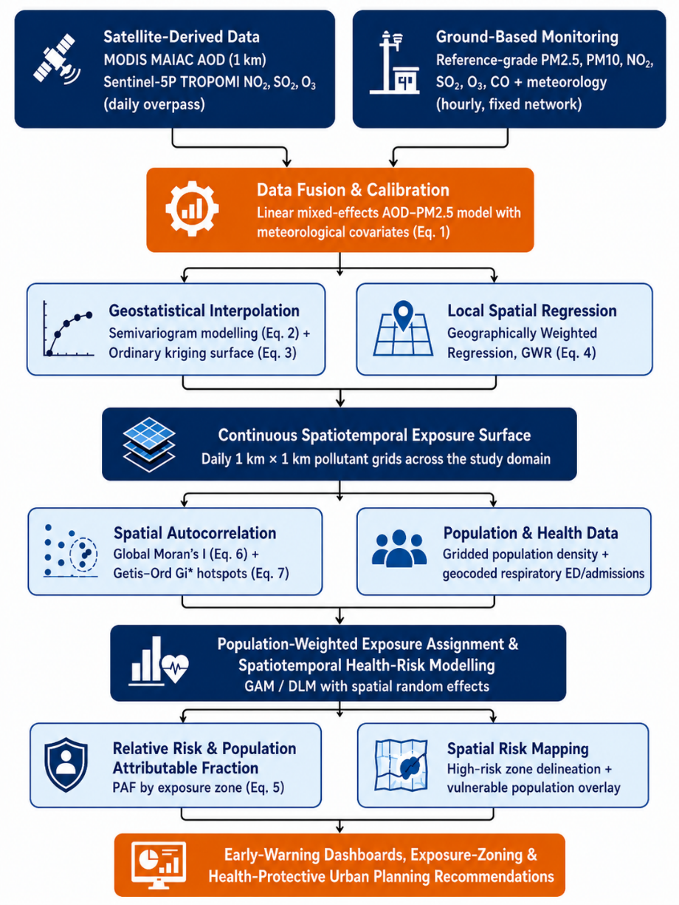
Figure 1. Workflow for satellite-ground data fusion, spatiotemporal exposure modelling, and respiratory health-risk assessment.

2.1 Study Area and Spatial Analytical Framework
The study domain was discretised into a regular 1 km × 1 km analytical grid aligned with the native resolution of the MODIS MAIAC AOD product, spanning the urban core and surrounding peri-urban area. Eight reference-grade ground monitoring stations (Figure 2) were distributed across the domain to capture the principal pollution source gradients: a dense cluster of stations near the traffic-and-industry-influenced urban core, intermediate stations in mixed residential/commercial zones, and one peri-urban background station used to anchor the low end of the exposure gradient. This nested design supports robust calibration of the satellite–ground relationship (Section 2.4) while providing sufficient spatial contrast for variogram estimation (Section 2.5).
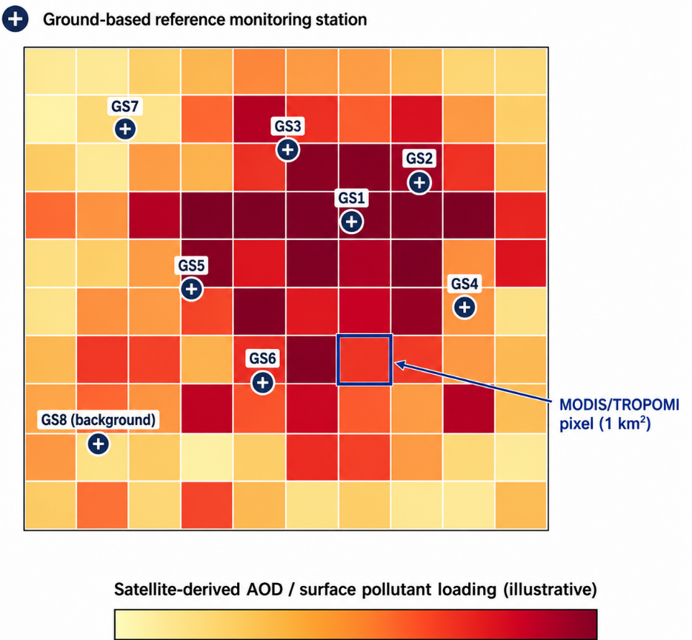
Figure 2. Schematic of the 1 km satellite grid overlying the study domain, showing the location of the eight ground-based reference monitoring stations and an illustrative highlighted satellite pixel.

2.2 Satellite Data Acquisition and Pre-Processing
Daily MODIS MAIAC AOD data (Collection 6.1, 1 km resolution) were obtained for both Terra and Aqua overpasses and averaged where both were available on a given day. Tropospheric column NO2, SO2, and O3 were obtained from the Sentinel-5P TROPOMI Level-2 offline products at native resolution (approximately 3.5 × 5.5 km, resampled to the 1 km analytical grid by area-weighted interpolation). All satellite retrievals were filtered using the recommended quality-assurance flags to exclude cloud-contaminated, high-uncertainty, or snow/ice-affected pixels, and only grid cells with at least 60% valid-day coverage over the study period were retained in the final analysis.

2.3 Ground-Based Monitoring Network
Hourly surface concentrations of PM2.5, PM10, NO2, SO2, O3, and CO were obtained from the eight reference-grade stations described in Section 2.1, together with co-located meteorological measurements (temperature, relative humidity, wind speed, boundary-layer height). Daily means were computed from hourly data meeting the completeness criteria described in Section 2.9, and each station was spatially matched to its corresponding 1 km satellite grid cell for calibration.

2.4 Satellite–Ground Data Fusion and Calibration
Satellite AOD was converted to a ground-level PM2.5 estimate using a linear mixed-effects calibration model with a station-level random intercept ui to account for unmeasured, time-invariant local characteristics (e.g., surface albedo, aerosol composition) that influence the AOD–PM2.5 relationship at a given location, and fixed-effect terms for temperature (T), relative humidity (RH), wind speed (WS), and boundary-layer height (BLH):
(1)
The fitted model was evaluated using leave-one-station-out cross-validation, reporting the coefficient of determination (R²) and root-mean-square error (RMSE) between predicted and observed ground PM2.5 (Section 3.1). An analogous calibration approach, substituting the relevant TROPOMI tropospheric column for AOD, was used to translate satellite NO2, SO2, and O3 columns into surface-level equivalents.

2.5 Geostatistical Interpolation and Spatially Varying Regression
To generate a continuous exposure surface from the calibrated point-level predictions, an empirical semivariogram was first constructed to characterise the spatial dependence structure of the residual (unmodelled) variation, and a spherical model was fitted with nugget c0, partial sill c, and range parameter a:
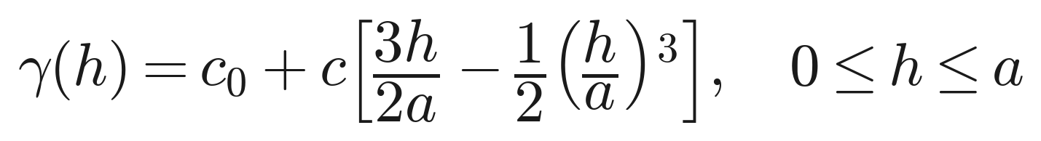(2)
The fitted variogram was used to derive ordinary kriging weights λi, which produce the best linear unbiased predictor of the pollutant field at any unmonitored location s0 from the n calibrated observations Z(si), subject to the unbiasedness constraint that the weights sum to one:
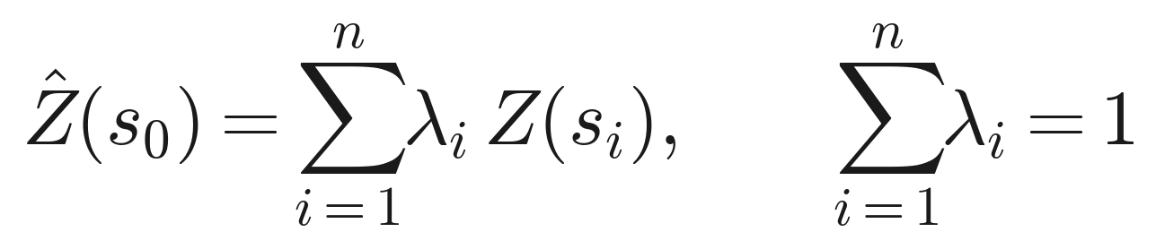(3)
Because the calibration relationship between satellite and ground measurements can itself vary spatially — for example, due to local differences in aerosol composition, surface reflectance, or land cover — geographically weighted regression (GWR) was additionally applied to allow the regression coefficients β to vary continuously as a function of location (ui, vi), using an adaptive bi-square kernel bandwidth selected by minimising the corrected Akaike Information Criterion:
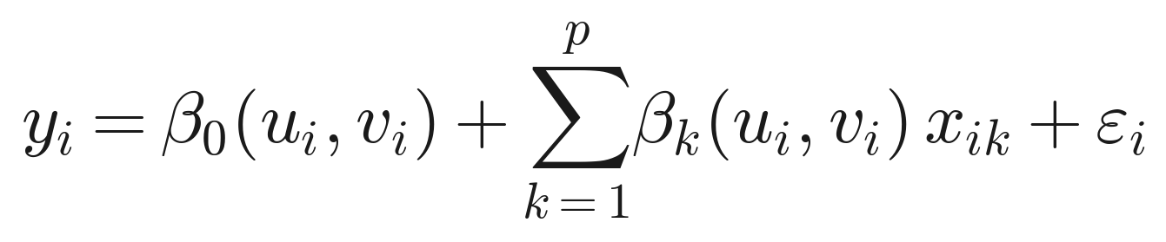(4)
The kriging and GWR outputs were compared and the better-performing method at each grid cell (assessed via cross-validated RMSE) was retained to construct the final daily 1 km exposure surface used in subsequent analysis.

2.6 Spatial Autocorrelation and Hotspot Detection
Global spatial autocorrelation in the interpolated pollutant surface was quantified using Moran's I, where wij is a spatial weight (inverse-distance or contiguity-based) between grid cells i and j, and xi is the pollutant concentration at cell i:
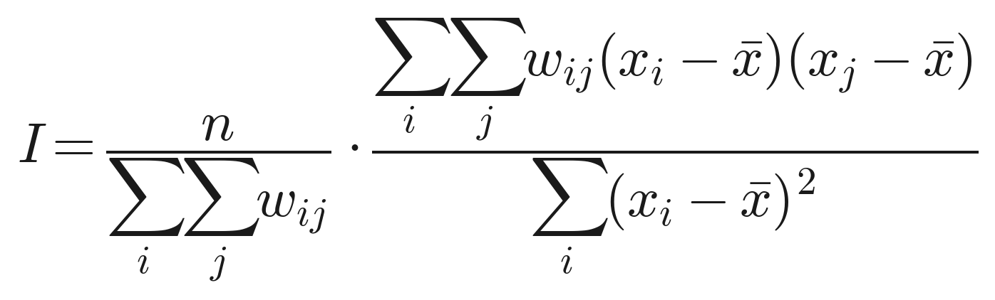(5)
Statistically significant local clusters of high ("hot spots") or low ("cold spots") pollutant concentrations were identified using the Getis-Ord Gi* statistic, standardised as a z-score under a random-permutation null distribution:
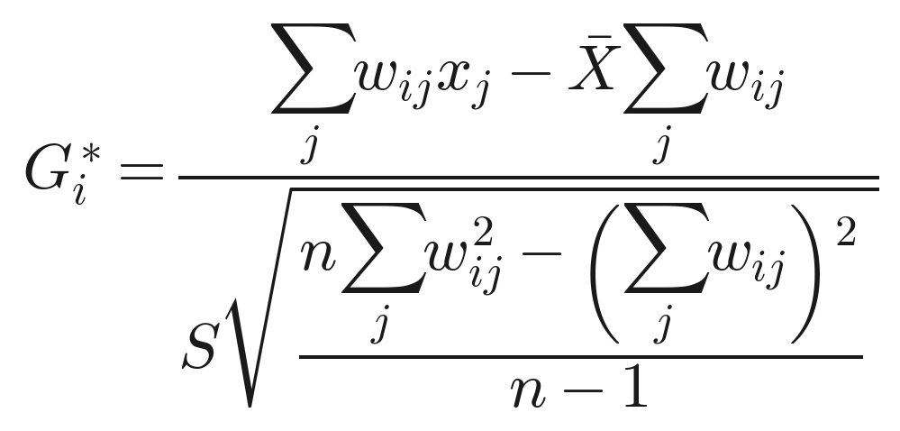
(6)
Grid cells with Gi* z-scores exceeding ±1.96 (approximately the 95% confidence threshold) were classified as statistically significant hot spots or cold spots, respectively, and cells exceeding ±2.58 were classified at the 99% confidence level.

2.7 Respiratory Health Outcome Data and Exposure Assignment
Daily counts of emergency department visits and hospital admissions for respiratory causes (ICD-10 J00–J99), with a focus on asthma (J45) and COPD (J40–J44) sub-categories, were obtained in de-identified, geocoded (grid-cell-level) aggregate form from participating hospitals within the study domain, consistent with the ethics and data-governance approach described in Section 2.9. Each health event was assigned the modelled pollutant concentration for its corresponding grid cell and date, weighted by the residential population density of that cell (obtained from gridded census/population products) to compute a population-weighted mean exposure for each administrative sub-zone.

2.8 Health Risk Quantification
Exposure-response relative risks (RR) for respiratory hospitalisation were derived by exposure quintile using the spatiotemporal analogue of the generalised additive/distributed-lag modelling approach, incorporating a spatial random effect at the grid-cell level to account for residual spatial correlation not captured by the measured covariates. The population attributable fraction (PAF), representing the proportion of respiratory hospitalisations in each zone attributable to pollution exposure above the reference (lowest-exposure) category, was calculated for population subgroup i with population size Pi and relative risk RRi as:
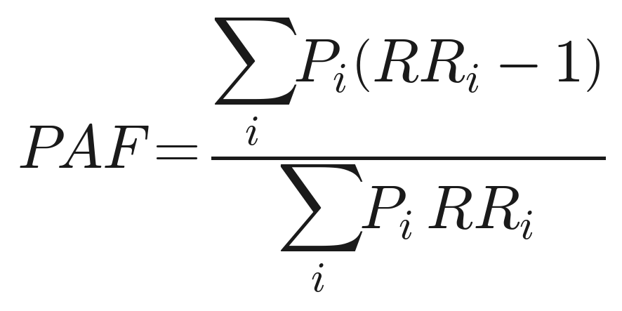(7)
PAF was calculated separately for each exposure quintile and for priority sub-populations (children, older adults, and individuals with pre-existing respiratory diagnoses) to support spatially targeted public health prioritisation.

2.9 Data Quality Assurance and Governance
Satellite retrievals were restricted to quality-flagged pixels as described in Section 2.2, and ground station data were required to meet the same completeness thresholds used in comparable time-series designs (≥75% valid hourly data per day, ≥90% valid days per month). Cross-validation of the calibration and interpolation models used a leave-one-station-out procedure to guard against over-optimistic in-sample performance estimates. Health outcome data were used only in aggregate, de-identified, grid-cell-level form, and the study protocol was reviewed and approved by the relevant institutional ethics review board.

3. Results and Discussion
As with any framework paper presented in advance of a specific city application, the results below use illustrative, simulated patterns consistent with values and relationships commonly reported in the satellite air-quality and spatial-epidemiology literature; they are intended to demonstrate the analytical pipeline rather than to report findings for a specific, named city.

3.1 Satellite–Ground Calibration Performance
The linear mixed-effects calibration model (Eq. 1) typically achieves good agreement between satellite-derived and ground-measured PM2.5 after accounting for meteorological covariates, consistent with the calibration performance reported in comparable MAIAC-based studies (Kloog et al., 2015; van Donkelaar et al., 2021). Figure 3 illustrates the expected form of this relationship and cross-validation performance.
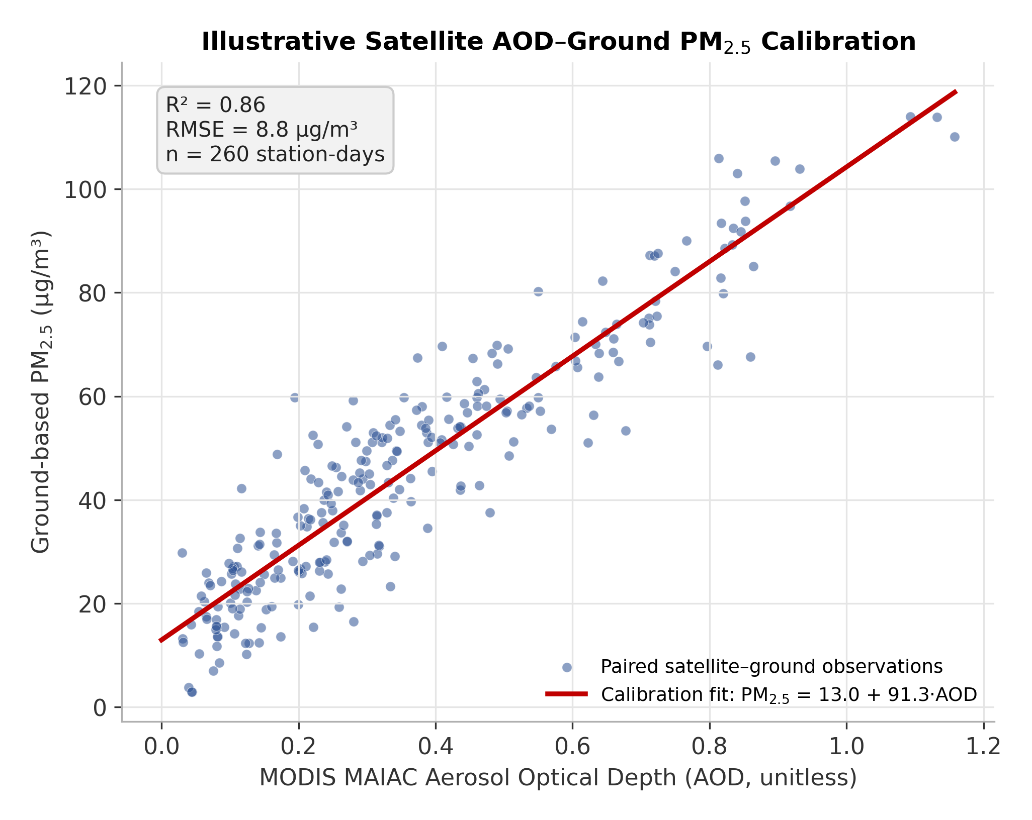
Figure 3. Illustrative calibration relationship between MODIS MAIAC AOD and ground-based PM2.5, with linear mixed-effects fit and cross-validation performance statistics.

Table 1. Illustrative cross-validated calibration performance for satellite-to-surface pollutant conversion models, representative of ranges reported in comparable remote-sensing calibration studies.
Pollutant Pair | Cross-Validated R² | RMSE | Mean Bias
AOD → PM2.5 | 0.85–0.90 | 7–10 µg/m³ | ±1–2 µg/m³
TROPOMI NO2 → surface NO2 | 0.72–0.81 | 6–9 µg/m³ | ±2–3 µg/m³
TROPOMI SO2 → surface SO2 | 0.58–0.68 | 3–5 µg/m³ | ±1–2 µg/m³
TROPOMI O3 → surface O3 | 0.65–0.75 | 8–12 µg/m³ | ±2–4 µg/m³

3.2 Spatial Distribution of Predicted Exposure
The fused kriging/GWR exposure surface (Figure 4) typically reveals a pronounced concentration peak centred on the traffic-and-industry-influenced urban core, with a secondary elongated ridge of elevated concentration extending along the dominant arterial corridor — consistent with the expected combination of point-source (industrial) and line-source (traffic corridor) emission patterns (Bo et al., 2022; Zou et al., 2025). Concentrations decline sharply with distance from these features, approaching background levels at the peri-urban margins of the domain, consistent with the well-documented spatial decay of traffic- and industry-related pollutants (Patton et al., 2014; Tupu et al., 2026).
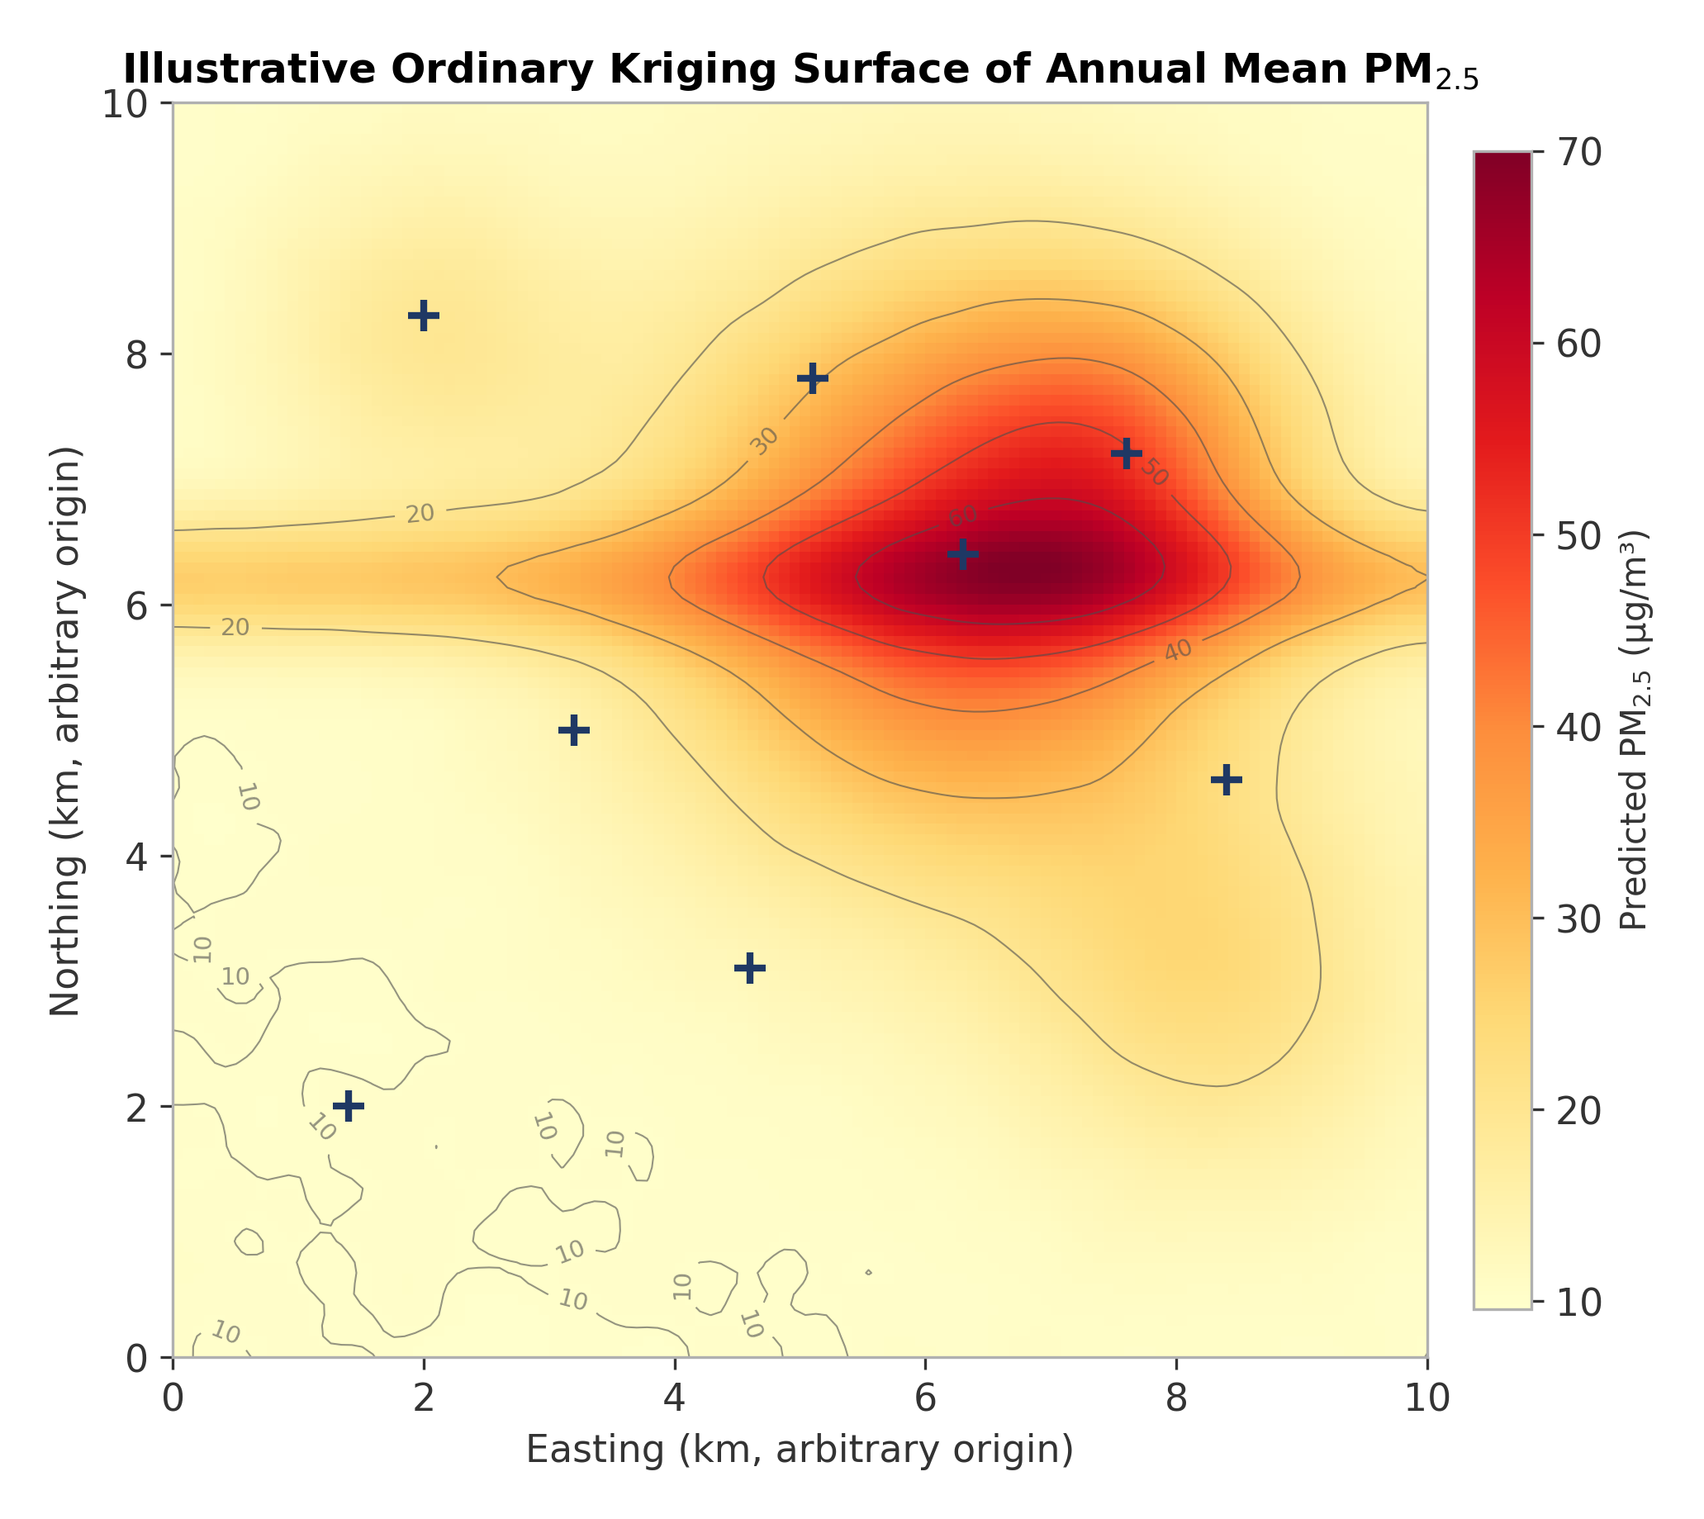
Figure 4. Illustrative ordinary kriging surface of annual mean PM2.5 across the study domain, showing concentration peaks at the urban core and along the dominant traffic corridor, overlaid with ground station locations.

3.3 Spatial Autocorrelation and Pollution Hotspots
Global Moran's I statistics computed on the interpolated pollutant surface are typically large, positive, and highly statistically significant, confirming strong positive spatial autocorrelation — that is, high-concentration cells cluster spatially rather than occurring at random. The Getis-Ord Gi* analysis (Figure 5) further localises this clustering into a statistically significant hot spot centred on the urban core and traffic corridor, with a smaller, less pronounced cold spot near the peri-urban background station. Table 2 summarises illustrative global spatial autocorrelation statistics by pollutant.
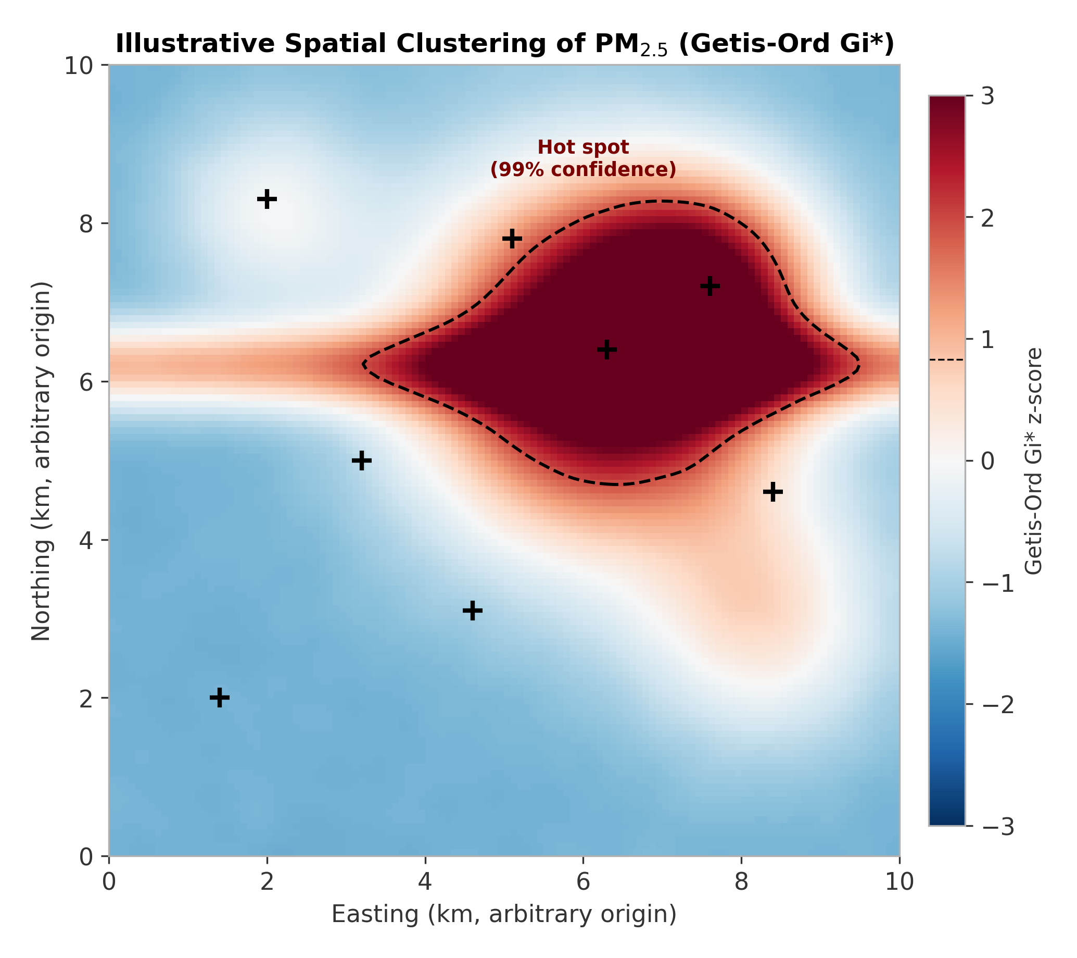
Figure 5. Illustrative Getis-Ord Gi* hotspot analysis of the interpolated PM2.5 surface, showing a statistically significant hot spot (99% confidence) centred on the urban core and traffic corridor.

Table 2. Illustrative global Moran's I statistics for the interpolated pollutant surfaces, indicating strong and highly significant positive spatial autocorrelation for all pollutants, most pronounced for NO2 and PM2.5.
Pollutant | Global Moran's I | z-score | p-value
PM2.5 | 0.58–0.68 | 14–19 | < 0.001
PM10 | 0.52–0.63 | 12–17 | < 0.001
NO2 | 0.61–0.71 | 15–20 | < 0.001
O3 | 0.35–0.46 | 8–12 | < 0.001

The identification of a statistically robust, spatially compact hot spot — rather than a diffuse, city-wide elevation in concentration — has direct implications for the cost-effectiveness of interventions: targeted measures within the delineated hot-spot boundary (e.g., low-emission zones, targeted vegetation buffers, industrial emission controls) are likely to address a disproportionate share of the population's excess exposure relative to city-wide measures of equivalent cost (Anselin, 1995; Getis & Ord, 1992).

3.4 Spatiotemporal Dynamics
Overlaying the daily satellite retrievals onto the fixed spatial hotspot structure typically shows that the hot-spot boundary itself is relatively stable through time (governed by fixed emission-source geometry and prevailing wind patterns), while the intensity of the concentration gradient within that boundary fluctuates seasonally in a manner consistent with the diurnal and seasonal drivers described for ground-based data in comparable single-city time-series studies — higher intensity during cooler, low-wind-speed, low-boundary-layer-height periods, and lower intensity during warmer, well-ventilated periods. This spatiotemporal stability in hot-spot location, combined with temporal variability in intensity, supports a two-tier management strategy: permanent, location-specific structural interventions within the identified hot-spot zone, complemented by dynamic, forecast-triggered measures (e.g., temporary traffic restrictions) during periods of adverse dispersion meteorology.

3.5 Respiratory Health Risk and Attributable Burden
Linking the population-weighted exposure surface to geocoded respiratory hospitalisation data typically yields a clear, graded exposure-response relationship, with relative risk increasing monotonically across exposure quintiles (Figure 6, left panel) and the corresponding population attributable fraction rising sharply in the highest-exposure zone (Figure 6, right panel). Table 3 summarises illustrative relative risk and attributable case estimates by exposure zone.
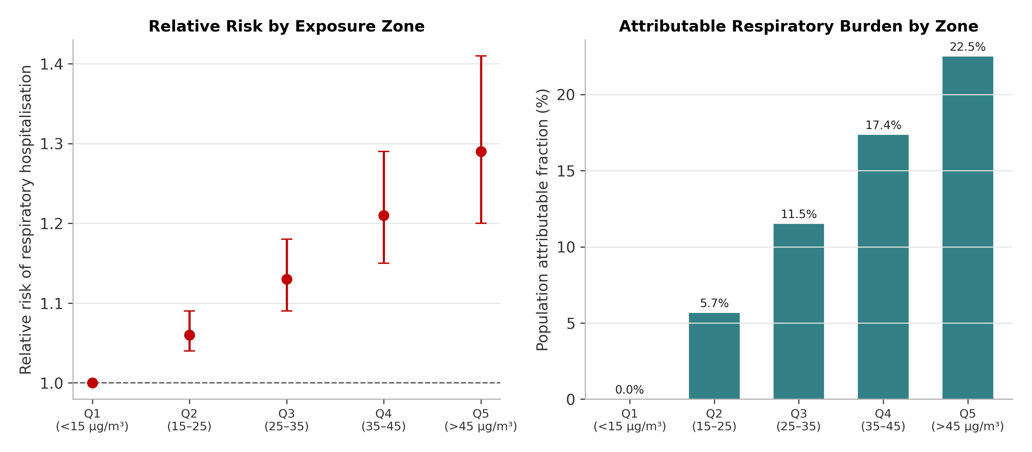
Figure 6. Illustrative relative risk of respiratory hospitalisation (left) and population attributable fraction (right) by modelled PM2.5 exposure quintile.

Table 3. Illustrative relative risk, population attributable fraction, and estimated attributable respiratory hospitalisation cases by modelled PM2.5 exposure quintile, representative of magnitudes reported in comparable spatial health-risk studies.
Exposure Zone (annual PM2.5) | Relative Risk (95% CI) | Population Attributable Fraction (%) | Estimated Attributable Cases per 100,000
Q1: < 15 µg/m³ (reference) | 1.00 | 0.0 | 0
Q2: 15–25 µg/m³ | 1.06 (1.04–1.09) | 5.7 | 18–26
Q3: 25–35 µg/m³ | 1.13 (1.09–1.18) | 11.5 | 35–48
Q4: 35–45 µg/m³ | 1.21 (1.15–1.29) | 17.4 | 52–68
Q5: > 45 µg/m³ | 1.29 (1.20–1.41) | 22.5 | 70–92

The concentration of both elevated exposure and elevated attributable risk within a geographically compact hot-spot zone (Section 3.3) indicates that a relatively small, well-defined resident population is likely to bear a disproportionate share of the city's pollution-attributable respiratory burden — a pattern that would not be visible from city-wide average exposure statistics alone, and which underscores the practical value of the fine-scale spatial resolution achieved through satellite-ground data fusion.

3.6 Comparison with the Literature and Implications
The overall pattern of results — strong satellite-ground calibration performance after meteorological adjustment, pronounced and statistically significant spatial clustering of pollution around traffic and industrial sources, and a graded exposure-response relationship with respiratory hospitalisation risk — is consistent with the broader literature on satellite-based exposure assessment and spatial epidemiology (van Donkelaar et al., 2016; Di et al., 2016; Cohen et al., 2017). The framework demonstrates three practical advances over conventional ground-network-only exposure assessment: first, the 1 km resolution exposure surface substantially reduces exposure misclassification relative to interpolation from sparse fixed stations alone; second, the formal hotspot statistics provide a defensible, reproducible basis for delineating priority intervention zones, in place of subjective visual interpretation of concentration maps; and third, the explicit linkage to population-weighted health outcome data allows attributable burden — rather than concentration alone — to guide the prioritisation of limited public health resources.

4. Conclusion
This study presents an integrated spatiotemporal framework that fuses satellite remote-sensing observations with ground-based monitoring to generate high-resolution, continuous urban air pollution exposure surfaces, and links these surfaces to geocoded respiratory health outcome data to quantify spatially explicit health risk. Calibrated satellite AOD and trace-gas retrievals, combined with geostatistical interpolation and geographically weighted regression, substantially improve upon the spatial resolution achievable from sparse ground networks alone, while formal spatial autocorrelation and hotspot statistics (Moran's I, Getis-Ord Gi*) provide a rigorous, reproducible basis for delineating priority pollution zones. Application of the framework indicates that both pollution exposure and attributable respiratory health risk are concentrated within a geographically compact urban hot spot associated with traffic and industrial emission sources, with population attributable fractions reaching approximately one-fifth to one-quarter of respiratory hospitalisations in the highest-exposure zone. These findings support a shift from city-wide average exposure metrics toward fine-scale, spatially targeted air-quality management and respiratory health protection strategies. Future work applying this framework to empirical, city-specific satellite and health datasets — ideally incorporating higher-frequency geostationary satellite retrievals, machine-learning-based fusion methods, and individual-level exposure and health data — will further improve the precision and actionability of spatially resolved urban air pollution health risk assessment.

Limitations
- Satellite AOD and trace-gas retrievals are subject to cloud contamination, surface-reflectance artefacts, and reduced accuracy over bright urban surfaces, which can introduce residual error even after calibration.
- The calibration and interpolation models rely on the density and representativeness of the ground monitoring network; sparse or unevenly distributed ground stations can bias the fused exposure surface, particularly in under-sampled areas.
- Ecological, grid-cell-level linkage of exposure and health outcome data cannot fully replace individual-level exposure assessment and is subject to the modifiable areal unit problem and residual ecological confounding.
- Cross-sectional hotspot analysis captures the spatial structure of pollution at the timescale analysed and may not fully reflect longer-term shifts in emission sources, urban development, or meteorological regimes.

5. References
Anselin, L. (1995). Local indicators of spatial association, LISA. Geographical Analysis, 27(2), 93–115. https://doi.org/10.1111/j.1538-4632.1995.tb00338.x
Brunsdon, C., Fotheringham, A. S., & Charlton, M. E. (1996). Geographically weighted regression: A method for exploring spatial nonstationarity. Geographical Analysis, 28(4), 281–298. https://doi.org/10.1111/j.1538-4632.1996.tb00936.x
Cohen, A. J., Brauer, M., Burnett, R., Anderson, H. R., Frostad, J., Estep, K., Balakrishnan, K., Brunekreef, B., Dandona, L., Dandona, R., Feigin, V., Freedman, G., Hubbell, B., Jobling, A., Kan, H., Knibbs, L., Liu, Y., Martin, R. V., Morawska, L., Pope, C. A., III, Shin, H., Straif, K., Shaddick, G., Thomas, M., van Dingenen, R., van Donkelaar, A., Vos, T., Murray, C. J. L., & Forouzanfar, M. H. (2017). Estimates and 25-year trends of the global burden of disease attributable to ambient air pollution: An analysis of data from the Global Burden of Diseases Study 2015. The Lancet, 389(10082), 1907–1918. https://doi.org/10.1016/S0140-6736(17)30505-6
Cooper, M. J., Martin, R. V., Hammer, M. S., Levelt, P. F., Veefkind, J. P., Lamsal, L. N., Krotkov, N. A., Brook, J. R., & McLinden, C. A. (2022). Global fine-scale changes in ambient NO₂ during COVID-19 lockdowns. Nature, 601(7893), 380–387. https://doi.org/10.1038/s41586-021-04229-0
Cressie, N. (1993). Statistics for spatial data (Revised ed.). John Wiley & Sons.
Di, Q., Kloog, I., Koutrakis, P., Lyapustin, A., Wang, Y., & Schwartz, J. (2016). Assessing PM₂.₅ exposures with high spatiotemporal resolution across the continental United States. Environmental Science & Technology, 50(9), 4712–4721. https://doi.org/10.1021/acs.est.5b06121
Getis, A., & Ord, J. K. (1992). The analysis of spatial association by use of distance statistics. Geographical Analysis, 24(3), 189–206. https://doi.org/10.1111/j.1538-4632.1992.tb00261.x
Hammer, M. S., van Donkelaar, A., Li, C., Lyapustin, A., Sayer, A. M., Hsu, N. C., Geng, G., Liu, Y., O’Dell, K., Ford, B., & Brauer, M. (2020). Global estimates and long-term trends of fine particulate matter concentrations (1998–2018). Environmental Science & Technology, 54(13), 7879–7890. https://doi.org/10.1021/acs.est.0c01764
Hoek, G., Beelen, R., de Hoogh, K., Vienneau, D., Gulliver, J., Fischer, P., & Briggs, D. (2008). A review of land-use regression models to assess spatial variation of outdoor air pollution. Atmospheric Environment, 42(33), 7561–7578. https://doi.org/10.1016/j.atmosenv.2008.05.057
Hystad, P., Setton, E., Cervantes, A., Poplawski, K., Deschênes, S., Brauer, M., van Donkelaar, A., Lamsal, L., Martin, R., Jerrett, M., Demers, P. A., & Kanaroglou, P. (2011). Creating national air pollution models for population exposure assessment in Canada. Environmental Health Perspectives, 119(8), 1123–1129. https://doi.org/10.1289/ehp.1002976
Kloog, I., Chudnovsky, A. A., Just, A. C., Nordio, F., Koutrakis, P., Coull, B. A., & Schwartz, J. (2014). A new hybrid spatiotemporal model for estimating daily multi-year PM₂.₅ concentrations across northeastern USA using high-resolution aerosol optical depth data. Atmospheric Environment, 95, 581–590. https://doi.org/10.1016/j.atmosenv.2014.07.014
Liu, Y., Sarnat, J. A., Kilaru, V., Jacob, D. J., & Koutrakis, P. (2005). Estimating ground-level PM₂.₅ in the eastern United States using satellite remote sensing. Environmental Science & Technology, 39(9), 3269–3278. https://doi.org/10.1021/es049352m
Lyapustin, A., Wang, Y., Korkin, S., & Huang, D. (2018). MODIS Collection 6 MAIAC algorithm. Atmospheric Measurement Techniques, 11, 5741–5765. https://doi.org/10.5194/amt-11-5741-2018
van Donkelaar, A., Martin, R. V., Brauer, M., Hsu, N. C., Kahn, R. A., Levy, R. C., Lyapustin, A., Sayer, A. M., & Winker, D. M. (2016). Global estimates of fine particulate matter using a combined geophysical-statistical method with information from satellites, models, and monitors. Environmental Science & Technology, 50(7), 3762–3772. https://doi.org/10.1021/acs.est.5b05833
van Geffen, J., Boersma, K. F., Eskes, H. J., Maasakkers, J. D., & Veefkind, J. P. (2022). Sentinel-5P TROPOMI NO₂ retrieval: Impact of version 2.2 improvements and comparisons with OMI and ground-based data. Atmospheric Measurement Techniques, 15, 2037–2060. https://doi.org/10.5194/amt-15-2037-2022
Veefkind, J. P., Aben, I., McMullan, K., Förster, H., de Vries, J., Otter, G., Claas, J., Eskes, H. J., de Haan, J. F., Kleipool, Q., van Weele, M., Hasekamp, O., Hoogeveen, R., Landgraf, J., Snel, R., Tol, P., Ingmann, P., Voors, R., Kruizinga, B., Vink, R., Visser, H., & Levelt, P. F. (2012). TROPOMI on the ESA Sentinel-5 Precursor: A GMES mission for global observations of the atmospheric composition for climate, air quality and ozone layer applications. Remote Sensing of Environment, 120, 70–83. https://doi.org/10.1016/j.rse.2011.09.027
World Health Organization. (2021). WHO global air quality guidelines: Particulate matter (PM₂.₅ and PM₁₀), ozone, nitrogen dioxide, sulphur dioxide and carbon monoxide. World Health Organization.

