Low Vision Among Adults: Etiology, Risk Factors and Management Outcomes at a Tertiary Eye Care Centre in Bangladesh
Jerin Hossen^{1,*}, Muhammad Hisham², Shunanda Sharma³
¹Chittagong Eye Infirmary & Training Complex (CEITC), Pahartali, Chattogram, Bangladesh
²Medicine Specialist, Chittagong Medical Hospital, Chattogram, Bangladesh
³Eye Specialist, Chittagong Shevron Eye Hospital, Chattogram, Bangladesh
*Corresponding author: Jerin Hossen, Chittagong Eye Infirmary & Training Complex (CEITC), Pahartali, Chattogram, Bangladesh
Email: jerin98hossen@gmail.com Phone: +880 1307-883587
ABSTRACT
Purpose: To identify the causes and risk factors of low vision in adults and to assess visual outcomes following the provision of optical and non-optical low vision management at a tertiary eye care centre.
Methods: A hospital-based prospective study was conducted on 110 adult low vision patients (aged 18 years and above) attending the low vision clinic of CEITC, Chattogram, between September 2023 and August 2024. Patients were selected purposively. Each underwent a comprehensive ocular and low vision assessment including distance and near visual acuity (LogMAR and N notation), refraction, contrast sensitivity, colour vision, visual field, and intraocular pressure. Optical and non-optical low vision devices were trialled and prescribed. Data were analysed in SPSS v16.0; a paired t-test was used to compare outcomes, with p<0.05 considered significant.
Results: The mean age was 33.22 ± 1.21 years and most patients (38.2%) were aged 18–27 years; 61.8% were male. Most were literate (73.6%) and from rural areas (72.7%). Macular dystrophy (25.5%) was the leading cause, followed by retinitis pigmentosa (16.4%) and pathological myopia (10.9%); retinal disease accounted for 68.2% of cases overall. Compound myopic astigmatism (30%) was the commonest refractive status. After spectacle correction and distance device trial, 12.7% of eyes reached near-normal acuity (6/6–6/18); improvement in distance acuity was statistically significant (p<0.001). Spectacles were prescribed to about 90% of patients, near devices to 42%, and distance devices to 14.5%.
Conclusion: Low vision predominantly affected young rural adults, with hereditary retinal disease — chiefly macular dystrophy — as the leading cause. Optical correction and low vision devices significantly improved visual function, underscoring the need for early detection, awareness and accessible rehabilitation in underserved communities.
Keywords: Low vision; Consanguinity; Risk factors; Low vision devices; Bangladesh.
1. INTRODUCTION
Low vision is a major focus of global health initiatives, representing substantial health and socioeconomic challenges, particularly in developing countries such as Bangladesh. The World Health Organization (WHO) estimated that of approximately 285 million visually impaired people worldwide, about 246 million have low vision, with more than half living in Asia and the vast majority from rural communities.¹ This burden continues to rise with population growth, ageing and improved survival from chronic disease.
WHO defines a person with low vision as one who has impairment of visual functioning even after treatment, with a visual acuity of less than 6/18 down to light perception, or a visual field of less than 10° from fixation, but who uses, or is potentially able to use, vision for the planning or execution of a task.¹ Unlike a blind person, an individual with low vision retains residual useful vision that can be enhanced with appropriate clinical evaluation, devices and rehabilitation. The provision of low vision services is a priority of the VISION 2020: The Right to Sight initiative.²
Demographic, socioeconomic and cultural factors strongly influence the prevalence and distribution of low vision. The National Blindness and Low Vision Survey of Bangladesh reported cataract, refractive error and macular degeneration as leading causes,³ while risk factors include diabetes, ageing, poor nutrition, ultraviolet exposure, illiteracy and limited access to eye care. When low vision affects the economically active population, it imposes a considerable financial burden. This study therefore investigated the demographic profile, causes, risk factors, parental consanguinity and prescribed optical and non-optical aids among adult low vision patients, to inform planning of services, active care and rehabilitation.
2. MATERIALS AND METHODS
Study design and setting. This hospital-based prospective study was conducted at the low vision clinic of the Chittagong Eye Infirmary and Training Complex (CEITC), a tertiary eye care centre in Chattogram, Bangladesh, over one year (September 2023 to August 2024).
Participants. A total of 110 adult patients aged 18 years and above, diagnosed with low vision according to WHO criteria and referred from other clinics, were enrolled using purposive sampling. The minimum sample size of 80 was derived from n = z²pq/d² (z = 1.96, p = 0.216, d = 0.09); 110 patients were recruited. Patients unable to respond to low vision assessment or unwilling to participate were excluded.
Procedures. After informed consent, demographic and clinical history was recorded by face-to-face interview. Distance visual acuity was measured with the LogMAR chart and near acuity at 40 cm with the N-notation chart. Refraction was performed by streak retinoscopy followed by subjective refinement. Contrast sensitivity (Bailey-Lovie), colour vision (City University test), central and peripheral visual fields (Amsler chart and confrontation), and intraocular pressure (Goldmann applanation tonometry) were assessed. Anterior segment and dilated fundus examination were performed. Optical (telescopes, magnifiers, 6D base-in prism) and non-optical devices were trialled and the best aided acuity recorded.
Statistical analysis. Data were entered in Microsoft Excel and analysed in SPSS v16.0 using frequencies, cross-tabulation, measures of central tendency and dispersion. A paired t-test compared pre- and post-management outcomes, with p<0.05 considered statistically significant.
3. RESULTS
Demographic profile. Of 110 patients, the majority (38.2%) were aged 18–27 years with a mean age of 33.22 ± 1.21 years; 61.8% were male. Most were literate (73.6%) and from rural areas (72.7%), and 56.4% belonged to the medium income group. Housewives (21.8%) and students (19.1%) were the commonest occupational groups (Table 1).
Table 1: Demographic and clinical profile of the study population (n = 110).
Characteristic | Category | Value (%)
Age group | 18–27 years (modal) | 38.2
Sex | Male | 61.8
Literacy | Literate | 73.6
Residence | Rural | 72.7
Income | Medium | 56.4
Marital status | Married | 61.0
Consanguinity | Positive (congenital cases) | 10 patients
Medical history | Diabetes mellitus | 7.6
Medical history | Hypertension | 6.8
Glare symptom | Present | 24.0
Causes and etiology. A wide range of ocular diseases caused low vision. Macular dystrophy was predominant (25.5%), followed by retinitis pigmentosa (16.4%), pathological myopia (10.9%) and congenital nystagmus (9.1%) (Figure 1). On categorisation by anatomical site, retinal disease accounted for 68.2% of cases, optic nerve disease for 10.9%, and uveal and glaucomatous disease for 3.6% each. Patients with a positive consanguinity history were mostly affected by retinal and optic nerve disease.
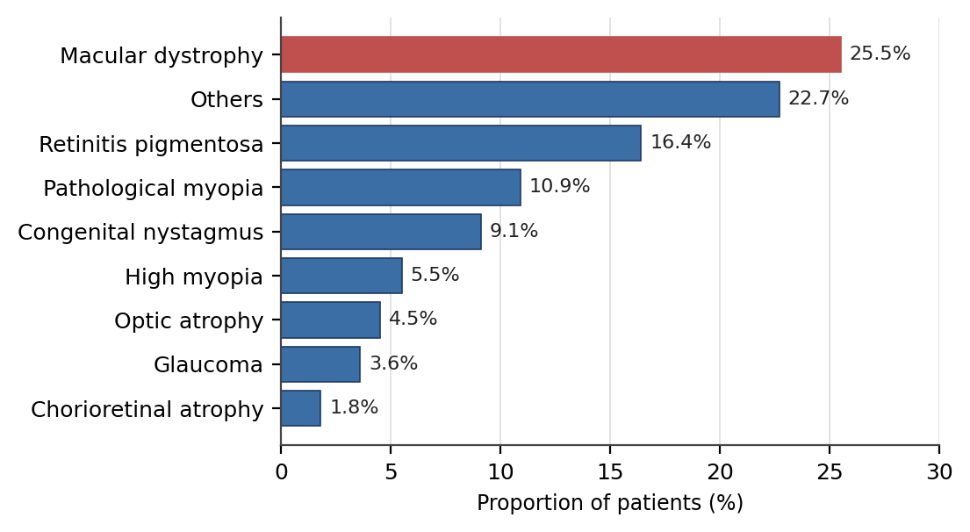
Figure 1. Causes of low vision among patients attending the low vision clinic (n = 110).
Refractive status. On retinoscopy, refractive error was found in 93.6% of patients. Compound myopic astigmatism was commonest (30%), followed by simple myopic astigmatism (19.1%) and high hyperopia (14.5%); only 6.4% were emmetropic.
Distance visual acuity outcomes. Most eyes (60%) presented with acuity in the <6/18–6/60 range. After spectacle correction this rose to 65.3% within the same band, and after distance device trial 12.7% of responders reached near-normal acuity (6/6–6/18) (Figure 2). The mean presenting acuity of 6.00 ± 0.76 LogMAR improved to 1.79 ± 1.13 with best correction and 1.64 ± 1.15 after device trial. The improvement was statistically significant (p<0.001, paired t-test). Around 85.5% of patients were not prescribed a distance device owing to poor or no response.
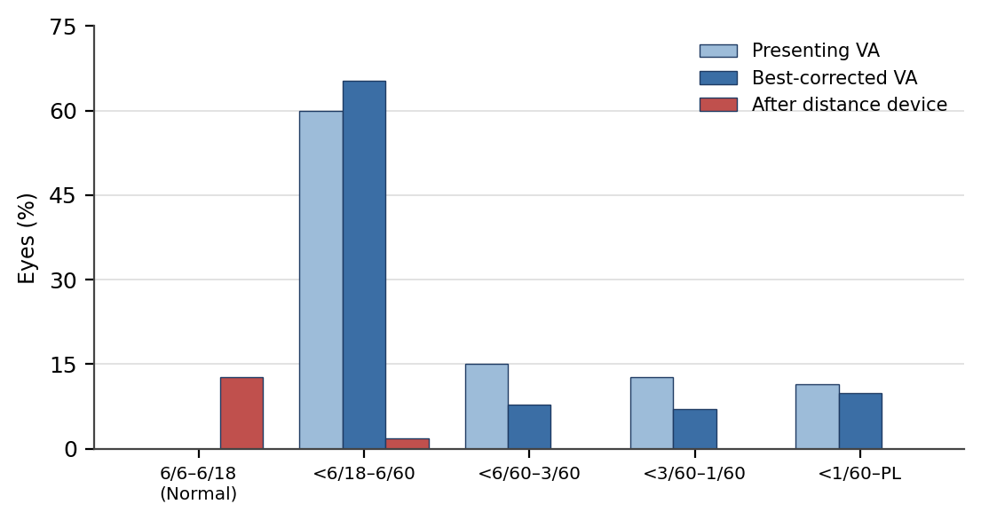
Figure 2. Distribution of distance visual acuity at presentation, after best correction, and after distance device trial.
Near visual acuity outcomes. Before correction, 34.5% of patients read N8. This improved to 40.9% after best correction and was further aided by near devices (Table 2). The improvement with near optical devices was statistically significant (p<0.05), whereas the change with spectacles alone was not. About 58% of patients were not prescribed a near device, having either adequate near vision or no response.
Table 2: Near visual acuity at presentation, after best correction and after near optical device (n = 110).
Near acuity | Presenting (%) | Best corrected (%) | After near device (%)
N8 | 34.5 | 40.9 | 28.4
N10 | 15.5 | 22.7 | 8.2
N12 | 17.3 | 17.3 | 1.8
N16 | 10.0 | 2.7 | 0.9
N24 | 4.5 | 3.6 | –
Not assessable | 18.2 | 10.9 | 58.0
Prescribed low vision devices. Spectacle correction was prescribed to about 90% of patients, with 7.3% receiving spectacles plus a telescope. For near tasks, the spectacle magnifier (28.2%) was most frequent, followed by near addition (9.4%). For distance, the 4× monocular telescope (12.7%) was commonest. Non-optical aids were tailored to need; orientation and mobility counselling (18.8%), bright illumination (combined 24.9%) and a sighted-guide or torch light were frequently advised (Table 3). Genetic counselling (33.3%) and eccentric viewing training (20.9%) were the leading counselling interventions.
Table 3: Commonly prescribed low vision devices and non-optical aids.
Device / aid | Patients (%)
Spectacles (distance correction) | ~90
Spectacle magnifier (near) | 28.2
4× monocular telescope (distance) | 12.7
Near addition | 9.4
Orientation & mobility counselling | 18.8
Torch light / sighted guide | 17.1 / 16.4
Bright direct/indirect illumination | 24.9
4. DISCUSSION
The magnitude of low vision varies between and within countries. In this series of 110 patients, low vision predominantly affected young adults (mean age 33.2 years) with a male preponderance (61.8%), consistent with several clinic-based studies reporting more male attenders.⁴⁻⁶ This contrasts with the global pattern in which most visual impairment occurs after 50 years of age, reflecting a younger, largely hereditary disease burden in this population.⁸
Most patients were from rural areas (72.7%), where low vision is often associated with poverty, limited services and reduced health awareness.¹⁰ Female attendance was comparatively low, likely reflecting reduced access to and utilisation of eye care by women in developing settings — a pattern also noted in the national Bangladesh survey.³ The literacy rate among participants (73.6%) mirrored the national figure, and illiterate patients appeared less likely to seek care.
Macular dystrophy (25.5%) was the leading cause, followed by retinitis pigmentosa and pathological myopia, with retinal disease accounting for two-thirds of cases. A positive consanguinity history clustered among hereditary retinal and optic nerve disorders, in keeping with reports that parental consanguinity is significantly more frequent among patients with macular dystrophy and retinitis pigmentosa.¹¹ This hereditary predominance differs from clinic profiles elsewhere, where cataract, age-related macular degeneration, diabetic retinopathy and glaucoma feature more prominently.⁵ ¹²
Visual rehabilitation produced measurable benefit. Distance acuity improved significantly after refractive correction and device trial, with 12.7% of responders reaching near-normal vision — comparable to studies reporting significant gains in distance acuity following appropriate aids.³ ¹³ Near acuity improved significantly with near optical devices, and a spectrum of non-optical aids and counselling supported daily function. These findings reinforce that, contrary to the notion that nothing can be done, residual vision can be enhanced with appropriate devices and rehabilitation.¹⁶ ¹⁷
Compared with international research, this study highlights a younger age of onset, a higher hereditary retinal disease burden, the contribution of consanguinity and rural disadvantage, and a reliance on basic optical aids rather than advanced assistive technologies such as electronic magnifiers and closed-circuit television. It also points to a relative lack of systematic rehabilitation frameworks. Limitations include the single-centre, purposive design and the inability to assess some patients for colour vision, contrast and fields owing to poor cooperation, which may limit generalisability.
5. CONCLUSION
Low vision in this tertiary-centre population predominantly affected young rural adults, with hereditary retinal disease — chiefly macular dystrophy — as the leading cause and consanguinity an important associated factor. Optical correction and low vision devices produced significant improvement in both distance and near function and quality of daily activities. Early detection, increased public awareness, genetic counselling and accessible, structured low vision rehabilitation services are needed, particularly for underserved rural communities.
Declarations. The authors report no conflicts of interest. Informed consent was obtained from all participants. The authors thank the staff of the CEITC low vision clinic and all participating patients.
REFERENCES
1. World Health Organization. Global data on visual impairments 2010. Geneva: WHO; 2012.
2. World Health Organization. Global initiative for the elimination of avoidable blindness: VISION 2020 – the right to sight. Geneva: WHO; 1997.
3. Dineen BP, Bourne RRA, Ali SM, et al. Prevalence and causes of blindness and visual impairment in Bangladeshi adults: results of the National Blindness and Low Vision Survey of Bangladesh. Br J Ophthalmol. 2003;87(7):820–8.
4. Thakur AK, Sharma IP. Profile of low vision clinics in the eastern region of Nepal: a retrospective study. Br J Vis Impair. 2011;29(3):215–26.
5. Alotaibi AZ. A retrospective study of causes of low vision in Saudi Arabia: a case of Eye World Medical Complex in Riyadh. Glob J Health Sci. 2016;8(5):205–10.
6. Olusanya B, Onoja G, Ibraheem W. Profile of patients presenting at a low vision clinic in a developing country. BMC Ophthalmol. 2012;12:31.
7. Ramke J, Palagyi A, Naduvilath T, et al. Prevalence and causes of blindness and low vision in Timor-Leste. Br J Ophthalmol. 2007;91(9):1117–21.
8. Entekume G, Patel J, Sivasubramaniam S, et al. Prevalence, causes and risk factors for functional low vision in Nigeria: results from the national survey of blindness and visual impairment. Invest Ophthalmol Vis Sci. 2011;52(9):6714–9.
9. Ackuaku-Dogbe EM, Abaidoo B, Bramah ZI. Causes of low vision and their management at Korle Bu Teaching Hospital, Accra, Ghana. J West Afr Coll Surg. 2016;6(3):105–18.
10. Wang GQ, Bai ZX, Shi J, et al. Prevalence and risk factors for eye diseases, blindness and low vision in Lhasa, Tibet. Int J Ophthalmol. 2013;6(2):237–41.
11. Akkaya S, Yilmaz Tugan B. Rate of parental consanguineous marriage among patients with visual impairment. Beyoglu Eye J. 2019;4(1):29–34.
12. Gao G, Ouyang C, Dai J, et al. Baseline traits of patients presenting at a low vision clinic in Shanghai, China. BMC Ophthalmol. 2015;15:16.
13. Chotikavanich S, Chanvarapha N, Loket S, et al. A 5-year retrospective record review of hospital-based low-vision rehabilitation in Thailand. Clin Optom. 2018;10:41–6.
14. Gyawali R, Paudel N, Adhikari P. Quality of life in Nepalese patients with low vision and the impact of low vision services. J Optom. 2012;5(4):188–95.
15. Ganesh S, Sethi S, Srivastav S, et al. Impact of low vision rehabilitation on functional vision performance of children with visual impairment. Oman J Ophthalmol. 2013;6(3):170–4.
16. Sahli E, Idil A. A common approach to low vision: examination and rehabilitation of the patient with low vision. Turk J Ophthalmol. 2019;49(2):89–98.
17. Oduntan OA, Nthangeni ME, Raliavhegwa-Makwela M. A review of the rehabilitation of low vision patients. S Afr Optom. 2008;67(4):166–75.
18. Taylor HR, Keeffe JE. World blindness: a 21st century perspective. Br J Ophthalmol. 2001;85(3):261–6.
19. Flaxman AD, Wittenborn JS, Robalik T, et al. Prevalence of visual acuity loss or blindness in the US: a Bayesian meta-analysis. JAMA Ophthalmol. 2021;139(7):717–23.
20. Brilliant RL, editor. Essentials of low vision practice. Boston: Butterworth-Heinemann; 1999.

