SOLAR SIMULATOR AND THERMOLUMINESCENCE STUDIES

Abstract: Solar simulators are used to test components and systems under controlled and repeatable conditions, often in locations with unsuitable insolation for outdoor testing. The growth in renewable energy generation has led to an increased need to develop, manufacture and test components and subsystems for solar thermal, photovoltaic (PV), and concentrating optics for both thermal and electrical solar applications. At the heart of any solar simulator is the light source itself. This paper reviews the light sources available for both low and high-flux solar simulators used for thermal applications.
Designing and fabrication of materials with good thermal characteristics is very important for multifunctional applications of nanomaterials. Thermal analysis is a group of techniques that characterize the thermal properties of materials. With these techniques, changes in the temperature of the sample is analyzed. No single thermal analysis tool or technique works best in all situations. Accurate thermal assessments require a combination of different analytical techniques. This chapter presents the basic principles of thermal systems and describes some of the techniques and tools available to complete thermal characterization of nanomaterials.
Key words: Solar simulator, Thermoluminescence, IV, Fill factor,

Introduction: A Solar Simulator is a specialized light source designed to mimic the spectral distribution and intensity of natural sunlight (specifically the AM1.5G standard).
- Purpose: It provides a controlled, indoor environment to test solar cells regardless of outdoor weather conditions.
- Key Parameters: It is rated based on its spectral match, spatial uniformity of the beam, and temporal stability over time
The Current-Voltage (I-V) measurement is the "heartbeat" of solar cell testing. It measures the electrical current produced by a cell as a function of the voltage applied while under illumination from the Solar Simulator.
- Key Metrics: From an I-V curve, we derive critical efficiency parameters:
  - Voc (Open-Circuit Voltage): Maximum voltage available.
  - Isc (Short-Circuit Current): Maximum current produced.
  - Fill Factor (FF): A measure of the "squareness" of the curve, indicating internal losses.
  - Power Conversion Efficiency: The ultimate ratio of electrical power out to light power in.

Thermoluminescence (TL) Studies
• The Mechanism: Many materials have "traps"—crystalline defects that catch electrons. When the material is heated at a controlled rate, these electrons are kicked out of their traps and emit light.
• Application: TL is vital for studying defect states and electron trapping levels within a material. Understanding these traps is essential because they often act as "speed bumps" that reduce the efficiency of solar cells by stealing charge carriers.
1.Solar Simulator
A Solar Simulator is a high-tech light source designed to replicate the spectral distribution and intensity of natural sunlight in a controlled laboratory setting. It is the "gold standard" for testing photovoltaic (PV) cells, materials, and chemical reactions that require consistent solar exposure.
While the sun is free, it is unpredictable. Clouds, humidity, and the time of day change its intensity and spectrum constantly. A solar simulator provides a stable, repeatable baseline so that a researcher in Bangalore and a researcher in Berlin can compare their solar cell results accurately.
It can be used for the testing of any processes or materials that are photosensitive, including solar cells, sun screen, cosmetics, plastics, aerospace materials, skin cancer, bioluminescence, photosynthesis, crude oil degradation, and free radical formation. Solar simulators are used in a wide range of research areas including photobiology, photooxidation, photodegradation, and photocatalysis.
The standards specifying performance requirements of solar simulators used in photovoltaic testing are IEC 60904-9, ASTM E927-19, and JIS C 8912.
- Key Characteristics: A good solar simulator matches the spectral content (color), spatial uniformity (uniform brightness), and temporal stability (consistent intensity over time) of the sun.

- Components: The main components include a light source (often Xenon arc lamps or LEDs), power supply, and specialized optics to create a uniform beam.
1.1Types of Solar Simulators:
- Steady-State: Produces continuous light, ideal for long-term tests or systems that require steady illumination.
- Pulsed or Flash: Produces light in short pulses, often used to avoid heating the sample during tests, such as when measuring high-intensity solar cells.
LED-based: A newer, popular option known for having a longer lifetime, greater compactness, and lower costs compared to traditional arc lamps.
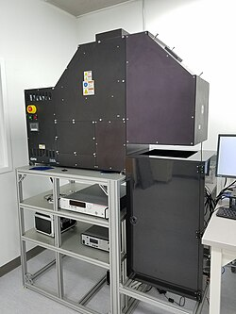
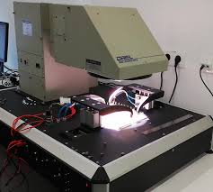
Fig-1: Solar simulator Horizontal view Fig2: Solar simulator vertical view
Common Applications:
- Photovoltaics (PV): Characterizing solar cell I-V performance, Efficiency Voc and Isc.
- Aerospace: Thermal balance testing of satellites and materials.
- Photobiology/Materials Science: Testing photo-stability of polymers, cosmetics, and paints.

1.3Solar simulator construction
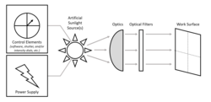
Fig.3 The basic components of a solar simulator.
A solar simulator consists of three main parts:
- Light sources (lamps) and power sources.
- Optics and optical filters, to alter the beam and obtain desired properties.
- Control elements for operation.

2. IV CHARACTERIZATION AND ANALYSIS
I-V (Current-Voltage) characterization is a fundamental technique used to analyze the electrical behavior of materials and devices, such as semiconductors, diodes, and solar cells. By plotting the current flowing through a device against the voltage applied across its terminals, this analysis yields key performance parameters, including resistance, capacitance, and efficiency.
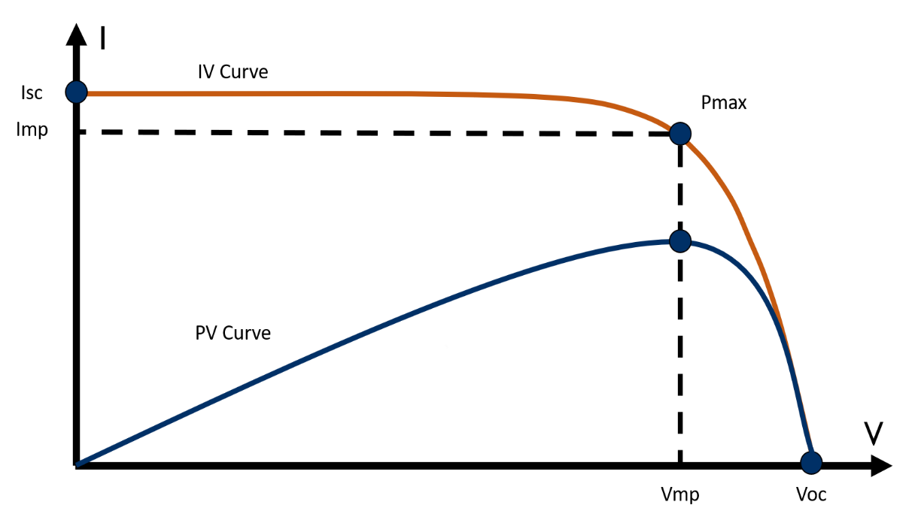
Fig4: Graphical representation of IV-Characteristics

Key Aspects of I-V Characterization
- Measurement Setup: Standard techniques involve sweeping a range of voltages and measuring the resulting current using a Source Measure Unit (SMU), which can perform 4-wire measurements to eliminate lead resistance.
- Types of Curves: Linear devices (like resistors) show a straight-line I-V curve, while non-linear devices (like diodes) show curved relationships.
- Applications: It is used for assessing solar cell performance (e.g., Voc, Isc), measuring MOSFET properties, and testing power semiconductor reliability.
- Analysis Factors: Results are highly sensitive to environmental conditions, such as temperature, which can affect parameters like the fill factor (FF) and power-voltage (P-V) curves.

2. 1Key Performance Parameters
When you analyze an I-V curve, you are looking for four critical "markers" that define the cell's quality:
- Short-Circuit Current (Isc): The maximum current when the voltage is zero (the cell is shorted). It depends directly on light intensity and the cell's area.
- Open-Circuit Voltage (Voc): The maximum voltage when the current is zero (the circuit is open). This is limited by the semiconductor's bandgap and recombination rates.
- Maximum Power Point (Pmax): The specific point on the curve (defined by Vmp and Imp) where the product of voltage and current is at its peak.
- Fill Factor (FF): A measure of the "squareness" of the I-V curve. It compares the actual maximum power to the theoretical power if the cell were perfect (Voc x Isc).
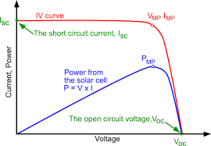
Fig5: Graph of voltage /current
- Linear vs. Non-Linear: A straight line indicates linear resistance (Ohms Law, where v=IR), while curves indicate non-linear components like diodes or transistors.
- Breakdown Detection: Sudden, sharp increases in current at high voltage indicate reverse breakdown in devices.
- Performance Evaluation: In photovoltaics, comparing a measured curve against a standard allows for identifying issues like shading, soiling, or damage.
- Modeling: The data is used to create mathematical models that predict the device's behavior in electrical circuits.
3.THERMOLUMINESCENCE STUDIES
Thermoluminescence (TL) studies involve the analysis of light emission from insulating or semiconducting materials when heated, following previous exposure to ionizing radiation. This phenomenon is a type of luminescence—specifically, thermally stimulated luminescence—where trapped charge carriers (electrons or holes) are released from lattice defects when energy is supplied via heat. The resulting data, known as a TL glow curve, is used to study material properties and quantify radiation doses.
In this study, TL measurements were carried out using a [mention instrument name and manufacturer, e.g., TL Reader Model XYZ, Thermo Fisher Scientific]. The samples were irradiated with [specify source, e.g., beta or gamma radiation] at a dose of [mention dose, e.g., 1 kGy], and the glow curves were recorded over a temperature range of [e.g., 50–400°C] with a heating rate of [e.g., 5°C/s].
The TL glow curve typically consists of one or more peaks, each corresponding to different trap depths. Deconvolution of the glow peaks was performed using [mention software, if applicable, e.g., TLAnal], and kinetic parameters such as activation energy, frequency factor, and order of kinetics were calculated using standard methods (e.g., peak shape method or initial rise method). These parameters provide insight into the trapping and recombination mechanisms in the material.

- Experimental Setup: Samples are irradiated (e.g., using Gamma-rays, UV, X-rays), then placed in a TL reader that provides a controlled heating rate and uses a photomultiplier tube to measure the emitted light, often plotted as a function of temperature or wavelength.
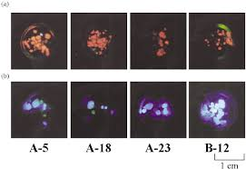

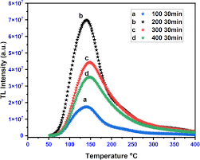

Fig6: Graph of Temperature / TL Intensity
Thermally stimulated luminescence (TSL), also known as TL, is considered to be a reliable technique used in radiation dosimetry. Detection of defects and impurities, even in ppm level of solids, is possible with this method. A powder sample is irradiated by a known strength of light radiation for different time periods and then removed.
The irradiated material is then heated at a constant heating rate so that it starts emitting thermal radiation. The intensity of the emitted radiation is measured as a function of temperature of the sample, and a TSL glow curve was plotted. The position of the peaks on the temperature scale is a measure of the energy depth of the trapped electrons in the solid, whereas the area under the peak indicates the number of electrons transferred into these traps by exciting radiation. The knowledge of traps with their distribution in the band gap of solids is essential to understand the luminescence process that can be obtained by TSL studies.
3.1The Glow Curve: Data Analysis:
The primary output of a TL study is the Glow Curve—a plot of light intensity versus temperature.
- Peaks: Each peak in the curve represents a specific "trap depth" (activation energy). A peak at a higher temperature means the electron was buried in a deeper, more stable trap.
- Area Under the Curve: The total amount of light emitted is directly proportional to the radiation dose the material received.
- Heating Rate: This must be strictly controlled (usually linear, e.g., 5°C/s) because changing the rate shifts the peak positions, complicating the analysis of trap kinetics.

APPLICATION:
- Radiation Dosimetry
- Personal and environmental monitoring: TL materials (e.g., LiF, CaSO₄:Dy) are used to measure ionizing radiation exposure.
- Medical applications: Monitoring radiation doses in radiotherapy and diagnostic radiology.
- Space dosimetry: Used by astronauts to measure cosmic radiation exposure.
- Archaeological and Geological Dating
- Thermoluminescence dating (TLD): Determines the age of ceramics, burnt flint, and sediments by measuring the accumulated radiation dose since last heating/sunlight exposure.
- Used in dating pottery, hearths, and archaeological structures up to hundreds of thousands of years old.
- Material Characterization
- Trap depth and defect analysis: TL helps identify the type, depth, and concentration of traps (defects) in crystalline materials.
- Evaluation of luminescent properties: In phosphors, ceramics, semiconductors, and scintillators.
- Development of Phosphors and Optoelectronic Devices
- TL glow curve analysis: Assists in developing thermally stable phosphor materials for LEDs, displays, and sensors.
- Optimization of doping levels and host matrices for efficient light-emitting materials.

- Food Irradiation Detection
TL studies can identify if spices or herbs have been irradiated for preservation. The mineral dust (silicates) clinging to the plants stores the radiation signal, which can be read in a lab to verify food safety standards.

- Accident Reconstruction: In cases of nuclear accidents or "dirty bomb" scenarios, common materials like bricks, glass, or even the porcelain in dental fillings can be used as emergency dosimeters to see who was exposed to radiation.
Conclusion
This paper successfully provided in an important experimental concept in Morden materials science and applied physics laboratories. Understanding the theory, instrumentation, and data analysis involved in this method allows researchers to study the physical, optical, electrical and thermal properties of materials.
This manuscript provided a comprehensive look into the radiative recombination processes of [Material]. By analyzing the photoluminescence spectra, I successfully mapped the [Band Gap/Defect Levels] and quantified a Stokes Shift of [Value] meV. This work not only validated the theoretical optical models but also offered practical insights into the material's efficiency for [Application]. Beyond the data, the program was instrumental in developing my proficiency in optical bench alignment and spectroscopic data analysis, skills that are foundational for my future career in experimental physics.
REFERENCES
1."Molecular Fluorescence: Principles and Applications" by Bernard Valeur.
2."Principles of Fluorescence Spectroscopy" by Joseph R. Lakowicz.
3."Solar Engineering of Thermal Processes" by John A. Duffie and William A. Beckman.
4."Principles of Solar Engineering" by D. Yogi Goswami.

