Effect of Dynamic Sitting Exercise on Mechanical Low Back Pain in Desk Job Workers- A Quasi experimental study

Authors:
Asavari Barshikar¹, Vedanti Bhure², Khushi Gelda³, Rajas Mudey⁴, Pratiksha Sayam⁵, Harshada Wasade⁶

Affiliation:
¹Junior Resident, Department of musculoskeletal physiotherapy, Datta Meghe college of physiotherapy
²Junior Resident, Department of musculoskeletal physiotherapy, Datta Meghe college of physiotherapy
³Junior Resident, Department of musculoskeletal physiotherapy, Datta Meghe college of physiotherapy
⁴Junior Resident, Department of musculoskeletal physiotherapy, Datta Meghe college of physiotherapy
⁵Junior Resident, Department of musculoskeletal physiotherapy, Datta Meghe college of physiotherapy
⁶Junior Resident, Department of musculoskeletal physiotherapy, Datta Meghe college of physiotherapy

Abstract
Background: Mechanical low back pain (MLBP) is highly prevalent among desk job workers due to prolonged sitting, static postures, and reduced physical activity. Sustained sitting postures lead to muscular fatigue, reduced lumbar mobility, and functional disability. Dynamic sitting exercise has been proposed as a simple workplace-based intervention to counteract these effects.
Objective: To evaluate the effect of dynamic sitting exercise on pain intensity, lumbar range of motion, and quality of life in desk job workers with mechanical low back pain.
Methods: An experimental pre–post study was conducted on 30 desk job workers aged 18–24 years with mechanical low back pain of more than three months’ duration. Participants performed dynamic sitting exercises for four weeks. Outcome measures included the Numerical Rating Scale (NRS), Modified-Modified Schober’s Test (MMST), and Oswestry Disability Index (ODI). Data were analyzed using non-parametric Wilcoxon signed-rank test.
Results: Statistically significant improvements were observed post-intervention in pain intensity, lumbar flexion and extension, and quality of life (p < 0.05).
Conclusion: Dynamic sitting exercise is an effective, time-efficient intervention for reducing pain, improving lumbar mobility, and enhancing quality of life among desk job workers with mechanical low back pain.
Keywords: Mechanical low back pain, desk job workers, prolonged sitting, dynamic sitting exercise, physiotherapy

Introduction

Mechanical low back pain is one of the leading causes of disability worldwide, particularly among individuals engaged in desk-based occupations¹. Rapid industrialization and technological advancement have resulted in a workforce that spends prolonged hours in seated postures, often with inadequate ergonomic support, predisposing individuals to musculoskeletal disorders².
Mechanical low back pain refers to pain originating from spinal structures without underlying inflammatory, neoplastic, or systemic pathology³. This condition is strongly influenced by posture and movement and is commonly aggravated by prolonged sitting⁴. Desk job workers are particularly vulnerable due to sustained static postures, reduced lumbar movement, and insufficient activation of stabilizing musculature⁵.
Prolonged sitting has been shown to reduce lumbar lordosis, increase intradiscal pressure, and impair blood flow to spinal tissues, leading to muscle fatigue and pain⁶. Over time, this contributes to reduced lumbar mobility and functional limitations affecting work efficiency and quality of life⁷.
Dynamic sitting exercise, developed from chair-based decompression principles, combines lumbar extension with abdominal drawing-in maneuver. This exercise aims to offload the lumbar spine, improve muscle activation, and restore spinal mobility during prolonged sitting⁸. It can be easily incorporated into the work routine without additional equipment, making it suitable for desk job workers.

Methodology
An experimental pre–post study was conducted in a community setting. 58 desk job workers aged 18–24 years, engaged in computer-based or seated work for more than six hours per day, and experiencing mechanical low back pain for more than three months were recruited using convenience sampling.
Individuals with acute low back pain, diagnosed spinal pathology, inflammatory disorders, congenital spinal deformities, or a history of spinal surgery were excluded.
Baseline assessment included pain intensity using the Numerical Rating Scale, lumbar range of motion using Modified-Modified Schober’s Test, and quality of life using Oswestry Disability Index. Participants were instructed and demonstrated dynamic sitting exercises, consisting of lumbar hyperextension followed by abdominal drawing-in maneuver.
The exercise protocol was performed three times daily, five days per week, for four weeks, with a five-second hold for ten repetitions. Post-intervention assessment was conducted after four weeks using the same outcome measures.

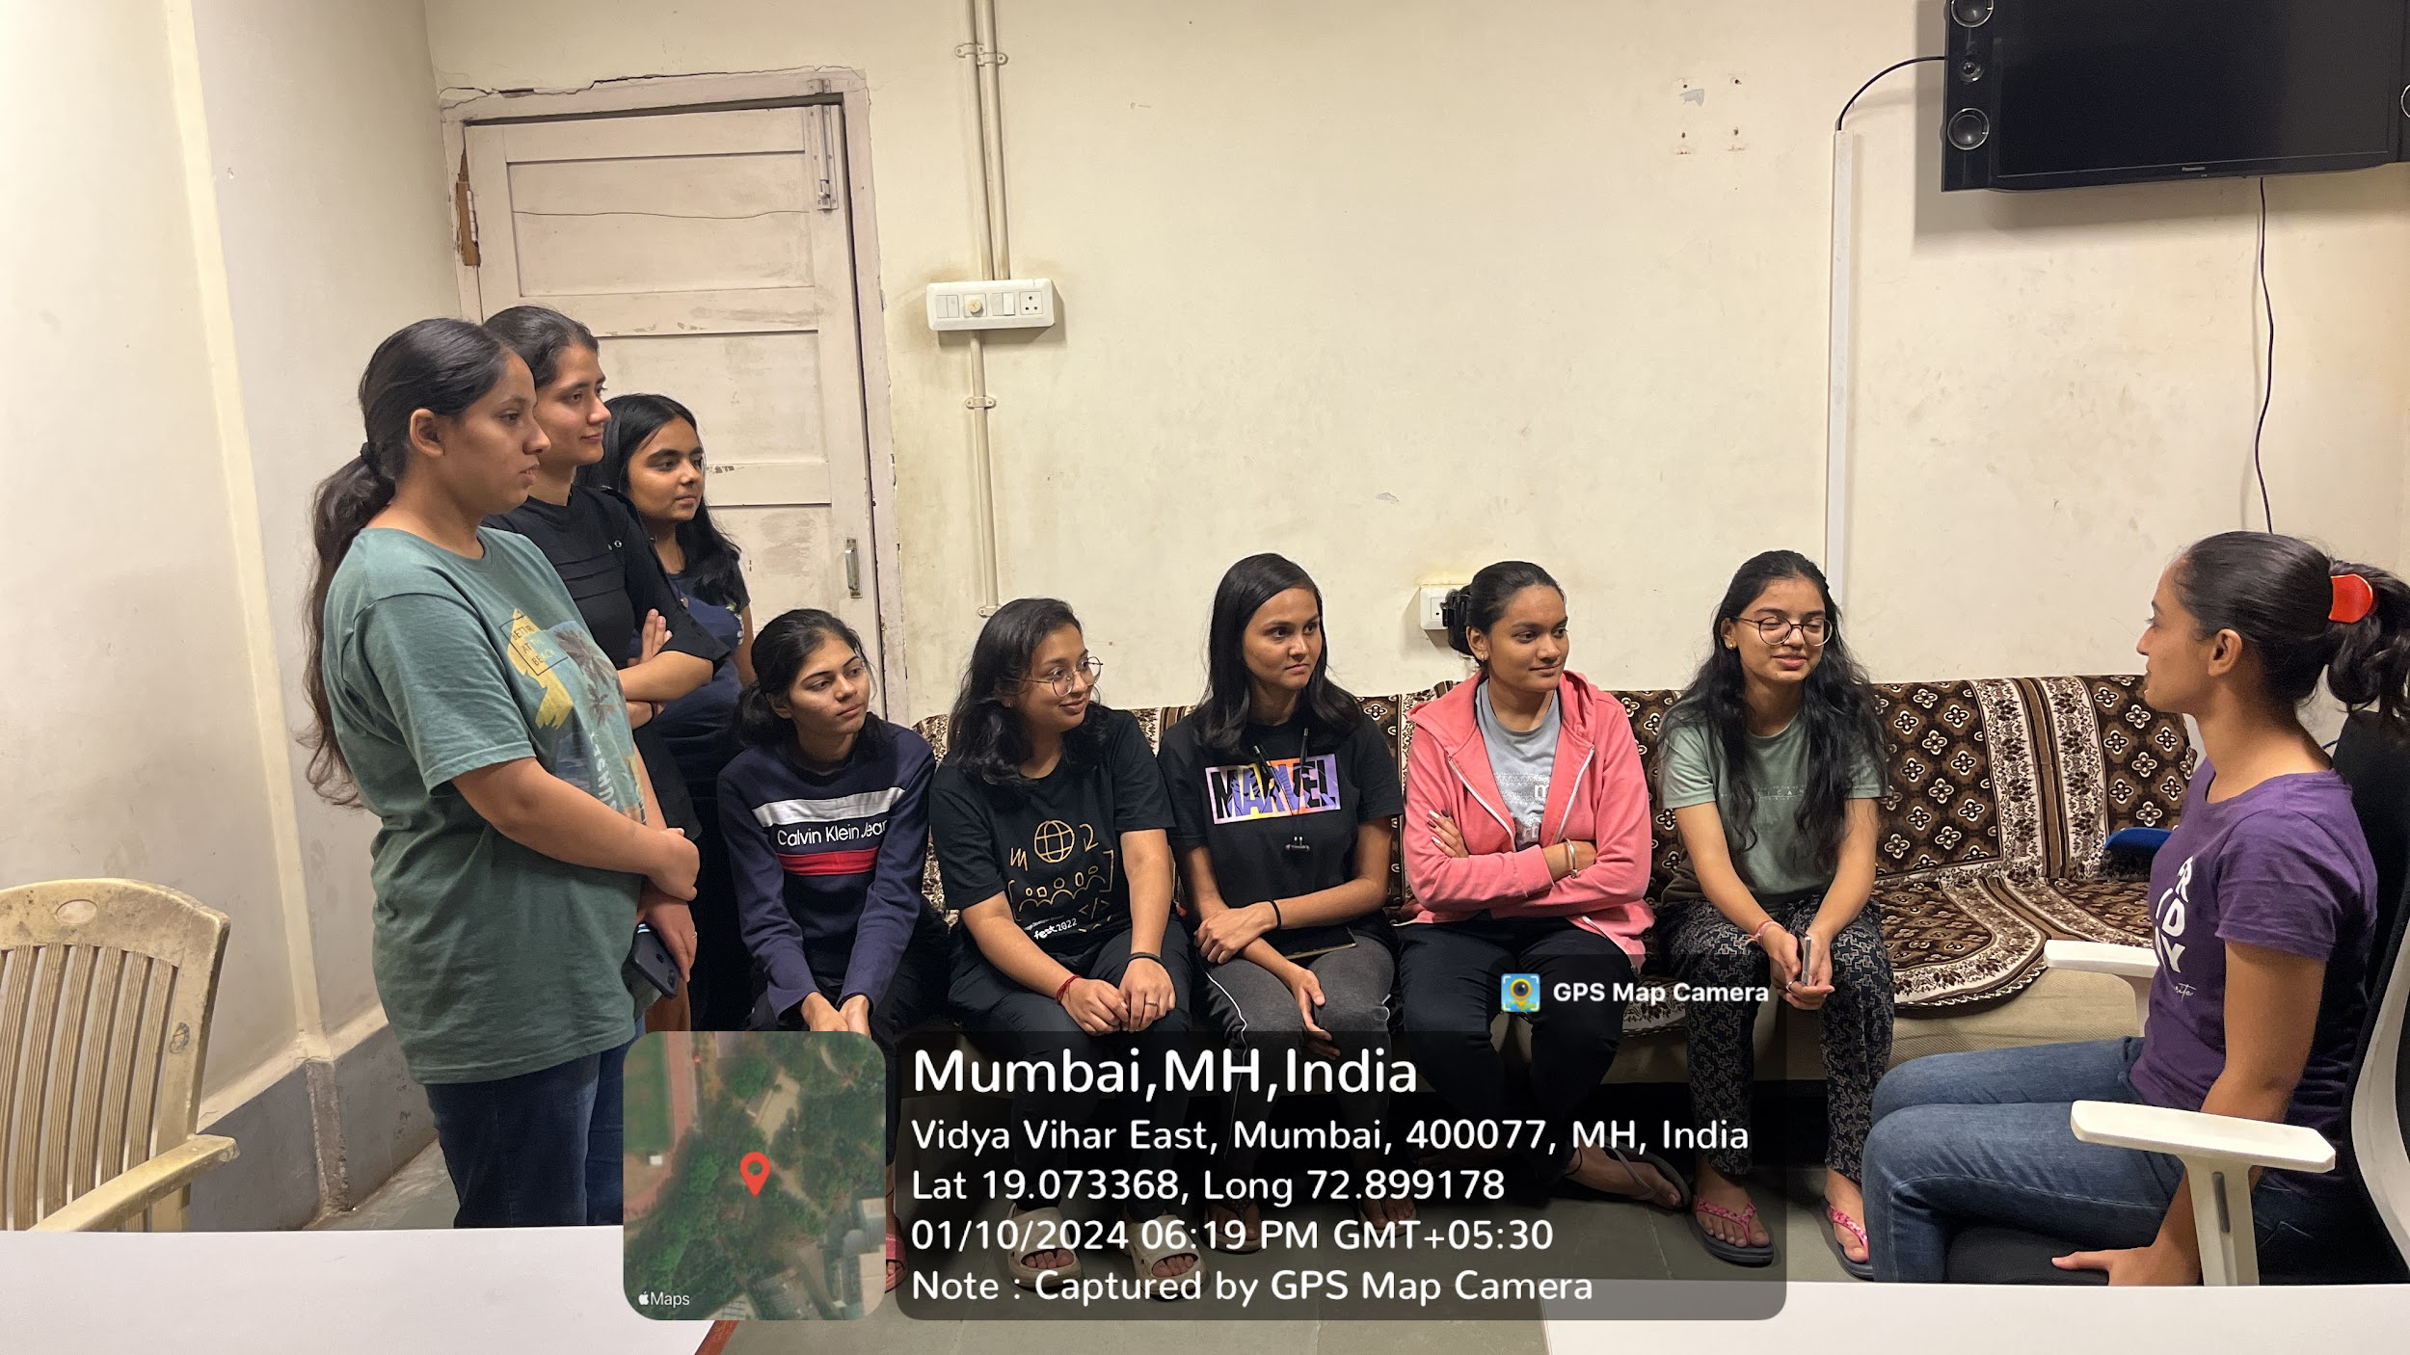
Fig: demonstration of dynamic sitting exercise


Fig: dynamic sitting exercise position

Statistical Analysis

Data were entered in Microsoft Excel and analyzed using GraphPad Prism software. Normality testing was performed using the Shapiro–Wilk test, which indicated non-normal distribution. Hence, non-parametric Wilcoxon signed-rank test was used. Statistical significance was set at p < 0.05.

Results:
Sr. no | Outcome measure | Pre test mean | Post test mean | P value
1. | NRS | 4.77 | 1.23 | <0.001
2. | MMST Flexion | 5.55 | 5.92 | <0.005
2. | MMST Extension | 3.57 | 4.48 | <0.001
3. | ODI | 5.55 | 5.17 | <0.013

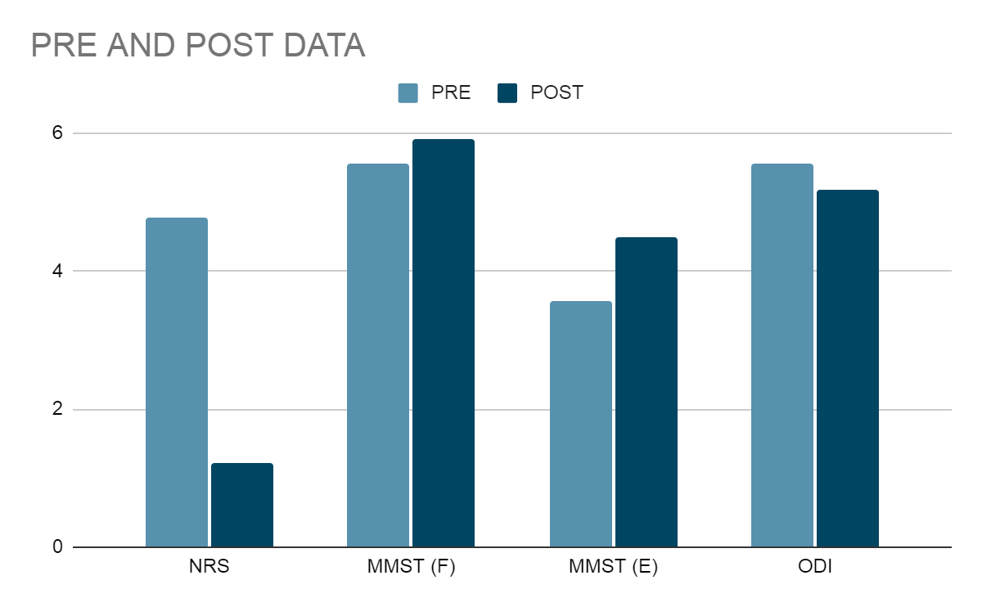

Fig: graphical representation of data

This study included desk job workers from IT companies with 38 males and 20 females aged between 18- 24.The pre data collected had a mean of 5.03 for pain, 5.45 for MMST, and 11.44 for quality of life. After reassessment the mean difference was 3.35 for NRS with post value being 1.68 with a P value of <0.005 indicating 95% intraclass confidence interval, the difference for MMST flexion was 0.91 with a post value of 5.89 p value being <0.005 stating 95% intraclass confidence interval, for extension the mean difference was 0.44 with a post value of 4.48 <0.001 indicating 99% intraclass confidence interval, the mean difference for quality of life was 6.86 p value being <0.013 indicating 87% confidence interval with moderate significance.

Discussion

The present study demonstrates that dynamic sitting exercise significantly reduces pain and improves lumbar mobility among desk job workers with mechanical low back pain. These findings align with previous research highlighting the detrimental effects of prolonged sitting on spinal health⁶,⁹.
Desk job workers often adopt sustained flexed postures, leading to muscle fatigue, reduced intervertebral disc nutrition, and stiffness⁵. The significant improvement in MMST scores observed in this study indicates restoration of lumbar flexibility, which is essential for functional activities and injury prevention.
Dynamic sitting exercise promotes intermittent spinal unloading and activation of deep stabilizing muscles through abdominal drawing-in maneuver, enhancing spinal stability and circulation⁸. Similar improvements in lumbar mobility have been reported in sedentary populations performing dynamic sitting interventions¹⁰.
Improvement in ODI scores suggests enhanced functional capacity and reduced disability, emphasizing the practical relevance of this intervention in occupational settings. The simplicity and feasibility of this exercise make it highly applicable for workplace health promotion programs.

Conclusion
Dynamic sitting exercise is an effective, low-cost, and easily implementable intervention for managing mechanical low back pain among desk job workers. Regular practice leads to significant reduction in pain, improvement in lumbar mobility, and enhancement of quality of life.

Limitations
The study lacked a control group, limiting causal inference. The small sample size and short follow-up duration restrict generalizability. Objective ergonomic assessment and muscle activation analysis were not included.

Future Scope
Future studies should include randomized controlled trials with larger samples and longer follow-up. Ergonomic modifications combined with dynamic sitting exercise should be explored. Comparative studies across different occupational groups are recommended.

References:

- Hoy D, March L, Brooks P, et al. The global burden of low back pain: estimates from the Global Burden of Disease 2010 study. Ann Rheum Dis. 2014;73(6):968–74.
- Maher C, Underwood M, Buchbinder R. Non-specific low back pain. Lancet. 2017;389(10070):736–47.
- Waongenngarm P, Rajaratnam BG, Janwantanakul P. Sitting posture associated with musculoskeletal symptoms and muscle activity in office workers: A systematic review. Appl Ergon. 2015;51:207–16.
- Lis AM, Black KM, Korn H, Nordin M. Association between sitting and occupational LBP. Eur Spine J. 2007;16(2):283–98.
- Callaghan JP, McGill SM. Intervertebral disc herniation: lumbar mechanics. Eur Spine J. 2001;10(2):151–60.
- O’Sullivan PB. Diagnosis and classification of chronic low back pain. Med J Aust. 2005;182(5):230-234.
- Van Dieën JH, Selen LPJ, Cholewicki J. Trunk muscle activation in low back pain patients versus controls: A systematic review. Clin Biomech. 2003;18(9):867–76.
- Panjabi MM. The stabilizing system of the spine. Part I. J Spinal Disord. 1992;5(4):383–9.
- Fairbank JC, Pynsent PB. The Oswestry Disability Index. Spine. 2000;25(22):2940–52.
- Chatchawan U, Ruangchainikom M, Jarujams V, et al. Effects of dynamic sitting exercise program on low back pain in office workers. J Phys Ther Sci. 2015;27(6):1987–90.
- Shariat A, Cleland JA, Danaee M, et al. Clinical prediction rule for identifying low back pain patients who benefit from stabilization exercise. Phys Ther. 2013;93(9):1201–9.
- Van Dieën JH, Hoozemans MJ, Toussaint HM. Stoop or squat: a review of biomechanical loading of the low back in lifting. Ergonomics. 1999;42(10):1353–63.
- Magnussen LH, Døssing K, Bontti S, et al. The effect of exercise on pain and function in chronic low back pain: A randomized controlled trial. Spine. 2014;39(18):E1055–62.
- Macedo LG, Maher CG, Latimer J, et al. Motor control exercise for persistent, non-specific low back pain: a systematic review. Spine. 2009;34(4):E
- Hartvigsen J, Hancock MJ, Kongsted A, et al. What low back pain is and why we need to pay attention. Lancet. 2018;391(10137):2356–67.
- Heneweer H, Staes F, Aufdemkampe G, et al. Physical activity and low back pain: a systematic review. Eur Spine J. 2011;20(6):826–45.
- MacDermid JC, Turgeon T, Richards RS, et al. Patient-Rated Wrist/Hand Evaluation: reliability, validity, and responsiveness. J Hand Ther. 1998;11(4):258–69.

