Title: Digital Financial Knowledge: A bibliometric and Conceptual Review

Abstract
Purpose:
Digital financial services have expanded rapidly, increasing scholarly interest in Digital Financial Literacy (DFL) as a key determinant of financial inclusion, behavioural outcomes, and participation in digital economies. Despite the growing body of literature, limited attention has been given to the role of Digital Financial Knowledge (DFK) as a distinct component within the broader DFL framework. This study aims to examine the intellectual structure and thematic development of DFL research and to clarify the conceptual position of DFK through a comprehensive bibliometric and conceptual review.
Design/Methodology/Approach:
The study adopts a hybrid review methodology combining bibliometric analysis and structured conceptual synthesis. Bibliometric data were retrieved from the Web of Science Core Collection and analysed using the Bibliometrix R package through the Biblioshiny interface. To complement the bibliometric findings, relevant literature from Emerald, Google Scholar, and other scholarly sources was systematically reviewed to examine the conceptualisation of knowledge-related dimensions within DFL research.
Findings:
The bibliometric analysis reveals significant growth and increasing interdisciplinary engagement in DFL research. Major research themes include financial inclusion, technology adoption, and financial behavioural outcomes. Although DFK does not appear as a standalone construct within the dominant literature, it is implicitly embedded within broader discussions of financial literacy. The conceptual synthesis identifies financial literacy, digital awareness, and risk awareness as core knowledge dimensions, while also highlighting inconsistencies in their definitions and measurement. Based on these findings, a more coherent conceptual framework of DFL is proposed, positioning DFK as a foundational component of digital financial literacy.
Research Limitations:
The bibliometric analysis is limited to publications indexed in the Web of Science database, which may exclude relevant studies from other sources. Future research should empirically validate the proposed framework and develop standardised measures of DFK to enhance theoretical consistency and cross-study comparability.

Practical Implications:
By clarifying the conceptual boundaries of DFK within DFL, the study provides valuable insights for researchers, educators, policymakers, and financial service providers. This study can support the development of targeted financial education programmes, measurement instruments, and policy interventions aimed at strengthening digital financial capabilities and promoting effective participation in evolving digital financial ecosystems.

Keywords: Digital Financial Literacy, Digital Financial Knowledge, Financial Behaviour, Bibliometric Analysis, Conceptual Review

Introduction
The rapid use of digital financial technologies has changed the structure of the global financial system in significant ways. Mobile banking, digital payment systems, online lending, cryptocurrency markets, and finance that works with e-commerce have all changed how individuals and businesses access, manage, and invest their finances (Ravikumar et al., 2022a). As digital financial ecosystems grow, increasing amounts of study is focused on figuring out what skills people need to be able to navigate these systems safely and effectively. In this context, Digital Financial Literacy (DFL) has emerged as an essential concept in finance, economics, consumer behaviour, development studies, and sustainability studies.
Recent empirical research underscores the expanding significance of Digital Financial Literacy (DFL) across a wide range of socioeconomic outcomes. Studies associate DFL with improved financial well-being and reduced financial stress (Choung et al., 2023; S. A. Bhat et al., 2025) enhanced financial inclusion and access to formal financial services (Kamble et al., 2024; Zaimovic, 2026) and improved employment quality among urban populations (Ma & Cao, 2025). In rural and developing market contexts, DFL has been associated with increases in household income and decreases in income disparity (Xu et al., 2024). More recently, research has extended DFL into domains such as sustainable finance (Mazzoli & Baiocco, 2025) and corporate governance (Fan et al., 2025) demonstrating its conceptual flexibility.
During this development, a fundamental analytical issue has received inadequate attention: the role and definition of Digital Financial Knowledge (DFK) within the broader Digital Financial Literacy (DFL) framework. Several empirical models clearly define digital financial knowledge as an independent variable influencing behavioural outcomes (S. A. Bhat et al., 2026; Zaimovic, 2026), other studies integrate knowledge within comprehensive frameworks of literacy, capability, or behaviour (Kumar, 2023; Setiawan et al., 2022). DFK is sometimes considered a cognitive mechanism that mediates the relationship between digital access and financial inclusion (Zaimovic, 2026), whereas in other instances, it is incorporated into combined indicators of literacy or capability (Choung et al., 2023) This conceptual mobility raises questions about construct clarity, dimensional bounds, and measurement accuracy.
When knowledge, skills, behavioural execution, and contextual elements are not distinctly articulated, measurement boundaries may become less clear in order to contribute to definitions of DFK. In response to this gap, the present study undertakes a hybrid bibliometric and conceptual review of DFL research, with a specific focus on clarifying the position of DFK within the field. First, a bibliometric analysis of Web of Science-indexed publications is conducted to map the intellectual structure, thematic evolution, and dominant research clusters shaping DFL research. The dataset indicates a clear upward trajectory in publication activity, accompanied by diversification into areas such as sustainability, entrepreneurship, financial inclusion, and behavioural finance. Second, a structured conceptual synthesis is employed to investigate the definitions, operationalizations, and integrations of DFK within established frameworks. This approach allows for a more comprehensive understanding of how DFK interacts with existing models.
This research presents three main contributions. This study offers a systematic bibliometric analysis of the expanding DFL literature, highlighting essential journals, thematic clusters, and outcome domains. Secondly, it enhances conceptual clarity by analysing the recurring cognitive and digital elements related to DFK. Third, it presents a comprehensive, multidimensional definition of DFK that clarifies its distinctions from DFL while ensuring theoretical consistency between the constructs. The study enhances digital financial research by integrating quantitative mapping with qualitative synthesis, thereby establishing a more robust conceptual foundation for future empirical research, scale development, and policy formulation in digitally mediated financial contexts.
The remainder of the paper is organized as follows. Section 2 outlines the bibliometric and conceptual review methodology. Section 3 presents the results of the bibliometric analysis. Section 4 develops the conceptual synthesis and advances a consolidated definition of Digital Financial Knowledge. Final section discusses theoretical and research implications with limitations and directions for future research.

Review Design and Methodology

2.1 Review Design
This study adopts a bibliometric and conceptual review approach to thoroughly examine the emerging area of Digital Financial Knowledge (DFK). Bibliometric analysis is particularly suited for synthesising large volumes of scientific literature, enabling the identification of intellectual structures, research trends, and thematic evolution within the field (Donthu et al., 2021). It offers a thorough and clear scientific framework for analysing scholarly output through quantitative tools, thereby minimising the subjectivity generally linked to traditional narrative reviews.
A structured two-stage review approach is used for this study, which combines bibliometric analysis with conceptual synthesis. Not only do we want to look at how Digital Financial Literacy (DFL) study is organised intellectually, but we also want to see how Digital Financial Knowledge (DFK) is defined and placed in the larger body of literature. Even though bibliometric methods make it easy to find publication trends, important journals, and thematic groups, they do not fully clear up conceptual ambiguities. So, a complementary qualitative synthesis is used to look at trends in definitions, areas of conceptual fragmentation, and areas where dimensions come together.
The integration of performance analysis and science mapping allows the study to move beyond descriptive trend analysis toward theory refinement. Specifically, bibliometric mapping provides an empirical basis for identifying dominant research streams, whereas the conceptual synthesis clarifies the cognitive framework supporting DFK and distinguishes it from broader literacy and capability constructs.

2.2 Data Source and Search Strategy
The bibliometric dataset was obtained from the Web of Science Core Collection. The search was conducted using relevant keywords related to “Digital Financial Literacy” and “Digital Financial Knowledge” within titles, abstracts, and keywords. Only peer-reviewed journal articles were retained to ensure academic quality and comparability.
After applying inclusion and screening criteria, the final dataset comprised 42 journal articles. Duplicate records and non-article document types were excluded. The selected studies represent diverse disciplinary domains, including finance, economics, consumer behaviour, sustainability, and development studies.

Bibliometric Analysis Procedures
Following established bibliometric frameworks (Donthu et al., 2021) this study employs both performance analysis and science mapping techniques.

Performance Analysis
Performance analysis examined a range of significant aspects of research output, such as how many papers were published each year and which journals were used. It also examined thoroughly at citation counts on both a regional and a global level to learn more about the academic work's status and reach. Another aspect that was studied was the geographic distribution of research, which showed where the study was done and how it influences respective fields. The research also found that financial inclusion, well-being, and sustainability were the most important outcome domains. This thorough evaluation made it possible to see that Digital financial literacy research had a wide range of themes, which helped to create an empirical basis for better conceptual understanding.

Conceptual Synthesis and Coding Procedure
Following bibliometric mapping, a structured conceptual synthesis was conducted. After bibliometric mapping, a conceptual synthesis of 42 articles was conducted, with an emphasis on three analytical dimensions: Construct Positioning, which analyses the differentiated treatment of Digital Financial Knowledge (DFK) alongside Digital Financial Literacy (DFL) and the integration of knowledge within literacy; Dimensional Architecture, which includes cognitive, procedural, behavioural, and attitudinal components; and Measurement Strategy, which consists of objective knowledge assessments, self-evaluated literacy, and composite capability indices. This structured coding enabled identification of recurring patterns, including construct inflation, dimensional overlap, and measurement redundancy. Particular attention was paid to studies isolating digital financial knowledge as a mediating or foundational cognitive component. The synthesis ultimately informed the development of a consolidated, multi-dimensional definition of Digital Financial Knowledge presented in Section 4.

Research Questions
The methodology followed three research questions:
RQ1: What are the publication and thematic trends in Digital Financial Literacy research?
RQ2: How does literature define digital financial knowledge?
RQ3: What is the theoretical definition of DFK within DFL?

Data Collection and Selection Process
The dataset was modified by removing non-journal publications to assure data quality and relevance. Three conference papers were specifically excluded, leaving a final dataset of 42 peer-reviewed journal publications. Due to the targeted search approach and the application of database-level filters (such as subject categories, document type, and language), no more records were eliminated during the screening phase. The selected papers were considered appropriate for bibliometric analysis as they directly address digital financial constructs within the wider framework of digital financial literacy. The resulting dataset was exported in a suitable format and examined using the Bibliometrics software program in R (Biblioshiny interface), providing performance analysis and science mapping.

Bibliometric Results

3.1 Overview of the Dataset
This section outlines the bibliometric mapping of Digital Financial Knowledge research based on metadata obtained from the Web of Science Core Collection. In reference to the search technique outlined in Section 2, a final dataset has 42 peer-reviewed articles that were published between 2021 and 2026. The data set includes work from 141 authors from 27 academic sources. This shows that the journals are not too far out and that an extensive number of contributors are involved in the research. The literature shows a lot of collaboration, with an average of 3.52 co-authors per document and 40.48% of publications having international collaboration. This means that the Digital Financial Literacy study is not limited to one area, but is part of a global academic network.
The average citation count per document is 27.83, which shows that the field is quite important in both academia and policy. This is because the documents are only 1.98 years old. The dataset has 2,217 cited references, which shows how strong the theoretical basis is for current Digital Financial Literacy research. The annual growth rate of 8.45% shows that the field is steadily developing, which shows how important digital financial literacy has grown in current financial systems.
Table 1: Main Information About the Dataset
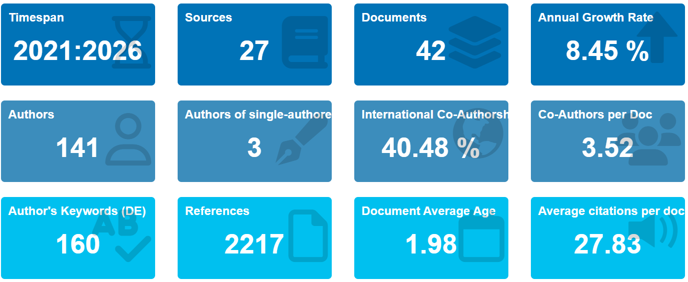
Sources: Author’s own work

3.2 Scientific Production and Performance Analysis

3.2.1 Annual Scientific Production
The annual scientific production of Digital Financial Literacy research shows a clear and consistent upward trajectory over the study period. As shown in Figure 1, the number of publications increased progressively from 2 articles in 2021 to 17 articles in 2025, indicating a substantial expansion in scholarly attention toward digitally mediated financial capability.
The growth pattern can be broadly divided into two phases. The initial phase (2021–2022) reflects a developing stage, with relatively limited publication output. This is followed by a consolidation phase (2023–2024), during which the number of studies increases steadily, suggesting growing recognition of the field. The most notable surge occurs in 2025, where publication output rises sharply, marking a transition into a rapid expansion phase.
Overall, the observed trend indicates that Digital Financial knowledge has evolved from an emerging topic into a rapidly developing research domain. This expansion aligns with the increasing global adoption of digital financial services, the proliferation of fintech innovations, and policy emphasis on financial inclusion in digitally transforming economies.
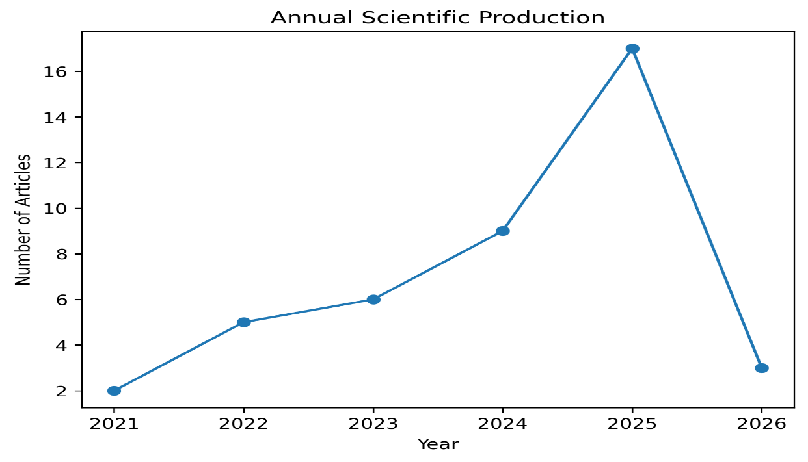
Figure 1. Annual Scientific Production of Digital Financial Knowledge Research (2021-2016)
Sources: Author’s own work

3.2.2 Country Scientific Production
The geographical distribution of scientific production in digital financial knowledge reveals significant disparities, predominantly concentrated in a select number of countries, particularly emerging and developed economies. China leads the field with an impressive 32 publications, underscoring the nation's rapid digital transformation and strategic policies promoting financial technologies and digital financial inclusion. The United States trails with 10 publications, reflecting ongoing academic engagement in technological innovation and behavioural finance related to digital finance.
Following closely is India with 9 publications, illustrating an increasing scholarly interest in digital financial inclusion within emerging markets, notably via the proliferation of mobile payment systems and government driven digital initiatives. Other notable contributors include South Korea (8 publications) and the United Kingdom (6 publications), both recognized for their advanced technology and robust digital financial infrastructures. Italy (5 publications) and Finland (3 publications) further signify the growing academic focus on digital finance in Europe. Additionally, nations like Indonesia (4 publications), Malaysia (3 publications), and Australia (3 publications) underscore the rising significance of digital financial literacy research throughout the Asia-Pacific region. The involvement of these countries highlights the crucial role of developing digital financial capabilities in economies where enhancing financial inclusion remains a pivotal policy objective.
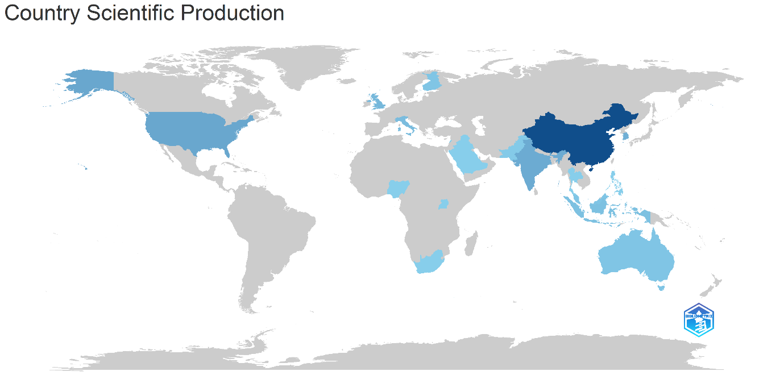
Figure 2. Country Scientific of Digital Financial Knowledge Research
Sources: Author’s own work

3.2.3 Most Relevant Sources
The distribution of publications across sources indicates a moderately dispersed research landscape, with no single journal dominating the field. The most productive outlets include Finance Research Letters and the International Journal of Bank Marketing, each contributing four articles, followed by Heliyon, SAGE Open, and Sustainability, each with three publications.
This pattern reflects the interdisciplinary nature of Digital Financial Literacy research, which spans the domains of finance, marketing, behavioural sciences, and sustainability. The presence of journals such as Behavioural Sciences and Acta Psychologica. Further highlights the integration of psychological and behavioural perspectives into digital finance research.
Overall, the absence of a highly concentrated publication outlet suggests that the field is still evolving and has not yet consolidated within a specialized journal, reinforcing its emerging and cross-disciplinary character.
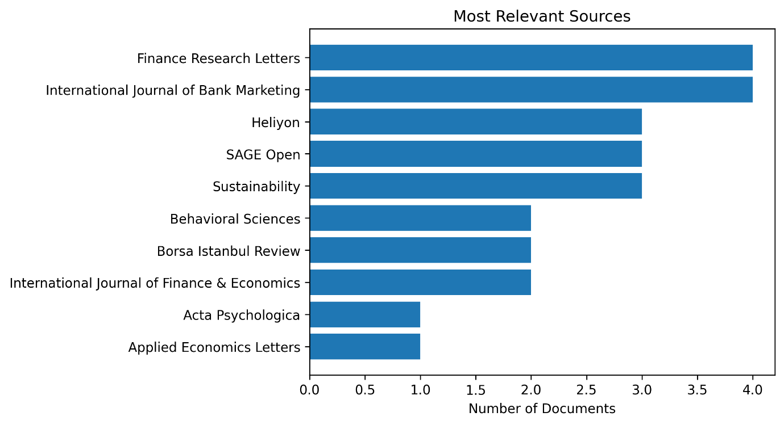
Figure 3. Most Relevant Sources
Sources: Author’s own work

3.3 Conceptual Structure of Literature

3.3.1 Keyword Co-occurrence Analysis
The keyword co-occurrence analysis reveals the conceptual structure of the Digital Financial Literacy (DFL) literature, identifying digital financial literacy as the most central theme, evidenced by its highest betweenness centrality (323.309) and PageRank score (0.143). This indicates its role as a crucial bridge linking various thematic areas. Additionally, financial literacy remains significant, with a betweenness centrality of 184.590, reflecting its foundational role in digital financial discussions and the continuity between traditional and digital financial frameworks.
The network analysis identifies key themes in digital finance, focusing on digital financial capability, inclusion, and adoption, which emphasize the access to and use of digital services. The term 'consumers' indicates a behavioral perspective, highlighting user engagement with platforms. However, Digital Financial Knowledge (DFK) is notably absent as a distinct term, suggesting it is integrated within broader ideas like digital financial literacy and capability. This supports the view that DFK is conceptually overshadowed in current research. Overall, the analysis underscores digital financial literacy as the main concept, closely linked to financial inclusion, adoption behavior, and digital capability, incorporating behavioral and contextual factors.
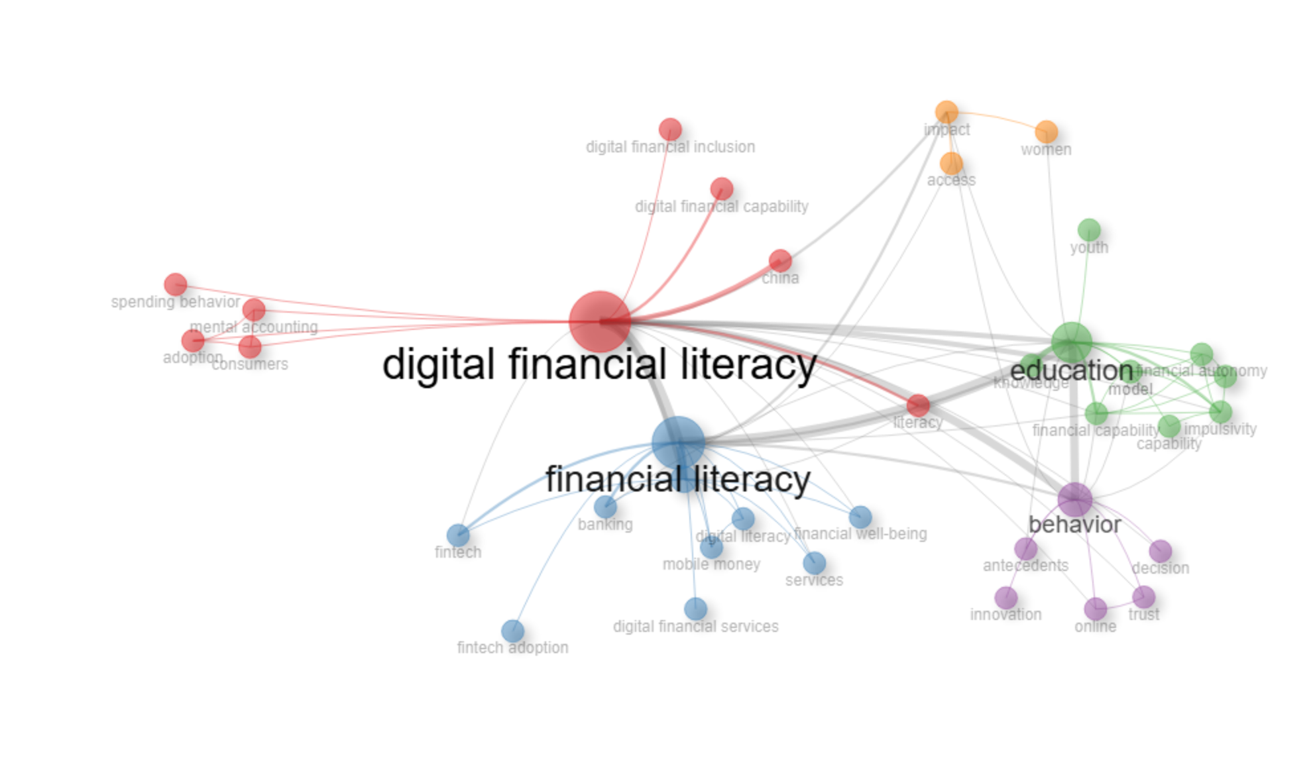
Figure 4. Keyword Co-occurrence Analysis
Sources: Author’s own work

3.3.2 Thematic Map Analysis
The thematic map analysis presents a detailed overview of the Digital Financial Literacy (DFL) research domain by categorizing themes according to their centrality (importance) and density (development). The analysis reveals a diverse and uneven thematic landscape. The theme of digital financial literacy shows high density (85.054), moderate centrality (1.197), and the highest frequency (39 occurrences), indicating its well-developed and cohesive nature within the field. Similarly, financial literacy is characterized by strong centrality (1.622) and moderate density (45.833), underscoring its foundational influence in digital financial discourse.
Additionally, themes such as behavior (density = 87.500) and model (density = 94.702) reveal high density values, suggesting a robust conceptual development and internal structure. These themes are commonly linked to behavioral finance frameworks and empirical models that evaluate digital financial adoption and outcomes. In contrast, themes like financial inclusion (centrality = 3.178) and education (centrality = 2.394) indicate high centrality, reflecting their critical relevance and connections to the broader research domain. These themes act as transversal topics that integrate digital financial literacy with policy discussions, particularly in the areas of economic development and inclusion.
The thematic analysis shows that effect and access are important subjects, but they are not yet the main ones in the literature. Digital Financial Knowledge (DFK) is not acknowledged as a distinct cluster; rather, it is integrated with overarching issues such as digital financial literacy and education. This indicates that DFK is not yet distinctly defined or implemented, highlighting a deficiency in the emphasis on knowledge as a separate component within the domain of digital financial literacy, financial inclusion, and education.

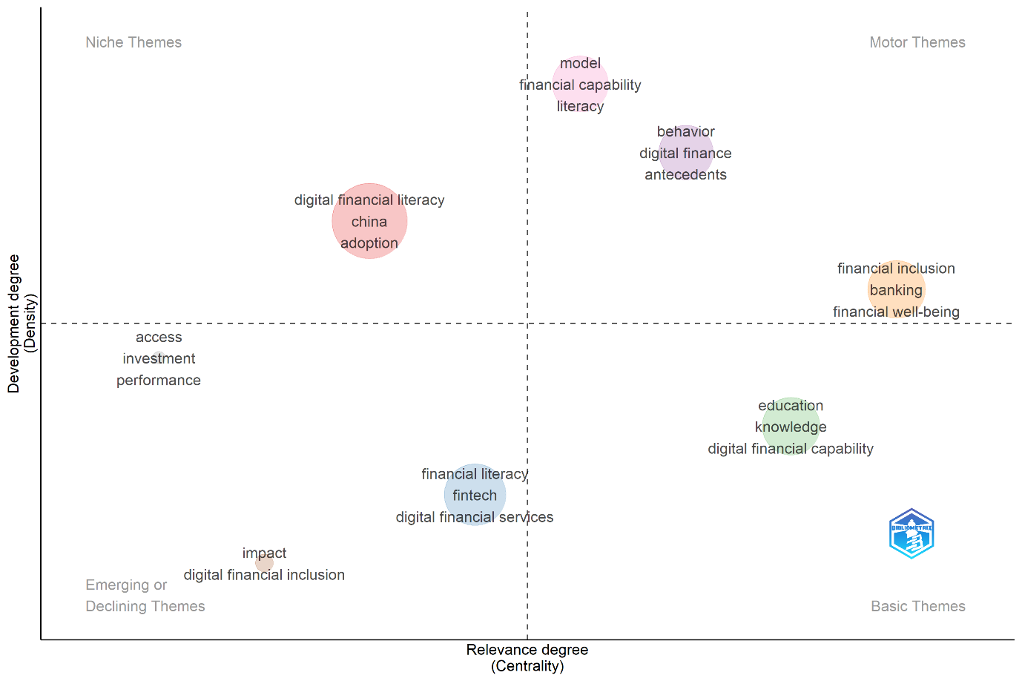
Figure 5. Thematic Map
Sources: Author’s own work

3.3.3 Conceptual Insights
The bibliometric analysis provides substantial information regarding the positioning of Digital Financial Knowledge (DFK) within the research landscape. The term DFK is not explicitly presented as a separate keyword or thematic area; rather, it is inferred within more expansive frameworks such as digital financial literacy, financial literacy, and education. This indicates that DFK is not regarded as a standalone term in the literature; rather, it is incorporated within the multidimensional framework of Digital Financial Literacy (DFL), where cognitive knowledge is intertwined with behavioural, attitudinal, and technological dimensions. Digital financial literacy is the most important idea in this subject since it is so central and common in the analysis.
The co-occurrence network also points to a concentration on applied research topics like financial inclusion, adoption, and consumer behaviour, where knowledge is more of a supporting element than a separate category of analytics. This indicates a significant deficiency; although knowledge is recognised as vital for digital financial inclusion, it does not consist of well-defined theoretical parameters and practical application. The results highlight the necessity to separate and redefine Digital Financial Knowledge as a unique construct to improve its clarity and relevance within the study domain.

3.4 Intellectual Structure

3.4.1 Co-citation Analysis
A key finding from the co-citation network is a lack of a distinct intellectual cluster focused on Digital Financial Knowledge (DFK). The current literature predominantly focuses on general financial literacy, with limited adaption to digital environments. This indicates that DFK has not yet developed into a distinct theoretical field of study, remaining associated with broader literacy frameworks. The research framework indicates a dependence on traditional financial literacy theories, although current research efforts are beginning to integrate digital components, highlighting a rapidly expanding but evolving domain where terms of Digital Financial Knowledge are not fully established.

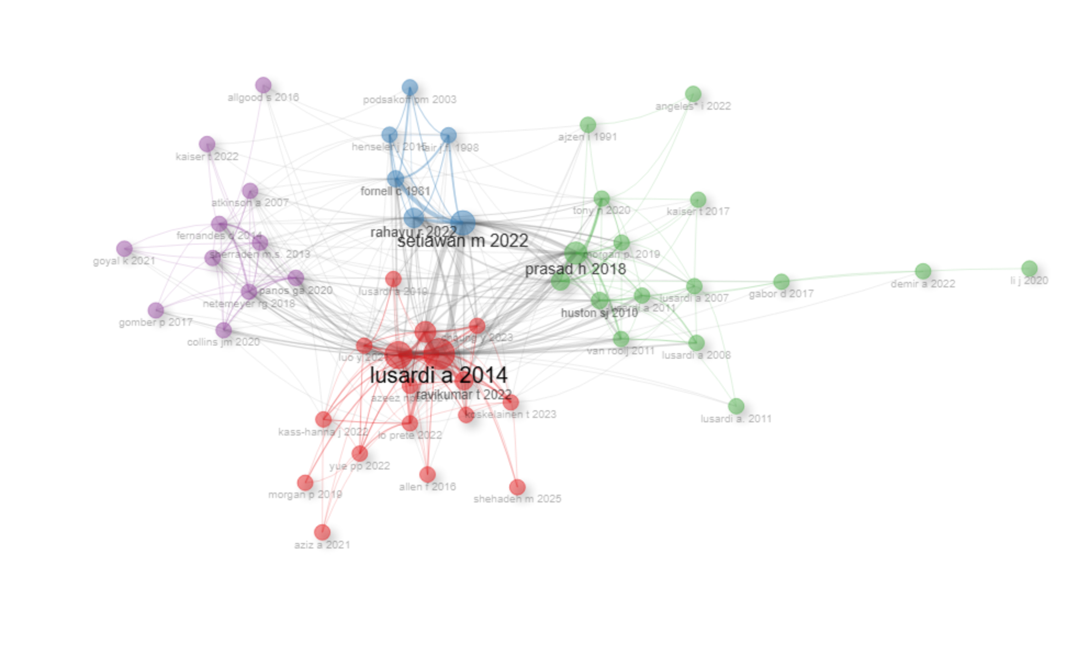
Figure 6. Co-citation Analysis
Sources: Author’s own work

As the bibliometric results provide an extensive overview of the intellectual and thematic development of the area, it is essential to conduct further theoretical analysis in order to shed light on the importance and scope of Digital Financial Knowledge in this emerging field.

4. Conceptual synthesis: Towards Digital Financial Knowledge

4.1 Conceptual Fragmentation in Digital Financial Research
The scope of research on digital financial capabilities has increased as a result of the digital financial ecosystems' recent rapid growth. Despite this growth, the literature shows significant conceptual fragmentation with regard to the operationalization and definition of Digital Financial Knowledge (DFK). DFK is rarely defined as a theoretically independent construct in high-quality peer-reviewed studies. Instead, the use of overlapping terminology, such as Digital Financial Literacy (DFL) (S. A. Bhat et al., 2026; Zaimovic, 2026), Financial Knowledge (Loke et al., 2026; Szalai et al., 2025), Digital Knowledge (Badrudin et al., 2025), often using them as interchangeable alternatives for similar cognitive and technical competencies.
A recent development in the literature is the incorporation of knowledge into wider multidimensional frameworks of DFL. In these formulations, knowledge is regarded as a fundamental element, positioned alongside digital skills, attitudes, and behavioural outcomes. Consequently, analyses of DFL often incorporate theoretical financial knowledge with actual digital capabilities, making it challenging to distinguish between cognitive comprehension and practical technical proficiency (G. Bhat, 2021; Zaimovic, 2026).In certain instances, studies evaluate digital knowledge mostly through indicators related to fraud detection or risk understanding, whereas others combine objective financial knowledge with subjective digital confidence, without explicitly defining digital financial knowledge as an independent construct (Badrudin et al., 2025; Szalai et al., 2025).
A similar area of study has searched for greater conceptual clarity by separating financial knowledge from broader literacy frameworks. Initial efforts to define DFK as a separate construct defined it as a multidimensional concept that connects conventional financial knowledge with the skills necessary for digitally mediated financial environments (Normawati et al., 2021; Rahman et al., 2023).
Following contributions expanded on this framework by separating traditional economic knowledge, such as understanding inflation, interest rates, and financial instruments from digital-specific skills associated with technological navigation, platform usage, and security awareness (Achanta & Lepcha, 2025; Vieira et al., 2024) .The findings from these studies promote a cognitively constrained definition of DFK, framing it as the organized competence required to comprehend and effectively interact with digital financial systems.
Other frameworks, however, greatly expand the construct. Using a multidimensional model with twelve determinants, such as contextual and psychometric elements like product suitability, self-determination, and social norms, as well as knowledge of digital financial services and risk management, (Ravikumar et al., 2022b) operationalize digital financial literacy. Integrative models demonstrate how behavioural, environmental, and systemic elements that go beyond cognitive comprehension are becoming more and more integrated into digital financial institutions. Dimensional norms are inconsistent, as demonstrated by the existence of expansive, integrative models and formulations with cognitive constraints. As a result, even while scholarly interest in digital financial knowledge is expanding, different research has different classifications.
The studied literature shows that knowledge is crucial to digital financial research, although its conceptual standing is unclear. Ambiguity reduces cross-study comparison and measurement development. Thus, this study explores whether repeating thematic elements across research indicate latent convergence that can help define digital financial knowledge.

4.2 Cross - Study Convergence of Core Elements
The previous section demonstrates conceptual variability and dimensional expansion in the literature; yet, an extensive assessment of the reviewed body of literature reveals considerable consistency. Despite variances in language and scope, fundamental components are universally present throughout research disciplines. This convergence indicates that the conceptual framework of the construct remains stable despite its adaptable external boundaries. The studies commonly address cognitive financial knowledge, digital awareness, risk and cybersecurity understanding, and practical digital knowledge.

Cognitive Financial Knowledge
The most frequently stated component is traditional financial knowledge as a basis for digital interaction. Numerous studies view digital financial competence as an extension of traditional financial literacy rather than a substitution. This dimension includes the understanding of economic fundamentals like inflation and interest rates, together with knowledge of financial products in the digital age. In the absence of this cognitive foundation, mere digital access is often considered inadequate for informed financial behaviour (Achanta & Lepcha, 2025; Normawati et al., 2021; Vieira et al., 2024).

Digital Awareness
A second recurring factor is digital awareness, which pertains to the recognition of digital financial platforms, services, and technologically driven transaction instances. Several studies emphasize the importance of understanding the relationship between general digital literacy and its application in financial contexts. This awareness is highlighted as a significant factor in effectively navigating financial tools and resources in a digital environment (A. Lyons & Kass-Hanna, 2021; Morgan et al., 2020). It demonstrates a person's comprehension of the accessibility, functionalities, and consequences of digital financial service providers in a more digitized environment.

Risk and Cybersecurity Understanding
Risk and security awareness is significantly highlighted in a considerable number of the examined studies. This dimension includes understanding of online vulnerabilities, such as fraud scams, phishing attempts, and data privacy issues. Several studies notably differentiate between general risk awareness and the understanding of preventative measures necessary to secure digital financial transactions (Nigama, 2022; S. A. Bhat et al., 2026; Ravikumar et al., 2022b).

Digital Knowledge
A significant number of studies integrate procedural digital knowledge, which pertains to the comprehension of the operational mechanisms behind digital financial processes. This encompasses an understanding of transaction mechanisms, authentication procedures, and the logic behind platform navigation. One must be familiar with the processes of transactions, the procedures for authentication, and the rationale behind platform navigation (Badrudin et al., 2025; Morgan et al., 2020).
Collectively, these four dimensions constitute the most regularly repeated elements in the reviewed literature. While various research may incorporate other psychological or contextual variables, the general agreement on these basic features indicates a latent structural underpinning for expressing Digital Financial Knowledge with enhanced conceptual clarity.

4.3 Defining the Conceptual Scope of Digital Financial Knowledge
While the previous section stressed the importance of concurring on fundamental concepts, the literature review addressed how important it is to articulate the difference between Digital Financial Literacy (DFL) and Digital Financial Knowledge (DFK). According to the studies that were examined at, Digital Financial Literacy (DFL) is a multidimensional framework that covers knowledge, behaviour, attitude, and skill-based concepts (A. C. Lyons & Kass‐Hanna, 2021; Su et al., 2022). Many frameworks define DFL as the ability to understand, utilize, and confidently engage with digital financial services, including motivation and behaviour (Ravikumar et al., 2022a).
In contrast, certain studies present DFK as the cognitively structured core that is integrated into the broader digital financial literacy construct (Normawati et al., 2021; Vieira et al., 2024).In this context, DFK denotes the structured collection of financial and digital knowledge requisite for behavioural implementation. Research differentiating financial knowledge from digital knowledge as distinct predictors of literacy further reinforces this distinction (Prakash et al., 2025). By isolating cognitive components, such methodologies facilitate a more accurate analysis of knowledge gaps encompassing an inadequate understanding of inflation, digital encryption, or the mechanics of financial products, irrespective of motivational or technical constraints.
A particularly complex area of overlap pertains to procedure details. Some frameworks regard digital navigation as a behavioural ability integrated inside digital financial literacy (DFL), whereas other research conceptualise it as an understanding of digital financial processes (Loke et al., 2026). In this interpretation, understanding transaction mechanisms, authentication protocols, and system logic constitutes structured procedural knowledge rather than mere technical execution. This distinction allows procedural familiarity to remain within the cognitive boundaries of DFK without collapsing it entirely into behavioural capability.
The distinction between DFK and DFL is primarily one of conceptual scope. DFL shows how knowledge, skills, and behaviour are used in digital financial environments as a whole and DFK, on the other hand, refers to the cognitive-digital base that supports this kind of engagement. Clarifying this border improves construct accuracy and minimises redundancy in empirical operationalisation. After finding the common themes in the literature, the next step is to articulate a unified conceptual definition of digital financial knowledge based on the studies that were examined.
Understanding basic financial concepts, digital financial systems, the risks that come with them, and the steps needed to safely interact in digitally mediated financial environments are all parts of digital financial knowledge. Thus, this review contributes to the advancement of analytical precision in digital financial research by meticulously explaining the scope of DFK, distinguishing it from the broader construct of Digital Financial Literacy, and articulating its constituent dimensions. A more stable foundation for empirical operationalisation, measurement development, and theoretical refinement in future studies is also provided by such clarification, which also reduces construct redundancy.

5. Discussion

5.1 Theoretical Implications
The outcomes of the current research add to the prevailing topic of discussion on digital financial capabilities by providing a more elaborate theoretical foundation for Digital Financial Knowledge (DFK). Previous studies have primarily defined Digital Financial Literacy (DFL) as a multidimensional construct that includes knowledge, skills, attitudes, and behavioural capabilities. However, this analysis highlights a continuing ambiguity concerning the role and limits of knowledge within this framework. The bibliometric data indicates that the literature predominantly focuses on DFL as a fundamental construct, but the conceptual synthesis illustrates that knowledge-related components are often integrated, fragmented, or mixed together with behavioural and technical knowledge.
This study explains Digital Financial Knowledge (DFK) by describing it as a distinct part of digital financial literacy frameworks. It sets knowledge, skills, and behaviour, focusing on the conceptual ambiguity identified in previous studies. This clarity supports the development of more structured approaches to measure digital financial capability in today's financial environments.
Additionally, identifying usually common factors such as financial literacy, digital literacy, and risk and cybersecurity awareness establishes a systematic foundation for conceptualising Digital Financial Knowledge (DFK) more coherently. This perspective enhances the literature by providing a more precise and complex way to define the knowledge component, while keeping an apparent distinction from broader attitudinal and behavioural factors.

5.2 Integration of Bibliometric and Conceptual Findings
A major contribution of this study is the integration of bibliometric mapping and conceptual synthesis, which jointly contribute to an extensive overview of the field structure and development. The bibliometric study shows that the research focus on digital financial literacy, financial inclusion, behavioural outcomes, and the usage of digital financial services. The keyword co-occurrence and thematic mapping analyses do not recognise Digital Financial Knowledge as a distinct construct, highlighting its restricted prominence within the formal framework of the literature.
The conceptual examination substantially supports these findings by showing that knowledge is not often seen as a distinct attribute. Instead, it is continually integrated into more extensive frameworks of literacy.
The conceptual examination thoroughly supports these findings by showing that knowledge is not often seen as a separate attribute. Rather, it is continually integrated into more comprehensive frameworks of literacy. The co-citation analysis adds to this conclusion, indicating that the conceptual frameworks of the area are rooted in conventional financial literacy theories, with digital enhancements integrated into established paradigms rather than conceived autonomously.
The convergence of these quantitative and qualitative observations underscores significant gap, although knowledge is implicitly acknowledged as an essential component of digital financial usage, it consists only of explicit conceptual clarification and operational distinction. This connection between bibliometric absence and conceptual ambiguity makes the case stronger that DFK is still not fully developed as its own area of study.

5.3 Policy Implications
The findings of this study carry important implications for policymakers, educators, and financial service providers. The study highlights crucial implications for legislators, educators, and financial service providers regarding financial literacy initiatives. The research advocates for defining Digital Financial Knowledge as a distinct cognitive area, proposing that specifically designed interventions focused on enhancing this knowledge will result in better and measurable outcomes. For instance, financial education programs should aim to deepen comprehension of digital financial products, the risks associated with cybercrime, and the mechanics of transactions
By defining Digital Financial Knowledge as a distinct cognitive domain suggests targeted interventions for knowledge development can improve outcomes. Financial education programs should aim to enhance understanding of digital products, cybersecurity risks, and transaction mechanisms, rather than just promoting usage. It is crucial to have standardised frameworks and measurement methodologies to evaluate digital financial knowledge. These are particularly important in emerging nations, where fraud and disinformation have become more common due to fast digitalisation.

5.4 Future Research Directions
The study further lays out few directions for future research. Future empirical study should investigate the causal influence of DFK on financial outcomes, including inclusion, well-being, and the quality of decision-making. Distinguishing the effects of knowledge from those of skills and behaviour would yield more profound insights into the mechanisms underlying digital financial capacity. Cross-national and comparative research are essential to investigate the manifestation of DFK across diverse institutional, cultural, and technological contexts. As digital financial ecosystems are different all across the world, it will be important for theory development and policy design to comprehend these variances.
Future study may also investigate the interactions between traditional banking and emerging technologies, including fintech platforms, AI-driven financial services, and digital currencies. As the digital financial world keeps changing, consumers will probably must be mindful more, which makes it even more important to have explicit and observable knowledge constructions.

6. Conclusion
This research offers an extensive analysis of the Digital Financial Literacy (DFL) literature by employing a hybrid methodology that combines bibliometric analysis with conceptual synthesis. Utilising a dataset of 42 Web of Science–indexed papers, the study delineates the intellectual, thematic, and structural growth of the area, while concurrently addressing a significant conceptual gap related to Digital Financial Knowledge (DFK).
The bibliometric results show that the research area is growing quickly and is focused on digital financial literacy, financial inclusion, behavioural outcomes, and technology adoption. Nonetheless, despite the prominence of knowledge in these conversations, Digital Financial Knowledge does not surface as a distinct or independently acknowledged issue. Instead, it stays a part of wider frameworks for literacy and skills. The conceptual analysis supports this observation by showing that there is a lot of fragmentation and inconsistency in how studies identify, use, and combine knowledge.
This study shows an enhanced conceptualisation of Digital Financial Knowledge (DFK) as a cognitively constrained, multidimensional construct encompassing financial literacy, digital awareness, risk and cybersecurity knowledge, and procedural understanding. By distinguishing knowledge from skills and behaviours, the research improves clarity and coherence in the digital financial literature. The results support progress from general literacy frameworks to more specific structures, establishing DFK as an essential independent area. This progress not only makes theory more accurate, but it also makes it easier to build specific measuring tools, effective policy changes, and future empirical study. As digital financial ecosystems change, it will be important to understand the cognitive basis of user involvement in order to encourage safe and open participation in the digital economy.

Statements and Declarations

Ethics Approval and Consent to Participate
Not applicable.

Consent for Publication
Not applicable.

Funding
The authors received no financial support for the research, authorship, and publication of this research.

Competing Interests
The authors declare that they have no known competing financial or non-financial interests that could have appeared to influence the work reported in this paper.

Author Contributions
Ms. YDL contributed to the conceptualisation and design of the study. Dr. ARP, Ms. YDL, and Mr. BA were involved in data extraction and bibliometric analysis using R (Biblioshiny). Ms. YDL conducted the conceptual synthesis and prepared the first draft of the manuscript. Dr. ARP and Mr. BA critically reviewed, edited and refined the manuscript. All authors read and approved the final version of the manuscript.

Bibliography
Badrudin, R., Fahlevi, M., Putri, S., & Putri, O. (2025). Journal of Open Innovation : Technology , Market , and Complexity Financial stress and its determinants in Indonesia : Exploring the moderating effects of digital knowledge , age , and gender. Journal of Open Innovation: Technology, Market, and Complexity, 11(2), 100528. https://doi.org/10.1016/j.joitmc.2025.100528
Bhat, G. (2021). Digital Payment Service in India - A Case Study of Unified Payment Interface. India. International Journal of Case Studies in Business, 5(1), 2581–6942. http://doi.org/10.5281/zenodo.5091207.Electroniccopyavailableat:https://ssrn.com/abstract=3885763
Bhat, S. A., Lone, U. M., SivaKumar, A. K., & Krishna, U. M. G. (2025). Digital financial literacy and financial well-being – evidence from India. International Journal of Bank Marketing, 43(3), 522–548. https://doi.org/10.1108/IJBM-05-2024-0320
Bhat, S. A., Lone, U. M., Sivakumar, A., & Krishna, U. M. G. (2026). Digital financial literacy and financial well-being – evidence from India. January, 522–548. https://doi.org/10.1108/IJBM-05-2024-0320
Choung, Y., Chatterjee, S., & Pak, T. Y. (2023). Digital financial literacy and financial well-being. Finance Research Letters, 58, 104438. https://doi.org/10.1016/j.frl.2023.104438
Donthu, N., Kumar, S., Mukherjee, D., Pandey, N., & Lim, W. M. (2021). How to conduct a bibliometric analysis: An overview and guidelines. Journal of Business Research, 133(March), 285–296. https://doi.org/10.1016/j.jbusres.2021.04.070
Fan, S., Deng, W., Zhou, Y., & Su, X. (2025). Impact of digital financial literacy on corporate ESG performance. Finance Research Letters. https://doi.org/10.1016/j.frl.2025.108010
Kamble, P. A., Mehta, A., & Rani, N. (2024). Financial Inclusion and Digital Financial Literacy: Do they Matter for Financial Well-being? Social Indicators Research, 171(3), 777–807. https://doi.org/10.1007/s11205-023-03264-w
Kumar, D. (2023). Digital Payment System in India : A Brief Study. 1–11. https://doi.org/10.55041/IJSREM18093
Loke, Y. J., Siew, H., & Lee, H. (2026). Bridging the digital divide in the adoption of digital financial services. 32(2), 82–92. https://doi.org/10.1108/JABES-04-2024-0183
Lyons, A. C., & Kass‐Hanna, J. (2021). A methodological overview to defining and measuring “digital” financial literacy. FINANCIAL PLANNING REVIEW. https://doi.org/10.1002/cfp2.1113
Lyons, A., & Kass-Hanna, J. (2021). A Multidimensional Approach to Defining and Measuring Financial Literacy in the Digital Age. SSRN Electronic Journal. https://doi.org/10.2139/ssrn.3873386
Ma, L., & Cao, P. (2025). Digital financial literacy and employment quality of urban residents in China. Finance Research Letters, 86, 107924. https://doi.org/10.1016/j.frl.2025.107924
Mazzoli, C., & Baiocco, S. (2025). Unlocking sustainable investing through digital financial literacy: the impact of advanced digital skills. International Journal of Bank Marketing. https://doi.org/10.1108/IJBM-10-2024-0622
Morgan, P. J., Huang, B., & Trinh, L. Q. (2020). Policiy Brief. Minding the Gaps in Digital Financial Education Strategies. Task Force 6. Economy, Employment, and Education in the Digital Age.
Nigama, K. (2022). Empowering Street Vendors : Digital Knowledge for Better Financial Management.
Normawati, R., Rahayu, S., & Worokinasih, S. (2021). Financial Knowledge, Digital Financial Knowledge, Financial Attitude, Financial Behaviour and Financial Satisfaction on Millennials. Proceedings of the 1st International Conference on Law, Social Science, Economics, and Education, ICLSSEE 2021, March 6th 2021, Jakarta, Indonesia, March. https://doi.org/10.4108/eai.6-3-2021.2305967
Prakash, R., Yangchen, A., & Lepcha, D. (2025). Digital financial knowledge , insights from private ‑ sector employees in Sikkim. Digital Finance, 7(4), 901–920. https://doi.org/10.1007/s42521-025-00126-7
Rahman, S. A., Ismail, R., & Hasmidi, K. N. (2023). DIGITAL FINANCIAL KNOWLEDGE , FINANCIAL BEHAVIOR AND FINANCIAL STRESS DETERMINANTS OF FINANCIAL WELL-BEING AMONG EMPLOYEES OF PERODUA MANUFACTURING SDN BHD , RAWANG , SELANGOR. 178–187.
Ravikumar, T., Suresha, B., Prakash, N., Vazirani, K., & Krishna, T. A. (2022a). Digital financial literacy among adults in India: measurement and validation. Cogent Economics and Finance, 10(1). https://doi.org/10.1080/23322039.2022.2132631
Setiawan, M., Effendi, N., Santoso, T., Dewi, V. I., & Sapulette, M. S. (2022). Digital financial literacy, current behavior of saving and spending and its future foresight. Economics of Innovation and New Technology, 31(4), 320-338.
Su, X., McNett, J., Morgan, E., & Sharma, M. (2022). the Associations Between Home Economics Education and Familial Risk Factors for Delinquency: an Exploratory Study. In S. R. Maxwell & S. L. Blair (Eds.), Contemporary Perspectives in Family Research (Vol. 20, pp. 39–57). Emerald Publishing Limited. https://doi.org/10.1108/S1530-353520220000020003
Szalai, S. M., Jenei, S., & Németh, E. (2025). Knowledge or Confidence ? Exploring the Interplay of Financial Literacy , Digital Financial Behavior , and Self-Assessment in the FinTech Era. 1–23.
Vieira, K. M., Matheis, T. K., Lehnhart, E. dos R., & Tavares, F. O. (2024). Digital Financial Knowledge Scale (DFKS): Insights from a Developing Economy. International Journal of Financial Studies, 12(4). https://doi.org/10.3390/ijfs12040120
Xu, G., Feng, L., Wang, W., & Liang, Q. (2024). Digital Financial Literacy and Rural Income Inequality. SAGE Open. https://doi.org/10.1177/21582440241275642
Zaimovic, A. (2026). The nexus between digital financial knowledge and financial inclusion : digital financial attitudes and behaviour as mediators enhancing. 27, 2022–2024. https://doi.org/10.1108/IJBM-01-2024-0053

