An analysis of research published on organisational politics in higher education: A Bibliometric Perspective
NishuChauhan, Prof. Shweta Singh

ABSTRACT
Purpose
This paper aims to analyse the publication structure on the research published on organisational politics in higher education between 2000 to 2025.
Design/ Methodology
Bibliographic data on organisational politics in higher education extracted from Scopus database, and then they were analysing data through VOSviewer software and RStudio.

Findings
This study examines141 papers on organisational politics in higher education published between 2000 to 2025. The research finds the top producing nations, institutions, authors, journals, citations, co-citations, co-authorship and co-occurrence of the organisational politics in higher education. It also includes information on the most referenced publications and published authors. The VOSviewer program and RStudio is also used in the study to visualize the mapping.

Originality/value
The main contribution of the study is that it provides an overview of the trends of organisational politics in higher education, which may help the researcher and practitioners to comprehend the trends and future research directions.

Keywords
Organisational politics, Higher education, VOSviewer, citation analysis, co-authorship analysis, co-citation, co-occurrence of keywords, RStudioand bibliometric analysis.

INTRODUCTION
The term "organisational politics" has been defined differently by many academics. These definitions include a variety of behaviours that include both formal and informal use of authority and power to influence others, with a focus on forming alliances. Therefore, using power is intended to have an impact on decision-making. Politics can be defined as the unofficial, splintering behaviour of a person or a group toward certain of its members and isregarded as illegitimate. And neither a formal authority nor a recognised expert has given their approval to this activity. The impression management theory, which separates the technique of ingratiation to leverage political power on others (Gardner and Martinko, 1998), is one of the theories that captures a lot of significance. In accordance with Schlenker (2000), impression management is regarded as a conscious effort to arrange the characters that are anticipated in the shared interactions (Krishnan, 2012).
The prior literature makes clear that organisational politics is one of the most significant workplace phenomena that either directly or indirectly influences the conduct and attitudes of academics and officers (Atta & Khan, 2016). What aspects of organisational politics could aid or hinder performance is the question at hand. Organizational politics involves a few different elements. These elements include authority, assigning blame, starting fights, exposing secrets, and favouritism. Other factors that affect organisational politics include personal ones like age, gender, job title, and tenure, dispositional ones like autonomy, competence, and relatedness, organisational ones like centralization, formalisation, and hierarchical structures, and job-related ones like skill variety, job autonomy, and feedback (Sultan, Kanwal, & Gul, 2015).
According to Asrar-ul-Haq et al. (2019), organisational politics is generally understood as a set of employee behaviours geared toward securing self-interests without considering the organization's or its members' well-being. Forming power alliances, forming strong alliances, exchanging favors, pressuring or blaming others, information manipulation, impression management, forming alliances with powerful people, rational persuasion, and imposing obligations on others are typical examples of these behaviors(Turabik & Baskan,2020). Organizational members typically view these actions as selfish, unfair, and unjust(Basar & Basim , 2016). Thus, it is empirically proven that higher levels of organisational politics perception frequently result in a variety of unfavourable employee outcomes, including job stress, turnover intention, job dissatisfaction, reduced work engagement, lower level of organizational citizenship behavior, (Asrar-ul-Haq et al., 2019).

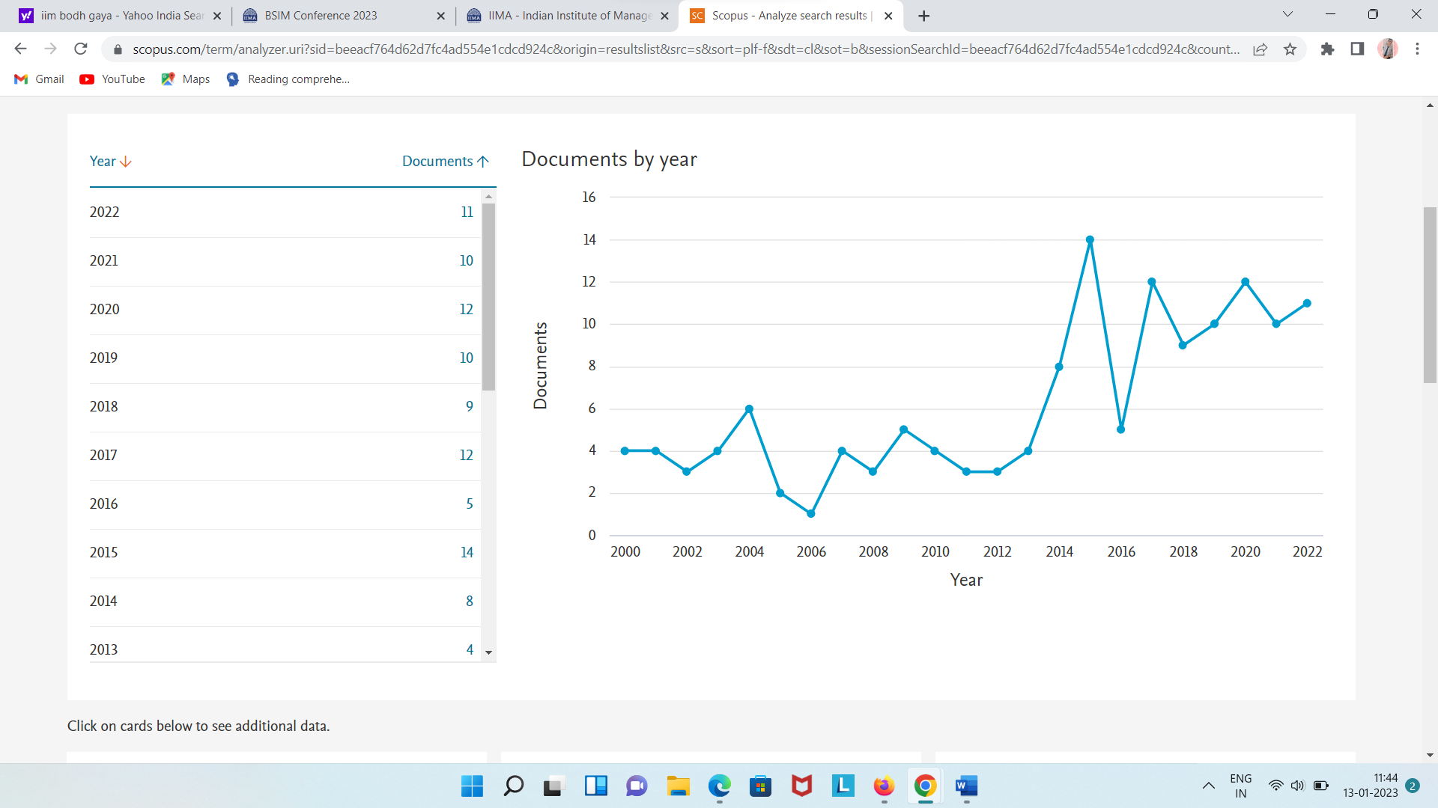

Fig. 1 Document per year

Fig. 1 shows the simple line graph that represent the number of the papers on the subject is rapidly increasing. The trend accelerated rapidly from 2019 with 10 papers, 12 papers were published in 2020, 10 papers in 2021 and 11 papers published in 2022.

METHODOLOGY

To achieve our research goals, we conducted a bibliometric analysis. The first aspect of this method is about findings and gathering articles for analysis, which should really represent the organisational politics and academics. The second stage presents bibliometric analysis to map the field and identify the most important themes within it.

Search strategy and data collection

To identify the appropriate articles for our aim, we executed a search on the Scopus database by using keywords related to organisational politics and academics.
Using two operators, i.e., “AND” & “OR”. We combined the string for organisational politics “organizational politics" OR "favouritism" OR "partiality" AND "higher education" OR "academics" OR "educational institution"in the title, abstract and keywords.
The search was performed till 2022, and we got 171 papers. Filtering these papers initially ranged from 2000 to 2022, then we got 171 papers. After that filtering data that belongs to articles, book chapter, conference paper and reviews then apply limits to, we got 145 papers. In the last filtering, we select only English language papers. Finally, we got 141 papers which will analysing with the help of RStudio and VOSviewer software.

Data Analysis
RStudio and VOSviewer is used in this analysis to assess the bibliography data obtained by Scopus. RStudio and VOSviewer is free software that allows you to create and visualize detailed bibliographic maps based on citation data, occurrence and co-occurrence data.

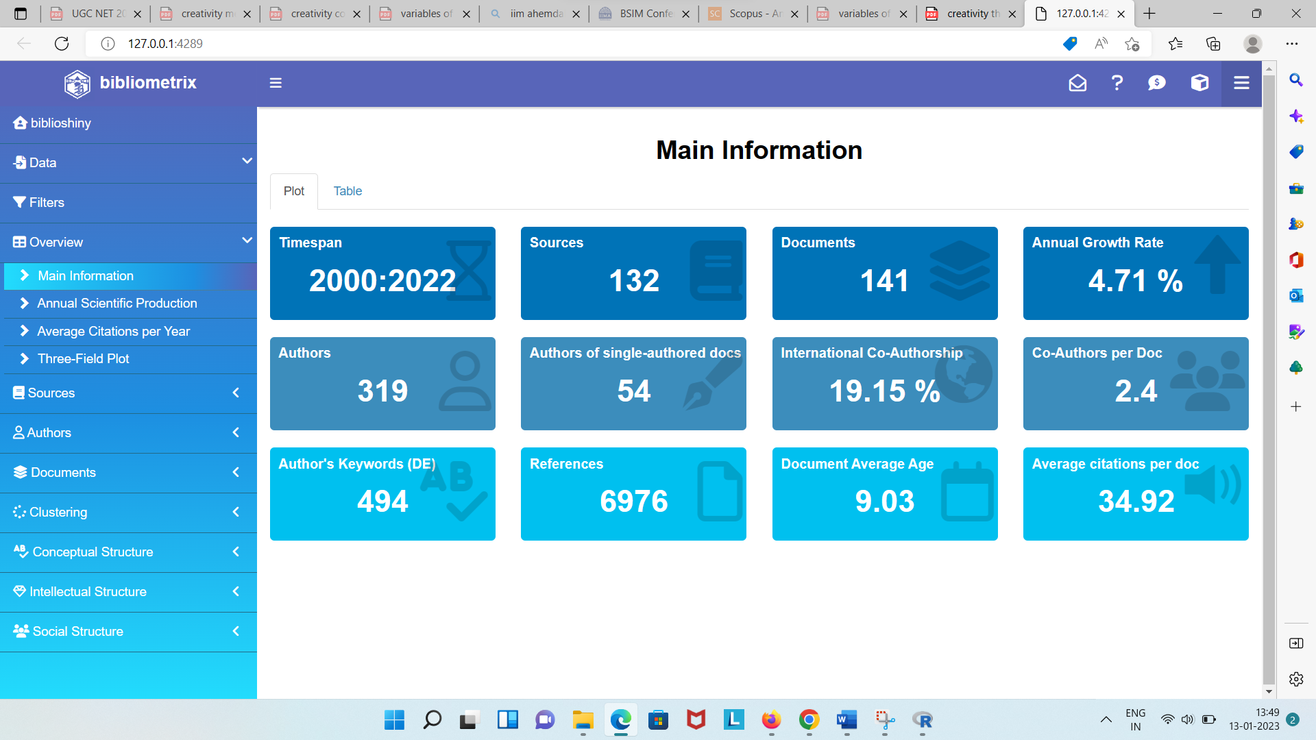

Fig. 2- Main Information
(Fig.1)There is total 141 documents for analysis. These documents collected from 132 sources, 319 authors and authors of single-authored docs are 54. There is 4.71% annual growth rate, 494 keywords, documents average age is 9.03 and average citation per doc is 34.92.

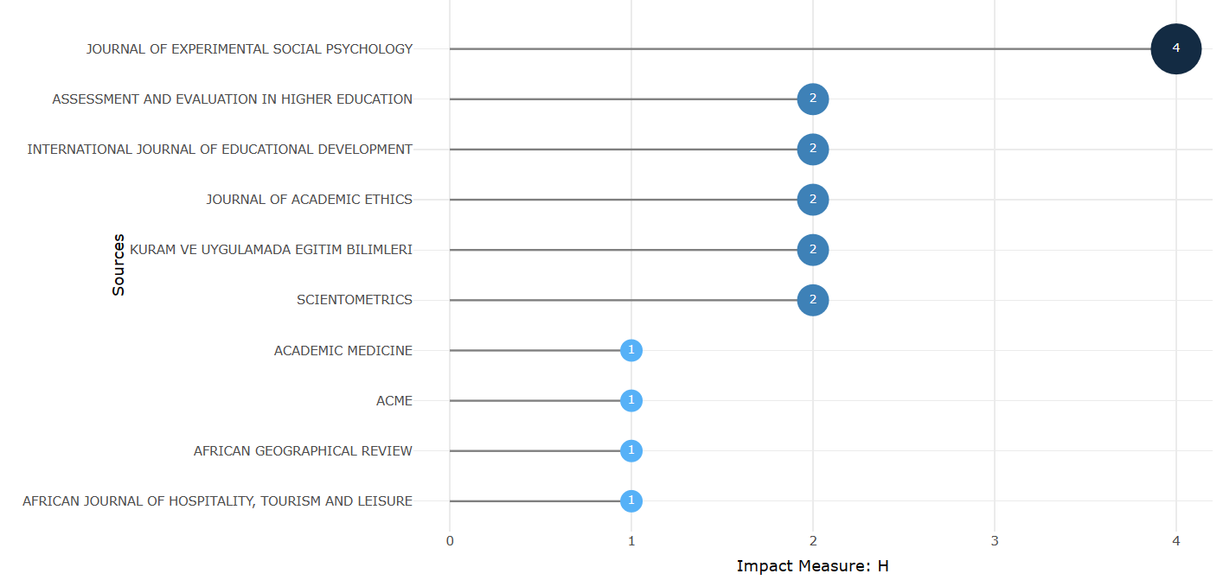

Fig. 3- Source impact diagram

Fig.3 shows the source impact diagram. Journal of experimental social psychology is the top source journal with 4 h-index, assessment and evaluation in higher education with 2 h-index and international journal of educational development with 2 h-index.

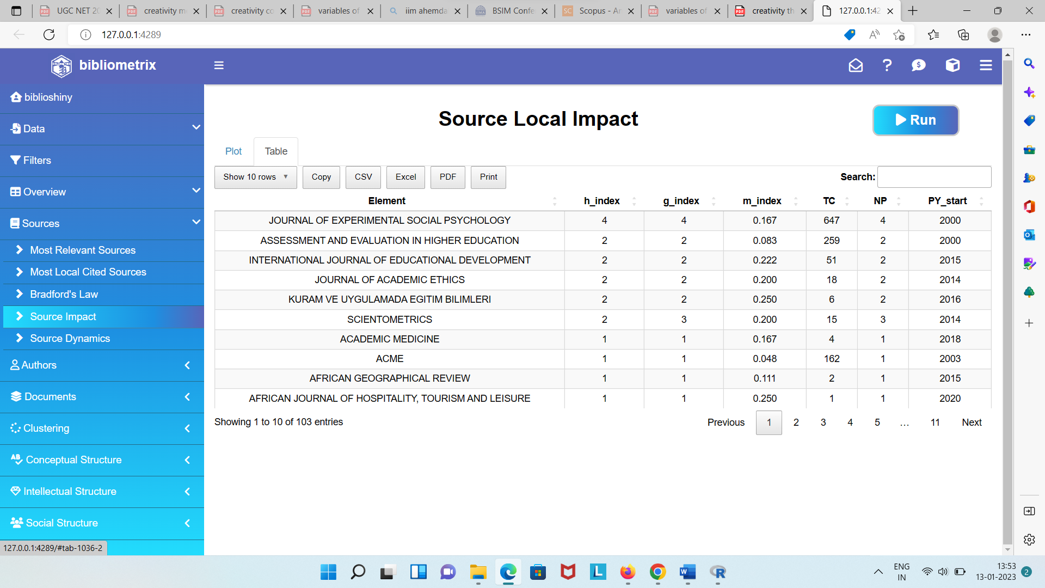
Fig.3- Source impact table

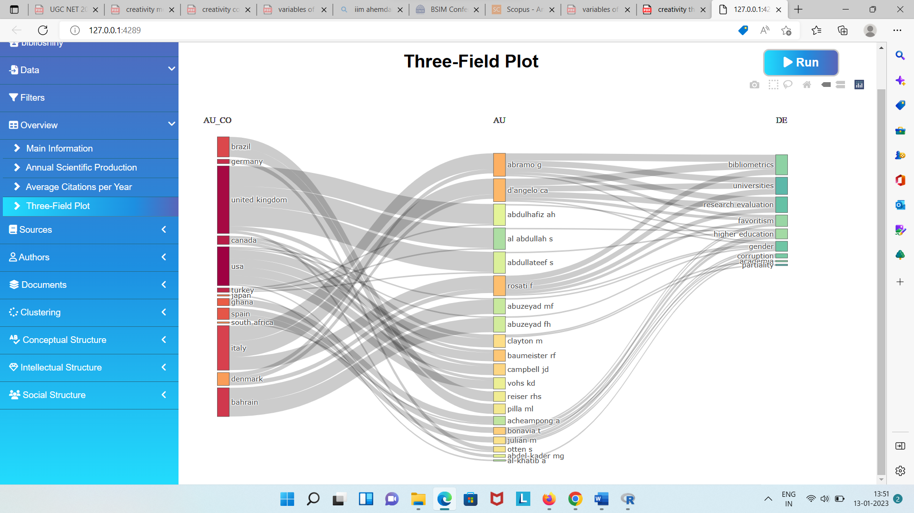

Fig.4- Three field Plot

Figure 4. presents the three-field analysis with keywords right side, authors on the left and countries on left side. Figure shows that Brazil is the top most country working in the related field, then followed by Germany, United Kingdom and Canada. The top authors are Abramo g, then followed by d’anglo ca and abdulhafiz ah. Top keywords are bibliometric, universities and research evaluation.

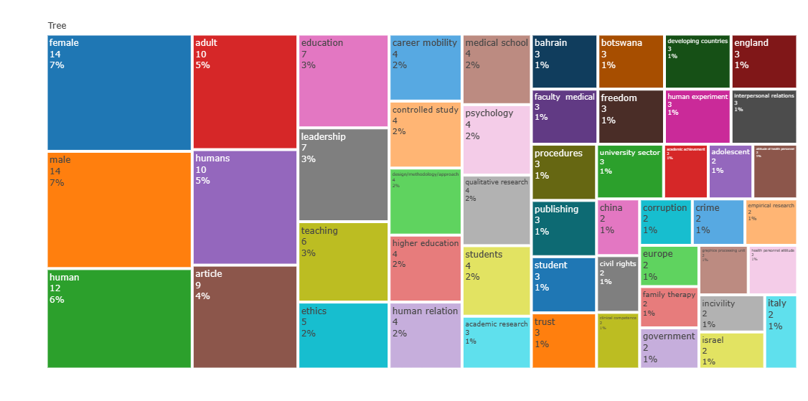
Fig.5- Tree map

Fig. 5 shows the tree map that explain the contribution of keywords in the study. Top keywords are female (14 occurrence) with 7% contribution, male (14 occurrence)

with 7% and human (12 occurrence) with 6% contribution.

Co-Authorship Analysis:

Counting and studying the extent to which authors, institutions, and countries collaborate on authorship to determine their relatedness.
Co-authorship analysis provides a visualisation map of cooperation between the authors. Fig. 6, There is total 132 clusters, 320 authors, 465 links and 478 total link strength. Top three most productive authors are andulhafiza.h, abdullateef s. and al Abdullah s. with 1 dcoument, 2 citations and 14 link strength.

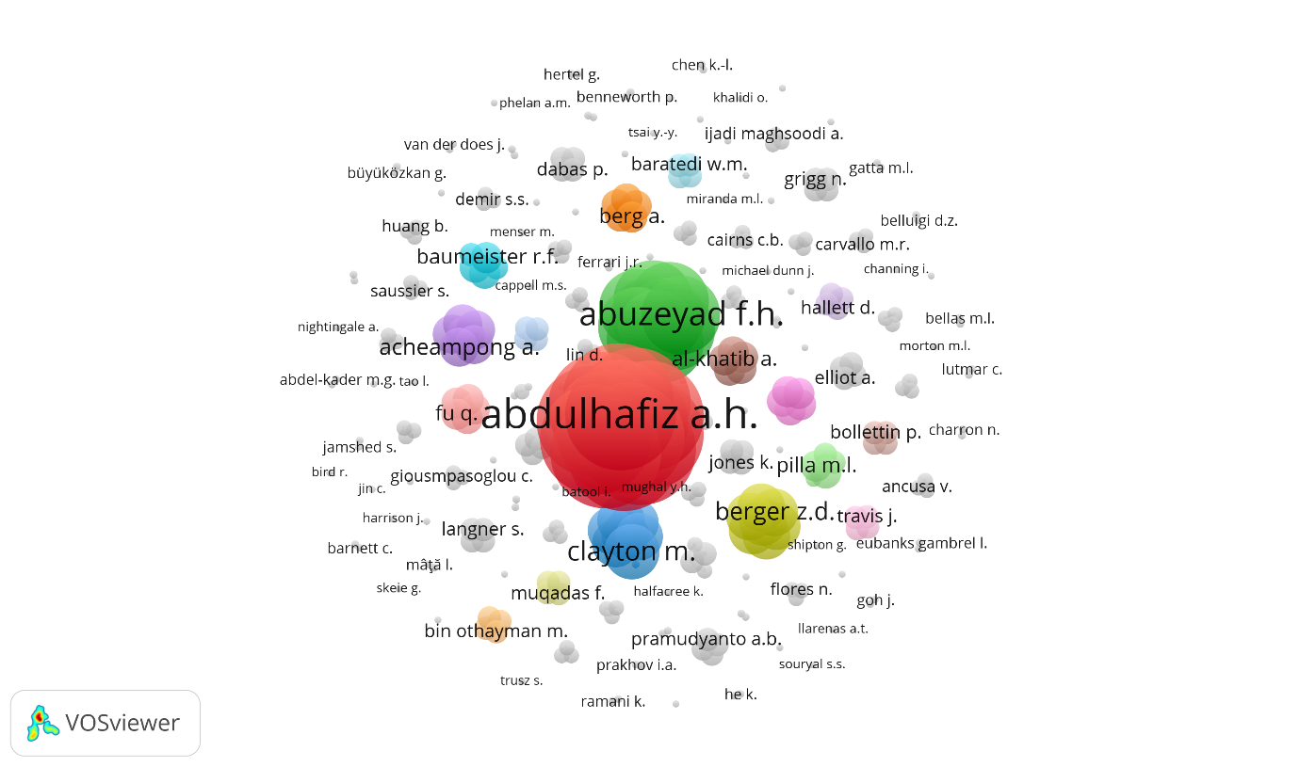
Fig. 6- Co-authorship analysis with authors

Fig.7 In the context of institutions, there is total 14 institutions, 2 clusters, 81 links and 84 total link strength. Top three institutions are Brown university, United States with 2 clusters, 13 links, 2 documents and 15 total link strength, then followed by Florida state university, United States and University of Utah, United states with 2 clusters, 2 documents, 13 links and 15 total link strength.

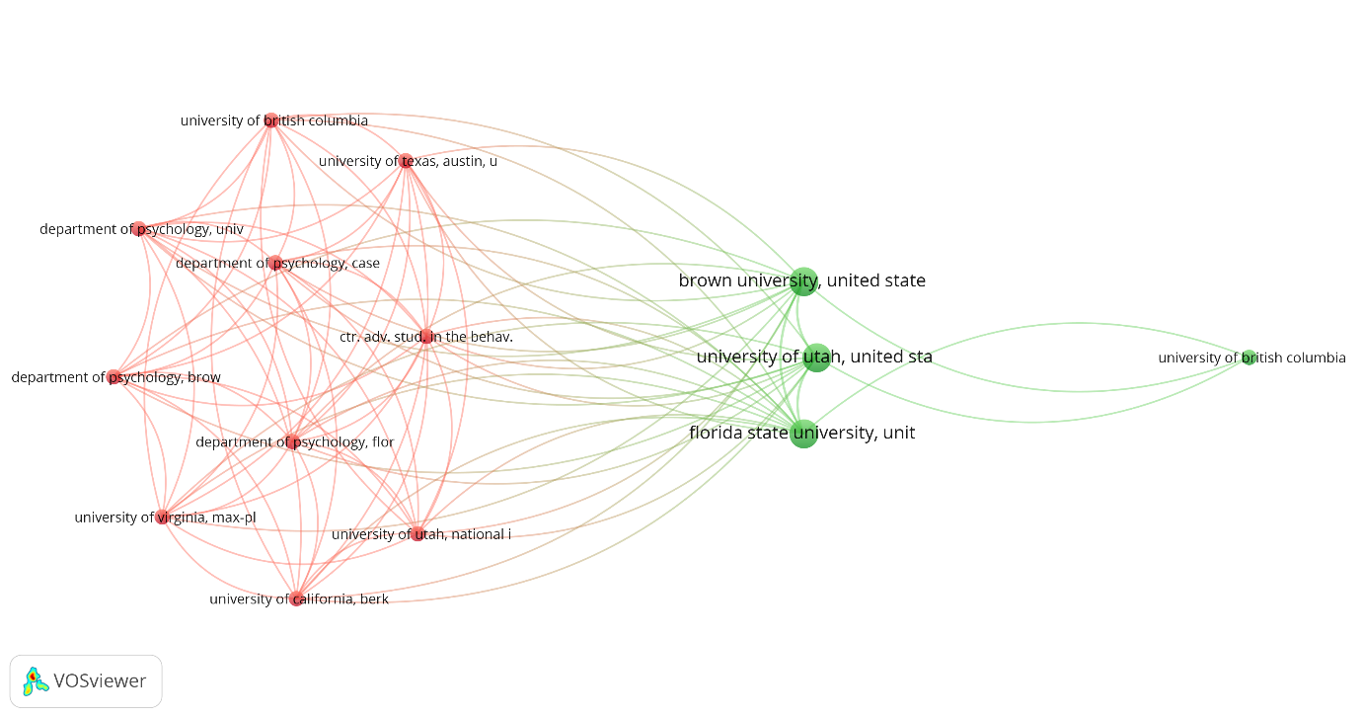
Fig.7- Co-authorship analysis with institutions

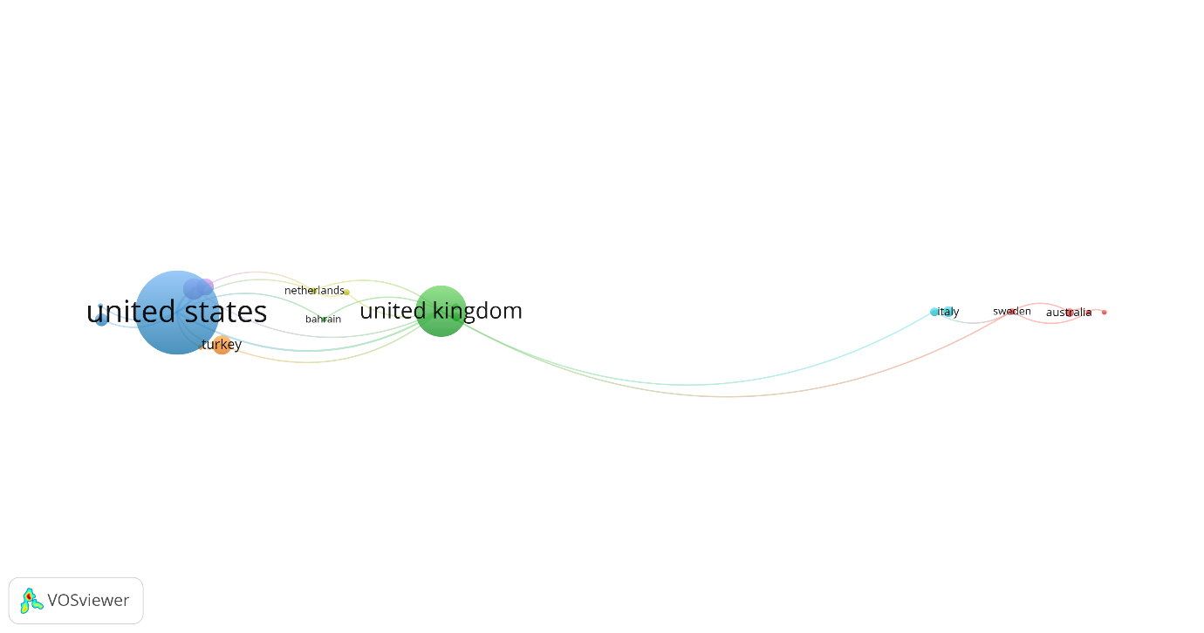
Fig.8- Co-authorship analysis with countries

Fig. 8 shows the analysis the situation in term of in international collaboration, we look at nations are working together to publish articles on organisational politics. Out of 50 countries, 28 meets the threshold (select countries with minimum 2 countries collaboration). There is total 7 clusters, 28 links and 38 total link strength. United states is the top producing country with 42 documents, 3122 citations and 16 total link strength then followed by United kingdom with 25 documents, 1070 citations and 11 total link strength and then Canada with 10 documents, 2124 citations and 7 total link strength.

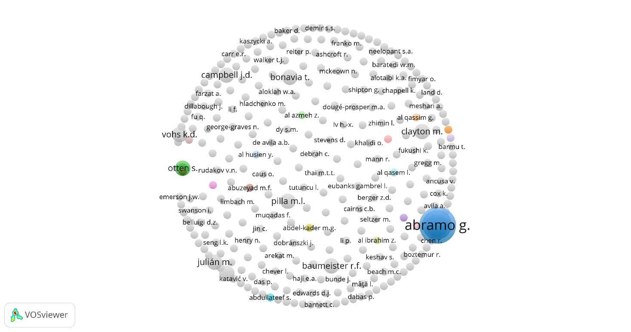
Fig.8- Citation analysis with authors
Citation analysis:

measuring how many times articles, authors, journals, institutions, and nations cite each other to assess the strength of their linkages.Fig. 7 shows the analysis of citation analysis with authors. There is total 309 clusters, 25 links and 33 total link strength. Top 3 authors are abramo g. with 5 documents, 76 citations and 8 total link strength then Rosati f. with 4 documents, 57 citations and 8 total link strength and Moskowitz g. b. with 1 document, 57 citations and 7 total link strength.

Reference
- Abramo, G., D’Angelo, C. A., & Rosati, F. (2014). Relatives in the same university faculty: nepotism or merit?. Scientometrics, 101, 737-749.
- Al Azmeh, Z., Dillabough, J., Fimyar, O., McLaughlin, C., Abdullateef, S., Aloklah, W. A., ... & Kadan, B. (2021). Cultural trauma and the politics of access to higher education in Syria. Discourse: Studies in the Cultural Politics of Education, 42(4), 528-543.
- Asrar-ul-Haq, M., Ali, H. Y., Anwar, S., Iqbal, A., Iqbal, M. B., Suleman, N., ... & Haris-ul-Mahasbi, M. (2019). Impact of organizational politics on employee work outcomes in higher education institutions of Pakistan: Moderating role of social capital. South Asian Journal of Business Studies.
- Atta, M., & Khan, M. J. (2016). Perceived organizational politics, organizational citizenship behavior and job attitudes among university teachers. Journal of Behavioural Sciences, 26(2).
- Basar, U., & Basim, N. (2016). A cross‐sectional survey on consequences of nurses' burnout: moderating role of organizational politics. Journal of advanced nursing, 72(8), 1838-1850.
- Clayton, M., & Stevens, D. (2004). School choice and the burdens of justice. Theory and Research in Education, 2(2), 111-126.
- da Silva, J. A. T., Katavić, V., Dobránszki, J., Al-Khatib, A., & Bornemann-Cimenti, H. (2019). Establishing rules for ethicists and ethics organizations in academic publishing to avoid conflicts of interest, favoritism, cronyism and nepotism. KOME: An International Journal of Pure Communication Inquiry, 7(1), 110-125.
- DiTomaso, N. (2015). Racism and discrimination versus advantage and favoritism: Bias for versus bias against. Research in Organizational Behavior, 35, 57-77.
- Gardner, W. L., & Martinko, M. J. (1998). An organizational perspective of the effects of dysfunctional impression management. Monographs in organizational behavior and industrial relations, 23, 69-126.
- Gossett, J. L., & Bellas, M. L. (2002). You Can't Put a Rule around People's Hearts… Can You?: Consensual Relationships Policies in Academia. Sociological focus, 35(3), 267-283.
- Hertel, G., & Kerr, N. L. (2001). Priming in-group favoritism: The impact of normative scripts in the minimal group paradigm. Journal of Experimental Social Psychology, 37(4), 316-324.
- Krishnan, V. R. (2012). Transformational leadership and personal outcomes: empowerment as mediator. Leadership & Organization Development Journal.
- Lutmar, C., & Reingewertz, Y. (2021). Academic in-group bias in the top five economics journals. Scientometrics, 126(12), 9543-9556.
- Mainali, B. R. (2019). Brain drain and higher education in Nepal. In Higher Education in Nepal (pp. 87-99). Routledge.
- Muqadas, F., Rehman, M., Aslam, U., & Ur-Rahman, U. (2017). Exploring the challenges, trends and issues for knowledge sharing: A study on employees in public sector universities. VINE Journal of Information and Knowledge Management Systems, 47(1), 2-15.
- Muramalla, V. S. S. R., & Alotaibi, K. A. (2019). Equitable workload and the perceptions of academic staff in universities. The International Journal of Educational Organization and Leadership, 26(2), 1.
- Roos, P. A., & Gatta, M. L. (2009). Gender (in) equity in the academy: Subtle mechanisms and the production of inequality. Research in Social Stratification and Mobility, 27(3), 177-200.
- Rudakov, V. N., & Prakhov, I. A. (2021). Gender differences in pay among university faculty in Russia. Higher Education Quarterly, 75(2), 278-301.
- Schlenker, B. R., & Pontari, B. A. (2000). The strategic control of information: Impression management and self-presentation in daily life.
- Seymour, K. (2015). Politics and positionality: Engaging with maps of meaning. Social Work Education, 34(3), 275-285.
- Skeie, G. (2017). Impartial teachers in religious education–a perspective from a Norwegian context. British Journal of Religious Education, 39(1), 25-39.
- Sultan, S., Kanwal, F., & Gul, S. (2015). Factors of perceived organizational politics: an analysis of what contributes the most?. Pakistan Journal of Commerce and Social Sciences (PJCSS), 9(3), 999-1011.
- Turabik, T., & Baskan, G. A. (2020). The relationship between organizational democracy and political behaviors in universities. Journal of Applied Research in Higher Education.
- Tutuncu, L., Yucedogru, R., & Sarisoy, I. (2022). Academic favoritism at work: insider bias in Turkish national journals. Scientometrics, 127(5), 2547-2576.
- Yan, W., Liu, Q., Chen, R., & Zhang, M. (2021). Favoritism or equality: difference analysis of users' utilization of academic social networks for top research corporations. Online Information Review, 45(1), 240-260.

Nishu Chauhan, (Research Scholar), Department of Management Studies, B.P.S Women University Khanpur, (Haryana), chauhannishu9873@gmail.com. Postal address- VPO Loomb, loomb,baraut District Baghpat, 250623(Uttar Pradesh)
Prof. Shweta Singh, Department of Management Studies, B.P.S Women University Khanpur, (Haryana) hoodashweta@gmail.com

