Koi-Friend: IoT-Enabled Aquaculture System with Feeding, Mortality Detection, Budgeting, Monitoring, and Alerts

Introduction
Aquaculture is essential for global food security and the ornamental fish sector, especially in emerging and impoverished areas where small- and medium-scale fish farming substantially supports local economies [1]. Koi fish farming, as an ornamental species, constitutes a specialized and high-value sector requiring stringent regulation of environmental and operating conditions. Koi fish exhibit heightened sensitivity to variations in food amounts, water quality metrics, and ambient variables. Even slight alterations in feed dosage or water chemistry can induce stress, precipitate disease outbreaks, and cause abrupt mortality, culminating in significant economic losses for farmers.
Traditional koi farming methods mostly rely on manual feeding, regular water analysis, and visual observation of fish behaviour.[2] Despite their widespread use, these methods are labour-intensive, uneven, and strongly reliant on the farmer's expertise and availability. Manual feeding frequently results in inconsistent feed distribution and waste, but the tardy identification of atypical fish behaviour or subpar water quality can exacerbate modest problems into significant losses. Moreover, the majority of small- and medium-sized koi farmers do not have access to integrated technology systems that merge real-time operational monitoring with financial tracking and decision-making help.

Recent breakthroughs in the Internet of Things (IoT) and artificial intelligence (AI) present substantial prospects for the modernization of aquaculture management [3]. The Internet of Things facilitates ongoing sensing, remote surveillance, and automation of pond management, whilst artificial intelligence methodologies, including computer vision, enable the early identification of anomalous patterns that may elude immediate human observation. Notwithstanding these technical advancements, current solutions frequently tackle discrete issues, such as feeding automation or water quality assessment. Comprehensive platforms designed for koi fish farming that include operational monitoring, financial analysis, and sustainability considerations are scarce.

This paper presents a comprehensive IoT-enabled aquaculture system for koi fish farming, incorporating automated feeding, live fish health and death detection, real-time water quality monitoring, and budget tracking with cost forecasting inside a singular web-based platform [4]. The suggested system integrates sensing, automation, edge-based AI processing, and financial analytics to mitigate operational inefficiencies, decrease fish loss, and facilitate data-driven decision-making for sustainable koi aquaculture.

LITERATURE REVIEW
The utilization of Internet of Things technology in aquaculture has garnered considerable interest owing to the necessity for ongoing monitoring and automation in pond ecosystems. Numerous studies have shown that IoT sensor networks can accurately assess water quality indicators, including pH, temperature, dissolved oxygen, and turbidity, facilitating real-time monitoring and threshold-based notifications for aqua culturists [5]. These technologies diminish dependence on manual measurements and facilitate swifter reactions to environmental alterations. Nevertheless, several current implementations concentrate exclusively on environmental monitoring and do not incorporate feeding automation or health evaluation.

Feeding management constitutes a pivotal and expensive element of aquaculture operations. Ineffective feeding procedures lead to feed loss, suboptimal water quality, and inconsistent fish development. [6] Prior studies indicate that automated feeding systems enhance uniformity and minimize waste; nevertheless, the majority of commercially available solutions are restricted to fundamental feeding control and lack adaptive monitoring or interaction with comprehensive farm management platforms. This constraint diminishes their efficacy in dynamic pond ecosystems, particularly in ornamental fish cultivation.

Recent progress in computer vision and deep learning has facilitated automated surveillance in agricultural and aquacultural applications. [7] YOLO family object detection techniques are extensively utilized for their real-time efficiency and comparatively minimal computational expense. These models have been utilized for fish detection and behavioural analysis in controlled settings, yielding encouraging outcomes. [8] YOLOv8 enhances deployment flexibility and accuracy, rendering it appropriate for edge devices such single-board computers. Notwithstanding these developments, the majority of studies concentrate solely on detection tasks and fail to incorporate health classification, environmental sensing [9], or alert mechanisms into a cohesive system.

Energy efficiency and sustainability are critical factors in outdoor IoT implementations. Solar-powered IoT systems [10] have been suggested as an effective alternative for sustained operation in agriculture and aquaculture, especially in regions with restricted access to grid electricity. Floating platforms have supplementary issues stemming from motor loads and processing demands, underscoring the necessity for sophisticated power management solutions. Current studies highlight energy harvesting yet frequently neglect power priority and secure shutdown protocols in multi-module systems.

Financial oversight and expenditure forecasts are infrequently examined in smart aquaculture studies. [11] Although IoT solutions deliver operational data, farmers frequently lack the means to convert this knowledge into financial insights. Time-series forecasting methodologies, including ARIMA, have been effectively utilized in various fields for cost estimation and strategic planning. The integration of expense monitoring with operational and energy data can improve decision-making; however, this integration is currently constrained in existing aquaculture solutions.
The current literature illustrates the efficacy of IoT-based sensors, automated feeding systems, real-time computer vision models, and solar-powered implementations. Nonetheless, there is an absence of cohesive systems that amalgamate automated feeding, fish health and mortality assessment, water quality surveillance, real-time notifications, and budget forecasts into a singular web-based platform. This study tackles these deficiencies by presenting a cohesive IoT-enabled aquaculture system specifically designed for koi fish farming.

Besides technical constraints, numerous current smart aquaculture systems experience inadequate acceptance among small-scale farmers owing to expense, complexity, and insufficient integration of various farm management components. Systems that concentrate solely on sensing or automation, without delivering actionable information, frequently fall short in facilitating long-term planning and economic sustainability. Consequently, there is increasing interest in comprehensive solutions that amalgamate real-time monitoring, automated control, intelligent warning, and financial visibility inside a unified platform. This integration is crucial for ornamental aquaculture, because production value is significantly affected by environmental and operational choices.

METHODOLOGY
The below figure 1 represents the overall system architecture of the proposed IoT-enabled aquaculture system.
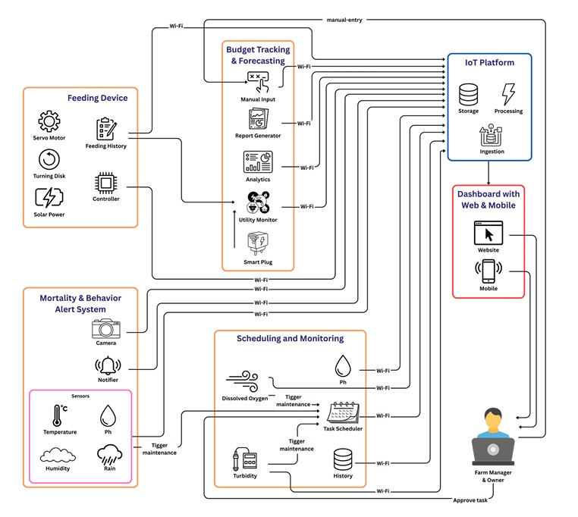
This research employs a modular system design methodology that incorporates IoT sensing, edge-based computer vision, automated actuation, and web-based data administration. The comprehensive methodology comprises four functional components: automated feeding, fish health and mortality assessment, water quality monitoring, and budget tracking with forecasting. Each component is built autonomously and subsequently merged via a centralized backend and online dashboard.

Automated Feeding System
The automatic feeding system is established as a mounted unit affixed at the pond's perimeter and energized by a dedicated solar panel. A NEMA 17 stepper motor is used to dispense fish feed into a container situated on a load measurement platform. A 5 kg load cell integrated with a HX711 amplifier module quantifies the feed weight in real time. Upon reaching the predetermined feed quantity, the stepper motor ceases operation to avert overfeeding.

Upon precise measurement, a brushless DC motor moves a feeding plate to uniformly distribute feed across the pond's surface. Feeding operations can be initiated manually or programmed via the web dashboard by designating the feeding time, feed quantity, and target pond. An emergency stop mechanism is established to promptly cease feeding in the event of unforeseen circumstances. The feeding history, device condition, and power status are incessantly recorded and exhibited on the dashboard.

Smart Floating Boat and Power Management
A smart floating boat is utilized to transport the fish health monitoring and water quality sensing modules. The boat is propelled by two DC motors and operated remotely using a web dashboard. Four ultrasonic sensors are affixed to the boat to identify impediments and avert collisions during navigation.
The boat is entirely powered by a solar panel linked to a rechargeable battery. The battery's voltage and current are monitored in real-time. Power management logic prioritizes critical navigation functions when battery voltage falls below specified levels. Non-essential modules are automatically deactivated to avert total system failure. When battery voltage attains critical thresholds, all systems are securely deactivated and automatically recommence operation during solar recharging.

Fish Health and Mortality Detection
Fish health monitoring is conducted using a Raspberry Pi equipped with a camera module mounted on a floating platform. The system continuously captures live video streams from the pond and performs real-time monitoring. A YOLOv8-based computer vision model is used to detect fish in the incoming video frames. Once fish are detected, their condition is analysed and classified into health categories such as healthy, unhealthy, or dead.

The classification process combines image-based features with temporal behaviour analysis to improve accuracy, especially in identifying abnormal conditions. A self-curated dataset of approximately 5,000 images was used for training and validation. The trained model is deployed on the Raspberry Pi, where inference is performed locally to reduce latency and ensure real-time processing without relying on network connectivity.

Detection results are transmitted to the backend and displayed on the web-based dashboard. When unhealthy or dead fish are detected, alerts are generated and delivered through the dashboard and SMS notifications, enabling timely intervention.

Fig. 3. Live Fish Health Monitoring Flow Chart

Water Quality Monitoring
Water quality monitoring utilizes IoT sensors that measure turbidity, pH, ammonia, dissolved oxygen, carbon dioxide, and temperature. The sensors, not entirely waterproof, are affixed to a floating unit positioned just above the water's surface. A little water pump is employed to extract pond water into the sensing chamber for precise measurement.

A rain detection sensor is incorporated to detect sudden rainfall occurrences that could impact water quality and fish behaviour. The dashboard provides real-time updates on rain status.
Sensor data is relayed to the backend at consistent intervals. The web dashboard enables farmers to adjust permissible threshold levels for each metric. Alert notifications are issued when sensor values surpass established thresholds. Moreover, maintenance tasks are generated automatically via a work calendar to facilitate proactive pond management.

Fig. 4. Water Quality Monitoring Flow Chart

Budget Tracking and Forecasting
The budget tracking module integrates manual expense input with IoT-enabled energy monitoring. A POS-style interface enables farmers to document expenditures associated with feed, labour, chemicals, maintenance, and utilities. Voltage and current sensors quantify the energy consumption of system components, facilitating the allocation of costs to operational tasks.

Financial data is analysed to determine the cost per farming cycle and the cost per surviving fish. Time-series forecasting methods are utilized on previous expenditure data to anticipate future costs and facilitate financial planning. All budget analyses and projections are represented via the web dashboard.

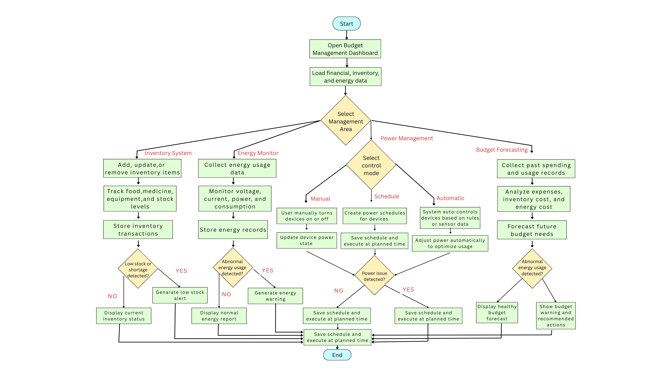

Fig. 5. Budget Management Flow Chart

System Integration and Data Flow
All components interact with the backend through Spring Boot REST APIs and EMQX-based MQTT messaging. The backend manages MySQL data storage, Supabase real-time updates, and alert processing. The React.js web dashboard provides real-time visualization, control, live video streaming through MediaMTX, and reporting capabilities. The modular architecture supports scalability and future expansion without changing the core system design.

TABLE 1. Major System Component and Their Functions
Component | Hardware/ Software Used | Function
Automated Feeding System | NEMA 17 motor, 5 kg load cell, HX711, | solar power Precise feed dispensing and uniform distribution
Fish Health Monitoring | Raspberry Pi, camera, YOLOv8 models | Live detection of healthy, unhealthy, and dead fish
Water Quality Monitoring | pH, turbidity, NH₃, CO₂, DO sensors | Real-time water parameter monitoring and alerts
Budget and Forecasting | POS module, energy data, time-series analysis | Cost tracking and financial prediction
Smart Boat and Power Management | DC motors, ultrasonic sensors, solar panel, Voltage/current sensors | Mobile sensing, navigation, and obstacle avoidance, control relays Energy prioritization and safe shutdown
Web Dashboard | React.js, Spring Boot, EMQX, MediaMTX | Monitoring, control, alerts, and reporting

Implementation Environment and Tools
The proposed system was implemented using a combination of IoT hardware platforms, edge computing devices, and web technologies to ensure affordability, scalability, and practical deployment in real-world koi fish farming environments. The web dashboard was developed using React.js to provide an interactive and user-friendly interface for monitoring, control, and reporting. Spring Boot was used to develop the backend service and REST APIs required for communication between system modules and the dashboard. MySQL was used as the primary database for storing system records, sensor readings, feeding logs, alerts, and budget-related data, while Supabase was used to support selected backend services and real-time updates.

For IoT communication, EMQX was used as the MQTT broker to enable lightweight and reliable message exchange between distributed devices and backend services. Media MTX was used to manage live video streaming from the pond monitoring camera to the dashboard. ESP32 microcontrollers were used for sensor interfacing, actuator control, and embedded device communication. Raspberry Pi was used as the edge processing device for the fish health and mortality detection module, where YOLOv8-based inference was executed locally to reduce latency and minimize network dependency.A

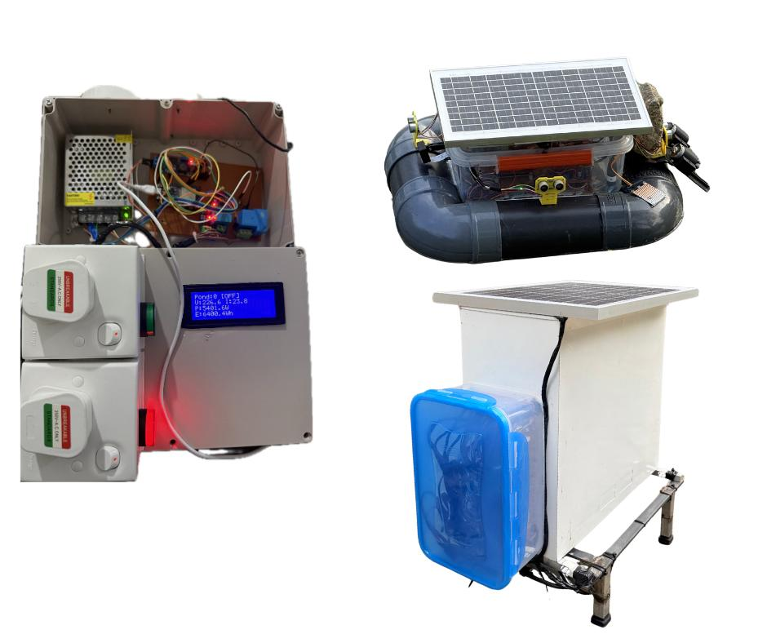
The overall system was deployed on a Hostinger KVM 2 VPS using Docker-based containerized services, allowing flexible deployment, easier service management, and improved maintainability. Communication among components was achieved using both REST APIs and MQTT protocols to support modular integration and real-time operation. [12].

Fig. 6. IoT Devices and Hardware Prototypes

IoT Devices and Hardware Prototypes Implemented
This research entailed the design and execution of various bespoke IoT hardware modules to facilitate automated feeding, environmental monitoring, fish health assessment, and energy management. Each device was designed to function in outdoor pond environments, prioritizing energy efficiency, dependability, and modular integration.

The automated feeding apparatus comprises a stationary feeder unit positioned at the pond's perimeter, with a NEMA 17 stepper motor for regulated feed distribution and a 5 kg load cell equipped with a HX711 amplifier for accurate weight assessment. A brushless DC motor propels the feeding plate to guarantee consistent feed distribution over the pond surface. The feeder operates on a specialized solar panel and features real-time monitoring of battery health and device functionality.
A sophisticated prototype of a floating vessel was created to accommodate mobile sensing and monitoring apparatus. The vessel incorporates dual propulsion motors for navigation and four ultrasonic sensors for obstacle identification and collision prevention. A solar-powered battery system provides energy to onboard components, while voltage and current sensors provide ongoing power monitoring and priority-driven power management.

Fish health monitoring is conducted via a Raspberry Pi-based vision module that is outfitted with a camera. This module does real-time inference with YOLOv8 models to detect fish presence and assess health conditions. Water quality detecting modules were implemented, incorporating sensors for pH, turbidity, ammonia, dissolved oxygen, carbon dioxide, and temperature. Owing to watertight limitations, sensors were installed above the water level, and a pump-operated sampling mechanism was employed to extract pond water into the sensing chamber.

Collectively, these IoT devices constitute a decentralized hardware ecosystem that facilitates real-time sensing, automation, and intelligent decision-making inside the proposed aquaculture system. The below figure 6 represents the IoT devices and hardware modules developed for system implementation.

Results and Discussion
The suggested IoT-enabled aquaculture system underwent evaluation via prototype deployment and functional testing in an actual koi pond setting. The review concentrated on system functionality, integration dependability, responsiveness, and practical usage, as the system is presently in the implementation and validation phase, rather than on extensive statistical benchmarking.

The automated feeding system exhibited consistent and precise performance during numerous feeding cycles. The load-cell-based weight measurement facilitated accurate feed administration in accordance with user-specified quantities, so efficiently averting overfeeding. Upon reaching the designated feed quantity, the stepper motor ceased dispensing, while the brushless motor uniformly distributed the feed across the pond's surface. This method diminished observable feed wastage and enhanced distribution uniformity in comparison to manual feeding. The online dashboard effectively implemented manual control, scheduled feeding, and emergency stop functionalities, demonstrating dependable user interaction and control.
The intelligent floating boat facilitated mobility sensing and monitoring inside the pond ecosystem. The dual motor navigation facilitated seamless travel, while ultrasonic sensors proficiently identified obstructions and averted collisions. The power management logic operated as designed under different battery situations. As battery voltage diminished, non-essential modules were automatically deactivated to emphasize navigational safety. At crucial voltage thresholds, the system safely ceased functioning and subsequently resumed during solar recharge. These findings underscore the significance of energy-conscious design for floating IoT platforms functioning in outdoor environments.
The fish health and mortality monitoring module facilitated real-time camera-based assessment of fish conditions utilizing the implemented YOLOv8 models. The system incessantly acquired visual data from the pond environment and analysed frames on the Raspberry Pi to detect fish presence and their health status as healthy, unhealthy, or dead.

The two-stage detection methodology enhanced reliability by applying health categorization exclusively to verified fish detections. Detection findings were shown on the online dashboard in near real-time, enabling farmers to concurrently observe fish conditions and system decisions. Upon the detection of unhealthy or dead fish, alarm notifications were produced and recorded for subsequent intervention. This live detection features diminished dependence on manual inspection and facilitated a swifter response to probable fish loss.
Water quality monitoring delivered continuous real-time assessments of turbidity, pH, ammonia, dissolved oxygen, carbon dioxide, and temperature. Positioning non-waterproof sensors above the water surface and employing a pump to deliver water samples guaranteed consistent and precise measurements. The capability to adjust threshold values via the dashboard facilitated adaption to specific pond circumstances. Upon sensor readings above permissible thresholds, alarm notifications and maintenance activities were initiated, facilitating prompt corrective measures and proactive pond management.

The budget tracking and forecasting module effectively combined operational cost documentation with IoT-driven energy monitoring. The POS interface facilitated uniform documentation of expenditures associated with feed, labor, maintenance, and utilities. Energy consumption statistics provide further understanding of operational expenses. Metrics like cost each cycle and cost per surviving fish were computed and shown via the dashboard. Time-series forecasting generated projected future cost patterns, illustrating the viability of financial planning assistance within aquaculture management systems. Although predicting accuracy will enhance with extended data histories, the preliminary results substantiate the integration methodology.
The aggregated findings demonstrate that the suggested system successfully amalgamates automated feeding, fish health monitoring, water quality assessment, and budget analysis into a cohesive platform. The modular architecture facilitates scalability and future improvements, encompassing live video surveillance, enhanced disease classification, and predictive control measures. The system exhibits significant potential as a viable and sustainable solution for intelligent koi aquaculture.

The cohesive design of the proposed system markedly alleviated the cognitive and operational strain on farmers by consolidating several management functions into a unified interface. The capability to monitor live fish health, assess water parameters, regulate feeding, and analyse cost data from a single dashboard enhanced situational awareness and response efficacy. This integrated strategy resolves prevalent fragmentation challenges identified in current aquaculture systems, which necessitate distinct technologies for monitoring, control, and record keeping.

Conclusion
This research introduced an IoT-enabled aquaculture management system tailored for koi fish farming, incorporating automated feeding, real-time fish health and death detection, continuous water quality monitoring, and budget management with cost forecasting into a cohesive web-based platform. The system exhibited dependable performance via prototype execution and functional evaluation, underscoring the efficacy of integrating IoT sensing, edge-based computer vision, and intelligent automation to enhance operational efficiency and minimize fish loss. The automated feeding system ensured precise feed allocation and consistent distribution, while the live video health monitoring module facilitated prompt identification of atypical fish situations. Real-time water quality monitoring and alarm generating facilitated proactive pond management, while the budget tracking module offered significant financial insights for cost control and planning. The integration of solar energy with priority-driven energy management significantly improved system sustainability and resilience in outdoor settings.

Future endeavours will concentrate on enhancing live video analytics, augmenting disease classification precision via more extensive datasets, including predictive control methodologies, and assessing system efficacy over prolonged operating durations. Further upgrades may encompass mobile application support and sophisticated decision-support capabilities to better aid farmers in sustainable koi aquaculture management.

Acknowledgment
The authors like to convey their profound appreciation to their project supervisors and mentors for their unwavering direction, constructive criticism, and technical assistance during the research and development phase. The authors recognize the significant collaboration of koi fish growers and field practitioners who facilitated field observations, aided in data gathering, and imparted practical ideas that improved the system's real-world applicability. Furthermore, gratitude is expressed to all persons who indirectly contributed to this effort through conversations, testing help, and encouragement during the implementation and evaluation stages.

References
- FAO, The State of World Fisheries and Aquaculture. Rome: Food and Agriculture Organization of the United Nations, 2022.
- M. Badiola, J. Mendiola, and B. Bostock, “Aquaculture development in the context of food security,” Aquaculture Economics & Management, vol. 16, no. 3, pp. 221–236, 2012.
- S. R. N. Reddy and P. Kumar, “Internet of Things based smart aquaculture monitoring system,” International Journal of Engineering Research and Technology, vol. 6, no. 6, pp. 227–231, 2017.
- A. Munir, S. A. Khan, and M. Ali, “A review on smart aquaculture systems,” Journal of Ambient Intelligence and Smart Environments, vol. 12, no. 3, pp. 231–246, 2020.
- Y. Chen, J. Chen, and Z. Li, “Water quality monitoring in aquaculture using IoT sensors,” IEEE Access, vol. 7, pp. 102–111, 2019.
- M. B. New, “Feed management practices in aquaculture,” Aquaculture, vol. 155, no. 1–4, pp. 1–19, 1997.
- Z. Q. Zhao, P. Zheng, S. T. Xu, and X. Wu, “Object detection with deep learning: A review,” IEEE Transactions on Neural Networks and Learning Systems, vol. 30, no. 11, pp. 3212–3232, Nov. 2019.
- Y. Li, H. Zhang, and Q. Shen, “Fish detection and behavior analysis using deep learning,” Computers and Electronics in Agriculture, vol. 171, pp. 105–117, 2020.
- J. Jocher, A. Chaurasia, and A. Qiu, “YOLOv8: Ultralytics real-time object detection,” Ultralytics, 2023. [Online]. Available: https://github.com/ultralytics/ultralytics
- M. R. Islam, M. A. Rahman, and S. Ahmed, “Solar powered IoT based smart monitoring system,” IEEE Sensors Journal, vol. 20, no. 15, pp. 8825–8833, Aug. 2020.
- G. E. P. Box, G. M. Jenkins, and G. C. Reinsel, Time Series Analysis: Forecasting and Control, 4th ed. Hoboken, NJ, USA: Wiley, 2008.
- A. Banks and R. Gupta, MQTT Version 3.1.1, OASIS Standard, 2014.

