Geospatial Dynamics of Urban Irrigation Agricultural Landuse for Sustainable Income Generation on the Jos Plateau
Dr. Emmanuel Omomoh, Dr. Sunday Nannim, Dr. Rogers Rengje Danlami Gujarhar, Moses Omitunde Omirinde, Gwamzhi Ponsah Emmanuel
Abstract
Urban agriculture has become increasingly significant in African cities as a strategy for food security, income generation, and sustainable urban development. This study employed geospatial techniques to map and analyze market gardening activities and it’s landuse changes in Jos South Metropolis, Nigeria, over a ten-year period (2014-2024). The research addresses critical knowledge gaps regarding the spatio-temporal dynamics, and sustainability challenges of urban agriculture in Jos Metropolis, where comprehensive data on arable farming activities has been lacking despite extensive crop cultivation. High-resolution satellite imagery with 15 cm spatial resolution was acquired for both time periods and processed using ArcGIS 10.8 software. Through systematic on-screen digitization and spatial analysis, the study quantified changes in agricultural land use, settlements, and water bodies. Extensive field work involved systematic reconnaissance of Jos South Local Government Area to identify active market gardening sites, establish ground control points, and conduct interviews with local farmers and agricultural extension agents. Results revealed that market gardens covered 9.59 km² in 2014, declining slightly to 9.03 km² in 2024, representing a 5.8% reduction. Conversely, settlements expanded dramatically from 43.82 km² to 79.32 km², a 34.76% increase, while water bodies decreased from 4.57 km² to 4.46 km², highlighting increased pressure on water resources with growing urbanization. The implication of this is that urban agriculture and preponderance of water bodies has become part of the city’s landscape despite the multiple resource utilization situation. The study identified various constraints to sustainable urban agriculture including land tenure insecurity, with 63% of dry season farmers being landless, limited access to irrigation water, pest and diseases, inadequate fertilizer supply, and increasing competition for land from urban development. Field surveys documented diverse cropping systems with farmers cultivating temperate vegetables such as tomatoes, lettuce, cabbage, carrots, and Irish potatoes throughout the year using fadama lands along river channels and mine ponds. The intensive cropping systems documented included some plots undergoing three cropping cycles per year, demonstrating both the productivity potential and sustainability challenges. The research successfully demonstrates the capability of remote sensing and GIS in monitoring urban agricultural dynamics and provides crucial baseline data for urban planning and agricultural policy formulation. The findings underscore the need for integrating urban agriculture into the Greater Jos Master Plan to ensure food security while accommodating urban growth. The study recommends establishing agricultural zones in fadama areas, strengthening extension services, developing policies that provide secure land tenure for urban farmers, and creating synergies between rural and urban production systems to sustain this vital economic activity in the face of rapid urbanization.
Keywords: Urban agriculture, market gardening, geospatial analysis, land use change, remote sensing, GIS

1.0 Introduction
Urban agriculture is not a novel phenomenon; it is likely as old as the earliest urban settlement, with an estimated 800 million urban residents involved in commercial and subsistence agriculture in or around cities globally (WFP, 2022; Mwaijande, 2024). Over the past couple of decades, urban agriculture has increasingly gained recognition as a viable intervention strategy for urban residents to sustain themselves and earn extra income (Matamanda & Chirisa, 2024). A number of authors have supported the claim that urban agricultural practice is increasingly becoming a means of livelihood for many urban and peri-urban inhabitants globally, most especially in African cities (Teklemariam & Cochrane, 2021; Khumalo et al., 2024; Kiribou et al., 2024; Yan et al., 2022; Kwiringira et al., 2024).
Urban agriculture has always been an essential element of Jos. The commercial mining of tin and associated minerals, which started in the region around 1904, brought about the introduction of irrigated or dry-season agriculture (Fadama) to the Jos Plateau in the 1940s by Hausa and Kanuri miners (Phillips-Howard et al., 1990). The replacement of the ancient Shadoof by mechanical pumps enabled irrigated farming to spread further up-slope towards watersheds wherever water was available. The large-scale tin mining greatly modified the landscape for several decades, creating 316 km² of spoil heaps, open-cast pits, and tailings (Phillips-Howard et al., 1992). The open-cast pits, when filled with water, became mine-ponds now used for irrigation, domestic and industrial water supply, fish farming, and recreation. As mining activity widened many valleys, it helped to create more fadama land highly suitable for dry-season farming.
Adepetu (1985) noted that irrigated agriculture expanded rapidly on the Jos Plateau since the early 1980s, driven by growing vegetable markets, mechanical pumps, and artificial fertilizers. There is great potential for further expansion, with sufficient water to irrigate over 600,000 ha of the Plateau (Phillips-Howard & Schoeneich, 1991). The near-temperate climate makes Jos City unique in Nigeria and the West African sub-region, permitting sound horticultural practices and enabling the cultivation of temperate vegetables that cannot be grown elsewhere in the country.
Rainfed and dry-season farming take place throughout the year within heterogeneous, multiple-resource utilization situations in Jos. Urban agriculture enhances food supply and provides employment for urban dwellers (Tessema et al., 2025). According to Kiribou et al. (2024), urban areas also provide market access and potentials for agricultural produce. However, despite extensive crop cultivation in Jos Metropolis, there is a dearth of information on this activity. Comprehensive data regarding the changes, trend, nature, and status of arable farming activities in Jos is still lacking, and urban farming remains relatively invisible to policy makers and unrecognized by urban planning authorities.
Since 2008, the world’s urban population has outnumbered its rural population for the first time in history (UNDESA, 2022). Urban food insecurity is often overlooked since, at aggregate level, economic and social conditions in urban areas appear better than in rural areas (FAO et al., 2023). FAO et al. (2023) suggested that urban food security has become one of the greatest humanitarian challenges of this century, yet it is scarcely recognized in contemporary political debate. Wegerif & Wessels (2024) argued that the lack of attention by African governments to urban food security may be due to policy makers’ perception of food security as a household-level responsibility.
In the case of Jos Metropolitan Area, the impact arising from inadequate food supply stretches far beyond its physical boundaries. Considerable areas of hinterland that the city depends upon for food supplies have been under severe pressure, not because of large population alone, but because the environment has been devastated and local resources greatly restricted by open-cast mining. Because of the uniqueness of Jos in the production and supply of agricultural products, there is a growing need to generate relevant data that could help reveal the nature and character of urban agriculture in Jos.
The aim of this study is to demonstrate the capability of space technology in mapping and generating comprehensive data on market gardening activities in Jos Metropolis. The specific objectives are to: (i) determine the extent of urban agricultural land use between 2014 and 2024; (ii) examine the ways farmers gain access to land; (iii) identify the types of crops grown; (iv) explain the farming practices involved in urban cultivation; and (v) examine the constraints to urban agricultural land use. The study is limited to dry-season arable farming within the continuously built-up area of Jos South Metropolitan Area, focusing on small, medium, and large-scale arable farmers cultivating plots along river channels, around mine ponds, and on flood plains.

2.0 Study Area

2.1 Location, Position, and Size
Jos Metropolis is geographically unique in many respects, including its location, altitude, and weather conditions. It has an average elevation of about 1,250 m above sea level and stands about 600 m above the surrounding plains. The capital of Plateau State, Jos city lies between latitudes 9°36′ and 10°1′16′′N and longitudes 8°38′32′′ and 8°59′14′′E, approximately 300 km from the Federal Capital Territory, Abuja. Jos Metropolis comprises Jos North LGA (291 km²) and Jos South LGA (510 km²), bounded by the Bauchi plains to the north, Barki Ladi to the south, Bassa/Rukuba complex to the west, and Jarawa to the east.
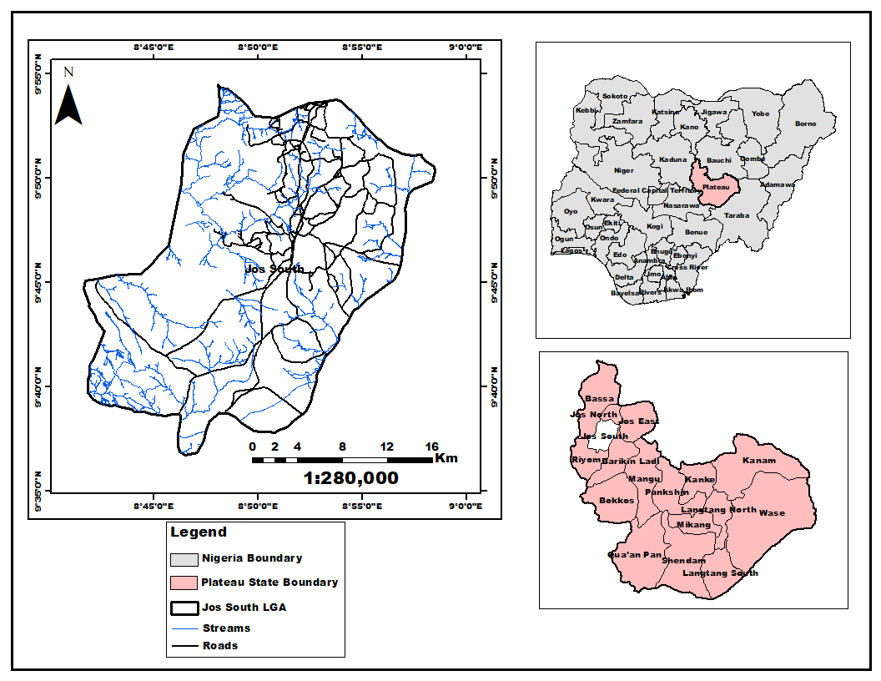
Figure 1: Study Area Map, Jos South, Plateau State, Nigeria

2.2 Climatic Characteristics
The climate of Jos Plateau is influenced by its altitude and seasonal migration of the Inter-Tropical Convergence Zone (ITCZ). Altitude lowers temperatures and induces orographic rainfall (Eziashi, 1995; Olowolafe et al., 2000). The mean annual temperature is about 22°C; mean monthly maxima range from about 27°C to 31°C (March/April), while mean monthly minima range from about 12°C to 18°C (December/January) (Alford & Tuley, 1974; Hill & Rackham, 1974). In exceptionally cool harmattan periods, temperatures may drop well below 10°C. Mean annual rainfall is about 1,465 mm, varying from ~1,800 mm in the southwest to ~1,000 mm in the southeast (rain shadow) (Ajaegbu et al., 1989). The hydrological peak of the rainy season is generally in August. Rainwater accumulates in numerous mine ponds that provide irrigation water for dry-season cultivation. Land preparation for rainfed crops begins in late April to May; for dry-season crops, from October. Tables 1 and 2 present the meteorological records from the University of Jos station (2000–2010).
Table 1: Mean Monthly Temperature (°C) of Jos Metropolis
Year/Month 2000 2001 2002 2003 2004 2005 2006 2007 2008 2009 2010 Ave
Jan 19.6 19.1 19.1 19.7 19.7 18.9 18.1 19.3 19.3 19.9 19.9 17.54
Feb 22 25.2 25.2 25.2 24.4 24.4 21 21 21.6 24.7 24.7 23.3
Mar 25.2 29.1 29.1 27.4 27.4 26..6 26.6 25.9 25.9 21.4 21.4 26.4
Apr 25 26.1 26.1 25 25 27.3 27.3 27.1 27.1 28 28 26.55
May 27 29.6 29.6 31.3 31.2 28 27 25.8 26.8 26.3 25.3 28.2
Jun 29.5 27.3 24.1 22.9 23.5 21.3 21.2 20.9 20.4 19.9 19.5 23.1
Jul 29.9 22.5 21.3 21.2 20.9 20.4 19.9 20.5 19.6 20.2 19.6 21.5
Aug 19.7 18.9 18.2 18.4 18.3 18.9 17.9 17.6 17.3 22.5 24.9 19.3
Sep 22.1 21.2 21 19.4 19.5 18.3 21.3 22.3 25.1 26.3 27.3 22.5
Oct 28.9 28.3 27.2 23.6 21.8 20.8 20.2 21.3 20.7 20.5 20.2 23.95
Nov 19.1 18.7 18.7 18.8 20.7 25.3 26.8 27.7 28.7 29.2 29.7 23.95
Dec 27.6 27.4 26.6 23.8 21 19.5 18.8 17.7 17.3 16.6 16.7 21.18
Source: University of Jos Meteorological Station, Jos
Table 2: Average Monthly Rainfall (mm) of Jos Metropolis
Year/month 2000 2001 20002 2003 2004 2005 2006 2007 2008 2009 2010
Jan 0 0 0 0 0 0 0 0 0 0 0
Feb 0 0 0 0 1 0 35 0 0 0 0
Mar 10.8 0 9 0 14.1 0 0 11.1 3 0 48.4
Apr 52.7 99.2 155.9 199.9 216.7 88.2 51.1 82.5 69.2 87.6 76.6
May 191.2 202.2 81.9 185.2 223.8 123.9 222.9 176.6 244 135.8 142.1
Jun 234.8 105 365.4 183.7 246.3 310.6 146.6 310 117.1 100.4 218.1
Jul 169.3 301.5 406.2 160.9 249.4 223.8 168.2 303.5 272.7 167.8 245.3
Aug 297.8 264.6 266 283.1 129 263.4 307.9 286 307.6 299.4 345.4
Sep 165 263.1 209.3 257.5 41 138.1 245.6 184.1 195.2 190.3 263.5
Oct 38.4 11.8 91 36.3 0 55.9 67.9 1.8 93.6 176 93.2
Nov 0 0 0 1.8 0 0 0 0 0 30.4 0
Dec 0 0 0 0 0 0 0 0 24.7 0 0
Ave 96.667 103.95 131.9 109.03 100.97 100.32 103.8 112.966 108.7 98.97 119.383
Source: University of Jos Meteorological Station, Jos

2.3 Landform, Drainage, and Soils
The land surface of the Jos Plateau consists of plains, hills, and depressions formed during the Miocene and Pliocene periods (Ajaegbu et al., 1989). Jos Metropolis forms the most important watershed in the region, dividing drainage basins into the Lake Chad Basin (northeast), the Sokoto-Rima Basin (northwest), and the Rivers Niger and Benue Basins (southwest and southeast). The study area has a network of numerous streams including River Delimi and River Gyel, and is dotted with mine ponds serving as viable irrigation water sources.
The soils of the Jos Plateau have been characterized at various levels (Grove, 1952; Hill & Rackham, 1974; Ajakpo, 1986). D'Hoore (1964) identified three principal soil groups: (i) Lithosols, weakly developed soils on ferruginous crusts; (ii) Ferruginous Tropical Soils, common on sandy parent materials, suitable for groundnut production and mechanized agriculture; and (iii) Eutropic Brown Soils, found on ferro-magnesium mineral-rich rocks, very fertile and well distributed in the Jos-Bukuru metropolis, forming the basis of fadama agriculture. Soils derived from biotite-granites are characterized by low total nitrogen, phosphorus deficiency, and low calcium status (Macleod et al., 1971; Olowolafe & Dung, 2000), making fertilizer application critical for sustained productivity.

2.4 Population and Human Activities
The growth of Jos was closely linked to tin mining. The population grew from 8,000 in 1920 to 11,000 by 1931 (Bingel, 1978), increasing from about 40,000 in 1960 to 594,955 in 1991 and 736,016 in 2006 (NPC, 1992; 2006). The city's population is heterogeneous, comprising indigenous Berom, Jarawa (Afusare), Anaguta, and Rukuba groups alongside Hausas, Igbo, Yoruba, and others. The Hausas are predominantly involved in dry-season farming. After the decline of tin mining, abandoned mine ponds, huge spoil dumps, and pits now characterize significant parts of the area, while the agricultural economy has absorbed many former mining workers and their families.

3.0 Materials and Methods

3.1 Primary Data Collection and Field Work
Extensive fieldwork was carried out to locate and document existing gardens engaged in dry-season irrigation farming within Jos South LGA. The field survey involved systematic reconnaissance of the entire study area to identify active market gardening sites and establish ground control points for subsequent remote sensing analysis. GPS coordinates were recorded for each garden location, with detailed observations on farming practices, irrigation systems, crop types, and seasonal variations. Interviews were conducted with local farmers and agricultural extension agents to gather information on crops, cropping systems, changes in cultivation patterns, and challenges faced by market gardeners.

3.2 Satellite Data Acquisition and Preprocessing
High-resolution satellite imagery with 15 cm spatial resolution was acquired from the National Space Research and Development Agency (NASRDA) for 2014 and 2024. The ten-year temporal window was sufficient to capture significant changes in market gardening patterns while ensuring data availability and quality. The 15 cm resolution was particularly important as it enabled identification and mapping of small-scale agricultural features including individual plots, irrigation channels, and farm boundaries. The imagery underwent rigorous preprocessing, geometric correction, radiometric calibration, atmospheric correction, and was reprojected to a common coordinate system for accurate temporal comparison.

3.3 Digital Image Analysis and Feature Extraction
The satellite images were processed using ArcGIS 10.8 desktop software. Systematic on-screen digitization and manual vectorization were employed to delineate market gardens based on spectral characteristics, geometric patterns, and spatial context. Drainages, water bodies, settlements, and major roads were also digitized as separate vector layers. Each feature class underwent multiple quality control checks to ensure accuracy and consistency in boundary delineation across both time periods. Change-detection algorithms were then applied to quantify the magnitude and direction of land use changes, generating total area coverage, percentage changes, and spatial distribution patterns for all mapped features.

4.0 Results and Discussion

4.1 Spatial Distribution and Temporal Changes in Land Use
The geospatial analysis revealed significant changes in land use patterns within Jos South Metropolis between 2014 and 2024. Table 3 summarises the area coverages for all classes; Figures 2–5 illustrate the spatial distributions.
Table 3: Area Coverage of Land Use Classes in Jos South (2014 vs. 2024)
Land Use Class | 2014 Area (km²) | 2024 Area (km²)
Settlements | 43.82 | 79.32
Water Bodies | 4.57 | 4.46
Market Gardens | 9.59 | 9.03

Results indicated that irrigated agriculture in Jos South covered 9.59 km² in 2014 as opposed to 9.03 km² in 2024, a reduction of 0.56 km² (5.8%). Within the same period, settlements increased from 43.82 km² to 79.32 km², an explosive increase of 34.76%. Water bodies reduced from 4.57 km² to 4.46 km², highlighting increased pressure on water resources driven by urbanization, farming, and competing demands on available resources.
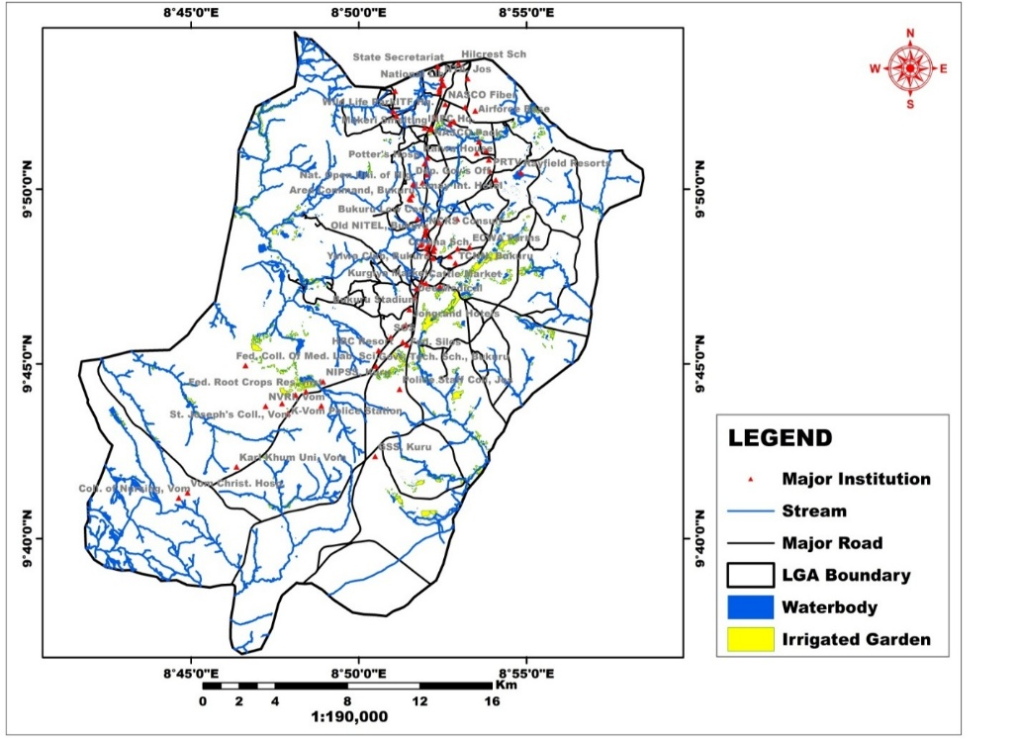
Figure 2: Urban Irrigated Agriculture and Potential Water Sources in Jos South (2024)
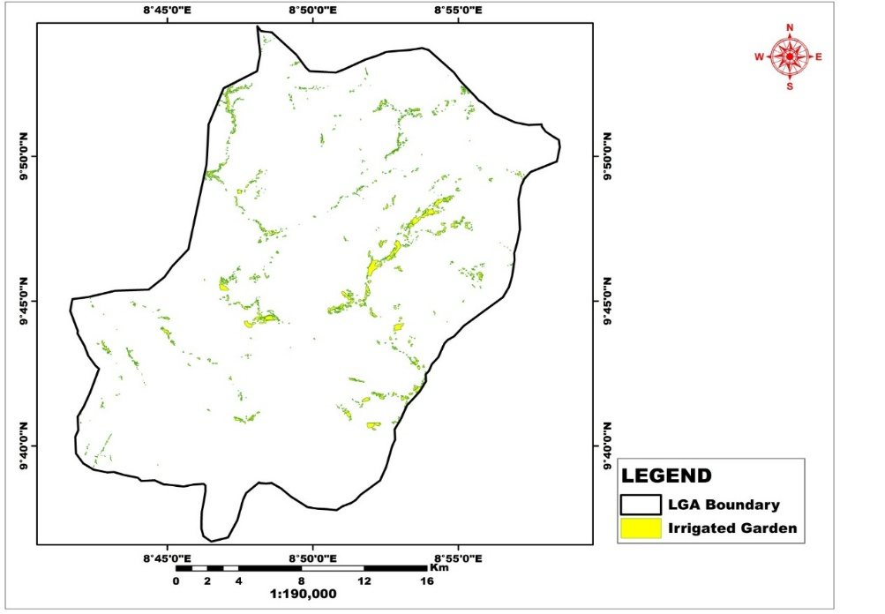
Figure 3: Urban Irrigated Agriculture in Jos South (2024)
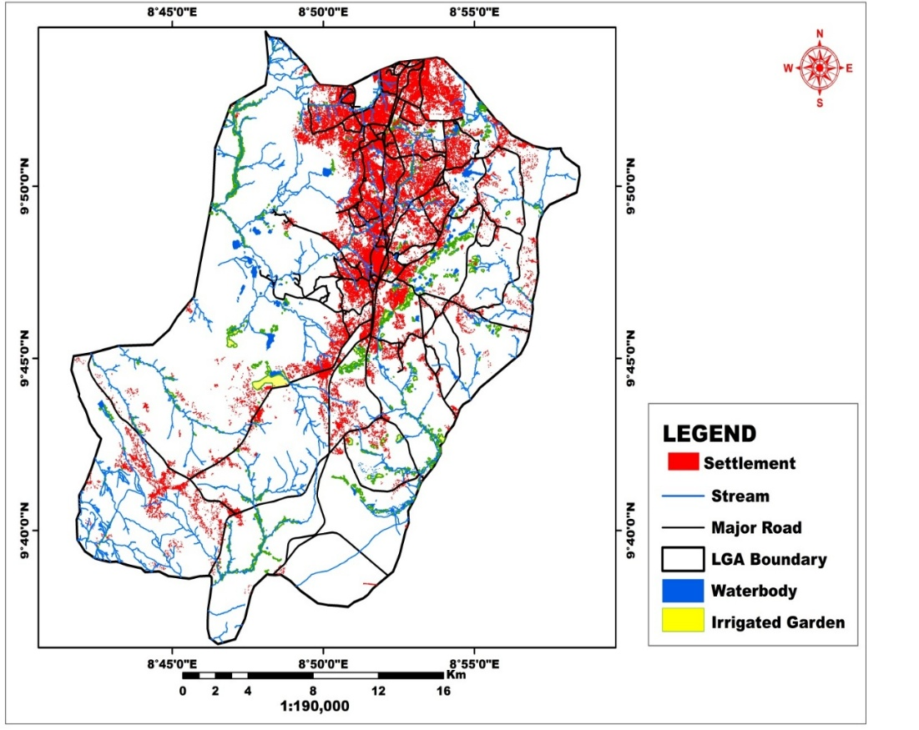
Figure 4: Urban Growth and Irrigated Agriculture in Jos South (2014)
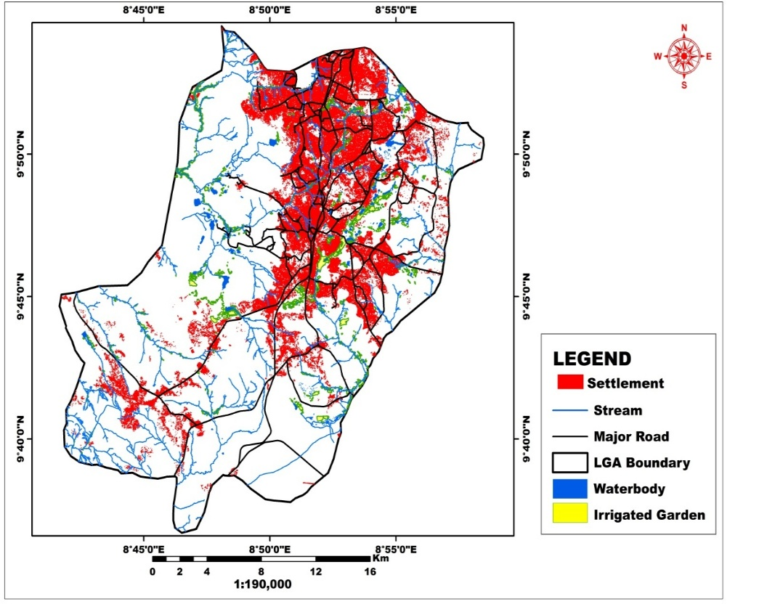
Figure 5: Urban Growth and Irrigated Agriculture in Jos South (2024)
The 34.76% increase in settlement area juxtaposed with the 5.8% decrease in market garden area reflects the growing pressure of urbanization on agricultural land. This finding aligns with similar studies in other African cities: Kidido & Ajabuin (2022) reported that urban agricultural livelihoods are threatened by tenure insecurity and encroaching development in peri-urban Ghana, while Musa & Abubakar (2024) noted that urban growth in Nigeria continues to diminish land available for agriculture through landscape fragmentation. Despite these pressures, the persistence of 9.03 km² of market gardens in 2024 demonstrates the resilience of urban agriculture in Jos, corroborating Sacks et al. (2023) observation that urban agriculture is integrated into the urban economic and ecological system and serves multiple functions beyond food production.
The reduction in water bodies from 4.57 km² to 4.46 km² is particularly concerning given the critical role of mine ponds and river channels in irrigated agriculture. This finding suggests increasing competition for water resources among various urban uses and highlights the need for integrated water resource management.

4.2 Methods of Acquisition of Farmlands
Farmland along river channels and around mine ponds (flood plains) is cultivated year-round. Key fadama areas in Jos South include the stretch from behind Nasco Company in Anglo Jos southward to Zaramangada and parts of Rayfield, and those on the city edges at Raho Kana in Bukuru extending to behind Grand Cereal.
Land is a costly commodity within the city. The study revealed that about 63% of dry-season respondents were landless, they did not own the land they farmed. Many urban residents were willing to farm but lacked access to land. Farmers interviewed reported farming on land where they did not know the owner, common around new development areas where plots are sold but awaiting construction. The demand for agricultural land is typically met by short-term, informal tenancy agreements, creating insecurity of tenure and considerable difficulties especially for dry-season farmers.
It was revealed that some migrant farmers from northern states and from Plateau State communities (Barki Ladi, Mangu, Bokkos, Bassa), even those who have lived in Jos for several years, still lack land rights. Such seasonal migrants carry out rainfed cultivation in their home villages then come to Jos seeking viable fadama land for dry-season cultivation, attracted by access to irrigation water throughout the farming season and ready markets for fruits and vegetables. This land tenure situation reflects a systemic challenge across African urban centers, similar findings have been documented by Matamanda et al. (2022) in Harare and Kwiringira et al. (2024) in Kampala, underscoring the need for policy interventions that provide secure land tenure for urban farmers.

4.3 Crops Cultivated and Cropping Systems
A wide variety of crops are cultivated year-round in Jos South metropolis. Dry-season crops include tomatoes, lettuce, cabbage, carrots, cucumber, green peas, green pepper, celery, cauliflower, beetroot, strawberry, and garden egg. Maize, tomatoes, cucumber, cabbage, pepper, ugu, and spinach are grown in both rainy and dry seasons. The availability of fadama along stream channels and numerous mine ponds created a unique opportunity for irrigated agriculture, while the near-temperate climate enables production of temperate vegetables that Jos can supply to markets across southern Nigeria during periods when production elsewhere is not possible.
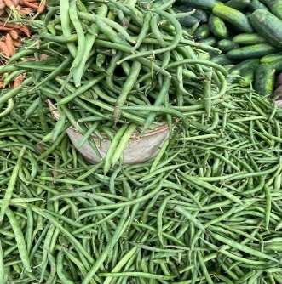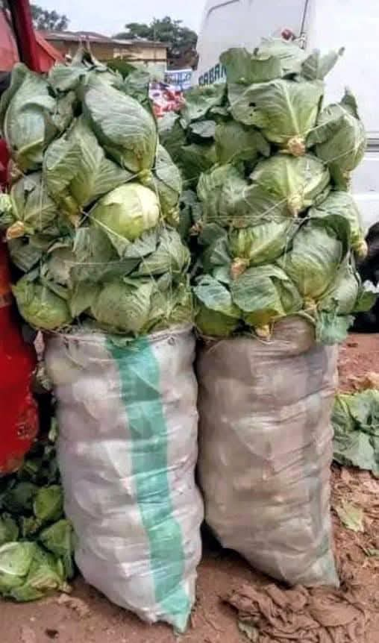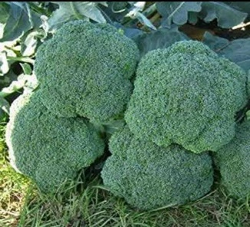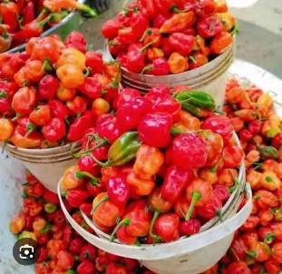
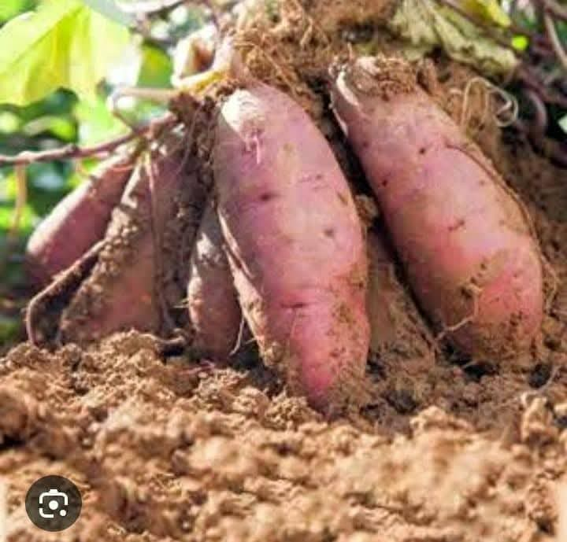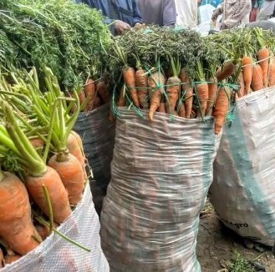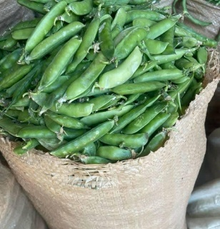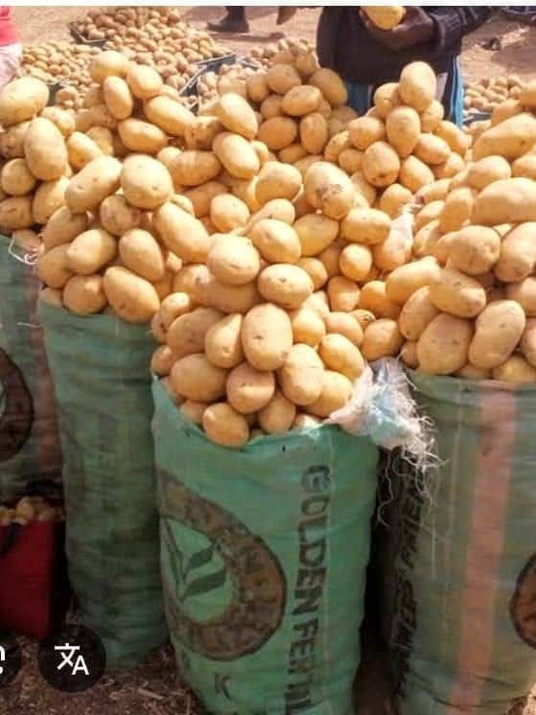
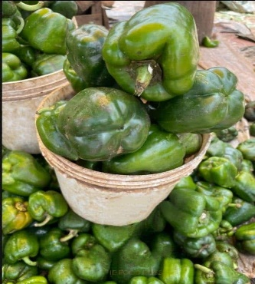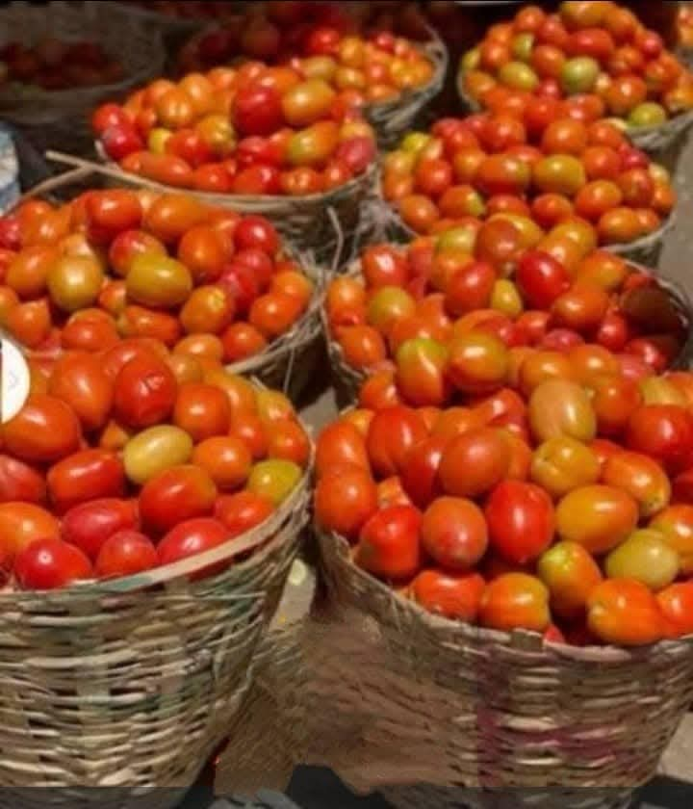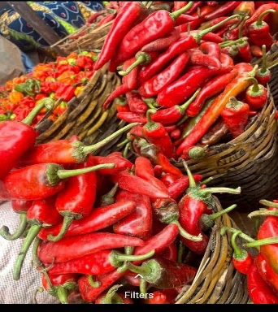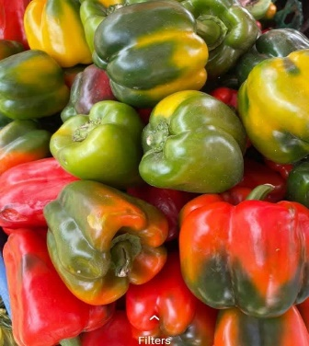
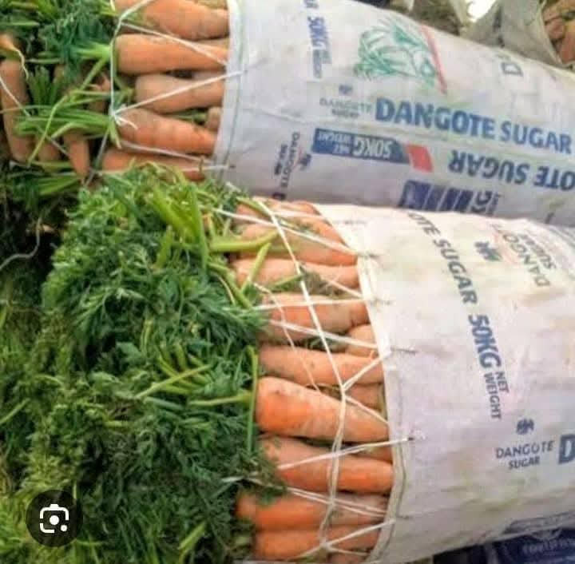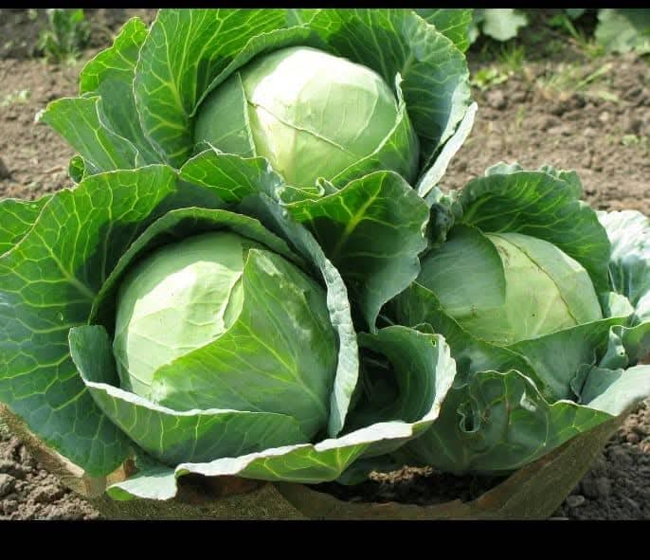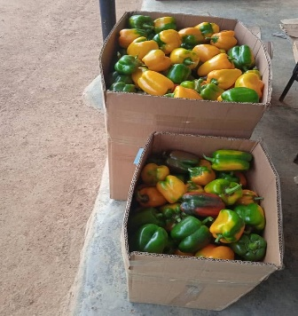
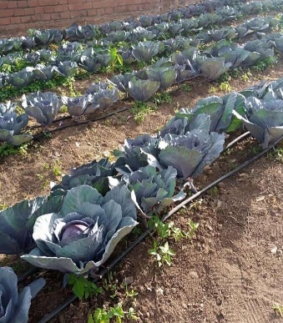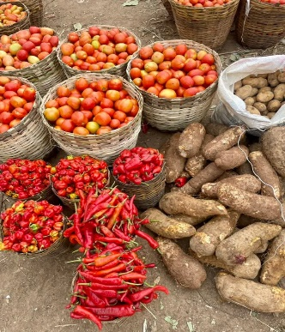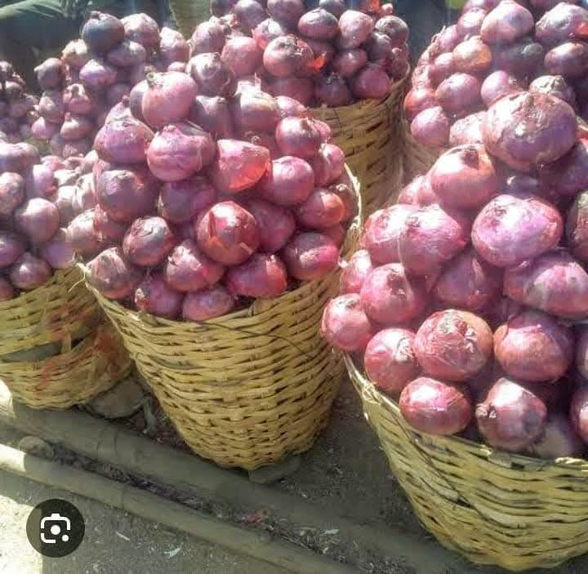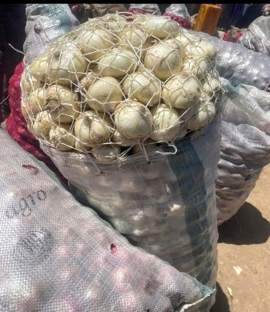
Figure 6: Photographic Collage of Crop Types and Market Garden Produce in Jos South
Cropping intensity is remarkably high. Because urban land pressure precludes traditional bush-fallow fertility restoration, some plots undergo three cropping cycles per year: a first dry-season cycle (tomatoes, lettuce, cabbage, green beans, green peas) from mid-September to December for the Christmas market; a second dry-season cycle from January to April; and a rainy-season cycle (maize or Irish potatoes) from May to September. This intensity of year-round cultivation without adequate fallow periods places tremendous pressure on soil fertility, explaining the high and critical dependence on inorganic fertilizers, particularly given the inherently low nitrogen and phosphorus status of Jos Plateau soils derived from biotite-granites (Olowolafe & Dung, 2000).

4.4 Irrigation Practices and Water Management
The frequency and volume of irrigation water applied depend on crop type, stage of development, soil texture, and water availability. Clay soils hold more water than sandy soils, while leaf canopies help keep the ground moist longer by limiting direct solar exposure. At the peak of the dry season (January–April) when irrigation water is scarce, farmers in fadama locations such as Zaramangada and behind Nasco in Anglo Jos come together to construct earth dams along river channels and develop calendars for water-use scheduling, a collective water management practice that reflects both community organization and the intensity of water demand.

4.5 Harvesting and Marketing
Harvesting of crops during dry-season cultivation relies largely on communal labour, family members, friends, buyers, and neighboring farmers. Farmers organize collective harvesting, hire trucks, and transport produce to markets in Enugu, Aba, Onitsha, Calabar, Port Harcourt, Benin, Warri, and Lagos. For local markets within Jos-Bukuru Metropolis, harvesting is timed to weekly market days: Mondays for the Tuesday market at the Building Material Market, and Wednesdays for the Thursday Faringada market. During festive seasons, particularly Christmas, buyers from across southern Nigeria converge on Jos, transforming weekly markets into daily ones and significantly boosting farm incomes.

4.6 Constraints to Urban Agriculture
Farmers in Jos Metropolis encounter numerous constraints: pests and diseases (the most commonly reported and most severe), inadequate fertilizer supply, lack of capital, poor soil fertility, restricted farmland access, pollution and shortage of irrigation water, shortage of agricultural labour, crop theft, absence of storage facilities, and exploitative middlemen. The intensity of problems differs between cropping seasons and between locations.
The demand for urban land is high and competitive. Accessibility to farmland is especially critical for dry-season farmers, who are at greatest risk from the informal nature of tenure arrangements. Only those who own land through inheritance or purchase enjoy security of tenure. Kidido & Ajabuin (2022) and Naab et al. (2023) have noted that arguments about farming as a non-lucrative use of high-value urban land frequently exclude farming interests from planning decisions, further marginalizing urban farmers.

4.7 Discussion of Findings
The findings of this study demonstrate that urbanization does not necessarily mean the end of agricultural production in Jos. There are full-time farmers who farm all year round, and many others, including men, women, lone parents, the underemployed, the unemployed, retrenched workers, and the retired, are involved in urban agriculture. Many farmers concentrated at Anglo-Jos were retrenched from Nasco, the former Jos Steel Rolling Mill (now Zuma Steel Rolling Mill), Jos International Breweries, Europharm, and Makerel Smelting Company. For these individuals, urban farming represents not a transitional activity but a permanent livelihood.
The dry-season farmers identified in this study include three distinct groups: settlers (largely Hausas from Kano, Jigawa, and Borno States, many from families who worked in tin mining and took up agriculture after its decline), migrants or seasonal farmers (Hausas from the north and indigenes from Barki Ladi, Mangu, Bokkos, Jos East, and Bassa LGAs who come to Jos at the start of every dry season), and indigenous farmers. Dry-season cultivation is predominantly small-scale, with an average holding of less than one hectare, and farmers suffer from the diseconomies of scale.
Significantly, market gardening activities in Jos are no longer an interim activity that will cease when land becomes ripe for development. As urban growth expands, new development areas open up sparsely built zones where residents often have temporary access to vacant land for farming. The diversity of crops grown, particularly temperate vegetables not producible elsewhere in Nigeria, represents a competitive advantage. The ability to supply fresh vegetables to southern Nigerian markets throughout the year provides significant income opportunities and contributes to national food security.

5.0 Conclusion
Urban agriculture has, over the years, become a significant part of Jos Metropolis that can no longer be ignored. The moderate climate of the Jos Plateau and the availability of fadama land and mine ponds provide unique assets for sustained agricultural production. The geospatial analysis successfully demonstrated the capability of remote sensing and GIS technology in monitoring and mapping urban agricultural land use dynamics over a decade.
Between 2014 and 2024, market garden areas declined marginally by 5.8% (from 9.59 km² to 9.03 km²), while settlements expanded dramatically by 34.76% (from 43.82 km² to 79.32 km²), indicating intense competition for urban land. Water bodies declined from 4.57 km² to 4.46 km². Despite these pressures, the persistence of 9.03 km² of market gardens in 2024 underscores the resilience and economic importance of this activity to Jos residents.
The study documented significant challenges facing urban farmers: land tenure insecurity affecting 63% of dry-season farmers, inadequate irrigation water supply, pest and disease pressures, limited fertilizer access, and encroachment from urban development. These constraints threaten the sustainability of this vital economic sector unless deliberate policy interventions are implemented. The city is characterized by both challenges and considerable potentials for boosting sustainable food production. There is therefore a pressing need to accommodate urban agriculture into the Greater Jos Master Plan to ensure its continued contribution to food security, employment generation, and sustainable urban development.

6.0 Recommendations
1. Integration into Urban Planning: Agriculture should be recognized as an integral part of the urban ecosystem in Jos-Bukuru Metropolis and specific agricultural activities zoned in the Jos Master Plan. Practical steps should protect and preserve key fadama areas, at Raho Kana in Bukuru, adjacent to the University of Jos permanent site, and around the Seminary along Zaria Road. The fadama behind Nasco and Coca-Cola stretching to Zaramangada requires rationalization, as industrial and agricultural land uses are incompatible in that corridor.
2. Strengthening Extension Services: The activities of the Agricultural Services Training Centre (ASTC) in Vom should be intensified, including regular training programs, improved access to mechanized services, and enhanced provision of quality inputs (improved seeds, fertilizers, pesticides) at affordable prices.
3. Land Tenure Security: Government should develop policies providing secure, long-term land tenure for urban farmers, including agricultural zones with formal leasing arrangements that protect farmers from arbitrary displacement while accommodating legitimate urban development needs.
4. Water Resource Management: Existing mine ponds must be protected, water-use efficiency improved, and alternative irrigation sources explored. Integrated water resource management strategies are needed to balance agricultural and other urban demands.
5. Rural–Urban Production Synergies: Policies should support value chains connecting rural production areas with urban markets and processing facilities in Jos, strengthening overall food system resilience across the region.
6. Farmer Organizations and Continuous Monitoring: The formation and strengthening of farmer cooperatives and associations should be encouraged to improve bargaining power and political voice in planning processes. Continuous geospatial monitoring of urban agricultural land use should be institutionalized to supply timely data for planning and policy formulation. Further research should focus on sustainable intensification, integrated pest management, and organic farming systems suited to urban environments.

References
Gilbert, S., & Shi, M. (2023). Land use/land cover changes detection in Lagos City of Nigeria using remote sensing and GIS. Remote Sensing Applications: Society and Environment, 29, 100921. https://doi.org/10.1016/j.rsase.2023.100921
Adepetu, A. A. (1985). Market gardening on the Jos Plateau: A case study. Department of Geography and Planning, University of Jos.
Kwiringira, J., Mohling, E. W. P., Mathias, A., et al. (2024). Urban agriculture as an evolved sustainable urban livelihood: Evidence from Kampala City, Uganda. Agriculture & Food Security, 13, 53. https://doi.org/10.1186/s40066-024-00507-y
Ajaegbu, H. I. (1995). Market gardening activities in Nigeria: The case of the Jos urban area. In D. George, L. M. Van, & H. I. Ajaegbu (Eds.), Proceedings of a workshop on small scale market gardening around Jos, Nigeria. Ashgate Publishing Limited.
Ajaegbu, H. I., Adepetu, A. A., Ajakpo, J. E., Ihemegbulem, V. C., Jumbo, S. E., Olaniyan, J. A., Okechukwu, G. C., & Schoeneich, K. (1989). Jos Plateau environmental excursion guide. Department of Geography and Planning, University of Jos.
Ajakpo, J. E. (1986). Soil characteristics and soil development on the mine spoils and areas on the Jos Plateau. In H. I. Ajaegbu (Ed.), Jos Plateau Environmental Resources Development Programme: Final report 1982–1986. Department of Geography and Planning, University of Jos.
Alford, M. T., & Tuley, P. (1974). Interim report on landforms, soils, climate and vegetation of Jos Plateau. Land Resources Division Miscellaneous Reports, 1(153).
FAO, IFAD, UNICEF, WFP, & WHO. (2023). The state of food security and nutrition in the world 2023: Urbanization, agrifood systems transformation and healthy diets across the rural–urban continuum. FAO. https://doi.org/10.4060/cc3017en
Bingel, Z. (1978). Jos: The evolution of the town. Department of Geography and Planning, University of Jos.
Yan, D., Liu, L., Liu, X., & Zhang, M. (2022). Global trends in urban agriculture research: A pathway toward urban resilience and sustainability. Land, 11(1), 117. https://doi.org/10.3390/land11010117
D’Hoore, J. L. D. (1964). Soil map of Africa on scale 1:5,000,000: Explanatory monograph. Commission for Technical Cooperation in Africa.
Matamanda, A. R., & Chirisa, I. (2024). The role of urban planning in strengthening urban food security in Africa: Insights from Lesotho, Zimbabwe and South Africa. Urban Forum, 35, 1–18. https://doi.org/10.1007/s12132-024-09530-5
Eziashi, A. C. (1995). Analysis and classification of natural river channels on the Jos Plateau (Doctoral dissertation, University of Jos).
Food and Agriculture Organization. (2023). The state of food security and nutrition in the world 2023. FAO. https://www.fao.org/publications/sofi/2023
Musa, K., & Abubakar, M. L. (2024). Monitoring urban growth and landscape fragmentation in Kaduna, Nigeria, using remote sensing approach. Journal of Degraded and Mining Lands Management, 11(4). https://doi.org/10.15243/jdmlm.2024.114.6243
Kiribou, E. M., Kpoda, N. W., Ouoba, A., & Sanon, M. (2024). Urban farming system and food security in sub-Saharan Africa: Analysis of the current status and challenges. Urban Agriculture & Regional Food Systems, 9, e70007. https://doi.org/10.1002/uar2.70007
Grove, A. T. (1952). Land use and soil conservation on the Jos Plateau. Geological Survey of Nigeria Bulletin, 22.
Hill, I. D., & Rackham, L. J. (1974). Interim report on landforms, soil, climate and vegetation on the Jos Plateau. Land Resources Division Miscellaneous Reports, 2(153).
Chinseu, E. L., Stringer, L. C., & Dougill, A. J. (2021). Why do smallholder farmers dis-adopt conservation agriculture? Insights from Malawi. Land Degradation & Development, 32(5), 1840–1850. https://doi.org/10.1002/ldr.3820
Teklemariam, D., & Cochrane, L. (2021). The rush to the peripheries: Land rights and tenure security in peri-urban Ethiopia. Land, 10(2), 193. https://doi.org/10.3390/land10020193
Khumalo, N. Z., Sibanda, M., & Mdoda, L. (2024). Implications of a climate-smart approach to food and income security for urban Sub-Saharan Africa: A systematic review. Sustainability, 16(5), 1882. https://doi.org/10.3390/su16051882
Kidido, J. K., & Ajabuin, B. A. (2022). Peri-urban land governance and market dynamics: Perceptions and adaptation strategies of smallholder farmers in Tamale, Ghana. African Geographical Review, 42(5), 515–538. https://doi.org/10.1080/19376812.2022.2076132
Macleod, W. N., Turner, D. C., & Wright, E. P. (1971). The geology of the Jos Plateau. Geological Survey Bulletin, 32.
Kwiringira, J., Mohling, E. W. P., Mathias, A., et al. (2024). Urban agriculture as an evolved sustainable urban livelihood: Evidence from Kampala City, Uganda. Agriculture & Food Security, 13, 53. https://doi.org/10.1186/s40066-024-00507-y
Wegerif, M. C. A., & Wessels, M. T. (2024). Going with the food flow: The contribution of urban agriculture to a growing African city. Development Southern Africa, 41(5), 1214–1229. https://doi.org/10.1080/0376835X.2024.2398547
Wegerif, M. C. A. (2024). Street traders’ contribution to food security: Lessons from fresh produce traders’ experiences in South Africa during Covid-19. Food Security, 16, 115–131. https://doi.org/10.1007/s12571-023-01422-z
Matamanda, A. R., Mandebvu-Chaora, C., & Rammile, S. (2022). The interplay between urban agriculture and spatial (in)justice: Case study analysis of Harare, Zimbabwe. Land Use Policy, 115, 106029. https://doi.org/10.1016/j.landusepol.2022.106029
Morgan, W. T. W. (1985). Farmers and their farms on four fadamas on the Jos Plateau. JPERDP Interim Report No. 2. Department of Geography, University of Durham.
Tessema, G. A., et al. (2025). The roles of urban agriculture to household food security: A case study in Kirkos sub-city, Addis Ababa City, Ethiopia. Frontiers in Sustainable Food Systems, 9, 1444320. https://doi.org/10.3389/fsufs.2025.1444320
Sacks, M., Bhagat, F., & Viljoen, A. (2023). Urban agriculture and the sustainability nexus in South Africa: Past, current, and future trends. Urban Forum, 35, 1–17. https://doi.org/10.1007/s12132-023-09480-4
National Population Commission. (1992). Census news: A house magazine of Nigerian Population Commission, 3(1).
National Population Commission. (2006). 2006 population and housing census of the Federal Republic of Nigeria. NPC.
Olowolafe, E. A. (2008). Effects of using municipal waste as fertilizers on soil properties in Jos area. Resources, Conservation and Recycling, 52(8–9), 1266–1270.
Olowolafe, E. A., & Dung, J. E. (2000). Soils derived from biotite-granite on the Jos Plateau, Nigeria: Their nutrient status and management for sustainable agriculture. Resources, Conservation and Recycling, 29(4), 231–244.
Phillips-Howard, K. D., Adepetu, A. A., & Kidd, A. D. (1990). Aspects of change in fadama farming along the Delimi River, Jos L.G.A. JPERDP Interim Report, 18. Department of Geography, University of Durham.
Phillips-Howard, K. D., & Schoeneich, K. (1991). The irrigation potentials of water resources on the Jos Plateau. JPERDP Interim Report, 25. Department of Geography, University of Durham.
Phillips-Howard, K. D., Schoeneich, K., & Mabur, E. J. (1992). The potential use of disused mine dams for irrigation: The case of Gana Daji Reservoir, Plateau State. JPERDP Interim Report. Department of Geography, University of Durham.
Beyene, M. T., et al. (2025). Peri-urbanization and smallholder farmers’ socio-economic marginality in peri-urban Addis Ababa. Cogent Social Sciences, 11(1), 2551875. https://doi.org/10.1080/23311886.2025.2551875
Mwaijande, F. (2024). Urban agriculture: A pathway for enhancing food security and poverty resiliency in Tanzania. African Journal of Empirical Research, 5(2). https://doi.org/10.51867/ajernet.5.2.31
Frontiers in Environmental Science. (2025). Predicting changes in land use and land cover using remote sensing and land change modeler. Frontiers in Environmental Science, 13, 1540140. https://doi.org/10.3389/fenvs.2025.1540140
United Nations Department of Economic and Social Affairs. (2022). World urbanization prospects: The 2022 revision. UNDESA. https://population.un.org/wup/
World Food Programme. (2022). Urban food insecurity in sub-Saharan Africa: A WFP assessment report. WFP. https://www.wfp.org/publications
United Nations Population Fund. (2023). State of world population 2023: 8 billion lives, infinite possibilities. UNFPA. https://www.unfpa.org/swp2023
Adesola, I. A., et al. (2024). Land use land cover (LULC) analysis in Nigeria: A systematic review of data, methods, and platforms with future prospects. Bulletin of the National Research Centre, 48(1), 135. https://doi.org/10.1186/s42269-024-01286-z
Hannah, C., Davies, J., Green, R., Zimmer, A., Anderson, P., & Battersby, J. (2022). Food systems and rural–urban linkages in African secondary cities. Urban Transformations, 4(1), 8. https://doi.org/10.1186/s42854-022-00042-8
Inam, A., et al. (2023). Integrating remote sensing and GIS-based map analysis in determining spread of built-ups and land-use dynamics of terrain of Onitsha Metropolis, Anambra State, Nigeria. Land, 13(11), 1896. https://doi.org/10.3390/land13111896
Kiribou, E. M., Kpoda, N. W., Ouoba, A., & Sanon, M. (2024). Urban farming system and food security in sub-Saharan Africa: Analysis of the current status and challenges. Urban Agriculture & Regional Food Systems, 9, e70007. https://doi.org/10.1002/uar2.70007
Khumalo, N. Z., Sibanda, M., & Mdoda, L. (2024). Implications of a climate-smart approach to food and income security for urban Sub-Saharan Africa: A systematic review. Sustainability, 16(5), 1882. https://doi.org/10.3390/su16051882
Teklemariam, D., & Cochrane, L. (2021). The rush to the peripheries: Land rights and tenure security in peri-urban Ethiopia. Land, 10(2), 193. https://doi.org/10.3390/land10020193
Sacks, M., Bhagat, F., & Viljoen, A. (2023). Urban agriculture and the sustainability nexus in South Africa: Past, current, and future trends. Urban Forum, 35, 1–17. https://doi.org/10.1007/s12132-023-09480-4
Naab, F. Z., et al. (2023). Land tenure, food security, gender and urbanization in Northern Ghana. Heliyon, 9(9), e19617. https://doi.org/10.1016/j.heliyon.2023.e19617

