Tabla Beyond the Percussion: Scientific, cultural and cognitive Perspective on Tabla Pedagogy in Hindustani Classical Music Tradition

- Introduction
‘Tabla’ is often described in teaching contexts as a technically advanced percussion instrument made up of two tuned drums, each producing distinct tonal qualities (Courtney, 1990). While this description is mechanically correct, scholars argue that it oversimplifies the instrument’s deeper role in Hindustani classical music (Ranade, 1981; Clayton, 2000). In this tradition, tabla strokes are not seen as isolated sounds but as culturally meaningful utterances, embedded within systems of lineage, discipline, and aesthetic philosophy (The Tabla of Lucknow, 1989). The practice of tabla playing is closely tied to the bol system—a set of mnemonic syllables that encode the exact way strokes are performed while also serving as a method of oral transmission, memory, and stylistic identity (Bhalchandra, 1991; Jamuna, 1991). These syllables are understood not only as technical markers but also as expressions of a cultural logic that connects rhythm, teaching methods, and philosophical ideas into a unified framework of knowledge (Jagdhale, 2015; Srivastava, 2011). Indian Music is typically standing on four pillars viz, science (Shaastra), technique (tantra), knowledge (vidya) and art (kala). Taalyogi Padmashree Pt. Suresh Talwalkar stated in his views and opinion about same that “the science can be understood, technique can be taught, knowledge can be shared because it’s no one’s individualistic virtue and art can be eternal and it comes from within after rehearsing the learned and practiced skills over and over again which gets matured with elapsed interval of vector of time.” This perspective highlights that tabla pedagogy is both a technical and cultural system, where learning is inseparable from oral tradition and aesthetic values.
This study has been grounded in sustained teaching experience across institutional settings, long‑term engagement with students at varying levels of proficiency, and extensive field interactions with eminent tabla artists. Such methodological positioning has allowed for a reflexive approach that integrates scholarly analysis with lived pedagogy, thereby bridging theoretical inquiry and practical knowledge (Vashisth, 2002). Fundamental strokes have thus been reframed not as isolated mechanical gestures but as components of a broader cultural knowledge system. In this way, the tabla has been emphasized as a dynamic site of meaning making, where technique, oral tradition, and aesthetic values converge to produce a practice simultaneously musical, philosophical, and social.
Consequently, tabla pedagogy has been exemplified as a mode of musical training in South Asia that is not confined to technical mastery but is embedded within larger frameworks of cultural continuity, identity formation, and aesthetic cultivation (Clayton, 2000; Ranade, 1981). The instrument has thereby been situated as a medium through which knowledge is transmitted, discipline embodied, and artistic philosophy enacted, positioning tabla practice within a living tradition that is both historically grounded and dynamically evolving. From a structural perspective, the repertoire of the tabla, including kaidas, relas, and gats, corresponds to mridangam’s ‘korvais’ and ‘mohrā’ patterns. Both are mathematically organized rhythmic designs that culminate in precise alignment with the ‘sam’ (the first beat of the cycle), demonstrating a shared logic of cyclic rhythm (tala) and improvisation (Clayton, 2000; Srivastava, 2011).
This adaptation illustrates that both instruments embody a common epistemological framework in Indian percussion traditions. Mnemonic syllables are not merely technical markers but vehicles of cultural logic, integrating rhythm, pedagogy, and philosophy into a coherent system of knowledge. The historical origins of the tabla have remained a subject of considerable scholarly debate, with some theories proposing its evolution from the pakhawaj and others situating its emergence within Indo‑Persian courtly culture (Ranade, 1981; Clayton, 2000). Although these narratives continue to generate discussion, it is more firmly established that by the eighteenth and nineteenth centuries distinct gharanas—stylistic schools of practice—had crystallized. These gharanas did not simply codify technical repertoire; they formalized principles of stroke clarity, tonal aesthetics, compositional structures, and pedagogical sequences, embedding the instrument within a lineage‑based system of transmission (The Tabla of Lucknow, 1989; Bhalchandra, 1991). Each school articulated a particular philosophy of sound, shaping the cultivation and teaching of rhythm, timbre, and articulation. As Shri Umesh Moghe’s ‘Delhi ka Tabla’ demonstrates, lineage in tabla practice cannot be reduced to genealogical succession but is fundamentally aesthetic in nature. A ‘bol’—the mnemonic syllable encoding a stroke—functions as a carrier of stylistic memory, where subtle variations in tonal attack, sustain, and decay reflect inherited sensibilities transmitted across generations (Moghe, 2005). These micro‑differences embody the ethos of a gharana, linking technical execution to broader cultural and philosophical orientations. In this sense, the tabla is not merely an instrument of rhythm but a repository of aesthetic heritage, where each stroke resonates with accumulated tradition and each pedagogical utterance reinforces continuity within a living cultural system (Courtney, 1990; Srivastava, 2011).
- Review of literature
The acoustical study of Indian percussion traditions reveals a remarkable synthesis of cultural innovation and scientific design. Raman’s pioneering work on the ‘Mridanga’ and ‘Tabla’ demonstrated that unlike ordinary drums producing in harmonic overtones, these instruments are engineered to yield harmonic sequences analogous to the first five harmonics of a vibrating string. His experiments with sand figures showed how superposition of normal modes creates stable nodal patterns, while structural features such as the heavy wooden shell, central loading, and marginal leather ring suppress unwanted higher overtones and sustain musical tones (Raman, 1934). Ranade (1981) complements this acoustical perspective by situating Indian music within its historical and cultural continuum, emphasising oral tradition, improvisation, and 'Guru- Shishya' education as crucial to transmission. He underscores the plurality of Indian music, with Hindustani and Carnatic systems coexisting alongside folk and tribal traditions, all unified by the foundational concepts of ‘Raga’, ‘Tala’, and improvisation. Clayton (2000) advances this discussion by analyzing temporal structures in North Indian music performance, highlighting how cyclical rhythm (tala) interacts with improvisation to balance fixed metric frameworks and performer creativity. His work situates rhythm as both structural and expressive, shaping the dynamic flow of performance. The cultural analysis of the Lucknow ‘gharana’ of tabla further illustrates how percussion traditions embody both artistry and identity. Rooted in the courts of Lucknow, this ‘gharana’ emphasizes delicacy, grace, and rhythmic sophistication through compositions such as ‘kaidas’, ‘relas’, and ‘gats.’ It reflects not only technical mastery but also socio-cultural refinement (The Tabla of Lucknow, 1989). Bhalchandra’s ‘Taal Vadhya Shastra’ (1991) provides theoretical grounding, codifying rhythmic cycles and improvisational strategies that underpin such traditions. Similarly, Courtney’s ‘Solo Tabla Drumming’ (1990) systematically explores performance practice, demonstrating how improvisation unfolds within precise rhythmic frameworks. Other treatises extend this codification of rhythm. Jamuna’s ‘Taal Vadhya Parichay’ (1991) introduces percussion instruments within the broader framework of ‘taal’ and ‘vadhya’, emphasizing oral transmission and cultural significance. Jagdhale’s ‘Taalsparsh’ (2015) bridges pedagogy and scholarship, guiding learners from basic rhythmic patterns to advanced improvisational designs. Srivastava’s ‘Taal Parichay’ (2011) systematically presents major ‘talas’, their subdivisions (matras), and practical repertoire, while Vashisth’s ‘Taal Martandh’ (2002) catalogues rhythmic cycles and improvisational possibilities, underscoring rhythm as a central creative force in Indian classical performance.

  - The Bol System as Epistemology
Tabla pedagogy has traditionally been observed to commence not with the physical act of drumming but with the oral practice of recitation. Students are initially trained to vocalize syllables such as ‘nā’, ‘tin’, ‘tun’, ‘dhā’, and ‘dhin’, which encode precise information regarding the membrane zone to be struck, the finger placement required, (Fig. 1 - 6) the relative force of the stroke, and the expected resonance or tonal quality (Courtney, 1990; Jamuna, 1991). In this way, the ‘bol’ system has been described as a semiotic framework that bridges linguistic articulation and embodied technique, functioning simultaneously as a mnemonic device and a pedagogical tool (Srivastava, 2011; Jagdhale, 2015). Classroom observations consistently reveal that rhythmic clarity emerges first in speech before manifesting in instrumental precision. The act of vocalizing syllables cultivates cognitive organization of rhythm, enabling learners to internalize metric structures and temporal divisions prior to their translation into physical execution on the drum surface (Clayton, 2000; Ranade, 1981).
This pedagogical sequence confirms the ‘bol’ as a linguistic technology of rhythmic cognition, where oral articulation scaffolds motor learning and reinforces stylistic identity (The Tabla of Lucknow, 1989; Vashisth, 2002). By foregrounding recitation, tabla pedagogy underscores the inseparability of language and rhythm, demonstrating how vocal practice not only precedes but actively shapes the acquisition of instrumental fluency. In this sense, the tabla exemplifies a broader South Asian epistemology in which musical knowledge is transmitted through oral‑aural modalities, embedding technical mastery within a cultural logic of speech, memory, and embodied discipline (Bhalchandra, 1991; Moghe, 2005).
In tabla pedagogy, ‘bols’—the mnemonic syllables such as ‘dhā’, ‘tin’, ‘nā’, and ‘dhin’ are structured as a linguistic system that encodes rhythmic knowledge. They function as semiotic markers that bridge oral articulation and embodied technique, allowing rhythm to be transmitted through speech before being realized on the instrument (Courtney, 1990; Jamuna, 1991). This oral‑aural modality situates ‘bols’ as more than symbolic representations; they are integral to the epistemology of Indian percussion, enabling learners to internalize rhythm cognitively prior to physical execution (Clayton, 2000; Ranade, 1981). Beyond their technical function, ‘bols’ serve as carriers of stylistic memory and cultural identity. Subtle variations in tonal attack, sustain, and decay reflect inherited sensibilities transmitted across generations, embodying the ethos of specific ‘gharanas’ (The Tabla of Lucknow, 1989; Moghe, 2005). In this sense, ‘bols’ are not merely pedagogical tools but repositories of cultural heritage, linking technical execution to broader philosophical orientations. They encode lineage-based aesthetics, ensuring that each stroke resonates with accumulated tradition and each recitation reinforces continuity within a living cultural system (Courtney, 1990; Ranade, 1981). Structurally, both systems function as semiotic frameworks that bridge linguistic articulation and embodied technique. The ‘tabla’s’ repertoire of ‘kaidas’, ‘relas’, ‘gats’ corresponds to ‘korvais’, ‘mohra’ structures of ‘mridangam’ and ‘uthan’, ‘paran’ of ‘pakhawaj’ which mathematically organized to resolve at the ‘sam’ (first beat of any ‘tala’ cycle). This demonstrates a shared epistemological logic: rhythm is conceived cyclically, and improvisation unfolds within codified frameworks (Srivastava, 2011; Jagdhale, 2015).
  - Tabla Pedagogy in North Indian Classical Music
The pedagogy of tabla in the North Indian classical tradition exemplifies a unique model of embodied cognition, where learning is not merely the acquisition of technical skills but the cultivation of rhythmic intelligence and expressive depth. Rooted in the guru–shishya paradigm, this transmission process emphasizes adaptive feedback, stylistic nuance, and the subtle interplay between technique and emotion. Unlike purely notational or digital systems, which can provide structural clarity but remain abstract, tabla pedagogy relies on lived experience, oral transmission, and embodied practice. The student learns not only to reproduce syllables (bols) but to internalize their affective and dynamic qualities, thereby developing expertise that integrates cognition, motor control, and emotional resonance.
The language of tabla is vast, constructed through combinations of syllables that form words, sentences, and ultimately entire rhythmic narratives. This linguistic dimension allows tabla to function as a storytelling instrument, where rhythm itself becomes a medium of expression. The Dayan (right-hand drum) is often associated with precision, speed, and maintenance of laya (tempo), showcasing technical intricacies and structural clarity. In contrast, the Bayan (left-hand drum) enriches the performance with bass resonance, tonal variation, and emotive depth. Together, they create a dialogic balance between structure and expression, intellect and emotion, control and spontaneity. Central to this expressive capacity is the concept of Khaali–Bhari, a defining feature of North Indian rhythm. Bhari refers to bols played with bass resonance, while Khaali denotes bols articulated without bass. This alternation is not merely a technical device but a profound aesthetic principle, shaping the emotional contour of a composition. The presence or absence of bass creates tension, release, and contrast, much like silence and sound in language or light and shadow in visual art. Through Khaali–Bhari, tabla conveys emotions without relying on words, demonstrating that affective communication can be achieved through purely sonic and rhythmic means. From a pedagogical perspective, this highlights the importance of experiential learning. Students are trained to feel the difference between Khaali and Bhari, to sense how tonal weight alters the emotional fabric of rhythm, and to embody these distinctions in performance. Digital tools and notation can support this process by offering visual or auditory references, yet they cannot substitute the embodied knowledge gained through practice under a teacher’s guidance. The guru–shishya system ensures that learners receive fine-grained feedback on timbre, dynamics, and expressive intent, aspects that are difficult to capture in symbolic representation alone. Thus, tabla pedagogy illustrates how rhythm functions as a language of emotion, where meaning is conveyed not through semantic content but through embodied sound patterns. The alternation of Khaali– Bhari, the interplay of Dayan and Bayan, and the oral transmission of bols together create a distinctive model of musical cognition. It demonstrates that addressing emotions does not always require words; rather, rhythm, timbre, and dynamic variation can themselves serve as powerful vehicles of human expression. In this way, tabla stands as both a technical discipline and a profound art of emotional storytelling.
- Embodied Rhythm and Oral Pedagogy
Stroke production on the tabla has been shown to require refined motor control that integrates biomechanical precision with sensory awareness. The right hand, which primarily executes rapid articulations on the smaller drum (dayan), develops finger independence through systematic training designed to isolate and coordinate individual digits. This independence enables nuanced differentiation between strokes such as ‘nā’, ‘tin’, and ‘tun’, each demanding distinct contact points and controlled release (Courtney, 1990; Jamuna, 1991).
In contrast, the left hand, which plays the larger drum (bayan), negotiates pitch modulation through pressure‑based techniques. By varying the distribution and degree of palm and finger pressure on the membrane, performers achieve subtle tonal inflections and resonance, producing the characteristic gliding bass effects that distinguish the instrument (Clayton, 2000; Srivastava, 2011).
Efficiency in stroke production is cultivated not through muscular force but through relaxed musculature and controlled contact duration. Pedagogical emphasis is placed on minimizing unnecessary tension, thereby enabling fluidity, speed, and endurance. The balance between relaxation and precision ensures clarity of strokes while preventing fatigue, underscoring the ‘tabla’s’ demand for both technical discipline and embodied sensitivity (Ranade, 1981; Vashisth, 2002). In this way, tabla performance exemplifies the integration of biomechanical training and aesthetic refinement, situating technical mastery within a broader framework of embodied musical practice (Jagdhale, 2015; Moghe, 2005).
- Analysis and Discussion
In tabla practice, technique, oral tradition, and aesthetics converge to form a unified system of musical knowledge. The technical dimension is encoded through ‘bols’, mnemonic syllables that specify stroke placement, finger articulation, and tonal quality, ensuring that rhythm is first internalized cognitively before being executed physically (Courtney, 1990; Jamuna, 1991). Oral tradition reinforces this technical foundation by transmitting repertoire and stylistic nuances through recitation, memory, and the Guru–Shishya pedagogy, embedding rhythmic knowledge within cultural continuity (Ranade, 1981; Clayton, 2000). Aesthetic sensibilities are cultivated simultaneously, as each stroke is shaped not only by mechanical precision but also by lineage‑based philosophies of sound, where clarity, resonance, and timbre are valued differently across stylistic schools. The role of ‘gharana’ traditions is central in shaping these tonal sensibilities. Each ‘gharana’ articulates a distinct philosophy of rhythm and sound, emphasizing particular approaches to stroke clarity, tonal depth, and compositional design. Subtle variations in attack, sustain, and decay become markers of stylistic identity, linking technical execution to inherited cultural orientations (The Tabla of Lucknow, 1989; Moghe, 2005). The ‘syahi’ (black paste loading applied to the drumhead) plays a critical role in shaping the acoustics of the tabla. From a scientific perspective, the ‘syahi’ redistributes vibrational modes across the membrane, altering the natural inharmonic spectrum of a stretched drum skin into a quasi‑harmonic series. This modification suppresses unwanted overtones and stabilizes specific resonant frequencies, thereby producing overtones that approximate integer multiples of a fundamental pitch (Raman, 1934). The result is that the ‘dayan’ (the smaller right‑hand drum) can be tuned to align with the tonic (sā) of a raga performance, allowing it to function as both a rhythmic and tonal instrument within Hindustani music (Clayton, 2000; Ranade, 1981). This scientific innovation distinguishes the tabla from other percussion instruments, enabling it to sustain musical tones rather than purely percussive sounds.
The practice of tabla exemplifies a convergence of motor learning, oral pedagogy, and acoustical engineering, forming a coherent system of musical cognition. Mnemonic syllables (bols) act as symbolic codes that map directly onto motor gestures, functioning as cognitive scaffolds that stabilize rhythmic sequences in working memory before they are embodied through hand movements. This sequencing reflects principles of neurocognitive rehearsal, where linguistic encoding precedes fine motor execution, ensuring temporal accuracy and minimizing error in performance (Courtney, 1990; Jamuna, 1991). The oral dimension reinforces this technical foundation by embedding repertoire and stylistic nuance within relational pedagogy. Through recitation, memory, and the guru–shishya framework, rhythmic knowledge is transmitted intergenerationally, sustaining cultural continuity while shaping interpretive sensibilities (Ranade, 1981; Clayton, 2000). This oral scaffolding is not merely a teaching device but a mechanism of cultural epistemology, where knowledge is preserved and transformed through embodied practice rather than textual codification.
Aesthetic cultivation occurs simultaneously, as each stroke is shaped by lineage-based philosophies of sound. Distinct stylistic schools (gharanas) articulate unique orientations toward resonance, clarity, and timbre, embedding technical execution within inherited cultural frameworks. Subtle variations in attack, sustain, and decay become markers of identity, linking acoustical detail to broader cultural logic (The Tabla of Lucknow, 1989; Moghe, 2005).
From an acoustical perspective, the syahi—the black paste applied to the drumhead—constitutes a remarkable innovation. By redistributing vibrational modes across the membrane, it transforms the naturally inharmonic spectrum of a stretched skin into a quasi-harmonic series. This modification suppresses unstable overtones and stabilizes resonant frequencies, producing partials that approximate integer multiples of a fundamental pitch (Raman, 1934). As a result, the dayan can be tuned to the tonic (sā) of a raga, allowing the instrument to function simultaneously as a rhythmic and tonal entity (Clayton, 2000; Ranade, 1981). This acoustical transformation distinguishes tabla from other membranophones, enabling it to sustain musical tones rather than producing purely percussive sounds. Scientifically, it represents an integration of physics, cognition, and cultural aesthetics: acoustics provide tonal stability, oral pedagogy ensures rhythmic clarity, and lineage traditions embed interpretive depth. Together, these dimensions position tabla as a dynamic knowledge system—an instrument that embodies cultural heritage, cognitive processes, and scientific innovation within a unified framework of musical practice.
Traditional ‘guru–shishya’ pedagogy in Indian classical music is grounded in immersive apprenticeship, where knowledge is transmitted through sustained oral interaction, observation, and embodied repetition. This pedagogical model privileges proximity, intuition, and gradual internalization over formal instruction, allowing students to absorb not only technical repertoire but also aesthetic sensibilities, behavioural norms, and philosophical orientations. The learning process unfolds organically, often without explicit curricular boundaries, and is shaped by the relational dynamics between teacher and disciple. In contrast, institutional classroom settings introduce structured syllabi, standardized assessments, and time-bound instructional frameworks. These environments necessitate the segmentation of learning into discrete modules, often governed by academic calendars and examination schedules. While such structures facilitate broader access and scalability, they also impose constraints on the depth and rhythm of traditional oral transmission.
The authors’ teaching experience within these dual contexts reveals an ongoing negotiation between immersive oral pedagogy and institutional curricular demands. This negotiation involves adapting the fluidity of ‘guru–shishya’ methods to fit within formal educational structures, while striving to preserve the integrity of lineage-based transmission and aesthetic immersion. Rather than viewing these pedagogical models as mutually exclusive, this study explores how their intersection can generate hybrid modes of instruction that retain the depth of oral tradition with individualistically aligned value addition while embracing the organizational clarity of institutional frameworks. Such hybridity reflects the evolving landscape of music education in contemporary India, where traditional knowledge systems are increasingly mediated through academic infrastructures. The challenge lies in maintaining the experiential richness of apprenticeship while navigating the logistical and epistemic demands of formal education. In both formal lecture-demonstrations and informal interactions with senior tabla artists, pedagogical emphasis is consistently placed on the cultivation of tonal purity and aesthetic discipline. These interactions reveal that technical proficiency alone is insufficient; students are repeatedly reminded that speed without clarity compromises the integrity of lineage and undermines the expressive potential of the instrument. Such admonitions reflect a deeper pedagogical ethos in which stroke training is not merely a matter of physical execution but also an ethical commitment to preserving stylistic authenticity and aesthetic values. The insistence on clarity, control, and tonal refinement underscores the dual nature of tabla pedagogy as both technical and moral. Each stroke is expected to embody not only biomechanical precision but also an inherited sensibility shaped by gharana- specific aesthetics. In this context, the act of playing is inseparable from the responsibility of upholding tradition. The pedagogical discourse surrounding stroke production thus functions as a form of ethical instruction, where mastery is measured not only by speed or complexity but by fidelity to lineage and the disciplined pursuit of sonic excellence. The circulation of tabla practice has increasingly transcended regional boundaries, facilitated by global festivals, commercial recordings, and the proliferation of online instruction. In this expanded pedagogical landscape, digital technologies have introduced new modalities of learning and analysis. Tools such as waveform visualization, spectral analysis, and automated stroke classification provide students with quantifiable representations of sound, enabling them to examine frequency distribution, amplitude variation, and temporal precision with scientific accuracy. The spectrogram analysis performed on audio file illustrated the separation and spectral characteristics of the instrumental components in the audio recording. The original mix spectrogram displays the complete acoustic energy distribution across time and frequency, showing both sustained harmonic structures and transient percussive events extending up to approximately 20 kHz. After applying Harmonic–Percussive Source Separation (HPSS), the sitar harmonic spectrogram reveals predominantly continuous horizontal frequency bands representing the stable tonal harmonics produced by the plucked strings, while most transient rhythmic elements are suppressed. Following equalization (EQ cleaning), the sitar harmonic component becomes more prominent and spectrally clearer, with enhanced mid-frequency energy and reduced background noise, allowing better visualization of the instrument’s harmonic resonance. In contrast, the tabla percussive spectrogram exhibits distinct vertical energy spikes corresponding to rapid transient attacks produced by drum strokes, reflecting the rhythmic structure of the performance. Together, these spectrograms demonstrate how spectral decomposition techniques can effectively isolate harmonic and percussive elements, enabling clearer analytical observation of melodic (sitar) and rhythmic (tabla) components within the musical recording. (Fig. 7) These computational approaches offer valuable pedagogical support, particularly in institutional contexts where visual aids can enhance comprehension of complex rhythmic structures. Yet, the reliance on digital reduction carries inherent risks. By translating embodied performance into abstract data points, computational systems may flatten the subtle nuances of touch, pressure, and resonance that are central to the ‘tabla’s’ expressive identity. The tactile and aesthetic dimensions of stroke production—shaped by lineage, discipline, and sensibility—cannot be fully captured by frequency bands or waveform clusters. Thus, while digital tools enrich pedagogy by providing analytical clarity, they must be employed with caution, ensuring that technological mediation does not displace the embodied knowledge at the heart of the tradition. Music information retrieval (MIR) techniques have increasingly been applied to the study of tabla performance, offering computational tools for identifying onset patterns, spectral centroids, and other quantifiable acoustic features. These methods provide valuable insights into rhythmic organization and timbral distribution, enabling researchers to visualize and classify strokes with scientific precision. Algorithmic segmentation, however, remains limited in its capacity to capture the full complexity of tabla pedagogy. While MIR systems can detect temporal boundaries and spectral shifts, they often overlook the lineage based tonal subtleties and gestural micro variations that are emphasized in oral transmission. The preservation of this system depends not on textual codification but on relational pedagogy, where oral transmission and embodied discipline form the basis of continuity. Knowledge is sustained through the Guru–Shishya relationship, in which authority is established by lineage and reinforced through direct interaction, memory, and repetition (Ranade, 1981; Srivastava, 2011). In this way, the ‘bol’ system operates as a dynamic epistemology rather than a static notation, embedding technical mastery within cultural logic and social structures. Its resilience lies in the interplay of oral tradition, embodied practice, and aesthetic philosophy, ensuring that tabla remains both a musical instrument and a repository of cultural heritage (Bhalchandra, 1991; Vashisth, 2002).
- Conclusion
Taking a scientific perspective, tabla pedagogy can be analyzed as a system of embodied cognition where oral transmission functions as a cognitive scaffold for motor learning. In this model, recitation of bols precedes instrumental execution, ensuring rhythmic clarity before physical articulation (Clayton, 2000; Ranade, 1981). This sequencing reflects principles of cognitive psychology: speech acts as a preparatory representation, stabilizing temporal patterns in working memory and guiding motor planning.
The learner internalizes rhythm linguistically before embodying it physically, a process that aligns with theories of motor learning where symbolic rehearsal enhances precision and reduces error rates. The epistemology of tabla is sustained not through textual codification but through relational pedagogy, memory, and embodied practice. This positions the instrument as a repository of cultural knowledge and a dynamic system of meaning rather than a mechanical tool (Srivastava, 2011; Jagdhale, 2015; Vashisth, 2002). Oral recitation, mnemonic devices, and lineage-based teaching (gharana traditions) embed technical mastery within frameworks of cultural continuity and identity formation. Empirical observation confirms that rhythmic clarity is achieved in speech before being embodied in motor control, demonstrating how oral pedagogy functions as both a cognitive and cultural mechanism. The role of gharana traditions illustrates how lineage shapes tonal sensibilities and interpretive choices. These traditions embed technical mastery within cultural frameworks, reinforcing identity and continuity (The Tabla of Lucknow, 1989; Moghe, 2005). Pedagogy thus emerges not only as a method of skill acquisition but also as a mode of cultural transmission, reinforcing social authority and aesthetic philosophy through relational teaching practices. This relational dimension resonates with sociocultural theories of learning, where knowledge is co-constructed through interaction and embedded in community practices. From a scientific standpoint, tabla pedagogy integrates acoustics, embodied discipline, and cultural logic into a coherent framework of musical practice (Bhalchandra, 1991; Vashisth, 2002). The alternation of Khaali–Bhari, the interplay of Dayan and Bayan, and the oral transmission of bols exemplify how rhythm functions as a language of emotion and cognition. Future research could expand these insights through comparative studies of mnemonic systems across Indian percussion traditions, examining how oral scaffolds support motor learning and rhythmic expertise. Cognitive processes underlying musical training (Srivastava, 2011; Jagdhale, 2015) suggest that tabla pedagogy offers a model for understanding how symbolic rehearsal, embodied practice, and cultural transmission converge in expertise development. Additionally, examining the global transmission of oral traditions in diasporic and cross‑cultural contexts would provide valuable understanding of how relational pedagogy adapts to new environments while preserving cultural identity. Such directions would deepen both scientific and cultural appreciation of tabla pedagogy, situating it within broader discourses of rhythm, cognition, and heritage. In this way, tabla emerges as a dynamic knowledge system—an integration of motor learning, oral tradition, and cultural epistemology—rather than a mere instrument of mechanical sound production.
- References
Bhalchandra, D. M. Taal Vadhya Shastra. Gwalior: Sharma Pustak Sadan, 1991.
Clayton, Martin. Time in Indian Music: Rhythm, Meter & Form in North Indian Raga Performance. Oxford: Oxford University Press, 2000.
Courtney, David. Solo Tabla Drumming. 1990.
Jamuna, D. P. Taal Vadhya Parichay. New Delhi: Kanishka Publishers, 1991. Jagdhale, Suresh. Taalsparsh. Vols. 1–2. Mumbai: Sanskar Prakashan, 2015. Ranade, Ashok D. Traditions of Indian Music. New Delhi: Indian Heritage, 1981. Srivastava, G. C. Taal Parichay. Vols. 1–3. Ilahabad: Rubi Prakashan, 2011.
The Tabla of Lucknow: A Cultural Analysis of a Musical Tradition. Cambridge: Cambridge University Press, 1989.
Vashisth, S. Taal Martandh. Hatras: Sangeet Karyalaya, 2002. Moghe, Umesh. Delhi ka Tabla. 2005.
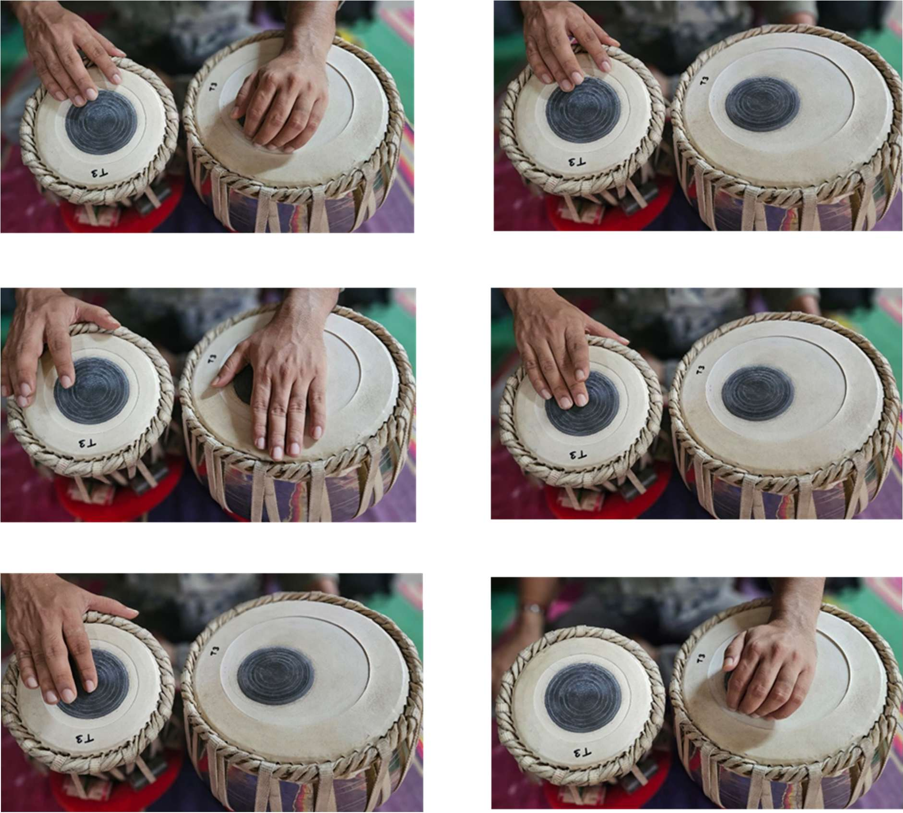
Figure 1 – Hand Position for syllable ‘dhā’
Figure 2 – Hand Position for syllable ‘nā’
Figure 3 – Hand Position for syllable ‘tin’
Figure 4 – Hand Position for syllable ‘ti’
Figure 5 – Hand Position for syllable ‘tā’ Figure 6 – Hand Position for syllable ‘gh’
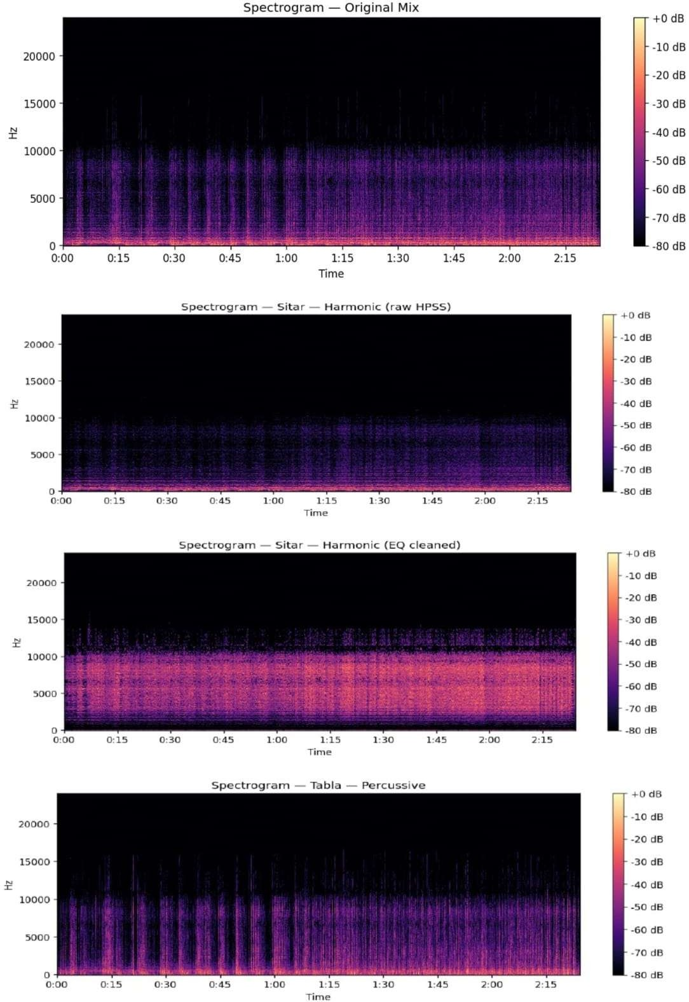
Figure 7 – Tabla and Sitar audio was processed for spectrogram and frequency analysis with bandstop (notch) Butterworth filter (10–4000 Hz, order 4) is applied post-HPSS to attenuate tabla bleed remaining in the harmonic stem. Tabla energy concentrates in the low-frequency range (~80–250 Hz) and around sharp transients (~2–4 kHz); the notch targets this overlap region.

