Hybrid CNN-Transformer Architecture with Frequency-Modulated Superpixel Tokenization for High-Resolution Remote Sensing Image Segmentation

Viraj Singh
B.Tech in Computer Science and Engineering Greater Noida, India

Neha Bagwari
School of Computing Science and Engineering Galgotias University, Greater Noida, India

Abstract—Remote sensing image segmentation plays an impor-tant role in understanding satellite images for tasks like land clas-sification, environmental monitoring and city planning. However, achieving exact results is challenging because traditional models often do not get balance detail and overall context. Convolutional Neural Network (CNNs) are good at capturing local features, but they miss long-range relationships. It essentially uses a filter (kernel) with shared parameters to achieve feature extraction by computing the weighted sum of the centre pixel and adjacent pixels. On the other hand, transformer-based models capture global information but are comparatively expensive and may lose small details. The transformer divides the input image into patches and adds position encodings.
In this project we combines the strength of both CNNs and transformers. Our project uses a CNN based encoder to capture features and a transformer based decoder to understand global relationships. In addition we introduce a new module called Frequency-Modulated Superpixel Tokenization (FMST), which improved features quality by including frequency informa-tion and decreasing unnecessary data through superpixel-based grouping.
The proposed method improves segmentation accuracy while keeping the computational cost efficient. Analytical results show better performance as compared to existing models, mainly in complex scenarios, producing more accurate boundaries and understandable segmentation maps. This method gives a stabilize and productive solution for high-resolution remote sensing image analysis.
- Introduction
Remote sensing image segmentation is widely used to analyze high-resolution satellite images for several practical applications such as urban planning, land-use mapping, en-vironmental monitoring, and disaster management. However, achieving high accuracy in remote sensing segmentation is still challenging due to issues such as variations in object sizes, similarities between different classes, differences within the same class, and the presence of complex and unclear boundaries.
In now days, Convolutional Neural Network (CNNs) taking more of the parts in semantic segmentation tasks. The models

Hemant Baghel
B.Tech in Computer Science and Engineering Greater Noida, India

that are used in the semantic segmentation such as U-Net and DeepLab have demonstrated strong performance that captures local spatial features very effectively through hierarchical feature extraction. In spite the success, CNN- based model often struggle in modeling long range dependencies that’s why we focus on limited regions. This limitation become more noticeable in remote sensing scenarios, where understanding global context is essential for differentiate between areas that may look visually similar.
To reduce that limitations, transformer based model intro-duced self attention mechanism to capture global relationships an image. Architectures such as SegFormer have shown strong performance by reducing some of the limitations of traditional CNN- based model and giving a global understanding context. However, these methods often require higher computational resources and can face difficulties in preserving fine spatial details, particularly around object boundaries. Furthermore, since remote sensing are usually high in resolution, processing a large number of tokens in transformer-based architectures becomes computationally expensive.
In this work, we present a hybrid model that combines CNN-based feature extraction with transformer-based global context learning for remote sensing image segmentation. The key contribution of this approach is the introduction of a Frequency-Modulated Superpixel Tokenization (FMST) mod-ule, which improves feature quality by adding frequency infor-mation and reducing redundancy using superpixels. The model uses a ConvNeXt encoder to extract multi-scale features, which are then refined through the FMST module before being processed by a transformer decoder for better global understanding.he refined features are passed to a transformer-based decoder, which captures global dependencies across the image. In addition, the use of the FMST module helps reduce unnecessary computations by minimizing redundant features. The main contributions of this work can be summarized as follows. First, we introduce a Frequency-Modulated Super-

pixel Tokenization module for improving feature representa-tion. Second, we develop a hybrid CNN-transformer archi-tecture that effectively combines local and global informa-tion. Third, we achieve improved segmentation performance, especially in complex remote sensing scenarios. Finally, we provide experimental results to demonstrate the effectiveness of the proposed method.
- Related Work
- CNN-Based Segmentation
CNN are used for the segmentation of the images because they understand the pattern of images.Earlier models such as FCNs were used for improving the things by replacing the connected layer with convolution layers.The use of this net-work allowed to make predictions for every pixel of an image and work with different size of images. Later, models such as SegNet and U-Net were made for the better segmentation by using different structures of encoding and decoding.The encoders were used for reducing the size of the images and learn their important features while the work of the decoder was to create detailed map for segmentation.Unit also use skip connection which helps in improving accuracy and transferring important details from encoder to decoder whereas SegNet pooled information from encoder to guiding the decoder and helps to preserve structure. However, the models based on the CNN have still limitations. They are mainly focusing on small areas of images, so they are struggling for understanding the relationship of long-range or full picture .Even if they are using the deeper network, it is harder for them to capture the context which is globally used.This is the reason that they are facing difficulty for complex images, especially when an object is larger or different size and appearance or look similar.
- Transformer-Based Approaches
The models based on transformer such as CNNs are recently becoming a strong alternative for image-related tasks. Origi-nally ,they were succesfull in Natural Language Processing, and now different models of Vision Transformer uses a tech-nique known as self-attention for understanding relationship between different part of images. CNNs, focuses on nearby pixel using filters whereas transformer can directly compare and connect different parts of images. This helps in capturing the relationships of long-range as well as understanding the overall context of images more efficiently. Vision Transformers are used for dividing the images into small and fixed patches and later on, these patches are being flattened to be treated like tokens which is similar to the words in sentence. After that, the tokens are passed through various layers of self-attention and metworks feed-forward . This process is used in model to learn about the global featuring and understanding an entire image more accurately. With the help of this idea, the advanced models such as SegFormer which uses transformer hierarchically and decoding the layers which are ligtweight. This helps in making it more reliable which various tasks such as semantic segmentation, where predictions are required for each pixel. this model performing well because they are used
for combining information from various features. However, the models based on transformer has their own limitation. The mechanism of self-attention needs too much computation, especially when patches are larger. It is used to make them slower and resource-heavy for images of high-resolution which are used for remote sensing. Also, because the image is divided into different patches, some details may be lost. This is usedn for affecting a model’s ability for detecting smaller objects and maintaining sharp boundaries. Because of this, even the transformer are too good to understand a full image, they have to struggle with localization unless the additional improvement is made.
- Hybrid Architectures
Recently, Hybrid acchitectures which combines CNNs and transformers have become very popular for semantic segmen-tation. This approach tru to use the strengths of all methods–CNN is good for capturing the features such as textures abd edges locally, while transformer is good for understanding the entire image context.After joining them,hybrid model overcome the limitations for using only one method. Basically they use firstly, CNN based encoder for extracting features from input image. The encoder is effective for capturing the low-level detail such as edges,spatial pattern and textures and it does efficiently with minimum computational cost. These features are then passed to transformer modules which is used to understand the relationship between different part of image, even if they are too far.
- Proposed Methodology
- Overall Framework
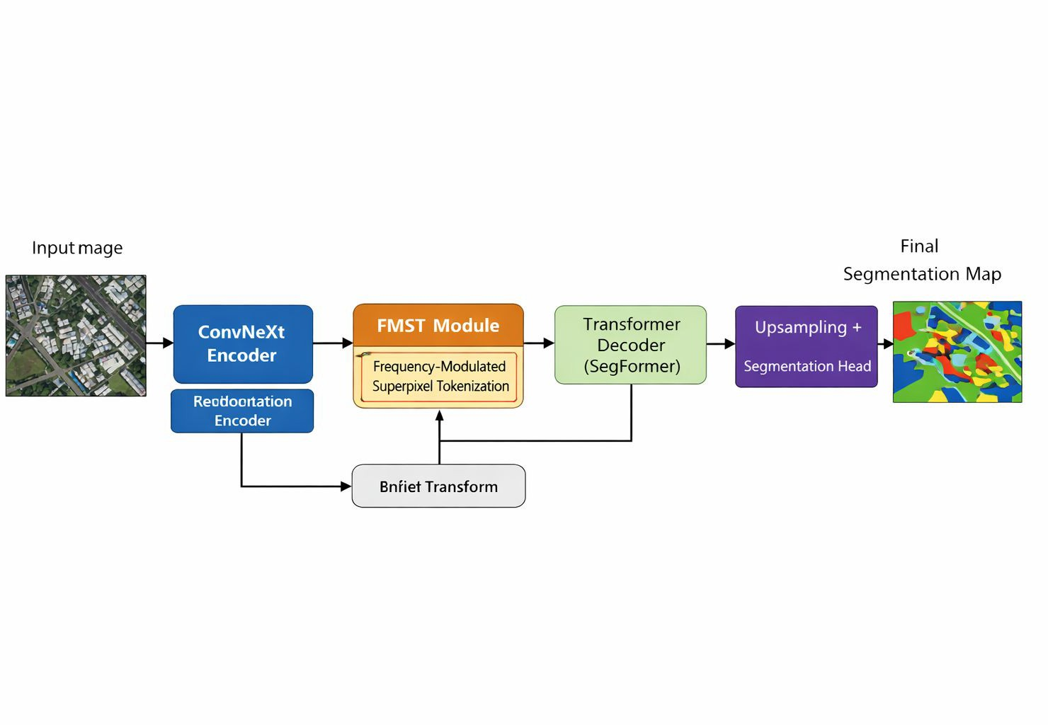

Fig. 1. Proposed Hybrid CNN-Transformer Architecture with Frequency-Modulated Superpixel Tokenization (FMST) module.

Fig. 1 illustrates the overall architecture of the proposed hybrid CNN-Transformer model. The input image is first processed using a ConvNeXt encoder to extract multi-scale features. These features are refined using the FMST module, which reduces redundancy and enhances feature representa-tion. The refined tokens are then passed to a transformer-based

decoder for global context modeling, followed by upsampling to produce the final segmentation map.
The proposed system is designed to combine the advantages of both CNNs and transformers in a simple and effective way. It is made up of three main parts:
  - CNN based encoder :- First step, the input image is passed through the CNN encoder, which acts as an scan-ner fro visual details. By analyzing small, specific areas of the picture, it breaks the image down into fundamental details such as edges, shapes, textures, and patterns.
  - Frequency Modulated Superpixel Tokenization (FMST) module :- Following encoder, the FMST module prepares the data for the transformer by arranging it. It groups the pixels into superpixels to remove repetitive information and highlights detailed patterns, making the whole process much faster and easier for the computer to handle.
  - Transformer based decoder :- In the last step, the data reaches to the transformer decoder. It uses ”self attention ” to look at the whole picture at once which ensures it understand how distant elements interact with each other. The model becomes highly accurate at arranging and or-dering, even in highly complex or diverse environments.
- CNN Encoder
The process starts with the ConvNeXt encoder, acts like a smart scanner. It analyzes the image in progressive stages: early layers detect basic elements like edges and textures, while deeper layers identify complex structures and regions. By analyzing the image at multiple zoom levels, it captures objects of all sizes and gathers the necessary local data for the next stages of the model.
- Frequency-Modulated Superpixel Tokenization (FMST)
The Frequency Modulated Superpixel Tokenization (FMST) module serves as foundation of this architecture, specifically designed to bridge the gap between high resolution image data and the computational power analyzing identical neighboring pixels one by one.
  - Superpixel Grouping:- Instead of forcing the computer to look at every single pixel in isolation, it lumps sim-ilar colors and textures together into superpixels. For Example:- a large patch of uniform sky is grouped together. This reduces data redundancy.
  - Frequency Enhancement:- While grouping the pixels can sometimes can cause a model to lose details. To avoid this, the module shifts into frequency domain. Which spot where rapidly changes like the sharp edge of an object or the rough texture of a fabric. This ensures that even though the data is being compressed and fine grained details of the image are preserved and highlighted .
  - Token Reduction:- The Standard visual transformers suf-fer from high Computational costs due to the number of input tokens. By converting Raw pixels into superpixels and enriching them frequency data, the FMST module reduces the total number of the tokens that needs to be
processed. This makes the transformer run much faster and require far less memory.
- Transformer Decoder
While the CNN encoder extract local details but lacks to see the entire image at once. The transformer decoder is used to resolve this problem. It is achieves through a mechanism called Self Attention. Not just looking at the nearby pixels, the self attention mechanism uses mathematically which compares every data token with every other in the image. It allows the model to make highly detailed decisions about the objects boundaries, resulting in significantly sharper, cleaner, and more accurate segmentation.
- Experimental Setup
- Dataset
Here we use a standard dataset like LoveDA to shown the consistency , that helps researchers to easily compare their new model’s functioning directly against existing models like U-Net or SegFormer under the exact same conditions.
Remote sensing imagery is very complex to analyze than regular photos because of variations in scales, complex bound-aries , and objects shown similar from above. Additionally the datset shown the images from both Urban and Rural areas that helps users to differentiate between a paved road and a dirt path to easily identify the difference in land-use .
Likely, it helps the researchers by using this data if their Proposed Model could accurately outline these different cate-gories
- Evaluation Metrics
Performance is measured using:
  - Intersection over Union (IoU):- In this research, we would easily describe IoU as a method of calculation. Also we can say the ratio of two similar index like area of overlap to the area of union that differentiate prediction segmentation map and the ground truth label. The way which is more common to measure the accuracy of the prediction done by ai with the real-world outline is the IoU. Intersection over Union (IoU) measures the overlap between the predicted segmentation and the ground truth. It is defined as the ratio of the intersection area to the union area of the predicted and ground truth regions. A score of 1.0 means that the AI is prefectly outlining the area.In this study the proposed model is achieved by an IoU of 0.66, and then outperformed by the older U-Net model i.e. 0.52.
  - F1-Score:- The F1-score is balance between more than one thing i.e. the preceision and recall. Concept: If AI is ”trigger-happy” and mark everything as ”building” then its recall would be high, but the precision would be low. The F1-score make sure that the Ai is accurate and thorough. Goal: This proposed model reaches the F1-Score of 0.80, which shows it has a better balancing of these factors than baseline models

  - Pixel Accuracy:- The simplest metric which is used for representing the percentage of total pixels and identified by ai correctly. Concept: If image has 100 pixel and the ai is correctly identifying 85 of them then the category is right (e.g: road or water), its accuracy must be 85Goal; This study shows a proposed model which reaches 0.85
i.e. 85
- Implementation Details
This model training is proposed by a systematic cycle designed to refine the ability of ai to interpret a complex satellite image. It is used for utilizing the Adam Optimizer, an algorithm which acts as digital guide, adjust the model of internal setting to minimize error on the basis of learning rate of 0.001. this specific rate ensures that a model learns at a steady, stable and is not so fast that it miss details, it is not so slow to become inefficient . The training conducts on a GPU system, which is used for providing the massive parallel processed power and requires to handle a high-resolution data which is founded in LoveDA dataset. For ensuring that the model understands the pattern geographic rather than memorizing specific image. The argument of data is applied artificially vary training sample. While whole process repeats for 10 epochs for maximizing the performance.
- Results and Discussion
A. Quantitative Analysis
The performance of the proposed model is compared with baseline models including U-Net, DeepLab, and SegFormer using standard evaluation metrics.

TABLE I
Comparison with Existing Models

Model | IoU | F1-score | Accuracy
U-Net | 0.52 | 0.68 | 0.78
DeepLab | 0.60 | 0.75 | 0.82
SegFormer | 0.63 | 0.78 | 0.84
Proposed (FMST-Net) | 0.66 | 0.80 | 0.85

As shown in Table I, the proposed model achieves superior performance across all evaluation metrics. The improvement is particularly significant in terms of IoU and F1-score, indi-cating better boundary delineation and class-wise prediction accuracy.
An ablation study shows that removing the FMST module results in a noticeable drop in performance, confirming its importance in enhancing feature representation.
- Conclusion
This CNN-Transformer is approaching with superpixel tookenisation based on frequency-module which provides it an effective solution for remote sensing segmentation of high-resolution. The CNNs are captured for combining local details and to understand transformer of global context, this model is used for achieving a powerful and balanced representation of image. The tokenization based on superpixel is used for enhanching with frequency information, it helps to reduce the
computational complexity for preserving important structural detail. As a result, The approach is used for improving the accuracy of segementation, especially with large variation scale and apperance for complex scenes. It is also used for addressing the traditional CNN as well as transformer model which makes it efficient and reliable for data of high-resolution.Overall , the hybrid method is used for representing a direction which is promising for future and real-world prob-lem and applications in remote image sensing and advanced analysis of images wheather the image is easier or complex.
Acknowledgement
I would like to thank my guide for thier valuable time and guidance for supporting this work. Their encouragement and insights helped me to understand this concept of transformer, hybrid architectures and CNNs more efficiently. I am thankful to my institute for providing them necessary resources to complete this study successfully.
References
- O. Ronneberger, P. Fischer, and T. Brox, “U-Net: Convolutional Net-works for Biomedical Image Segmentation,” in Proc. MICCAI, 2015,
pp. 234–241.
- V. Badrinarayanan, A. Kendall, and R. Cipolla, “SegNet: A Deep Convolutional Encoder-Decoder Architecture for Image Segmentation,” IEEE Trans. Pattern Anal. Mach. Intell., vol. 39, no. 12, pp. 2481–2495, 2017.
- J. Long, E. Shelhamer, and T. Darrell, “Fully Convolutional Networks for Semantic Segmentation,” in Proc. CVPR, 2015, pp. 3431–3440.
- L.-C. Chen et al., “DeepLab: Semantic Image Segmentation with Deep Convolutional Nets, Atrous Convolution, and Fully Connected CRFs,” IEEE Trans. Pattern Anal. Mach. Intell., vol. 40, no. 4, pp. 834–848, 2018.
- E. Xie et al., “SegFormer: Simple and Efficient Design for Semantic Segmentation with Transformers,” in Advances in Neural Information Processing Systems (NeurIPS), 2021.
- E. Maggiori et al., “Convolutional Neural Networks for Large-Scale Remote-Sensing Image Classification,” IEEE Trans. Geosci. Remote Sens., vol. 55, no. 2, pp. 645–657, 2017.
- X. Zhu et al., “Deep Learning in Remote Sensing: A Comprehensive Review,” IEEE Geosci. Remote Sens. Mag., vol. 5, no. 4, pp. 8–36, 2017.
- Z. Liu et al., “ConvNeXt: A ConvNet for the 2020s,” in Proc. CVPR, 2022.

