FROM COLONIAL ARMIES TO CONTEMPORARY COUNTERINSURGENCY: MILITARY INSTITUTIONS, STATE FORMATION, AND CONFLICT GOVERNANCE IN CAMEROON, 1884–2025.

ABSTRACT
This article examines the historical evolution of military institutions in Cameroon from German colonial rule in 1884 to contemporary counterinsurgency operations in 2025. It studies how colonial military structures, originally created for conquest, territorial control, and political administration, influenced the formation of postcolonial defence institutions and continue to shape modern approaches to conflict governance. Using a historical comparative methodology, the study analyses archival records, colonial administrative documents, government decrees, military texts, constitutional documents, and secondary scholarly sources to trace the transformation of Cameroon’s military institutions across three periods: colonial rule (1884–1960), post-independence state formation (1960–2016), and contemporary security crises (2016–2025). The findings reveal enduring institutional continuities, including centralized command systems, internal security responsibilities, and militarized approaches to political challenges. The article contributes to African military history and security studies by demonstrating how colonial legacies continue to influence contemporary counterinsurgency strategies against Boko Haram and armed separatist movements in the Northwest and Southwest regions. It concludes that sustainable peace requires combining military professionalism with political dialogue, accountability, civilian protection, and inclusive governance reforms.
KEYWORDS: Military Institutions, Colonial Legacies, Counterinsurgency, State Formation, Cameroon
1. INTRODUCTION
The history of military institutions in Cameroon is inseparable from the broader processes of colonial conquest, state formation, political authority, and conflict governance. From the establishment of German colonial rule in 1884 to contemporary counterinsurgency operations in 2025, armed forces have remained central to the exercise of state power and the organisation of security. In most African colonial contexts, military institutions were not created primarily for external defence but for territorial conquest, the suppression of resistance, taxation enforcement, and the consolidation of imperial authority (Tilly, 1990; Bayart, 1989). Cameroon reflects this pattern in a particularly continuous way due to successive colonial regimes and strong postcolonial institutional inheritance.
The formal establishment of German Kamerun followed the signing of protection agreements between German representatives and coastal chiefs in July 1884, culminating in the proclamation of German sovereignty on 14 July 1884 (Deutsche Kolonialgesellschaft, 1884). Colonial rule quickly relied on military force to extend control inland through expeditionary campaigns led by the Schutztruppe, a colonial military force designed for coercive administration rather than conventional warfare. Officers such as Hans Dominik played a central role in these campaigns, which combined military operations with punitive expeditions and territorial pacification (Morlang, 2014). The military thus became the foundational instrument of colonial governance in Cameroon.
Following Germany’s defeat in the First World War, Cameroon was placed under League of Nations mandate in 1919 and divided between French and British administration (League of Nations, 1922). French Cameroun developed a centralized security system supported by colonial troops (tirailleurs sénégalais) and administrative policing structures, while British Southern Cameroons operated under indirect rule with a lighter military footprint but strong reliance on local authorities (Le Vine, 1964). Despite differences in administrative style, both systems maintained the principle that internal order depended on coercive capacity and surveillance.
At independence on 1 January 1960, Cameroon inherited fragmented colonial military structures that required rapid reorganization into a national defence system. Under President Ahmadou Ahidjo, the military became a central pillar of state consolidation and political stability (Joseph, 1978). Key legal and institutional instruments, including early defence legislation such as Law No. 67/LF/9 of 12 June 1967 on national defence organisation, formalized the structure of the armed forces within a highly centralized executive system. The military also played a decisive role in internal security operations during the conflict involving the Union des Populations du Cameroun (UPC), which marked one of the earliest postcolonial insurgencies.
The post-Ahidjo period under President Paul Biya further reinforced the military’s central role in internal governance. The attempted coup of April 6th, 1984 highlighted the political sensitivity of military control within the state structure (Bayart, 1989). Subsequent reforms, including Decree No. 2001/177 of 25 July 2001 reorganizing the armed forces, reflected efforts to modernize defence institutions while maintaining centralized command authority.
From 2013 onward, Cameroon’s military entered a new operational phase with the escalation of Boko Haram attacks in the Far North, requiring counterterrorism and border security operations (International Crisis Group, 2016). More significantly, the outbreak of the Anglophone Crisis in 2016 transformed internal dissent into armed conflict in the Northwest and Southwest regions, involving separatist groups and extensive military deployment (Konings & Nyamnjoh, 2003). Military operations in these regions have been characterised by counterinsurgency strategies, population control measures, and contested civil–military relations.
The increasing role of the armed forces in domestic security raises important analytical questions about continuity and change in Cameroon’s military governance. Although contemporary threats differ from colonial conditions, significant institutional continuities remain visible, particularly in centralized command structures, intelligence-led governance, and the framing of political crises as security threats. These continuities suggest that contemporary counterinsurgency practices are historically embedded rather than purely reactive.
This article therefore examines the evolution of Cameroon’s military institutions from 1884 to 2025, arguing that colonial military structures created durable institutional patterns that continue to shape postcolonial state formation and conflict governance. It addresses how colonial armies influenced national military development, how postcolonial regimes adapted inherited structures, and how contemporary security crises reflect long-term institutional trajectories.
2. THEORETICAL FRAMEWORK
This study is grounded in historical institutionalism, civil–military relations theory, and security governance approaches in order to explain the long-term evolution of military institutions in Cameroon and their role in state formation and conflict management. Historical institutionalism provides the main explanatory framework, arguing that institutions created at critical historical moments tend to persist through path dependency even when political systems change (Tilly, 1990). In Cameroon, colonial military structures established under German rule in 1884 created centralized coercive systems oriented toward territorial control rather than external defence. These structures were inherited and adapted by French and British colonial administrations and later by postcolonial governments, producing continuity in command hierarchies and internal security functions.
Civil–military relations theory further explains how the armed forces interact with civilian authority. While Huntington (1957) emphasises professional separation between military and civilian spheres, Cameroon reflects a different trajectory where the military has remained closely integrated into domestic governance due to its colonial legacy as an internal control instrument. This has reinforced strong executive control over the armed forces under successive administrations.
Security governance theory complements these perspectives by highlighting how states manage insecurity through combined military, administrative, and political mechanisms rather than military force alone. In Cameroon, responses to Boko Haram and the Anglophone Crisis illustrate a hybrid security approach where military operations coexist with administrative and political measures, though persistent grievances limit long-term effectiveness. Together, these frameworks show that Cameroon’s contemporary counterinsurgency practices are historically rooted in colonial military systems and sustained through postcolonial institutional continuity.
3. METHODOLOGY AND SOURCES
This study adopts a qualitative historical methodology, grounded in historical institutionalism in order to examine the evolution of military institutions in Cameroon, from 1884 to 2025. The approach is designed to trace long term institutional change and continuity by analysing how colonial military systems were established, adapted and reproduced in the postcolonial period, and how they continue to shape contemporary counterinsurgency practices. The research relies primarily on documentary and archival analysis. Drawing on colonial administrative records, German Schutztruppe reports, French and British colonial archives, League of Nations mandate documents, and post independence government materials, the study reconstructs the development of military institutions across three historical phases. These include the German colonial period, the Anglo French mandate and trusteeship period, and the postcolonial era of independent Cameroon. Additional sources include constitutional texts, defence legislation, presidential decrees, military restructuring policies and official security reports.
Key legal and institutional documents consulted include the 1884 protection treaties signed during the German annexation of Cameroon, the League of Nations Mandate of 1922 establishing Anglo French administration, the Constitution of Cameroon of 1961, the 1972 unitary state constitution, the 1996 constitutional revision Law No 67 LF 9 of 12 June 1967 on national defence organisation, and Decree No 2001 177 of 25 July 2001 reorganizing the armed forces. These documents are used to identify shifts in institutional design command structures and civil military relations over time.
Secondary literature is also used to complement primary sources, particularly scholarly works on African military history, colonial governance, state formation and conflict studies. This includes historical analyses of colonial armies, postcolonial state building and security sector transformation in Africa which provide interpretive frameworks for understanding Cameroon’s military evolution. Methodologically, the study follows a chronological and comparative design. The chronological dimension allows for the reconstruction of institutional development across time, while the comparative dimension highlights continuities and changes between colonial and postcolonial military systems. This dual approach makes it possible to identify patterns of institutional persistence, especially in centralized command structures, internal security roles and militarized governance practices. Overall, the methodology combines historical reconstruction with institutional analysis to demonstrate how Cameroon’s contemporary security challenges are deeply rooted, in long term historical processes rather than isolated political events.
4. GERMAN KAMERUN AND THE FORMATION OF COLONIAL MILITARY POWER 1884–1916.
The establishment of German colonial rule in Cameroon marked the beginning of formalized military governance in the territory and laid the institutional foundations for later security structures in the postcolonial state. The process began with the signing of protection treaties between German representatives and coastal chiefs, in July 1884 and the proclamation of German sovereignty on 14 July 1884, which initiated a system of colonial rule grounded in coercion and expeditionary military control (Deutsche Kolonialgesellschaft, 1884). From the outset, German authority relied less on negotiated governance and more on military enforcement as the principal mechanism of territorial consolidation.
Early colonial administration combined civil governance with military operations. The appointment of Governor Julius von Soden in 1885 marked the beginning of structured colonial administration in Cameroon. However, even under his leadership, expansion into the interior depended heavily on military expeditions to suppress resistance and secure control over trade routes and local political entities. This fusion of administration and coercion reflected broader German imperial strategy, where military force was considered essential for establishing authority in overseas territories (Tilly, 1990).
The core instrument of German military power was the Schutztruppe für Kamerun, established in the early 1890s. This force consisted of German officers commanding African soldiers, recruited locally and from other colonial regions. It was designed as a mobile expeditionary force rather than a conventional standing army, reflecting German colonial doctrine that prioritized rapid deployment, punitive expeditions, and territorial pacification. The Schutztruppe operated under the authority of colonial governors but was effectively controlled by senior military commanders on the ground.
Among the most influential military figures in German Kamerun was Captain Hans Dominik, who later became a major and led extensive campaigns in the Bamenda Grassfields and northern regions. Dominik’s operations were characterised by punitive expeditions, village destruction, forced submission, and hostage-taking practices that were typical of German colonial warfare strategies (Morlang, 2014). His campaigns significantly expanded German territorial control but also entrenched coercive governance practices that shaped later colonial and postcolonial security approaches.
Another key figure was Governor Jesko von Puttkamer, who served multiple terms between 1895 and 1907. Puttkamer promoted aggressive military expansion and supported repeated punitive expeditions against resistant communities. His administration reinforced the integration of military authority and civil governance, making coercive force a routine instrument of colonial administration. Although criticized even within German imperial circles for excessive brutality, his policies contributed significantly to the consolidation of German rule across much of Cameroon.
Colonial military governance was further shaped by metropolitan officials such as Bernhard Dernburg and Wilhelm Solf, who attempted administrative reforms in the late colonial period. These reforms sought to regulate military excesses and introduce more systematic governance structures, yet they did not fundamentally alter the reliance on coercive force as the backbone of colonial authority. Military stations were established in strategic locations such as Douala, Yaounde, and Bamenda, forming a network of fortified posts that combined administration, surveillance, and rapid military deployment.
The First World War (1914–1916) marked the collapse of German military rule in Cameroon. Under Governor Karl Ebermaier and military commander Carl Zimmermann, German forces resisted Allied invasion by British, French, and Belgian troops. Despite initial resistance, German Kamerun fell in February 1916, ending colonial German military authority in the territory (Morlang, 2014). However, the institutional legacy of German military organisation, including centralized command structures and coercive administrative practices, persisted beyond the colonial period and influenced subsequent French and British rule.
Overall, the German colonial period established key patterns of military governance in Cameroon. These included centralized command authority, reliance on punitive expeditions, integration of African soldiers into colonial armies, and the use of permanent military stations for territorial control. These patterns became deeply embedded in the colonial state and later influenced both French and British administration as well as postcolonial military institutions (Tilly, 1990).
5. THE FIRST WORLD WAR AND THE TRANSFORMATION OF MILITARY AUTHORITY 1914–1960.
The First World War marked a decisive rupture in Cameroon’s colonial military order as German authority was dismantled and replaced by Anglo French administration. Between 1914 and 1916 German Kamerun became a theatre of war, between German colonial forces led by Governor Karl Ebermaier and military commanders, such as Carl Zimmermann and invading Allied forces, composed of British French and Belgian troops. The German Schutztruppe initially adopted a strategy of tactical withdrawal into the interior, relying on mobile resistance units, however, sustained Allied pressure eventually led to the collapse of German positions in February 1916, ending German colonial military rule in Cameroon (Morlang, 2014).
Following Germany’s defeat, Cameroon was placed under the League of Nations mandate system in 1919, and formally divided into French Cameroun and British Southern Cameroons. This arrangement was confirmed in the 1922 mandate agreements, which required administering powers to govern in the interest of local populations, while effectively maintaining colonial control (League of Nations, 1922). Military governance did not disappear under this system, but was reorganized under new colonial administrations that continued to rely on coercive policing, intelligence networks, and military expeditionary operations as central instruments of territorial control.
In French Cameroun, the colonial administration established a centralized security system, combining French military units, colonial administrators and African soldiers known as tirailleurs sénégalais. These forces were deployed for internal security, border control and suppression of resistance movements. The French colonial military system was closely integrated with administrative governance, reflecting a doctrine in which political authority and military power were mutually reinforcing (Le Vine, 1964). One of the most significant developments during this period was the expansion of intelligence gathering systems and colonial policing structures, which enabled surveillance of political mobilization and nationalist activity.
The rise of nationalist movements in the late colonial period significantly reshaped military governance. The Union des Populations du Cameroun (UPC), led by Ruben Um Nyobe, emerged in the late 1940s as a major independence movement, demanding reunification and sovereignty. The colonial administration responded with increasing repression, particularly after the banning of the UPC in 1955, which escalated into armed conflict in parts of French Cameroun, especially the Sanaga Maritime region. French military, colonial police and local auxiliaries conducted coordinated counterinsurgency operations, combining military force intelligence penetration and population control strategies (Joseph, 1978).
The killing of Ruben Um Nyobe in September 1958, represented a turning point in the suppression of the UPC insurgency, and demonstrated the central role of military force in managing political opposition during the late colonial period (Joseph, 1978). French counterinsurgency strategies during this period included village regroupment, forced relocation, intelligence, infiltration and targeted elimination of resistance leadership, practices that closely mirrored broader French colonial warfare doctrines used in Algeria and Indochina.
In British Southern Cameroons the military presence was comparatively limited due to the policy of indirect rule. However security governance was maintained through colonial police forces, district officers and traditional authorities who exercised delegated administrative control, while less militarized than the French zone, British administration still relied on coercive authority to regulate political activity and maintain order (Le Vine, 1964). These contrasting colonial systems created different administrative cultures and security expectations that later influenced postcolonial governance tensions after reunification.
The transition to independence in 1960, did not dismantle colonial military structures, but transformed their institutional form. French Cameroun gained independence on 1st of January, 1960, followed by reunification with British Southern Cameroons, in 1961 under a federal arrangement. The newly independent state inherited fragmented colonial security systems that required rapid integration into a national army. Under President Ahmadou Ahidjo the military became a central institution for state consolidation, national unity and regime stability (Joseph, 1978). One of the most important postcolonial security challenges was the continued armed resistance of remnants of the UPC insurgency, which persisted into the early 1960s. The new state responded with military operations that reproduced many colonial counterinsurgency techniques, including intelligence led operations, population control and targeted military campaigns. This continuity demonstrates how colonial military doctrines were not dismantled at independence but adapted within postcolonial state structures.
The legal foundation for the national military was progressively established through key institutional reforms, including Law No 67 LF 9 of 12th June 1967, on national defence organisation, which formalized the structure of the armed forces under centralized executive control (Government of Cameroon, 1967). This legislation reinforced presidential authority over the military and institutionalized the integration of defence policy within the executive branch, thereby consolidating the military as a central pillar of state power. Overall the period from 1914 to 1960 illustrates both rupture and continuity in Cameroon’s military history. While German colonial rule was replaced by French and British administration the underlying logic of coercive territorial control remained consistent. The postcolonial state inherited these institutional frameworks, and adapted them to new political conditions, thereby embedding military governance within the foundations of national authority.
6. INDEPENDENCE AND THE CONSTRUCTION OF THE CAMEROONIAN ARMED FORCES 1960–1982.
The attainment of independence in French Cameroun on the 1st of January, 1960, and the subsequent reunification with British Southern Cameroons in 1961 marked a critical transition in the history of military institutions in Cameroon. However, this political transformation did not correspond to a radical restructuring of the inherited colonial security apparatus. Instead, the new state inherited fragmented military formations, administrative policing structures and intelligence systems that had been shaped by decades of German, French and British colonial rule (Le Vine, 1964).
The first postcolonial government under President Ahmadou Ahidjo prioritized state consolidation, national unity and internal security over rapid military restructuring. In this context the armed forces were not conceived solely as instruments of external defence but as central pillars of regime stability and territorial integration. The early postcolonial military was therefore shaped by the dual challenge of nation building and counterinsurgency, particularly in response to internal resistance movements that had emerged during the late colonial period (Joseph, 1978).

One of the most significant challenges faced by the new state was the continuation of the UPC insurgency, which had originated under colonial rule and persisted into the early years of independence. The UPC operated in several regions including Sanaga Maritime and parts of the Centre and Littoral areas. The government response combined military operations, intelligence gathering and population control measures, in ways that closely mirrored French colonial counterinsurgency practices. The killing of Ruben Um Nyobe in 1958 had already weakened the movement but armed resistance continued into the early 1960s, requiring sustained military engagement (Joseph, 1978).
In order to consolidate control over the armed forces the, Ahidjo administration implemented a series of institutional reforms, aimed at centralising military command under presidential authority. The armed forces were reorganized into a unified national structure, integrating former colonial units and newly recruited personnel. This process was guided by the principle of executive control over defence policy which reflected both colonial administrative inheritance and the political priorities of the new state.
A key institutional development during this period was the adoption of Law No 67 LF 9 of 12 June, 1967, on national defence organisation, which formalized the structure of the armed forces and reinforced their subordination to the presidency Government of Cameroon 1967. This legal framework established the Ministry of Defence as a central coordinating institution, while ensuring that ultimate command authority remained with the head of state. This arrangement entrenched a highly centralized civil military structure that limited institutional autonomy of the armed forces.
The military also played an important role in maintaining territorial integrity, and managing political opposition during the Ahidjo era. The state faced several attempted coups, and internal dissent including the 1964 coup attempt which reinforced the leadership’s perception of the military as both a security asset and a potential political threat. As a result military appointments, promotions and deployments were closely monitored by the executive, to ensure loyalty and prevent factionalism within the armed forces. Training and organisational development during this period remained heavily influenced by French military doctrine. Cameroon maintained close defence cooperation with France, which provided training equipment and advisory support. French military presence and influence ensured continuity in operational doctrine, particularly in counterinsurgency strategy, intelligence operations and hierarchical command structures. This external influence reinforced existing colonial legacies within the Cameroonian armed forces while also facilitating their professionalization (Le Vine, 1964).
By the late 1970s, the Cameroonian military had become a central institution of state power, responsible not only for national defence, but also for internal security border protection and regime stability. The military’s expanded role reflected broader trends in postcolonial African states, where armed forces often assumed multifunctional responsibilities, in contexts of political consolidation and limited institutional differentiation (Bayart, 1989). The end of the Ahidjo era in 1982 marked a significant political transition but did not fundamentally alter the institutional structure of the armed forces. The military remained central to state authority and continued to operate within a highly centralized command system that reflected both colonial inheritance, and postcolonial political adaptation. Overall, the period from 1960 to 1982, demonstrates that the construction of the Cameroonian armed forces, was not a process of institutional rupture, but rather one of adaptation and continuity. Colonial military structures were reconfigured to serve the needs of the postcolonial state, while preserving core features of centralisation, coercive authority and internal security orientation.
7. MILITARY GOVERNANCE UNDER PAUL BIYA 1982–2016
The arrival of Paul Biya in November 1982 represented an important political transition in Cameroon, but it did not fundamentally change the structure of the military inherited from colonial and early postcolonial systems. Instead of restructuring the armed forces into a fully independent professional institution, the new leadership maintained and strengthened a system where the military remained closely tied to political power and central government authority. This continuity reflects long term institutional patterns, in which coercive institutions were historically designed to protect the state and manage internal order rather than operate independently as in classical civil military separation models discussed by Bayart (1989) and Tilly (1990).
Consolidation of executive control and the 1984 crisis
A major turning point in the early Biya period was the attempted coup of 6 April 1984 carried out by elements within the Presidential Guard, linked to networks associated with former President, Ahmadou Ahidjo. This event revealed deep divisions within the military establishment and raised concerns about loyalty and political fragmentation within the armed forces. The coup was quickly suppressed, but it had a lasting impact on the structure of military governance as it led to widespread restructuring, dismissal of officers considered unreliable, and reinforcement of presidential control over the security apparatus Joseph (1978).
After the coup attempt, President Biya adopted a strategy of tightening control over the armed forces, by ensuring that senior officers were politically loyal and directly dependent on the presidency. Military leadership became less autonomous and more integrated into executive decision making processes. The Ministry responsible for defence was also progressively subordinated to presidential authority which reinforced the centralisation of command Osidimbea (2024).

Institutional restructuring and decrees
Following the 1984 crisis, a series of legal and administrative reforms were introduced to stabilize and reorganize the military structure. One important measure was Decree No 83/1983 which reorganized military regions and strengthened territorial command structures. This reform improved central oversight of military units and reduced the risk of regionalized power bases within the armed forces. Later, Decree No 2001/177 of 25 July 2001 further reorganized the armed forces by clarifying the roles of the army, air force, and gendarmerie under a unified command system controlled by the president as commander in chief. This reinforced a system of centralized decision making where military coordination remained firmly under executive authority.
Plate 1: His Excellency President Paul Biya, Commander in Chief of the Cameroon Armed Force
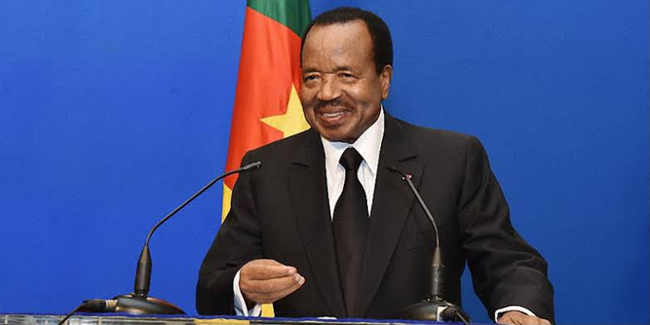
Source: Authors collection January, 2026
Another symbolic but important institutional change occurred in 1985, when the Ministry of Armed Forces was replaced by the Ministry of Defence. This shift was not only administrative but also political, because it signaled a stronger fusion between state leadership and military governance (Osidimbea, 2024).
Key military leadership and command figures
During this period, several senior military officers played important roles in shaping defence policy and internal security structures. General Pierre Semengue served as the first Chief of Staff of the Armed Forces from 1976 to 1993 and provided continuity between the Ahidjo and Biya administrations.
Plate 2: General Pierre Semengue
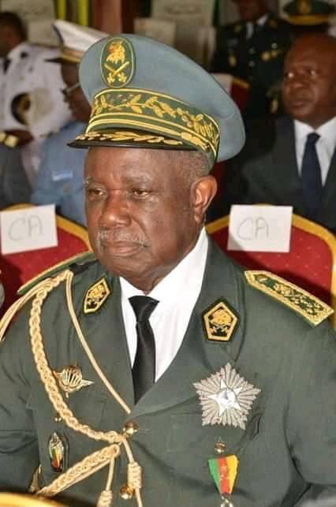
Source: Authors collection January, 2026
Another top military official was General René Claude Meka who became Chief of Staff in 2001 later played a central role in coordinating military operations and professionalizing aspects of the armed forces.
Plate 3: General René Claude Meka
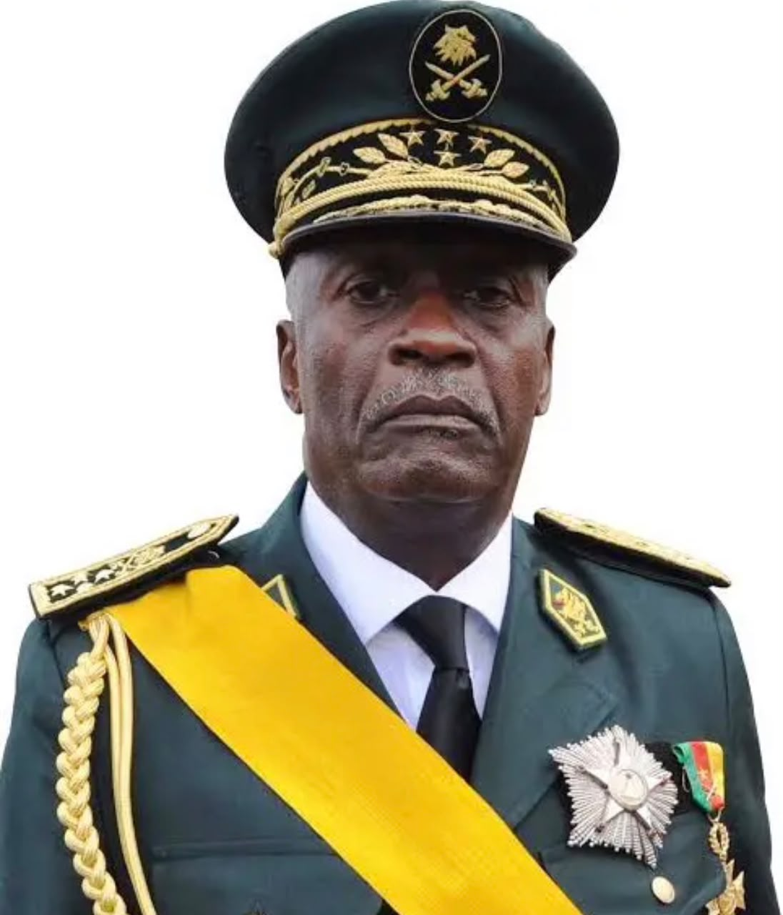Source: Authors collection January, 2026.
Other important figures included General Elokobi Daniel Njock who contributed to internal security restructuring during the 1990s, and senior commanders of the Rapid Intervention Battalion known as BIR, which was created in 2001.
Plate 4: General Elokobi Daniel Njock
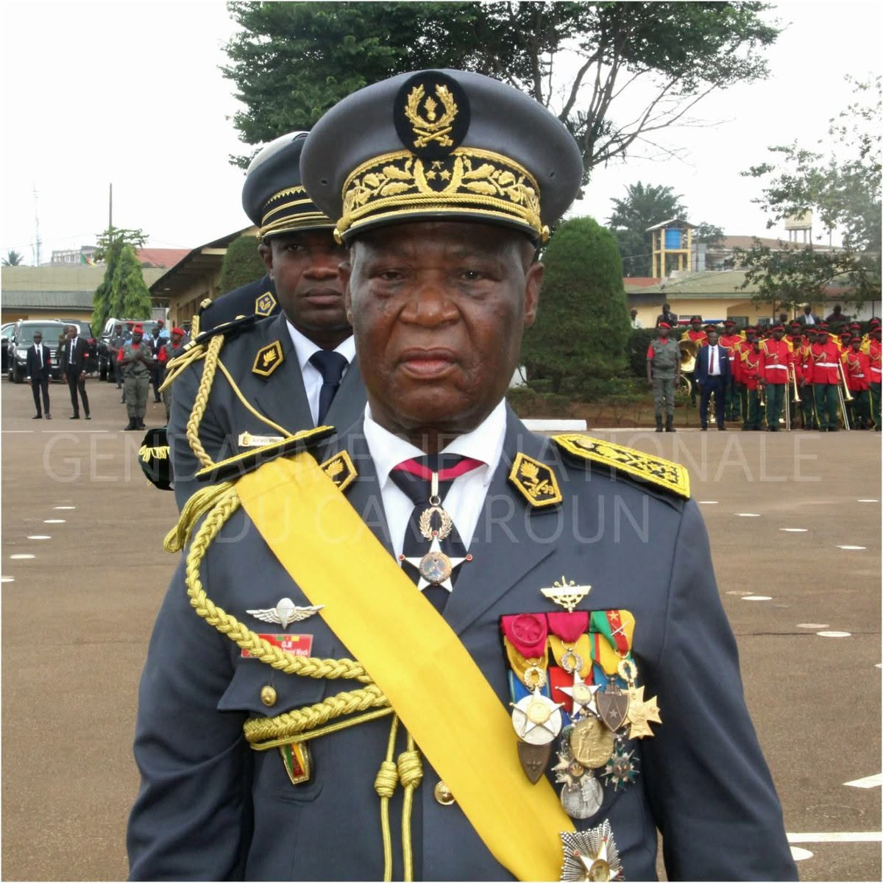Source: Authors collection January, 2026.
The BIR became one of the most important elite forces in Cameroon, especially for counterterrorism and internal security operations and remained directly linked to presidential authority International Crisis Group (2016).
Political liberalisation and securitization of dissent
Although Cameroon introduced multiparty politics in the early 1990s, this did not significantly reduce the role of the military in domestic governance. Instead, the armed forces became increasingly involved in managing political protests, strikes and civil unrest particularly in urban areas. Bayart (1989) explains this as part of a broader pattern in which postcolonial African states, rely on coercive institutions to maintain political order during periods of economic and political uncertainty.
During the 1990s, economic crisis and structural adjustment policies contributed to social tensions, which increased the use of security forces in public order management. Intelligence services and paramilitary units expanded their role in monitoring political opposition which reflected continuity with colonial systems where surveillance and coercion were closely linked.
Emergence of Boko Haram and external security threats
From 2013, Cameroon faced a new security challenge with the expansion of Boko Haram activities from neighbouring Nigeria. The insurgency led to attacks on civilian, military positions and border communities in the Far North region. International Crisis Group (2016) notes that, this situation required large scale military mobilization and cooperation with regional forces from Nigeria, Chad and Niger through joint operations. This conflict strengthened the importance of elite military units such as the BIR, which were deployed for rapid response and counterterrorism operations. However the asymmetrical nature of the conflict exposed weaknesses in intelligence coordination, logistics and civilian protection demonstrating structural limits in the security system despite increased military deployment.
Emergence of the Anglophone Crisis
By the mid 2010s, tensions in the Northwest and Southwest regions had increased significantly due to grievances related to language administration, and political representation. These tensions escalated in 2016, with protests by lawyers and teachers, and later developed into armed conflict following the emergence of separatist groups in 2017. Konings and Nyamnjoh (2003) explain that these tensions are rooted in historical differences between the former British and French colonial territories. The military response involved deployment of ground forces, gendarmerie units and elite battalions, leading to an expanded counterinsurgency operation in the North West and South West regions. This marked a further deepening of the military’s role in internal governance and conflict management.
Overall the period from 1982 to 2016 shows that despite political reforms and institutional changes, the structure of military governance in Cameroon remained highly centralized and closely tied to executive authority. The armed forces continued to play a central role in regime stability, internal security and crisis management. The creation of elite units, expansion of counterinsurgency operations and reliance on presidential decrees all reflect long term continuity in which, military power remains embedded in the political structure of the state rather than operating as an independent professional institution. Bayart (1989) and Tilly (1990) both help explain this continuity as part of deeper historical processes rooted in colonial and postcolonial state formation.
8. CONTEMPORARY COUNTERINSURGENCY AND CONFLICT GOVERNANCE 2016–2024.
The period from 2016 to 2024, represents the most complex phase in the evolution of Cameroon’s military institutions since independence, as the armed forces became deeply involved in simultaneous internal conflicts that reshaped their operational doctrine, institutional priorities and political significance. The emergence of the Anglophone Crisis in 2016 in the Northwest and Southwest regions alongside the ongoing Boko Haram insurgency in the Far North created a dual security environment that required sustained counterinsurgency operations across multiple theatres of conflict (International Crisis Group, 2016).
The Anglophone Crisis originated from protests by lawyers and teachers in late 2016 over issues of linguistic marginalization and administrative inequality within the Cameroonian state. The situation escalated significantly in 2017, when separatist groups began to organise armed resistance, and declared symbolic autonomy in parts of the English speaking regions. The state response involved the rapid deployment of military forces, gendarmerie units and elite intervention battalions under centralized presidential command, reflecting the long standing tradition of executive control over security governance (Konings & Nyamnjoh, 2003).
The military strategy adopted during this period combined territorial control, population security operations, intelligence gathering, and targeted engagements with armed groups. The Rapid Intervention Battalion (BIR), created earlier in 2001 became one of the principal operational forces in both the Anglophone regions and the Far North region, due to its mobility training and direct chain of command to the presidency (International Crisis Group, 2016). This structure reinforced the centralisation of military authority and highlighted the continued importance of elite units in regime security.
The escalation of violence in the Anglophone regions led to widespread displacement, civilian casualties and the destruction of infrastructure further complicating the security landscape. Military operations were often conducted in environments characterised by guerrilla tactics, ambushes and fragmented armed groups which limited the effectiveness of conventional military approaches. The situation highlighted structural tensions between counterinsurgency objectives and civilian protection responsibilities within the armed forces.
At the same time, the Boko Haram insurgency in the Far North continued to shape military operations through cross border attacks, suicide bombings and raids on civilian settlements. Cameroon intensified cooperation with regional partners including Nigeria, Chad and Niger through multinational joint task forces which represented a shift toward regionalized security governance. The military therefore operated within a broader transnational security framework, while maintaining strong domestic command centralisation (International Crisis Group, 2016).
Several presidential and institutional measures were implemented to reinforce military coordination and operational effectiveness, including enhanced budgetary allocations for defence expansion of intelligence services and continued reliance on presidential decrees to manage security structures. Although specific operational directives remained largely confidential, the governance pattern remained consistent with earlier historical phases in which executive authority exercised direct control over military decision making.
Key military leadership figures during this period included General René Claude Meka, as Chief of Staff of the Armed Forces who oversaw strategic coordination of military operations across multiple regions, and senior commanders of the Rapid Intervention Battalion who were responsible for counterinsurgency deployment in both northern and western conflict zones. Their roles reflected the increasing professionalization of operational command structures, while still operating within a highly centralized political system. The prolonged nature of the conflicts from 2016 onward revealed significant challenges in Cameroon’s security governance model. While the military succeeded in maintaining territorial presence in key areas, the persistence of insurgent activity indicated limitations in intelligence integration, civilian engagement and conflict resolution strategies. The reliance on militarized responses to political grievances reinforced historical patterns that can be traced back to colonial administrative systems in which coercion was prioritized over negotiation as a mechanism of governance (Tilly, 1990).
By 2025, the Cameroonian armed forces had become deeply embedded in a complex security environment, characterised by asymmetric warfare, humanitarian crises and overlapping regional threats. The military’s role extended beyond conventional defence to include, governance functions, humanitarian coordination and internal stabilization efforts. This expansion further blurred the boundaries between military and civilian spheres of authority reinforcing long term institutional continuities rooted in colonial military governance.
Overall, the period from 2016 to 2025 demonstrates both adaptation and continuity within Cameroon’s military institutions. While operational strategies evolved to address new forms of insurgency the underlying structure of centralized command, executive control and militarized conflict management remained largely unchanged. The persistence of these patterns underscores the historical argument of this study that contemporary counterinsurgency practices in Cameroon are deeply embedded in long term institutional trajectories, originating in the colonial period.
9. SYNTHESIS OF FINDINGS AND HISTORICAL CONTINUITIES 1884–2025
The historical trajectory of military institutions in Cameroon, from the German colonial period to the contemporary counterinsurgency era, reveals a strong pattern of institutional continuity shaped by successive regimes of coercive governance and administrative centralisation. Across more than a century of political change, the armed forces have remained a core instrument of territorial control, state formation and internal security management, rather than being redefined as a narrowly external defence institution. A first major continuity is the persistence of centralized command structures established during the German colonial occupation from 1884 to 1916. The Schutztruppe system created under Governor Julius von Soden and later military commanders such as Jesko von Puttkamer, and Hans Dominik was based on direct executive control, rapid deployment and punitive expeditions against resistant communities (Morlang 2014). This logic of centralized coercion was later inherited by French and British colonial administrations under the League of Nations mandate system of 1922, which maintained military policing and intelligence networks as key instruments of governance League of Nations 1922.
This structure was further consolidated after independence in 1960 under President Ahmadou Ahidjo, who institutionalized a unified national army through Law No 67 LF 9 of 12 June 1967, which placed the armed forces under direct presidential authority. The continuity of executive control was further reinforced under Paul Biya, particularly after the 1984 coup attempt which led to restructuring and tighter control of military leadership (Joseph, 1978). This demonstrates a long term pattern in which political authority and military command remain fused rather than institutionally separated.
A second continuity is the persistent use of the military for internal security and regime stability rather than external defence. From the UPC insurgency in the 1950s and 1960s, to the Anglophone Crisis from 2016 and the Boko Haram insurgency from 2013, the armed forces have consistently been deployed to manage domestic political and security challenges. This reflects a colonial legacy in which military forces were originally designed for internal pacification, rather than interstate warfare (Tilly 1990).
A third continuity is the increasing reliance on elite military units and intelligence led operations. The creation of the Rapid Intervention Battalion in 2001, under Decree No 2001 177, represents a continuation of this logic by establishing a highly mobile, centrally controlled force directly linked to presidential authority (Government of Cameroon, 2001). The BIR became a key instrument in both counterterrorism operations against Boko Haram and counterinsurgency operations in the Anglophone regions (International Crisis Group, 2016).
A fourth continuity is the integration of military and administrative governance especially in crisis regions. During both colonial and postcolonial periods, military stations functioned not only as security units but also as administrative centres for surveillance, population control and territorial management. This model can be traced back to German fortified posts in Douala, Yaoundé and Bamenda, and continues today in militarized administrative responses to insurgency zones in the Far North and Northwest regions (Le Vine, 1964).
However alongside continuity there are also important transformations. The scale and complexity of modern security threats have expanded significantly particularly with transnational terrorism and identity based armed conflicts. Contemporary military operations now involve regional cooperation, multinational joint task forces and more sophisticated intelligence systems as seen in the fight against Boko Haram. This represents an evolution beyond classical colonial military structures, although still grounded in centralized command logic (International Crisis Group, 2016).
Overall, the synthesis demonstrates that Cameroon’s military institutions are best understood as historically layered structures where colonial foundations remain deeply embedded within postcolonial governance arrangements. The result is a hybrid system in which modern counterinsurgency operations coexist with long standing traditions of coercive state formation and centralized authority.
10. CONCLUSION
This study examined the evolution of military institutions in Cameroon from 1884 to 2025 and demonstrated that, contemporary counterinsurgency practices are deeply rooted in historical patterns of colonial and postcolonial governance. The analysis shows that despite major political transitions, including independence in 1960, reunification in 1961 and political liberalisation in the 1990s, the fundamental structure of military governance has remained remarkably stable. The German colonial period established the foundational model of coercive territorial control through the Schutztruppe, which was later adapted by French and British mandate administrations. The postcolonial state under Ahmadou Ahidjo institutionalized these patterns through centralized military command structures, legally formalized in 1967 and politically reinforced under Paul Biya following the 1984 coup attempt.
Across all historical phases, the military has consistently functioned as a tool of internal security and regime preservation rather than a purely external defence institution. This continuity is evident in responses to the UPC insurgency, the Boko Haram conflict and the ongoing Anglophone Crisis, where military force has been central to state responses to political and security challenges. The study concludes that Cameroon’s military institutions reflect a path dependent trajectory, shaped by colonial inheritance, postcolonial adaptation and contemporary security pressures. The persistence of centralized command structures and militarized governance indicates that, current security challenges cannot be understood without reference to long term historical institutional development.

SOURCES CONSULTED
- Books and articles
Bayart, J.-F. The state in Africa: The politics of the belly. UK: Longman, 1989.
Bongfen Chem-langhee. “The Road to the Unitary State of Cameroon, 1959-1972.” Annals of the Faculty of Arts, letters and Social and Science, Vol VI, No 1&2, 1990: 7-23.
Canute Ambe Ngwa & Mark Bolak Funteh. Crossing the Line in Africa: Reconsidering and Unlimiting the Borders within a Contemporary Value. Bamenda: Langaa RPCIG, 2019.
Confidence Chia Ngam and Reymond Njingti Budi. “The Anglophone question in Cameroon: History Context and Evolution from ‘Everyday’ Resistance to Armed Conflict, 1961-2017.” AFRICANA STUDIA, no. 33 (2020): 3-6.
Deutsche Kolonialgesellschaft. Colonial treaty archives and administrative reports on Kamerun. Berlin Colonial Records, 1884.
Emmanuela, Imasuen. “Insurgency and humanitarian crises in Northern Nigeria: The case of Boko Haram." Academic Journals: African Journal of Political Science and International Relations 9, no 7 (2015): 284-296.
Huntington, S. P. The soldier and the state: The theory and politics of civil–military relations. UK: Harvard University Press, 1957.
International Crisis Group. Cameroon: Confronting Boko Haram. International Crisis Group, 2016.
Joseph, R. A. Gaullist Africa: Cameroon under Ahmadu Ahidjo. Yale University Press, 1978.
Konings, P., & Nyamnjoh, F. B. Negotiating an Anglophone identity in Cameroon. Brill, 2003.
Le Vine, V. T. The Cameroons: From mandate to independence. USA: University of California Press, 1964.
League of Nations. Mandate for the Administration Of Cameroon. Switzerland: Geneva Archives, 1922.
Ngoh VJ. Former Southern Cameroons. The “Third Option” and the Anglophone problem, 1959 2022: A Historico-conflict study. Limbe: Press Print 2023: 165-200.
Ngoh, VJ. History of Cameroon since 1800. Limbe: Press Print, 1996.
Ngwoh. V. K. “An Evaluation of Nation Building Policies in Cameroon since Colonial Times”, Afro Asian Journal of Social Sciences 8, no. 2 (2017): 1-23.
Okoli, Al Chukwuma, and Philip Iortyer. "Terrorism and humanitarian crisis in Nigeria: Insights from Boko Haram insurgency." Global Journal of Human Social Science-GJHSS-F 14, no 1 (2014): 43-54.
Osidimbea. Ministère de la Defense Cameroun: Histoire et organisation, 2024.
Tilly, C. (1990). Coercion, capital, and European states, AD 990–1992. Blackwell.
Zimmermann, C. (1916). Report on military operations in Kamerun. German Colonial Military Archives.
- Decrees/ Circulars/ Constitutions/Archives
Decree No. 2001/177 of 25 July 2001 reorganizing the armed forces
Deutsche Kolonialgesellschaft archives on Kamerun treaties (1884)
Government of Cameroon. Decree No. 2001/177 of 25 July 2001 Reorganizing the Armed Forces, 2001.
Government of Cameroon. Law No. 67/LF/9 of 12 June 1967 on National Defence Organisation, 1967.
Law No. 67/LF/9 of 12 June 1967 on national defence organisation
NAB, CO554/1777, File No. WAF 33/74/02, Movement for Unification of the two Trust Territories of Cameroons, 1961.
The Constitution of the Federal Republic of Cameroon, 1961
The Constitution of the united Republic of Cameroon 1972

