Safe Workplace Initiative: A Workplace Awareness Program

ABSTRACT

The Creating a Safe Workplace Initiative: A Workplace Awareness Program is designed to inform employees and members of an organization regarding sexual harassment in the workplace and the importance of creating an environment that is safe, respectful, professional, and ethical. Sexual harassment is a serious issue that can negatively impact the emotional well-being, mental health, work performance, and quality of life of the individual at the centre of the issue, as well as lead to a reduction in productivity in the organization, damage to working relationships, and negative perceptions of an organization. Therefore, the purpose of this program is to provide a proactive approach to developing a culture of respect, accountability, and zero tolerance for sexual harassment, in all its forms.

The program will include various interactive and engaging sessions designed to encourage active participation and foster meaningful learning. These sessions will include educational presentations from experienced speakers, interactive quizzes, scenario simulation exercises, group discussions, and reflective activities. As a result of these different types of sessions, the participants will have a mix of theoretical knowledge as well as practical knowledge related to sexual harassment and sexual harassment issues, allowing them to identify inappropriate behaviours, and respond appropriately in their own workplace.

The program will inform individuals about various types of sexual harassment. This includes verbal harassment, physical harassment, and bullying through electronic means. The training will also address the misconception about sexual harassment and how to identify sexual harassment when it happens. The goal of the program is to educate people on their rights and responsibilities at work as well as to promote respect for others, regardless of their background.

It will also provide people with information on how to report harassing conduct at work. It will guide them on who to report the harassment to and how to report it without fear. The program's goal is to instill a sense of security in individuals when they report a harassment-related incident. It also encourages people to support one another and help those who have been victimized.

Compliments of the above, the program is also designed to provide employees with an environment that is conducive to good work performance. Employees receive education on building a workplace where everyone is treated in a kind, honest, and respectful manner. Employees develop a positive attitude toward their employers when employers show interest in employee welfare.

Keywords: Sexual Harassment, Sexual Awareness, Workplace Safety, Anti-Sexual Harassment Act 2022 (Act 840), Employee Awareness, Organisational Culture

INTRODUCTION

Sexual Harassment is a significant issue that can impact the wellbeing of individuals, how they get along with others and how productive they are in their respective workplaces. Sexual harassment can be demonstrated in various ways, including verbal, non-verbal, physical, or through the use of electronic media. These behaviours can create an unsafe workplace, adversely impact the victim, and lead to emotional distress, psychological trauma, and decreased job performance.

The Anti-Sexual Harassment Act 2022 empowers victims of sexual harassment through the ability to seek redress, create an Anti-Sexual Harassment Tribunal (TAGS), increase public awareness and prevent future occurrences of sexual harassment. Victims of sexual harassment may also experience difficulties interacting with others or continuing their employment as a result of the trauma suffered.

Therefore, it is essential to create awareness and understanding of sexual harassment to promote safe, professional, and respectful workplace cultures. The Safe Workplace Initiative: Creating a Safe Organisation provides an educational and preventative programme designed to assist participants in recognising different forms of sexual harassment and in determining appropriate responses when confronted with such behaviours.

PROGRAM DESCRIPTION

The Safe Workplace Initiative is a program aimed at providing employees with more education regarding sexual harassment at their workplace. It allows employees to become aware of the definitions and differences between acceptable and unacceptable behaviours at work, in addition to providing knowledge and skills to create a safer, more professional, and ethical workplace. The Safe Workplace Initiative is a collaboration between the third-year Counselling internship students from Universiti Malaysia Sarawak (UNIMAS) and Teknikkl Institusi.

The program will focus on using prevention techniques and practical application techniques to assist employees in effectively dealing with sexual harassment in the workplace. This will be done using interactive learning activities such as informal discussion sessions, quizzes, and role playing simulations. Participants will develop an understanding of how to identify whether a behaviour is considered sexual harassment, and they will also become familiar with the steps they need to take if they are a victim or witness of sexual harassment.

This program will allow participants to share their experiences in a supportive and comfortable environment and will encourage meaningful discussion regarding their experiences. Through group discussions, all participants will have access to the appropriate reporting procedures in accordance with the Anti-Sexual Harassment Act 2022 (Act 840). This will empower participants to report incidents of sexual harassment and obtain the help they need.

PROGRAM OBJECTIVES.

    - To enhance participants' understanding of the forms, impacts, and implications of sexual harassment in the workplace in accordance with the Anti-Sexual Harassment Act 2022 (Act 840).
    - To increase awareness of the importance of maintaining professional boundaries and ethical conduct within the organisation.
    - To assist participants in identifying the appropriate reporting channels and suitable actions to take in cases of sexual harassment.
    - To promote a safe, respectful, and harassment-free workplace culture.

LITERATURE REVIEW

  - LITERATURE REVIEW

The focus of this study is the concept of verbal sexual harassment. It also examines the results of previous studies related to the higher education ecosystem at both local and international levels, and discusses the three main theoretical foundations that form the design and dynamics of this intervention module's activities.

Concept and Conceptualization of Verbal Sexual Harassment

Within the academic environment, there is often a blurred line between casual social interaction and formal professional communication. This situation creates a "grey zone," which is frequently manipulated or misinterpreted by instructors. According to Muzaffar et al. (2022), verbal sexual harassment can be defined as any type of comment, word, joke, question, or remark containing sexual elements that are unwelcome by the recipient. This type of harassment directly contributes to the creation of a learning environment or workplace that is intimidating, hostile, non-conducive, and detrimental to individual dignity.
Expressions of verbal sexual harassment are manifested through various types of inappropriate verbal behavior, according to research on the relationship dynamics between instructors or lecturers and students at the college level (Holmqvist Gattario et al., 2026). One such behavior is evaluating a person's physical appearance and sexual appeal, where the perpetrator makes sexually toned comments or implicit insinuations regarding a student's looks, clothing, or sexual attractiveness. Furthermore, there is the problem of the normalization of sexual jokes, which involves incorporating jokes, comedy, or stories containing sexual elements or references into teaching and learning (PdP) sessions with the aim of livening up the classroom atmosphere or maintaining a relaxed teaching style.
The use of unprofessional nicknames is another frequently observed form of verbal harassment. This relates to using terms of endearment or intimate names that do not meet professional standards, such as sayang (darling), comel (cute), dear, or manis (sweet), when speaking to students, whether in the classroom or outside. Subsequently, harassment also occurs in the form of sexualized personal inquiries, where students are asked about their private lives, relationship status, orientation, or intimate experiences, regardless of their academic subject or performance (Arwa Masadeh et al., 2024). Verbal sexual harassment that

leaves no physical evidence makes it more difficult to detect in an academic context. Therefore, in such cases, proof depends entirely on the testimony or statements from the victim's own mouth. This ultimately hinders the formal complaint process within the organization from proceeding smoothly.

Analysis of Past Studies Regarding Sexual Harassment Issues in Educational Institutions
A literature review of various empirical studies shows that sexual harassment in the educational environment is not just an isolated incident. It is a systemic problem that requires structured intervention focused on the source of the problem, which are the instructors themselves.

High Frequency and the Phenomenon of Normalization

It has been confirmed by empirical studies on the landscape of sexual harassment in Malaysian educational institutions that the incidence rate of sexual harassment is at an alarming level. The results show that verbal harassment is the variation most frequently experienced by students in academic settings. However, because it lacks physical impact, perpetrators often normalize the behavior as mere "banter" or as a way to interact with others, which leads victims to choose to suppress their feelings (Mohd et al., 2022).
The use of digital technology and social media has created new spaces for sexual harassment that are harder to detect, in addition to verbal harassment, according to studies. Often, online harassment, such as the sending of sexual messages or unwanted comments on virtual learning platforms is left unmonitored (Choi et al., 2025). This creates a new layer in the spectrum of sexual harassment that challenges conventional norms, such as victims are not only exposed physically but also in their own digital spaces. Then, this makes ethical monitoring and enforcement more challenging.
Furthermore, the imbalanced power culture in the student-lecturer relationship worsens this phenomenon of normalization. Due to concerns about the impact of the behavior on their grades, letters of recommendation, or the smoothness of their studies, students often feel they have no voice or power to reject such behavior. When instructors use their power to "protect" or "reprimand" in a sexualized manner, they create an environment where the line

between teaching and harassment becomes blurred. This condition fosters a "culture of silence," which hinders openness in reporting misconduct.

Decline in Psychological Function and Academic Performance

Institutional management cannot ignore the effects of exposure to verbal sexual harassment. Sexual harassment of university students has persistent negative effects. These impacts include a significant decline in mental health, such as anxiety disorders, depression, and personal trauma. Furthermore, victims experience a decline in academic performance, increased absenteeism from lectures, and a decrease in intrinsic motivation to participate in campus activities (Mapayi et al., 2026). This directly prevents students from enjoying a safe learning environment that would help them achieve their academic potential.
The psychological impact on victims often persists throughout their period of study. Longitudinal studies show that victims of sexual harassment on campus are more likely to experience symptoms of post-traumatic stress disorder (PTSD), which can affect their ability to succeed in their careers after graduation. When victims experience feelings of insecurity and a loss of self-confidence, they not only hinder their own personality growth but are also prevented from engaging in social interactions with peers and other teachers. All of these factors together form a chain of detrimental effects on the quality of a student's life.
Sexual harassment acts as a serious cognitive disruption in terms of academic performance. Students experiencing harassment or an unsafe environment may struggle to concentrate during class and experience a significant decline in short-term memory. When a victim's mind is constantly on alert (hypervigilance) to avoid or manage harassing situations, their mental energy is consumed by self-protection. Consequently, the gap in academic achievement between victims and other students widens. This ultimately affects the students' prospects for social mobility (Zara et al., 2024).

Failure of Internal Support Systems and Reporting Barriers

An important factor contributing to the persistence of this problem is the weakness of the institutional support ecosystem itself. A comprehensive study by Behzadi Fard et al. (2024) on sexual harassment in higher education institutions shows that the majority of victimized students do not disclose or report the incidents they experienced through the organization's official channels.

Systemic and attitudinal barriers, such as social stigma, fear of being accused of blowing a small issue out of proportion or being "too sensitive," a lack of confidentiality protection, and the tendency of certain support units (such as counseling units that lack deep knowledge of harassment ethics) to advise victims to drop the case to protect the institution's reputation, are among the barriers identified in the study. Furthermore, the root cause of the failure in early prevention identified is the lack of formal training involving professional ethical boundaries for teaching staff.
The absence of clear, victim-centered reporting protocols is another significant factor contributing to the failure of support systems. Many educational institutions have been found to have policies that are too rigid or focused on the organization's security rather than student welfare. Victims tend to withdraw when a lengthy and traumatic investigation requires overly technical evidence. Victims feel exposed and anxious about negative reactions from the perpetrator or management closely associated with the perpetrator due to the absence of an effective, anonymous reporting channel.
Finally, because of the lack of teacher training, early prevention is ineffective. Educators may commit "micro-harassment" (unconscious harassment) or fail to detect signs of harassment in their students if they do not understand their professional ethics (Gianakos et al., 2022). Sexual harassment sensitivity training is not mandated by institutions, which suggests that they do not prioritize this issue. Therefore, this cycle of harassment will continue to repeat and harm the higher education ecosystem if leaders do not strive to change the system and provide continuous training.

Intervention Theory

There are three fundamental psychological frameworks that support one another in addressing the problem of verbal sexual harassment from cognitive, behavioural, and social perspectives in order to guarantee the intervention module has a long-lasting effect.
The irrational assumptions that frequently lead educators to see sexual harassment as "friendly banter" are challenged by Rational Emotive Behaviour Therapy (REBT). The activities' primary objective is to participate in a cognitive confrontation, which has been demonstrated to successfully lower illogical workplace attitudes and encourage moral professional behaviour (Abiogu et al., 2021). This strategy seeks to change the offender's

perspective on their conduct by substituting a rational belief system based on professional ethics for destructive, out-of-date viewpoints.
By adopting the reframing process, Cognitive Behavioural Therapy (CBT) assists educators in identifying and changing the cognitive distortions that can impede their ability to think clearly. This therapy technique helps instructors realign their perceptions with professional ethical norms and has been demonstrated to improve professional problem-solving and conflict resolution within diverse teams (Harriott, 2025). As a result, individuals are able to stop considering sexual harassment as a light-hearted teaching approach and start to perceive encounters more impartially, devoid of preconceived notions.
Developing a proactive and safe organisational culture for all college students requires the application of Social Learning Theory (SLT). Participants can be trained to become skilled in professional and firm intervention techniques by using observation, modelling, and vicarious reinforcement. This effectively breaks the social learning chain that encourages harassment and creates a new cultural norm of collective disapproval (Sharma et al., 2025).

METHODS

Research Design

This study employed a quantitative pre-test and post-test approach to evaluate participants’ responses to the Sexual Awareness and Education Program. Specifically, a one-group pre-test–post-test design was utilized, in which all participants received the intervention without a control group. The intervention comprised four structured submodules addressing key dimensions of sexual awareness, recognition of sexual harassment, evaluation of sexual behavior, and self-reflection, all grounded in psychoeducational principles. Pre- and post-assessment instruments were integrated into each submodule to measure participants’ improvement in sexual awareness, knowledge of sexual harassment, sexual behavior, and reflective understanding. This design enabled direct comparison between pre-test and post-test results, providing empirical evidence of the module’s effectiveness in enhancing sexual awareness and fostering adaptive understanding among participants.

Participants

The program initially involved a total of 35 participants, of whom 30 completed all four submodules. Participants were nominated from various units and departments to ensure comprehensive representation across the organization. To comply with reporting standards and improve the clarity of the sample description, limited aggregate demographic information such as general age range and gender distribution was collected and reported without compromising confidentiality. The demographic characteristics of the participants are presented in Table 2, summarizing age and gender distribution. These data were compiled in summary form only, ensuring that no individual participant could be identified. To maintain confidentiality and prevent identification, all responses were coded numerically. Participants were fully informed about the purpose of the study, confidentiality procedures, and their right to withdraw at any time without consequence. Prior to data collection, informed consent was obtained from the relevant authorities for participation in this study.

Table 2. Demographic Characteristics of Participants (N = 30)

Variable | Category | n | %
Age Range | 20-29 years | 6 | 20.0
Age Range | 30-39 years | 8 | 26.7
Age Range | 40-49 years | 12 | 40.0
Age Range | 50 years | 4 | 13.3
Gender | Male | 13 | 43.3
Gender | Female | 17 | 56.7

Procedure

The intervention was conducted at the Teknikkl Institusi auditorium hall throughout the structured sessions. At the beginning, participants received a briefing on the program objectives and the sequence of activities upon arrival. They first completed a set of pre-assessment instruments consisting of the Sexual Awareness Questionnaire (SAQ) and the Sexual Harassment Knowledge Quiz before the intervention began.
The program was facilitated by trained facilitators under the supervision of a registered counselor. The four submodules were delivered sequentially through lectures, group discussions, videos, and hands-on activities. Participants were guided to identify their level of sexual awareness, recognize various forms of sexual harassment, evaluate their attitudes and behaviors using standardized assessments, and engage in guided self-reflection aligned with the psychoeducational approach applied throughout the modules.
After the intervention was completed, participants filled out a set of post-assessment instruments consisting of the Sexual Assessment Scale (SAS) and a structured reflection instrument to evaluate their learning outcomes. To ensure consistency and reliability, data collection procedures were standardized across all groups. Finally, a brief discussion session was held at the end of the program to review learning objectives, gather feedback, and express appreciation to the participants.

4.0 INSTRUMENTS

To evaluate the effectiveness of the early awareness program on issues related to sexual harassment, three assessment instruments were used: the Sexual Assessment Scale (SAS) as both the pre-test and post-test measure, the Sexual Harassment Knowledge Quiz, and the Sexual Awareness Questionnaire. The use of these three instruments aimed to identify participants’ levels of knowledge, awareness, understanding, and changes in perception before and after the program. These instruments helped assess the extent to which the program enhanced participants’ understanding of the concept of sexual harassment, its various forms, risk factors, impacts on victims, and appropriate preventive measures.

Sexual Assessment Scale

The Sexual Assessment Scale (SAS) developed by Hendrick and Hendrick (1987) was used as both the pre-test and post-test instrument to measure changes in participants’ awareness and understanding of sexual issues, as well as their experiences or comprehension of symptoms related to sexual matters. The pre-test was administered before the program began to obtain an initial overview of participant’s knowledge and awareness levels, while the post-test was conducted after the program to observe changes or improvements in learning outcomes. The comparison of scores between the pre-test and post-test provided evidence of the effectiveness of the educational intervention delivered.

Sexual Harassment Knowledge Quiz

The Sexual Harassment Knowledge Quiz was used as a reinforcement and assessment instrument to evaluate participants’ understanding of the topic of sexual harassment. The quiz contained questions related to the definition of sexual harassment, types of behaviors categorized as sexual harassment, situations involving harassment, and actions that can be taken by individuals who experience or witness such incidents. This instrument helped identify the extent to which participants were able to recognize and distinguish between appropriate behaviors and those that constitute sexual harassment in everyday life.

Sexual Awareness Questionnaire

The Sexual Awareness Questionnaire (SAQ) developed by Hendrick and Hendrick (1987) was used to measure participants’ overall awareness of sexual issues, including knowledge, attitudes, and understanding of personal boundaries and consent. Through this questionnaire, participants’ level of awareness regarding sexual harassment issues was identified and used as an indicator to evaluate the effectiveness of the program objectives.
The validity and reliability of the instrument were established prior to data collection. The Sexual Awareness Questionnaire (SAQ) was tested using Pearson correlation analysis, comparing the obtained r values with the table value of 0.244 at a significance level of α =
0.05. All items were found to be valid, with r values ranging from 0.282 to 0.689 (r calculated > r table). The reliability of the instrument was assessed using Cronbach’s alpha, yielding an overall value of 0.89, indicating a high level of internal consistency.

5.0 DATA COLLECTION

Data collection for the early awareness program on sexual harassment issues was conducted using three assessment instruments: the Sexual Assessment Scale (SAS), the Sexual Harassment Knowledge Quiz, and the Sexual Awareness Questionnaire. The use of these instruments aimed to identify participants’ initial level of knowledge, measure their understanding of sexual harassment issues, and evaluate changes in awareness after completing the program.
At the beginning of the program, 30 participants completed the Sexual Assessment Scale (SAS) as the initial pre-test. The instrument was distributed through a Google Form prepared by the organizers to facilitate data collection. This initial data collection was intended to obtain an overview of participants’ understanding and awareness before receiving any information or exposure related to sexual harassment through program activities.
Subsequently, participants completed two additional instruments, the Sexual Harassment Knowledge Quiz and the Sexual Awareness Questionnaire, which were administered alternately with interactive activities throughout the program. The sequence began with participants completing the SAS, followed by awareness activities on sexual harassment. After these activities, participants answered the Sexual Harassment Knowledge

Quiz to assess their understanding of situations, forms, and characteristics of sexual harassment. They then participated in other activities before completing the Sexual Awareness Questionnaire, which measured their awareness of personal boundaries, individual rights, consent, and preventive measures against sexual harassment.
At the end of the program, participants were again asked to complete the Sexual Assessment Scale (SAS) as the final post-test. This data collection was conducted to compare the results with the initial pre-test scores. The comparison between pre-test and post-test SAS scores was used to evaluate the effectiveness of the program in enhancing participants’ understanding, knowledge, and awareness of sexual harassment issues. Data obtained from all three instruments served as the basis for analyzing the program’s outcomes.

6.0 FINDINGS

Descriptive Statistics
Measures | N | Mean | Standard Deviation
Pre-test | 30 | 23.57 | 6.51
Pro-test | 30 | 34.00 | 6.37

Paired Samples t-Test Result
Domain | Value
t | -39.284
df | 29
Sig. (2-tailed) | < .001
Mean Difference | -10.433
95% CI Lower | -10.977
95% CI Upper | -9.890

To evaluate the effectiveness of the early awareness programme on sexual harassment issues, comparative analysis was conducted only on the Sexual Assessment Scale (SAS). This is because the SAS was the only instrument administered to participants twice, namely at the beginning of the programme as a pre-test and at the end of the programme as a post-test. The use of the same instrument before and after the programme enabled changes in participants’ understanding and awareness to be assessed more accurately.

A total of 30 participants completed the SAS before the programme commenced through a Google Form provided by the organisers. The pre-test scores offered an initial overview of participants’ knowledge and awareness regarding sexual issues and sexual harassment prior to receiving information and exposure through the programme activities. Upon completion of all awareness activities, participants completed the SAS once again as a post-test to determine changes in their understanding after participating in the programme.
Based on the descriptive statistical analysis, the mean score for the pre-test was 23.57 (SD = 6.51), while the mean score for the post-test increased to 34.00 (SD = 6.37). The mean difference of 10.43 points indicates that participants demonstrated an improvement in their scores after attending the programme. This increase suggests that participants developed a better understanding of sexual harassment issues following the information sessions, educational activities, and awareness-related interventions conducted throughout the programme.
Furthermore, the Paired Samples t-test revealed a statistically significant difference between the pre-test and post-test scores, t(29) = -39.284, p < .001. These findings indicate that the observed improvement in scores was unlikely to have occurred by chance and provide evidence that the programme was effective in enhancing participants’ awareness and understanding of sexual harassment issues.
Although the Sexual Harassment Quiz and the Sexual Awareness Questionnaire (SAQ) were also utilised during the programme, these instruments were not included in the pre-test and post-test comparison because they were administered only once to participants. Therefore, both instruments served as supplementary assessment tools to identify participants’ level of understanding following the activities, whereas the SAS functioned as the primary instrument for evaluating the overall effectiveness of the programme.

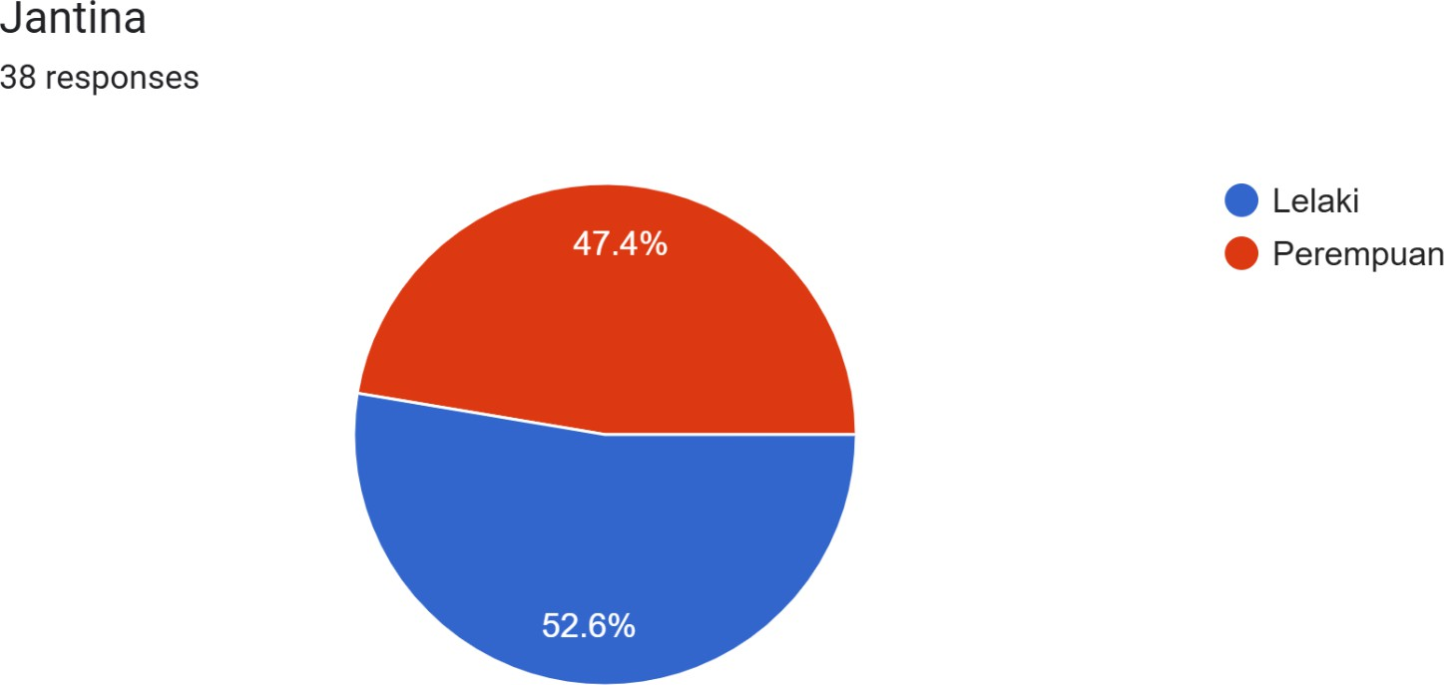
Sexual Awareness Questionnaire (SAQ)

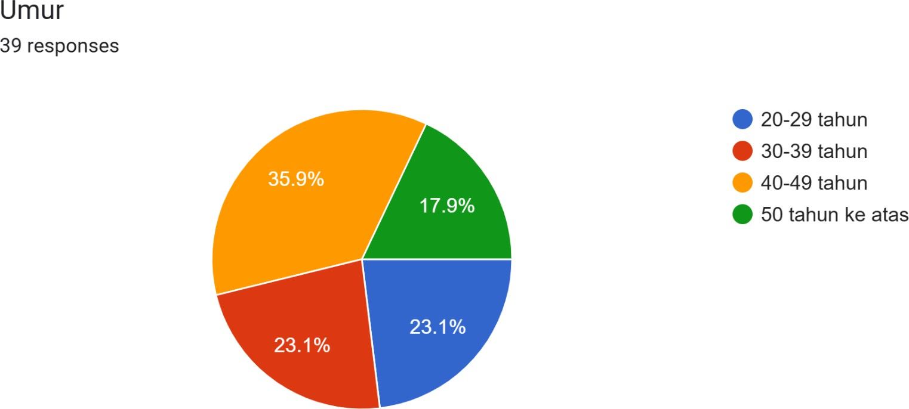

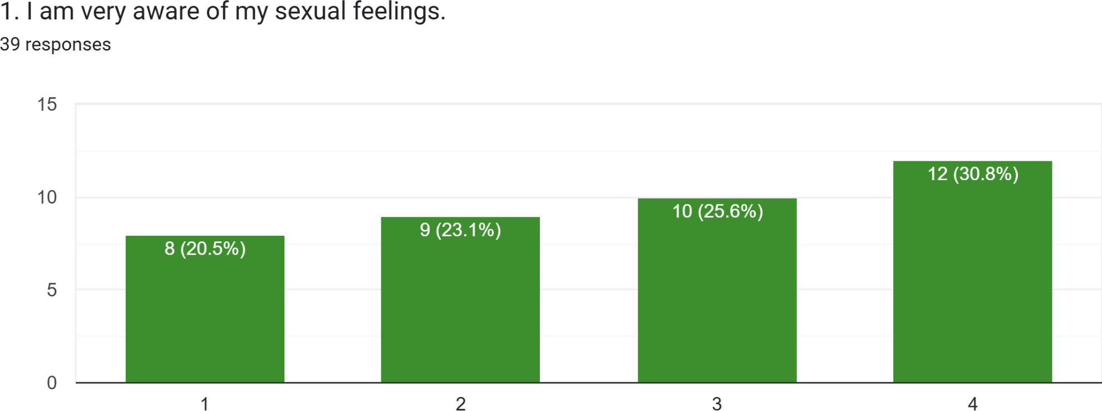

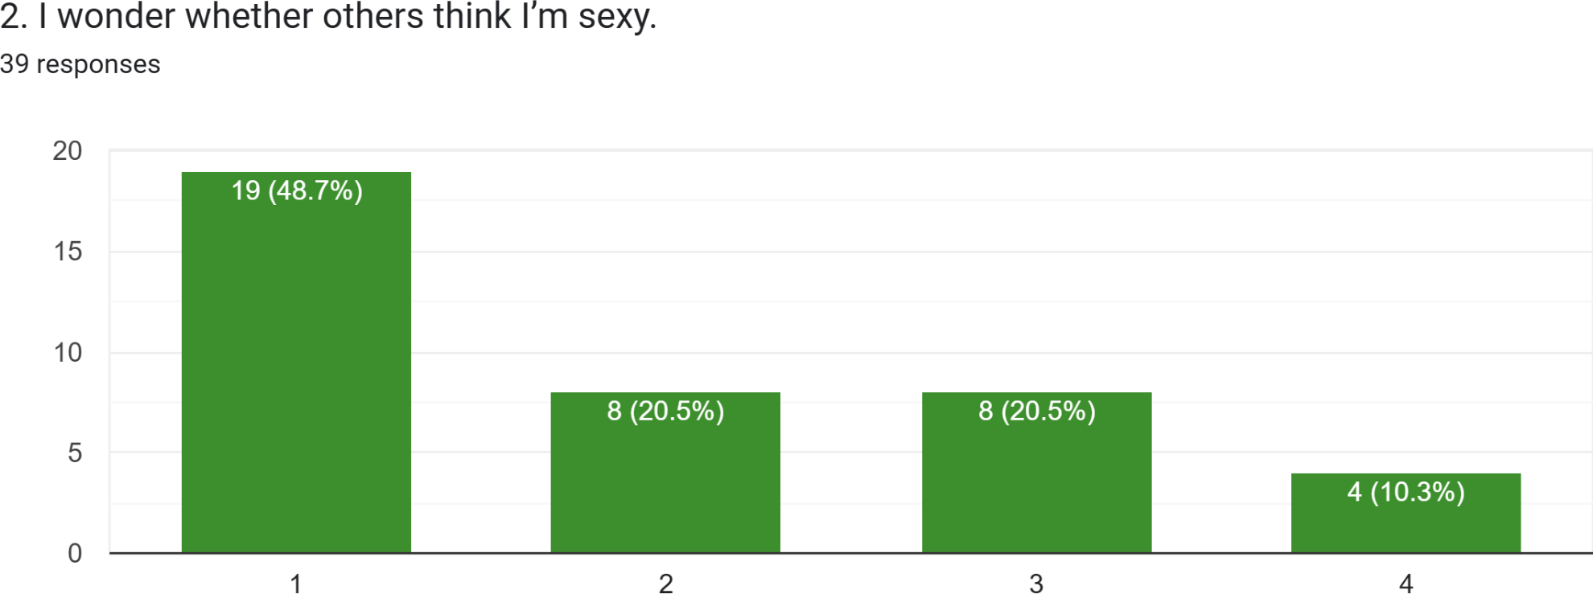

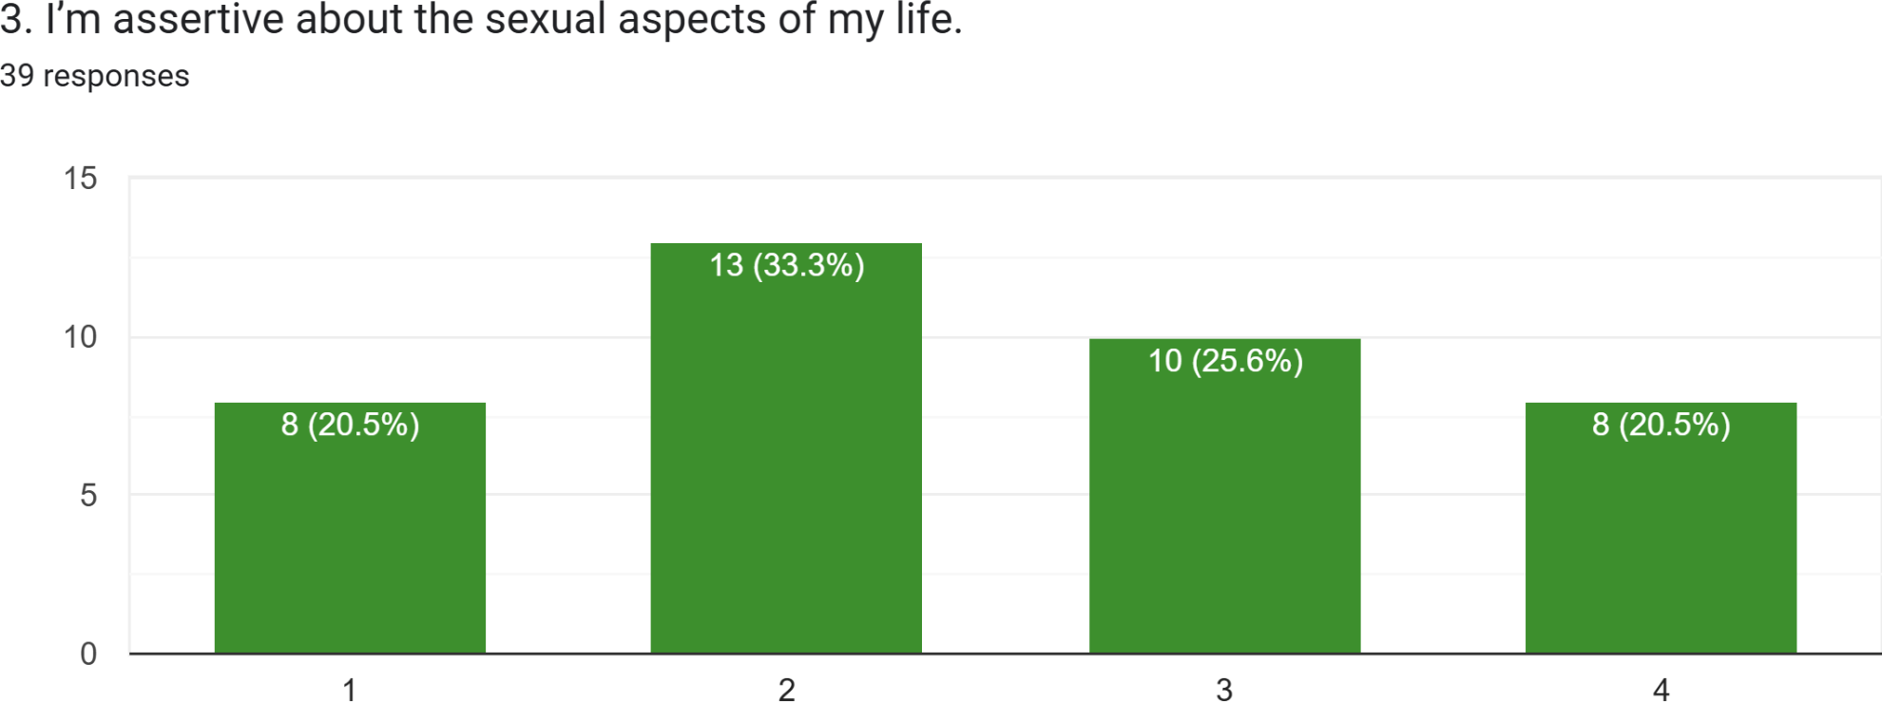

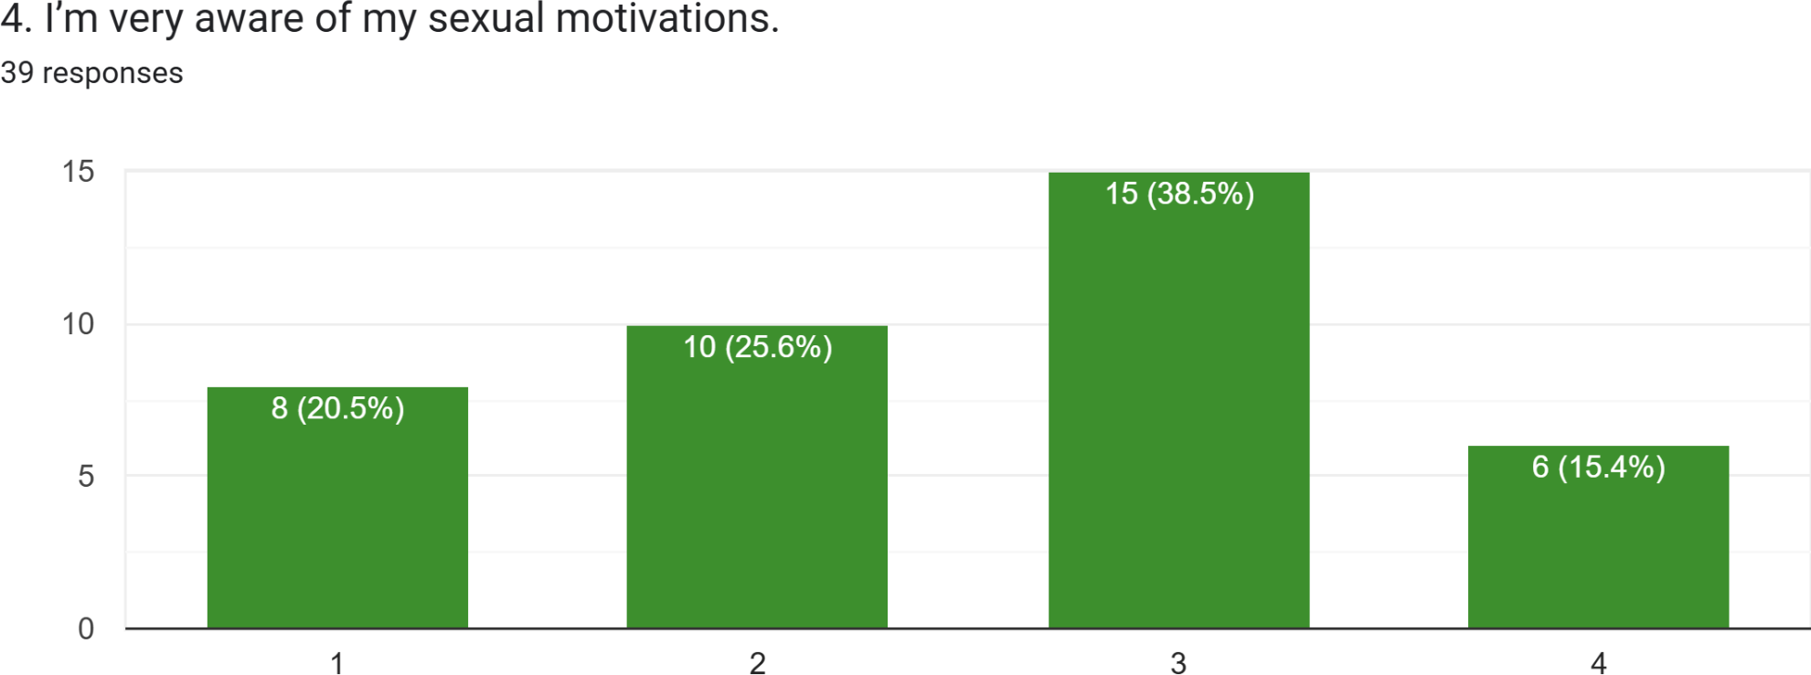

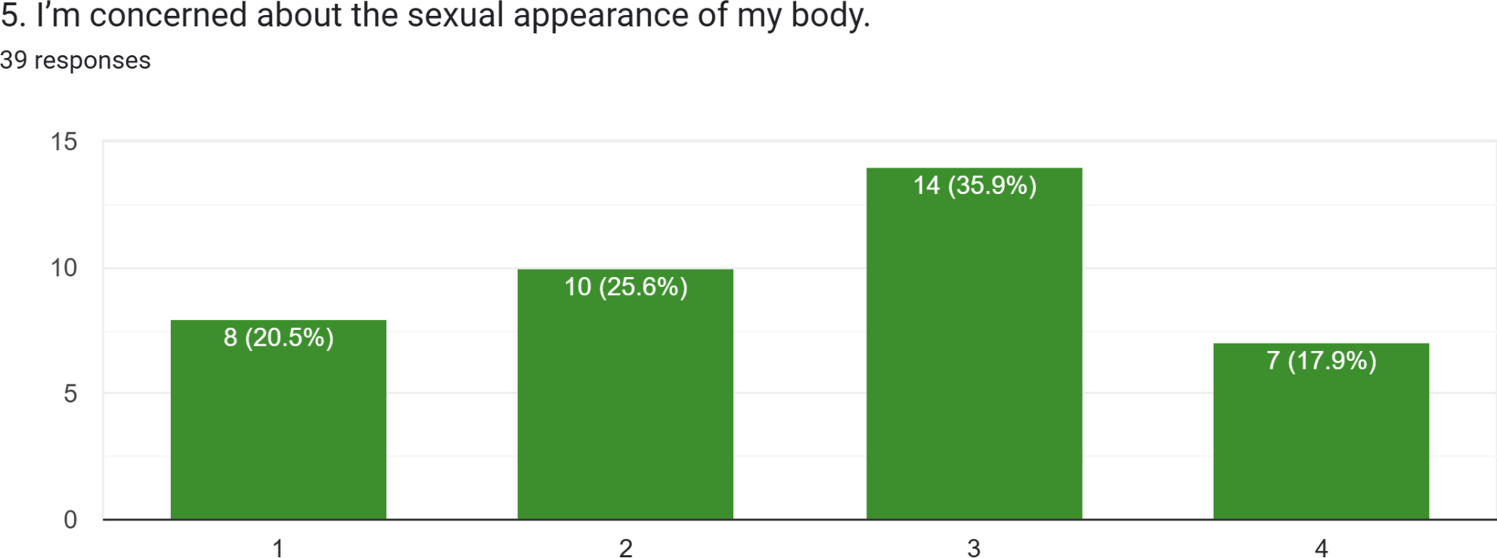

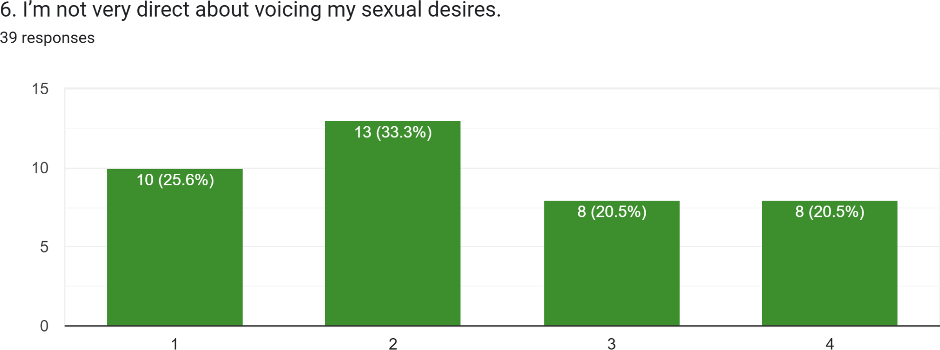

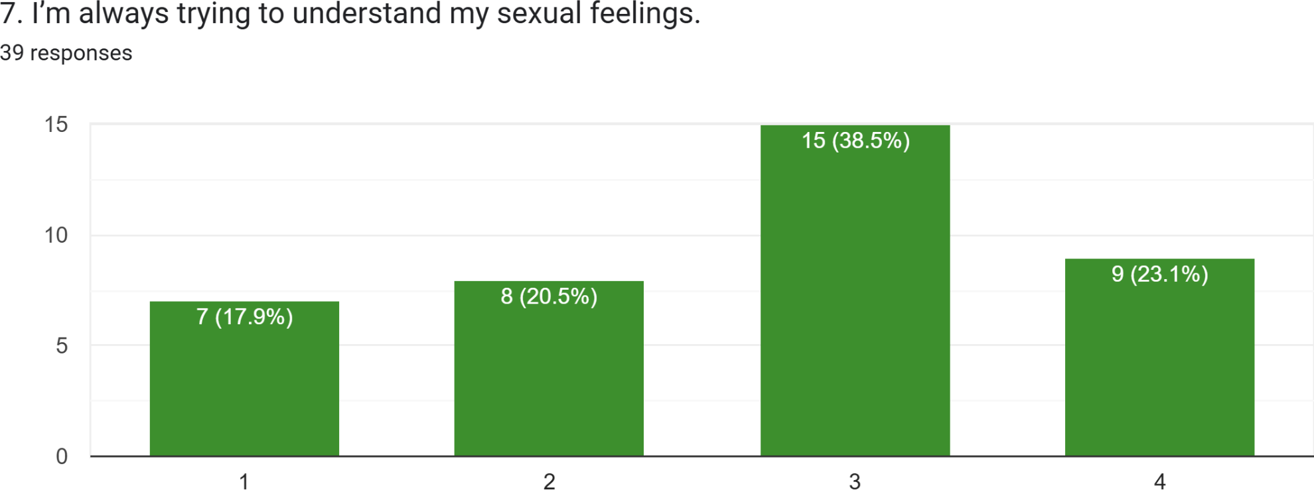

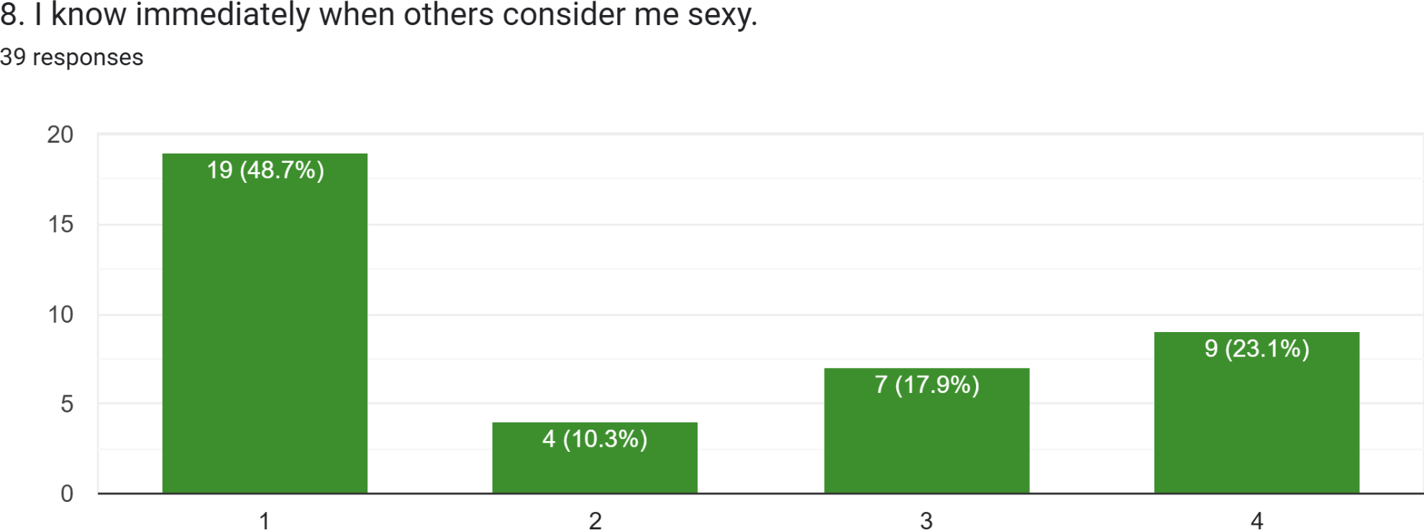

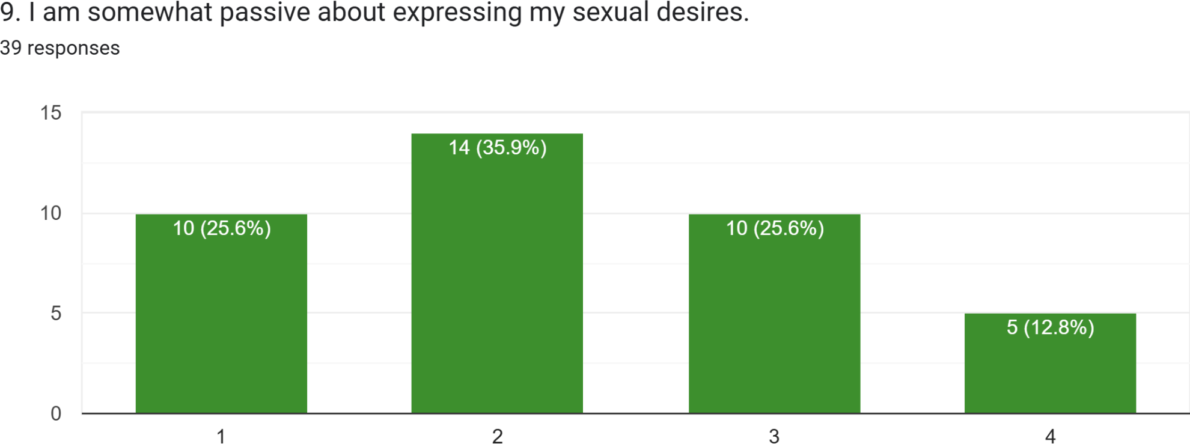

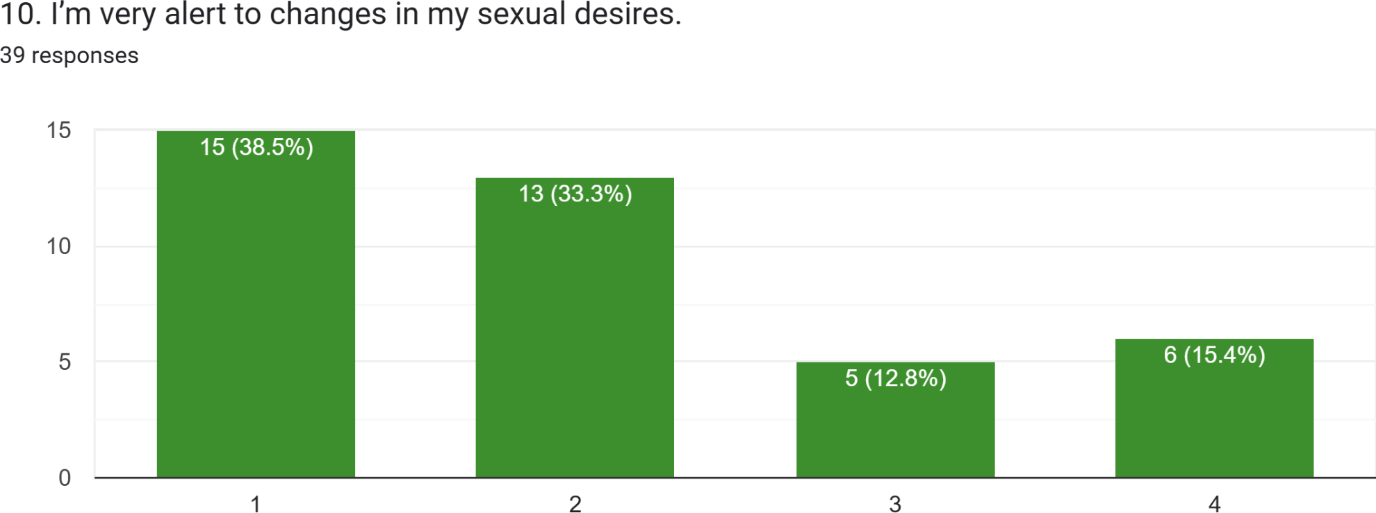

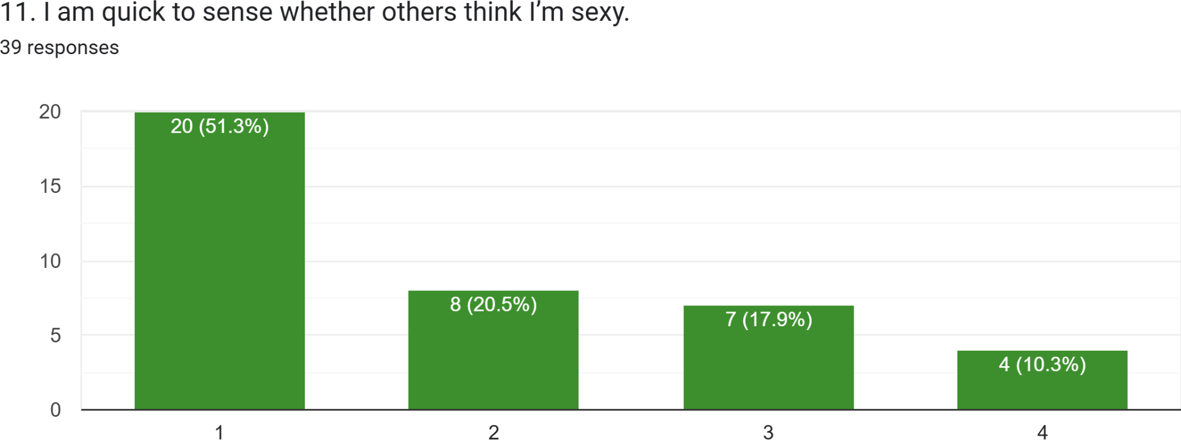

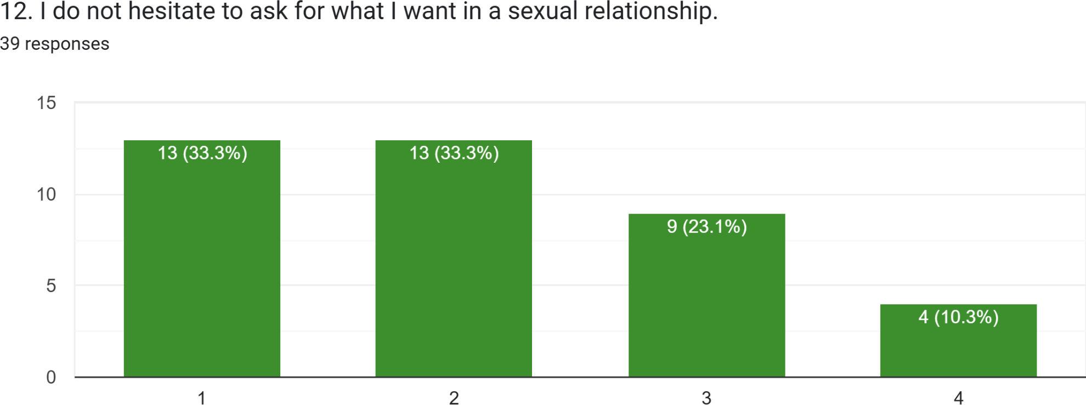

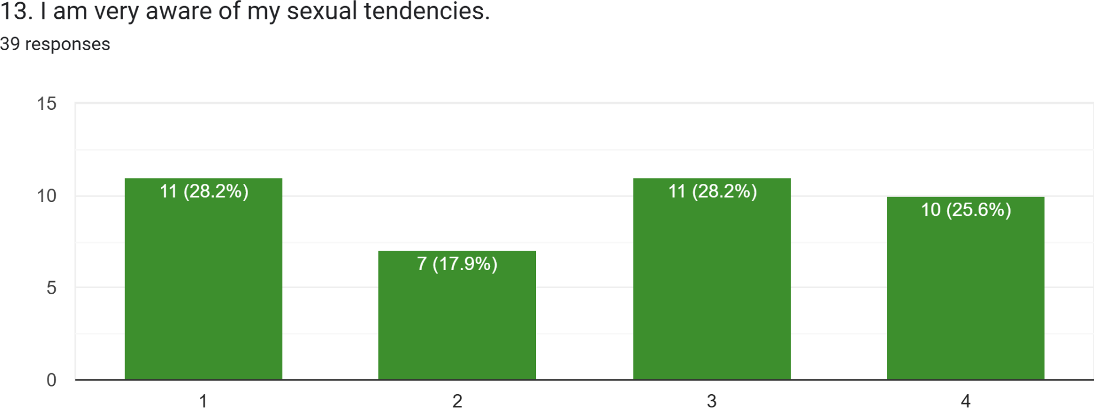

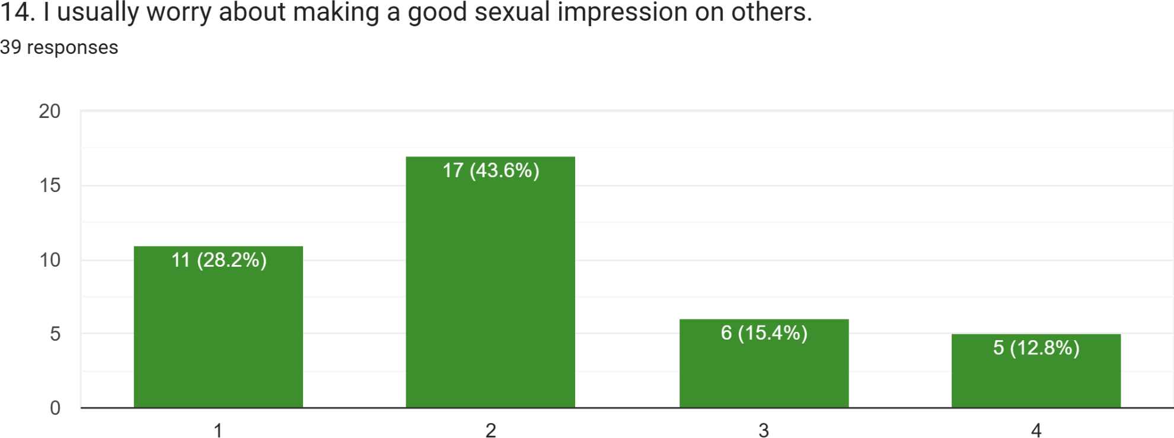

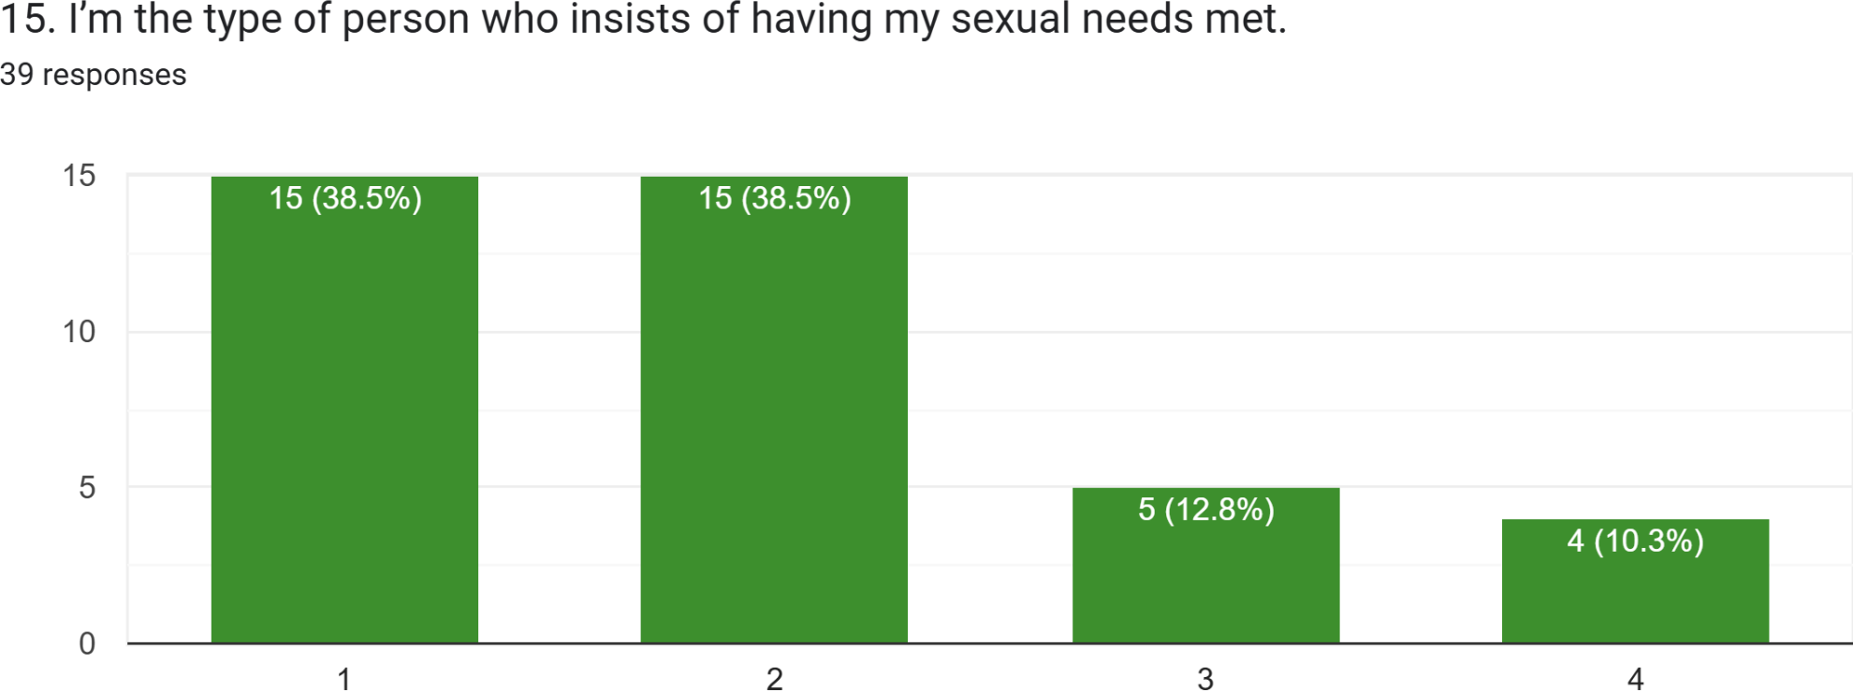

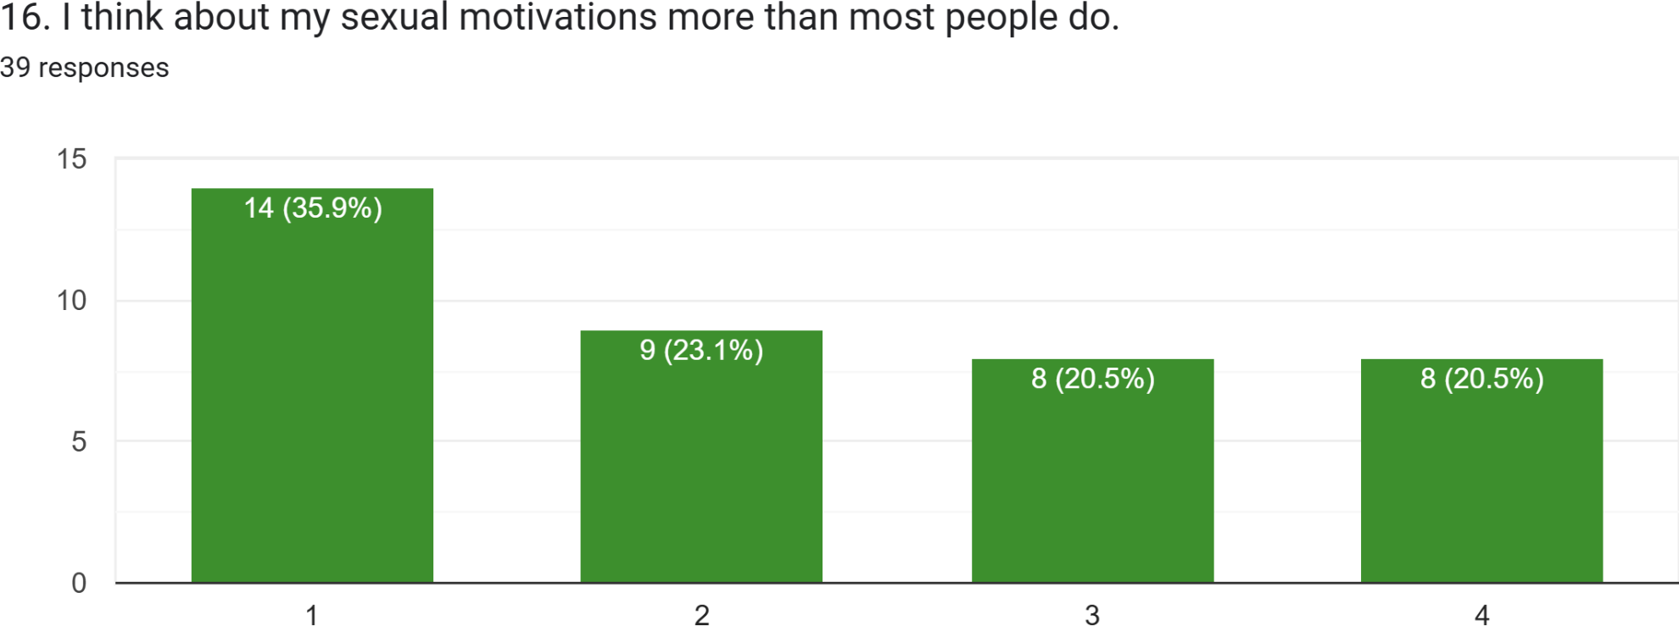

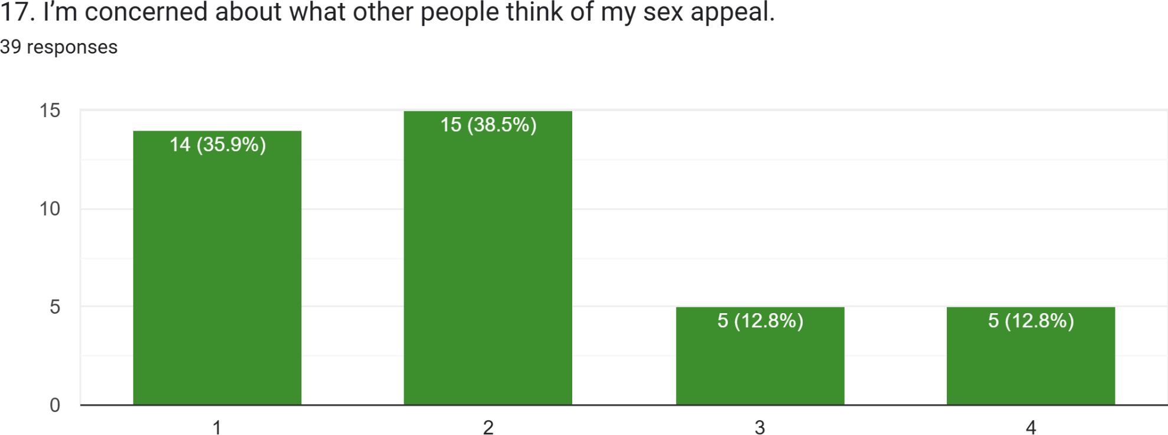

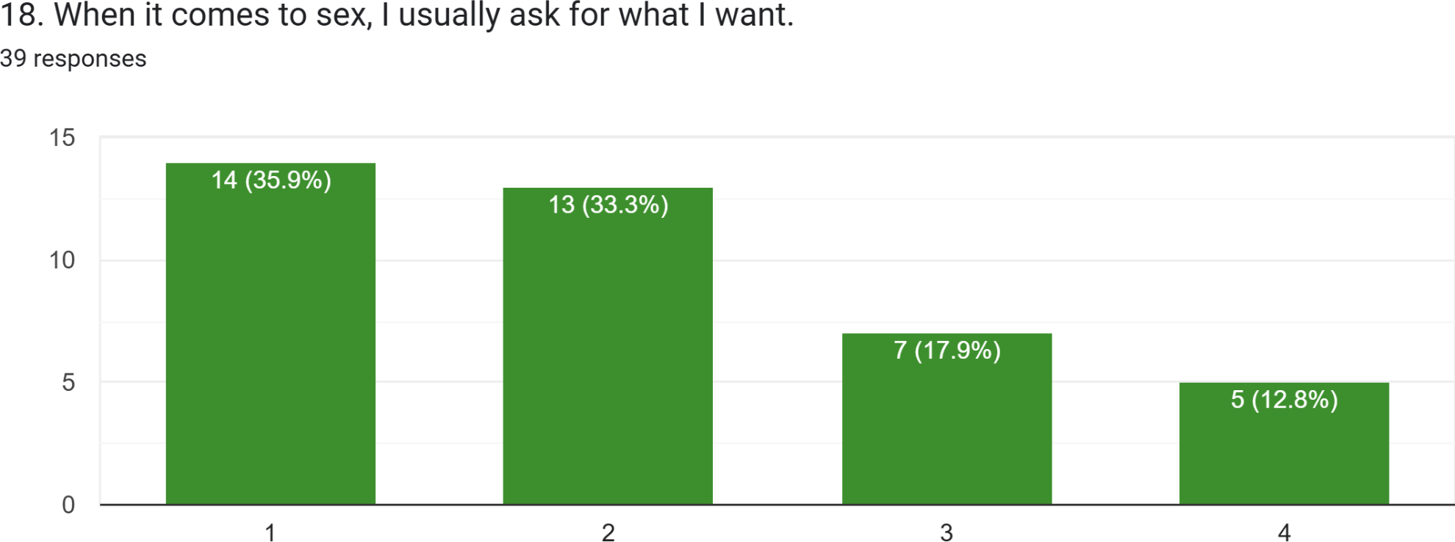

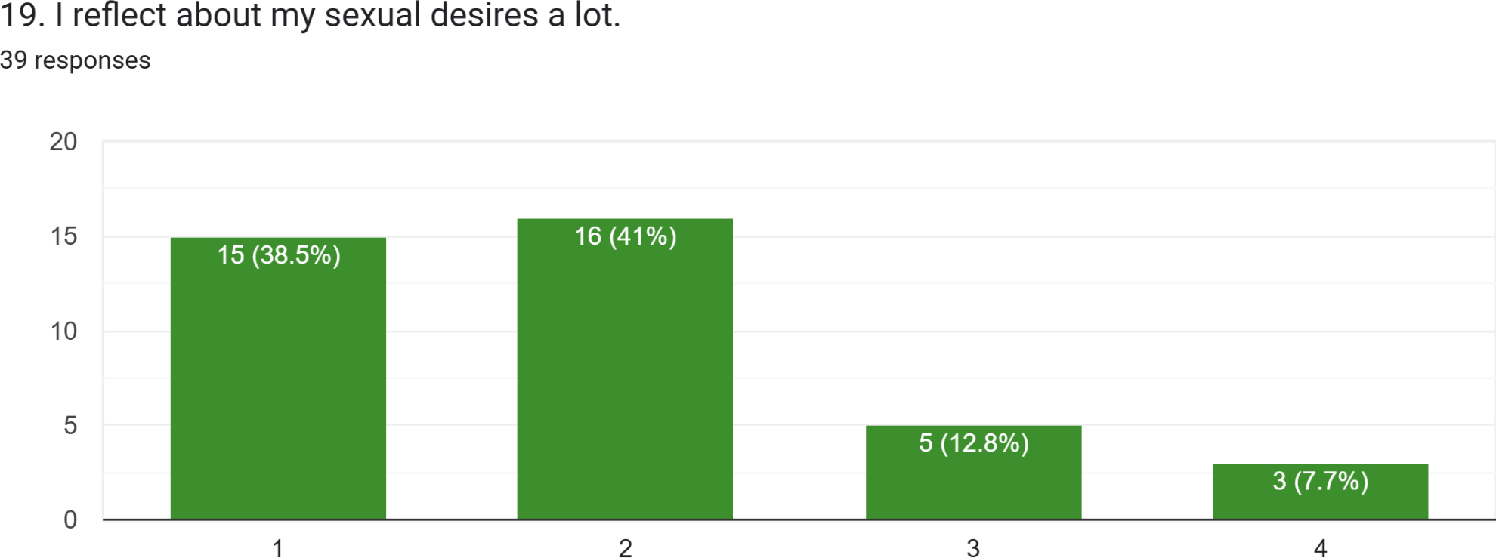

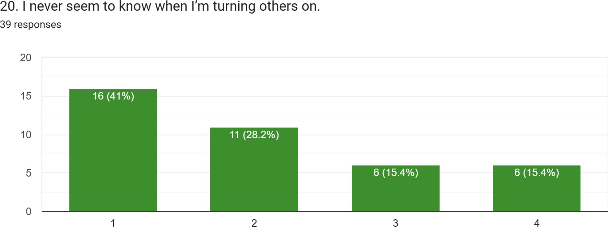

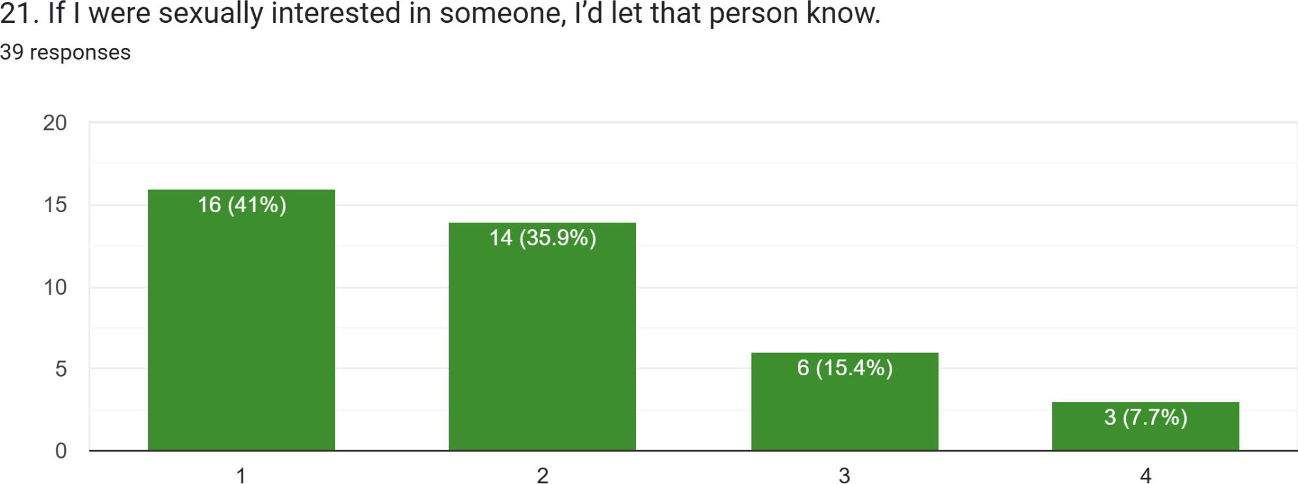

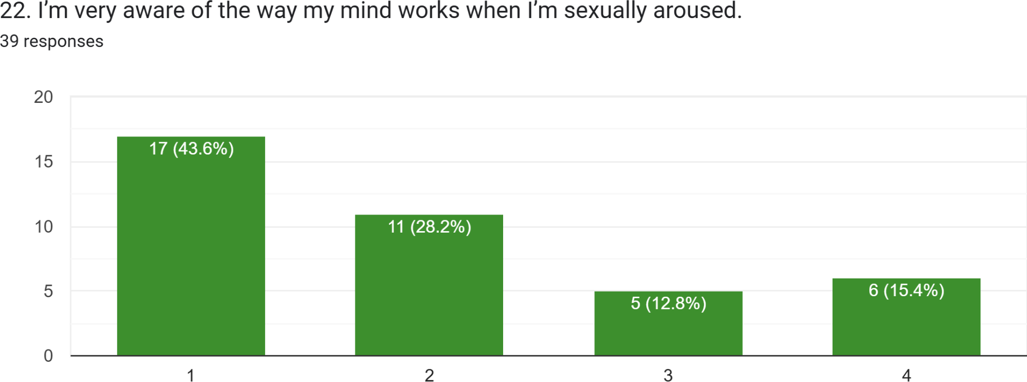

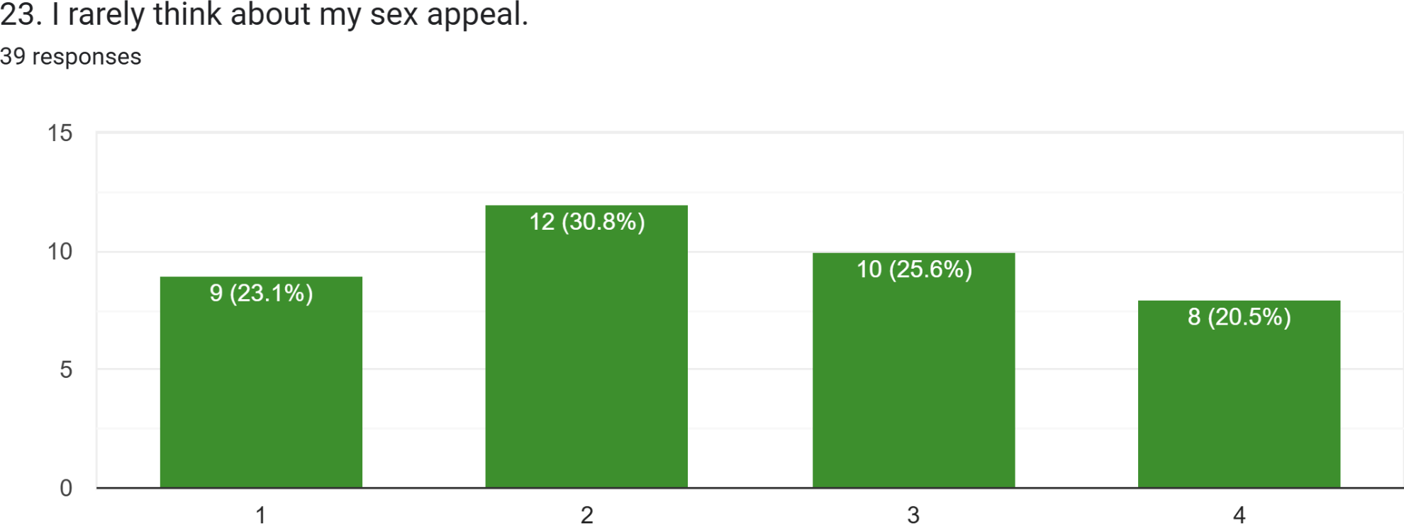

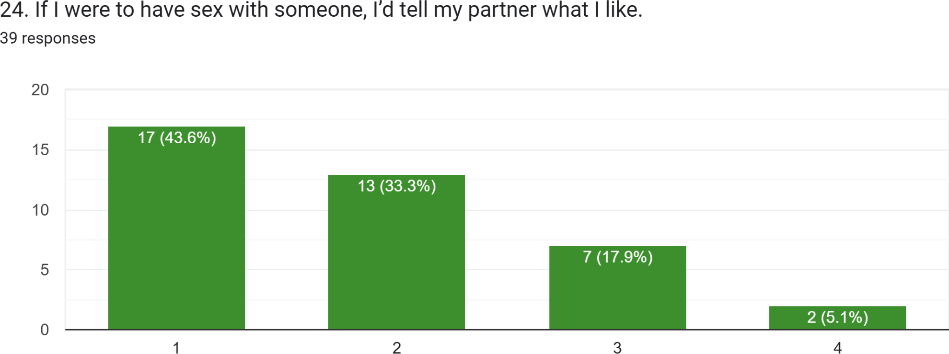

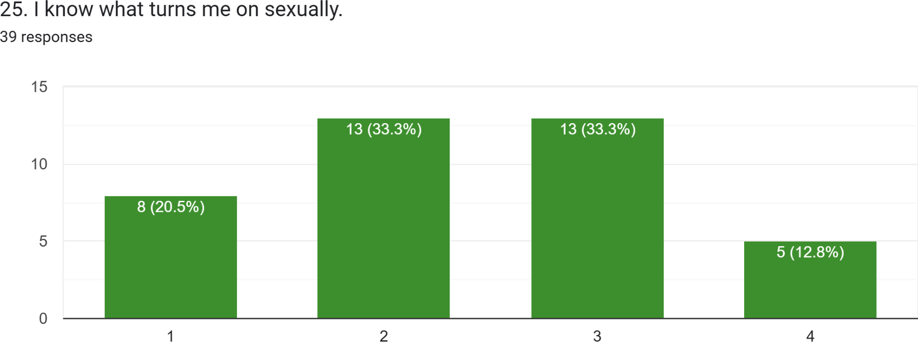

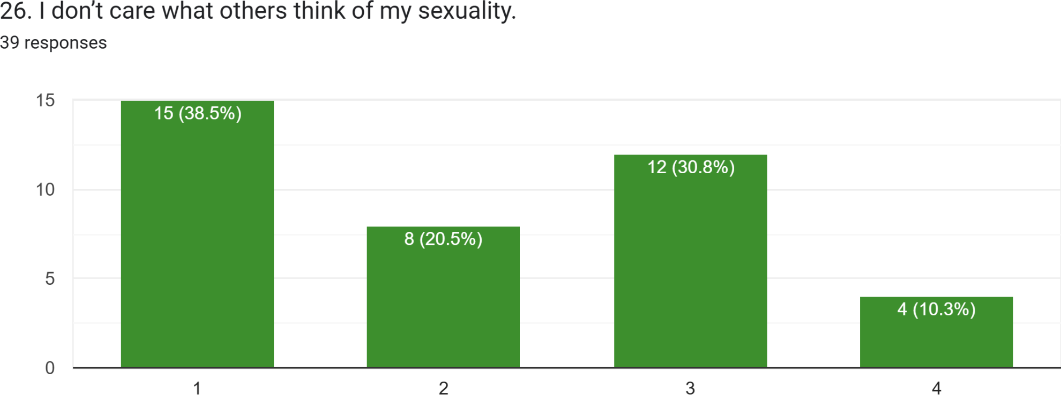

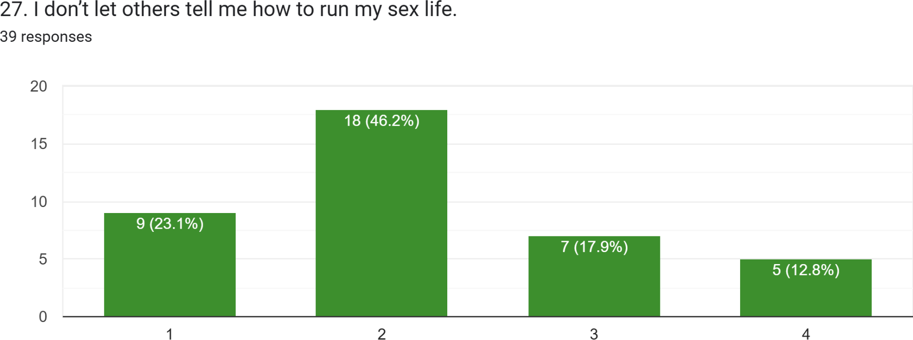

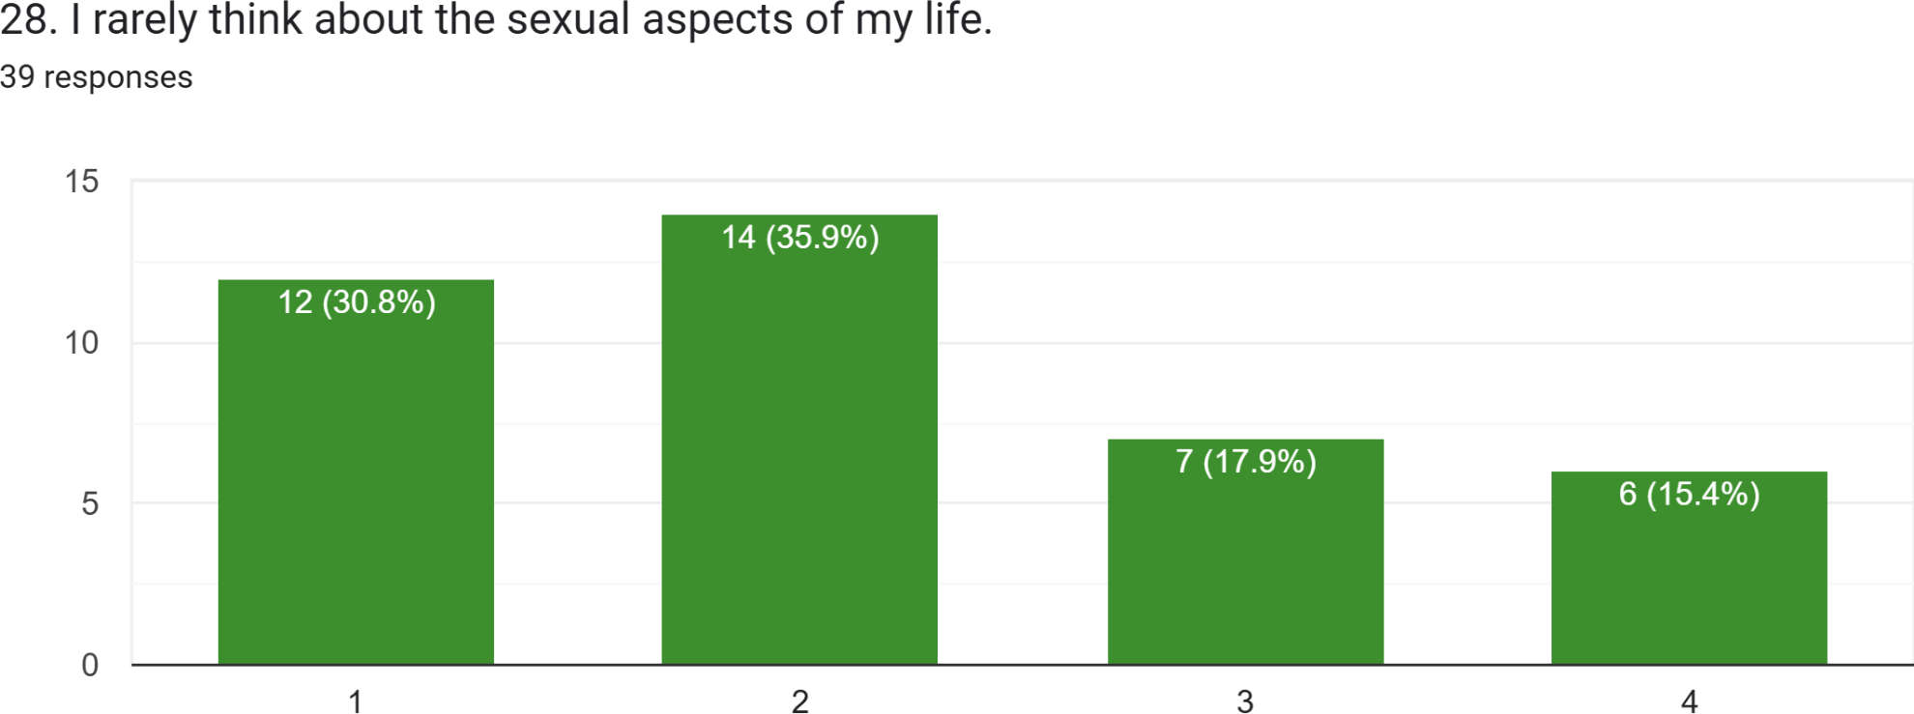

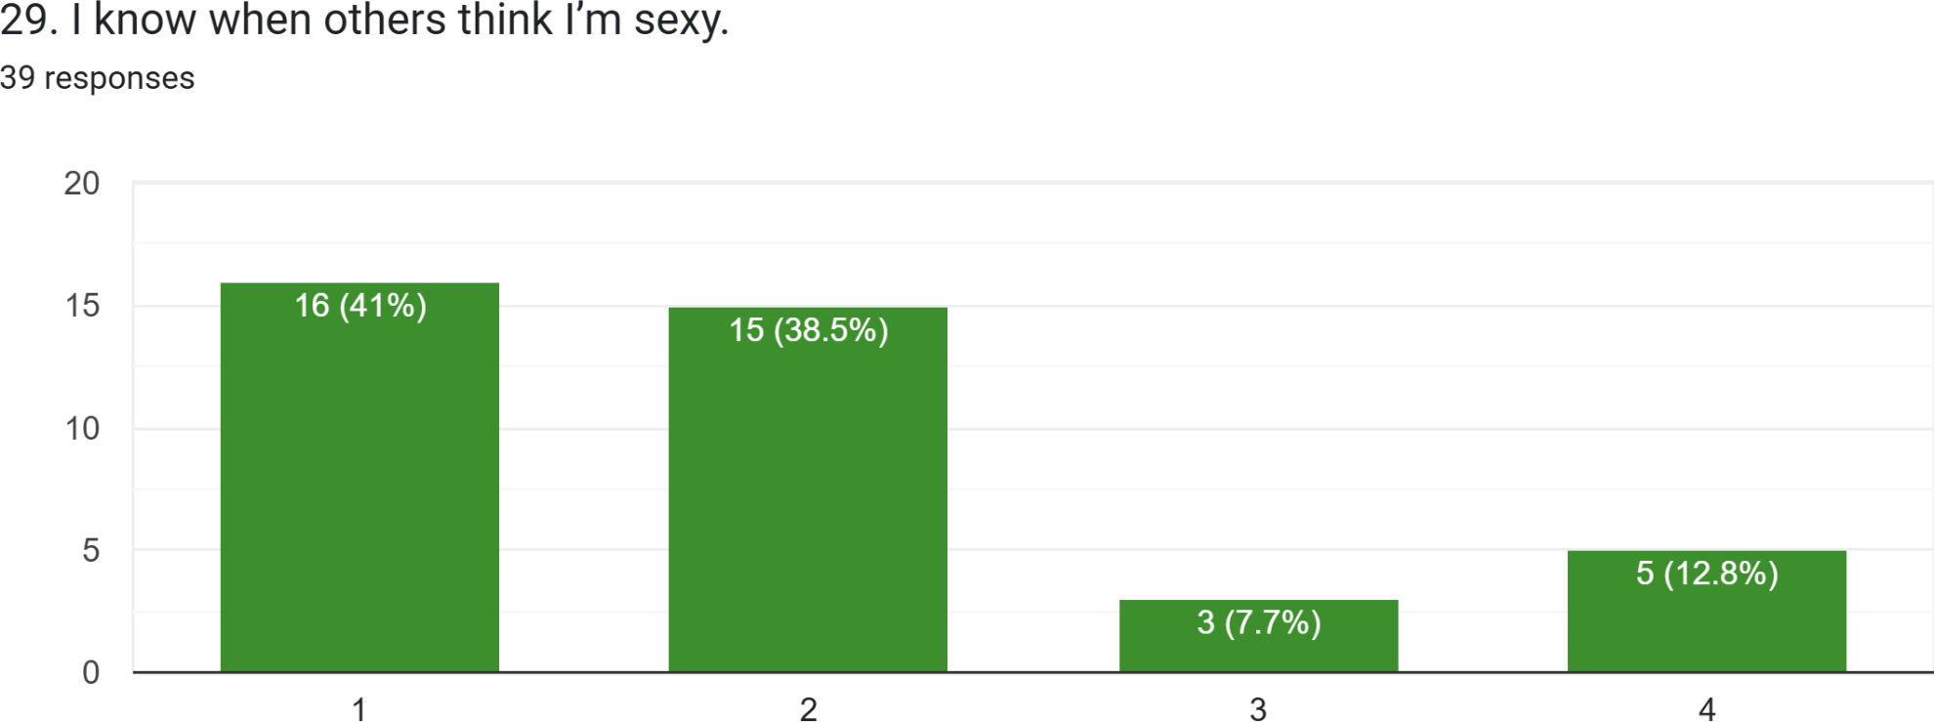

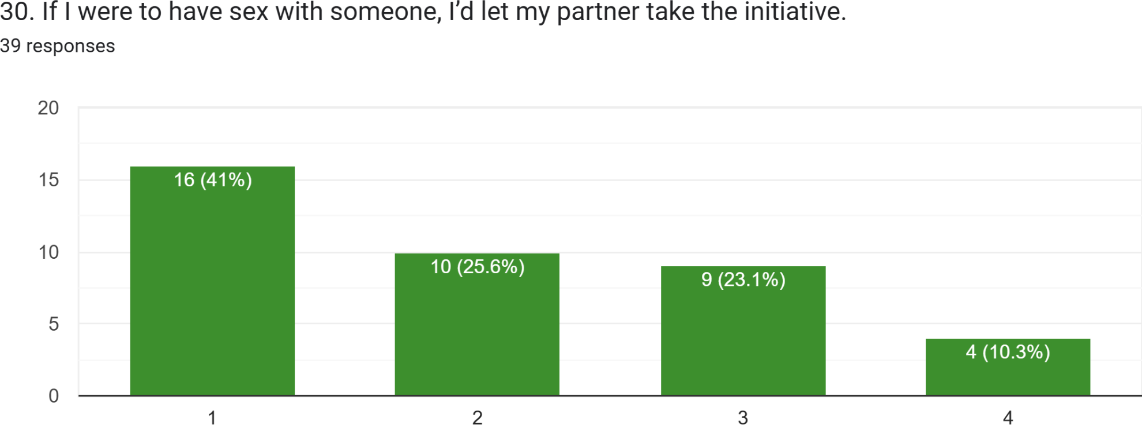

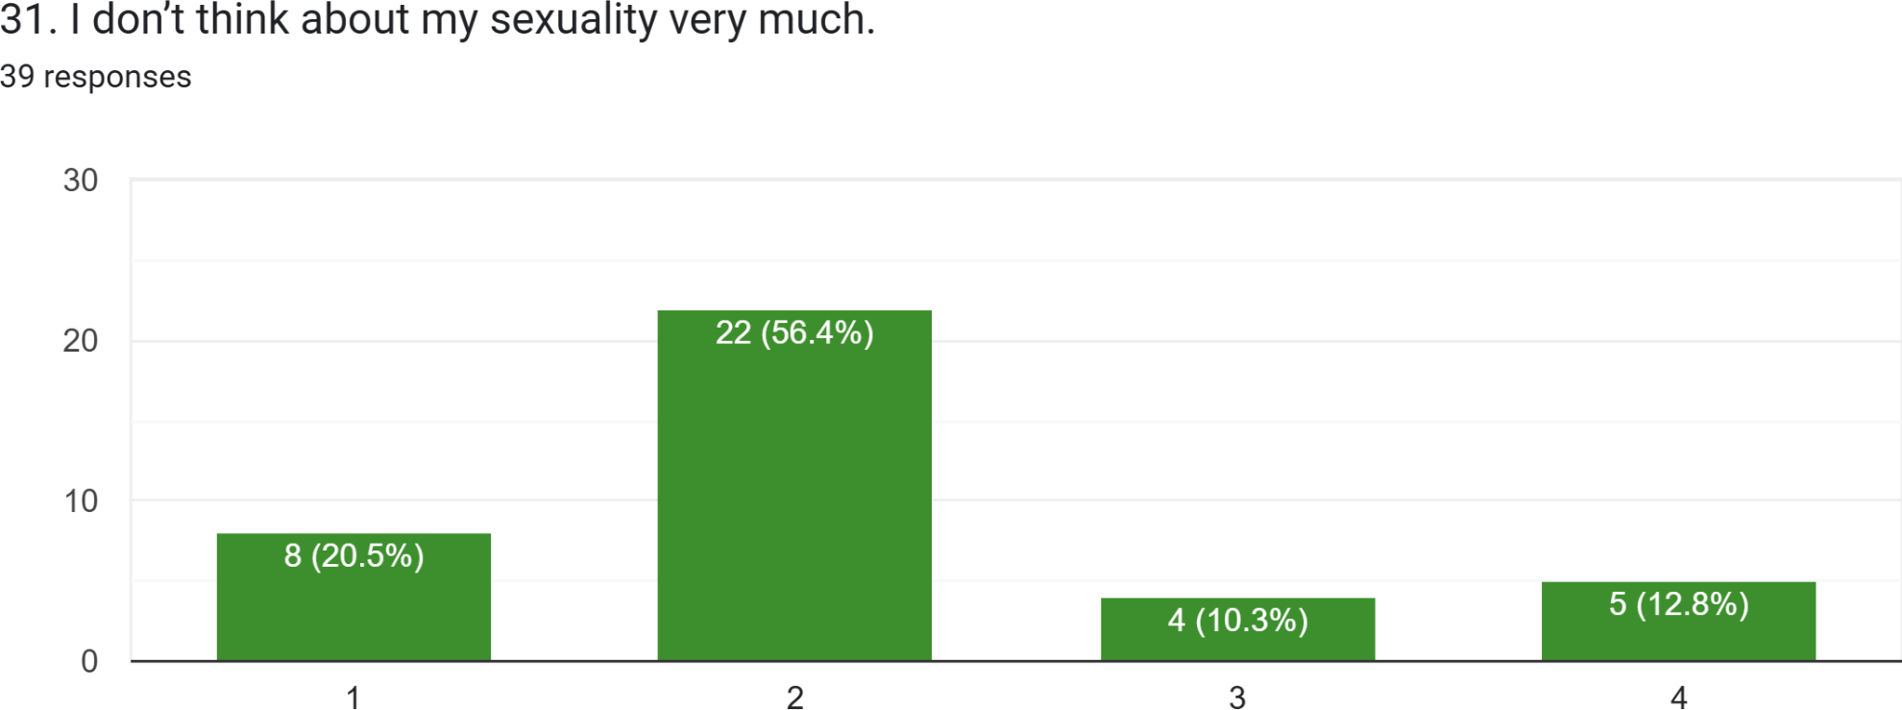

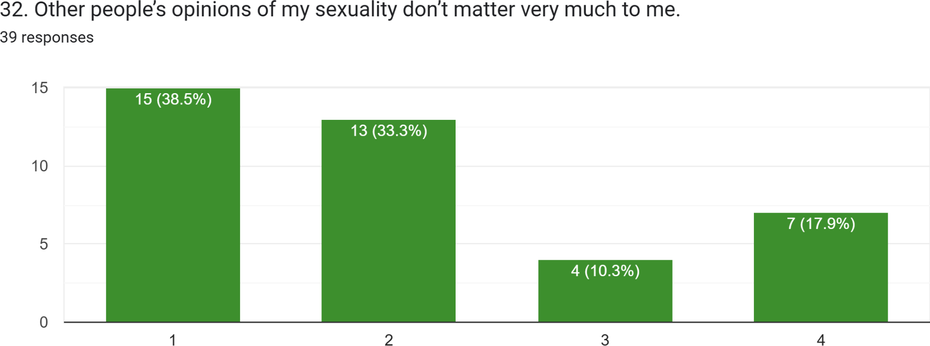

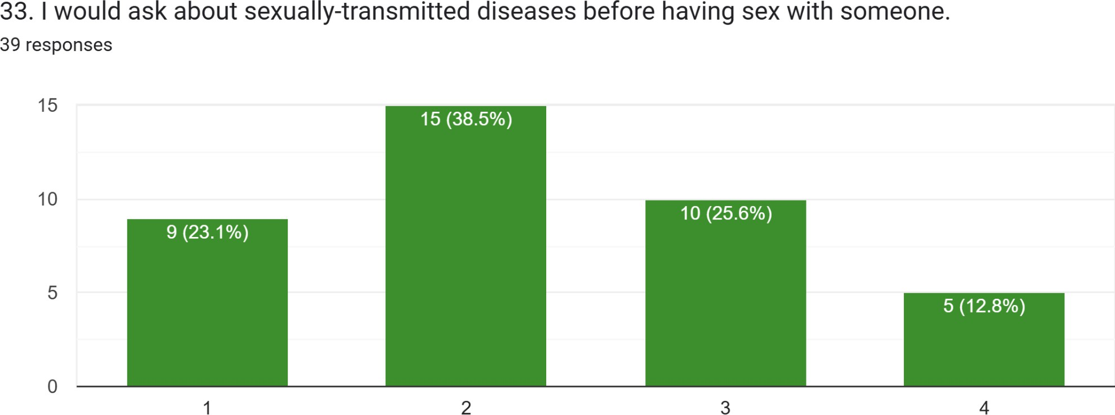

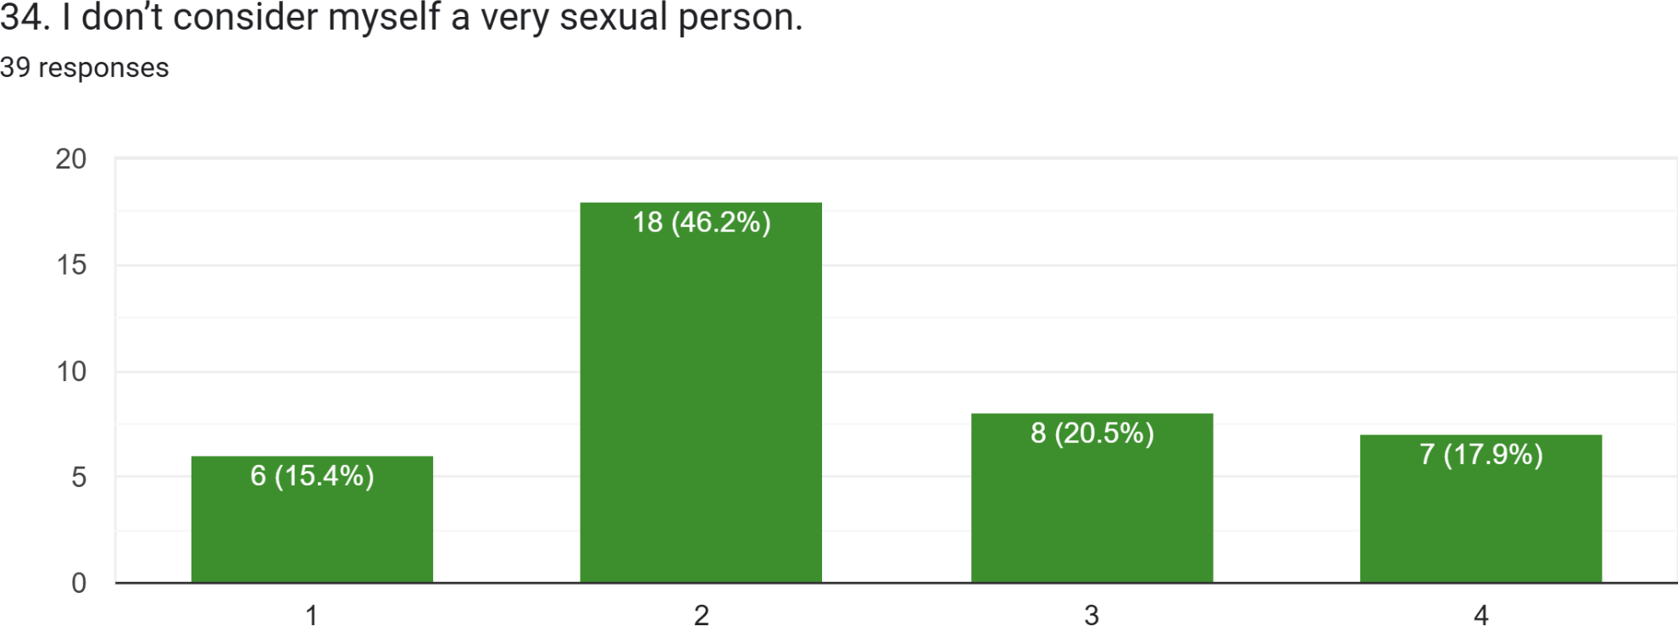

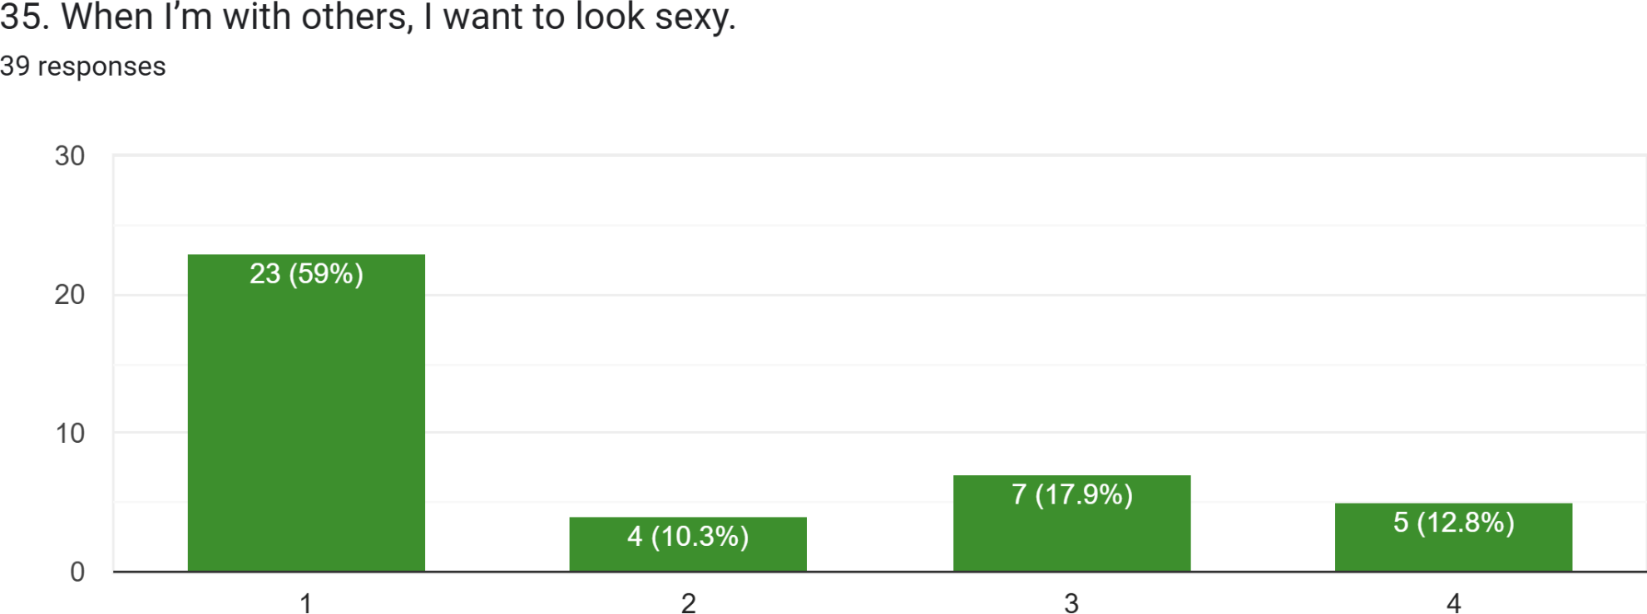

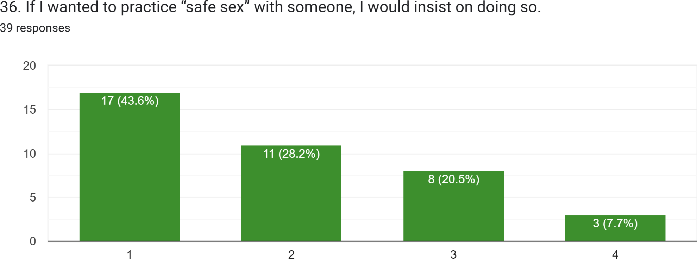

- Kuiz Gangguan Seksual

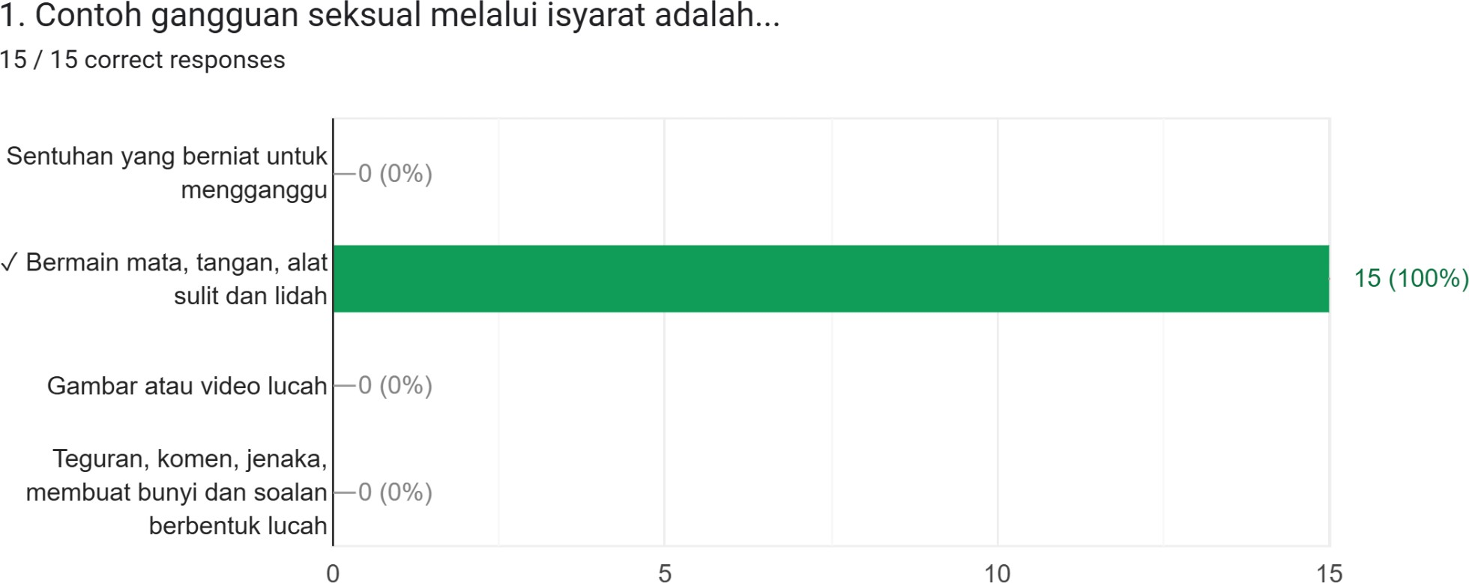

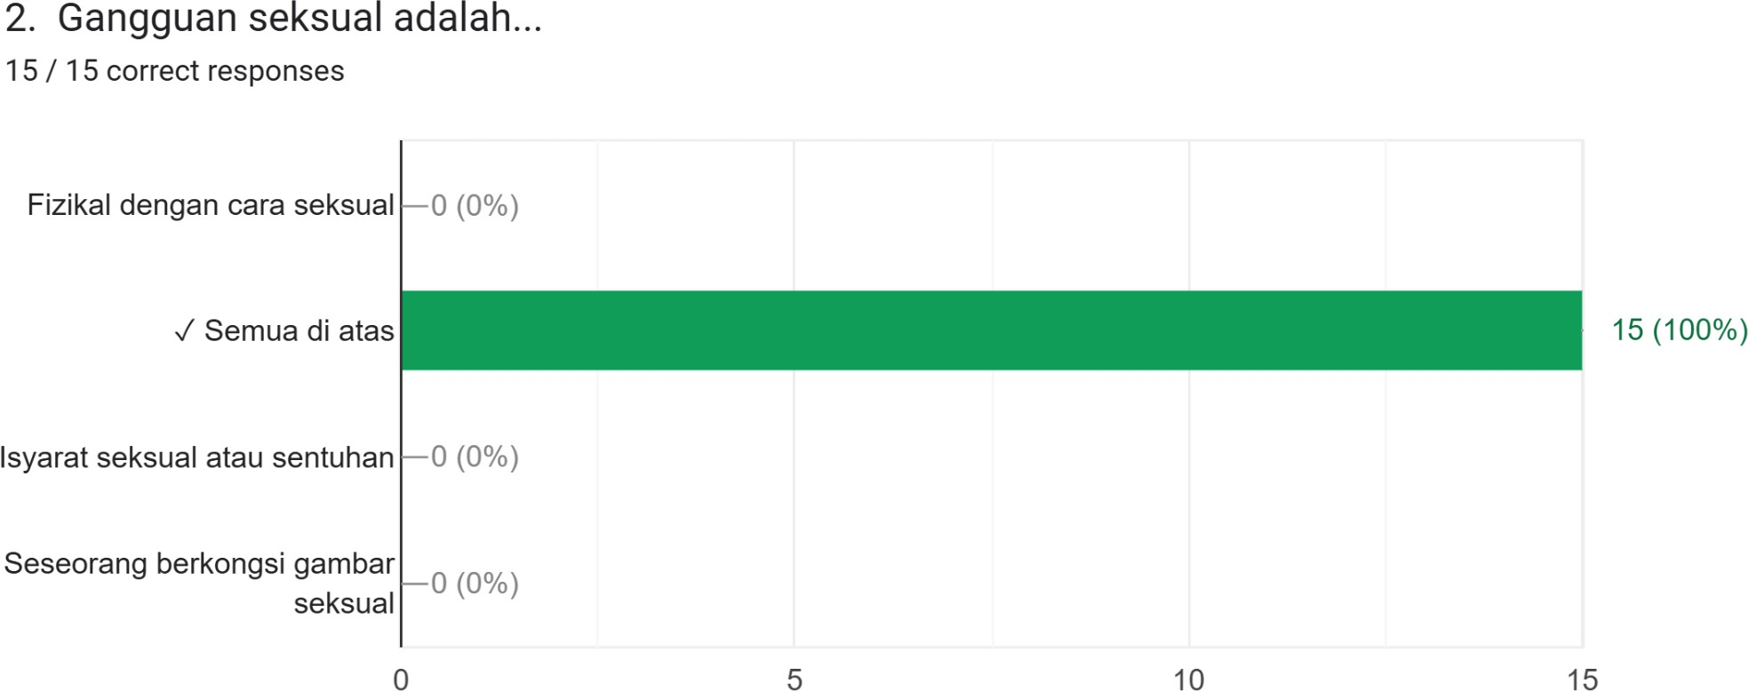

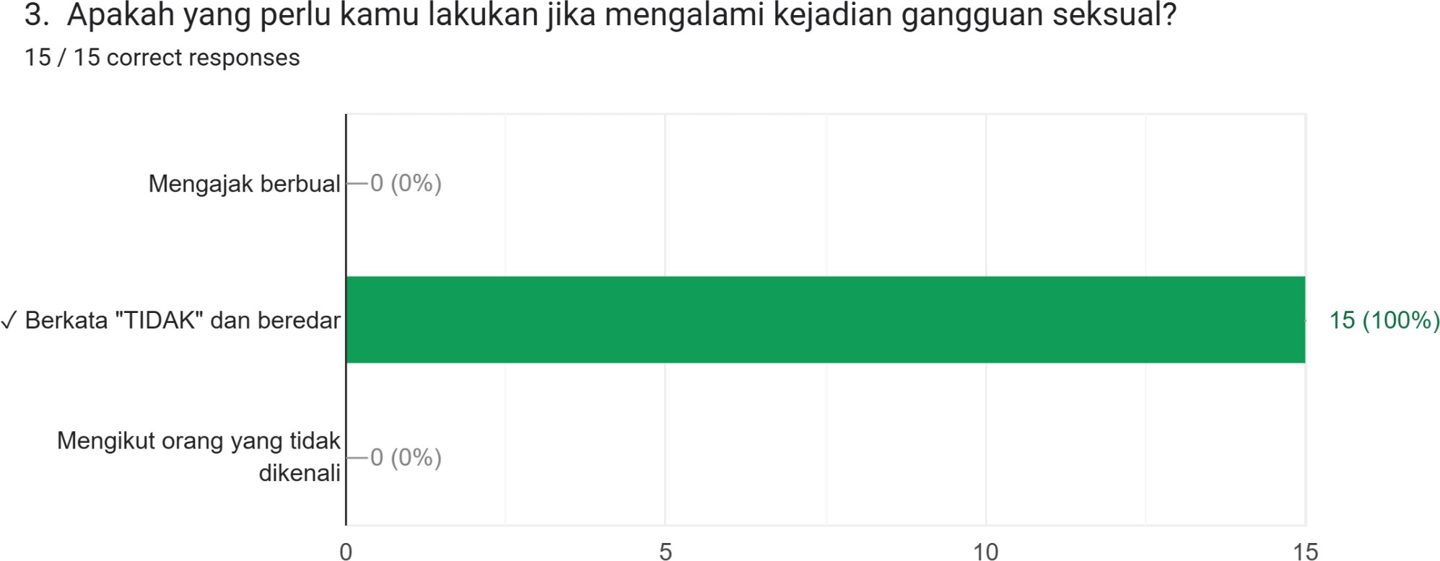

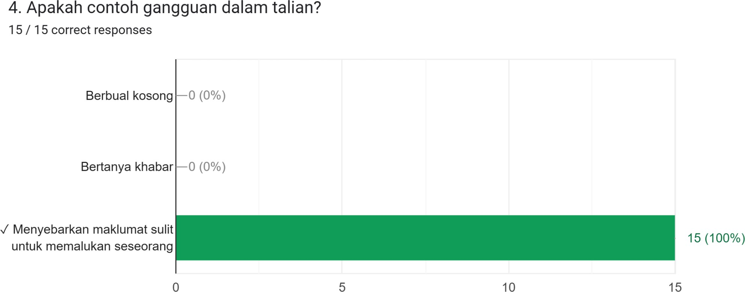

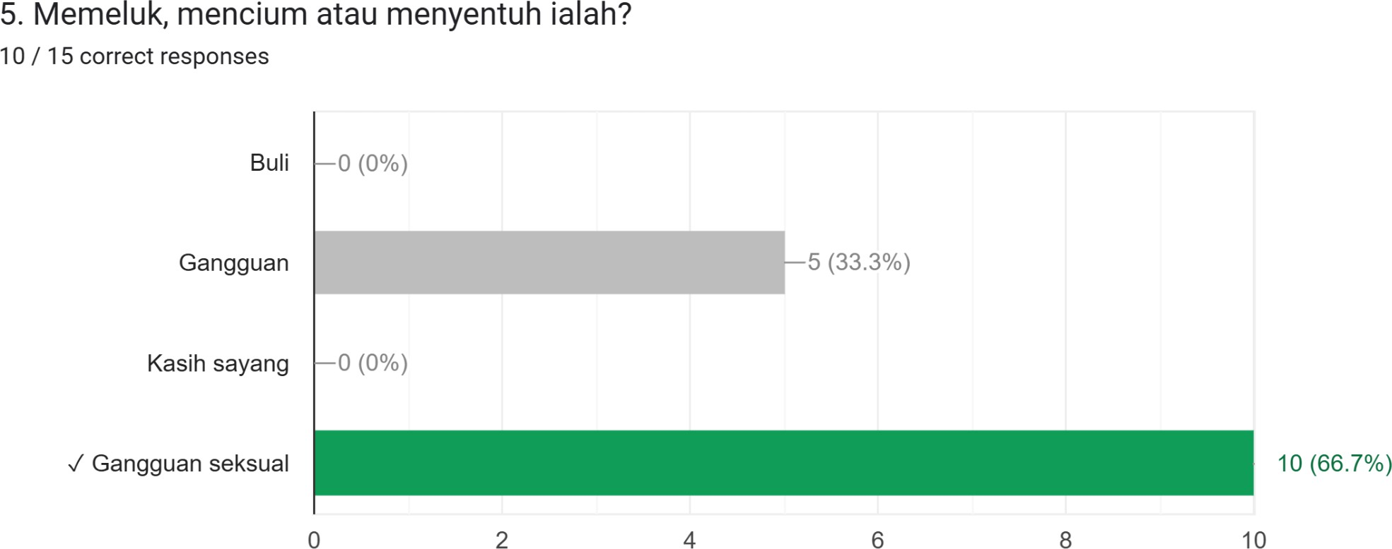

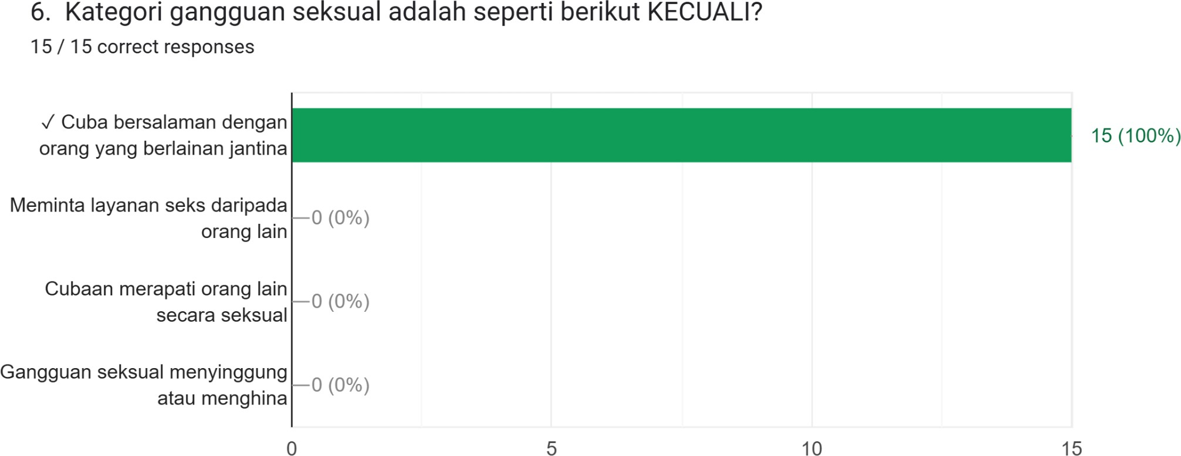

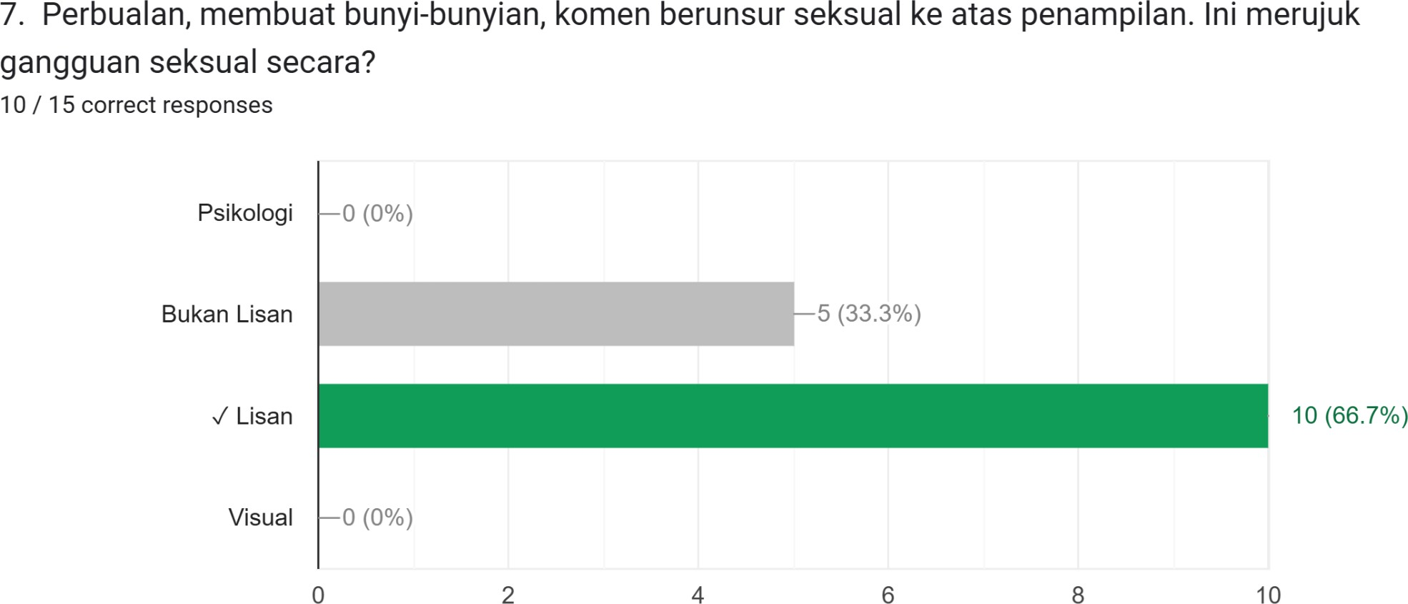

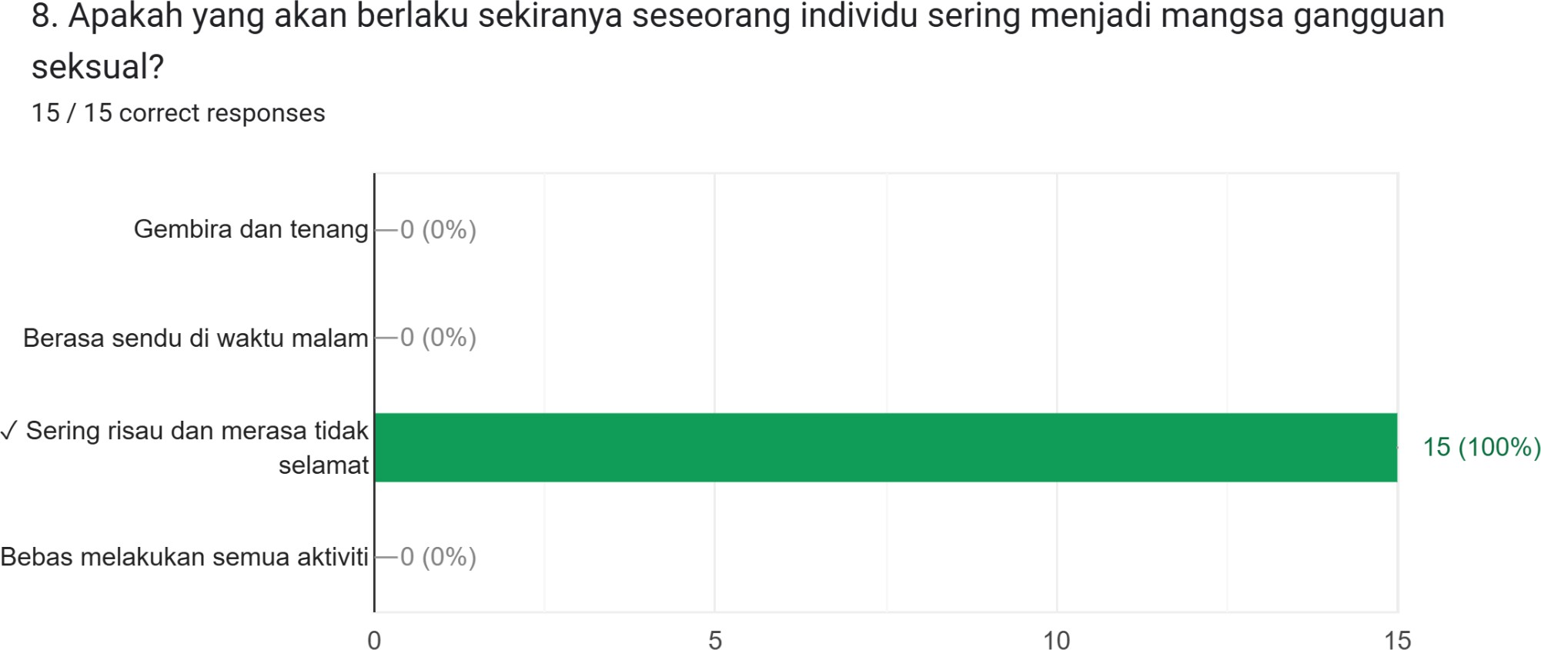

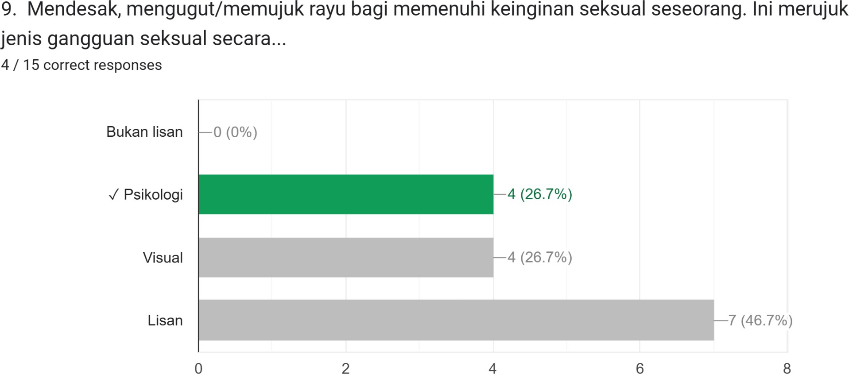

- Sexual Symptom Assessment Scale (SSAS)

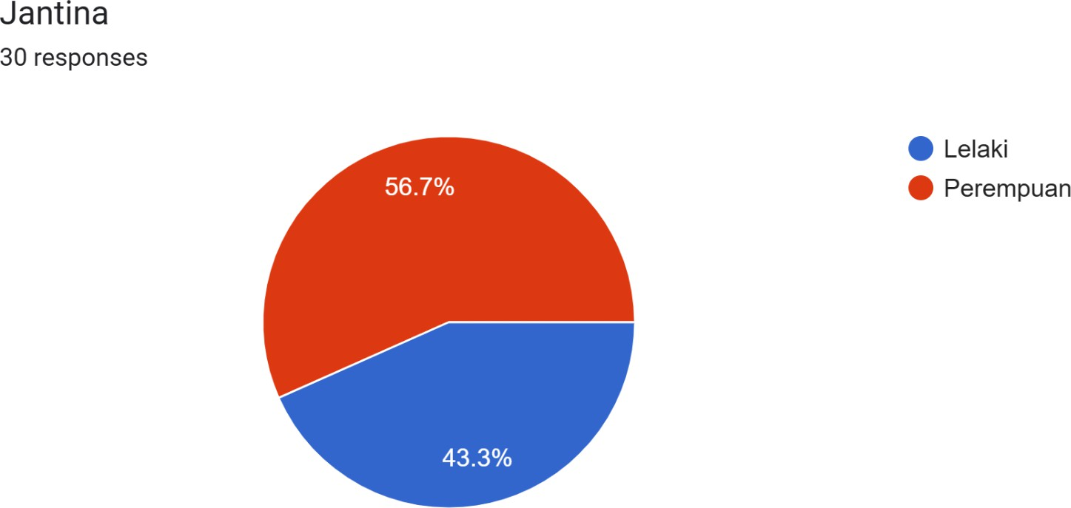

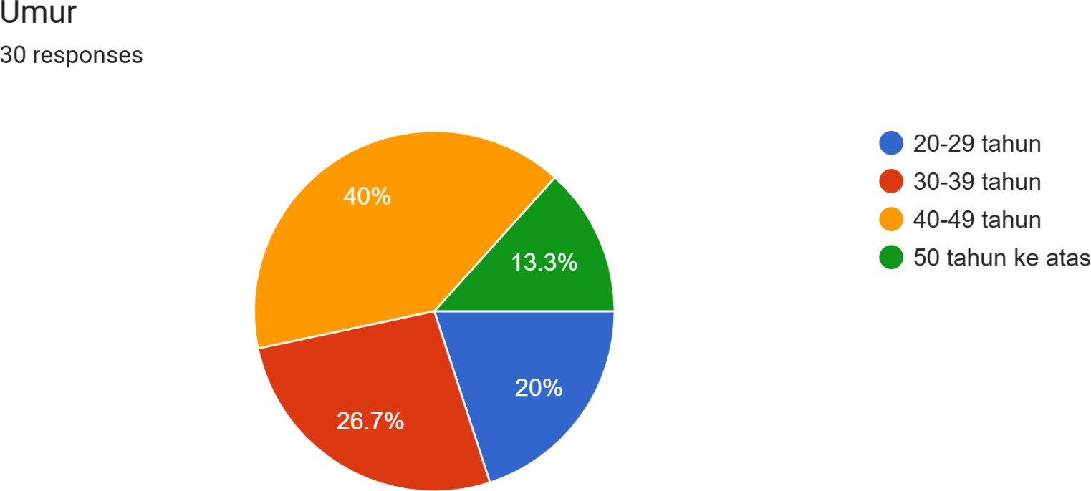

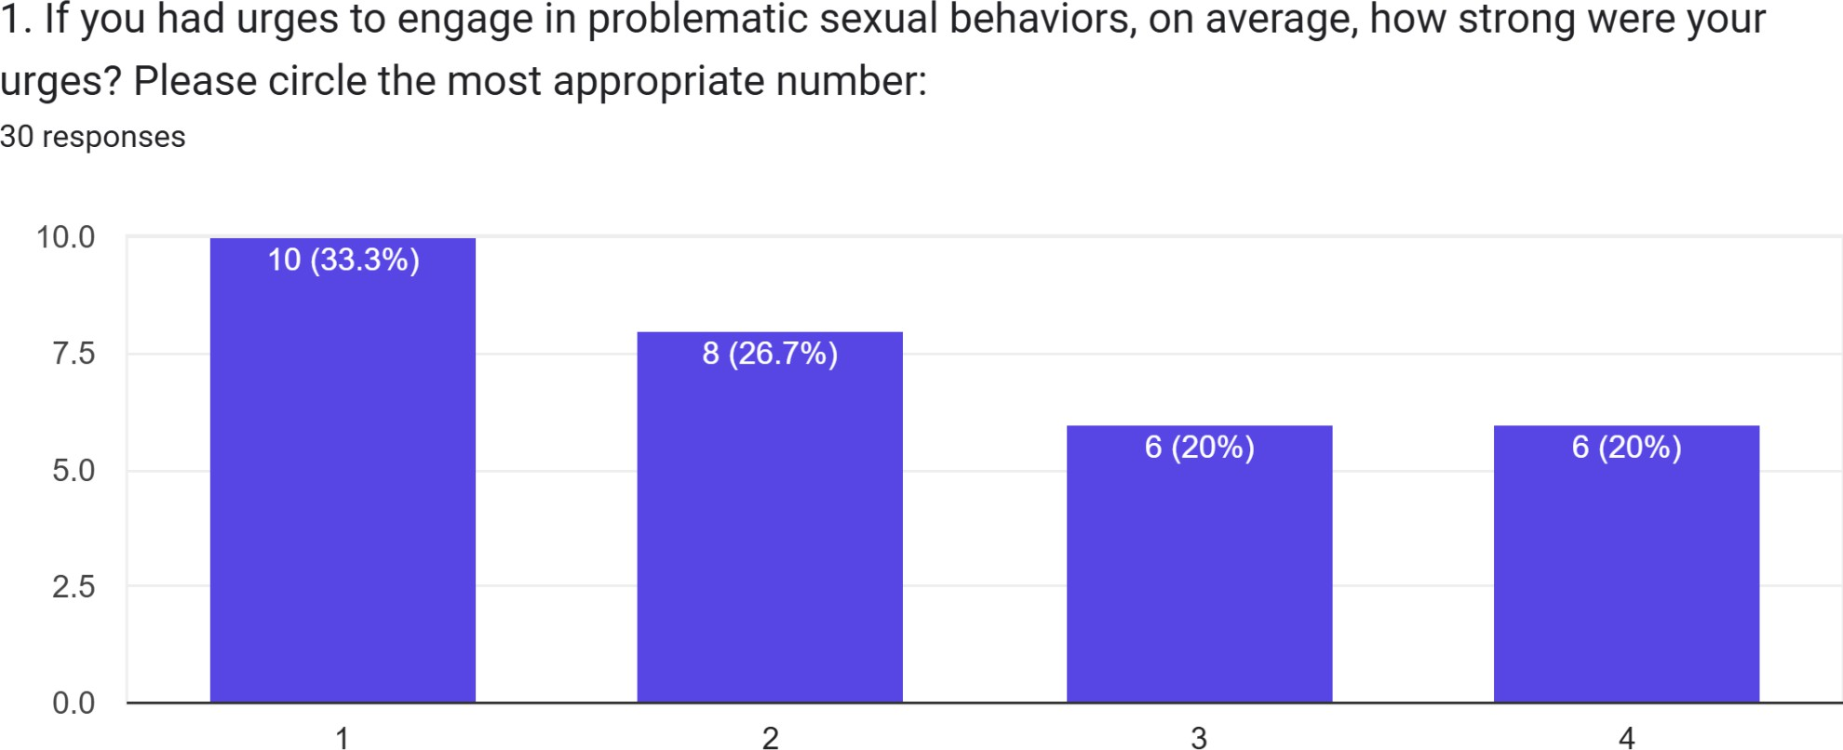

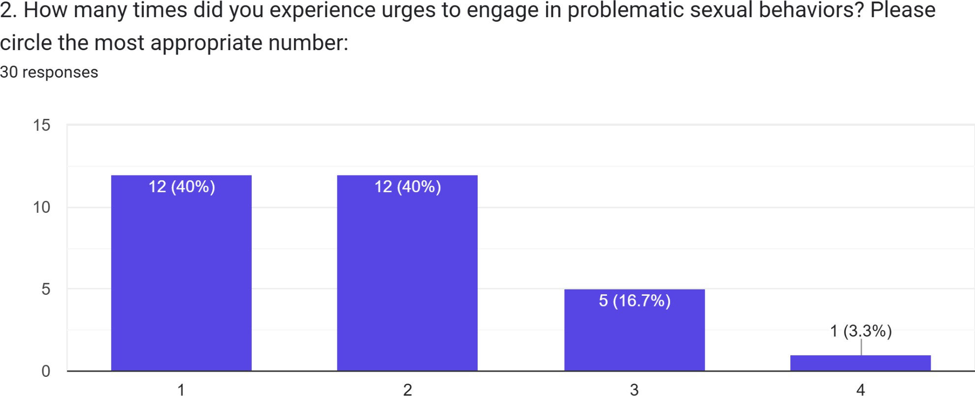

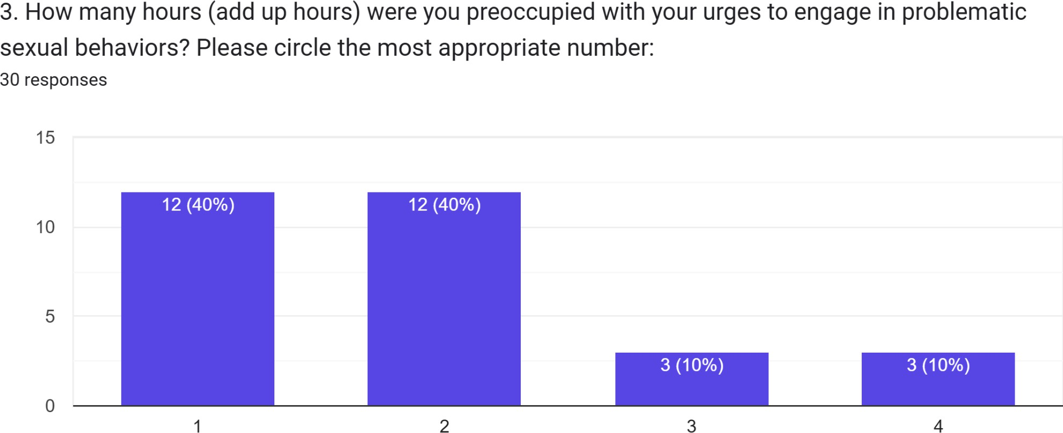

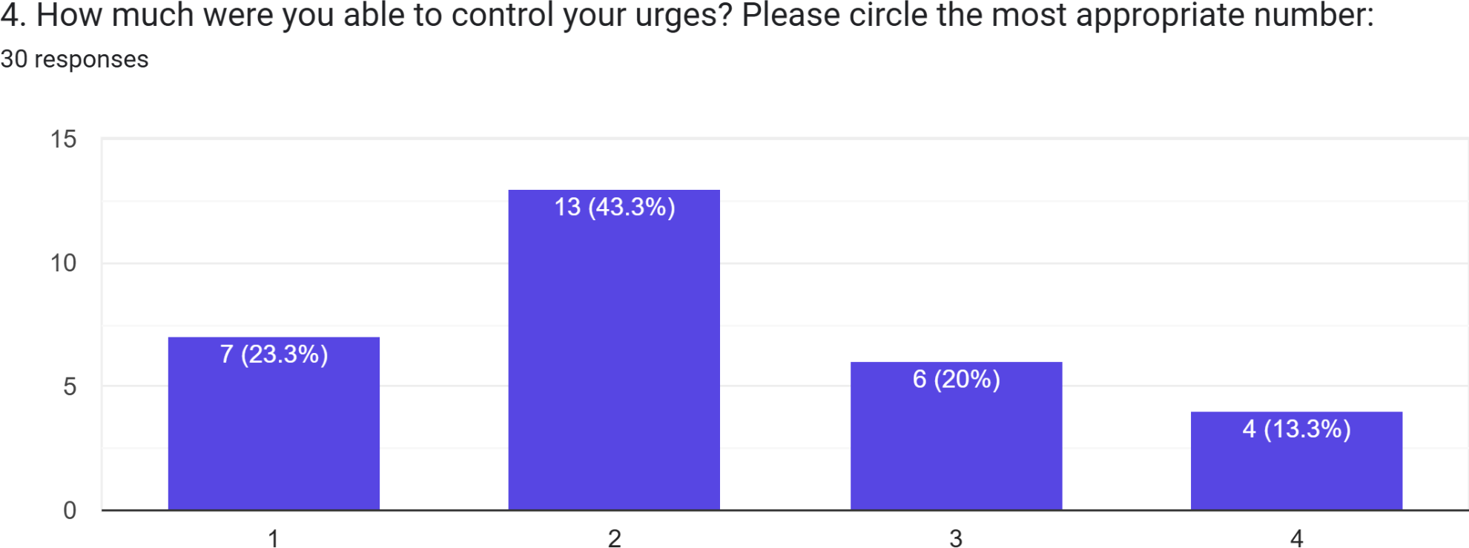

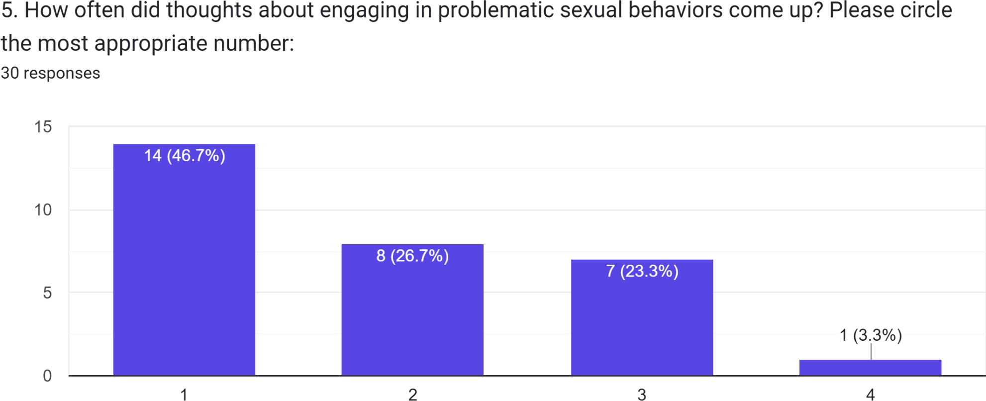

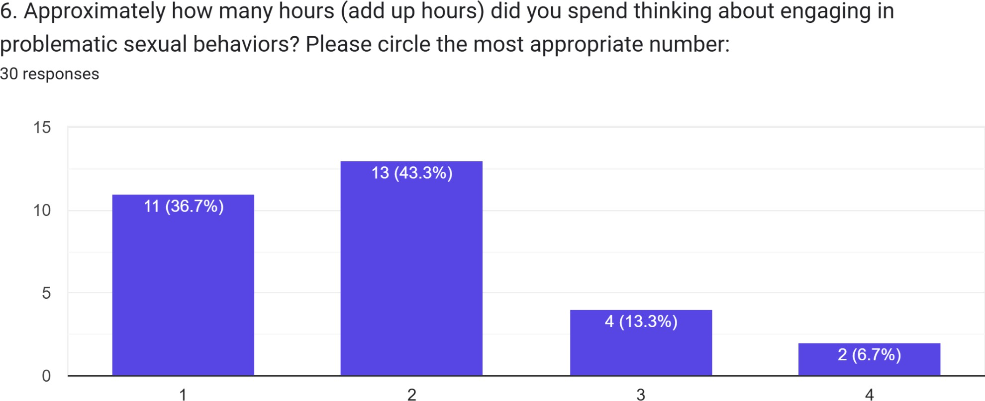

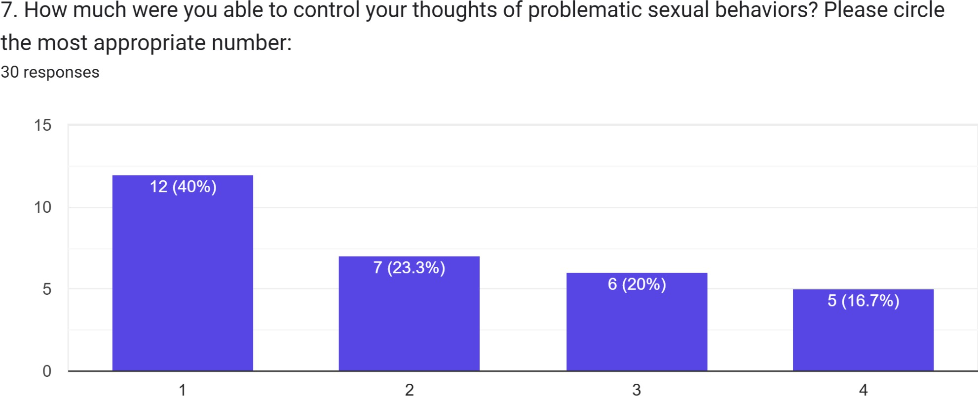

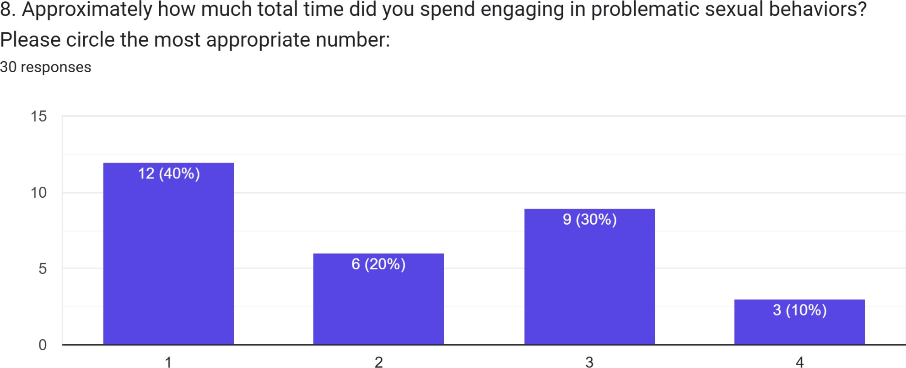

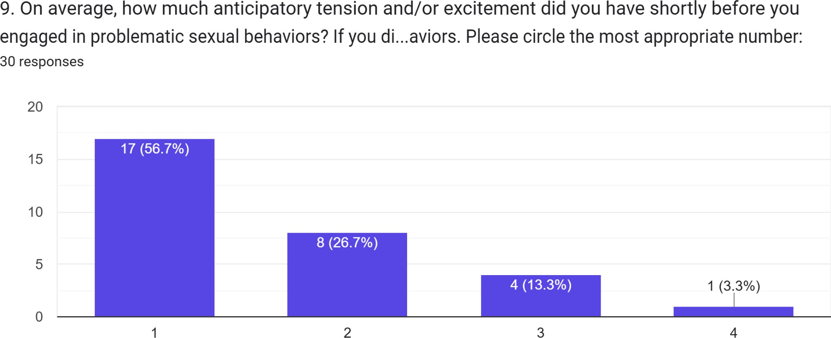

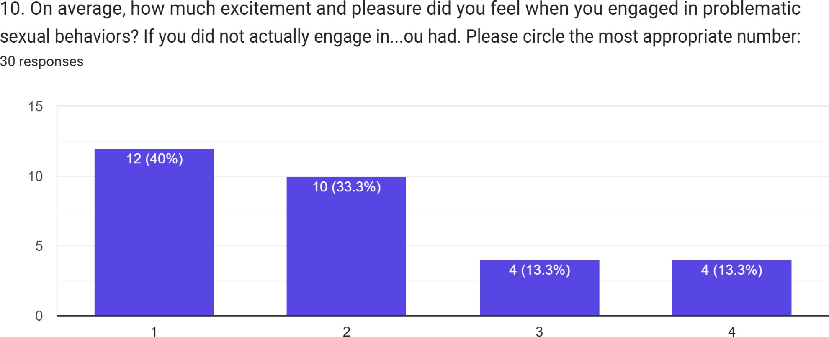

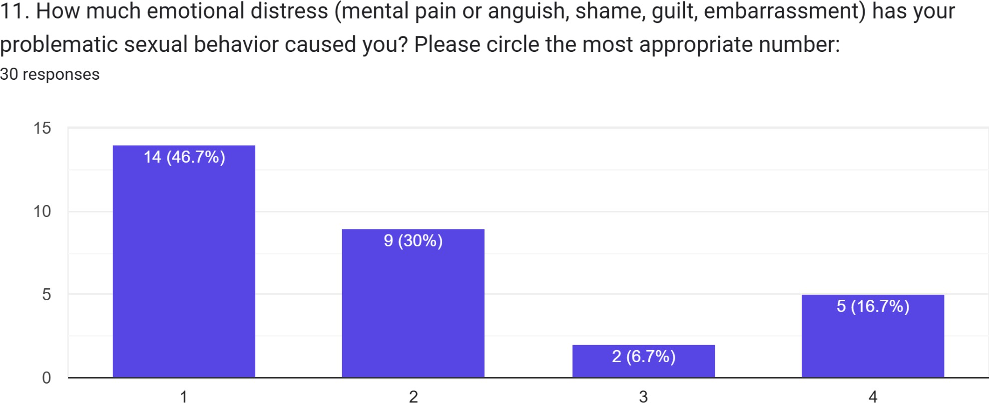

- Final Reflection

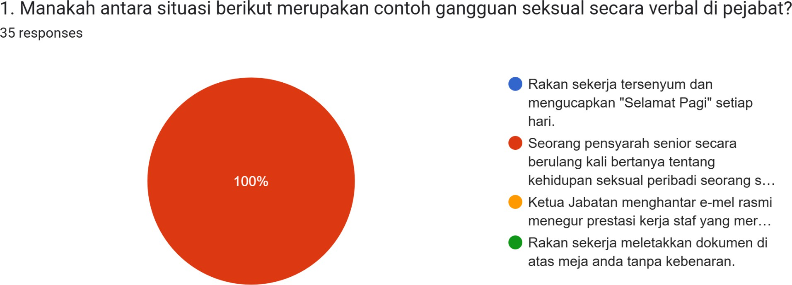

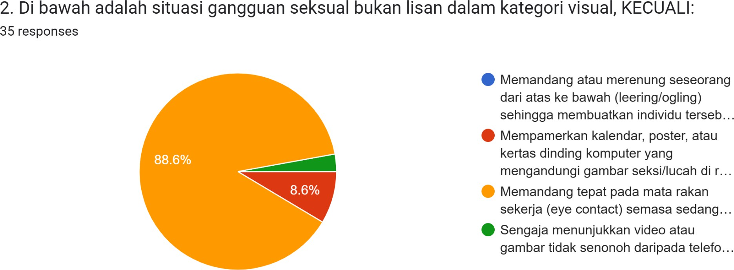

3. What were the main inputs or lessons you gained throughout this programme?
- It taught me how to handle situations or problems in a more mature and professional manner.
- I learned about the different types of harassment and the proper procedures for reporting complaints.
- I became more aware and sensitive to issues related to sexual harassment.
- I gained new knowledge and understanding about sexual harassment.
4. Could you provide any suggestions for improving our programme?

- Incorporate more multimedia elements such as videos, games, or group activities to make the programme more engaging.
- Include more fun and interactive games.
- Increase the number of activities that involve movement and active participation.
- Conduct the programme more frequently in the future.

DISCUSSION

This discussion section interprets and elaborates on the research findings in order to evaluate the effectiveness of the Safe Workplace Initiative Programme: Creating a Safe Organisation in addressing the issue of sexual harassment in the workplace, particularly within the context of educational institutions. This discussion relates the quantitative findings obtained from the Sexual Assessment Scale (SAS) instrument to the objectives of the programme, the literature review, and the three theoretical frameworks that shaped the intervention design, while also highlighting the limitations of the study.

Interpretation of Findings and Achievement of Programme Objectives

The quantitative findings of this study support the achievement of the programme's main objective, namely to increase participants' understanding of the forms, effects, and implications of sexual harassment in the workplace based on the Anti-Sexual Harassment Act 2022 (Act 840). Based on descriptive statistical analysis of 30 participants, the mean pre-test SSAS score was 23.57 (SD = 6.51), which increased to 34.00 (SD = 6.37) at post-test, representing a mean increase of 10.43 points. This increase indicates that participants had a better level of awareness and understanding of sexual harassment issues after participating in the programme.
The Paired-Samples t-Test analysis showed a statistically significant difference between the pre-test and post-test scores, namely t(29) = -39.284, p < .001. This value indicates that the increase in scores was not due to chance, but was rather a direct effect of the educational intervention implemented. In other words, the combination of interactive activities such as casual discussion sessions, awareness quizzes, and simulations successfully helped participants more clearly distinguish between acceptable social interactions and behaviour classified as sexual harassment.

This achievement is particularly important given that a study by Shalihin et al. (2022) found that verbal sexual harassment is often normalised as ordinary joking due to the absence of physical injury. The significant increase in SAS scores reflects that this phenomenon of normalisation can be reduced, and that participants became more sensitive to the importance of maintaining professional and ethical boundaries within the organisation.

Application of Theoretical Frameworks in Explaining Changes in Perception and Behaviour
The statistically demonstrated increase in awareness described above can be explained through three main theoretical frameworks underlying the programme's design, namely Rational Emotive Behaviour Therapy (REBT), Cognitive Behavioural Therapy (CBT), and Social Learning Theory (SLT). These three theories explain why the change in participants' perception occurred.

Rational Emotive Behaviour Therapy (REBT)

Through the Human Barometer activity, the programme succeeded in challenging irrational beliefs among participants. For example, the perception that affectionate nicknames or physical comments were a method of building rapport was directly debated by the facilitator acting as Devil's Advocate, and replaced with a more rational understanding grounded in professional ethics and the legal implications under Act 840. This process of cognitive confrontation is consistent with the increased understanding reflected in the post-test scores.

Cognitive Behavioural Therapy (CBT)

The Reframing technique applied in the Harassment or Not activity helped participants change their cognitive distortions. Participants were trained to view behaviour that had previously been regarded as harmless instructional humour as a form of violation of safety rights and workplace ethics. This cognitive restructuring enabled participants to more accurately distinguish between permissible friendly interaction and high-risk behaviour that violates the code of ethics and national legislation.

Social Learning Theory (SLT)

The programme also addressed the culture of silence through The Intervention Lab activity. Participants were given concrete modelling examples of how to intervene against harassment firmly and safely through the construction of action scripts, while group presentations created vicarious reinforcement as participants learned from the courage of their peers. This approach is consistent with the findings of Flynn et al. (2024), which emphasise the need for formal training to overcome reporting barriers and weaknesses in organisations' internal support systems.

Implications for Psychological Wellbeing and Performance

This discussion also highlights the programme's positive impact on the psychological wellbeing and performance of organisational members. As stated by Athanasiades et al. (2023), victims of sexual harassment often experience deterioration in mental health such as anxiety and depression, alongside a decline in performance and motivation. By creating a work environment that is safe and free from harassment, as evidenced by the significant increase in participants' awareness, this programme indirectly contributes to increased motivation, productivity, and emotional wellbeing within the organisation.

Strengthening Reporting Channels and Follow-up Action

One of the strengths of this programme is the comprehensive exposure to the correct reporting channels in accordance with the Anti-Sexual Harassment Act 2022, including the role of the Anti-Sexual Harassment Tribunal (TAGS). Participants, whether as victims or witnesses, became more confident in taking appropriate action when faced with situations of sexual harassment. This knowledge is critical in ensuring that justice can be upheld and perpetrators face appropriate consequences, thereby preventing the recurrence of similar incidents in the future.

Limitations of the Study

Although the findings show significant effectiveness, several limitations need to be taken into account when interpreting these results. First, the study used a single-group pre-test–post-test design without a control group. Therefore, the increase in scores cannot be attributed entirely to the intervention alone, as external factors such as the testing effect could

not be controlled for. Second, the small sample size (N = 30), limited to a single organisation, means that these findings cannot be widely generalised to a larger population. Third, pre-test and post-test comparisons could only be conducted for the SAS, while the Sexual Harassment Quiz and the Sexual Awareness Questionnaire served only as supporting assessments, as they were administered only once. Future research is recommended to employ a control group and a larger sample in order to strengthen the validity of the findings.
Overall, this discussion demonstrates that a structured intervention combining educational elements, practical simulations, and the application of psychological theory can significantly increase participants' awareness of sexual harassment issues in the workplace. The findings and implications discussed here form the basis for the conclusions and recommendations presented in the concluding section.

Reflection

The Safe Workplace Initiative programme provided a highly meaningful experience in enhancing my understanding of sexual harassment issues in the workplace. Through interactive activities such as quizzes, scenario simulations, and group discussions, I gained a clearer understanding of the various forms of sexual harassment, their impacts on individuals, and the preventive measures that can be taken. As a member of the module committee, I also gained valuable experience in designing and implementing activities that aligned with the programme objectives. Although there were challenges in ensuring that the activities ran smoothly and effectively engaged the participants, this experience helped me strengthen my communication skills, programme management abilities, teamwork, and problem-solving competencies.

Recommendations

To enhance the effectiveness of the programme in the future, it is recommended that the duration of implementation be extended to allow participants more time to engage in discussions and simulation activities. In addition, incorporating more real-life case studies and experience-sharing sessions from experts or individuals who have encountered sexual harassment situations could create a deeper impact on participants. Follow-up programmes may also be conducted to assess participants’ levels of understanding and awareness after a certain period of time.

Conclusion

Overall, the Safe Workplace Initiative programme successfully achieved its objectives of increasing participants’ awareness and understanding of sexual harassment issues in the workplace. The programme findings demonstrated a significant improvement in participants’ knowledge levels following the interventions implemented. The programme not only provided exposure to the forms and consequences of sexual harassment but also helped participants understand the appropriate reporting channels and the importance of fostering a safe, professional, and respectful workplace culture. Therefore, initiatives such as this should be sustained and expanded to promote organisations that are safer and free from sexual harassment.

ACKNOWLEDGEMENTS
The authors would like to thank the Institut Kemahiran MARA Kuching for their cooperation and participation in this study.

AUTHOR CONTRIBUTIONS
All authors contributed to the conception and design of the study, the implementation of the intervention, data analysis, and the writing and revision of the manuscript.

CONFLICT OF INTEREST
The authors declare no conflict of interest.

DATA AVAILABILITY STATEMENT
The data that support the findings of this study are available from the corresponding author upon reasonable request.

ETHICAL STATEMENT
This study was conducted in accordance with ethical standards. Informed consent was obtained from all participants, and confidentiality was maintained throughout the study.

FUNDING
This research received no external funding.

REFERENCES

Abiogu, G. C., Ede, M. O., Agah, J. J., Ebeh, J. J., Ejionueme, L. K., Asogwa, E. T., Ekwueme, F. O., Agu, P., Nwafor, B., Omeke, F., & Ogoke, J. (2021). Effects of Rational Emotive Behavior Occupational Intervention on Perceptions of Work Value and Ethical Practices: Implications for Educational Policy Makers. Journal of
Rational-Emotive & Cognitive-Behavior Therapy. https://doi.org/10.1007/s10942-021-00389-0

Arwa Masadeh, Rula Al-Rimawi, Salem, A., & Rami Masa’deh. (2024). Jordanian nursing students’ experience of harassment in clinical care settings. BMC Nursing, 23(1). https://doi.org/10.1186/s12912-024-02146-x

Behzadi Fard, S., Razban, F., Tian, X., & Dehghan, M. (2024). No Safe Haven for Reporting Sexual Harassment at Work: A Qualitative Meta-synthesis. Sexuality Research and Social Policy. https://doi.org/10.1007/s13178-024-01067-3
Choi, S. Y. P., Yip, T. P., & Nakano, L. Y. (2025). Out-of-Frame, Misframe, and Reframe: Challenges Faced by Victims in Identifying and Interpreting Online Sexual Harassment and Their Policy Implications. Sexuality Research and Social Policy. https://doi.org/10.1007/s13178-025-01160-1
Gianakos, A. L., Freischlag, J. A., Mercurio, A. M., Haring, R. S., LaPorte, D. M., Mulcahey,
M. K., Cannada, L. K., & Kennedy, J. G. (2022). Bullying, Discrimination, Harassment, Sexual Harassment, and the Fear of Retaliation During Surgical Residency Training: A Systematic Review. World Journal of Surgery, 46. https://doi.org/10.1007/s00268-021-06432-6
Harriott, S. A. (2025). Healing Workplace Dynamics. IGI Global eBooks, 131–150. https://doi.org/10.4018/979-8-3693-9556-1.ch006

Hendrick, S. S., & Hendrick, C. (1987). Multidimensionality of sexual attitudes. Journal of Sex Research, 23(4), 502–526.

Holmqvist Gattario, K., Hallén, H., Skoog, T., Thornberg, R., & Lunde, C. (2026). Study protocol for EthnoPRISE: an ethnographic study of peer sexual harassment in school. BMC Psychology. https://doi.org/10.1186/s40359-026-04361-4

Mapayi, B. M., Ibigbami, O., Akinsulore, A., Akanji, M., Opara, O., Olukokun, K. J., Agoke, O., Banjo, O., & Foláyan, M. O. (2026). Sexual harassment against sexual minority students in a university in Nigeria. Discover Psychology, 6(1).
https://doi.org/10.1007/s44202-026-00606-w

Mohd, Jamil, I. N., Nur, & Mohd, H. (2022). Sexual Harassment in Malaysian Educational Institution – A review of Its Factors and Effects. Asian Journal of Civilizational Studies (AJOCS), 4(3), 19–31. https://www.ajocs.com/index.php/ajocs/article/view/157

Muzaffar, S., Mallow, Malaysia, I., Nilai, B., Sembilan, N., Khusus, D., & Malaysia. (2022). Sexual harassment in education: Identifying the issue and finding the possible solution. https://www.ocerints.org/intcess22_e-publication/papers/Muzaffar%20Syah%20Mallo w.pdf
Sharma, T., Aryal, B., Gyawali, K., & Pandit, S. (2025). How Social Learning Theory Explains the Persistence of Sexual Harassment. Shiksha Shastra Saurabh, 25, 128–141. https://doi.org/10.3126/sss.v25i1.90506

Zara, G., Oriana Binik, Ginocchio, D., Merzagora, I., Giannini, A., Addabbo, T., Castelli, L., Criscenti, C., Ferrari, S., Marialaura Di Tella, Franco Freilone, Giulia Lausi, Rossetto, I., Veggi, S., & Laura, G. (2024). Looking for a preventive approach to sexual harassment in academia. A systematic review. European Journal on Criminal Policy and Research. https://doi.org/10.1007/s10610-024-09582-0

