Exploring Factors of Learners' High Learning Outcomes in Values Education and Behavioral Outcomes
Joseph Jay U. Aureada
SDO Tayabas City

Abstract
This study aimed to explore the factors contributing to the high Mean Percentage Scores (MPS) in Edukasyon sa Pagpapakatao (EsP) and to examine the discrepancy between learners’ academic performance and their behavioral outcomes in the Division of Tayabas City. Specifically, it sought to (1) describe the effectiveness of the EsP curriculum in promoting values learning, (2) identify barriers affecting its implementation, and (3) propose strategies to improve the alignment between academic and behavioral outcomes. A descriptive research design was employed, involving a purposive sample of 48 teachers and guidance counselors directly engaged in EsP implementation. Data were collected through a structured and open-ended survey administered via Google Forms and analyzed using descriptive statistics and thematic analysis. Findings revealed that high academic performance in EsP is associated with the integration of values across subject areas, interactive teaching strategies, and stakeholder involvement. However, a gap persists between cognitive understanding and actual behavior due to limited experiential learning, insufficient teacher training, and weak reinforcement mechanisms. The study concludes that a holistic, experiential, and collaborative approach is essential to bridge this gap and recommends strengthening teacher capacity-building, enhancing home-school-community partnerships, and institutionalizing continuous monitoring of learners’ behavioral development.
Keywords: Values Education, Behavioral Outcomes, Character Formation

Introduction
Edukasyon sa Pagpapakatao (EsP) plays a critical role in shaping learners’ moral character, social responsibility, and ethical decision-making. Within the K to 12 curriculum of the Department of Education (Philippines) (2013), EsP is designed to develop values that guide learners’ behavior in real-life situations. Across schools, EsP consistently registers high Mean Percentage Scores (MPS), indicating strong academic performance. However, this achievement presents a paradox: despite high scores, schools continue to report behavioral concerns such as bullying, absenteeism, and non-compliance with school rules.
This disconnects between academic performance and actual behavior raises a critical issue in values education. While learners may demonstrate cognitive mastery of values, they may struggle to internalize and apply them in real-life contexts. This concern is supported by Benninga, Jacques S. et al. (2006), who found that strong academic outcomes in character education do not always result in positive behavioral change. Similarly, Lickona, Thomas (1991) emphasized that values education must go beyond knowledge acquisition and focus on character formation through practice and reinforcement.
Theoretical perspectives further explain this gap. Dewey, John (1938) and Kolb, David A. (1984) highlight the importance of experiential learning in translating knowledge into action, while Bandura, Albert (1977) underscores the role of social environments in shaping behavior. In the context of Tayabas City, teachers and guidance counselors report that limited experiential opportunities, insufficient guidance services, and weak home-school collaboration contribute to the persistence of behavioral issues despite high academic performance.
Given this context, this study addresses the following problems: (1) How effective is the EsP curriculum in promoting values learning? (2) What barriers affect its effective implementation? and (3) What strategies can be proposed to improve the alignment between academic achievement and behavioral outcomes? By addressing these questions, the study aims to provide evidence-based recommendations to strengthen values education and bridge the gap between knowing and practicing values.

Methods
This section presents the research design, participants, data-gathering instruments, procedures, and data-analysis techniques employed in the study.

Study Design
This study employed a descriptive research design to examine the factors contributing to the high Mean Percentage Scores (MPS) in EsP and the discrepancy between academic achievement and behavioral outcomes. This design enabled the systematic description of current practices and perceptions without manipulating variables.

Participants/Subjects
The participants comprised 48 teachers and guidance counselors from the Schools Division of Tayabas City, selected through purposive sampling for their direct involvement in EsP implementation.

Data Gathering Instrument
A researcher-developed survey questionnaire was administered via Google Forms, consisting of structured and open-ended items aligned with the study objectives.

Procedure
Data collection involved securing permission, distributing the survey, obtaining informed consent, and collecting responses within a specified period while ensuring confidentiality and voluntary participation.

Data Analysis
Quantitative data were analyzed using descriptive statistics, while qualitative responses were analyzed through thematic analysis to identify emerging themes.

Results and Discussion

1. Effectiveness of the EsP Curriculum
The findings indicate that the EsP curriculum effectively promotes learners’ theoretical understanding of values, as evidenced by consistently high MPS; however, respondents reported that students experience difficulty in applying these values in real-life situations. This suggests that while EsP is effective at the cognitive level, it is less effective in achieving behavioral outcomes, indicating a gap between knowledge acquisition and value internalization. This supports the findings of Benninga, Jacques S. et al. (2006), who noted that academic success in character education does not automatically lead to behavioral change, and aligns with Dewey, John (1938), who emphasized that learning must be grounded in experience to be meaningful.

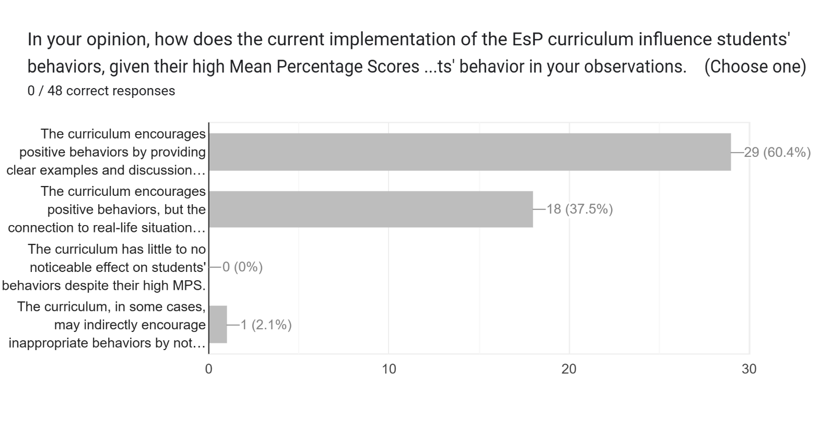

2. Barriers to Effective Implementation
The study identified barriers such as overcrowded classrooms, limited teacher training, low parental involvement, and underutilization of the Homeroom Guidance Program. These constraints hinder the delivery of meaningful and experiential learning, limiting the effectiveness of EsP in shaping behavior. This finding reflects the views of Fullan, Michael (2007), who emphasized that successful educational reform requires adequate support systems and teacher capacity-building, and supports Vygotsky, Lev S. (1978), who highlighted the importance of social interaction and support structures in learning development.

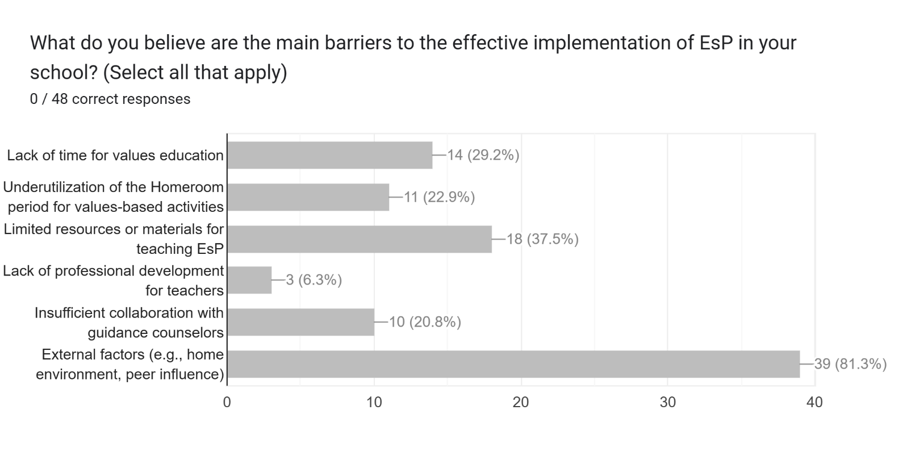
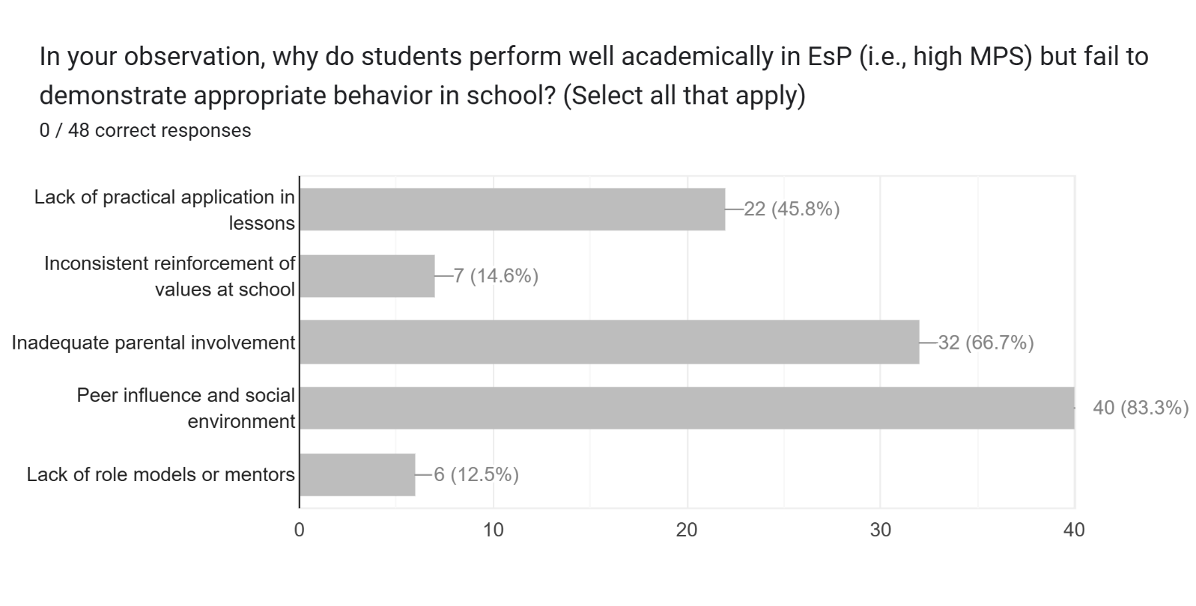

3. Proposed Strategies to Improve Alignment
The findings suggest the need for strategies such as values-driven activities, peer mentoring, behavioral monitoring, strengthened guidance services, and increased stakeholder involvement. These strategies imply that values education must adopt a holistic and collaborative approach that integrates experiential learning and community participation. This aligns with Kolb, David A. (1984) on experiential learning and Lickona, Thomas (1991), who advocated for a whole-school approach to character education to ensure that values are consistently practiced and reinforced.

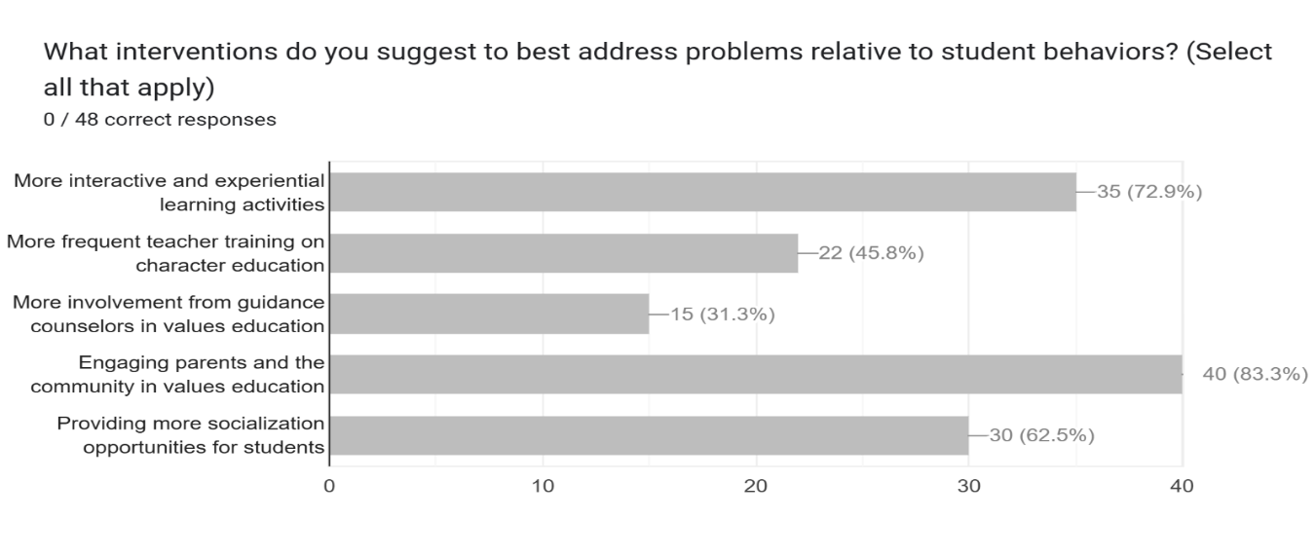
Conclusion
The study revealed that high learning outcomes in Edukasyon sa Pagpapakatao (EsP) are influenced by the integration of values across subject areas, interactive teaching strategies, and stakeholder involvement. However, despite learners’ strong cognitive understanding of values, challenges remain in consistently applying these in real-life situations. Findings suggest that values education becomes more meaningful when supported by experiential learning, continuous reinforcement, and collaboration among schools, families, and communities. The study emphasizes the importance of holistic approaches that promote both academic achievement and behavioral development.

Recommendations
Based on the findings, the following recommendations aim to optimize values education and character-building initiatives:

- Strengthen experiential and values-driven learning.
- Enhance teacher capability-building on values integration.
- Reinforce home-school-community partnerships.
- Monitor behavioral outcomes alongside academic performance.
- Consider implementing the ASAL sa ARAL Program to support academic recovery and values formation.

References

Benninga, J. S., Berkowitz, M. W., Kuehn, P., & Smith, K. (2006). Character and academics: What good schools do. Phi Delta Kappan, 87(6), 448–452. https://doi.org/10.1177/003172170608700610

Berkowitz, M. W., & Bier, M. C. (2005). What works in character education: A research-driven guide for educators. Journal of Research in Character Education, 3(1), 29–48.

Department of Education (Philippines). (2013). K to 12 curriculum guide: Edukasyon sa Pagpapakatao (EsP). Pasig City: DepEd.

Department of Education (Philippines). (2019). Policy guidelines on the K to 12 basic education program. Pasig City: DepEd.

Dewey, J. (1938). Experience and education. Macmillan.

Kolb, D. A. (1984). Experiential learning: Experience as the source of learning and development. Prentice Hall.

Lickona, T. (1991). Educating for character: How our schools can teach respect and responsibility. Bantam Books.

Vygotsky, L. S. (1978). Mind in society: The development of higher psychological processes. Harvard University Press.

Bandura, A. (1977). Social learning theory. Prentice Hall.

Fullan, M. (2007). The new meaning of educational change (4th ed.). Teachers College Press.

