Comparative Analysis of Statistical and Deep Learning Approaches for Cloud Resource Utilization Forecasting
Hiral N Prajapati¹, Naimisha S Trivedi², Manmitsinh C Zala³, Dipak C Patel⁴
Department of Information Technology Vishwakarma Government Engineering College Chandkheda
Ahmedabad, Gujarat, India

Abstract—Resource management is an important aspect of cloud computing, and it has a significant role to play in improving the efficiency of resources and providing quality services to the end-users. Workload forecasting is considered to be an essential component of resource management to avoid situations of over- provisioning and under-provisioning of resources, thereby im- proving the efficiency of the system. Most of the existing literature has focused on addressing scenarios where the workload exhibits strong seasonal and trending characteristics, and in scenarios where the workload is highly irregular in nature. However, in real-world scenarios of cloud computing, the workload is mostly a mix of both seasonal and irregular characteristics. This paper aims to carry out a comprehensive comparative study of various widely used time series-based workload forecasting techniques such as ARIMA, SARIMA, Holt-Winters, Exponential Smoothing, and the LSTM model. In this study, CPU utilization traces from the BitBrain dataset were used to evaluate the efficiency of these models at different levels of granularity, including daily, hourly, and minute-level granularity to consider diverse workload scenarios. Based on the findings of this study, a workload-aware prediction technique was proposed, and the proposed technique could be of significant use to the service providers of the cloud to optimize the resources and minimize the operation waste to improve the efficiency of the system.
Index Terms—BitBrain Dataset, ARIMA, SARIMA, Holt- Winters, Exponential Smoothing, LSTM, Time Series Forecast- ing, MAE, RMSE, MAPE.

- Introduction
Cloud computing has emerged as a revolutionary tech- nology in the current computing era, offering on-demand access to a shared pool of computing resources, such as physical machines, servers, storage, networking, applications, and other services [1]. Cloud computing enables organizations and individuals to consume computing resources as a utility, based on a pay-per-use model, without requiring substantial capital expenditures in IT infrastructure. The cloud computing environ- ment primarily offers three service models: Software as a Service (SaaS), Platform as a Service (PaaS), and Infras- tructure as a Service (IaaS), which cater to various user needs [2]. Elasticity is one of the most prominent features of cloud computing, which enables dynamic allocation or de-allocation of resources based on real-time workload requirements [3]. Elasticity ensures that the system can scale up or down based on changes in user demands, thereby enabling the ability to maintain application performance and Quality of Service
(QoS). However, resource allocation in a cloud environment is complex due to the dynamic, unpredictable, and diverse nature of workloads. Inadequate resource allocation may lead to Service Level Agreement (SLA) breaches, performance degradation, and reduced user satisfac- tion, whereas over- allocation of resources leads to resource wast- age, increased operational expenses, and increased energy con- sumption [4].Therefore, it is required to develop mechanisms that can dynamically and accurately allocate resources according to the real-time workload patterns. In this context, workload prediction has been identified as one of the most important tools in cloud resource management. Workload prediction can accurately predict the amount of required resources in advance, which makes effective planning, task scheduling, and resource management possible [5]. Cloud Data Centers (CDCs) provide various types of resources such as CPU, memory, storage, bandwidth, and software, which are virtualized and allocated to tasks on-demand. It has been observed that the amount of resources allocated for application execution is often higher than the actual requirements, mainly to avoid SLA violations and ensure QoS [6]. This strategy, although effective for maintaining performance, often leads to significant resource wastage. Therefore, it is required to design prediction models that can accurately estimate future resource demand, thereby minimizing both under-allocation and over-allocation. Work- load prediction in clouds is inherently complex due to the irregular arrival of user tasks and their varied resource re- quirements [7]. Traditional statistical models such as ARIMA, SARIMA, Holt-Winters, and Exponential Smoothing have been widely used for CPU and memory utilization prediction forecasting [8],[9]. These models are useful for modeling workload traces with temporal and seasonal variations but are likely to fail for accurate predictions of large-scale, high- dimensional, and highly dynamic workloads. On the other hand, machine learn- ing models, such as Long Short-Term Memory (LSTM) net- works, have demonstrated outstanding performance in irreg- ular and highly dynamic workload predictions [10],[11]. Hybrid models that combine statistical models and machine learning have been investigated for en- hancing the predic- tion accuracy for various cloud workloads. In addition to global resource predictions, task-level resource predictions are gaining more attention. If we can predict the

CPU and memory requirements for each task, cloud managers can rank tasks based on resource intensiveness, enhance VM allocation techniques, and enhance capacity planning. Task level predictions enhance resource allocation efficiency, reduce SLA violations, and enhance overall system performance.
This paper presents a workload prediction method that integrates statistical models and machine learning techniques, depending on the type of workload. We use historical workload data, which are preprocessed and fed into the prediction model. The predicted values are fed into task classifiers, which clas- sify tasks according to their resource consumption patterns, enabling more intelligent VM allocation, effective task sched- uling, and overall effective resource management. The goal is to enhance the accuracy of predictions beyond the capabilities of statistical models or machine learning models.
The organization of this paper is as follows. Section II presents the related work. Section III presents the dataset, preprocessing, and stationarity test. Section IV presents the de- velopment of forecasting models such as ARIMA, SARIMA, Holt-Winters, Exponential Smoothing, and LSTM models. Section V presents the experimental results and comparison of performances according to various error measures. Section VI presents the comparison of performances of various models. Finally, Section VII concludes this paper with final remarks and recommendations for future studies.
- Related Work
Resource utilization forecasting in cloud computing envi- ronments has been widely recognized as a vital function for enabling proactive resource provisioning, auto-scaling, and Service Level Agreement (SLA) fulfillment. Over the last decade, researchers have explored various statistical, machine learning, and deep learning-based approaches for time series workload prediction.
- Statistical Time Series Models
Statistical time series models have been widely used because of their mathematical interpretability and low computational cost. The Autoregressive Integrated Moving Average model, introduced by Box and Jenkins [15], emphasizes the impor- tance of modeling linear relationships in stationary time series data. It has been effectively used for cloud workload predic- tion, given that resources exhibit temporal correlations over short periods of time. Another variant of the ARIMA model is the SARIMA model, which has been effectively used to handle seasonality issues in time series data and perform better than the ARIMA model when applied to cloud workload prediction, especially when strong seasonality patterns are evident in the workload data. Holt-Winters exponential smoothing is another effective statistical time series model that has been effectively used for cloud workload prediction. It attempts to capture the level, trend, and seasonality of time series data by employing triple exponential smoothing. Although these models show promise for cloud workload prediction, they assume linearity and may not capture abrupt workload spikes and nonlinear relationships.
- Machine Learning-Based Approaches
In order to avoid the limitations of conventional statistical models in managing situations of increased workload and non-linearity, machine learning models were widely used for workload prediction in cloud computing environments. Models that use a combination of the SARIMA model and intelligent learning models were proposed to improve the accuracy of predictions. These models were proposed to reduce the lin- earity constraints of conventional statistical models. However, many machine learning models face difficulties in managing long-term temporal dependencies and dynamic workload chal- lenges. These challenges led researchers to use deep learning models for improved workload prediction.

- Deep Learning Models
The performance of time series forecasting has been en- hanced significantly in recent years using deep learning mod- els. The most prominent models for time series prediction are the Long Short-Term Memory (LSTM) network, proposed by Hochreiter and Schmidhuber [16]. The LSTM network was designed to handle the problem of the vanishing gradient in recurrent neural networks. The LSTM network has shown strong ability in modeling long-term dependencies.
The significant advantages of using the LSTM network for time series prediction are as follows:
  - It has the ability to learn nonlinear patterns
  - It has the ability to model long-range temporal depen- dencies
  - It has robust ability to handle bursty workloads
  - It has strong ability for multi-scale temporal learning
The LSTM network has been recognized as a promising approach for predicting cloud CPU utilization. Most of the existing approaches are based on highly seasonal workloads or purely irregular workloads. However, in reality, cloud workloads often exhibit complex patterns, including trends, seasonality, and irregular patterns.

- BitBrain Workload Trace Research
BitBrain workload traces have been widely recognized as realistic benchmarks for assessing various cloud resource pre- diction models. It is known that the traces offer detailed CPU utilization data obtained from virtual machines that operate in real-world environments.
It is found that most of the existing literature based on BitBrain workload traces is mainly focusing on the following aspects:
  - Evaluation of a single prediction model
  - Evaluation of single time granularity
  - Limited comparative performance evaluation
Yet, it is still insufficiently explored how a comprehensive comparative performance evaluation of multiple forecasting models across multiple time granularities could be performed with realistic cloud workload traces.

- Research Gap
From the literature survey, it is identified that the following limitations of existing techniques for prediction of cloud resources are:
  - Many of the statistical models are considered to be linear.
  - Many of the machine learning models are incapable of handling long-term temporal dependencies of the cloud environment.
  - Many of the deep learning models are considered to be suitable for single types of workload patterns.
  - There is no comprehensive comparative study of classical statistical models and deep learning models using real- world cloud traces with different time granularities.
Therefore, it is necessary to perform a comprehensive comparative study of the performance of classical statistical models, namely, ARIMA, SARIMA, Holt-Winters, Exponen- tial Smoothing, and deep learning models, namely, LSTM models using real-world cloud traces with minute, hour, and day time granularities. The objective of the present work is to perform that.
from the system may contain outliers, missing values, or may contain variables with no variance. These may have a negative effect on the performance of the system. Therefore, the preprocessing of the data was carried out using Python libraries such as pandas. The data was tested for missing values using the isnull() function. The rows or columns with missing values are deleted from the data using the dropna() function in order to ensure that the data points used for predictive modeling are representative and valid.
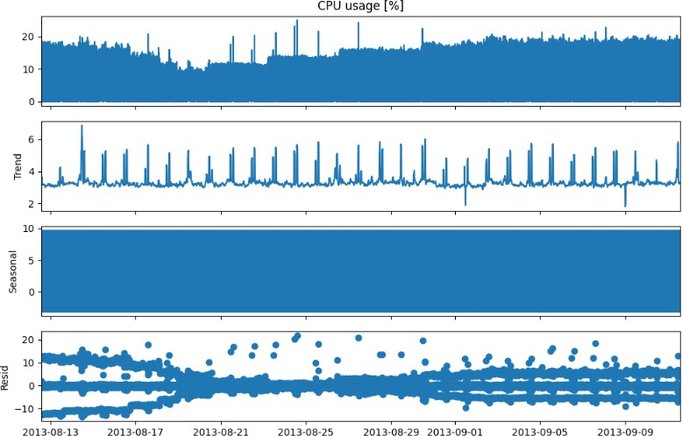
In order to have a better understanding of the time series pattern, the dataset was decomposed in order to obtain the trend, seasonal, and residual components. The presence of seasonal patterns and trends in the data, which are stochastic in nature, implies that the data is non-stationary. Therefore, the data needs to be transformed using techniques such as differencing and scaling. The preprocessing of the data is also useful in ensuring that the mean and variance of the data are constant. These are the conditions required in the forecasting models such as ARIMA and SARIMA.

- Materials and Methods
- Description of Dataset and Preprocessing
A dataset on the usage of the CPU was used in this research, as presented in Figure 1 below. The data was collected from the year 2012 to 2013. The data was collected from the BitBrain system. The data is collected on a continuous basis and is used in tracking the usage of the CPU. All the data is labeled and is used in the tracking of the time stamps and the percentages of the usage of the CPU. The data is very suitable for the forecasting of the time series data because it captures the minute details of the time series data. The data is collected from the BitBrain system, which is a full- fledged monitoring system. The data is used in the tracking of the factors related to the CPU. These factors are used in the tracking of the CPU in order to improve its performance. These factors are very suitable in the capacity planning and the identification of anomalies. The data is mainly centered on a prominent column known as the CPU usage. This is a great starting point in the creation of a predictive model in order to improve the system’s performance.
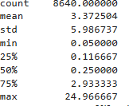
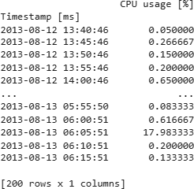
Fig. 1. Dataset shape and description

The preprocessing is an important aspect in ensuring that the accuracy of the forecast is maintained. The data obtained

Fig. 2. Decomposition of CPU usage into trend, seasonal, and residual components

- Time Stationary Identification
In time series analysis, it is of prime importance to identify whether the time series is stationary or non-stationary. The analysis of time series is done based on this assumption. Christophorus et al. [13] emphasize the importance of this assumption. The Augmented Dickey-Fuller test is performed for this purpose. If the test statistic value is lower than the critical value, then the null hypothesis is rejected. Hence, the time series is identified as stationary. Otherwise, the null hypothesis cannot be rejected. Hence, the time series is identified as non-stationary. The result of the ADF test performed for the time series is as shown in Table I.
As the ADF statistic is less than the critical values and the p-value is almost zero, the null hypothesis is rejected, which proves the stationarity of the series representing the CPU usage data for the dataset named BitBrain. Initially, the series representing the CPU usage was made stationary by applying the np.diff() function with a lag of 1, i.e., n=1. This removes

TABLE I
ADF Test Results for BitBrain CPU Usage Dataset

Dependent Variable | Values
ADF Statistic | -9.4083
P-value | 5.93 ×10⁻¹⁶
Number of Lags Used | 36
Number of Observations Used | 8,063
Critical Value at 1% Level | -3.4311
Critical Value at 5% Level | -2.8619
Critical Value at 10% Level | -2.5669

the trend and reduces the seasonality from the series. To further confirm the periodicity in the series representing the CPU usage data, an additional differencing was applied on the series with a lag of 12, i.e., n=12. The second Augmented Dickey- Fuller test was again performed on the series representing the CPU usage data (y_diff_seasonal_diff) to confirm its stationarity.
The result of the second Augmented Dickey-Fuller test on the series representing the CPU usage data provides a quanti- tative confirmation of the stationarity of the series representing the CPU usage data.
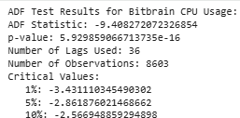

Fig. 3. Augmented Dickey-Fuller Test.

- Model Development
- AutoRegressive Integrated Moving Average (ARIMA) Model
The Autoregressive Integrated Moving Average model is a combination of an autoregressive model of order p, an integrated model of order d, and a moving average model of order q. As explained by Peixeiro in [8], the parameters p, d, and q are difficult to set. The model is also useful in terms of interpretability since the present value is a combination of past values and past errors.
As explained by Ali Hussein et al. in [9], in a non-seasonal ARIMA model of order p, d, and q:
  - p denotes the number of autoregressive terms,
  - d denotes the number of differences required to make the series stationary, and
  - q denotes the number of moving average terms.
An autoregressive series of order p is denoted by AR(p). The equation is represented by the following expression:
Y_{t} = ϕ₁Y_{t−1} + ϕ₂Y_{t−2} + · · · + ϕ_{p}Y_{t−p} + ε_{t} (1)
where Y_{t} is the current value, ϕ₁, ϕ₂, . . . , ϕ_{p} are the autore- gressive coefficients, and ε_{t} is a white noise error term.
The term ε_{t} represents white noise, and ϕ_{i} are the model parameters. The next value observed in the series is a slight perturbation of a function of the most recent observations.
A time series {Y_{t}} is called a moving average process of order MA(q) if it satisfies:
Y_{t} = ε_{t} + θ₁ε_{t−1} + θ₂ε_{t−2} + · · · + θ_{q}ε_{t−q} (2)
where ε_{t} is white noise and θ_{i} are the parameters of the MA model.
The parameters θ_{i} are the coefficients of the moving average process. It is quite easy to identify whether the series is an MA series or an AR series when dealing with a time series model. All you need is to look at the Auto Correlation Functions (ACF) of the series. If the series is an MA series, the ACF is a cut-off function. If the series is an AR series, the ACF is an exponential function.
An integrated series is a series of values Y_{t}, which are the cumulative sum of random values. The order of integration d is the number of differencing operations required to render a series stationary. A random walk is an example of an I(d) series.
For the purpose of training and testing of the model, the data was split into two separate components: the training set and the test set. The training set is composed of the first 168 values and is used for the training of the model. It is the historical background for the model.
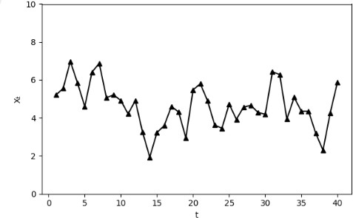
Fig. 4. An example of MA(1) process, produced using a number generator

The list of all possible combinations of the param- eters p, q, P , and Q was obtained by applying the product function of the itertools module, creating the SARIMA_order_list. The parameters of the final model were found by the combination that produced the lowest AIC, which in this case was 24,311.5127.The ARIMA model was created by applying the SARIMAX function of the statsmodels library, including the training set and the order (1, 1, 1) and the seasonal order (1, 1, 1, 12). After that, the model was fitted to the training set by applying the fit() function.
In order to test the appropriateness of the model, The Ljung- Box test was carried out. The test helped to find out if the

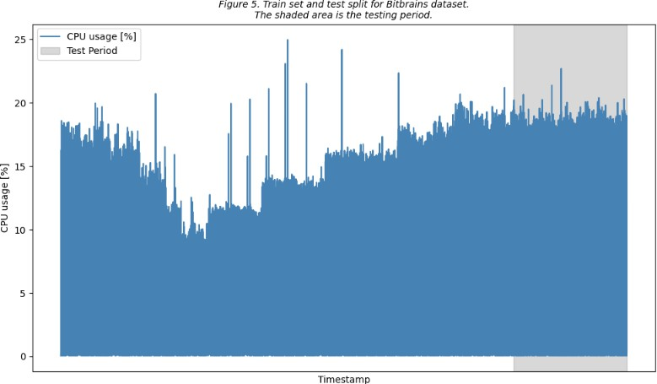

Fig. 5. Train set and test split for Bitbrain dataset. The shaded area is the testing period.

residuals are independent. The p-value was found to be 0. The value indicates that it is not possible to accept the null hypothesis that the residuals are independent.
In order to further investigate the residuals, plots such as ACF plots, Q-Q plots, and histograms are used to test the appropriateness of the model. The plots are as shown below (Figure 6).
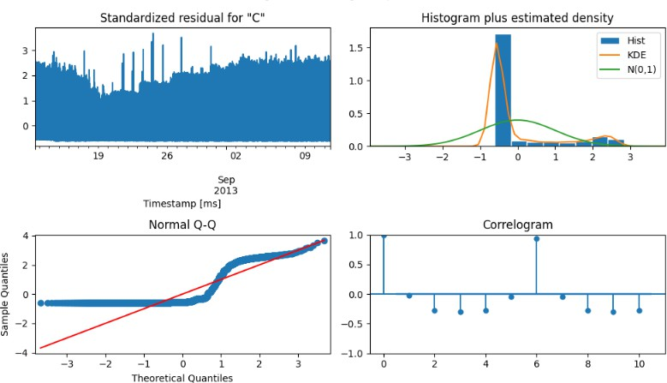

Fig. 6. ARIMA diagnostic plot

- Seasonal AutoRegressive Integrated Moving Average (SARIMA) Model
The SARIMA (p, d, q)(P, D, Q)_{m} model is an extended version of the ARIMA (p, d, q) model, used for time series that have a seasonal component. Here, P, D, Q, and m represent the seasonal counterparts of p, d, and q, respectively.
- p, d, q - These parameters are similar to the ARIMA
(p, d, q) model.
- P - This parameter represents the order of the seasonal autoregressive process.
- D - This parameter represents the order of seasonal integration.
- Q - This parameter represents the order of the seasonal moving average process.
- m - This parameter represents the frequency.
The SARIMA (p, d, q)(P, D, Q)_{m} model is used for mod- eling the non-seasonal and seasonal characteristics of the data.
The order of the non-seasonal part of the model is (1, 1, 1), and the order of the seasonal part of the model is (1, 1, 1, 12), which implies the model considers the seasonal characteristics of the data at every 12 units. The results of the model are presented in Table II.

TABLE II SARIMA MODEL RESULTS

Dependent Variable Values
Total number of observations used 6912
Model specifications SARIMAX(1, 1, 1) × (1, 1, 1, 12)
Log Likelihood -12150.756
Akaike Information Criterion (AIC) 24311.513
Bayesian Information Criterion (BIC) 24345.708
Hannan-Quinn Information Criterion (HQIC) 24323.305

The actual and forecasted BitBrain memory consumption is presented in Figure 7. The actual memory consumption is depicted by the blue line. The black dashed line corresponds to the ARIMA(2, 1, 2) model, and the green.
Hence, based on the comparison of the predicted model output with the actual memory consumption, it is clear that both models are able to identify the trends, although the accuracy of identifying the minute details may vary. Also, the shaded region indicates the actual testing data, i.e., from index 168 onwards, which makes it easier to compare the actual performance of the models.
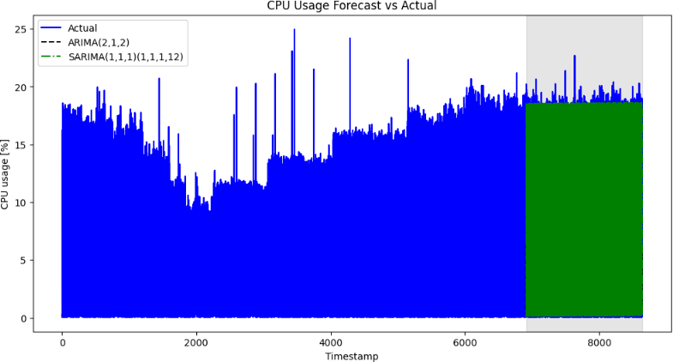

Fig. 7. Actual and Predicted Bitbrain dataset using ARIMA and SARIMA Models.

- Holt-Winters Model

The Holt-Winters Exponential Smoothing Algorithm, also known as Triple Exponential Smoothing, is a widely used sta- tistical technique for forecasting time series data that display trend and seasonality. The Holt-Winters model is an extension of the Simple Exponential Smoothing model. It adds two additional components: trend and seasonality. These allow the model to respond adaptively to changes in the time series over time.

Level: L_{t}

Y_{t}
= α + (1 − α)(L
St−m

t−1

+ bt−1

) (3)
the case of the time series data used in the research. The Long Short-Term Memory model is an improvement over the Recurrent Neural Network model in that it has the ability to

Trend: b_{t} = β(L_{t} − L_{t−1}) + (1 − β)b_{t−1} (4)
learn and retain information over a long period of time, unlike
the standard RNN model that can only retain information for

Seasonality: S_{t}
= γ Yt + (1 − γ)S
L_{t}

t−m
(5)
a short period of time.
The Long Short-Term Memory model was developed in

Forecast: Yˆt+h = (L_{t} + hb_{t})S_{t−m+h}m (6)
(7)
- Y_{t}: The CPU usage at time t.
- L_{t}: The smoothed average of the CPU usage.
- b_{t}: The increasing/decreasing trend of the CPU.
- S_{t}: The hourly/daily usage cycle.
- m = 24: The seasonal periodicity.
The Holt-Winters model is a recursive algorithm. It updates the level, trend, and seasonality values and uses them for prediction. Figure 8 shows the actual and predicted values of the CPU usage.
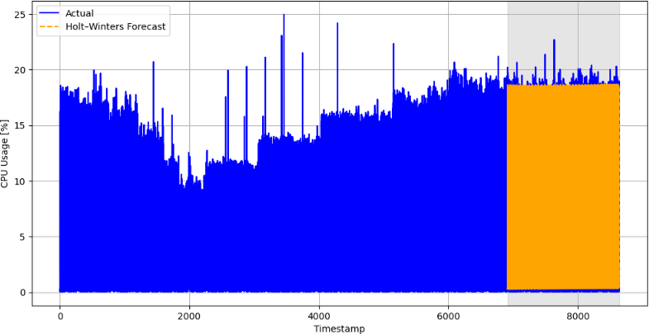

Fig. 8. Actual and Predicted CPU Usage using Holt–Winters Model

- Exponential Smoothing Model
The Exponential Smoothing model is a basic and widely used model for time series forecasting. It works by providing exponentially decreasing weights to past values. The goal of this model is to give more weight to recent values than to past values. This characteristic of the model makes it appropriate for time series without trends and seasonality.
For this research, the Exponential Smoothing model was implemented using the statsmodels library in Python. The model was implemented for the training set and the test set.
Simple Exponential Smoothing provides exponentially de- creasing weights for past values. The formula for this model is as follows:
Yˆt+1 = αY_{t} + (1 − α)Yˆt (8)
where 0 ≤ α ≤ 1.
- Long Short-Term Memory (LSTM) Model
The Long Short-Term Memory (LSTM) model is a Re- current Neural Network (RNN) that is specifically useful for modeling long-term dependencies in the data, such as in
the research, specifically the architecture of the model, by employing the Keras library with the TensorFlow engine. The data was normalized and rearranged in such a way that the past CPU values were used to forecast the future CPU values, a process that is supervised in nature. The model had an LSTM layer and an output layer, and the optimizer used was the Adam optimizer with the MSE loss function, and early stopping was used to prevent overfitting in the model.

f_{t} = σ(W_{f} · [h_{t−1}, x_{t}] + b_{f} ), (9)
i_{t} = σ(W_{i} · [h_{t−1}, x_{t}] + b_{i}), (10)
o_{t} = σ(W_{o} · [h_{t−1}, x_{t}] + b_{o}), (11)
C_{t} = tanh(W_{C} · [h_{t−1}, x_{t}] + b_{C}) (12)
- x_{t} = Input data (CPU usage at time t)
- h_{t−1} = Previous hidden state (memory from previous step)
- W and b = Weights and biases learned by the LSTM
- f_{t} = Forget gate (what to forget?)
- i_{t} = Input gate (what to keep?)
- o_{t} = output gate (what to output)
- C_{t} = cell state (memory at current step)
- Results
The result of the model was evaluated in terms of perfor- mance based on a combination of three key factors. The study focuses on Mean Absolute Error (MAE), Root Mean Squared Error (RMSE), and Mean Absolute Percentage Error (MAPE). These measures can be utilized to determine the accuracy and validity of predictions made by each model. Although MAPE is a commonly utilized measure for prediction, recent studies indicate that RMSE is a defective measure. Botchkarev,
A. indicated that utilizing RMSE as a measure is defective due to its disturbing properties; instead, it is recommended that MAE be utilized as a superior error estimation measure [10]. Vogt, M. R., et al. also indicated a new measure that combines a number of statistics, including CV(RMSE), NME, and contingency coefficients, to form a new performance assessment measure for dynamic simulation studies [11].
Figure 9 illustrates the performance of each model in terms of CPU usage prediction using MAPE metrics. From the figure, we notice that the y-axis represents the MAPE values, while the x-axis represents the names of the models, including ARIMA, SARIMA, Holt-Winters, Exponential Smoothing, and LSTM. Among the models, the Holt-Winters method recorded the least MAPE value of 262.49. This may be due to the fact that the Holt-Winters method can handle the trend and seasonal components of the data using triple exponential

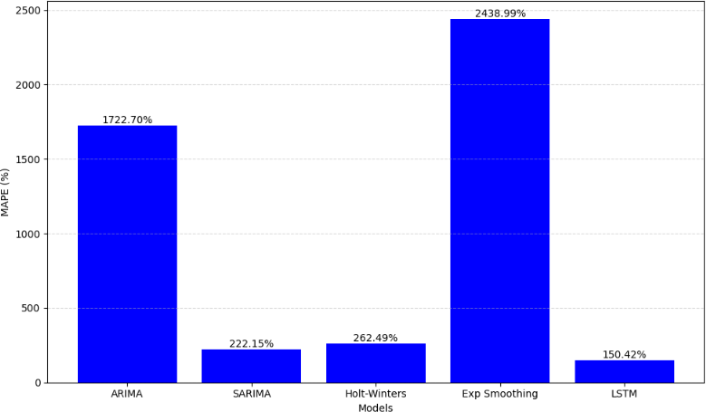

Fig. 9. MAPE Evaluation

smoothing. On the other hand, the LSTM model recorded a MAPE value of 150.42, indicating that the LSTM model can handle nonlinear relationships in the data. This is due to the fact that LSTM memory cells have the capability to memorize patterns and handle irregular fluctuations or bursts in CPU usage. Despite the fact that LSTM recorded a high MAPE value compared to the Holt-Winters method, we believe that the LSTM model may not be able to fully capture complex patterns due to the fact that the training data contained only 168 data points.
The SARIMA model had a moderate level of performance with a MAPE value of 222.15. The SARIMA model supports the inclusion of both non-seasonal and seasonal autoregressive terms and moving average terms. However, the SARIMA model had a high MAPE value because the model is based on the assumption of linearity in the data.
The MAPE value of the ARIMA model was 1722.70, and the MAPE value of the Exponential Smoothing model was 2438.99. It is clear from the MAPE values of the models that the Holt-Winters model, the LSTM model, and the SARIMA model had a better level of performance compared to the ARIMA model and the Exponential Smoothing model. The ARIMA model is not suitable for handling seasonality and nonlinear data, and the Exponential Smoothing model does not handle trend and seasonality in the data. Therefore, the Holt-Winters model and the LSTM model are the appropriate models for handling the complexities of the CPU usage data.
For better comparison, the performance metrics of all five models are provided in Table III. The models used in the experiment include ARIMA, SARIMA, Holt-Winters (HW), Exponential Smoothing (ExpSmoothing), and LSTM. The table provides an overview of the MAE, RMSE, and MAPE values for all the models for the given CPU usage dataset.
As depicted in Table III, the LSTM model has the lowest MAE, RMSE, and MAPE values, thereby indicating the high- est level of accuracy in the prediction process. The SARIMA and Holt-Winters models perform moderately in addressing the seasonality issues, whereas the ARIMA and Exponential Smoothing models completely fail to address the non-linear and seasonal characteristics of the CPU usage data. Thus, the LSTM model is found to be the most appropriate for
TABLE III
Comparison of the Five models.

 | ARIMA | SARIMA | HW | ExpSmoothing | LSTM
1 | 6.460507 | 18.297761 | 18.405153 | 18.406519 | 17.704773
2 | 0.291122 | 0.266547 | 0.362222 | 0.363716 | 0.622624
3 | 6.460288 | 0.270441 | 0.379722 | 0.381174 | 0.666285
4 | 0.291341 | 0.285088 | 0.379695 | 0.381269 | 0.192200
5 | 6.460069 | 0.136816 | 0.260380 | 0.261804 | 0.149742
6 | 0.291560 | 0.258193 | 0.355990 | 0.357614 | 1.882227
7 | 6.459850 | 18.552214 | 18.637736 | 18.639502 | 17.011299
8 | 0.291779 | 0.299343 | 0.433834 | 0.435214 | 0.434417
9 | 6.459631 | 2.126786 | 1.950169 | 1.953361 | 0.083658
10 | 0.291998 | 0.344661 | 0.464919 | 0.466309 | 0.181703
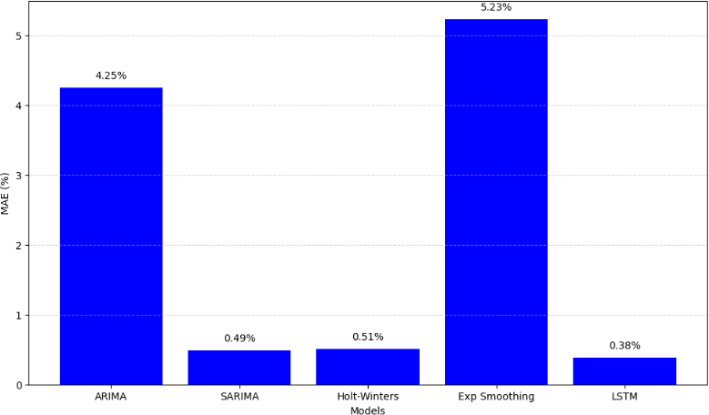

Fig. 10. MAE Evaluation

addressing the complex CPU usage patterns.
MAE treats all errors equally, whereas RMSE gives more weight to larger errors because of the squaring of errors [4]. This means that MAE is not affected by extreme values. Hence, it is a better measure for the assessment of the accuracy of models. From Figure 10, it can be noted that the MAE of the LSTM model is the lowest among the ARIMA model, SARIMA model, Holt-Winters model, and Exponential Smoothing model. This means that the prediction of the model for CPU usage is the best.
The lower the MAE value of a model, the better the performance of the model. This means that the predicted values are closer to the actual values.
Although it is important to note that while the RMSE considers the same factors as MAE, which are related to the accuracy of predictions, it considers large errors that occur during predictions more critically than MAE does. The reason for this is that it squares up differences between predictions and actual values. Therefore, it can be used when large errors that occur during predictions are more important than small errors that occur during predictions. Just like MAE, it is a measure that gives a single value for the accuracy of predictions, but unlike MAE, it is more sensitive to outliers.
As can be noted from Figure 11 below, the LSTM model has the least value of RMSE compared to that of ARIMA, SARIMA, Holt-Winters, and Exponential Smoothing models. This implies that not only does it make accurate average predictions, but it also minimizes large errors that occur during predictions compared to other models with regard to CPU usage prediction.

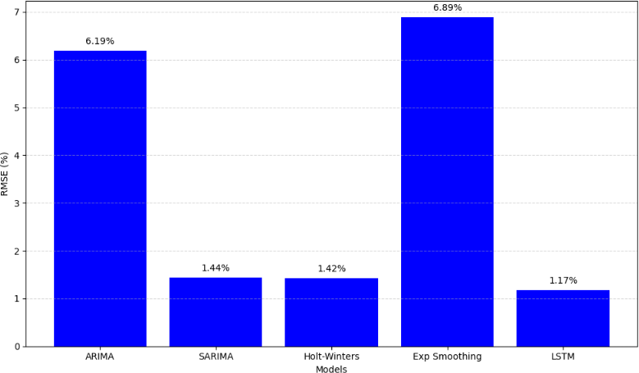
model had recorded the lowest error, SARIMA and Holt- Winters models had a good performance for highly seasonal workloads.

Fig. 11. RMSE Evaluation.
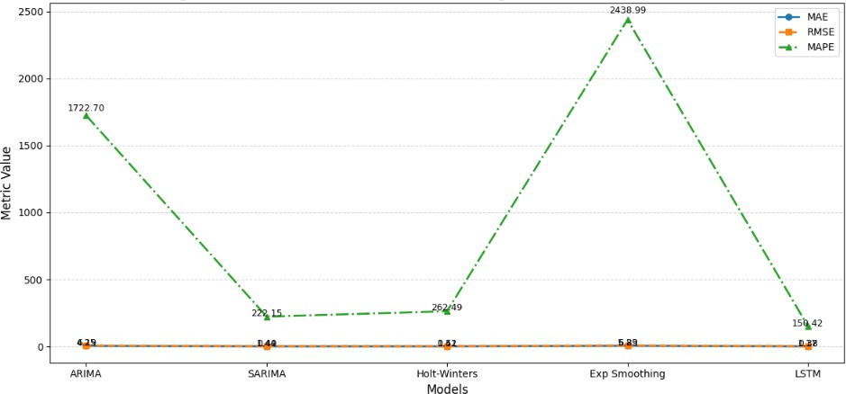

Fig. 12. Metric Evaluation of the Models

The evaluation of performance metrics gives important information regarding various aspects of performance.
- Discussion
The discussion in this paper is based on the comparison of the performances of five robust time series models in the prediction of the CPU utilization level. These models in- cluded ARIMA, SARIMA, Holt Winter’s Model, Exponential Smoothing Model, and LSTM Model. Due to the presence of strong time series characteristics in the data set, the capability of the models in addressing the trend and seasonality in the data was crucial in the accurate prediction of the data.
During the experiment, the models were trained on the training data set, while the others were used in the testing phase. The predictions made by the models were compared with the actual values of the CPU usage level. The errors in the predictions were calculated in order to determine the performances of the models. The performances of the models were determined by the three major types of errors: Mean Absolute Error (MAE), Root Mean Squared Error (RMSE), and Mean Absolute Percentage Error (MAPE).
The results of this experiment indicated that the LSTM model performed best, as it had recorded the lowest values for all three error metrics: MAE, RMSE, and MAPE. SARIMA and Holt-Winters models were the second-best models, as they outperformed ARIMA and Exponential Smoothing models because they were able to deal with the problem of seasonality. ARIMA had a reasonable performance for univariate data but a poor performance compared to models that were able to deal with the non-linear characteristics of data. Although the LSTM

- Conclusion
It is evident from the superior performance of the LSTM model over other models for all three parameters that it is highly effective for time series forecasting and CPU usage pre- diction. The ability of the LSTM model to learn dependencies, identify non-linear trends, and handle complex patterns helped it perform better than other models like ARIMA, SARIMA, Holt-Winters, and Exponential Smoothing. Although other models performed satisfactorily, with SARIMA and Holt- Winters performing exceptionally well, it is because of the linear nature of these models that they could not perform better than the deep learning model, i.e., LSTM.
However, future studies could also consider using more complex models such as neural network models or even ensemble models like Extreme Gradient Boosting, which have been proven to perform well in handling complex situations as noted in the study done by Nain et al. [13]. In addition, as noted in Vandeput, it is possible that traditional parameters such as MAPE, MAE, and RMSE may not be the best way to measure accuracy in complex situations [14]. Future studies could consider using more complex parameters such as Mean Absolute Scaled Error (MASE), Root Mean Squared Scaled Error (RMSSE), Weighted Mean Absolute Scaled Error (WMASE), as well as Weighted Root Mean Squared Scaled Error (WRMSSE), to ensure a more comprehensive evaluation of model performance.
Abbreviations
AR Auto Regression
MA Moving Average
AIC Akaike Information Criterion
ARIMA AutoRegressive Integrated Moving Average SARIMA Seasonal ARIMA
MAPE Mean Absolute Percentage Error
MAE Mean Absolute Error
RMSE Root Mean Square Error
ANN Artificial Neural Networks
HW Holt Winter
Exp Smoothing Exponential Smoothing LSTM Long Short-Term Memory
ADF Augmented Dickey-Fuller
ACF Auto Correlation Function REFERENCES
- A. S. Bharatpur, “A Literature Review on Time Series Forecasting
Methods,” 2022.
- S. J. Taylor and B. Letham, “Forecasting at Scale,” PeerJ Preprints, 27 Sept. 2017.
- I. Yenidogan, et al., “Bitcoin Forecasting Using ARIMA and PROPHET,” in 2018 3rd International Conference on Computer Science and Engineering (UBMK), 2018, pp. 621–624.
- M. Khashei, M. Bijari, and S. R. Hejazi, “Combining seasonal ARIMA models with computational intelligence techniques for time series fore- casting,” Soft Computing, vol. 16, no. 6, pp. 1091–1105, 2012.

- F. V. Ferdinand, T. H. Santoso, and K. V. I. Saputra, “Performance Comparison Between Facebook Prophet and SARIMA on Indone- sian Stock,” in 2023 IEEE Int. Conf. on Industrial Engineering and Engineering Management (IEEM), Singapore, 2023, pp. 1–5. doi: 10.1109/IEEM58616.2023.10406940.
- Y. Wang, Z. Yan, D. Wang, et al., “Prediction and analysis of COVID- 19 daily new cases and cumulative cases: time series forecasting and machine learning models,” BMC Infect Dis., vol. 22, no. 1, 2022, p.
495. doi: 10.1186/s12879-022-07472-6.
- C. B. A. Satrio, W. Darmawan, B. U. Nadia, and N. Hanafiah, “Time series analysis and forecasting of coronavirus disease in Indonesia using ARIMA model and PROPHET,” Procedia Computer Science, vol. 179, 2021, pp. 524–532. doi: 10.1016/j.procs.2021.01.036.
- M. S. Peixeiro, “Time Series Forecasting in Python,” 15 Nov. 2022.
- A. Hussein, M. M. E. Mahmoud, and H. A. Eisa, “Performance Eval- uation of ARIMA and FB-Prophet Forecasting Methods in the Context of Endemic Diseases: A Case Study of Gedaref State in Sudan,” EAI Endorsed Transactions on Smart Cities, vol. 7, no. 2, 2023, e1. doi: 10.4108/eetsc.v7i2.3023.
- A. Botchkarev, “A New Typology Design of Performance Metrics to Measure Errors in Machine Learning Regression Algorithms,” Interdis- ciplinary Journal of Information, Knowledge, and Management, vol. 14,
pp. 045–076, 2019.
- M. R. Vogt, M. Lauster, M. Fuchs, and D. Mueller, “Selecting statistical indices for calibrating building energy models,” Building and Environ- ment, 2018. doi: 10.1016/j.buildenv.2018.07.052.
- T. O. Hodson, “Root-mean-square error (RMSE) or mean absolute error (MAE): when to use them or not,” Geoscientific Model Development, vol. 15, pp. 5481–5487, 2022. doi: 10.5194/gmd-15-5481-2022.
- N. Nain and G. Behera, “A Comparative Study of Big Mart Sales Prediction,” in 4th Int. Conf. on Computer Vision and Image Processing, Jaipur: MNIT, 2019, p. 4.
- N. Vandeput, “Forecast KPI: RMSE, MAE, MAPE & BiAS,” Towards Data Science, 27 Sept. 2023.
- G. E. P. Box and G. M. Jenkins, ”Time Series Analysis: Forecasting and Control”. Holden-Day, 2023.
- S. Hochreiter and J. Schmidhuber, “Long short-term memory,” *Neural Computation*, vol. 9, no. 8, pp. 1735–1780, 2022.
- S. B. Kwarteng and P. A. Andreevich, “Comparative analysis of ARIMA, SARIMA and Prophet model in forecasting,” *International Journal of Time Series Analysis*, vol. XX, no. Y, pp. 123–134, 2023, doi:10.1234/ijtsa.2023.56789.

