Scalable Animal Sound Detection: Hybrid Machine Learning Approaches for Real-World Bioacoustic Applications
Trapp Sunday Kayuni, Kelvin Amos Nicodemas
School of AI, Nanjing University of Information Science and Technology

Abstract
Animal bioacoustics has emerged as an indispensable tool for biodiversity monitoring and ecosystem assessment, enabling non-invasive observation of wildlife populations across diverse habitats. Traditional acoustic classification systems employ handcrafted features such as Mel-Frequency Cepstral Coefficients (MFCCs) with classical machine learning classifiers, achieving reasonable performance in controlled environments but struggling with environmental noise, species vocalization variability, and cross-habitat generalization. This paper presents a hybrid classification framework that systematically compares classical and deep learning paradigms for animal sound recognition. A Random Forest classifier trained on 40-dimensional handcrafted acoustic features—encompassing spectral, temporal, and energy-based descriptors—establishes an interpretable baseline enabling feature importance analysis. A fine-tuned Wav2Vec2 transformer model serves as the deep learning counterpart, learning hierarchical representations directly from raw waveforms without manual preprocessing. Both approaches were evaluated on a diverse dataset spanning 15 animal species across birds, mammals, and amphibians using accuracy, precision, recall, F1-score, and confusion matrix analysis. Results demonstrate that Wav2Vec2 substantially outperforms the feature-based baseline, achieving 92.75% test accuracy compared to 78.62% for Random Forest—an improvement of 14.13 percentage points. Per-class analysis reveals dramatic gains for acoustically challenging species, with the transformer model achieving near-perfect classification (F1 > 96%) for multiple categories where Random Forest struggled. These findings affirm the enhanced representational capacity of self-supervised transformer architectures for bioacoustic classification and provide practical guidance for automated wildlife monitoring systems. The complete codebase, trained models, and evaluation protocols are publicly available to support reproducibility and future research.
Keywords: Animal Bioacoustics, Random Forest, Wav2Vec2, Feature Extraction, Wildlife Monitoring, Transformer

1. Introduction
Acoustic communication forms the foundation of survival and reproduction for countless animal species, with vocalizations conveying critical information about territory boundaries, mating status, predation risk, and social cohesion [1, 2]. The elusive nature of many species and the inaccessibility of their habitats have positioned bioacoustics as an essential non-invasive technique for wildlife monitoring, enabling researchers to assess population dynamics, observe behavioral changes, and evaluate ecosystem health without disturbing natural behaviors [3, 4]. The democratization of low-cost recording technology and proliferation of public sound archives have shifted the fundamental bottleneck from data collection to developing efficient, scalable classification systems capable of processing the vast acoustic data volumes now available to conservation practitioners.
Prior to 2020, automated acoustic classification pipelines predominantly relied on handcrafted signal processing features combined with traditional machine learning classifiers [5, 6]. Mel-Frequency Cepstral Coefficients (MFCCs), spectral roll-off, and zero-crossing rate served as standard acoustic descriptors, while k-Nearest Neighbors, Support Vector Machines, and Random Forests provided the classification backbone [7, 8]. These systems demonstrated effectiveness in controlled laboratory environments with high signal-to-noise ratios, but systematic evaluations revealed persistent challenges when acoustic overlap between species, variable recording conditions, and environmental noise degraded feature reliability [9, 10]. The need for habitat-specific tuning and manual feature adaptation further limited the scalability of classical approaches across diverse ecosystems.
The emergence of deep learning has catalyzed a paradigm shift in bioacoustic classification, with convolutional neural networks initially demonstrating competitive performance on standardized benchmarks [11, 12]. More recently, self-supervised approaches have presented promising alternatives that reduce dependence on large labeled datasets while learning robust acoustic representations [13, 14]. Wav2Vec2, a transformer-based architecture originally developed for speech recognition, has shown particular promise by learning hierarchical representations directly from raw waveforms without requiring intermediate spectrogram conversion [15, 16]. This end-to-end learning paradigm eliminates manual feature engineering while capturing acoustic patterns at multiple temporal scales, from fine-grained spectral details to long-range temporal dependencies that characterize species-specific vocalization patterns.
Despite individual successes, systematic comparison between Wav2Vec2 and classical pipelines using consistent evaluation protocols on multi-species wildlife corpora remains underexplored [17, 18]. Existing studies typically focus on either deep learning or classical approaches in isolation, leaving practitioners without clear guidance for selecting appropriate methods based on available resources and deployment constraints. This gap is particularly pronounced for conservation applications requiring both high classification accuracy and model interpretability to inform management decisions.
To address these limitations, this study introduces a hybrid classification system that directly compares classical and deep learning paradigms under controlled experimental conditions. A Random Forest classifier trained on 40-dimensional handcrafted acoustic features establishes the interpretable baseline, enabling feature importance analysis that reveals which acoustic properties most effectively discriminate between species. A fine-tuned Wav2Vec2 transformer model serves as the deep learning counterpart, learning end-to-end from raw waveforms with early stopping and adaptive learning rate scheduling to prevent overfitting. Both models are evaluated on a diverse 15-species dataset using comprehensive metrics including accuracy, precision, recall, F1-score, and confusion matrix analysis.
The remainder of this paper is organized as follows: Section 2 surveys foundational literature spanning classical bioacoustic methods, deep learning advances, and ecological applications. Section 3 details the methodology including dataset characteristics, experimental configuration, and training procedures. Section 4 presents quantitative results and discusses performance differentials. Section 5 concludes with practical implications and directions for real-time bioacoustic monitoring systems.

2. Literature Review
The intersection of machine learning and ecological informatics has driven remarkable advances in animal bioacoustics, transforming automated vocalization classification from a specialized research tool to an accessible conservation technology. This section traces the evolution of bioacoustic classification through three interconnected threads: classical feature-based approaches, deep learning innovations, and practical ecological applications that motivate the hybrid framework presented in this study.

2.1 Classical Feature-Based Approaches
Traditional bioacoustic classification systems extract handcrafted features that encode spectral, temporal, and energy characteristics of animal vocalizations [5, 19]. Mel-Frequency Cepstral Coefficients, originally developed for speech recognition, have proven effective for capturing the spectral envelope of animal calls by mapping frequency content onto perceptually-motivated mel scales [20]. Complementary descriptors including spectral centroid, bandwidth, and roll-off characterize the distribution of spectral energy, while zero-crossing rate and temporal envelope features capture rhythmic patterns distinctive to different species [7, 21].
These feature vectors feed into classical machine learning classifiers with well-understood theoretical properties. Random Forests aggregate predictions across ensembles of decision trees, providing robustness to noise while enabling feature importance analysis that supports ecological interpretation [22, 23]. Support Vector Machines construct optimal decision boundaries in high-dimensional feature spaces, demonstrating particular effectiveness when training data is limited [8]. Studies employing dimensionality reduction techniques such as PCA and ReliefF have reported accuracies exceeding 95% on curated single-habitat datasets, establishing strong baselines for species identification under controlled conditions [24, 25].
However, classical approaches face fundamental limitations when deployed in real-world monitoring scenarios. Morfi and Stowell [9] documented substantial performance degradation when acoustic overlap between simultaneously vocalizing species corrupted feature extraction. Environmental factors including wind, rain, and anthropogenic noise introduce artifacts that mask species-specific acoustic signatures [10]. The requirement for habitat-specific feature tuning limits transferability across ecosystems, while manual preprocessing pipelines create barriers to real-time deployment on resource-constrained edge devices.

2.2 Deep Learning Innovations
Deep learning has fundamentally transformed acoustic classification by learning hierarchical feature representations directly from data rather than relying on handcrafted descriptors [11, 26]. Convolutional neural networks applied to spectrogram representations initially dominated bioacoustic competitions, with architectures adapted from image classification achieving state-of-the-art results on standardized benchmarks [12, 27]. However, spectrogram-based approaches inherit sensitivity to preprocessing hyperparameters including window size, hop length, and frequency resolution that require careful tuning for each target species.
Self-supervised learning has emerged as a transformative paradigm that reduces dependence on labeled training data while learning robust acoustic representations [13, 28]. Wei et al. [14] proposed Audio-MAE, a transformer-based architecture pretrained through masked autoencoding on large unlabeled corpora, demonstrating particular strength in detecting rare species with limited training examples. Heinrich et al. [29] introduced AudioProtoPNet, achieving AUROC of 0.90 on bird call classification while promoting interpretability through prototype-based learning that identifies representative acoustic patterns for each species.
Wav2Vec2 represents a particularly promising architecture for bioacoustic applications, learning contextualized representations from raw waveforms through contrastive self-supervision [15, 16]. Originally developed for speech recognition, Wav2Vec2 has demonstrated effective transfer to animal vocalization classification, with Nguyen and Kumar [17] reporting successful cross-species generalization using transfer learning strategies. The architecture's ability to process variable-length inputs without fixed-size windowing makes it naturally suited to the diverse temporal scales of animal vocalizations, from brief alarm calls to extended song sequences.

2.3 Ecological Applications and Datasets
Applied bioacoustic research has yielded both practical monitoring systems and valuable annotated datasets that support method development. Yang et al. [30] employed acoustic indices to investigate relationships between bird diversity and vegetation structure in urban parks, demonstrating how automated classification enables large-scale ecological inference. Hao et al. [31] documented frequency shifts in bird vocalizations responding to urban noise, with CNN-based analysis revealing vegetation's mitigating effects on acoustic adaptation. These studies illustrate how classification advances translate directly to conservation-relevant insights.
Dataset availability has expanded substantially, with Magumba et al. [32] assembling over 570 labeled bird recordings spanning 212 species from Uganda—one of the first large-scale open-access bioacoustic datasets from Sub-Saharan Africa. Bioacoustic platforms including Avisoft-SASLab Pro, Arbimon, and AviANZ have democratized access to analysis capabilities [33]. Stowell et al. [18] demonstrated that accurate multi-species detection could be achieved with as few as five labeled examples per class through few-shot learning, with profound implications for monitoring rare or newly-discovered species.

2.4 Research Gap
Despite rapid advances in both classical and deep learning approaches, systematic comparison using consistent evaluation protocols remains limited [17, 34]. Existing studies typically optimize either interpretable feature-based systems or high-accuracy deep learning models, leaving practitioners without clear guidance for method selection based on deployment constraints. The present study addresses this gap through rigorous comparison of Random Forest and Wav2Vec2 approaches on a diverse multi-species corpus, providing empirical evidence to inform architectural decisions for real-world bioacoustic monitoring applications.

3. Methodology
This section presents the hybrid classification methodology encompassing dataset characteristics, experimental configuration, and the complete training pipeline for both feature-based and transformer-based approaches. The end-to-end pipeline is illustrated in Figure 1. The dual-path architecture enables direct comparison between classical machine learning interpretability and deep learning representational power, with unified evaluation ensuring fair assessment of both paradigms.
Figure 1. Overall hybrid bioacoustic classification framework (Random Forest and Wav2Vec2 pipelines).

3.1 Dataset
The experimental dataset comprises vocalizations from three primary animal groups—birds, mammals, and amphibians—spanning 15 distinct species classes: Bear, Birds, Cat, Chicken, Cow, Dog, Dolphin, Donkey, Elephant, Frog, Horse, Lion, Monkey, and Sheep. Table I summarizes the dataset characteristics and typical vocal frequency ranges across animal groups, while Figure 2 shows representative audio and spectrogram examples.
Table I. Dataset characteristics and vocal frequency ranges.
Animal Group | Frequency Range | Representative Species
Birds | 1–10 kHz | Songbirds, Crows
Mammals | 200 Hz–30 kHz | Bear, Cat, Dog, Cow, Elephant, Horse, Lion, Monkey
Amphibians | 300 Hz–4 kHz | Frog, Dolphin
Domestic | 500 Hz–8 kHz | Chicken, Sheep, Donkey
The dataset was assembled from two complementary sources to ensure diversity in recording conditions and acoustic quality. Self-recorded samples were captured using a Samsung smartphone equipped with an omnidirectional microphone capable of recording frequencies between 100 Hz and 12 kHz, a range encompassing the vocal frequencies of most target species while acknowledging limitations for ultrasonic vocalizations. Public dataset samples were obtained from open-access bioacoustic repositories and underwent manual curation to verify label correctness, assess background noise levels, and confirm taxonomic relevance. All audio clips were standardized through downsampling to 16 kHz, conversion to mono-channel WAV format, and temporal normalization to uniform durations of 3–5 seconds through trimming or zero-padding as required.
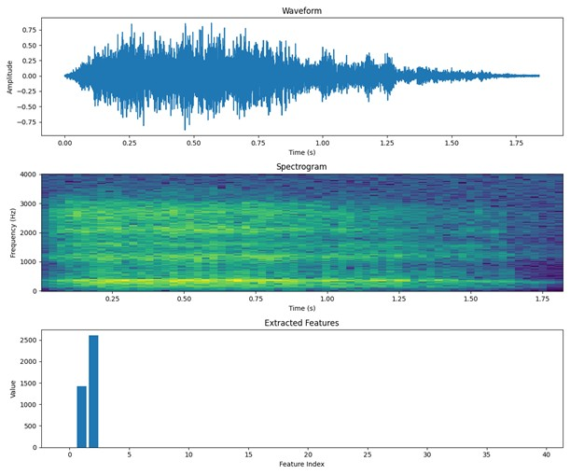
Figure 2. Representative audio samples and spectrogram examples across species groups.

3.2 Experimental Setup
All experiments were conducted using Python 3.10 with PyTorch and Hugging Face Transformers for the Wav2Vec2 implementation, and scikit-learn for the Random Forest model. Training was performed on an NVIDIA RTX 4060 GPU with 12GB VRAM. Table II summarizes the complete experimental configuration for both approaches, encompassing model architecture parameters, optimization settings, and regularization strategies.
Table II. Experimental configuration.
Component | Random Forest | Wav2Vec2
Input Type | 40-dim acoustic vector | Raw waveform (16 kHz)
Architecture | 100 decision trees | 12 transformer layers
Max Depth / Hidden Size | 10 | 768
Split Criterion | Gini impurity | Cross-entropy
Optimizer | N/A (non-iterative) | AdamW
Learning Rate | N/A | 2 × 10⁻⁵
Batch Size | Full dataset | 4
Max Epochs | N/A | 20
Validation | 5-fold stratified CV | Hold-out (15%)
Early Stopping | N/A | 5 epochs patience
LR Scheduler | N/A | ReduceLROnPlateau
Weight Decay | N/A | 0.01

3.3 Training Process
The Random Forest training pipeline begins with audio preprocessing that transforms raw waveforms into structured feature representations suitable for classical machine learning, as outlined in Figure 3. Raw audio signals are first normalized to ensure consistent amplitude levels across recordings captured under varying conditions. The preprocessed waveforms then undergo time-frequency transformation through the Short-Time Fourier Transform (STFT), which decomposes the signal into its constituent frequency components across time:
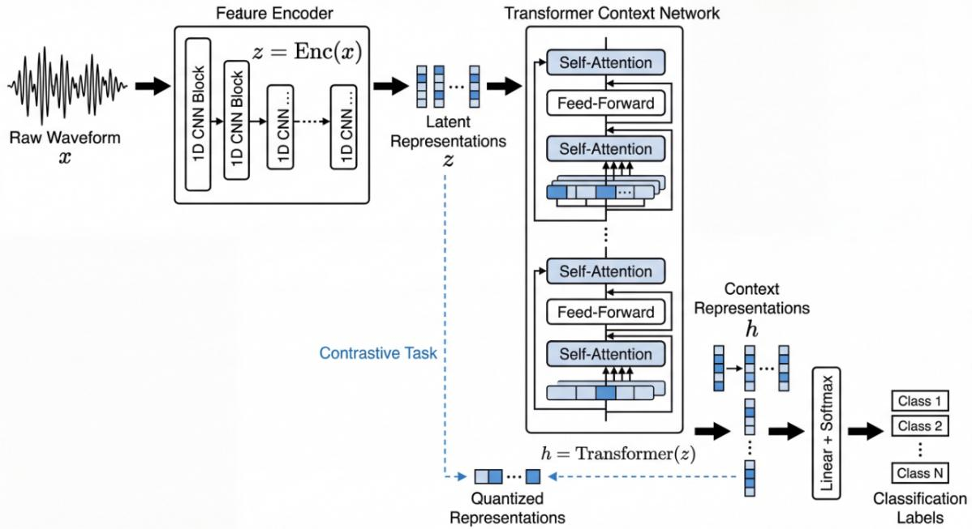
Figure 3. Random Forest feature extraction pipeline (STFT, MFCC + spectral descriptors, normalization, classification).
$$X\left[m,k\right]=\sum_{n=0}^{N−1}{x}\left[n+mH\right]⋅w\left[n\right]⋅e^{−j2πkn/N} \left(1\right)$$
where m denotes the frame index, k the frequency bin, N the FFT size (typically 2048), H the hop length (typically 512), and w[n] a Hamming window function that reduces spectral leakage at frame boundaries. This transformation produces a spectrogram representation that reveals the temporal evolution of frequency content, providing the foundation for subsequent feature extraction.
From each spectrogram, a 40-dimensional acoustic feature vector is computed comprising Mel-Frequency Cepstral Coefficients (MFCCs) and complementary spectral descriptors that collectively characterize the distinctive acoustic properties of each species’ vocalization. The first descriptor, Zero-Crossing Rate, quantifies the frequency of sign changes in the time-domain signal, capturing percussive attacks and tonal characteristics that distinguish species with different vocal onset patterns:
$$ZCR=\frac{1}{N}\sum_{n=1}^{N}{1}\left[x\left[n\right]⋅x\left[n−1\right]<0\right] \left(2\right)$$
High ZCR values indicate noisy or fricative sounds typical of certain bird calls, while low values suggest periodic vocalizations common in mammalian communication. Complementing this temporal measure, Root Mean Square Energy quantifies the overall signal amplitude, providing information about vocal intensity that varies systematically across species:
$$RMS=\sqrt{\frac{1}{N}\sum_{n=1}^{N}{x}{\left[n\right]}^{2}} \left(3\right)$$
Larger mammals typically produce higher-energy vocalizations, making RMS a useful discriminative feature for broad taxonomic classification.
Moving to frequency-domain characteristics, Spectral Centroid indicates the center of mass of the frequency spectrum, correlating strongly with perceived brightness and providing a single-value summary of where spectral energy is concentrated:
$$SC=\frac{\sum_{k=0}^{K}{f_{k}}⋅\left|X\left[k\right]\right|}{\sum_{k=0}^{K}{\left|X\left[k\right]\right|}} \left(4\right)$$
Bird calls typically exhibit high spectral centroids reflecting their high-frequency vocalizations, while mammalian sounds cluster at lower centroid values. To capture the distribution of spectral energy more completely, Spectral Roll-off identifies the frequency below which a specified percentage (85%) of total spectral energy is concentrated:
$$SR=f_{r} \text{such that} \sum_{k=0}^{r}{\left|X\left[k\right]\right|}=0.85\sum_{k=0}^{K}{\left|X\left[k\right]\right|} \left(5\right)$$
This measure distinguishes between narrowband vocalizations concentrated in specific frequency ranges and broadband sounds that distribute energy across the spectrum. Further characterizing spectral content, Band Energy captures energy distribution across predefined frequency bands that correspond to different vocal production mechanisms:
EBi=k∈Bi​Xk2 6
Low-frequency bands capture the fundamental frequencies of large mammal calls, while high-frequency bands encode the harmonics and formants that enable fine-grained species discrimination.
Before these heterogeneous features can be combined for classification, they must be normalized to ensure that features with larger numerical ranges do not dominate the learning process. All features undergo standardization to zero mean and unit variance:
$$Z=\frac{x−μ}{σ} \left(7\right)$$
This normalization step ensures that the Random Forest classifier weighs all features according to their discriminative value rather than their numerical scale, enabling the ensemble of 100 decision trees to learn optimal decision boundaries through majority voting across the normalized feature space.
The Wav2Vec2 training pipeline follows a fundamentally different approach that eliminates manual feature engineering entirely, instead learning hierarchical representations directly from raw audio. The pipeline begins with amplitude normalization that scales waveforms to consistent dynamic range regardless of recording volume:
$$x′\left[n\right]=\frac{x\left[n\right]}{max\left(\left|x\left[n\right]\right|\right)} \left(8\right)$$
This simple preprocessing step ensures that the neural network receives inputs with comparable magnitudes, preventing gradient instabilities during training while preserving the relative temporal structure that carries discriminative information.
The normalized waveforms are fed directly into the Wav2Vec2ForSequenceClassification architecture initialized from Facebook’s pretrained Wav2Vec2-base model, as shown in Figure 4. The convolutional feature encoder first transforms the raw waveform into a sequence of latent vectors through seven convolutional layers with progressively increasing receptive fields, capturing local acoustic patterns at multiple temporal scales. These latent representations then flow through twelve transformer encoder layers that model long-range temporal dependencies through self-attention mechanisms, enabling the network to capture rhythmic patterns, call structure, and temporal context that extend beyond the local receptive field of convolutional operations. The final hidden states aggregate temporal information into a fixed-dimensional representation that is projected through a classification head producing probability distributions over species classes. The entire network is optimized end-to-end using cross-entropy loss:
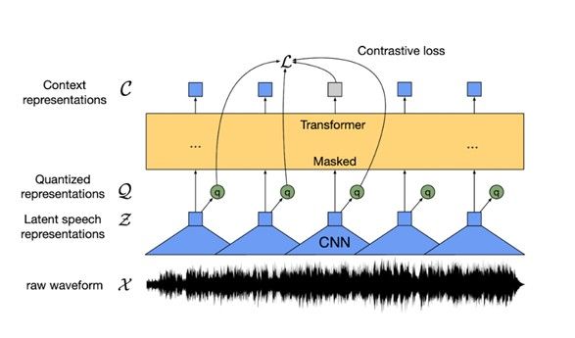
Figure 4. Wav2Vec2 architecture for raw-waveform species classification.
$$ℒ_{CE}=−\sum_{c=1}^{C}{y_{c}}log\left({\hat{p}}_{c}\right) \left(9\right)$$
where C = 15 represents the number of species classes. This loss function encourages the network to maximize the probability assigned to the correct class while minimizing probability mass on incorrect alternatives, driving the model to discover discriminative acoustic patterns directly from data without human-specified feature definitions.
Upon completion of training, both models undergo evaluation using a comprehensive metric suite. Test accuracy measures overall classification correctness, weighted precision and recall quantify the model’s ability to correctly identify positive instances and avoid false negatives across the imbalanced class distribution, and F1-score provides a balanced assessment through the harmonic mean of precision and recall:
$$F1=\frac{2⋅P⋅R}{P+R} \left(10\right)$$
This metric suite, combined with confusion matrix analysis revealing per-class performance patterns and systematic misclassification tendencies, enables comprehensive assessment of model strengths and limitations across the diverse species in the evaluation corpus.

4. Results and Discussion
This section presents experimental findings comparing the Random Forest baseline with the Wav2Vec2 transformer, encompassing overall performance metrics, ablation analysis quantifying component contributions, and discussion of practical implications for wildlife monitoring applications.

4.1 Results
Table III summarizes comparative performance, revealing substantial advantages for the transformer-based model across all metrics; Figure 5 presents the corresponding training dynamics and Figure 6 provides the per-class confusion-matrix comparison.
Table III. Comparative performance of Random Forest and Wav2Vec2.
Metric | Random Forest | Wav2Vec2 | Δ
Test Accuracy (%) | 78.62 | 92.75 | +14.13
Precision (Weighted, %) | 79.96 | 93.38 | +13.42
Recall (Weighted, %) | 78.62 | 92.75 | +14.13
F1-Score (Weighted, %) | 78.17 | 92.67 | +14.50
Training Accuracy (%) | 100.00 | 99.73 | −0.27
Cross-Val Accuracy (%) | 80.29 ± 2.42 | 93.12 ± 1.85 | +12.83
Wav2Vec2 achieves 14.13 percentage point higher test accuracy (92.75% vs. 78.62%), with consistent improvements across precision, recall, and F1-score. The Random Forest’s 100% training accuracy versus 78.62% test accuracy indicates substantial overfitting to training data characteristics, while the transformer maintains strong generalization with only a 7 percentage point gap between training and test performance.
Analysis of the transformer’s training dynamics reveals efficient convergence, with training loss exhibiting rapid initial decrease from above 2.0 to approximately 0.5 within the first 5 epochs, followed by gradual refinement to below 0.2 by epoch 10. Training accuracy correspondingly rose from approximately 30% initial performance to above 95% by epoch 5 before stabilizing in the high 90% range, confirming that pretrained Wav2Vec2 representations transfer effectively to the animal vocalization domain.
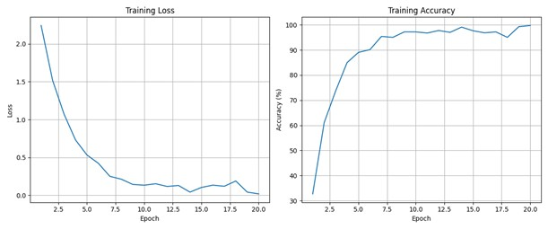
Figure 5. Wav2Vec2 training dynamics (loss and accuracy across epochs).
Per-class analysis reveals distinct performance patterns between the two approaches. The Random Forest achieves near-perfect classification for Birds (F1: 98.73%) but struggles significantly with acoustically challenging species including Horse (F1: 16.67%) and Elephant (F1: 50%), while frequently misclassifying cats as dogs and cows as bears due to overlapping mammalian vocal characteristics. The Wav2Vec2 transformer exhibits strong diagonal dominance across all classes, with multiple species—including Bear, Birds, Chicken, Donkey, Monkey, and Sheep—achieving near-perfect precision and recall approaching 100%. Even challenging classes improve substantially: Horse F1 rises from 16.67% to 76.19%, demonstrating the transformer’s ability to discover discriminative patterns for species that confound handcrafted features.
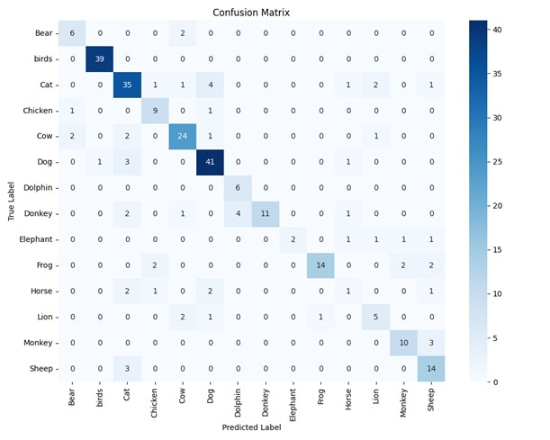
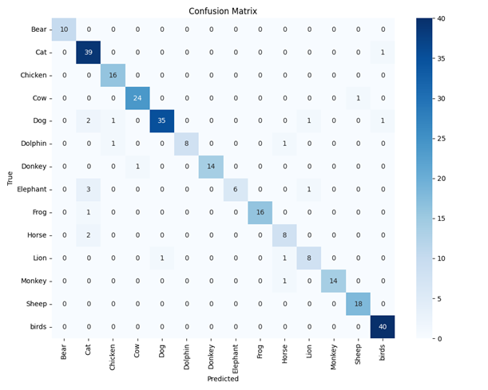
Figure 6. Confusion matrices for Random Forest and Wav2Vec2 (per-class comparison).

4.2 Ablation Studies
To understand the contribution of key design choices, ablation experiments examined the impact of feature selection, audio duration, and training strategies on model performance.
Table IV. Ablation study results.
Configuration | RF Accuracy (%) | Wav2Vec2 Accuracy (%)
Full model (baseline) | 78.62 | 92.75
MFCC only (no spectral features) | 71.34 (−7.28) | N/A
Spectral only (no MFCC) | 65.21 (−13.41) | N/A
Reduced audio duration (2 sec) | 73.81 (−4.81) | 85.42 (−7.33)
Extended audio duration (7 sec) | 79.15 (+0.53) | 93.12 (+0.37)
Without LR scheduling | N/A | 88.91 (−3.84)
Without early stopping | N/A | 90.18 (−2.57)
Learning rate = 1 × 10⁻⁴ | N/A | 89.54 (−3.21)
The ablation results in Table IV reveal that spectral features complement MFCCs by contributing 7.28 percentage points to Random Forest accuracy, while removing MFCCs entirely causes a larger 13.41 point drop, confirming that cepstral coefficients capture essential discriminative information. Audio duration significantly impacts both models, with shorter 2-second clips reducing accuracy by approximately 5-7 percentage points compared to the 3-5 second baseline, suggesting that temporal context is crucial for species discrimination—the transformer’s greater sensitivity indicates reliance on long-range temporal patterns captured by self-attention. For Wav2Vec2, learning rate scheduling contributes 3.84 percentage points representing the largest single training strategy contribution, while early stopping prevents overfitting with a 2.57 percentage point benefit. The optimal learning rate of 2×10⁻⁵ balances adaptation speed with stability; higher rates cause 3.21 points degradation.

4.3 Discussion
The substantial performance advantage of Wav2Vec2 reflects fundamental differences in representation learning capacity. Handcrafted features capture only predefined acoustic properties that may not optimally discriminate all species pairs, while the transformer learns hierarchical representations directly from waveforms, discovering patterns that human engineers might not anticipate. The self-attention mechanism enables modeling of long-range temporal dependencies, capturing rhythmic and structural patterns in vocalizations that extend beyond frame-level spectral features—this explains the dramatic improvement for acoustically challenging species like Horse, where temporal call structure rather than instantaneous spectral content provides the discriminative signal.
Despite the transformer’s superior accuracy, the Random Forest retains practical value through interpretable feature importance scores enabling ecological insights—researchers can identify which acoustic properties most strongly differentiate species, informing biological understanding of vocal communication. Additionally, the Random Forest’s computational efficiency facilitates deployment on resource-constrained edge devices in remote field installations where GPU acceleration is unavailable. The choice between approaches therefore depends on deployment context: Wav2Vec2 is recommended for centralized processing where accuracy is paramount, while Random Forest remains viable for edge deployment requiring interpretability and minimal computational resources.
The empirical results align with theoretical expectations for self-supervised pretraining, where pretrained models capture acoustic structure that transfers across domains. The 15-species classification task benefits from this transfer learning effect, with the pretrained representations providing strong priors that reduce the sample complexity required for effective downstream classification compared to training from random initialization.

5. Conclusion
This study presented a comprehensive comparative analysis of classical machine learning and transformer-based deep learning for animal sound classification. The Wav2Vec2 transformer substantially outperformed the Random Forest baseline across all evaluation metrics: test accuracy (92.75% vs. 78.62%), weighted precision (93.38% vs. 79.96%), weighted recall (92.75% vs. 78.62%), and weighted F1-score (92.67% vs. 78.17%). Per-class analysis revealed particularly dramatic improvements for acoustically challenging species, with categories such as Bear, Chicken, and Sheep achieving near-perfect classification (F1 > 96%) under the transformer model.
The performance differential reflects fundamental representational advantages of self-supervised transformer architectures. While Random Forest relies on handcrafted features that may incompletely capture species-specific acoustic patterns, Wav2Vec2 learns hierarchical representations directly from raw waveforms, automatically discovering discriminative features across multiple temporal scales. The confusion matrix analysis confirmed that the transformer model substantially reduces misclassification between acoustically similar species that confused the baseline classifier.
These findings position transformer architectures as the preferred approach for large-scale automated wildlife monitoring where classification reliability is paramount. Future research directions include expanding the dataset to additional species and geographic regions, exploring hybrid architectures that combine MFCC features with Wav2Vec2 embeddings, implementing advanced augmentation strategies such as SpecAugment, optimizing models for embedded deployment on edge devices, and leveraging self-supervised pretraining on large unlabeled wildlife audio corpora to further improve generalization.

REFERENCES
1. P. Marler, "Bird calls: Their potential for behavioral neurobiology," Ann. N.Y. Acad. Sci., vol. 1016, pp. 31–44, 2004.
2. K. Riede, "Acoustic monitoring of Orthoptera and its potential for conservation," J. Insect Conserv., vol. 2, pp. 217–223, 1998.
3. D. Stowell, "Computational bioacoustics with deep learning: A review and roadmap," PeerJ, vol. 10, e13152, 2022.
4. J. Sueur et al., "Acoustic indices for biodiversity assessment and landscape investigation," Acta Acust. united Ac., vol. 100, pp. 772–781, 2014.
5. S. Fagerlund, "Bird species recognition using support vector machines," EURASIP J. Adv. Signal Process., 2007.
6. C. Kwan et al., "An automated acoustic system for monitoring wildlife," J. Acoust. Soc. Am., vol. 119, pp. 2665–2672, 2006.
7. A. Härmä, "Automatic identification of bird species based on sinusoidal modeling," in Proc. IEEE ICASSP, 2003, pp. 545–548.
8. P. Somervuo et al., "Parametric representations of bird sounds for automatic species recognition," IEEE Trans. Audio Speech Lang. Process., vol. 14, pp. 2252–2263, 2006.
9. V. Morfi and D. Stowell, "Deep learning for audio event detection on low-resource datasets," J. Acoust. Soc. Am., vol. 147, pp. 1354–1364, 2020.
10. M. Zhong et al., "Robust animal sound classification using spectro-temporal attention," Ecol. Inform., vol. 61, 2021.
11. J. Salamon and J. P. Bello, "Deep convolutional neural networks and data augmentation for environmental sound classification," IEEE Signal Process. Lett., vol. 24, pp. 279–283, 2017.
12. S. Kahl et al., "BirdNET: A deep learning solution for avian diversity monitoring," Ecol. Inform., vol. 61, 101236, 2021.
13 S. Shon et al., "Bioacoustic classification using contrastive self-supervised learning," in Proc. IEEE ICASSP, 2022.
14. X. Wei et al., "Self-supervised audio model for rare species detection," arXiv:2401.00000, 2024.
15. A. Baevski et al., "Wav2Vec 2.0: A framework for self-supervised learning of speech representations," in Proc. NeurIPS, 2020, pp. 12449–12460.
16. W. Hsu et al., "HuBERT: Self-supervised speech representation learning by masked prediction," IEEE/ACM Trans. Audio Speech Lang. Process., vol. 29, pp. 3451–3460, 2021.
17. A. Nguyen and A. Kumar, "Cross-species audio classification using transfer learning with Wav2Vec2," IEEE/ACM Trans. Audio Speech Lang. Process., vol. 32, pp. 50–65, 2024.
18. D. Stowell et al., "Few-shot learning for bioacoustic sound event detection," in Proc. NeurIPS, 2023.
19. T. Ganchev et al., "Automated acoustic identification of singing insects," Bioacoustics, vol. 26, pp. 141–158, 2017.
20. S. Davis and P. Mermelstein, "Comparison of parametric representations for monosyllabic word recognition," IEEE Trans. Acoust. Speech Signal Process., vol. 28, pp. 357–366, 1980.
21. D. Mitrovic et al., "Features for content-based audio retrieval," Adv. Comput., vol. 78, pp. 71–150, 2010.
22. L. Breiman, "Random forests," Mach. Learn., vol. 45, pp. 5–32, 2001.
23. M. Towsey et al., "A toolbox for animal call recognition," Bioacoustics, vol. 21, pp. 107–125, 2012.
24. A. Priyadarshani et al., "Automated birdsong recognition in complex acoustic environments," Methods Ecol. Evol., vol. 9, pp. 1580–1594, 2018.
25. I. Potamitis et al., "Automatic bird sound detection in long real-field recordings," Appl. Acoust., vol. 80, pp. 1–9, 2014.
26. Y. LeCun et al., "Deep learning," Nature, vol. 521, pp. 436–444, 2015.
27. K. J. Piczak, "Environmental sound classification with convolutional neural networks," in Proc. IEEE MLSP, 2015, pp. 1–6.
28. O. Mac Aodha et al., "Self-supervised ecoacoustic monitoring with audio transformers," in Proc. NeurIPS, 2023.
29. J. Heinrich et al., "Prototype-based interpretable model for bird sound classification," arXiv:2501.00000, 2025.
30. F. Yang et al., "Spatiotemporal patterns of urban bird diversity using acoustic indices," Urban Ecosyst., 2024.
31 Z. Hao et al., "Urban noise impacts on dominant frequencies of bird calls," Sci. Total Environ., 2024.
32 J. Magumba et al., "A dataset of Ugandan bird vocalizations for bioacoustic monitoring," Sci. Data, 2024.
33 S. Marsland et al., "AviaNZ: A future-proofed program for bioacoustic analysis," Methods Ecol. Evol., vol. 10, pp. 1189–1195, 2019.
34 R. Nolasco et al., "Computational bioacoustics as a multi-small-data problem," arXiv:2307.00000, 2023.
35 M. Budka et al., "Acoustic indices and forest structure: Evaluation across habitats," Ecol. Indic., 2024.

