FinGuard: An AI-Integrated Mobile Application for Predictive Health Monitoring in Ornamental Fish Keeping

ABSTRACT

Fishkeeping has evolved into a commercially and recreationally successful venture in the Philippines, but fishkeepers still struggle in maintaining steady aquatic conditions as well as identifying any signs of fish stress or diseases. Existing fish monitoring solutions are fragmented, as some measure water quality parameters while others observe fish behavior without integrating them to provide predictive health analysis. In this paper, FinGuard – an AI-enabled fish predictive health monitoring mobile application is proposed. The system utilizes IoT sensors to monitor the water quality of ornamental fish aquariums in real-time by collecting data about water parameters, including temperature, pH, dissolved oxygen, and turbidity. FinGuard is able to analyze fish behaviors via a Computer Vision module, which analyzes video recordings and provides predictions of health issues based on the analyzed information and collected environmental conditions. The system also has a logbook for aquariums, an analytics dashboard showing the current status of all aquariums, and a recommendations module providing relevant suggestions about actions necessary to improve fish health. The mobile application is being built using Agile software development lifecycle with the use of Flutter framework for mobile app development, Python and Flask for backend, and TensorFlow and OpenCV libraries for machine learning and computer vision purposes, respectively. Finally, Firebase will be used as a cloud database.

Keywords: Ornamental Fish Keeping, Artificial Intelligence, Internet of Things, Computer Vision, Machine Learning, Predictive Health Monitoring, Mobile Application

INTRODUCTION

The culture of ornamental fish has become a popular pastime as well as a growing sector within aquaculture in the Philippines. With the increasing popularity of home aquarium keeping, there is a rising demand for proper aquatic management practices to ensure the health and survival of ornamental fish species. Maintaining stable water conditions remains a significant challenge for fish keepers, as sudden changes in temperature, pH level, dissolved oxygen, and water clarity can quickly cause stress, disease, and even mortality in sensitive fish. As aquarium systems become more advanced and more densely stocked, there is a clear need for efficient and intelligent monitoring solutions that can help maintain optimal environmental conditions and support early detection of potential health risks.

Indeed, water stability in terms of pH, temperature, oxygen levels, and ammonia content remains a critical aspect in maintaining good health in aquarium fish. Any delay in monitoring deteriorated water conditions may lead to fatal consequences, as certain fish, like guppies, are extremely vulnerable to ammonia poisoning, and others, such as goldfish, need oxygen stability for survival (Lobillo-Eguíbar et al., 2023). Traditional aquarium maintenance that includes manual water testing performed occasionally is simply not enough to detect the changes quickly enough and ensure fish survival. As a result, many breeders lose their fish for no reason at all.

Using modern technology allows one to install sensors to monitor such parameters as temperature, lighting, oxygen, and pH automatically and even share data about these factors via smartphones to maintain the stability (Flores-Iwasaki et al., 2025). However, commercially available aquarium monitors do not provide information beyond the basic threshold notifications and cannot predict possible future threats or interpret the fish's behavior (Flores-Iwasaki et al., 2025). Modern artificial intelligence (AI) and machine learning (ML) techniques may fill this gap, as several studies confirm the feasibility of using AI and computer vision to analyze aquarium data for detecting fish stress symptoms and predicting possible diseases (Patro et al., 2023). With such innovations, fish can be monitored and any deviation from normal behavior detected with remarkable precision (Al-Abri & Bourdoucen, 2025).

Nevertheless, there is still no advanced integration of predictive health monitoring systems for Filipino ornamental fish keepers. Commercial devices focus on monitoring water quality or fish behaviors solely, but do not integrate these two types of monitoring and combine them into a comprehensive application. Thus, the proposed solution would be an innovative integration of various technologies, namely, IoT sensors and computer vision, into a predictive system powered by AI. It is believed that using this technology could help breeders and enthusiasts in reducing ornamental fish mortality and improving the well-being of fish in general. At the same time, such technology could also make the Philippine ornamental aquaculture industry more profitable.

The main objectives of this study include: (1) creating a monitoring system based on IoT sensors to allow real-time analysis of water quality and proactive alerts; (2) developing a computer vision module powered by AI to detect abnormal fish behavior associated with developing disease; and (3) implementing ML algorithms to predict possible future risks and offer care recommendations for keeping the fish healthy.

RELATED LITERATURE AND STUDIES

Recent scholarly works indicate the increasing effectiveness of IoT and AI applications to monitor aquaculture and ornamental fish populations. As pointed out by Flores-Iwasaki et al. (2025), sensors such as pH and temperature sensors, particularly DS18B20, are frequently applied to perform aquaculture monitoring tasks, whereas IoT technology enables enhancing fish growth and minimizing their death rate. Similarly, studies by Shete et al. (2024) and Jais et al. (2024) confirm the possibility of creating affordable and efficient IoT monitoring systems that would offer continuous feedback on water quality with acceptable levels of accuracy.

Moreover, several research studies demonstrate the feasibility and effectiveness of hardware and software components utilized within the FinGuard project. Thus, for instance, Hermansyah et al. (2023) developed a monitoring system for ornamental fish in an aquarium that includes such components as ESP8266, DS18B20, pH sensor, and mobile monitoring performed using application Blynk, while Paturusi and Susilo (2025) developed an ESP32-based monitoring system with DS18B20, pH, and TDS sensors for freshwater ornamental fish ponds. The above-mentioned information shows that monitoring of water quality using microcontroller devices is feasible for ornamental fish management and corresponds to the hardware design of the proposed monitoring system.

In addition, there have been some previous research works related to AI-based fish monitoring. Thus, according to Al-Abri and Bourdoucen (2025), computer vision techniques may be effectively used to detect fish, track their movements, and assess their state. Meanwhile, Patro et al. (2023) revealed that machine learning approaches may be used to analyze the behavior of ornamental fish and estimate their condition based on the data collected by IoT sensors. Moreover, according to studies by Nugraha and Rosita (2024) and Aziezah et al. (2025), the use of IoT and AI technologies allows performing real-time aquarium monitoring and water quality classification, respectively.

RESEARCH DESIGN AND METHODOLOGY

Research Design

The research design used in this study is a developmental research design because the main aim is to create, test, and evaluate an effective system that can help ornamental fish keepers. The FinGuard system will function as an efficient mobile app that can be able to monitor the state of the aquarium and give predictive alerts regarding the health status of the fish. The use of this research design is due to the identified gap in monitoring and literature supporting the efficiency of the IoT and AI technology integration in managing the aquaculture industry (Flores-Iwasaki et al., 2025; Shete et al., 2024; Aziezah et al., 2025). In order to develop FinGuard, the Agile Software Development Life Cycle (SDLC) will be adopted. This software development life cycle will be appropriate for the system since FinGuard will have different interrelated modules such as IoT sensors, behavioral analysis from videos, predictive algorithmic model, mobile app interface, and logging. Thus, Agile will facilitate iterative testing and debugging of each module independently.

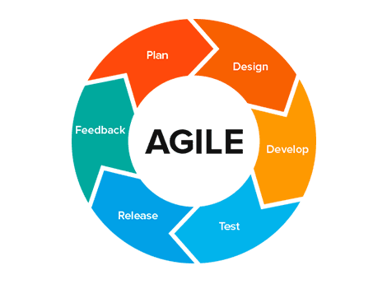
Figure 1: Agile Model

The FinGuard system development will occur in six stages via an Agile methodology. In the Planning Stage, the goals, characteristics, and technical specifications of the system are determined. Some important elements that need to be considered are the IoT sensors, camera input, cloud database, and machine learning model. Potential risks associated with the system, such as sensor reliability, lighting, availability of the Internet, and accessibility to users, should be discussed during this stage. The Designing Stage involves coming up with the design for the whole system in terms of the structure, data relationships, functional processes, and user interface. These are what will guide the developers in implementing the system in the Development Stage. The implementation entails the development of the mobile app, sensor installation, machine learning, and dashboard. The Testing Stage consists of evaluating the functionality and effectiveness of the system in terms of sensor response, consistent behavior detection, correct alerts, and usability of the dashboard. The Deployment Stage involves installing the system in the actual aquarium and testing its performance.

Dataset Description

There are three types of data on which the FinGuard works. The first type of data is environmental data, which includes measurements of water temperature, pH, amount of dissolved oxygen, and turbidity. These are factors that directly impact the well-being of fish since a deviation even in the optimal range causes them stress, poor immunity, or even susceptibility to diseases. Second are behavioral data, which include swimming behavior, frequency of movements, feeding behavior, breathing through gills at the water surface, tendency to group, or absence of any activity. Third are historical data, which consist of previously registered parameters, registered alerts, and suggested actions.

SYSTEM ARCHITECTURE

The system architecture of FinGuard is organized around three principal components: input, process, and output. These components work together to enable real-time monitoring, intelligent analysis, and user-friendly presentation of aquarium health information.
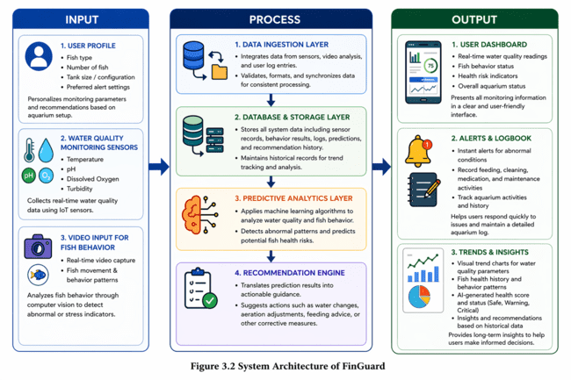
Figure 2: FinGuard System Architecture

Input components comprise three parts. The first one is the user profile, which allows the fish keeper to fill in information on the fish type, tank size, number of fish, and alert preferences for personalizing monitoring. Another part is IoT water quality sensors, which gather data on temperature, pH, dissolved oxygen, and turbidity in the tank in real-time. Finally, there is the video input part based on the ESP32-CAM module for capturing live videos of fish.

The process part includes four layers. First, data ingestion collects data from sensors, video, and logs of user activity. Secondly, validation and synchronization of all input data are performed. Thirdly, the database and storage layer allow for saving all information related to the system, such as data collected by the sensors, results of behavioral analysis, predictions, and logging. Next, the predictive analytics layer uses the data to find possible issues using machine learning algorithms. Finally, the recommendation engine turns the result of the predictions into specific recommendations, such as changing water, adjusting the aerator, altering the frequency of fish feeding, and consulting the issue with an expert.

Output components provide the result of operations via three different interfaces. Firstly, a user interface includes real-time data on water quality parameters, fish behavioral status, risk assessment, and aquarium state as a whole. Secondly, the alerts and logbook allow receiving alerts in case of problems detected by the system and recording actions taken regarding aquarium maintenance, such as feeding or cleaning the tank. Thirdly, the trends and insights show trends in graphs for water parameters and fish health, as well as the result of analysis in terms of AI-generated health status score being either Safe, Warning, or Critical.

SYSTEM METHODS

This section presents the three main methods used by the proponents to develop the core features of the FinGuard system. Each method corresponds to a specific monitoring challenge identified in the study, namely environmental water quality tracking, fish behavioral observation, and predictive health risk analysis, ensuring that every technical approach directly supports the overall goals of the system.
Three core methods guide FinGuard's operation, each addressing a distinct aspect of ornamental fish health monitoring.

Method 1: Environmental Water Quality Monitoring and Health Assessment

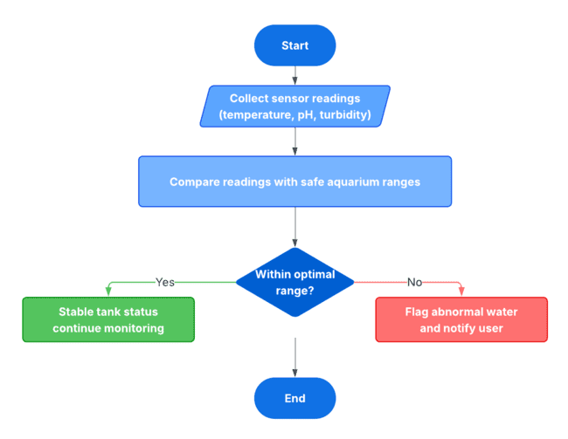
Figure 3: Environmental Water Quality Monitoring and Health Assessment

The technique controls the constant monitoring and analysis of water quality information. IoT devices monitor temperature, pH, and turbidity periodically and relay information to the mobile application, where the information is then analyzed relative to the acceptable values for the desired ornamental fish variety. In the event that all the parameters are within the ideal values, the condition of the aquarium is noted as being normal. However, in the event any of the parameters goes beyond or is about to breach the safe values, a problem is identified, and the system immediately alerts the user.

Method 2: Fish Behavior Observation and Pattern Tracking

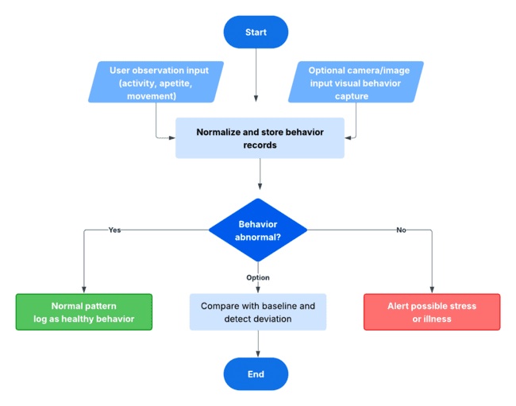
Figure 4: Fish Behavior Observation and Pattern Tracking

Using this approach, FinGuard is able to collect and analyze the fish’s behavior based on two sources of input: recorded behavior observed by users, such as slowed movements, strange swimming habits, gasping for air, lack of appetite, and abnormal grouping behaviors, and optional video feeds from the ESP32-CAM camera. These collected behavioral patterns are analyzed and compared against known healthy behaviors. In the event that fish behaviors indicate abnormalities, the user will be alerted that their fish may be experiencing stress and ill health. This technique is useful when combined with environmental monitoring, as some fish can show signs of being sick through their behaviors before any changes to the environment occur.

Method 3: Predictive Health Risk Analysis and Recommendation Generation
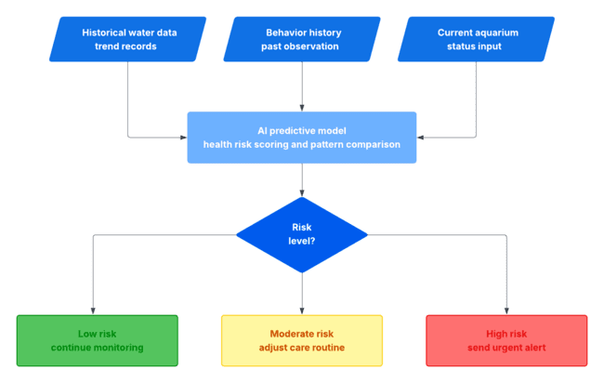
Figure 5: Predictive Health Risk Analysis and Recommendation Generation

The technique combines the use of historic water quality parameters and behaviors in order to predict the health risks associated with a given set of observations. In doing so, the predictive model will examine trends in behavior that can be attributed to any one of various patterns, including the gradual degradation of water quality, consistent temperature fluctuations, or repeated aberrations in fish behavior, and classify them as either low, moderate, or high risk. Based on the classified risk, the recommendation engine provides a series of actionable advice for addressing the potential risks, including carrying out a water change, changing feeding habits, testing filtration systems, adding aeration, or visiting an aquatic health expert.

SYSTEM DIAGRAMS AND TOOLS

The tools that were applied for designing and developing FinGuard, as well as those that contribute to the performance of its functions, are discussed in this section. These tools include both hardware and software that will be described using technical models such as a flow chart of the system, use-case diagram, entity relationship diagram, and data flow diagrams.

Flowchart of the Proposed System
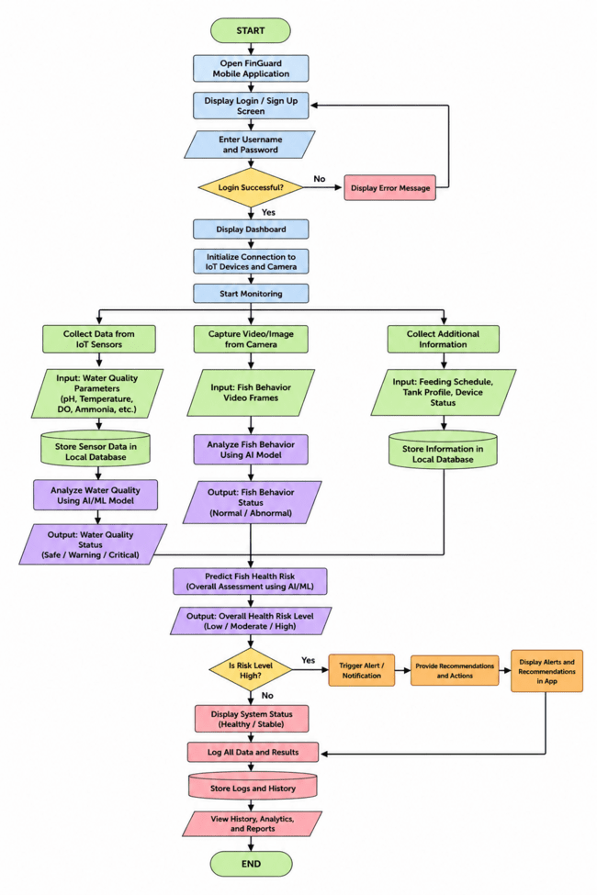
Figure 6: FinGuard System Flowchart

In this flowchart, the whole operational process of the FinGuard application is depicted, starting from the user login process all the way until health evaluation and care recommendations. The process starts with the user opening the application and logging in. After being successfully authenticated, the connection to IoT devices and the camera device will be initialized, marking the beginning of monitoring. In this step, the system is collecting information regarding water quality from the sensors, fish behavior from the video capture, and other necessary information about the user and the aquarium configuration settings. These collected inputs are analyzed using AI and machine learning algorithms in order to evaluate water condition and fish behavior status. The results are evaluated with the help of a predictive engine that determines the health risk level. A high health risk level automatically leads to immediate notifications and care recommendations.

Data Flow Diagram — Level 0
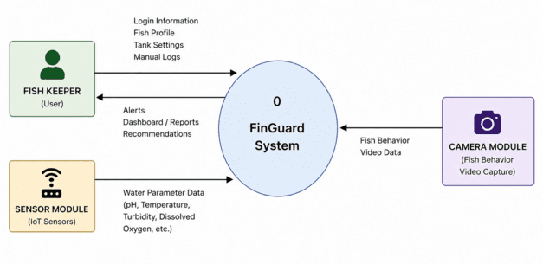
Figure 7: Data Flow Diagram (DFD) Level 0

At Level 0, FinGuard is shown as a centralized process that interfaces with three outside entities, which include the Fish Keeper, Sensor Module, and Camera Module. The Fish Keeper supplies FinGuard with the user login details, fish profiles, tank information, and manual fish behavior records. The Sensor Module sends water quality data like pH levels, temperature, turbidity, and dissolved oxygen to FinGuard in real time. The Camera Module sends fish behavior videos. In return, FinGuard analyzes all the data received and informs the Fish Keeper of any developments.

Data Flow Diagram — Level 1
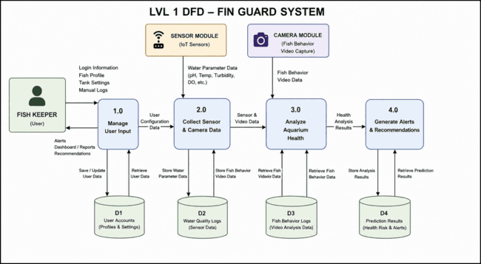
Figure 8: Data Flow Diagram (DFD) Level 1

The Level 1 DFD further breaks down the functionality of FinGuard into five processes, including Manage User Inputs, Gather Sensor & Camera Data, Assess Aquarium Health Status, Send Alert & Recommendation, and Maintain Monitoring Records. The user inputs are first authenticated before being saved into the User Accounts data store. The sensor data and camera data are gathered separately, and each of them is then stored in Water Quality Logs and Fish Behavior Logs. The process of assessment makes use of artificial intelligence and machine learning models to identify any anomaly and predict any risk. The assessment findings are then saved in the Prediction Results data store. Following the assessment, alerts and recommendations are sent to the Fish Keeper.

Entity-Relationship Diagram
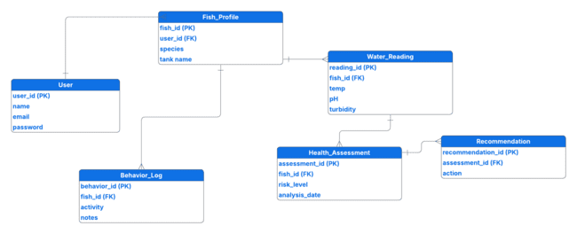
Figure 9: Entity Relationship Diagram

All these features, including monitoring of water quality, logging fish actions, receiving notifications, checking the log of the monitoring system, getting information about predictive health and care advice, can be done using only one interface. The platform is created in such a way that it would be easy to use by beginners and experienced keepers of ornamental fish.

RESULTS AND DISCUSSIONS

Results of the developed FinGuard: An AI-Integrated Mobile Application for Predictive Health Monitoring in Ornamental Fish Keeping are outlined in this section using screenshots of the main functions of the application, which include real-time water quality monitoring, analysis of fish behavior, prediction of health risks, and recommendations generation. The results illustrate the working capacity of the whole system, including hardware and software components, computer vision, and machine learning. An explanation of how the implemented functionalities work is provided in the corresponding sections below.

IoT-Based Water Quality Monitoring System

The entity relationship diagram provides a depiction of the data structure behind the FinGuard system. The User entity describes the account holder who maintains one or several fish profiles. The fish profile has an association with water readings, behaviors, and health risks. The health risks information will be connected to recommendations, making sure that every condition analyzed receives a proper recommendation. Through such a data structure, it can ensure a well-maintained record that can be tracked for trend analysis.

Use Case Diagram
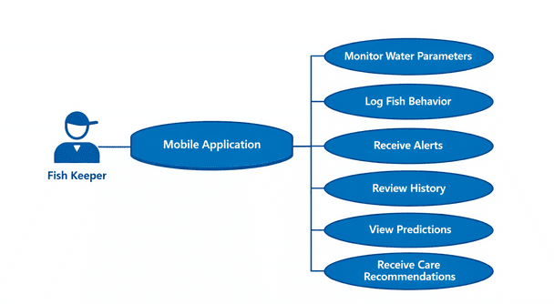
Figure 10: Use Case Diagram
Firstly, designing a monitoring system using IoT sensors to monitor essential water parameters, including temperature, pH value, dissolved oxygen level, and turbidity, while alerting users about their proximity to the safe range of values, was accomplished through the use of the ESP32 microcontroller, water quality sensors, the ESP32-CAM board, and the Firebase cloud storage facility on the FinGuard application.

Results:
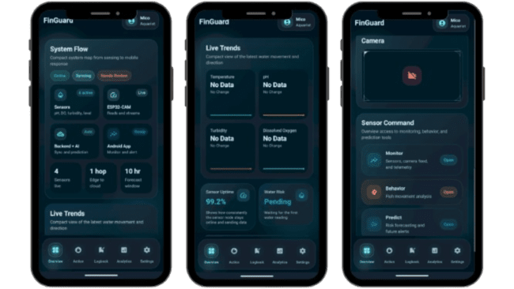
Figure 11: FinGuard Overview and System Flow Screen

Figure 11 shows the Overview page of the FinGuard mobile application, which is the primary landing page of the application after launching the software. As shown in Figure 11, the System Flow tab reflects the operational status of the components that are connected to the system in real-time by highlighting four working sensors, namely, the pH sensor, the dissolved oxygen sensor, the turbidity sensor, and the water level sensor; the live ESP32-CAM module; the automatic backend/AI modules; and the Android mobile application for monitoring and alerts. The display indicates the overall system status in terms of the number of sensors live, the number of hops from edge-to-cloud, and the live 10-hour forecast.

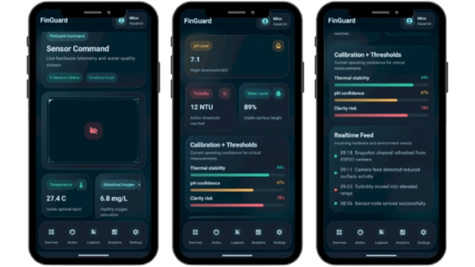
Figure 12: Sensor Command and Realtime Water Quality Feed Screen

Figure 12 shows the Sensor Command interface, which can be accessed via the Monitor tab in the Overview page. As seen in the diagram, all sensors' live data are shown in the software, where the temperature sensor shows data of 27.4 °C within the acceptable range. The dissolved oxygen sensor measures 6.8 mg/L, meaning that there is an appropriate oxygen saturation in the water. In addition, pH is observed to be 7.1 with a slight decline, while turbidity is recorded to be at 12 NTU, surpassing the acceptable level. The current water level is seen to be 89% and indicates that the surface level of the water remains constant. In the Calibration and Thresholds tab, thermal stability, pH confidence, and clarity risks show values of 84%, 67%, and 78%, respectively.

Discussion:

The real-time monitoring of water quality functionality ensures that the FinGuard app is capable of collecting and presenting environmental data from all connected IoT devices using the ESP32 processor and Firebase cloud connectivity. The Sensor Command interface integrates live sensor data, calibration verification measures, and an event timeline, thus enabling aquarium hobbyists to constantly assess tank conditions without having to conduct manual testing. The application highlights the parameters whose value has exceeded or approached the level requiring attention, like the turbidity parameter highlighted in the demo video, thus giving users insight into potential environmental issues before they begin to harm the fish.

AI-Based Fish Behavior Observation and Analysis

The second objective involved utilizing AI to develop and build an artificial intelligence model for a vision-based computer program that would employ video data input to detect any abnormal behaviors exhibited by the fish, thereby determining whether the fish were stressed or suffering from diseases. This objective was accomplished using the ESP32-CAM module, the OpenCV video processing system, and the Behavior Intelligence function in the FinGuard application.

Results:
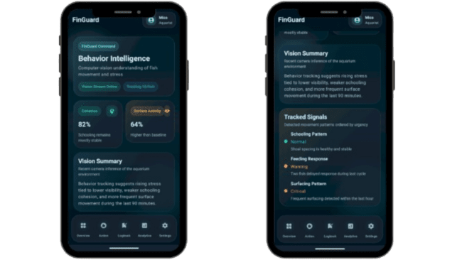
Figure 13: Behavior Intelligence Screen

Figure 13 shows the Behavior Intelligence screen of the FinGuard mobile application tracking 18 fish in real-time via the vision live feed, where the computer vision algorithm analyses the behavioral movements in real-time based on data collected by the ESP32-CAM vision device. In this respect, two behavior measurements are presented by the behavior intelligence screen: Cohesion of 82% (meaning schooling remains mostly stable), and Surface Activity of 64%, measured above the normal baseline. The behavior summary section interprets the behavioral trends in plain text, highlighting that the behavioral trend analysis shows increasing stress due to poor visibility, unstable schooling, and surface activity in the last 90 minutes.

The tracked signals section categorizes all identified movements according to urgency levels. Here, schooling patterns are categorized as normal with shoal spacing remaining healthy. However, the feeding response is identified as critical due to the delayed feeding responses from two fish in the last feeding session. Moreover, surfacing patterns are categorized as critical due to increased surfacing activities, a behavioral trend that may be indicative of dissolved oxygen depletion.

Discussion:

The Behavior Intelligence capability allows the FinGuard system to analyze the behaviors of fish through the ESP32-CAM video stream via the computer vision algorithm. The innovation introduces the behavioral aspect of analyzing fish, which goes beyond the water parameter analysis, as sensors provide the data. In this regard, there is added information on fish health through behavior patterns such as stress indicators, which might be unnoticed until now due to a lack of changes in water parameters. The urgency levels include Normal, Warning, and Critical classifications, providing an easy way for users to determine the urgency level of the behavioral deviation even when they lack aquaculture experience. Furthermore, the vision summary, it makes the results more understandable to beginners and advanced fish owners alike, making it easier for users to take appropriate actions before any physical health degradation happens.

Machine Learning Predictive Health Risk Analysis and Recommendation Generation

The third objective was to use machine learning for predictive analytics that integrates water quality and behavioral data to predict future health dangers, producing proactive warnings and customized suggestions. This objective was successfully achieved through the Prediction Radar, Action, Logbook, and Analytics features integrated within the FinGuard mobile application.

Results:
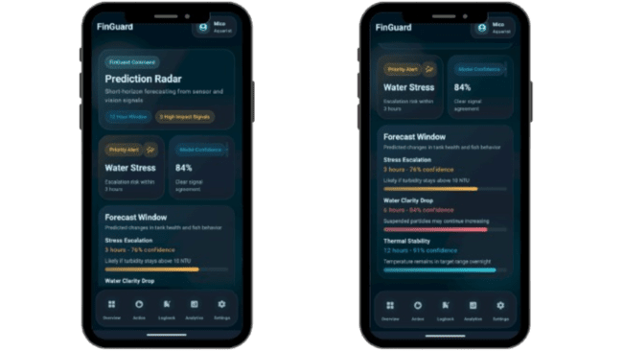
Figure 14: Prediction Radar Screen

Figure 14 shows the Prediction Radar screen of the FinGuard app. In the above figure, it can be seen that the prediction algorithm is working on a 12-hour prediction window and has identified three significant signals in terms of data coming from sensors and vision algorithms. The Priority alert shows that there is water stress, with risks of escalation predicted in the next three hours with 84% confidence levels based on model signal agreement in terms of environmental and behavioral input.

The Forecast Window shows three particular predicted events, along with their respective confidence levels and prediction windows. The first event is the occurrence of stress escalation within three hours with a 76% confidence level, especially if turbidity is greater than 10 NTU. A reduction in water clarity, i.e., the increase in suspended particles, is predicted within six hours with 84% confidence level. Finally, thermal stability is predicted to last within the next 12 hours with 91% confidence level.

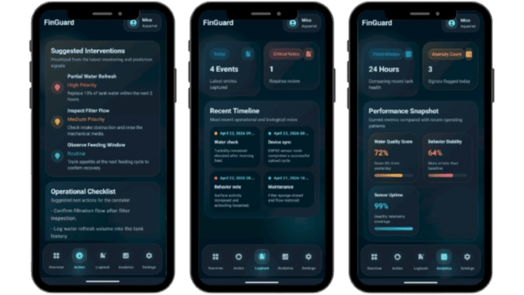
Figure 15: Action, Logbook, and Analytics Screens

Figure 15 shows another three sections on the FinGuard app. First, there is an Action screen where Suggested Interventions can be seen based on monitoring and predictive signals. They include a High Priority signal to partially replace tank water by 15%, a Medium Priority signal to check filter flow and rinse mechanical media, and a Routine intervention to observe the feeding window and monitor the appetite during the next feeding session. Further, an Operational Checklist can be found at the bottom part of the screen that gives particular directions for the caretaker based on the system analysis.

Another screen to review is the Logbook, where a Recent Timeline can be seen. There are four logged entries for today, including one that requires immediate attention. The logged entries involve water check notes, device sync notes, behavior observation, and maintenance actions. Overall, the fish keeper has the ability to track all aquarium management actions and trace them.

An Analytics screen provides performance information in the form of a Snapshot showing a comparison between today's data and the recent operating trends. Specifically, the Water Quality Score equals 72%, down by 8% from the previous day. Behavior Stability is recorded at 64%, which means that it was less stable compared to the established baseline. Moreover, Sensor Uptime equals 99%, meaning perfect telemetry coverage. Finally, there are three anomalies within a 24-hour timeframe.

Discussion:

The Predictive Radar functionality enhances FinGuard beyond a mere monitoring application, turning it into an effective decision support system through combining sensor and behavioral information to predict future health risks related to the fish tank and the corresponding confidence in the predictions. Instead of warning users after something happens, the application allows detecting future problems, for instance, the predicted increase in water stress within three hours, so that fish keepers can take precautionary measures beforehand. The Action screen comes as an additional useful functionality, providing specific care recommendations based on the predictive analytics output and allowing performing them without needing to analyze the information obtained from the sensors and behaviorally collected data on their own. The Logbook keeps a record of all monitoring activities, maintenance operations, and behavioral data entered, thus facilitating accountability and further pattern identification. Finally, the Analytics screen shows a more comprehensive overview of user performance in terms of how the water quality and the state of fish changed over time. These features prove FinGuard's ability to implement all necessary components for fish management in one convenient app.

CONCLUSION

The solution provided by FinGuard represents an integrated, AI-driven response to one of the most persistent problems that ornamental fish hobbyists face – namely, the early detection of deteriorating water parameters and the emergence of stress or other signs of ill health. This is achieved by combining IoT water sensors, computer vision technology, and machine learning models for fish behavior recognition and health risk prediction in one mobile application. Unlike the currently available standalone devices that offer nothing but simple water parameters measurement and threshold-based alerts, FinGuard allows solving several key problems inherent to ornamental fish keeping.

First of all, FinGuard is capable of providing continuous water condition monitoring and health risk analysis, overcoming the problems associated with unreliable manual and occasional tests. Furthermore, with the ability to detect behavioral changes, the system makes it possible to recognize fish diseases at an early stage when they become apparent, not through physiological symptoms but through unusual behavior patterns. Finally, FinGuard's prediction capabilities allow recognizing future problems in advance, which is essential for the prevention of fish death or illness.

For hobbyists, the system will provide the benefits of real-time monitoring, early warnings, and intelligent recommendations on fish care practices. For breeders and small enterprises specializing in ornamental fish production, it would serve as a central tool for predicting problems and reducing losses while increasing fish survival rates. From the perspective of education and research, FinGuard can be used as an example of applying IoT and AI in intelligent aquaculture. The Philippine ornamental fish industry itself will benefit from improving fish health and productivity.

In accordance with the evidence presented in the reviewed literature, the combination of IoT and AI in aquaculture systems produces consistent positive results in terms of fish survival rates (Shete et al., 2024; Aziezah et al., 2025; Patro et al., 2023). FinGuard leverages proven technologies to solve the existing problem in the Philippine ornamental fish-keeping community. Possible development directions include increasing the number of supported species (now, only guppies and goldfish), improving performance in different lighting conditions, and developing intervention capabilities (e.g., automatic feeding schedule adjustment).

REFERENCE

- Al-Abri, S., Keshvari, S., Al-Rashdi, K., Al-Hmouz, R., & Bourdoucen, H. (2025). Computer vision based approaches for fish monitoring systems: A comprehensive study. Artificial Intelligence Review, 56, 257–290. https://doi.org/10.1007/s10462-025-11180-3
- Aziezah, N., Sholihah, W., Marcelita, F., Novianty, I., Hendriana, A., & Kusumanti, I. (2025). Artificial neural network-based classification of water quality status in ornamental fish farming using IoT sensor data. Current STEAM and Education Research, 3(3), 137–148. https://doi.org/10.58797/cser.030302
- FAO. (2019). The state of world fisheries and aquaculture 2019: Sustaining the planet's seafood. Food and Agriculture Organization of the United Nations. https://www.fao.org/fishery/en/publication/87494
- Flores-Iwasaki, M., Guadalupe, G. A., Pachas-Caycho, M., Chapa-Gonza, S., Mori-Zabarburú, R. C., & Guerrero-Abad, J. C. (2025). IoT sensors for water quality monitoring in aquaculture systems: A systematic review and bibliometric analysis. AgriEngineering, 7(3), 78. https://doi.org/10.3390/agriengineering7030078
- Hermansyah, A., Septian, T. W., Perdana, A. P. P., Faris, M. F., & Islam, K. (2023). Prototype of automatic control system for water temperature and acidity in ornamental fish aquarium based on IoT. Indonesian Journal of Electronics, Electromedical Engineering and Medical Informatics, 5(3), 187–192. https://doi.org/10.35882/ijeeemi.v5i3.272
- Jais, N. A. M., Abdullah, A. F., Kassim, M. S. M., Karim, M. A. M., Fatimah, M. F., & Muhadi, N. A. (2024). Improved accuracy in IoT-based water quality monitoring for aquaculture tanks using low-cost sensors: Asian seabass fish farming. Heliyon, 10(8), e29022. https://doi.org/10.1016/j.heliyon.2024.e29022
- Lobillo-Eguíbar, J., Fernández-Cabanás, V. M., Bermejo-Nogales, A., & Luque de Castro, M. D. (2023). Sustainability of freshwater fish production: A holistic approach. Sustainability, 15(3), 2250. https://doi.org/10.3390/su15032250
- Nugraha, A. I., & Rosita, Y. D. (2024). Web-based integration of IoT and artificial intelligence for monitoring aquariums. MATICS: Jurnal Ilmu Komputer dan Teknologi Informasi, 16(1), 7–12. https://doi.org/10.18860/mat.v16i1.23471
- Patro, K. S. K., Yadav, V. K., Bharti, V. S., Sharma, A., Shankar, K., & Senthilkumar, T. (2023). IoT and ML approach for ornamental fish behaviour analysis. Scientific Reports, 13, 21415. https://doi.org/10.1038/s41598-023-48057-w
- Paturusi, S. B., & Susilo, A. (2025). Design of IoT-based water quality monitoring system in freshwater ornamental fish ponds. Jurnal TIFDA, 2(1), 19–23. https://doi.org/10.70491/tifda.v2i1.86
- Periyadi, A., Budidarma, I., Sukmono, S. P. J., & Reksa, I. H. (2020). IoT-based guppy fish farming monitoring and controlling system. TELKOMNIKA (Telecommunication Computing Electronics and Control), 18(3), 1538–1545. https://doi.org/10.12928/TELKOMNIKA.v18i3.14850
- SEAFDEC/AQD. (2015). Ornamental fish production: A potential livelihood activity. Southeast Asian Fisheries Development Center, Aquaculture Department. https://repository.seafdec.org.ph/
- Shete, R. P., Bongale, A. M., & Dharrao, D. (2024). IoT-enabled effective real-time water quality monitoring method for aquaculture. MethodsX, 13, 102906. https://doi.org/10.1016/j.mex.2024.102906
- Tayamen, M. M., & Mendoza, A. B. (2016). Ornamental fish production in the Philippines. Philippine Journal of Science, 145(1), 51–57.
- Zuhaer, A., Khandoker, A., Enayet, N., Partha, P. K. P., & Awal, M. A. (2026). Sustainable aquaculture: An IoT-integrated system for real-time water quality monitoring featuring advanced DO and ammonia sensors. Aquacultural Engineering, 112, 102620. https://doi.org/10.1016/j.aquaeng.2025.102620

