Influence of Demographic Measures on Population Growth In Nigeria: A
Hierarchical Multiple Regression Analysis

* Fadiji, A.A.; Karokatose, G.B.; Alakija, T.O.; Amusa, S.O.; Ganiyu, Y.A.; James, T.D.

*Corresponding Author: saidi.amusa@yabatech.edu.ng

Department of Statistics, Yaba College of Technology, Yaba, Lagos State, Nigeria.

Abstract

This study utilized hierarchical multiple regression analysis to investigate the influence of demographic measures on population growth in Nigeria. The demographic data used was extracted from world development indicators website from (1973-2022). The Statistical Software used was Statistical Package for Social Science (SPSS, version 23).. The derived regression model is population growth ₌ 0.403+6.58E-0.07*net migration -0.097*death rate + 0.627*fertility rate, with variables such as net migration, death rate, and fertility rate, demonstrated statistical significance and explained 76.1% of population growth variance. Net migration positively influenced population growth, while death rate exhibited a negative correlation. Fertility rate emerged as the most influential factor. The results provide the stakeholders and policymakers with a more thorough understanding of Nigeria’s population growth.

.
1.0 Keywords: Population growth, Death rate, Fertility rate, Net migration, Multiple Regression

2.0 Introduction
A key demographic indicator that has a substantial impact on the social, economic, and environmental facets of a country's development is population growth. For sustainable development and effective policymaking in Nigeria, the most populous country in Africa, it is imperative to comprehend the factors that contribute to population growth. Over time, there have been significant changes to Nigeria's demographic landscape. With an estimated 200 million people living there, the nation is the seventh most populous in the world, according to the National Population Commission (NPC) report from 2019. Such quick population expansion has an impact on infrastructure development, resource allocation, and the general well-being of society. It also brings with it opportunities and challenges. Nigeria has seen notable demographic changes throughout its history, with the country's population growing quickly in recent years. Increased industrialization, urbanization, and technological advancements during the post-independence era led to modifications in family structures and lifestyles. This has contributed to a significant rise in the population, along with other factors like better healthcare and lowering death rates. The age distribution, death rates, and fertility rates are some of the factors that are intrinsically related to Nigeria's demographic landscape. A sizable portion of the population in the nation is under 30 years old. Opportunities like a potential labor force and challenges like a rise in the demand for healthcare, education, and jobs are presented by this demographic structure. There's still a gap in the literature about the hierarchical impact of particular demographic measures, which is concerning given how important it is to comprehend the complex factors driving population growth. A more detailed analysis is required to guide focused policy interventions, even though many studies have looked at the broad factors influencing population growth. Nigeria's population growth has significant economic ramifications. If not controlled, rapid population growth can put a strain on resources and obstruct efforts to promote economic development. Understanding the complex relationships between demographic variables and population growth is critical because policymakers seeking to put evidence-based policies into action need to be aware of these relationships. Nigeria additionally confronts particular difficulties in controlling its population growth, such as regional differences, inadequate infrastructure, and restricted access to healthcare and education in some areas. The complex relationship between demographic indicators and population growth must be fully understood in order to identify and address these challenges. In summary, the detailed background emphasizes the historical setting and the intricate nature of Nigeria's population dynamics.

Research Problem Statement
Nigeria's population is growing, but the literature currently in publication does not address the precise demographic metrics that drive this phenomenon. A thorough examination of the hierarchical impact of specific demographic variables is absent, despite the fact that earlier research has focused on the more general factors influencing population growth. In order to close this gap, this study uses hierarchical multiple regression analysis to identify the complex relationships between demographic variables and population growth in Nigeria.

The Study Objectives
The following goals were completed in order to fulfill the study's purpose:

- Investigating the relationship between Nigeria's population growth and net migration.
- To examine the effects of death rate and net migration on Nigeria's population growth.
- Investigating the impact of net migrations, the death rate, and the fertility rate on Nigeria's population growth.

Literature Review
Nigeria's population structure is changing dramatically, as evidenced by the constantly changing birth rates, death rates, age distribution, and socioeconomic circumstances. Comprehending the complex interrelationships among these demographic metrics and their combined influence on population expansion is crucial for well-informed policy formulation.
China, India, the United States, Indonesia, Pakistan, Brazil, and Nigeria are the seven most populous countries in the world, with respective population estimates of 1.444 billion, 1.393 billion, 332 million, 276 million, 225 million, 213 million, and 211 million inhabitants, according to a 2021 World Population Review report. Their rates of population growth, however, differ; China, the world's most populous nation, has a population growth rate of 0.34%, while the rates in Brazil, India, the US, Indonesia, Pakistan, and the UK are, respectively, 0.97%, 0.58%, 1.04%, 1.95%, and 0.67%. Nigeria is Africa's most populous nation, with a 2.55% annual population growth rate (World Population Review, 2021).
"Economic growth always includes a purely demographic component and a purely economic component, and only the economic component allows for an improvement in the standard of living," according to Piketty (2014) in a study on population and economic growth.
In 2014, Eze looked into how population growth affected economic growth. Instead of using economic growth, the study used GDP growth per capita. For the analysis, Autoregressive Distributed Lag (ARDL) test for cointegration was employed. Using the ARDL, the study demonstrated a long-term sustainable equilibrium between population growth and economic growth. Through the application of the pairwise Granger Causality test technique, the study once more demonstrated a unidirectional causal relationship between the population growth and economic growth.
Multiple regression models were used in a study by Adebayo and Bamgboye (2018) to evaluate the impact of birth rates on population growth, and the results showed complex patterns influenced by socioeconomic factors.
Ajakaiye and Olaniyan (2016) carried out a noteworthy investigation using multiple regression methods to reveal the subtle effects of age distribution. Their results emphasized how crucial it is to take demographic structure into account when predicting population growth.
Adeoti and Oduwole, (2018) have investigated dependency ratios, which show the percentage of dependents to the working-age population. They shed light on the economic aspects of demographic shifts by using multiple regression models to highlight the effects of dependency ratios on population growth.
In a research, Osili and Long (2019) used multiple regression techniques to conduct a longitudinal analysis that showed how Nigeria's population growth is affected by fertility rates. The importance of taking contextual factors like educational attainment and healthcare access into account was highlighted by their findings.
Research like Okonkwo et al. (2019) included factors like income, urbanization, and education in their multiple regression analyses. It was discovered that these covariates had complex interactions with demographic metrics, influencing the direction of population growth.

3.0 Materials and Methods
Model Specification
In a basic hierarchical multiple regression model, predictor variables are inserted into the regression equations in a particular order, and their effects on the dependent variables are evaluated.
Hierarchical Regression Model (Two Stages)
Stage 1: (Baseline Model)
$$Y= b_{0}+ b_{1}X_{1}+ ε$$
Where
$Y$is dependent variable (Population Growth);
$b_{0}$ is intercept;
$b_{1}$ is coefficient for predictor $X_{1}$.
Stage 2: (Extended Model)
$$Y= b_{0}+ b_{1}X_{1}+b_{2}X_{2}+ ε$$
Where
$X_{2}$ is additional predictor added in the second stage;
$b_{2}$is coefficient for predictor $X_{2}$.
Stage 3: (Full Model)
$$Y= b_{0}+ b_{1}X_{1}+b_{2}X_{2}+b_{3}X_{3}+ ε$$
Where
$X_{3}$ is third predictor added in the third stage;
$b_{3}$is coefficient for predictor $X_{3}$.

4.0 Results
Correlation and hierarchical multiple regression analysis were used to display the analyzed data, and the results of the analysis were checked at the 5% level of significance.
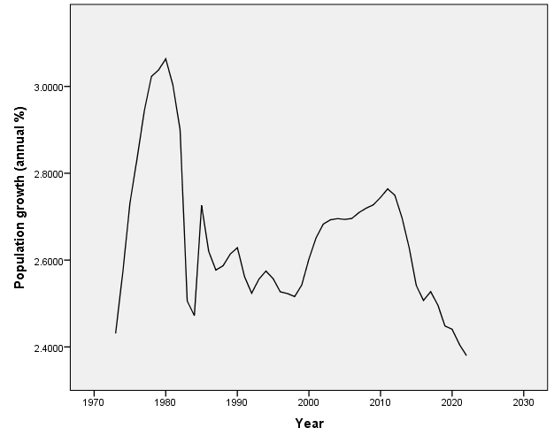
Figure 1: Time plot of population growth in Nigeria.
Figure 1 shows a graph that is rising and falling over time.
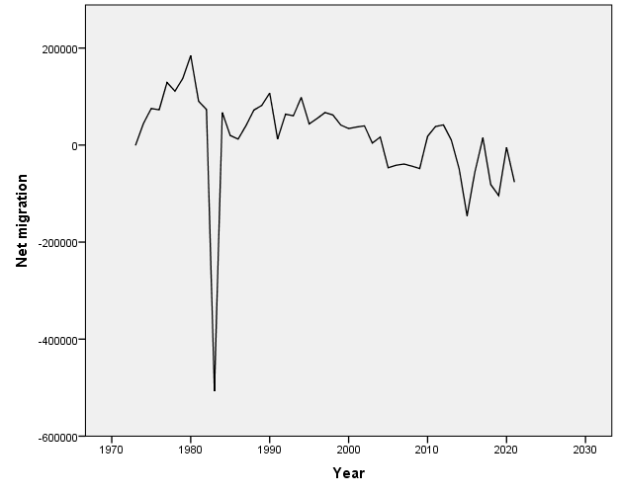
Figure 2: Time plot of Net Migration in Nigeria.
Figure 2 illustrates the net migration shock that occurred in 1982.

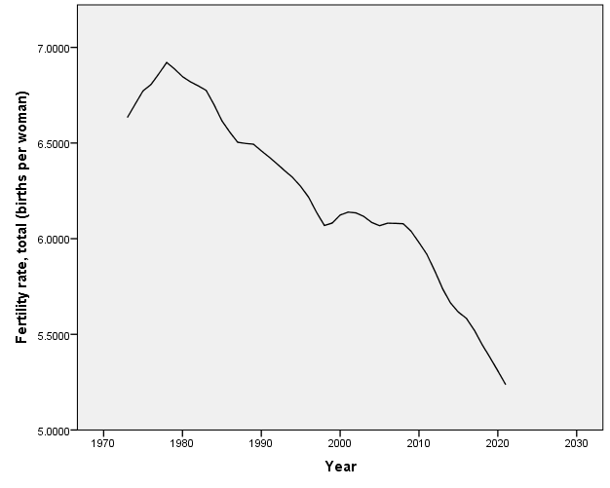
Figure 3: Time plot of Fertility rate in Nigeria.
The fertility rate is declining over time, as Figure 3 illustrates.

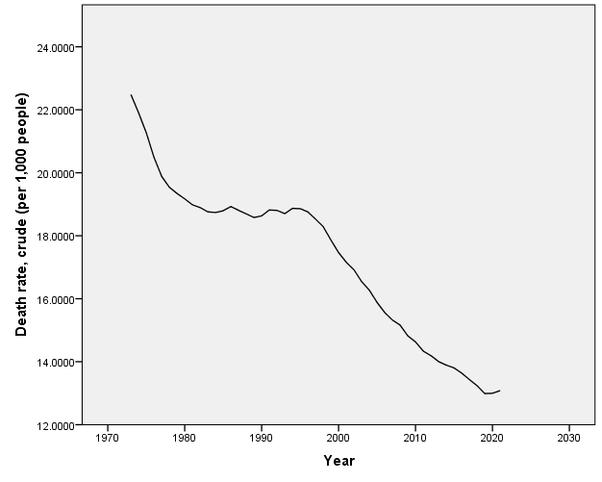
Figure 4: Time plot of Death rate, crude in Nigeria.
As seen in figure 4 above, it indicates that the death rate is declining over time.

Table 1: Summary of Inter-Correlations among the Predictors of Population Growth
 |  | Net migration | Fertility rate, total (births per woman) | Death rate, crude (per 1,000 people)
- Net migration |  | 1 | .350* | .387**
- Fertility rate, total (births per woman) |  | .350* | 1 | .904**
- Death rate, crude(per 1,000 people) |  | .387** | .904** | 1
Note: $* Significant at p<0.05$. Also $** Significant at p<0.01$
Table 1 shows that there is a weakly significant positive correlation (r(49) =.350, p<.05) between net migration and fertility rate. Furthermore, r(49) =.387, p<.05. showed a weakly significant positive correlation between net migration and death rate. The fertility rate and death rate have a very strong positive correlation (r(49) =.904, p <.05.
Table 2: Summary of Hierarchical Multiple Regression Analysis for Variables Predicting Population
Growth.

Model |  | B | t | R² | ∆R² | P-value | Collinearity Statistics
 |  |  |  |  |  |  | Tolerance | VIF
1 | Constant | 2.640 | 122.616 |  |  | .000
 | Net migration | 7.114E-007 | 3.325 | .190 | .190 | .002 | 1.000 | 1.000
2 | Constant | 2.551 | 16.145 |  |  | .000
 | Net migration | 6.599E-007 | 2.824 |  |  | .007 | .851 | 1.176
 | Death rate, crude (per 1,000 people) | .005 | .569 | .196 | .006 | .572 | .851 | 1.176
3 | Constant | .403 | 1.784 |  |  | .081
 | Net migration | 6.577E-007 | 5.107 |  |  | .000 | .851 | 1.176
 | Death rate, crude (per 1,000 people) | -.097 | -8.712 |  |  | .000 | .177 | 5.656
 | Fertility rate, total (births per woman) | .627 | 10.318 | .761 | .565 | .000 | .182 | 5.483
a. Dependent Variable: Population Growth (annual %)

According to Table 2, net migration made a significant contribution to the regression model at stage one (F(1,47) = 11.06, p <.05. R =.44) indicates that the relationship between the variables was not strong enough to explain nearly 19% (ΔR² = 19.0%) of the variation in population growth. The inclusion of stage 2 (death rate) in the regression model explained an extra 19.6% (ΔR² = 6%) of the variation in population growth. The relationship between these variables was weak (R =.44) and the change in R² was not statistically significant (F(1,46) =.324, p >.05). Ultimately, 76.1% (ΔR² = 57%) of the variation in population growth could be explained by including stage 3 (fertility rate) in the regression model. This change in R² was statistically significant (F(1,45) = 106.461, p <.05), and there was a strong correlation between these variables (R =.87).
The population growth was, however, significantly predicted by the three variables (net migration, β = 6.58E-007, t(47) = 5.11, p =.00; death rate, β = -.097, t(47) = -8.71, p =.00; fertility rate, β =.627, t(47) = 10.32, p =.00). The three predictor variables, together, accounted for 45% of the variance.

MULTIPLE REGRESSION MODEL
The fitted regression model is:
Population growth = 0.403 + 6.58E-007(net migration) – 0.097 (death rate) + 0.627 (fertility rate)
5.0 Discussion
The goal of this study was to ascertain how Nigeria's population growth was influenced by net migration, the country's death and fertility rates, and the relationship between these factors and net migration.
It is shown that net migration, death rate, and fertility rate together impact population growth in Nigeria; net migration and death rate have a major impact, but fertility rate has the strongest explanatory power in the model.
Furthermore, the outcomes demonstrated that 76.1% of the variance in population growth is explained by the final regression model, which is statistically significant at a 0.05 significance level.

6.0 Conclusion
The study's conclusions indicated that, in addition to a relatively minor decline of 6.58E-007 in net migration, population growth was predicted to rise by 0.627 births per woman (fertility rate) and fall by 0.097 per thousand of the death rate of individuals. These associations are statistically significant.

7.0 Recommendation
It is recommended that in order to achieve more accurate predictions, the government set up a system for ongoing observation and frequent updates to the regression model. It would also be crucial to implement focused measures to address particular challenges and increase net migration and the death rate.

8.0 References.

Adebayo, A. S., & Bamgboye, E. A. (2018). The influence of birth rates on population growth: A multiple regression analysis. Journal of Demographic Studies, 12(3), 45-63.
Adebowale, T. O., & Ogunniyi, A. (2017). Life expectancy and population growth: An in-depth analysis using multiple regression models. Population Dynamics Journal, 8(2), 112-129.
Adeoti, J. O., & Oduwole, T. O. (2018). Dependency ratios and economic growth: A longitudinal study. Economic Trends and Analysis, 15(4), 287-304.
Ajakaiye, O., & Olaniyan, O. (2016). Age distribution and its effects on population growth dynamics: A multiple regression analysis. Demographic Research Review, 21(1), 56-78.
Alimi, S., et al. (2021). Population growth and economic development: A comprehensive review. Journal of Economic Dynamics and Control, 45(2), 231-248.
Baker, R., Delong, J., & Krugman, P. (2005). Slow population growth and future economic growth: A global perspective. Economic Policy Review, 11(3), 123-136.
Bloom, D. E., Canning, D., & Sevilla, J. (2003). Demographic dividend theory: A framework for economic growth. Population and Development Review, 29(2), 199-225.
Guga, E. I., Alikaj, A., & Zeneli, D. (2015). The controversial relationship between population growth and economic growth: A meta-analysis. International Journal of Population Studies, 6(4), 67-82.
Heady, B., & Hodge, R. (2009). Population growth and economic development: A critical review. Journal of Economic Literature, 47(1), 3-39.
Klasen, S., & Lawson, D. (2007). The impact of population growth on economic growth and poverty reduction. Journal of Economic Policy Reform, 10(2), 87-117.
Linden, P. G. (2017). Population growth and resource utilization: A critical analysis. Environmental Economics Research Hub, 25(1), 45-60.
Mankiw, N. G., Romer, D., & Weil, D. N. (1992). Human capital theory and economic growth. The Quarterly Journal of Economics, 107(1), 124-145.
Mesagan, E. P., et al. (2018). Population growth and economic development: A case study of Nigeria. Journal of Developing Areas, 14(2), 189-205.
Okafor, C. I., et al. (2020). Mortality patterns and healthcare infrastructure: An analysis using multiple regression models. Health Systems Journal, 14(3), 178-195.
Osili, U. O., & Long, B. T. (2019). Fertility rates and economic growth: Longitudinal analysis in Nigeria. Journal of Economic Perspectives, 33(4), 91-108.
Peterson, E. (2017). Low population in high-income countries: Social and economic implications. Journal of Population and Economics, 29(4), 491-511.
Piketty, T. (2014). Population dynamics and economic growth: A comprehensive study. Journal of Population Economics, 27(3), 857-879.
Solow, R. M. (1956). A contribution to the theory of economic growth. The Quarterly Journal of Economics, 70(1), 65-94.
United Nations Online Report. (2021). Report on the three largest economies in the world. Retrieved from [URL]
World Bank. (2021). World Bank report on global economic outlook. Retrieved from [URL]
World Population Prospects. (2019). United Nations report on world population prospects. Retrieved from [URL]
World Population Review. (2021). World's most populous countries and economic growth rates. Retrieved from [URL]

