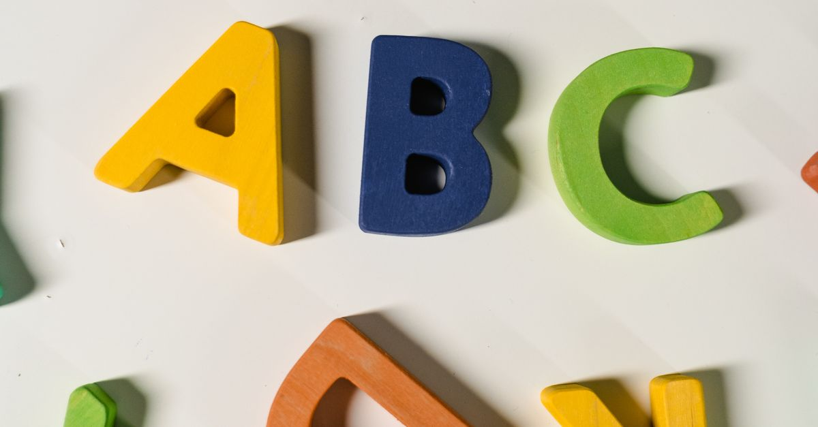
[INTRO - Sci-Fi Themed Music Plays]
[Visual: A futuristic cityscape with neon lights and flying vehicles. The camera zooms in on a holographic display of the AGWEP Alphabet.]
Narrator (V.O.):
Welcome, fellow explorers of the cosmos! Today, we embark on a journey through the AGWEP Alphabet, a unique script that transcends the boundaries of language and time. Prepare to unlock the secrets of communication in a universe where every letter holds the power of creation!
[CUT TO: A digital interface showcasing the AGWEP Alphabet.]
---
[SECTION 1: Introduction to AGWEP Alphabet]
Narrator (V.O.):
In the vast expanse of the multiverse, the AGWEP Alphabet stands as a beacon of innovation. This script is not just a collection of characters; it is a gateway to understanding the intricate tapestry of existence.
[Visual: Animated letters forming words and symbols, glowing with energy.]
Narrator (V.O.):
The AGWEP Alphabet consists of two distinct scripts: the Strong Script and the Small Script. Each character is imbued with meaning, resonating with the frequencies of the universe.
---
[SECTION 2: Strong Script]
[Visual: Each letter of the Strong Script appears one by one, with a brief description of its significance.]
Narrator (V.O.):
Let’s begin with the Strong Script. Here are the characters that form the backbone of AGWEP:
[Visual: The letters appear in a bold, glowing font.]
- A B C D E F G H I Ⅎ K L M N O P Q R S T U V W X Y Z Ǝ Ʌ Ө Ð Ŧ Ⴈ Ԉ И Ŋ Ƨ Ƶ Æ Ͻ П 𐐅 Ⳙ Ⱗ Ꝏ Ѥ Ꞇ Ø Є Э Ш Ѧ
Narrator (V.O.):
Each letter is a symbol of power, representing concepts that range from the fundamental forces of nature to the very essence of life itself.
[Visual: A cosmic backdrop with each letter illuminating the night sky.]
---
[SECTION 3: Small Script]
[Visual: Transition to the Small Script, with letters appearing in a softer, more fluid style.]
Narrator (V.O.):
Now, let’s explore the Small Script, a delicate counterpart to the Strong Script. Here are its characters:
[Visual: The letters appear in a flowing, ethereal font.]
- a b c d e f g h i ⅎ k l m n o p q r s t u v w x y z ǝ ʌ ө ð ŧ ⴈ ԉ и ŋ ƨ ƶ æ ͻ п 𐐭 ⳙ ⱗ ꝏ ѥ ꞇ ø є э ш ѧ
Narrator (V.O.):
This script embodies the subtleties of communication, allowing for nuanced expression in the realms of thought and emotion.
---
[SECTION 4: Pronunciation]
[Visual: A holographic display of the pronunciation guide, with animated characters speaking the sounds.]
Narrator (V.O.):
But how do we bring these letters to life? Through pronunciation! The AGWEP Alphabet is spoken with a rhythm that echoes through the stars:
[Visual: Each sound is accompanied by an animation of characters forming words.]
- ए बी सी डी ई एफ जी एच आय जे के एल एम एन ओ पी क्यू आर एस टी यू व्ही डब्ल्यू एक्स वाय झेड ऐ औ यूटा डीटा टीटा एल्फा एन्फा एन्स एन्ज एस्फा झेस्फा ॲ ऑ ॲय ऑय ऑव डब्ली डब्लो केच सेच फाय इक्वल डीव उइ एम्न
Narrator (V.O.):
Feel the energy as you pronounce each letter, connecting with the very fabric of the universe!
---
[SECTION 5: The Power of AGWEP]
[Visual: Scenes of intergalactic communication, beings from different worlds using the AGWEP Alphabet.]
Narrator (V.O.):
The AGWEP Alphabet is more than just a tool for communication; it is a bridge between worlds. Imagine beings from distant galaxies sharing knowledge, emotions, and stories through this powerful script.
[Visual: A montage of diverse alien species interacting, using the AGWEP Alphabet in various forms.]
Narrator (V.O.):
In a universe filled with diversity, the AGWEP Alphabet unites us all, reminding us that language is not just a means of communication, but a shared experience that transcends the stars.
---
[CONCLUSION]
[Visual: The camera pans out to the cosmic landscape, with the AGWEP Alphabet glowing brightly.]
Narrator (V.O.):
So, fellow travelers, as we conclude our journey through the AGWEP Alphabet, remember that every letter, every sound, and every word holds the potential to shape our reality.
[Visual: The screen fades to black with the text “Unlock the Universe with AGWEP.”]
Narrator (V.O.):
Join us next time as we delve deeper into the mysteries of the cosmos. Until then, keep exploring, keep questioning, and may the AGWEP Alphabet guide your way!
[OUTRO - Sci-Fi Themed Music Fades Out]
[Visual: Subscribe and Like buttons appear on the screen.]

