A Smart Collaborative Learning Platform Using NLP, Deep Learning Models, and Recommendation Algorithms for Automated Content Generation

Rhonnel S. Paculanan¹  Rhonnel.paculanan@arellano.edu.ph | Francis Arlando L. Atienza²  flatienza@udm.edu.ph | Jesus G. Calma Jr.³  calmajrjesus@gmail.com
Rejan L. Tadeo⁴  rltadeo@udm.edu.ph | Christina P. Atal⁵  cpatal@udm.edu.ph | Joy N. Sadol⁶  jnsadol@udm.edu.ph

Arellano University¹ , Universidad de Manila^{2,3,4,5,6}

Abstract
This study presents the development of a smart collaborative learning platform that integrates Natural Language Processing (NLP), deep learning models, and recommendation algorithms to enhance modern digital education by enabling automated content generation and interactive learning experiences. It aims to address the limitations of traditional learning management systems by providing AI-generated quizzes, flashcards, and personalized study recommendations while promoting real-time collaboration and engagement among learners. The research employed a developmental and descriptive design, utilizing the Agile software development methodology to systematically plan, design, develop, test, deploy, and refine the system through iterative feedback and continuous improvement. Data were gathered from 450 respondents, including students, educators, IT professionals, and institutional representatives, using an ISO 25010-based evaluation instrument that measured system quality in terms of functionality, performance efficiency, usability, reliability, and portability. Statistical tools such as frequency, percentage, mean, standard deviation, and t-test were applied to analyze user responses and determine the effectiveness of the platform in improving engagement, interaction, and learning experience. The results and discussion revealed that the system successfully transformed uploaded learning materials into structured outputs such as study notes, flashcards, and quizzes, demonstrating the effectiveness of AI technologies in supporting both individual and collaborative learning environments. Findings showed a high level of user satisfaction, with an overall mean score of 3.88 interpreted as “Agree,” and usability receiving the highest rating, indicating that the platform is user-friendly, efficient, and reliable across different user groups. In conclusion, the study confirms that the AI-powered collaborative learning platform significantly enhances learning experiences and meets established software quality standards, and it is recommended that future work focus on improving AI capabilities, expanding system scalability, integrating with existing platforms, and conducting long-term evaluations to further validate its educational impact.
Keywords: Natural Language Processing (NLP), Collaborative Learning Platform, Automated Content Generation, Deep Learning Models

Introduction
Learning in the 21st century has evolved significantly due to the integration of digital technologies and online platforms that enhance access to educational resources. Learning platforms, commonly referred to as Learning Management Systems (LMS), provide structured environments where students can access materials, collaborate, and track their progress efficiently. According to Anderson (2020), digital learning environments promote flexibility and self-paced education, allowing learners to engage with content anytime and anywhere. Additionally, collaborative learning platforms encourage peer interaction, which has been proven to improve critical thinking and knowledge retention (Johnson & Johnson, 2019). The emergence of intelligent systems has further transformed these platforms by enabling adaptive learning experiences tailored to individual needs (Holmes et al., 2021). As a result, modern learning platforms are no longer limited to content delivery but now support interactive, personalized, and collaborative educational experiences.
Natural Language Processing (NLP), deep learning models, and recommender systems play a crucial role in enhancing intelligent educational platforms. NLP enables systems to understand, interpret, and generate human language, making it possible to extract meaningful information from textual data (Jurafsky & Martin, 2021). Deep learning models, particularly neural networks, enhance this capability by learning complex patterns and generating context-aware outputs (Goodfellow et al., 2016). Meanwhile, recommender systems analyze user behavior and preferences to provide personalized learning suggestions, improving engagement and learning efficiency (Ricci et al., 2015). Studies have shown that integrating these technologies can significantly enhance user experience by delivering relevant content and adaptive learning paths (Zhai et al., 2023). Together, these technologies form the backbone of intelligent systems that support automated and personalized learning processes.
Automated content generation refers to the use of artificial intelligence to create educational materials such as quizzes, summaries, and flashcards without manual intervention. This approach leverages NLP and generative AI models to transform raw input data into structured learning content (Brown et al., 2020). According to recent studies, automated content generation improves learning efficiency by reducing the time required to create study materials (Wei et al., 2025). It also supports active learning by providing instant practice questions and feedback. As a result, automated content generation has become a key feature in modern intelligent learning systems.
The primary goal of this study was to develop a smart collaborative learning platform that integrated NLP, deep learning models, and recommendation algorithms to support automated content generation and real-time interaction. The system aimed to enhance both individual and group learning experiences by providing AI-generated quizzes, flashcards, and personalized study recommendations. It also sought to promote collaborative learning through multiplayer features that allowed users to engage in shared study sessions. By combining intelligent automation with social interaction, the platform addressed the limitations of existing learning systems that focused mainly on individual learning (Holmes et al., 2021). Ultimately, the system aspired to create an adaptive, engaging, and efficient learning environment for modern learners.

Scope: This study focused on the design and development of a smart collaborative learning platform that integrated NLP, deep learning models, and recommendation algorithms for automated content generation. It included features such as AI-generated quizzes and flashcards, real-time multiplayer collaboration, and gamification elements to enhance user engagement. The system was evaluated based on usability, functionality, and performance to determine its effectiveness in supporting collaborative learning.

Limitations: The study was limited to a specific group of users and did not involve large-scale deployment or integration with existing learning management systems. The AI capabilities were confined to content generation and basic personalization, excluding advanced tasks such as deep semantic analysis or automated essay grading. Additionally, the research did not cover long-term learning outcomes, scalability, or commercial implementation of the system.
Theoretical Framework: The theoretical foundation of this study is based on the integration of NLP, deep learning, and recommender systems in automated content generation. NLP theory explains how machines process and understand human language, enabling systems to extract and generate meaningful educational content (Jurafsky & Martin, 2021). Deep learning theory, particularly neural network models, supports the system’s ability to learn patterns and produce accurate and context-aware outputs (Goodfellow et al., 2016). Recommender system theory contributes by personalizing content delivery based on user preferences and behavior (Ricci et al., 2015). Constructivist learning theory also underpins the system by emphasizing active participation and knowledge construction through collaboration (Vygotsky, 1978). Additionally, collaborative learning theory highlights the importance of peer interaction in improving understanding and engagement. These theories collectively support the development of an intelligent system that enhances both automated and collaborative learning experiences.
Conceptual Framework : The conceptual framework of the study is based on the Input–Process–Output (IPO) model with a feedback mechanism, which illustrates how the system transforms resources into an intelligent collaborative learning platform.
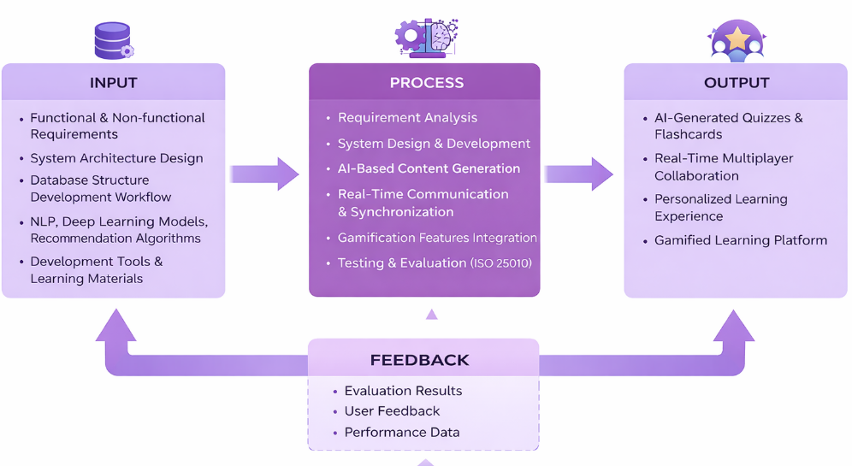
Figure 1: Conceptual Framework (IPO) of A Smart Collaborative Learning Platform Using NLP, Deep Learning Models, and Recommendation Algorithms for Automated Content Generation
- Input : The input stage includes all necessary resources such as functional and non-functional requirements, system architecture, database design, and development workflow. It also incorporates key technologies like NLP, deep learning, recommendation algorithms, software tools, hardware, and user-provided learning materials.
- Process :The process involves requirements analysis, system design, and development of AI-based content generation features such as quizzes and flashcards. It also integrates real-time communication, gamification elements, and concludes with testing and evaluation based on ISO 25010 standards.
- Output :The output is a Smart Collaborative Learning Platform (MindLobby) that offers AI-generated quizzes, flashcards, and real-time multiplayer collaboration. It also provides personalized learning, gamification features, and interactive tools to enhance engagement and knowledge retention.
- Feedback: The feedback stage collects user input, system performance data, and evaluation results to assess system effectiveness. This information is used to continuously improve system features, optimize performance, and enhance user experience.
Significance of the Study: This study is significant to several groups. For students, it provides an innovative platform that enhances both individual and collaborative learning experiences through AI-powered tools. For educators, it offers a supplementary system that can support teaching strategies by providing automated study materials and interactive learning environments. For researchers, the study contributes to the growing field of AI in education by exploring the integration of NLP, deep learning, and recommender systems in collaborative learning. For developers, it serves as a reference for designing intelligent and scalable educational platforms. Lastly, for institutions, it presents a potential solution for improving student engagement and learning outcomes through modern technology.

Hypothesis of the Study: (1) Null Hypothesis (H₀): There is no significant effect of the AI-powered collaborative learning platform on students’ engagement, interaction, and learning experience. (2) Alternative Hypothesis (H₁): The AI-powered collaborative learning platform significantly improves students’ engagement, interaction, and learning experience through automated content generation and real-time collaboration.

Synthesis of the Study. The reviewed studies highlight that artificial intelligence, particularly NLP, deep learning, and recommender systems, significantly enhances personalized and adaptive learning experiences. However, most existing platforms focus on individual learning and lack features that support real-time collaboration and group engagement. Therefore, this study integrates automated content generation with collaborative and gamified learning to address these gaps and improve both interaction and learning outcomes.
Research Type: This study utilized a developmental and descriptive research design to create and evaluate the proposed system. The developmental approach focused on designing and implementing the AI-powered collaborative learning platform, while the descriptive aspect assessed its performance and usability. This combination allowed the researchers to both build the system and examine its effectiveness in a real-world learning context.
A research instrument: Before the system was developed, baseline data were gathered from respondents using existing study methods to establish a point of comparison for evaluating the effectiveness of the proposed platform. After the system was developed, respondents evaluated it using the ISO 25010-based instrument focusing on functionality, performance efficiency, usability, reliability, and portability. The results were analyzed to determine improvements in system quality, user experience, and collaborative learning effectiveness compared to the initial baseline.
Software Development Process. The development of the Smart Collaborative Learning Platform used the Agile software development methodology. These are the stages of the Agile for the system development (1) Plan:
The development team identified the system requirements, objectives, and key features needed for the Smart Collaborative Learning Platform. (2) Design: The team created the system architecture, database structure, and user interface design to support the platform’s functionalities. (3) Develop: The developers implemented the system modules and integrated technologies such as NLP, deep learning, and recommendation algorithms. (4) Test: The team tested the system to detect errors and ensure that all features worked correctly and efficiently. (5) Deploy: The completed system was launched and made accessible for registered users, guests, and administrators. (6) Review: The development team evaluated system performance and gathered user feedback to improve future versions of the platform.

Context Diagram (DFD): The context diagram illustrated the overall system as a single process, showing how external entities interact with the system through inputs and outputs.
- Database (Entity Relationship Diagram): The Entity Relationship Diagram defined the structure of the database by illustrating entities, attributes, and relationships to ensure efficient data organization and retrieval.
- Use Case Diagram: The Use Case Diagram depicted the interactions between users and the system, identifying key functionalities and user roles within the platform.
- Development Tools (Python, Flask-SocketIO, GPT via OpenRouter API, Database Query): These tools were used to develop the system by enabling backend processing, real-time communication, AI-powered content generation, and efficient data management.

Evaluation Process (ISO 25010): The system was evaluated using ISO 25010 standards to measure its quality in terms of functionality, performance efficiency, usability, reliability, and portability.
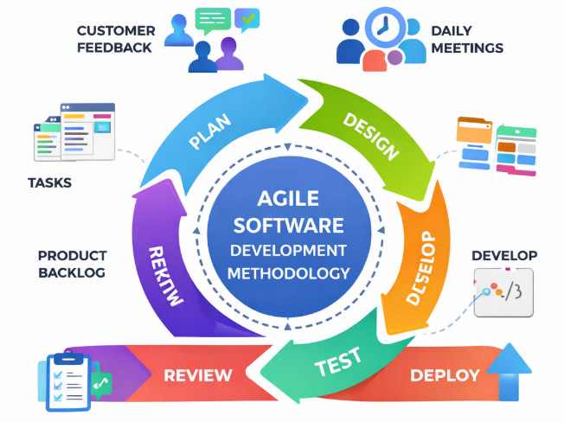  Figure 2: Agile Software Development Process of the system.  The diagram illustrated the Agile Software Development Methodology, where the system was developed through iterative stages including planning, designing, developing, testing, deploying, and reviewing while continuously incorporating feedback and improvements. | 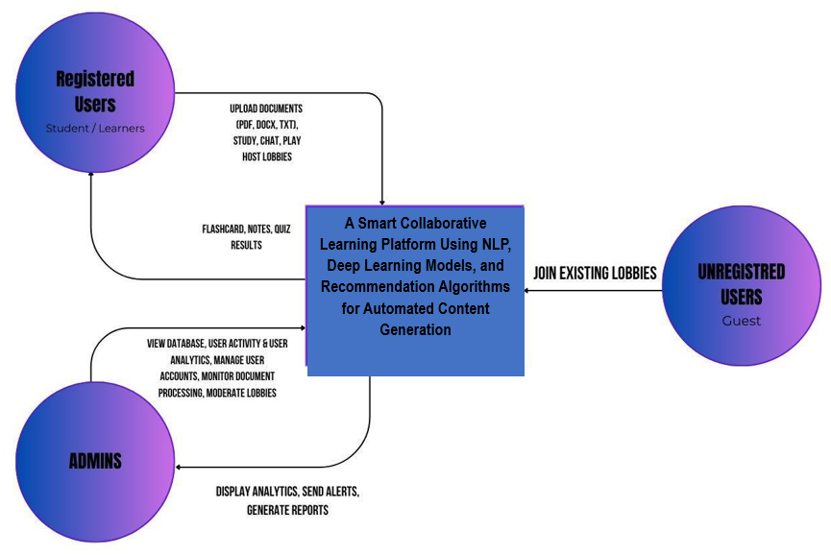  Figure 3: Dataflow Diagram of the system (Context Diagram)  This diagram illustrates a smart collaborative learning platform where registered users can upload and interact with content, unregistered users can join lobbies, and admins manage data, monitor activity, and generate analytics, all powered by NLP, deep learning, and recommendation algorithms.

Table 1: Statistical Tool used for the system
Statistical Tool | Purpose | Application in the Study
Frequency and Percentage | To describe the distribution of respondents’ answers | Used to summarize students’ responses regarding engagement, interaction, and learning experience.
Mean / Weighted Mean | To determine the average rating of responses | Used to measure the overall perception of students toward the AI-powered collaborative learning platform using a Likert scale.
Standard Deviation | To determine the variability of responses | Used to analyze how consistent or varied the students’ responses were.
t-test (Inferential Statistics) | To determine if there was a significant effect | Used to test the hypothesis and determine whether the AI-powered collaborative learning platform significantly improved students’ engagement, interaction, and learning experience at a 0.05 level of significance.

The system’s statistical treatment utilized frequency and percentage to summarize respondent data, mean/weighted mean to determine average responses, and standard deviation to measure the variability of the data. Additionally, t-tests were applied as inferential statistics to examine significant differences between groups or responses within the study.
Result and Discussion: The development of the Smart Collaborative Learning Platform followed the Agile methodology, progressing through planning, design, development, testing, deployment, and review stages to implement system features, integrate AI technologies, ensure functionality, and gather user feedback for continuous improvement. Context Diagram (DFD): The context diagram illustrated the system as a single process, showing how external entities interact through inputs and outputs. Database (ERD): The Entity Relationship Diagram defined the database structure by mapping entities, attributes, and relationships for efficient data management. Use Case Diagram: The Use Case Diagram depicted user interactions, key functionalities, and roles within the platform. Development Tools: Tools like Python, Flask-SocketIO, GPT via OpenRouter API, and database queries enabled backend processing, real-time communication, AI content generation, and data management.
The developed system, A Smart Collaborative Learning Platform Using NLP, Deep Learning Models, and Recommendation Algorithms for Automated Content Generation, successfully provided an interactive environment for students, guests, and administrators. The platform allowed registered users (students/learners) to upload learning materials such as PDF, DOCX, TXT, and study files, which were automatically processed by the system to generate flashcards, notes, and quiz results. This feature demonstrated the effectiveness of NLP and deep learning technologies in transforming uploaded documents into useful learning resources that supported student engagement and understanding.
The System:
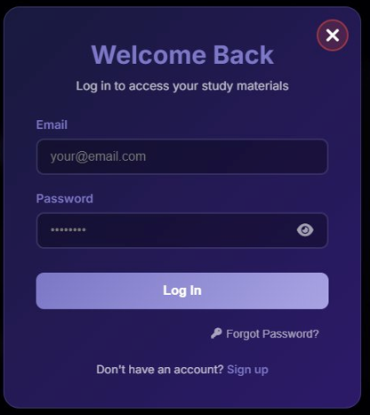 | 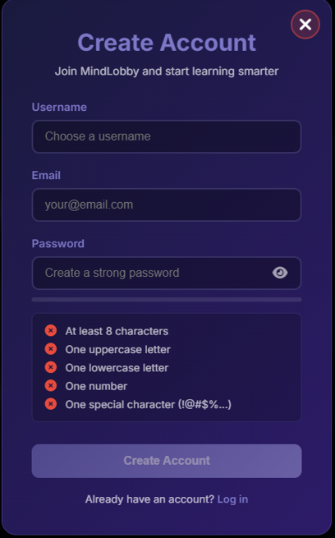 | 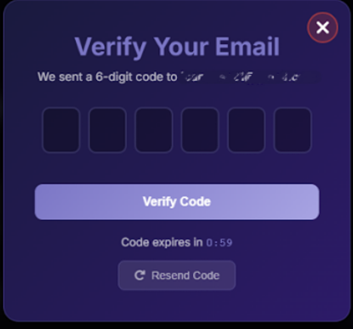 | 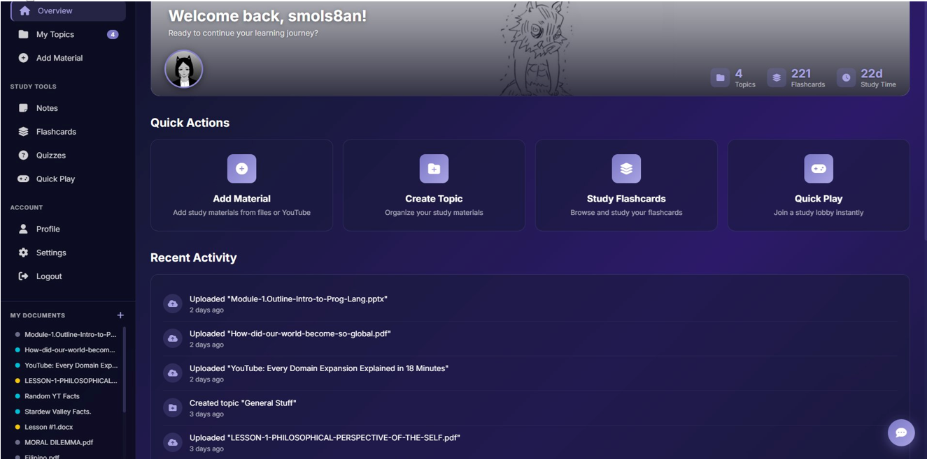
Figure 4: Login, Registration, OTP Email Verification And Studio Dashboard Of The System

The system included Login, Registration, and OTP Verification modules that allowed users to securely create and access their MindLobby accounts with email authentication and password validation features. After logging in, users accessed the Studio Dashboard, which served as the main hub for managing study materials, generating flashcards, tracking learning progress, and navigating features such as uploading materials, creating topics, studying flashcards, and joining quiz lobbies.

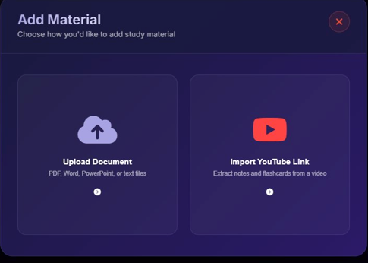 | 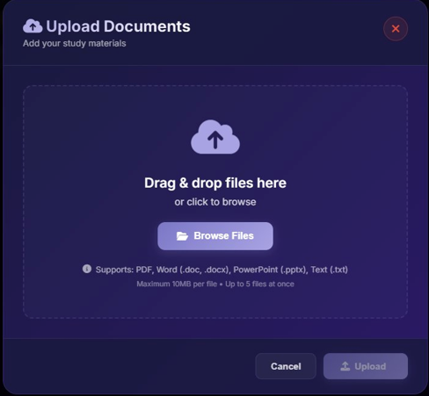 | 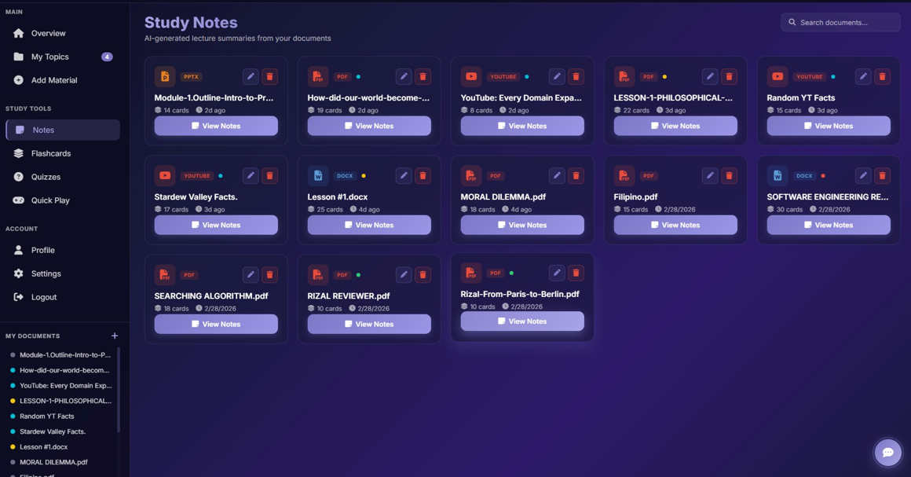
Figure 5: Add Material, Document Upload, Study Notes

The Add Material module allowed users to upload documents or import YouTube links, which were automatically processed by the system to generate AI-based flashcards and study notes. The Document Upload and Study Notes modules extracted text from uploaded files and displayed the AI-generated summaries in a structured format, while also providing options to study flashcards, start quizzes, download notes, or copy the content.

Figure 6: Add Material, Document Upload, Study Notes

The Add Material module allowed users to upload documents or import YouTube links, which were automatically processed by the system to generate AI-based flashcards and study notes. The Document Upload and Study Notes modules extracted text from uploaded files and displayed the AI-generated summaries in a structured format, while also providing options to study flashcards, start quizzes, download notes, or copy the content.

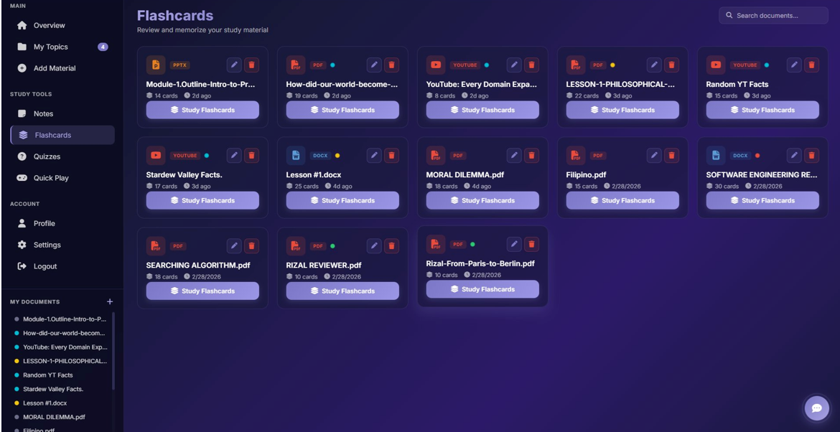 | 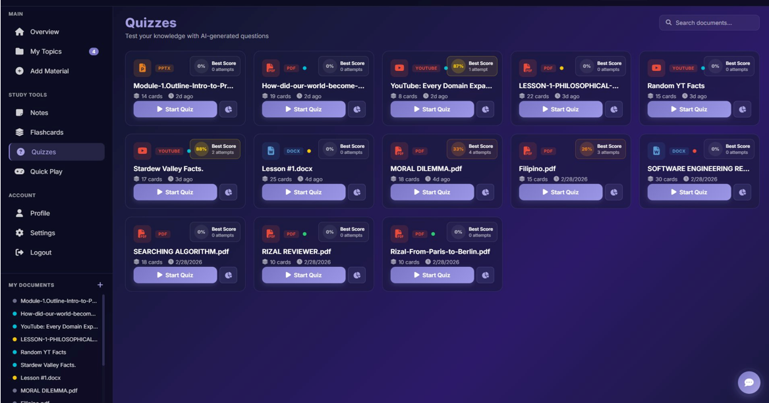
Figure 7: Flashcards, Quizzes

The Flashcards module organizes AI-generated question-and-answer pairs by document, allowing users to study one card at a time, track progress, flip cards for answers, and access features like shuffle, restart, study notes, and quizzes. The Quizzes module lets users test their knowledge with AI-generated multiple-choice questions, providing instant feedback, score tracking, and performance-based tier badges for each document.

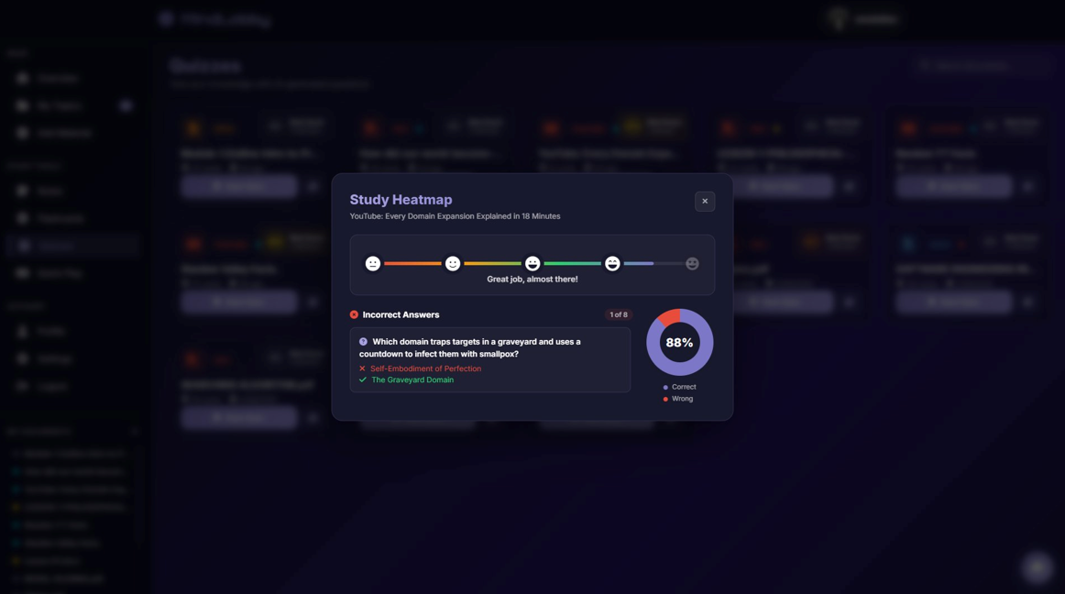 | 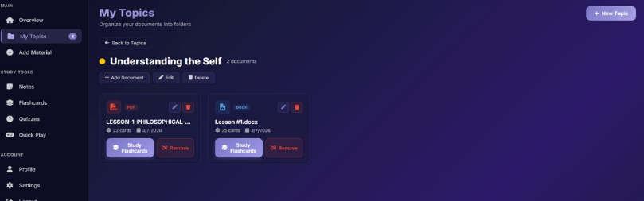  
Figure 8: My Topics, Study Heatmap

The Study Heatmap provides a visual overview of a user's quiz performance for a document, showing mastery levels with emoji markers, a correct-to-incorrect answer pie chart, and a detailed list of incorrect answers to highlight areas for review. The My Topics module helps users organize documents into color-coded folders, allowing creation, editing, and management of topics, as well as studying flashcards and managing documents within each topic.

Table 2: Respondent of the study of the system
Participant Group | Number of Participants | Function / Benefit of the Platform
Students | 415 | Enhances individual and collaborative learning experiences through AI-powered tools, enabling personalized study and interactive group activities.
Educators | 25 | Supports teaching strategies by providing automated study materials, interactive exercises, and real-time progress monitoring.
IT Professionals | 9 | Provides insights and practical reference for implementing, maintaining, and scaling intelligent educational platforms with AI integration.
Institutions | 1 | Offers a potential solution for improving student engagement, learning outcomes, and adoption of modern educational technologies.

Out of a total of 450 respondents, the majority were students (415), followed by educators (25), IT professionals (9), and institutions (1). This distribution highlights that the platform primarily serves students while also providing valuable support and insights for educators, IT professionals, and institutional stakeholders.

Table 3: Result and Discussion of ISO 25010 Software Quality Evaluation
ISO 25010 Criteria | Educators (25) | Students (415) | IT Professionals (9) | Institutions (1) | Overall Mean | Standard Deviation | Verbal Interpretation
1. Functionality | 3.92 | 3.88 | 3.85 | 4.00 | 3.91 | 0.41 | Strongly Agree
2. Performance Efficiency | 3.85 | 3.80 | 3.78 | 3.90 | 3.83 | 0.45 | Agree
3. Usability | 3.95 | 3.90 | 3.88 | 4.00 | 3.93 | 0.39 | Strongly Agree
4. Reliability | 3.87 | 3.82 | 3.80 | 3.90 | 3.85 | 0.43 | Agree
5. Portability | 3.88 | 3.84 | 3.82 | 3.95 | 3.87 | 0.42 | Agree
Overall Mean | 3.89 | 3.85 | 3.83 | 3.95 | 3.88 | 0.42 | Agree

The ISO 25010 Software Quality Evaluation of the system as assessed by educators, students, IT professionals, and institutions. The results indicate that the system achieved a high level of quality across all five ISO 25010 criteria, with an overall mean of 3.88, interpreted as Agree, showing that respondents generally perceived the system to be effective and reliable. Among the criteria, Usability obtained the highest overall mean of 3.93, verbally interpreted as Strongly Agree, suggesting that users found the system easy to use and user-friendly. Meanwhile, Performance Efficiency, Reliability, and Portability received overall means within the Agree range, indicating consistent and acceptable system performance across different user groups. Furthermore, the standard deviation values ranging from 0.39 to 0.45 demonstrate low variability in responses, implying that respondents had relatively consistent perceptions regarding the system’s quality. Overall, the findings confirm that the system meets the required ISO 25010 quality standards and is suitable for its intended users and operational environment.

Summary of Findings
The study developed a smart collaborative learning platform integrating NLP, deep learning, and recommendation algorithms to automate content generation and enhance learning experiences. The system successfully generated quizzes, flashcards, and study notes from uploaded materials, supporting both individual and group learning.
Evaluation using ISO 25010 standards showed that the platform performed well across all quality criteria, with an overall mean score of 3.88 (Agree), indicating high user satisfaction. Usability received the highest rating, meaning users found the system easy to use, while functionality, performance efficiency, reliability, and portability were also rated positively.
The respondents (mostly students) confirmed that the platform improved engagement, interaction, and learning efficiency. The integration of AI technologies effectively transformed learning materials into interactive and personalized content.

Conclusion
The study concludes that the AI-powered collaborative learning platform is effective in enhancing students’ learning experiences through automated content generation and real-time collaboration. It successfully addressed limitations of traditional learning systems by combining personalization, interactivity, and collaboration in a single platform.
The results support the alternative hypothesis, indicating that the system significantly improves student engagement, interaction, and overall learning experience. Additionally, the platform meets software quality standards and is suitable for educational use.

Recommendations
Based on the findings, the study recommends the following:
- System Enhancement
Improve AI capabilities by incorporating advanced features such as deeper semantic analysis, essay grading, and more accurate content generation.
- Scalability and Integration
Expand the system for large-scale deployment and integrate it with existing Learning Management Systems (LMS) to reach more users.
- Long-Term Evaluation
Conduct further studies to assess long-term learning outcomes and the sustained impact on student performance.
- Feature Expansion
Add more collaborative tools, gamification elements, and adaptive learning features to further enhance engagement.
- User Training and Adoption
Provide training for educators and students to maximize the platform’s potential and encourage wider adoption.
References
- Anderson, T. (2020). The theory and practice of online learning. AU Press.
- Brown, T. B., et al. (2020). Language models are few-shot learners. NeurIPS.
- Goodfellow, I., Bengio, Y., & Courville, A. (2016). Deep learning. MIT Press.
- Holmes, W., Bialik, M., & Fadel, C. (2021). Artificial intelligence in education. Center for Curriculum Redesign.
- Johnson, D. W., & Johnson, R. T. (2019). Cooperative learning.
- Jurafsky, D., & Martin, J. (2021). Speech and language processing.
- Pressman, R. (2020). Software engineering: A practitioner’s approach.
- Ricci, F., Rokach, L., & Shapira, B. (2015). Recommender systems handbook.
- Vygotsky, L. S. (1978). Mind in society. Harvard University Press.
- Wei, X., et al. (2025). Generative AI in collaborative learning.
- Zhai, X., et al. (2023). Artificial intelligence in education: A review.

