Investigation of the Effect of Stearate Additive on Process and Optical Properties in High-Filled PE-Based Masterbatch Production via Extrusion Process

Kutay Baycu¹, Can Gönenli^{2*}

¹Ege University, Graduate School of Natural and Applied Science
²Ege University, Department of Mechanical and Metal Technologies

ABSTRACT

In this study, high-filled polyethylene (PE)-based masterbatch formulations containing inorganic calcium carbonate (CaCO₃) at concentrations ranging from 72 to 81 wt.% were manufactured using an industrial-scale twin-screw extruder. To mitigate the rheological challenges associated with high filler loadings, specifically increased melt viscosity and particle agglomeration, a hybrid interfacial modifier system comprising calcium and zinc stearate was incorporated into the compounding process. This additive system was maintained at a fixed concentration of 1.2 wt.% to systematically evaluate its influence on both extrusion process stability and the optical characteristics of the final composite material.

Rheological monitoring indicated that the incorporation of the stearate hybrid measurably enhanced process continuity. At the critical maximum filler loading of 81 wt.%, extruder torque fluctuations were quantitatively reduced from an initial ±8% to ±3%. This reduction correlates with decreased internal friction between the hydrophilic CaCO₃ particles and the hydrophobic PE matrix, yielding a more stable melt flow and reducing mechanical stress on the extruder.

Furthermore, spectrophotometric evaluations in the CIELAB color space confirmed that the stearate addition directly influenced the optical properties of the masterbatches. The additive facilitated uniform filler dispersion, which minimized light-scattering defects and agglomeration-induced surface irregularities, resulting in a measurable increase in lightness (L*) values. These findings indicate that the integration of a stearate-based modifier system functions as an operational requirement for maintaining processing stability and achieving necessary dispersion levels in industrial-scale high-filled polymeric compounding.

Keywords: Polyethylene; Calcium Carbonate; Filled Masterbatch; Stearate; Extrusion

INTRODUCTION

Polyethylene (PE) is a widely used thermoplastic in the plastics industry due to its semi-crystalline structure, chemical resistance, low cost, and processability (Brydson, 1999; Fried, 2014; Gahleitner and Grein, 2014). In sectors such as packaging, automotive, construction, and agriculture, PE is used in various densities and molecular configurations. Neat PE often lacks the required mechanical properties or economic feasibility for certain applications when used alone. Consequently, the incorporation of fillers and additives into the polymer matrix is a standard practice to modify material properties (Paul and Bucknall, 2000). This principle of optimizing mechanical and structural performance through compositional adjustments is a standard approach in materials engineering, applicable to both polymer matrices and metallic alloys (Gönenli and Duymazlar, 2024).

Among inorganic fillers, calcium carbonate (CaCO₃) is used in PE-based composites due to its low cost, availability, and compatibility with polyolefin systems (Rothon, 2003; Xanthos, 2010). The addition of CaCO₃ improves characteristics such as stiffness and dimensional stability. Increasing the filler loading raises melt viscosity, which causes processing challenges, including flow problems, increased energy consumption, and reduced process stability during extrusion (Hoffmann and Grellmann, 2005; Rauwendaal, 2014).

In the production of high-filled masterbatches, metal stearates are used to address these processing difficulties. Additives such as calcium and zinc stearate function as internal lubricants, reducing friction between polymer chains and aiding the dispersion of inorganic particles within the polymer matrix (Pritchard, 1998). Literature indicates that these modifiers affect both the rheological behavior and the optical properties of the composite. Variations in color parameters and yellowing tendencies depend on the quality of filler dispersion (Saeed et al., 2016; Khan and Ahmad, 2011; Li et al., 2021; Ahmed and Jones, 2022; Kim and Park, 2023). These optical properties are evaluated using CIELAB L*, a*, b* parameters and yellowness index measurements according to established standards (ASTM E308-18; ASTM D1925-70).

While many studies are conducted under laboratory conditions, research evaluating both processing behavior and optical performance in industrial-scale, high-filled PE masterbatch systems is limited. Data-driven industrial studies provide information for assessing process performance in applied manufacturing (Ergün and Üçgül, 2025; Dursun, 2025).

This study investigates the effects of stearate additives on the processing behavior and optical properties of PE-based masterbatches containing 72–81 wt.% CaCO₃ using an industrial-scale twin-screw extruder. This concentration range reflects the technical specifications for high-filled masterbatch products used in industrial let-down operations. Formulations with and without stearates were compared under identical processing parameters. Production efficiency was evaluated based on mass throughput per unit time, and optical performance was measured using L*, a*, and b* color parameters. The materials and methods are presented, followed by the findings and conclusions.

MATERIALS AND METHODS

In this study, the production of high-filled polyethylene (PE)-based masterbatches was conducted using an industrial-scale twin-screw extruder. The raw materials were specified, and formulations with varying CaCO₃ ratios, both with and without stearate, were designed. Experimental production runs were executed to reflect actual manufacturing conditions.

Materials and Formulation Preparation

Commercial-grade polyethylene was used as the carrier polymer. Industrial-purity calcium carbonate (CaCO₃) was selected as the filler, with loading levels varying between 72 and 81 wt.%. A hybrid mixture of calcium stearate (AKSAB CA-3) and zinc stearate (AKSAB ZN-53) was utilized as the additive due to its synergistic effects in industrial formulations. For all stearate-containing formulations produced in this study, the stearate mixture was incorporated at a fixed concentration of 1.2 wt.% based on the total formulation weight. Rather than evaluating the individual effects of specific stearates, this study analyzed the cumulative processing impact of the presence (with stearate) versus the absence (without stearate) of this hybrid additive package at high filler concentrations. Prior to production, all raw materials were weighed to prepare the formulations and organized appropriately for the feeding system.

Production Process and Experimental Setup

Masterbatch production was performed using an industrial-scale twin-screw extruder. The general workflow of the production process is schematically illustrated in Figure 1. Raw materials were introduced through the feeding unit, and after obtaining a homogeneous structure in the melting and mixing zones, the product was discharged in granular form.

The extruder temperature profile and screw speed were kept constant throughout all experiments. Melt pressure, motor load, and feed rate were monitored and recorded during production. To observe potential process fluctuations caused by the high CaCO₃ content, the production runs were sustained continuously for defined periods.

Figure 1. Schematic of the industrial-scale twin-screw extruder used in masterbatch production
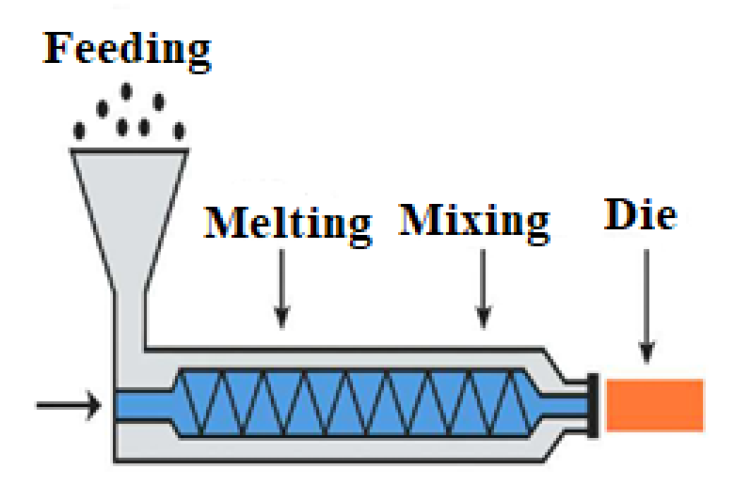

Experimental Workflow and Sampling

The experimental steps followed in this study are presented in Figure 2. The experimental process consists of formulation preparation, extrusion, sampling, and measurement stages. For each formulation, samples were collected at specific time intervals during the production process, and analyses were conducted on these samples. Sampling was performed under steady-state production conditions; transitional regimes were excluded from the evaluation.

Figure 2. Experimental flowchart for the production of high-filled PE-based masterbatches
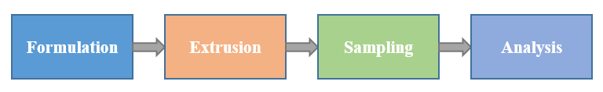

Color Measurements and Data Analysis

The color properties of the produced masterbatch samples were determined using CIE L*, a*, and b* parameters (ASTM E308-18). The yellowing tendency was evaluated based on the b* parameter in accordance with the relevant standard (ASTM D1925-70). Measurements were performed in three consecutive replicates for each formulation. Mean values and standard deviations were calculated for the obtained data. Variations in color parameters were analyzed comparatively concerning the CaCO₃ loading ratio and the presence of the stearate additive.

RESULTS

In this section, the processing behavior and color parameters of high-filled PE-based masterbatch systems, alongside the effects of stearate additive presence (with/without stearate) on these properties, are evaluated. The findings are analyzed based on data acquired under industrial-scale production conditions and discussed comparatively with the existing literature.

Production Behavior and Process Efficiency

The production process of high-filled PE-based masterbatch systems varies significantly depending on the filler content. This study evaluated the effect of stearate addition on process efficiency in formulations with CaCO₃ contents ranging from 72 to 81 wt.%. Production quantities per unit time are presented in Figure 3. The data in Figure 3 represent the average mass throughput recorded over 10-minute intervals under steady-state conditions. As the CaCO₃ ratio increased, production behavior became more sensitive, leading to process-induced fluctuations. In systems incorporating stearate, torque and current values were more stable, and the mass throughput at certain filler loadings was higher compared to stearate-free systems. This is attributed to the internal lubricating effect of stearate, which facilitates melt flow and reduces friction at the filler-polymer interface. Detailed analysis of the process data reveals that at the critical filler loading of 81 wt.%, extruder torque fluctuations reached ±8% in stearate-free systems. In stearate-containing systems, this fluctuation decreased to ±3%. These quantitative data demonstrate that stearate stabilizes viscosity and increases process stability.

Figure 3. Mass throughput for stearate-containing and stearate-free systems at various CaCO₃ loadings
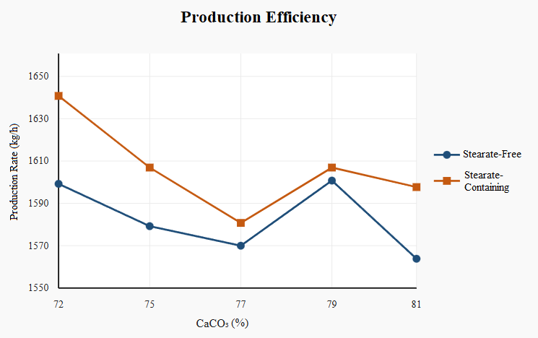

Effect of CaCO₃ Loading on Color Parameters

Increasing filler loading affects the optical properties of polymer-based systems. The variation of the L* parameter with respect to CaCO₃ content is presented in Figure 4. Variations in L* values occurred depending on the CaCO₃ ratio; at equivalent filler loadings, samples containing stearate generally exhibited higher L* values compared to stearate-free samples. This is attributed to the stearate additive improving filler dispersion and enhancing optical homogeneity. A distinct decrease in L* values was observed specifically at the 79 wt.% filler loading, which is associated with particle agglomeration and alterations in light-scattering behavior due to the high filler concentration.

Figure 4. Variation of the L* color parameter across different CaCO₃ loadings
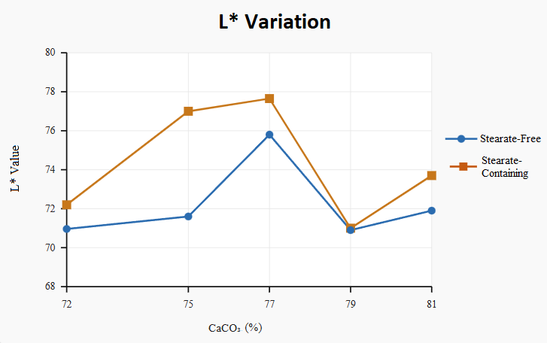

Effect of Stearate Additive on Color Stability

In high-filled PE-based masterbatch systems, color stability is influenced by additive utilization alongside filler loading. In this study, the effect of the stearate additive on color parameters was comparatively analyzed using L*, a*, and b* values; the results are presented in Table 1. The data in Table 1 comprise the means and standard deviations of three consecutive measurements conducted for each formulation. According to Table 1, a general increase in L* values was observed in the stearate-containing samples. For the a* parameter, a positive shift (toward red) was noted in the samples with stearate. The b* values exhibited varying behaviors depending on the filler loading; at certain concentrations, b* decreased in the stearate-containing systems, whereas limited variation was detected at other concentrations. These results indicate that the stearate additive affects optical parameters and that color stability must be evaluated in conjunction with the filler loading.

Table 1. Effect of stearate additive presence (with/without stearate) on color parameters (L*, a*, b*).
CaCO₃ (%) | Sample Type | L* | a* | b*
72 | Stearate-Containing | 72.20±0.05 | +0.86±0.02 | 2.62±0.03
72 | Stearate-Free | 70.96±0.08 | −1.71±0.04 | 2.56±0.05
75 | Stearate-Containing | 77.00±0.04 | +1.24±0.03 | 2.73±0.04
75 | Stearate-Free | 71.60±0.07 | −2.52±0.05 | 3.26±0.06
77 | Stearate-Containing | 77.65±0.03 | +1.17±0.02 | 0.55±0.01
77 | Stearate-Free | 75.80±0.06 | −2.90±0.04 | 4.39±0.07
79 | Stearate-Containing | 71.00±0.09 | +0.58±0.03 | −0.69±0.02
79 | Stearate-Free | 70.90±0.11 | −2.46±0.05 | +2.46±0.08
81 | Stearate-Containing | 73.70±0.06 | +0.84±0.04 | +1.30±0.03
81 | Stearate-Free | 71.90±0.09 | −2.11±0.06 | +2.41±0.07

CONCLUSIONS

In this study, the effects of stearate additive presence (with/without stearate) on the production behavior and optical properties of PE-based high-filled masterbatch systems containing 72–81 wt.% CaCO₃ were investigated using an industrial-scale twin-screw extruder. The results demonstrate that additive utilization in high-filled polymer systems significantly affects both process stability and product properties. The extreme filler loadings selected in this study represent commercial standards for cost optimization in industrial let-down operations.

Experimental findings indicate that as the CaCO₃ filler loading increases, the extrusion process becomes more sensitive, leading to fluctuations in process parameters. High filler content causes an increase in melt viscosity and strengthens filler-polymer interactions; this directly affects the flow behavior during production. Specifically, at an 81 wt.% filler loading, it was quantitatively proven that extruder torque fluctuations reached ±8% in stearate-free systems, whereas the application of stearate reduced this deviation to ±3%, thereby stabilizing the process.

Process performance was more balanced in systems utilizing the stearate additive. The reduction in friction between polymer chains and the improvement in melt flow, attributed to the internal lubricating effect of stearate, yielded an increase in mass throughput at certain filler loadings. Furthermore, torque and motor current values observed during production exhibited more stable trends. This confirms that the hybrid stearate system provides effective viscosity management even at high mineral concentrations.

Regarding optical properties, L* values were generally higher in stearate-containing samples, resulting in a brighter product appearance. This increase in the L* value is associated with the prevention of agglomeration and the achievement of a more homogeneous dispersion quality, facilitated by the surface modification induced by stearate on the filler particles. A positive shift tendency was observed in the a* parameter, while the b* values exhibited variable behaviors depending on the filler loading.

In conclusion, the incorporation of stearate additives in the production of high-filled PE-based masterbatches exerts positive effects on both process behavior and optical properties. The findings provide practical data for optimizing additive usage under industrial production conditions. Future studies investigating the effects of different additive types and hybrid filler systems on mechanical properties will contribute to a more comprehensive evaluation of these materials.

REFERENCES

- Ahmed, S. and Jones, F.R., 2022. Influence of filler dispersion on optical and processing behavior of highly filled polyethylene systems. Polymer Testing, 109, 107554.
- ASTM D1925-70, 2014. Standard Test Method for Yellowness Index of Plastics. ASTM International.
- ASTM E308-18, 2018. Standard Practice for Computing the Colors of Objects by Using the CIE System. ASTM International.
- Brydson, J.A., 1999. Plastics Materials. 7th Edition, Butterworth-Heinemann, Oxford.
- Dursun, A., 2025. Industrial scale analysis of polymer extrusion systems. Mühendislik Bilimleri ve Tasarım Dergisi.
- Ergün, E. ve Üçgül, İ., 2025. Industrial evaluation of polymer processing parameters in textile based polymer systems. Mühendislik Bilimleri ve Tasarım Dergisi.
- Fried, J.R., 2014. Polymer Science and Technology. 3rd Edition, Pearson Education, Upper Saddle River.
- Gahleitner, M. and Grein, C., 2014. Polyolefins—Structure, properties, and applications. Macromolecular Materials and Engineering, 299, 1-10.
- Gönenli, C. and Duymazlar, O., 2024. Investigation of tensile stress and percentage elongation relationships in alloys depending on the alloy elements. In: M. Bozdemir (Ed.), Makine Mühendisliği. YAZ Yayınları, Afyonkarahisar, pp. 116-133.
- Hoffmann, K. and Grellmann, W., 2005. Influence of fillers on processing and properties of thermoplastics. Polymer Testing, 24, 740-746.
- Khan, M.A. and Ahmad, S., 2011. Effect of calcium carbonate on mechanical and optical properties of polyethylene composites. Materials & Design, 32, 4215-4221.
- Kim, H.J. and Park, S.J., 2023. Processing and performance optimization of highly filled polyolefin compounds for industrial extrusion applications. Materials, 16, 4, 1528.
- Li, Y., Zhang, X., Wang, K. and Fu, Q., 2021. Effects of surface modification of calcium carbonate on rheological and mechanical properties of polyethylene composites. Polymers, 13, 9, 1452.
- Paul, D.R. and Bucknall, C.B., 2000. Polymer Blends. Wiley, New York.
- Pritchard, G., 1998. Plastics Additives: An A-Z Reference. Chapman & Hall, Dordrecht.
- Rauwendaal, C., 2014. Polymer Extrusion. 5th Edition, Hanser Publishers, Munich.
- Rothon, R.N., 2003. Particulate-Filled Polymer Composites. Smithers Rapra Press, Shawbury.
- Saeed, U., Nawaz, R. and Shahzad, A., 2016. Effect of fillers on rheological and optical properties of polymer composites. Composites Part B: Engineering, 99, 1-7.
- Xanthos, M., 2010. Functional Fillers for Plastics. Wiley-VCH, Weinheim.

