Effectiveness of Community-Based Development Programmes in Alleviating Poverty in Rural Community
Dr Ijeoma Blessing Unachukwu
Department of Economics Education
School of Arts and Social Sciences
Federal College of Education Technical, Umunze, Anambra State, Nigeria

Anukam Chidozirim Stephen
Department of Corporative and Rural Development
University of Agriculture and Environmental Sciences
Umuagwo, Imo State, Nigeria

ABSTRACT
This study empirically investigated the community development and poverty alleviation nexus in Awka South. A total of 120 questionnaires were administered to the residents of Awka South, out of these, 100 (about 83.3%) questionnaire were returned. The study adopted the descriptive statistic approach using tables, charts, frequencies, percentages et cetera to analyze the responses of the participants. In addition, one sample t-test is adopted in testing the hypotheses and cross tabulations are also used to examine the possible interaction between cases. The findings suggest that about 58% of the respondents are not aware of any poverty alleviation programme in their communities while about 42 of them claimed they are aware of such programmes. On whether a cooperative association exists in their locality, 53% of the respondents affirmed while 47% of them disagreed. Again, 60% of the respondents believe that poverty level in their community can be reduced through community development programmes while 40% think otherwise. On the factors that have influenced or impeded people’s participation in poverty alleviation programmes, lack of awareness ranks first (47%), followed by lack of transparency in the modus operandi of these programmes (21%), then illiteracy (19%) and bureaucratic bottleneck (13%) came third and forth. Two basic conclusions emerged from the findings of the study. First, poverty level can be reduced through community development programmes. Secondly, community development programmes have been hindered by some factors in Awka South. In line with the basic findings of this study, Government and/or NGOs should embark on aggressive community development programmes. Awareness campaign on the need to actively participate in poverty alleviation programmes should be carried out, especially in the rural areas.
Keywords: Community development, poverty alleviation, Awka South, Anambra State

1. INTRODUCTION
One of the broad objectives of the Millennium Development Goals (MDGs) is to reduce extreme poverty and hunger by half. Though Poverty is a global phenomenon, the level of the problem in developing countries, Nigeria inclusive, has reached alarming proportions. Globally, about 1.2 billion people are living in extreme poverty less than one dollar per day. Due to the high prevalence of poverty, reducing it has been a concern to many countries in the past few decades. Though, there have been a lot of improvements in the developed world, such cannot be said of developing ones especially in the Sub-Sahara Africa where poverty is prevalent due to many factors namely: poor governance and political instability, poor economic management, mismanagement of resources, poor programme implementation, corruption and lack of purposive leadership (Babatunde, Olorunsanya, & Adejola, 2008). The Nigerian case has been described as a paradox by the World Bank. This is because the poverty level contradicts the country’s immense wealth. Among other things, the country is enormously endowed with human, agricultural, petroleum, gas, and large untapped solid mineral resources. Rather than recording remarkable progress in socioeconomic development, Nigeria retrogressed to become one of the 25 poorest countries in the world (Ekpe, 2011). The 2010 poverty index indicated that 60.9% Nigerians now live in absolute poverty (Baba-Ahmed, 2012). Most of these poor people reside in the rural areas.
Official statistics show that in 1980 the national (average) poverty incidence was 28.1 per of the population. The distribution of the incidence across the states of the federation showed a maximum of 49.5 per cent recorded for Plateau (and Nassarawa which was excised from Plateau). This meant that every state had a poverty incidence below 50 per cent. By 1985, the national (average) poverty incidence had risen to 46.3 per cent, with the maximum of 68.9 per cent recorded in Bauchi (and Gombe which was carved out of Bauchi). As at 1996, the national average stood at 65.6 per cent with Sokoto, Kebbi and Zamfara (all old Sokoto State) recording the highest incidence of 83.6 per cent; followed by Bauchi and Gombe with 83.5 per cent. As at 2000, the incidence of poverty was believed to have risen to 70 per cent at the national level. According to CBN (2012) annual report, Nigeria's poverty profile deteriorated in 2012. Relative to the levels estimated in 2011, estimates for 2012 at relative, absolute and US dollar-per-day terms were put at 72.0, 62.0, and 63.0 percent respectively. The major efforts made in the pre-independence, according to Omale and Molem (2003), were in the area of farm settlement schemes. The aim was to bring scattered small communities together so that they could take advantage of economies of scale in farm inputs, agro-services, marketing, etc. These schemes recorded little or no success because those that were to be affected were not involved at the planning stages. Since then, a number of government programmes have been put in place to improve basic services, infrastructure and housing facilities for the rural population, extending access to credit, farm inputs and creating employment. Despite these poverty-related programmes and schemes in the country, the incidence of poverty has been increasing, both within and among locations, thus suggesting that the programmes and schemes have not been effective in mopping up poverty in Nigeria.
In an attempt to find a lasting solution to this perennial problem, every society strives to develop its infrastructure both human and material resources for the well being of its people just like the concept of industrialization, democracy and modernization. Different communities have been encouraged to engage in strategies which enable them to support their standards of living and also promote smooth social functioning within their communities. And there is now a general consensus that self-sustained community development is a vital factor for economic as well as social progress of any economy. In the light of the government’s deep concern for the widespread and scourging poverty in Nigeria, especially in the rural areas, this study therefore, investigate the impact of community development on poverty alleviation in Nigeria, using Awka South in Anambra State as a study area.
Problem Statement
Poverty has remained an endemic issue in Nigeria, especially in the rural areas. With the democratic government in 1999, measures were adopted to streamline poverty-related institutions, review past poverty alleviation programmes and harmonized sectorial effects at national level. From the review, major factors hindering the success of government efforts to reduce the level of Poverty were identified to include; poor coordination, absence of a comprehensive policy framework, excessive political interference, ineffective targeting of the poor, leading to leakage of benefits to unintended beneficiaries, overlapping functions, which led to institutional rivalry and conflicts among others. The need to find lasting solution to perennial problem of poverty in Nigeria culminated in the establishment of National Poverty Eradication Programme (NAPEP) in 2001. In spite of huge resources devoted to NAPEP, deterioration in fiscal discipline, corruption and poor implementation which undermined past efforts still make poverty eradication in Nigeria a mirage. Following the perceived ineffectiveness of some of the government’s anti-poverty programmes in tackling poverty, communities now engage in community development programmes aimed at eradicating poverty, especially in the rural areas, support their standards of living and also promote smooth social functioning within their communities. However, the effectiveness of community development programmes in reducing poverty has been an empirical question. Hence, this study is meant to assess the impact of community development project in eradicating poverty in Anambra state, using evidence from Awka South Local Government Area. To the best of the researcher’s knowledge, there is no known empirical study that have investigated the effectiveness of community development project in tackling poverty, especially in Awka South. This study is meant to fill part of this empirical gap.
Objective of the study
The main objective of this study is to assess the effectiveness of community-based development programmes in alleviating poverty in rural community. To achieve this objective, some specific objectives are set, thus:
1. To assess the nexus between community-based development programmes and poverty alleviation.
2. To investigate the factors that hinder effective community development programmes in Awka South.
3. To ascertain whether the impact of various government antipoverty programmes has been felt in the study area.

2 LITERATURE REVIEW
Concepts Clarification
Community is one of the important concepts which will be used extensively in this study. A community according to Gillies (1988) is “a group of people who have something In common. This can be a place where they live, their age their education, their religion, their interests, their political affiliations, their activities, their work, their problems or a combination of two or more of them”. The terminology Committee for Social Work in a working document by a Subcommittee Welfare Advisory Council for Black Communities in 1993, defines community as a “composition of people who live within a geographical bounded area, who are involved in social interaction and who have psychological ties with each other and with the place where they live”. In most of the definitions proffered, emphasis has been on interaction of the group of people in a geographic area. Ross (1955) considers community as a group of people who share some common interests or function, such as welfare, agriculture, education and religion. These Interests do not include everyone in the geographic community but only those individuals and groups who have a particular interest or function in common.
The term 'development' is a very broad term and a difficult one to conceptualize. Various types of development have been proposed by different authors. Some view development from the physical, social, moral, clinical, economic and social perspectives. Development as a human activity considered from a variety of perspectives and can be linked with three concepts. Firstly, development is as old as mankind and there is proof that successful development projects were undertaken in places like Ghana, long before there was any question of community development as taught in theory at present. Secondly, arguments in favour of development argue that man must be able to develop and maintain himself in order to survive in a world that is becoming ever complex. Thirdly, physical result is not proof of development, but rather the ability to be capable of creation of physical results, and, together with that, the will to proceed towards the process of creation. Again, this study adopts the definition by Hugo as the ideal definition. Development is a very broad and difficult concept to define. Various definitions mention a process of a shift from an acceptable situation to a better environment. It is this process where changes occur resulting in what is called development. The Awka South community, like other communities is undergoing through this process of development. The economic perspective fits because having different social problems associated with poverty; the living standard of people can improve through community participations.
Poverty is not an easy concept to define. As a result, a range of definitions exist, influenced by different disciplinary approaches and ideologies. The first attempt at providing a definition of poverty based on subsistence was made by VeitWilson (1986). Although his study was about poverty in the city of New York, his views on what constitutes subsistence living ought to have universal appeal. In his words, “my primary poverty line represented the minimum sum of which physical efficiency could be maintained. It was a standard of bare subsistence rather than living. In calculating it, the utmost economy was practiced. A family living upon a scale allowed for this estimate must be governed by the regulation, nothing must be bought but rather which is absolutely necessary for the maintenance of physical health and what is bought must be of the plainest and most economic description”. Here, what is being emphasized is that only expenditures relating to those basic necessities would be tolerated. It means, for example, that a drunkard, whose income is enough for his basic things but who prefers to spend his income on alcohol instead of spending it on the basic necessities of life is not poor based on subsistence poverty. Thus it means that secondary poverty exists when income is enough to provide basic minimum items necessary for subsistence living but this income was diverted to other expenditures outside the categories necessary for subsistence. In terms of countries, Nigeria cannot be considered to be poor based on these explanations because it has enough, which if well distributed, could eliminate poverty in the country. Perhaps this explains why the foreign creditors have not granted debt cancellation to Nigeria. Sen (1999) defines poverty as the failure to achieve basic capabilities such as being adequately nourished, living a healthy life, possession of skills to participate in economic and social life, permission to take part in community activities to mention a few. According to the World Bank (2000), poverty is categorized as both absolute and relative. Absolute poverty is described as a lack of basic security, the absence of one or more factors that enable individuals and families to assume basic responsibilities and to enjoy fundamental rights.

Theoretical Underpinning
In an attempt to explain the concept of community development, many theories have been postulated by different authors. However, this study will deal with the Jack Rothman’s three model approach. Rothman (1974), observe three models which form the empirical ways of community organization practice otherwise known as practice variables. He clarified that, since these models are not necessary theories, they are better described rather than defined. These models include: locality development model, the social planning model, and social action model.
Locality Development Model: The main assumption of this model is that the community can be better off when there is abroad participation of a wide spectrum of people at the community level in terms of determining goals and actions. It also presumes that local community people are apathetic, indifferent, skeptical and that their attitude impede economic progress and therefore requires getting the people to participate collectively both in determining the goals and action. Such collective action then changes their apathy to active skepticism to optimism, indifference to involvement. This approach maintains that as they participate, their individual personalities become transformed. This model is one of those that believe in the concept of “energy displacement theory” which held that if enough recreational facilities or activities are provided for their young people, crime will be reduced. Locality development model proposes that as man tries to change his social conditions, he changes in the process.
The Social Planning Model: The social planning model makes a different set of assumption thus: that society or any local community is very complex and as a result of that, to change the environment requires expert planners who can exercise technical ability and who can manage change. The major objective of this approach is to establish, arrange and deliver goods and service to people who need them. “Social integration” is not the social conditions of people to modify the quality; amount and range of services provided for the community. The social planning model brings meaningful solution to substantive community problems. It gathers facts about identified problems and decides on the most rational way of providing solutions to them.
The Social Action Model: The model assumes that in every community there is a disadvantaged section of the population that needs to be organized, perhaps in alliance with others to make an adequate demand to the larger community for increased resources or for treatment or more in accordance with social justice. This model seeks the redistribution of powers, resources and decisions making in the community. The models seek change in the basic policies in the big organization; it tries to affect legal reforms relying on political agitation as a way of coping with powerful trends and developments. It is committed to the reduction of inequality, changing social conditions as pre-condition for individual change.

Empirical Studies
Abiche (2004) studied the Ethiopian Kale Heywot Church community development program in five selected project areas, namely Lambuda, Durame, Shashamane, Debraziet and Nazret. The analysis subsequently examined the nature and extent of community participation in the project planning, implementation and decision-making phases. Thereafter, the study brought into focus general observations gleaned from the investigation and provides recommendation to the EKHC and other stakeholders that have been involved in development activities. Quantitative and qualitative methods of research have been applied throughout the investigation. The findings indicate that the Ethiopian Kale Heywot Church development program has played a significant role in terms of community development. Moreover, its development approach is responsive to local needs and able to mobilize local and external resources to support the poor, so that through empowerment and participation they will be released from the deprivation trap that they find themselves in. The study indicated that the EKHCDP has good linkages and networks with other communities and partners. However, the study indicated that the intensity of community participation in decision-making is still low in certain cases. However, the beneficiaries did not show a clear understanding of aspect of such as project ownership.
Imoh, Isaac and Nwachukwu (2009) comparatively analyzed the poverty status of community participation in selected rural development projects of Ini and Abak Local Government Areas (LGA’s) of Akwa Ibom State, Nigeria. The selected development projects included electricity, pipe borne water, school blocks, and road rehabilitation. The multi-stage sampling technique was adopted. Ini and Abak LGA’s were purposively selected on the basis of their proximity to the state capital, Uyo. A total of 200 community members were randomly sampled from ten households in five villages, in two wards, within two autonomous communities of the study areas. The variables they used are Participation, Sex, Age, Marital Status, Household size, Occupation, Religion, Educational level, Years spent in the community, urban exposure and Awareness. Results revealed that more males (78.6% ) than females participated in Ini LGA, while in Abak; more females (57.14% ) participated in the development projects. In comparison, the maximum probit analysis revealed that communities in Ini L.G.A participated more in self-help project than Abak Communities. Perhaps, this could be explained by the proximity of Ini to the state capital. The L.G.A was almost neglected in development projects resulting from its location which is about 66km from the state capital. The communities in Ini L.G.A struggled on their own to provide the needed infrastructure for development purposes. On the other hand, Abak L.G.A is closely located to the state capital, and the communities thereof expected the state government to provide most of the needed infrastructures. They observed low level of education in the study areas. Other obstacles to participation included lack of economic power, high cost of living, inadequate monitoring of projects and embezzlement of funds.
Onyenechere (2010) sought to determine if government’s vision in halving poverty or eradicating extreme poverty in line with the Millennium Development Goals through its numerous newly created agencies and programmes actually matches with efforts and reality on the ground in the rural communities of Imo State. The data were obtained through field observation, oral interviews, and questionnaire administration and a total of 211 households were served. The variables they used are Bad government, corruption, poor enlightenment, lack of viable cooperative societies, Funds, Elites interferences, Bad community leaders, Exclusion of beneficiaries from planning to excusion. The data received were analyzed using descriptive statistics. Findings revealed that the vision to reduce poverty is indeed there by the presence of multifarious agencies and programmes in the state, but their extent of reach is poor as 82.5% have no schemes in their community which could be said to have imparted to them or their family. Bad governance (43.1% ) and corruption (37.0% ) were the two greatest factors perceived by respondents as besetting the flow of expected deliverables from poverty reduction schemes. Strategies that would enable the rural poor to start benefiting significantly from those schemes were then suggested, in the light of the fact that intervention programmes are not only insufficient but do not appear to be effective. Strategies such as the empowerment and monitoring of intermediating field workers, the re-kindling of spirit of family and self-help and the employment of tripartite participation in poverty eradication should suffice.
Khan, Kurosaki and Miura (2011) analyzed the Effectiveness of Community-Based Development in Poverty Reduction To assess the targeting performance of community based development activities and deduce the impact of such activities on poverty reduction, they implemented a survey of a non-governmental organization (NGO) in northwestern Pakistan. A distinct characteristic of this NGO is that it is managed mostly by women and its interventions are conducted through community-based organizations (COs), most of whose members are also female. This characteristic is rather unusual for a male-dominated society like Pakistan. Descriptive analyses of village, CO, and household level data shows that the NGO was able to target poorer villages. Villages with COs are characterized by lower adult literacy rates, lower availability of basic amenities, and higher susceptibility to natural disasters. With regard to household-level welfare indicators—such as consumption, women’s empowerment, children’s school enrolment, and the weight-for-age of infants—they found that the consumption levels of CO member households tended to be lower than that of households in non-CO villages. However, the difference between CO member households and non-member households in CO villages was insignificant, possibly owing to the mixing of the selection effect (i.e., poorer households are served by the NGO) and the causal effect of interventions on poverty reduction. On women’s empowerment and child schooling, CO member households tend to perform better than other households, suggesting the favorable impact of the interventions and/or the self-selection of such household’s visà-vis program participation.
Ntombebhongo (2012) investigated whether government-sponsored community development projects in the township of Mdantsane, Buffalo City Metropolitan Municipality, South Africa, have achieved the intended goal of alleviating poverty among the beneficiaries. The specific outcomes of poverty alleviation are: improved income, acquisition of new skills, reduced dependence on welfare grants. Four urban farming projects were selected, namely: Buffalo City Organic Producers, Sakhisizwe Nursery, Lusindiso Farmer’s Trading Co-operative and Mbombela Co-operative. Focus group discussions and a mini survey were conducted with project beneficiaries, while relevant government officials were interviewed. Conceptual insights were drawn from community development theory. The findings showed that the broader context within which the projects occurred was characterized by a pro-poor social policy, relative availability of resources with which to translate it into action, and a measure of entrepreneurial potential amongst community members. However, while one of the projects showed some promise (in the sense that beneficiaries acquired new skills and had a generally positive attitude despite not enjoying any improved income status), all the others appeared doomed and trapped in dynamics such as excessive government control of the management of the initiatives, ineffective project monitoring, and the mischaracterization of the initiatives by both the government and the beneficiaries. A distorted sense of ownership and perverse community participation seemed to prevail, which in turn robbed the initiatives of their poverty alleviation potential. The study thus concluded that specific benefactor-beneficiary dynamics are crucial for the success of a given anti-poverty intervention.
Lami and Midala (2014) examined the impact of poverty alleviation programmes in Borno state, Nigeria. The objectives of the study were to assess the impact of poverty alleviation programmes in the areas of agricultural development and Job creation for unemployed youth in Borno State, Nigeria. The researcher used survey design. The target population of the study comprised of 460 staff of ministry of poverty alleviation and youth empowerment Maiduguri, Borno state, 1900 beneficiaries of the programme was used as the sample space. The research instrument used for this was questionnaire. The variables used are awareness, participation, credit facilities, vocational training. The findings of the study revealed that with the aid of this programme, modern agricultural technology and inputs were provided to the people in the state; Jobs opportunity was created for unemployed youth in the state. The impact of this programme was found out to be statistically significant. They found that Poverty Alleviation Programme have immensely impact a positively to the people of Borno State.

3. METHODOLOGY
This study adopted descriptive survey research design. This study was carried out in Awka South local Government Area of Anambra state. Awka South is located within longitude 6⁰10^{’N} and latitude 7⁰04^{’N} with population of about 189,049 people. Awka South Local Government (LGA) is made up of nine towns, namely, Amawbia, Awka, Ezinato, Isiagu, Mbaukwu, Nibo, Nise, Okpuno and Umuawulu. The population of this research work is the entire indigene of Awka South. From this population, a representative sample was selected. The simple random sampling procedure and the availability sampling procedure were adopted. Awka South is made of nine towns. Each of these towns were used as a cluster, and in each of the clusters, the researcher used availability method in the simple random selection of the groups from where respondent were selected. The simple random sampling procedure was considered appropriate in this study, because it gives every study population an equal chance of being selected, it is more scientific. The sample size constitutes the position of the entire population of study, which has been taken for this research work. The Selection of sample size is an empirical question. Ary, Jacobs, and Razeriah (1972) suggested a sample size of 10% - 20% of the population. Thus, if there are about 22,620 women in Awka South, then the sample size (that 10% of 22,620) is approximately 2,260. Therefore the sample size for this study is 2,260 respondents. The study employed the use of structured questionnaires and personal interviews to obtain data from the population sample in support of the study. The questionnaire was designed according to Likert pattern of agree, disagree and Yes or No and Unsure responses. Respondents were required to choose from any of the responses. The study adopted the descriptive statistic approach using tables, charts, frequencies, percentages etcetera to analyze the responses of the participants. In addition, one sample t-test is adopted in testing the hypotheses and cross tabulations are also used to examine the possible interaction between cases.

4. DATA PRESENTATION AND ANALYSIS
Total of 120 questionnaire were administered to the residents of Awka South, out of these, 100 (about 84%) questionnaire were returned and the analyses thereof are based on the 100 questionnaire returned. As a preliminary, we present the bio data of the participants to have a glimpse of the nature of the respondents. This is shown in the Table 4.1
Table 4.1: Bio Data of Respondents
Variable | Responses | Frequency | Percentage
Gender | Male | 60 | 60
Gender | Female | 40 | 40
Age | 21-30 | 39 | 39
Age | 31-40 | 39 | 39
Age | 41-50 | 19 | 19
Age | 51 and above | 3 | 3
Educational qualifications | NCE/OND | 43 | 43
Educational qualifications | HND/Degree | 34 | 34
Educational qualifications | Masters | 19 | 19
Educational qualifications | PhD | 2 | 2
Educational qualifications | Other | 2 | 2
Source: Field Survey, 2026

The sex distribution shows that 40 respondents are male while 60 are female. 39 respondents fall within the age bracket of 21 – 30 years, another 39 falls within the age bracket of 31 – 40 years. While 19 respondents are within the age bracket of 41 – 50, 3 respondents are 50 years and above.43 and 34 respondents are NCE/OND and HND/Degree holders, 19 respondents are Master’s Degree holders. While 2 respondents claim they are PhD holder, 2 respondents possess other qualifications other than the ones mentioned above.
Table 4.2: Are you aware of any poverty alleviation programme in your community? Does a Cooperative Association exist in your locality?
 |  | Does a Cooperative Association exist in your locality?
 |  | YES | NO | Total
Are you aware of any poverty alleviation programme in your community? | YES | 23 | 19 | 42
 | NO | 30 | 28 | 58
Total |  | 53 | 47 | 100
Source: Field Survey, 2026
Table 4.2 shows that out of 42 respondents that are aware of poverty alleviation programme in their community, 19 respondents claim that cooperative association does not exist while 23 respondents claim that cooperative association exist in their locality. On the other hand, out of the 53 respondents that are of the opinion that cooperative association exist in their locality, 30 of them are unaware of any poverty alleviation programme in their community while 23 respondents are aware of poverty alleviation programme in their community.
The Fig.4.1 shows the various ways associations have contributed to poverty alleviation programmes in Awka South. 28% of the respondents have contributed financially, 31% of the respondents have contributed by providing highbred seedlings, and 27% and 14% of the participants have contributed by providing social amenities and enlightenment programmes respectively.
Figure 4.1: How has your association contributed to poverty alleviation programmes in your community?

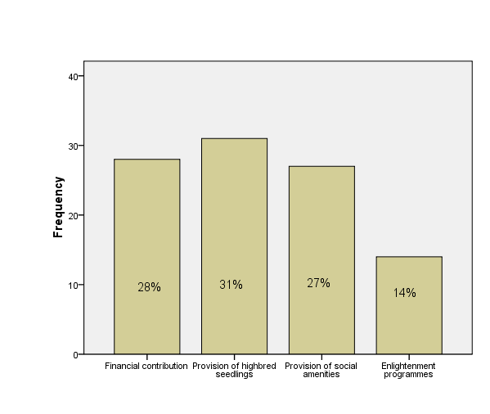
Source: Field Survey, 2026

Table 4.3: Do you belong to any NGO? Has your NGO/Association been consulted to make input in government poverty alleviation policies?
 |  | Has your NGO/Association been consulted to make input in government poverty alleviation policies?
 |  | YES | NO | Total
Do you belong to any NGO? | YES | 21 | 26 | 47
Do you belong to any NGO? | NO | 15 | 38 | 53
Total |  | 36 | 64 | 100
Source: Field Survey, 2026
Table 4.3 shows that out of 47 respondents that belong to NGO, 26 respondents claim that their NGO/Association has not been consulted to make input in government poverty alleviation policies while 21 respondents claim that their NGO/Association has been consulted to make input in government poverty alleviation policies. Out of 36 respondents that claim that their NGO/Association has been consulted to make input in government poverty alleviation policies, 15 of them do not belong to any NGO.

Table 4.4: How would you assess NGO/Association participation in poverty alleviation policies? Do you think poverty level in your community can be reduced through community development programmes?
 |  | Do you think poverty level in your community can be reduced through community development programmes?
 |  | YES | NO | Total
How would you assess NGO/Association participation in poverty alleviation policies? | Very low | 24 | 15 | 39
 | Low | 24 | 14 | 38
 | High | 5 | 6 | 11
 | Very high | 7 | 5 | 12
Total |  | 60 | 40 | 100
Source: Field Survey, 2026
Table 4.4 shows that out of 39 respondents who scored their NGO/Association very low, 24 of them believe that poverty can be reduced through community development programmes while 15 respondents think otherwise. While 24 respondents out of 38 who scored of The interaction of questions 1 and 2 shows that out of 42 respondents that are aware of poverty alleviation programme in their community, 19respondents claim that cooperative association does not exist while 23 respondents claim that cooperative association exist in their locality. On the other hand, out of the 53 respondents that are of the opinion that cooperative association exist in their locality, 30 of them are unaware of any poverty alleviation programme in their community while 23 respondents are aware of poverty alleviation programme in their community.
Table 4.5: Do you think any of these will reduce poverty in your community?
 | YES | NO | Total
- Education | 94 | 6 | 100
- Distributing motorcycles to the youths | 88 | 12 | 100
- Giving out soft loans | 80 | 20 | 100
- Provision of social amenities to the rural areas | 87 | 13 | 100
Source: Field Survey, 2026
From the Table 4.5, 94 and 88 respondents think that education and distribution of motorcycles to the youths will reduce poverty in their community respectively, while 6 and 12 respondents in that order think otherwise. Also, 80 and 87 respondents think that giving out soft loans and the provision of social amenities to the rural areas respectively will reduce poverty in their community, 20 and 13 respondents in that order think differently.
Fig. 4.2 shows the distribution of the respondents view on whether poverty is linked to crime/societal vices. The figure shows that 82% of the respondents believe that poverty is linked to crime/societal vices while 18% of the respondents believe otherwise.
Figure 4.2: In your opinion, is poverty linked to crime/societal vices in your community?
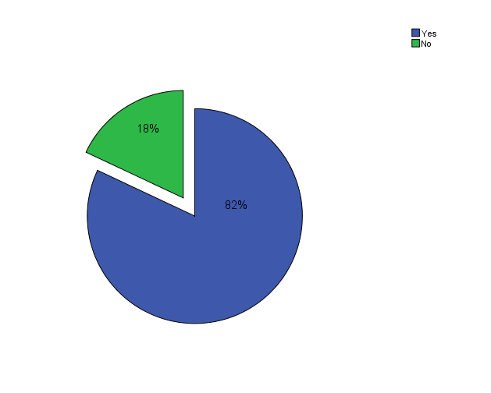
Source: Field Survey, 2026
Table 4.5: What class in the society do you think the programme you mention in question 1is meant for? How would you assess the participation of people in the programme?
 |  | How would you assess the participation of people in the programme?
 |  | Very low | Low | High | Very high | Total
What class in the society do you think the programme you mention in question 1is meant for? | Women | 4 | 2 | 5 | 5 | 16
 | Youths | 7 | 6 | 20 | 9 | 42
 | Petty traders | 2 | 4 | 8 | 5 | 19
 | Rural farmers | 4 | 0 | 14 | 5 | 23
Total |  | 17 | 12 | 47 | 24 | 100
Source: Field Survey, 2026
The interaction in Table 4.5 shows that out of 42 respondents that are aware of poverty alleviation programme in their community, 19 respondents claim that cooperative association does not exist while 23 respondents claim that cooperative association exist in their locality. On the other hand, out of the 53 respondents that are of the opinion that cooperative association exist in their locality, 30 of them are unaware of any poverty alleviation programme in their community while 23 respondents are aware of poverty alleviation programme in their community.
Figure 4.3 shows that programmes. While 19% and 47% of the respondents believed illiteracy and lack of awareness have influenced or impeded people’s participation in these programmes respectively, 21% and 13% cited lack of transparency and bureaucratic bottleneck respectively as factors.
Figure 4.3: What do you think has influenced or impeded people’s participation in these programmes?
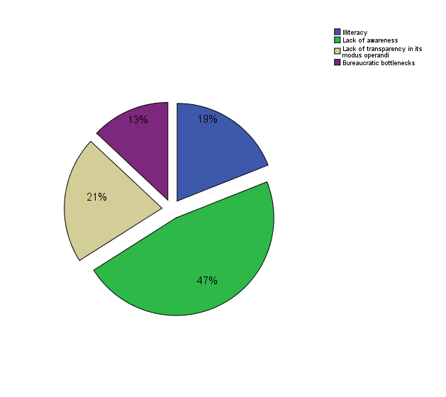
Source: Field Survey, 2026

Figure 4.4: What do you think is/was the social objective that influenced the programme(s) you mentioned
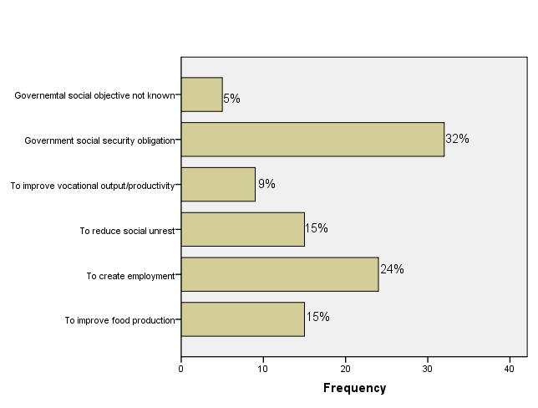
Source: Field Survey, 2026

Figure 4.4 shows the various social objectives that influence poverty alleviation programmes. Government social security obligation ranks first with 32%, followed by the need to create employment. 15% of the respondents believe that the need to improve food production influenced these programmes and another 15% of the respondents went for the need to reduce social unrest. While 9% of the respondents believe that the need to improve vocational output/productivity constitutes the social objective that influenced these programmes, 5% of the respondents claimed that the government social objective is not known.

Test of Hypotheses
The two hypotheses postulated earlier are tested using the one sample t-test.
Decision Rule: If the p-value is less than or equal to 5% (>0.05) then you reject the null hypothesis and claim support for the alternative hypothesis.
Hypothesis One: H₀: Community development programmes have not been hindered by some factors in Awka South.
Table 4.6: One-Sample T- Test
 | Test Value = 0
 | t | df | Sig. (2-tailed) | Mean Difference | 95% Confidence Interval of the Difference
 |  |  |  |  | Lower | Upper
Factors that influence or impede community development programmes in Awka South | 13.883 | 99 | .000 | 1.28000 | 1.0971 | 1.4629
Source: Generated by the Researcher using SPSS based on Field Survey, 2026
Table 4.6 shows the one-sample t-test for the hypothesis that community development programmes have not been hindered by some factors in Awka South. This hypothesis is rejected given that the P-value (0.000) is less that the 0.05 significance level. Hence, we conclude that community development programmes have been hindered by some factors in Awka South.

Hypothesis Two: H1: Poverty level cannot be reduced through community development programmes.
Table 4.7: One-Sample T- Test
 | Test Value = 0
 | t | df | Sig. (2-tailed) | Mean Difference | 95% Confidence Interval of the Difference
 |  |  |  |  | Lower | Upper
Do you think poverty level in your community can be reduced through community development programmes? | 8.124 | 99 | .000 | .40000 | .3023 | .4977

Source: Generated by the Researcher using SPSS based on Field Survey, 2026
Table 4.7 shows the one-sample t-test for the hypothesis that Poverty level cannot be reduced through community development programmes. This hypothesis is rejected given that the P-value (0.000) is less that the 0.05 significance level. Hence, we conclude that Poverty level can be reduced through community development programmes.

5. CONCLUSION AND RECOMMENDATIONS
The study empirically investigates the Community Development and Poverty Alleviation nexus in Awka South. A total of 120 questionnaires were administered to the residents of Awka South, out of these, 100 (about 83.3%) questionnaire were returned. The study adopted the descriptive statistic approach using tables, charts, frequencies, percentages et cetera to analyze the responses of the participants. In addition, one sample t-test is adopted in testing the hypotheses and cross tabulations are also used to examine the possible interaction between cases. The findings suggest that about 58% of the respondents are not aware of any poverty alleviation programme in their communities while about 42 of them claimed they are aware of such programmes. On whether a cooperative association exists in their locality, 53% of the respondents affirmed while 47% of them disagreed. Again, 60% of the respondents believe that poverty level in their community can be reduced through community development programmes while 40% think otherwise. On the factors that have influenced or impeded people’s participation in poverty alleviation programmes, lack of awareness ranks first (47%), followed by lack of transparency in the modus operandi of these programmes (21%), then illiteracy (19%) and bureaucratic bottleneck (13%) came third and forth.
Two basic conclusions emerged from the findings of the study. First, poverty level can be reduced through community development programmes. Secondly, community development programmes have been hindered by some factors in Awka South. In line with the basic findings of this study, Government and/or NGOs should embark on aggressive community development programmes. Awareness campaign on the need to actively participate in poverty alleviation programmes should be carried out, especially in the rural areas.

REFERENCES
Abiche, T. T. (2004). Community Development Initiatives and Poverty Reduction: The Role of the Ethiopian Kale Heywot Church in Ethiopia. MA Degree Thesis, University of the Western Cape.

Ary, D., Jacobs, L. C. & Razavieh, A. (1972). Introduction to Research in Education. New York: Holt, Rinehart and Winston.

Baba-Ahmed, F. (2012). Dimension of Poverty: Some Conceptual and Policy Challenges. Social International Development Journal, 50(2), 50-63.

Babatunde, R. O., Olorunsanya, E. O. & Adejola, A. D. (2008). Assessment of Rural Household Poverty: Evidence from South-Western Nigeria. American-Eurasian Journal of Agricultural & Environmental Sciences, 3, 900-905.

Ekpe, A. E. (2011). Poverty alleviation in Nigeria through capitalism economic framework: Problems and Challenges. Journal of sustainable Development in Africa, Pennsylvania: Clarion University of Pennsylvania.

Gillies, P. (1998). Effectiveness of alliances and partnerships for health promotion. Health Promotional International, 13, 99–120.

Imoh, A. N., Isaac U. J., & Nwachukwu, E. O. (2009). Comparative Analysis of Poverty Status of Community Participation in Rural Development Projects of Akwa Ibom State, Nigeria. New York Science Journal, 2(6).

Khan, H. U., Kurosaki,T., & Miura, K .(2011). The Effectiveness of Community-Based Development in Poverty Reduction: A Descriptive Analysis of a Women-Managed NGO in Rural Pakistan. Research Project Institute of Economic Research Hitotsubashi University Japan.

Lami, Y. & Midala, A. S. (2014). The impact of poverty alleviation programmes in the areas of Agricultural development and job creation for unemployed youth in Borno State. International Journal of Education and Research, 2(9), 50-62.

Ntombebhongo, G. (2012). Government–Sponsored Community Development Projects as Poverty Alleviation tools? Evidence from Mdantsane, East London (Master of Social Science Thesis, University of Fort Hare, South Africa).

Omale, I. and Molem, S.(2003), ‘A survey of Approaches to Poverty Alleviation and an Assessment of Previous Programmes’, in Ibanda, M.A.A. et al eds ‘Integrating Poverty. Alleviation strategies into plans and programmes in Nigeria’, NCEMA/World Bank.

Onyenechere, E. C. (2010). Appraisal of Rural Development Programmes in Imo State of Nigeria. Journal of Social Sciences, 22(3), 173-178.

Rawntree, B. S. (1941). Poverty and progress. A second social survey of New York. Longmans in Concept of Poverty. By Peter Townsend (edited) London.

Ross, M. G. (1955). Community organization, theory and principles. Retrieved from file://C:\Users\Asutosh Pradhan\Downloads\e-books 18.1.2011\communityorganiz00ross_d

Rothman, J. (1974). Three Models of Community Organization Practice in Cox, F. M., et al. (eds.), Strategies of Community Organization, Itasca, Ill.: F. E. Peacock Publishers, 1970 and 1972.

Sen, A., 1999. Development as freedom. Oxford: Oxford University Press.

VeitWilson, J. H. (1986). Paradigms of Poverty: A Rehabilitation of B.S. Rowntree. Journal of Social Policy, 15, 69-99.

World Bank. (2000). Measuring poverty. Retrieved from
https://www.worldbank.org/ext/en/topic/poverty/measuring-poverty

