EXPERIMENTAL EVALUATION OF THE EFFECT OF ADDITIVE ON VEGETABLE OIL-BASED LUBRICANTS

1.0 INTRODUCTION
The development and use of industrial lubricants have undergone significant changes as a result of the increased emphasis on global environmental sustainability. The conventional petroleum-based lubricants can effectively reduce wear and friction in mechanical systems. However, they provide significant environmental issues due to their possible toxicity and non-biodegradability. (Singh & Chauhan, 2021). These challenges are concerns and have fueled interest in alternative lubricants derived from renewable resources, particularly vegetable oils. Vegetable oil-based lubricants are becoming more and more popular due to their high biodegradability, low eco-toxicity, and the potential to reduce over reliance on non-renewable fossil fuels. (Rios, et al., 2022). Despite these benefits, their use have been restricted due to some disadvantages, such as low heat resistance, poor oxidative stability, and hydrolytic degradation susceptibility. (Song el at., 2019).
In the quest to overcome these limitations, researchers are continually exploring various strategies to enhance the performance of vegetable oil-based lubricants. One of the most promising approaches currently is the incorporation of chemical additives. (Stachowiak & Batchelor, 2018). Common types of additives include antioxidants, pour point depressants, anti-wear additives, extreme pressure additives, corrosion inhibitors and defoamers.
Recent research studies suggest that adding nano-particles and nano-additives to vegetable oils as lubricants can significantly improve their tribological properties such as friction coefficient and wear rate; significantly improving the oxidative stability, frictional characteristics, and general durability of these bio-lubricants. (Kumar & Chauhan, 2023). Challenges in using additives in vegetable oil-based lubricants like developing cost-effective additives, improving oxidative stability and thermal resistance, and ensuring compatibility with existing systems remain a huge limitation. Also, the effectiveness of specific additives under varying operational conditions remains under-explored. This calls for the need for more comprehensive studies to fully understand the interactions between vegetable oil-based lubricants and the additives used to enhance their performance. (Zhang & Wang, 2021).
The findings from this research are expected to contribute to the ongoing development of environmentally friendly lubricants, offering practical solutions to the challenges associated with the use of bio-lubricants in the ever increasing demand for its applications. This work also underscores the importance of innovative additive technologies in advancing the performance and sustainability of industrial lubricants, aligning with global efforts to reduce environmental impact and promote the use of renewable resources.
3.0 RESULTS AND DISCUSSIONS
Table 3: Comparison of the Physiochemical Analysis of Groundnut and Sasame Extract.
Physiochemical Analysis | Groundnut Oil/Extract | Sasame Oil/Extract
Specific Gravity | 0.91 | 0.92
Pour Point (ºC) | -2 | -14.67
Flash Point (ºC) | 265 | 228
Cloud Point (ºC) | 6 | -9
Acid Value (mg KOH/g oil) | 0.36 | 0.14
Saponification Value (mg KOH/g oil) | 187.90 | 11.22

The thermal conductivity of groundnut oil at varying temperatures and additive (32g fine mixture Al₂O₃ + MgSO₄ hepta-hydrate and 5ml Oleum, thoroughly mixed) is given in table 4
Table 4: Thermal Conductivities (W/⁰ C) of Groundnut Oil
Temperature (⁰C) | Sample A | Sample B | Sample C | Sample D | Sample E
50 | 0.45 | 0.52 | 0.72 | 0.76 | 0.82
60 | 0.20 | 0.33 | 0.42 | 0.45 | 0.51
70 | 0.22 | 0.25 | 0.29 | 0.30 | 0.37
From these experimental values, it can be seen that the thermal conductivity of the groundnut oil increases with increase in additive, with the optimum sample at 40% additive. However, at higher temperatures the thermal conductivity of groundnut oil falls. This is an indication that, higher quantities of the additive (32g fine mixture Al₂O₃ + MgSO₄ hepta-hydrate and 5ml Oleum, thoroughly mixed) makes groundnut oil a lubricant with better thermal conductivity and groundnut oil is a poor lubricant at elevated temperatures. This behaviour is demonstrated in figure 1
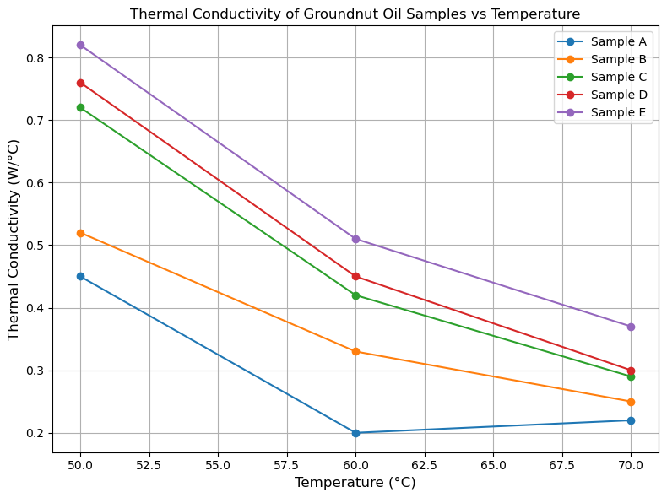
Figure 1: Variation of Thermal Conductivity of Groundnut Oil with Temperature
The thermal conductivities of Sasame oil at varying temperatures and additive (32g fine mixture Al₂O₃ + MgSO₄ heptahydrate and 5ml Oleum, thoroughly mixed) is given in table 5
Table 5: Thermal Conductivities (W/⁰ C) of Sasame Oil
Temperature (⁰C) | Sample A | Sample B | Sample C | Sample D | Sample E
50 | 0.63 | 0.72 | 0.87 | 0.89 | 0.95
60 | 0.39 | 0.42 | 0.47 | 0.59 | 0.62
70 | 0.28 | 0.30 | 0.32 | 0.42 | 0.52
The values in table 5 also show an increase in the thermal conductivity of Sasame Oil as the additive increases, with an optimum value at 40% additive. However, the thermal conductivity of Same Oil decreases at higher temperatures indicating that higher quantities of additive (32g fine mixture Al₂O₃ + MgSO₄ hepta-hydrate and 5ml Oleum, thoroughly mixed) makes Sasame oil a better lubricant, but higher temperatures make Sasame oil a poor lubricant, as shown in figure 2 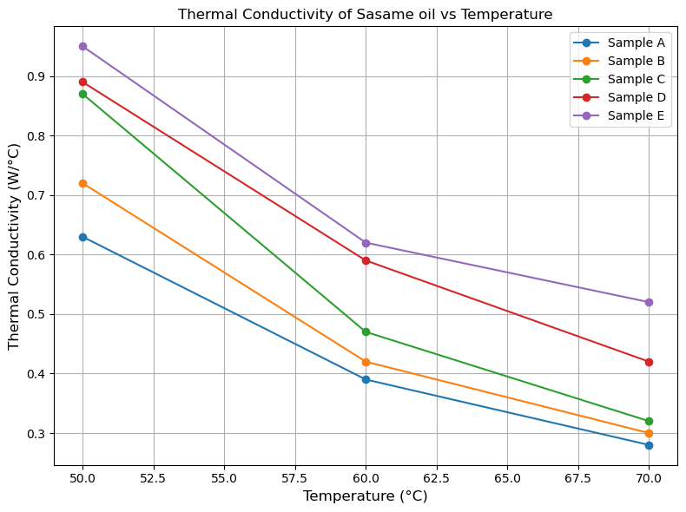Figure 2: Variation of Thermal Conductivity of Sasame Oil with temperature

The kinematic viscosity of groundnut oil at varying temperatures and additive are given in table 6
Table 6: Kinematic viscosity of groundnut oil at varying temperatures and additive
Temperature (⁰C) | Sample A | Sample B | Sample C | Sample D | Sample E
50 | 23.21 | 22.03 | 22.82 | 22.70 | 21.80
60 | 17.53 | 18.16 | 17.84 | 17.46 | 15.69
70 | 15.45 | 14.01 | 13.78 | 12.59 | 11.02

From values in table 6, it can be seen that the kinematic viscosity of groundnut oil decreases with increase in temperature, but increases with an increase with an increase in the quantity of additive (32g fine mixture Al₂O₃ + MgSO₄ hepta-hydrate and 5ml Oleum, thoroughly mixed), indicating that, groundnut oil has better lubricity at higher quantities of additive (32g fine mixture Al₂O₃ + MgSO₄ hepta-hydrate and 5ml Oleum, thoroughly mixed), but loses its lubricity at elevated temperatures. This behaviour is displayed in figure 3
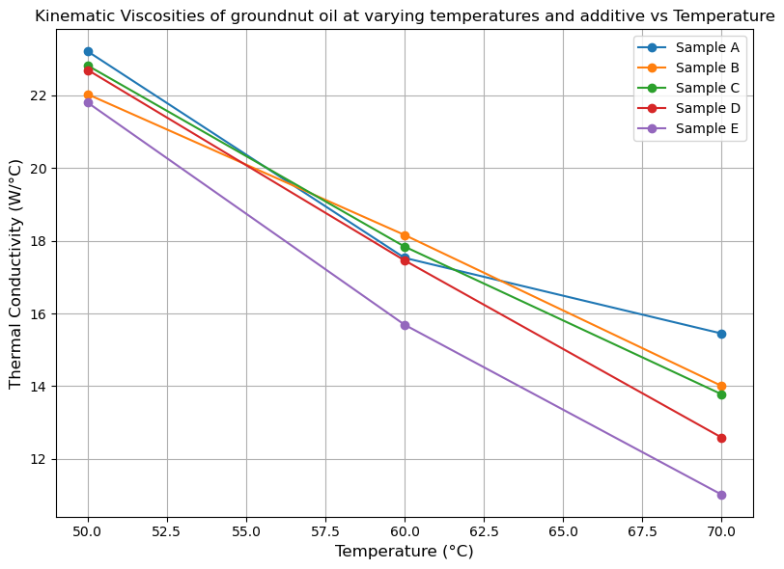
Figure 3: Variation of kinematic viscosity of groundnut oil with temperature
The kinematic viscosity of Sasame oil at varying quantities of additive (32g fine mixture Al₂O₃ + MgSO₄ hepta-hydrate and 5ml Oleum, thoroughly mixed) and temperature is given in table 7
Table 6: Kinematic viscosity of sesame oil at varying temperatures and additive
Temperature (⁰C) | Sample A | Sample B | Sample C | Sample D | Sample E
50 | 29.01 | 28.83 | 26.50 | 20.50 | 18.65
60 | 22.40 | 21.72 | 20.10 | 15.00 | 13.55
70 | 16.90 | 16.00 | 14.69 | 13.30 | 11.45
From the values in table 6, it can be seen that, the kinematic viscosity of sesame oil decrease with increase temperature and additive (32g fine mixture Al₂O₃ + MgSO₄ hepta-hydrate and 5ml Oleum, thoroughly mixed), which means that sesame oil is less viscous and a poorer lubricant at higher quantities of additive (32g fine mixture Al₂O₃ + MgSO₄ hepta-hydrate and 5ml Oleum, thoroughly mixed) and temperature. This trend is illustrated in figure 4
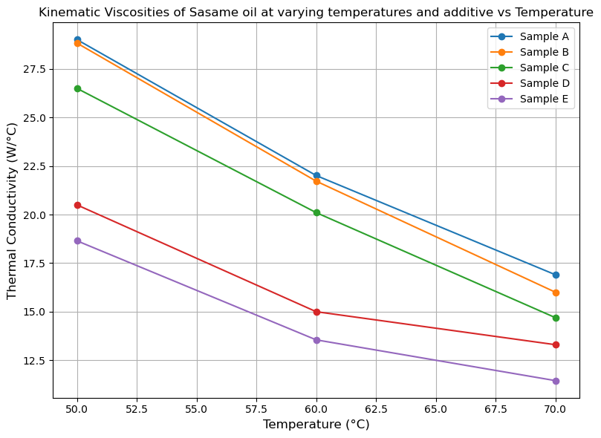
Figure 4: Variation of kinematic viscosity of sesame oil with temperature

- CONCLUSION
From the results obtained, it can be seen that groundnut oil has higher kinematic viscosity with increasing quantity of the additive used (32g fine mixture Al₂O₃ + MgSO₄ hepta-hydrate and 5ml Oleum, thoroughly mixed), as opposed to sesame oil. Also, the thermal conductivity of sesame oil increases with increase in additive, while its viscosity decreases with increase in additive. Since viscosity is the most important property of a lubricant, the additive is most suitable for use in the production of lubricant, to obtained more effective lubricants.

