AI-Driven Transformation Roadmap for Manufacturing SMEs

ABSTRACT

Manufacturing SMEs are increasingly pressured to adopt digital technologies and artificial intelligence (AI) to remain competitive in global export markets. However, many SMEs continue to experience weak innovation performance, poor commercialization outcomes, fragmented R&D structures, and limited scalability despite substantial investment in digital transformation initiatives. This suggests that technological adoption alone is insufficient to generate sustainable export competitiveness when organizations lack integrated R&D transformation strategies, governance alignment, and innovation capability maturity.
Strategic problem of weak AI-driven innovation transformation among manufacturing SMEs, particularly those operating within export-oriented industries. The study adopts an executive-level strategic consulting perspective and applies advanced R&D and innovation management frameworks to diagnose the structural causes of underperformance. Rather than treating AI adoption as a purely technological issue, the analysis conceptualizes the problem as a broader organizational and strategic transformation challenge involving capability development, governance redesign, commercialization readiness, and ecosystem integration.
The project applies multiple analytical frameworks, including the CLIMB R&D Maturity Framework, Innovation Ecosystem Analysis, Technology vs Market Matrix, and Innovation Governance Framework. The diagnostic findings reveal that many manufacturing SMEs suffer from fragmented innovation governance, low AI commercialization capability, weak cross-functional integration, talent shortages, reactive technology adoption, and insufficient strategic alignment between R&D investments and export market requirements. Furthermore, digital initiatives are frequently implemented as isolated operational upgrades rather than as components of a coherent innovation strategy.
Based on these findings, the report proposes a comprehensive AI-driven R&D transformation roadmap designed to enhance export competitiveness. The proposed transformation model includes five strategic pillars:
- AI-integrated R&D governance redesign
- Smart manufacturing capability development
- Commercialization acceleration mechanisms
- Innovation talent transformation
- Data-driven ecosystem collaboration
The proposal further incorporates phased implementation strategies, commercialization pathways, risk mitigation mechanisms, and governance review structures to ensure long-term scalability and sustainability.
The study concludes that successful AI transformation within manufacturing SMEs requires more than technology investment. Sustainable export competitiveness depends on the organization’s ability to institutionalize innovation governance, integrate AI into strategic R&D processes, and redesign decision-making structures capable of managing uncertainty, scalability, and market adaptation. The findings contribute to understanding of how innovation strategy, R&D governance, and AI-enabled transformation intersect within contemporary manufacturing environments.

1.0 Introduction
Global manufacturing industries are undergoing rapid transformation driven by digitalization, artificial intelligence (AI), automation, and evolving international market expectations. The emergence of Industry 4.0 technologies has fundamentally altered how organizations develop products, manage operations, commercialize innovations, and compete within export markets. For manufacturing SMEs, these changes present both significant opportunities and substantial strategic challenges.
While large multinational corporations possess the financial resources, technological infrastructure, and organizational capabilities necessary to implement AI-driven innovation strategies at scale, many manufacturing SMEs continue to struggle with fragmented digital transformation initiatives, weak commercialization performance, and limited innovation scalability. Despite increasing awareness of AI technologies and government encouragement toward industrial digitalization, SMEs frequently encounter difficulties converting technological adoption into sustainable export competitiveness.
This problem is particularly critical within export-oriented manufacturing sectors where international competition increasingly depends on innovation speed, product customization, operational intelligence, and technological responsiveness. In such contexts, organizations that fail to integrate AI into their R&D and innovation systems risk strategic stagnation, declining market relevance, and reduced long-term competitiveness.
Accordingly, this project investigates the strategic transformation challenges faced by manufacturing SMEs and proposes an AI-driven R&D transformation roadmap designed to strengthen innovation capability and export competitiveness.

2.0 Review of Literature

The TOE framework (Tornatzky & Fleischer, 1990) provides a comprehensive lens for understanding technology adoption in organizations. This framework identifies three key dimensions:

Technological factors: Including AI capabilities, infrastructure, and technical readiness
Organizational factors: Encompassing governance structures, leadership, and resource availability
Environmental factors: Covering market pressures, regulatory environment, and competitive dynamics

RBV theory (Barney, 1991) suggests that firms can achieve sustainable competitive advantage through the strategic deployment of valuable, rare, inimitable, and non-substitutable resources. In the context of AI-driven R&D, this theory helps explain how manufacturing SMEs can develop unique capabilities through AI integration.

The concept of Industry 4.0 (Kagermann et al., 2013) has revolutionized manufacturing by integrating cyber-physical systems, IoT, and AI. Research by Lasi et al. (2014) highlights how these technologies enable smart manufacturing, characterized by increased flexibility, efficiency, and customization capabilities.

Multiple studies have documented the applications of AI in manufacturing:
Predictive maintenance: Using machine learning algorithms to predict equipment failures (Lee et al., 2014)

Quality control: Computer vision systems for defect detection (Zhou et al., 2018)

Supply chain optimization: AI-driven demand forecasting and inventory management (Ivanov et al., 2019)
Research by Westerman et al. (2014) identifies resource constraints as a major barrier to digital transformation in SMEs. These constraints include:
Limited financial resources for technology investment
Shortage of skilled personnel with AI expertise
Insufficient infrastructure for data management

A study by Vial (2019) emphasizes that organizational readiness is critical for successful digital transformation. Key factors include:

Leadership commitment and vision
Organizational culture and change readiness
Existing technological infrastructure

Gartner's Digital Maturity Model (Gartner, 2016)

MIT's Digital Transformation Framework (Westerman et al., 2014)
These models provide structured approaches for organizations to evaluate their current state and plan their transformation journey.

The concept of innovation ecosystems (Adner, 2017) is particularly relevant for SMEs. Research shows that SMEs can overcome resource limitations by:
Collaborating with research institutions and universities

Partnering with technology vendors and service providers
Participating in industry consortia and networks

2.1 CLIMB² R&D Maturity Framework Analysis
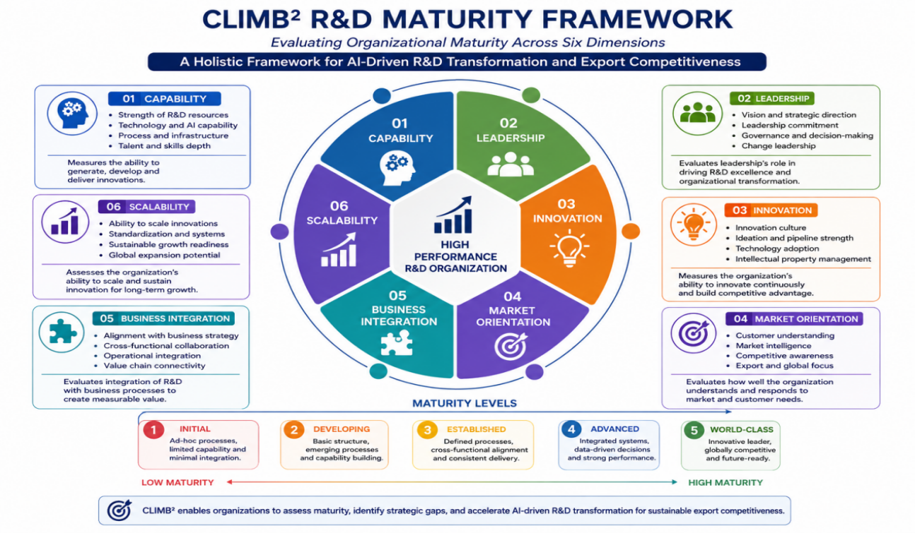
2.1.1 Capability Deficiency
Many manufacturing SMEs possess limited internal AI capability. Technology adoption often depends heavily on external vendors, creating dependency rather than organizational learning. Internal R&D teams frequently lack expertise in:
AI integration
predictive analytics
smart manufacturing systems
digital process optimization
Consequently, technological implementation becomes fragmented and operationally isolated.
2.1.2 Leadership and Strategic Alignment Weakness
A major structural weakness lies in leadership orientation toward digital transformation. Many SME leaders perceive AI primarily as a productivity tool rather than as a strategic innovation capability.
This creates several consequences:
weak long-term innovation planning
underinvestment in R&D capability development
short-term decision orientation
reactive rather than proactive transformation behavior
Without executive-level innovation vision, AI adoption remains tactical rather than transformational.
2.1.3 Innovation Process Fragmentation
Innovation activities within SMEs are often disconnected from commercialization pathways and export market requirements. Product innovation, operational improvement, and digital initiatives operate in separate silos, reducing organizational synergy.
As a result:
innovation cycles become slow
commercialization success rates remain low
technological experimentation lacks strategic direction
The absence of integrated innovation governance prevents organizations from converting technological potential into market value.

2.2 Innovation Ecosystem Analysis
Manufacturing SMEs operate within broader innovation ecosystems involving suppliers, logistics providers, universities, government agencies, AI vendors, and export platforms.
However, ecosystem collaboration remains weak in many SME environments.
2.2.1 Weak External Collaboration
Many SMEs maintain transactional rather than strategic relationships with ecosystem partners. Collaboration with universities, research institutions, and technology providers is limited, reducing knowledge transfer and innovation capability development.
This weak ecosystem integration restricts:
technology diffusion
AI experimentation capability
commercialization acceleration
access to innovation funding

2.2.2 Export Market Misalignment
Many SMEs adopt AI technologies without adequately understanding export market expectations. Consequently, technological investments may improve operational efficiency while failing to enhance customer value or international differentiation.
This reflects a broader strategic gap between:
technology adoption and market-oriented innovation strategy
Such misalignment reduces the commercial effectiveness of AI transformation initiatives.

2.3 Technology vs Market Matrix Analysis
The Technology vs Market Matrix is applied to evaluate whether manufacturing SMEs possess sufficient alignment between technological readiness and market readiness. A recurring problem observed among SMEs is that technology adoption frequently progresses faster than commercialization capability.
This imbalance creates a strategic condition where organizations become technologically active but commercially underprepared.
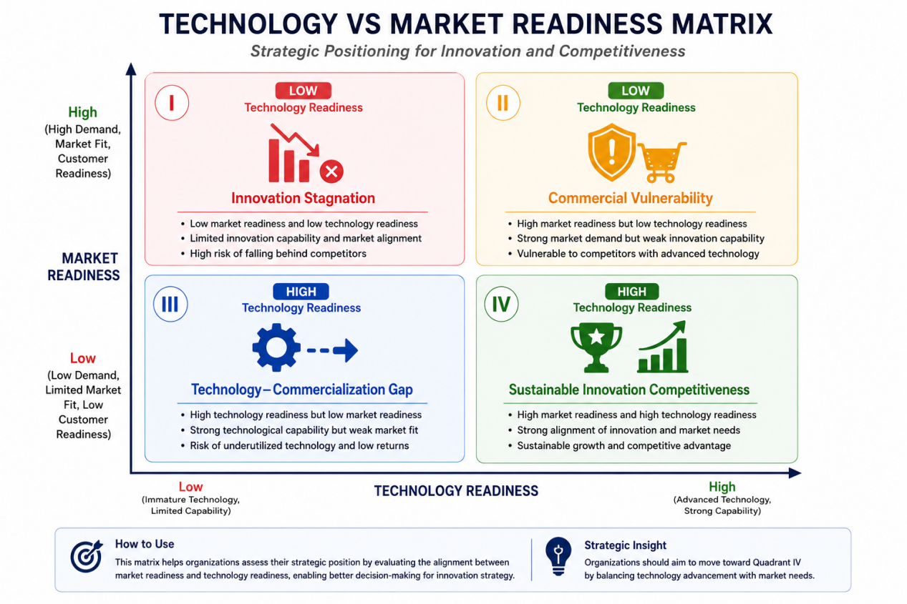

Most manufacturing SMEs currently occupy the “Technology-Commercialization Gap” quadrant. In this position:
AI tools are implemented internally
automation systems are partially operational
data collection capabilities exist
However:
export differentiation remains weak
customer value creation is unclear
commercialization scalability is limited
This indicates that technological modernization alone does not automatically translate into export competitiveness.
Furthermore, organizations frequently overestimate the strategic value of technology while underestimating the importance of commercialization ecosystems, customer adaptation, and innovation governance.
Consequently, many SMEs become trapped in what may be described as “operational digitalization without strategic transformation.”

2.4 Innovation Governance Analysis
Innovation governance refers to the structures, leadership mechanisms, accountability systems, and strategic processes through which innovation activities are coordinated and evaluated.
The diagnostic analysis reveals that many manufacturing SMEs lack formal innovation governance systems capable of managing AI-driven transformation effectively.

2.4.1 Fragmented Decision-Making Structures
Digital transformation decisions are often decentralized across departments without strategic integration. Production teams, IT functions, marketing divisions, and R&D units operate independently, leading to fragmented implementation priorities.
This fragmentation generates several operational inefficiencies:
duplicated technology investment
inconsistent innovation objectives
poor cross-functional communication
weak strategic coordination
Without centralized innovation governance, AI initiatives become disconnected operational projects rather than components of a coherent transformation strategy.

2.4.2 Weak Innovation Performance Metrics
Another major weakness involves the measurement of innovation success.
Many SMEs evaluate digital transformation primarily through short-term operational indicators such as:
cost reduction automation efficiency production speed
While these indicators are important, they fail to capture broader strategic outcomes including:
export competitiveness commercialization scalability innovation adaptability
ecosystem integration long-term resilience
This narrow evaluation logic encourages short-term optimization rather than sustainable innovation capability development.

3.0 Conclusion
The transition to Industry 4.0 is not merely a technological upgrade; it is an existential imperative for manufacturing SMEs seeking to survive in global export markets. This research has demonstrated that the current approach of "operational digitalization" is insufficient. It creates a "Technology-Commercialization Gap" where SMEs possess advanced tools but lack the strategic capability to monetize them in international markets.
The proposed AI-Driven R&D Transformation Roadmap offers a solution. By realigning Governance, developing Smart Manufacturing Capabilities, accelerating Commercialization, transforming Talent, and leveraging the Ecosystem, SMEs can close this gap.
Ultimately, sustainable export competitiveness in the AI era will not belong to the company with the most robots, but to the company with the most integrated strategy. It belongs to the organization that can successfully institutionalize innovation governance and redesign its decision-making structures to manage uncertainty, scalability, and market adaptation. This roadmap provides the blueprint for that transformation.

References

Barney, J. (1991). Firm resources and sustained competitive advantage. Journal of Management, 17(1), 99‑120.

Bharadwaj, A., El Sawy, O. A., Pavlou, P. A., & Venkatraman, N. (2013). Digital business strategy: Toward a next generation of insights. MIS Quarterly, 37(2), 471‑482.

Gartner. (2016). Gartner's digital maturity model. Gartner Research.

Ivanov, D., Dolgui, A., & Sokolov, B. (2019). The impact of digital technology and Industry 4.0 on the ripple effect and supply chain risk analytics. International Journal of Production Research, 57(3), 829‑846.

Kagermann, H., Wahlster, W., & Helbig, J. (2013). Recommendations for implementing the strategic initiative INDUSTRIE 4.0. Final report of the Industrie 4.0 Working Group.

Lasi, H., Fettke, P., Kemper, H.‑G., Feld, T., & Hoffmann, M. (2014). Industry 4.0. Business & Information Systems Engineering, 6(4), 239‑242.

Lee, J., Bagheri, B., & Kao, H.‑A. (2014). A cyber‑physical systems architecture for industry 4.0‑based manufacturing systems. Manufacturing Letters, 3, 18‑23.

Porter, M. E. (1990). The competitive advantage of nations. Free Press.

Tornatzky, L. G., & Fleischer, M. (1990). The processes of technological innovation. Lexington Books.

Vial, G. (2019). Understanding digital transformation: A review and a research agenda. The Journal of Strategic Information Systems, 28(2), 118‑144.

Westerman, G., Bonnet, D., & McAfee, A. (2014). Leading digital: Turning technology into business transformation. Harvard Business Review Press.

Zhou, L., Liu, Q., & Zhang, C. (2018). Deep learning for smart manufacturing: Methods and applications. Journal of Manufacturing Systems, 48, 144‑156.

